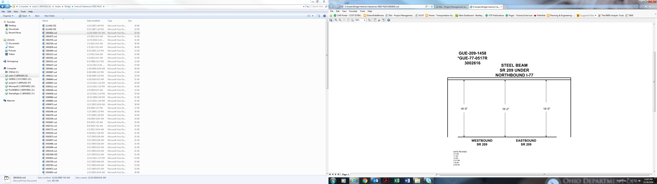

16’-5” 16’-2” 16’-5”

Date Revised: 3-7-69

11-92

12-95

3-31-98

7-8-99

9-30-04