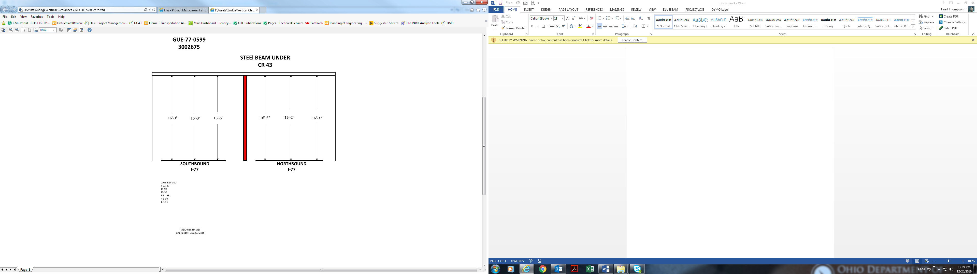

16’-5” 16’-2” 16’-3”

16’-3” 16’-3” 16’-5”

Date Revised: 4-22-87

11-92

12-95

3-31-98

7-8-99

1-5-11