BRIDGE MOUNTED OVERHEAD SIGN INSPECTION

BRIDGE NUMBER: GUE-77-0708

SFN: 3002705

FEATUR INTERSECTED: CR 35 over I-77

LOCATION OF THE SIGN ON BRIDGE: One sign on the right bridge rail over NB I-77.

TYPE OF SIGN (cantilever, box truss, skewed, flat, other): Flat.

CONDITION OF ANCHOR BOLTS/NUTS: Rusting.

CONDITION OF CONCRETE: Good.

CONDITION OF SIGN SUPPORTS: Good.

CONDITION OF SIGN ATTACHMENTS: 2 of the clips are loose and 1 is missing.

CONDITION OF SIGN LIGHTING: none

COMMENTS:

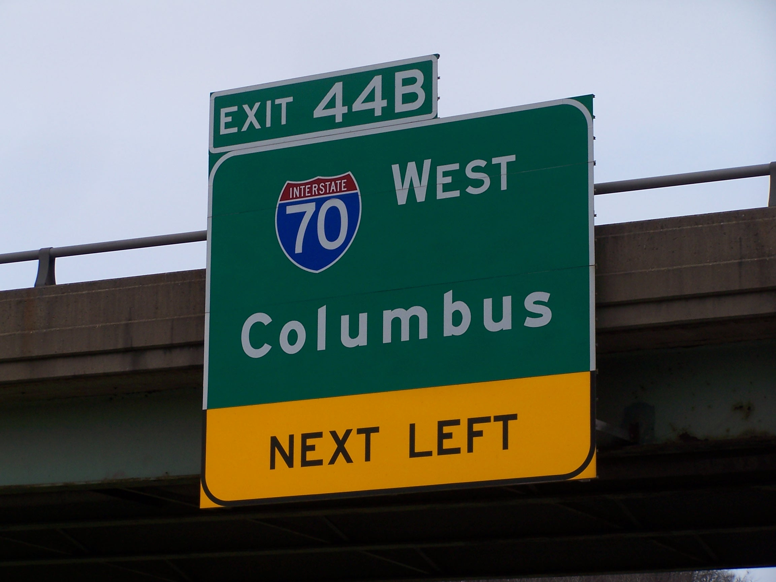

INSPECTED BY: Albert Abel
DATE: 11-17-2011

