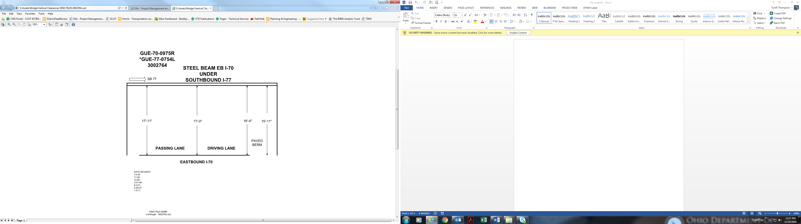

17’-11” 17’-0” 16’-4” 15’-11”

Date Revised: 3-2-87

11-92

12-95

3-31-98

8-2-01

6-26-07

1-5-11