BRIDGE MOUNTED OVERHEAD SIGN INSPECTION

BRIDGE NUMBER: GUE-77-0768L

SFN: 3002829

FEATUR INTERSECTED: SB I-77 over WB I-70

LOCATION OF THE SIGN ON BRIDGE: Two signs on the right bridge rail over WB I-70.

TYPE OF SIGN (cantilever, box truss, skewed, flat, other): Skewed.

CONDITION OF ANCHOR BOLTS/NUTS: Some of the anchors are set at an angle but they are in good condition.
CONDITION OF CONCRETE: Good.

CONDITION OF SIGN SUPPORTS: Good.

CONDITION OF SIGN ATTACHMENTS: Good.

CONDITION OF SIGN LIGHTING: none

COMMENTS:

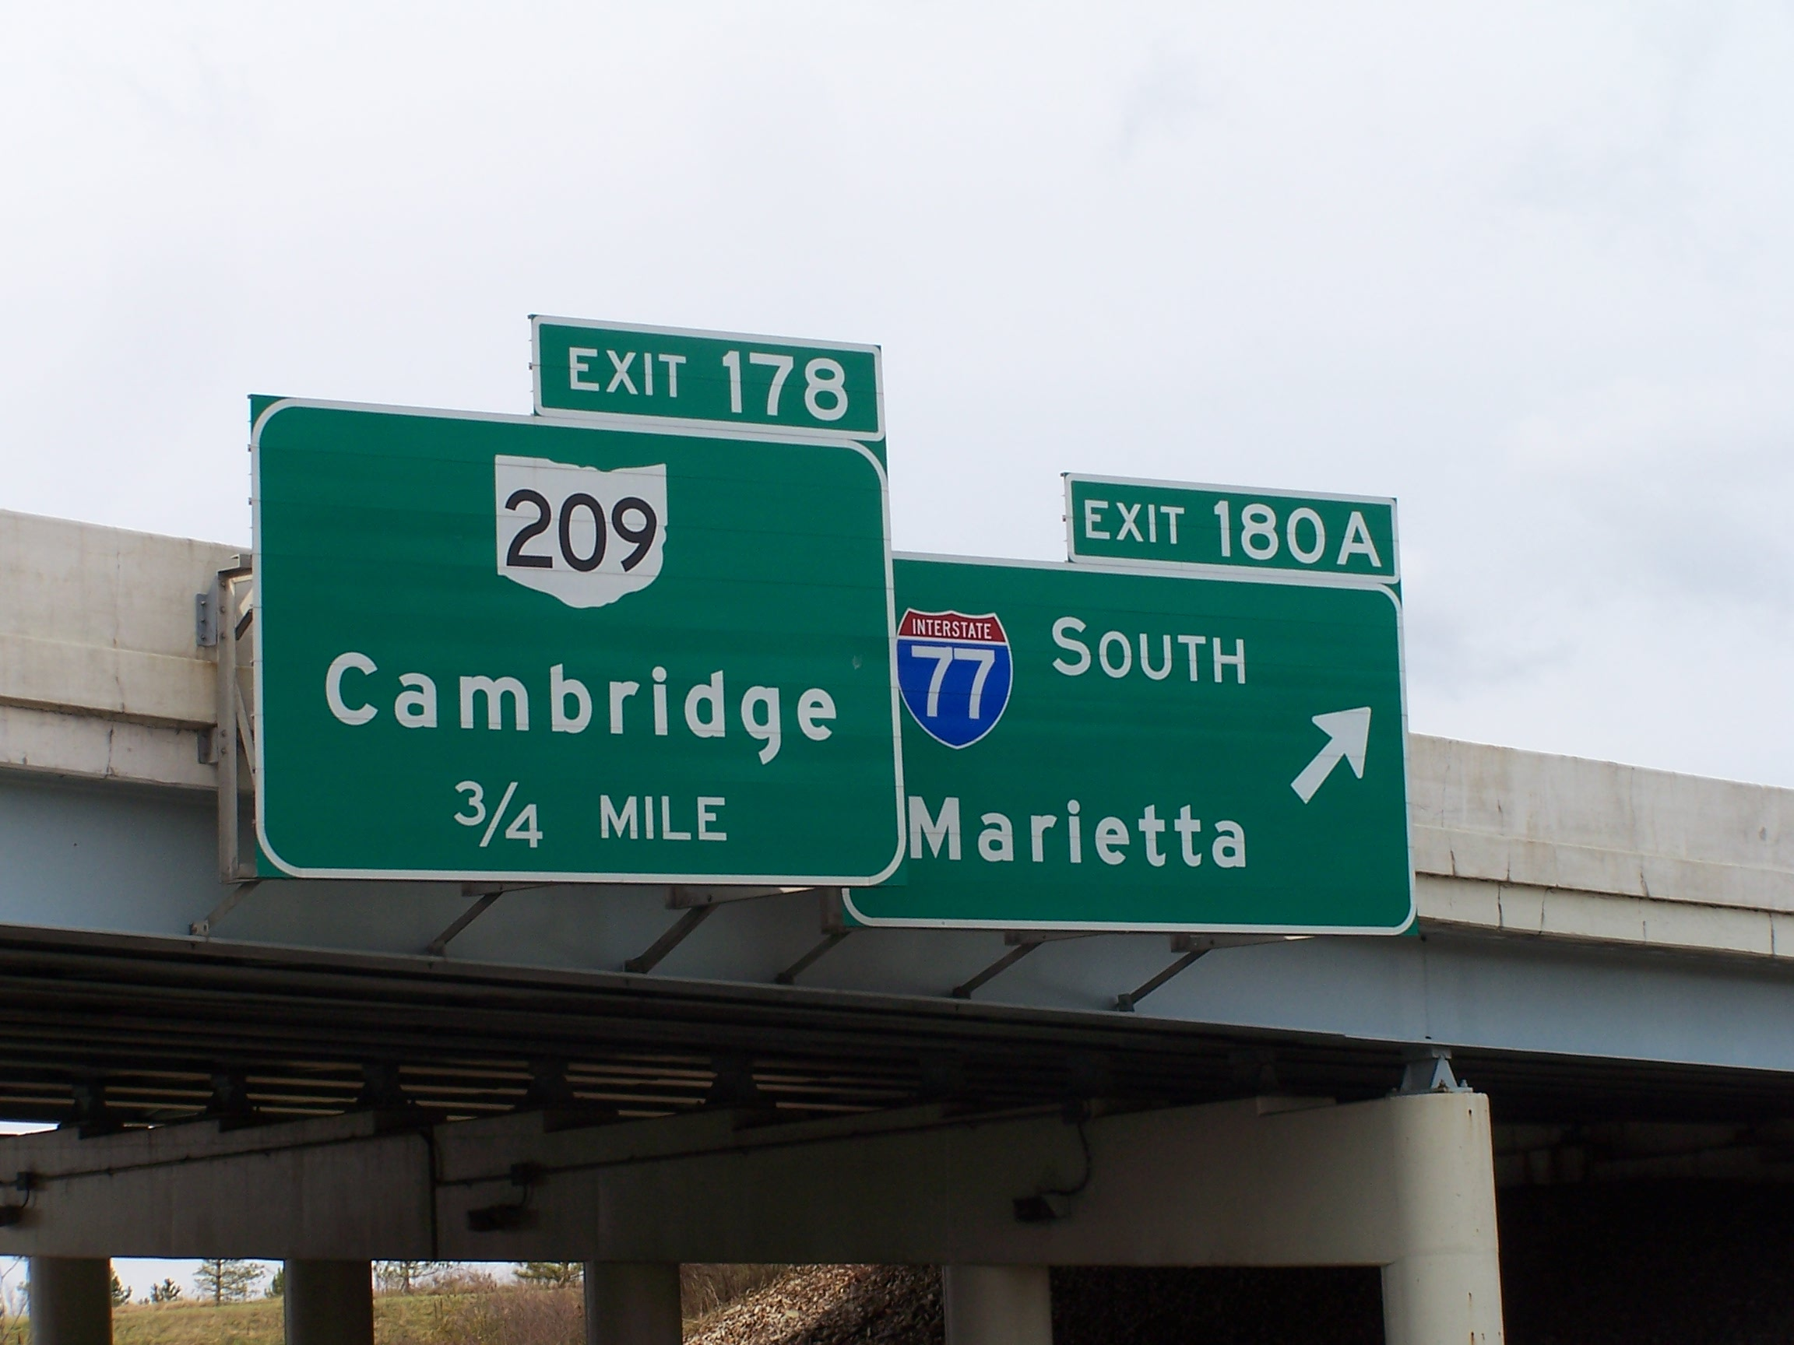

INSPECTED BY: Albert Abel
DATE: 10-22-2013

