D-5 BRIDGE WORK ORDER

TO: TOM BRADFORD DATE: 03/24/2010

FROM: Curtis Zigan, D-5 Bridge Engineer By: Jeff Watson

BRIDGE NUMBER: Gue-77-804 L SFN: 3002888

DESCRIPTION OF NEEDED WORK

Check deck edges (RT & LF) and remove loose concrete.
THANKS

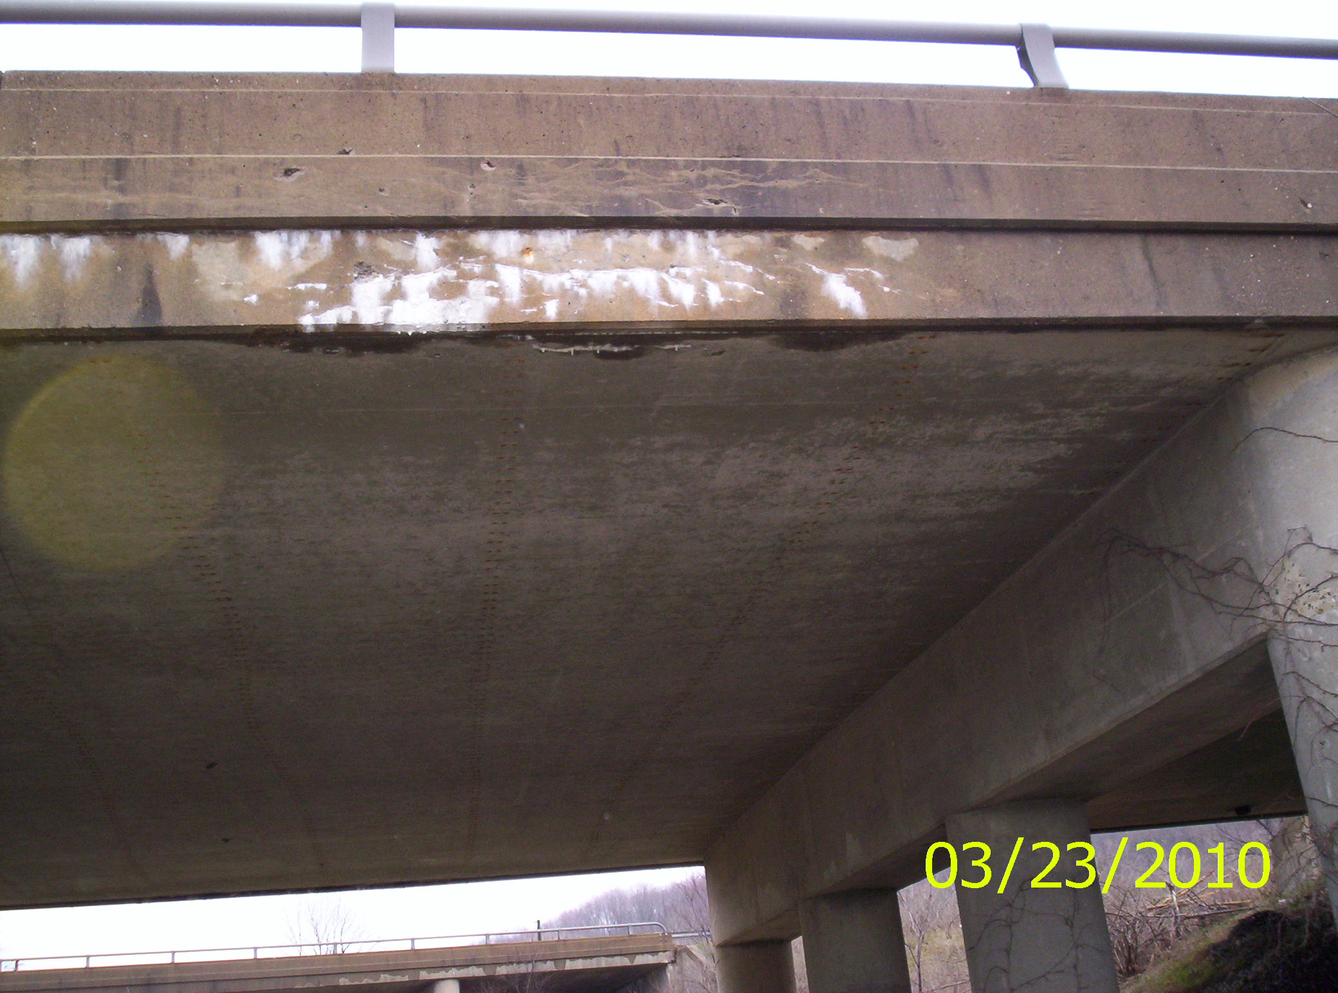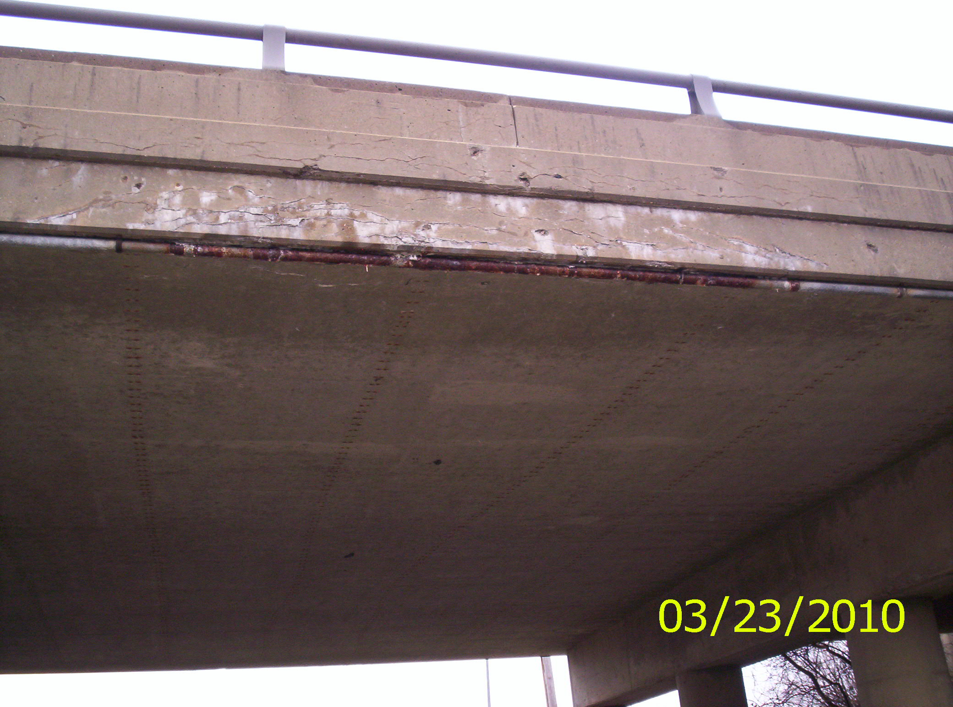

Left edge Right edge

Please sign, date and return this form after the repairs are completed.
COUNTY or DEPARTMENT MANAGER___________________________________
DATE COMPLETED____4/26/10 (Inspection of W/O 7/7/10 jaw)_______________________
C: bridge file
/tmp/in/input.doc

