D-5 BRIDGE WORK ORDER

TO: DOUG GEORGE DATE: 11/23/2010

FROM: Curtis Zigan, D-5 Bridge Engineer By: JEFF WATSON

BRIDGE NUMBER: GUE-77-0926R SFN:3003035

DESCRIPTION OF NEEDED WORK

The forward end of the bridge expansion joint is low.
Shim bearings to raise bridge deck to proper elevation.

THANKS
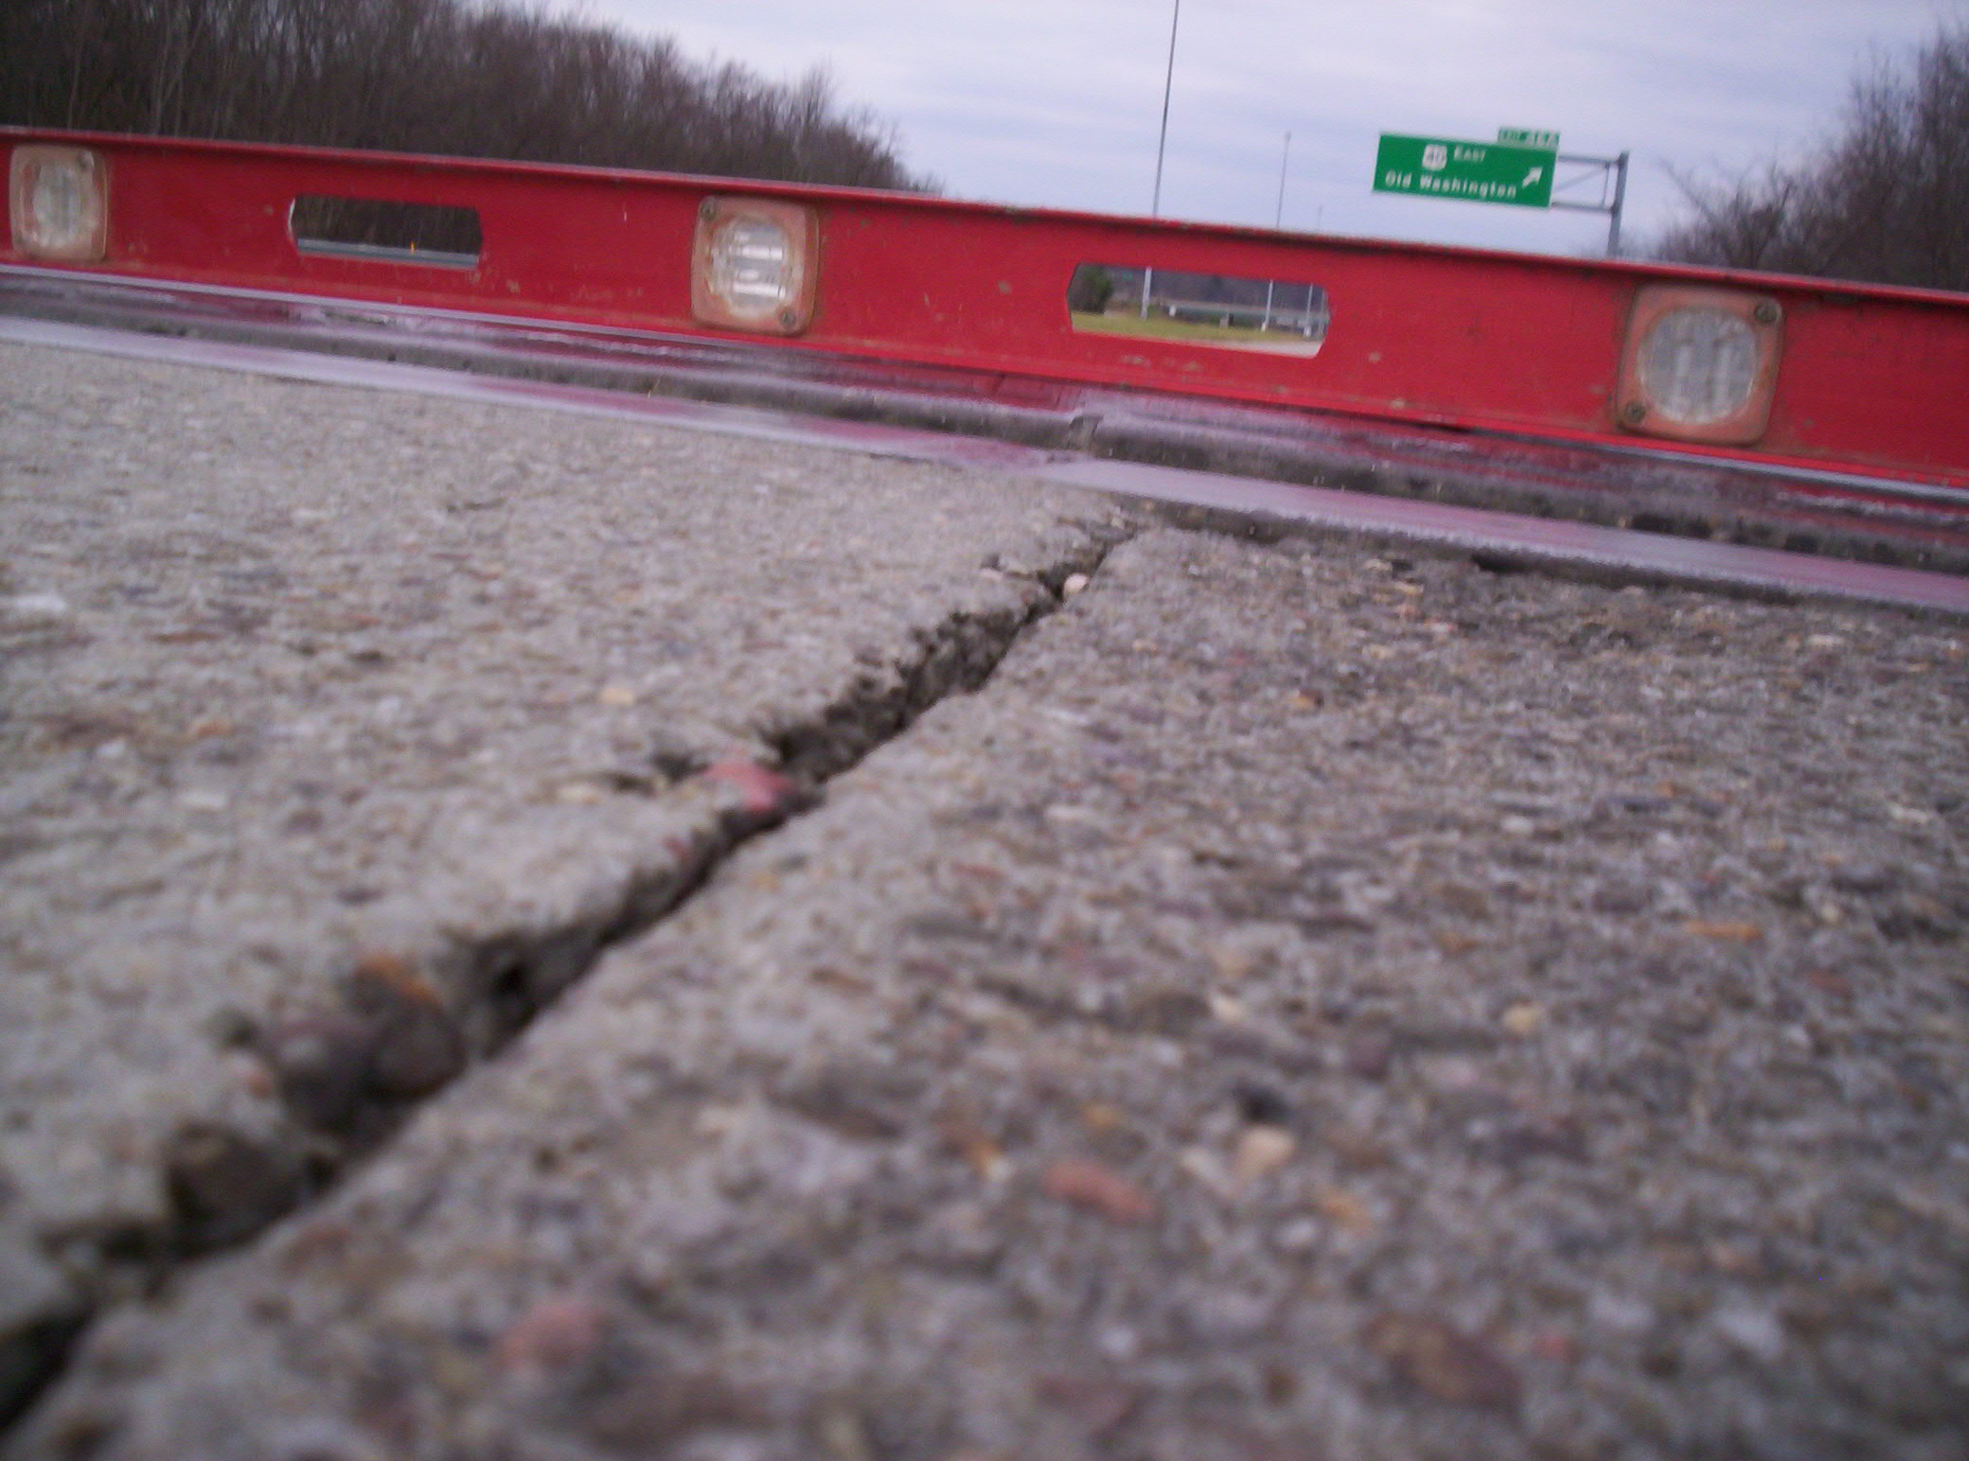

Please sign, date and return this form after the repairs are completed.

COUNTY or DEPARTMENT MANAGER___________________________________

DATE COMPLETED__________________________

C: bridge file
/tmp/in/input.doc

