D-5 BRIDGE WORK ORDER

TO: TOM BRADFORD DATE: 03/24/2010

FROM: Curtis Zigan, D-5 Bridge Engineer By: Jeff Watson

BRIDGE NUMBER: Gue-77-1474 R SFN: 3003272

DESCRIPTION OF NEEDED WORK

Check deck edge (LF) and remove loose concrete.
THANKS
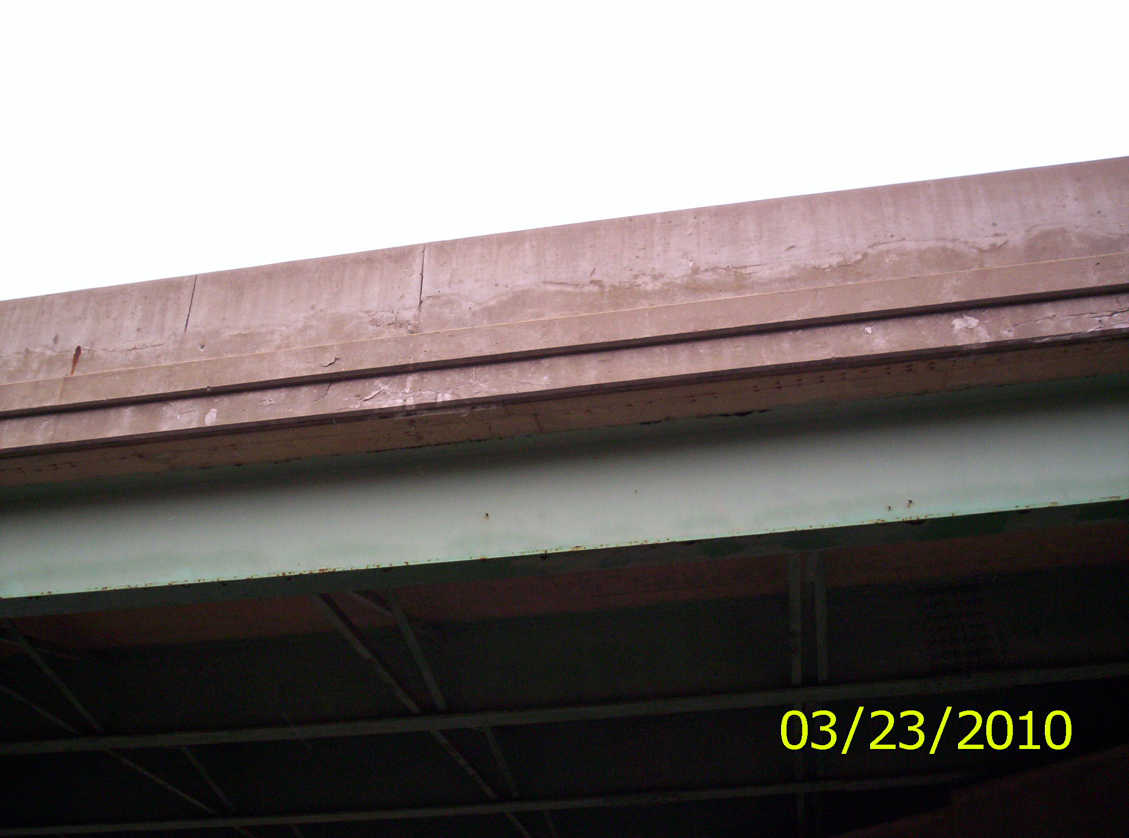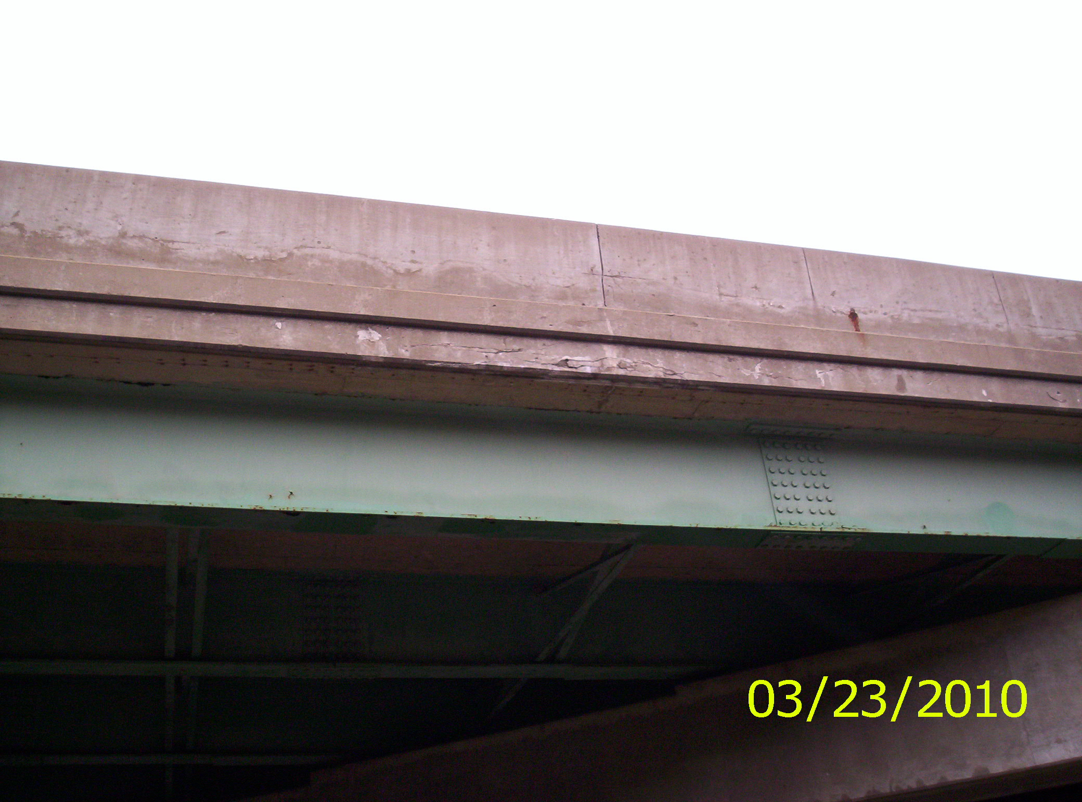
Left edge

Please sign, date and return this form after the repairs are completed.
COUNTY or DEPARTMENT MANAGER___________________________________
DATE COMPLETED____4/26/10 (Inspection of W/O 7/7/10 jaw)_______________________
C: bridge file
/tmp/in/input.doc

