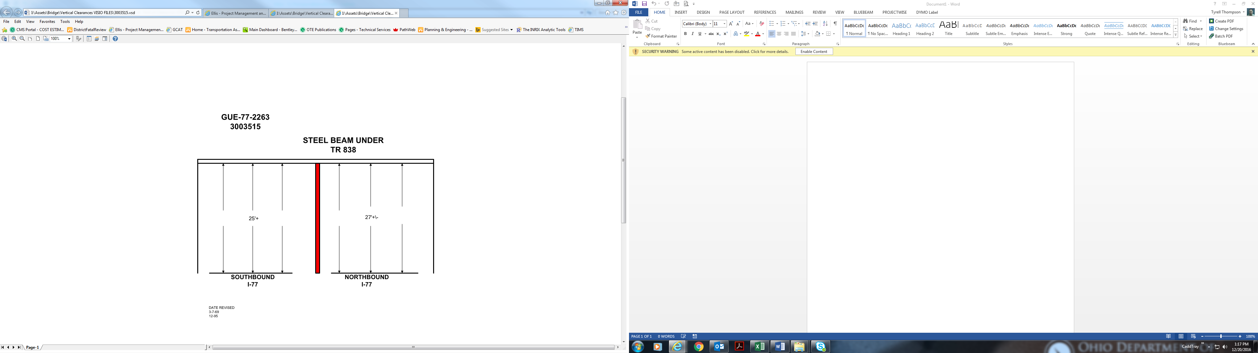

27+

25+

Date Revised: 3-7-69

12-95