D-5 BRIDGE WORK ORDER

TO: Tom Bradford Date: 10-01-09

FROM: CURTIS ZIGAN, D-5 BRIDGE ENGINEER BY: Albert Abel

BRIDGE NUMBER: GUE-70-1847R SFN: 3001806

DESCRIPTION OF NEEDED WORK

Remove loose spalling concrete from the left deck edge over TR 74.
(see photo)
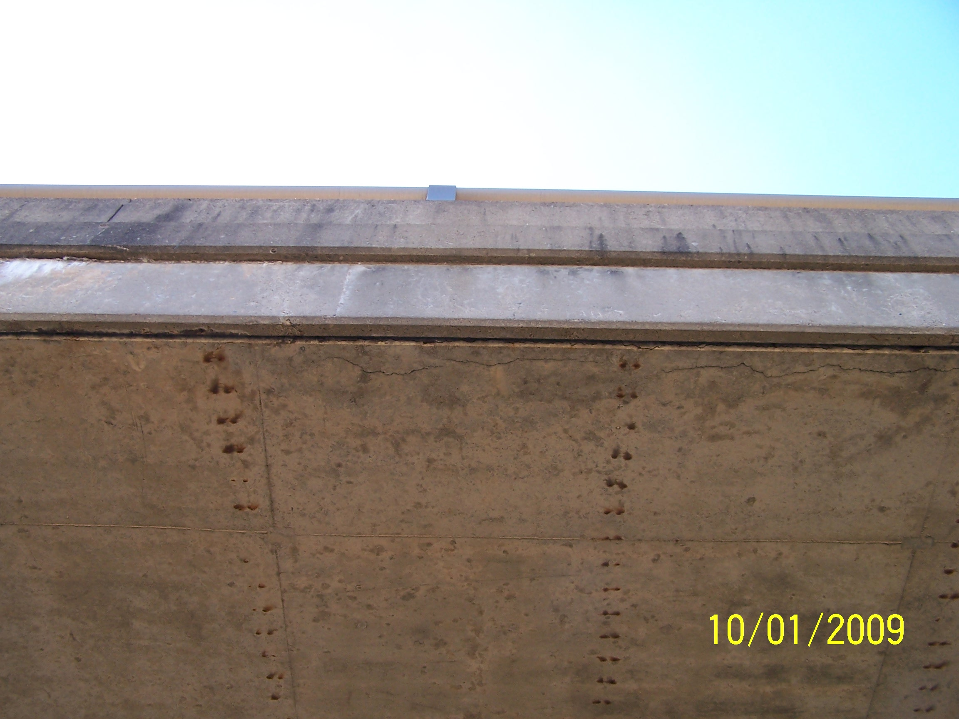
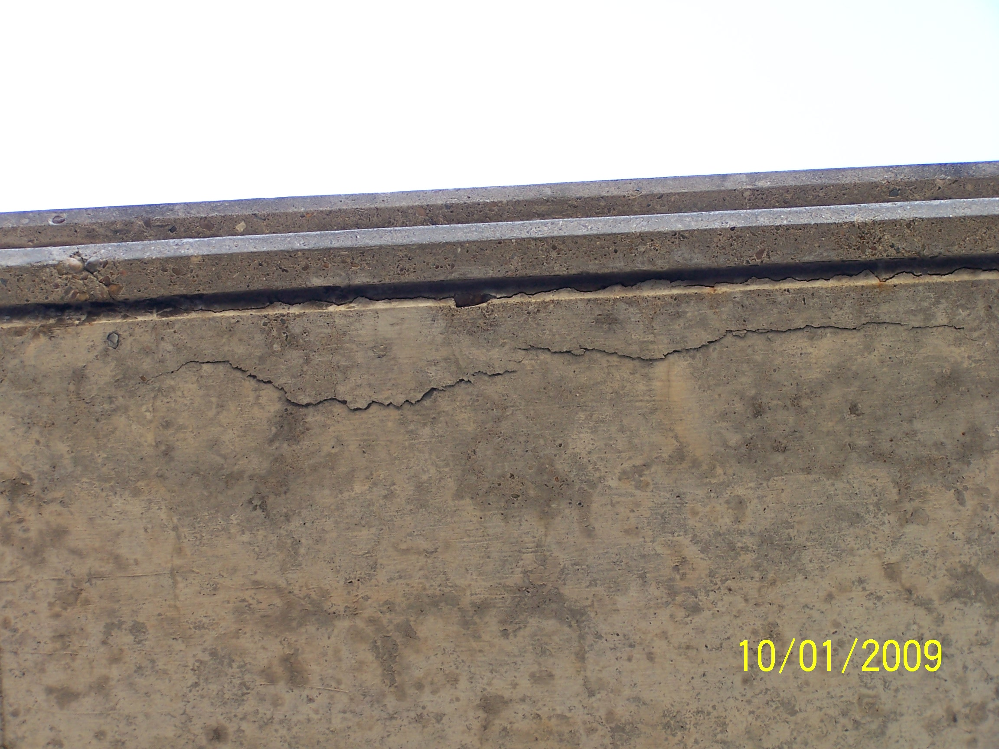

PLEASE SIGN, DATE AND RETURN THIS FORM WHEN THE WORK HAS BEEN COMPLETED.

COUNTY or DEPARTMENT MANAGER DATE COMPLETED

CC: bridge file
/tmp/in/input.doc

