Scope Meeting – PID 110109, DEL-37-6.88 & PID 111608, DEL-36-7.25
6/29/23

Attendance: Grace Dennis, Marci Lininger, Zane Diehl, Jessica Ormeroid, Jason Lucas, Brad Ruble, Dave Carlin, V Patel, Jonathan Owen, Dave Rankin, Dave Poling, Jon Roseler, Wade Dennis, Amy Turner, Troy Bryant,

Agenda:
- Brief Overview of the project limits and the proposed paving work:
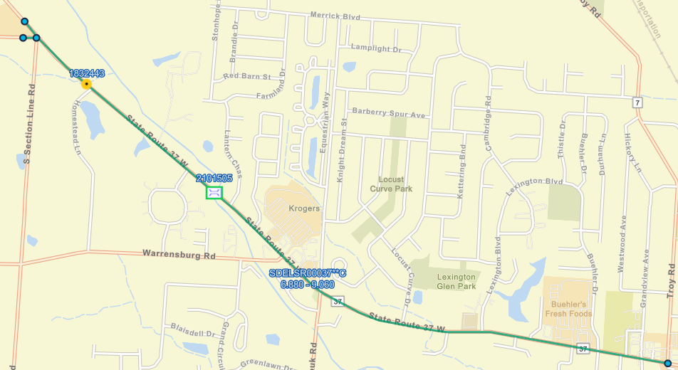

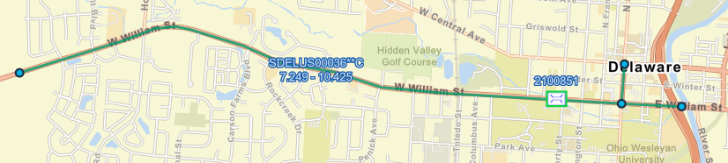

*City performing pavement repair ahead of the projects – should include some quantity with the plan. Plan to collect pavement repairs in 2024.

- Schedule/Timeline of Projects
  - This project is in fiscal year 2025 and proposed for a 3rd quarter sale (January-March), so the funds from the City of Delaware could be due as early as late November/early December to mid to late January.
    - Is there a certain month that would be preferred for sale in order to avoid any City funding shutdown? City to follow-up after meeting – would like to utilize 2025 funds – special sale either February or March.
    - Is the intent to keep both projects in FY25 – should we push one due to conflicting projects or funding constraints? PID 110109 – construction and payment be shifted to 2027. Keeping PID 111608 in 2025. PID 109070 constructing in 2025 – confirm with EK that schedule is accurate.

- Scope Review & Comments on outstanding items – for both PIDs 110109 & 111608:
  - City of Delaware Items:
    - Scope Item 11 – General Description of Work:
      - City to confirm if there are any valve boxes or manholes that shall be adjusted to grade with the project – currently included a contingency quantity of 4.
        - A quantity is to be included in both scopes – City doesn’t currently have a number – ok with contingency of 4.
      - For DEL-36-7.25 only: confirm suspend and resume project limits at Carson Farms – signal project at this location, no paving work, so no suspend and resume needed. Bidding soon – construction this fall or next summer.
    - Scope Item 19 – Side Roads
      - City to confirm the pave back limits noted during the initial field review. City confirmed prior to the scope meeting.
    - Scope Item 26 – Complete Streets Consideration
      - City needs to provide a disposition of curb ramps (compliant or non-compliant) in writing and whether or not the non-compliant ramps will be addressed ahead of the project or with the project. A general disposition of curb ramps can be provided – stating x number are compliant, x number will be upgraded ahead of the project, x number cannot be upgraded within ROW limits/utility conflicts, etc.
        - City will review curb ramps this summer (2023) and any replacements will be completed with citywide construction contract in 2024.
    - Scope Item 32 – Signals
      - City to confirm that the signals within the project limits were upgraded to radar – if not, are any signal upgrades desired? Waiting on response – will confirm, believe all loops are not use.
        - If signal upgrades are to be included, most likely need to be designed by the City.
    - Scope Item 33 – Pavement Marking
      - City to confirm how the crosswalks are to be put back – traditional ladder stripe or Delaware standard?
        - At non-critical intersections – install ODOT standard ladder stripe crosswalks. Just parallel lines, not ladder (Type 1)
        - At critical intersections (downtown business district, adjacent to schools, mid-block ped crossings, crosswalks with RRFB’s, multi-use path crossings on state route), use City of Delaware enhance crosswalk per RDWD-38.0. Jon to provide list of critical intersections and standard construction drawing referenced above.
    - Scope Item 34 – Delineation
      - City to confirm if RPM’s are to be reinstalled within the City limits
        - PID 110109 (DEL-37) – no RPM’s to be reinstalled within the City limits.
        - PID 111608 (DEL-36/521) – reinstall RPM’s only on US-36 from Western project limit to New Market Drive. None on 521.
    - Scope Item 35 – Guardrail
      - City to provide direction on any guardrail upgrades within the project limits.
        - All guardrail that is out of specification should be upgraded with project
          - PID 110109 (DEL-37): washout adjacent to guardrail – replace guardrail, place embankment, seed and mulch
            - Place embankment at a 10:1 slope from the edge of pavement to guardrail and then 2:1 after that (City owns land to South, so RW shouldn’t be an issue).
              - Worst case scenario – Delaware could make a RW dedication.
            - This location is within the 100 year floodplain (south side of roadway is in the floodway) – if we are going to cut down trees, be in the water, there will need to be permitting, may bump the enviro doc level.
            - Existing 15” culvert just East of lantern chase that goes under the road – there is a full-height headwall and the culvert is 8/10 full. Recommend extending the South side of the culvert.
    - Scope Item 42 – Maintenance of Traffic
      - City to confirm the preferred work hours – no lane closures 6A-9A or 3P-6P. On last resurfacing project on 37 – all paving occurred at night.
      - City to confirm special events that would not allow the contractor to work Jon to send list and holiday requirements.
    - Scope Item 51 – RW Encroachments
      - City to review this section once RW certification date is established and provide a disposition of encroachments to District RW Office two months prior to that date – currently anticipate no RW encroachments.
    - Scope Item 57 – Legislation
      - The only funding included in this portion is related to surface items (paving, milling, tack, etc), once the 100% City related items are established, the estimate will be updated.

  - District 6:

    - Monument boxes – any monument boxes within the project limits for PID 110109 (DEL-37)? Follow-up with Stafa.

    - Safety Group:
      - Scope Item 24/25 – Crash Analysis & Additional Safety Improvements
        - D6 Safety Group provided a crash analysis and no safety countermeasures are recommended at this time.
        - City performing safety action plan with MORPC. Hopeful that citywide signal project will help with rear end collisions.
          - SAP – to be finalized this fall.

    - Hydraulics
      - There is one culvert rated a 5 or below within the project limits (SLM 7.11), any work to be included with the project or performed ahead of time? To be replaced by special projects in 2024 – they will put guardrail back, but will need replaced with the resurfacing.
        - Any major tree clearing should be included with this project – Grace to touch base with Shane and Marci.
      - We also had a conversation with a resident that stated the ditch around this culvert (south side) has issues with drainage.
        - Property owner has a fence that is blocking the natural drainage way.

    - Bridge/Geotech
      - Scope Item 37 – Bridges/Bridge Scope of Work:
        - Provide scope of work for each bridge included in the projects (1 bridge within project limits for each project) – Routine (City) or major maintenance (D6)?
          - Who pays for saw & seal, extra asphalt & waterproofing? Confirm if City responsibility or D6 – seems reasonable to the City and can include in the scope.
            - Jonathan will follow-up on this item.

    - MOT:
      - Scope Items 42/43 – Vimal Patel or Gary Fetherolf to provide review of maintenance of traffic & maintenance of pedestrian traffic
        - No additional comments – city plans to replaced curb ramps ahead of project.

    - Real Estate:
      - Scope Item 51 – R/W Encroachment
        - The City of Delaware will provide D6 Real Estate group a disposition of RW encroachments within the project limits two months prior to the R/W cert date.
        - No additional comments.

    - Environmental: At this time – no environmental red flags were noted during the initial field review.

    - RR Coordination: PID 111608 – coordination will be required for this PID only

    - Legislation: Participatory legislation will be required on this project as identified in the scope of work.

    - Construction – none at this time.

    - Maintenance – no comments at meeting.

- Additional Discussion – none

