BUT-4/27/75 Questions for ODOT:

BUT-4:
The gate at the Great Miami River was not surveyed since it was not part of the survey map that was submitted with the scope.
Q1: Can you confirm if the remove/replace disposition of the gate is part of this project?
The reason I ask is because of your email to me on 7/13/2023 in which Brandon said “We will coordinate the disposition of the flapgate with MCD upon completion of the study”.
A1: KD - For the purpose of developing the Feasibility Study, proceed forward as if the work involved with removing/replacing the gate is a part of this project. ODOT will then present the Feasibility findings to MCD and request their input. Direction will be provided as a part of the review comments on the submitted Feasibility Study.
A1: BC - Evaluation of the need of the flapgate or other control structure is definitely a part of the study. It is stuck in the open position and has not known to be a problem, so I have a hunch it may not be needed. CVE is welcome to discuss with MCD to determine if there have been any flooding in this area that may have been attributed to the flapgate being open. Once CVE has determined it’s necessity or risk of removal, ODOT will then discuss with MCD if it needs to remain and who will maintain it. ODOT will then direct the consultant what to do for final design.

CVE Response: Do you have a contact person at MCD?
ODOT Reply – BC: The only person I’ve dealt with personally in the past at MCD is the Chief Engineer, Don O’Connor, but I think Barry Puskas who is the Chief of Technical and Engineering Services that did the plan review. https://www.mcdwater.org/resources/staff-bios

Q2: If it is part of the project, will the disposition be determined by ODOT/MCD per Brandon’s message or CVE?
A2: KD - CVE will propose the optimum design option as a part of the analysis performed by CVE, and as delineated in their Feasibility Study. ODOT will coordinate CVE’s FS findings with MCD, obtain MCD’s feedback and then make a final decision. The final decision will be a part of the FS review comments.

CVE Response: Understood.

Request 1: If by CVE, please provide the original bridge construction plans and any rehabilitation plans that might show the gate.
Response 1: \\D08fs100.dot.state.oh.us\archives\const\but\08c0005 (Sheet 12 and sheet 26)
https://ftp.dot.state.oh.us/pub/Districts/D08/117275/ExistingPlansRequested

CVE Response: I see the rehabilitation plans on the ftp site, but I do not see the directory starting with 08c0005. I am unable to access this directory: \\D08fs100.dot.state.oh.us\archives\const\but\08c000
ODOT Reply – KD: The request was for the original bridge construction plans. The original bridge construction plans are under 08C0013 (sheets 25-37). Use the https link provided above.

Q3: If it is part of this project, do you need it surveyed or can we locate it from record plans?
A3: KD - First locate on record plans. If additional information is required, then provide new survey data.

CVE Response: Understood.

Q4: The 7/13/2023 email mentions the detention basin was cleaned out in 2013. Were there plans for that? I’m curious what items and quantities were used.
A4: BC - No plans exist for this clean-out. This was done by our maintenance forces. You can see the limits of what was cleaned out in the 2013 Google Earth images.

CVE Response: Understood.

Q5: Per the scope narrative at location BUT-4-23.80, CFN 1981355, it says “Replace section of bad pipe. Bridge Department to determine limits.” Has ODOT determined these limits? Note that CFN 1981355 was not surveyed since it was beyond the limits of the survey map. We will request that it be surveyed.
A5: KD - ODOT staff are confirming the replacement of this pipe run.
\\Itcfs007\odrive\Hydraulics\Culvert Management\Culvert Photos\09-Butler\SR 4\23.804-1981355\2019

CVE Response: Understood.

Request 2: The drainage work photos for BUT-4-23.944 and BUT-4-23.945 are the same.
The proposed work for some of the conduits does not match the inspection reports in TIMS. For example, the inspection comments note culvert misalignment, but the fix is clean pipes.
Response 2: \\Itcfs007\odrive\Hydraulics\Culvert Management\Culvert Photos\09-Butler\SR 4\23.938-1981353\2019
\\Itcfs007\odrive\Hydraulics\Culvert Management\Culvert Photos\09-Butler\SR 4\23.944-1981352\2019
BC - There are some pipe misalignments that are minor/not allowing infiltration and we are OK with keeping. Please be specific with which note/culvert you feel does not match.

CVE Response: If ODOT is ok with the pipe misalignments, then we are good with the proposed scope as is.

Q6: The existing walk stops short of Catalina Court. Should the proposed walk extend to Catalina Court? It would require reconfiguring some of the drainage as that appears to be the constraint preventing the walk extension.
A6: BC - Yes. Reconfiguration is anticipated.

CVE Response: We will extend the west walk to the south radius return of Catalina Court. The drainage is likely being reconfigured as follows: the manhole likely becomes a catch basin and catch basin becomes a manhole and then another catch basin might be needed to intercept the ditch flow. Should the east walk be extended as well to match the new limits of the west walk?
ODOT Reply – KD: Yes.

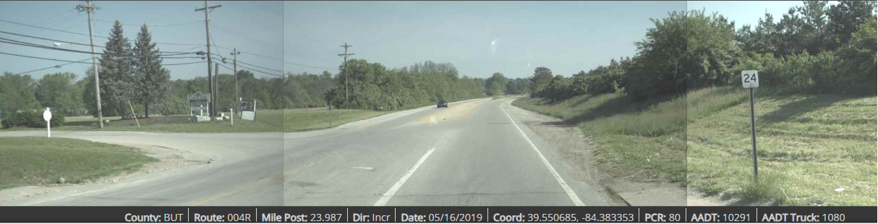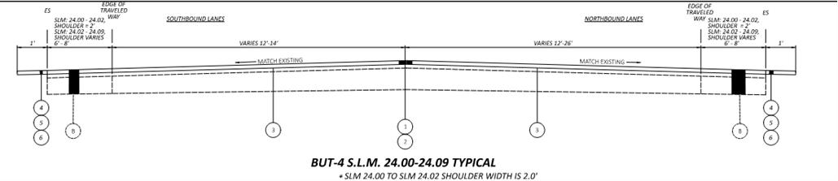

Will a pedestrian crossing be added?
ODOT Reply – KD: Yes. There is a resurfacing project (PID# 107580) that is currently in construction, where the existing pavement is being resurfaced as shown in the typical section above. The area of paved shoulder, along the east side of SR4, located between a new curb ramp and the end of the 8’ shoulder should be cleaned up and the gap closed under this project. The plans are included with those provided in the link:
https://ftp.dot.state.oh.us/pub/Districts/D08/117275/ExistingPlansRequested
A cross walk is warranted at this location to connect the two new curb ramps.

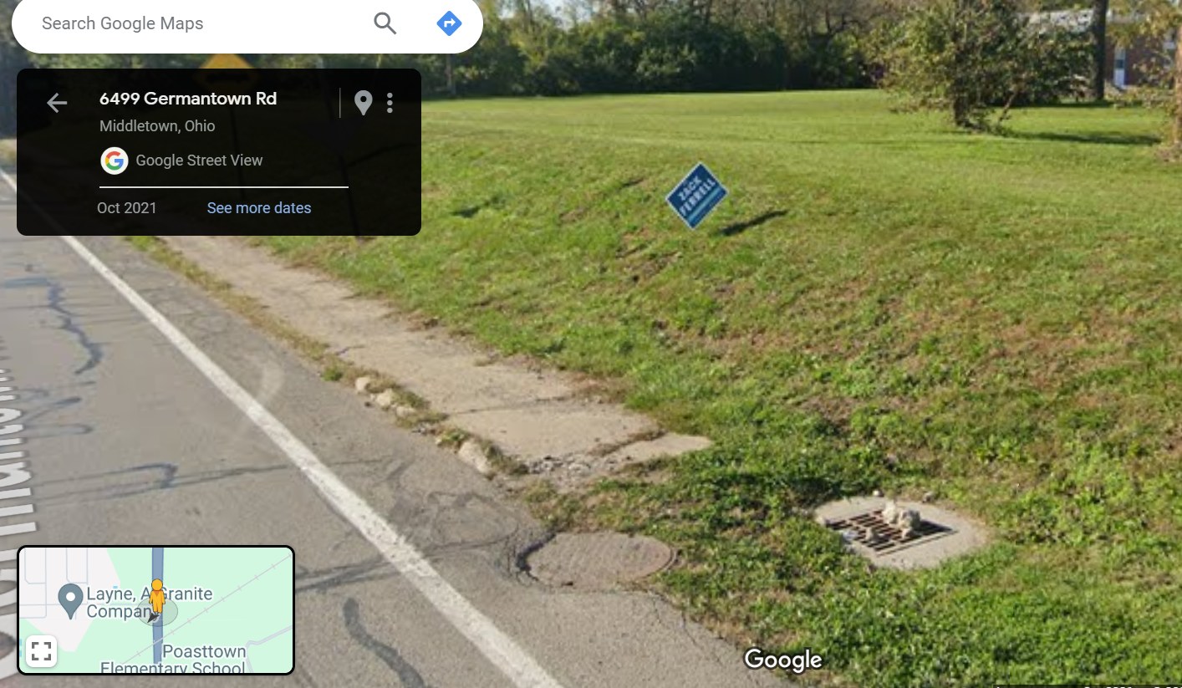

Q7-8: I see there are resurfacing plans (BUT-4-24.00, PID 107580) that will resurface north from Catalina Court. Please confirm that our resurfacing limits should extend to this resurfacing limit. Exactly where is this resurfacing limit? South radius return or somewhere else?
A7-8: JE - Yes, the north limit should abut the PID 107580 project.

CVE Response: What is the south limit of the BUT-4-24.00 project? Is it exactly mile marker 24, the south radius return of Catalina Court or north radius return?
ODOT Reply – KD: Yes….at exactly mile marker 24.00.

Q9-11: Where is this location’s south resurfacing limit? Should it be Trenton Franklin Road since that stretch has a PCR of 70? If so, would it be the north radius return or somewhere else?
A9-11: JE - The south limit on BUT-4 will be extended from SLM 23.922 to SLM 23.329. This revised limit will abut ODOT project, BUT-4-23.17 (PID 102783) which sells April 2024.

CVE Response: Please confirm the location of SLM 23.329. From reviewing PathWeb, it appears the SLM is just north of the north approach slab of the bridge over the Great Miami River. Is there a way for me to identify this location?
ODOT Reply – KD:
- I’ve added DESTAPE and SLM information to the https link already provided, defining specific beginning point on the bridge as SLM=23.196.
- Per the PID# 102783 project, the corresponding station location for the beginning of the bridge is Station 1223+37.60.
- The end of bridge station location is Station 1229+55.82.
- Adding 25 feet for the approach slab provides for a station location of Station 1229+80.82.
- Station 1229+80.82 – Station 1223+37.60 = 643.22 feet
- 643.22/5280 = 0.122
- 23.196 + 0.122 = 23.318
- Use SLM = 23.32 (northern end of the northern approach slab for the bridge over the GMR)
If paving over the approach slab and going up to the bridge joint use SLM=23.33.

BUT-27:
Request 3: Can ODOT provide the signal plans for the US 27/SR 130 signal? There is conduit and pull boxes and we do not have record plans.
Response 3: KSD – Yes. See link.
https://ftp.dot.state.oh.us/pub/Districts/D08/117275/ExistingPlansRequested

CVE Response: Received, however these are not the original signal plans. From looking at past imagery, this signal got constructed sometime between 1991-2003.
ODOT Reply – KD: The provided plans were the most recent signal work performed in 2015. The only project in our archive that installed traffic control at this location was BUT-27-10.48, which involved installing the current roadway geometry. Most of the signal installations are built from District-wide “bulk” installations where the contractor is awarded a description of work and the locations are determine by the D8 Traffic Engineer at a later time. I’ve added a sample project type. I will talk with our Traffic Department and see if they can nail down anything more specific for this location.

Request 4: Can ODOT provide the plans for BUT-27-13.147 PID 17820?
Response 4: KSD – Yes. See link.
https://ftp.dot.state.oh.us/pub/Districts/D08/117275/ExistingPlansRequested

CVE Response: Received.

Q12: How much asphalt resurfacing does ODOT want to do beyond the limits of the concrete pavement replacement? We were thinking 25 feet at the north and south end and a smaller distance, say 10 feet at SR 130 since it was just resurfaced.
A12: JE - Recommend resurfacing on the asphalt surfaces enough to clean up the MOT scars.

CVE Response: Understood.

BUT-75:
Request 5: Can ODOT repost the original plans (08c0035) or put on ProjectWise? For some reason, we were only able to download the first 61 sheets. A combined pdf would be preferred.
Response 5: KSD – Yes. See link.
https://ftp.dot.state.oh.us/pub/Districts/D08/117275/ExistingPlansRequested

CVE Response: Received.

General:
Request 6: BUT 4 and BUT 27 have a posted 45 MPH speed limit with their project limits. Please confirm that 45 MPH should be used as the design speed.
Response 6: JE - : Per L&D Vol 1, Section 104.02 (LINK) – the design speed can be either the posted speed or 5 mph higher than posted speed. Due to the rural nature of the BUT-27 location, the design speed should be 50mph. Due to the urban nature of the BUT-4 location, the design speed should be 45mph.
KD – For the US27 location, according to TIMS a speed study was performed in 1996 and recommended that the legally journalized speed within this area be reduced to 35 mph. Use the legal speed of 35 mph as the design speed. Confirming with Traffic Studies staff.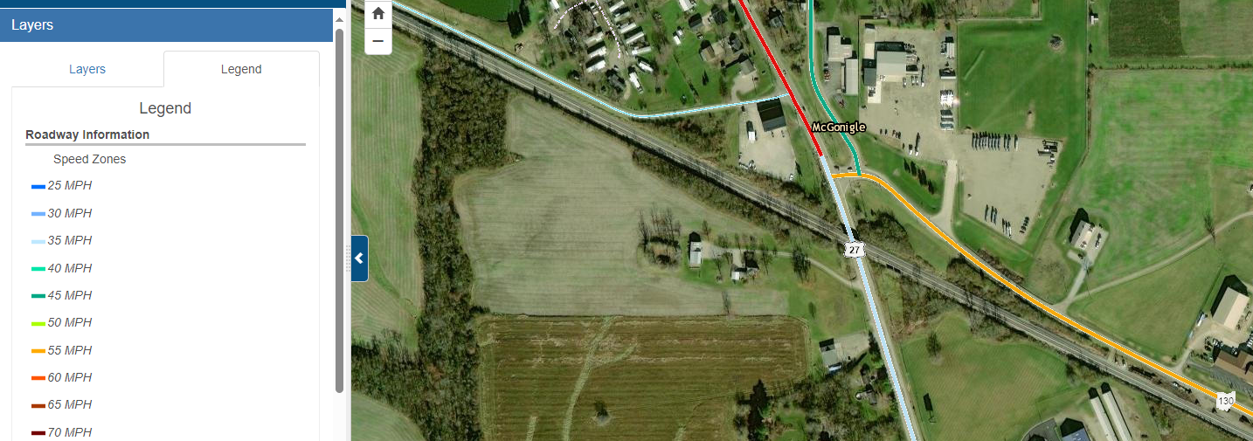

CVE Response: This was answered on 3/6/2024. BUT-27 will be designed for 50 mph.

Q13: Does ODOT District 8 maintain a utility contact list?
A13: KD - Yes.

Request 7: If so, can you forward?
Response 7: KSD - In process.

Request 8: Can we be provided access to the project on ProjectWise?
Response 8: KSD - In process. Completed 3/4/24.
https://ftp.dot.state.oh.us/pub/Districts/D08/117275/ExistingPlansRequested

