September 28, 2023

Bridging the Gap:

Capping Fort Washington Way

Bryan Williams

City of Cincinnati

801 Plum Street

Cincinnati, O.H. 45202

(513) 352-4506

Bryan.Williams@cincinnati-oh.gov
Letters of local funding commitment

Table of Contents
Narrative i
Project overview 3
Project Location & Map 10
Response to Merit Criteria 14
Criteria #1: Equity and Environmental Justice 14
Criteria #2: Access 15
Criteria #3: Facility Sustainability 17
Criteria #4: Community Engagement and Community-based Stewardship, Management, and Partnerships 19
Criteria #5: Equitable Development 20
Criteria #6: Climate and Environment 22
Criteria #7: Workforce Development and Economic Opportunity 22
Project Readiness: Environmental Risk 24
Technical Assessment Error! Bookmark not defined.
Financial Completeness Error! Bookmark not defined.
Environmental Risk 24
Inclusion in STIP/Transit Asset Management Plan: 24
Detailed Project Schedule 24
Required Approvals 25
Benefit-Cost Analysis (BCA) 26
Project Budget 27
Sources and Uses of Funds 28
Match Funding Commitments 29
DESIGN SUPPORT – DELETE FROM FILE WHEN NOT NEEDED Error! Bookmark not defined.
Heading 2 Error! Bookmark not defined.
Heading 3 Error! Bookmark not defined.

Appendices
- Letters of Support
- Technical Documents
- Financial Documents

Project overview

Introduction
The City of Cincinnati is requesting $149.4 million in Reconnecting Communities and Neighborhoods Program Capital Construction Grant funding to be matched by $37.8 million in local funds from the City of Cincinnati, Hamilton County, and the Cincinnati Chamber of Commerce to fully fund the design and construction of the $187.2 million Bridging the Gap: Capping Fort Washington Way Project (Bridging the Gap). If successfully funded, the City will be able to realize the vision – 30 years in the making – of reconnecting Cincinnati’s Central Business District to The Banks riverfront district by providing a five-acre civic park space and plaza over the Fort Washington Way Interstate that acts as a barrier between downtown and the Banks District - removing this significant barrier to access, mobility, and economic development.
Once constructed this project will provide the following benefits:
- Create five acres of new civic park space in the heart of Cincinnati’s central business district (CBD).
- Improve access to jobs in Cincinnati’s CBD, especially for transit users.
- Improve safety for all pedestrians travelling between the CBD and Riverfront District.
- An opportunity to create affordable housing in an area that saw displacement in the 1960s.
In addition to funding all final design and environmental work, The Bridging the Gap project scope will include the following physical elements:
Project elements:
- Construct an elevated cap park structure over Interstate 71 / U.S. Route 50 (locally known as Fort Washington Way) between Race Street and Walnut Street
- Construct all interior Tunnel Operating Systems
- Construct multimodal improvements and traffic safety countermeasures along surface roads and intersections within the project area

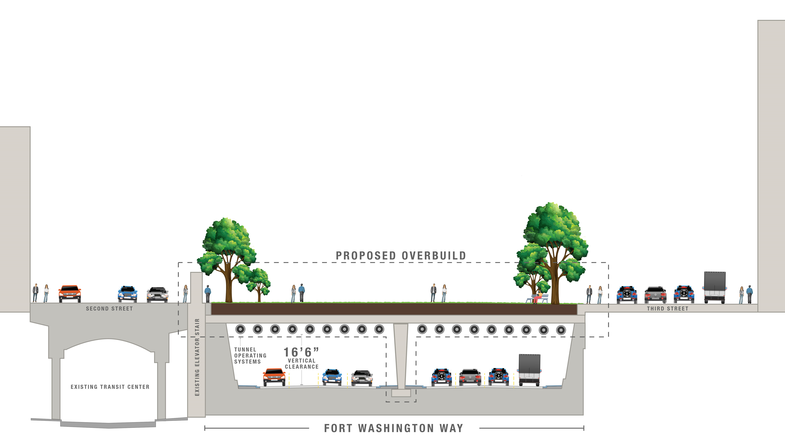

Community Character
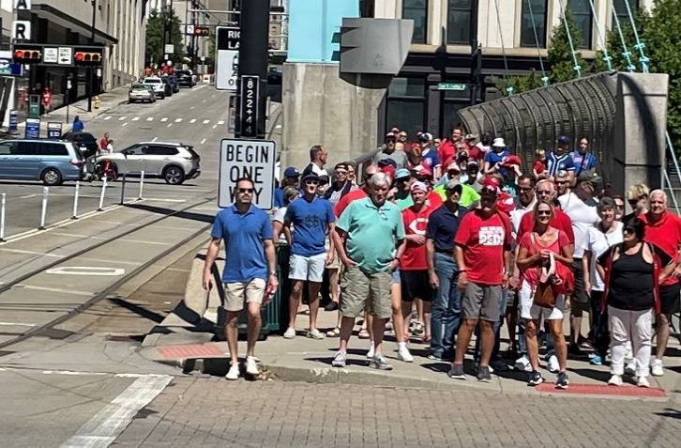
The Bridging the Gap project is located in an area that was subjected to urban renewal resulting in displacement of once vibrant communities in the early 1960s. Since initial construction, the roadway’s width has been reduced but Fort Washington Way still acts as a major barrier for area residents and visitors.
Each day, an estimated 8,000 boardings or alightings occur on Southwest Ohio Regional Transit Authority (SORTA) buses within one-quarter mile of the Bridging the Gap project site; 270 Red Bike bikeshare bikes are rented at stations around The Banks; and 2,300 trips are taken on the Cincinnati Streetcar. The Banks district plays host to major events throughout the year that constantly draw massive crowds down from the CBD, across Fort Washington Way to their destination. Among these events are 88 Cincinnati Reds games at Great American Ballpark (seating capacity of more than 40,000) between March and October and 10 Cincinnati Bengals games at Paycor Stadium (seating capacity of more than 80,000) between August and January.

Detailed Project Scope
Bridging the Gap is a project that builds upon the forethought of civic leaders and community partners who successfully advocated for the inclusion of support pilings that could support a future highway cap park when FWW was reconstructed in the early-2000s. This project intends to design and construct the highway cap structure, integrated tunnel safety systems below, and a vibrant civic park space above – all supported by the structural pilings included during the original reconstruction of FWW.

Bridge replacements & Cap Structure
Included in the project will be the replacement of three bridges that span FWW, along Race Street, Vine Street, and Walnut Street. These bridges are all 20+ years into their 50-year useful life, and – if not replaced – would be nearing 30 years by the time of completion of the Bridging the Gap project. Because of this, the City and ODOT desire to replace the bridges to proactively address any anticipated structural issues and bring them into the same maintenance schedule as the highway cap and tunnel, saving maintenance and construction costs in the process. The replacement of the bridges is estimated to cost $11.4 million.
The structure for the bridges and highway cap will be a similar to the existing bridge structures across FWW in design. This structural system will take advantage of the foundation pilings that were installed when FWW was reconstructed to support the Bridging the Gap civic park space on top of it. The tunnel portals on each end will be constructed higher to maintain sufficient clearance below the jet fans that will be needed to provide ventilation and clear smoke in the event of a fire inside either tunnel. Beyond where the jet fans are located at each entrance portal, the adjacent box beams will be stepped lower to provide only the required vertical clearance. Piers will be cast-in-place walls, and existing openings in the piers at the three reconstructed bridges will have new walls installed with fire-rated emergency doors at required intervals, to be used for egress in the event of a fire or other emergency event. It is estimated that the construction of the highway cap support structure will cost $33.2 million.

Tunnel systems (to be constructed under the cap)
To maintain traffic on FWW, a tunnel will be constructed to span the highway that includes all necessary tunnel systems. Construction of these elements are expected to cost $48.9 million and will include tunnel ventilation system, fire protection systems, electrical power systems, fire alarm and detection systems, tunnel roadway lighting, and miscellaneous safety items.

Tunnel ventilation system
A longitudinal mechanical ventilation utilizing in-tunnel mounted jet fans is proposed for the FWW cap tunnels. This type of ventilation system is the most cost-effective and efficient system considering the length, location, and existing physical limitations of the proposed cap. In order for this type of system to be effective a full-height, fire-rated wall must be constructed to separate the directions of traffic resulting in two physically separated traffic tunnels. In a fire emergency, the main goal of the proposed ventilation system is to create a longitudinal airflow in the direction of traffic flow.
During normal traffic operations, the proposed ventilation system can be operated when necessary to provide outside air to dilute vehicle emissions due to heavy traffic congestion and maintain safe air quality levels inside the tunnel. The graphic placement of jet fans at the tunnel entrance can be seen in figure X.

Fire protection systems
The proposed FWW Cap will require specific fire protection elements including a fire protection standpipe for the entire length and portable fire extinguishers placed along the roadway. A fixed firefighting system (FFFS) is also proposed to provide quick response suppression capability in the case of a significant vehicle fire and to help mitigate any damage to the cap structure.
The fire protection standpipe is proposed as a Class I manual, dry standpipe system running the length of the tunnel with fire hose valve connections placed at a maximum spacing of 275 feet. Multi-use portable fire extinguishers will be provided at each fire hose valve location, and both will be contained within lockable cabinets built into the tunnel walls.

Electrical power systems, Special System & Traffic Control
The electrical system will support life safety operations, fire emergency operations and tunnel operations. The electrical systems will maintain ventilation, lighting, communications, fire alarm and fire detection, exit signs, traffic control, and others for areas of refuge, exits, and exit routes, under all normal and emergency modes associated with the facility.
Closed-circuit television (CCTV) systems with surveillance cameras located throughout the tunnel will be used as the primary means to identify and locate fires in the tunnel. An automatic fire detection system consisting of a linear heat detection sub system, zoned to correspond with the fire protection systems, is proposed. A Fire Alarm Control Panel (FACP) would be provided to receive signals from the facilities’ automatic fire detection system and to initiate alarms.
An Automatic Incident Detection (AID) system will be installed within the tunnel and its immediate approaches to provide real-time detection and alarms related to traffic speeds and flows, stationary or stalled vehicles, congestion within and downstream of the tunnel, and vehicles traveling in the wrong direction within or approaching the tunnel.

Tunnel roadway lighting
The tunnel lighting system will be based on the latest research and recommendations from FHWA to provide adequate visibility while using the least amount of energy. It will be designed to accommodate safe entry into the tunnel during daytime and nighttime hours as well as under emergency power disruptions. It is currently proposed that each travel lane within the tunnel have a row of lighting luminaires installed above.

Park Space and street safety improvements
Bridging the Gap will provide approximately four acres of open green space, up to 1.65 acres of plaza space, and streetscape improvements with improved safety elements. Construction costs for all the park, civic space, and streetscape improvements total $21.4 million. The final design of these spaces will be determined via a public engagement and community outreach process.
The green space will provide an event lawn, complete with deck waterproofing, engineered soil, sodding, drainage, watering system, and electrical power. The civic plazas will incorporate concrete pavers, seating walls, planters, and ornamental landscaping.
Additionally, the City is scoping streetscape and street safety improvements along 2nd Street, 3rd Street, Race Street, Vine Street, and Walnut Street. 2nd Street and 3rd Street currently operate as one-way pairs, with five travel lanes on each street. As part of the project, the City will redesign each street to include traffic calming measures and pedestrian safety improvements, such as curb bump-outs, new crosswalks, modernized accessible pedestrian signals (APS), leading pedestrian intervals, on-street parking, and landscaping treatments. These traffic calming measures and streetscape improvements are expected to reduce the number of vehicular lanes on 2nd Street and 3rd Street from five lanes to three lanes. A traffic study will be completed to ensure that any negative impacts to vehicular traffic movement are minimized. Also included will be a new 0.5-mile two-way protected bike lane along 3rd Street that will connect to the City’s proposed 5.5- mile protected bike network within the CBD and the Over-the-Rhine neighborhood. The construction of these streetscape and safety improvements is estimated to cost approximately $9.1 million of the total $21.3 million park space ans street safety improvements budget.

Maintenance of Traffic
Maintenance of Traffic (MOT) for the Bridging the Gap project would require nighttime intermittent closures to place beams with traffic being rerouted during these closures, as beam placement cannot be done with traffic moving below. This project will also likely require lane closures near the outside edges and/or the median for micro-piling, as needed.
The interruption of traffic due to the construction of the new Brent Spence Companion Bridge is expected to cause a diversion of traffic, reducing volumes along FWW. As the scope of the Brent Spence project continues to be defined, there could be opportunities for MOT of the FWW cap to be coordinated with the MOT for the Brent Spence project. This coordination could help to minimize the disruptions to FWW and the surrounding roadway and highway network. As part of MOT design, a queue analysis will be completed to inform final MOT phasing plans. MOT phasing is expected to cost $700,000.

History, Background, and Barriers
Fort Washington Way (FWW) is the name given to a short stretch of highway that divides Cincinnati’s Central Business District (CBD) from the Ohio River. FWW provides access through downtown for three major highways: US-50, I-75 and I-71, extending approximately one-half mile between the Brent Spence Bridge and the split of I-71 and US-50 just east of Main Street. It is within a Federally designated Area of Persistent Poverty and an Opportunity Zone.
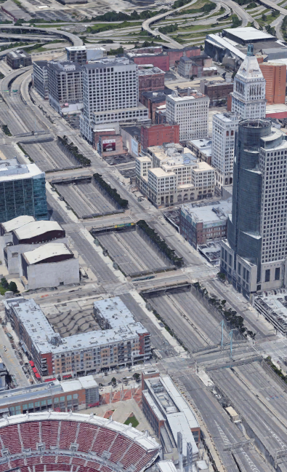
The 1948 Cincinnati Metropolitan Master Plan highlighted the need for two major transportation facilities to facilitate traffic flow: a Millcreek Expressway (which became I-75) and a Third Street Distributor (later named Fort Washington Way). Using federal grants, the city purchased properties during the 1950s and 1960s to implement the redevelopment plan. All buildings between the south side of Third Street and the north side of Second Street were demolished for the construction of FWW between 1957 and 1961 (Figure X, left image). Those displaced by the highway project were predominantly poor working classes and African Americans. Construction of FWW was completed in 1961 (Figure X, middle image).
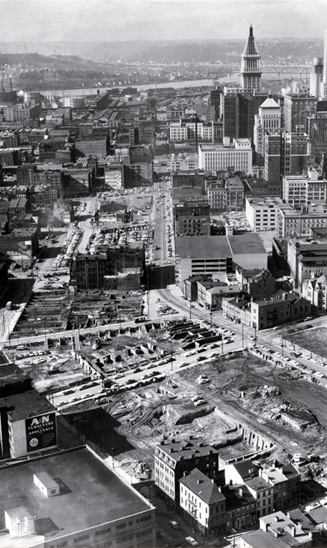
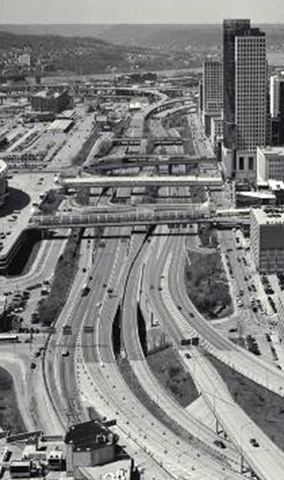
By the mid-1990’s, FWW was exceeding its original design limits with more than 120,000 vehicles using the highway daily. Heavy traffic congestion, high crash incidences due to complex interstate on- and off-ramps, and pedestrian safety were also problematic during peak traffic periods. The Ohio Department of Transportation (ODOT) initiated a project to address these issues. It was during this redesign that concerns were first documented about the long-term economic impacts of the division between the CBD and the riverfront.
FWW reconstruction began in 1997, ultimately reducing the overall width of the highway footprint – from 600 feet across to only 160 feet across today – and removing the complex network of on- and off-ramps to improve safety (see Figure 1, right image). A major win for the community. The redesigned FWW also reconnected Cincinnati’s historic street grid south of 3rd Street. By reducing the footprint of the freeway, an additional 15 acres of land was opened for future development of Cincinnati’s riverfront area. The area that was redeveloped now includes the National Underground Railroad Freedom Center Museum, two professional sports stadiums, and The Banks: a mixed-use district of public spaces and entertainment. With the additional street space created, 2nd Street is now utilized annually for regional street festivals that celebrate the heritage of the Cincinnati community, such as Oktoberfest Zinzinnati which is attended by over 700,000 attendees annually.
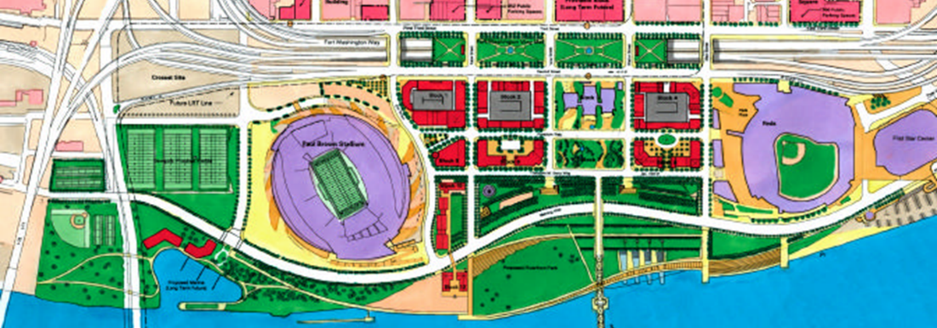
While the FWW reconstruction greatly reduced the width of the highway, there remains an open space over the highway that presents a significant barrier to access, mobility, and economic development between downtown and the riverfront. The highway gap creates a dead space between two high-activity areas of the CBD. Just two blocks north of FWW is Fountain Square, Cincinnati’s historic downtown civic space, centered around the Tyler Davidson Fountain. Fountain Square hosts regular concerts, social events, and celebrations. Hotels, museums, and street-level commercial activity create a bustling activity zone in the blocks surrounding Fountain Square. South of FWW sits The Banks, which also attracts visitors and residents from across the city daily. However, because of FWW, these two socially and economically significant activity centers have become disjointed.
Fortunately, when FWW was reconfigured, there was forethought by the City of Cincinnati, Hamilton County, and private sector partners about future use of the space above FWW. As part of the ODOT project, foundation pilings were built in the ground with the intention of one day using them to support an elevated highway cap park, as envisioned in the 2000 Central Riverfront Urban Design Master Plan (Figure X). At that time, the entire $10 million dollar cost of the design and construction of the pilings was privately raised with hopes that this long-term, visionary investment would help spur the reconnection of the CBD and Ohio River waterfront. That investment is equivalent to $17 million today, when adjusted for inflation.

Project Location
The Bridging the Gap project site is along the section of the depressed Fort Washington Way highway bounded by 2nd Street, 3rd Street, Race Street, and Walnut Street. The project is located in the 1st congressional district of which Cincinnati is contained within.
According to current census figures, the Cincinnati region is home to 2,214,265 residents, 310,053 of which live within the city proper. Approximately 18,000 residents live within the four core downtown neighborhoods of the CBD, Over-the-Rhine, West End, and Pendleton. Another 40,961 people live in the City of Covington, Kentucky, directly across the Ohio River from The Banks via the John A. Roebling Suspension Bridge. Demographically within the four core downtown neighborhoods of Cincinnati, 77.9% of households have one or no vehicle and 33.9% have income below the federal poverty limit. Racially and ethnically, 49.3% of the population are Black, 42.6% are White, 3.6% are Asian, and 1.9% are of Hispanic or Latino origin. The median household income is approximately $52,000.
The City of Cincinnati is the primary economic engine for the region, providing approximately 225,000 jobs and facilitating the efficient flow of commodities along its interstates and major thoroughfares. Cincinnati’s jobs are distributed throughout the city but are found in the highest density in the urban core, predominantly located within the ten blocks immediately north of FWW. According to the most recent Census data, there are an estimated 73,000 jobs within one mile of FWW; most of which are located within Federally designated Areas of Persistent Poverty and Opportunity Zone Census tracts as seen in Figure X. Of those jobs, 24.6% (17,959 jobs) are for workers with an educational attainment of a high school degree (or equivalent) or less. 79.8% of jobs (58,383) are held by White workers and 15.4% (11,258) are held by Black workers. 16.3% of jobs (11,887) are held by workers with monthly earnings of $1,250 or less.
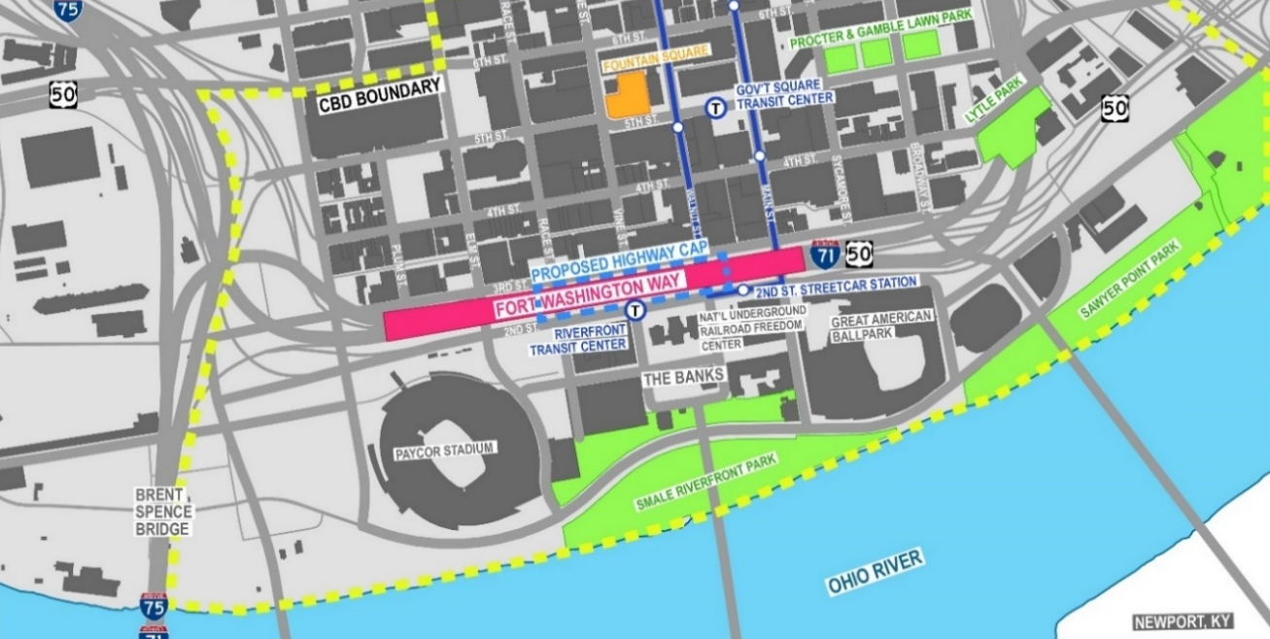
The Bridging the Gap project will provide approximately four acres of open green space and up to 1.65 acres of plaza space. The ultimate utilization of this space will be determined through public engagement as part of the design phase for the park space.
The streets surrounding FWW are all configured as multi-lane, one-way streets. Annual average daily traffic (AADT) counts collected in 2022 along FWW, indicate that approximately 110,000 vehicles use the depressed FWW interstate daily. This includes approximately 20,000 trucks that use this important freight corridor daily. 2018 AADT counts show that approximately 9,400 vehicles travel daily on 3rd Street, adjacent to the proposed FWW cap, and approximately 12,500 vehicles travel daily on 2nd Street. Vehicles traveling along these two five-lane arterials move at speeds of 35 mph or greater. Given these low vehicle counts and excess lane capacity on 2nd Street and 3rd Street, road diet and traffic calming measures are feasible.
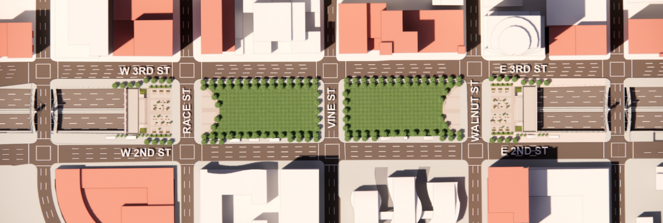
Public transit is readily accessible in the area surrounding FWW. This includes The Connector, a modern streetcar which provides service from a southern terminus station at 2nd Street & Walnut Street to a northern terminus station at Findlay Market, connecting The Banks through the CBD and into Over-the-Rhine. The Connector has set ridership records during every month of 2023, with ridership from January to May up nearly 40% over the same five-month period in 2022. The Connector has seen strong ridership growth after ridership levels were heavily impacted by the Covid-19 pandemic. Ridership on the Connector was 846,622 passengers in 2022, an all-time annual record that surpassed the previous annual record of 571,601 passengers in 2017.
In addition to the Connector, fixed-route bus service is provided by SORTA. The majority of SORTA’s bus routes connect to Government Square Transit Center – the primary transit center in downtown Cincinnati – located two blocks north of FWW. SORTA has also invested in the underground Riverfront Transit Center – located under 2nd Street – which was built in 2003 utilizing a grant from the Federal Transit Administration and completed in coordination with the reconstruction of FWW. This transit center is currently used by SORTA’s Metro Plus, a limited-stop express service along Montgomery Road, with connections to major universities and employment centers in Uptown and Downtown. SORTA also recently completed an alternatives analysis planning study to identify future BRT investments, which will also utilize the Riverfront Transit Center. The first two BRT lines will begin design in Fall 2023 and will include lines that service the Reading Road corridor and the Hamilton Avenue corridor, two high ridership corridors that identified in SORTA’s BRT alternative analysis. These BRT lines are projected to begin operations in late-2027 or early-2028, with the Reading Road corridor expected to attract 4,813 trips per day and the Hamilton Avenue corridor expected to attract 4,173 trips per day.
Recent economic development south of FWW has occurred primarily through the development of The Banks. In total, $128 million in public funding has leveraged over $800 million in private investment to create this mixed-use riverfront district bookended by Cincinnati's two professional sports stadiums. Immediately north of FWW along 3rd Street, there is also future economic development potential. Recent studies completed for the City estimate that there is potential for 2.6 million square feet of new or infill development within one block of the proposed Bridging the Gap project site (See appendix X).
This infill development presents an unprecedented opportunity to address the displacement that occurred in this area during the urban renewal of the 1960s by incentivizing mixed-use developments that contain affordable units of housing. This initiative is directly in-line with Mayor Aftab Pureval’s strategy to invest millions of dollars into local affordable housing through the City’s Affordable Housing Trust Fund.

Response to Merit Criteria
[[summary of how the project addresses the merit criteria]]
[[improve access to jobs especially for transit users, many of which live in equity areas of need]]
“Reconnecting our communities, and creating cohesive spaces that all residents can access and enjoy, has the power to unlock Cincinnati’s fullest potential,” said Cincinnati Mayor Aftab Pureval. “The Fort Washington Way planning grant is a major step towards making a transformational impact on the face of our city, and I’m excited by our collaborative work to pursue this incredible opportunity.”

https://www.fox19.com/2022/10/04/public-park-plazas-envisioned-fort-washington-way-highway-caps/
[[improve safety for all pedestrians travelling between the CBD and Riverfront District
[[capitalize on opportunities to right historic wrongs that resulted in displacement to persons the previously lived in the area]]

Criteria #1: Equity and Environmental Justice
During the development of the previously mentioned 2000 Central Riverfront Master Plan, the City of Cincinnati was intentional about including public involvement at all phases of the plan. To begin the process, the City convened a Riverfront Advisors Commission that was charged to “recommend mixed usage for the riverfront that guarantees public investment will create sustainable development on the site most valued by our community”. The Commission hosted a series of community forums and interviews throughout the region between February and September 1999 that were attended by hundreds of citizens. In the plan, the community identified capping FWW as a major opportunity to fix the mistake made at the height of the interstate highway construction of the 1950s. Removing this major barrier was and still is considered a major aspiration of the successful redevelopment of the central riverfront.
While the riverfront district was eventually built, the vision for capping over FWW was never taken forward and the depressed interstate continues to present a significant barrier to access, mobility, and economic development. The City, in partnership with Hamilton County and the private sector, is requesting RCN planning funds to continue this public engagement work. These funds will allow the City to implement new and innovative engagement tools to make sure the voices of all Cincinnatians, but especially those whose communities were impacted by the initial construction of the highway, are benefiting from the Bridging the Gap project.
The City plans to retain a public engagement firm with close ties to the community to develop a robust Community Participation Plan (CPP) that facilitates meaningful engagement during the design and environmental process and form a Community Advisory Board to ensure community voices are heard. The CPP will reach hard-to-access community members through culturally appropriate and innovative practices including social media, online and in-person surveys, stakeholder interviews, focus groups, and public open houses. A central focus of the Bridging the Gap project community participation plan will be to reach community members that live in the several Area of Persistent Poverty and Opportunity Zone Census tract located in close proximity to the Bridging the Gap project site and in areas accessible to the site via transit.

Criteria #2: Access
The City of Cincinnati and its public and private partners have long been aware of the difficulties associated with travelling across FWW, even after the highway footprint was significantly reduced when FWW was reconstructed in the early 2000s. The depressed highway carries personal and commercial vehicles safely and efficiently into and out of the CBD; however, the local streets across and adjacent to FWW – including 2nd Street and 3rd Street – have long crossing distances (in excess of 60 feet) for pedestrians and bicyclists, which poses a significant barrier to safe mobility. The existing design of these streets does not place high priority on pedestrian safety, and existing traffic volumes – ranging between 9,000 and 13,000 vehicles per day – strongly indicate that vehicular lane reductions are possible without significantly impacting motorist travel times. Bridging the Gap proposes to right-size and redesign these streets to increase pedestrian safety. Improvements at ten intersections will include traffic calming and pedestrian safety measures such as curb bump-outs, new crosswalks, modernized accessible pedestrian signals (APS), leading pedestrian intervals, and on-street parking. These traffic calming measures are expected to reduce the total of vehicular lanes on 2nd Street and 3rd Street from five lanes to three. A traffic study will be completed to ensure that any impacts to vehicular traffic movement are minimized while multimodal safety and accessibility are prioritized.
Improved bicycle infrastructure is also critical to encourage residents and visitors to utilize multi-modal options to access the Bridging the Gap civic greenspace. There is currently a lack of safe, separated bicycle facilities within the heart of Cincinnati’s CBD; however, the City has created a plan to increase the downtown bike network (Figure X), which includes proposals to add up to 5.5 miles of on-street protected bike lanes within the CBD and the Over-the-Rhine neighborhood. This network would tie into the larger regional bike network which includes downtown connections to the Ohio River Trail, Purple People bicycle and pedestrian bridge, and the Central Parkway protected bike lane – which will be extended to connect to more neighborhoods north of downtown. It would also provide connections to the 3.5 mile State to Central project – a Complete Streets network along Linn Street and 8th Street in the West End, Queensgate, and Lower Price Hill neighborhoods - which the City received $20 million in USDOT 2022 Rebuilding American Infrastructure with Sustainability and Equity (RAISE) grant funding to construct.
As part of the Bridging the Gap project, the City is proposing to add an additional two-way protected bike facility along 3rd Street, which would provide a direct connection between the Bridging the Gap civic greenspace and the City’s proposed downtown bike network. It will also provide connectivity to Red Bike bikeshare station near GE at the Banks, located at the intersection of 2nd Street & Vine Street. The Red Bike network has provided nearly 500,000 total rides since 2019, averaging 100,000 rides per year. On average, the GE at the Banks station has 1,000 bike check-outs per year from 2019 to 2023 and would likely experience increased use with the addition of the new park space. The station could also be relocated in the future to be better integrated within the Bridging the Gap park.
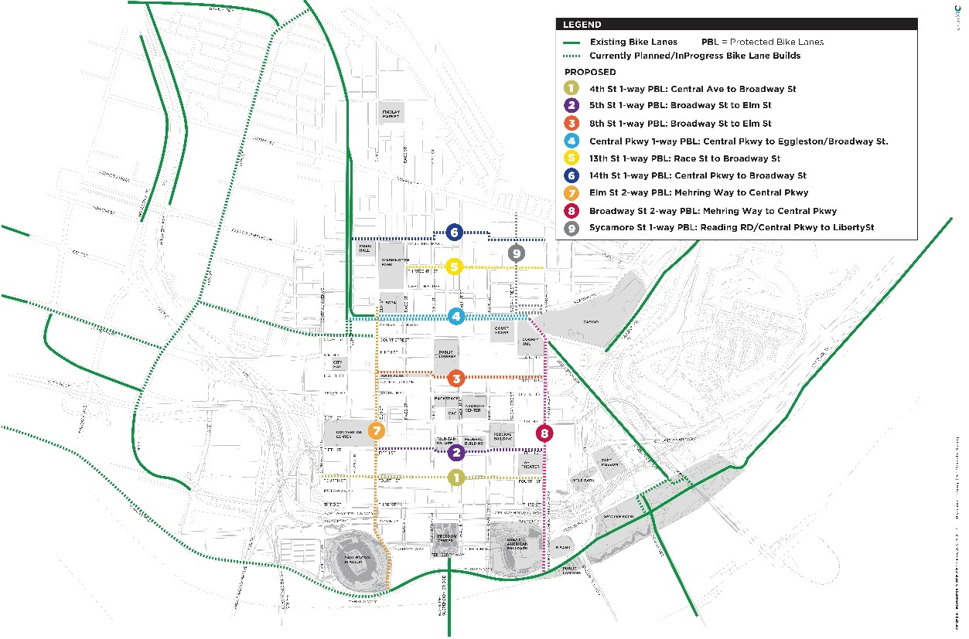
Adding the protected bike facility along 2nd Street will also provide a safe bike connection between the Riverfront Transit Center and the proposed downtown bike network, increasing opportunities for multimodal connectivity. The underground Riverfront Transit Center is accessed via multiple street-level entrances on 2nd Street between Elm Street and Main Street, including two ADA accessible elevators. Currently, SORTA’s Metro Plus bus service is the only route that uses the Riverfront Transit Center; however, two planned BRT lines are projected to begin operations here in late-2027 or early-2028, the Reading Road corridor expected to attract 4,813 trips per day and the Hamilton Avenue corridor expected to attract 4,173 trips per day.
Additionally, 41 of SORTA’s 48 bus routes currently provide service to Government Square, the principal downtown transit center located two blocks north of the Bridging the Gap project site at the intersection of 5th Street and Walnut Street. This includes access to nine frequent bus routes with service frequencies of 20 minutes or better. Access via bus routes operated by the Transit Authority of Northern Kentucky (TANK) …
The Connector – a 3.6 mile modern streetcar loop that was completed in 2016 – is accessible via the station at The Banks located on 2nd Street directly across from the Bridging the Gap project site. Service on the Connector is free and operates 365 days a year providing service extending from The Banks to Findlay Market in Over-the-Rhine. The Connector has set ridership records during every month of 2023, with ridership from January to May 2023 up nearly 40% over the same five-month period in 2022. Given all of these public transit services in close proximity, the Bridging the Gap project site is well integrated within the primary hub of Cincinnati’s public transit network, increasing mobility options for residents across the city who will visit this regional park space.
These multimodal safety improvements, in tandem with the current and planned public transit services available within walking distance of the project site, will help facilitate safe, multimodal access to the Bridging the Gap civic greenspace for residents across the city, as well as to The Banks district along the Ohio River and Cincinnati’s CBD; home to over 70,000 jobs.
After construction, it is anticipated that the Bridging the Gap project will provide ___ in overall safety benefits.

Criteria #3: Facility Sustainability

Infrastructure Vulnerabilities
The three bridges over FWW that are included in the Project scope – at Race Street, Vine Street, and Walnut Street – were constructed by the Ohio Department of Transportation in 2000 but are operated and maintained fully by the City of Cincinnati (maintenance agreement included in appendix). According to a recent bridge inspection report compiled by the City, the bridge deck, superstructure, and substructure are all in good or very good condition as they approach their half-life. Annual maintenance and operation costs for these bridges are currently minor; however, it is expected that these costs will increase as the bridges approach 30 years old in 2030 and that they will begin to experience cracking, spalling, delamination, and other issues until ultimately needing to undergo reconstruction before 2050.
By replacing these three bridges as they approach the 30-year mark, Bridging the Gap will ensure a long-term state of good repair and will put the bridges on a similar timeline as the FWW cap structure for future maintenance and eventual replacement after 50 years of use. Replacing the bridges as part of the project will minimize future disruptions to the civic park space and highway due to planned maintenance and eventual replacement.
After construction, it is anticipated that the Bridging the Gap project will provide ___ in overall O&M benefits.

MOVEMENT OF GOODS
By constructing the project, the City ensures there will be no long-term negative impacts to the movement of goods, both regionally and locally. The planned highway cap will not alter in any way the number of highway lanes or the general operations of the FWW highway passing below the Bridging the Gap civic park space. The reconstruction of FWW in the early-2000s began the process of reunifying the CBD and the riverfront and the existing highway capacity and traffic operations are well suited for current and future mobility needs.

Criteria #4: Community Engagement and Community-based Stewardship, Management, and Partnerships

A History of Inclusive Engagement
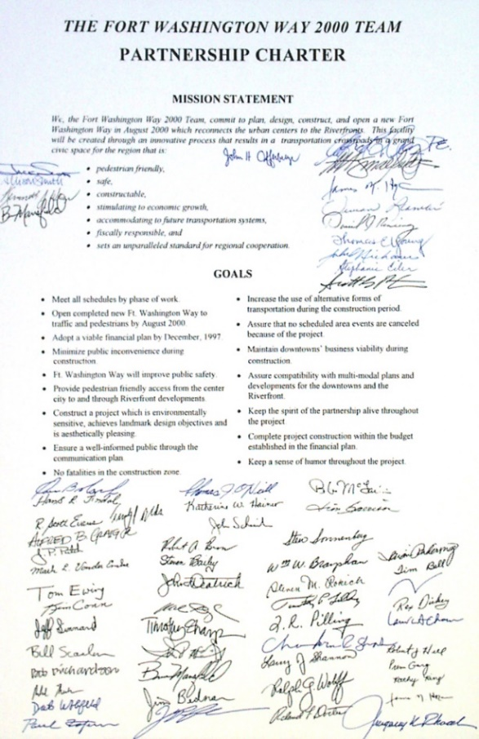
Partnerships have been the driving force in realizing the vision for Cincinnati’s riverfront, with planning efforts that began during the reimagining of FWW in the 1990’s through the development of the Central Riverfront Urban Design Master Plan in 2000 to today. The implementation of Bridging the Gap will be part of the master planned riverfront project, which has incorporated both formal and informal partnerships with one common goal: To reconnect the urban center of Cincinnati to the Ohio riverfront.
The FWW 2000 Team Partnership Charter highlighted goals of creating a pedestrian friendly infrastructure project as part of a grand civic space through design and construction, including the narrowing of the facility which would allow decking to reconnect the communities to the Ohio Riverfront.
In addition to the FWW Partnership Charter, the Urban Design Master Plan was developed collaboratively with the City of Cincinnati, Hamilton County, and OKI Regional Council of Governments and led by a Riverfront Advisory Commission comprised of business and community leaders.
As evidenced by the array of public and private support letters for this request, included as an appendix to this application, these collaborative efforts have continued and are supported by the City of Cincinnati, Hamilton County, community-based organizations, and anchor institutions.
Bridging the Gap is the final step towards realizing the decade-long vision of a vibrant neighborhood to live, work and play along Cincinnati’s riverfront, due in large part to coordinated planning and strategic local partnerships.

An Inclusive Future
The City of Cincinnati and its partners at the County and Chamber of Commerce consider Bridging the Gap as an opportunity to amend historic wrongs done to the community while improving safety for residents and visitors to the area. As part of the environmental process, an EJ analysis and requisite public engagement process will be completed; however, the city is committed to going above and beyond what is federally required to ensure that all community voices are heard. This investment in deep community engagement is a core principle of the City’s Engage Cincy initiative to provide opportunities for all to participate in meaningful and proactive ways during the City’s decision-making processes.
To ensure community voices are heard during the design and environmental process of the Bridging the Gap project, The City plans to do the following as part of their engagement plan:
- Convene a community advisor board made up of representatives from community organizations from the area. These board members will meet quarterly to receive frequent updates on the Project’s process directly from the city with the expectation that that information will be conveyed to members of their respective community organizations.
- Host frequent outreach events that are inclusive of local arts organizations, community organizations, and local artists so that the local art community and Cincinnati’s unique local cultures can inform placemaking decisions. Cincinnati has a thriving art community and a strong commitment to culturally significant public art, as seen in the city’s collection of public murals throughout the city.
- The City will also implement a full suite of engagement tools they frequently use on other high profile projects; including frequent social media posts, website hosted project material, in-person open houses, online design preference surveys, and full-page newspaper ads.

A Fiscally Smart Approach to Local Match Funds
Capital Construction Grant applications and Regional Partnerships Challenge Grant applications with construction activities should also address how resources of partners and other Federal and non-Federal funds will support the success of proposed activities by providing:
A complete description of resources committed to the project and fully outlining funding commitments from Federal and non-Federal sources, including: DOT formula funding, State or local funding, in-kind support, philanthropic contributions, public and private financing, and private sector funds. All funding should be reflected numerically in the budget.

Criteria #5: Equitable Development

Access to areas of persistent poverty
The Bridging the Gap project site is located within Hamilton County, which has been identified at the county-level as an Area of Persistent Poverty by U.S. DOT. At the Census Tract level, the project site is within Census Tract 265, which is also identified as an Area of Persistent Poverty. The map shown in Figure X shows the locations of Areas of Persistent Poverty within the City of Cincinnati and Hamilton County, overlaid with SORTA bus routes. Large sections of the City of Cincinnati are classified as such, particularly areas west of the I-71 corridor.
Bridging the Gap will be a regional park that is easily accessible to most city residents via public transit. Of SORTA’s 48 bus routes, 41 provide service within a one-quarter mile walking distance of the project site. More importantly, however, the project location is accessible via nine SORTA bus routes that have been classified as frequent routes, defined as routes that provide service every 20 minutes or better. Of the 76 census tracts within Hamilton County that are classified as areas of persistent poverty, 56 (73.7%) are within a one-quarter mile walking distance of one of the nine frequent SORTA bus routes which provide service within a five-minute walk of the Bridging the Gap project site. People residing within these communities will be able to rely on a frequent network of transit to connect them to this new regional civic space.
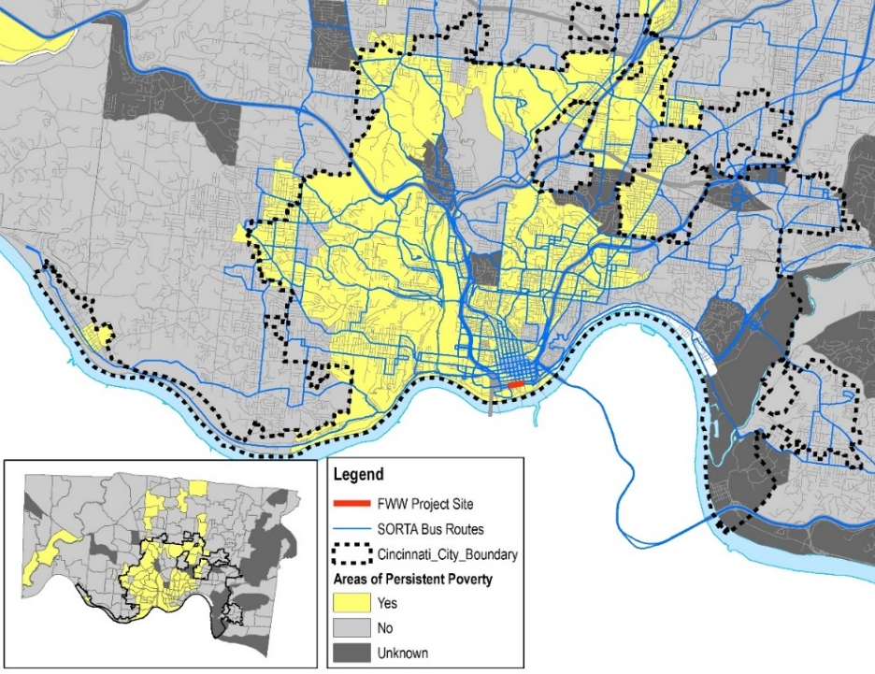
According to 2021 U.S. Census Bureau American Community Survey (ACS) data, a total of 150,185 people live within a quarter-mile walking distance of SORTA’s nine frequent bus routes, 123,385 of whom reside within the limits of the City of Cincinnati. Approximately 25.9% of the population along these nine frequent routes have income that is below the federal poverty limit over the past twelve months. Approximately 32.2% of the population along these routes is Black and 4.5% is Hispanic or Latino. Additionally, 58.2% of the population has access to zero or one vehicle. With SORTA’s future plans to continue to increase bus frequencies and to build out a network of BRT lines connecting directly to FWW, frequent and reliable transit access between historically underserved communities and the Bridging the Gap project site will only continue to improve in the years and decades to come.
Additionally, census tract 265 is also identified as an Opportunity Zone, as defined by U.S. Department of Housing and Urban Development (HUD). A public investment in Bridging the Gap is anticipated to spur additional private development along 3rd Street and surrounding areas, which will be even more likely due to the Opportunity Zone designation for the project area.

Criteria #6: Climate and Environment
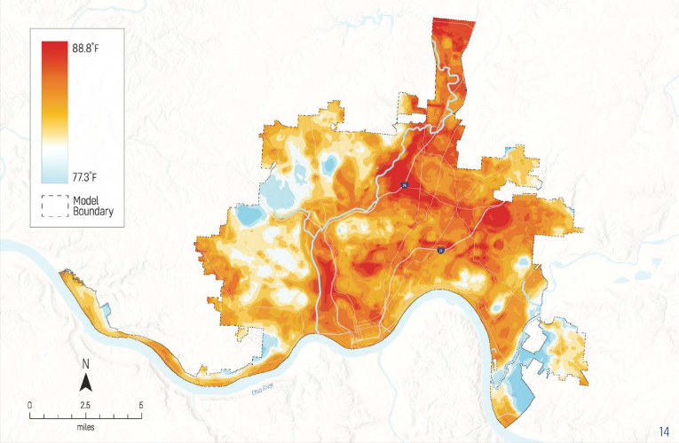
In March of 2023, the City of Cincinnati Planning Commission adopted the 2023 Green Cincinnati Plan (GCP) that sets the ambitious goals of reducing carbon emissions by 50% by the year 2030 and achieving carbon neutrality by 2050. Over the course of nine months feedback was received from nearly 3,800 residents at 42 community meetings or online. The plan features goals and strategies that directly reflect the community’s interest in addressing climate change at the local level and emphasizing building a more equitable and resilient city for all residents.
2020 Heat Watch Report predicts Cincinnati neighborhoods could experience up to a 10 degree difference in evening temperatures. (source: 2023 Green Cincinnati Plan)
Climate change is having an alarming impact across the world. In Cincinnati, “urban heat island” areas — those with a lot of impermeable surfaces like parking lots and large buildings — can get up to 12 degrees warmer than those with more tree canopies and green spaces. As of last April, Cincinnati had experienced nine 100-year rainstorm events in the past decade, according to data from OES. The city had spent more than $150 million to address basement flooding and hill-slide issues related to excessive rainfall in recent years.
By constructing the Bridging the Gap project that creates four acres of new permeable greenspace bound by trees; improves access to high-quality choices for lower-carbon travel like walking, cycling, rolling, and transit; and reduces the noise and visual pollution caused by an interstate, USDOT will be directly supporting several of the goals outlined in the plan and addressing several of Cincinnati’s environmental concerns, including urban heat island effects and flooding. Primarily the Project will help achieve the following goals:
- increase the number of residents within a quarter mile of safe bike and pedestrian infrastructure by 50 percent from 2022 levels by 2030
- expand the tree canopy by 10% in the Central Business District
- increase access to greenspaces so that every resident has a greenspace within a half-mile walk by 2028.

Criteria #7: Workforce Development and Economic Opportunity

DBE program goals and progress
The City of Cincinnati is committed to increasing inclusive economic development opportunities in contracting across all departments and projects. As a step towards increasing participation by disadvantaged business enterprises (DBE), the City commissioned an economic inclusion study in 2014 which was led by the City’s Economic Inclusion Advisory Council (EIAC). The EIAC was created for the purpose of helping to guide the study and was made up of local leaders from the public, private, and non-profit sectors. Through the study, the City released a final report in January 2015 that identified key recommendations to increase participation by minority business enterprises (MBE) and women-owned business enterprises (WBE), inclusive of contracting in the public, private, and non-profit sectors.
One of the key recommendations from the economic inclusion study was for the creation of a Department of Economic Inclusion. Established in 2015, the department’s goal is to ensure economic opportunity and inclusion for all citizens seeking to do business with the City of Cincinnati and serve as a catalyst for the growth of minority- and women-owned businesses in the City and throughout the region. The Department of Economic Inclusion is responsible for administering, enforcing, and monitoring the Equal Employment Opportunity Program, the Living Wage Program, MBE/WBE/SBE certification programs, and Local, State & Federal Prevailing Wage laws.
The Department of Economic Inclusion posts quarterly reports on MBE and WBE participation on the department’s webpage. The City’s participation goals include 17% MBE and 10% WBE for construction contracts and set at 14% MBE and 16% WBE for professional services contracts. Recent reports show…
A positive example of the City’s efforts to support DBE participation is the redevelopment of The Banks over the last decade. As development of The Banks has progressed, participation by Small Business Enterprises (SBE) and Disadvantaged Business Enterprises (DBE) has been a high priority for the City of Cincinnati and Hamilton County. SBE and DBE participation has been publicly documented since 2008, with quarterly reports made available for public review by The Banks Public Partnership. Currently, Small Business Enterprise (SBE) participation is 29.5% for The Banks project and includes 22.9% combined Minority and Female workforce participation for the current phase of the project.

redevelopment potential & affordable housing
Bridging the Gap is also expected to help spur the development of 7.9 acres of vacant or underutilized property along 2nd Street and 3rd Street (red-shaded properties shown in appendix X). The future redevelopment of these properties will provide potential opportunity for increased affordable housing development within the downtown core, a key priority for Cincinnati Mayor Aftab Pureval. Mayor Pureval has outlined an affordable housing plan which includes goals such as reforming Cincinnati’s zoning code to allow for more affordable housing development, partnering with developers to expand affordable housing stock, and creating programs to help low- and moderate-income Cincinnatians achieve homeownership. Any affordable units created adjacent to the Bridging the Gap site would have direct access to high-quality transit, recreational park space, and job opportunities.

Project Readiness: Environmental Risk

Environmental Risk
The City of Cincinnati and its project partners are dedicated to the successful completion of the Bridging the Gap project and anticipate receiving all environmental approvals in advance of project obligation. To ensure that this environmental milestone is met, the City will coordinate closely with the Ohio Department of Transportation for all NEPA documentation necessary to implement the Project.
Ohio (ODOT) is one of only eight states which has NEPA Assignment, meaning it has formally assumed responsibility for all environmental laws, rules and orders, interagency consultation, and any other environmental related actions for transportation projects in Ohio. Under this program, ODOT is deemed to be a Federal Agency [FHWA] for environmental matters. As a result, there would be less regulatory hurdles for proper clearance and a streamlined approval process resulting in an expeditious road to begin construction in the second quarter of 2026.

Inclusion in STIP/Transit Asset Management Plan:
Planning for the Bridging the Gap project began in earnest more than 20 years ago with the creation of the ____ Plan in 2000. Since then, countless references have been made to this project and its local and regional significance; however, momentum for the Project has been slow in recent years due to a lack of funding availability and addressing other regional priorities.
Momentum for the Project was renewed in early 2022 in preparation for submittal to the Reconnecting Communities Program Planning Grant Application. Though unsuccessful, the effort was enough to spark political interest in listing the project in the Ohio, Kentucky, and Indiana (OKI) Regional Council of Governments Transportation Improvement Program (TIP) and the State of Ohio STIP. An effort that is currently being pursued along with the development of this application and is expected to be complete before 2025; well in advance of the statutory deadline.

Detailed Project Schedule
The Bridging the Gap project schedule is a direct reflection of The City of Cincinnati and Ohio Department of Transportation’s joint effort to expedite the Project’s construction while maximizing the amount of public involvement.
Project’s ability to move ahead is largely contingent upon securing RCN funds and as such, the environmental and public engagement processes will be the first project elements to kick-off if the Bridging the Gap project is selected once award recipients are announced in the fourth quarter of 2024. The design process will kick-off in the first quarter of 2025, after the Project is programmed in the STIP and TIP and continue until mid-2026; finishing along the same timeline as environmental. Construction bid, procurement, and commencement activities will kick-off once design and environmental are complete in mid-2026. It is worth noting that The City does not anticipate substantial utility coordination or right-of-way activities but has allocated time in the schedule for these items.

Required Approvals

Environmental Permits and Review
At this time, because of potential minor property acquisition and anticipated US DOT Act, Section 4(f) de minimis findings for the connections to existing bike facilities and coordination required during implementation, the City anticipates a D1 documentation. A D1 project means it is “Categorically Excluded” in accordance with 23 CFR 771.117c and does not individually or cumulatively have a significant environmental impact. ODOT’s CE Guidance also lays out the process for approving environmental documents. Projects with lower levels of impact can be approved by ODOT district offices, again, minimizing time needed for project clearance.
The City’s Department of Transportation and Engineering (DOTE) currently has a standing monthly meeting with ODOT to discuss existing and future projects. Once notification of the Grant occurs, coordination will begin almost instantaneously.
Additionally, the City is also an active part of the Intermodal Coordinating Committee (ICC), which serves a technical advisory role for the Ohio Kentucky Indiana Regional Council of Governments, the MPO for the Greater Cincinnati region. The ICC meets monthly and has a formalized process for reviewing projects which need to be incorporated in the region’s Transportation Improvement Program (TIP) and for continuing transportation planning commensurate with the Unified Planning Work Program. The nature of the project is consistent with OKI’s Long-Term Transportation Plan and would not result in a delay for inclusion in the region’s TIP.
Based on the routine nature of D1 documentation and the ability to be incorporated into the TIP, the City expects timely NEPA clearance within the overall implementation schedule of less than 12 months.
Assessment of Project Risks and Mitigation Strategies
- address mitigation plans for negative impacts of the proposed capital project by describing:
- RCN funds will be obligated before the statutory deadline (September 30, 2026), and that the project can begin construction upon obligation of grant funds and that those funds will be spent once construction starts, with all funds expended by September 30, 2032.
- All real property and right-of-way acquisition will be completed in a timely manner

Public Involvement

Benefit-Cost Analysis (BCA)
To be added…

Project Budget
The City of Cincinnati is requesting $149.43 million in FY2023 Reconnecting Communities and Neighborhoods (RCN) funds to design and fully construction the $187.27 million Bridging the Gap project. If successful, the RCN funds will be supported by $37.84 million in local match funds sourced 1/3 from the City of Cincinnati’s ___ funds, 1/3 from Hamilton County’s ___ fund, and 1/3 from the Cincinnati Chamber of Commerce. Letters of commitment for each source of local match funds are included in the first pages of this application. This project is the culmination of more than 20 years of planning and community support and provides a great example of City, County, State, and Private stakeholders coming together to reconnect communities that will improve quality of life for all Cincinnatians.
Since FWW was reconfigured in the late 1990s, the City of Cincinnati, Hamilton County, and private sector partners have discussed the viability of converting the space above FWW to provide a public benefit. As part of the ODOT project, foundation pilings were built in the ground with the intention of one day using them to support an elevated highway cap park, as envisioned in the 2000 Central Riverfront Urban Design Master Plan.
While it’s difficult to quantify all previously incurred costs, it is worth noting that the entire $10 million dollar cost of the design and construction of the pilings was privately raised with hopes that this long-term, visionary investment would help spur the reconnection of the CBD and Ohio River waterfront. That investment is equivalent to $17 million today when adjusted for inflation. Furthermore, since interest in the project has been reinvigorated over the past few years, the City and its partners at the Chamber of Commerce have funded all planning-level work completed locally.

Emphasis on Contingency and Risk Aversion
The City of Cincinnati understands the potential risk associated with estimating costs before commencing design and environmental work and has allocated a generous 50% construction contingency to the overall project cost. This approach to risk aversion is also evident in the proposed project construction schedule shown in the previous section. While the City anticipates expediting construction to reach project closeout in under three years, it has shown four years on the project schedule to allow amble time to address any unforeseen issues.

Sources and Uses of Funds
Table 1 summarizes the RCN sources and uses of funds. All non-federal funds will be sourced from _____.
The budget should show the distribution of each funding source in each major planning or construction activity, including sub-recipient activity and compensation. For each source of funds, the budget should discuss any restrictions on timing or use. For example, if a particular source of funds is available only after a condition is satisfied, the application should identify that condition and describe the applicant’s control over whether it is satisfied. Similarly, if a particular source of funds is available for expenditure only during a fixed time period, the application should describe that restriction.
Table 1: Project Budget Summary by Source and Use, Future Eligible Costs
Table 2: Expenditures by Fiscal Year

Match Funding Commitments
- Documentation of funding commitments for those non-Federal and other Federal funds;
- Need to describe match funding and link to commitment/letter in appendix

