**C-R-S: CLE SR 32 12.14**

**PID 116569**

**Scope Narrative**

# PDP Phase Included in this Agreement:

# Agreement is for the Preliminary Engineering (PE) and Detail Design*.*

# Agreement between Consultant and Ohio Department of Transportation.

# This will be a 1 Part agreement for plan preparation through final design.

# Study Location:

Bridge No. CLE-32-1214 (SFN 1300431) which carries Half Acre Rd over SR 32

**Map of existing bridge:**

Existing bridge highlighted in green on the map.

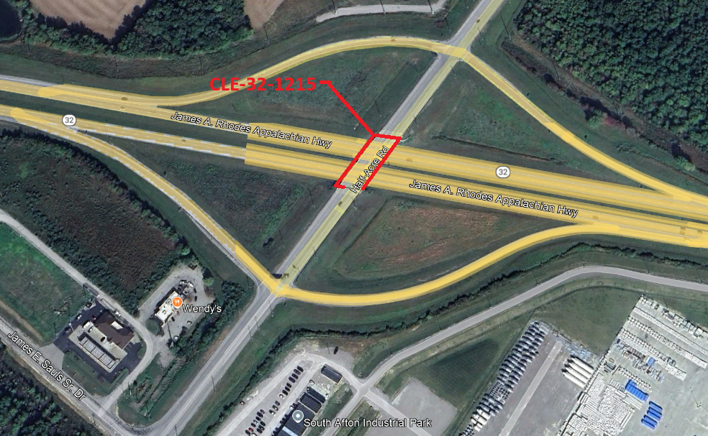

# Study Description:

**Purpose & Need:**

The CLE-32-1214 bridge that carries Half Acre Rd over SR 32 is in need of repair. The primary repairs needed are as follows:

1. Concrete deck is deteriorated on the underside with spalling and exposed reinforcing.
2. The vertical clearance is deficient.

Secondary deficiencies that require consideration are as follows:

1. Piers may not meet current seismic reinforcing requirements.
2. Vandal Fence is not provided on existing bridge.

**Project Scope:** Discipline specific scope items have been identified below.

**Structures:**

Develop detailed plans for the following:

1. Replace the existing deck, expansion joints, backwalls, and approach slabs. The new deck shall be a composite deck matching the existing width. Barriers shall be 42” tall per [SBR-1-20](https://www.dot.state.oh.us/SCDs/Structural/SBR-1-20.pdf) with a 6’ vandal protection fence on each side. Include a 2” conduit for future use in each barrier.
2. Raise the existing superstructure to achieve a 16.5’ vertical clearance. Existing VC is approximately 15.14’ in the EB direction and 15.43’ in the WB Direction. Existing V.C. shall be field verified for Stage 1.
3. Replace the abutment bearings with elastomeric bearings and convert the bridge to be semi-integral. Remove existing pedestals and raise the existing beam seat with concrete.
4. Replace the existing pier bearings with elastomeric bearings, replace the existing pier cap, and extend the columns vertically as necessary to accommodate the raised profile. Include an item for temporary support for the bridge (designed by the contractor) while the pier is replaced.
5. Sound and patch other portions of the substructure per 519 specifications if less than 5 square feet and with SS844 if larger than 5 SF.
6. Coordinate removal of the existing utilities off the structure.
7. Paint all structural steel with OZEU specifications. Color shall be Federal Color FS 595C-14277.
8. Seal superstructure barrier, deck edges, pier and abutments with epoxy urethane sealer, federal color 17778.
9. Replace approach guardrail, bridge terminal assemblies, and end terminal assemblies.
10. Load rate the rehabilitated structure per section 900 of the BDM. Per BDM 401.4, provide a design exception if needed.

Need to ask locals if they want baseline aesthetics on barrier and fence or if they have paint preferences.

Material notes:

1. Concrete: Include macro-fibers, corrosion inhibitor, and an internal curing agent in the concrete mix. District to provide notes during design development.
2. Reinforcing steel: Use continuously galvanized reinforcing steel for all new reinforcing steel.

Aesthetic considerations are not a driving factor but may be added later during design development once a preferred structure is determined.

**Roadway:**

1. New pavement on Half Acre Rd shall be asphalt concrete. Provide new pavement per ODOT’s standard flexible pavement. The existing pavement can be milled and filled with a variable depth asphalt where new pavement transitions into the existing pavement.
2. Alex Genbuaffe to work with locals to determine if the road should be restriped for 1 lane each direction and a center turn lane.

**Traffic Analysis:**

Not required.

**Geotechnical:**

None Required.

**Drainage:**

1. Determine if scuppers are needed on the existing bridge. Remove if not needed and provide for drainage off the end of the bridge. Is scuppers are to remain, locate new scuppers directly over drainage ditches and allow them to freefall.
2. 42” Corrugated metal Pipe (CMP) under Half Acre Rd just North of North abutment: Replace the first 20 feet to the west and the last 10 feet to the east with new conduit. Extend as necessary to accommodate raised roadway grade. Pave the invert in its entirety.
3. 24” Corrugated metal Pipe (CMP) under Half Acre Rd just North of intersection with Eastbound Ramps: Replace the east 10 feet with new conduit. Line the conduit in its entirety with a CIPP liner.
4. Check with Jeff Meyer to see if additional work is needed on other drainage structures.

**Maintenance:**

None required

**Maintenance of Traffic:**

1. Maintain one lane of traffic in each direction on Half Acre Rd.
2. Provide splice detail for crossframes to be cut for phased raising of structure.
3. Follow Permitted Lane Closure policy on SR 32. Provide Portable barrier protection along SR 32.
4. Multiple superloads (at least 14 axles) from manufacturing plant use Northbound Half-Acre Rd to westbound SR 32 daily that have. Design the MOT to ensure typical superloads are not disrupted.

**Environmental:**

The consultant shall coordinate the environmental work. See the task list in SAFe for anticipated coordination.

**Survey:**

Consultant to survey.

**Right-of-Way:**

Not anticipated.

**Utility Coordination Requirements:**

Consultant to try to avoid utility conflicts throughout design while holding to the scope of work. If utility conflicts cannot be avoided, they should be minimized. If the superstructure is raised, the six bridge mounted Cincinnati Bell telecom conduits will need to be raised or relocated off the bridge. The consultant shall coordinate this with Cincinnati Bell and see if any of the bridge mounted conduits contain fiber.

Conduit for future fiber optic line will be installed along Ronald Reagan Highway per PID 115815 (D08 CLE/HAM ITS Interconnect). A final alignment or as built plans are not available at this time but anticipate conduit should be in place in Summer 2023. The new conduit should be avoided with this project.

Consultant to provide a copy of the OUPS ticket information to ODOT PM (if applicable). Up to date utility contacts shall be used at each plan submission. Utility contact information can be requested by consultant from ODOT PM. If Ohio 811 (OUPS) are more than two (2) years old, a design non-marking ticket shall be requested to obtain most up to date Utility Members List. The ticket does not need to be submitted to obtain the Utility Members List.

Consultant to provide a utility set of plans with the utility lines shown in color using the most recent version of ODOTcadd_UTPen.tbl at each plan submission. This file is found in the standard ODOTcadd executable file that can be downloaded from the [CADD services webpage](http://www.dot.state.oh.us/Divisions/Engineering/CaddMapping/CADD_Services/Standards/Pages/Files.aspx). Additionally, Consultant to prepare a summary of potential utility conflicts at each plan submission. Summary to be provided to Utility Companies at each plan submission. Summary to include, but not limited to station and offset of conflict, type of conflict (direct, decreased cover, proximity, etc.), utility owner (if known) and utility type. Consultant to use District 8's 'standardized' letter for sending submissions and plans to Utility Companies for review and comment. Consultant to provide the ODOT PM a copy of all Utility Correspondence. Consultant to compile Utility Company responses and forward to the ODOT PM. Final compilation of utility correspondence is due 35 days after plan submission to utilities

A “no response” from a utility on a plan submission review cannot be considered as “no comment”, “no conflicts” and/or “a confirmation of the consultant’s findings” from the utility. A written response (email is sufficient) must be received from the utility verifying that they have no comments, no conflicts and/or they agree with the conflicts identified by the consultant.

Consultant to review the Utility Company responses and evaluate. The evaluation of the responses shall include validating that a conflict does exist or that a utility may remain in place. If a conflict does exist, consultant should provide an evaluation of the feasibility of potential resolutions. A disposition of utility status (i.e. utility to stay in place, utility facility relocation plan in writing or plan format) is required at the Stage 3 submission. This disposition shall be included to the utilities with the Stage 3 plan submission. This disposition shall be formulated based on utility responses from previous plan submissions.

A draft utility note shall be submitted after evaluation of the Stage 3 utility coordination in word format. The note should include discussion about the existing utilities for each utility, if they are staying in place and in service or if they are being relocated. If a utility is relocating, information about the location of their relocation should be included. Additionally, the relocation time frames should be included in the utility note as discussed with the utility companies. Example utility notes can be provided by the District utility coordinator upon request.

**Feasibility Study:**

A feasibility study is not anticipated for this project.

**Project Management:**

The consultant shall prepare their fee which will include Stage 1, Stage 2, Stage 3, and Final Tracings. The fee preparation should include narratives for the tasks and any scope revisions/additions necessary to justify completion of Final Tracings.

**Funding:**

This project will likely be financed by the following funds:

* District Preservation Bridge (Percentage of State and Federal)

Plan splits will be required per the funding in Ellis at the time of Stage 3 Plans.

**Design Designations (CLE-32-12.15):**

**(for scoping purposes: SR 32 is 29,534. Half Acre Rd is 6859 south, 4500 on bridge, and 2933 north of bridge. Ramps are about 1,600 each. Speed Limit is not posted on Half Acre and is therefore assumed to be 55 MPH.)**

|  |  |  |
| --- | --- | --- |
|  | Half Acre Rd | SR 32 |
| Functional Class | Local | 3 Principal Arterial Other |
| NHS | No | Yes |
| Posted Speed | 55 Mph | 60 MPH |
| Design Speed | 55 Mph | 60 MPH |
| 2024 AADT |  |  |
| Opening Year AADT (2029) |  |  |
| Design Year AADT (2049) |  |  |
| Design Hourly Volume (2049) |  |  |
| Directional Distribution |  |  |
| TRUCKS (24 Hour B&C) |  |  |

**Existing Plans:** For existing plans, please see the FTP site: <https://ftp.dot.state.oh.us/pub/Districts/D08/Programmatics/2025-January/116569%20CLE-32-1214/>

|  |  |  |  |  |  |
| --- | --- | --- | --- | --- | --- |
|  | **Arch No** | **Name** | **Year** | **PID** | **Description** |
| 1 | 08c0400 | CLE-32-12.16 | 1979 |  | Original Plans |
| 2 | 08c1887 | CLE-32-6.48 | 1997 | 12673 | Minor Rehab |
| 3 | 08c3502 | D08 Bridge Maint Fy14 | 2014 | 84530 | Minor Maintenance |

**Bridge Inspection Photos:**  See the [FTP site](https://ftp.dot.state.oh.us/pub/Districts/D08/Programmatics/2025-January/116569%20CLE-32-1214/) for existing inspection photos.

J:\structures\bridges\24 photos\CLE\SR32\1214

J:\structures\bridges\24 photos\CLE\SR32\1214\PIP 092624