**C-R-S: GRE 4 0.90**

**PID 77793**

**Scope Narrative**

# PDP Phase Included in this Agreement:

# Agreement is for the Preliminary Engineering (PE) and Detail Design*.*

# Agreement between Consultant and Ohio Department of Transportation.

# This is a Two-Part agreement to prepare a feasibility study, then prepare plans through final design.

# Study Location:

Bridges GRE-4-0090 L/R (SFN 2900033/2900068) which carries SR 4 over Union Rd, Located 1.28 miles north of the SR 4 / SR 444 interchange

**Map of existing bridge:**

The existing bridges are highlighted in red on the map below.

~~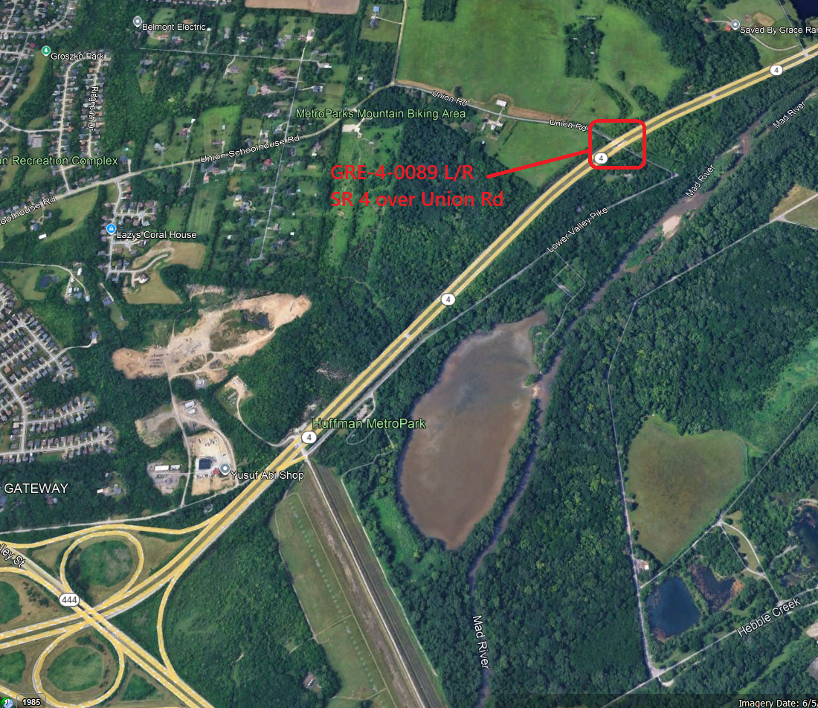~~

Study Description:

**Purpose & Need:**

The primary issues include:

1. Bridges GRE-4-0090 L/R (SFN 2900033/2900068) which carry SR 4 over Union Rd have a deteriorating superstructures. The westbound structure is currently rated a 4 (deficient). The eastbound superstructure is currently rated a 5 (near deficient). Both are showing signs of significant internal moisture.

Secondary issues that require consideration are as follows:

1. Areas of the structure such as the pier caps and westbound wearing surface have areas of delamination and spalling. The abutments have been substantially rehabilitated with built in steel supports and a new concrete facing.
2. The vertical clearance under the westbound structure is approximately 13.6 feet. The current standard for a new structure is 14.5 feet.
3. Average Daily Traffic on Union Rd is low at approximately 500 Average Daily Traffic (ADT)

**Feasibility Study:**

Prepare a feasibility study to examine the following options

1. Replace the bridges with embankment and make this an at-grade intersection with Union Rd to the north and south on the existing horizontal alignment. A new vertical alignment of Union Rd would be necessary.
2. Replace the bridges with embankment utilizing an at-grade intersection that is right in / right out on the southbound side only. Cul-de-sac Union Rd to the south. Replace both bridges with embankment. Utilize existing horizontal alignment or a new alignment to the southwest. A new vertical alignment of Union Rd will be necessary.
3. Cul-de-sac both ends of Union Rd.
4. Replace existing structure with new three span concrete slab bridges. Raise the southbound profile as necessary to obtain a minimum vertical clearance of 14.5 feet. Each structure shall carry two lanes of traffic.

At a minimum, the feasibility study shall include the following: Impacts of each alternative including a comparison or R/W, traffic impacts on SR 4, Lower Valley Pike, and Bath Rd., stakeholder and public involvement summary, total project cost, project limits, flood plain impacts (if any), MOT narrative and duration, drainage impacts, utility impacts (if any).

**Project Scope:** Discipline specific scope items have been identified below.

**Structures:**

1. Replace the existing bridges with 3 span slab bridges. Raise the southbound profile as necessary to obtain a minimum vertical clearance of 14.5 feet. Each structure shall carry two 12’ lanes, a 10’ outside shoulder, a 4’ inside shoulder, and 1.5’ wide barriers 42” tall per [SBR-1-20](https://www.dot.state.oh.us/SCDs/Structural/SBR-1-20.pdf).
2. Seal the exposed concrete surfaces with an Epoxy Urethane sealer per the typical limits shown in the bridge design manual. Color shall be Federal Color 17778 (light neutral).
3. Replace the existing approach guardrail as needed to meet MGS standards.
4. Load Rate the structure per section 900 of the BDM.

Materials for structures:

1. Concrete: Include macro-fibers and corrosion inhibitor in concrete mix. District to provide notes during design development.
2. Reinforcing steel: Use galvanized reinforcing steel for all new reinforcing steel.

**~~Roadway:~~**

1. ~~Mill and fill existing pavement as needed to eliminate MOT and utility relocation scars.~~

~~For any MOT scar clean-up beyond full depth pavement use:~~

~~1.5” Item 254 Pavement Planing, Asphalt Concrete~~

~~1.5”   Item 441 Asphalt Concrete Surface Course, Type 1, (448), PG64-22~~

~~The existing pavement is approximately:~~

|  |  |
| --- | --- |
|  |  |
|  |  |
|  |  |

~~The full depth composition will be flexible.~~

~~The full depth pavement composition is:~~

|  |  |
| --- | --- |
| ~~1.25”~~ | ~~Item 441 Asphalt Concrete Surface Course, Type 1, (448), PG64-22~~ |
|  | ~~Item 407 – Non-Tracking Tack Coat~~ |
| ~~1.75”~~ | ~~Item 441 – Asphalt Concrete Intermediate Course, Type 2 (448)~~ |
|  | ~~Item 407 – Non-Tracking Tack Coat~~ |
| ~~7”~~ | ~~Item 301 – Asphalt Concrete Base, PG 64-22 (449)~~ |
| ~~6”~~ | ~~Item 304 – Aggregate Base~~ |
| ~~TBD~~ | ~~Subgrade Treatment – Undercut (assumed)~~ |

**Traffic:**

**~~Geotechnical:~~**

~~Geotechnical borings and recommendations are to be provided by the consultant with the feasibility study.~~

~~A proposed boring plan with existing utility locations shall be provided to the District Geotechnical Engineer prior to drilling.~~

**~~Drainage:~~**

~~1. For alternatives that eliminate the existing bridge, provide drainage under SR 4.~~

**~~Maintenance:~~**

~~None required.~~

**~~Maintenance of Traffic:~~**

* + - 1. Maintain one lane of traffic in each direction on SR 4 using a cross-over.
      2. Close Union Rd to traffic curing construction. Detour traffic to Baker Rd to Kitridge to Bath to SR 4 to Lower Valley Pike.

**~~Environmental:~~**

~~The fieldwork for the Level 1 ESR shall be performed prior to the feasibility study. Identify stream/wetland and threatened & endangered species/habitat information within the study limits to be incorporated into the feasibility study. This information may play a role in identifying the preferred alternative design and will help scope future environmental tasks. The Level 1 ESR will be submitted through EnviroNet when Stage 1 Plans (or equivalent) are available to determine impacts to ecological resources.~~

~~The consultant shall coordinate the environmental work with District 8’s Environmental PM. See the task list in SAFe for anticipated coordination.~~

**Survey:**

ODOT will obtain aerial survey this winter and provide aerial survey for the project. The consultant shall supplement the survey provided as needed. The consultant shall also be responsible for providing the existing R/W.

**Right-of-Way:**

Right-of-way will possibly be required. Feasibility Study to determine project limits, number of parcels, and acreage of each parcel. ODOT to provide R/W estimate. Consultant to prepare R/W plans during final design.

**Utility Coordination Requirements:**

Consultant to try to avoid utility conflicts throughout design while holding to the scope of work. If utility conflicts cannot be avoided, they should be minimized. Consultant to provide a copy of the OUPS ticket information to ODOT PM (if applicable). Up to date utility contacts shall be used at each plan submission. Utility contact information can be requested by consultant from ODOT PM. If Ohio 811 (OUPS) are more than two (2) years old, a design non-marking ticket shall be requested to obtain most up to date Utility Members List. The ticket does not need to be submitted to obtain the Utility Members List.

Consultant to provide a utility set of plans with the utility lines shown in color using the most recent version of ODOTcadd_UTPen.tbl at each plan submission. This file is found in the standard ODOTcadd executable file that can be downloaded from the [CADD services webpage](http://www.dot.state.oh.us/Divisions/Engineering/CaddMapping/CADD_Services/Standards/Pages/Files.aspx). Additionally, Consultant to prepare a summary of potential utility conflicts at each plan submission. Summary to be provided to Utility Companies at each plan submission. Summary to include, but not limited to station and offset of conflict, type of conflict (direct, decreased cover, proximity, etc.), utility owner (if known) and utility type. Consultant to use District 8's 'standardized' letter for sending submissions and plans to Utility Companies for review and comment. Consultant to provide the ODOT PM a copy of all Utility Correspondence. Consultant to compile Utility Company responses and forward to the ODOT PM. Final compilation of utility correspondence is due 35 days after plan submission to utilities.

A “no response” from a utility on a plan submission review cannot be considered as “no comment”, “no conflicts” and/or “a confirmation of the consultant’s findings” from the utility. A written response (email is sufficient) must be received from the utility verifying that they have no comments, no conflicts and/or they agree with the conflicts identified by the consultant.

Consultant to review the Utility Company responses and evaluate. The evaluation of the responses shall include validating that a conflict does exist or that a utility may remain in place. If a conflict does exist, consultant should provide an evaluation of the feasibility of potential resolutions. A disposition of utility status (i.e. utility to stay in place, utility facility relocation plan in writing or plan format) is required at the Stage 3 submission. This disposition shall be included to the utilities with the Stage 3 plan submission. This disposition shall be formulated based on utility responses from previous plan submissions.

A draft utility note shall be submitted after evaluation of the Stage 3 utility coordination in word format. The note should include discussion about the existing utilities for each utility, if they are staying in place and in service or if they are being relocated. If a utility is relocating, information about the location of their relocation should be included. Additionally, the relocation time frames should be included in the utility note as discussed with the utility companies. Example utility notes can be provided by the District utility coordinator upon request.

**Project Management:**

Part 1 shall be the feasibility study. Upon acceptance of the feasibility, a contract modification will be requested to provide final plans and R/W.

**Funding:**

This project will be funded by District Bridge Allocations. Provide a separate cost for R/W and utility reimbursements.

**Design Designations:**

|  |  |  |  |  |
| --- | --- | --- | --- | --- |
|  | GRE-4 | Lower Valley Pike | Union Rd | Bath Rd |
| Functional Class | 03 Principal Arterial | 07 Local Rd | 07 Local | 05 Major Collector |
| NHS | Yes | No | No | No |
| Opening Year AADT (2030) |  |  |  |  |
| Design Year AADT (2050) |  |  |  |  |
| Design Hourly Volume (2050) |  |  |  |  |
| Directional Distribution |  |  |  |  |
| TRUCKS (24 Hour B&C) |  |  |  |  |
| Trucks (Design Hour) |  |  |  |  |
| Posted Speed | 60 MPH | 35 MPH | 35 MPH | 45 MPH |
| Design Speed | 60 MPH | 35 MPH | 35 MPH | 45 MPH |

**Existing Plans:** See the FTP Site for existing plans and photos.

|  |  |  |  |  |  |
| --- | --- | --- | --- | --- | --- |
|  | **Arch No** | **Name** | **Year** | **PID** | **Description** |
| 1 | 08C0806 | GRE-69-0.08 | 1957 | n/a | Original Plans |
| 2 | 08C2244 | GRE-4-0.00 | 2005 | 21742 | Minor Rehab (abutment) |
| 3 | 08C2374 | MOT-4-21.12 / GRE-4-0.00 | 1992 |  | Minor Rehab (overlay) |
|  |  |  |  |  |  |
|  |  |  |  |  |  |
|  |  |  |  |  |  |

**Bridge Inspection Photos:**  See the FTP site for existing inspection photos.

2024 Insp Photos:

\\D08fs100.dot.state.oh.us\archives\structures\bridges\24 photos\GRE\Sr4\0090 L

\\D08fs100.dot.state.oh.us\archives\structures\bridges\24 photos\GRE\Sr4\0090 R

FTP site with above info available here:

[ftp.dot.state.oh.us - /pub/Districts/D08/Programmatics/2026-January/GRE-4-0.90 PID 77793/](https://ftp.dot.state.oh.us/pub/Districts/D08/Programmatics/2026-January/GRE-4-0.90%20PID%2077793/)

**Schedule:**

The Official schedule will be maintained in Ellis. The consultant may propose changes to the schedule that don’t alter the final plan package submittal or sale dates.