C-R-S: FAY SR 41 9.48
PID 125968
Scope Narrative

PDP Phase Included in this Agreement:

Agreement is for the Preliminary Engineering (PE) and Detail Design.

Agreement between Consultant and Ohio Department of Transportation.

This is a Two Part agreement to prepare a feasibility study and final design construction plans.

Study Location:
Replace Bridge FAY-41-1.45 which carries SR 41 over Buck Run

Map of existing bridge:
The existing bridge is circled in red on the map below.

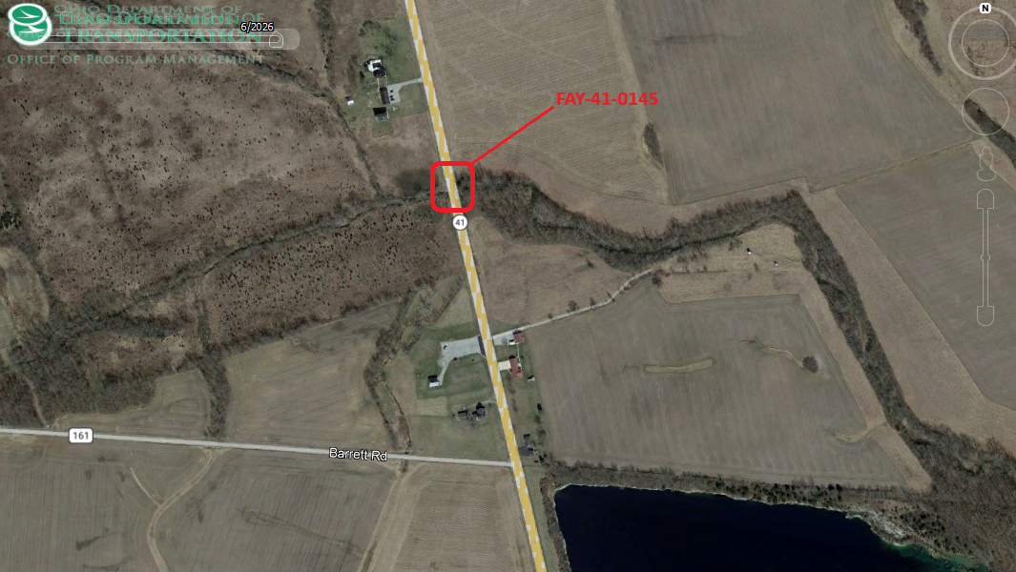

Study Description:

Purpose & Need:

The primary issues include:
Bridge FAY-41-0145 which carries SR 41 over Buck Run has a deteriorated boxbeam superstructure a 5 out of 9 (9 being best and 4 being deficient) and a deteriorated substructure rated a 4.
Secondary issues that require consideration are as follows:
- The foundation is exposed and the underlying soil/rock type is founded upon clay.
- Other bridge components such as guardrail attachments, pier, and expansion joints are also exhibiting deteriorated issues.

Feasibility Study:

The feasibility study for this project will consist of a hydraulic analysis and a Structure Type Study in Part 1. Once a structure type has been determined, final plans will be developed under Part 2. The feasibility study shall include:

- Structure type study that evaluates the following structure types:
-Single Span composite boxbeam superstructure.
-Three span slab bridge.
Spill-thru slopes are preferred, but full-height abutments may be considered if necessary for hydraulic purposes.
Include a preliminary site plans for both alternatives including wingwall lengths, assumed substructure type, assumed scour countermeasures, costs, proposed profile, and limits of channel modifications.
- Rock is anticipated to be between 30’ and 60’ deep. For the feasibility study, assume 45’ long friction piles.
- Hydrology and Hydraulics study.
- Determine if a TAF will be needed. Design elevations of the TAF if needed will be completed during Part 2
- Identify any utilities that will be affected.
- Provide Construction Work Limits for environmental work including contractor staging area(s), roadway impacts, hydraulic improvements, etc.
- R/W impacts including parcels, limits, and acreage. ODOT will provide the estimated cost

Project Scope: Discipline specific scope items have been identified below.

Structures:

- The proposed structure shall accommodate two 11’ wide lanes, two 6 ‘ wide shoulders, and two 1.5’ wide barriers per SBR-3-20.
- Seal the concrete per the typical limits defined within the BDM with epoxy urethane sealer 512 specifications, Federal Color 17778. Include a quantity for the removal of existing sealers.
- Update the Load Rating for both structures per the requirements of the BDM, Section 900.

Materials for structures:
- Concrete: Include macro-fibers in superstructure and barriers concrete and corrosion inhibitor in concrete in all substructure and superstructure concrete. District to provide notes during design development.
- Reinforcing steel: Use galvanized reinforcing steel for all new reinforcing steel.

Roadway:

Replace a minimum of 25 feet of approach roadway. Mill and fill beyond these limits as necessary for profile adjustments and/or MOT scar removal.

Traffic:

No traffic sign impacts are anticipated.

Lighting:
Not required.

Traffic Analysis:

No traffic analysis is required.

Geotechnical:
Upon acceptance of the feasibility study, obtain one boring per substructure in a staggered arrangement during Part 2. Obtain necessary soils information for scour analysis. The borings shall NOT be taken through the existing deck.

Drainage:

Stream Hydraulics
-Perform a hydrologic and hydraulic analysis per L&D Volume 2, Section 1107
-Complete FEMA coordination per L&D Volume 2, Section 1005
-Complete a Waterway Permit Hydraulic Analysis per L&D Volume 2, Section 1010.
-Upon acceptance of a feasibility study and soils information, conduct a scour analysis per L&D Volume 2, Section 1008.10.

Roadway Drainage
Rural grading drainage is anticipated.

Maintenance:

None required.

Maintenance of Traffic:

To Be Determined

Environmental:

Consultant to coordinate Environmental.

Survey:
The consultant shall provide all necessary survey for the project.

Right-of-Way:
The Feasibility Study shall include existing R/W and show where new R/W is needed. R/W plans will be completed with Part 2.

Utility Coordination Requirements:
Consultant to try to avoid utility conflicts throughout design while holding to the scope of work. If utility conflicts cannot be avoided, they should be minimized. Consultant to provide a copy of the OUPS ticket information to ODOT PM (if applicable). Up to date utility contacts shall be used at each plan submission. Utility contact information can be requested by consultant from ODOT PM. If Ohio 811 (OUPS) are more than two (2) years old, a design non-marking ticket shall be requested to obtain most up to date Utility Members List. The ticket does not need to be submitted to obtain the Utility Members List.

Consultant to provide a utility set of plans with the utility lines shown in color using the most recent version of ODOTcadd_UTPen.tbl at each plan submission. This file is found in the standard ODOTcadd executable file that can be downloaded from the CADD services webpage. Additionally, Consultant to prepare a summary of potential utility conflicts at each plan submission. Summary to be provided to Utility Companies at each plan submission. Summary to include, but not limited to station and offset of conflict, type of conflict (direct, decreased cover, proximity, etc.), utility owner (if known) and utility type. Consultant to use District 8's 'standardized' letter for sending submissions and plans to Utility Companies for review and comment. Consultant to provide the ODOT PM a copy of all Utility Correspondence. Consultant to compile Utility Company responses and forward to the ODOT PM. Final compilation of utility correspondence is due 35 days after plan submission to utilities.

A “no response” from a utility on a plan submission review cannot be considered as “no comment”, “no conflicts” and/or “a confirmation of the consultant’s findings” from the utility. A written response (email is sufficient) must be received from the utility verifying that they have no comments, no conflicts and/or they agree with the conflicts identified by the consultant.

Consultant to review the Utility Company responses and evaluate. The evaluation of the responses shall include validating that a conflict does exist or that a utility may remain in place. If a conflict does exist, consultant should provide an evaluation of the feasibility of potential resolutions. A disposition of utility status (i.e. utility to stay in place, utility facility relocation plan in writing or plan format) is required at the Stage 3 submission. This disposition shall be included to the utilities with the Stage 3 plan submission. This disposition shall be formulated based on utility responses from previous plan submissions.

A draft utility note shall be submitted after evaluation of the Stage 3 utility coordination in word format. The note should include discussion about the existing utilities for each utility, if they are staying in place and in service or if they are being relocated. If a utility is relocating, information about the location of their relocation should be included. Additionally, the relocation time frames should be included in the utility note as discussed with the utility companies. Example utility notes can be provided by the District utility coordinator upon request.

Project Management:
This project shall be a Two Part Project. Once the feasibility study is complete and accepted, the consultant shall prepare a modification for to complete final design.

Funding:
The construction project will be funded by District Allocation using 20% State and 80% Federal funds.

Design Designations:

 | FAY-41-1.45
Functional Classification | 05 Major Collector (Rural)
Design Functional Classification | 05 Major Collector (Rural)
National Highway System (NHS) | No
Opening Year ADT (2030) | 1,700
Design Year ADT (2050) | 1,700
Design Hourly Volume | 200
Direction Distribution | 0.56
Trucks (24 Hour B&C) | 10%
Trucks (Design Hour) | 9%
Design Speed | 60 MPH
Legal Speed | 55 MPH

Existing Plans: See the FTP Site for existing plans and photos.

 | Arch No | Name | Year | PID | Description
1 | 06c0624 | Bridge over Buck Run | 1930 | n/a | Original Construction of Substructure
2 | 0145 | FAY-41-01.64 | 1982 | n/a | Superstructure Replacement
3 | 06r0149 | R/W Plans Greenfield-Southern Rd | Unknown | n/a | R/W plans
4 | 06c0456 | Roadway Plans | 1962 | n/a | Roadway plans
5

Bridge Inspection Photos: See the FTP site for existing inspection photos.

2026 Insp Photos:
\\D08fs100.dot.state.oh.us\archives\structures\bridges\26 photos\FAY\SR41\0145

FTP site with above info available here:
\\ftp.dot.state.oh.us\pub$\Districts\D08\Programmatics\2026-September\FAY-41-0145_PID125968

Schedule:
The Official schedule will be maintained in Ellis. The consultant may propose changes to the schedule that don’t alter the final plan package submittal or sale dates.

