C-R-S: HAM IR 275 20.16
PID 119077
Scope Narrative

PDP Phase Included in this Agreement:

Agreement is for the Preliminary Engineering (PE) and Detail Design.

Agreement between Consultant and Ohio Department of Transportation.

This is a One-Part agreement to prepare a prepare plans through final design.

Study Location:
Rehabilitate Bridge HAM-275-20.16 that carries Mill Rd over I-275 in

Map of existing bridge:
The existing bridges are circled in red on the map below.

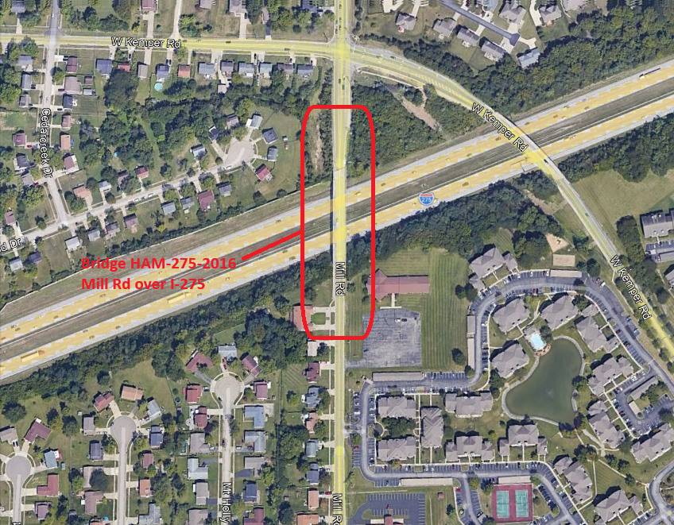

Study Description:

Purpose & Need:

The primary issues include:
- Bridge HAM-275-2016 which carries Mill Rd over i-275 has a deficient wearing surface that is rated a 4 out of 9 (9 being best and 4 being deficient) and is no longer protecting the underlying deck in large areas.
Secondary issues that require consideration are as follows:
- The deck is rated a 5 out of 9 (near deficient).
- The bridge does not meet current seismic requirements.
- The vertical clearance is approximately 15.9’. The current standard for new or reconstructed interstate overhead bridge is 16.5’.
- The are repairs needed to the substructure other bridge secondary components such as bearings, expansion joints, substructure.

Project Scope: Discipline specific scope items have been identified below.

Structures:

- Remove and replace the existing deck with a new composite deck, approach slabs per AS-1-15, and barriers per BR-2-15 and SBR-3-20. The bridge width shall be 40’-0” wide out to out with 6’ wide sidewalks on either side. * Sidewalk configuration being confirmed with the City of Forest Park. A 12’ fence is required over sidewalk areas and a 6’ fence is required on top of straight-faced barrier. Coordinate removal of the telephone conduits in the sidewalk. Include notes for proper disposal of the utility conduits since the material specified in the plans is an asbestos material.
- Replace the backwalls down to the beam seat and reconstruct as semi-integral. Patch deteriorated portions of the abutments and piers for epoxy injection, patching per 519, and patching with anodes per SS844 for patches larger than 5 square feet. Consultant to sound the existing substructure to determine repair quantities.
- Raise the structure to achieve a proposed vertical clearance of 16.5’. The approximate existing vertical clearance is 15.9’ Consultant to include existing vertical clearance measurements in their survey. Replace all pier and abutment bearings with elastomeric bearings.
- Remove Existing trees within 20 feet of the structure and within the existing R/W.
- Paint the existing structural steel per 514 OZEU Specifications. Color shall be Federal Color FS 595C-14277 (light green). (unless another color is requested and approved by the City).
- Seal the concrete per the typica limits defined within the BDM with epoxy urethane sealer 512 specifications, Federal Color 17778. Include a quantity for the removal of existing sealers.
- Replace the guardrail in front of Pier 1 and Pier 3 with concrete barrier.
- Update the Load Rating for both structures per the requirements of the BDM, Section 900.

Materials for structures:
- Concrete: Include macro-fibers and corrosion inhibitor in concrete mix. District to provide notes during design development.
- Reinforcing steel: Use galvanized reinforcing steel for all new reinforcing steel.

Roadway:

The roadway shall be reconstructed full thickness for 25’ beyond the approach slab. The roadway shall be milled and filled as needed to attain grade. Replace all existing approach guardrail to current standards.

Traffic:

TBD

Lighting:
Maintain existing lighting.

Traffic Analysis:

No traffic analysis is required.

Geotechnical:
No geotechnical work is anticipated.

Drainage:

The curb and gutter on the west side shall be to the extents of the roadway improvement. Analyze the existing drainage system to determine if scuppers are needed.

Maintenance:

None required.

Maintenance of Traffic:

Close Mill Rd and detour traffic Mandarin Dr. to Norbourne Dr., to W Kemper Rd.

Environmental:

The consultant coordinate all environmental work.

Survey:
The consultant shall provide all necessary survey.

Right-of-Way:
The consultant shall determine during Stage 1 plans the construction limits and if R/W is required. If it is determined R/W is necessary, the consultant shall submit a modification request to prepare R/W plans.

Known Utility Coordination
There are utility conduits (Cincinnati Bell) in the sidewalk that must be removed and relocated off the structure. The specified conduit type (Transite) is an asbestos material. Include asbestos removal notes and separate pay quantities to be charged to the utility.

There are overhead utilities across the Mill Rd at the south end of the bridge that may interfere with a concrete pump truck. Relocate these utilities if possible.

There are overhead utility lines including electric that parallel Mill Rd on the east side. Confirm that these overhead lines do interfere with concrete pumping of fence removal/replacement.

There is a solar powered automated license plate reader located at the southwest corner of the bridge on the embankment. Coordinate removal and relocation.

There is an ITS line along I-275 that needs to be identified in the plans so the contractor does not disturb it.

Utility Coordination Requirements:

Consultant to try to avoid utility conflicts throughout design while holding to the scope of work. If utility conflicts cannot be avoided, they should be minimized. Consultant to provide a copy of the OUPS ticket information to ODOT PM (if applicable). Up to date utility contacts shall be used at each plan submission. Utility contact information can be requested by consultant from ODOT PM. If Ohio 811 (OUPS) are more than two (2) years old, a design non-marking ticket shall be requested to obtain most up to date Utility Members List. The ticket does not need to be submitted to obtain the Utility Members List.

Consultant to provide a utility set of plans with the utility lines shown in color using the most recent version of ODOTcadd_UTPen.tbl at each plan submission. This file is found in the standard ODOTcadd executable file that can be downloaded from the CADD services webpage. Additionally, Consultant to prepare a summary of potential utility conflicts at each plan submission. Summary to be provided to Utility Companies at each plan submission. Summary to include, but not limited to station and offset of conflict, type of conflict (direct, decreased cover, proximity, etc.), utility owner (if known) and utility type. Consultant to use District 8's 'standardized' letter for sending submissions and plans to Utility Companies for review and comment. Consultant to provide the ODOT PM a copy of all Utility Correspondence. Consultant to compile Utility Company responses and forward to the ODOT PM. Final compilation of utility correspondence is due 35 days after plan submission to utilities

A “no response” from a utility on a plan submission review cannot be considered as “no comment”, “no conflicts” and/or “a confirmation of the consultant’s findings” from the utility. A written response (email is sufficient) must be received from the utility verifying that they have no comments, no conflicts and/or they agree with the conflicts identified by the consultant.

Consultant to review the Utility Company responses and evaluate. The evaluation of the responses shall include validating that a conflict does exist or that a utility may remain in place. If a conflict does exist, consultant should provide an evaluation of the feasibility of potential resolutions. A disposition of utility status (i.e. utility to stay in place, utility facility relocation plan in writing or plan format) is required at the Stage 3 submission. This disposition shall be included to the utilities with the Stage 3 plan submission. This disposition shall be formulated based on utility responses from previous plan submissions.

A utility note spreadsheet which can be used by ODOT to draft a utility note through Ellis shall be submitted after evaluation of the Stage 3 utility coordination. The template spreadsheet can be provided by ODOT as needed. The spreadsheet should include discussion about the existing utilities for each utility, if they are staying in place and in service or if they are being relocated. If a utility is relocating, information about the location of their relocation should be included. Additionally, the relocation time frames should be included in the utility note as discussed with the utility companies. Example utility notes can be provided by the District utility coordinator upon request.

Project Management:
This project shall be One Part Project to complete plans for the project. If it is determined R/W is necessary, a modification will be processed to include this work.

Funding:
This project will be funded District Allocation using a combination of Federal. And State funds.

Design Designations:

 | HAM US 50 19.80 | HAM IR 275 20.16
Functional Classification | 05 Major Collector | 01 Principal Arterial Interstate
Design Functional Classification | 05 Major Collector | 01 Principal Arterial Interstate
National Highway System (NHS) | no | Yes
Opening Year ADT (2031) | 8,861 (per TIMS for PIP Purposes) | 98,139 (per TIMS for PIP Purposes)
Design Year ADT (2051)
Design Hourly Volume
Direction Distribution
Trucks (24 Hour B&C)

Existing Plans: See the FTP Site for existing plans and photos.

 | Arch No | Name | Year | PID | Description
1 | 08c1562 | HAM-275-19.05 | 1965 | n/a | Original Construction
2 | 08c1651 | HAM-275-16.12 | 1986 | n/a | Rigid Overlay
3 | 08c3097 | HAM-275-1.26 | 1990 | n/a | Fence Installation
4 | 08c3547 | HAM-275-16.19 | 2014 | 82972 | Minor Rehabilitation
5

Bridge Inspection Photos: See the FTP site for existing inspection photos.

2025 Insp Photos: J:\structures\bridges\25 photos\HAM\IR275\2016
2026 Insp Photos: \\D08fs100\archives\structures\bridges\26 photos\HAM\IR275\2016

PIP photos are available here:\\D08fs100\archives\structures\bridges\26 photos\HAM\IR275\2016\PIP 07-28-26

FTP site with above info available here:
\\ftp.dot.state.oh.us\pub$\Districts\D08\Programmatics\2027- January\HAM-275-2016 PID 119077

Schedule:
The Official schedule will be maintained in Ellis. The consultant may propose changes to the schedule that don’t alter the final plan package submittal or sale dates.

