Prefinal - PRE 127 19.11 (6802702)

- The asphalt joint approx. 50’ from end of rear approach slab in concrete pavement is settled slightly lower than pavement. Feel this could cause damage to concrete, especially this winter if plows hit it.
- There is a 5’Lx1’W shallow spall/delam in rear approach slab along the deck joint.
- HL transverse cracks in wearing surface, most in NB lanes.
- Small area of gland appears loose in fwd. joint over sleeper slab.
- Should the vegetation around the guardrails be mowed or trimmed.
- Gland in the fwd. slab/deck joint appears twisted.
- Small spalls and delams run through bay 6 in all spans, appear to be where temporary barrier wall was placed.
- Transverse cracks throughout deck in all spans with light to moderate efflorescence. Cracking and efflorescence is heavier under the NB lanes.
- Some small debris on top of pier 2, west face.
- Barrier wall along the columns of pier 3 is not complete.

Photos can be viewed at J:\structures\bridges\24 photos\PRE\US127\1911\PreFinal 8-23-2024.

S. Lentz 8/2024
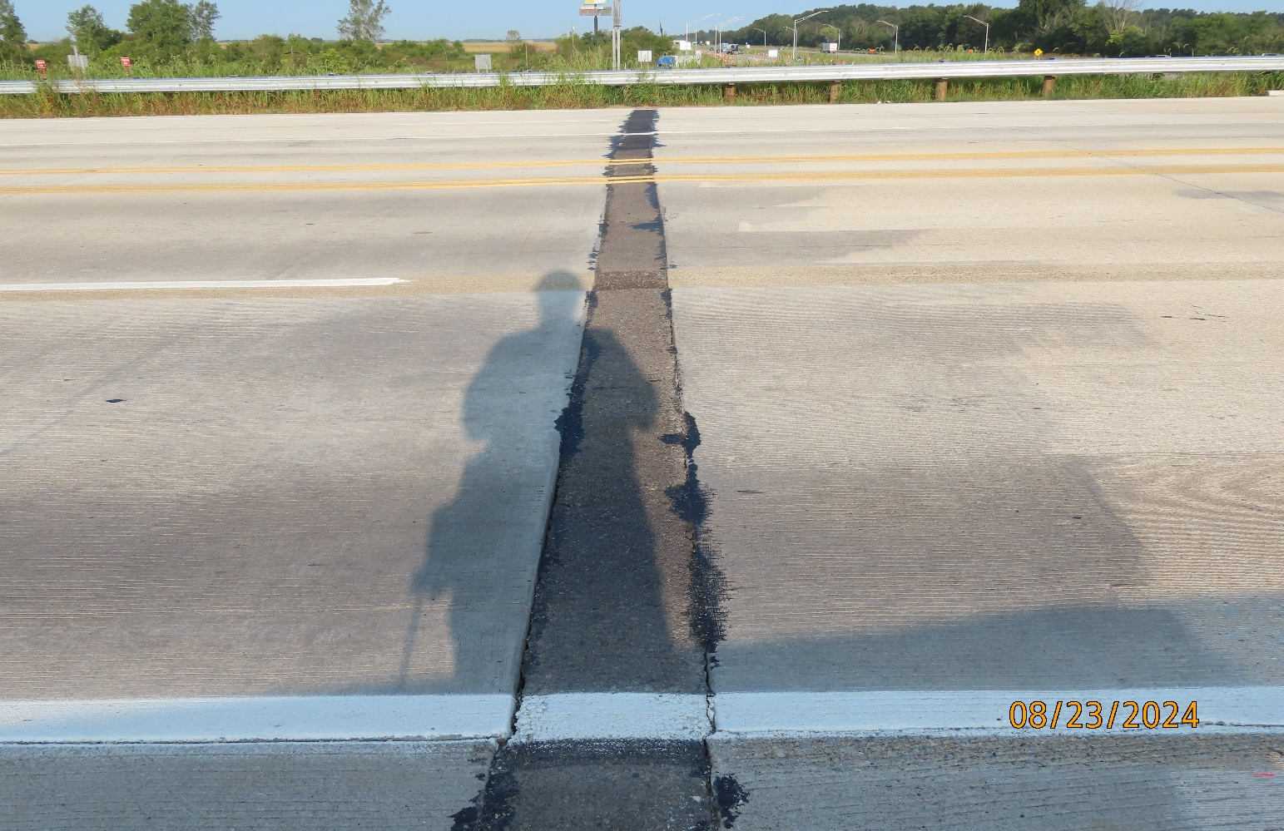
1.

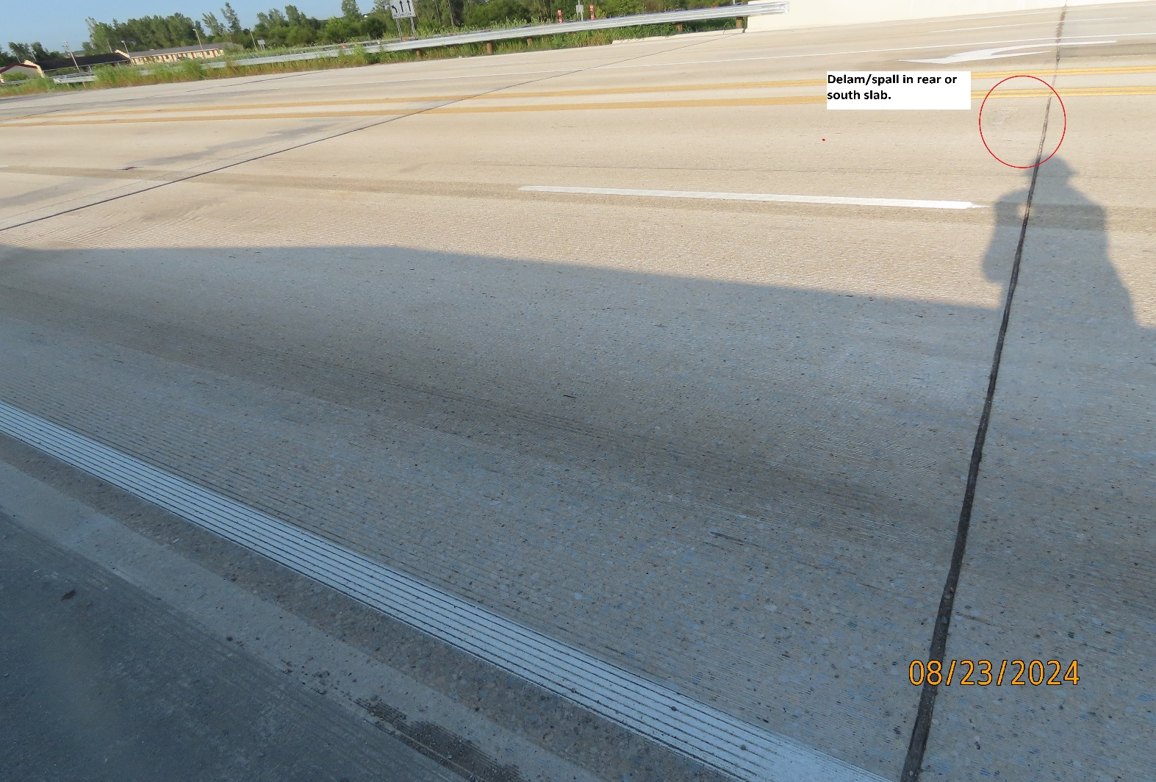
2.
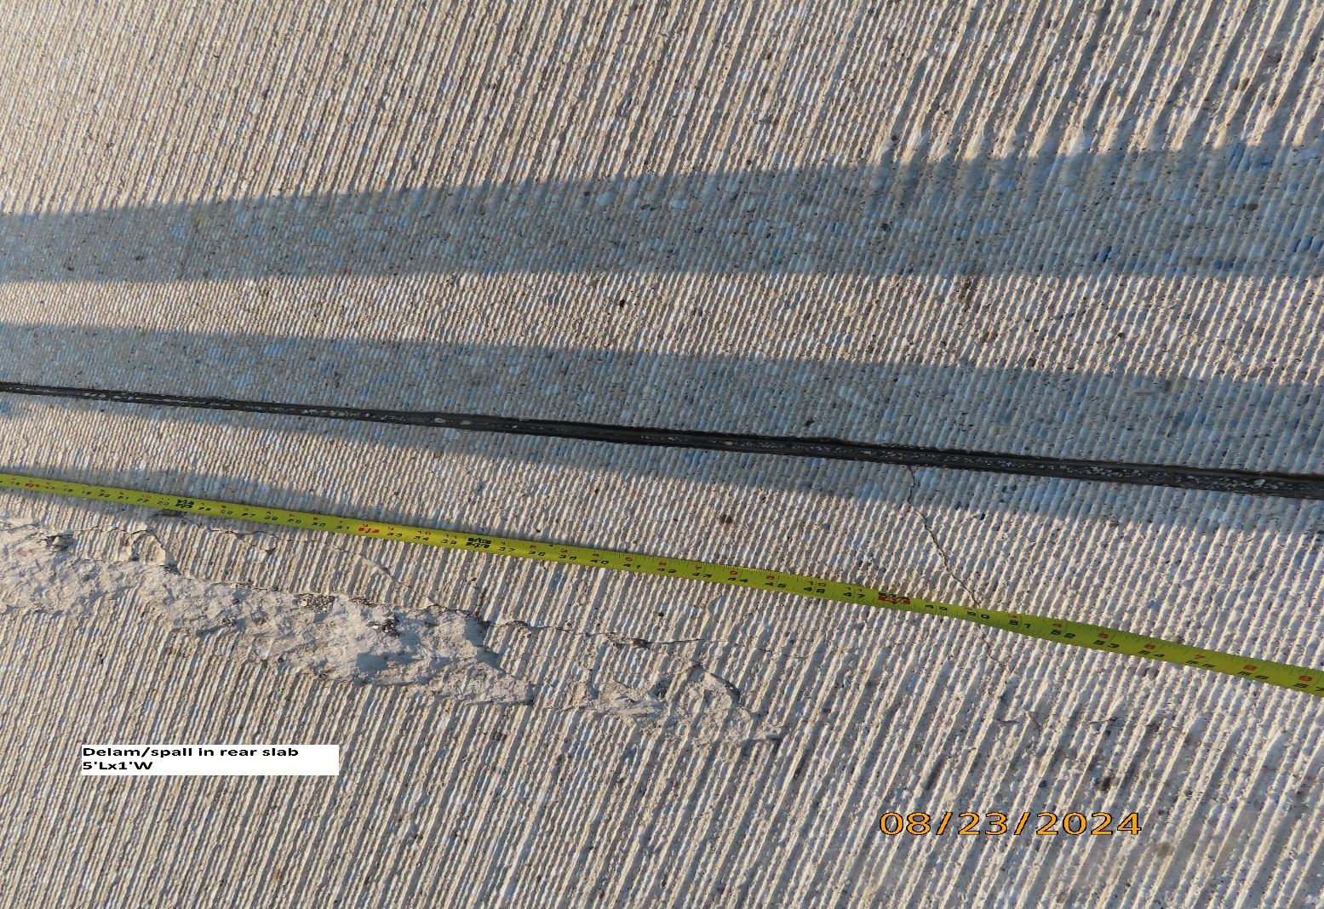
2.

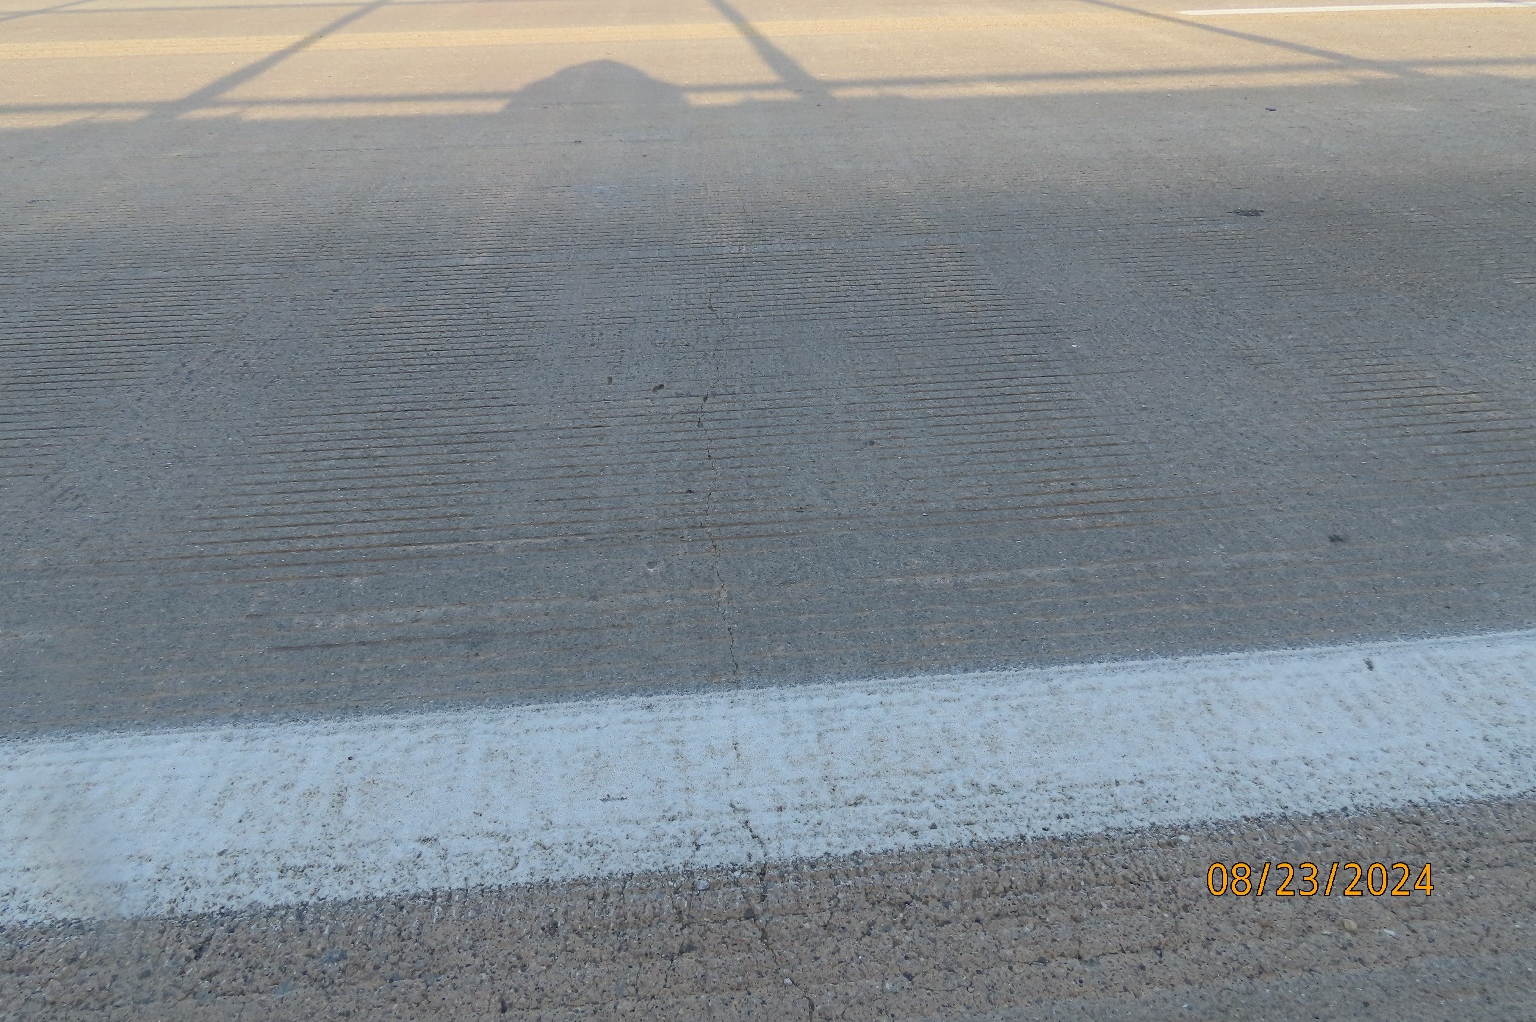
3.
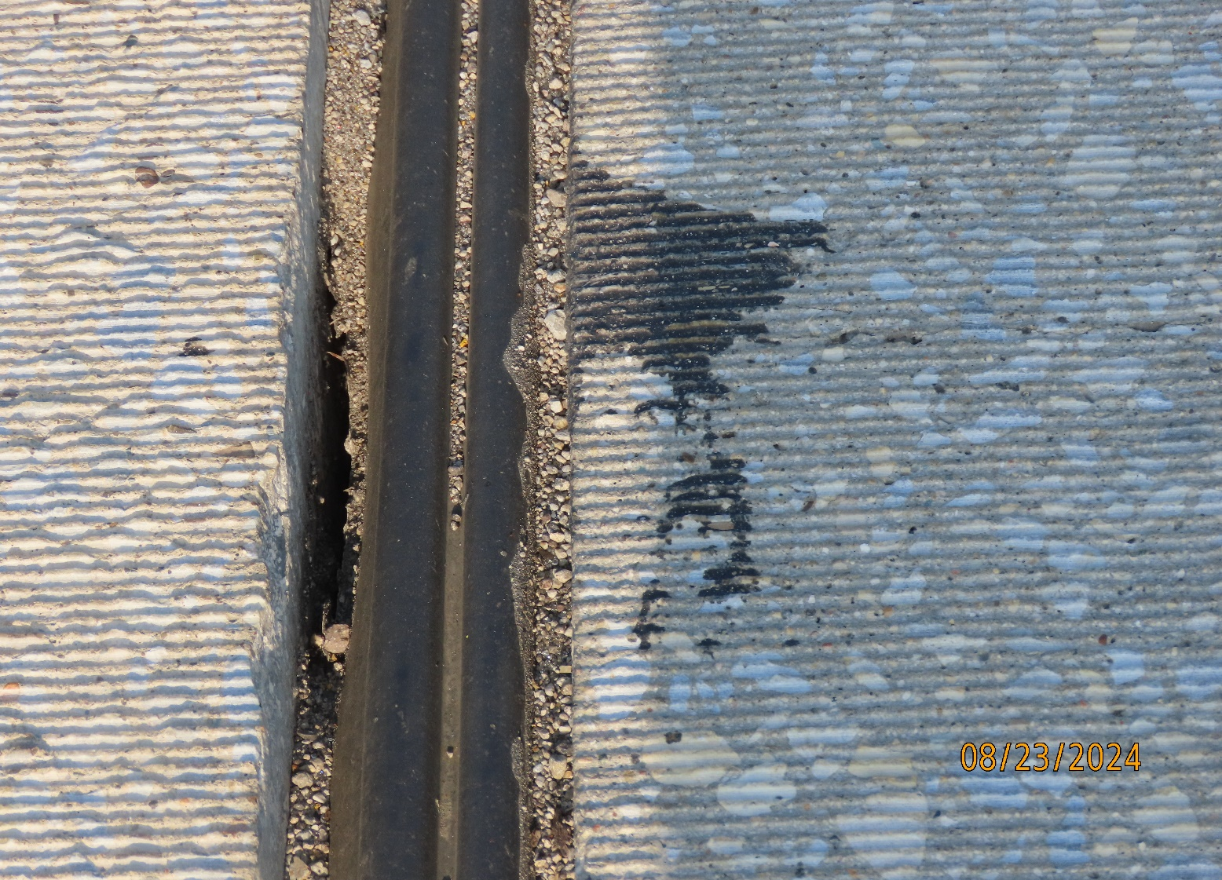
4.

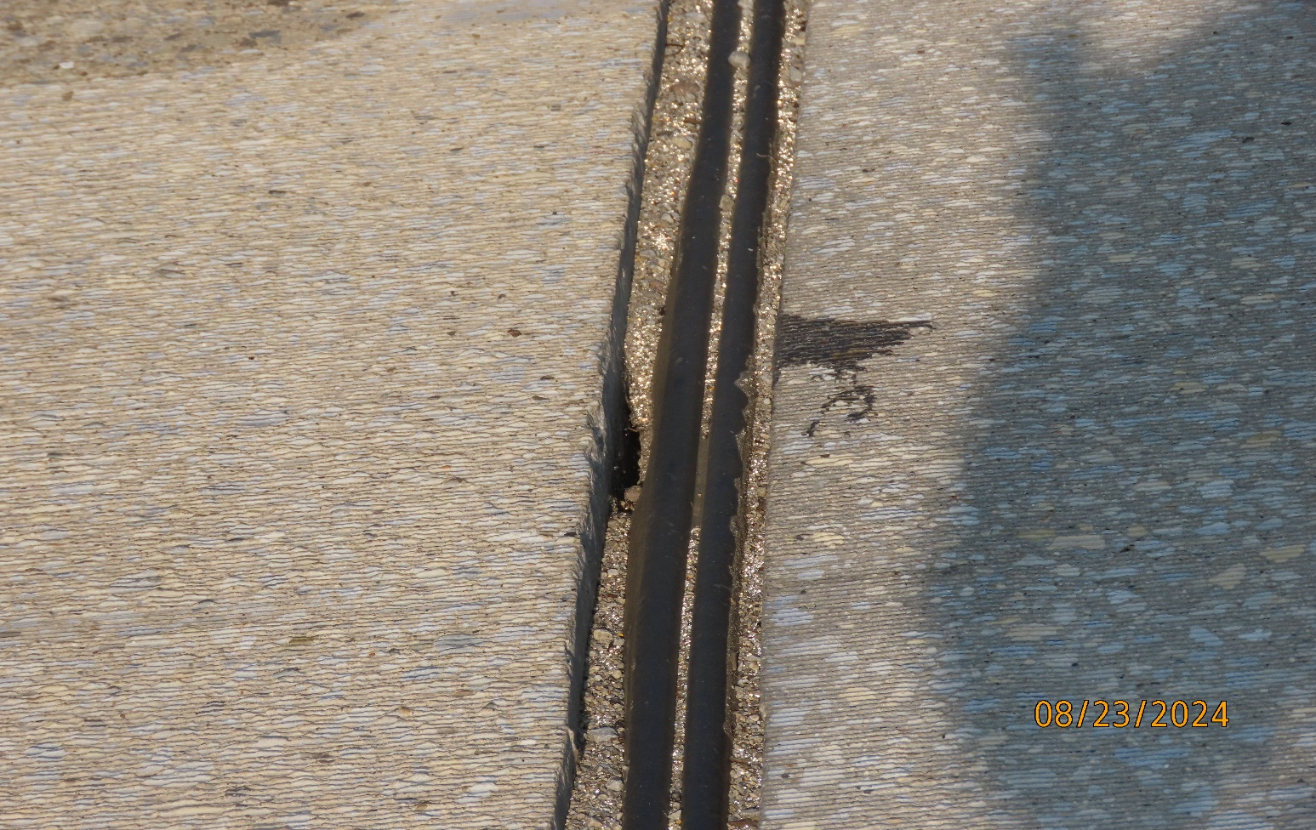
4.
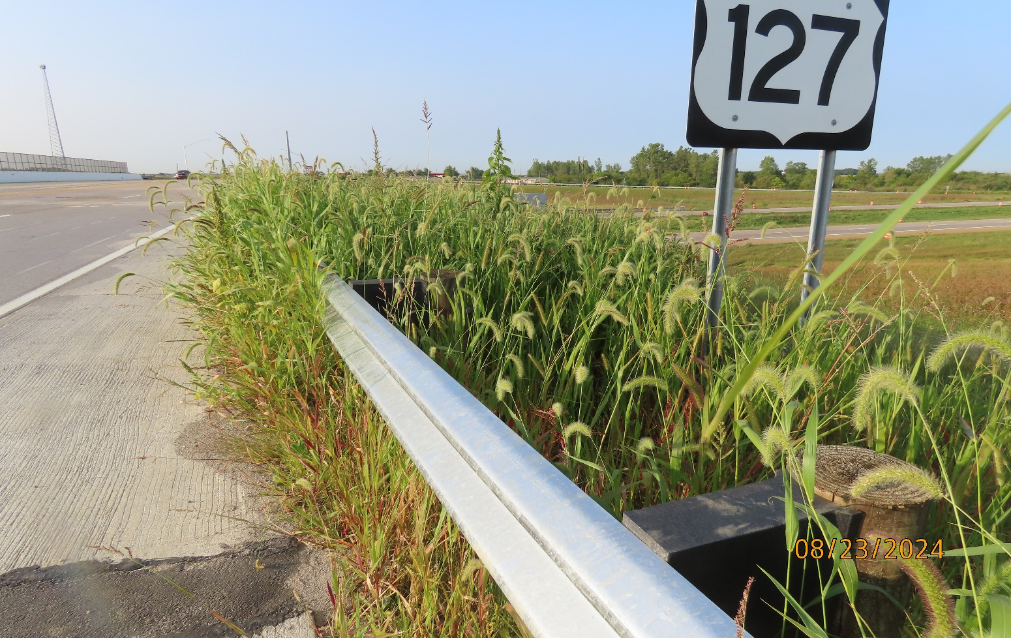
5.

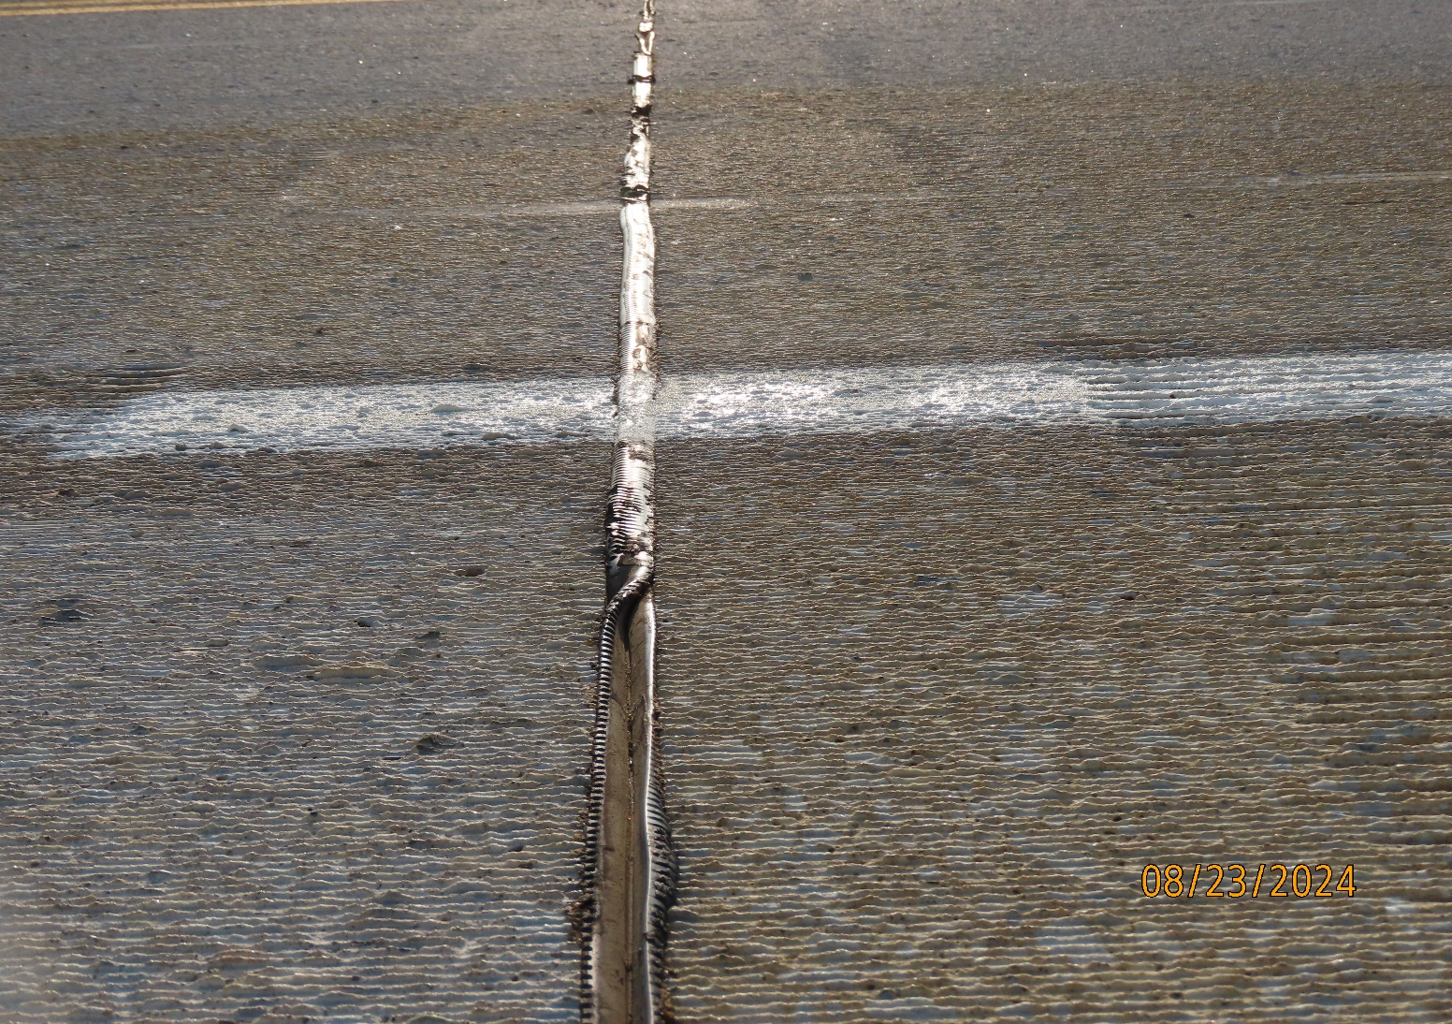
6.

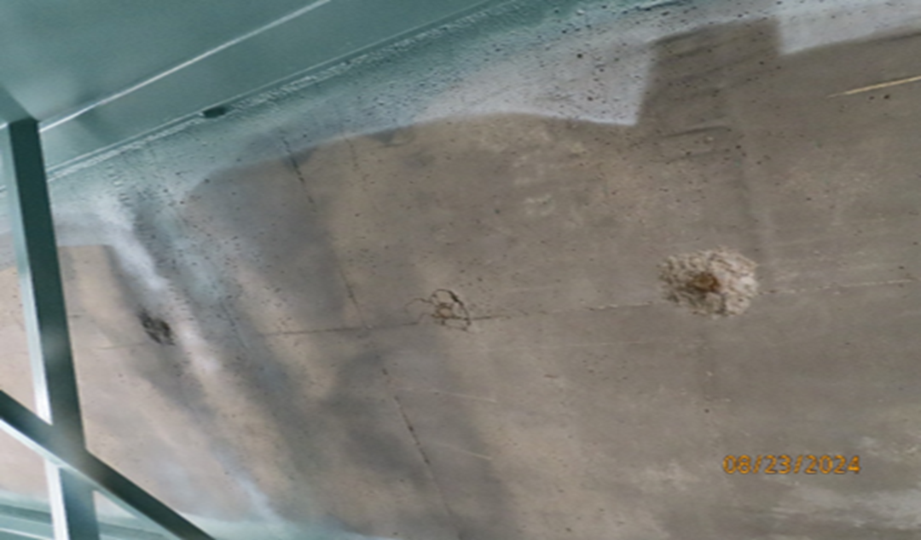
7.

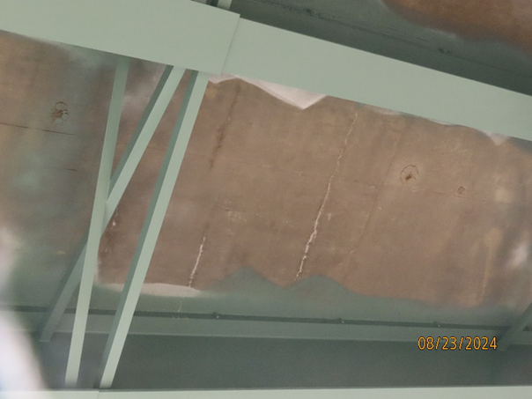
8.

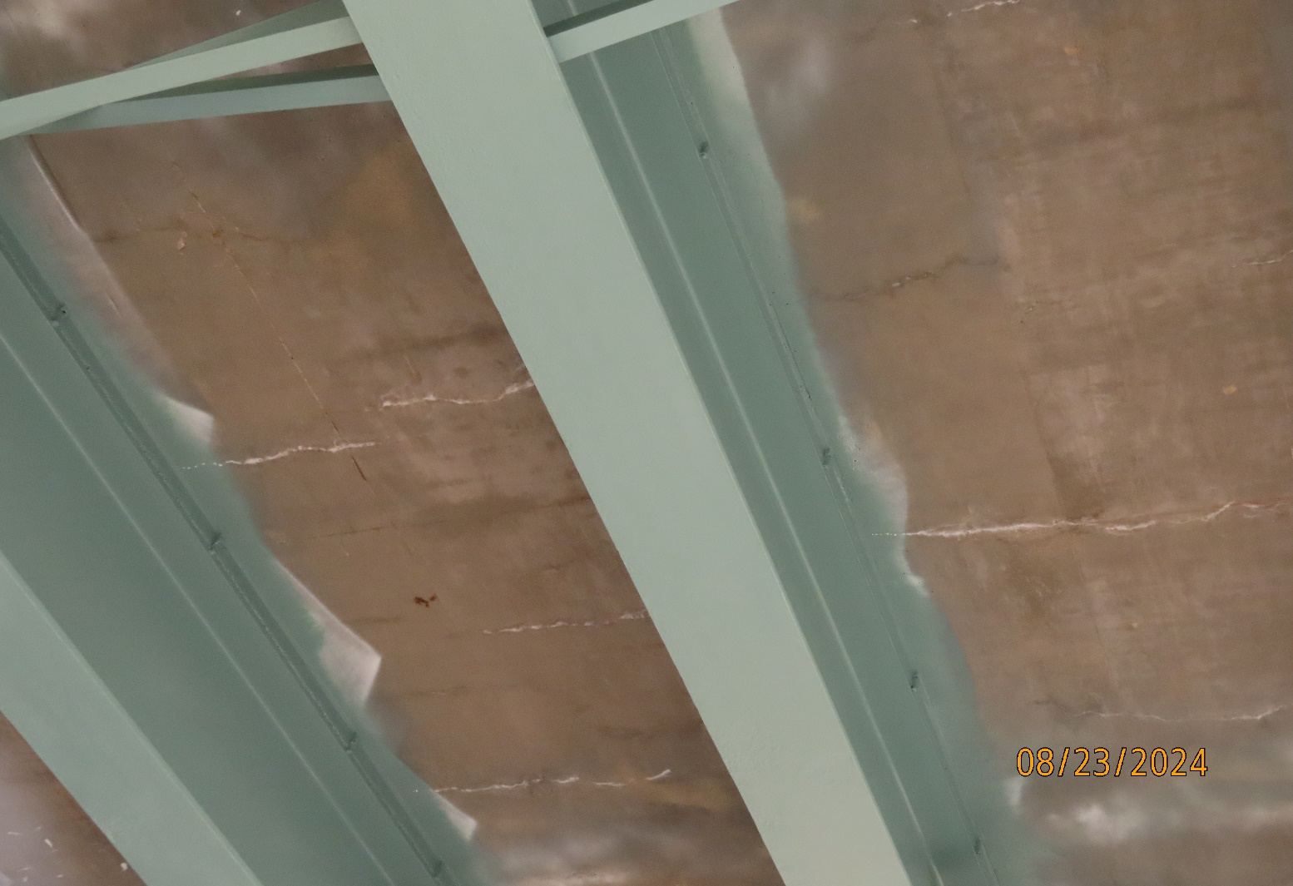
8.

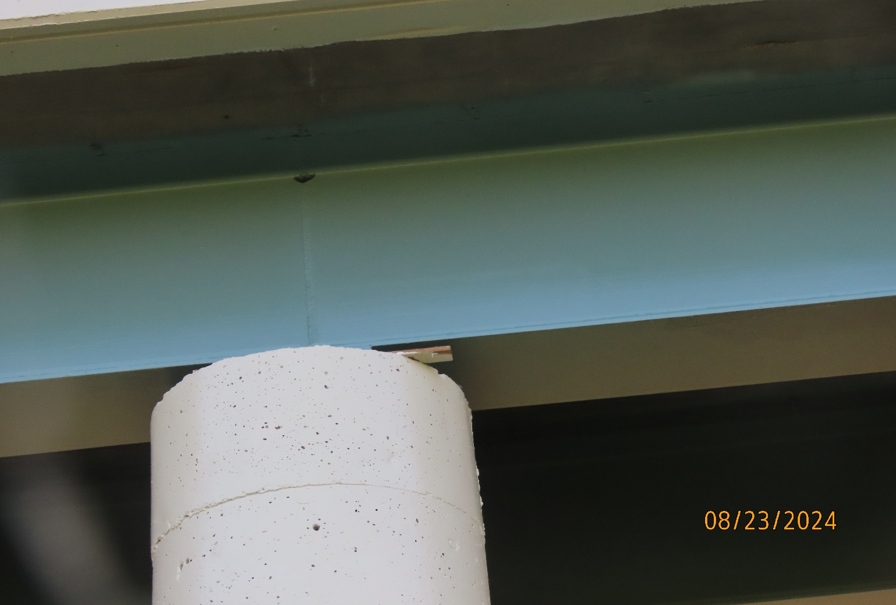
9.

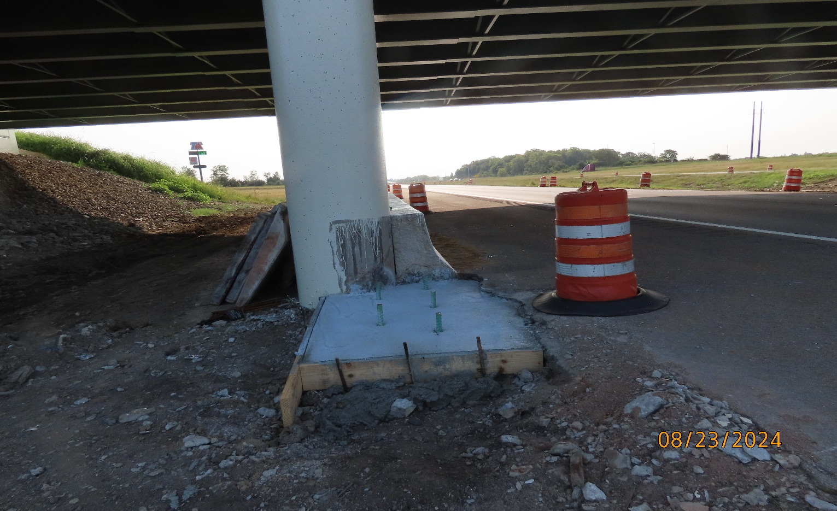
10.

