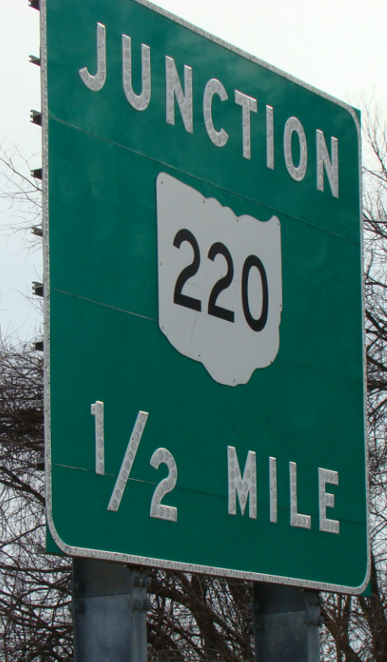We recommend replacing these. They are the old button style signs and were installed in 1997. We recommend adding “Schuster Rd” to the new sign below the 220 route shield.
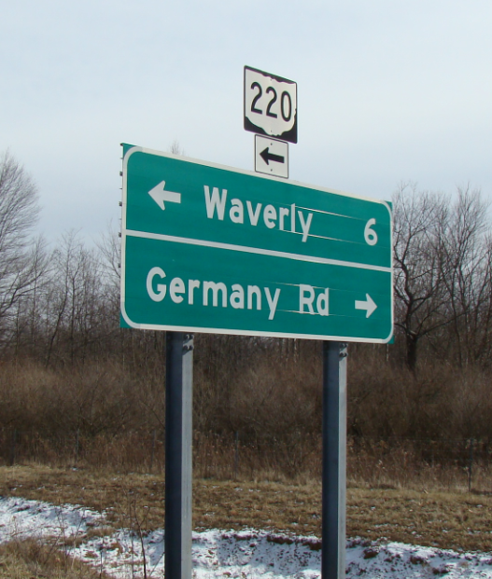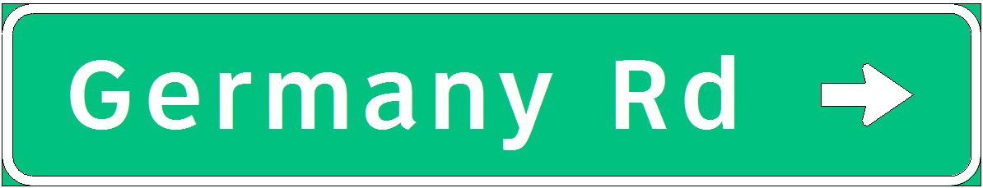The new Germany Rd (R) sign can go on these existing supports.
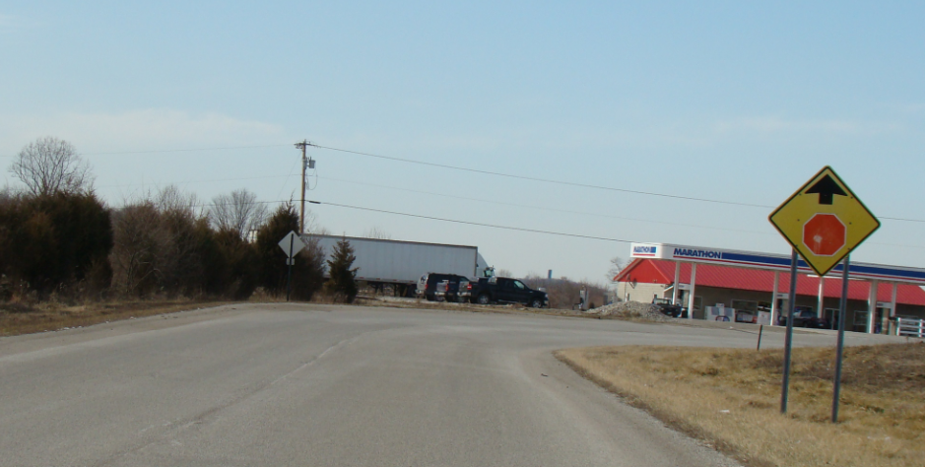Germany Rd. only has one stop ahead sign. There should be two. This one is faded.
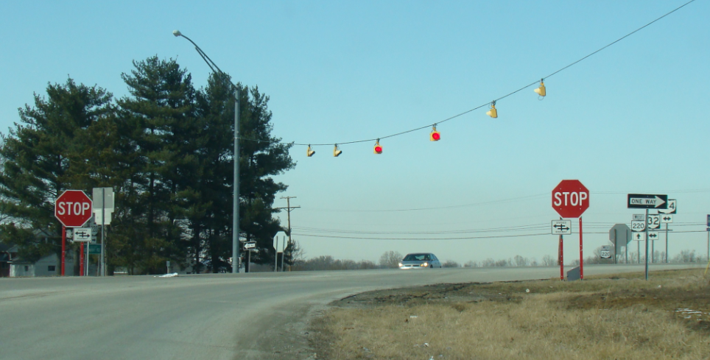 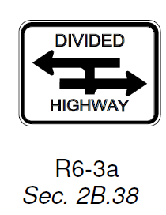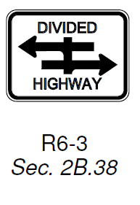The divided highway signs below these stop signs show the straight through movement(R6-3). You will not be able to make this movement after the project. The sign should just have the two arrows without the stub (R6-3a).

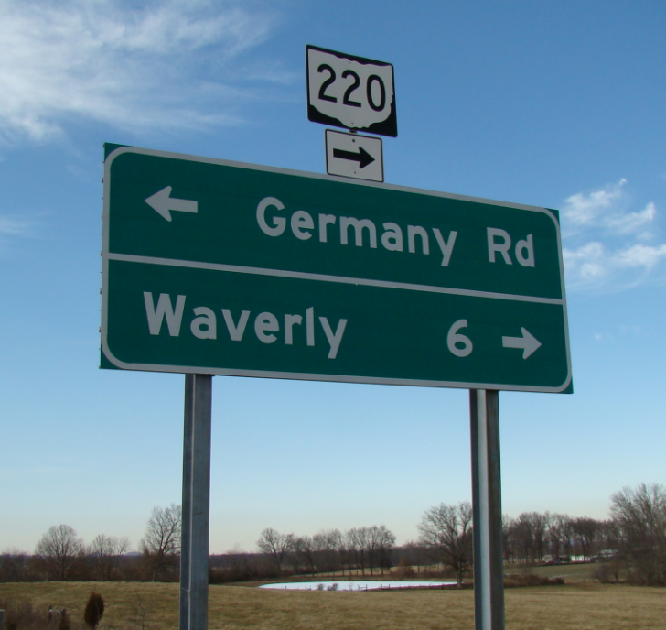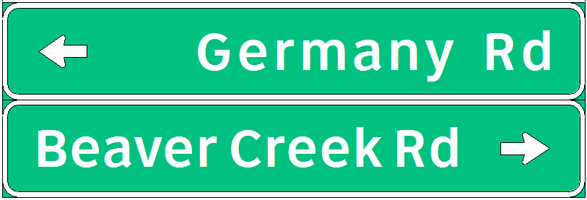This new sign will work on the old supports shown above.
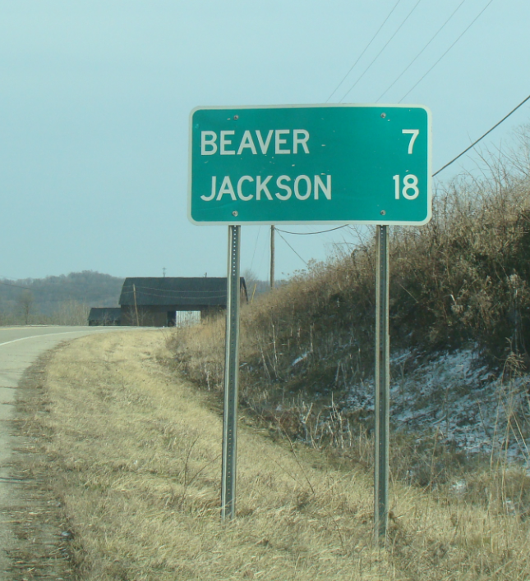This sign is on existing SR 220 and should be removed since you won’t be able to turn left out of the new intersection configuration.

