III – SUPERSTRUCTURE
The approaches consist of eleven reinforced concrete arch spans and one concrete-encased steel arch span. Four lines of arch ribs support the upper and lower decks with reinforced concrete beam and spandrel column construction (Photo 21). The concrete encased steel arches are part-through and have hanger supports for a portion of the lower deck (Photo 22).

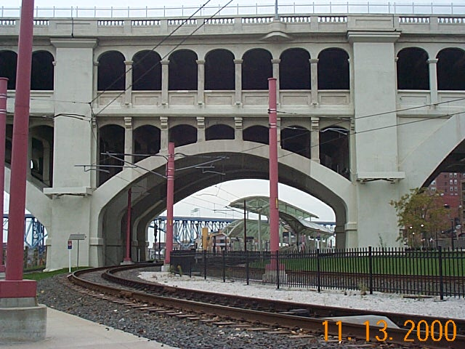
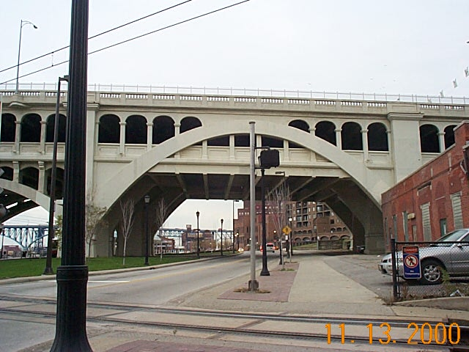
Photo 21 – Typical Concrete Approach, Span 11
dcp00238.jpg
Photo 22 – Concrete Encased Steel Approach, Spans 12
dcp00237.jpg

In contrast to the approaches, the main span superstructure is a single three hinge steel arch span of part-through design. The main arch elements are two lines of Pratt trusses spanning 591-ft between end bearings (Photo 23). Both roadway decks are supported by longitudinal stringers, which span between transverse floor beams. The stringers are rolled sections whereas the floor beams are built-up members consisting of plates and angles.

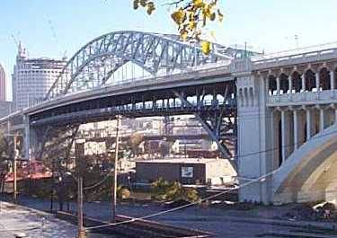
Photo 23 – Main Steel Span
dcp00102.jpg

Upper and lower deck floor beams are framed together by vertical built-up hangers having rigid connections to the floor beams. The floor beam frames are pin supported at the vertical posts of the trusses and at pairs of eye-bar hangers. The main members of the trusses are box sections made up of plate and angle sections tied together with lacing channels or bars. Corrosion resistant nickel steel was used for the main member plate and angle sections. For economy, carbon steel was used for all other members. Horizontal struts brace the two end truss panels and the lower level deck between floor beams. Lateral bracing is provided in the plane of the bottom flange of the upper and lower roadway floor beams and in the plane of each truss chord.
A typical cross section of the approach spans and main span superstructure are included as Exhibits D & E.
- Concrete Approach Spans
General
The concrete approach spans are in generally good condition. Minor areas of delaminated concrete were observed to the arch ribs, spandrel columns and floorbeams. Significant areas of delamination were noted to the bottom of the arch ribs in span 11. Total delaminated area to the approach spans is less than 3%.
Upper Deck Floorbeams
There are three distinct and different upper deck floorbeams, which are based on the time of construction. These are floorbeams from original construction, floorbeams replaced during the 1967 rehabilitation and floorbeams replaced during the 1995 rehabilitation. All remaining floorbeams from original construction were strengthened during the 1967 rehabilitation. The majority of deficiencies to the floorbeams were found on those original floorbeams (Photo 24), with the other minor spalls and delaminations found on the 1967 rehabilitation replacement floorbeams. All the 1995 rehabilitation floorbeams were found to be in excellent condition.
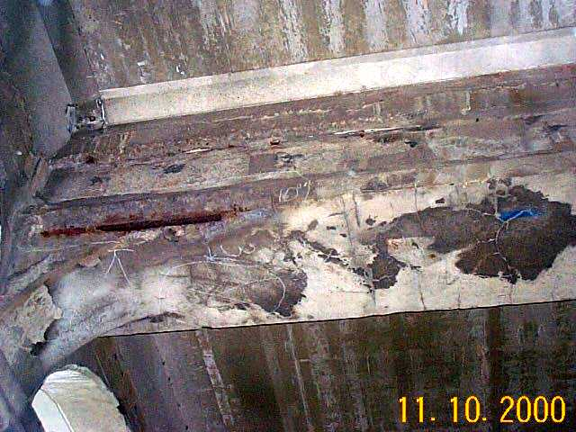
Photo 24 – Span 2, Floorbeam 8, South Bay (original)
dcp00223.jpg
Typically, the floorbeams are in good condition with 10 square feet or less of delaminated concrete were noted to the upper deck floor beams per span, per bay.

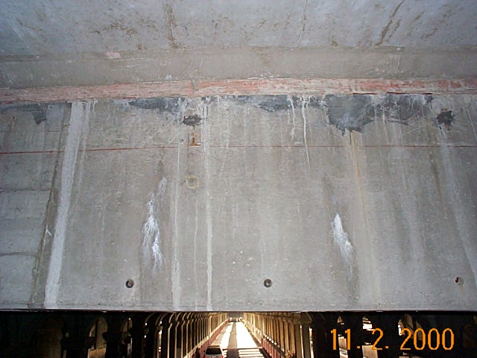
Exceptions to this were in span 1A south bay (26 s.f.), span 1 north bay (55 s.f.), span 2 south bay (23 s.f., Photo 3D), span 11 north bay (13 s.f.) and span 12 north and south bays (28 s.f. and 29 s.f., respectively). Spalls with exposed reinforcing were noted in span 2 south bay, span 12 north bay and span 13 north bay. Minor flexural cracks were also noted, but not significant. Sporadic cracks with efflorescence were observed to isolated floorbeams (Photo 25). The epoxy-injected cracks appear to be functioning properly.
Photo 25 - Span 1A, Floorbeam 4, Center Bay
dcp00113.jpg

Lower Deck Floorbeams
The lower deck floorbeams are in good condition. Generally, areas of delaminated concrete were noted to isolated, random floorbeams, while several other lower deck floorbeams have spalls with exposed reinforcing (Photo 26). While all the spalls have been sealed, bleeding and rust staining due to active corrosion is present at some locations (Photo 27). Minor hairline flexural and map cracks were noted but are not significant at this time.

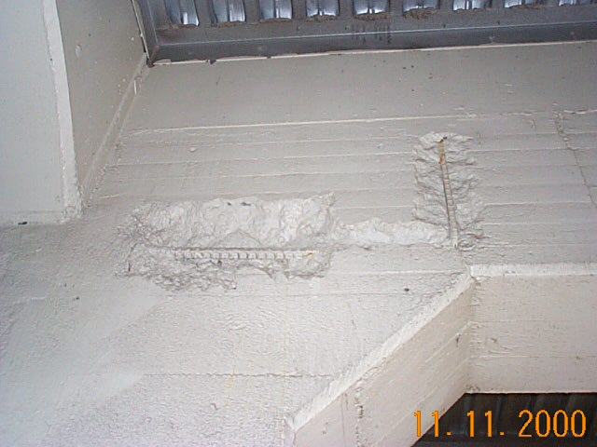
Photo 26 – Span 5, Floorbeam 2, South Bay dcp00226jpg
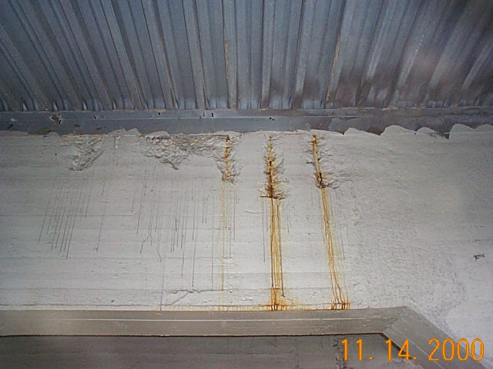
Photo 27 – Span 10, Floorbeam 5, South Bay
dcp00240jpg

In Span 12, spalls, cracks and crumbling concrete patches were noted. There are horizontal cracks at the south end of floorbeams 5 and 6 (Photo 28). A crumbling patch over Robert Lockwood Jr. Drive was noted on the east face of floorbeam 4 in the south bay (Photo 29). Similarly, a second poor patch with voids is located on the east face of floorbeam 6 in the center bay (Photo 30).

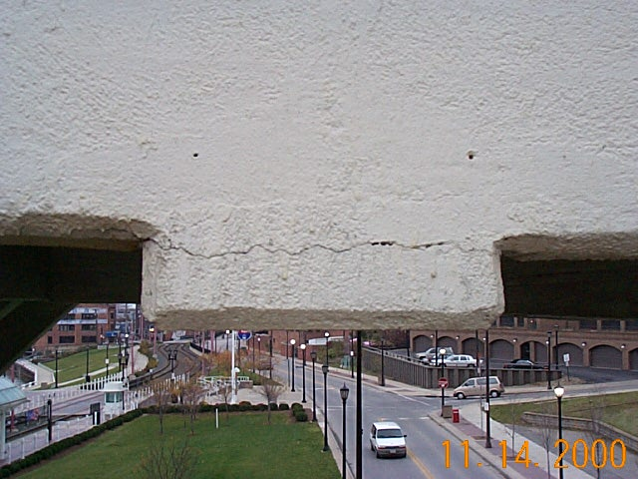
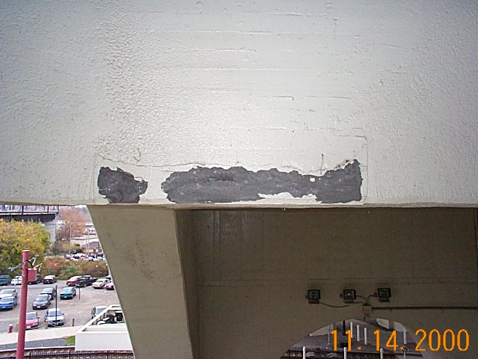
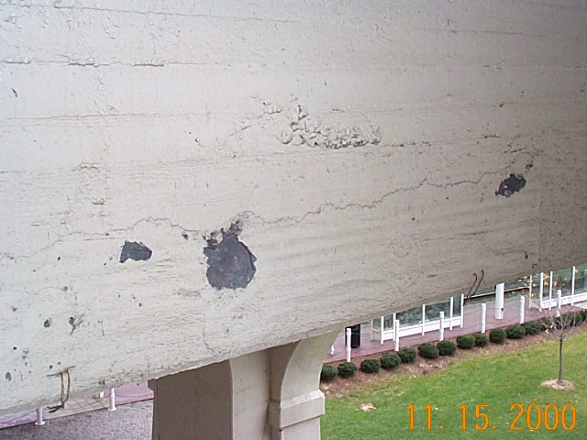

Photo 28 – Span 12, Floorbeam 5, South Face
dcp00248jpg
Photo 29 – Span 12, Floorbeam 4, South Bay
dcp00245jpg
Photo 30 – Span 12, Floorbeam 5, Center Bay
dcp00251jpg

Jack Arches
The upper deck jack arches are in good condition. Sporadic areas of voids, cracking and delamination (Photo 31) were noted, mainly in spans 1A and 1B and the north interior column line in span 2. There are two spalls with exposed reinforcing in span 1A at the north interior jack arch between floorbeam 5 and 6 and floorbeams 6 and 7 (Photo 32).

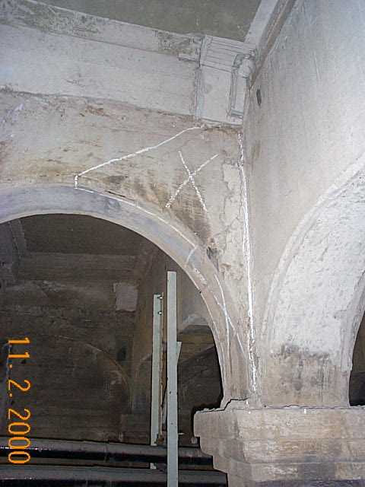
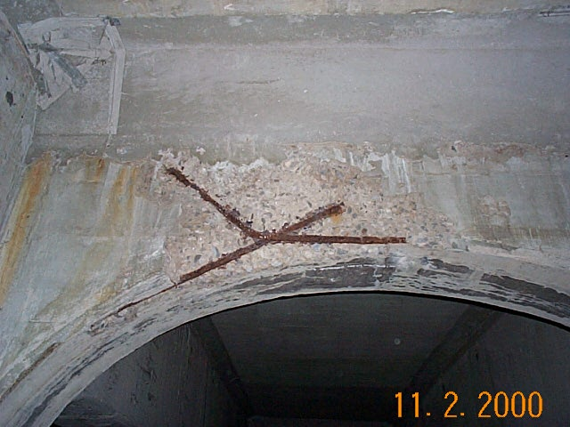
Photo 31 – Span 1A, South Interior Jack Arch between FB 8 & 9
dcp00120jpg
Photo 32 – Span 1A, North Interior Jack Arch between FB 6 & 7
dcp00119jpg

Upper Deck Columns
The upper deck columns are in generally good condition. Voids to columns replaced during the 1994 rehabilitation are common (Photo 33), as well as deterioration and peeling to the textured surface on original columns (Photo 34).

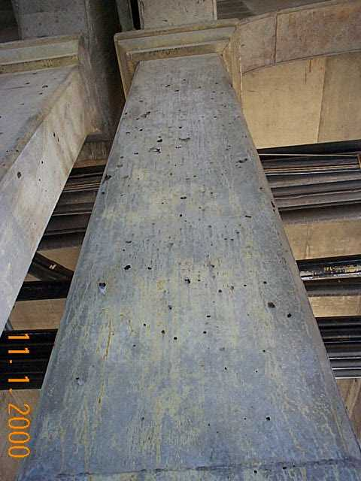
Photo 33 – Span 3, South Int. Column 18
dcp00099.jpg
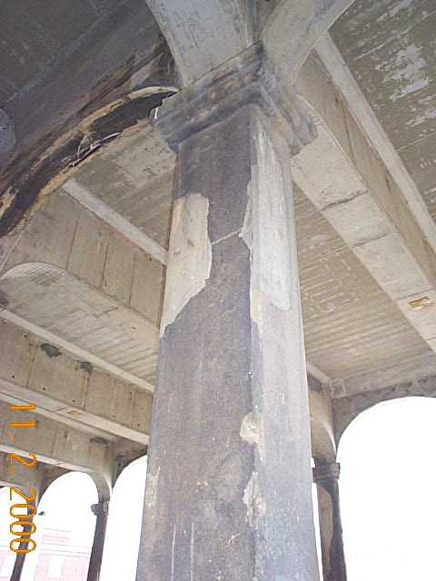
Photo 34 – Span 2, North Int. Column 11
dcp00132.jpg

Cracks, delamination and spalls to the corbel detail were noted throughout the concrete spans (Photo 35). Additionally, three columns in span 3 were replaced without the corbel detail (Photo 36). Minor spalls with exposed reinforcing were observed in spans 1A and 1B, typically near the corbel detail (Photo 37).

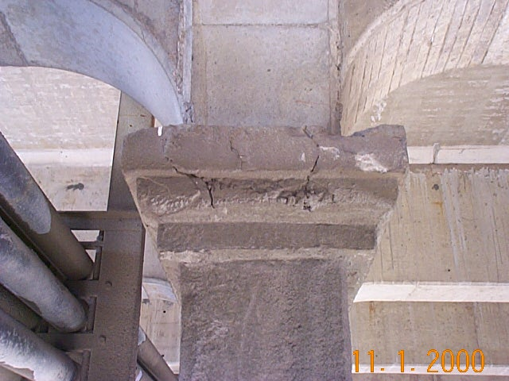
Photo 35 – Span 1 South Interior Column 7 dcp00091.jpg
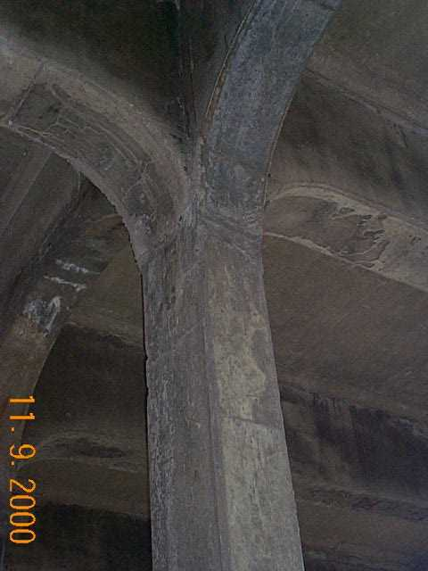
Photo 36 – Span 3, North Interior Col. 13 dcp00212.jpg

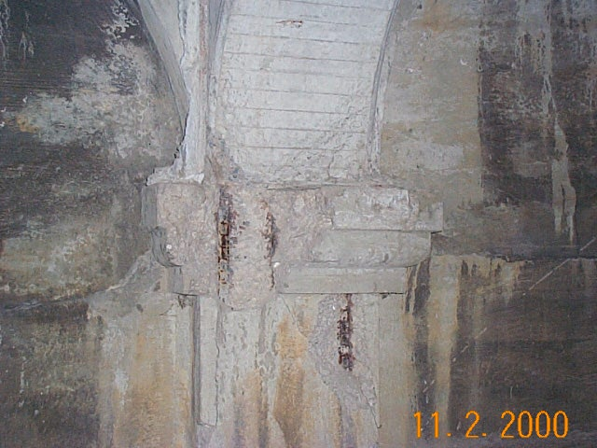
Photo 37 – Span 1A, North Exterior Column 5
dcp00116.jpg

Several columns also had spalls and/or voids to the column core above the corbel detail (Photos 38 and 39).

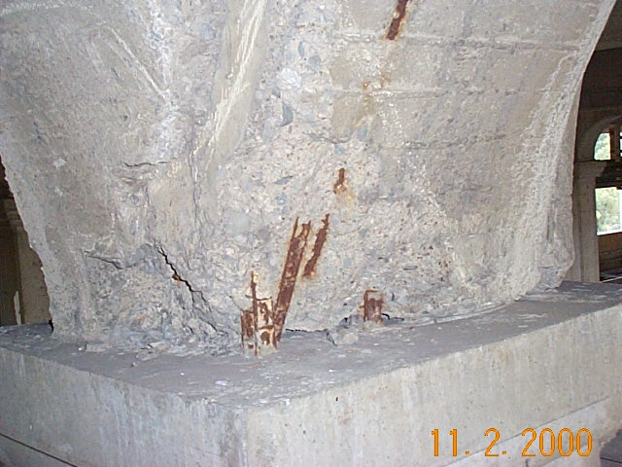
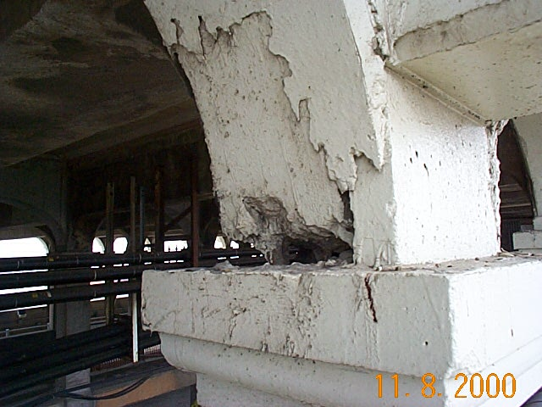
Photo 38 – Span 2, North Exterior Column 4
dcp00139.jpg
Photo 39 – Span 2, South Exterior Column 7
dcp00211.jpg

Lower Deck Columns
The lower deck columns are in good condition. Localized areas of voids, honeycombing and cracking from original construction were noted to several lower deck columns (Photo 40). An example of this is at South Interior Column 11 in Span 5.

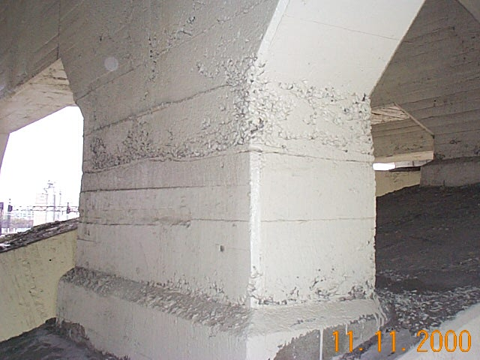
Photo 40 – Span 5, South Interior Column 11
dcp00228.jpg

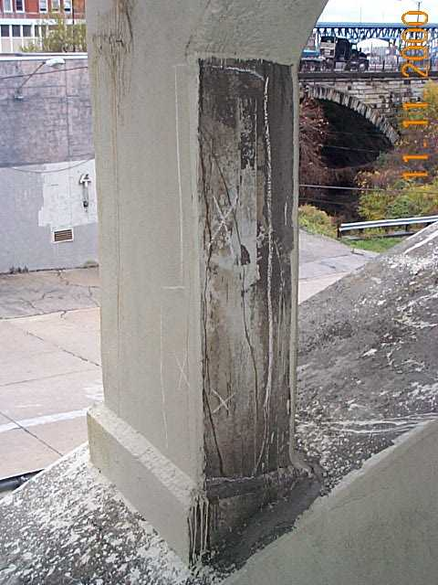
Several columns also have cracks and/or delaminations, including 4 s.f. to the North Exterior Column 1 and 20 s.f. to the North Exterior Column 4 in Span 2 (Photo 41); 5 s.f. to the North Exterior Column 3 and 4 s.f. to the North Exterior Column 16 in Span 3; and 9 s.f. to the South Exterior Column 1, 10 s.f. to the North Interior Column 10 and 11 s.f. to the North Interior Column 12 in Span 10.
Photo 41 – North Exterior Column 4, Span 2 dcp00224.jpg

Arch Ribs
A typical condition that was noted is the presence of debris on top of the arch ribs. This debris included mainly excess concrete waste material. An example of this is shown in photo 42, located at the South Interior arch between columns 9 and 10 in Span 5.

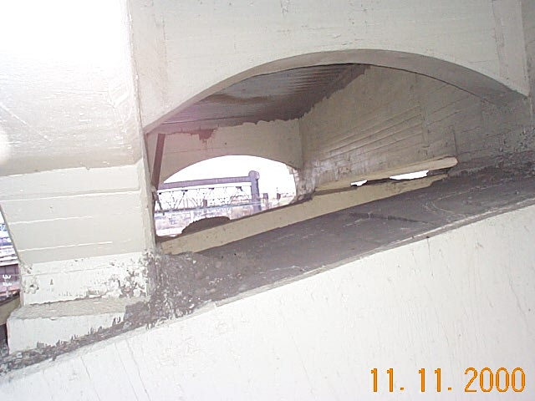
Photo 42 - Debris on top of concrete arches
dcp00227.jpg

Several other locations have areas that are cracked, delaminated, and/or have seepage, particularly in the north exterior line and the south exterior line. Near the West Abutment, the outside of the South Exterior arch shows this typical condition (Photo 43).

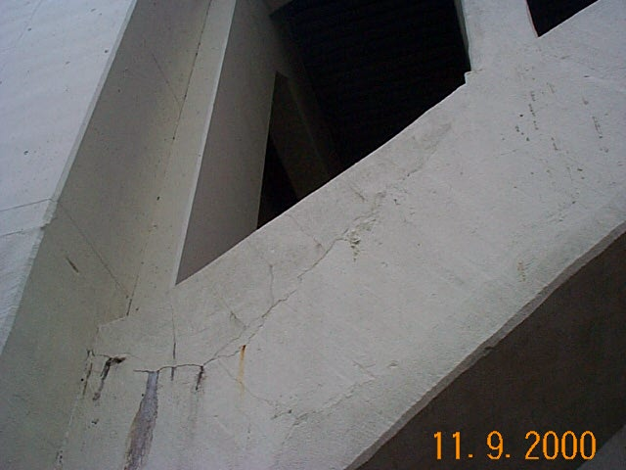
Photo 43 - Cracked exterior arch face, Span 1 South Face at West Abutment
dcp00214.jpg

In span 10, approximately 35% of the bottom of the arches were delaminated. This may be due to the fact that this span was the first to be patched and proper procedures may not have been developed. During the 1995 rehabilitation, a deep section of deficient concrete was uncovered on the southeast arch rib in span 5 between columns 1 and 2. It is uncertain if the problem was due to poor original materials or from deterioration. This area should be carefully monitored for additional deterioration.

- Steel Arch Span
General
Overall, the structural steel in the main steel arch span is in fair to good condition. The steel above the upper deck is in good condition with very few minor deficiencies noted. The majority of members below the upper deck that were not replaced during the 1994 rehabilitation exhibit moderate to heavy pitting, loss of section and localized areas that are holed through. All of these areas were cleaned and painted as part of the last rehabilitation. While there is no significant loss of additional section since that rehabilitation, rust staining and corrosion continues to be active at many locations.
One source for corrosion is the holes in the upper deck for the eyebars between the upper and lower arch. These holes allow water and de-icing chemicals from the upper deck to come in contact with floorbeam members, vertical hangers, and other members below the upper deck.
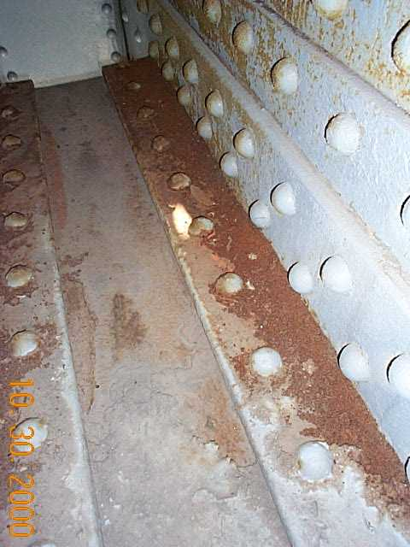Debris and most noticeably sand blasting material from the recent rehabilitation are present at random locations throughout the steel span. Some of the material has been painted over (Photo 44). The amounts of accumulation of debris ranges from minor to moderate (Photo 45).

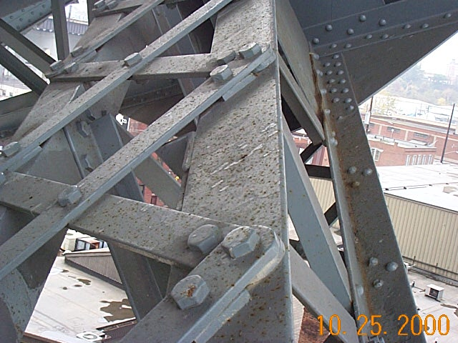
Photo 45 – Debris and Blast Material
dcp00085.jpg

Photo 44 – Debris under paint
dcp00020.jpg
Truss Main Members
The truss members above the upper deck are in good condition. Below the upper deck, however, a significant number of deficiencies were noted. Although numerous repairs and a total repainting was performed during the previous rehabilitation, areas of paint are beginning to deteriorate leading to minor corrosion and staining. Heavy staining, paint deterioration and flake rusting to the verticals at U2’-L2’ and U3’-L3’ and the diagonal between U1’ and L2’ below the upper deck (Photo 46 and 47).

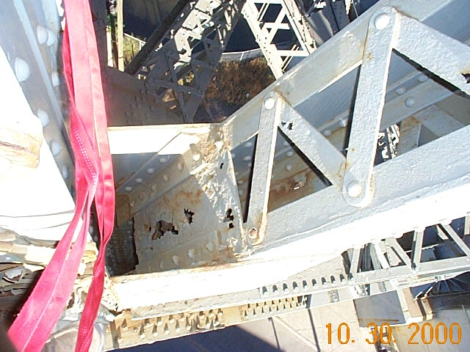
Photo 46 - South Arch at panel point L2
dcp00066.jpg

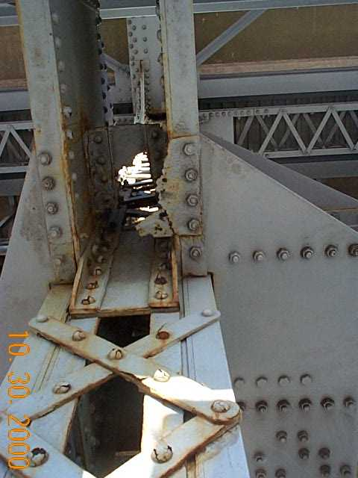
Photo 47 - South Arch U2-L2, flaking on lacing bars
dcp00063.jpg

Minor paint deterioration was commonly noted, especially at hanger locations below the upper deck. Rust staining is prevalent below the upper deck and flake rust is beginning to form at some locations. The lower chord pins and nuts at L11' and L6' are unpainted (Photo 48).
Random lacing bars and channels throughout the steel span have been holed through by rust and section loss throughout the steel arch span (Photo 49). In all instances, those areas were cleaned and painted during the last rehabilitation. Active rust staining and corrosion is occurring at numerous locations. At panel point L2’ of the north arch, broken lacing bars were noted.
Stay plates and keeper plates have been holed through throughout the main steel span (Photo 50). Similar to lacing bars and channels, those areas were also cleaned and painted during the last rehabilitation. There was either no active corrosion or very minor corrosion noted.
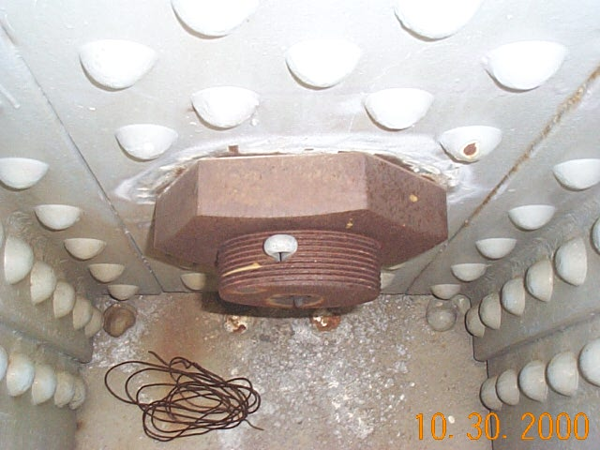
Photo 48 - North Arch Bottom Chord L11'
dcp00086.jpg
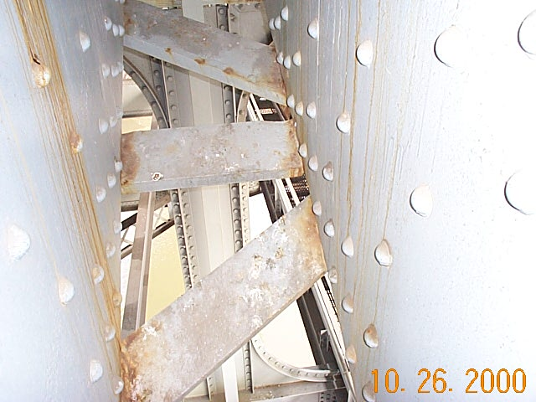
Photo 49 - South Arch L4-L5
dcp00058.jpg
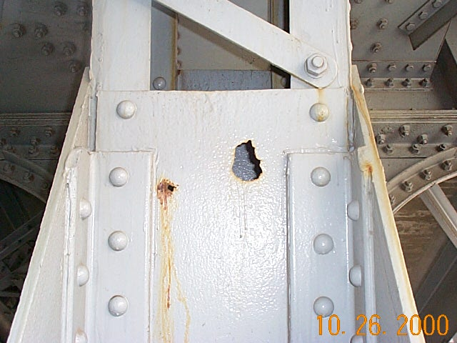
Photo 50 - South Arch Diagonal U3-L4
dcp00057.jpg

Accumulation of water and debris was common on angles that open upward. While the drilled holes in those members allow some drainage, full drainage is not achieved due to lack of slope. Water was also observed to have collected at panel points in both the upper and lower chords, especially inside vertical members.
Packrust and bowing to the top sliding plate at U12 of the north arch was noted. At U12 of the south arch, the bottom leg of the exterior angle behind the vertical sliding plate has corroded through.
The main truss gusset plates from Panel Points L1 to L4 and L1’ to L4’ have up to 30% section loss above the top flange of the lower chord (Photo 50a). Typically these plates have 1/8" to 1/4" loss in the area 2” above the lower chord and top lateral bracing gusset plates to both the exterior and interior faces. Throughout the life of the bridge, water has infiltrated through the upper deck truss openings and run along the top flange of the lower chord. This has caused early paint failure to the gusset plates, exposing the corrosion-resisting nickel steel. Currently, corrosion is beginning to reappear at these locations (Photo 50b).

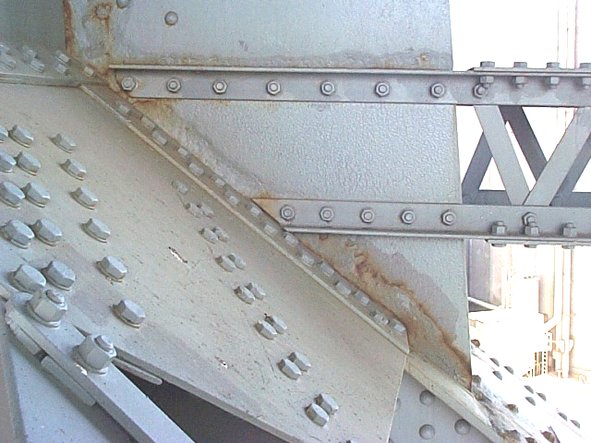
Photo 50a - South Arch North Gusset Plate at L2'
dcp00329.jpg
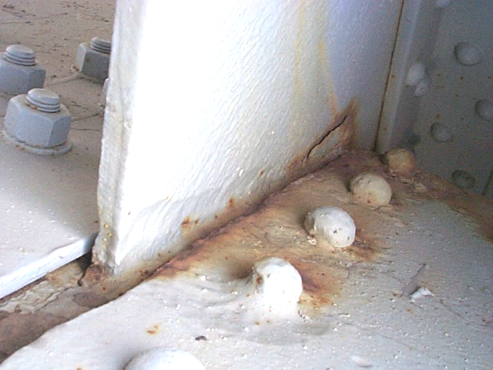
Photo 50b - North Arch South Gusset Plate at L1'
dcp00330.jpg

Eyebar Hangers and Vertical Hangers
The main span hangers are in good condition. Several vertical hangers were coped during the last rehabilitation at the lower deck floorbeam to minimize potential locations of packrust. Vertical hangers have section loss at the upper deck floorbeam. There is rust staining and minor active corrosion but no significant additional section loss has occurred since the last rehabilitation (Photo 51). Packrust between angles is common, especially at expansion joint locations (Photo 52).

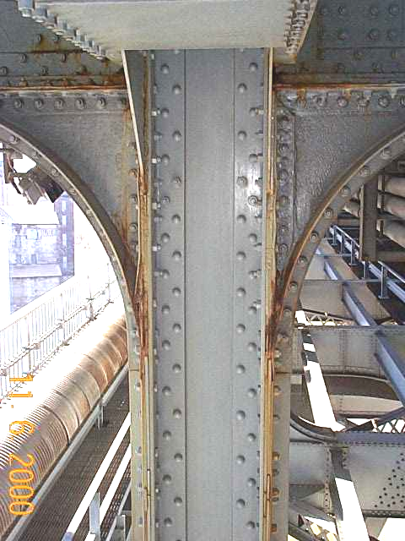
Photo 51 - South Arch at panel point 1'
dcp00164.jpg
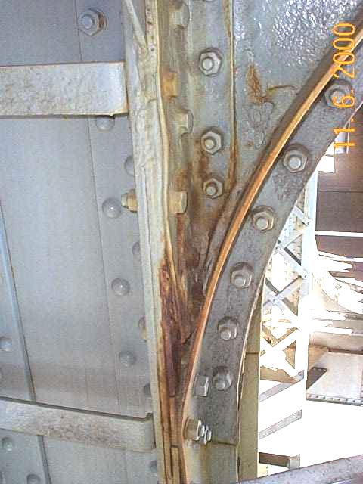
Photo 52 - South Arch at panel point 1'
dcp00162.jpg

Two sets of lacing bars to the North vertical hanger at 0’ are severed due to corrosion near the upper deck floorbeam. Additionally, a 4”x6” hole through the North vertical hanger at U4-L4 above the lower deck floorbeam was noted.
Floorbeams
The main span upper deck and lower deck floorbeams are generally in good condition. There is corrosion and rust staining to the upper deck floorbeam in the area around the pin and hanger assemblies (Photo 53). Holes through the web and bottom flange angles of the lower deck floorbeams occur throughout the steel arch span, but particularly at upper deck expansion joint locations at panel points 0, 5, 5’ and 0’. Hole locations are typical near the upper deck hanger pins (photo 54) and in the cantilever ends at 0 and 0'.

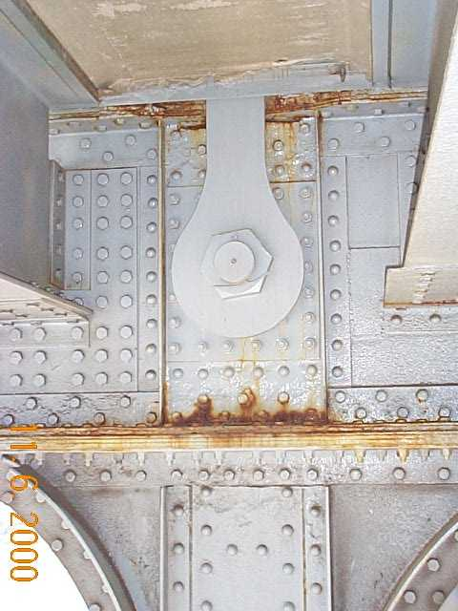
Photo 53 - Upper Deck Floorbeam at 7', South Arch
dcp00158.jpg
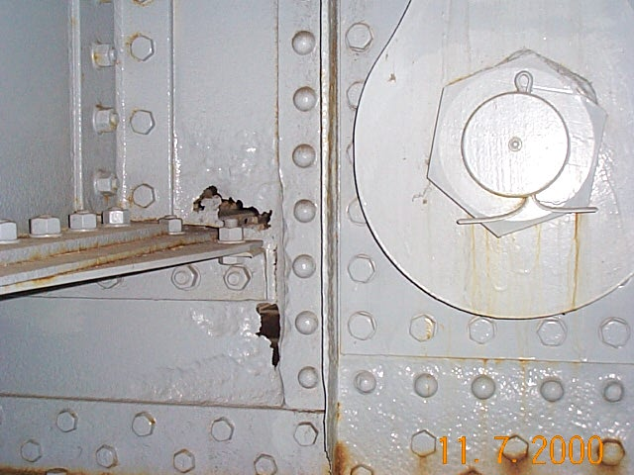
Photo 54 - Upper Deck Floorbeam at 8', North Arch hanger
dcp00200.jpg

As part of the 1995 rehabilitation project, some floorbeam top and bottom flanges were coped at hanger locations. No additional section loss was noted.
The stiffener at PP8’ near the north arch has been torn or cut 2/3 of the way through the stiffener. It was painted over during the last rehabilitation.
Stringers
The stringers are in fair condition. Minor deficiencies noted include several missing bolts at various locations and a horizontal and/or vertical offset of upper deck exterior stringers. There is a kink to upper deck stringer U between PP3' and PP4' (Photo 55), and upper deck stringer F at 6’ is missing 2 of 4 bolts to the floor beam connection angle. There is also a loose nut at that same location.

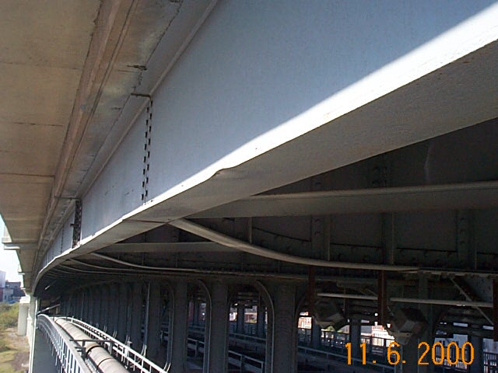
Photo 55 - South Exterior Upper Deck Stringer Span 4 near panel point 10'
dcp00159.jpg

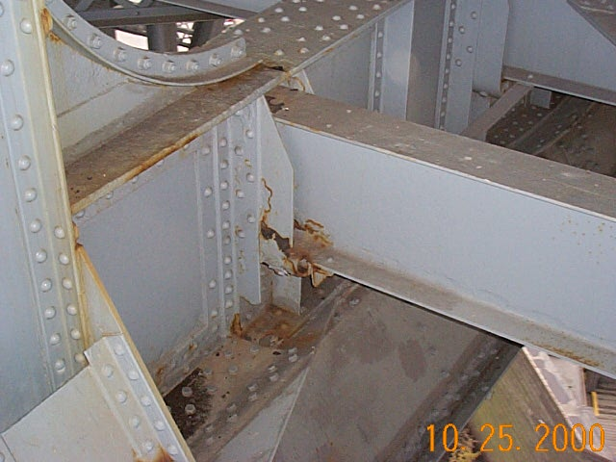
Section loss and holes through members were common to stringers 1-3 and 10-11 of the lower deck. Stringers 4-9 are typically in good condition with no significant section loss. The lower deck expansion stringer bearings at panel points 3 and 3’ exhibit section loss and have some holed through seat hangers (Photo 56). The upper deck stringers near the expansion joints at panel points 5 and 5’ were replaced in the 1995 rehabilitation and are in good condition.
Photo 56 - Lower Deck Stringer 10 at panel point 3'
Dcp00023.jpg
Bracing
The bracing members are in good condition. Similar to the main truss members, the bracing members above the splash zone are in better condition than the bracing members below the upper deck. As part of the 1995 rehabilitation project, the lower deck framing under the catwalks was modified as transverse and diagonal wind bracing members were removed.
There are holes through flanges, angle legs, lacing bars and gusset and connection plates common throughout the lower bracing. As stated previously, all have been painted over during the last rehabilitation.
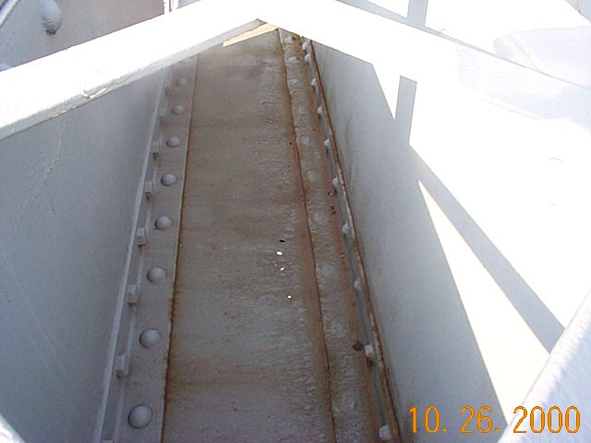
Minor rust staining and some active corrosion, especially near hanger locations was observed. The paint is beginning to breakdown, with areas of flaking and peeling paint and rust staining (Photo 57).
Photo 57 - Horizontal at U4'
dcp00056.jpg
Packrust between the bottom bracing members and gusset plates was noted (Photo 58). Isolated areas of construction damage were also noted, including a bent horizontal gusset plate at U5' at the south arch (Photo 59). Water and debris accumulates in the uphill angle legs of horizontal bracing members.

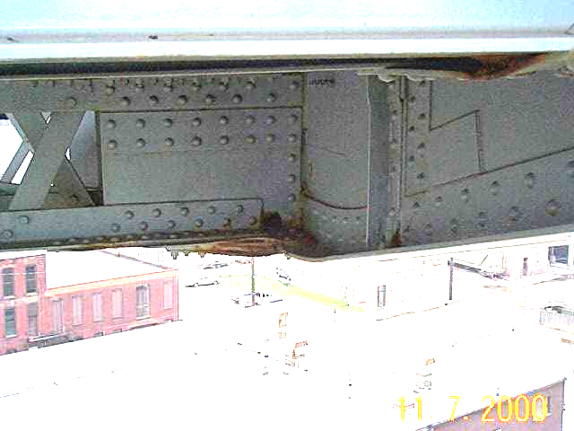
Photo 58 - Packrust at 8', South Arch
Dcp00197.jpg
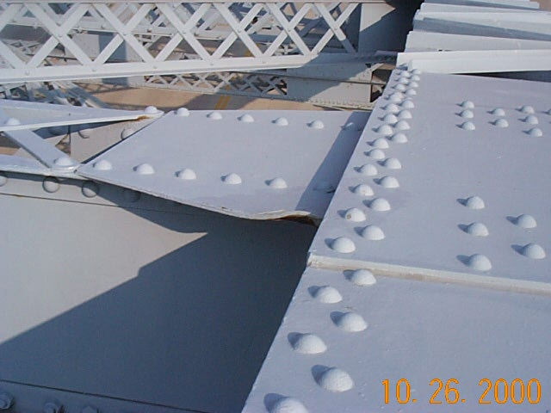
Photo 59 - Bent Gusset at U5', South Arch
Dcp00054.jpg

- Bearings
The main arch bearings at the tiebacks are pitted with minor active corrosion and rust staining. No additional section loss was observed. Accumulation of debris and water between stiffeners is typical. There is standing water above the pin inside the vertical member at all locations (Photo 60).

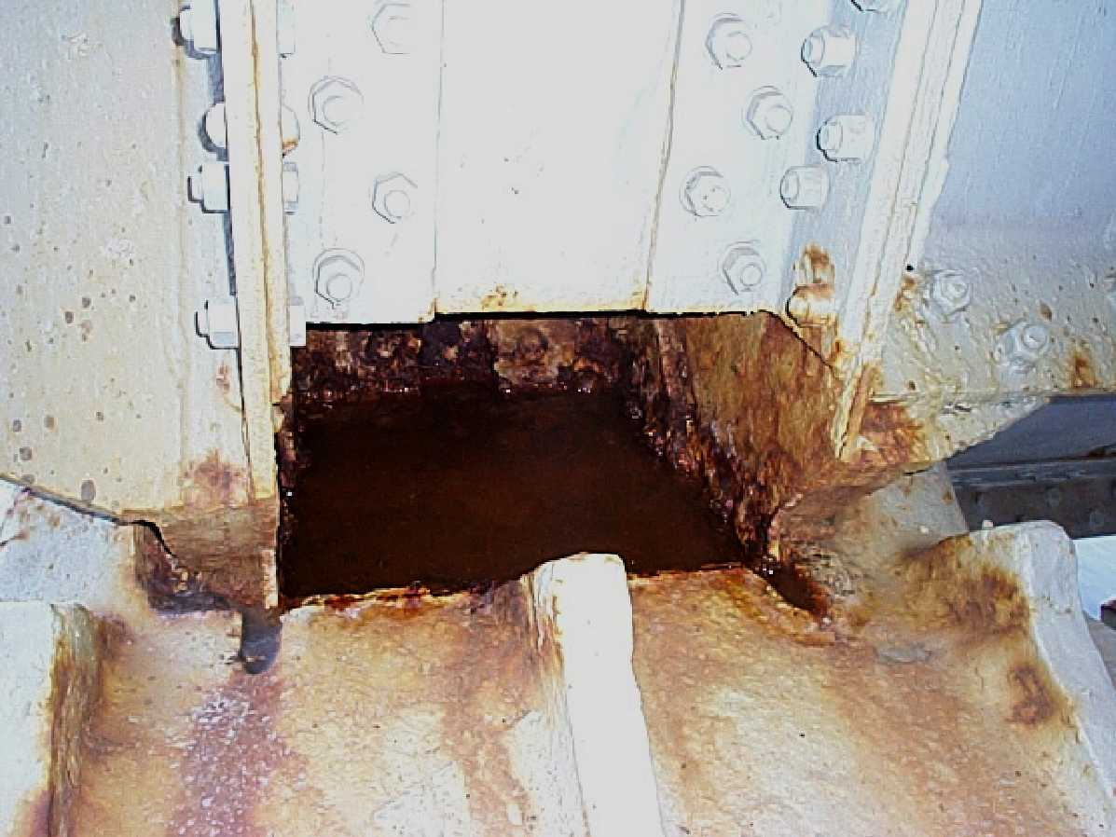
Photo 60 - Standing water at L0', North Bearing
Dcp00321.jpg

