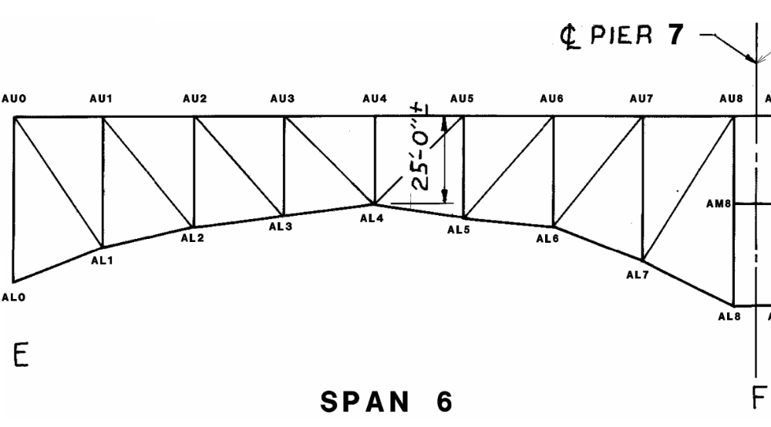
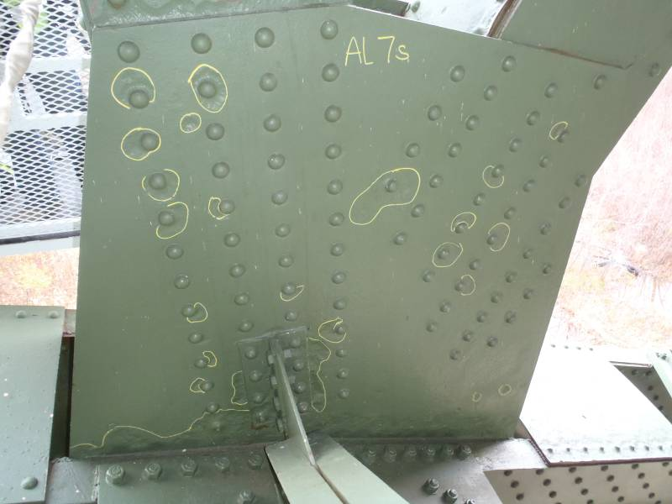
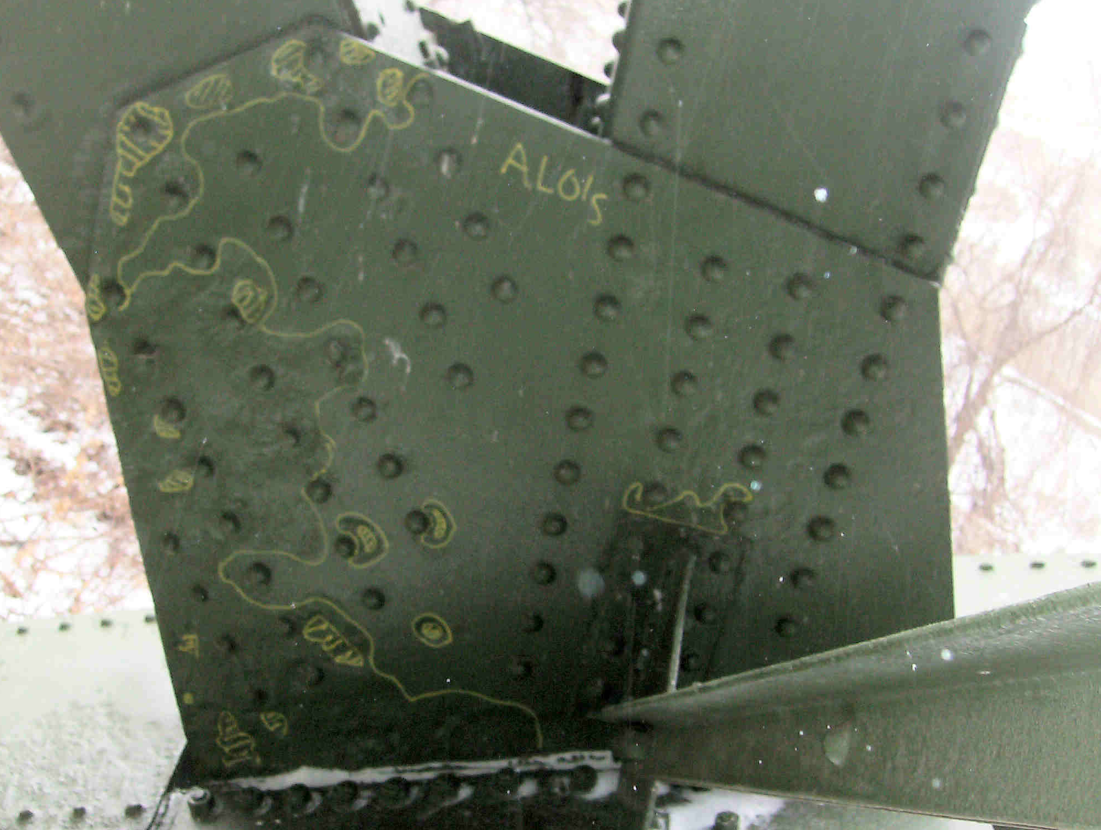
SPAN 6
TRUSS A
Small areas of pitting 1/4″ deep pitting are scattered throughout the south face of AL7S, as indicated with field markings.
The south gusset plate at AL1 exhibits widespread 1/4″ deep pitting throughout the west end of the plate (left), with small areas of pitting greater than 1/4″ deep scattered throughout (shown as hatched markings).

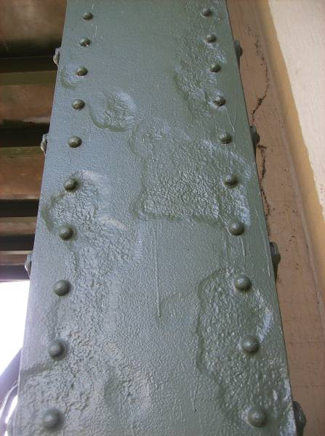
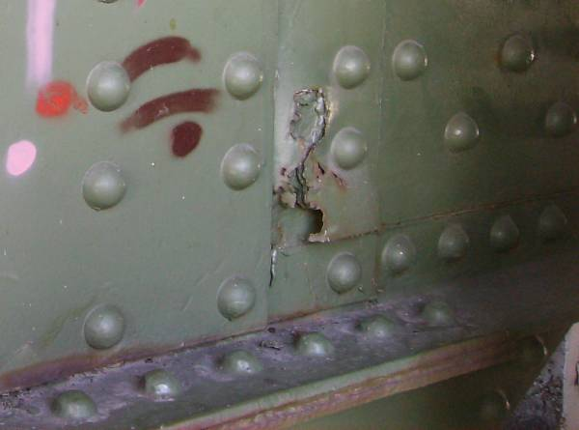
The north web plate of BL0-BU0 exhibits 1/8″ to 1/4″ deep pitting (see Section A-A).
Advanced corrosion at the south web fill plate at BL8 has resulted in a 6″ diameter hole.
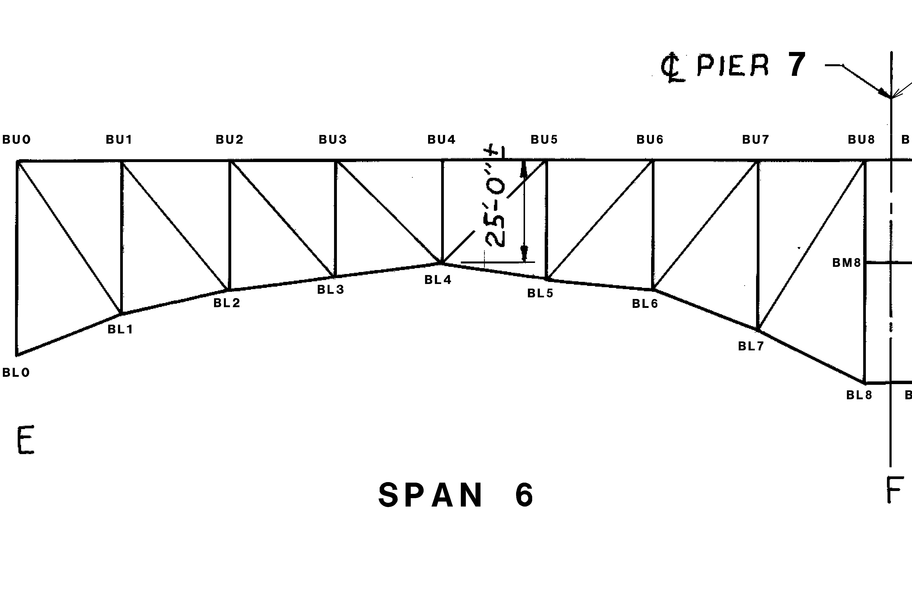
SPAN 6
TRUSS B

A
A

X X X
x x x X X X x x x
x x x x x x
1/8″ pitting x 1/3 web width
3/16″ pitting x 1/3 web width
1/8″ pitting x 2/3 web width
1/4″ pitting x 1/3 web width
Section A-A

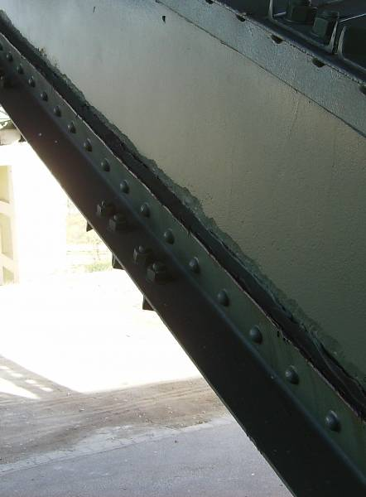
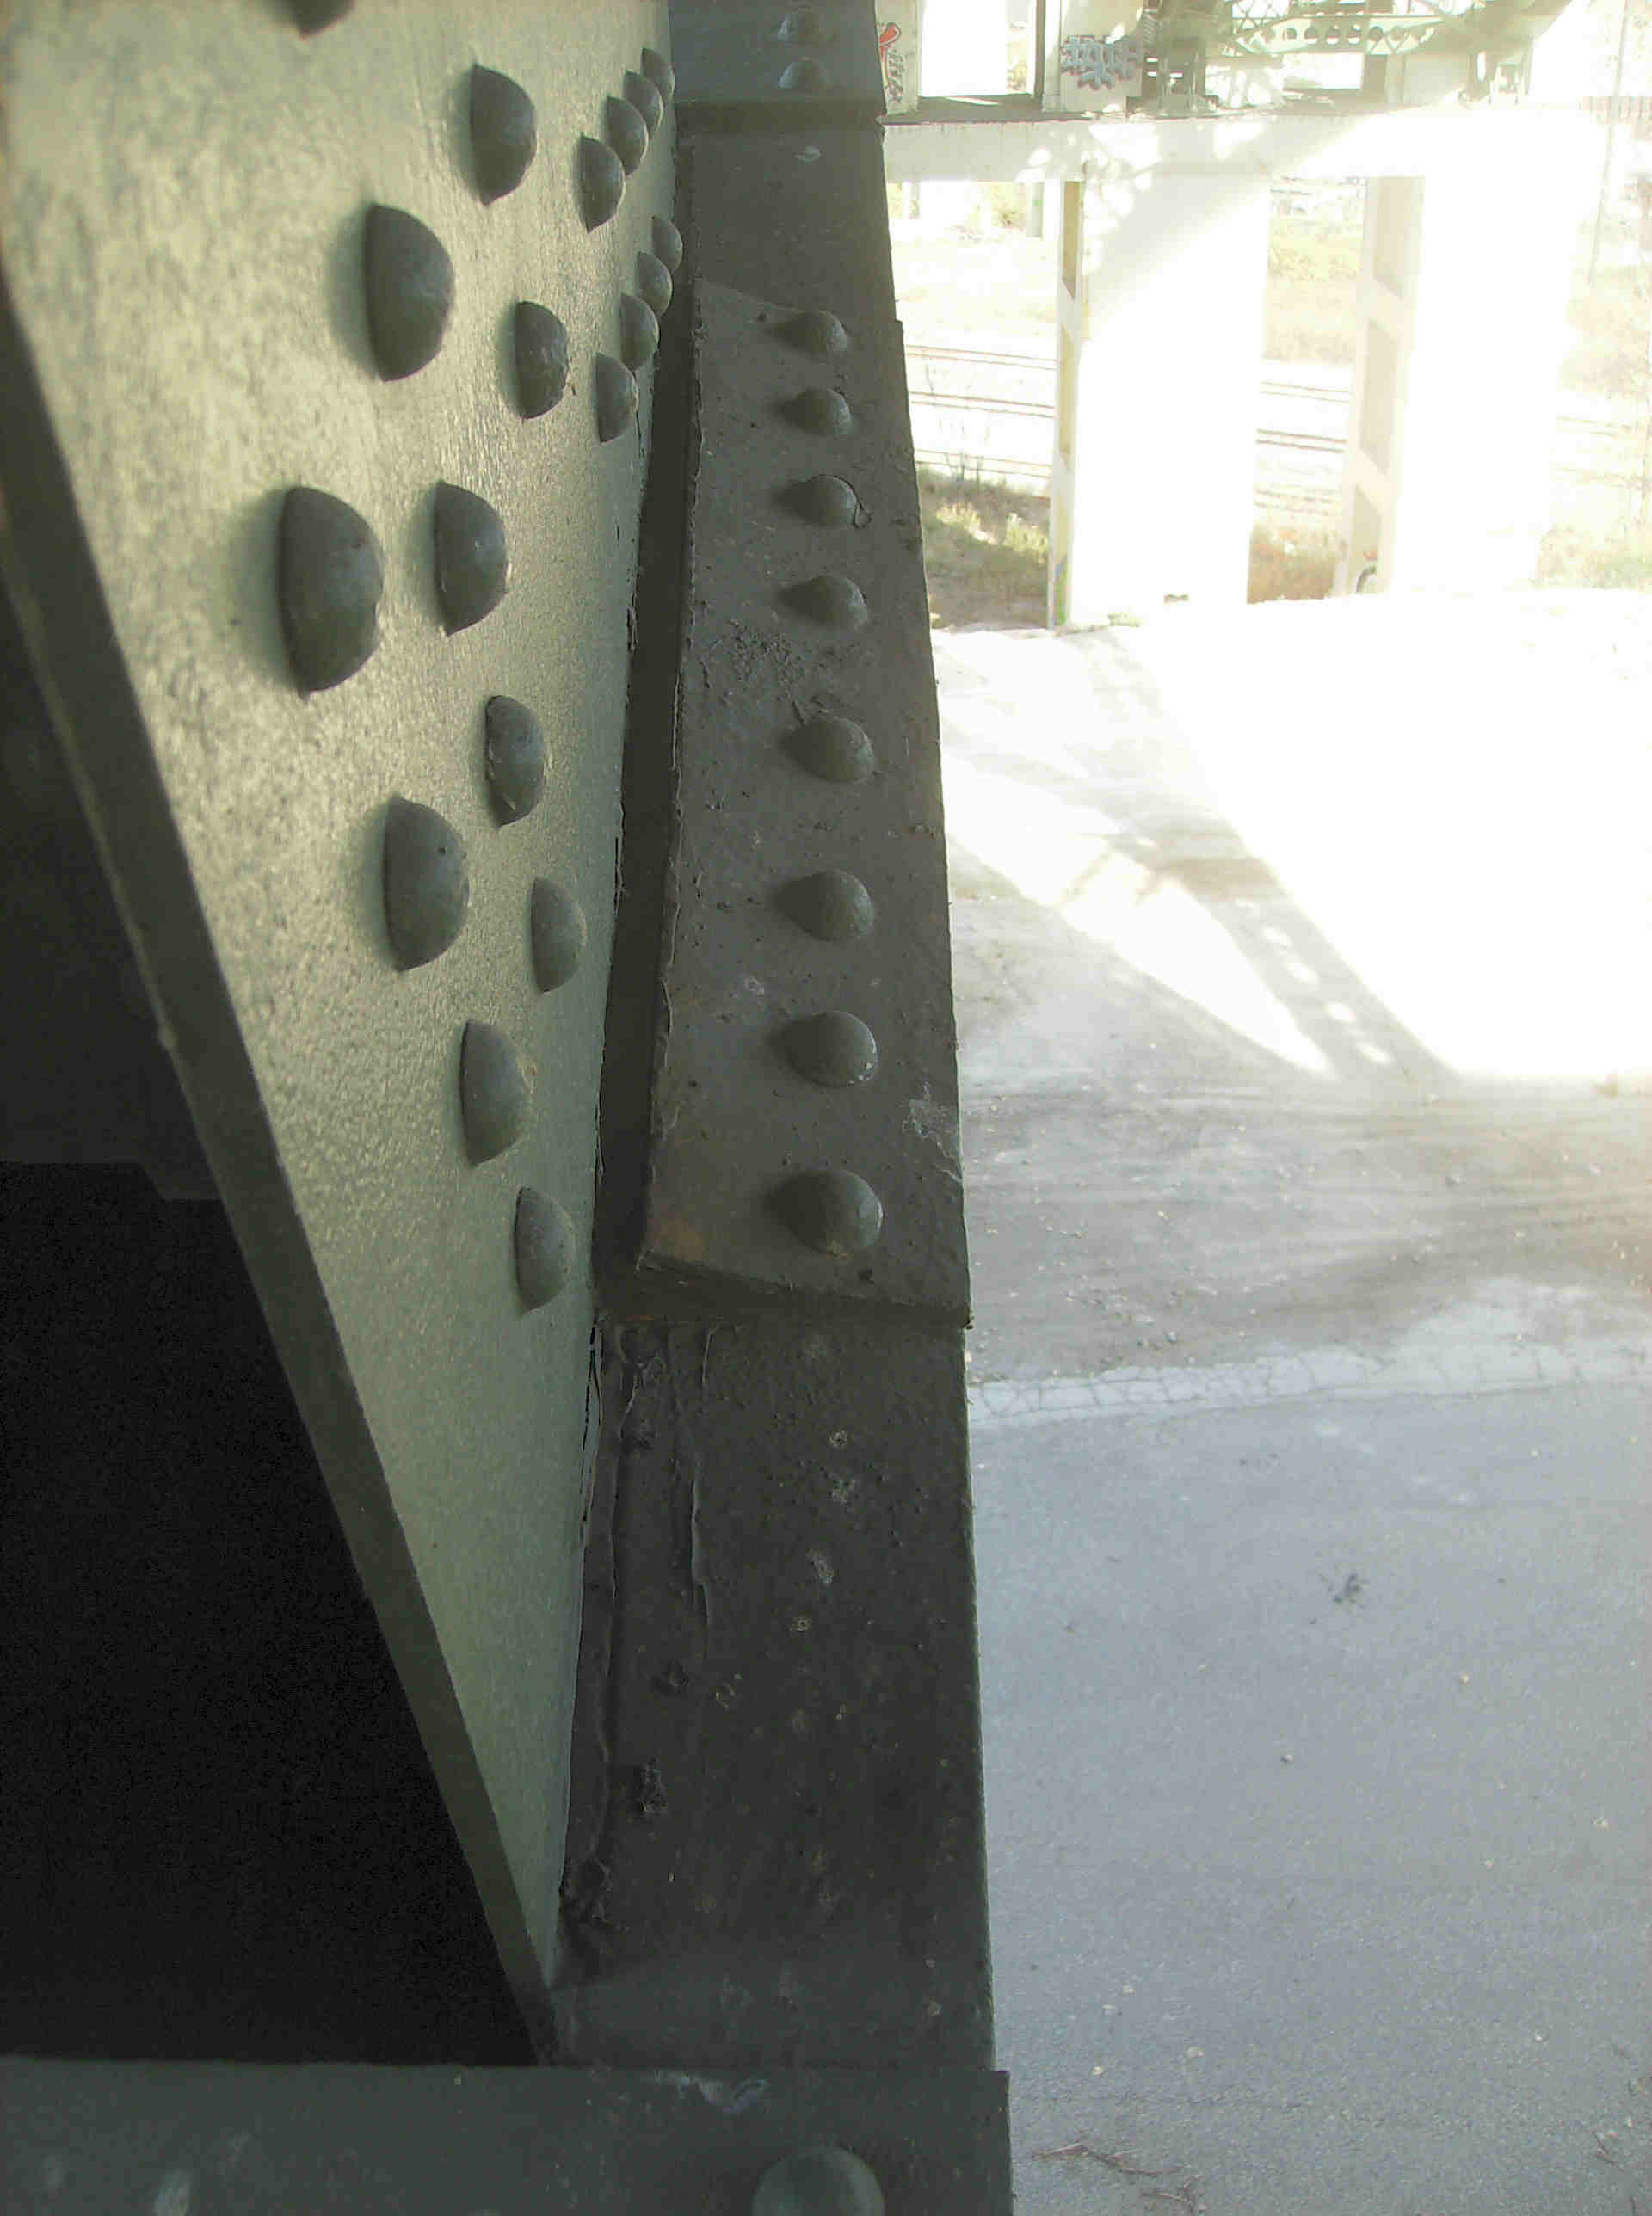
Pitting up to 1/8″deep is present in the bottom 4″ of the north web plate along the bottom flange angle at BL0-BL1.
Heavy pack rust up to 1″ has formed between the lower chord top flange and the flange splice plate at BL1. The pack rust is lifting the interior edge of the splice plate and is distressing the connection.
Gusset Plate
Flange Splice Plate

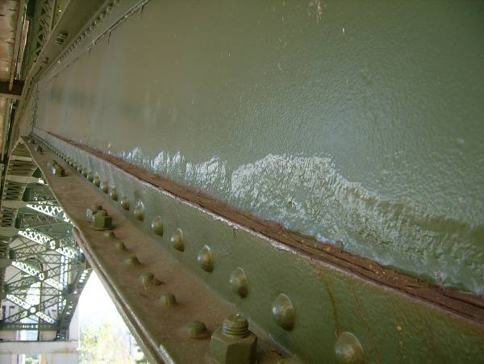
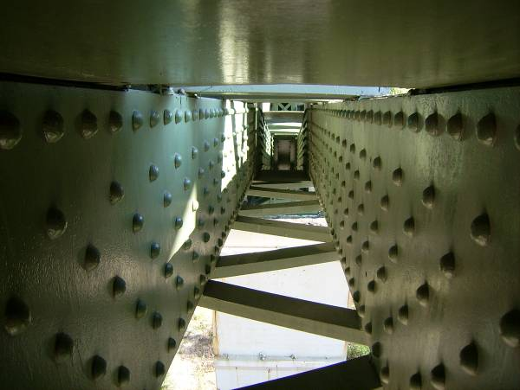
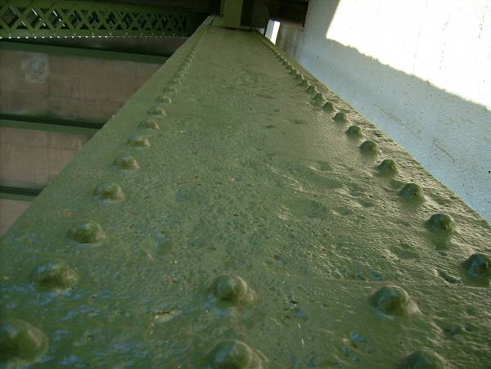
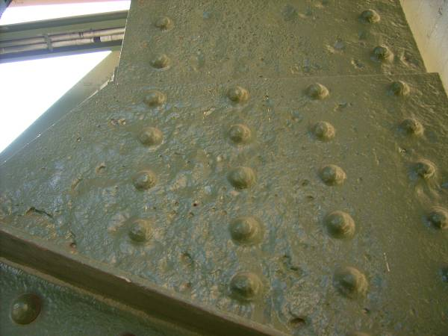
The north web plate of CL0-CL1 exhibits 6″ tall, 1/4″ pitting throughout the bottom half of the web.
The interior of the lower chord box section is typically cleaned and painted, typically with little or no active rusting (CL6-CL7 shown).
The north web plate of CL0-CU0 exhibits heavy pitting throughout with areas with pits up to 3/8″ deep.
The north gusset plate at CL0 exhibits heavy pitting throughout with areas with pits up to 3/8″ deep.
SPAN 6
TRUSS C

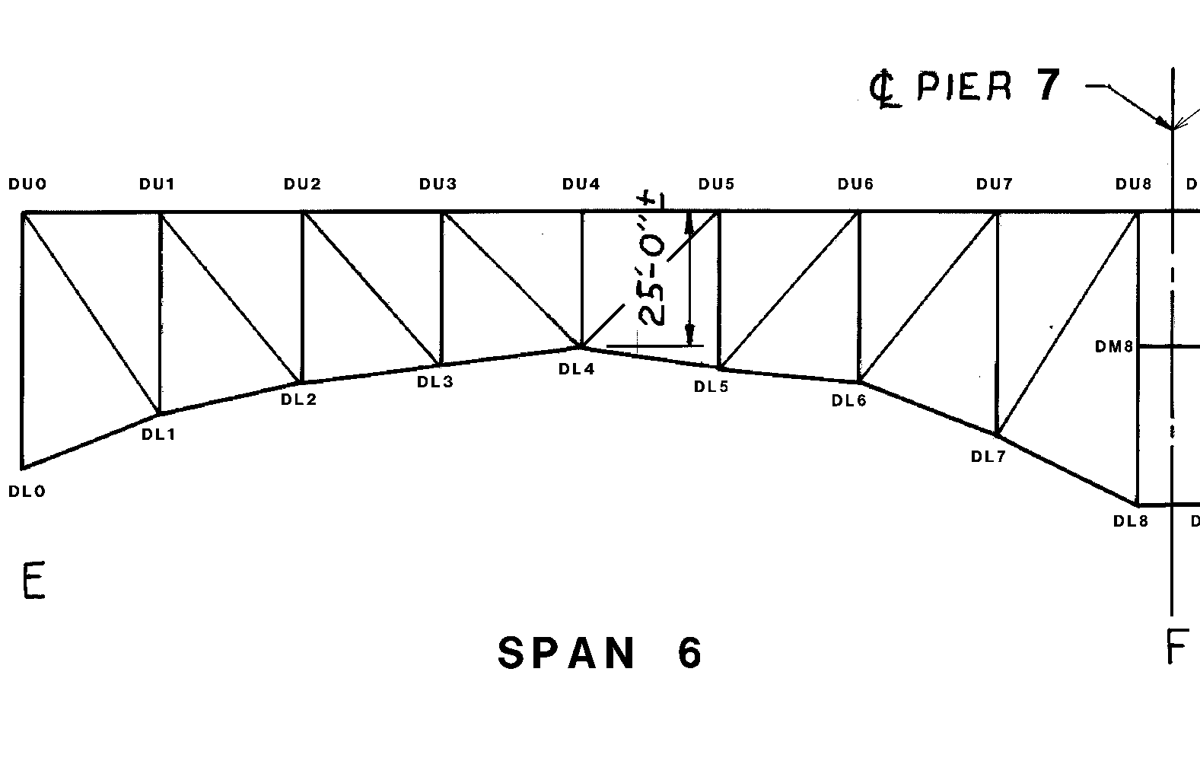
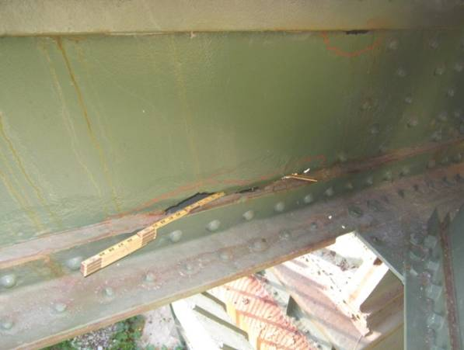
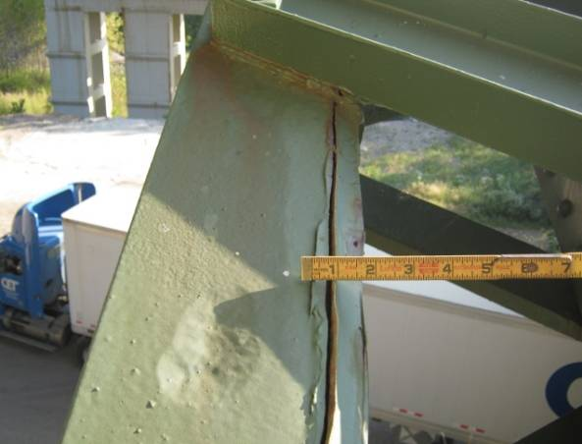
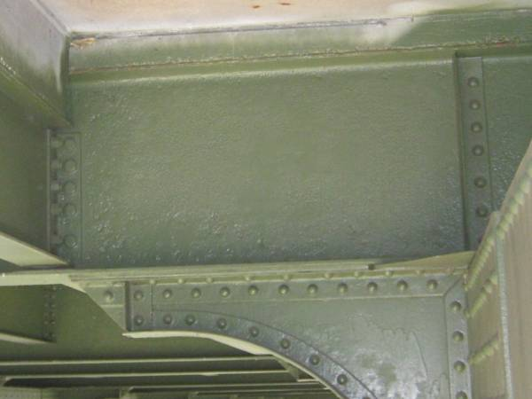
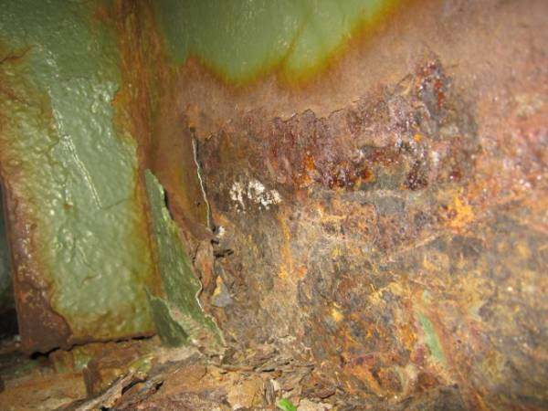
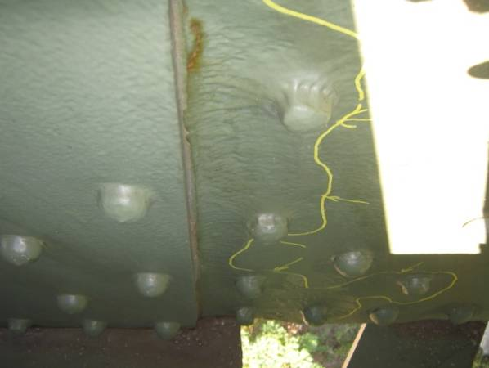
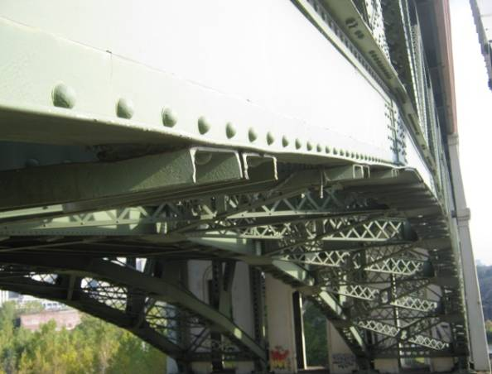
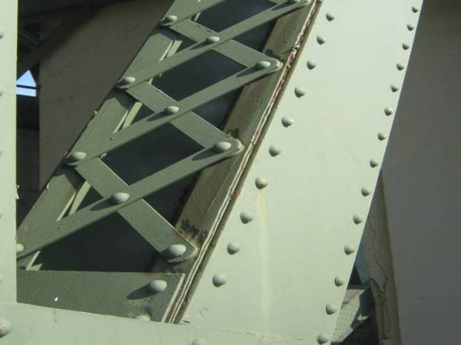
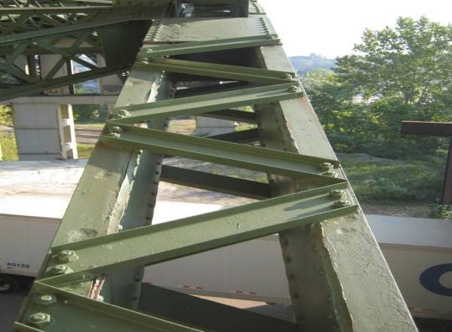
Typical evidence of pack rust reactivating between top flange angle and web plate (DL1-DL2 shown).
Floorbeam webs in Span 6 typically exhibit 1/8″ pitting along the bottom 3″ of the first 2′ adjacent to the connection at Truss D.
Active heavy corrosion with 1/16″ pitting on the bottom flange and lower 1/3 of the web of Floorbeam 0, adjacent to a failed deck joint.
Pitting up to 5/16″ deep was noted over the full height of the north web plate of DL7-DL8 adjacent to DL7.
The horizontal legs of bottom flange angles are warped slightly throughout the bridge at isolated lacing connections due to pack rust between the angles and the lacing channels.

Bottom chord members in Span 6 typically exhibit localized 1/4″ pitting (cleaned and painted) on the top flange angles and cover plates (DL1-DL2 shown).
SPAN 6
TRUSS D
DL0-DL1 exhibits a 2′L x 3″H hole in the north web plate near the bottom flange angle and a 6″L x 2″H hole adjacent to the top flange angle, 5′ from DL0.
1″ Ø hole in the north bottom flange angle
1/4″ pitting of the top flange splice plate
Isolated 1/4″ pitting on north stay plate
DL1-DL2 exhibits two 4″ Ø holes in the bottom half of the web plate.
Isolated pitting up to 1/4″ deep was noted along the top flange angles at lacing connections (DL7-DU8 shown).

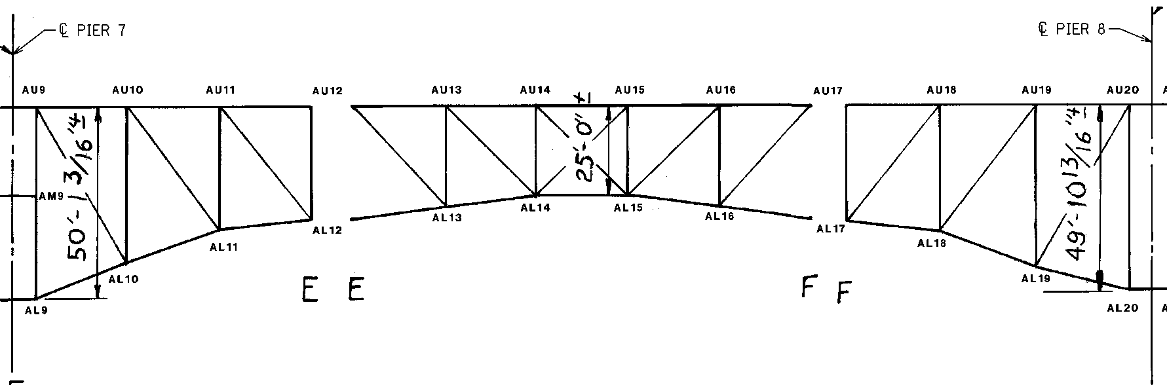
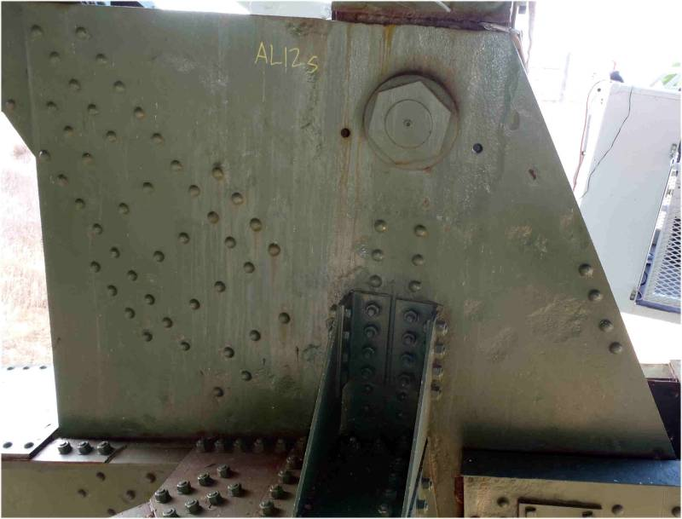
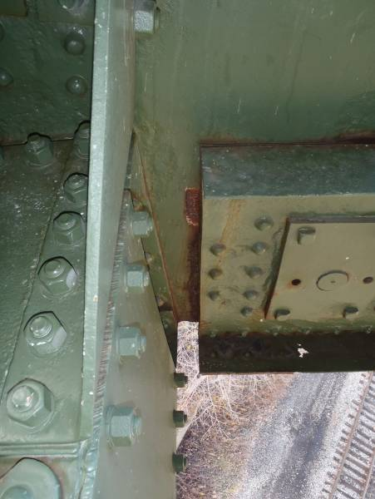
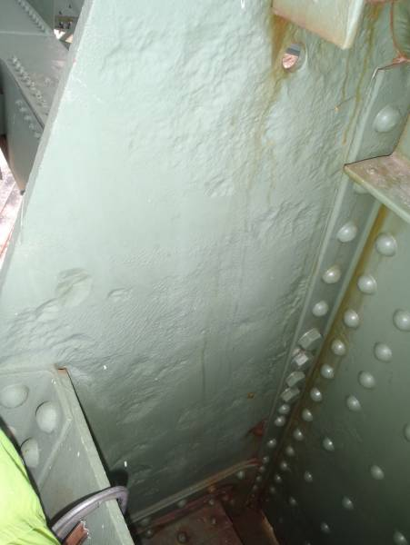
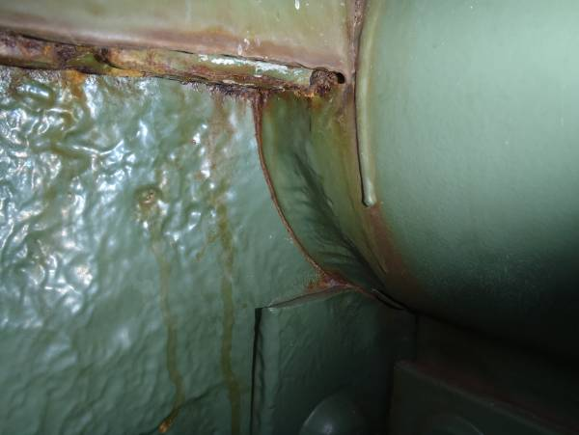
The south face of the south gusset plate at AL12 exhibits widespread areas of 3/16″ deep pitting, with one 2″∅ area with 5/16″ loss below the bearing pin. The north gusset plate has a 6″∅ area along the west free edge with as little as 1/4″ material remaining.
The north gusset plate at AL12 shows wear from abrasion with AL12-AL13.
The north face of the south gusset plate exhibits isolated areas of pitting up to 1/4″ deep.
SPAN 7
TRUSS A
The bearing pin at AL12 exhibits 3/16″ deep loss along the circumference adjacent to the pin plates. Additionally, the innermost pin plates exhibit 1/8″ deep pitting throughout the interior face adjacent to the pin.
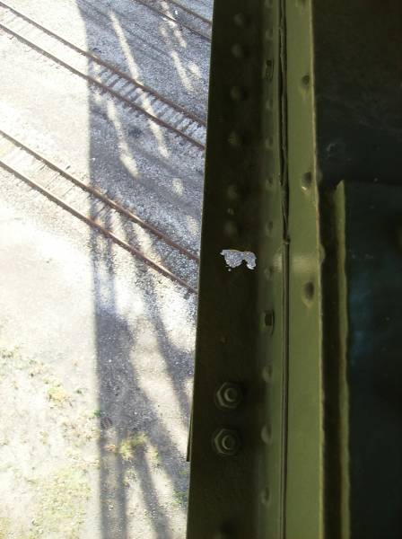
BL17-BL18 exhibits a 5″ diameter hole in the south bottom flange near BL17.
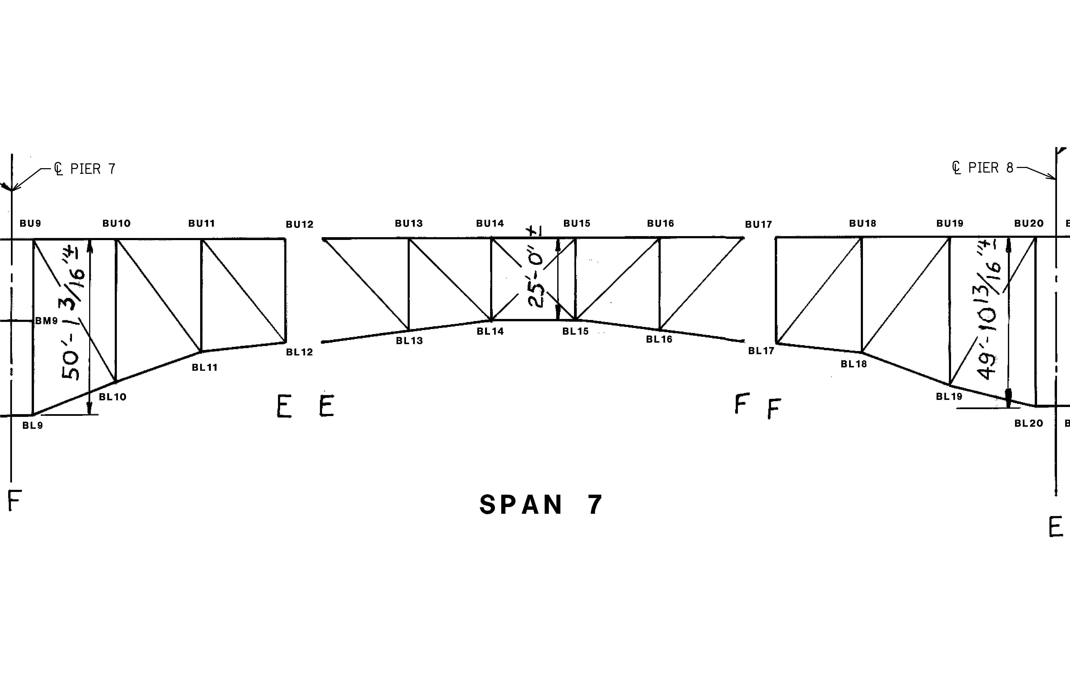
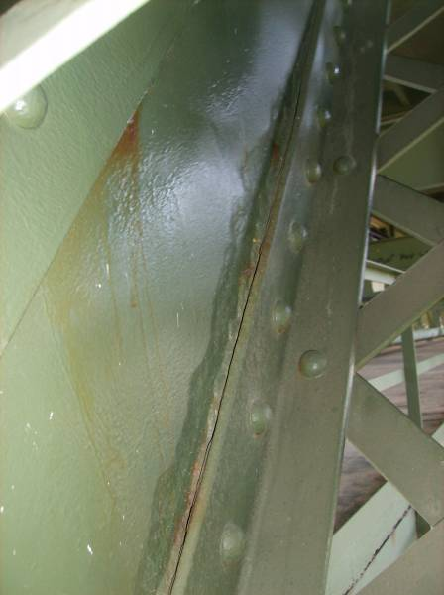
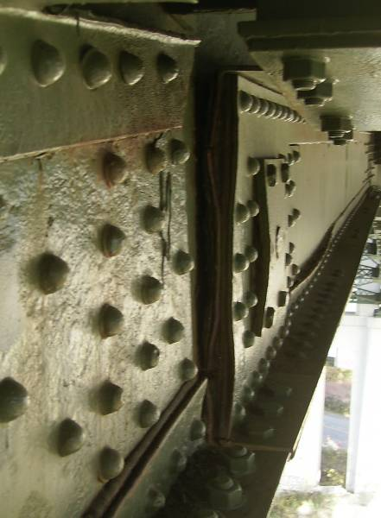
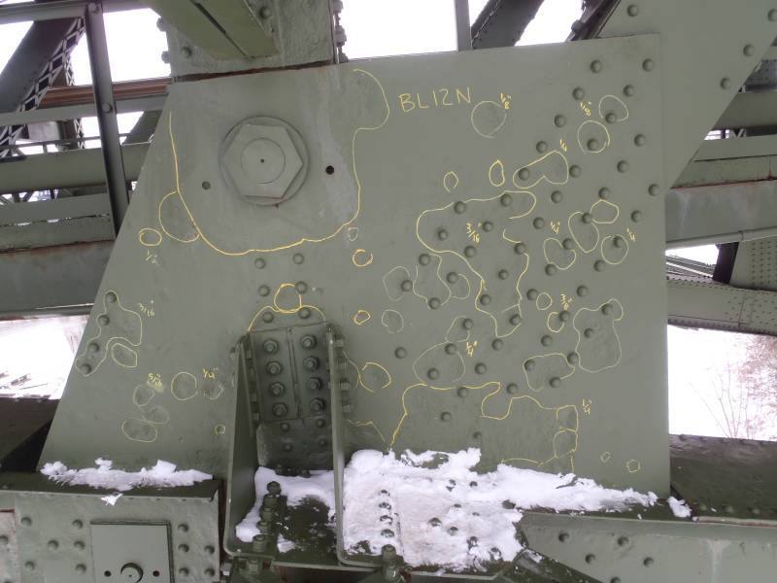
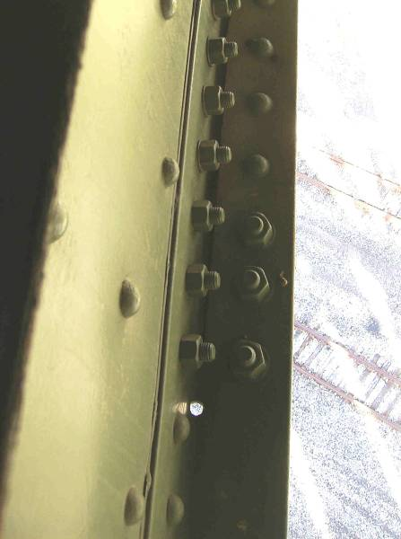
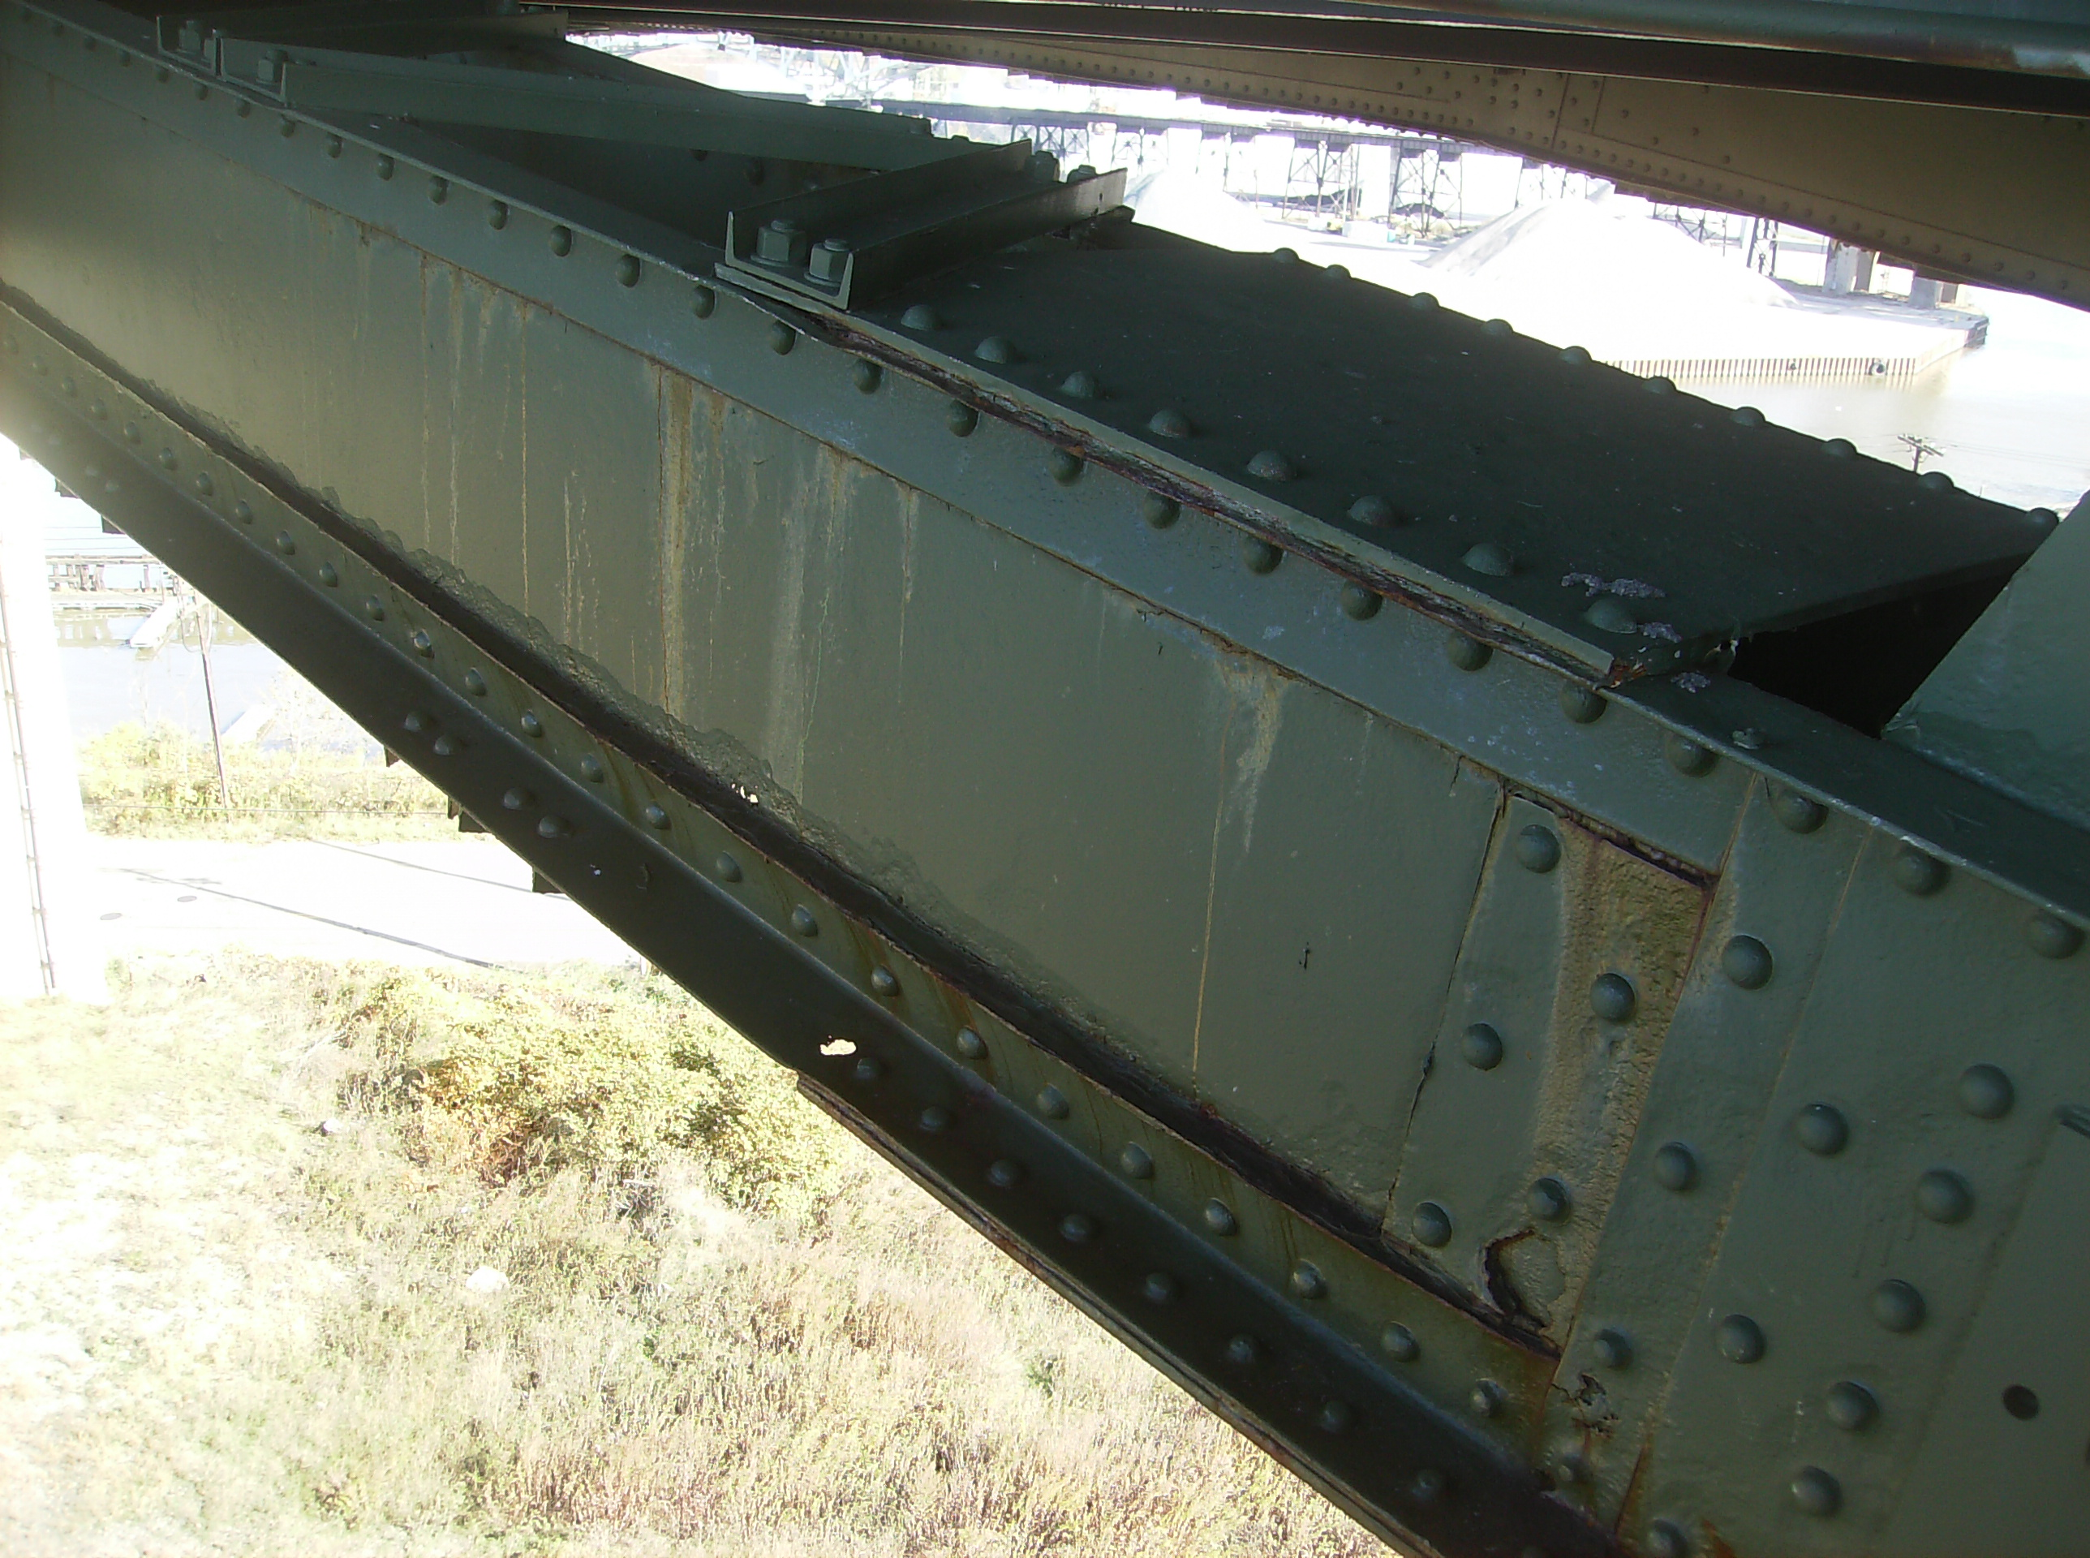
SPAN 7
TRUSS B
The interior face of the south web plate at BL12-LU11 exhibits 1/8″ deep pitting along the lower flange angle.
1
Heavy pack rust between the plates at the lower sliding pin location near BL12 has caused significant distortion of the plates. Heavy pitting is present on the web plate of BL11-BL12 (foreground).
Gusset plate BL12N exhibits small areas of deep pitting up to 5/16″ throughout. All locations exhibiting greater than 3/16″ deep pitting are highlighted with field markings. The south plate at BL12 exhibits conditions similar to those shown, while losses at BL17 are considerably less severe, typically 1/8″ deep.
The south bottom flange angle at BL13 exhibits longitudinal cracking due to pack rust between the outstanding leg of the flange and the bottom lateral bracing connection plate. Arrest holes have been drilled and the bottom connection plate has been replaced at this location.
1
The lower flange angle of BL12-BL13 exhibits a 1″ diameter hole. The adjacent web plate exhibits 1/8″ pitting and is perforated due to isolated advanced corrosion at one location.
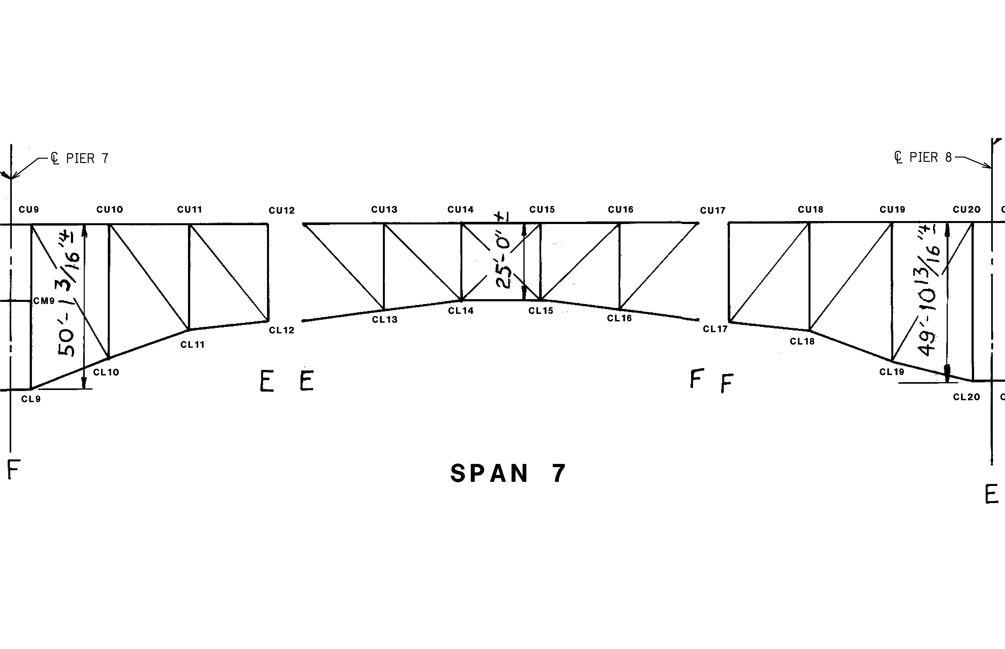
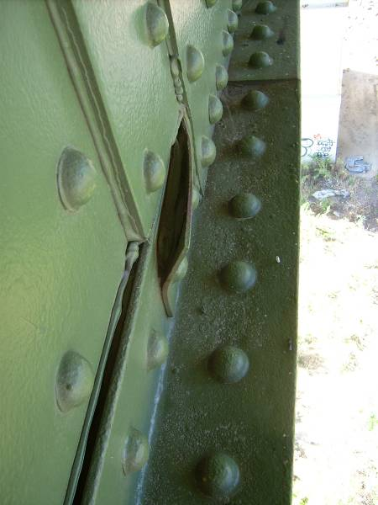
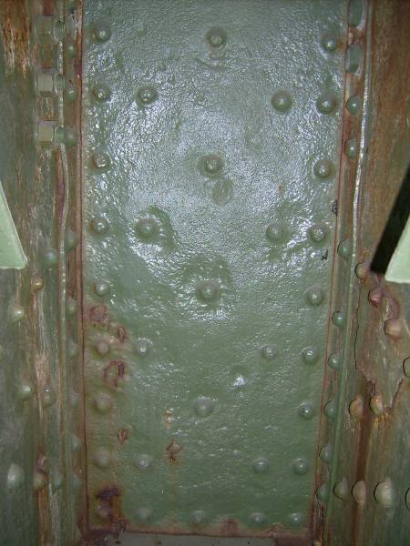
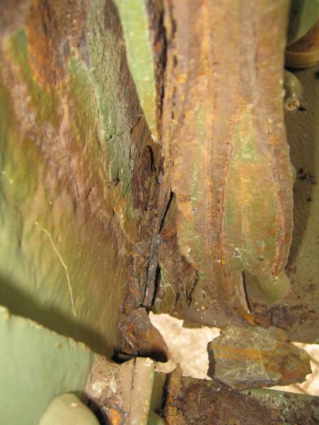
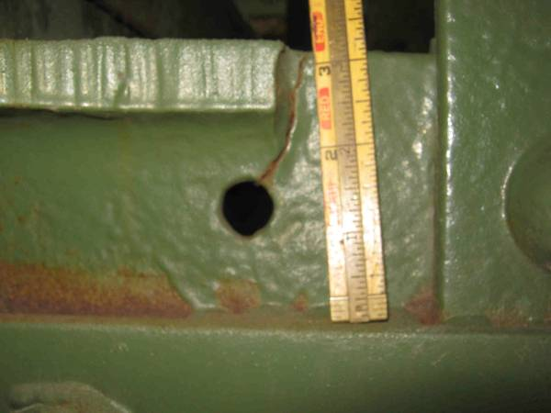
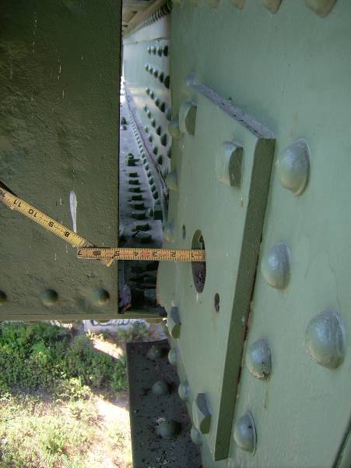
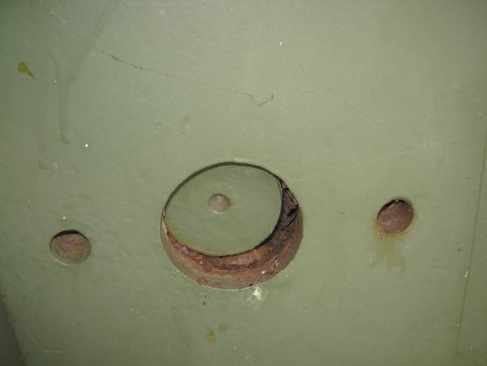
SPAN 7
TRUSS C
The bottom flange angle splice plate at CL11 is bowed out approximately 1.5″ due to heavy pack rust.
The internal diaphragm plate at CL12 exhibits heavy pitting around the rivet heads and along the edge of the plate at the gusset plate interfaces. Note the active rust throughout.
CL12-CL13 exhibits advanced section loss and heavy pack rust at the sliding pin location at CL12. A thin internal fill plate has rusted away at this location, and built up member connections are becoming distressed due to the pack rust and subsequent distortion of the web members, as shown.
Utility deck Floorbeams 14 and 15 exhibit cracking at the top flange coping near Truss C, extending down into stress relief holes. These cracks are approximately 1.75″ long and do not appear to have propagated beyond the stress relief holes
At the lower chord sliding pin at CL12, heavy pack rust has forced the pin plates away from the end of the pin. The end of the pin is approximately 1″ from flush with the keeper plate.
The lower chord sliding pin at CL12 is not bearing on the keeper plate, exhibiting lateral misalignment.

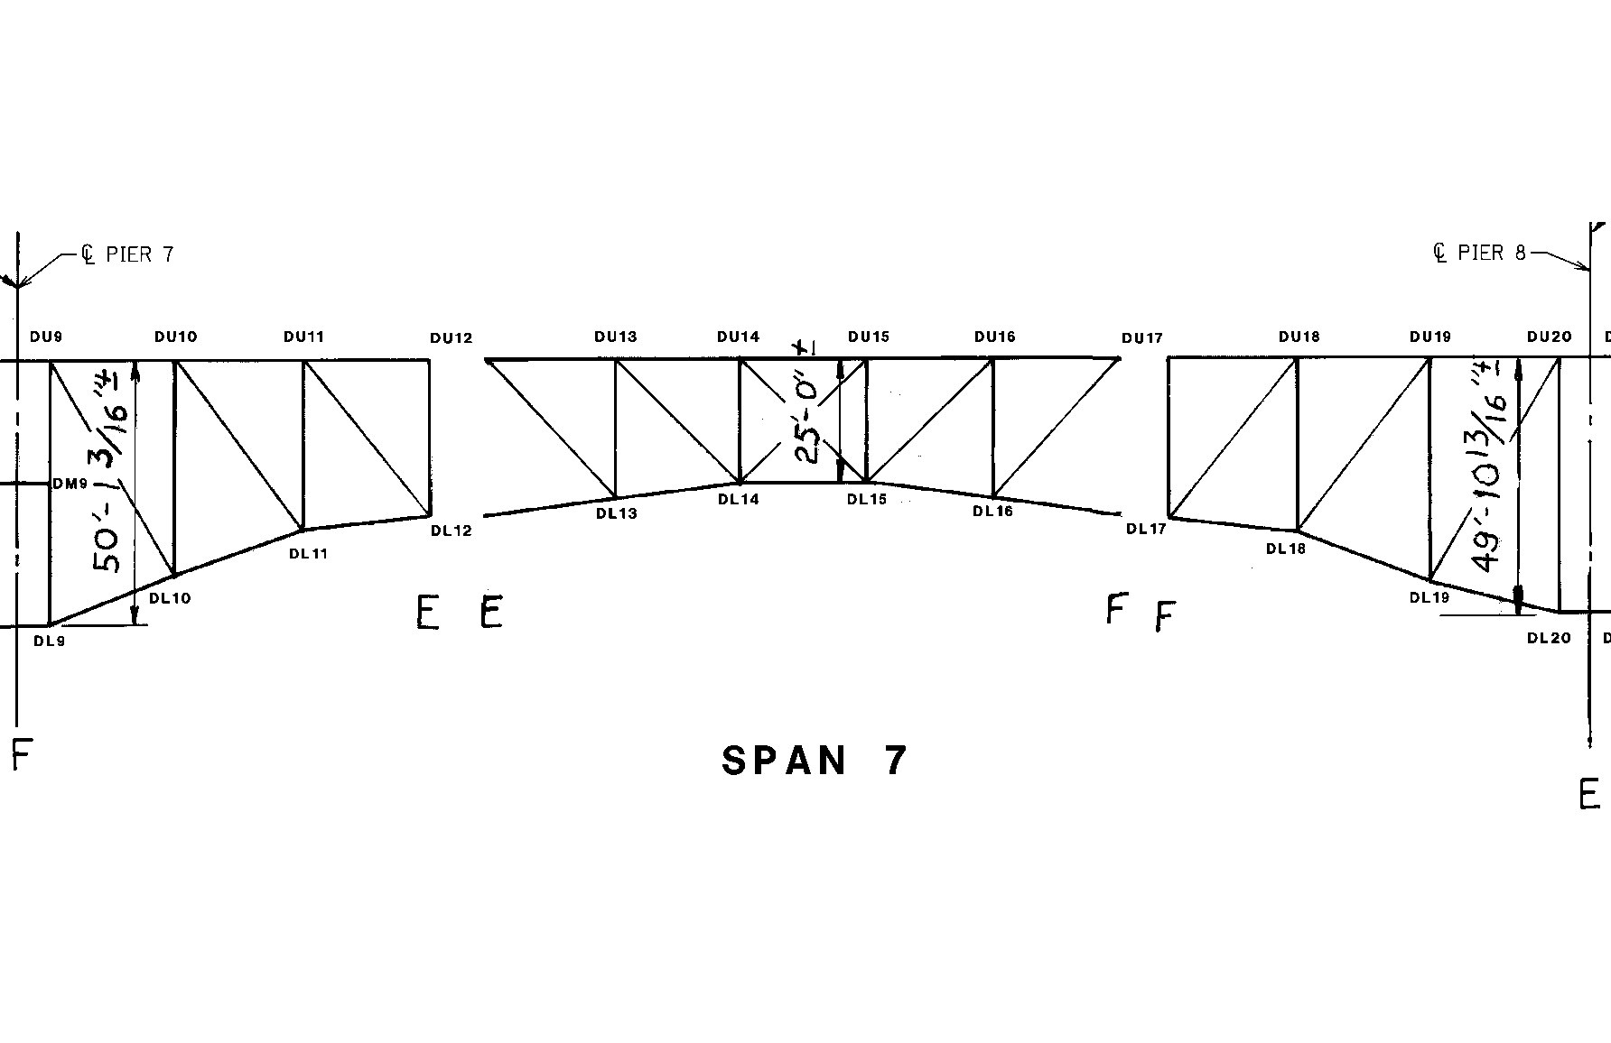
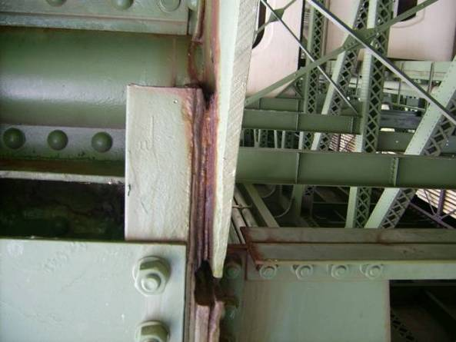
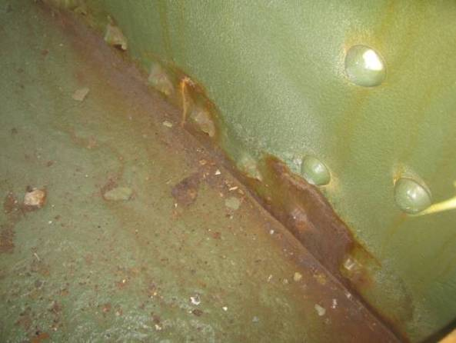
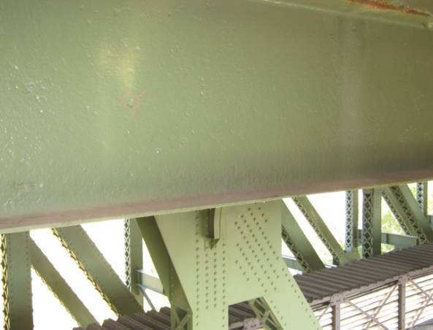
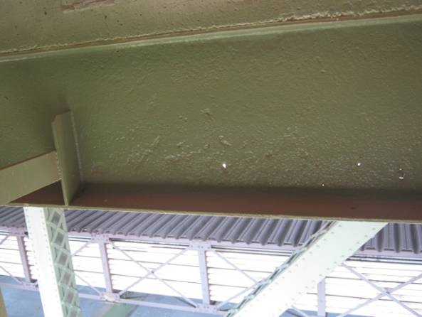
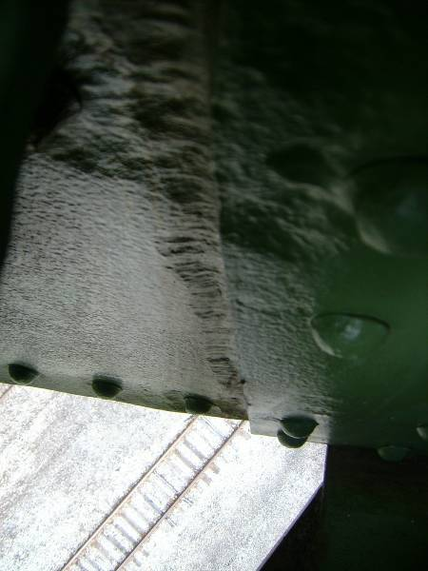
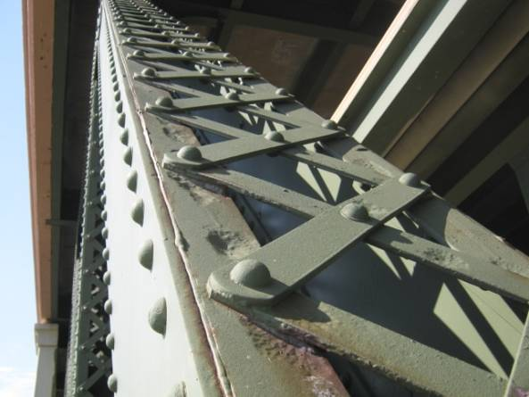
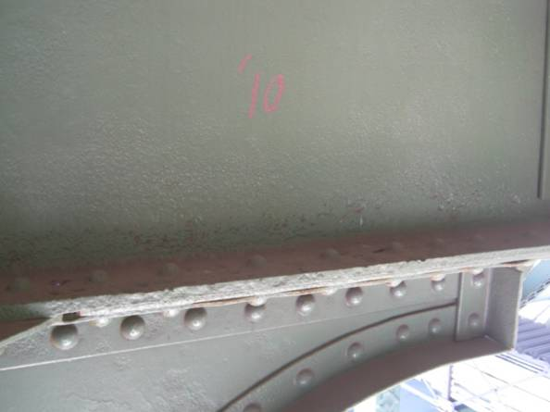
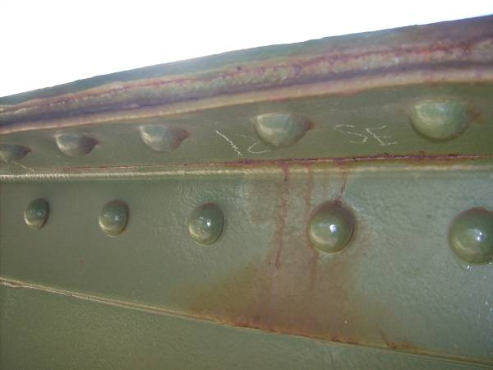
DL12-DL13 exhibits moderate corrosion and pitting up to 1/4″ deep over the lower 1/3 of north web plate, with a 2″ Ø hole near the bottom cover plate interface.
x x x x x x
Section A-A
Isolated pitting up to 1/4″ deep on the lower chord top stay plates is typical throughout Span 7.
B
B
A
A
Section B-B
Stringer 2 exhibits 1/16″ pitting with isolated 1/4″ pitting of the bottom flange and lower half of the web with isolated perforations between DU15 and DU16.
Up to 1/4″ pitting (cleaned and painted) extends the full height of the north web of DL14-DL15 adjacent to DL15. This condition is typical for Span 7 lower chord members.
2
2
1
1
Pitting up to 1/4″ is isolated on top flange angles at lacing connections on diagonals members throughout Span 7.
1
Floorbeams in Span 7 typically exhibit 1/16″ pitting with isolated 1/4″ pitting on the web and flanges between Truss D and Stringer 2 (first interior stringer) (Floorbeam at DU18 shown).
Longitudinal crack is located between legs of the north upper flange angle measuring 24″ long at DL15-DL16.
SPAN 7
TRUSS D
Pack rust is typical between web plates and flange angles and between flange angles and lacing channels. Isolated areas have reactivating rust.
Isolated 1/4″ pitting on the interior of north web plate
Active pack rust between the north gusset plate and vertical member angle at DL12
1/4″ deep pitting x 12″ wide (adjacent to lower gusset plate)
Stringer 2 exhibits pitting up to 1/4″ deep on the top of the bottom flange and typical 1/16” pitting with isolated 1/4" pitting throughout the web.
3″Ø hole in the north angle leg of DL13-DL14

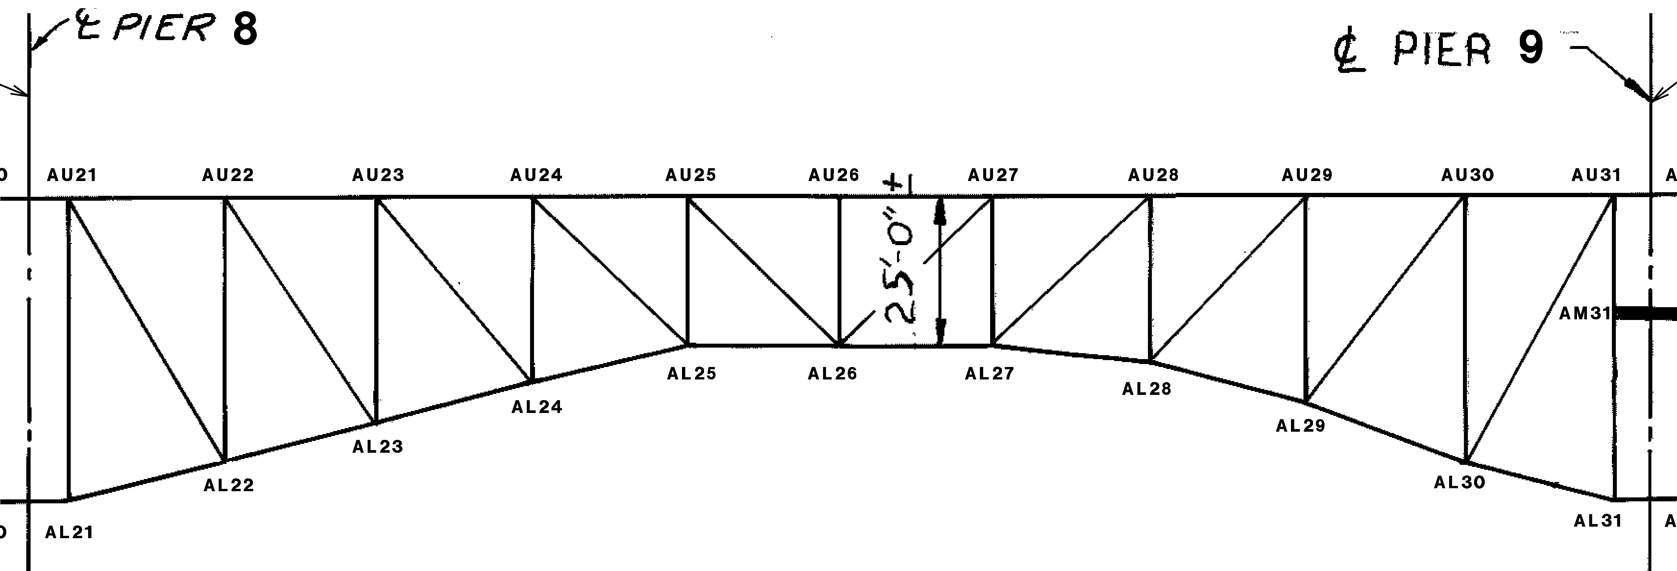
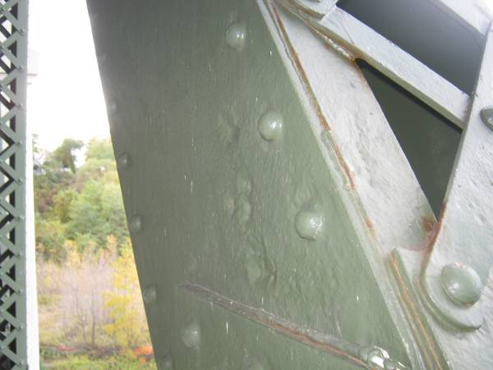
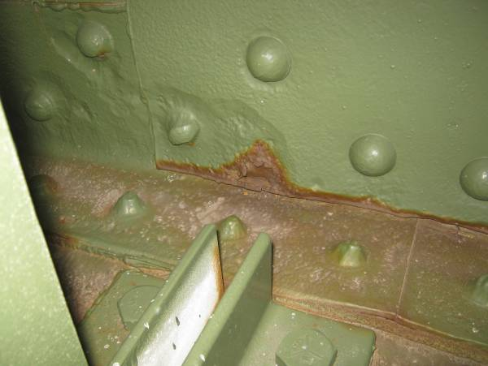
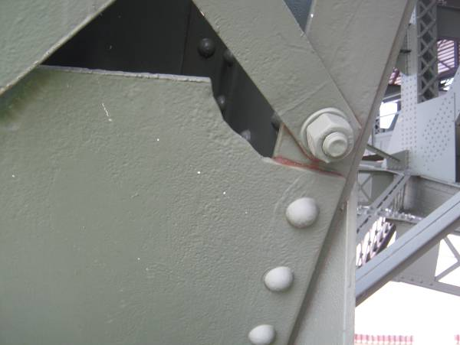
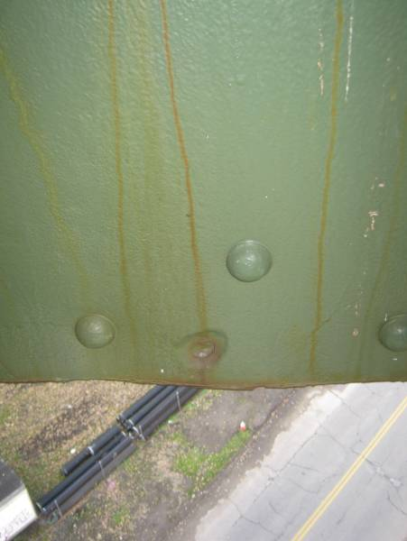
The south web splice plate at AL27 exhibits 1/4″ pitting with reactivating rust along the lower flange. Additionally, the adjacent bottom flange exhibits pitting up to 1/4″ deep and the rivet heads connecting the lateral bracing connection plate exhibit significant loss of section.
The lower cover batten plate of AL23-AU22 has been flame-cut to accommodate previous repair work done at this location. Note retrofit bolt at the lower lacing connection.
The north web plate of AL26-AL27 exhibits isolated advanced loss of section with a 2″ diameter perforation within the bounds of the vertical leg of the bottom flange.
SPAN 8
TRUSS A
The south web plate of AL23-AU22 exhibits pitting up to 3/16″ deep along the gusset plate interface.
1/2″∅ hole in the lower lateral bracing connection plate

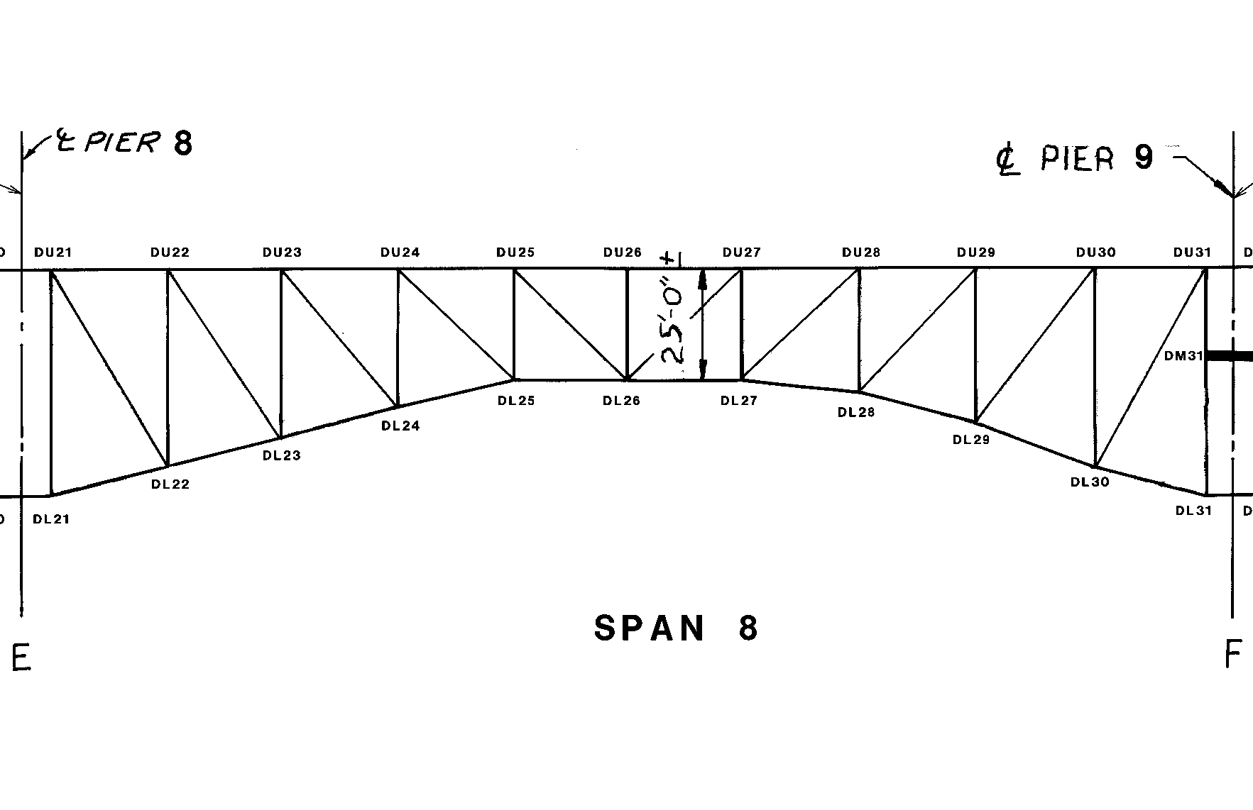
SPAN 8
TRUSS D
The floorbeams in Span 8 typically exhibit 1/16″ deep pitting throughout the east face between Stringer 2 and Truss D, with up to 1/4″ pitting found in isolated areas.
1
1/16″ deep pitting is typical over the full height of the north web plate adjacent to gusset plates throughout Span 8. Pitting at DL22 is up to 1/8″ deep at this location.


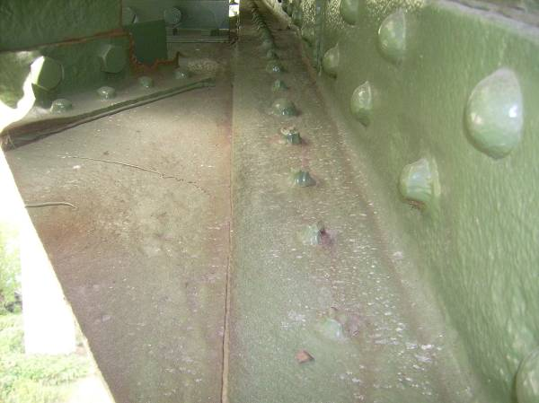
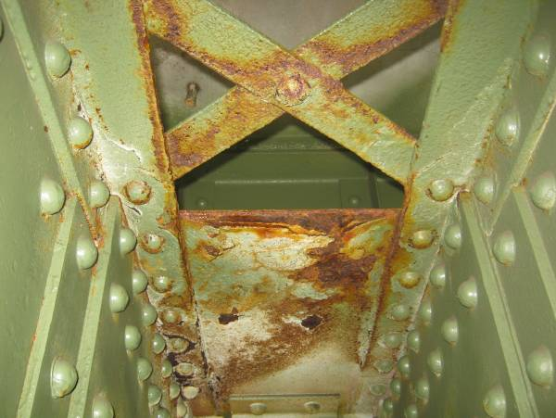
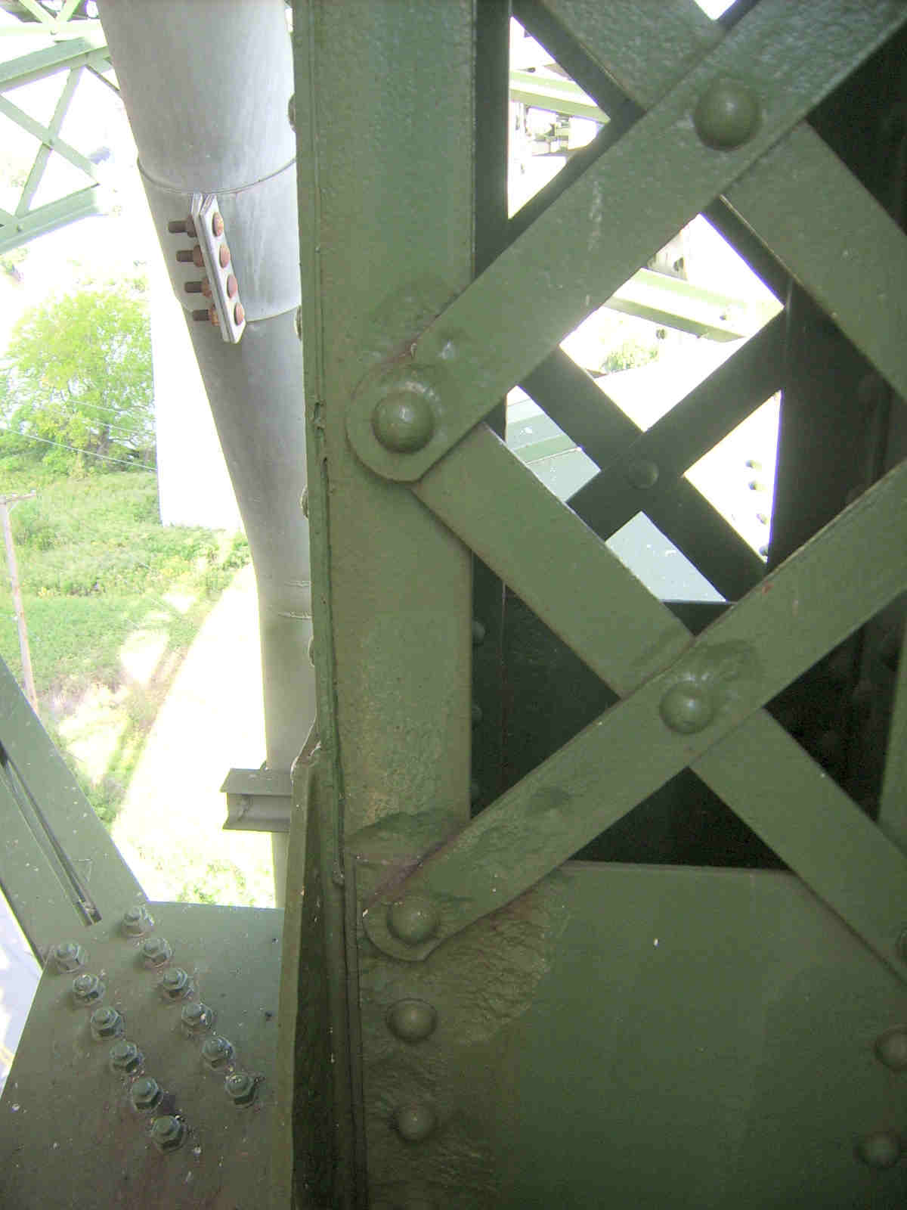


Section A-A
6″ Ø area of 1/4″ loss
3″ Ø area of 1/4″ loss
x
x
x

x
x
x
x
x
x
x
x
x
Full height of web plate with 1/8″ loss
The interior of the upper chord between the gusset plates at DU29 exhibits active rusting with only minor surface pitting.
DL21-DU21 exhibits areas of heavy pitting (up to 1/4″ deep) adjacent to the lacing connections on the flange angle legs and the lacing bars near the lower panel point.
Heavy pitting is typical along the horizontal surfaces of members at DL23, including approximately 50% loss of 9 of the 20 rivet heads connecting the lower lateral gusset plate to the lower chord flange at this location (cleaned and painted).

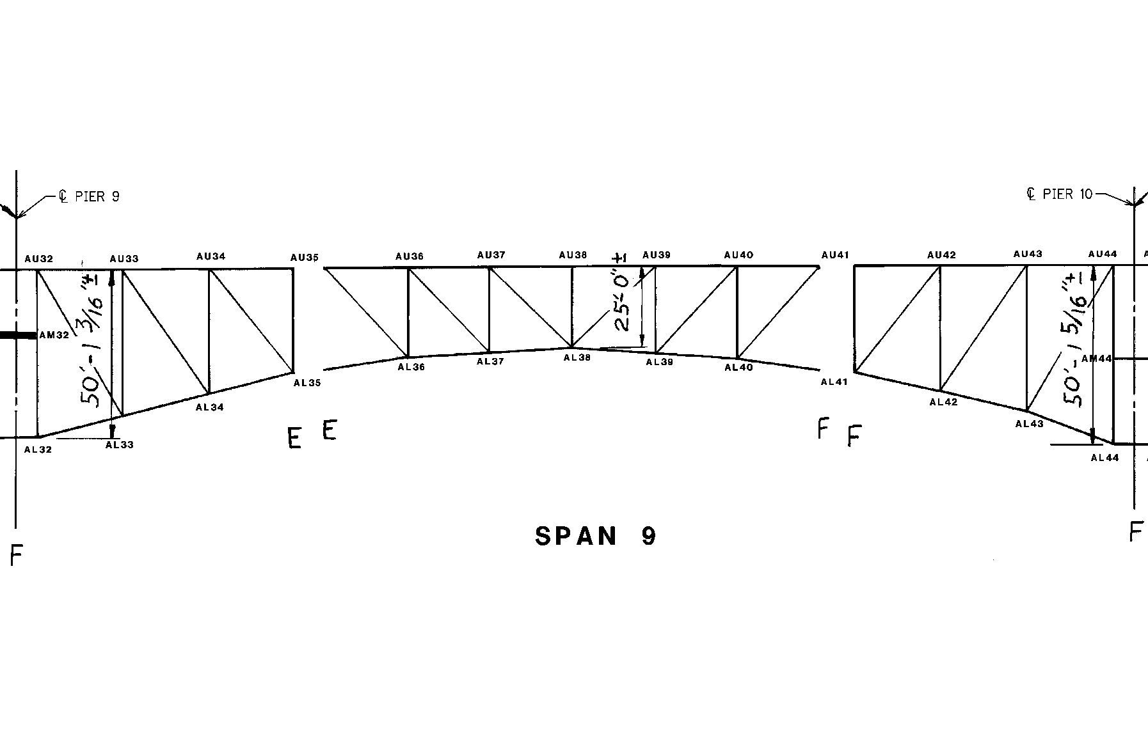
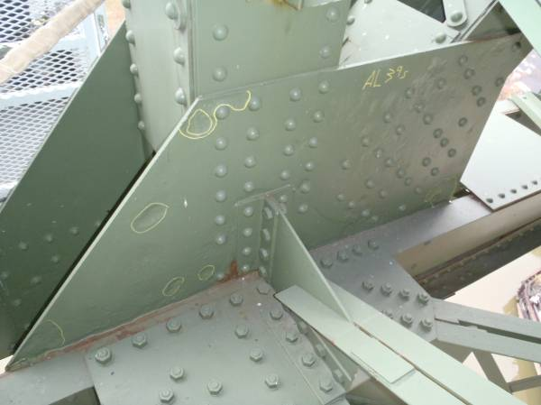
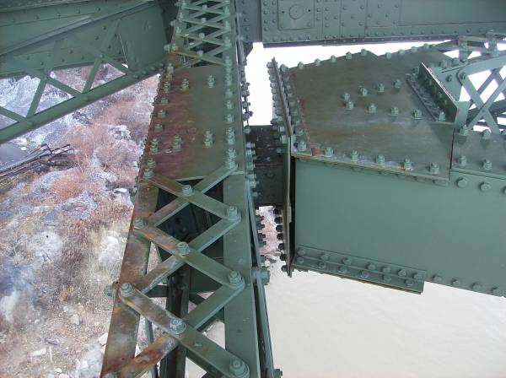
AL39S exhibits heavy isolated pitting throughout the south face of the plate. The remaining plate thickness at one location adjacent to the lower chord is 1/4″.
The built up strut at AL41 exhibit active surface corrosion throughout.

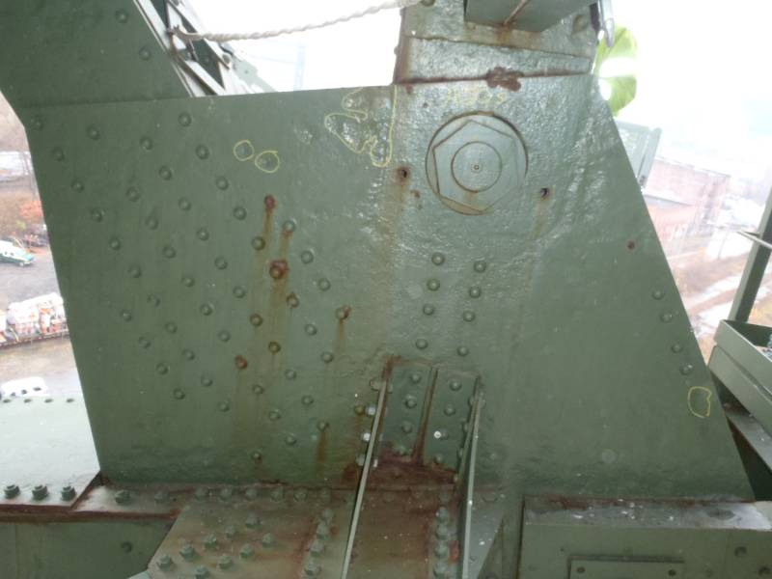
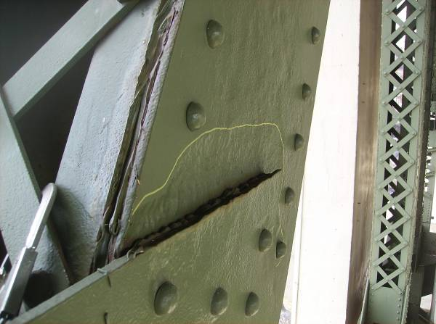
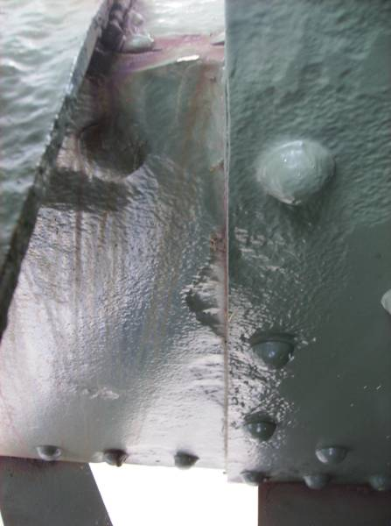
AL35S exhibits heavy pitting throughout the south face of the plate, with 1/4″ losses in isolated areas.
The south web plate of AL43-AU44 exhibits 1/4″ deep pitting across the full height of the plate at the lower gusset plate interface.
The south web plate of AL41-AL42 exhibits 1/4″ deep pitting along the gusset plate interface.
SPAN 9
TRUSS A

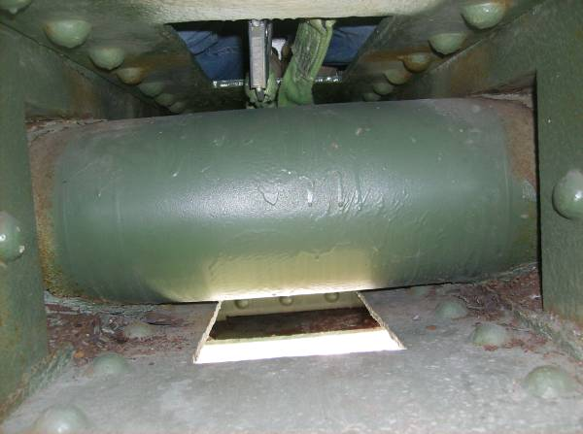
The lower sliding pin at BL41 exhibits losses up to 1/8″ adjacent to the pin plates along the pin circumference. The pin at BL35 exhibits similar conditions in addition to minor corrosion throughout the surface of the pin.

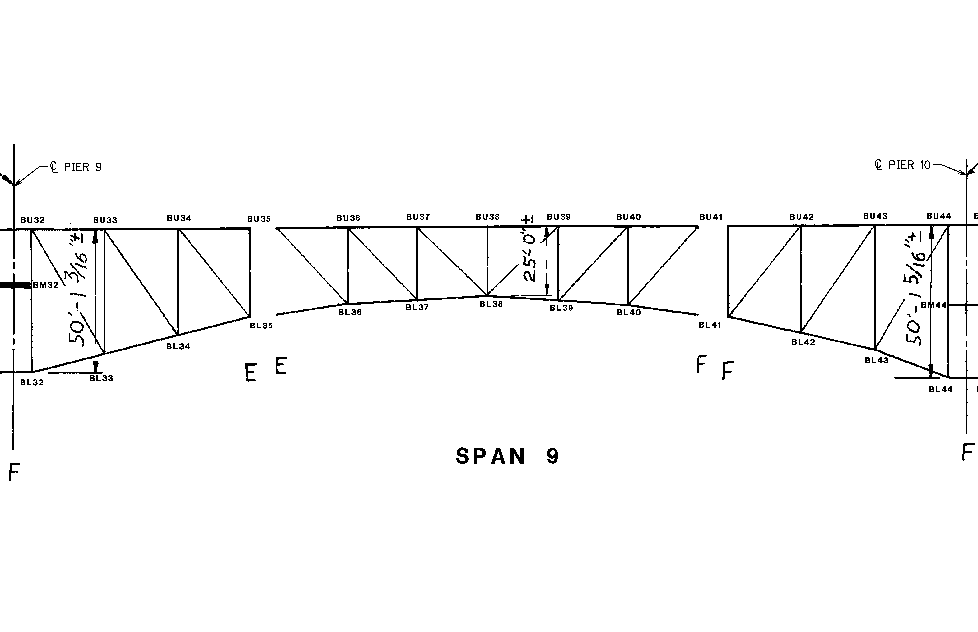
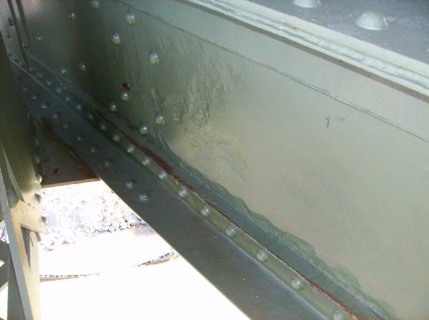

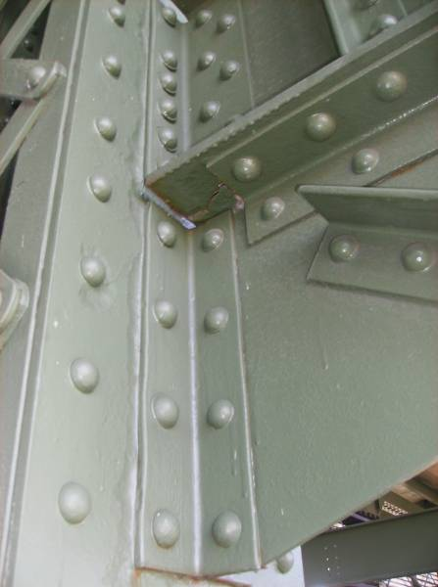
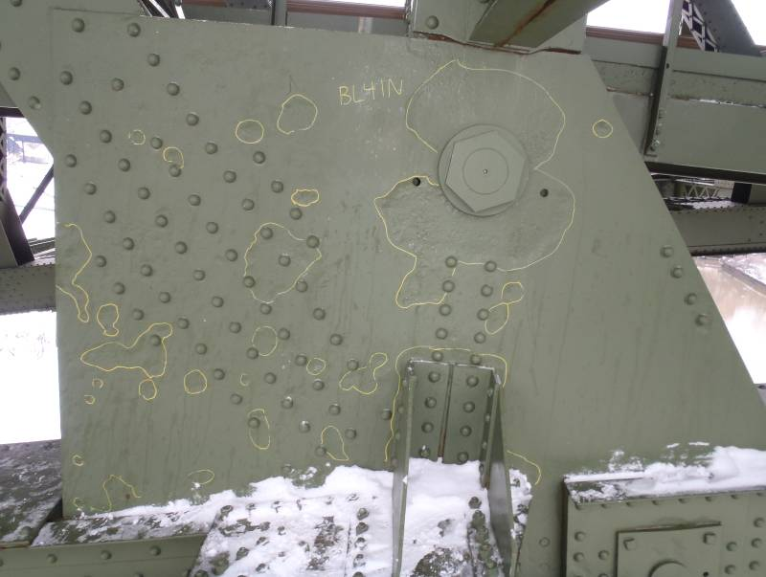
SPAN 9
TRUSS B
Heavy pitting of the north web plate along the bottom flange angle is typical for the lower half of BL35-BL36. The pitting on this member progressively worsens from west to east, with up to 5/16″ deep pitting near BL36 (shown in photo).
BL40-UL40 exhibits up to 3/16″ deep pitting adjacent to the sway strut connection (see Section A-A).
The north gusset plate at BL41 exhibits isolated areas of pitting up to 1/4″ with losses between 1/16″ and 1/8″ common throughout the north face. The north and south gusset plates at BL35 exhibit similar conditions.
3/16″ pitting adjacent to the strut connection
X X X X X X
Section A-A

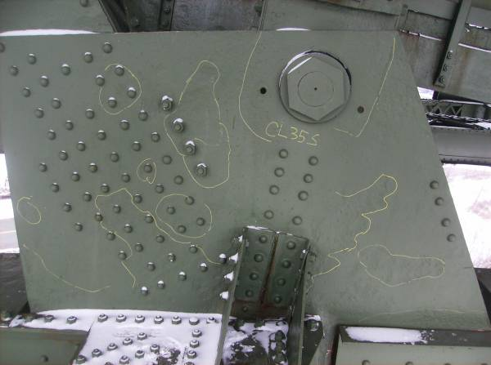
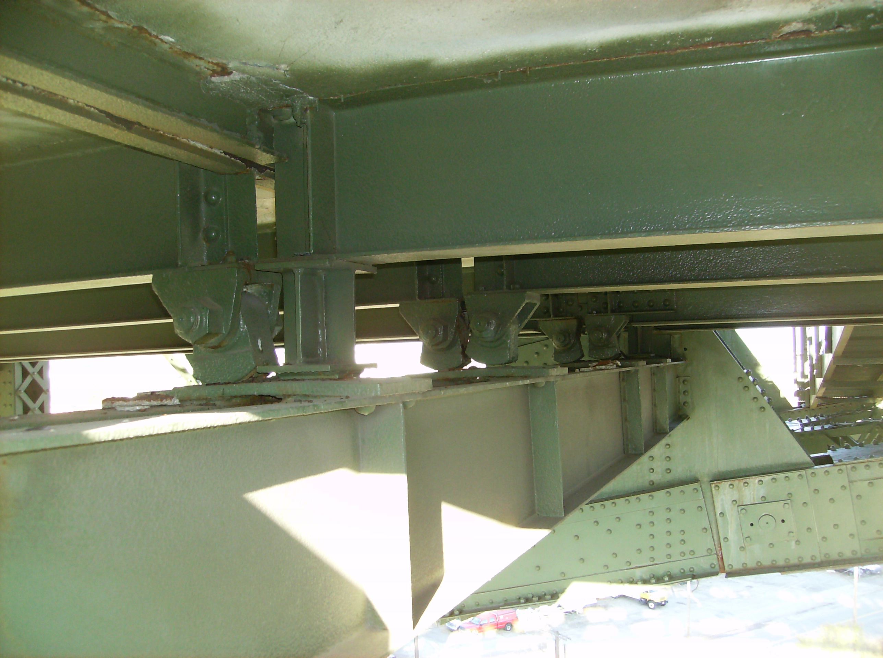
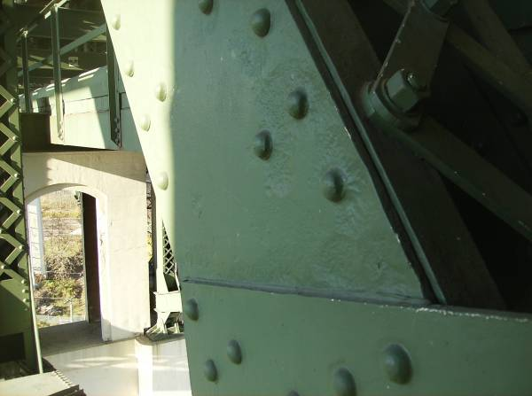
The south gusset plate at CL35 exhibits 1/8″ deep pitting throughout areas of the south face, with small areas with up to 1/4″ deep pits on the north face of the plate along the lower chord.
SPAN 9
TRUSS C
Stringer 3 is not bearing properly at the utility deck Floorbeam 35 bearing plates. Stringers 1 and 4 have retrofitted bearings, consisting of modified beam sections with welded vertical stiffeners. Note that pack rust between the top floorbeam flanges and the bearing plate has caused the plates to bow up.
The south web plate of CL35-CL34 exhibits 1/8″ deep pitting along the full width of the plate at the interface with the lower gusset plate.

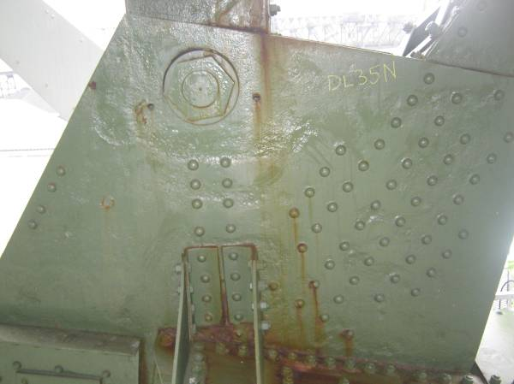
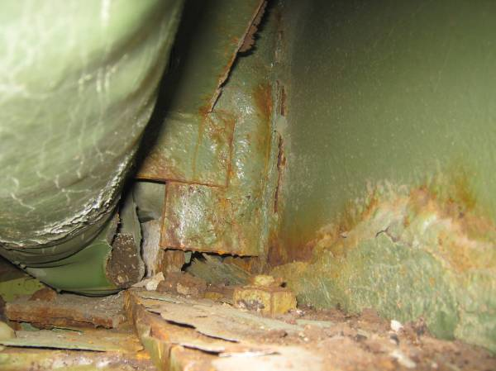
Rust reactivation is typical at the pinned gusset plates due to joint failures above (DL35N shown).
Floorbeam 35 exhibits active corrosion of the bottom flange and the adjacent web and vertical stiffeners with up to 1/16″ deep pitting. The joint trough has failed and water and debris are leaking onto the floorbeam.

The top cover plates on the lower chord exhibit isolated pitting up to 1/8″ deep throughout Span 9. Note: this condition is typical for both Trusses A & D throughout the entire structure.
The bearing pin at DL35-UL35 exhibits pitting up to 1/4″ deep along the circumference adjacent to the pin plates. This condition is common, though typically less severe, among the main bearing pins throughout the structure.

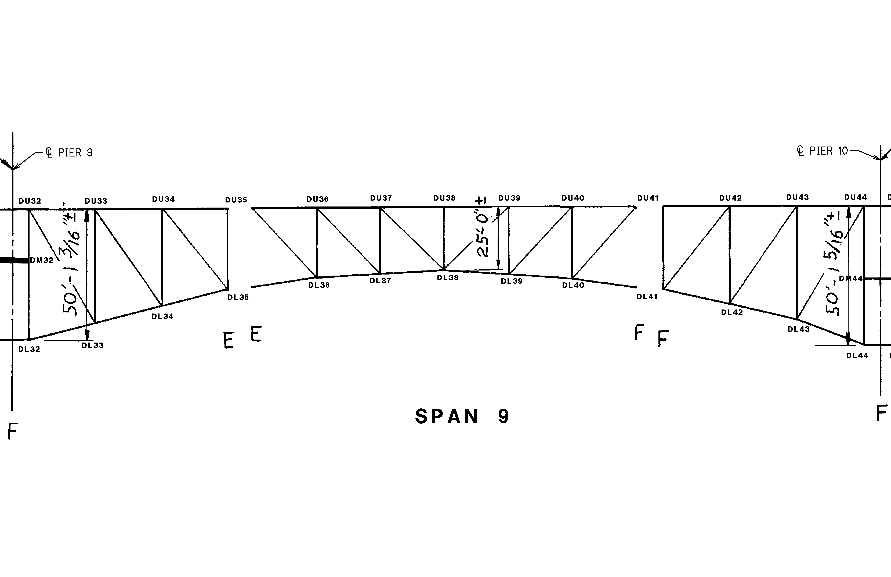
SPAN 9
TRUSS D

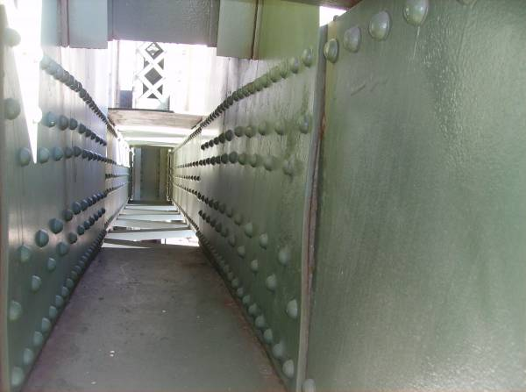
3/4″ thick pack rust has formed between the DL43 south gusset and the lower chord web plate resulting in localized minor distortion. This condition was also noted at DL37 in Span 9.
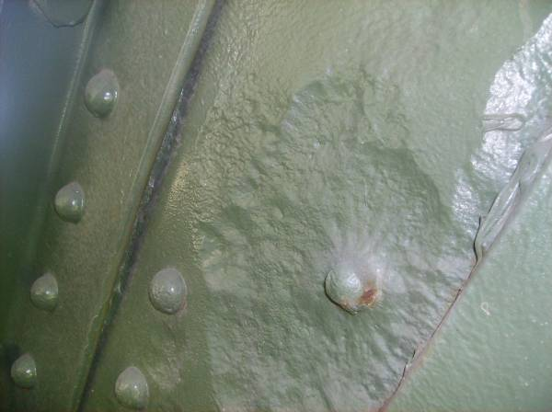
The south web plate of DL35-UL34 exhibits 3/8″ deep pitting on the interior face between the flange angle legs. This area is located approximately 1′ above the lower gusset plate (see Section A-A).

Between Truss D and Stringer 2, Floorbeam 42 exhibits a 1/4″Ø hole in the lower half of the web with 1/16″ pitting typical in the surrounding area along the bottom flange.
Eight of the 16 rivet heads at the lower lateral connection for DL35-CL35 exhibit significant loss at Truss D, with adjacent heavy pitting of the lower chord flange.

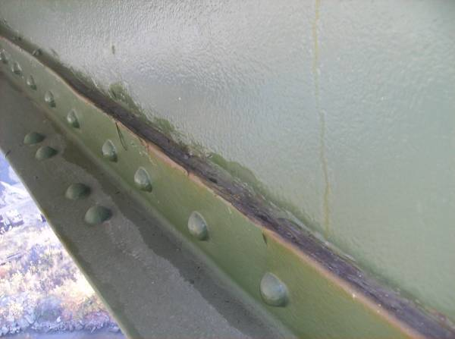
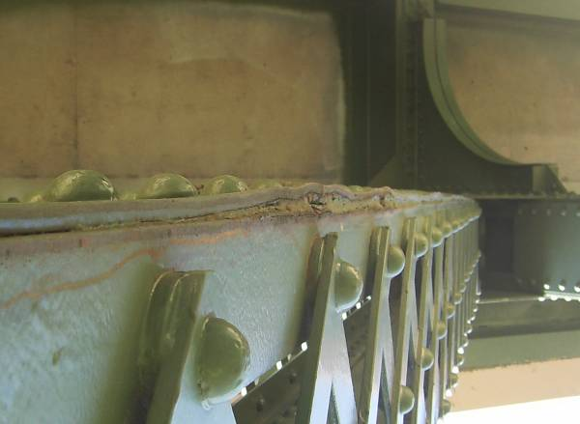
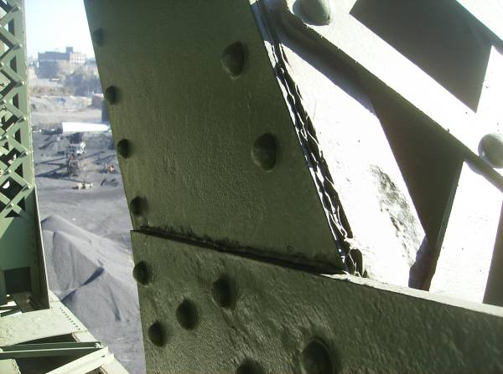
Lower chord members typically exhibit north web plate pitting along the bottom flange interface throughout the structure. DL34-DL35 exhibits up to 1/4″ deep pitting (4″ tall) for 3/4 of its length.
Pack rust between the bottom flange angle and web plate of diagonal members is common throughout the structure. Minor distortion can be seen as a result of the 1/2″ thick pack rust at DL42-DU43.
At the seam between the interior lower gusset plate and the diagonal web plate, 1/4″-5/16″ deep pitting was noted on member DL42-DU43. Note also the 1/4″ deep pitting of the northwest flange angle.
XX
X
X
X
x
x
x
x
x
x
Section A-A
Pitting up to 1/4″ deep for half the web width
Pitting up to 3/8″ deep

