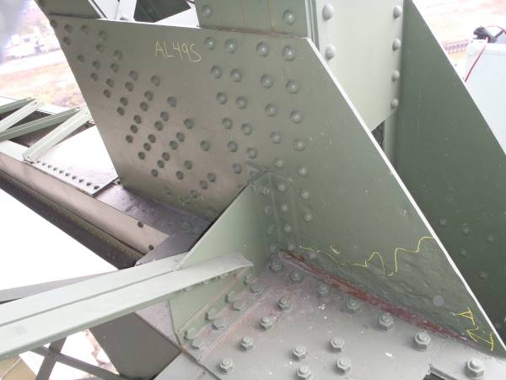
AL49S exhibits heavy pitting up to 1/4″ deep along the lower chord interface, as outlined on the plate.
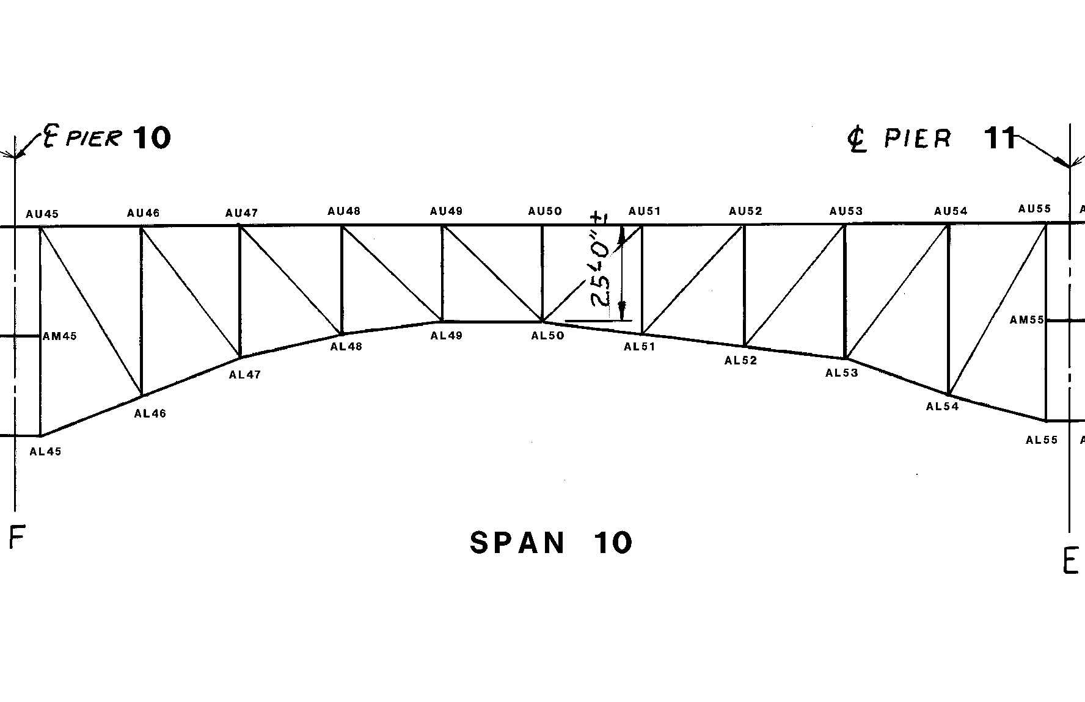
SPAN 10
TRUSS A

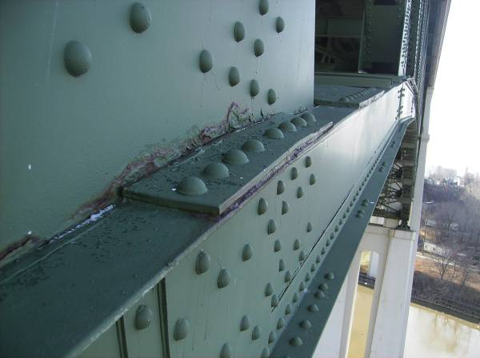
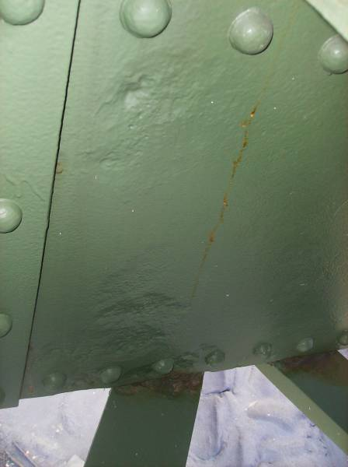
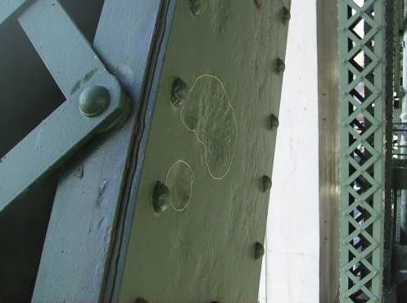
The top flange splice at AL53 exhibits minor distortion due to pack rust forming. Note the adjacent active rust on the gusset plate.
The south web plate of AL48-AL49 has heavy pitting up to 1/4″ deep for approximately half the web height near AL49. Similar conditions are found at AL 51.
The south web plate of AL54-AU55 exhibits isolated areas with up to 3/8″ deep. The largest area measures 6″∅ and is shown above.

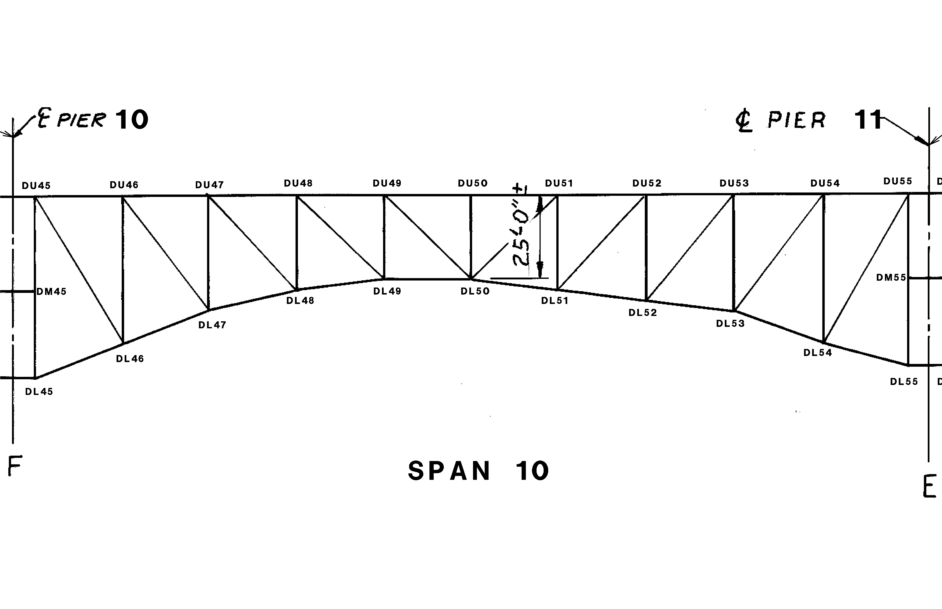
SPAN 10
TRUSS D

Similar to other spans throughout the structure, the lower chord north web plates exhibit losses along the lower flange angles. Losses in Span 10 are typified by 1/16″-1/8″ deep pitting occurring within the lower 2″ of the web and along 1/3 to 1/2 the length of each bay. This condition is typical throughout the structure on Truss D. The adjacent flange angles exhibit similar pitting. One location in member DL54-DL55 exhibits advanced section loss with “pinholes” in the outstanding leg.
2
Pack rust up to 1/8″ is typical (isolated up to 3/4″) between the diagonal member web plates and the lower flange angles along the length of the members.
2″ diameter hole in the lower chord north angle leg at DL52.

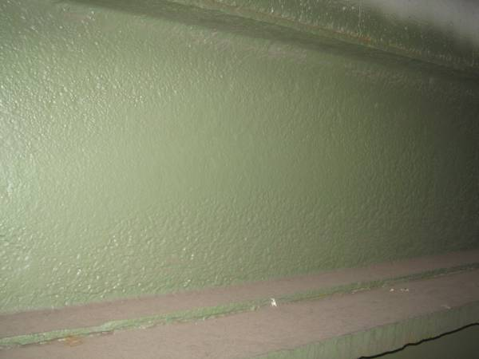
Pitting up to 1/8″ deep is freckled throughout the south face of Stringer 2 between Floorbeams 53 and 54. This condition is common for Stringer 2 throughout Span 10.

1
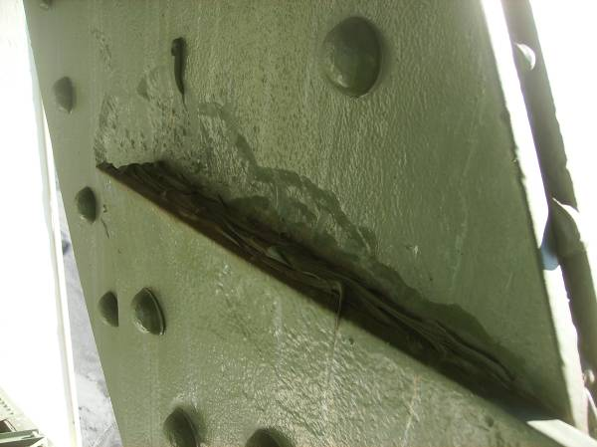
Member DL50-DU51 exhibits pitting of the north web plate at the interface with the lower gusset plate. Pitting at this location averages between 1/8″ to 1/4″ deep for the width of the plate.






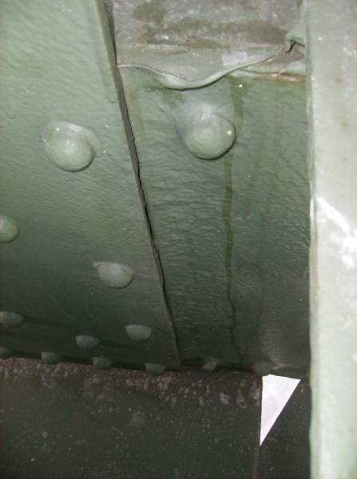
DL50-DL51 exhibits up to 1/4″ deep pitting over the full height of the north web at DL50. 1/8″ pitting is typically found at similar locations throughout the lower panels in Span 10.

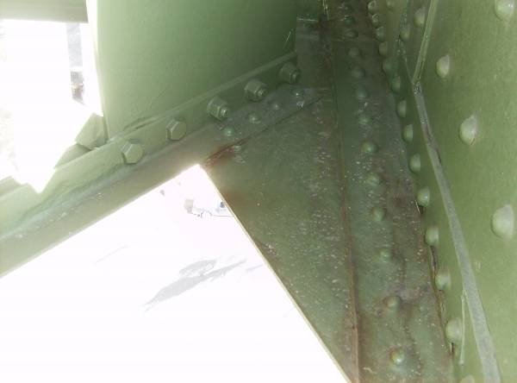
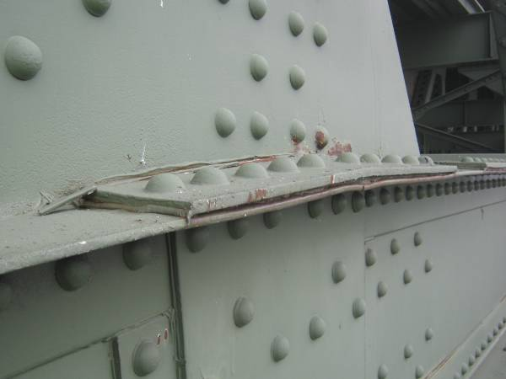
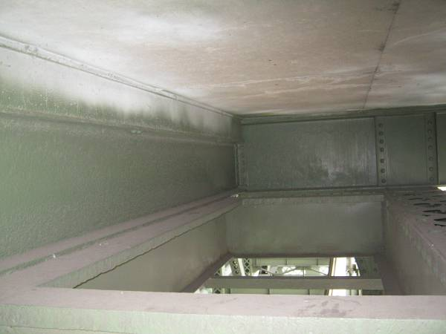
The lower lateral bracing connection plates typically exhibit pitting between 1/16″ and 1/8″ deep, with localized pitting up to 1/4″ deep. The adjacent bottom flange angles exhibit similar pitting. Light surface corrosion is typically forming at these locations.
At the flange splice plate at panel DL49, 1/2″ thick pack rust has developed and is deforming the flange angles. Reactivating pack rust at this detail is typical of lower chord splices throughout Span 10.
Between Floorbeams 53 and 54 an appurtenance (platform) is stitch welded to Stringer 1 and the interior face of the upper chord of Truss D.

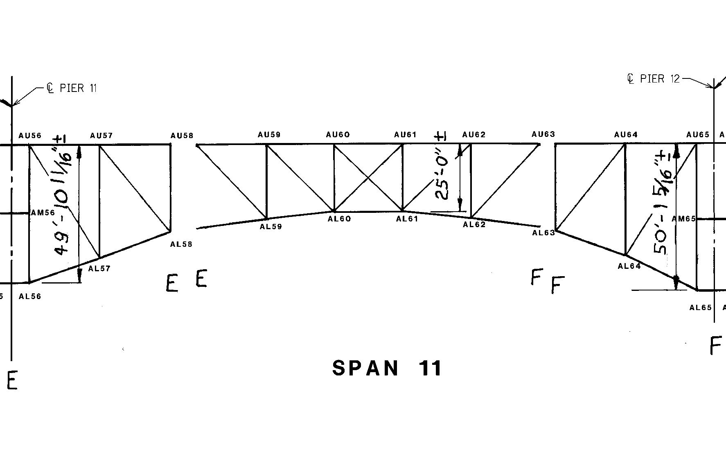

SPAN 11
TRUSS A
X X X X X X X X X
x x x x x x x x x x x
Section A-A
1/4″ pitting x full web height, with 3 small areas with up to 5/16″ loss
1/8″ pitting x full web height

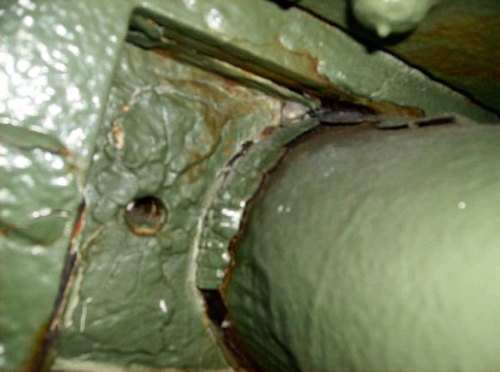
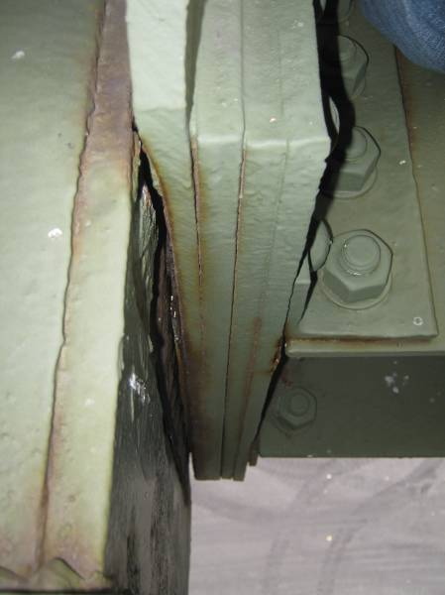
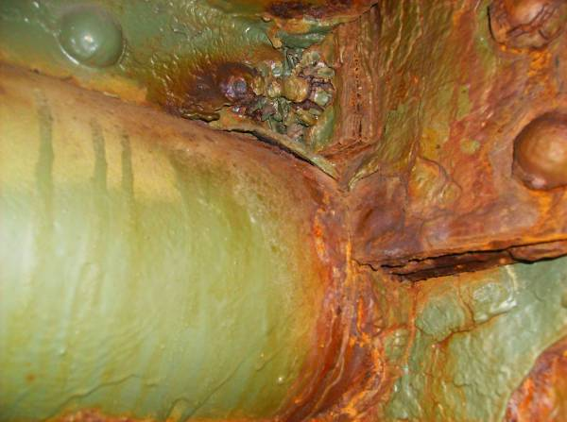
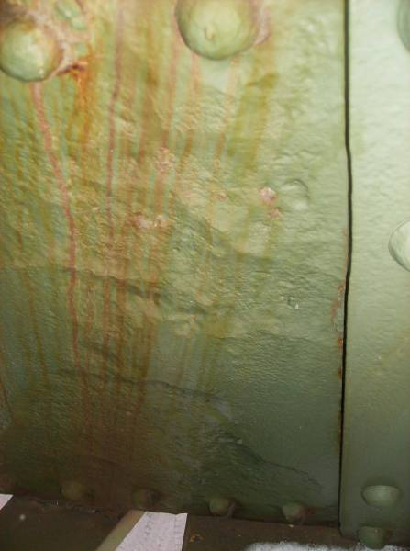
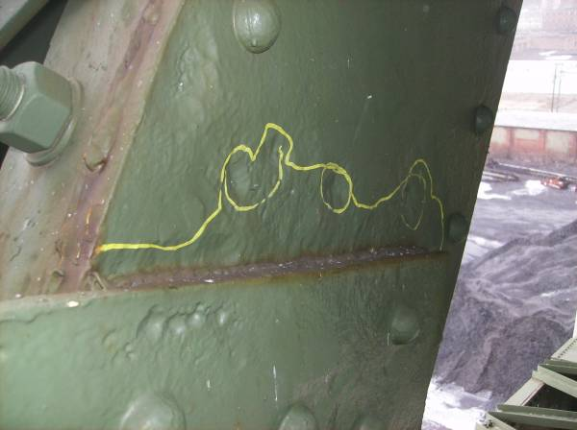
The lower sliding pin at AL63 is heavily corroded with rust scaling at the pin to pin plate interface. Rust is reactivating throughout these components.
Pitting up to 1/4″ deep is present on both members at the interface of the south pin plates and the south web plate of AL58-AL59.
Heavy corrosion is present throughout the interior of AL58-AU58 at the lower panel bearing pin.
The south face of the AL63-AL64 south web exhibits 1/4″ deep pitting along the full height of the plate at the AL63 gusset plate interface.
The south web plate of AL63-AU64 exhibits 1/4″ deep pitting across the full height of the web, with three small areas with 5/16″ loss. The north plate exhibits 1/8″ loss in the same section (see Section A-A).

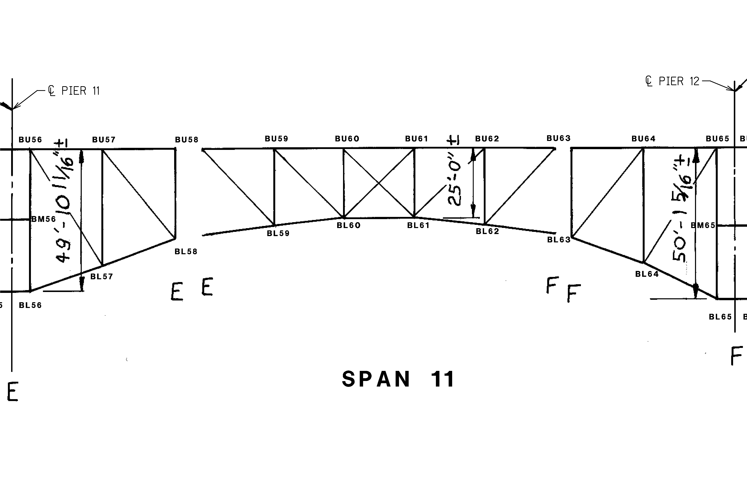
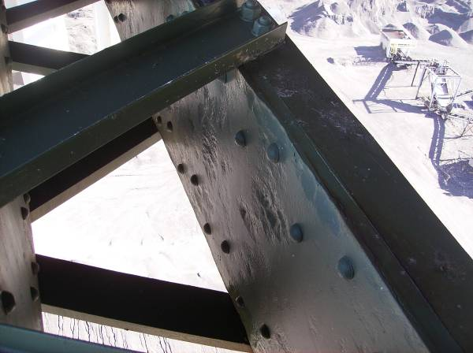
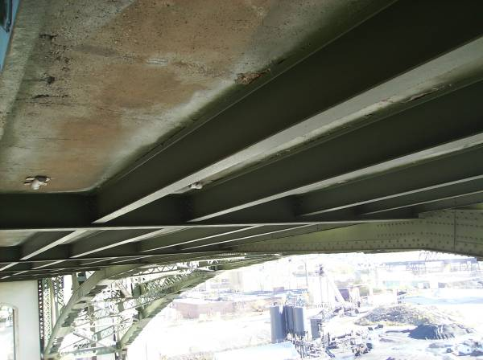
SPAN 11
TRUSS B
Localized heavy pitting up to 1/4″ deep is present throughout the north face of the south web plate at BL58-BL59.
Framing members throughout the structure are typically cleaned and painted. Floorbeam 59 is shown looking east.

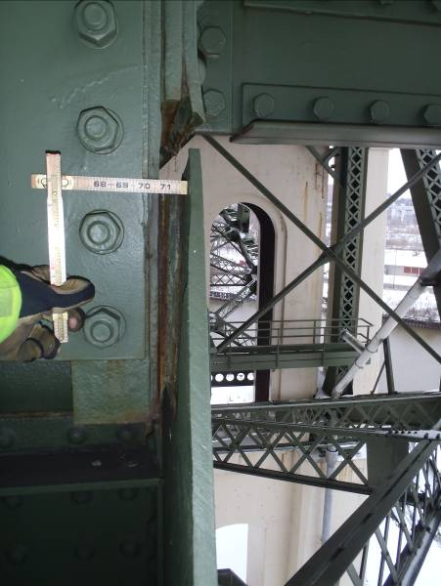
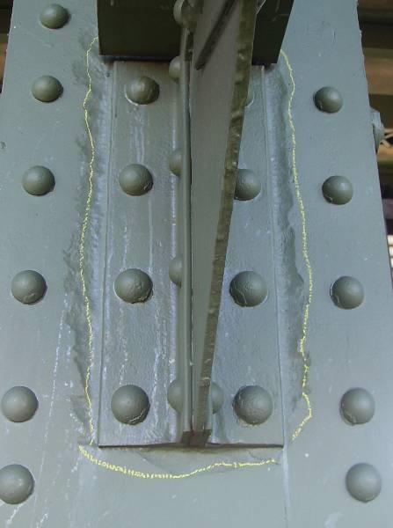
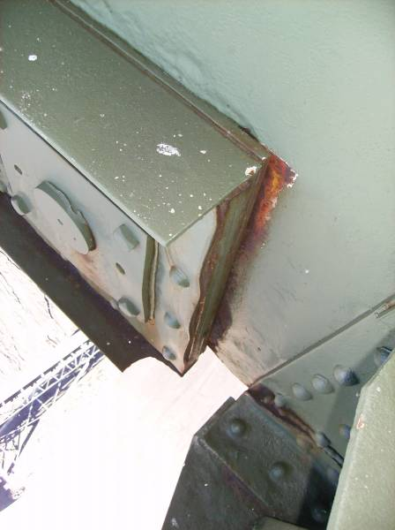
Pack rust up to 1.25″ has formed between the north gusset plate and the vertical member near the lower vertical pin at BL58.
BL59-BU59 exhibits web pitting up to 1/8″ surrounding the sway strut knee brace connection.
The north gusset plate at BL58 shows signs of abrasion with the lower chord at the sliding pin location, indicating movement of the suspended span. Note also the swelling of the pin plates between rivets on the lower chord member.

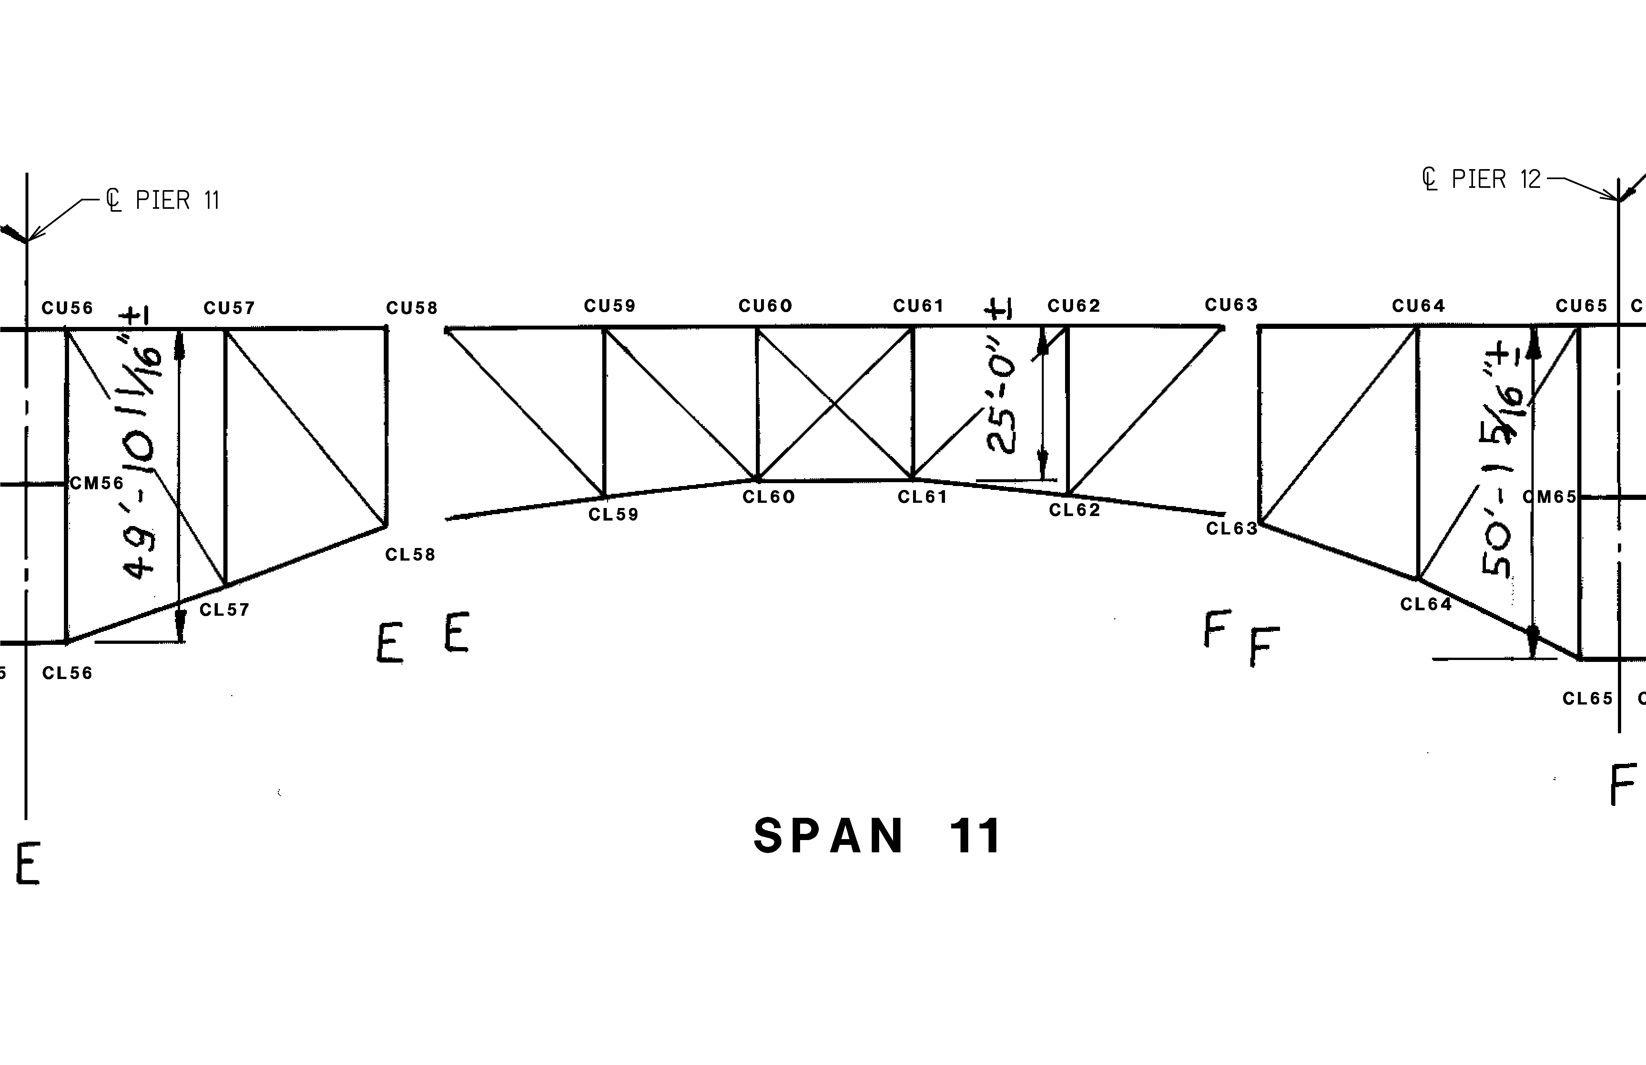
SPAN 11
TRUSS C
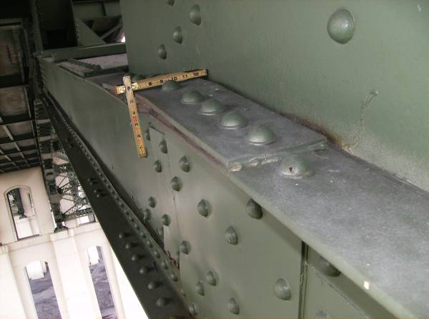

Pack rust at CL57S has caused distortion of the top flange and web splice plates. Approximately 1″ thick pack rust is present between the localized areas at each plate.

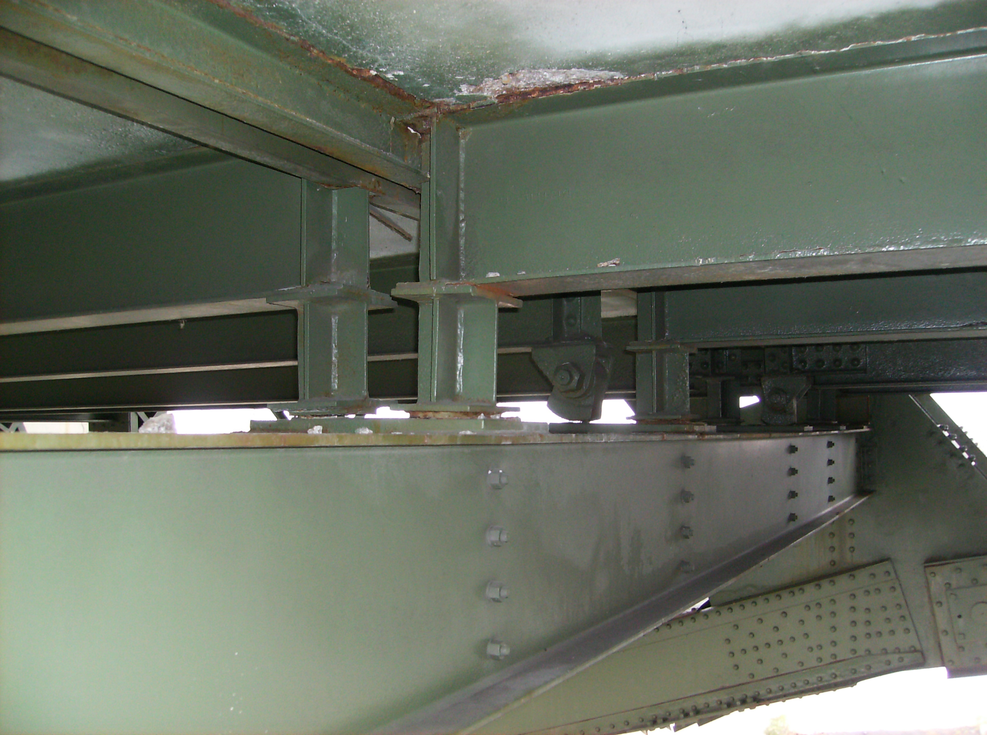
Isolated stringer bearings at utility deck Floorbeam 58 exhibit poor contact with the bearing plates (left). Additionally the retrofitted bearing for Stringer 4 in the near span (between L58 and L59) exhibits a cracked bearing to stringer bottom flange weld and is producing abrasion dust (right). The far span Stringer 3 rocker bearing is not in contact with the bearing plate (arrow).

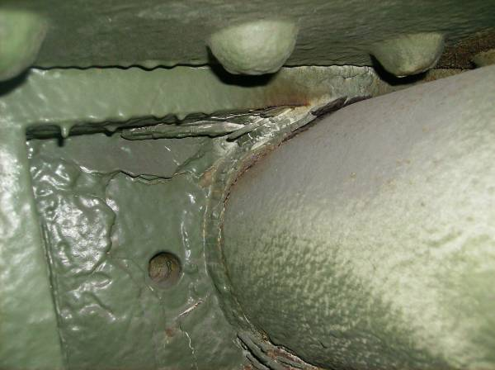
The sliding pin at CL63 exhibits pitting up to 1/4″ deep along the pin circumference. The pin plates also exhibit heavy pitting, especially along the pin interface.

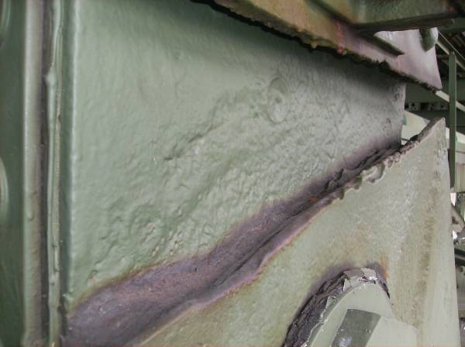
1/8″ deep pitting is typical (isolated locations up to 1/4″ deep) along the full width of both the north and south web plates of CL58-CU58 above the lower gusset plate interface

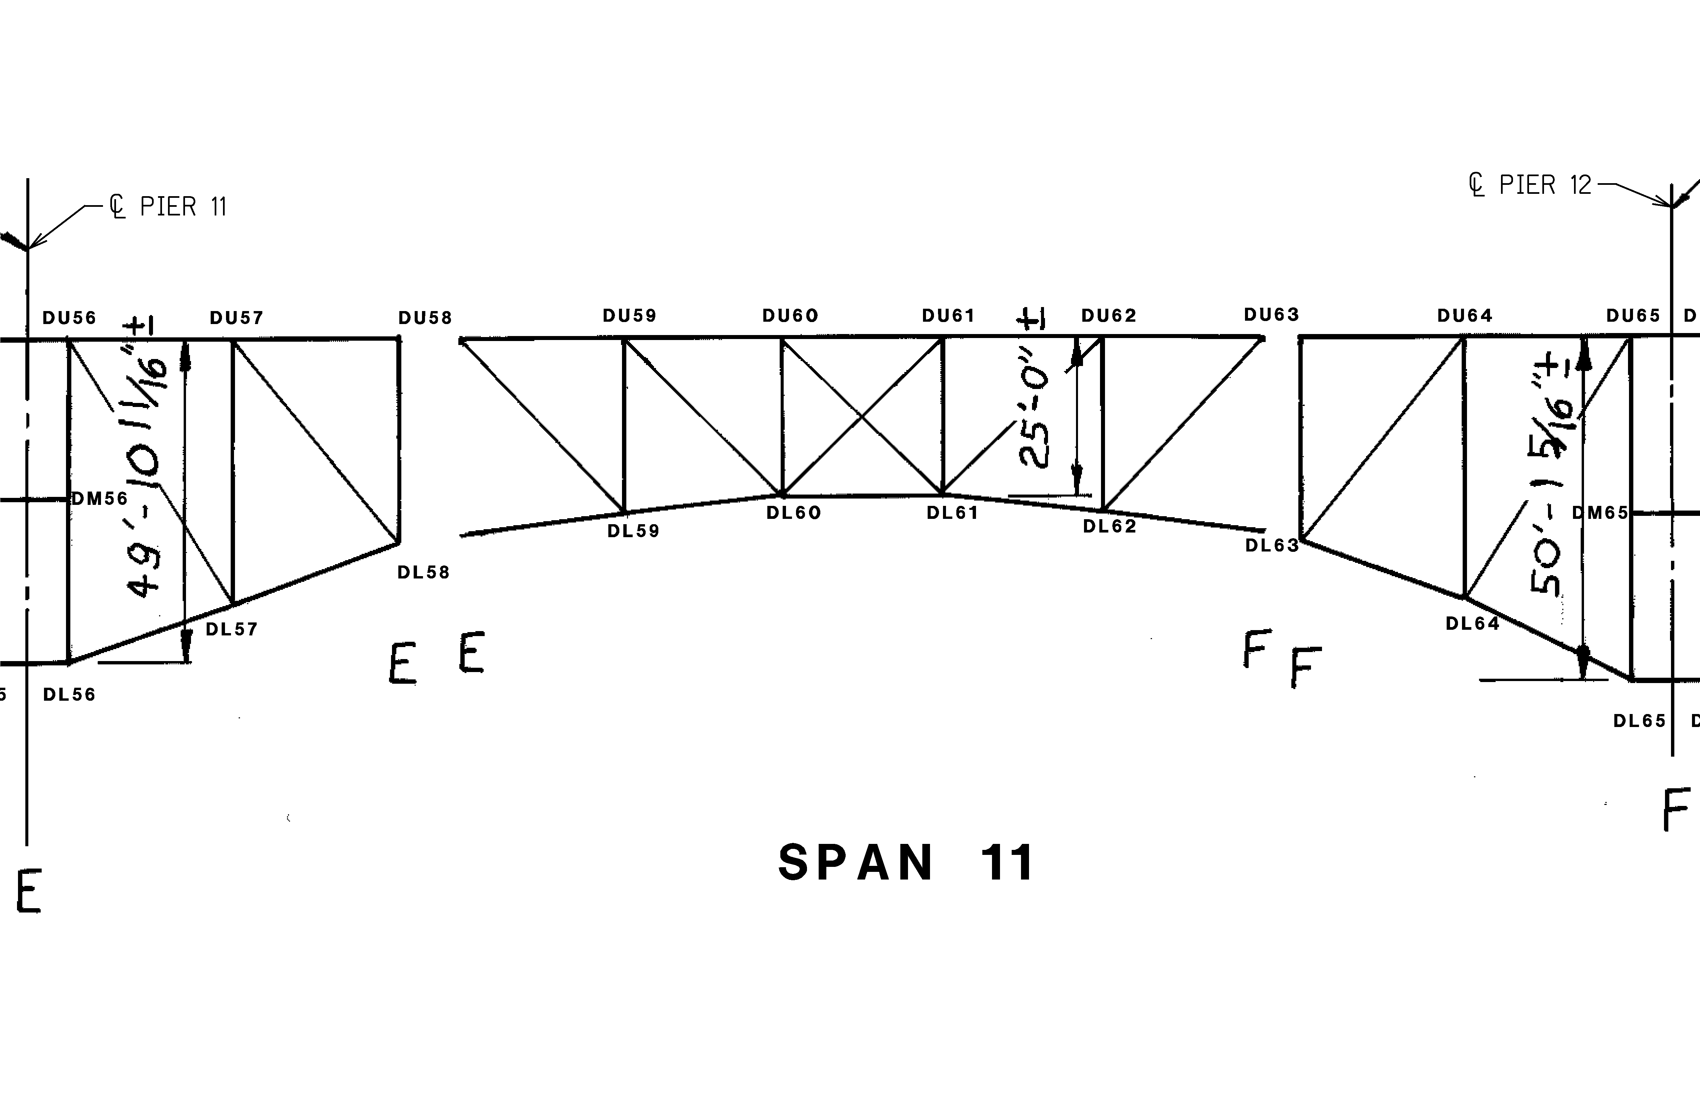
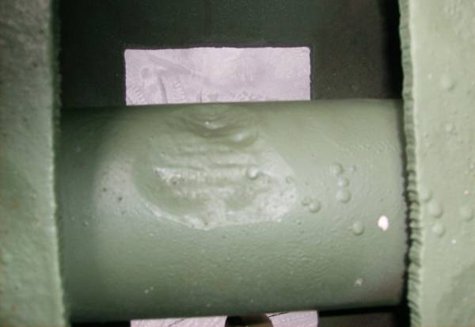
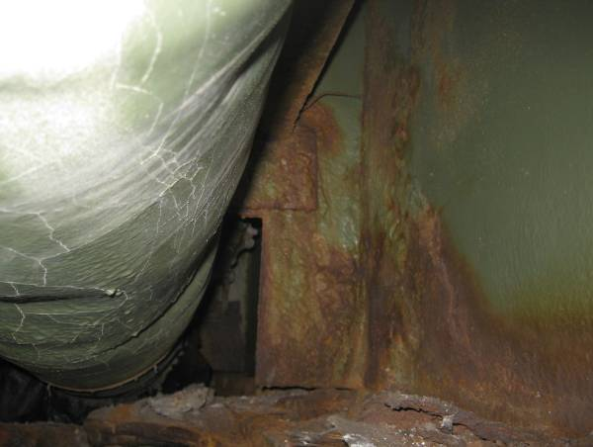
SPAN 11
TRUSS D
The lower sliding pin at DL63 has a 4″ diameter area exhibiting up to 5/16″ deep pitting. This location has been cleaned and painted with no active rusting.
Floorbeam 58 exhibits widespread moderate corrosion with 1/16″-1/8″ pitting adjacent to the drainage trough. This condition is typical for floorbeams at expansion joint locations due to joint deficiencies.
Similar to other spans throughout the structure, the lower chord north web plates exhibit losses along the lower flange angles. Losses in Span 11 are typified by 1/16″-1/8″ deep pitting occurring within the lower 2″ of the web and most of the length of each bay. The adjacent flange angles exhibit similar pitting.
Pack rust up to 3/4″ is found between the diagonal member web plates and the lower flange angles along the length of the members.

1
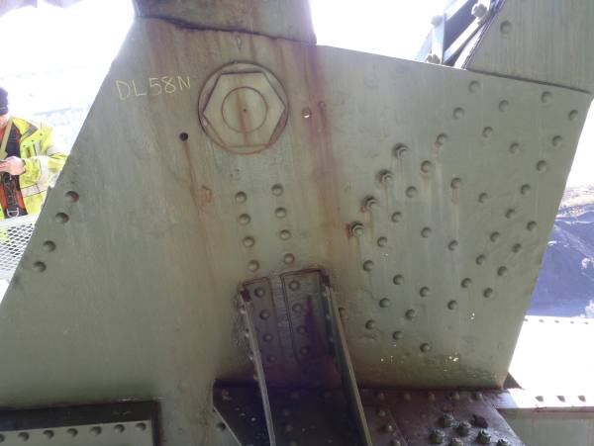
The north gusset plate at DL58 exhibits up to 3/16″ pitting, a condition typically found at the expansion locations throughout the structure.
1
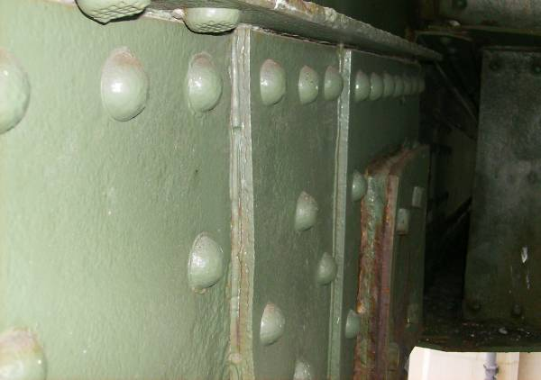
DL58-DL59 exhibits pack rust measuring approximately 1.5″ thick between the two outermost pin plates at DL58. Losses surrounding the pack rust are approximately 1/8″ on each plate. Similar conditions were noted at DL63 with 1/2″ thick pack rust.

Both gusset plates at DL64 are bowed approximately 3/16″ out of plane to the north.

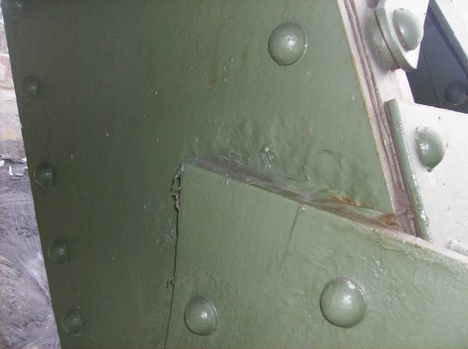
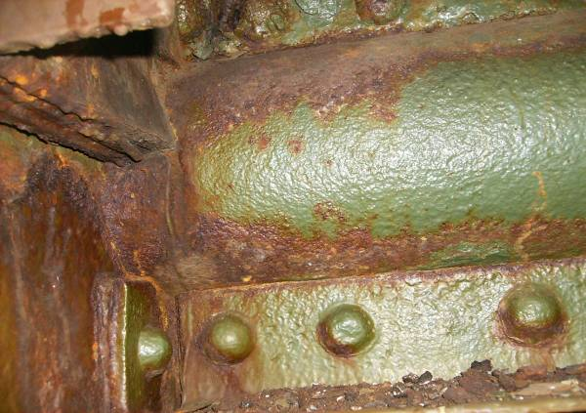
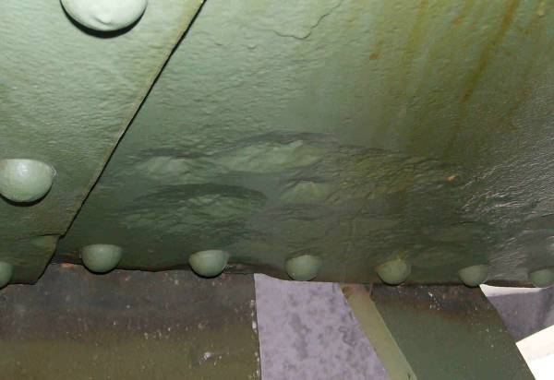
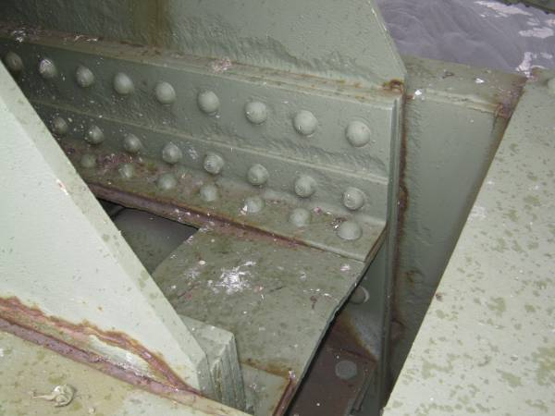
Pitting of the north web plate at the gusset plate interface on diagonal member DL64-UL65 is up to 3/16″ deep with light surface corrosion along the seam between the two plates. This condition is typical for Span 11, Truss D for other web members. Only member DL59-UL58 in Span 11 exhibited heavier pitting at this interface, with up to 5/16″ loss.
At the main bearing pin at vertical member DL58-UL58, surface rust is typical throughout with light to moderate pitting of adjacent components. Note: this condition is common among the truss pins, especially those below failed deck joints.
The lower half of the interior face of the DL64-DL65 north web plate exhibits pitting up to 5/16″ deep adjacent to the DL64 gusset plate. This condition is typical for Truss D lower chord web plates at the panel interfaces throughout Span 11; however, pitting varies from 1/8″ to the 5/16″ depth at DL64.
Active rusting is typical along the seams of the built up members at DL58. The south face of the north gusset plate exhibits 1/8″ pitting that has been cleaned and painted, while the same location on the south gusset plate exhibits up to 1/4″ loss (arrow). Additionally, note that the horizontal stiffener plate between the two gussets is bowed up, measuring approximately 1″ from its original plane.

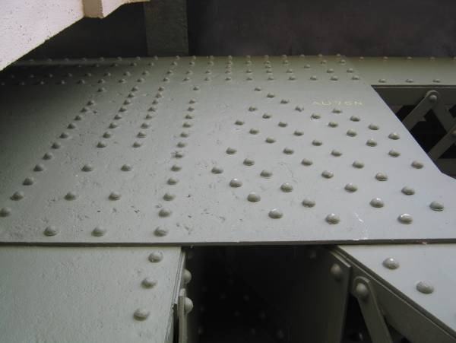
The north face of AU75N exhibits small, isolated locations of pitting up to 5/16″ deep. These areas are typically less than 1″ diameter each.
2″diameter hole in top stay plate of lower chord
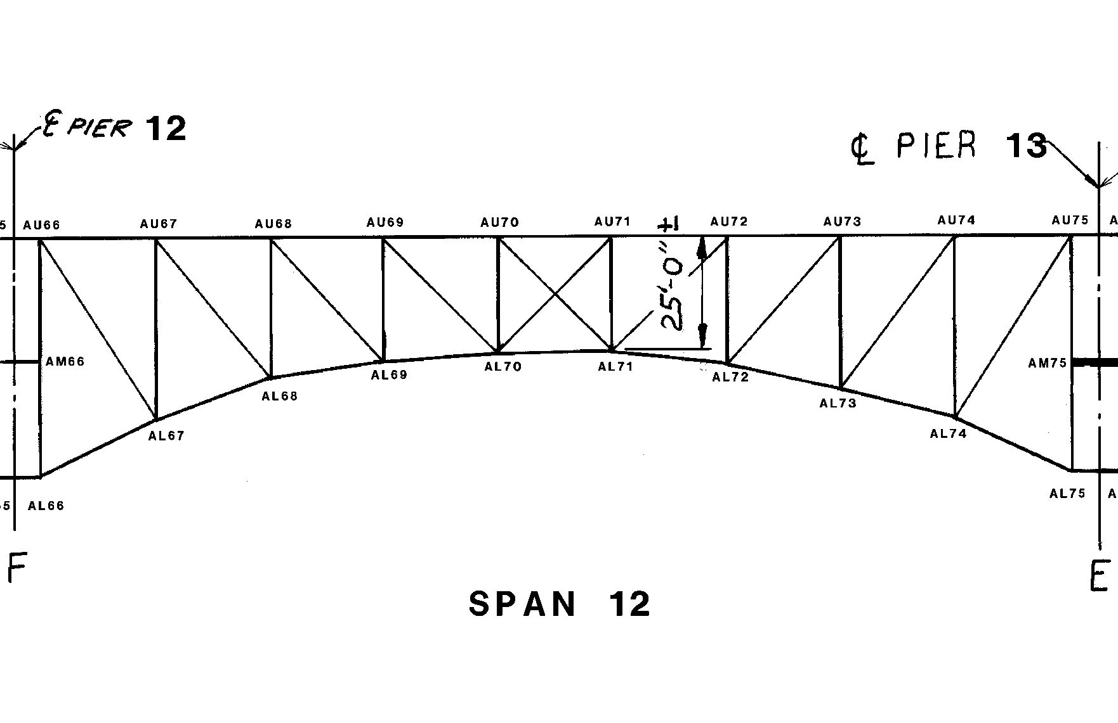
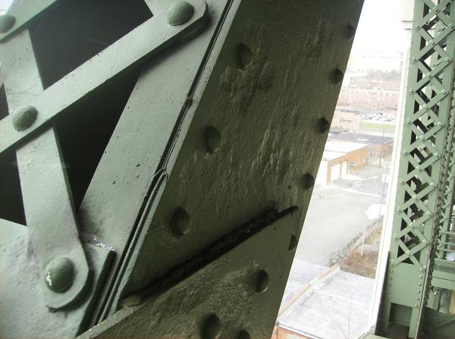
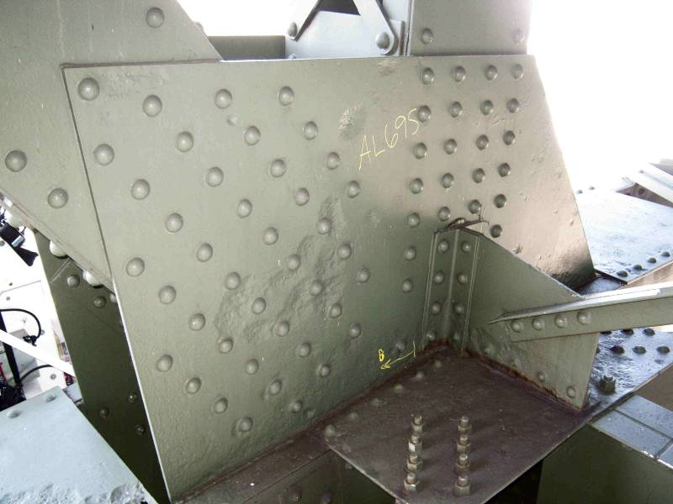
SPAN 12
TRUSS A
Heavy pitting is present along the web of AL73-AU74 at the lower gusset plate interface (Section A-A).
X X X X X X X X X
x x x x x x x x x x x
Section A-A
1/8″ pitting x full web height
3/16″ pitting x full web height
The south face of the south gusset plate at AL69 exhibits heavy pitting along the lower chord interface and adjacent to isolated rivet heads. Note the heavy pitting of the lateral connection plates at this location as well.
1″diameter hole in top stay plate of lower chord

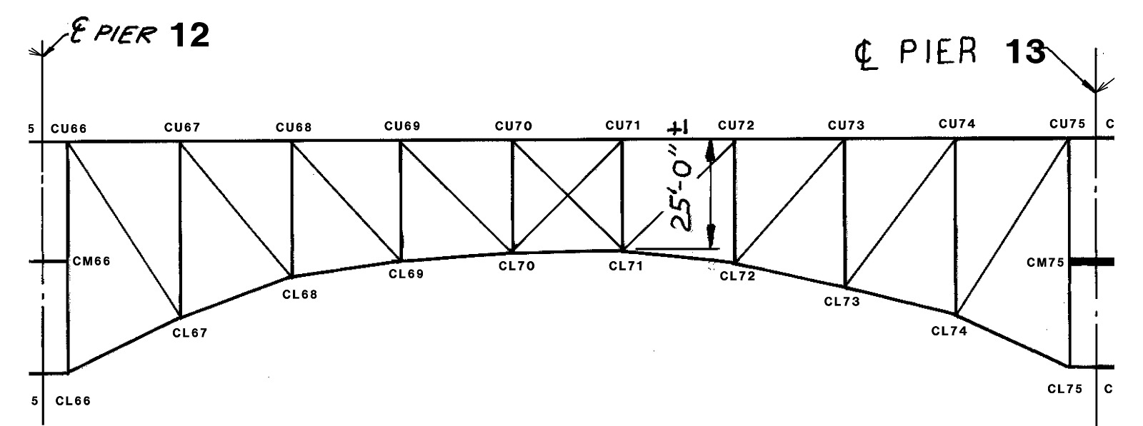
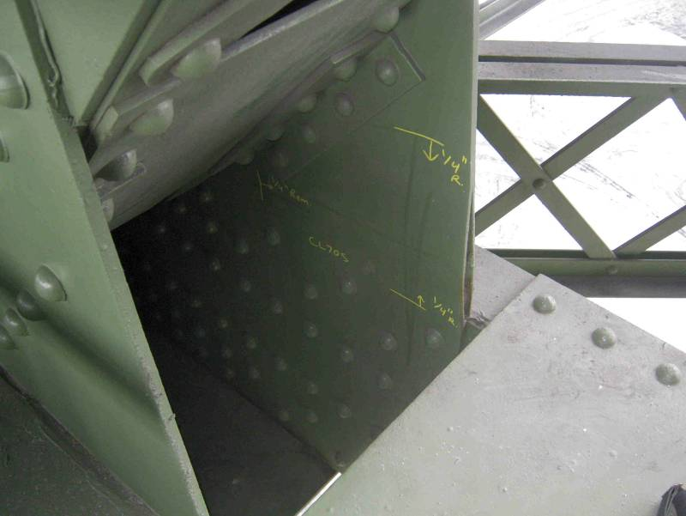
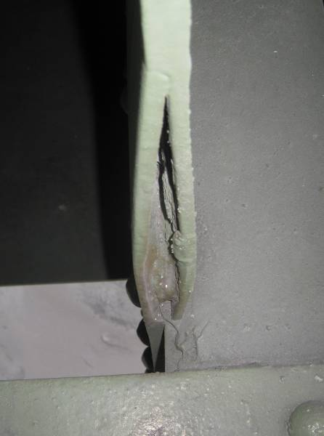
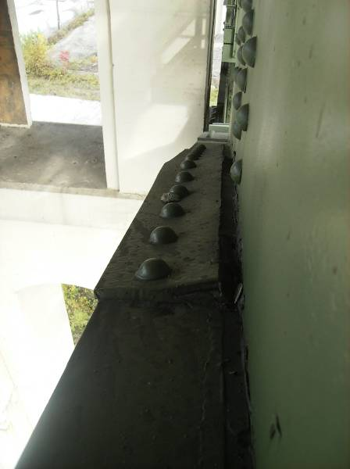
SPAN 12
TRUSS C
The south gusset plate at CL70 exhibits lamellar separation along the western free edge, with an effective remaining plate thickness of approximately 1/4″.
The top flange splice plate at CL74S is distorted due to pack rust.

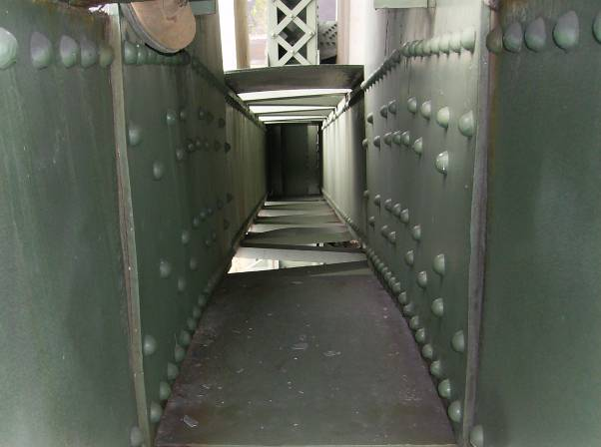
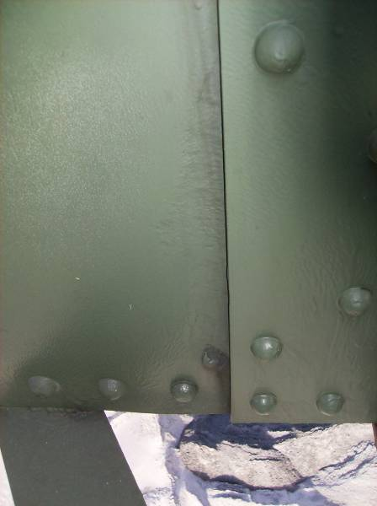
Pack rust between the gusset plates and web plates at DL67 has caused 1/2″ bowing of the gusset plates.
Adjacent to the north gusset and above the bounds of the lower flange angle, the lower chord web plate at DL72 is perforated by a 1″ diameter hole.
Stringer 1 exhibits up to 1/4″ pitting in the bottom half of the south face of the beam near the connection to Floorbeam 70.
The diagonal members throughout Span 12 typically exhibit 1/16″ – 1/8″ pitting along the gusset plate interfaces at the north web plates. This condition is typical throughout the structure.
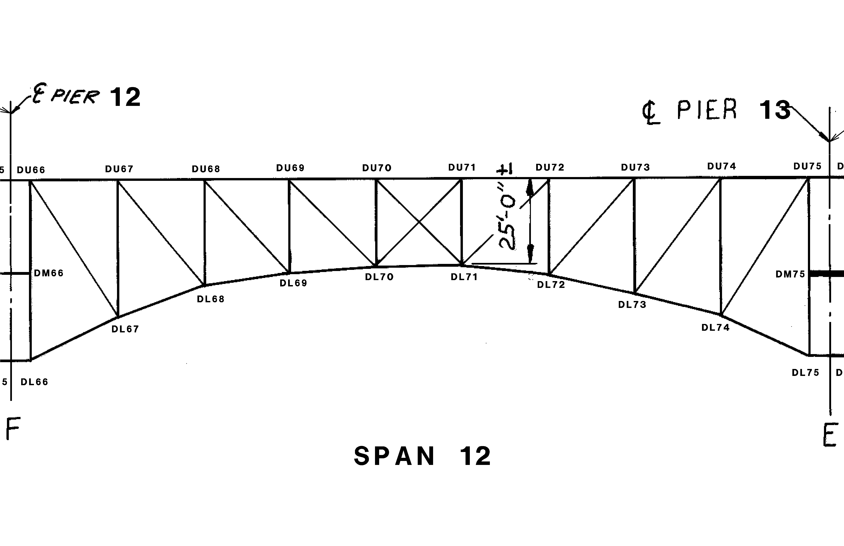
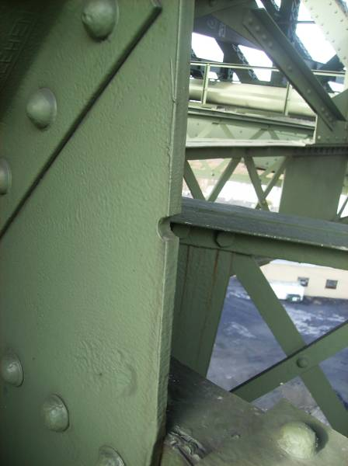
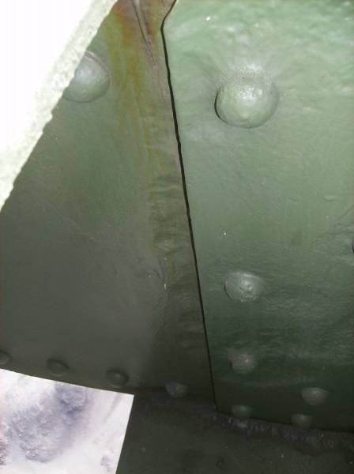
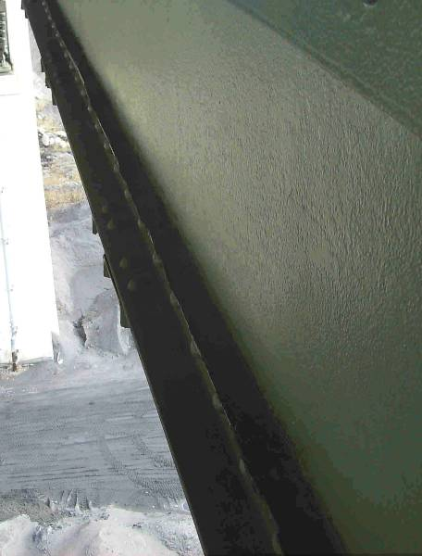
SPAN 12
TRUSS D
Both gusset plates at DL71 have misplaced drill/punch holes along the east free edge.
The lower chord, north web plate at DL69 exhibits pitting up to 1/4″ deep along the gusset plate interface. This condition is common throughout Span 12; however, losses are typically less, consisting of 1/8″ deep across the section. Also note the minor pitting along the interior face of the gusset plate adjacent to the lower chord.
The lower chord member DL69-DL70 exhibits pack rust up to 2″ thick between the north web plate and the lower flange angle. Pitting up to 3/16″ was noted on the north web plate along the flange angle.
Similar to other spans throughout the structure, the lower chord north web plates exhibit losses along the lower flange angles. Losses in Span 11 are typified by 1/16″-1/8″ deep pitting occurring within the lower 2″ of the web and most of the length of each bay. The adjacent flange angles exhibit similar pitting.

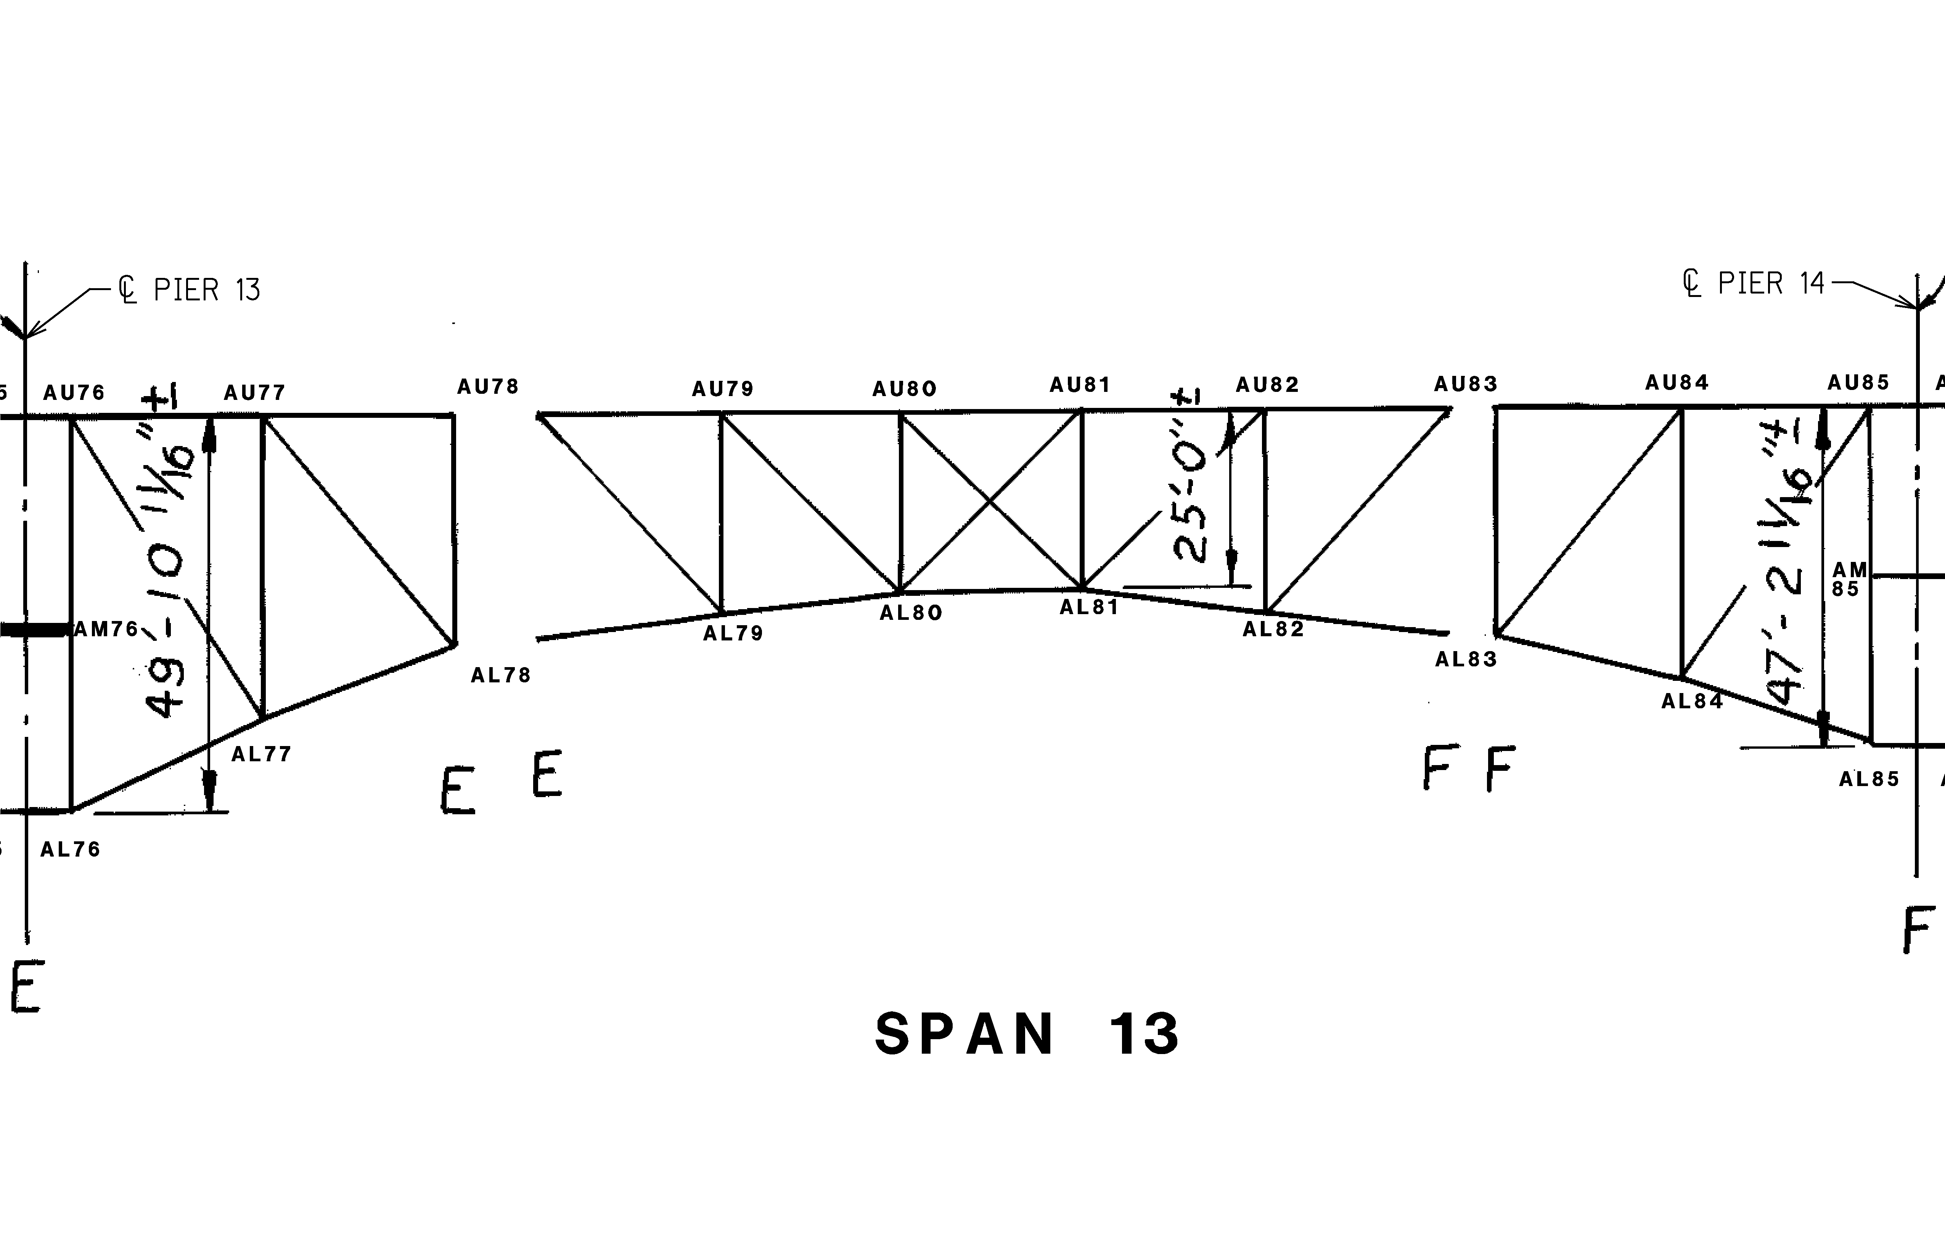
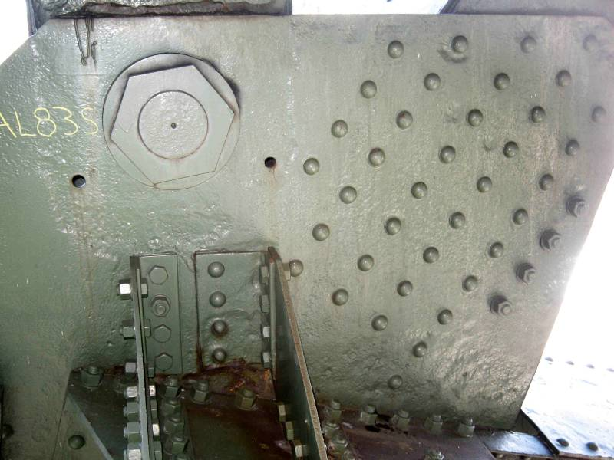
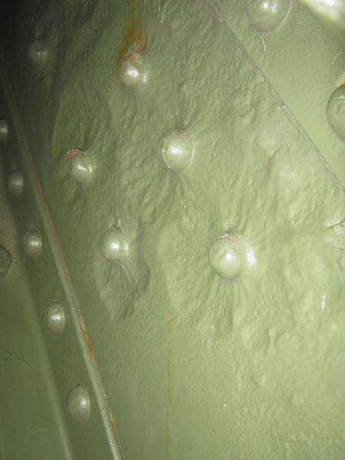
SPAN 13
TRUSS A
The south gusset plate at AL83 exhibits heavy pitting throughout the south face, with pitting up to 1/4″ deep along the lower chord interface. Similar conditions are exhibited by the south plate at AL78.
1/4″ deep pitting is present across the width of the north web plate of AL78-AU77 adjacent to the lower gusset plate rivets. The south web plate exhibits pitting up to 1/8″ deep.

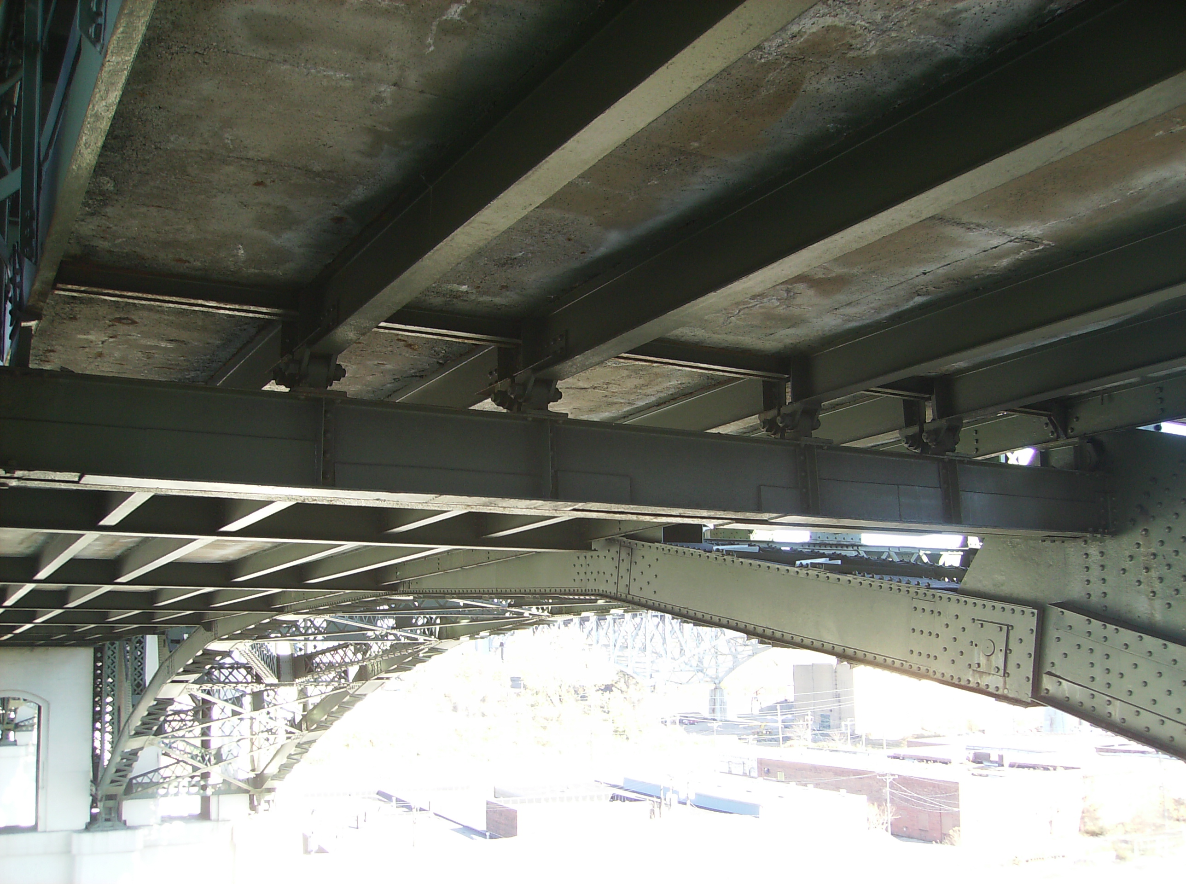
The utility deck Floorbeam 78 has received extensive web retrofits throughout the length of the member.

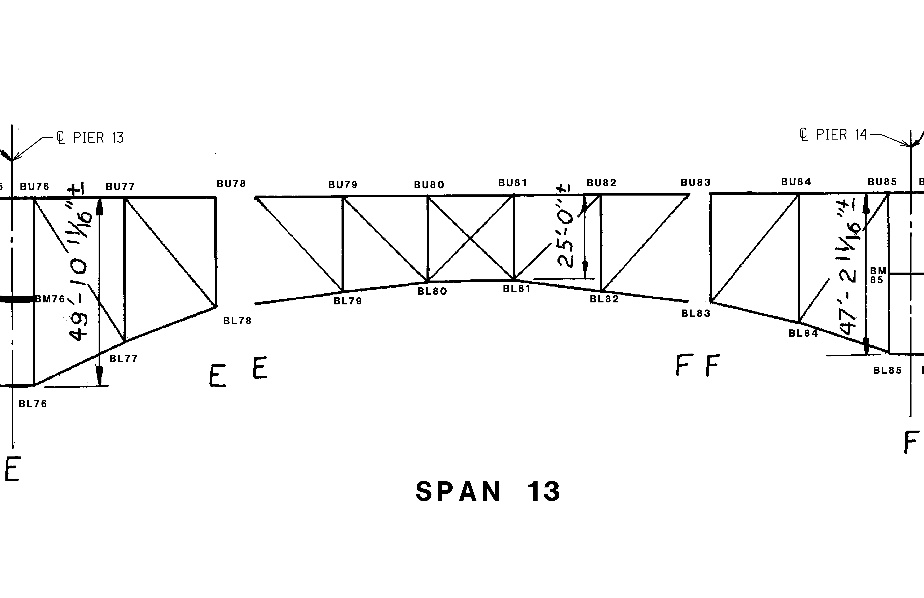
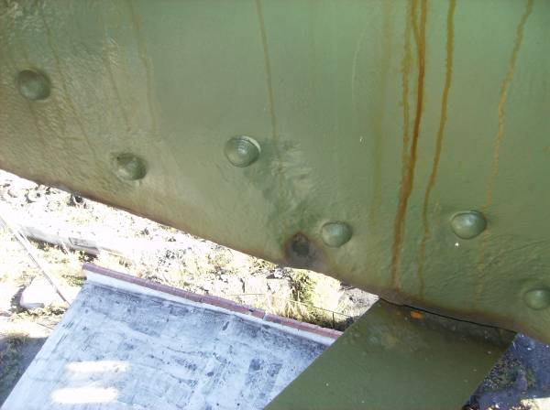
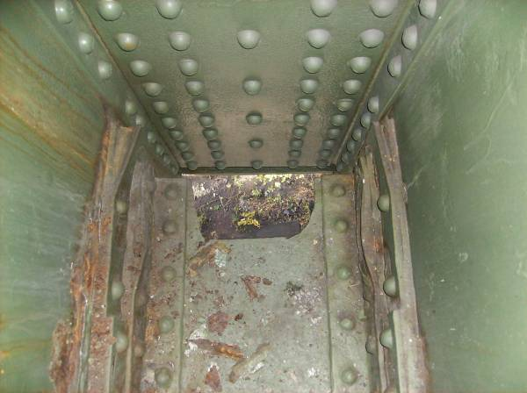
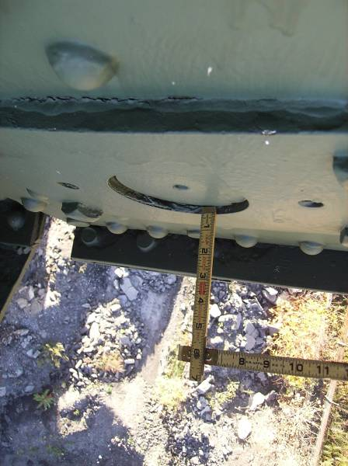
SPAN 13
TRUSS B
The south web plate of BL77-BL78 near BL78 is perforated, exhibiting a 2″ diameter hole opposite the bottom flange angle. Adjacent 1/4″ deep pitting is present at this location.
The internal pin plates at BL78 exhibit pack rust up to 1.5″ thick at the plate corners with localized distortion.
Pack rust at BL83 has pushed the sliding pin plates outward.

The north web plates exhibit 1/8″ deep pitting along the full width of the member at the gusset plate interface.
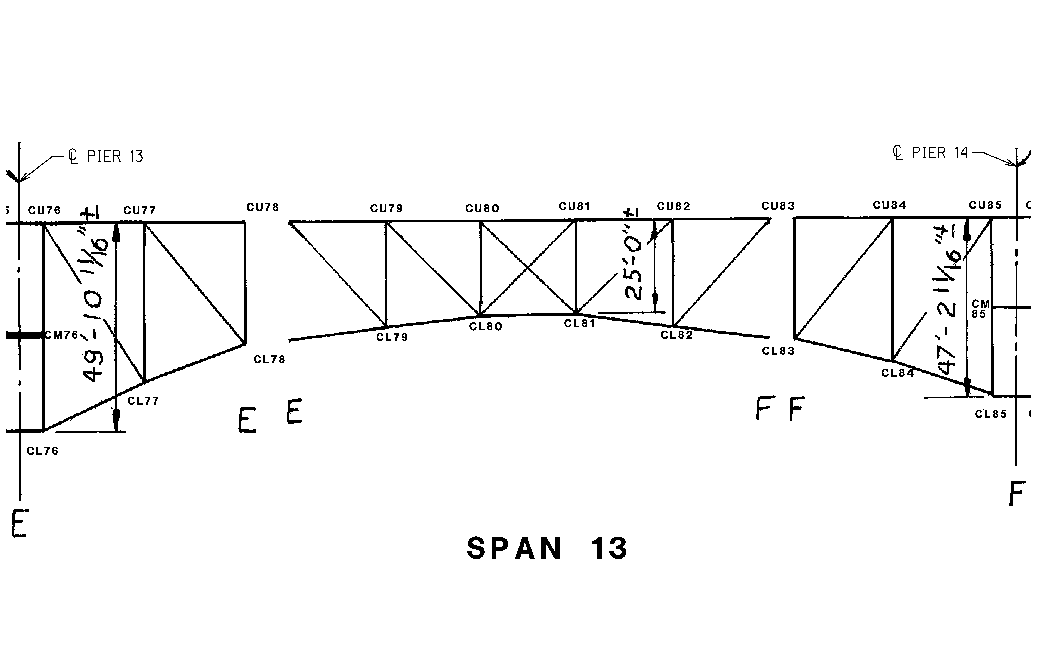
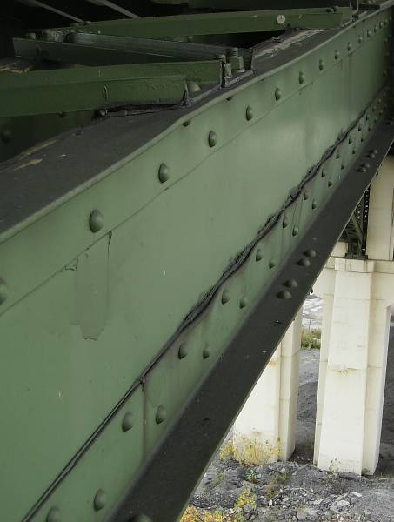
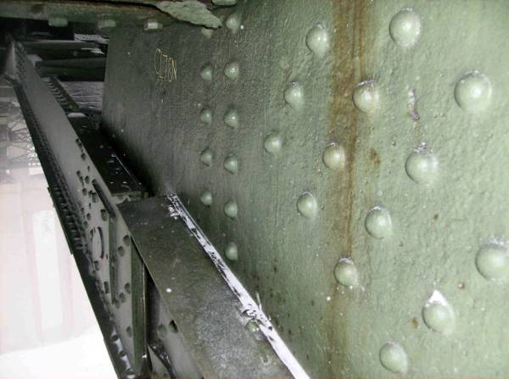
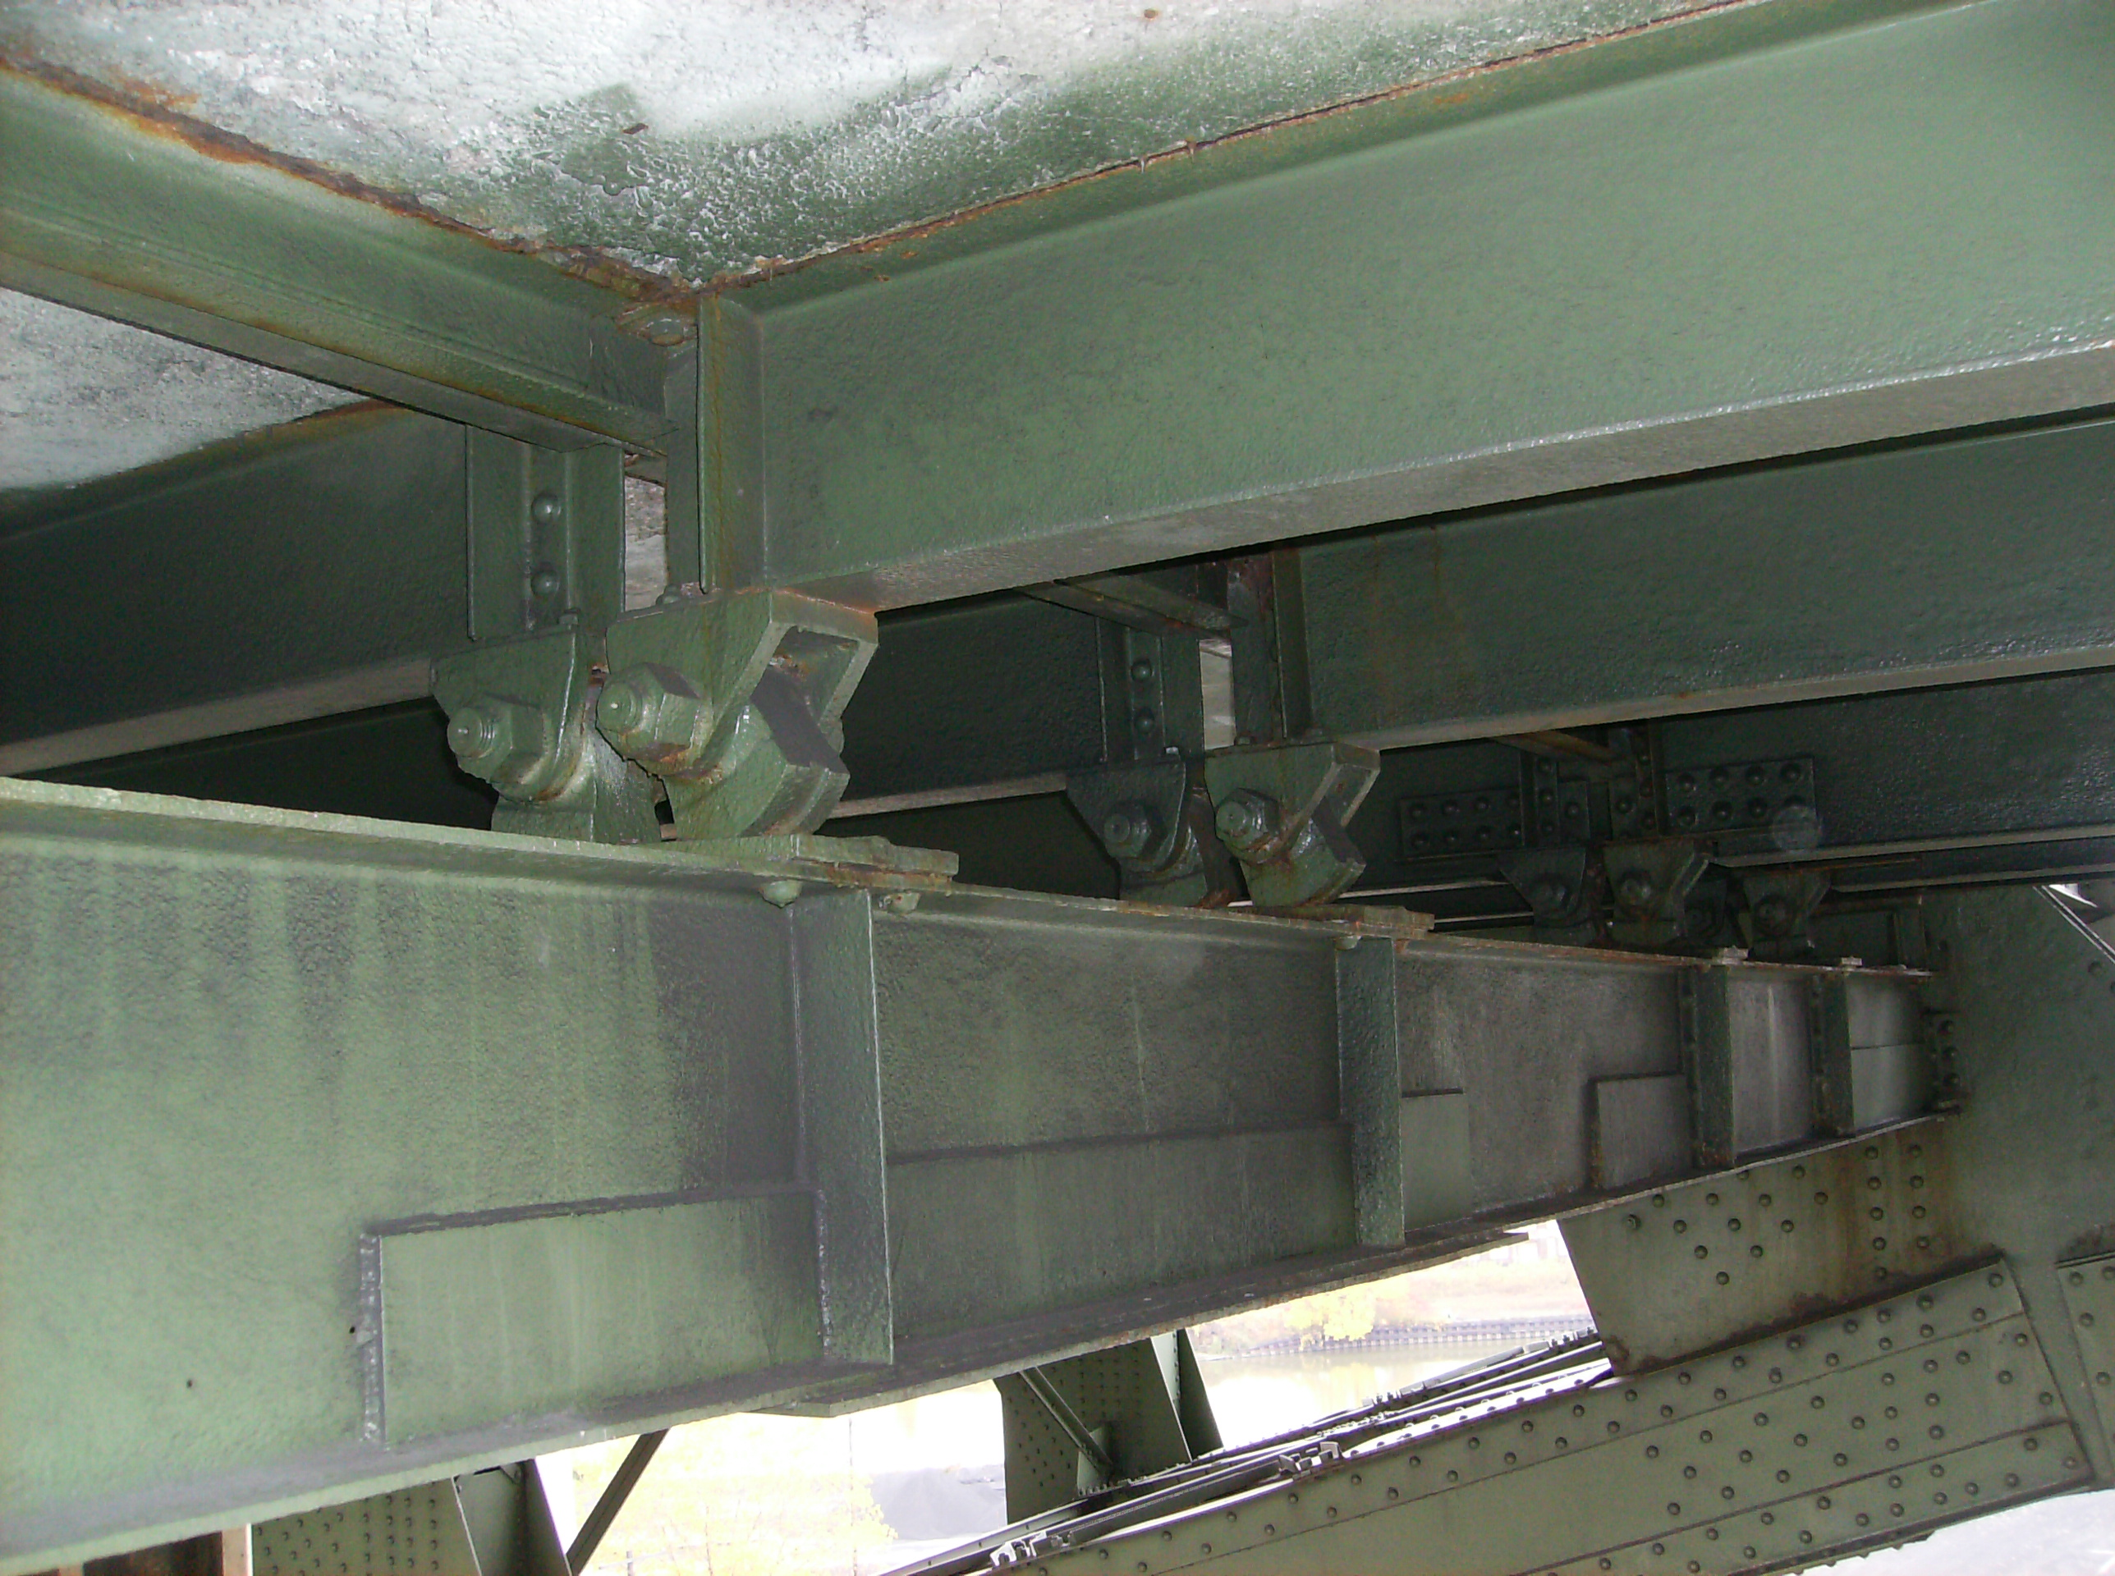
SPAN 13
TRUSS C
Pack rust between the bottom flange angle and south web of CL77-CL78 has distorted the vertical angle leg. The rust is reactivating, as indicated by rust staining. This condition is common among the lower chord members throughout Truss C.
The lower half of the north gusset plate at CL78 exhibits 1/8″ deep pitting throughout the north face, with small, isolated 1/4″ deep pits.
Utility deck Stringers 3 and 4 at Floorbeam 78 exhibit excessive rotation. Note the extensive retrofitting of the web and bottom flange of Floorbeam 78.

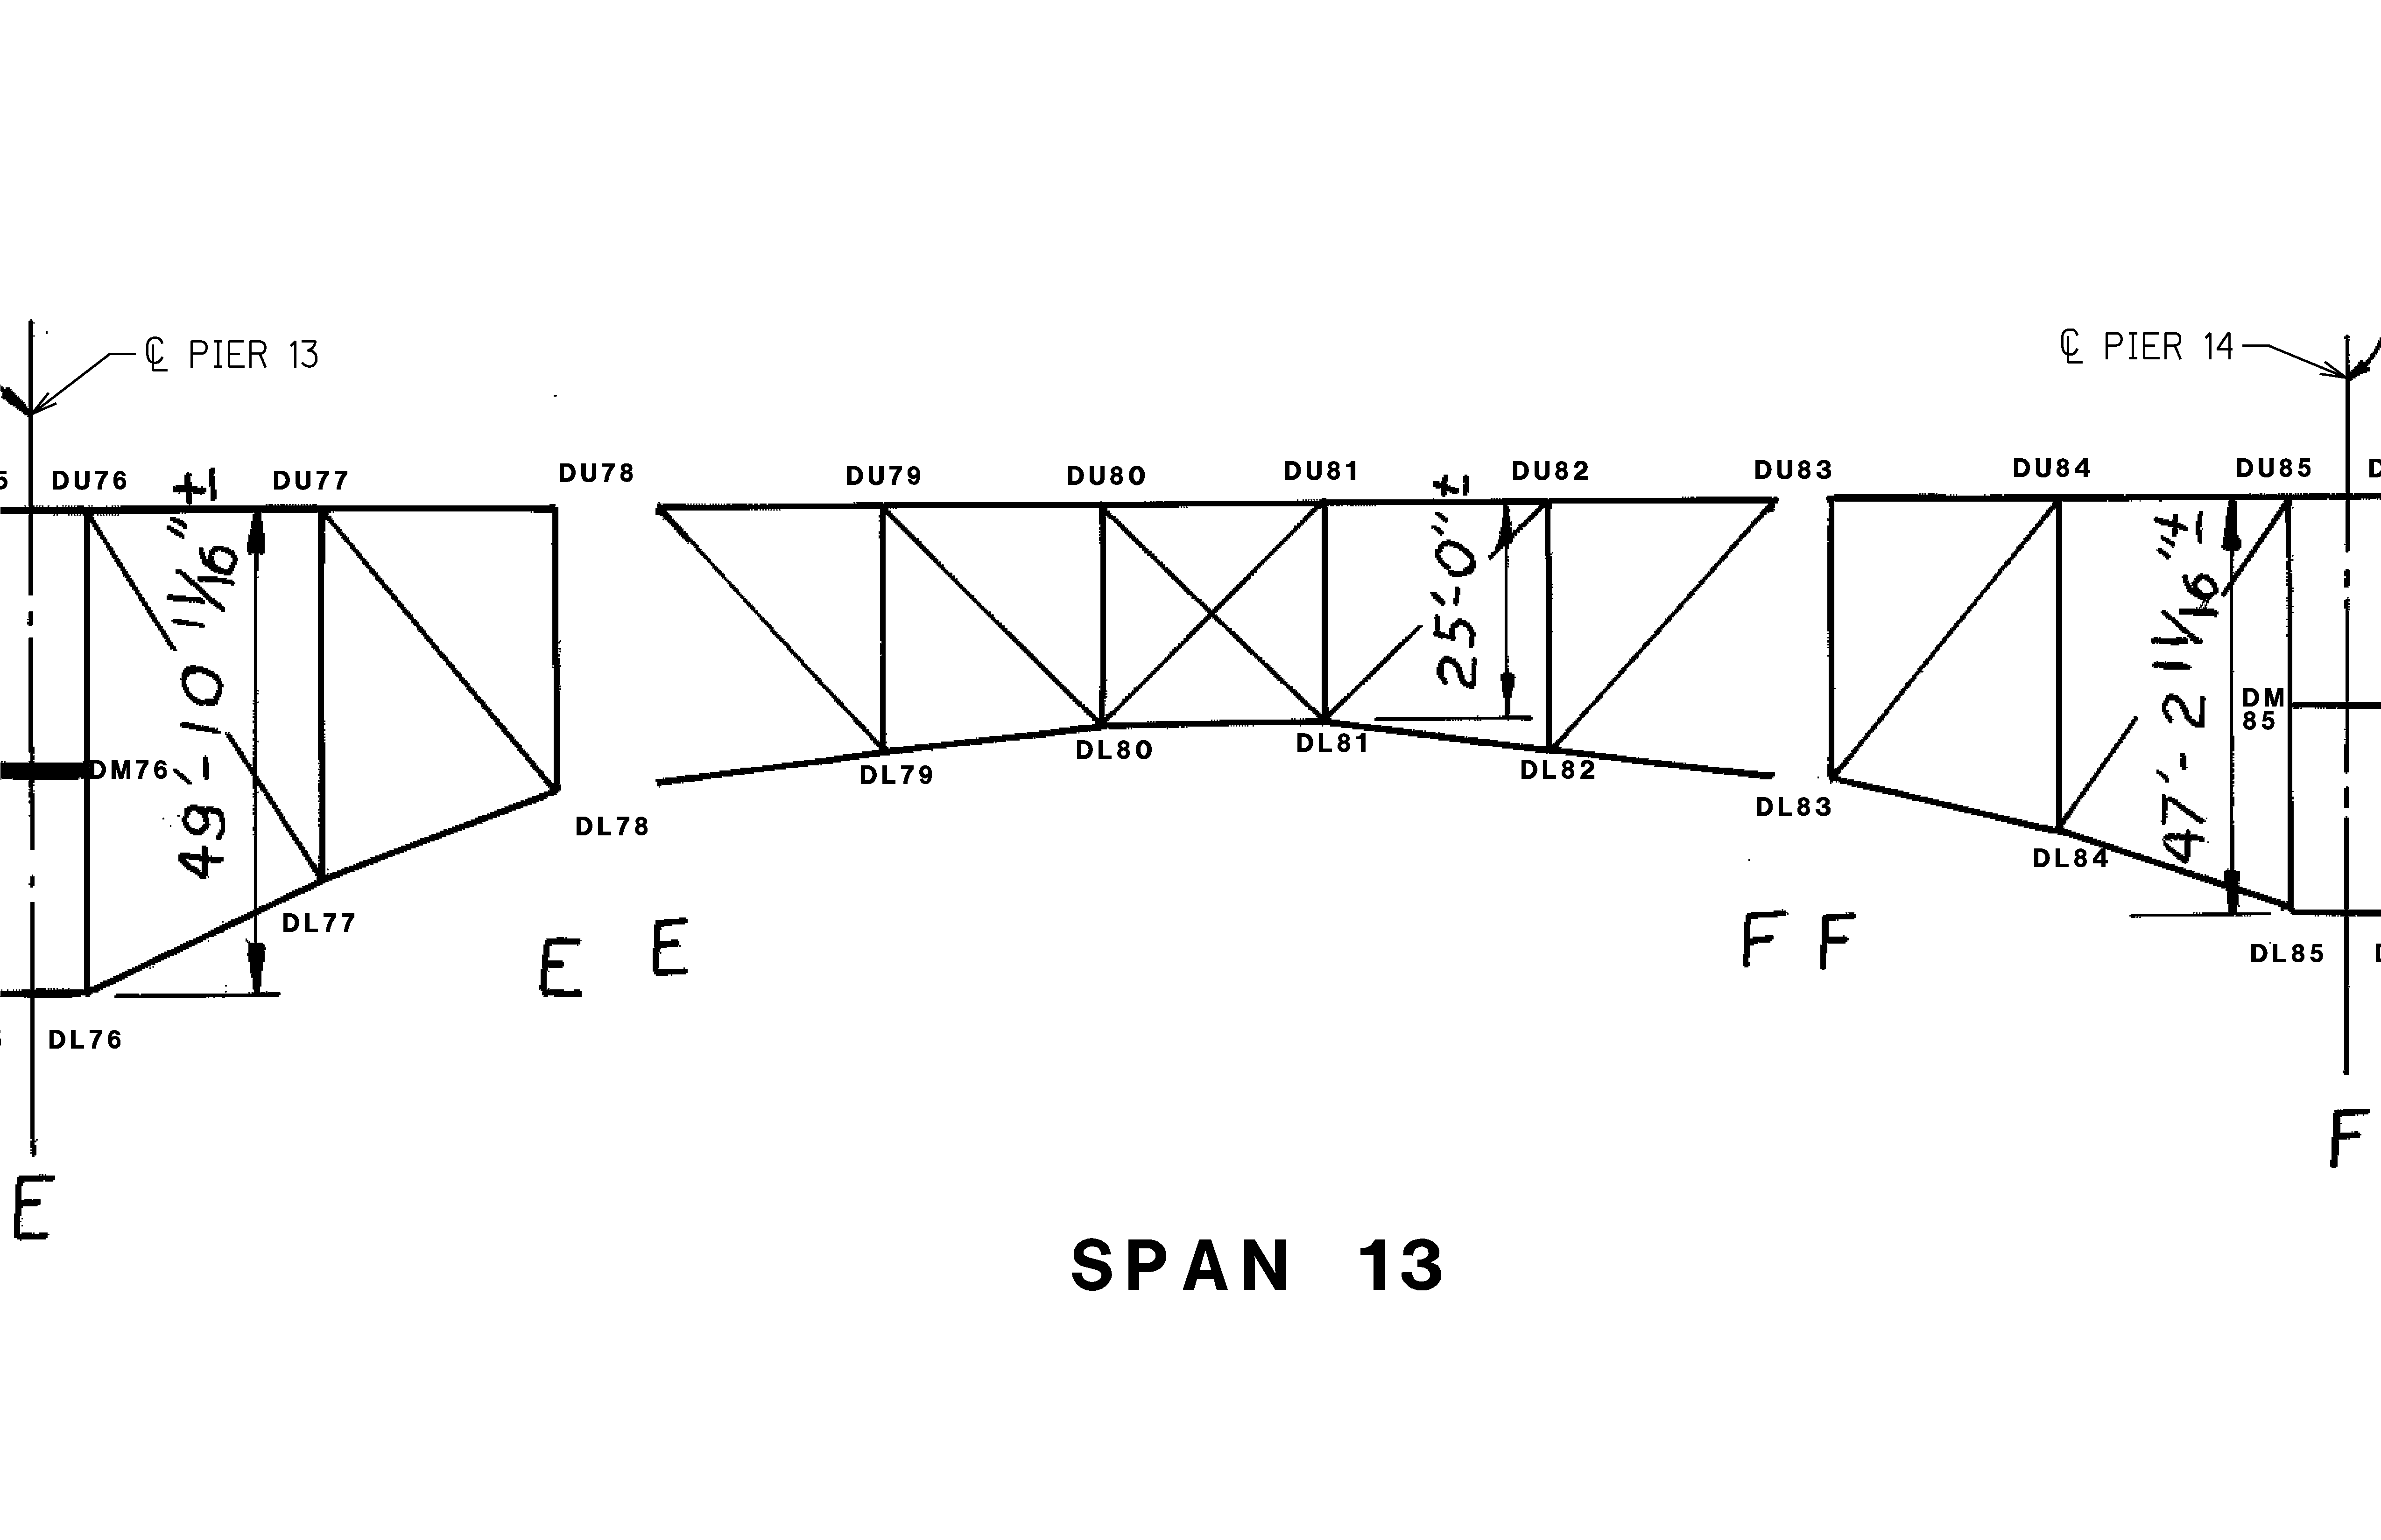
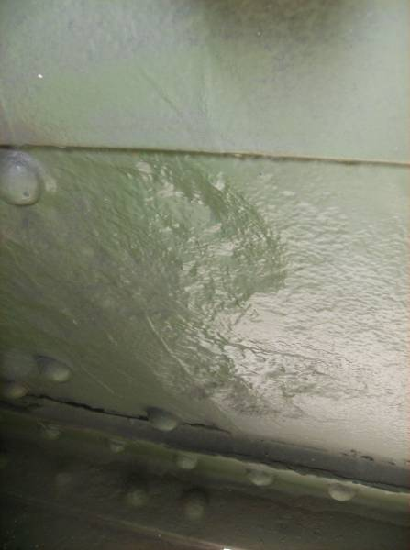
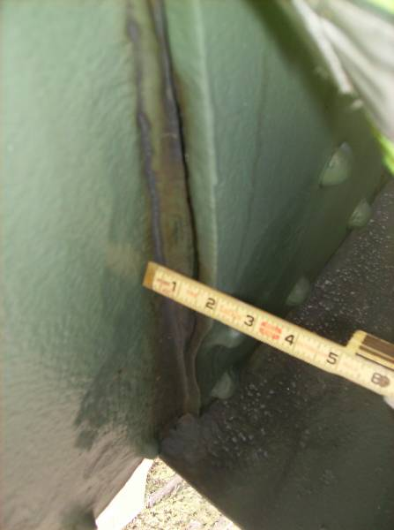
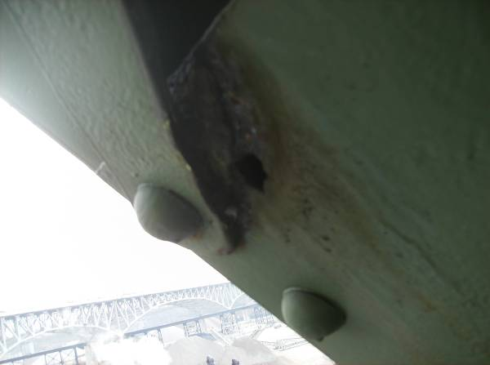
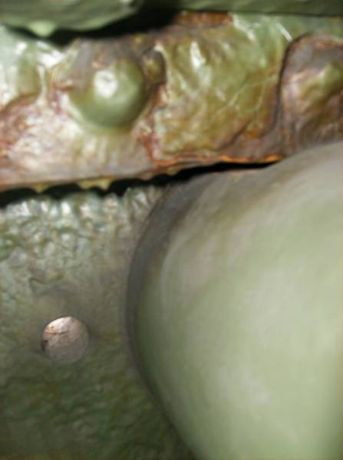
SPAN 13
TRUSS D
The north web plate of DL77-DL78 exhibits 1/8″, full height pitting near DL78. This condition is commonly found throughout Truss D and throughout Span 13; however, losses are typically less, measuring 1/16″ on average. The web plate at DL85 exhibits pitting up to 3/16″ deep in this area.
The north gusset plate at DL79 is bowed to the south approximately 1-3/16″ along the interface with the lower chord web of DL78-D79 due to heavy pack rust accumulating between the two plates. Also note the 1/16″-1/8″ loss of the web plate in this area.
The lower batten plate on the underside of diagonal member DL80-UL81 exhibits advanced corrosion with a 2″∅ hole and adjacent 1/4″ pitting near the lacing connection.
Isolated locations along the top flange angle of the lower chord exhibit pitting up to 1/4″ deep on the outstanding leg.
1
The south end of the lower sliding pin in member DL78-DL79 exhibits section loss in the upper half of the circumference. Losses of 1/16″-1/8″ are typical for the full circumference of the pin at the south gusset plate; however, an area exhibiting approximately 3/8″ is shown.
The truss web members throughout Span 12 typically exhibit 1/16″ – 1/8″ pitting at the gusset plate interfaces over the full height of the north web plates. Isolated locations exhibit pitting from 3/16″ up to 1/4″.

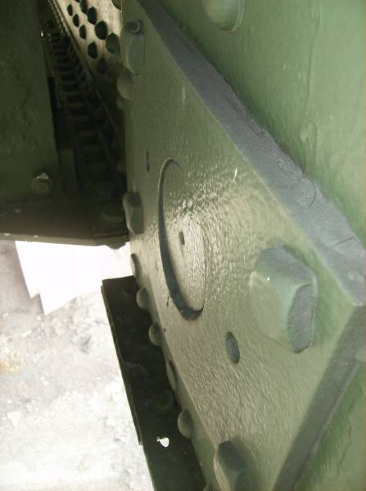
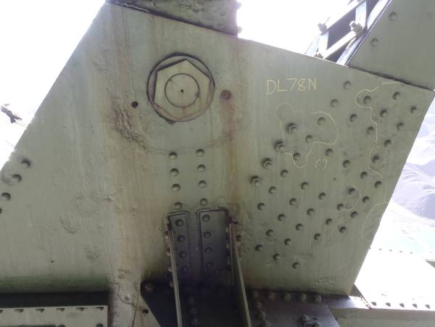
The suspended span sliding pin at DL83 is misaligned with the north keeper plate due to 3/8″ pack rust causing localized plate distortion.
Heavy pitting (greater than or equal to 1/4″ deep in isolated locations) of the lower gusset plates at the pin locations is typical with reactivating surface corrosion due to failing deck joints above.
1

