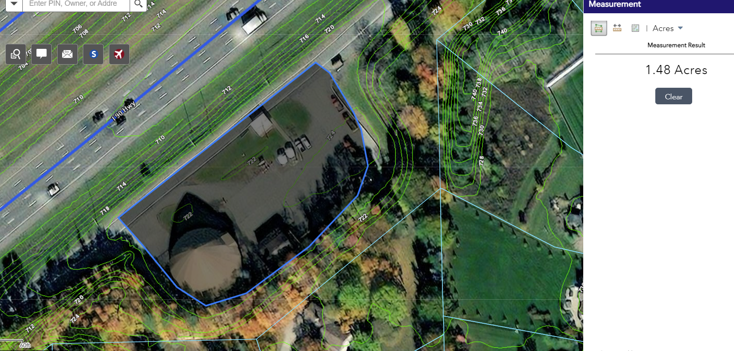
Drainage area is crude and errs on the large side
Q = C*i*A

C = 0.85
i10 = 4.41 in/hr
A = 1.48 ac

Q10 = 6.2 cfs a 15” pipe at 1.3% slope has enough full flow capacity to carry the 10-yr

