Culvert Inspection on Geauga SR-306 at SLM 1.94
36”x30” Sandstone Box Culvert with 60”x33” Concrete Extensions
Inspection Date: Thursday, May 7, 2009
Inspectors: Lou Mincek, Bill Gerber
General Comments:
The culvert is located along SR 306 in Bainbridge Township at approximately station 100+40. The original construction of the sandstone culvert is unknown, but the concrete extensions were built around 1928 under GEA-306-0.00 (originally Chillicothe Road). See plan sheets 6 and 34 of 37 for additional details. The original structure is an 36”x30” sandstone box culvert about 24 feet long, with a 21.5 feet concrete extension at the inlet, and a 13 feet extension at the outlet. There are full-height concrete headwalls at both the inlet and outlet. Along the upstream ditch, running parallel to SR 306 is a concrete retaining wall.
Specific Comments:
There are areas on both sidewalls, in the middle of the sandstone structure that have missing/abraded stones at the bottom slab. These areas are at least 10 feet in length on both sides and vary in depth to a couple of feet. It does not appear that fines are being washed into the culvert. The walls are straight without any disjointed stones. There is water seepage in some of the joints.
The sandstone roof appears to be in very good shape with no signs of spalling, cracking or deterioration. There was some water along the roof but it could not be determined if it was condensation or infiltration.
The sandstone floor has a lot of abrasion wear along its entire length. At some point, concrete was placed along the floor where the concrete extension meets the sandstone.
The headwall at the inlet appears to be in good shape with no large visible cracks or spalls. At the outlet, the headwall has some large areas of deterioration at the bottom of the opening and there is a large vertical crack with deterioration. There are areas of scour around the outlet headwall.
The main area of concern with the culvert is the concrete retaining wall along the upstream ditch running parallel to SR 306. It is tipping towards the ditch line, undermined at various locations, cracked and showing overall deterioration. Although the 1928 plans do not show this wall, I am assuming it is our maintenance. This will need confirmation.
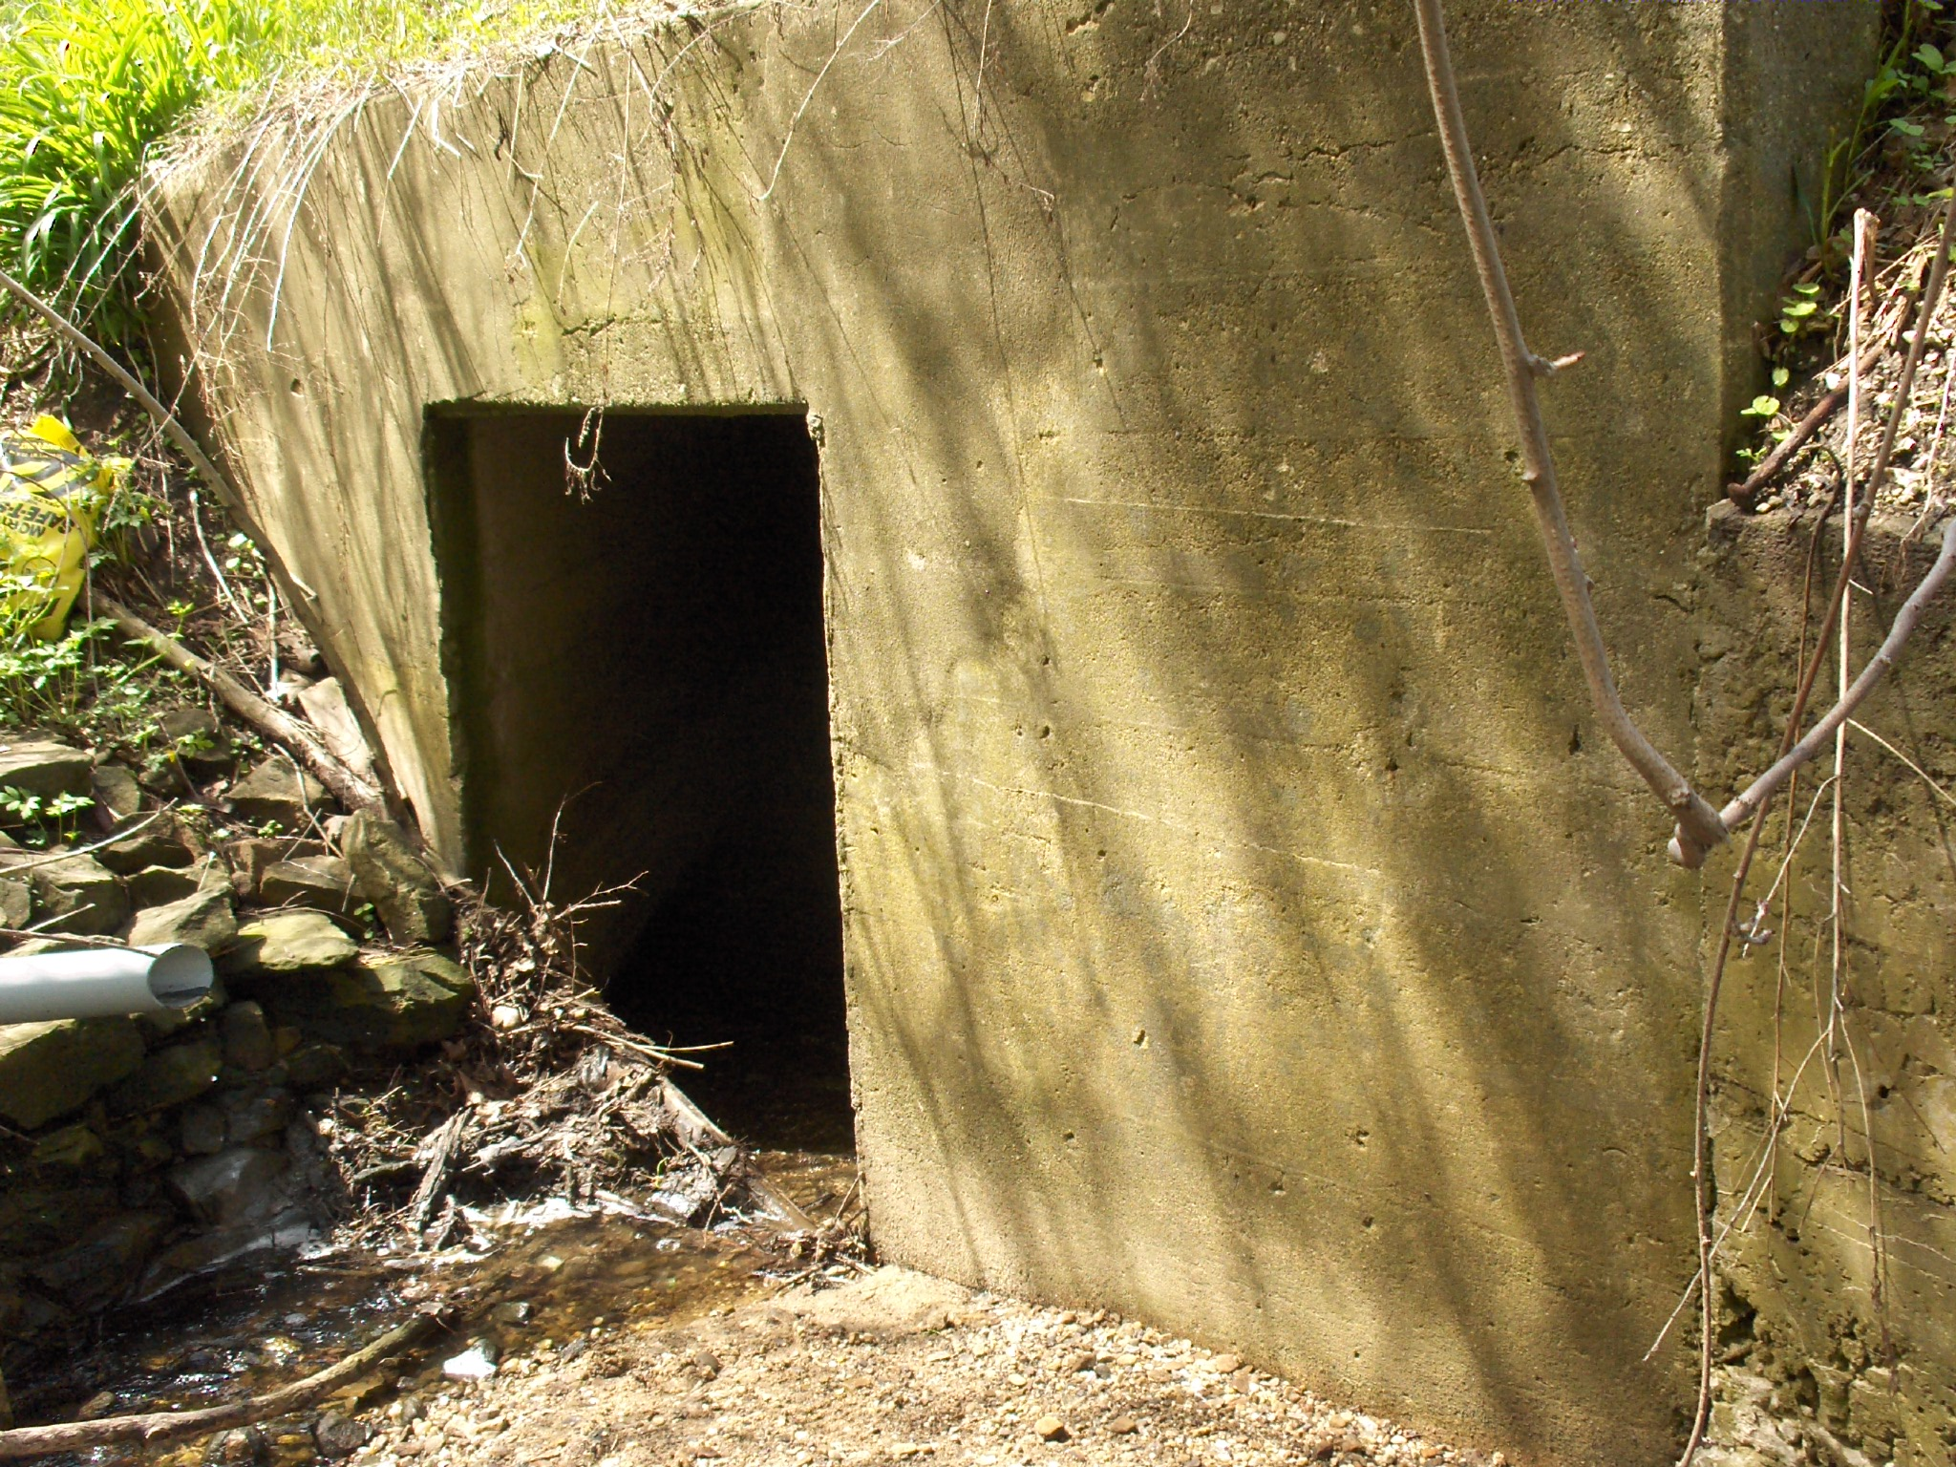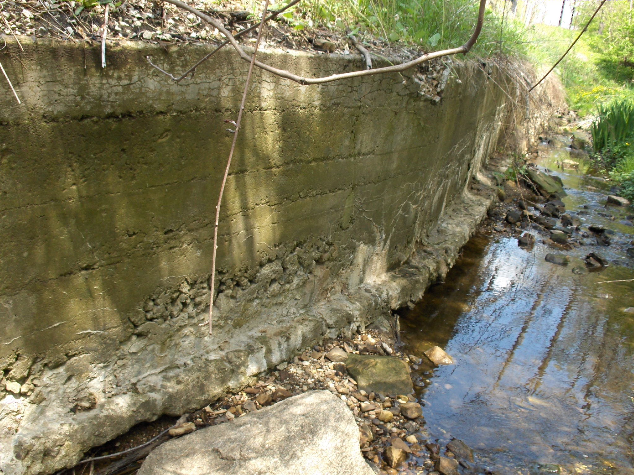
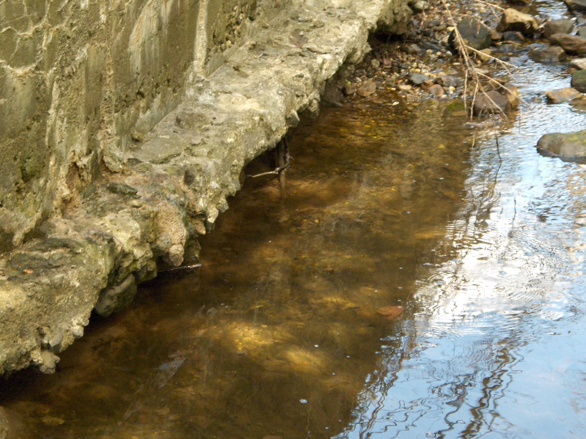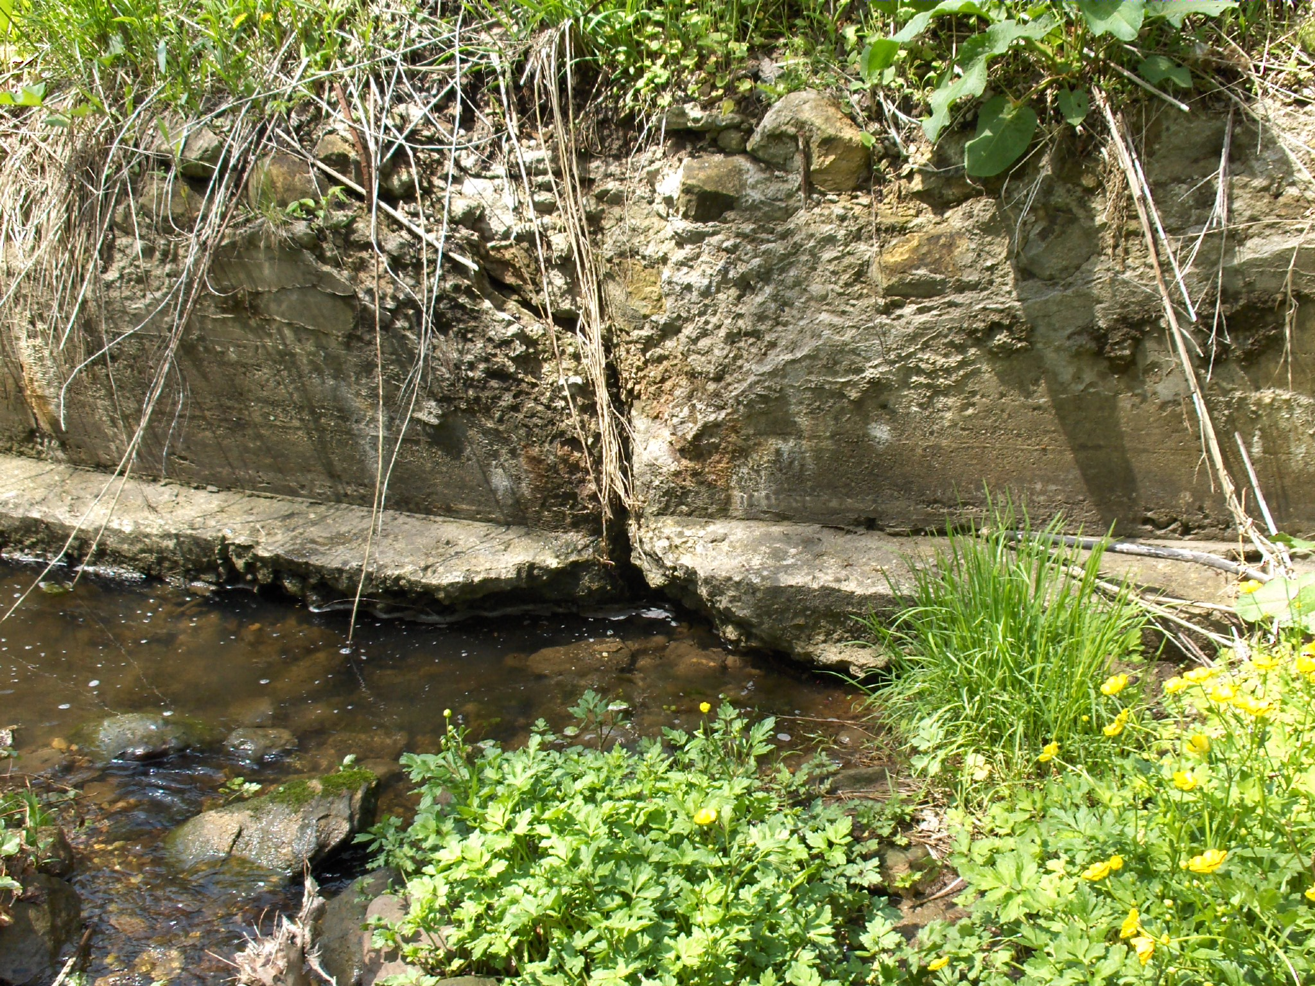

Photos 1-4: Culvert Inlet, headwall and retaining wall

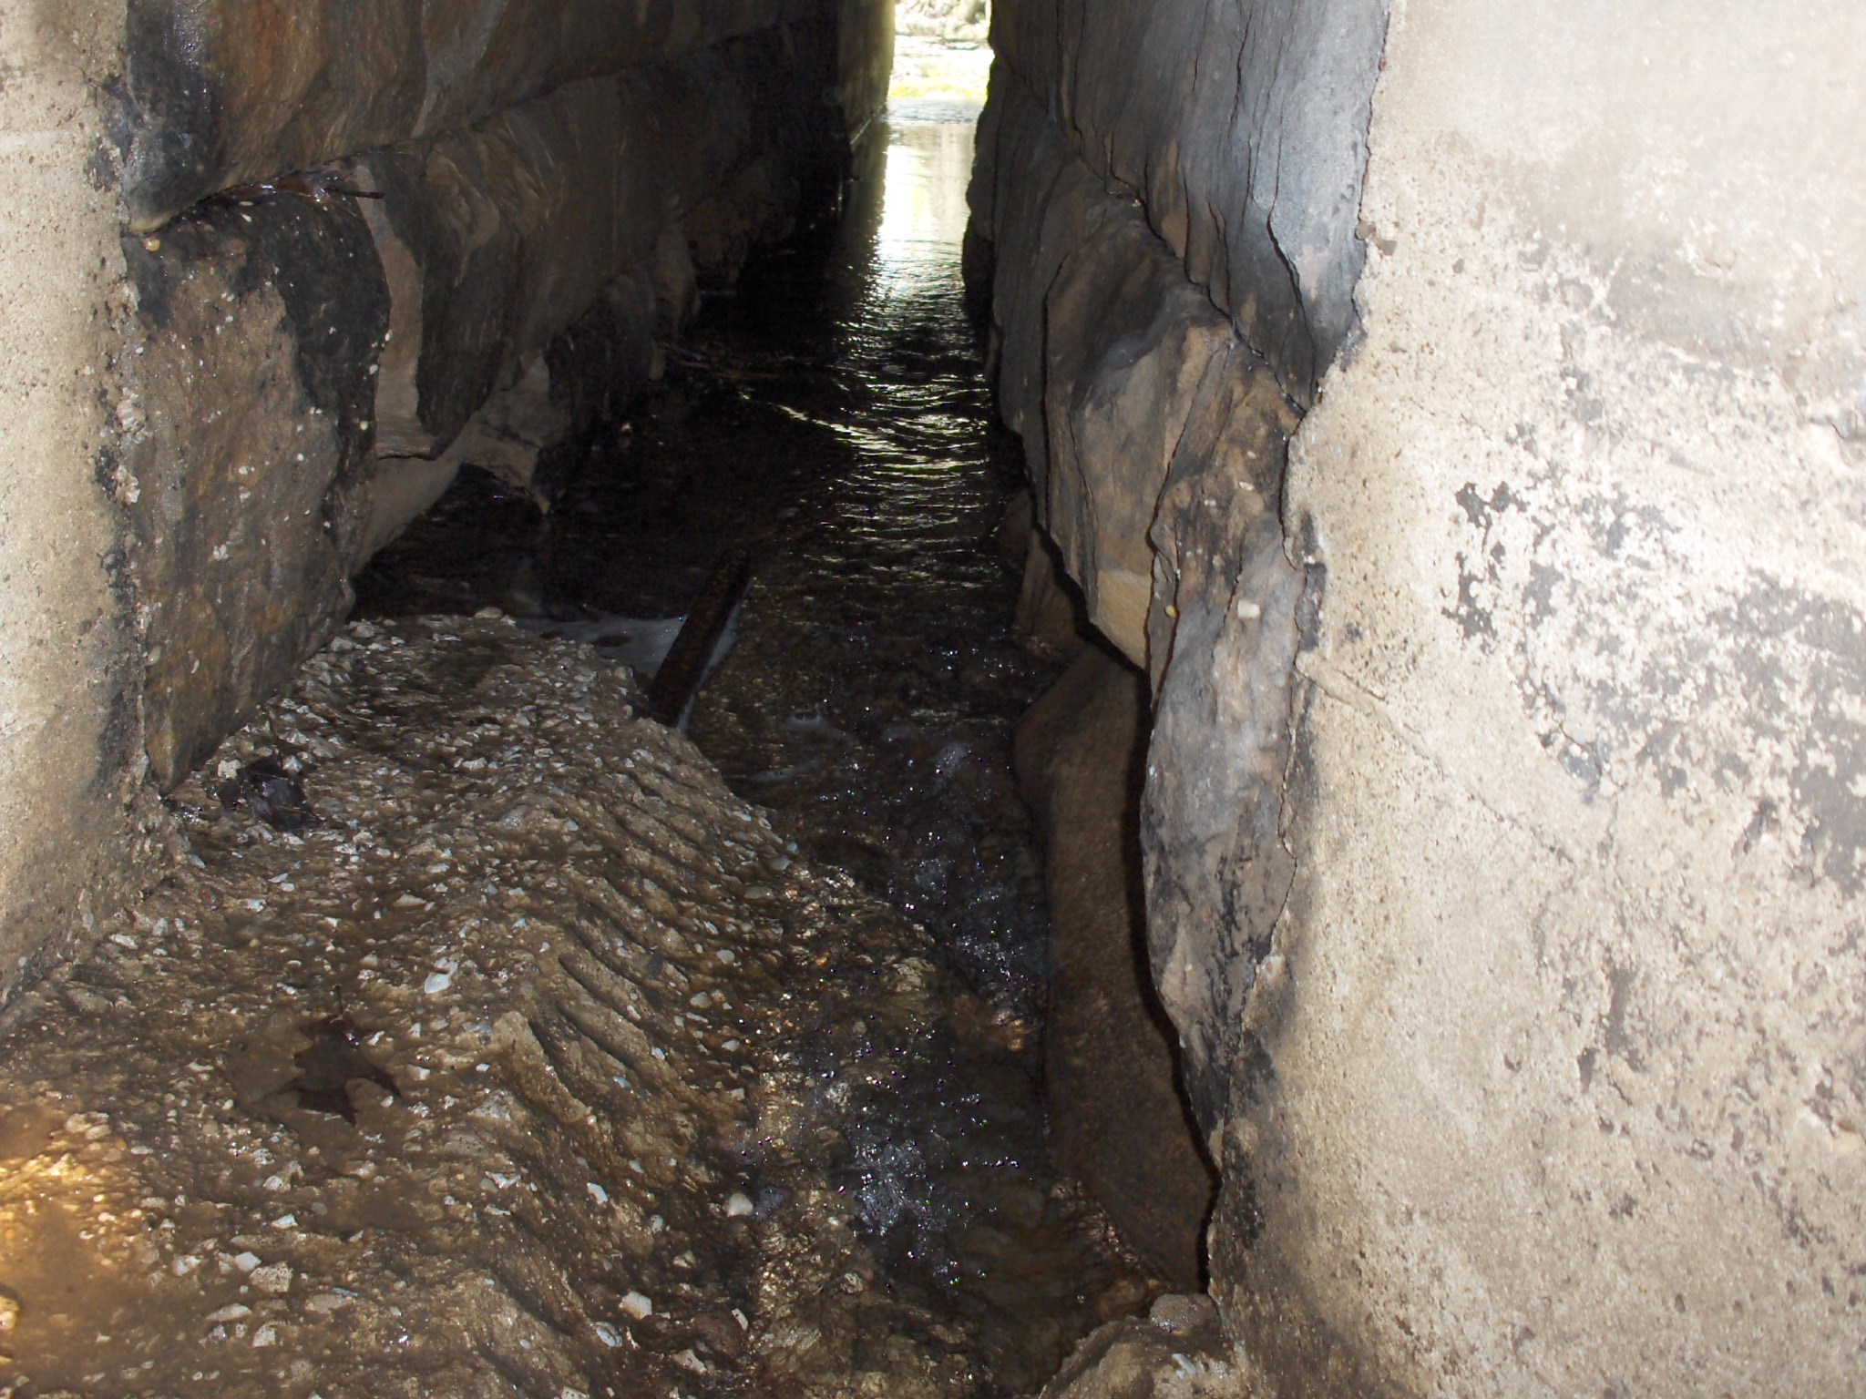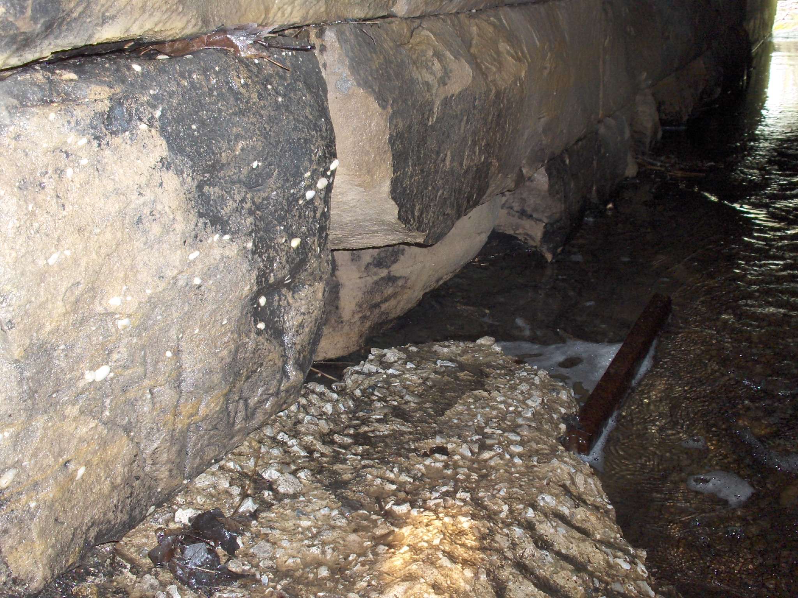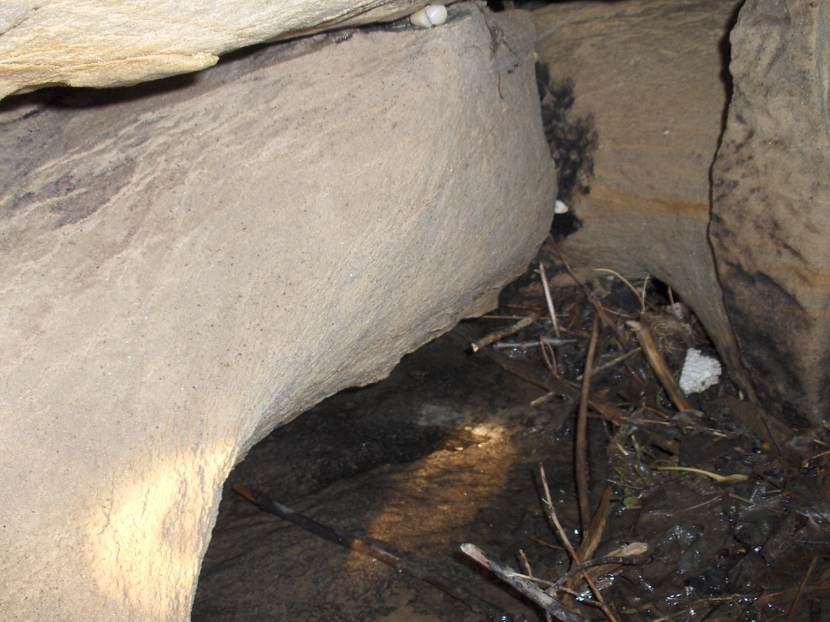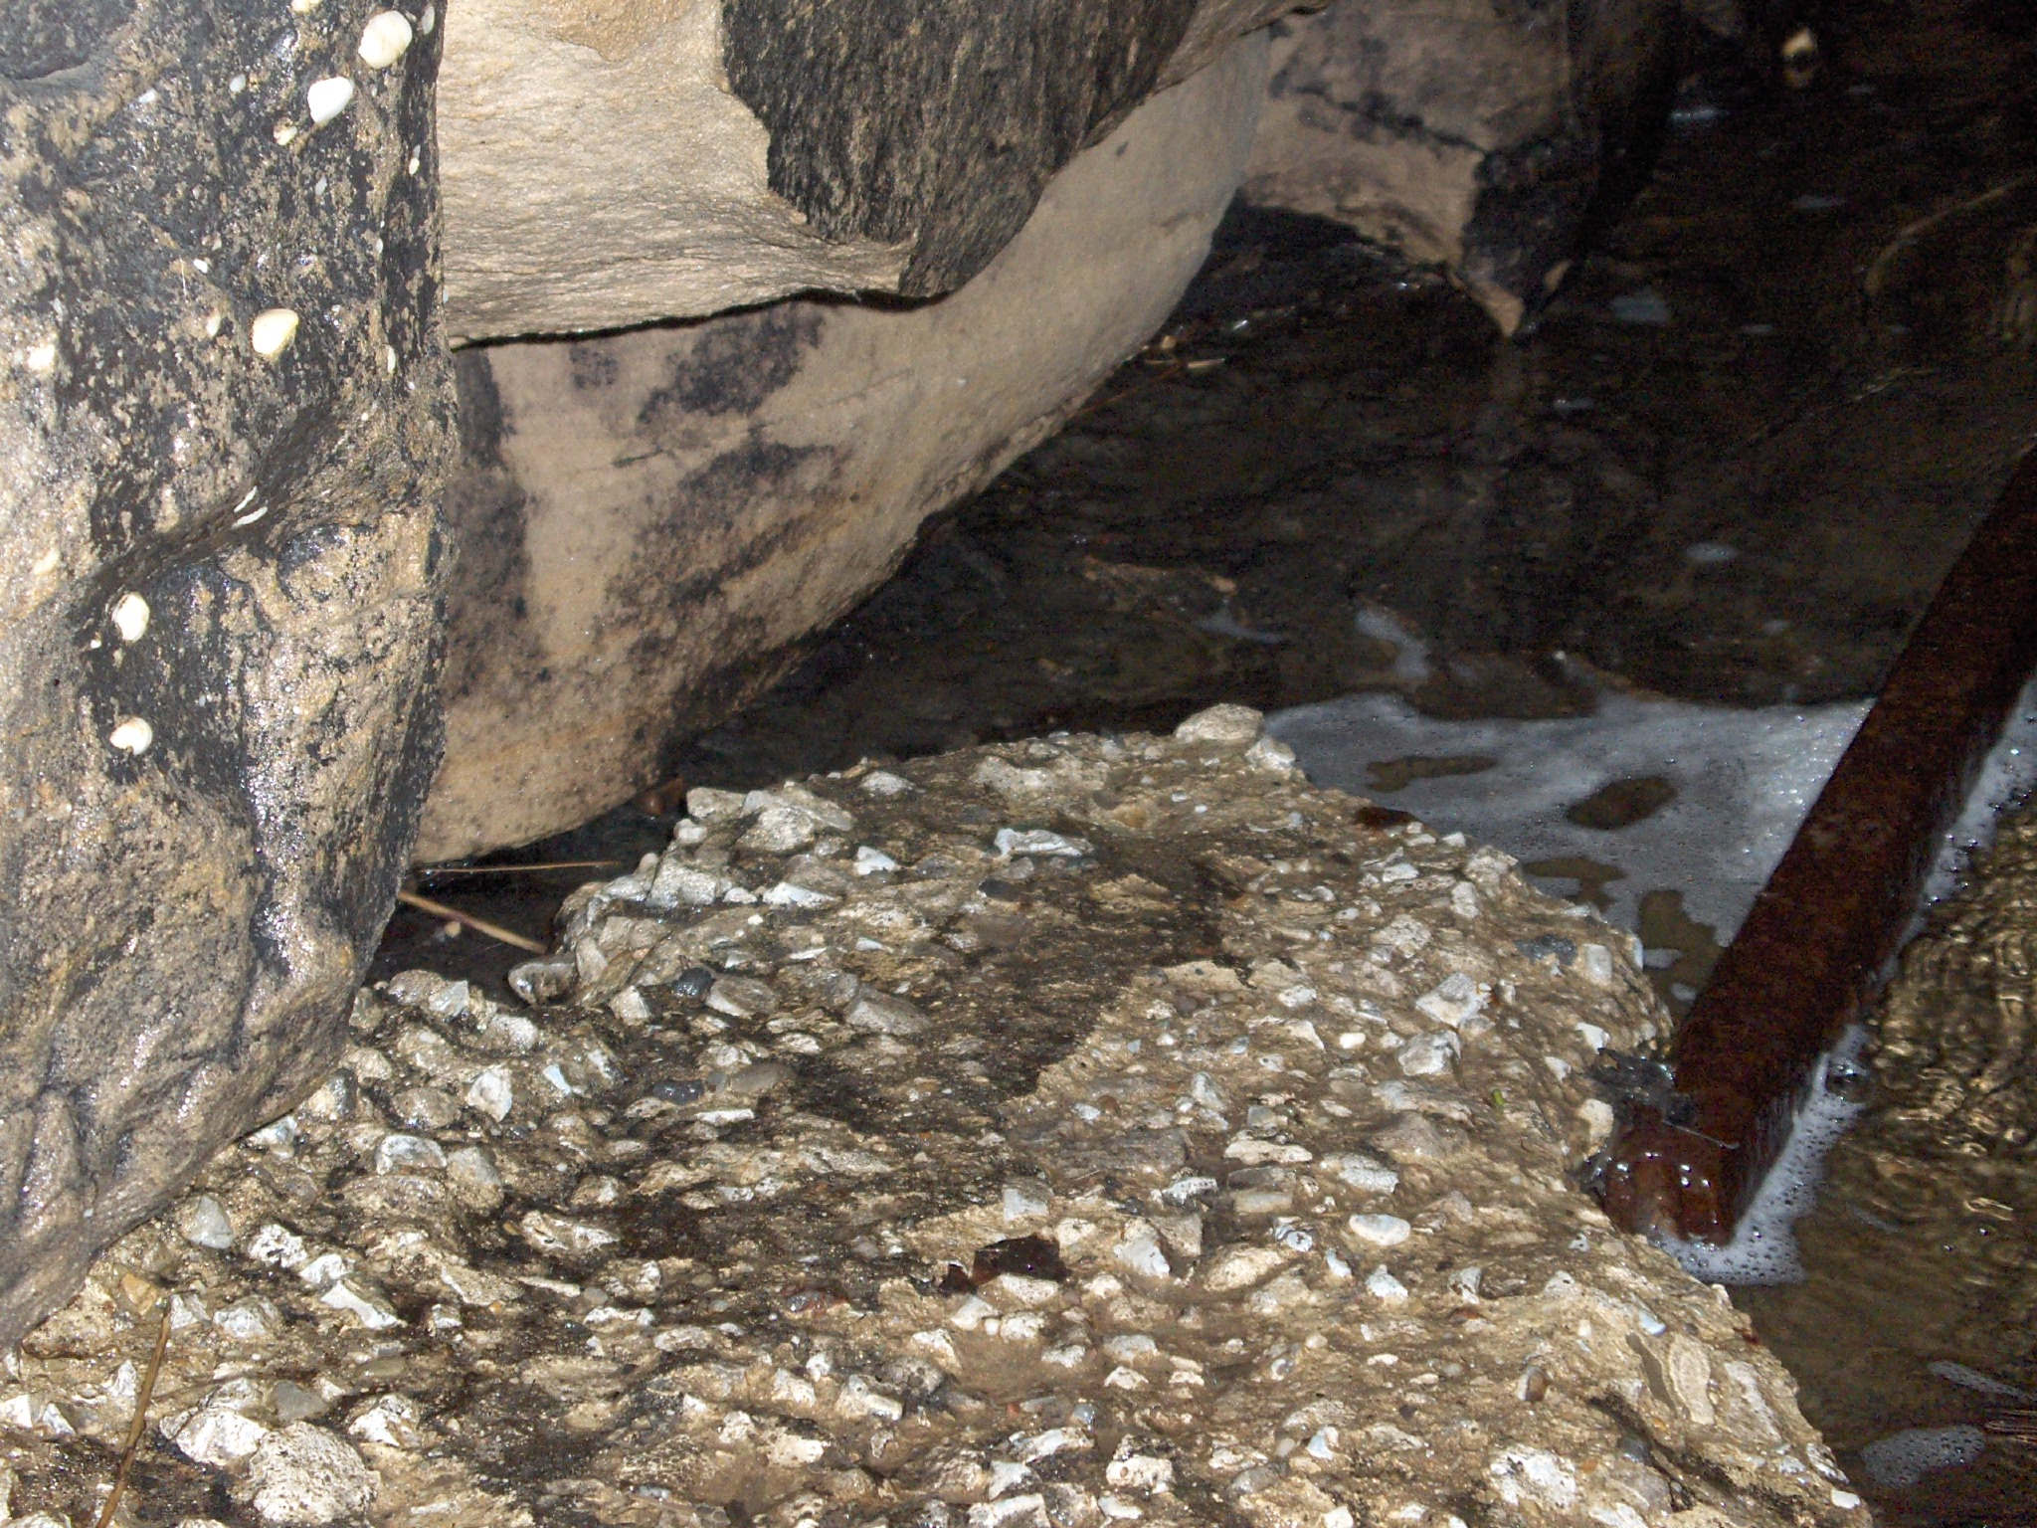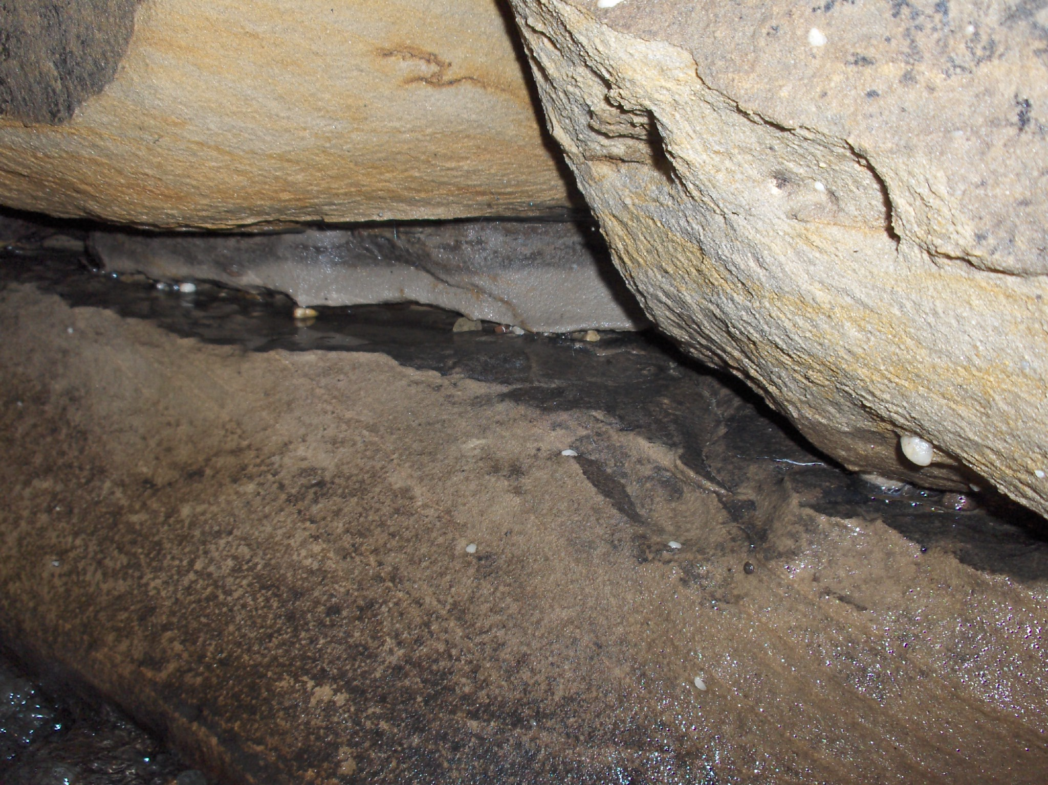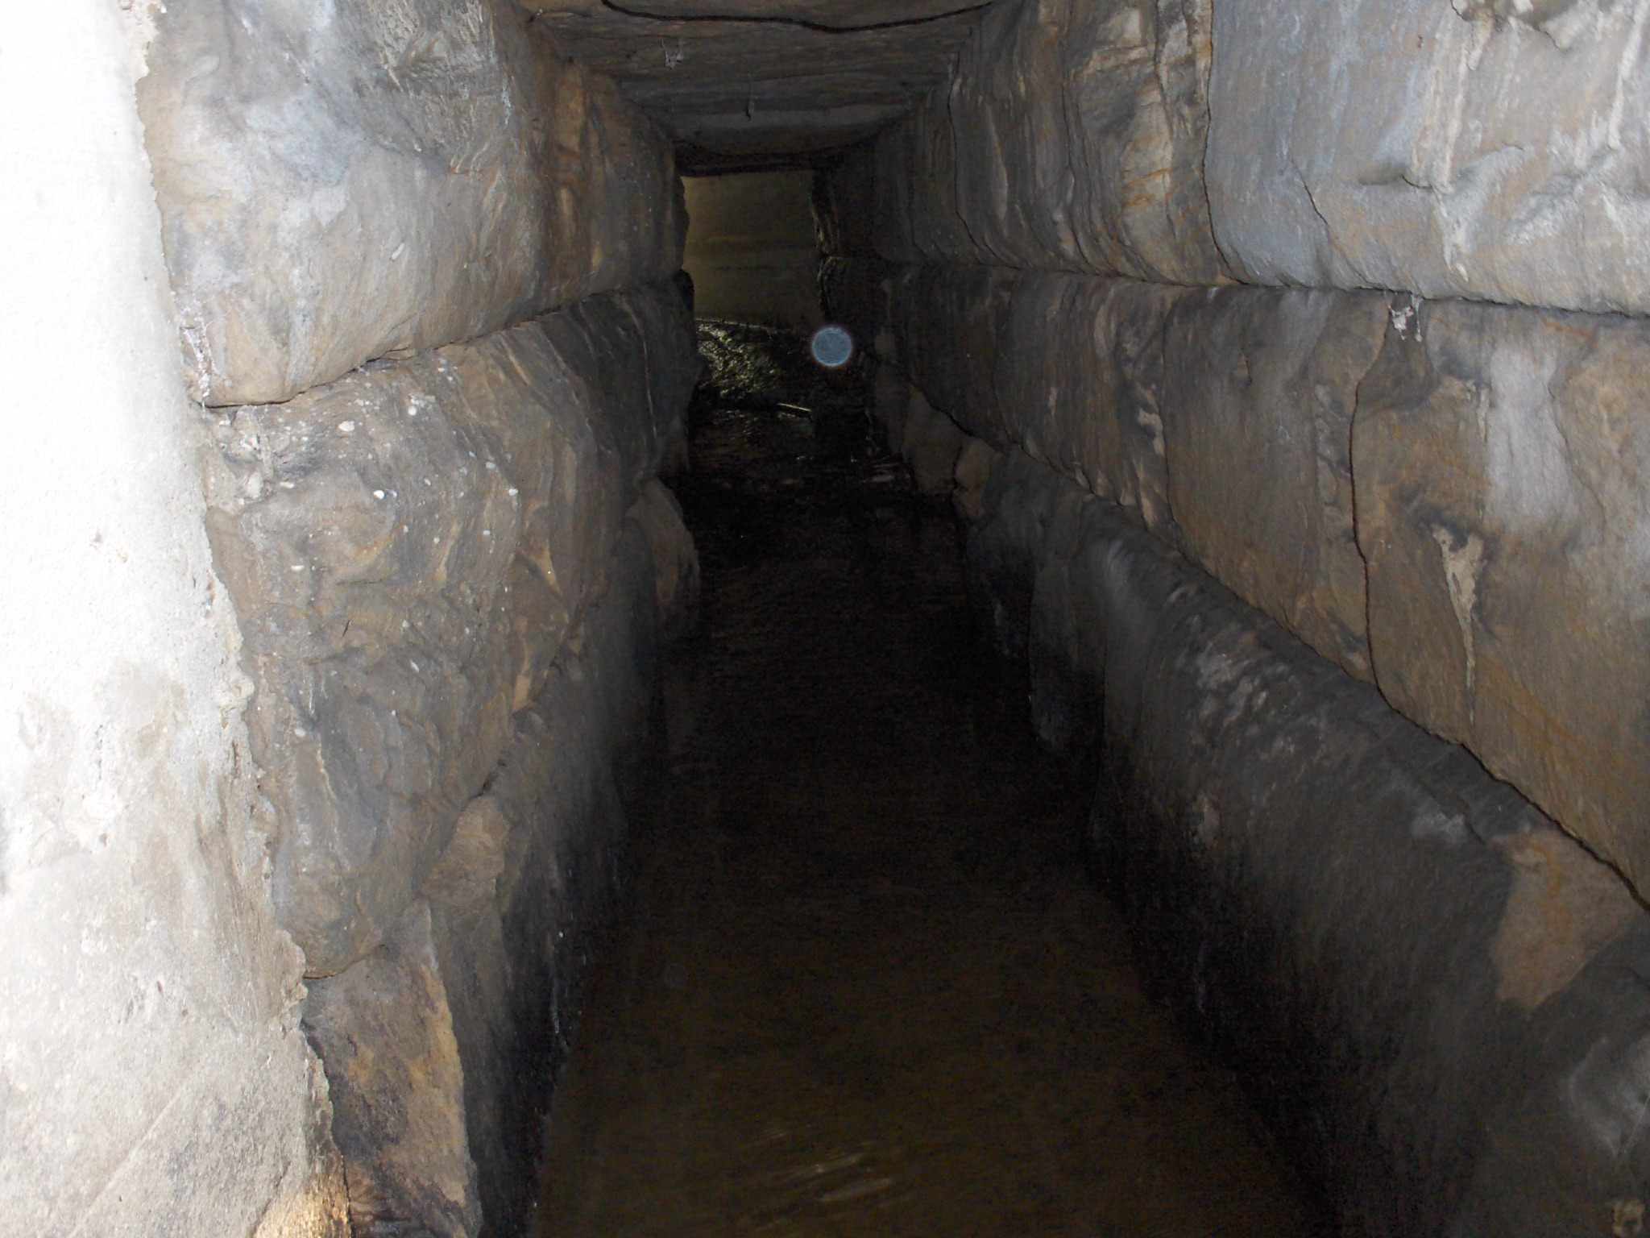
Photos 5-10: Sandstone floor and sidewalls showing abrasion and undermining

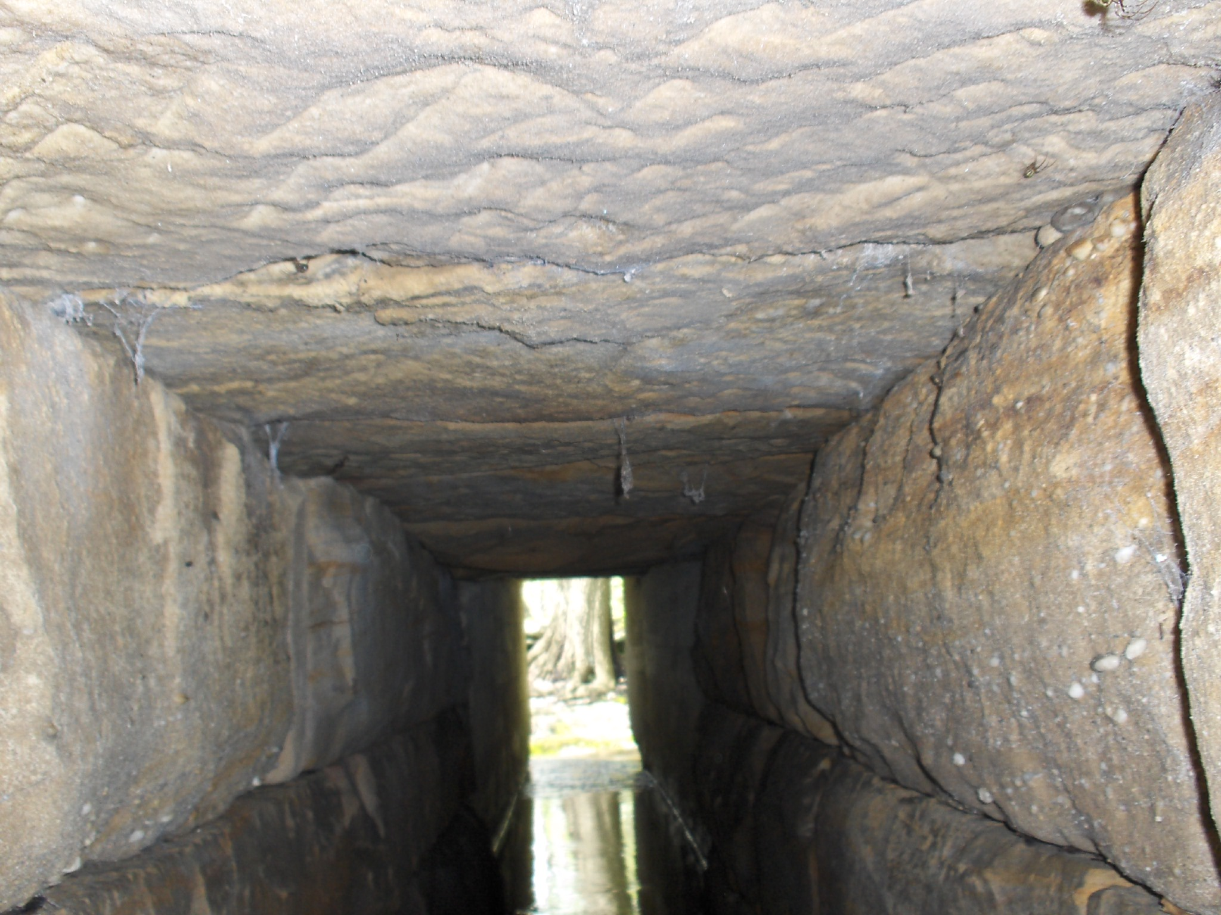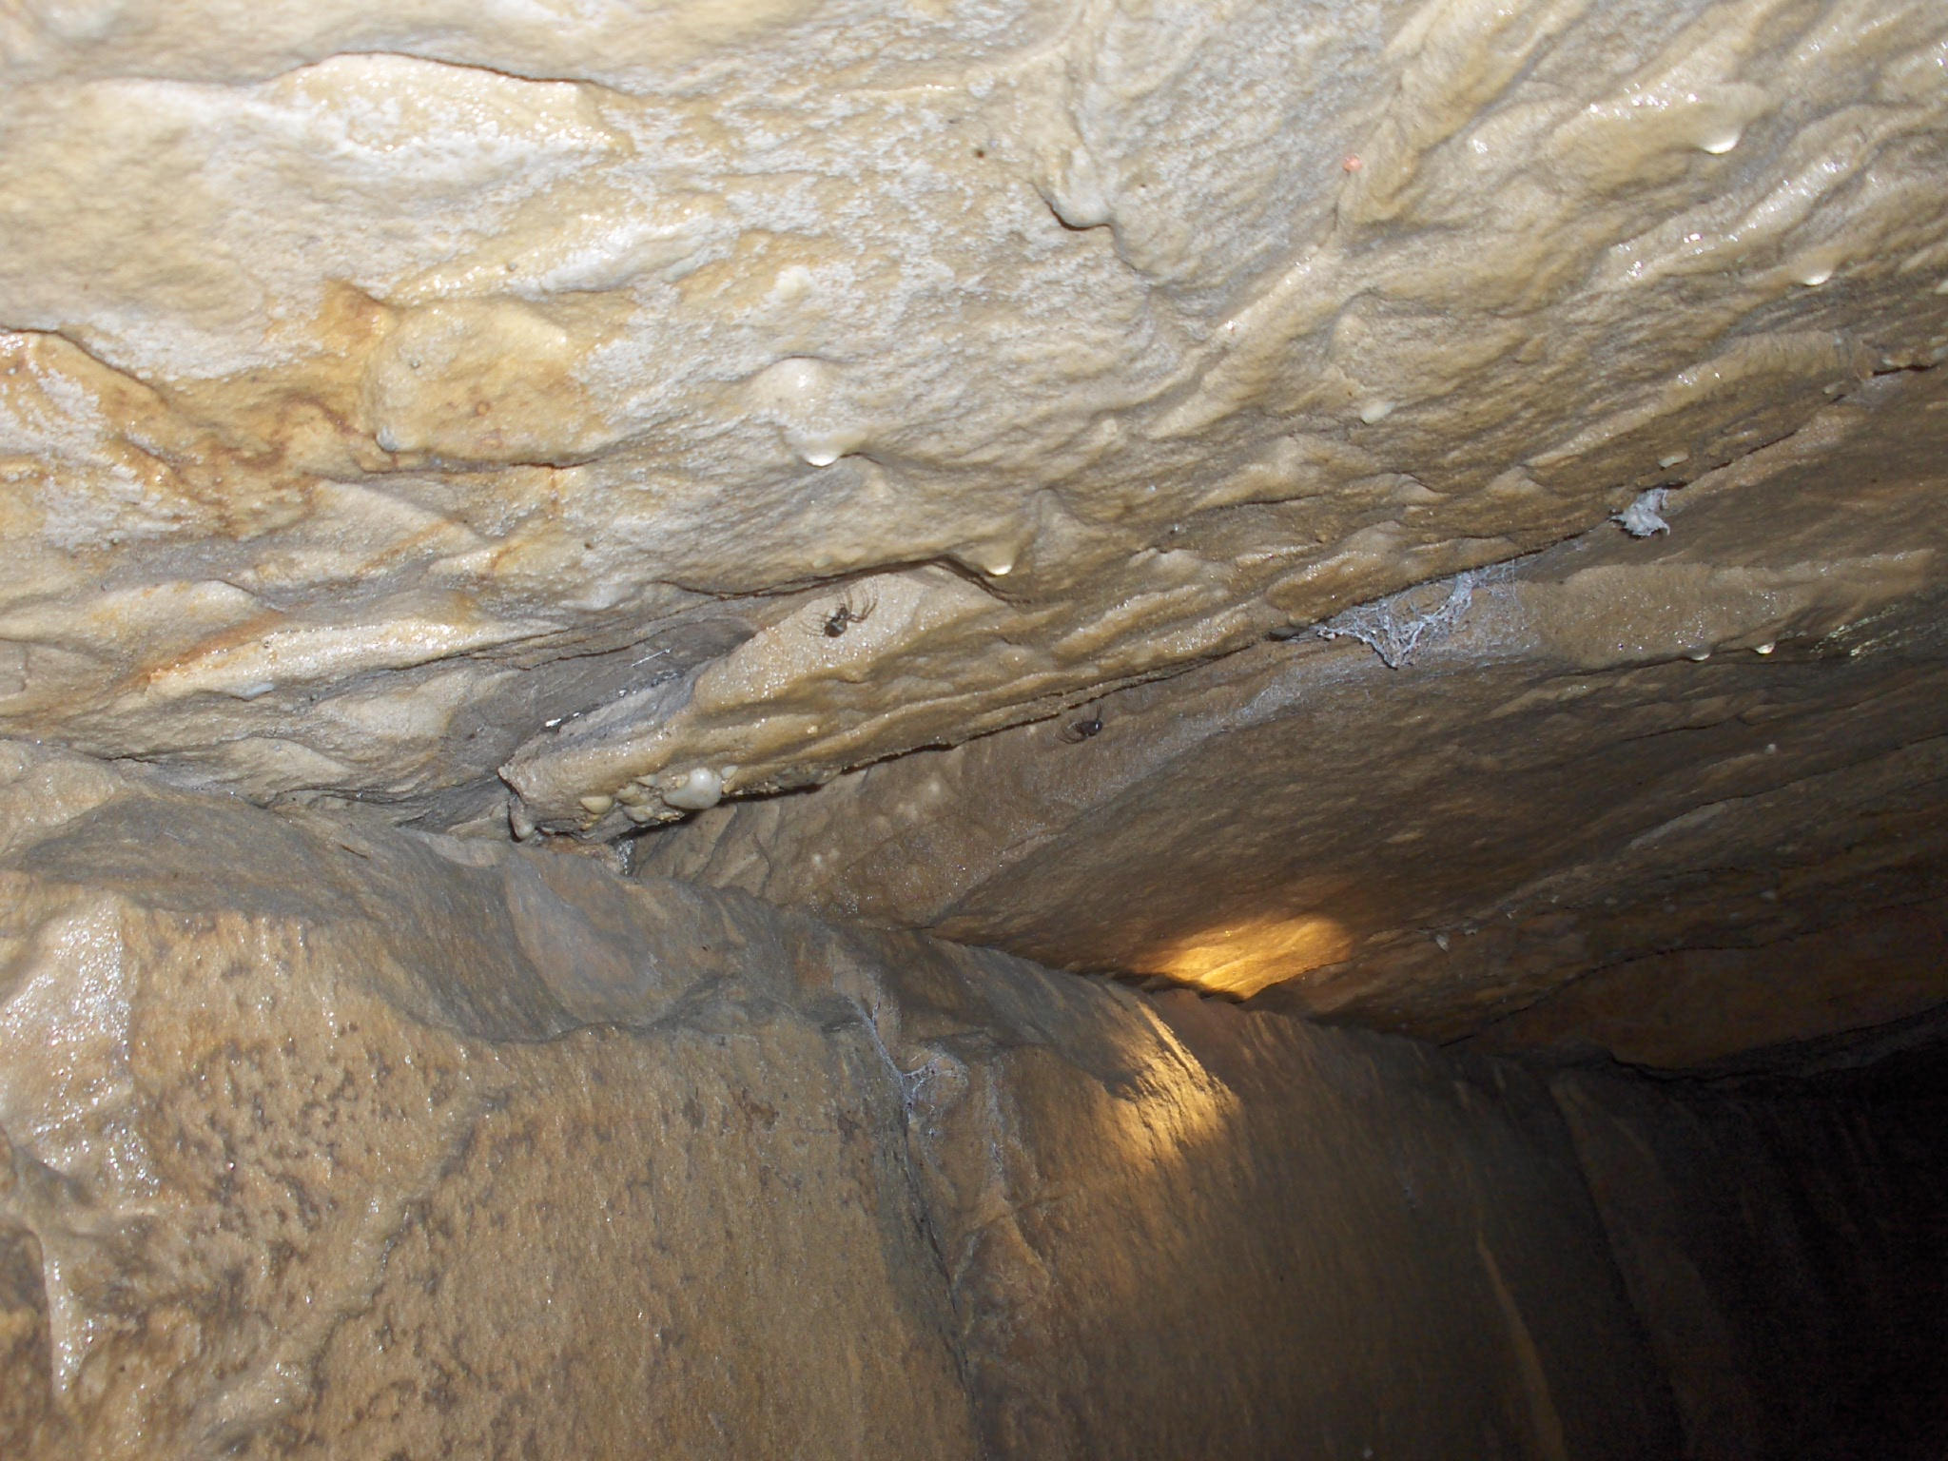
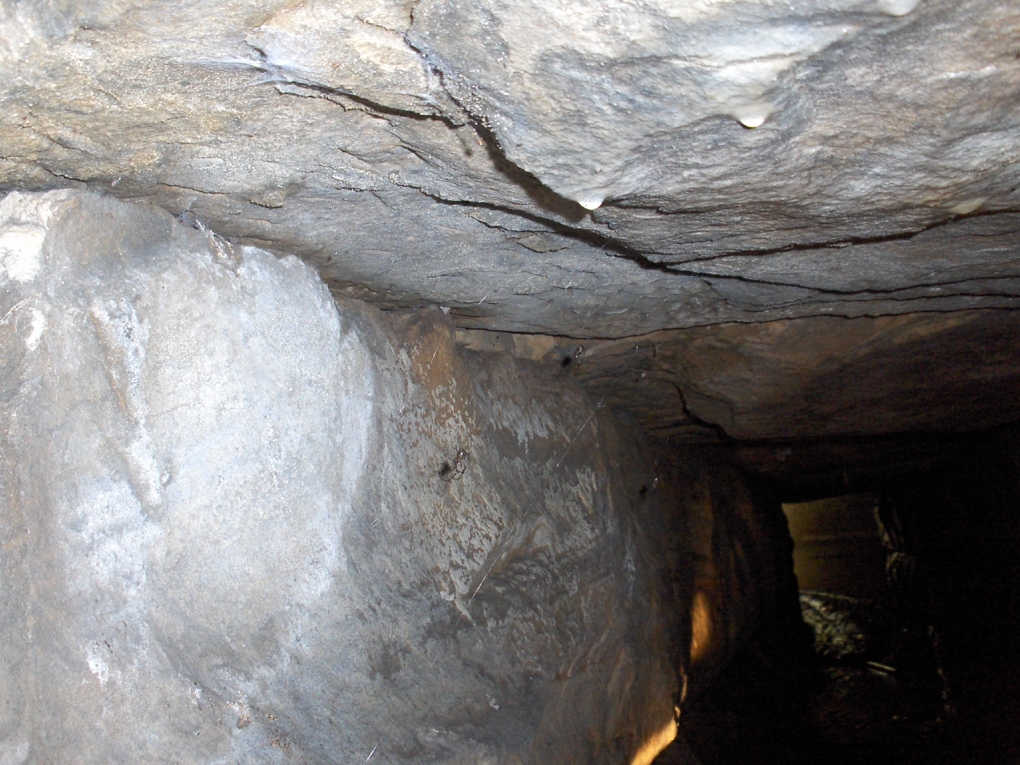
Photos 11-13: Views of sandstone roof
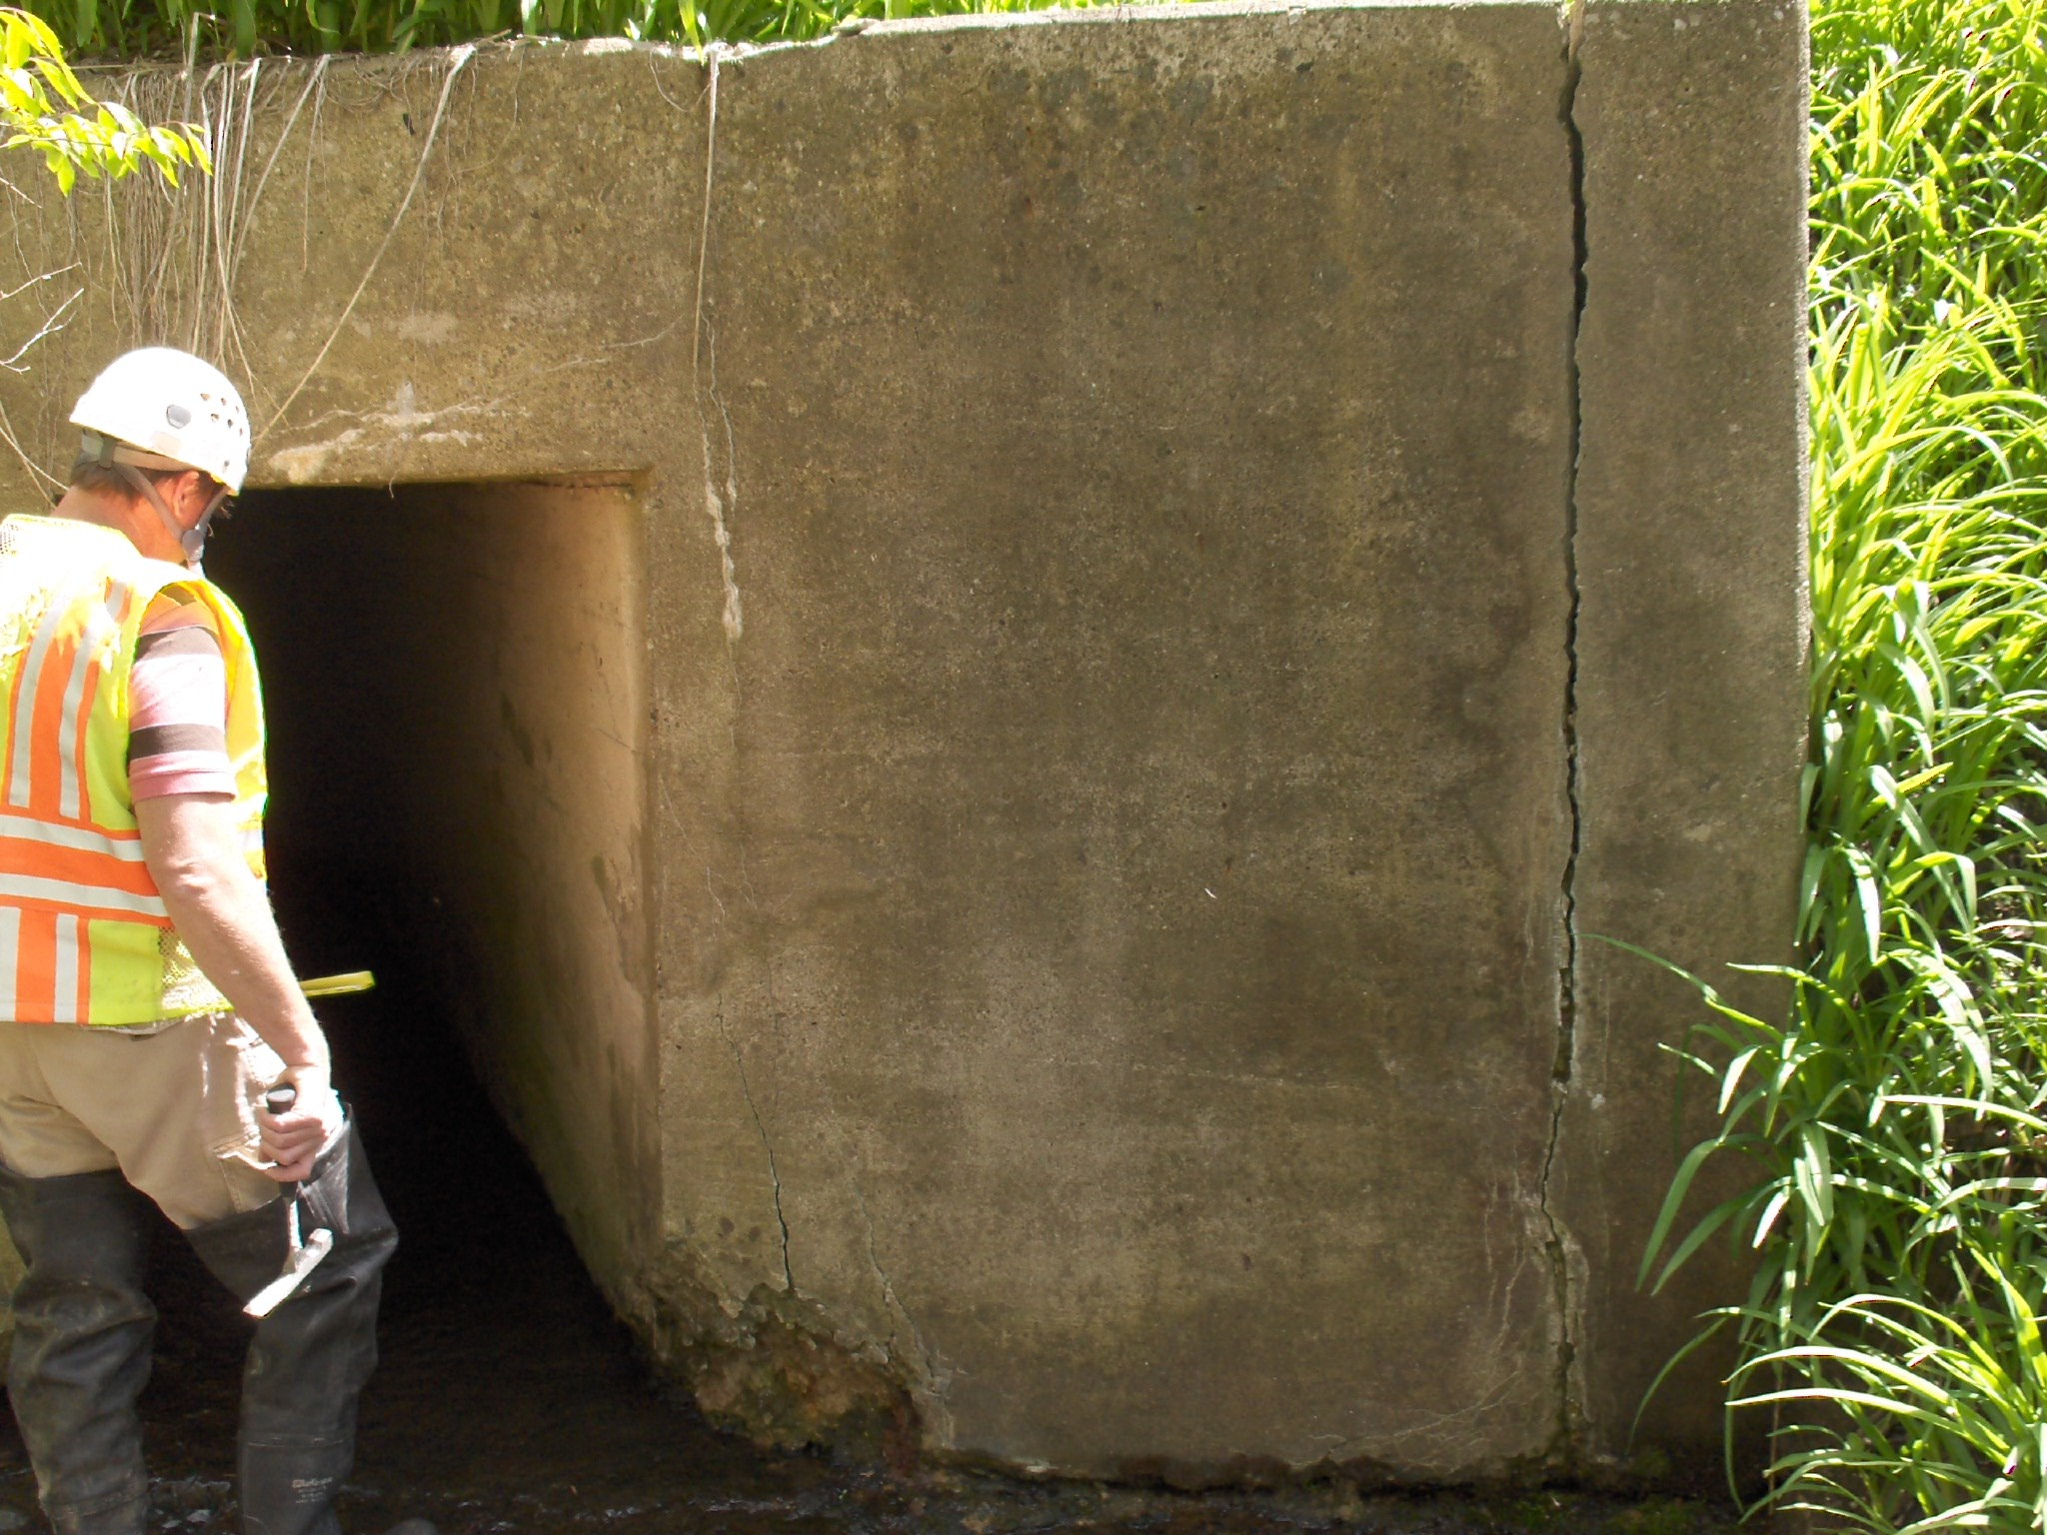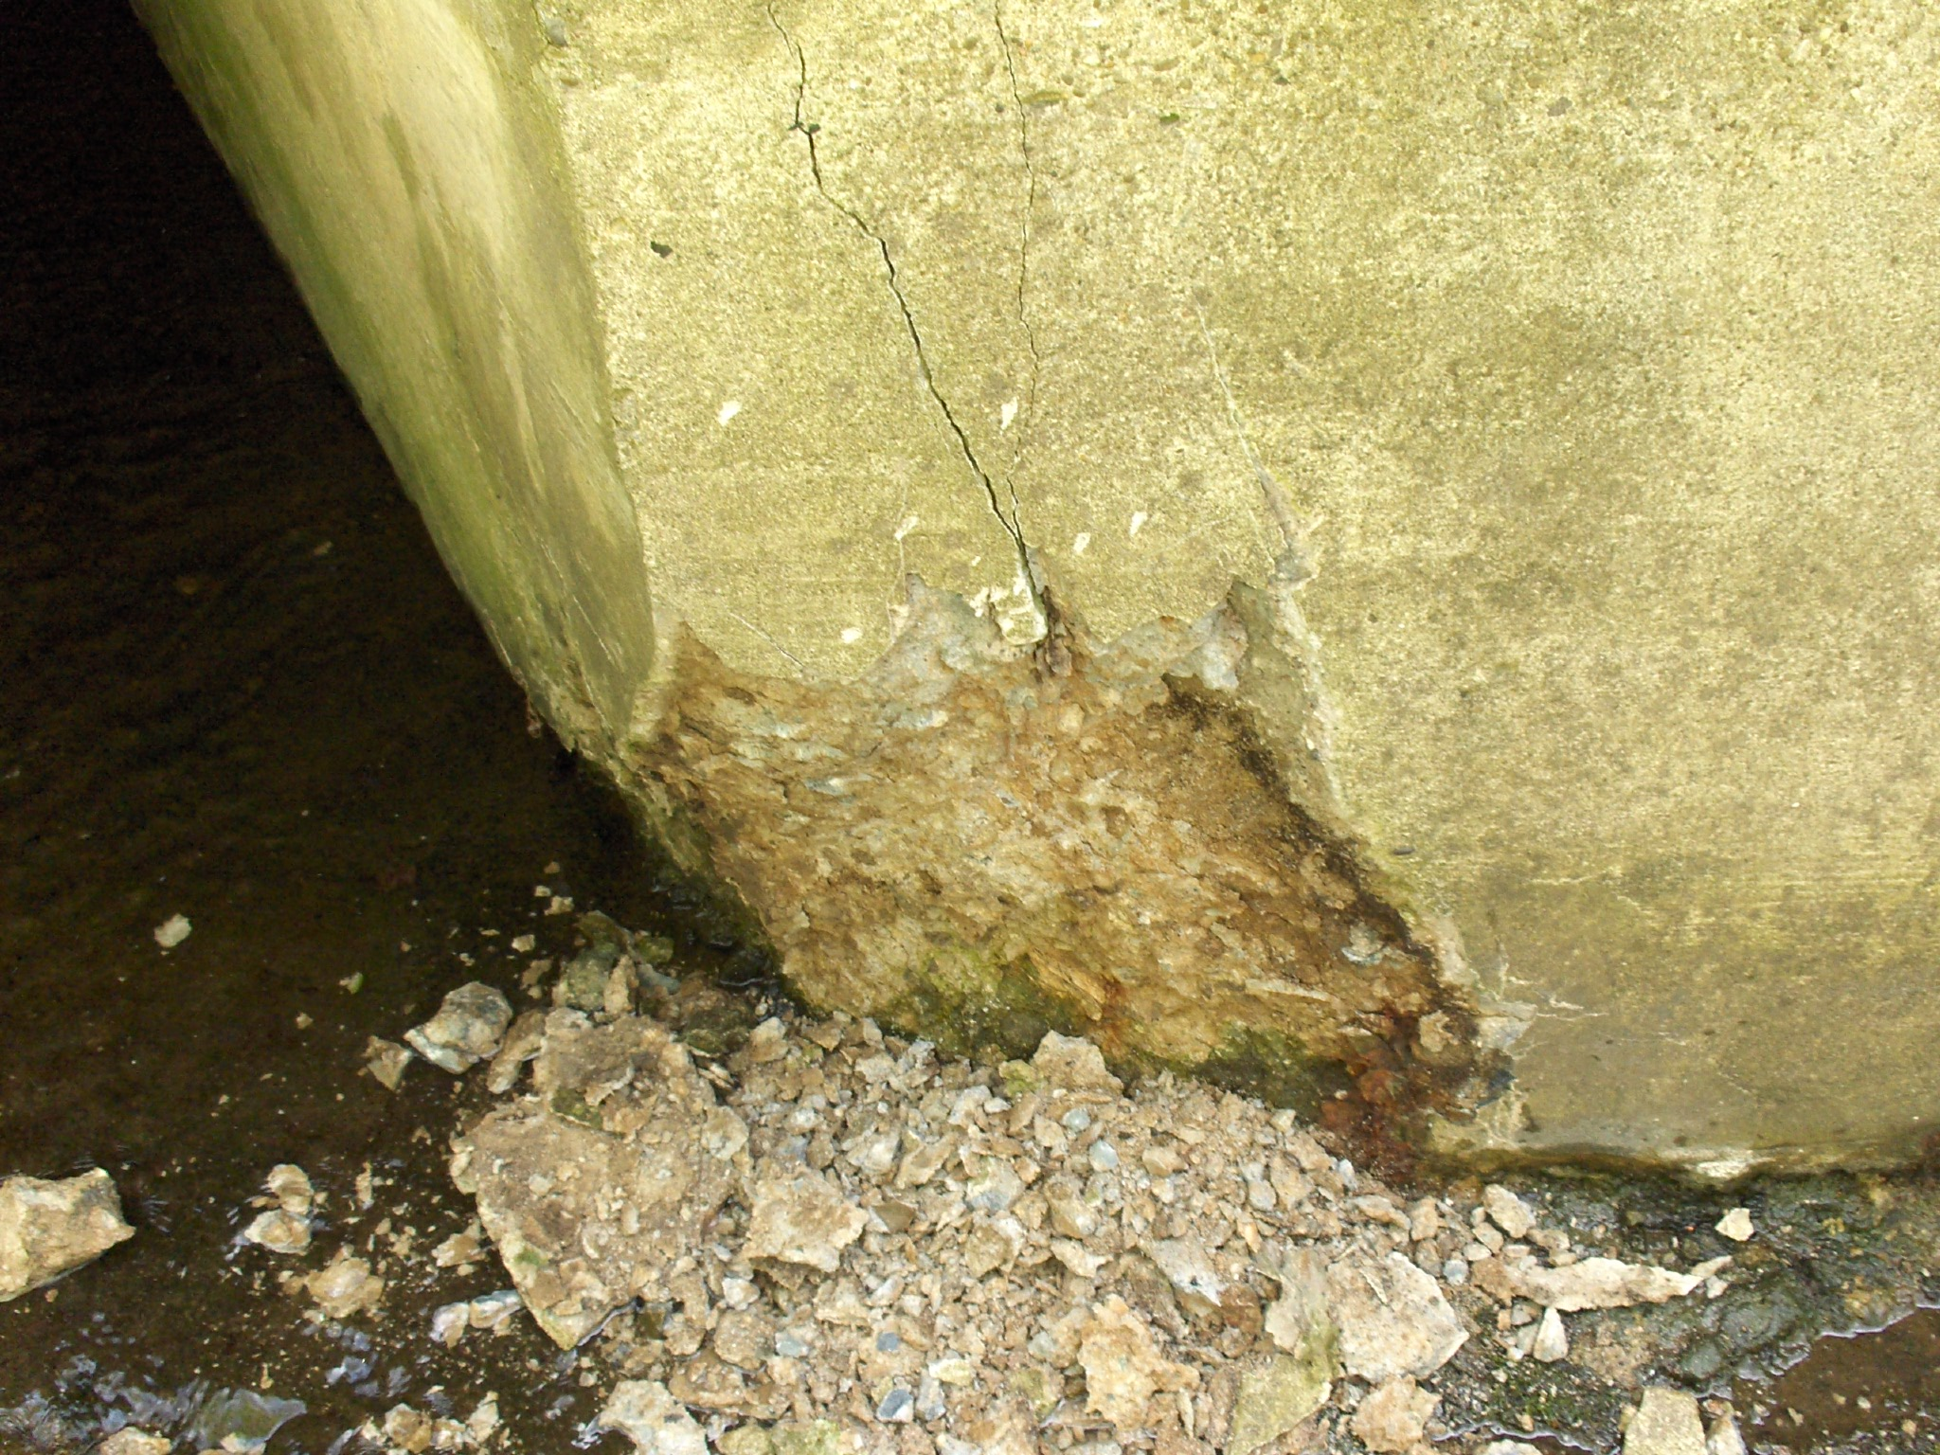
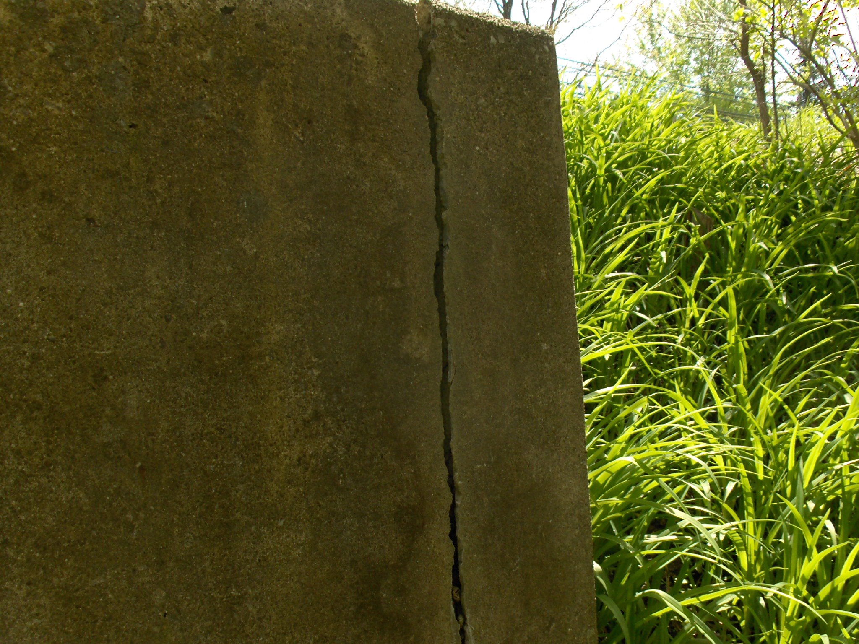
Photos 14-16: Deteriorated and cracked outlet headwall
Recommendations/Requested work:
- Place rock and cement slurry in abraded areas along the sidewalls and floor.
- Remove areas of bad concrete at headwall and patch.
- Replace retaining wall.

