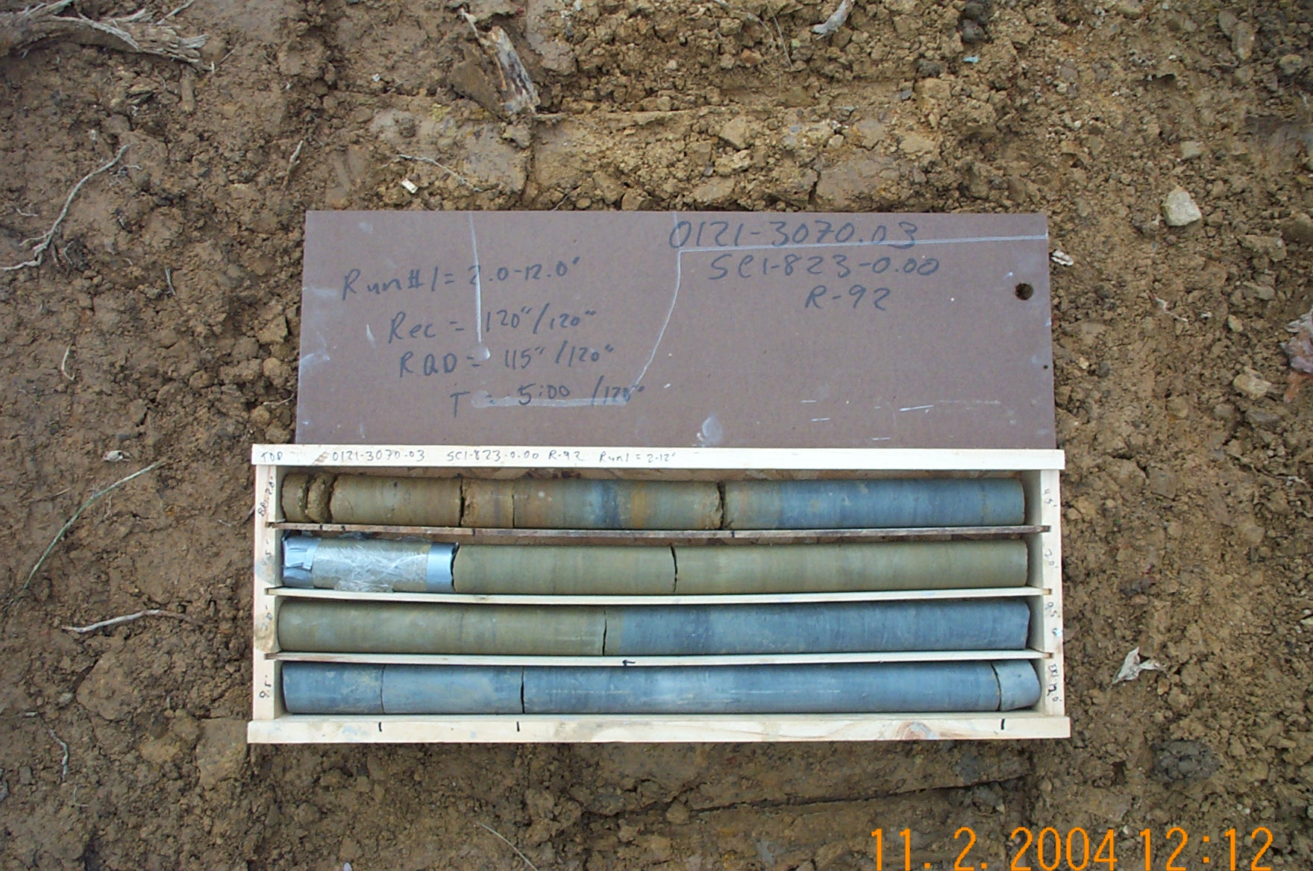
Photo 1. T:\Painter\portsmouthcore\R-092\R1-3fld.JPG

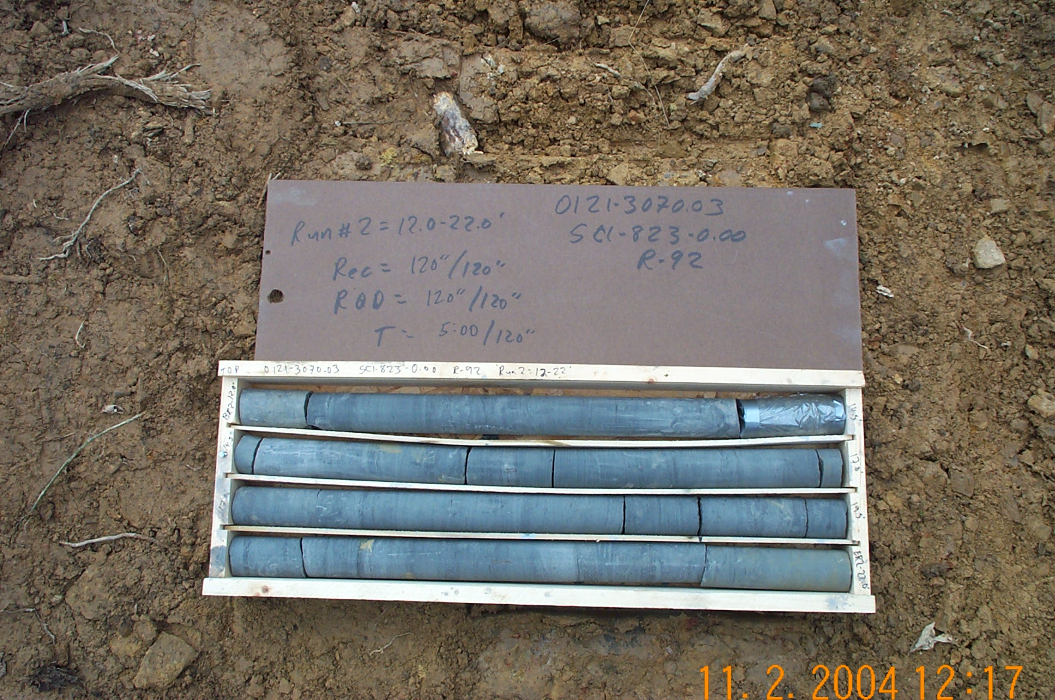
Photo 2. T:\Painter\portsmouthcore\R-092\R2-3fld.JPG

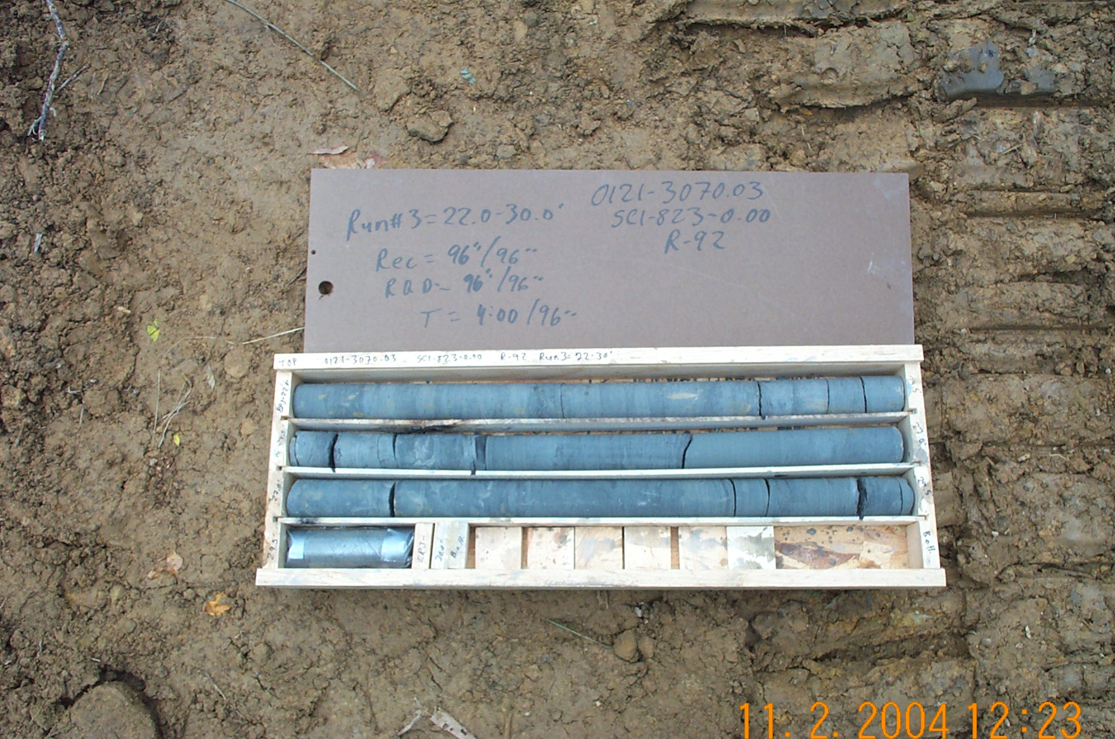
Photo 3. T:\Painter\portsmouthcore\R-092\R3-3fld.JPG

