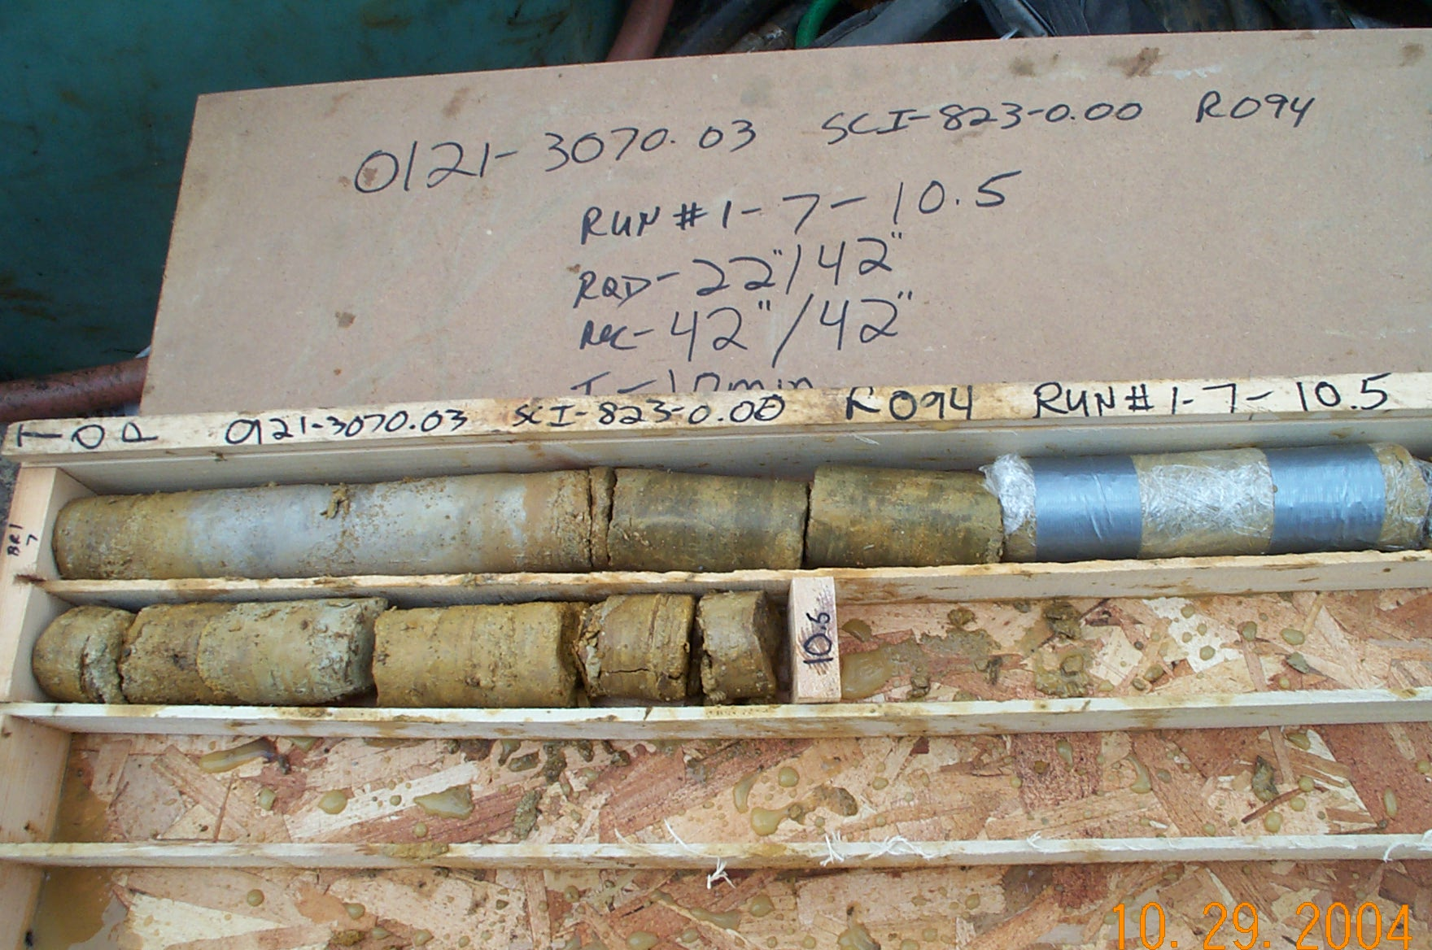
Photo 1. T:\Painter\portsmouthcore\R-094\R1-8fld.JPG

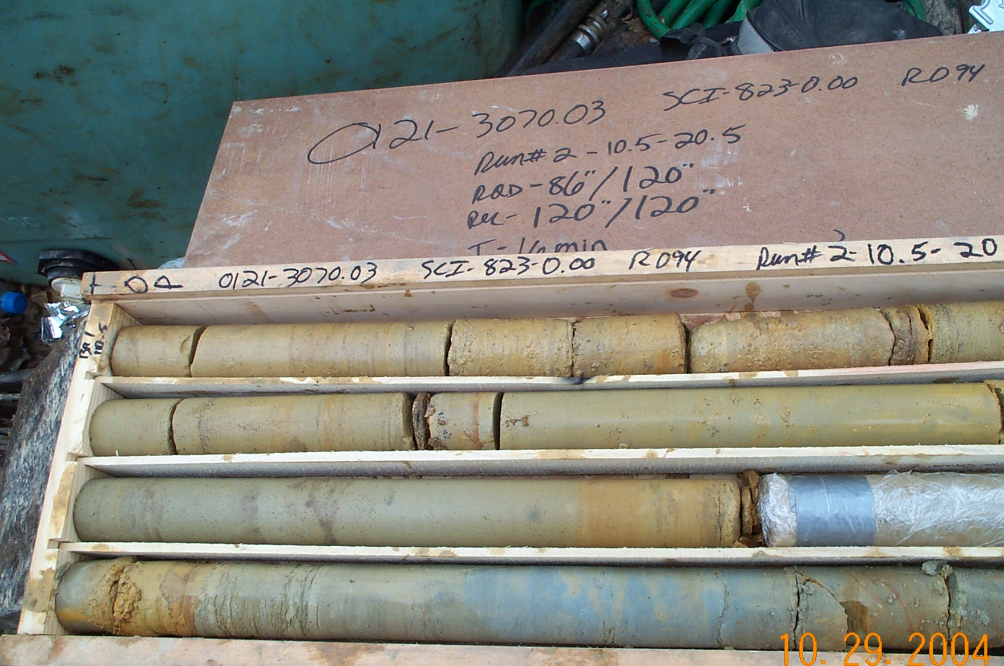
Photo 2. T:\Painter\portsmouthcore\R-094\R2-8fld.JPG

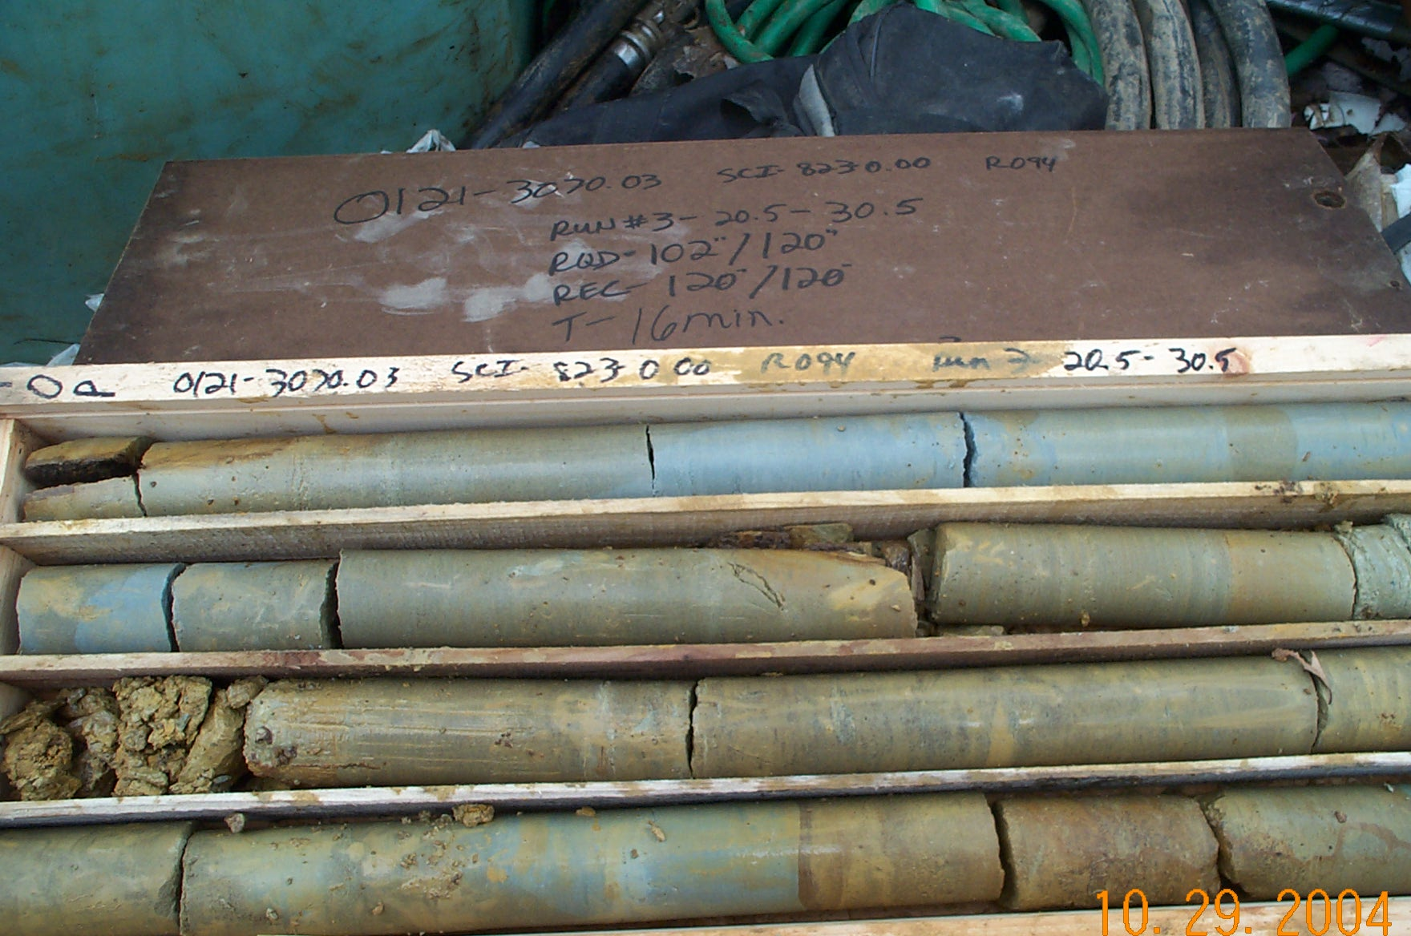
Photo 3. T:\Painter\portsmouthcore\R-094\R3-8fld.JPG

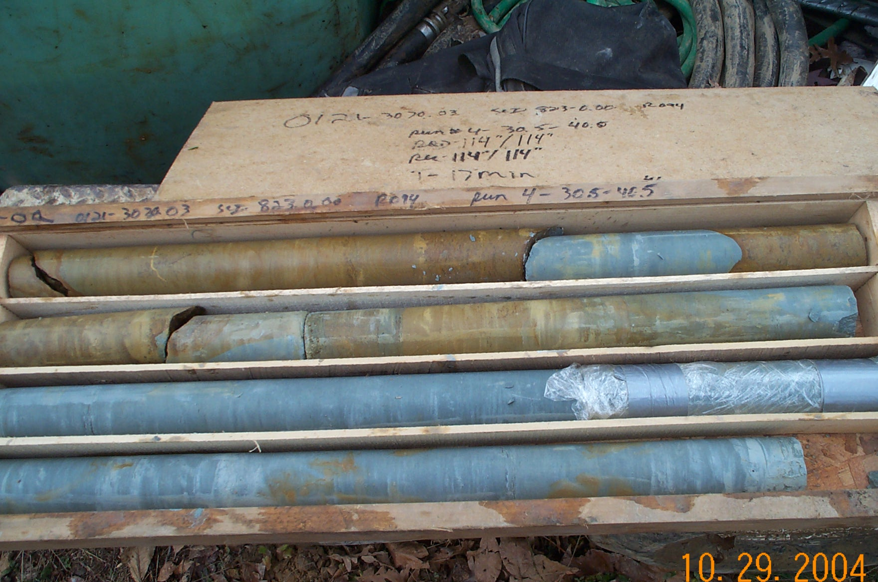
Photo 4. T:\Painter\portsmouthcore\R-094\R4-8fld.JPG

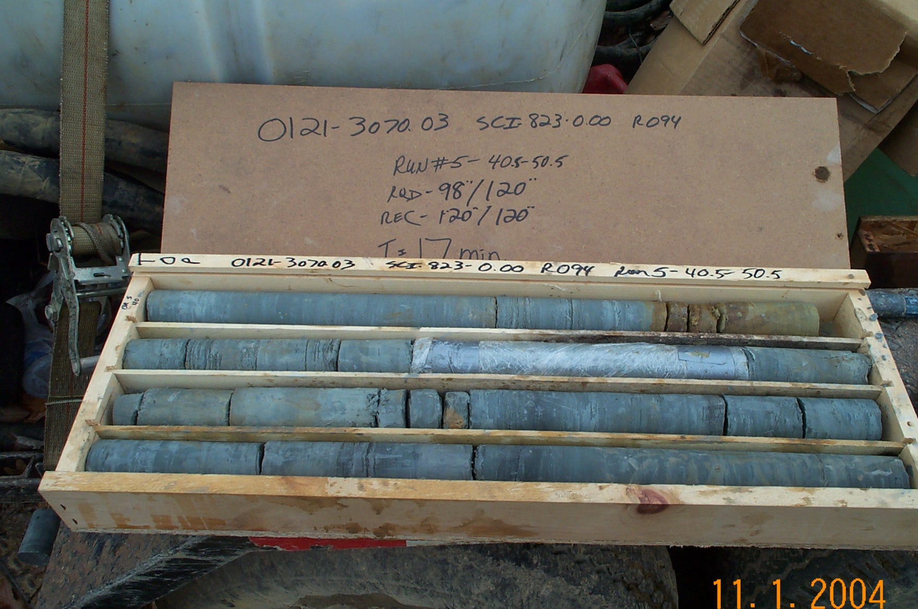
Photo 5. T:\Painter\portsmouthcore\R-094\R5-8fld.JPG

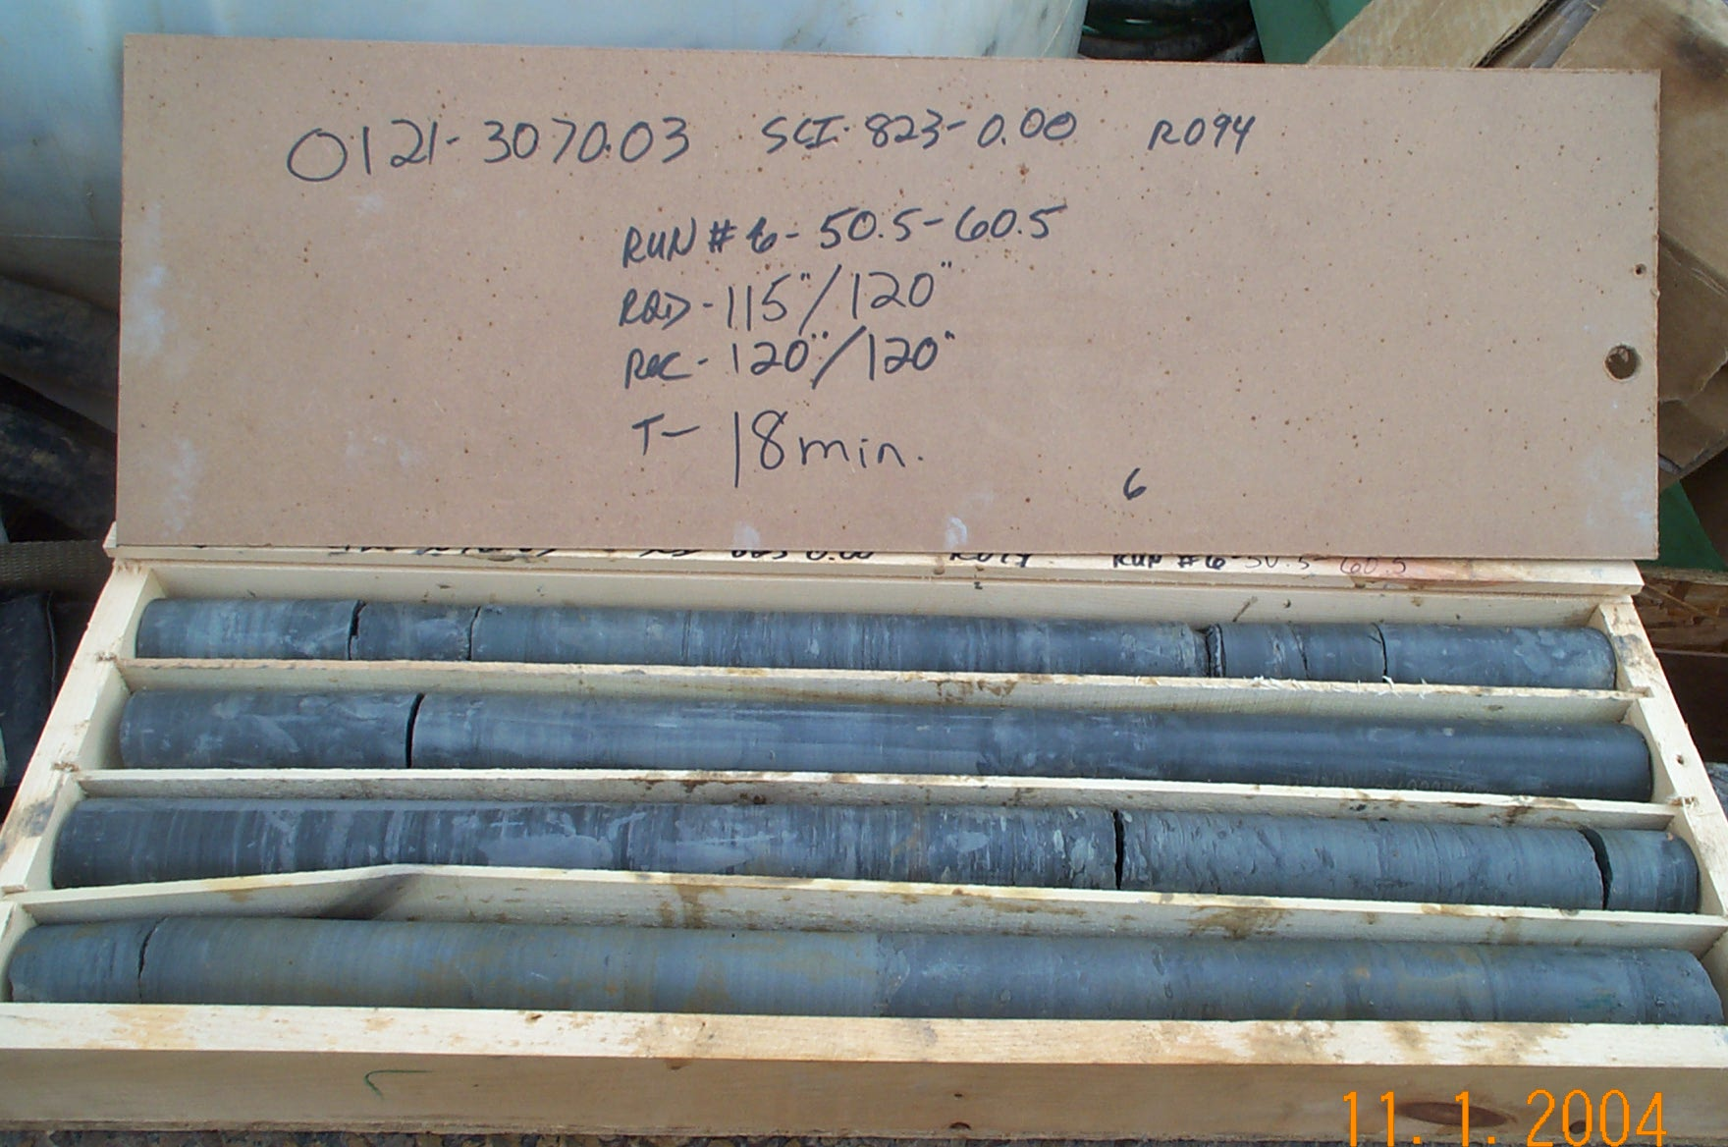
Photo 6. T:\Painter\portsmouthcore\R-094\R6-8fld.JPG

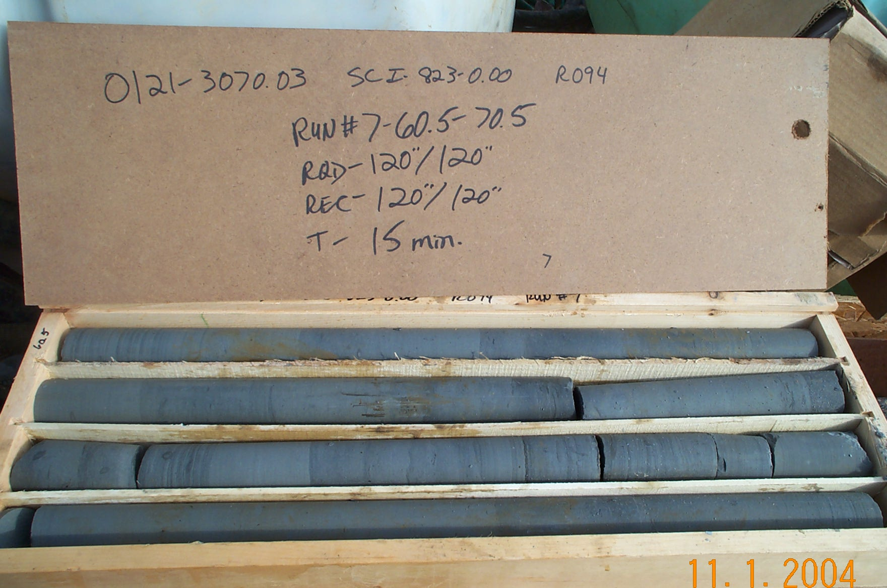
Photo 7. T:\Painter\portsmouthcore\R-094\R7-8fld.JPG

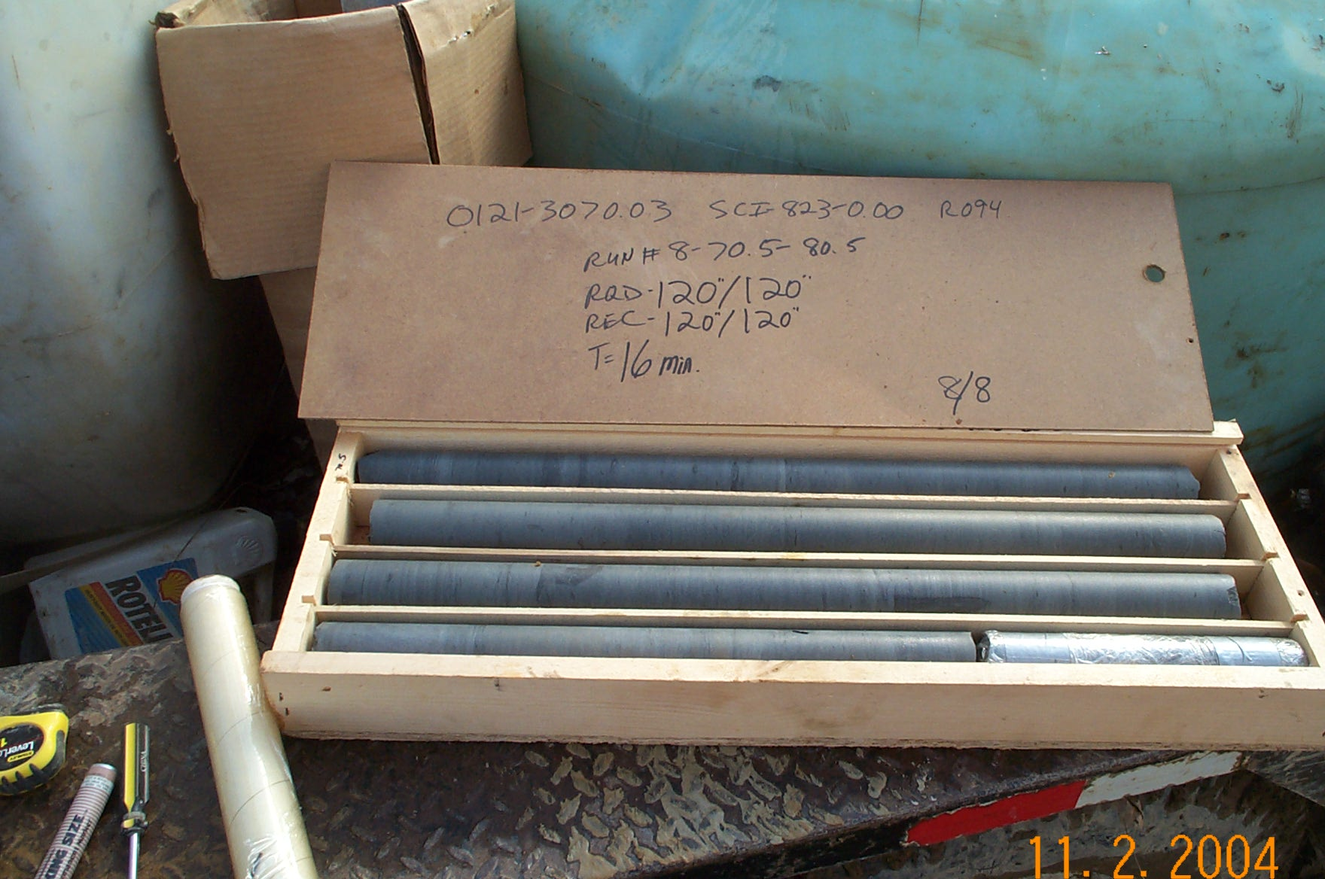
Photo 8. T:\Painter\portsmouthcore\R-094\R8-8fld.JPG

