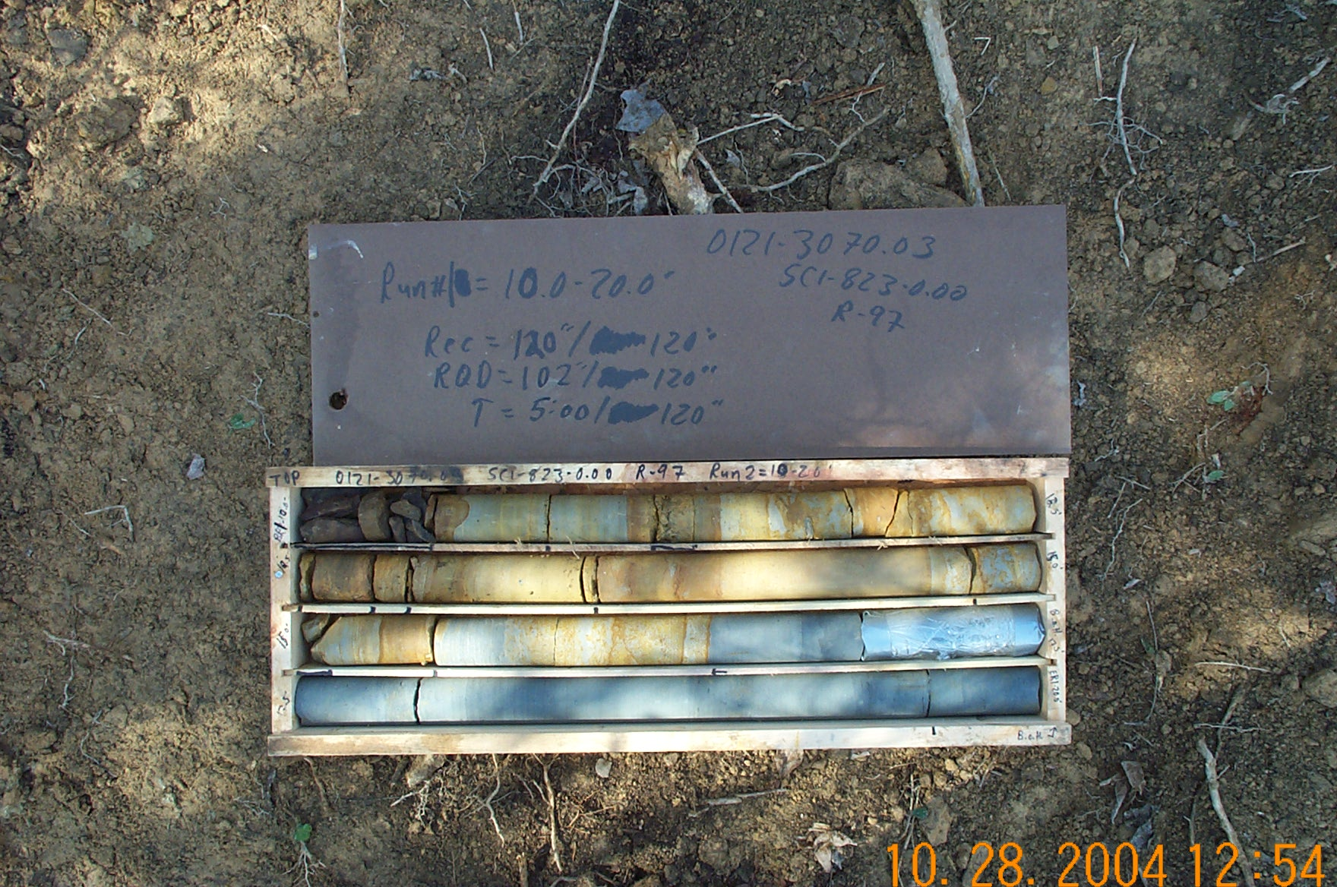
Photo 1. T:\Painter\portsmouthcore\R-097\R-1-1fld.JPG

