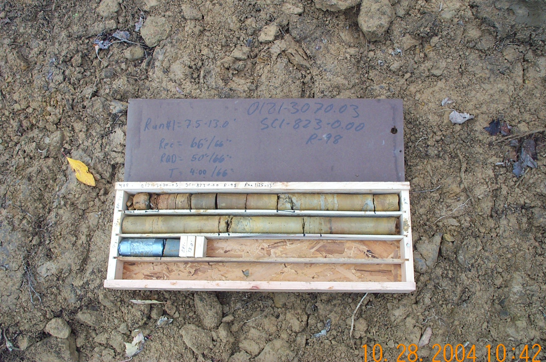
Photo 1. T:\Painter\portsmouthcore\R-098\R1-2fld.JPG

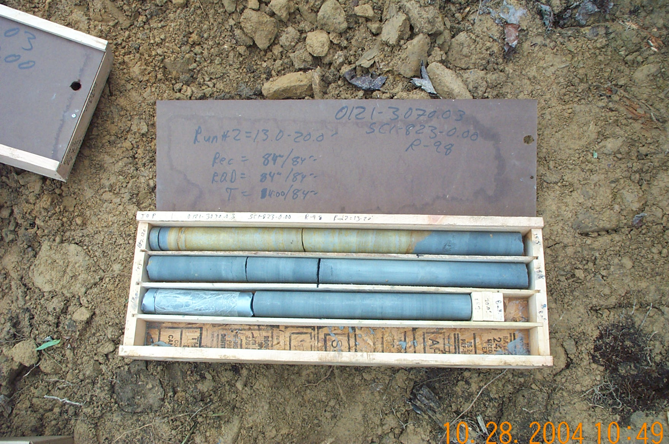
Photo 2. T:\Painter\portsmouthcore\R-098\R2-2fld.JPG

