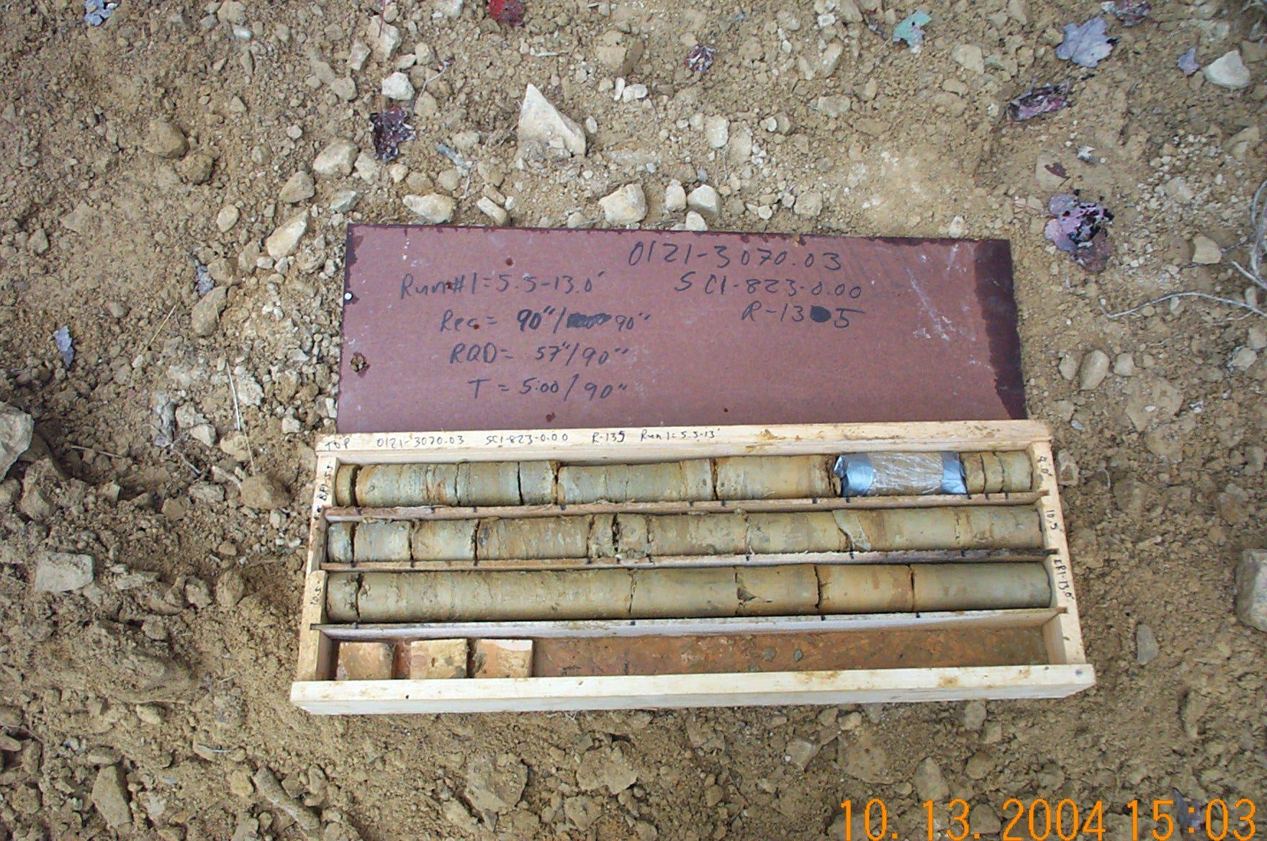
Photo 1. T:\Painter\portsmouthcore\R-135\R1-2fld.jpg

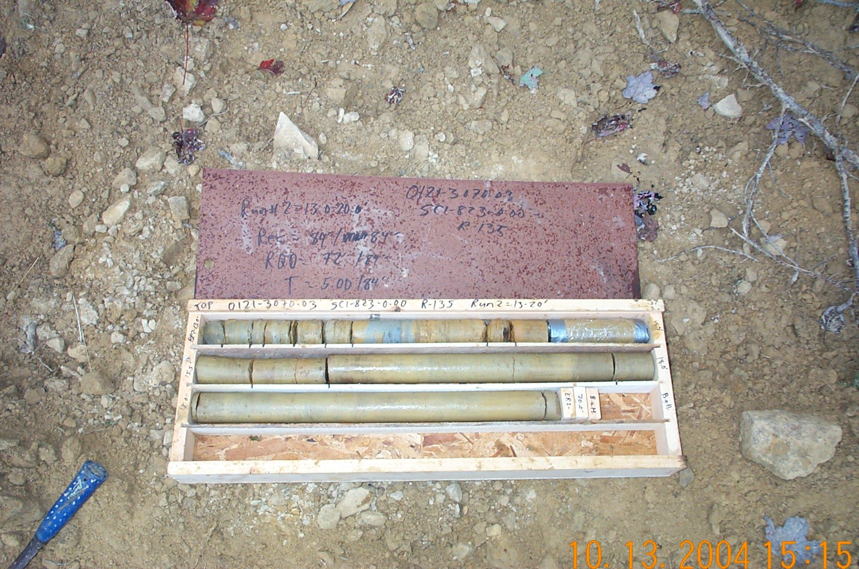
Photo 2. T:\Painter\portsmouthcore\R-135\R2-2fld.jpg

