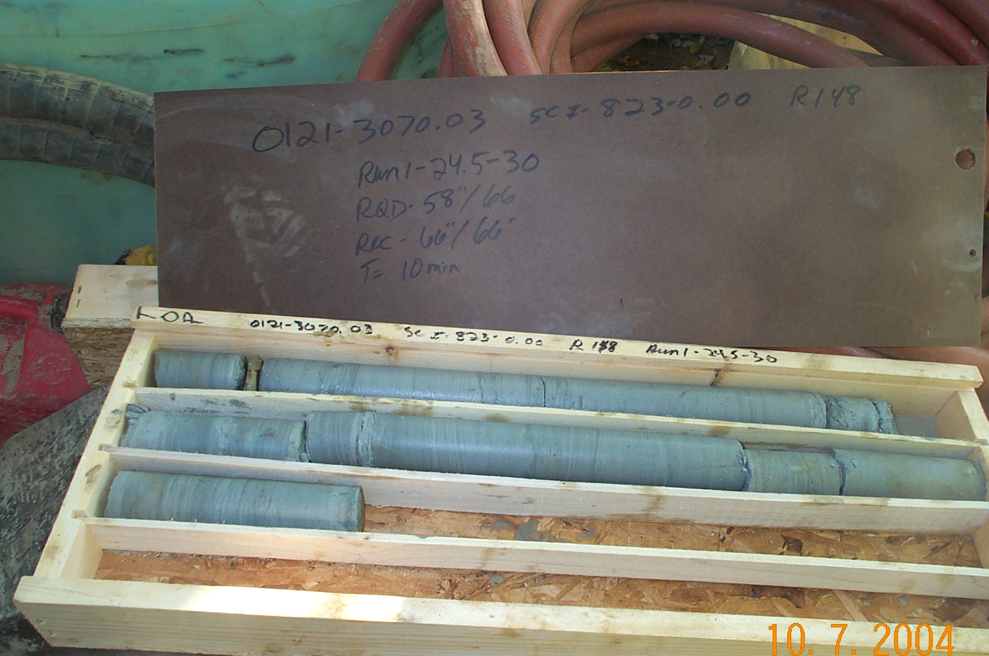
Photo 1. T:\Painter\portsmouthcore\R-148\R1-5fld.JPG

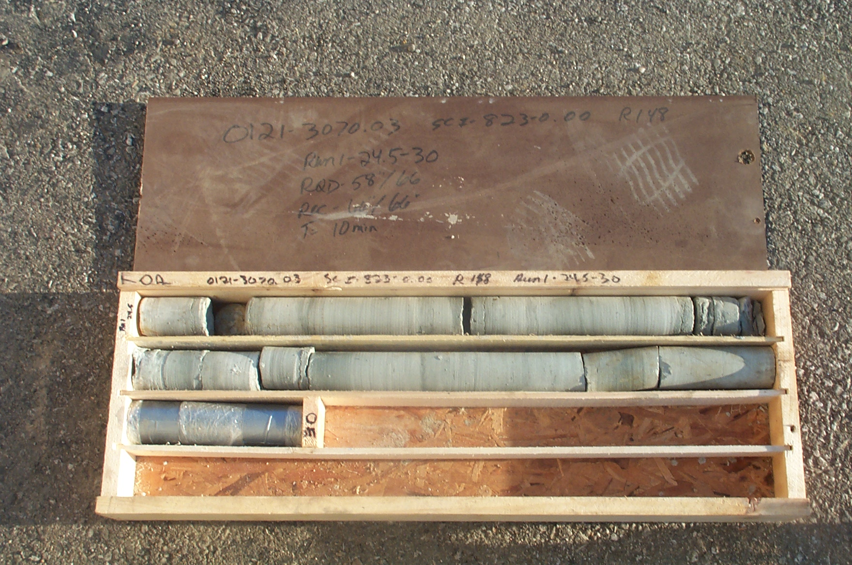
Photo 2. T:\Painter\portsmouthcore\R-148\R1-5shp.JPG

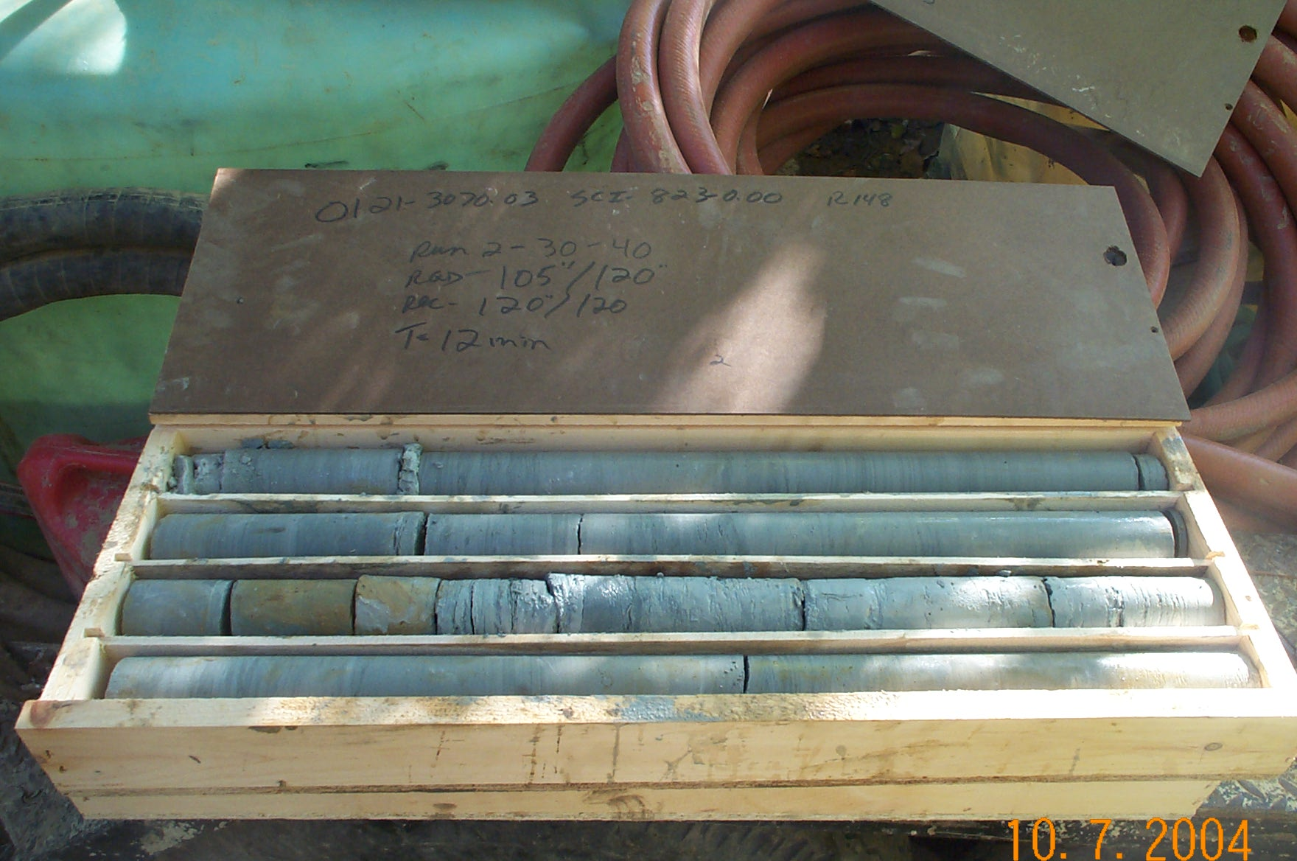
Photo 3. T:\Painter\portsmouthcore\R-148\R2-5fld.JPG

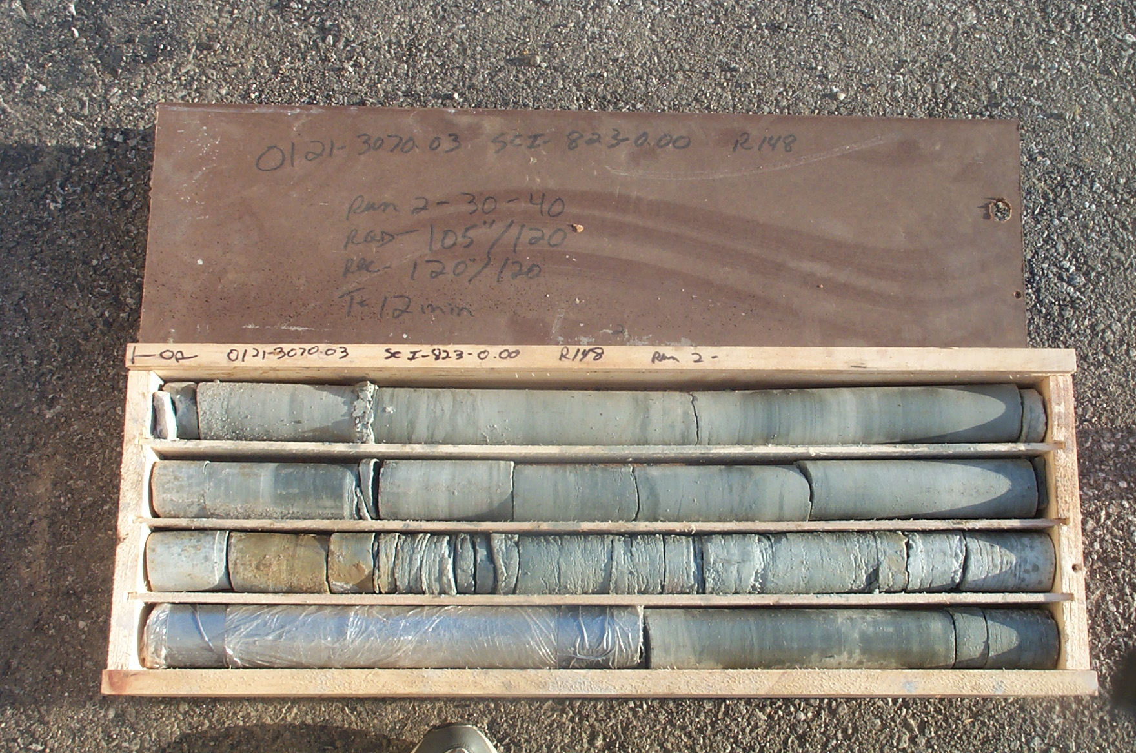
Photo 4. T:\Painter\portsmouthcore\R-148\R2-5shp.JPG

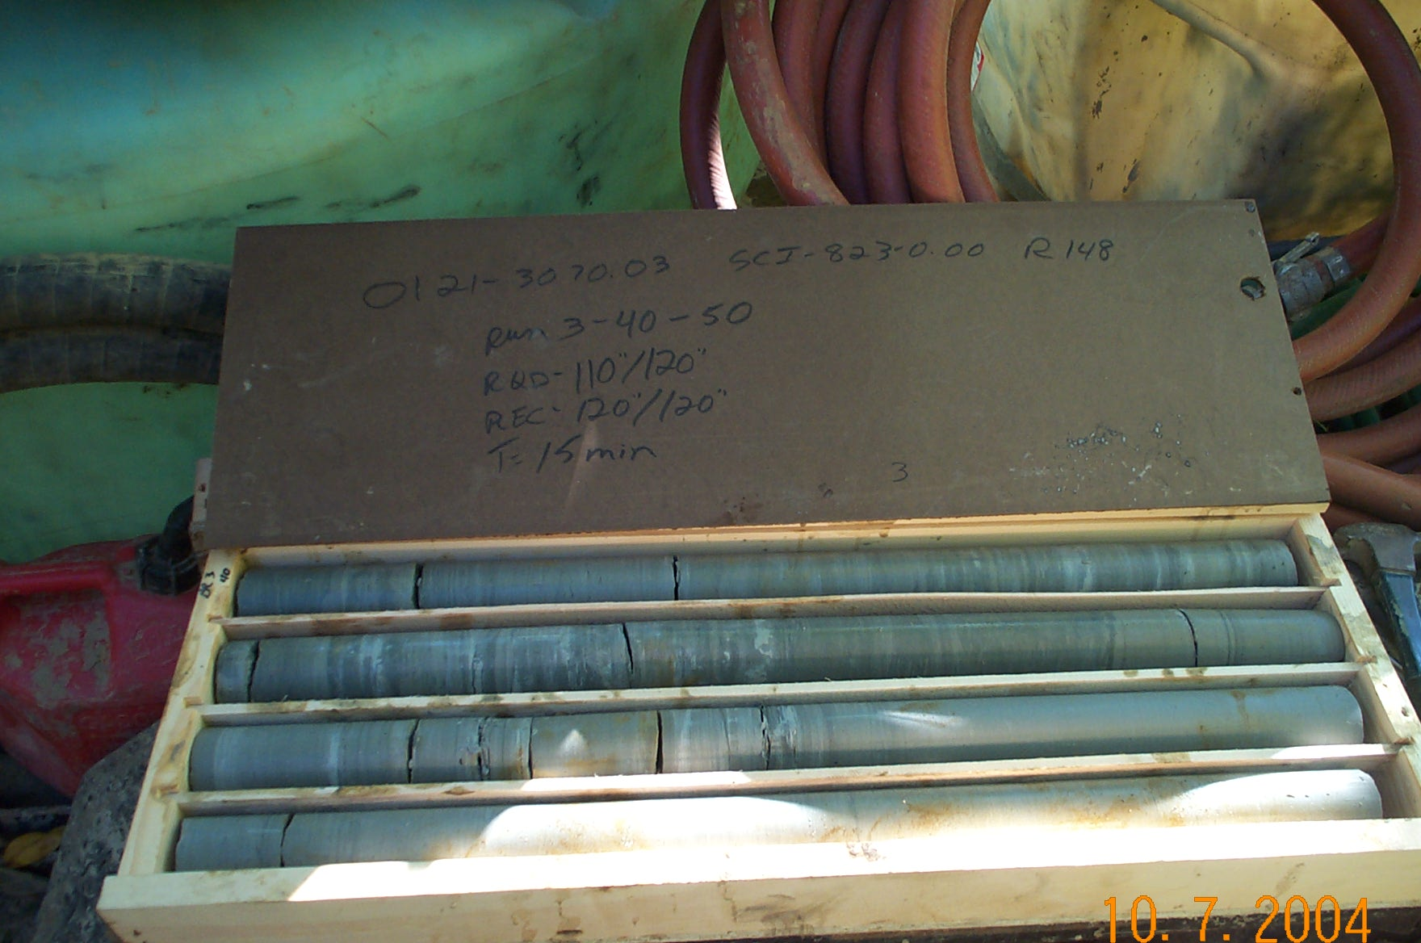
Photo 5. T:\Painter\portsmouthcore\R-148\R3-5fld.JPG

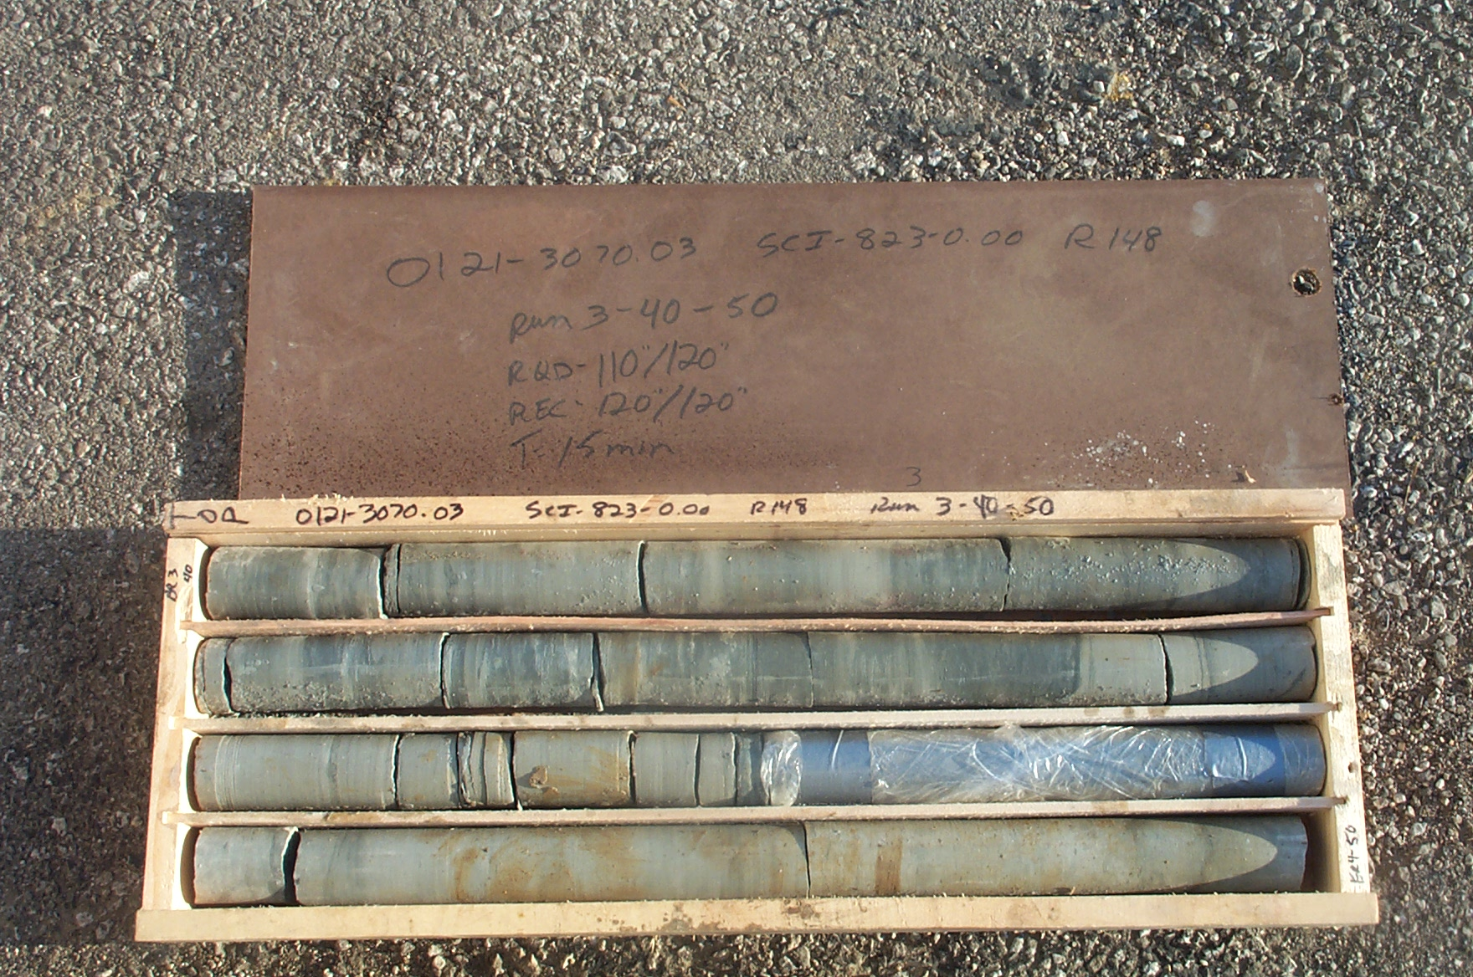
Photo 6. T:\Painter\portsmouthcore\R-148\R3-5shp.JPG

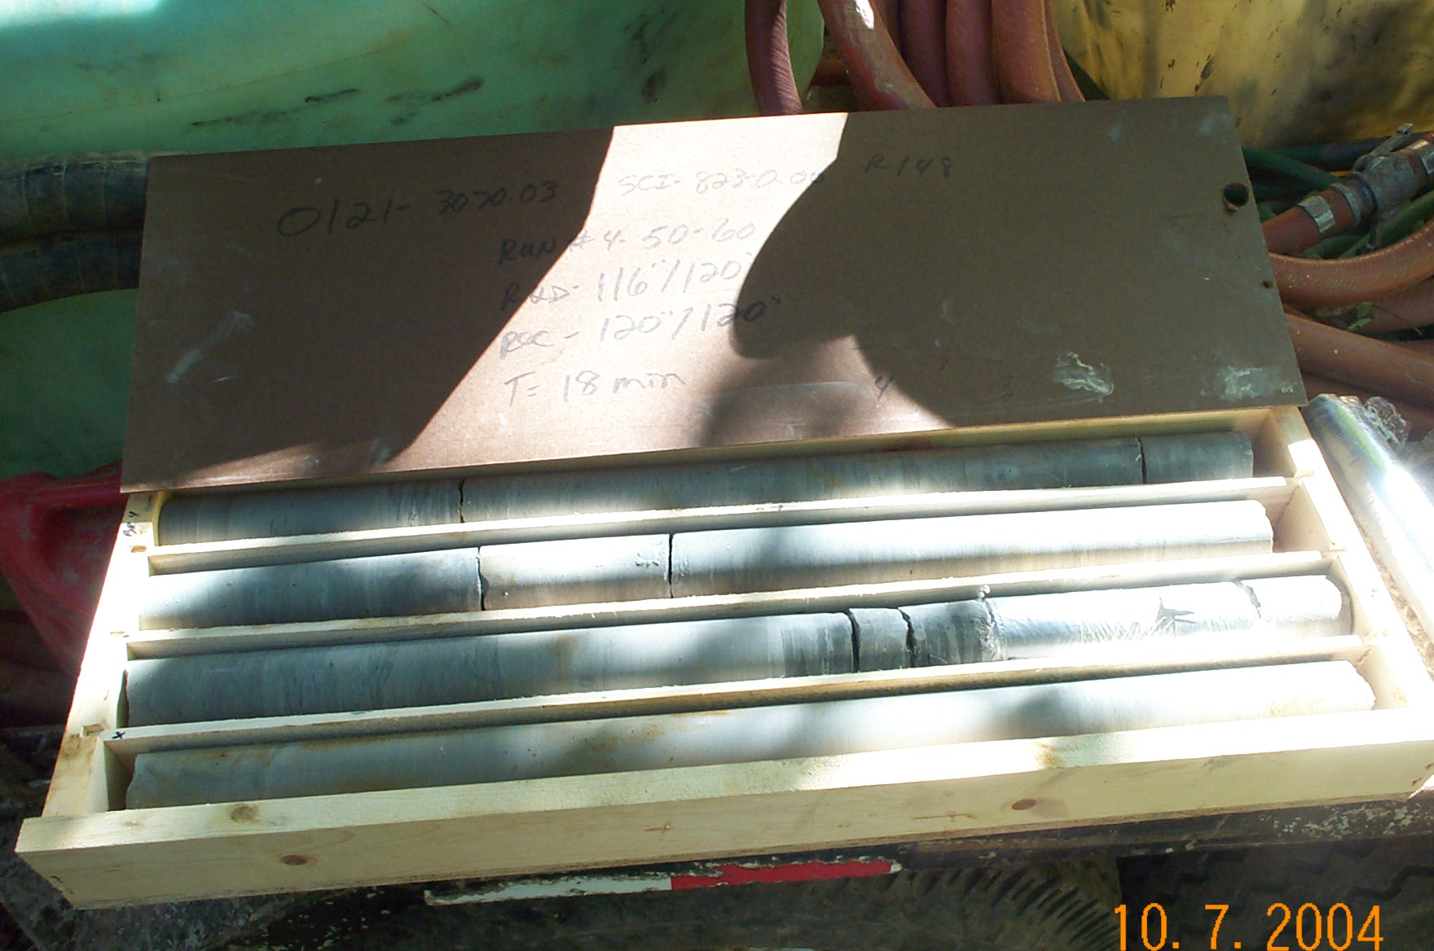
Photo 7. T:\Painter\portsmouthcore\R-148\R4-5fld.JPG

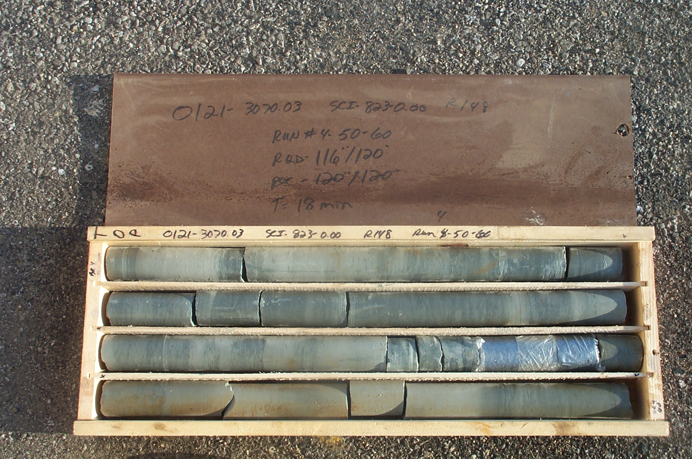
Photo 8. T:\Painter\portsmouthcore\R-148\R4-5shp.JPG

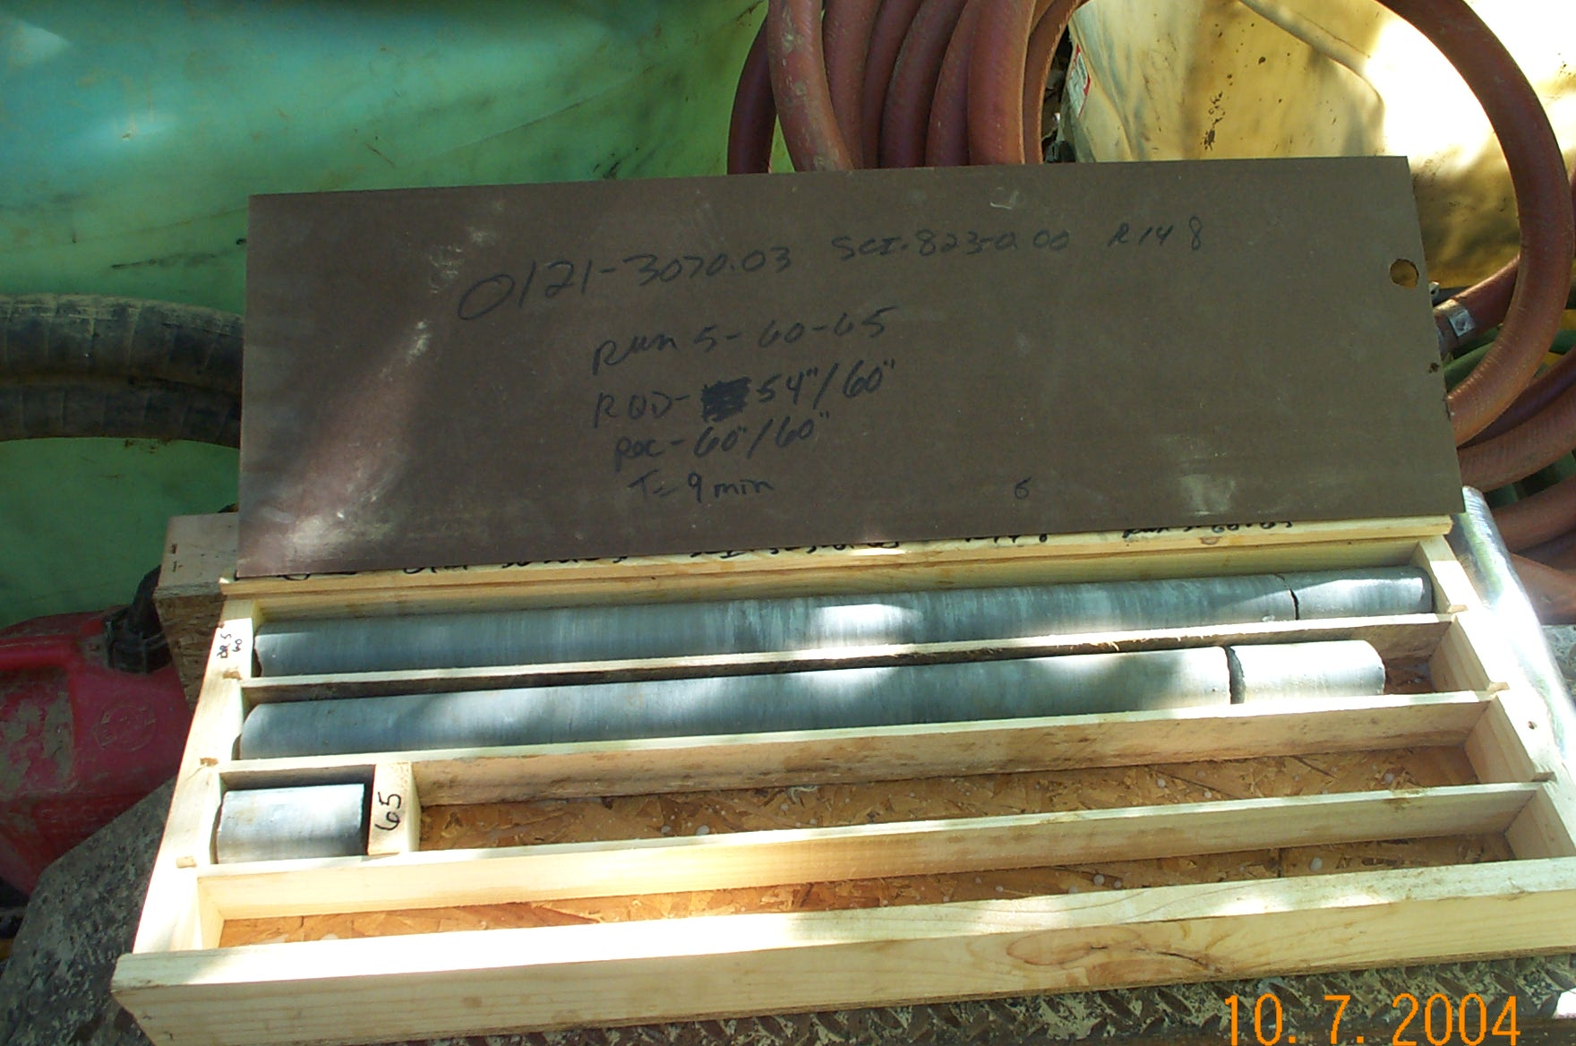
Photo 9. T:\Painter\portsmouthcore\R-148\R5-5fld.JPG

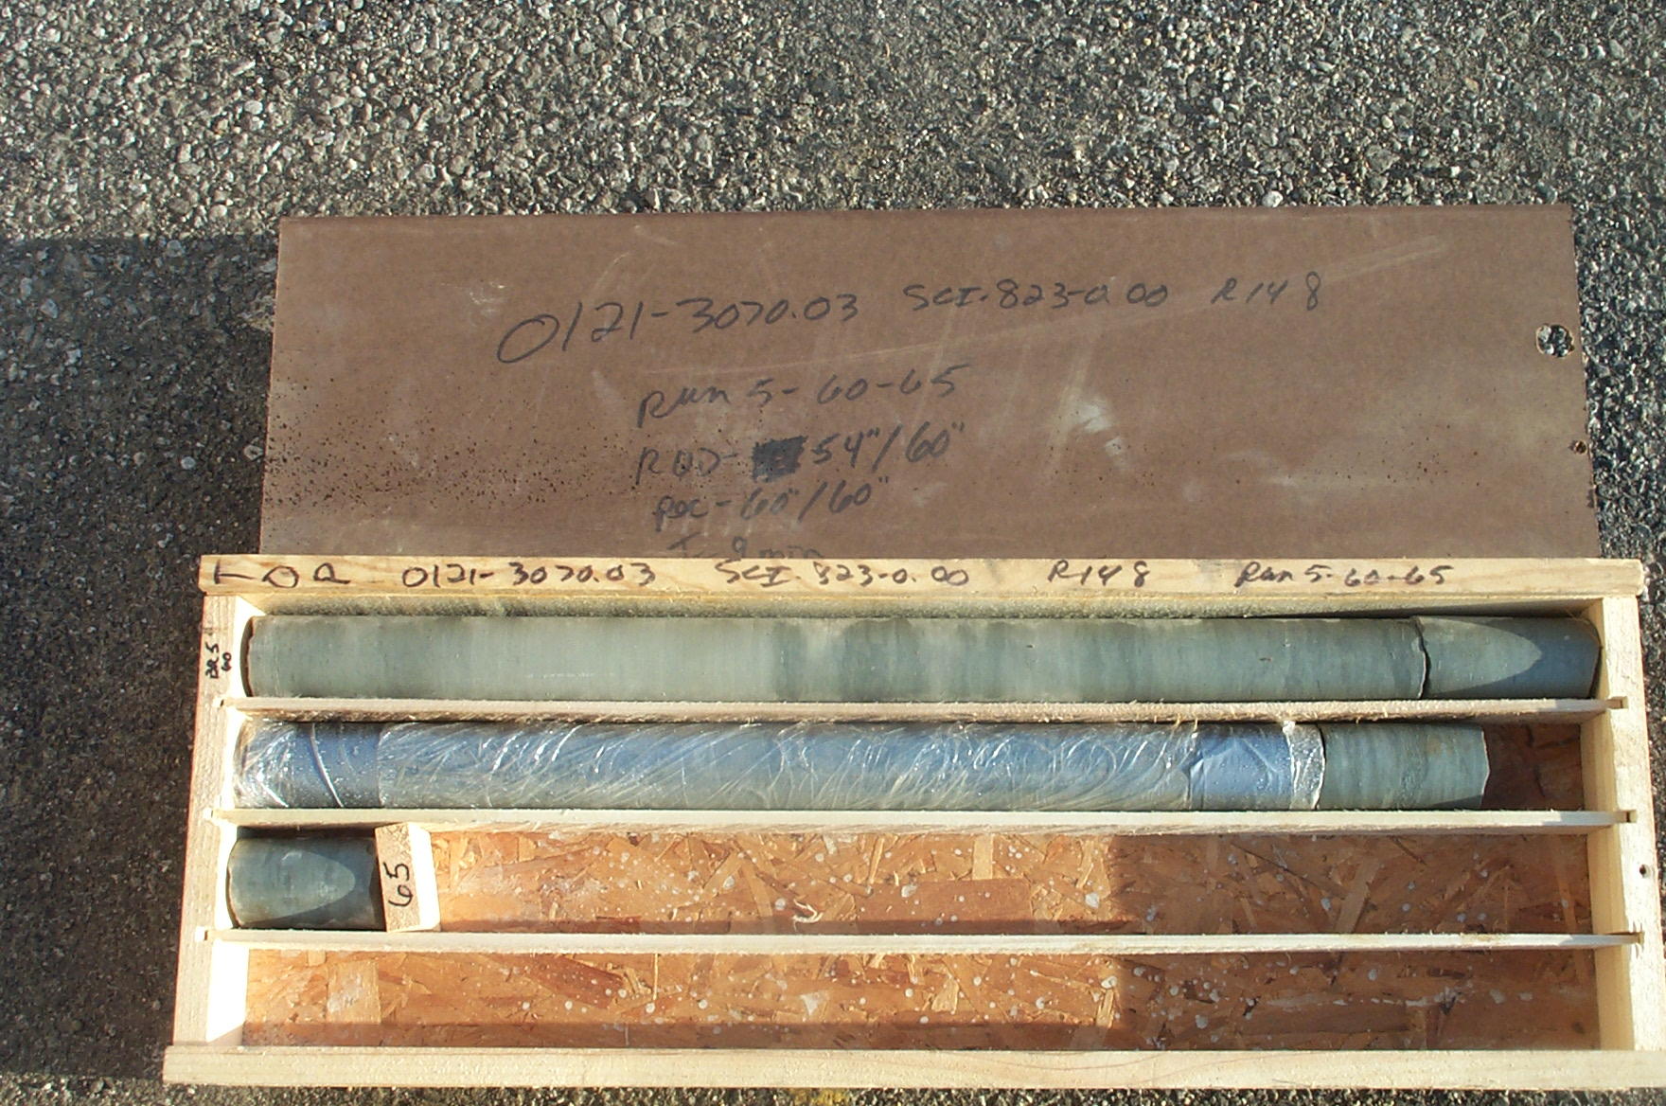
Photo 10. T:\Painter\portsmouthcore\R-148\R5-5shp.JPG

