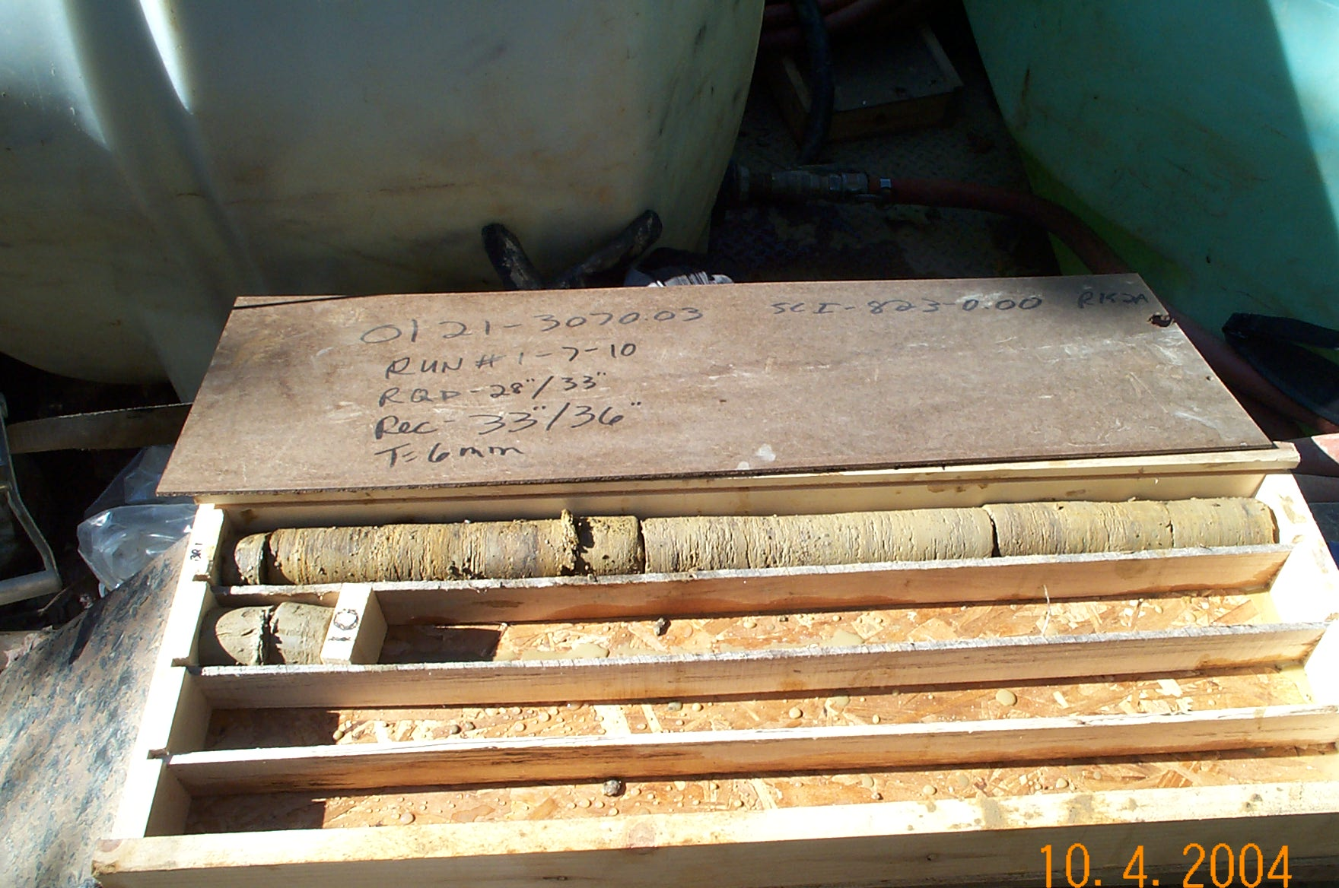
Photo 1. T:\Painter\portsmouthcore\R-152A\R1-10fld.JPG

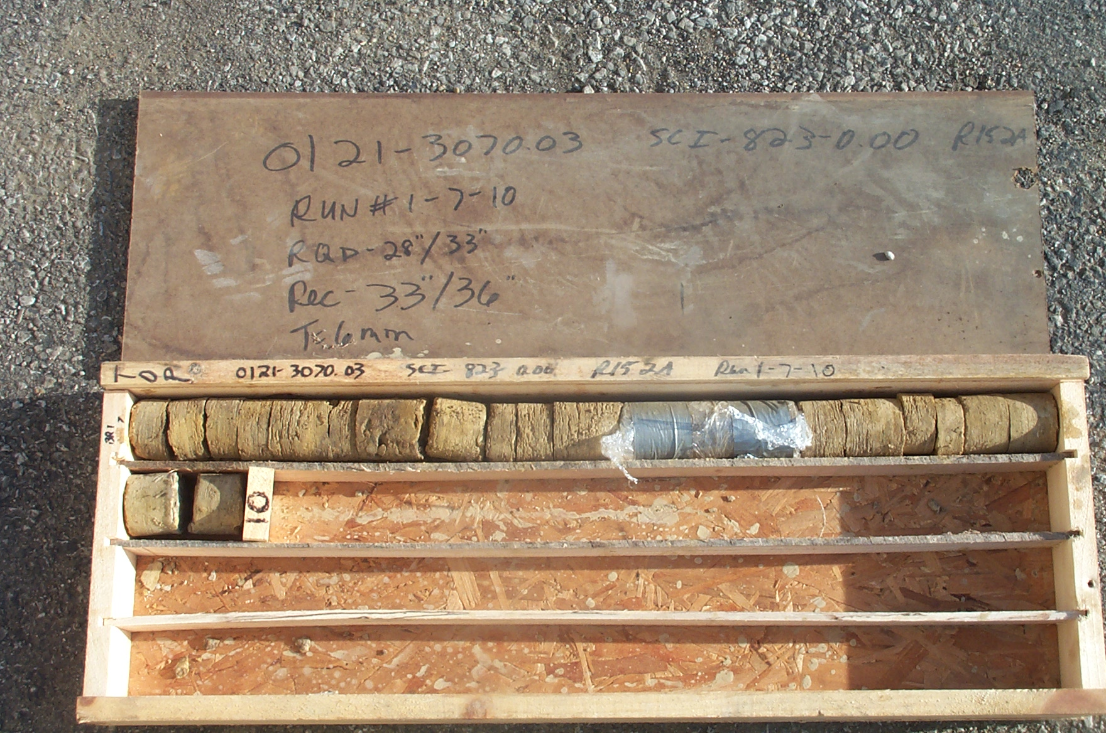
Photo 2. T:\Painter\portsmouthcore\R-152A\R1-10shp.JPG

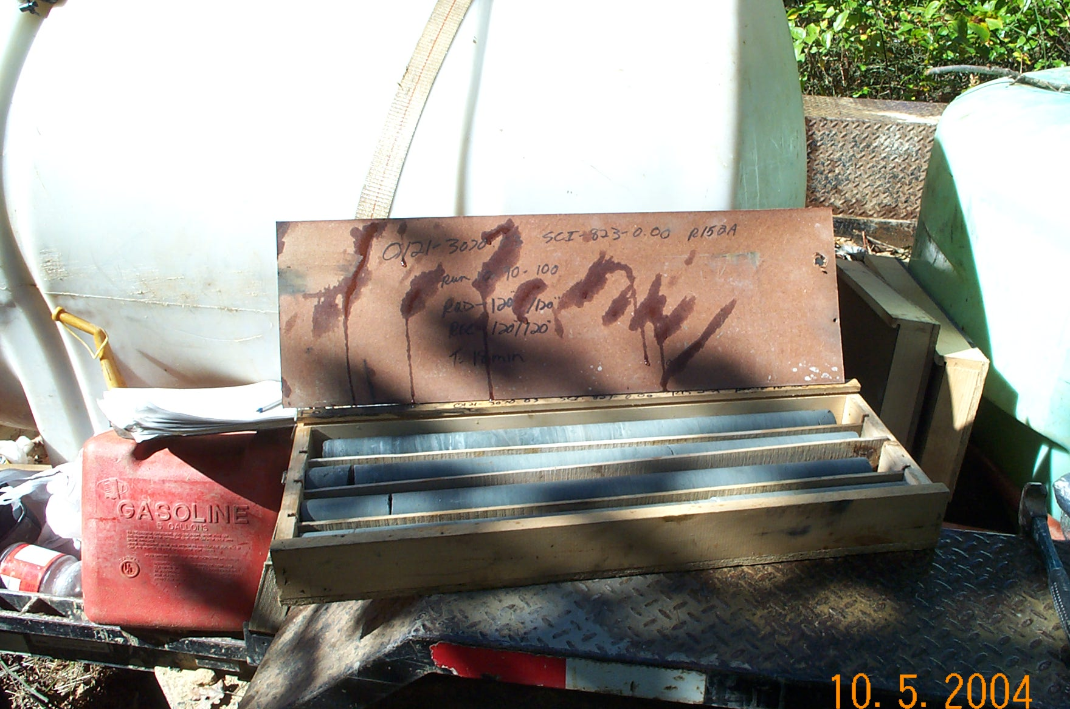
Photo 3. T:\Painter\portsmouthcore\R-152A\R10-10fld.JPG

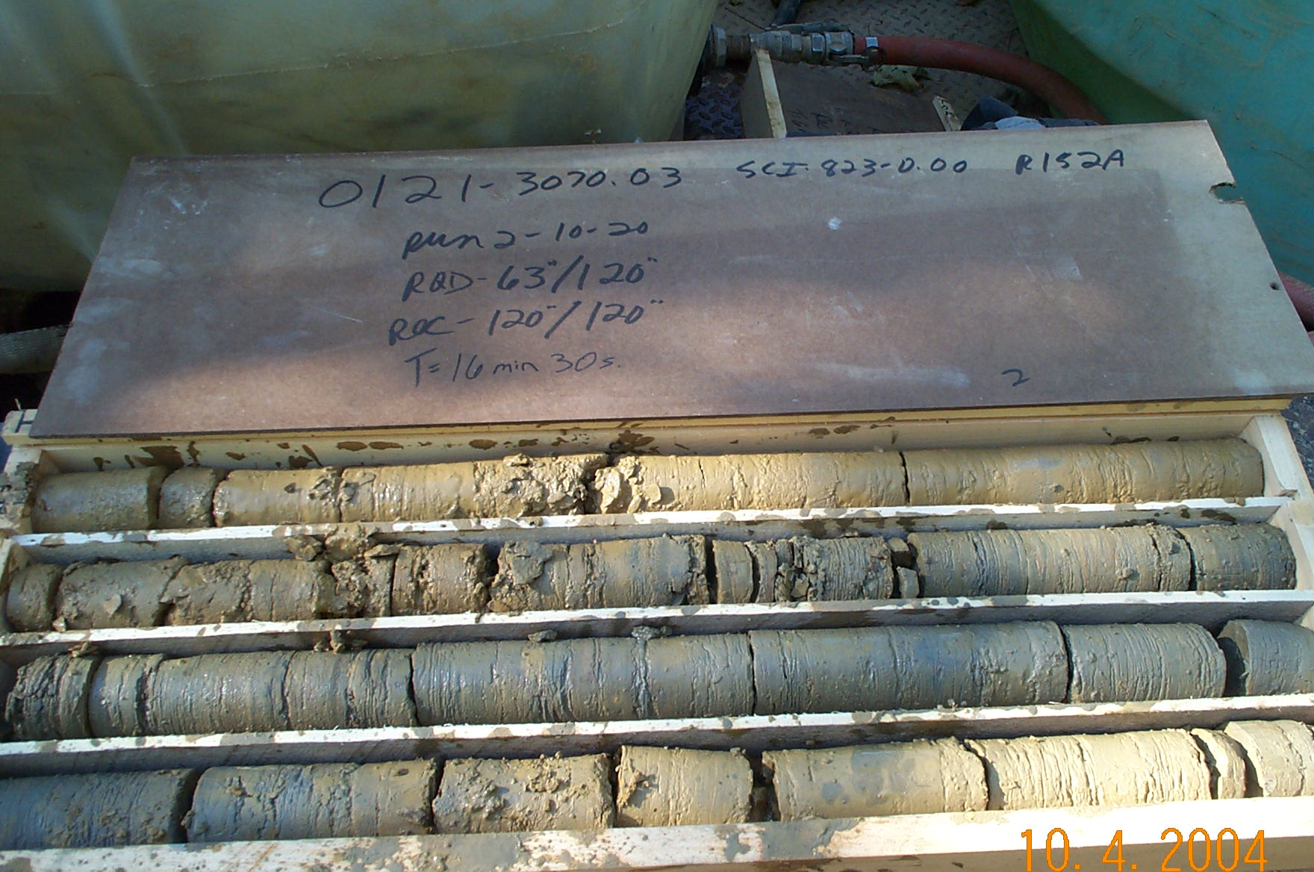
Photo 4. T:\Painter\portsmouthcore\R-152A\R2-10fld.JPG

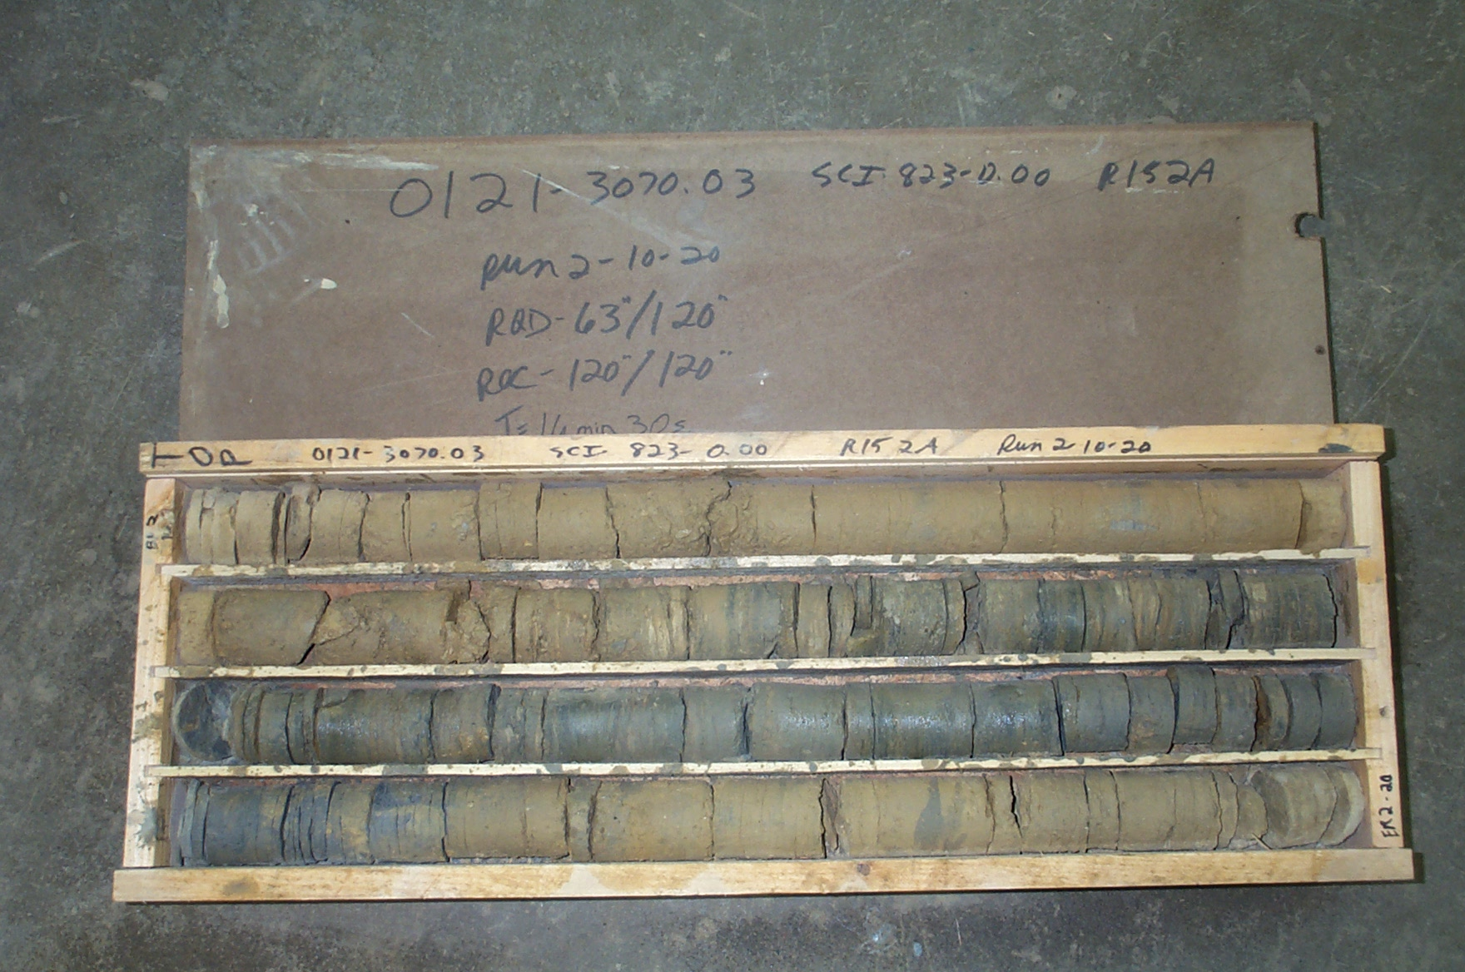
Photo 5. T:\Painter\portsmouthcore\R-152A\R2-10shp.JPG

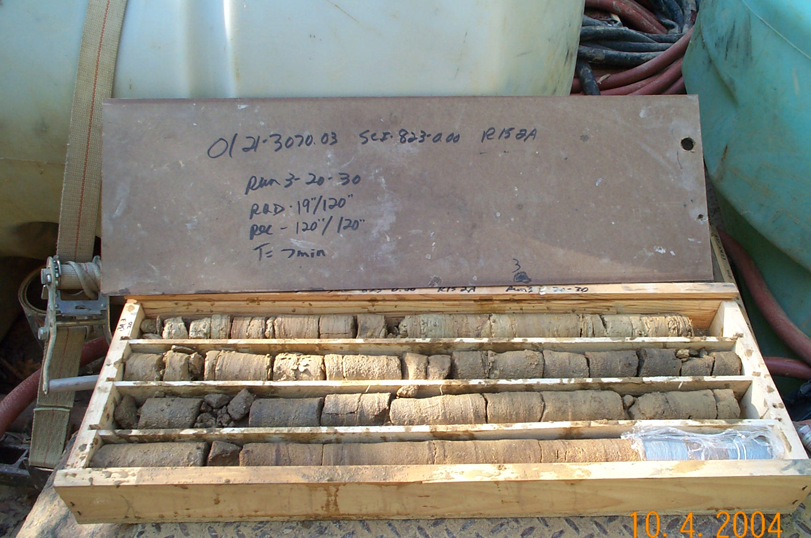
Photo 6. T:\Painter\portsmouthcore\R-152A\R3-10fld.JPG

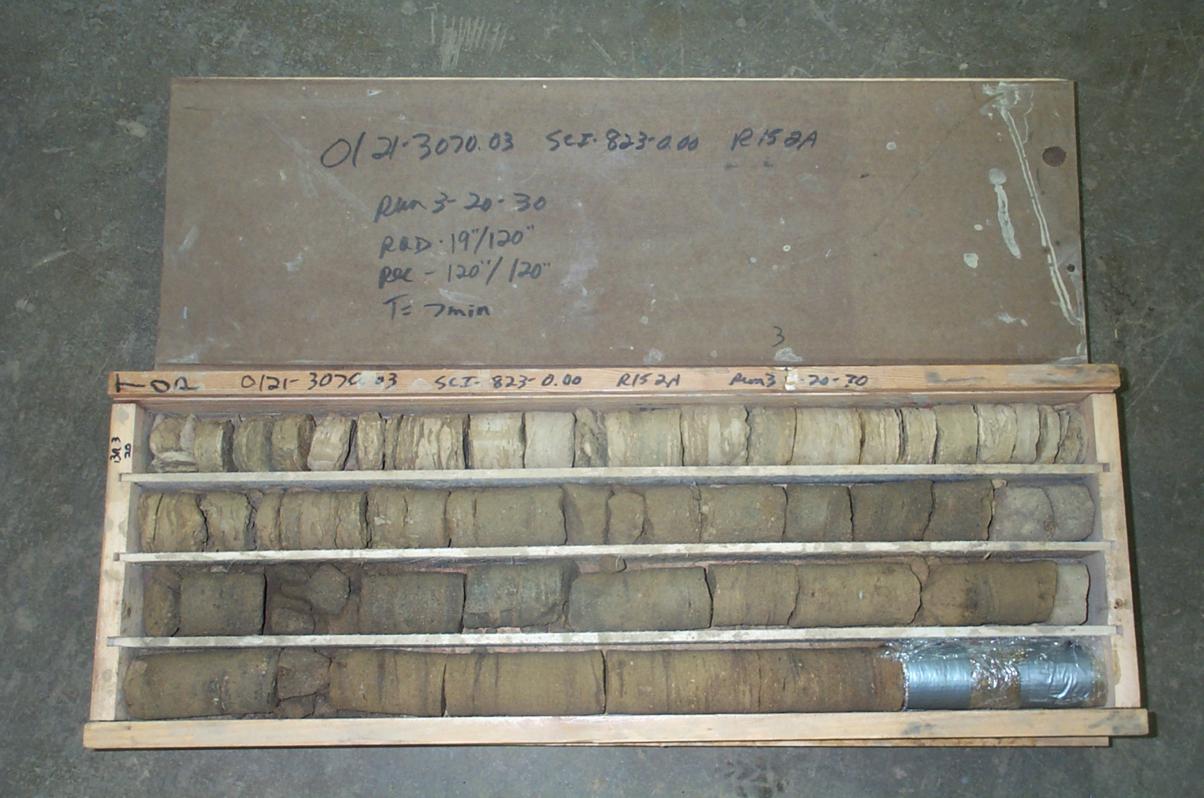
Photo 7. T:\Painter\portsmouthcore\R-152A\R3-10shp.JPG

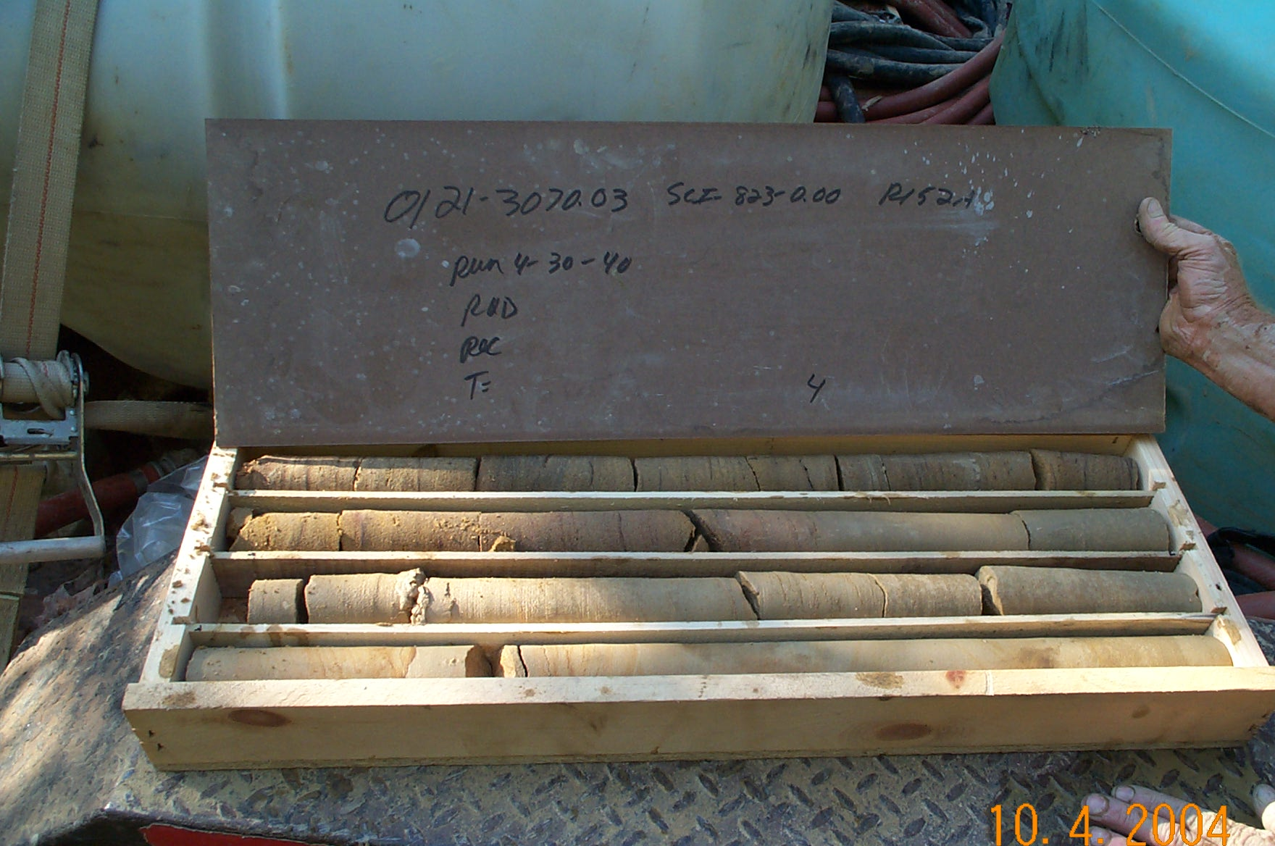
Photo 8. T:\Painter\portsmouthcore\R-152A\R4-10fld.JPG

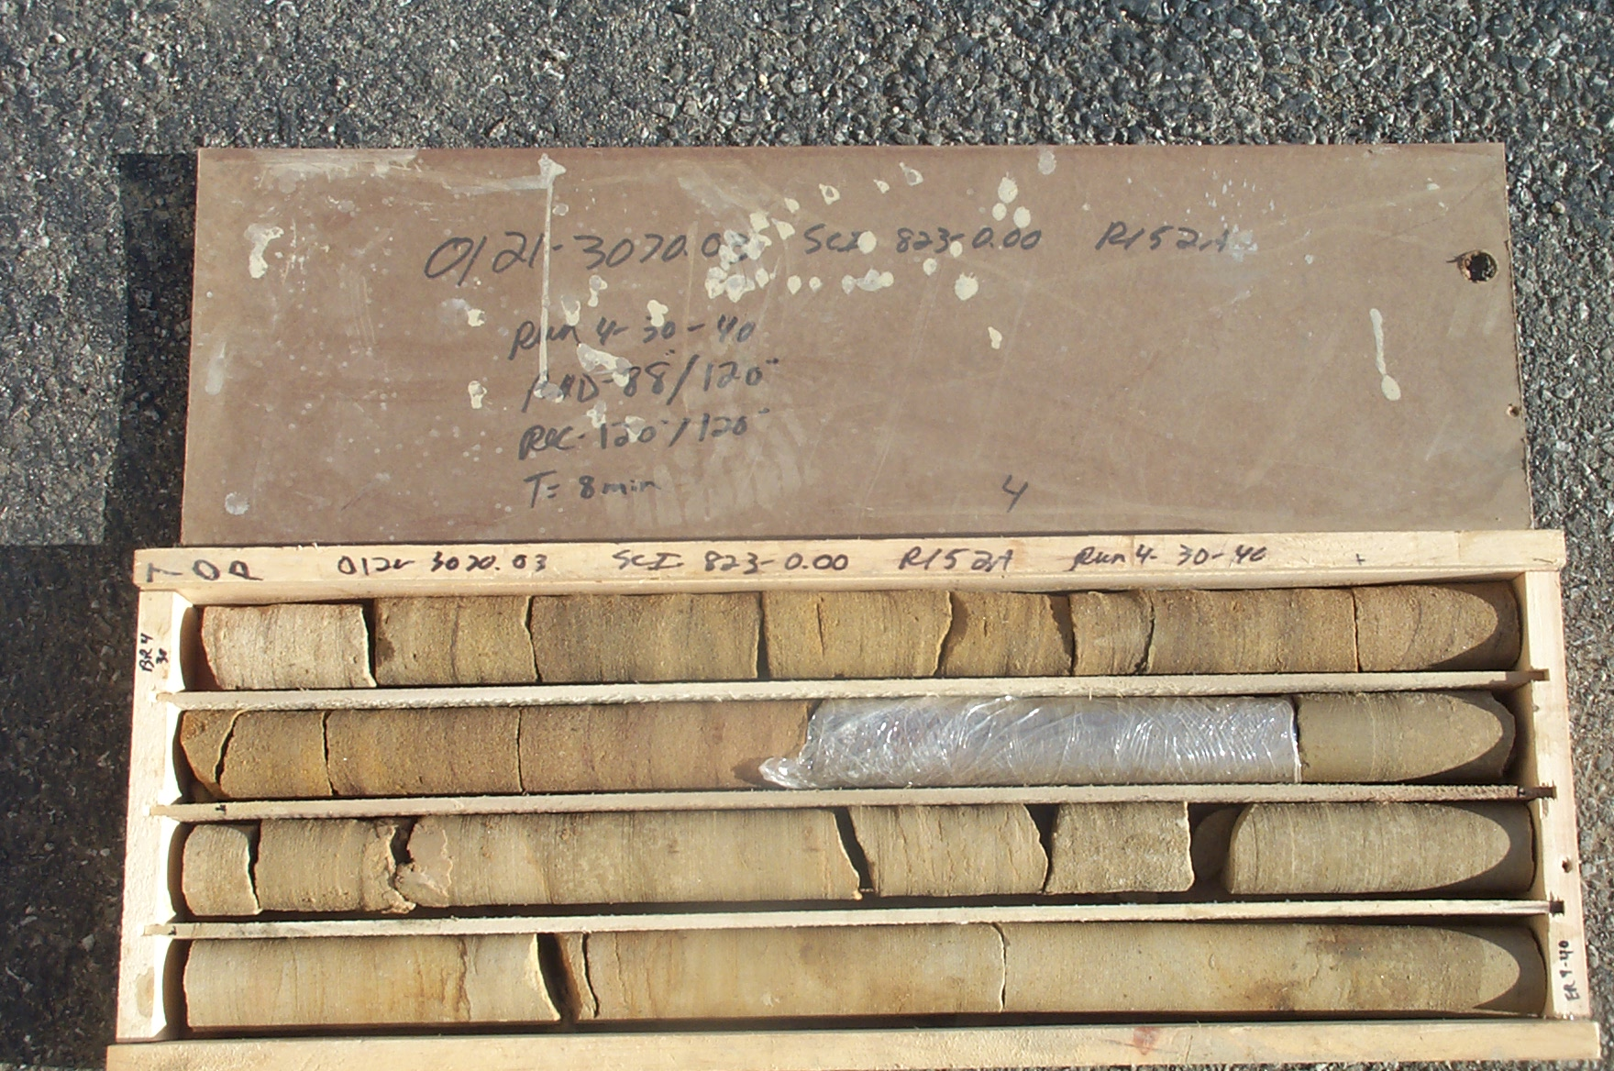
Photo 9. T:\Painter\portsmouthcore\R-152A\R4-10shp.JPG

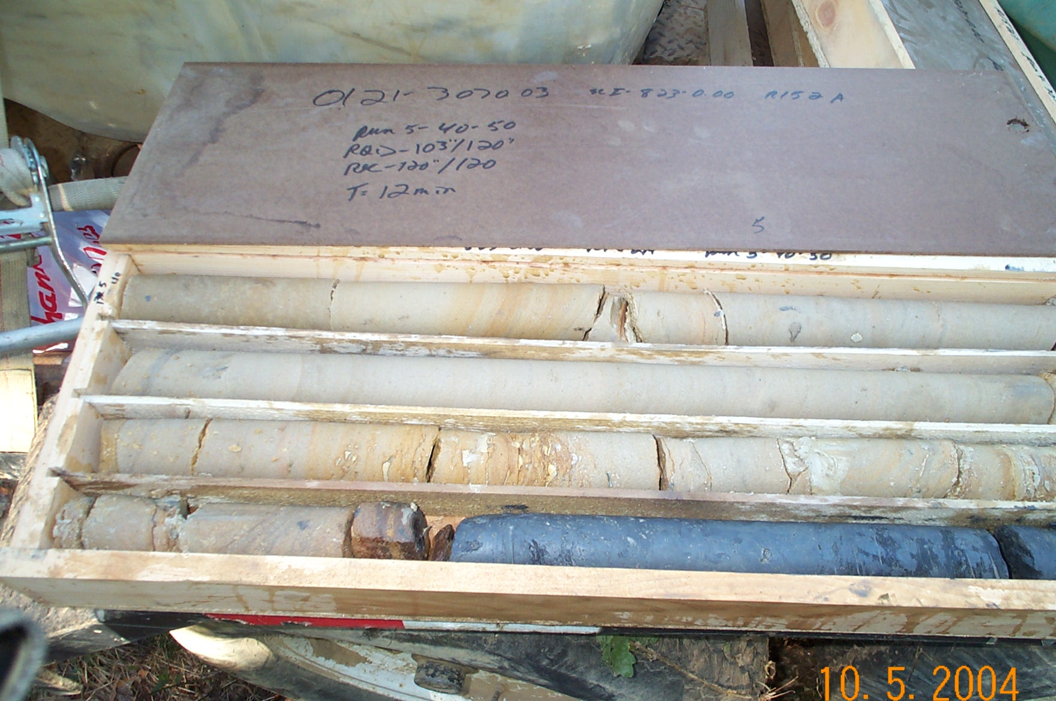
Photo 10. T:\Painter\portsmouthcore\R-152A\R5-10fld.JPG

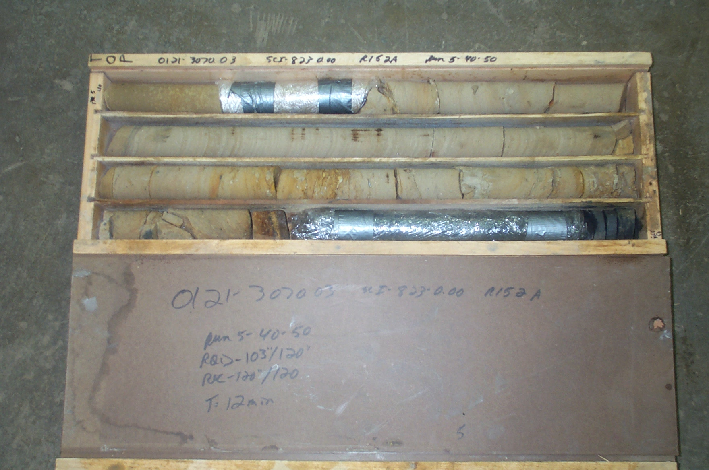
Photo 11. T:\Painter\portsmouthcore\R-152A\R5-10shp.JPG

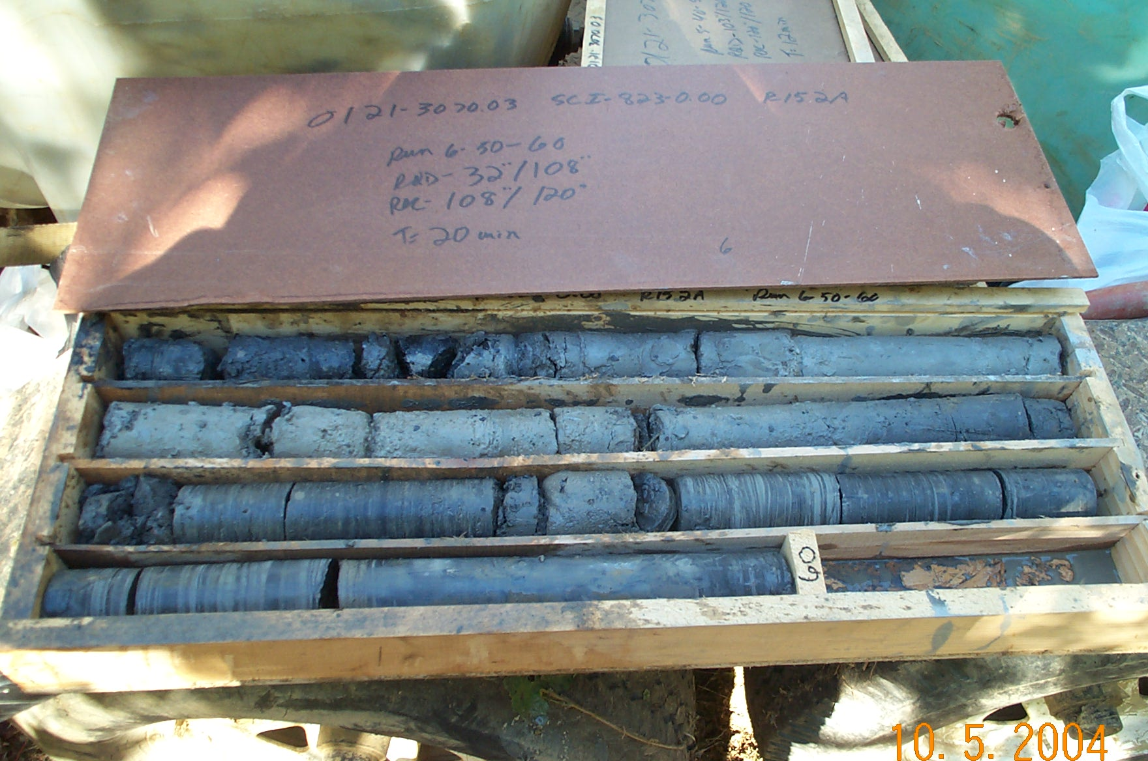
Photo 12. T:\Painter\portsmouthcore\R-152A\R6-10fld.JPG

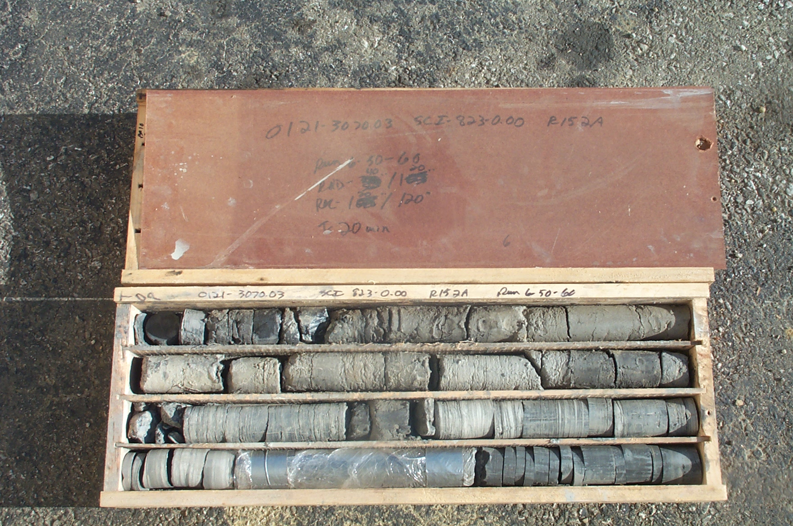
Photo 13. T:\Painter\portsmouthcore\R-152A\R6-10shp.JPG

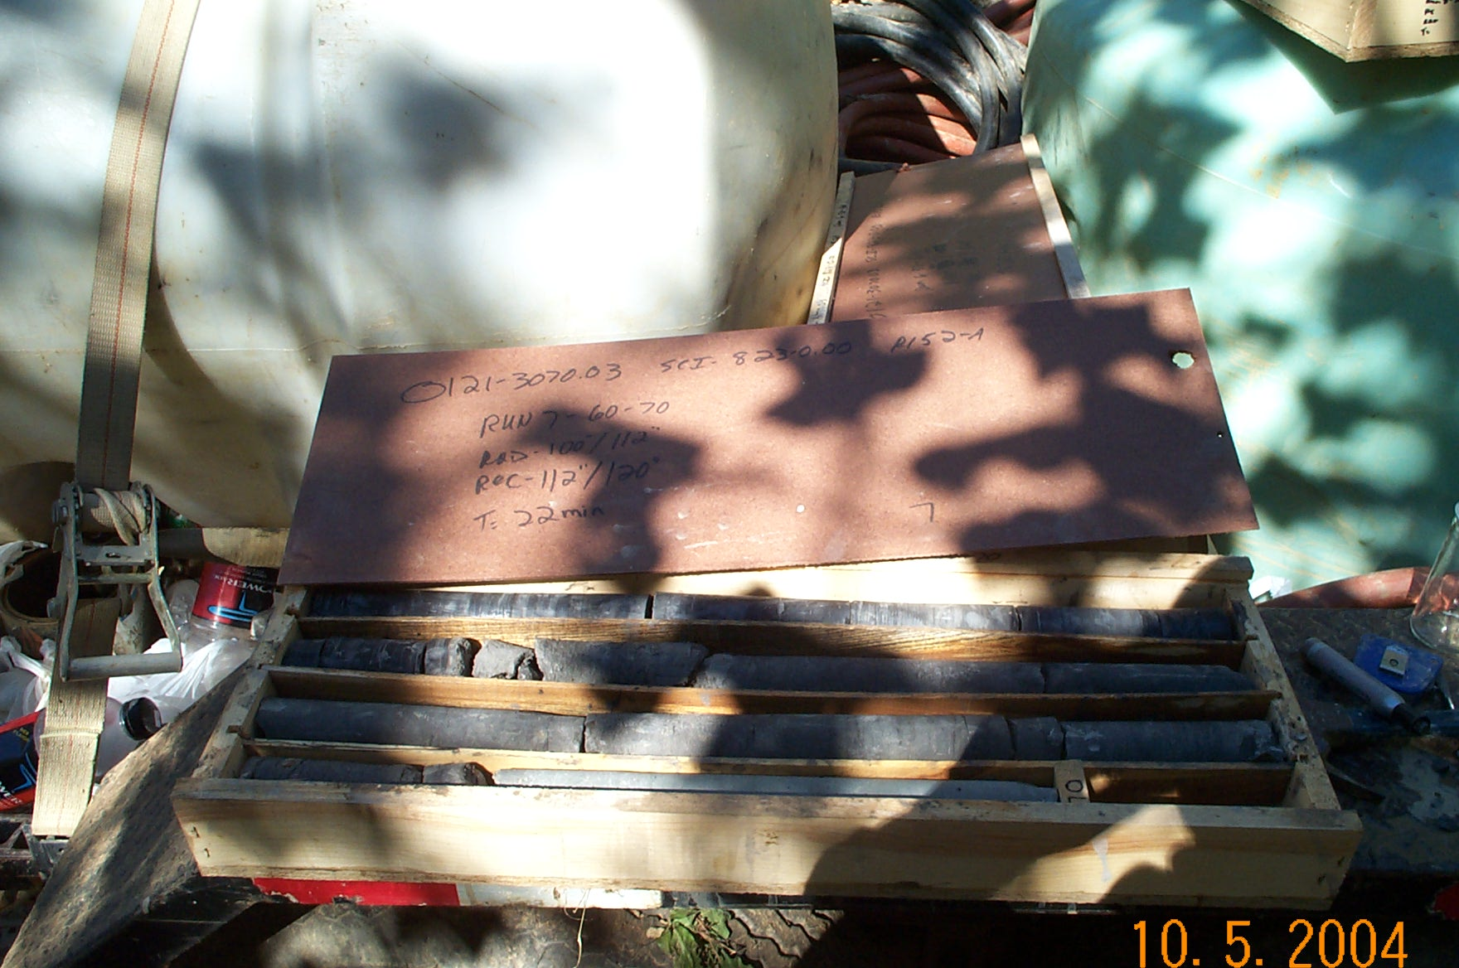
Photo 14. T:\Painter\portsmouthcore\R-152A\R7-10fld.JPG

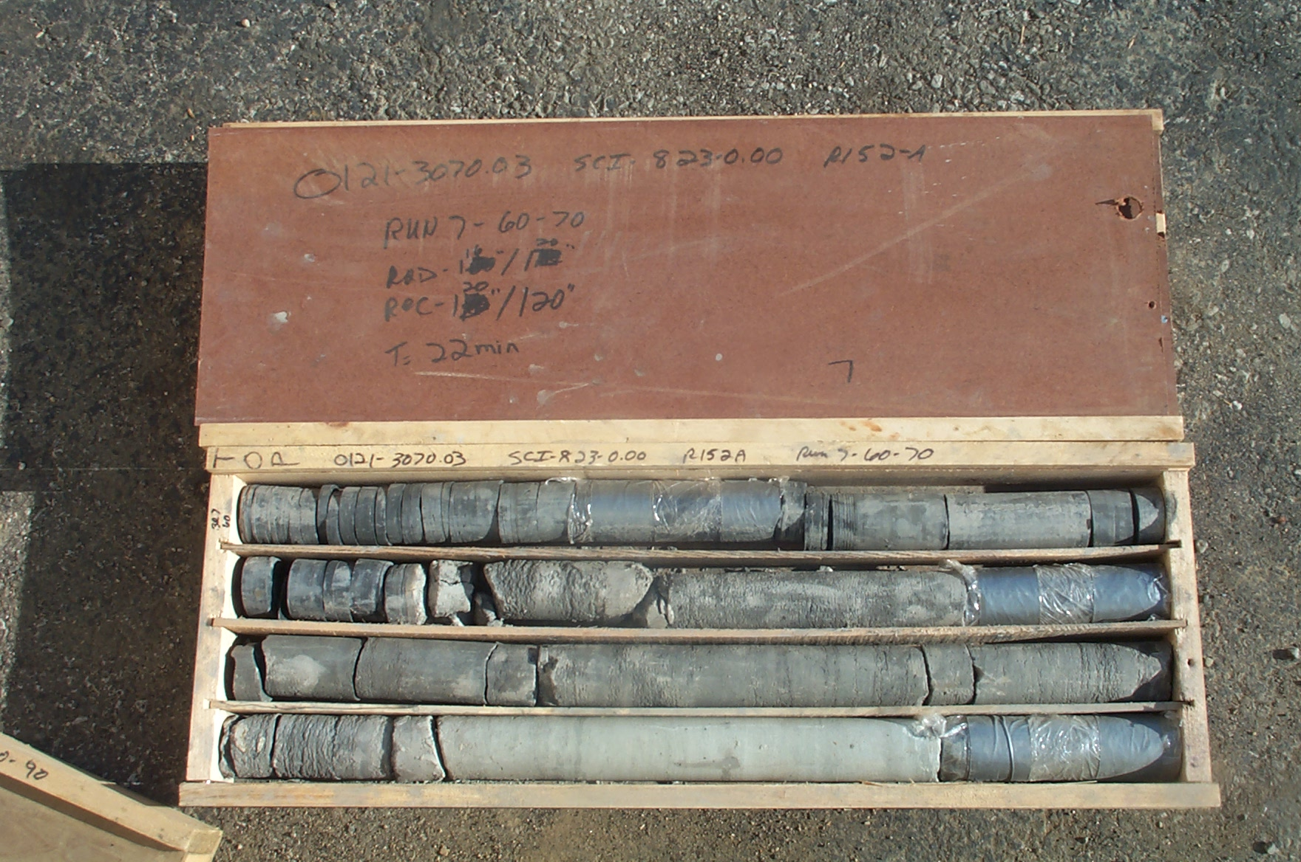
Photo 15. T:\Painter\portsmouthcore\R-152A\R7-10shp.JPG

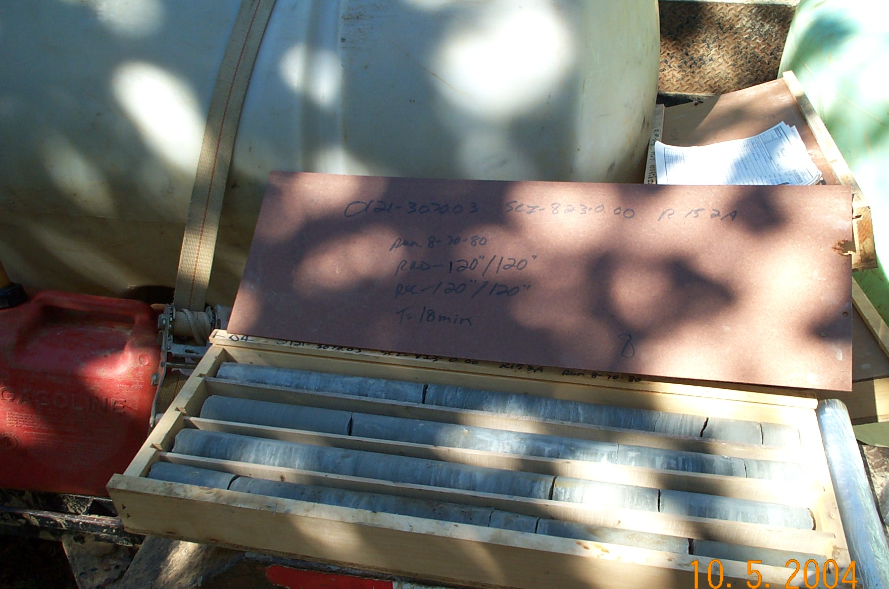
Photo 16. T:\Painter\portsmouthcore\R-152A\R8-10fld.JPG

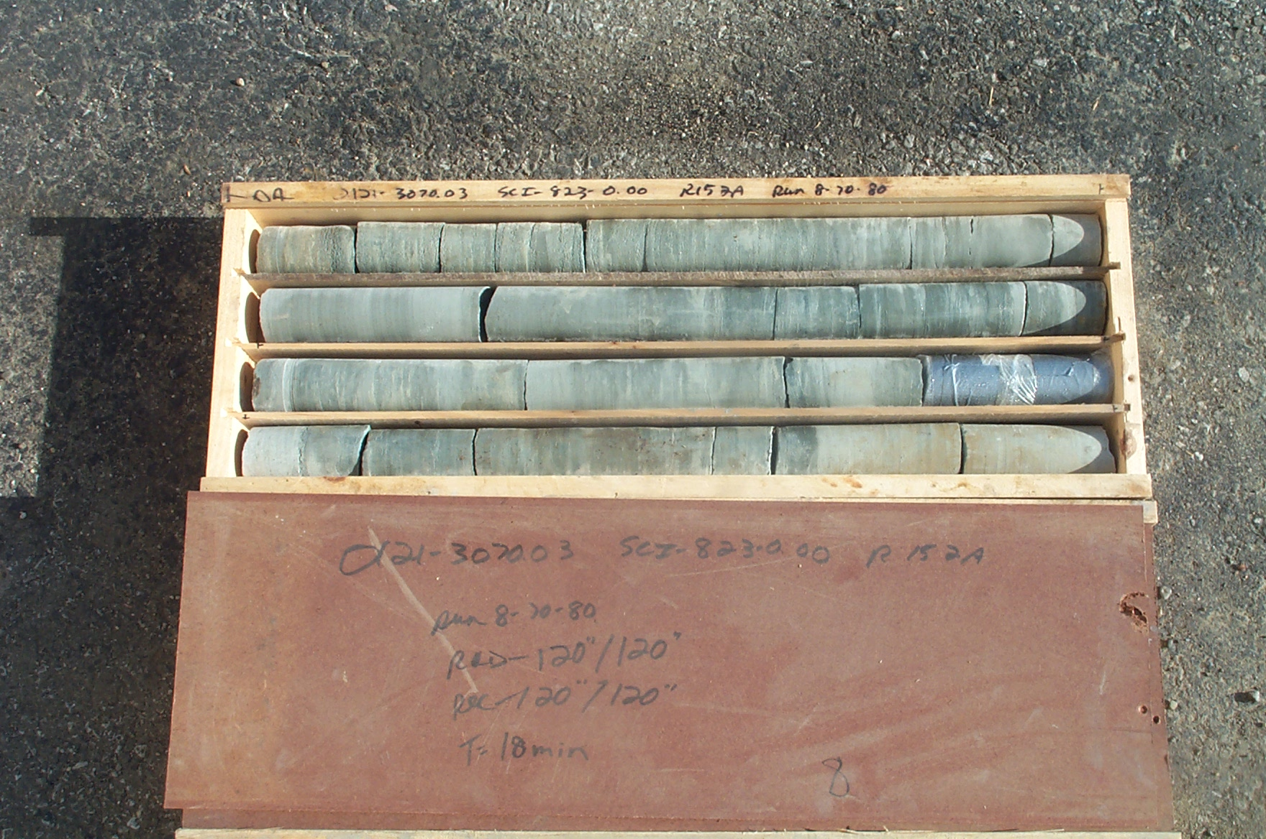
Photo 17. T:\Painter\portsmouthcore\R-152A\R8-10shp.JPG

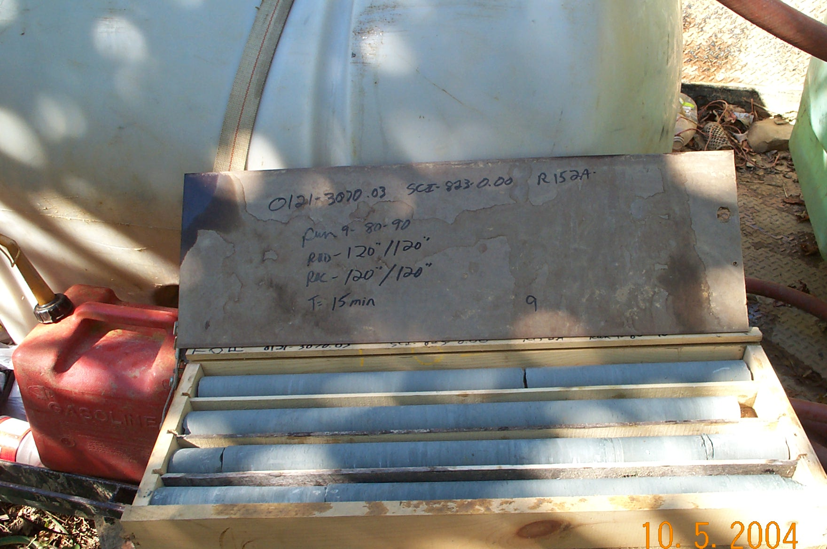
Photo 18. T:\Painter\portsmouthcore\R-152A\R9-10fld.JPG

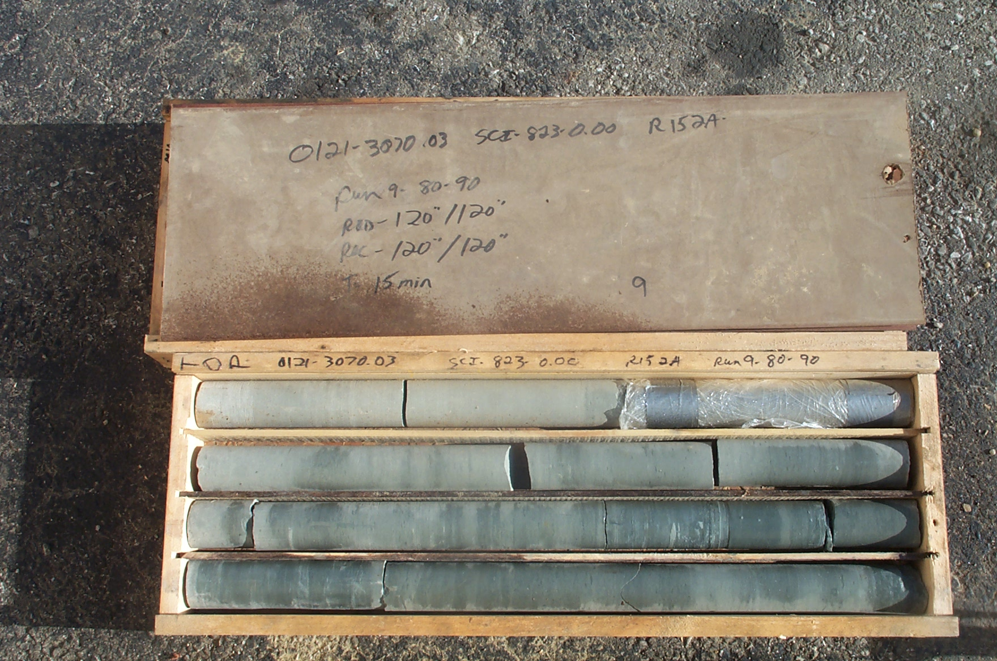
Photo 19. T:\Painter\portsmouthcore\R-152A\R9-10shp.JPG

