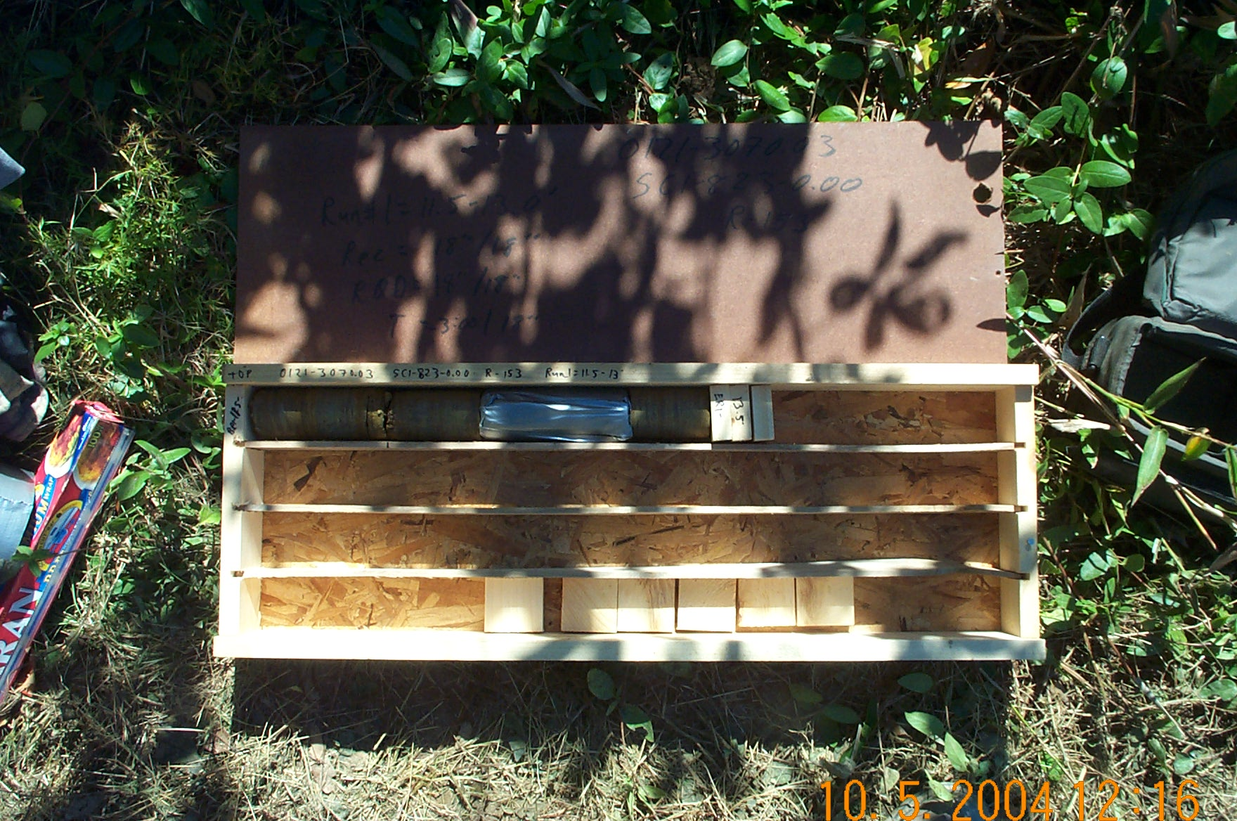
Photo 1. T:\Painter\portsmouthcore\R-153\R1-13fld.JPG

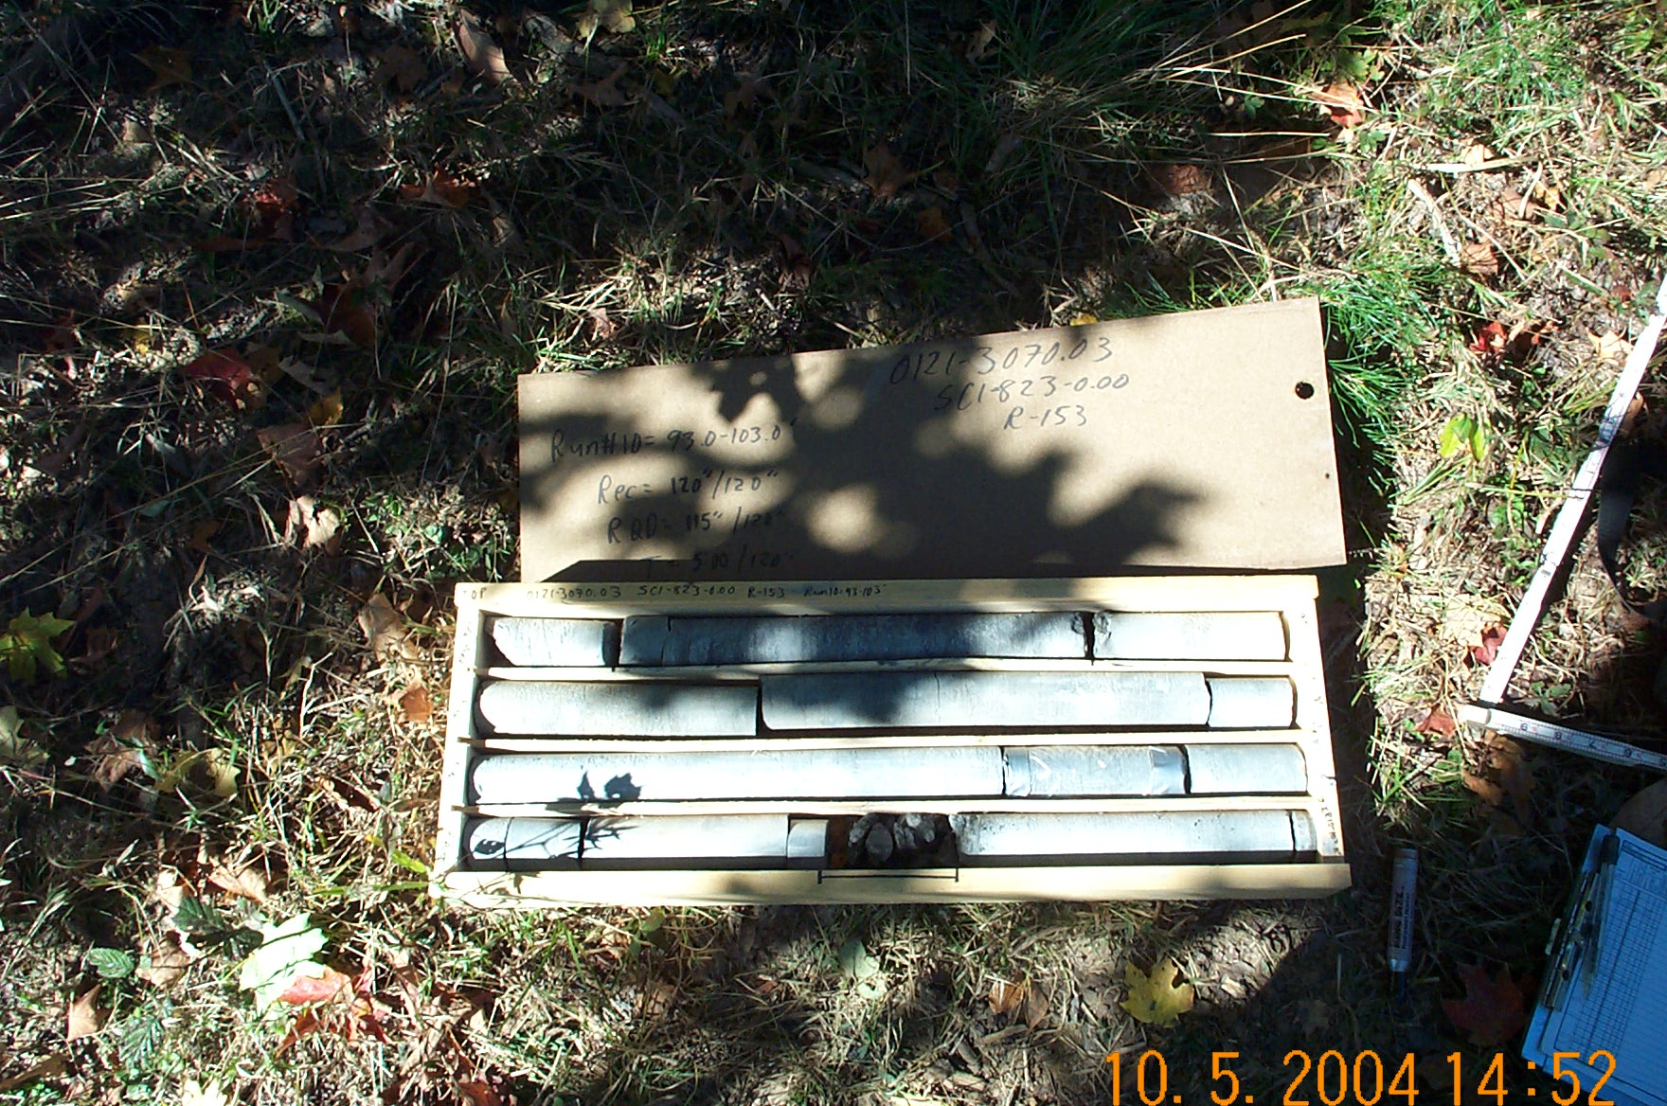
Photo 2. T:\Painter\portsmouthcore\R-153\R10-13fld.JPG

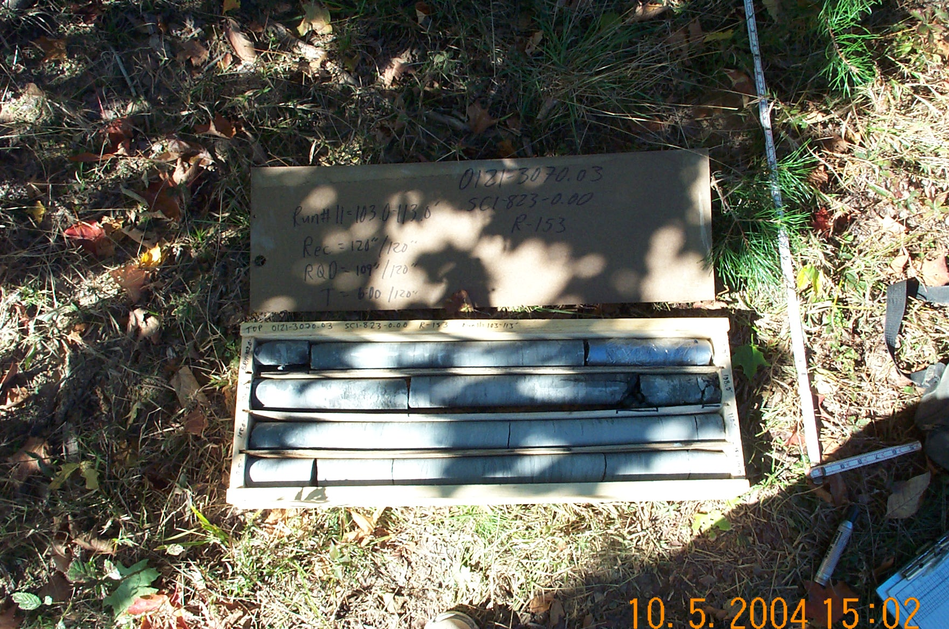
Photo 3. T:\Painter\portsmouthcore\R-153\R11-13fld.JPG

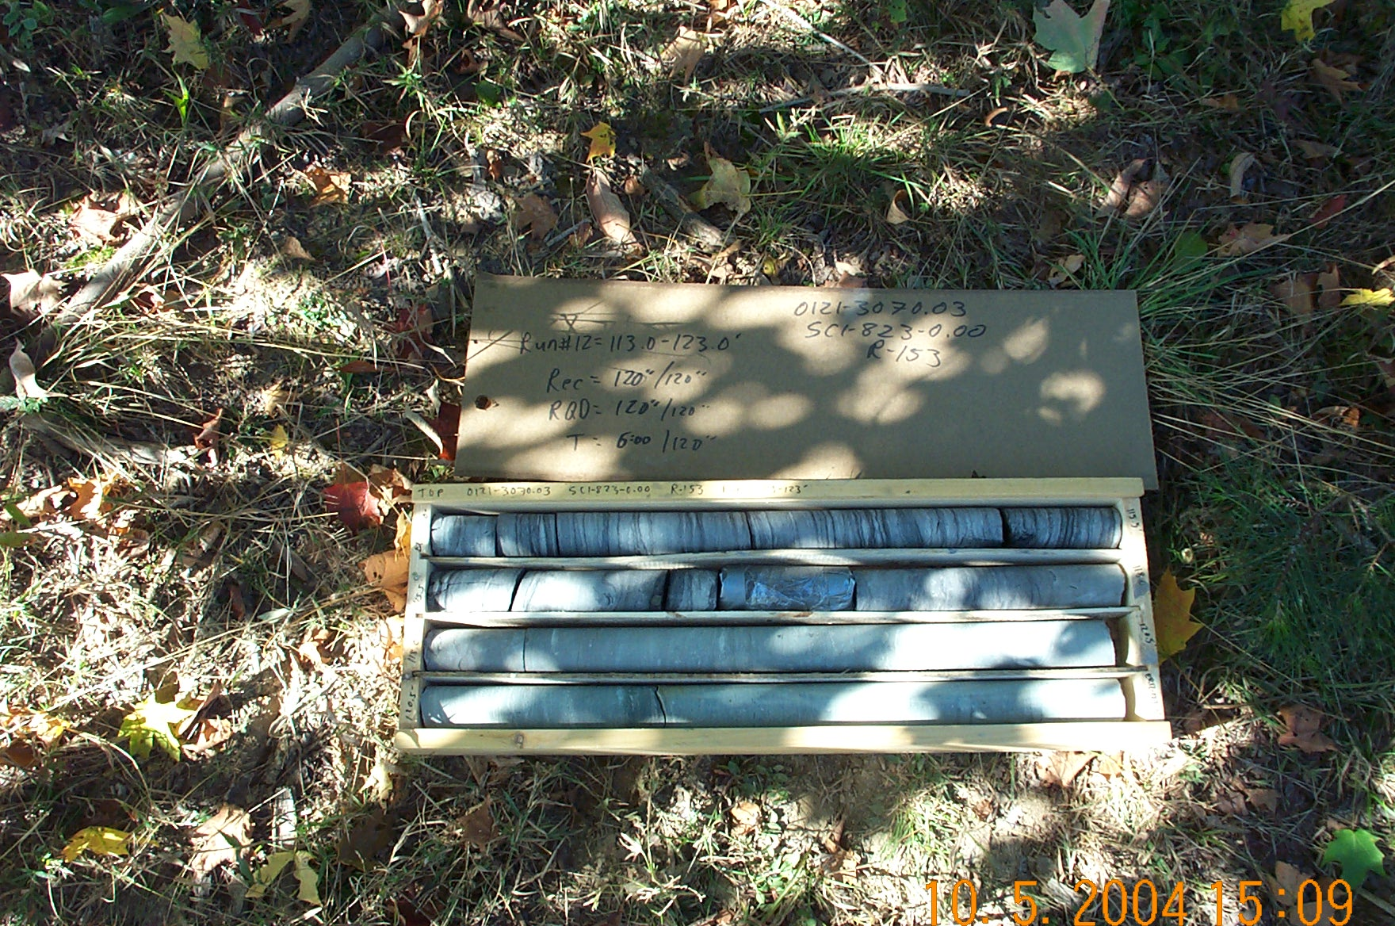
Photo 4. T:\Painter\portsmouthcore\R-153\R12-13fld.JPG

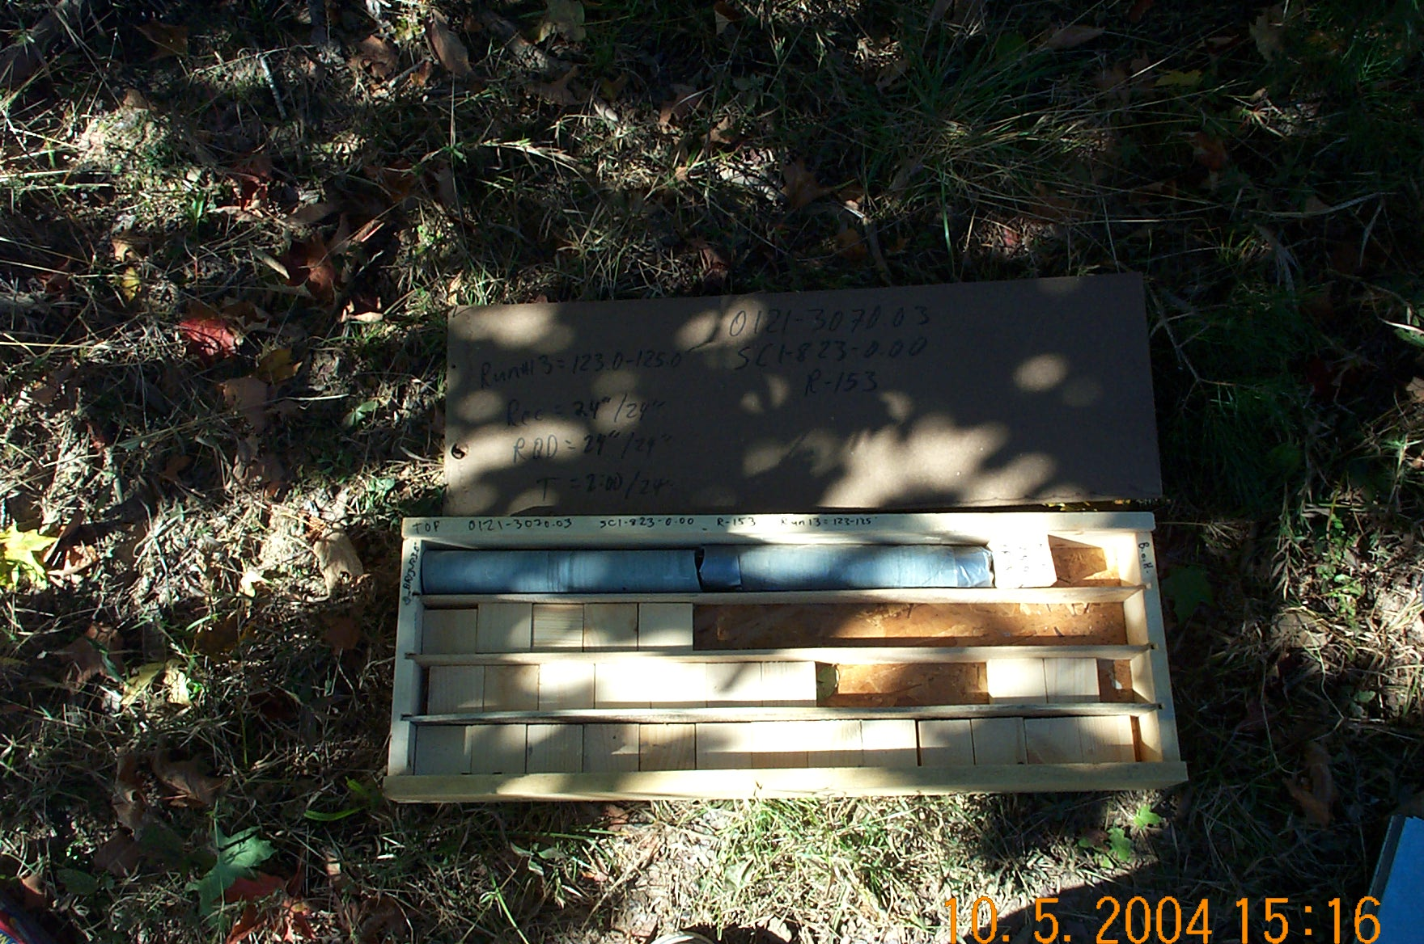
Photo 5. T:\Painter\portsmouthcore\R-153\R13-13fld.JPG

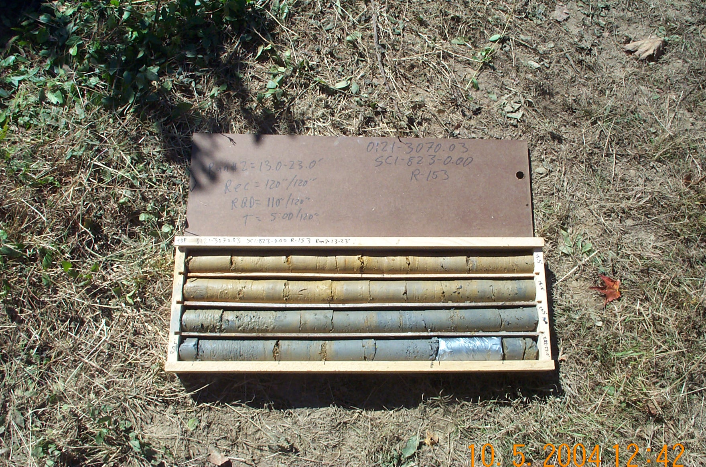
Photo 6. T:\Painter\portsmouthcore\R-153\R2-13fld.JPG

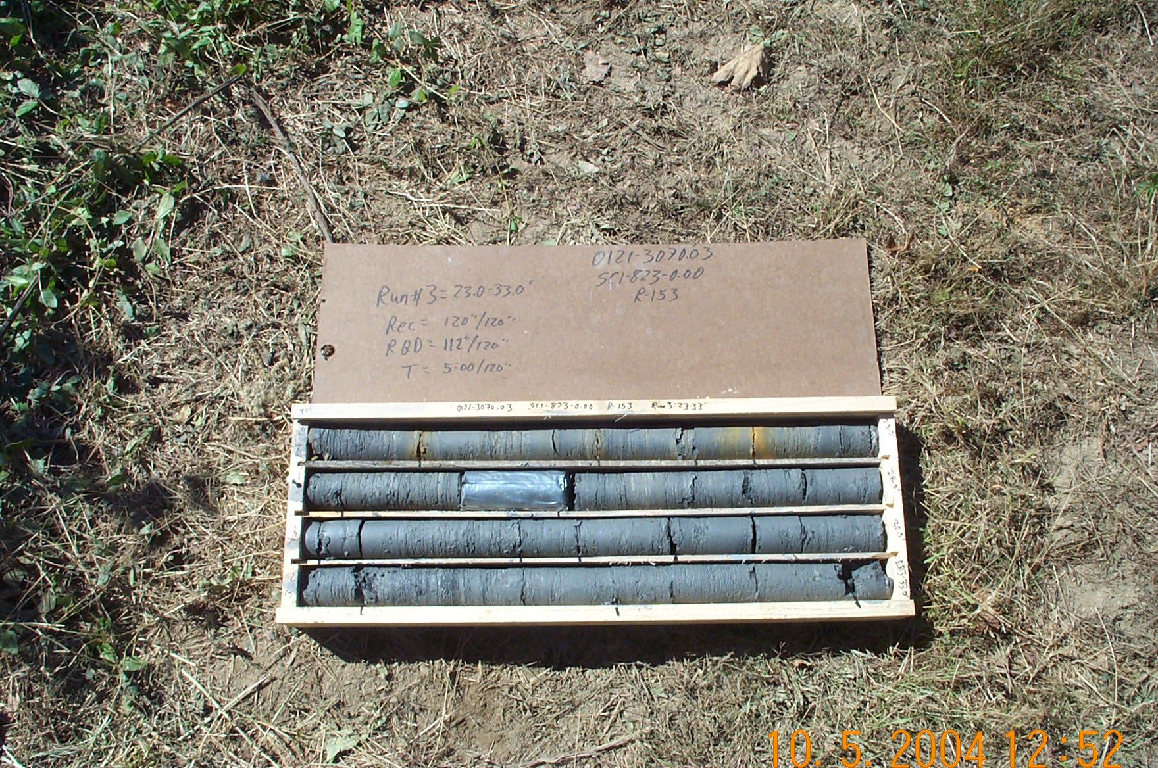
Photo 7. T:\Painter\portsmouthcore\R-153\R3-13fld.JPG

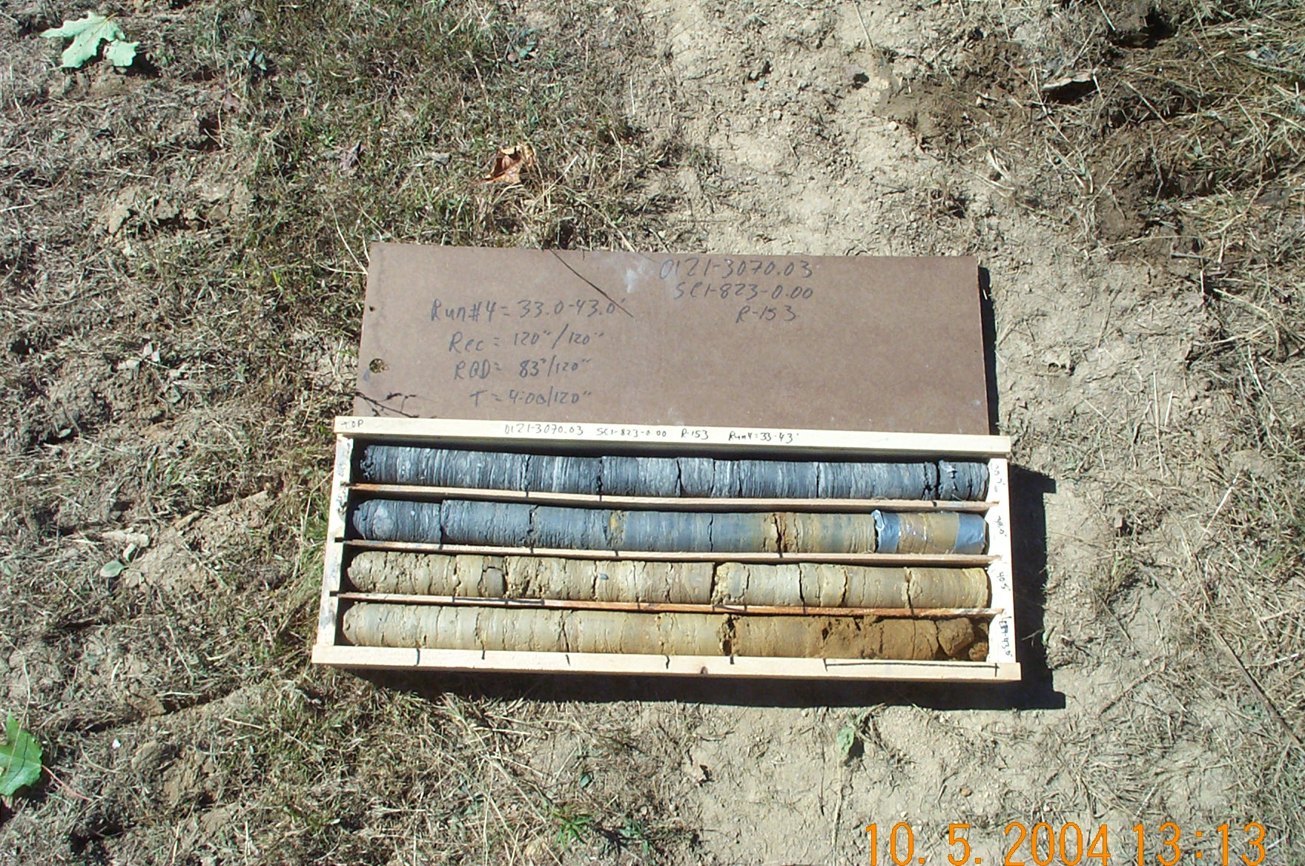
Photo 8. T:\Painter\portsmouthcore\R-153\R4-13fld.JPG

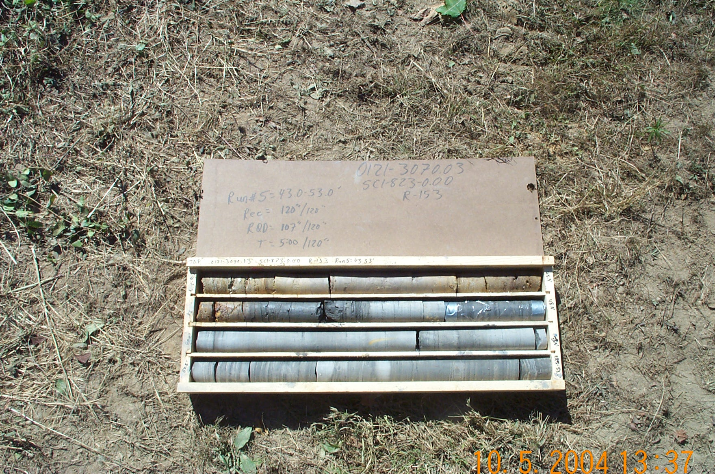
Photo 9. T:\Painter\portsmouthcore\R-153\R5-13fld.JPG

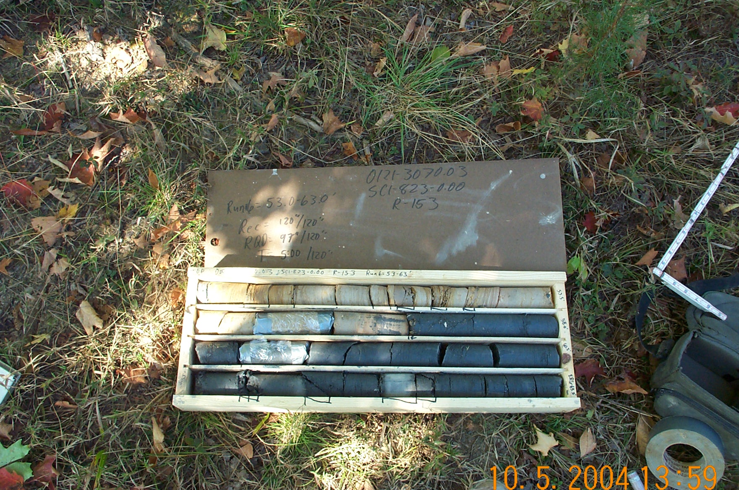
Photo 10. T:\Painter\portsmouthcore\R-153\R6-13fld.JPG

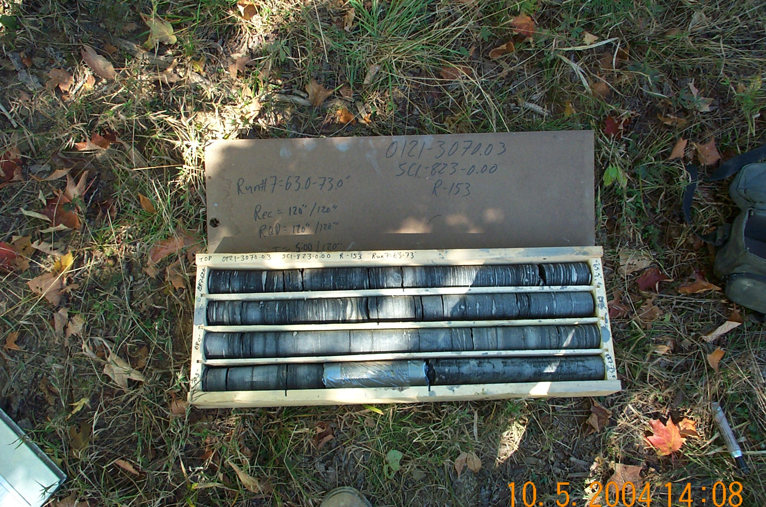
Photo 11. T:\Painter\portsmouthcore\R-153\R7-13fld.JPG

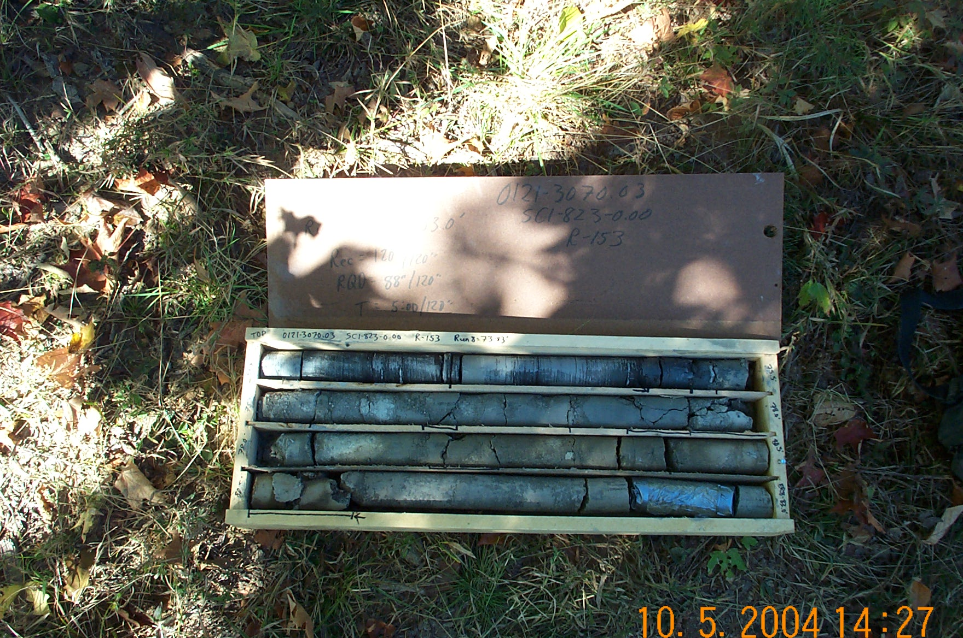
Photo 12. T:\Painter\portsmouthcore\R-153\R8-13fld.JPG

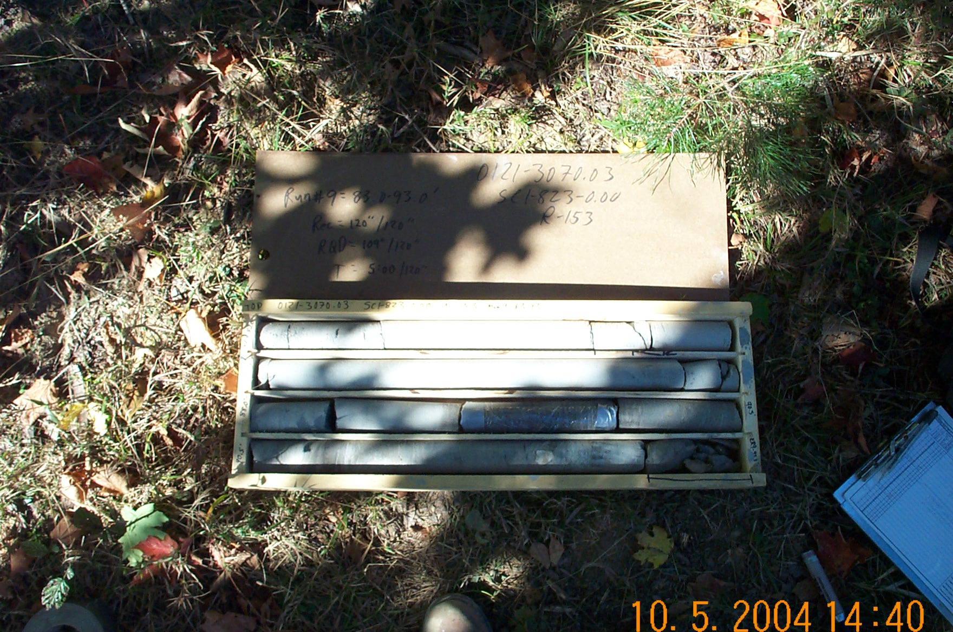
Photo 13. T:\Painter\portsmouthcore\R-153\R9-13fld.JPG

