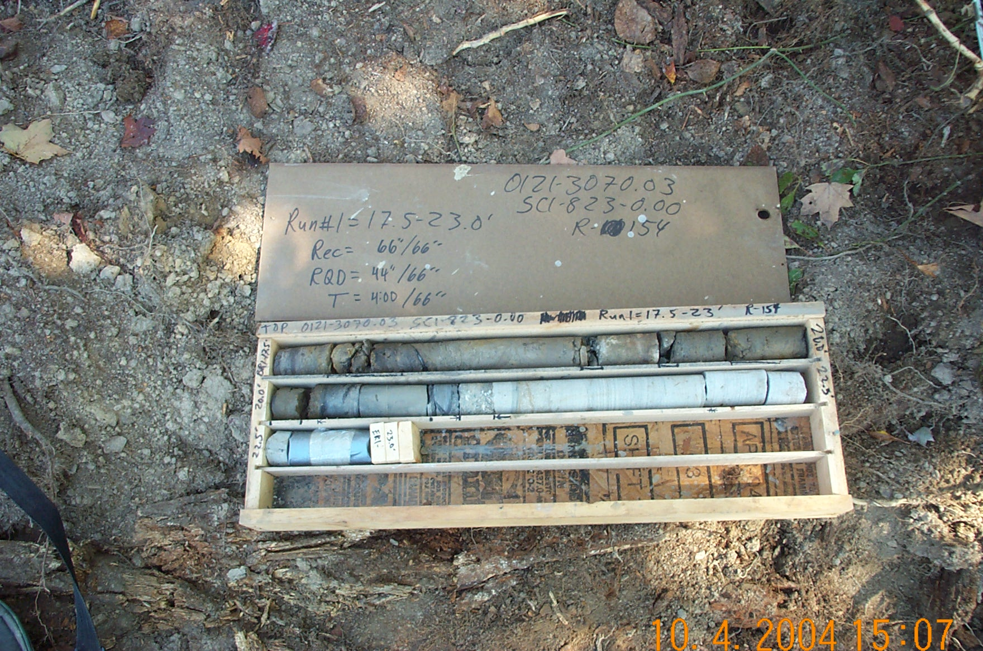
Photo 1. T:\Painter\portsmouthcore\R-154\R1-7fld.JPG

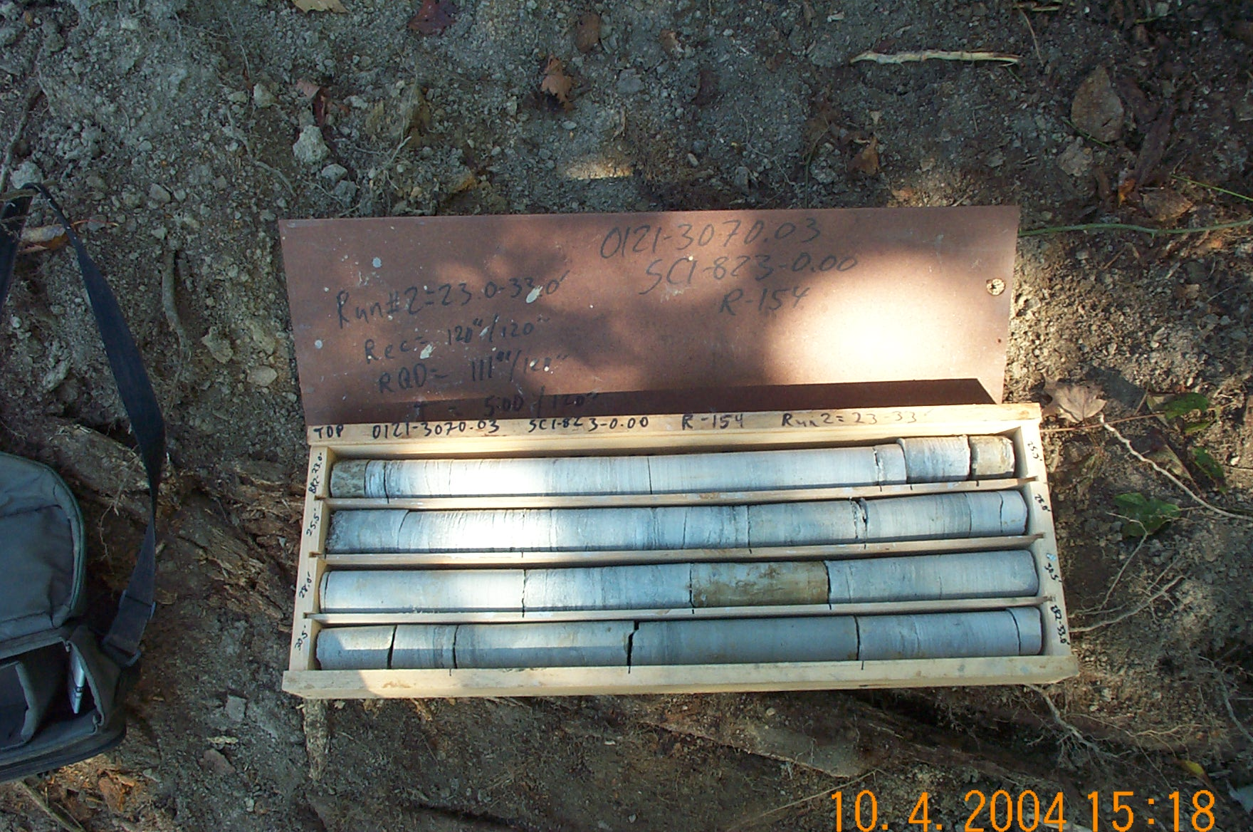
Photo 2. T:\Painter\portsmouthcore\R-154\R2-7fld.JPG

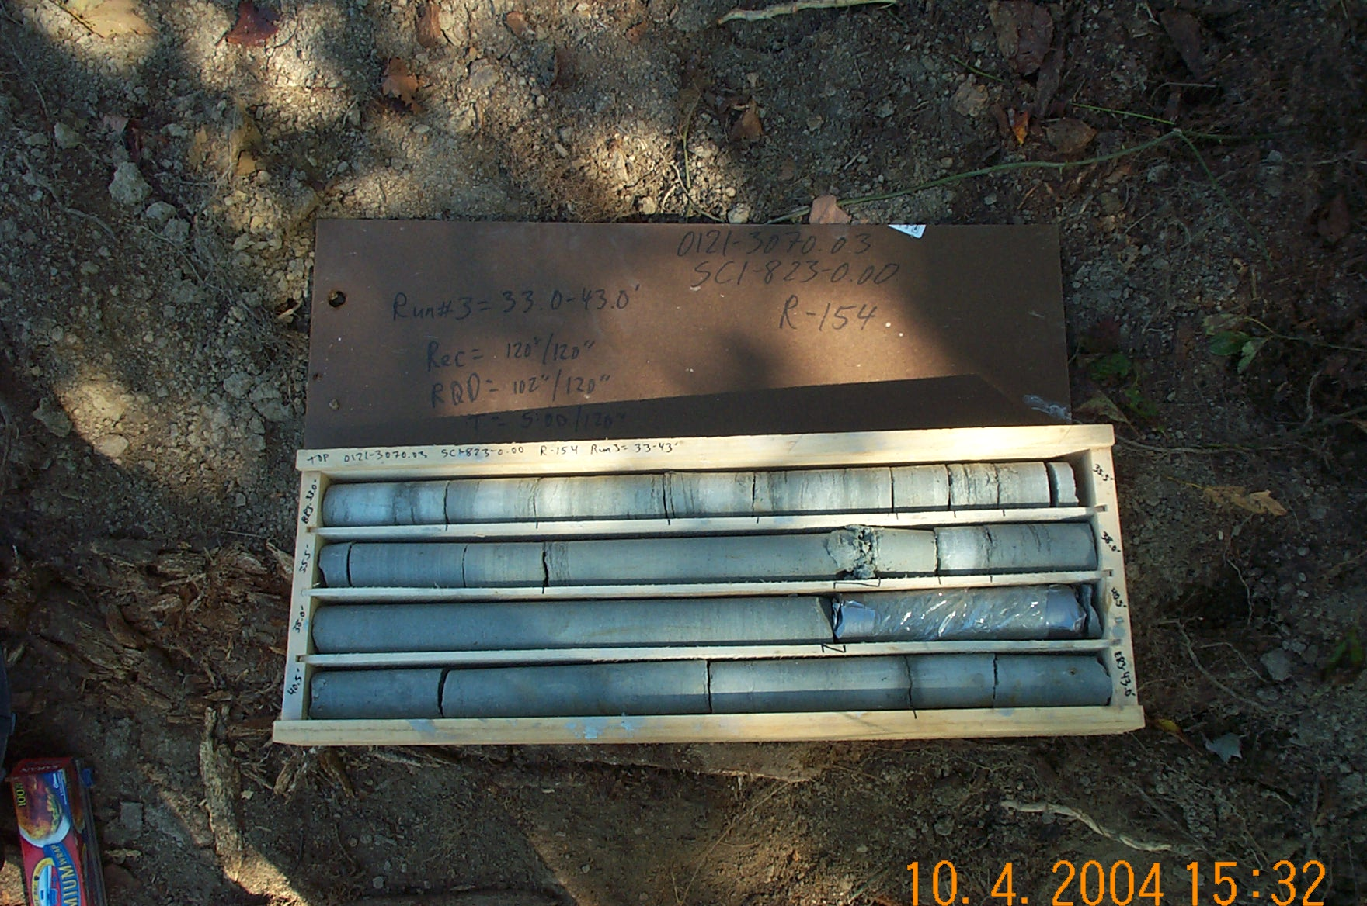
Photo 3. T:\Painter\portsmouthcore\R-154\R3-7fld.JPG

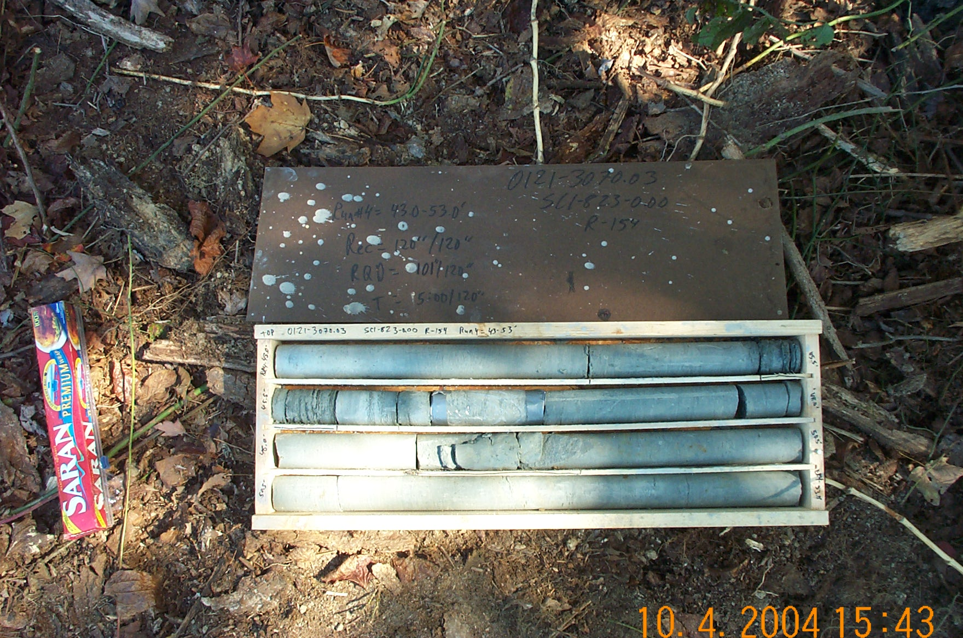
Photo 4. T:\Painter\portsmouthcore\R-154\R4-7fld.JPG

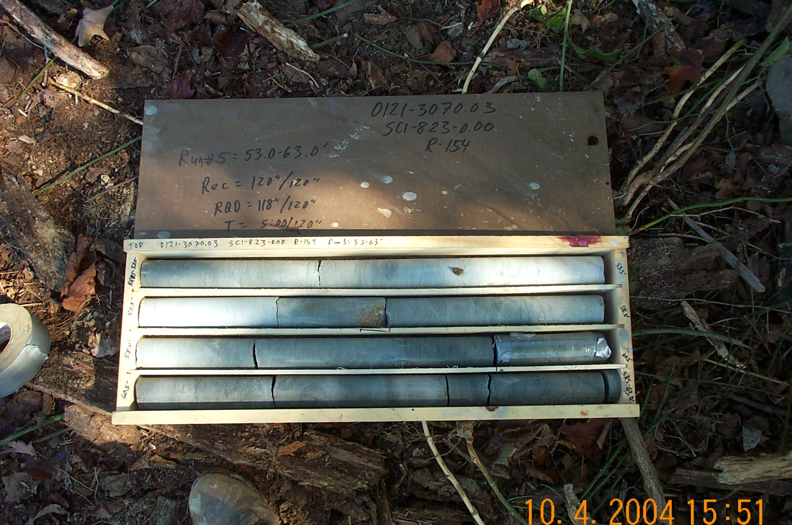
Photo 5. T:\Painter\portsmouthcore\R-154\R5-7fld.JPG

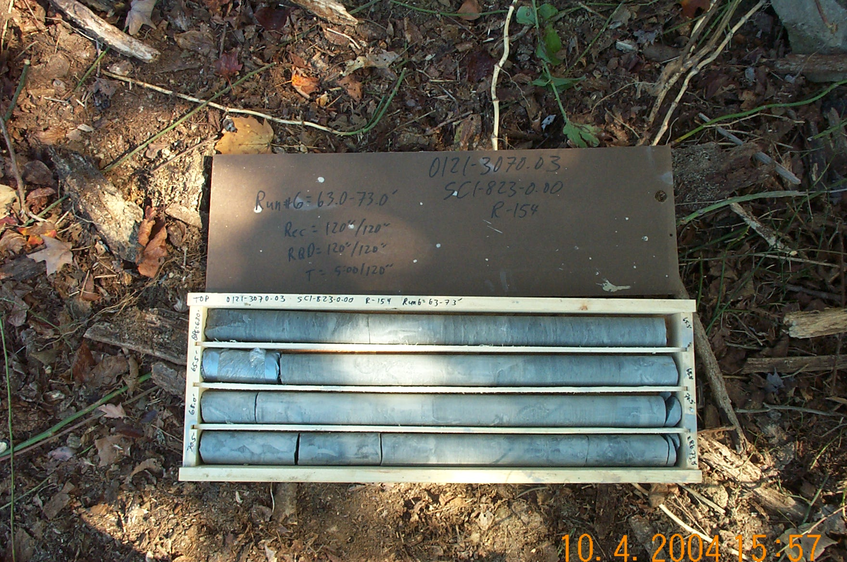
Photo 6. T:\Painter\portsmouthcore\R-154\R6-7fld.JPG

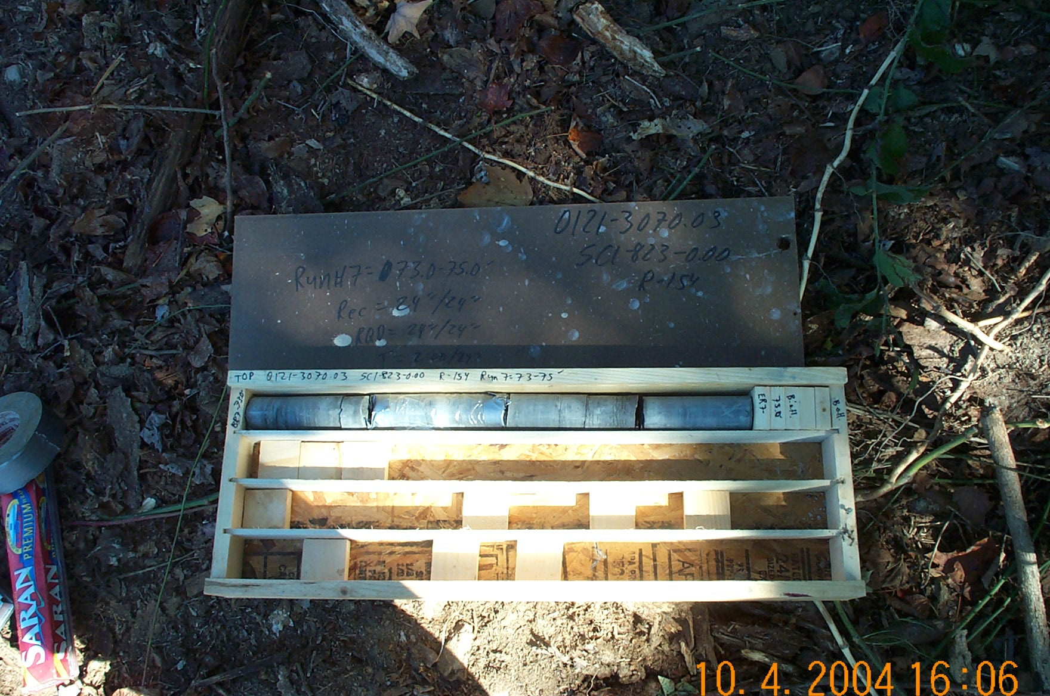
Photo 7. T:\Painter\portsmouthcore\R-154\R7-7fld.JPG

