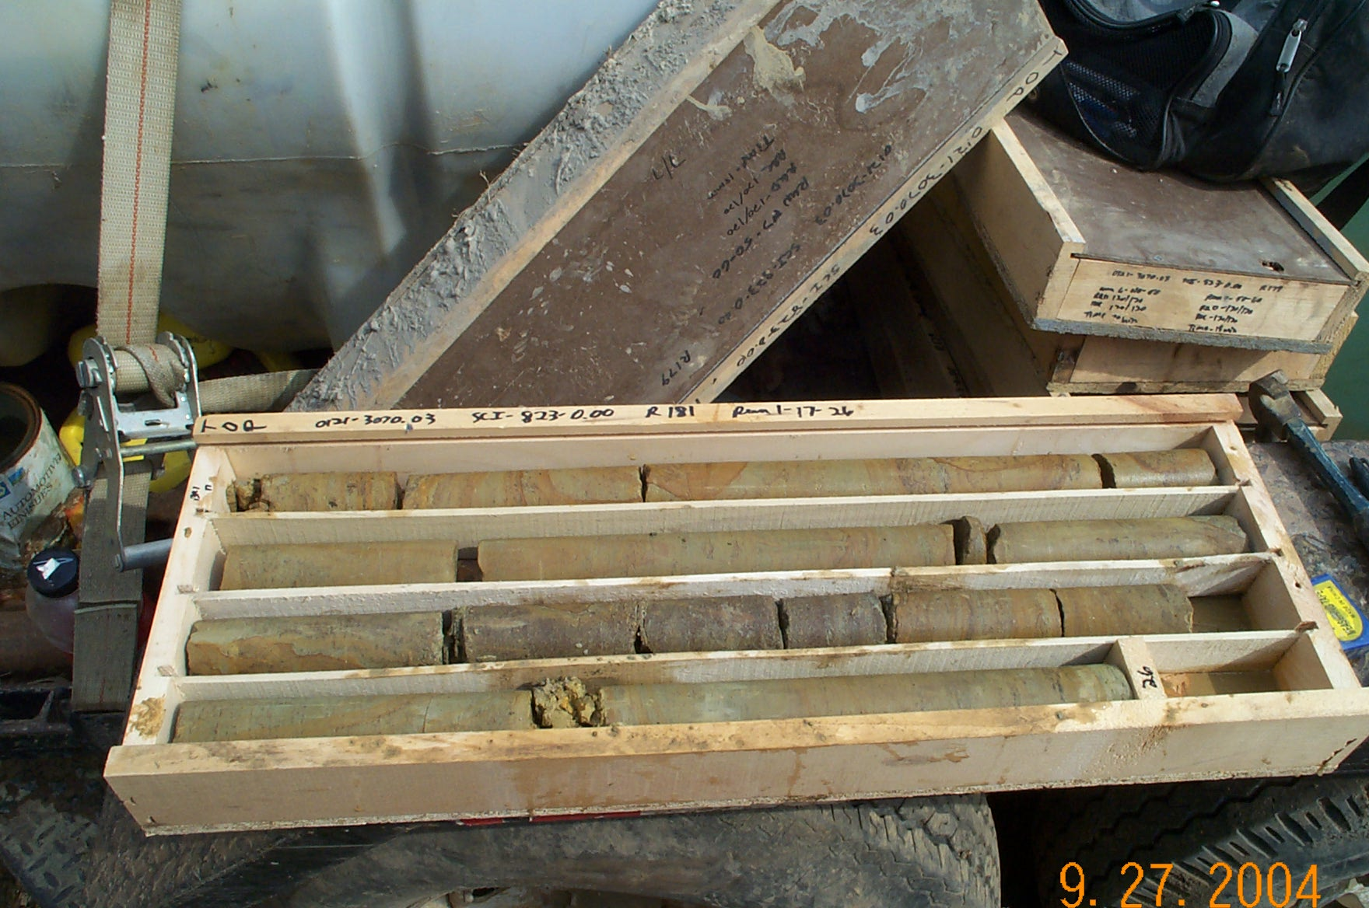
Photo 1. T:\Painter\portsmouthcore\R-181\R1-9fld.JPG

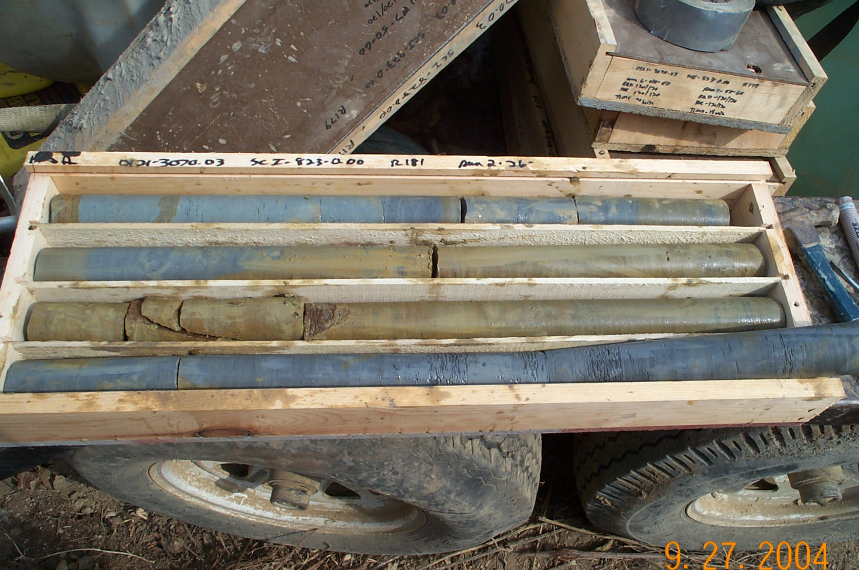
Photo 2. T:\Painter\portsmouthcore\R-181\R2-9fld.JPG

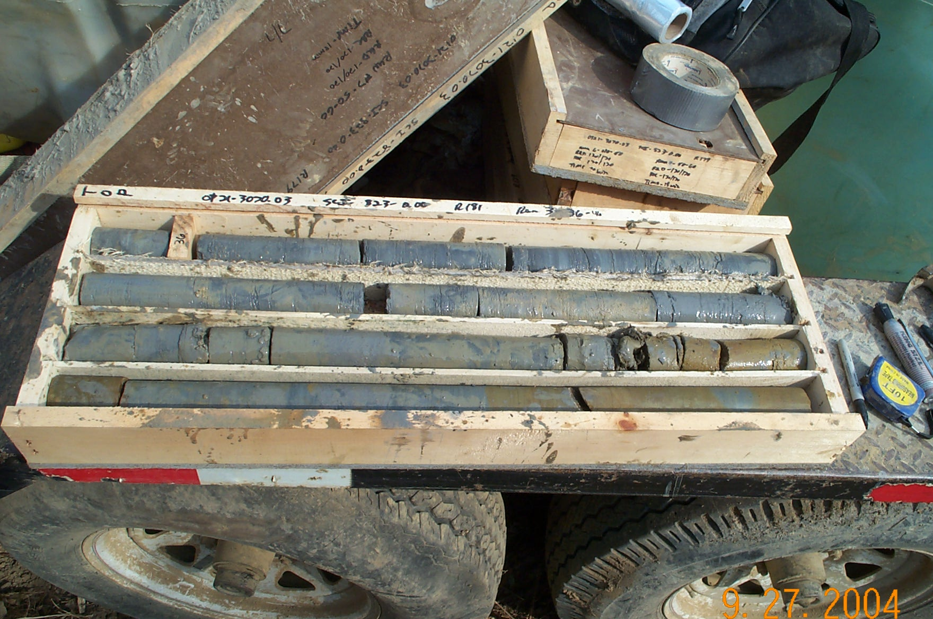
Photo 3. T:\Painter\portsmouthcore\R-181\R3-9fld.JPG

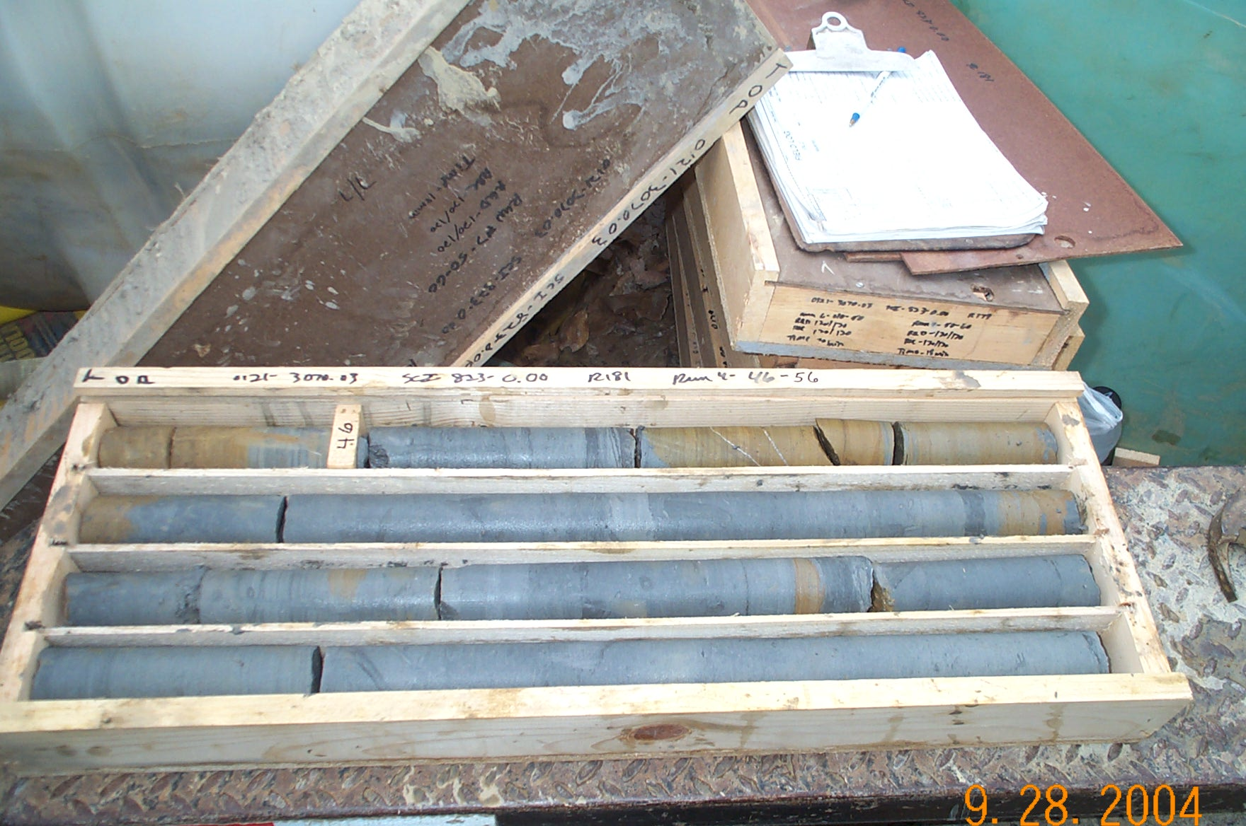
Photo 4. T:\Painter\portsmouthcore\R-181\R4-9fld.JPG

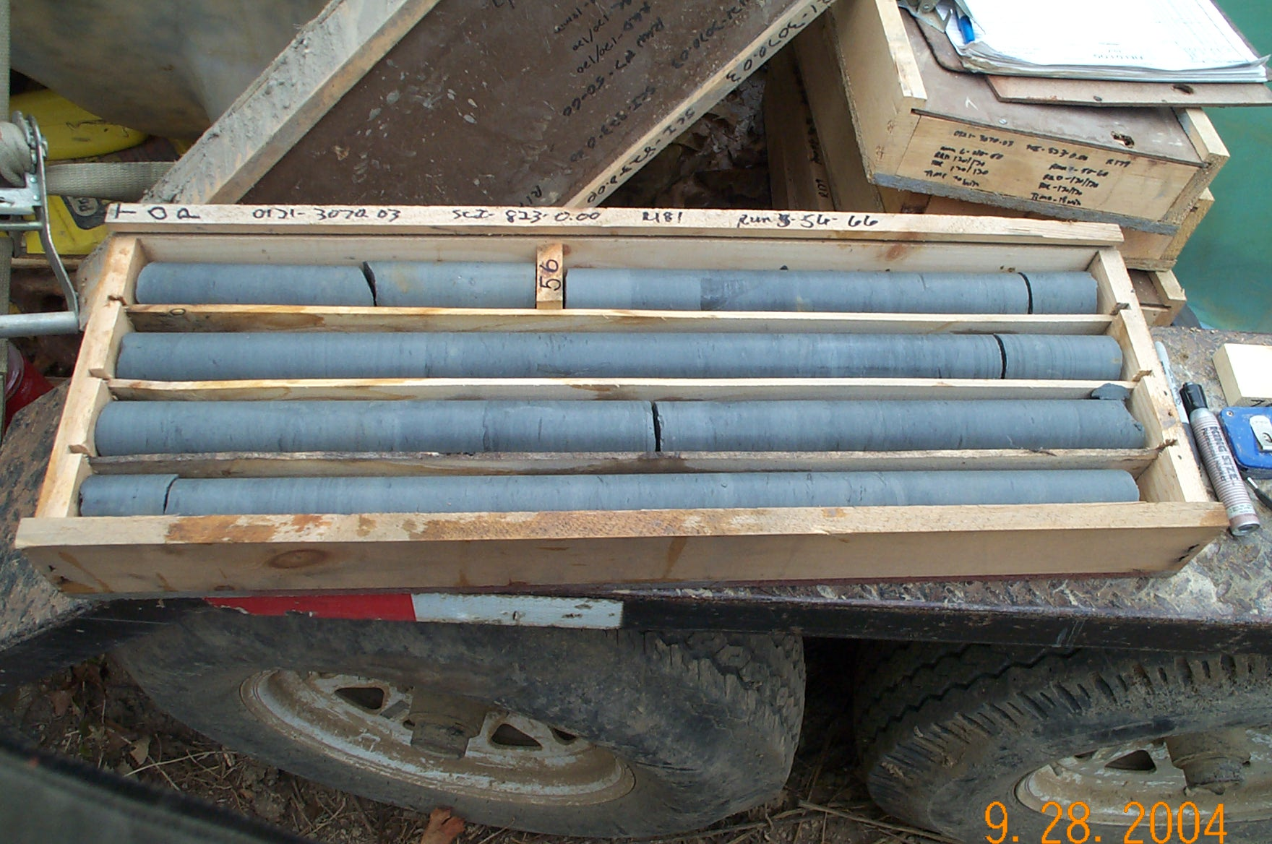
Photo 5. T:\Painter\portsmouthcore\R-181\R5-9fld.JPG

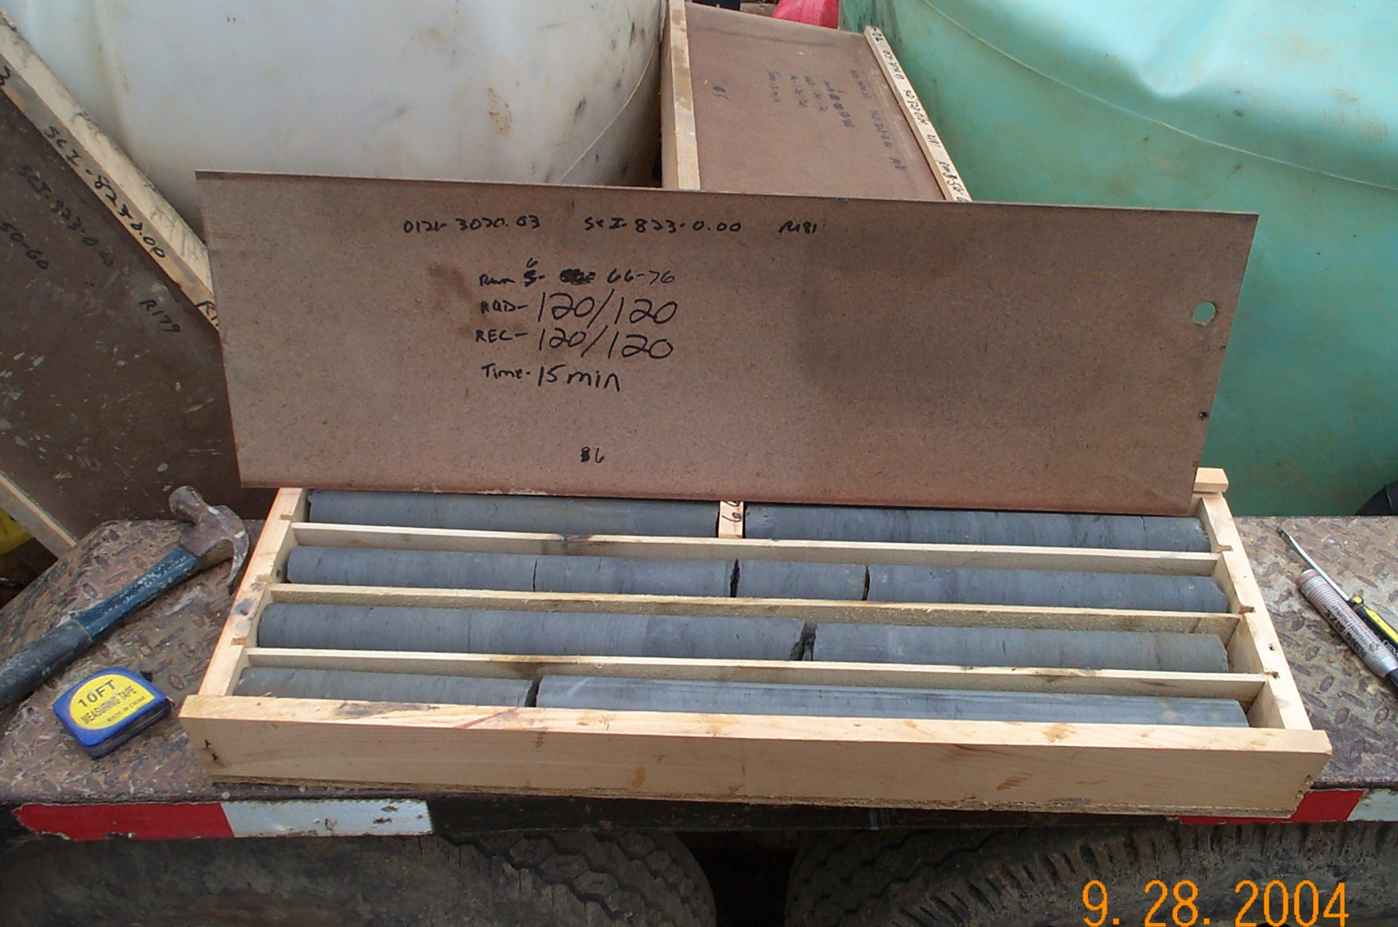
Photo 6. T:\Painter\portsmouthcore\R-181\R6-9fld.JPG

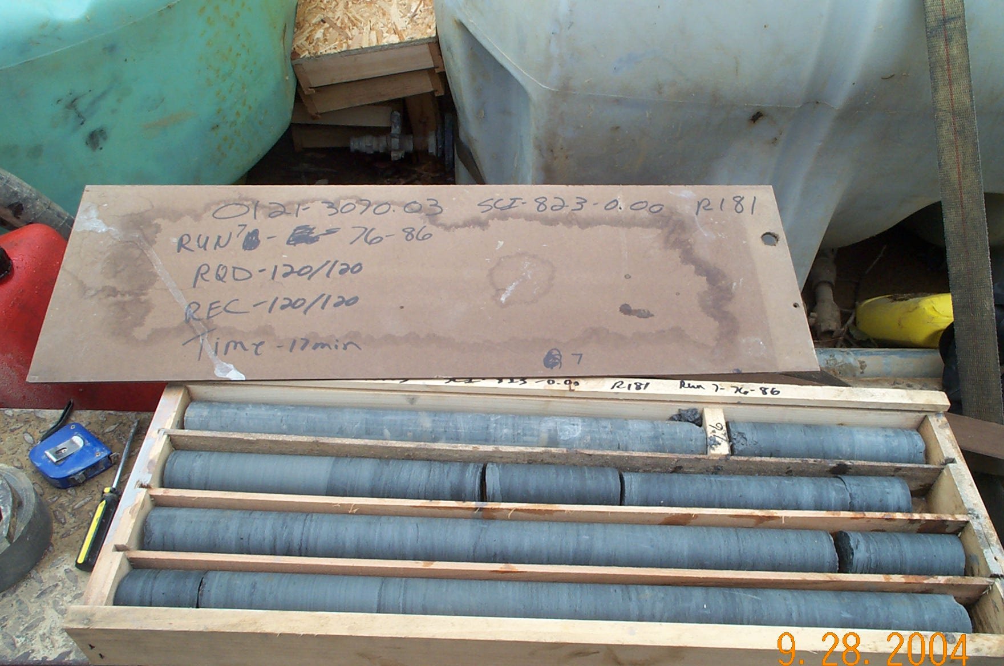
Photo 7. T:\Painter\portsmouthcore\R-181\R7-9fld.JPG

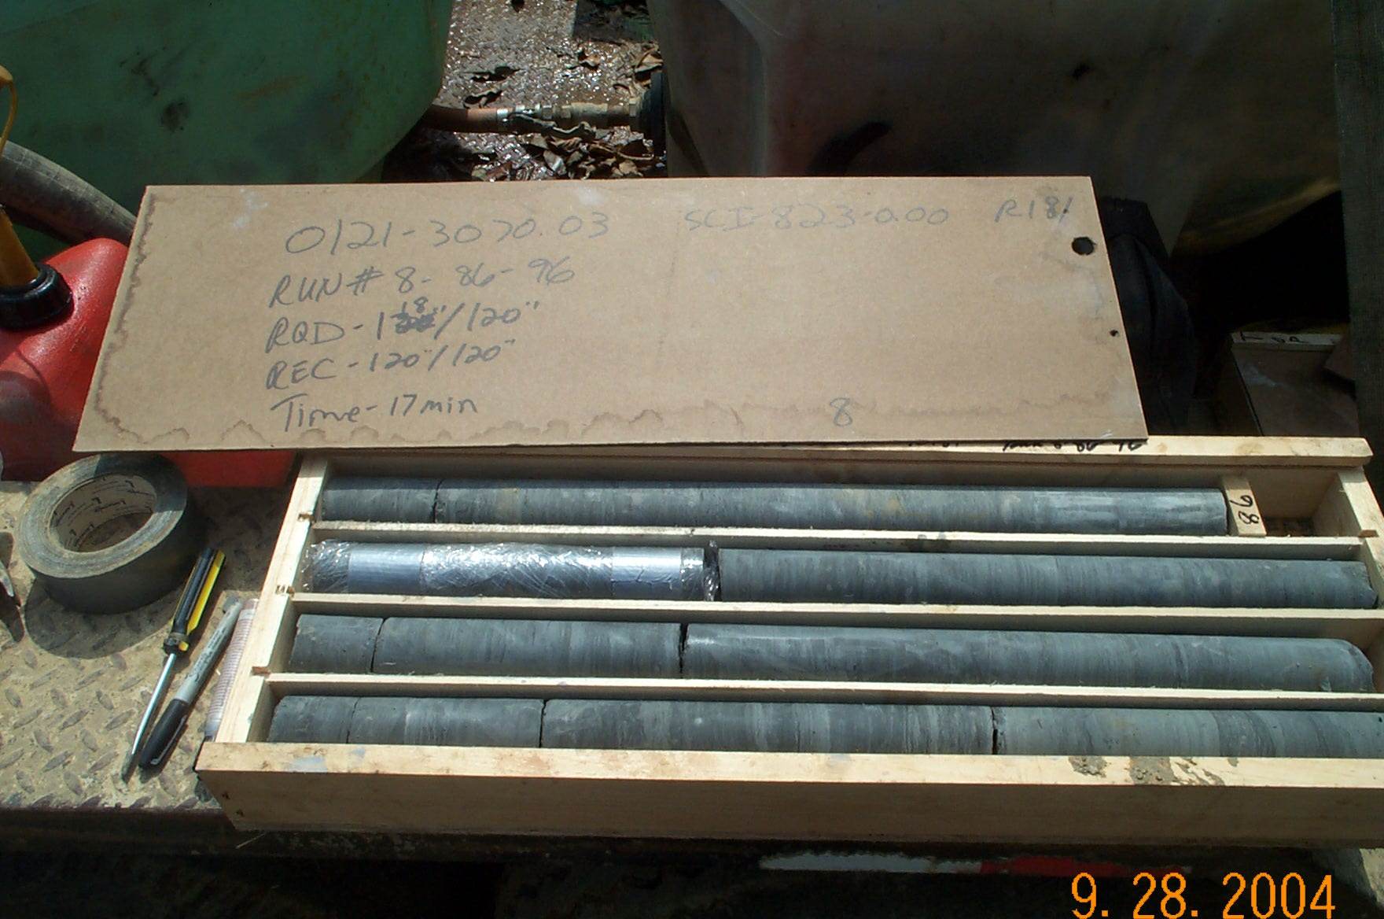
Photo 8. T:\Painter\portsmouthcore\R-181\R8-9fld.JPG

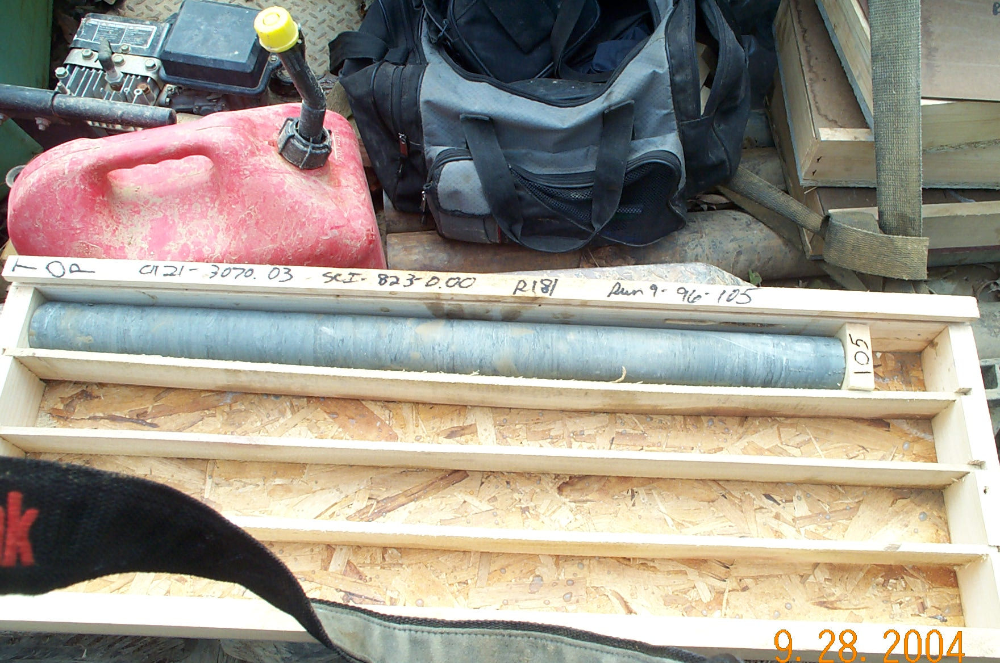
Photo 9. T:\Painter\portsmouthcore\R-181\R9-9afld.JPG

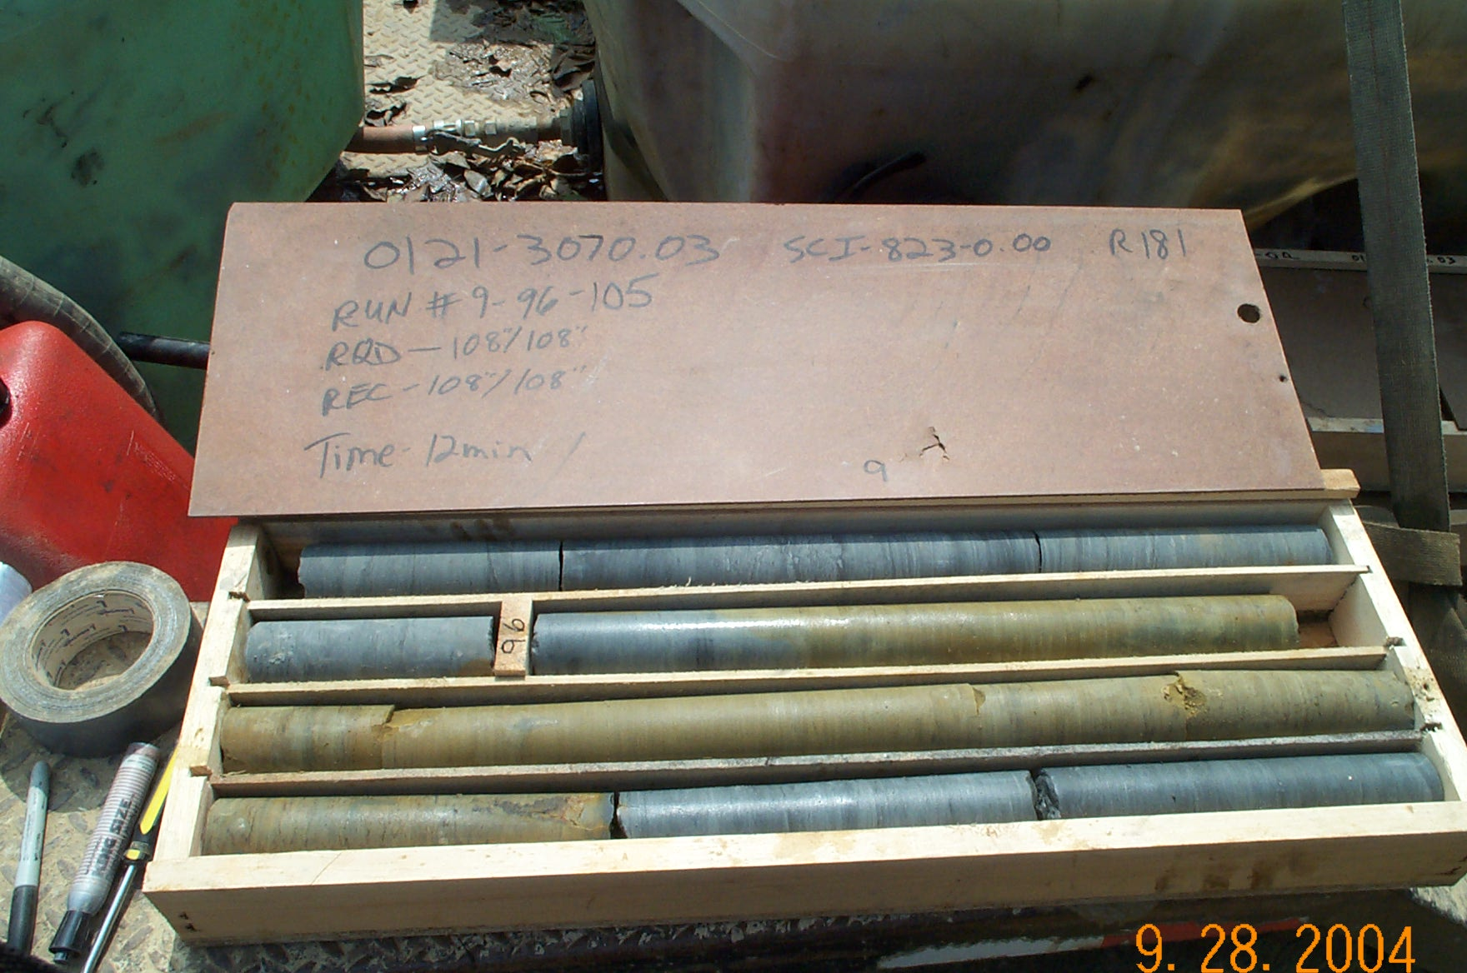
Photo 10. T:\Painter\portsmouthcore\R-181\R9-9fld.JPG

