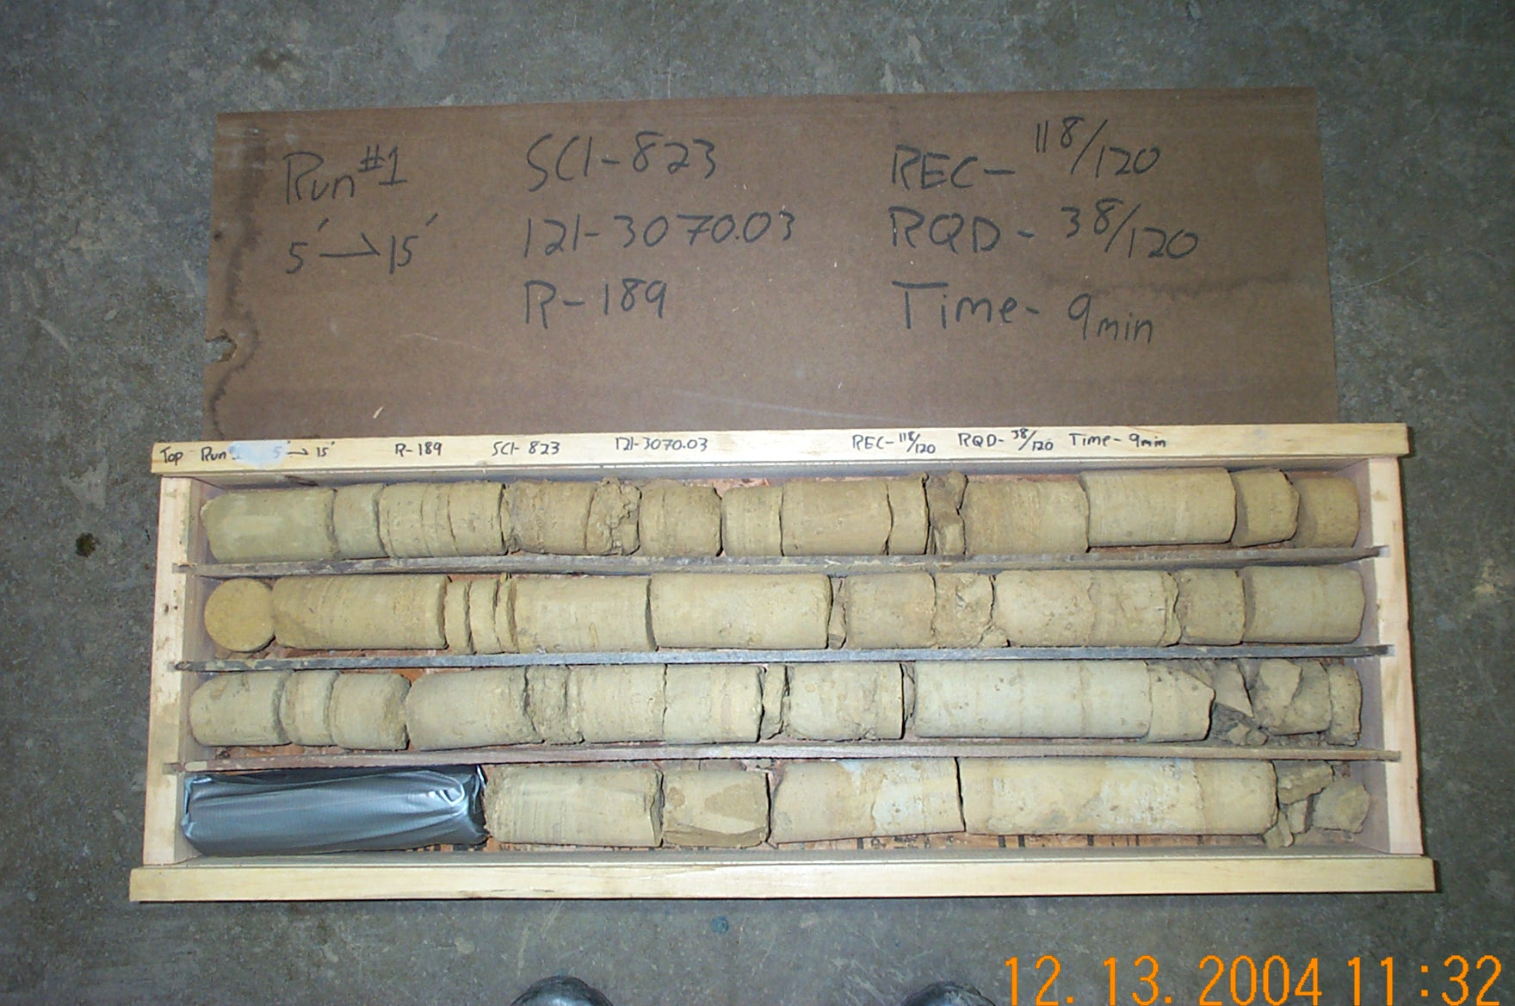
Photo 1. T:\Painter\portsmouthcore\R-189\R1-7shp.JPG

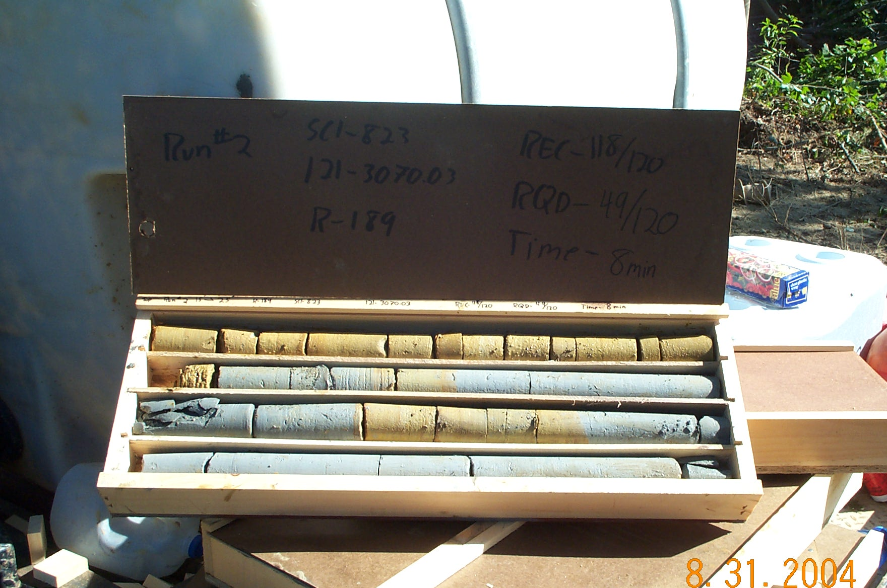
Photo 2. T:\Painter\portsmouthcore\R-189\R2-7fld.JPG

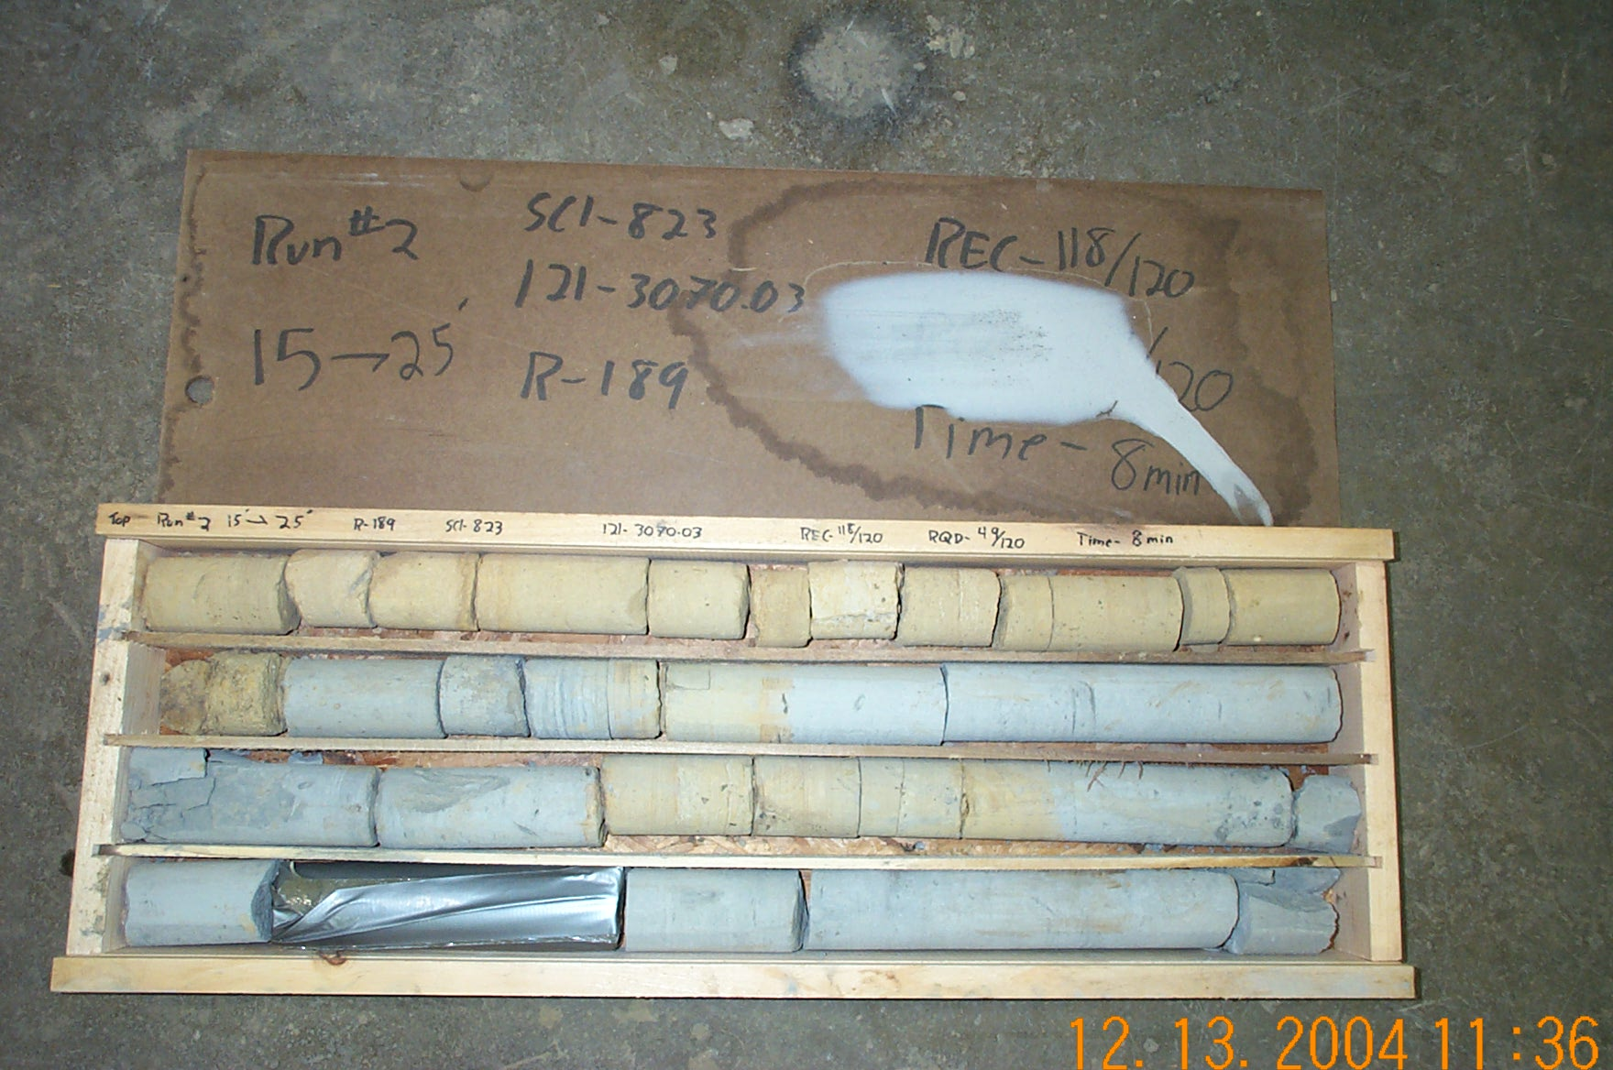
Photo 3. T:\Painter\portsmouthcore\R-189\R2-7shp.JPG

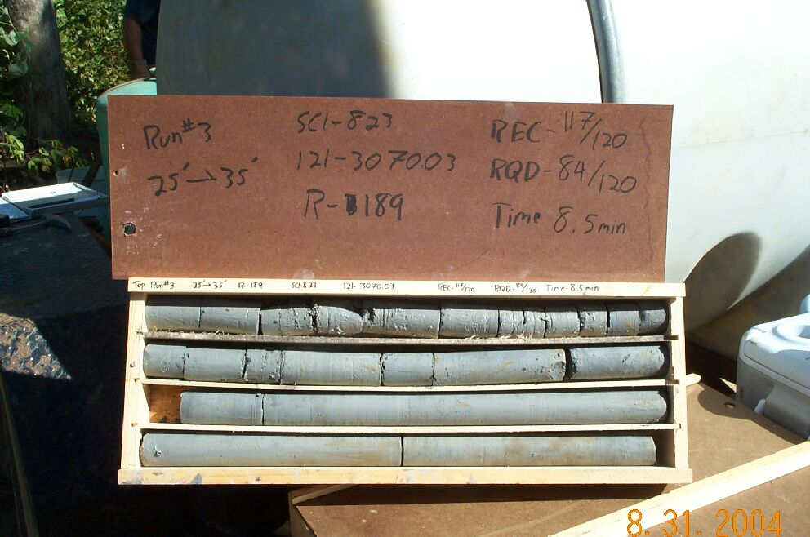
Photo 4. T:\Painter\portsmouthcore\R-189\R3-7fld.jpg

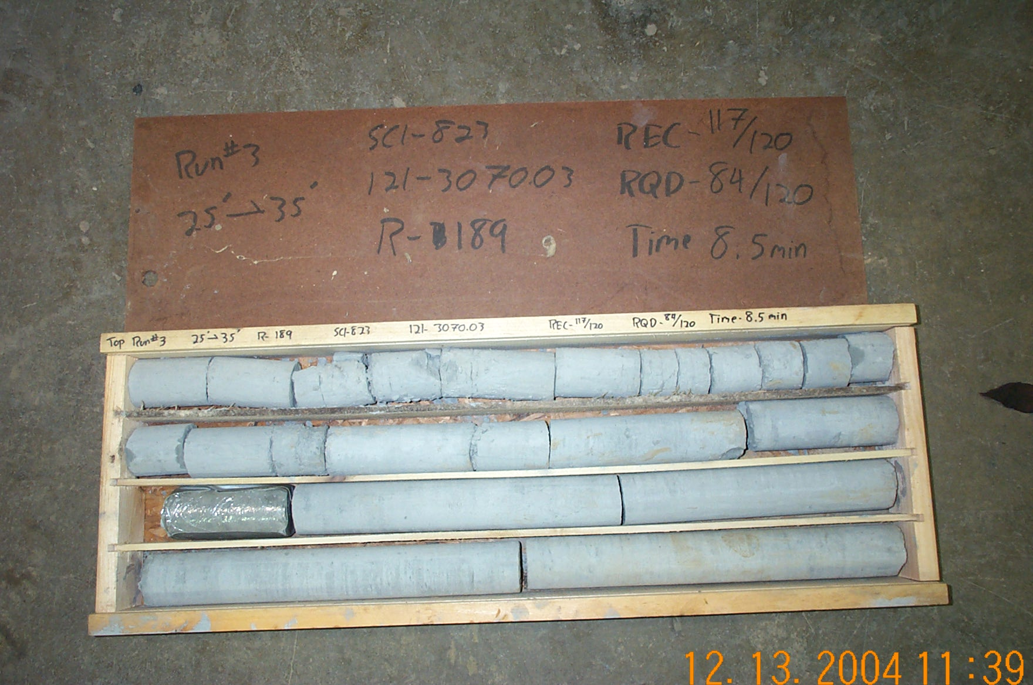
Photo 5. T:\Painter\portsmouthcore\R-189\R3-7shp.JPG

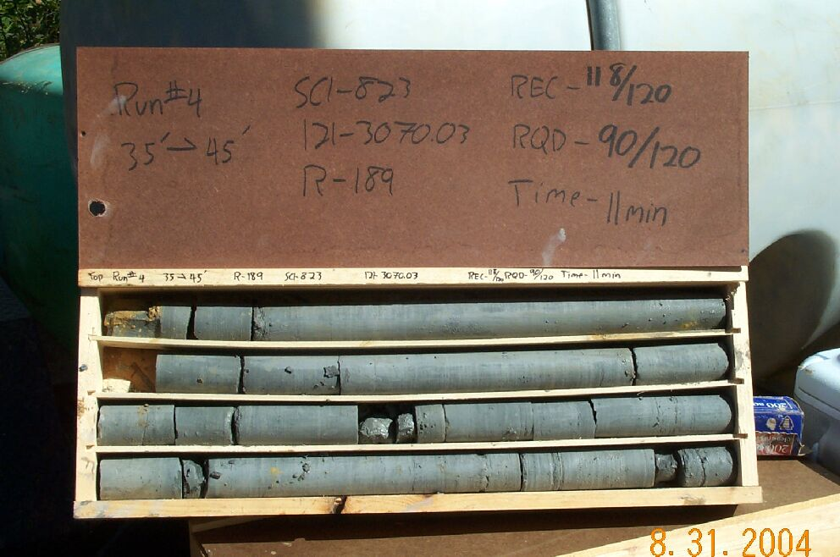
Photo 6. T:\Painter\portsmouthcore\R-189\R4-7fld.jpg

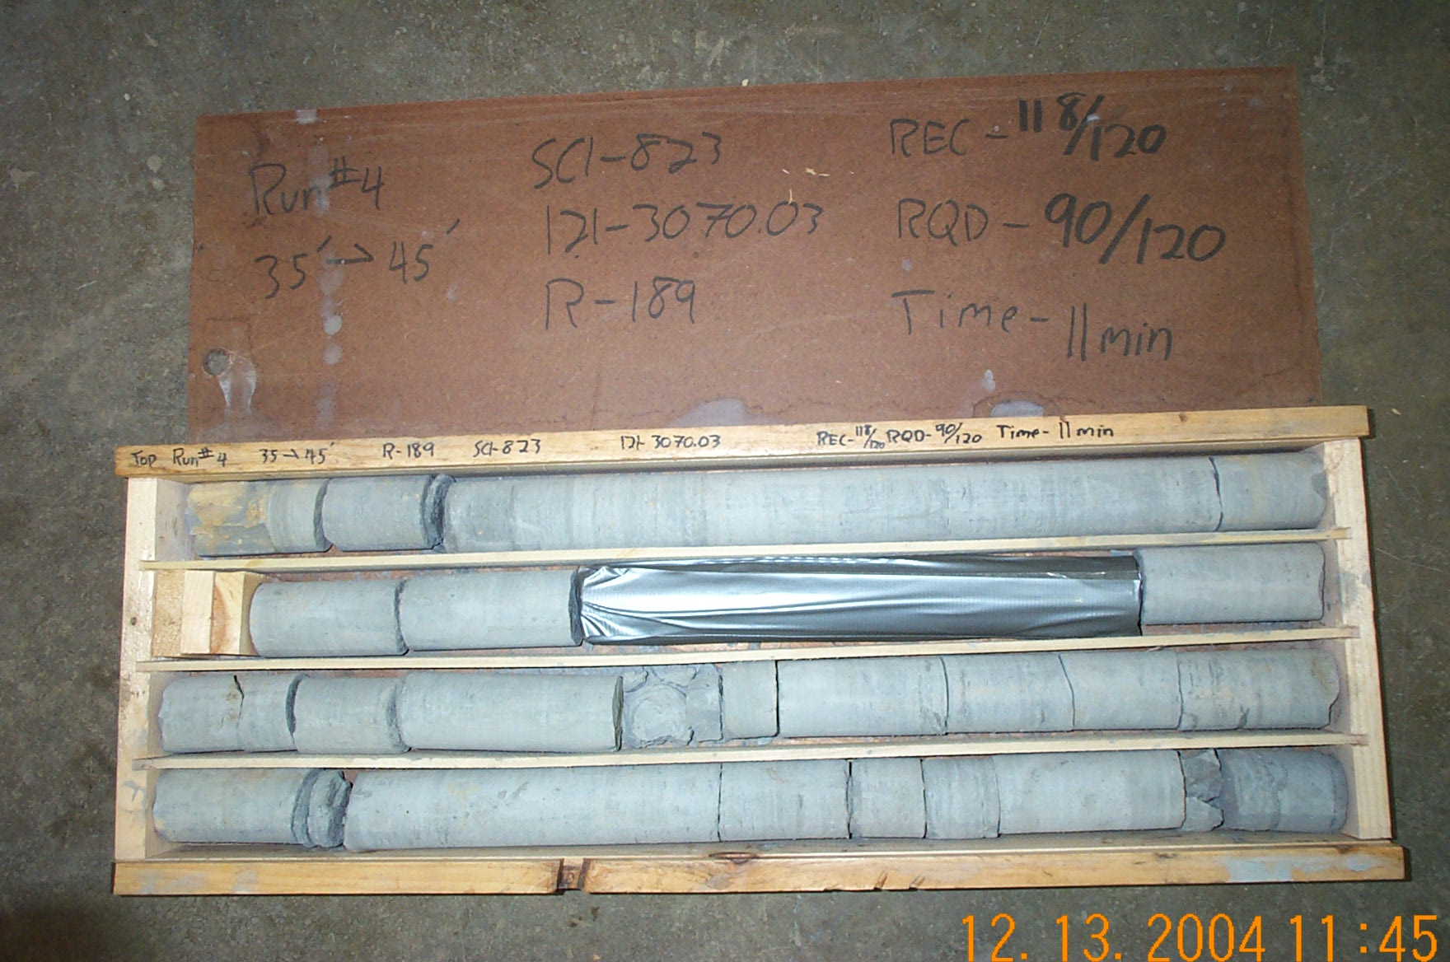
Photo 7. T:\Painter\portsmouthcore\R-189\R4-7shp.JPG

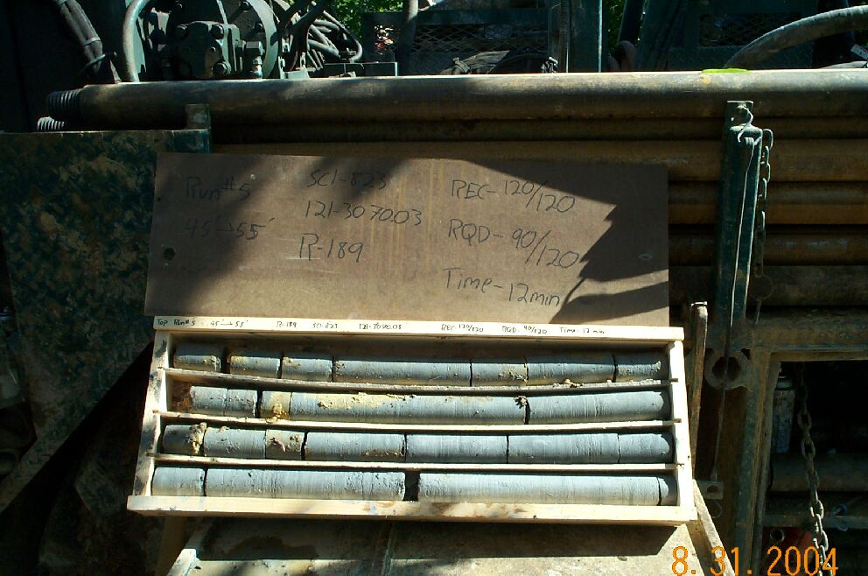
Photo 8. T:\Painter\portsmouthcore\R-189\R5-7fld.jpg

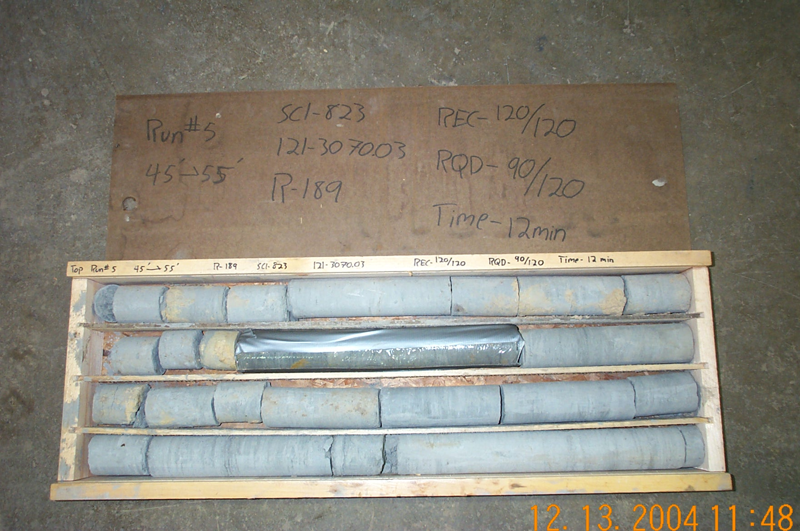
Photo 9. T:\Painter\portsmouthcore\R-189\R5-7shp.JPG

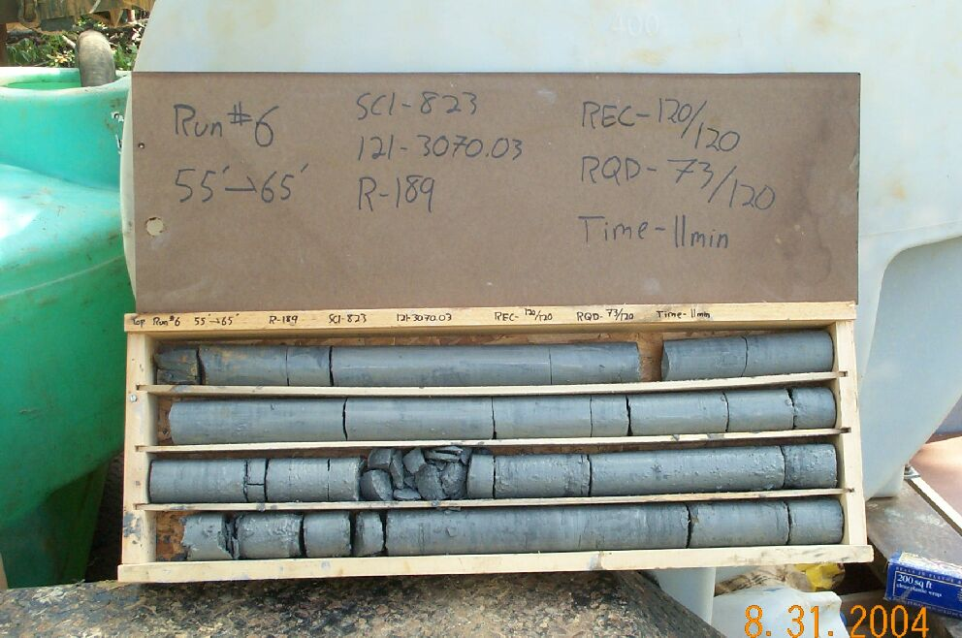
Photo 10. T:\Painter\portsmouthcore\R-189\R6-7fld.jpg

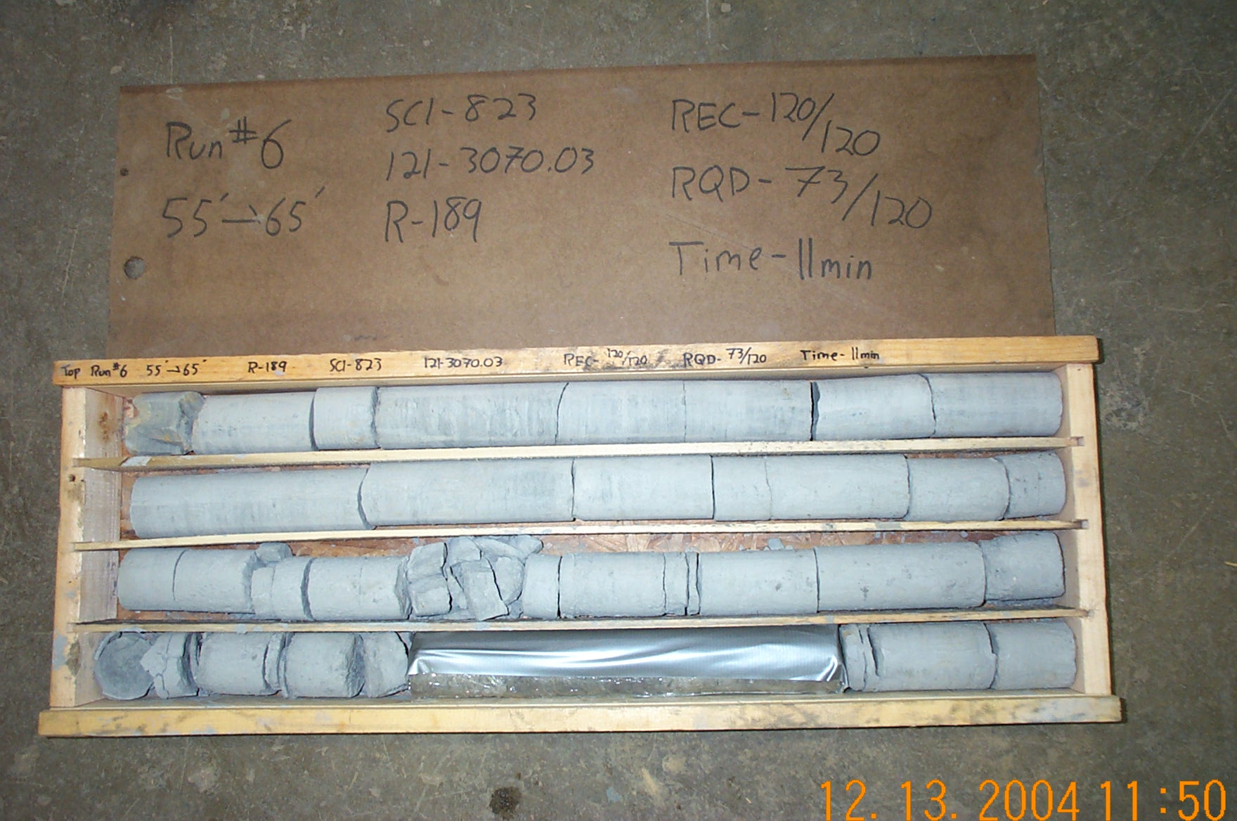
Photo 11. T:\Painter\portsmouthcore\R-189\R6-7shp.JPG

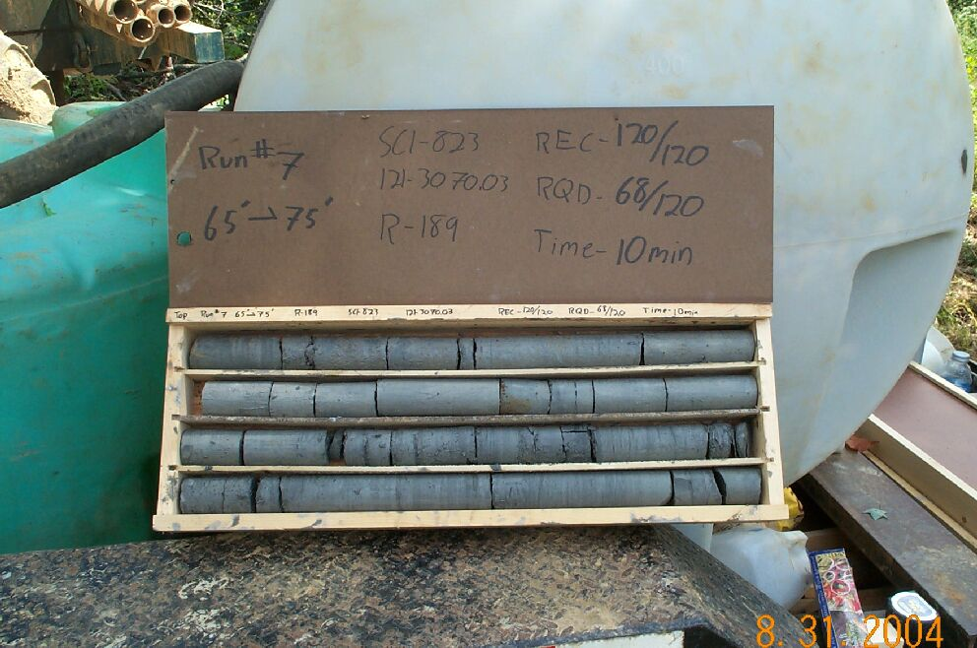
Photo 12. T:\Painter\portsmouthcore\R-189\R7-7fld.jpg

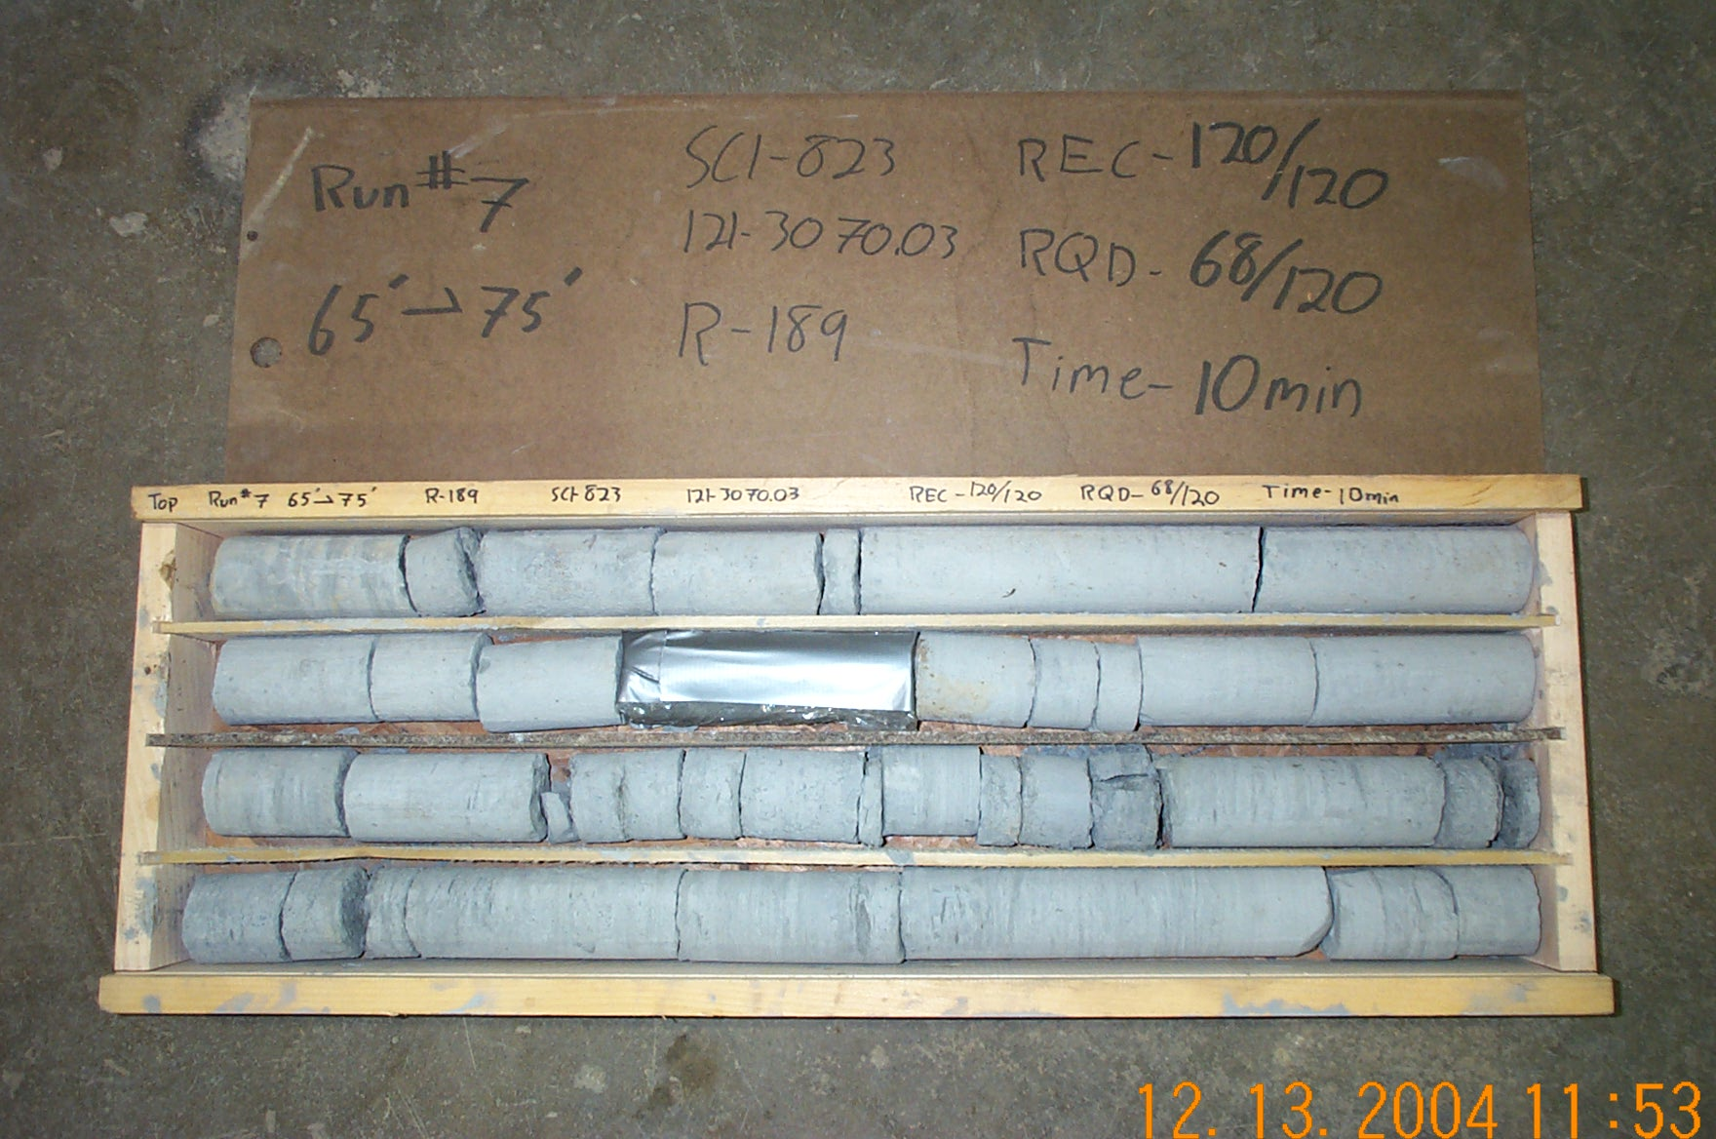
Photo 13. T:\Painter\portsmouthcore\R-189\R7-7shp.JPG

