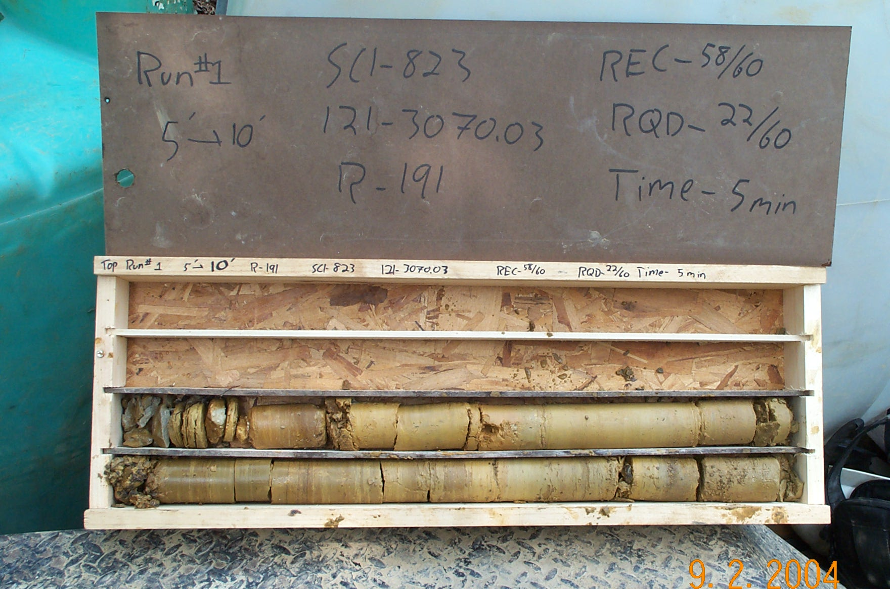
Photo 1. T:\Painter\portsmouthcore\R-191\R1-4fld.JPG

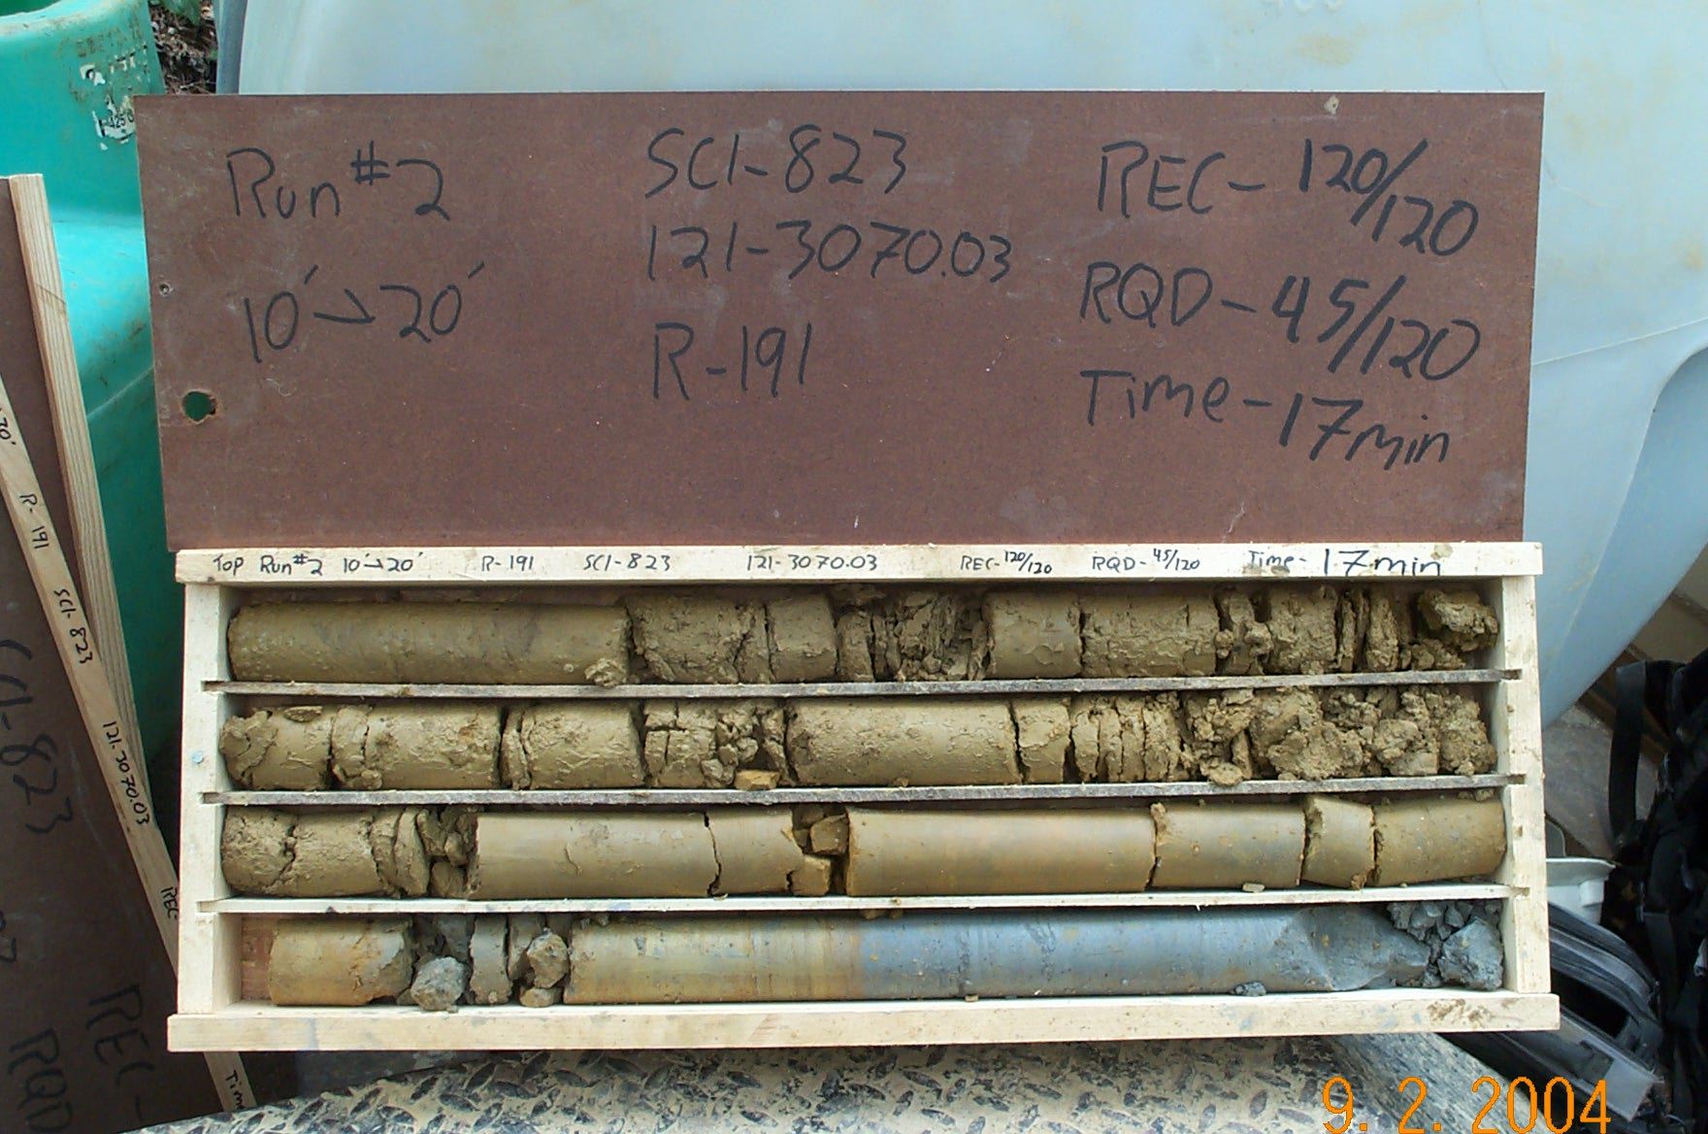
Photo 2. T:\Painter\portsmouthcore\R-191\R2-4fld.JPG

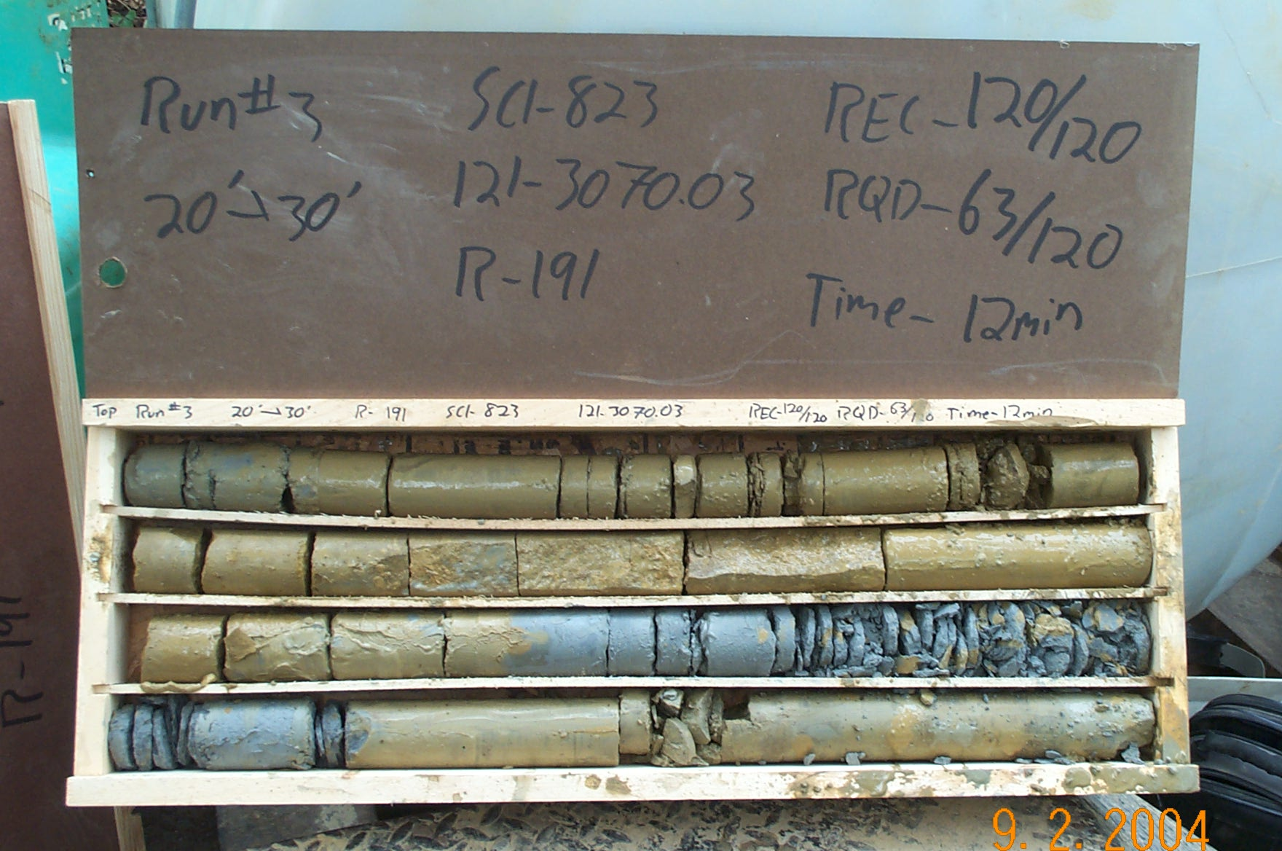
Photo 3. T:\Painter\portsmouthcore\R-191\R3-4fld.JPG

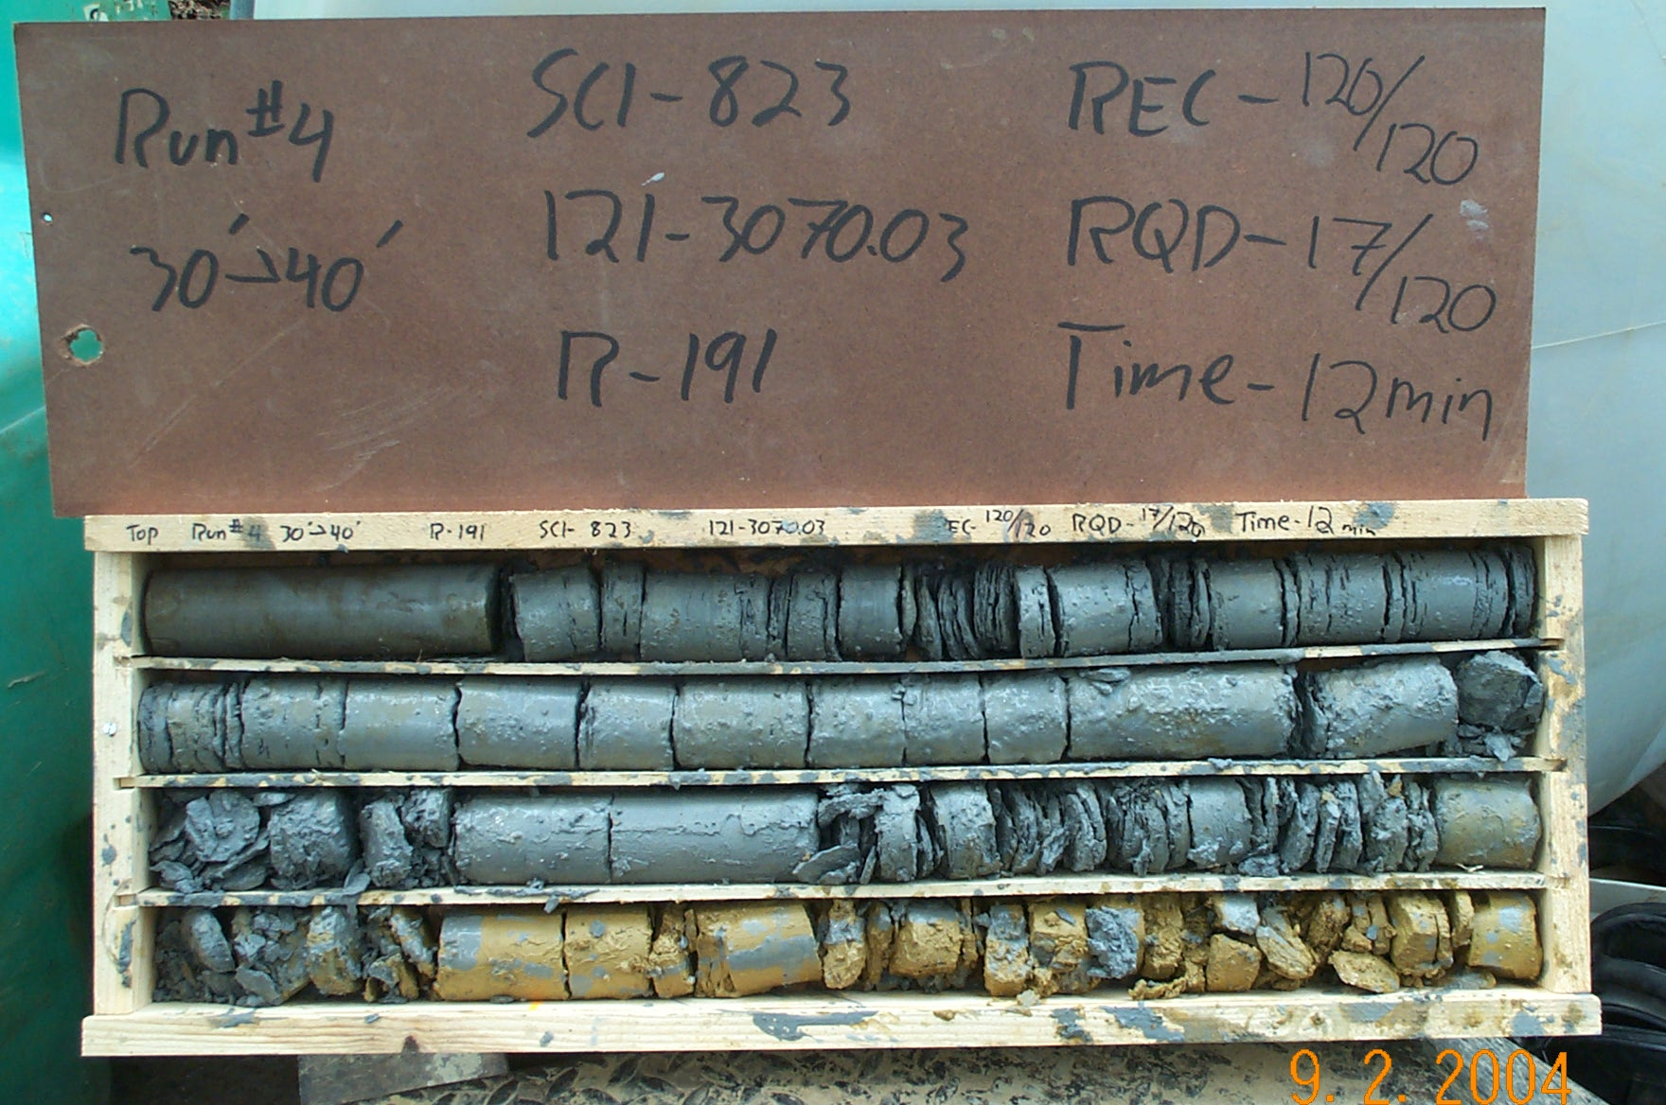
Photo 4. T:\Painter\portsmouthcore\R-191\R4-4fld.JPG

