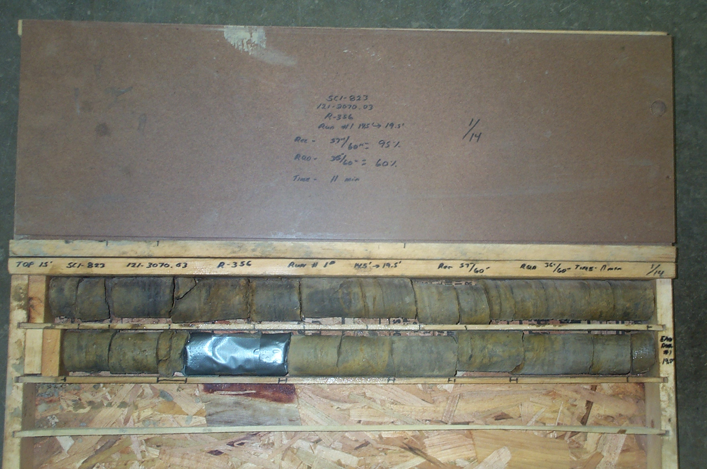
Photo 1. C:\portsmouthcore\R-356\R1-14shp.JPG

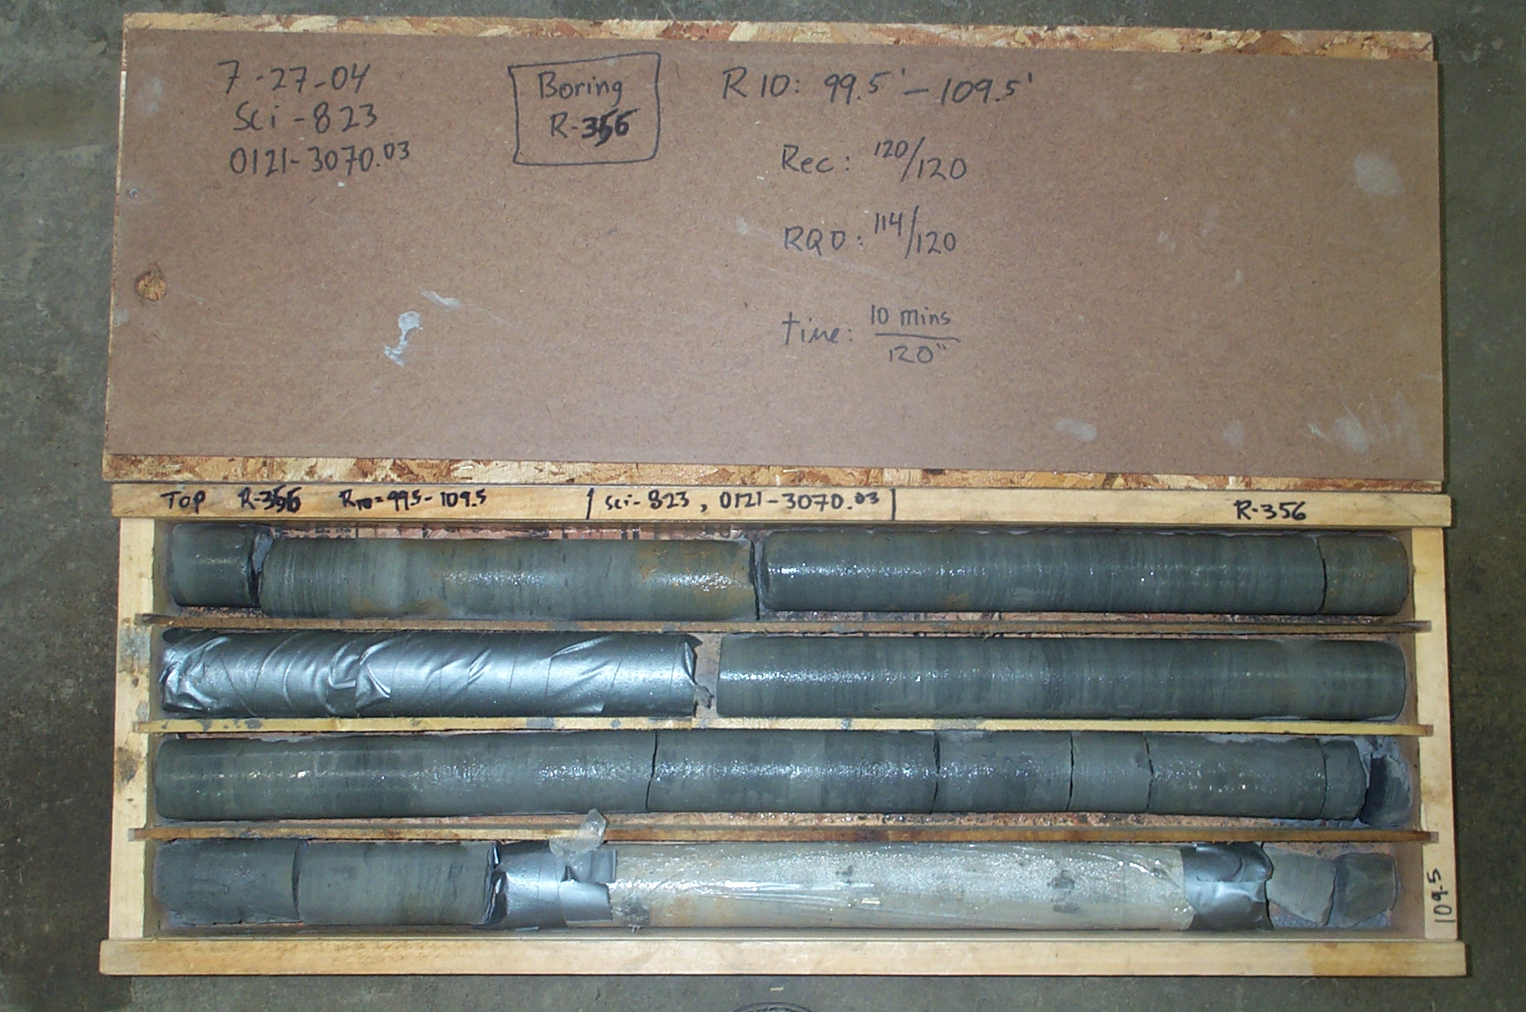
Photo 2. C:\portsmouthcore\R-356\R10-14shp.JPG

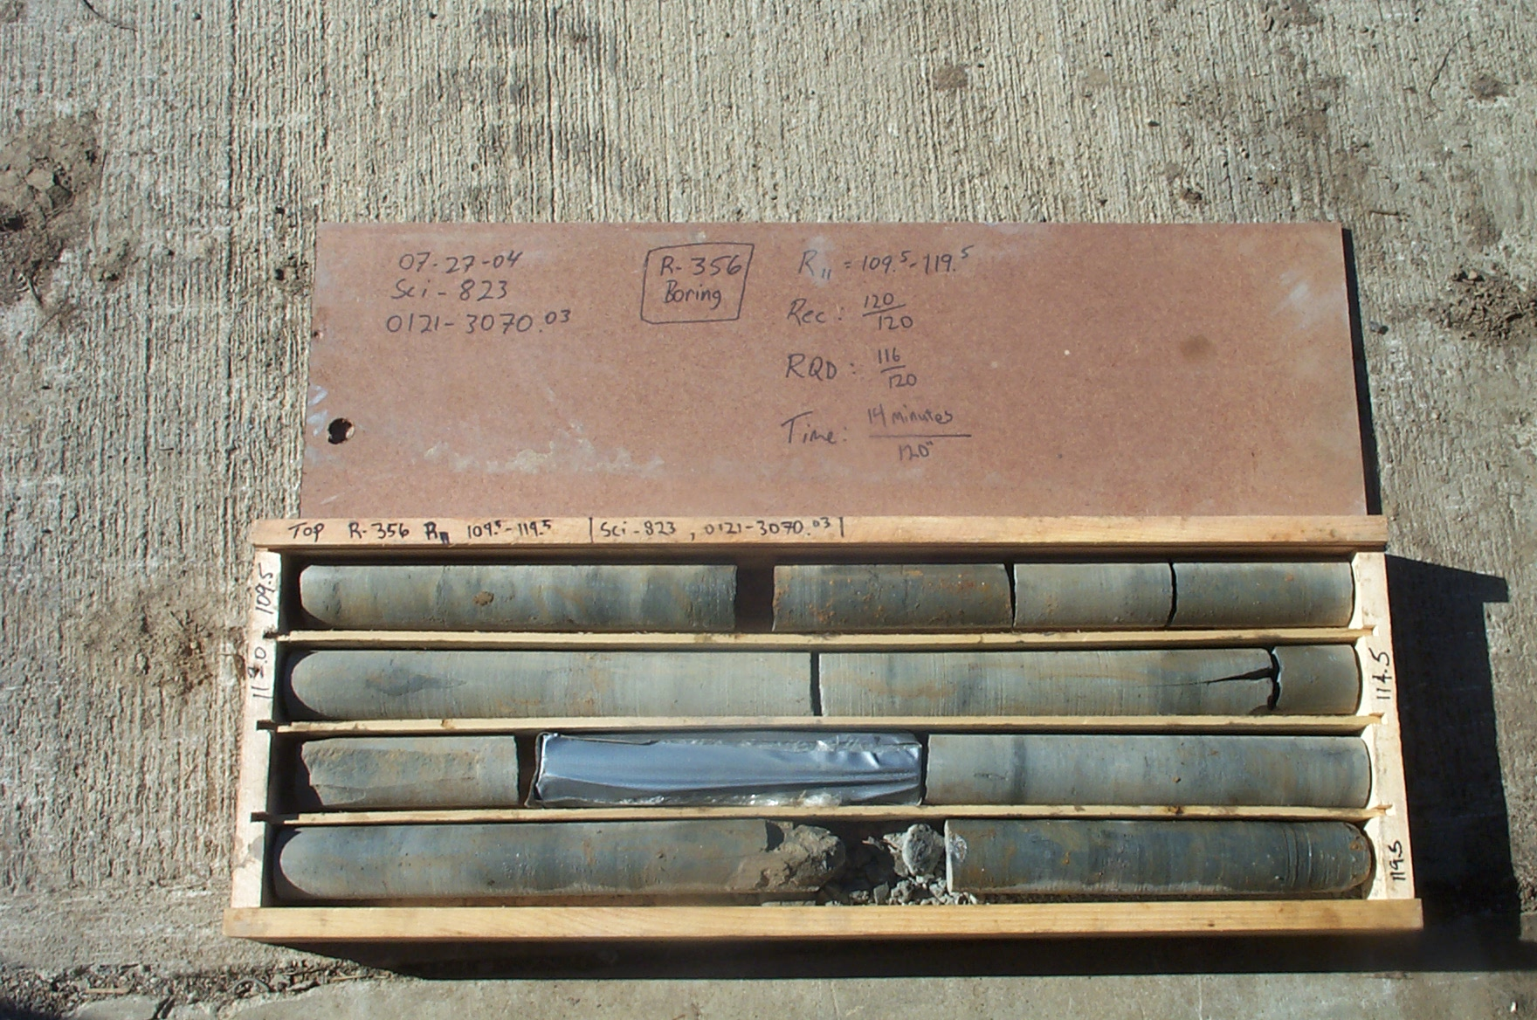
Photo 3. C:\portsmouthcore\R-356\R11-14shp.JPG

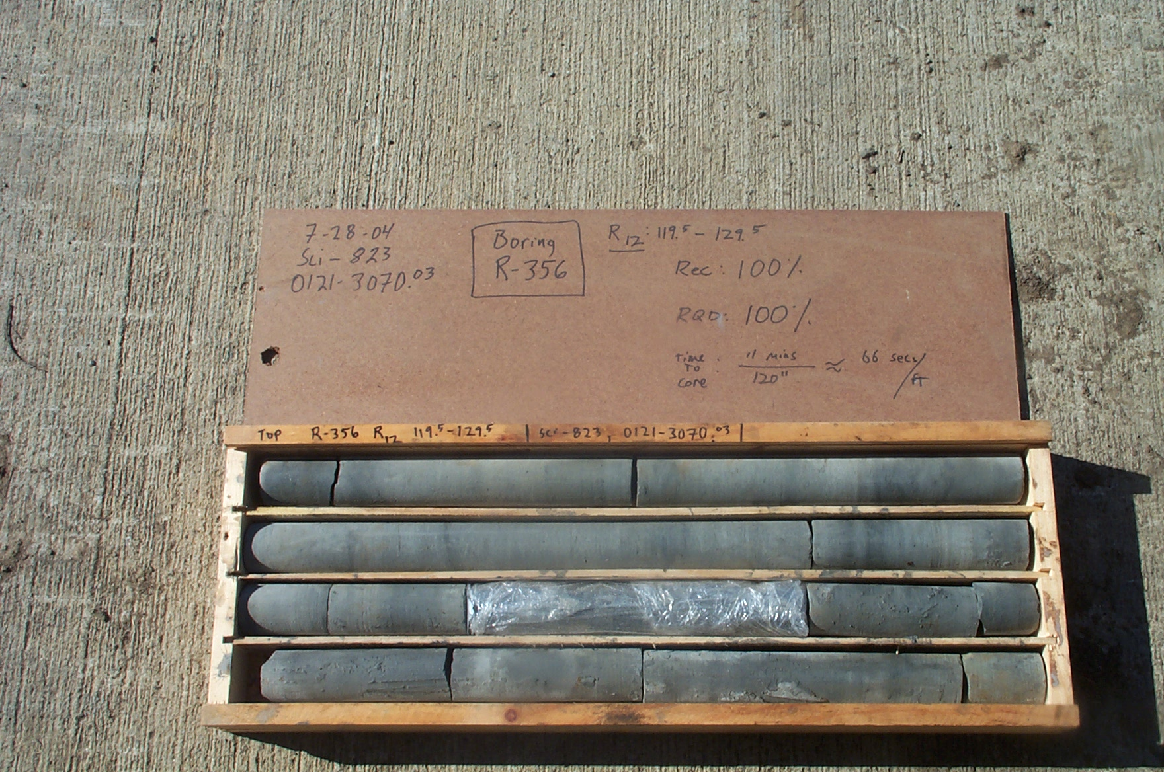
Photo 4. C:\portsmouthcore\R-356\R12-14shp.JPG

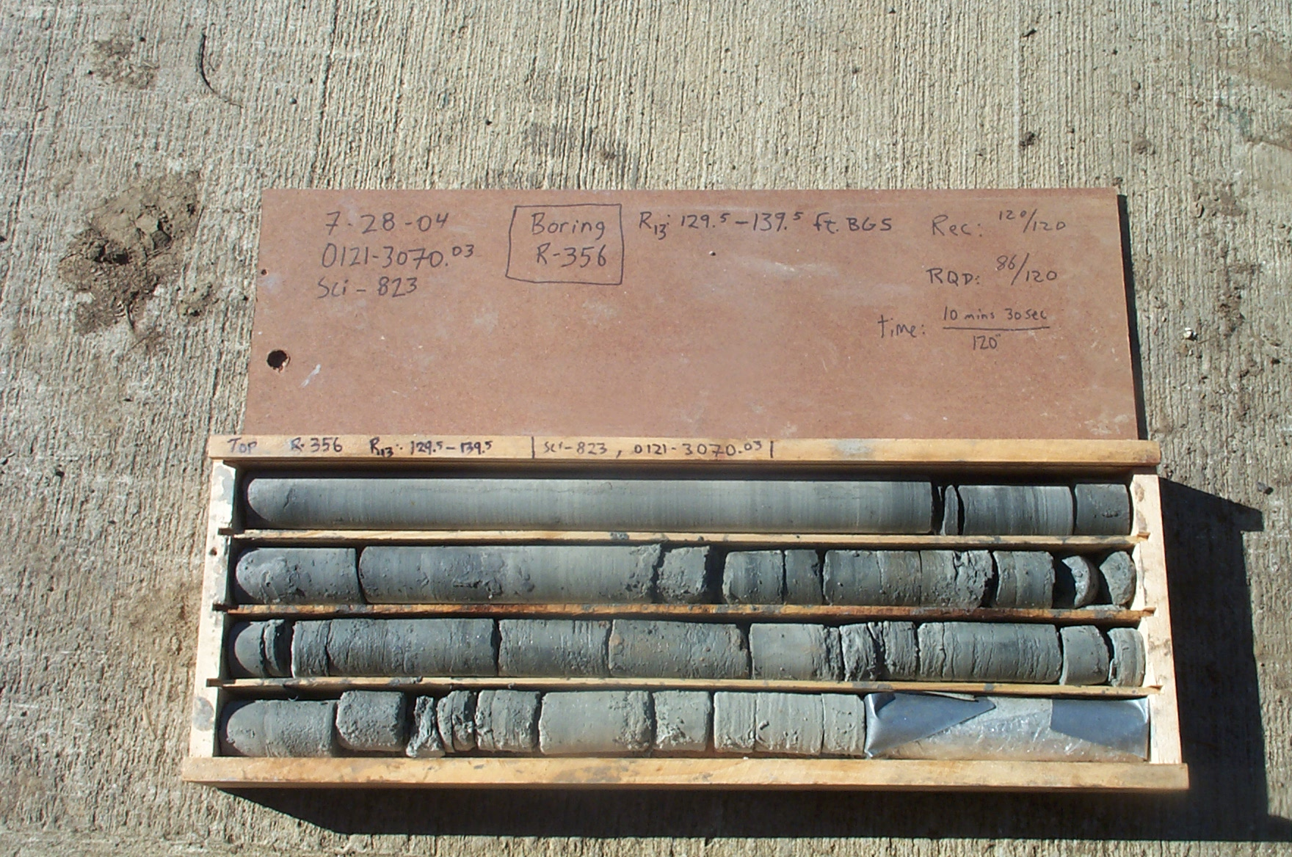
Photo 5. C:\portsmouthcore\R-356\R13-14shp.JPG

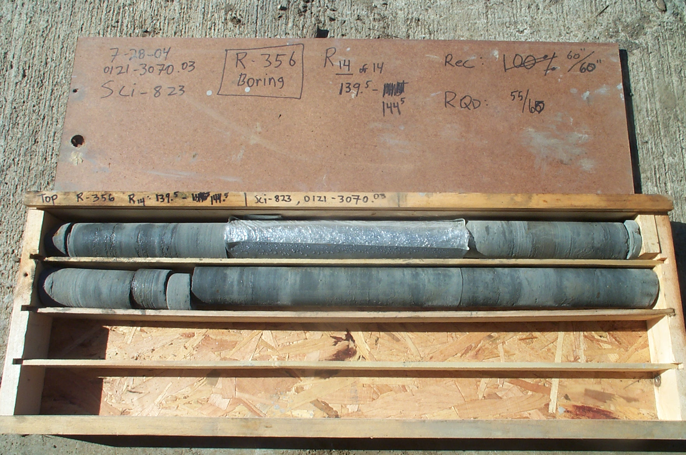
Photo 6. C:\portsmouthcore\R-356\R14-14shp.JPG

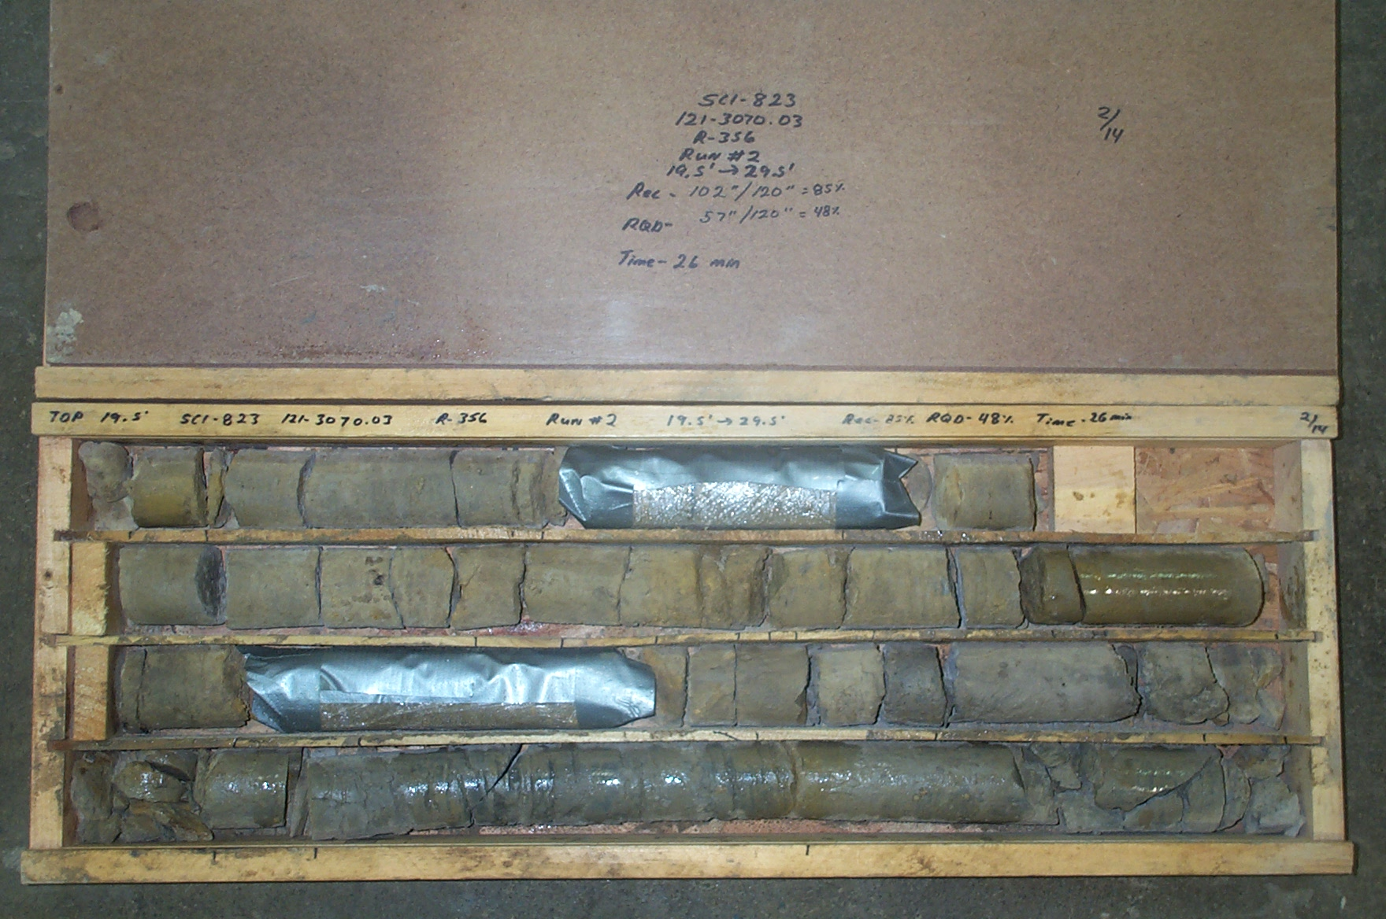
Photo 7. C:\portsmouthcore\R-356\R2-14shp.JPG

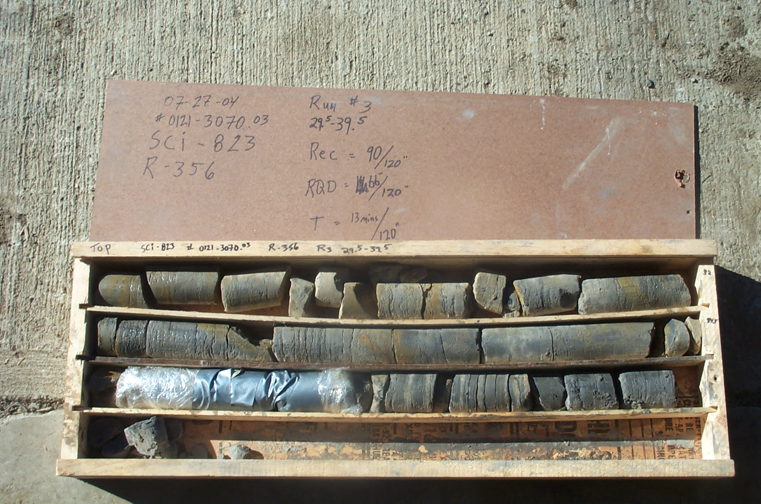
Photo 8. C:\portsmouthcore\R-356\R3-13shp.JPG

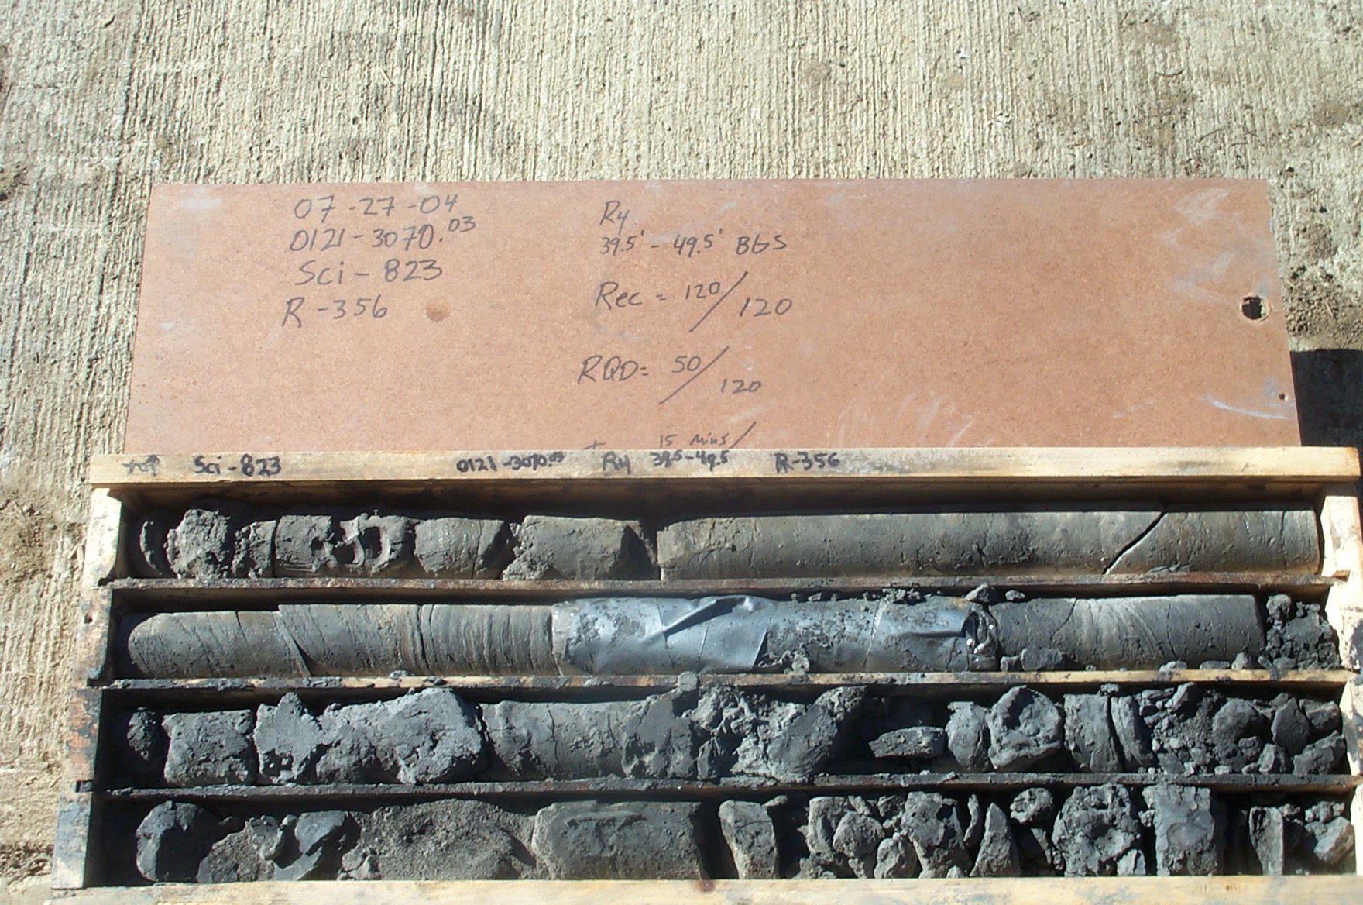
Photo 9. C:\portsmouthcore\R-356\R4-14shp.JPG

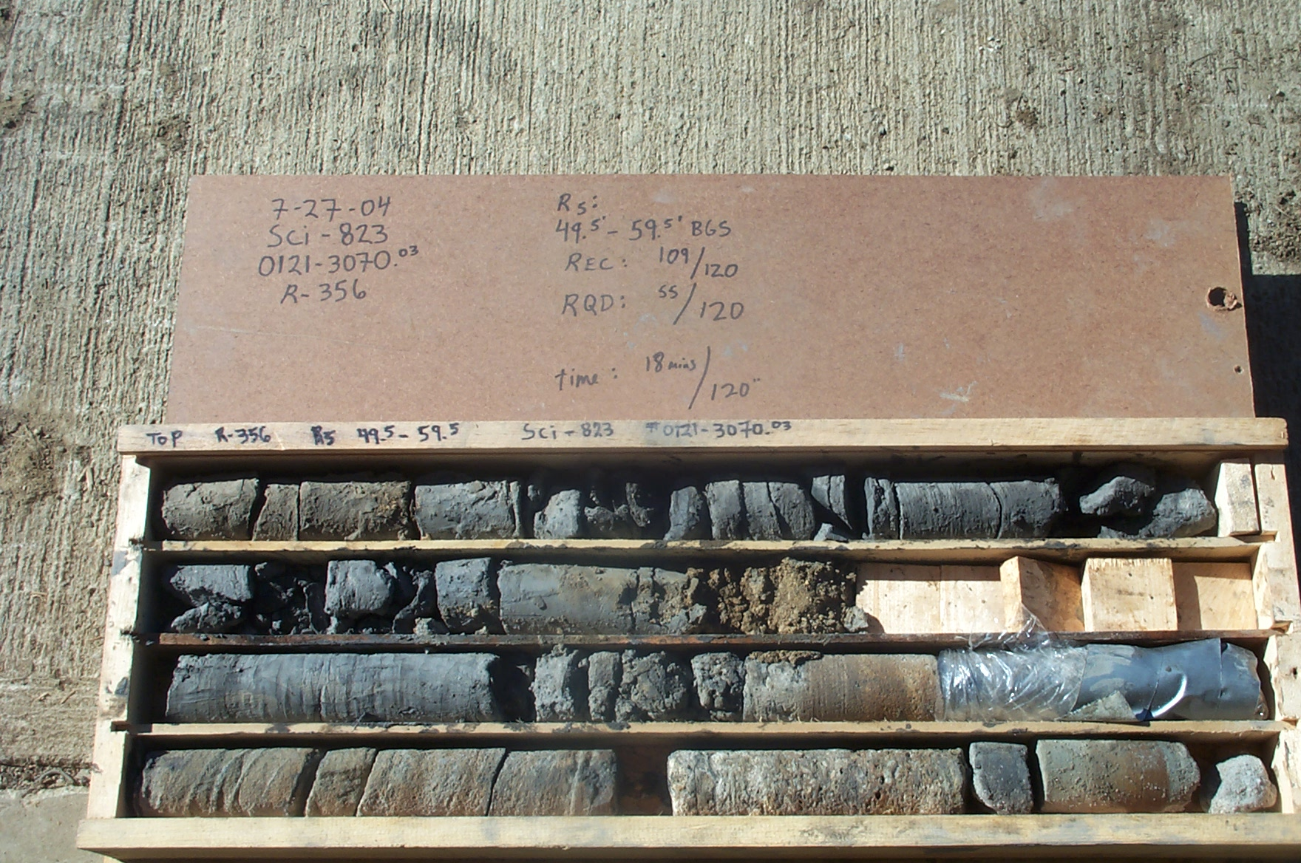
Photo 10. C:\portsmouthcore\R-356\R5-14shp.JPG

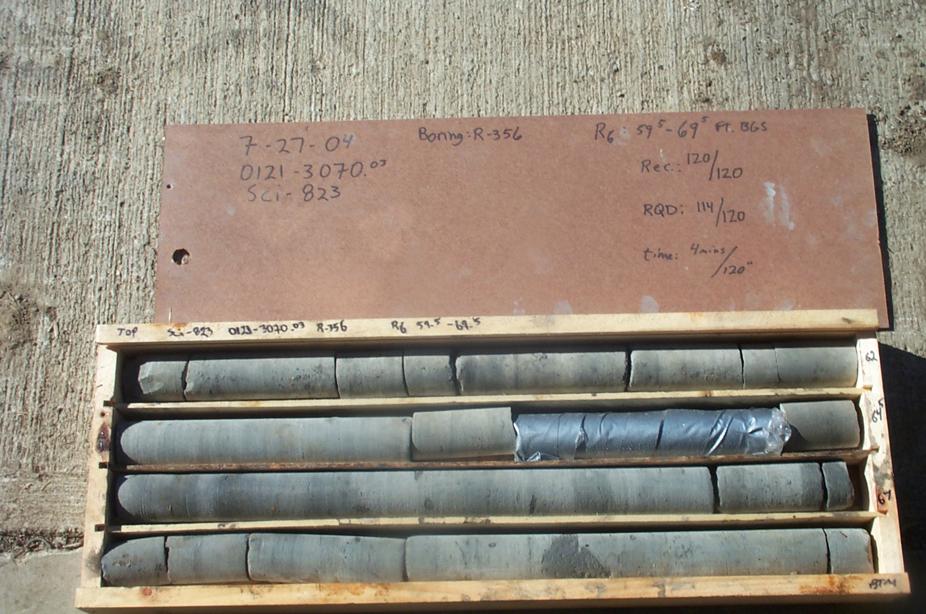
Photo 11. C:\portsmouthcore\R-356\R6-14shp.JPG

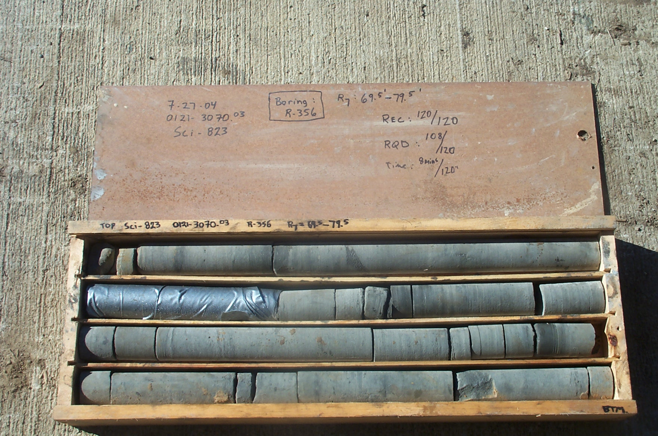
Photo 12. C:\portsmouthcore\R-356\R7-14shp.JPG

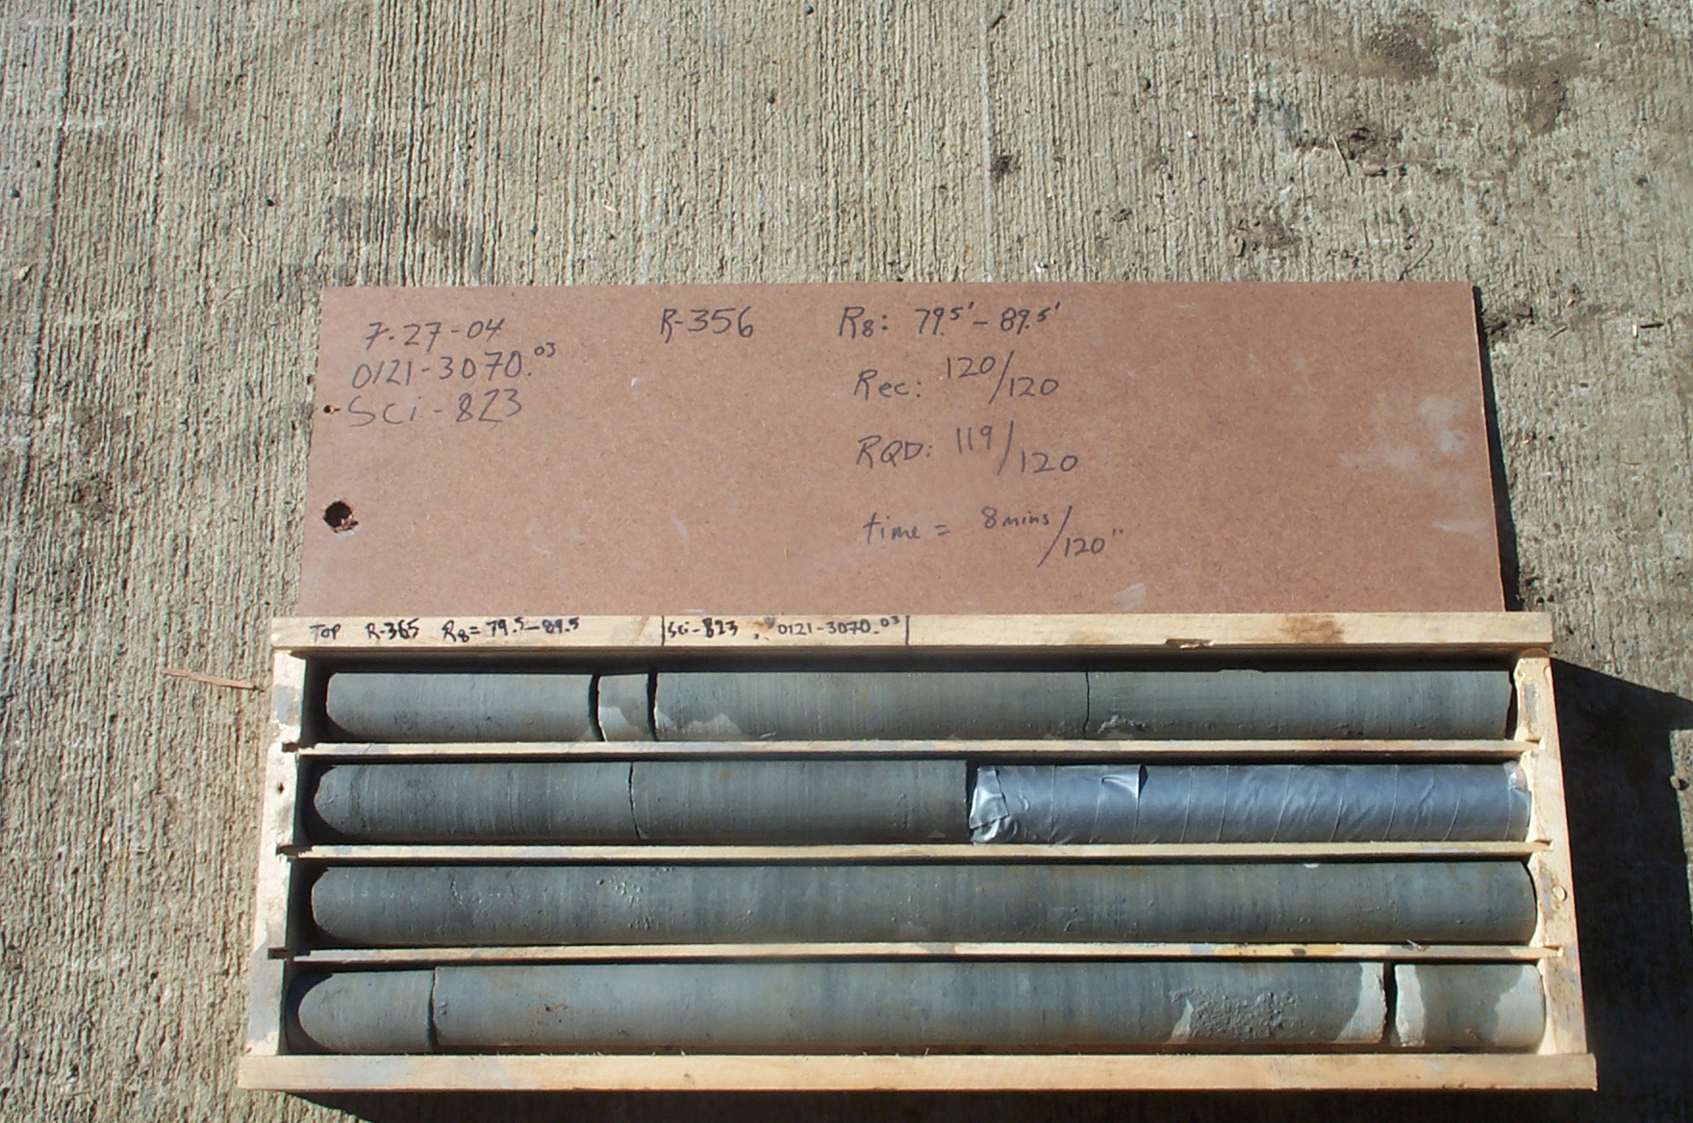
Photo 13. C:\portsmouthcore\R-356\R8-14shp.JPG

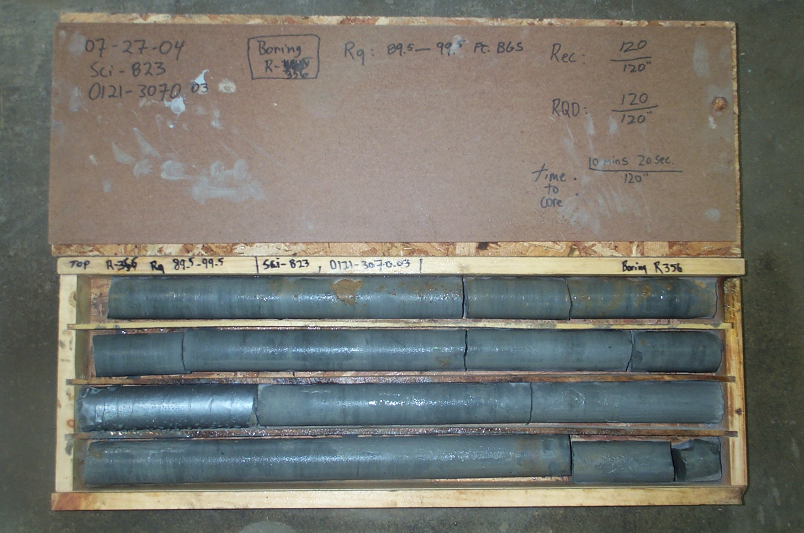
Photo 14. C:\portsmouthcore\R-356\R9-14shp.JPG

