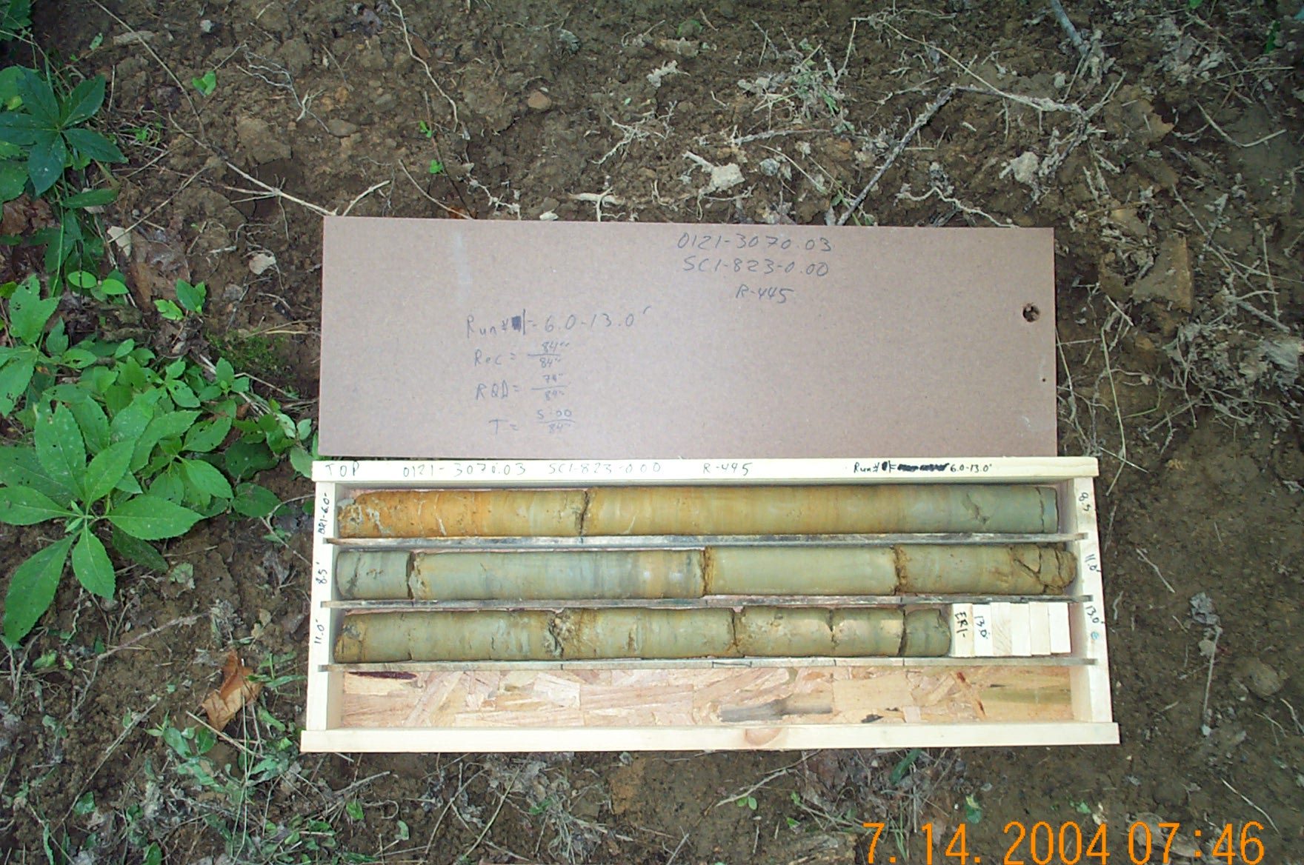
Photo 1. M:\proj\0121\3070.03\Core Photos\R-445\Rock Core Photos\R1-4fld.JPG

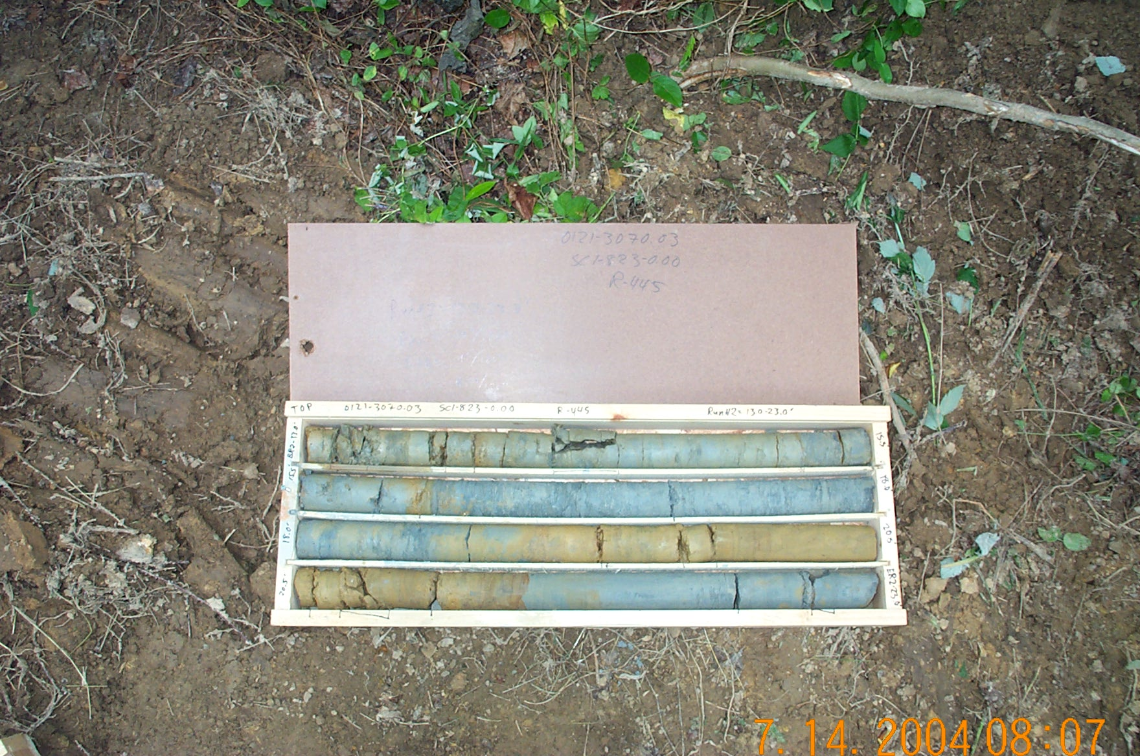
Photo 2. M:\proj\0121\3070.03\Core Photos\R-445\Rock Core Photos\R2-4fld.JPG

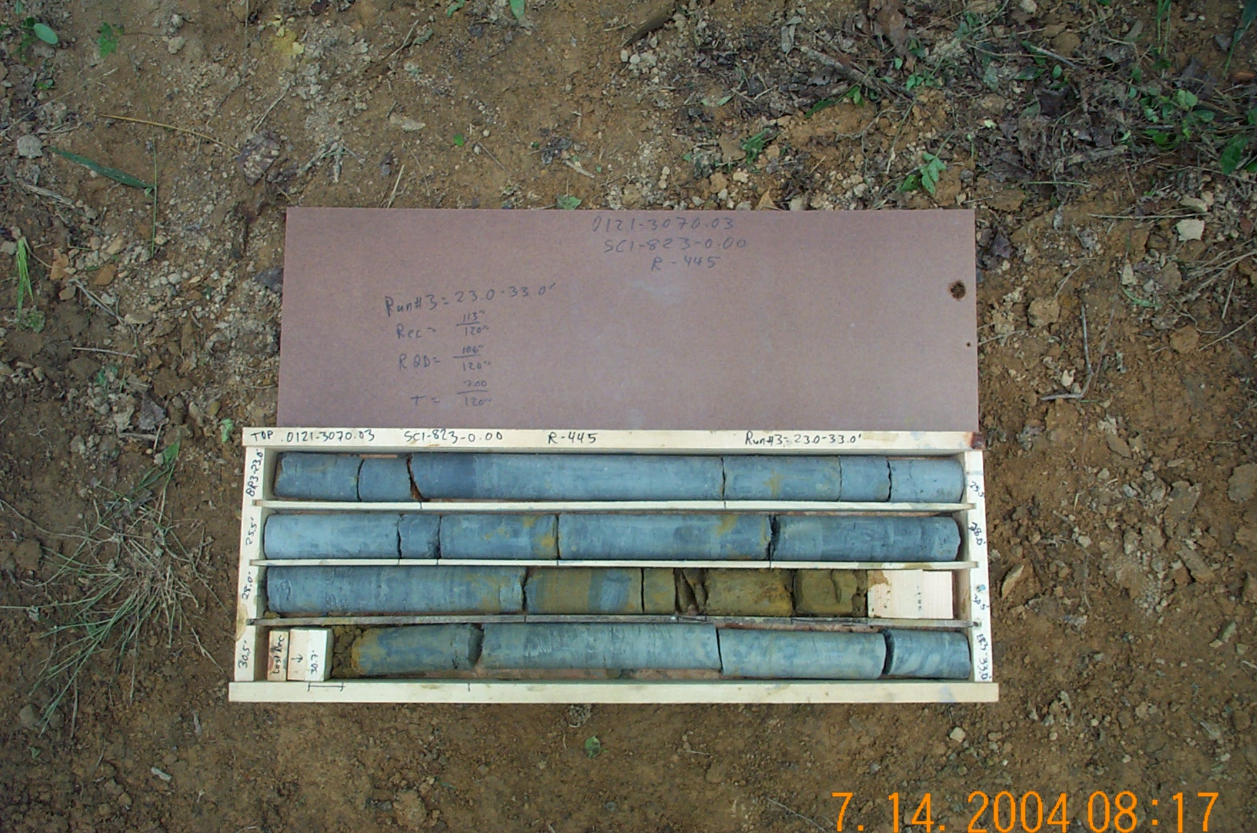
Photo 3. M:\proj\0121\3070.03\Core Photos\R-445\Rock Core Photos\R3-4fld.JPG

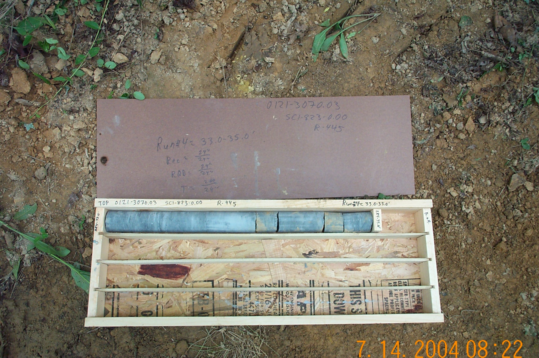
Photo 4. M:\proj\0121\3070.03\Core Photos\R-445\Rock Core Photos\R4-4fld.JPG

