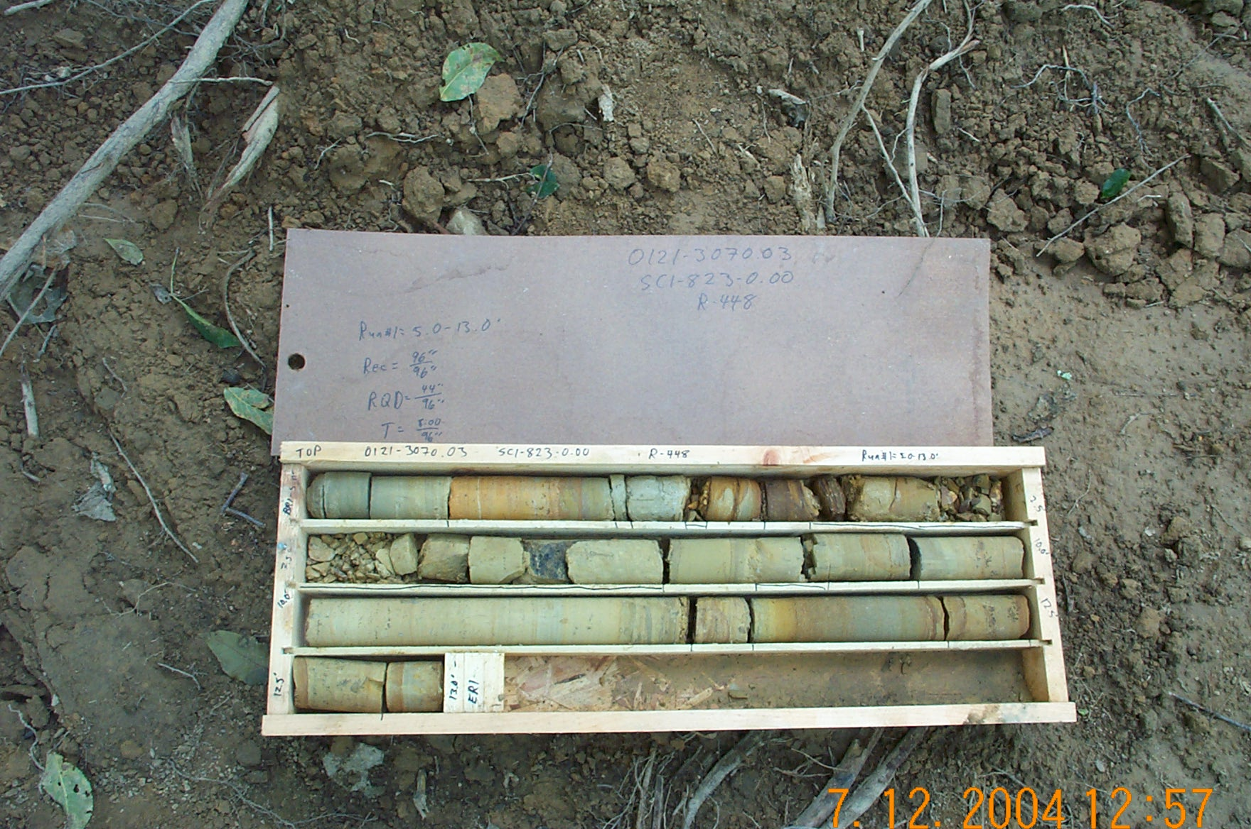
Photo 1. M:\proj\0121\3070.03\Core Photos\R-448\Rock Core Photos\R01-13fld.JPG

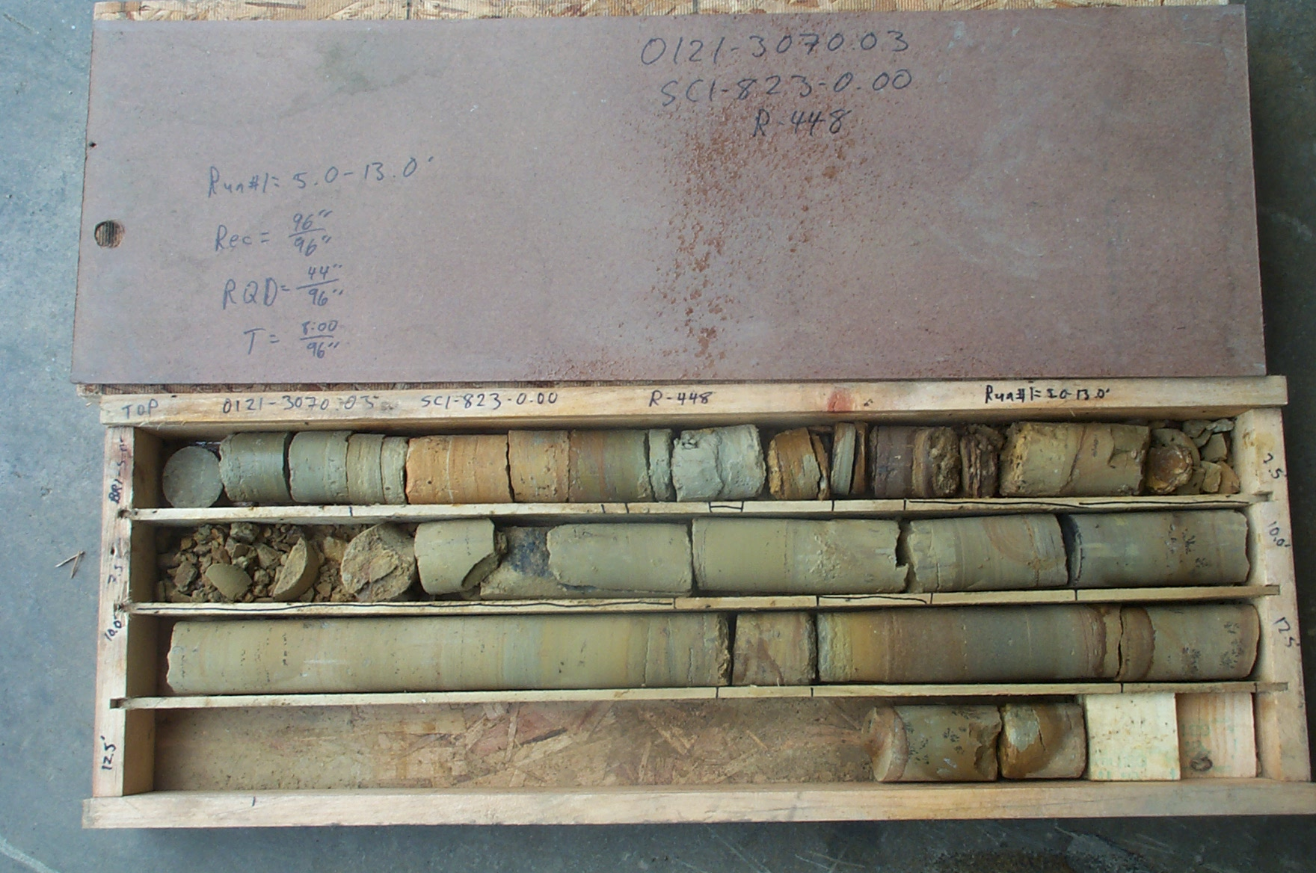
Photo 2. M:\proj\0121\3070.03\Core Photos\R-448\Rock Core Photos\R01-13shp.JPG

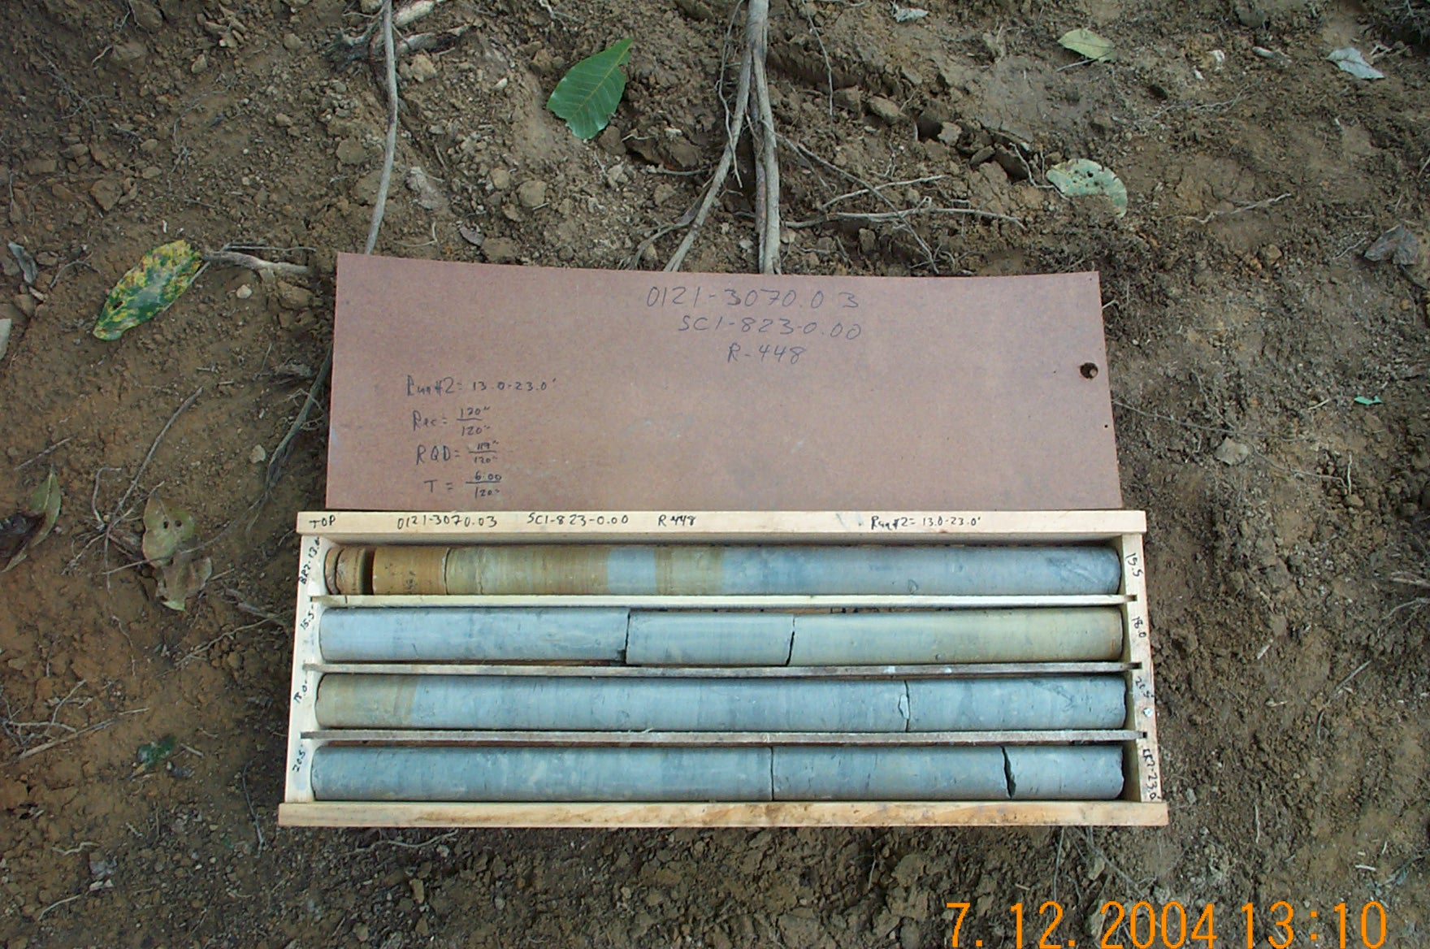
Photo 3. M:\proj\0121\3070.03\Core Photos\R-448\Rock Core Photos\R02-13fld.JPG

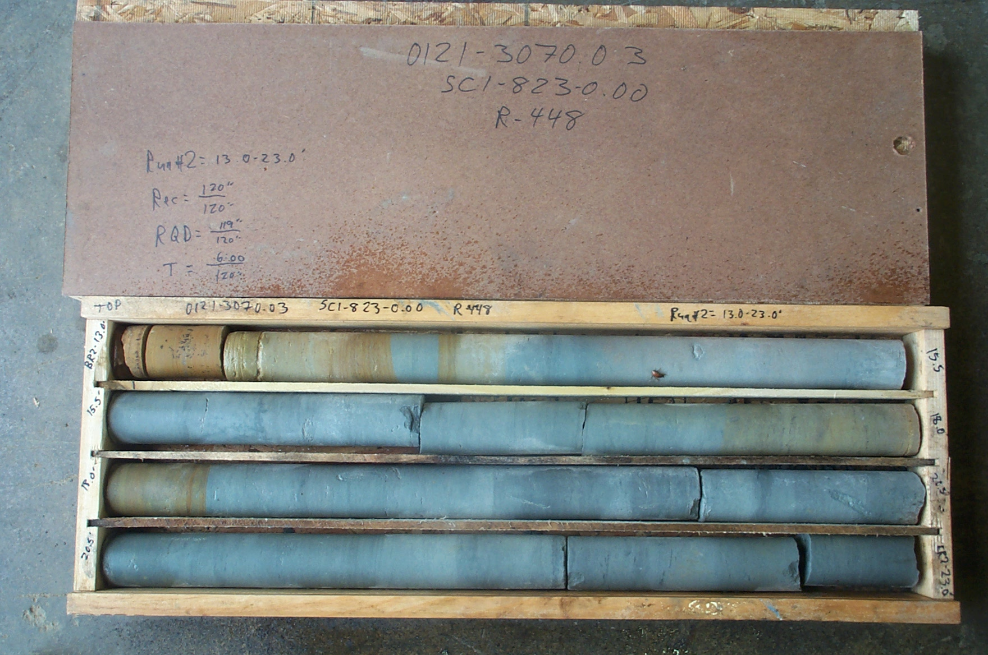
Photo 4. M:\proj\0121\3070.03\Core Photos\R-448\Rock Core Photos\R02-13shp.JPG

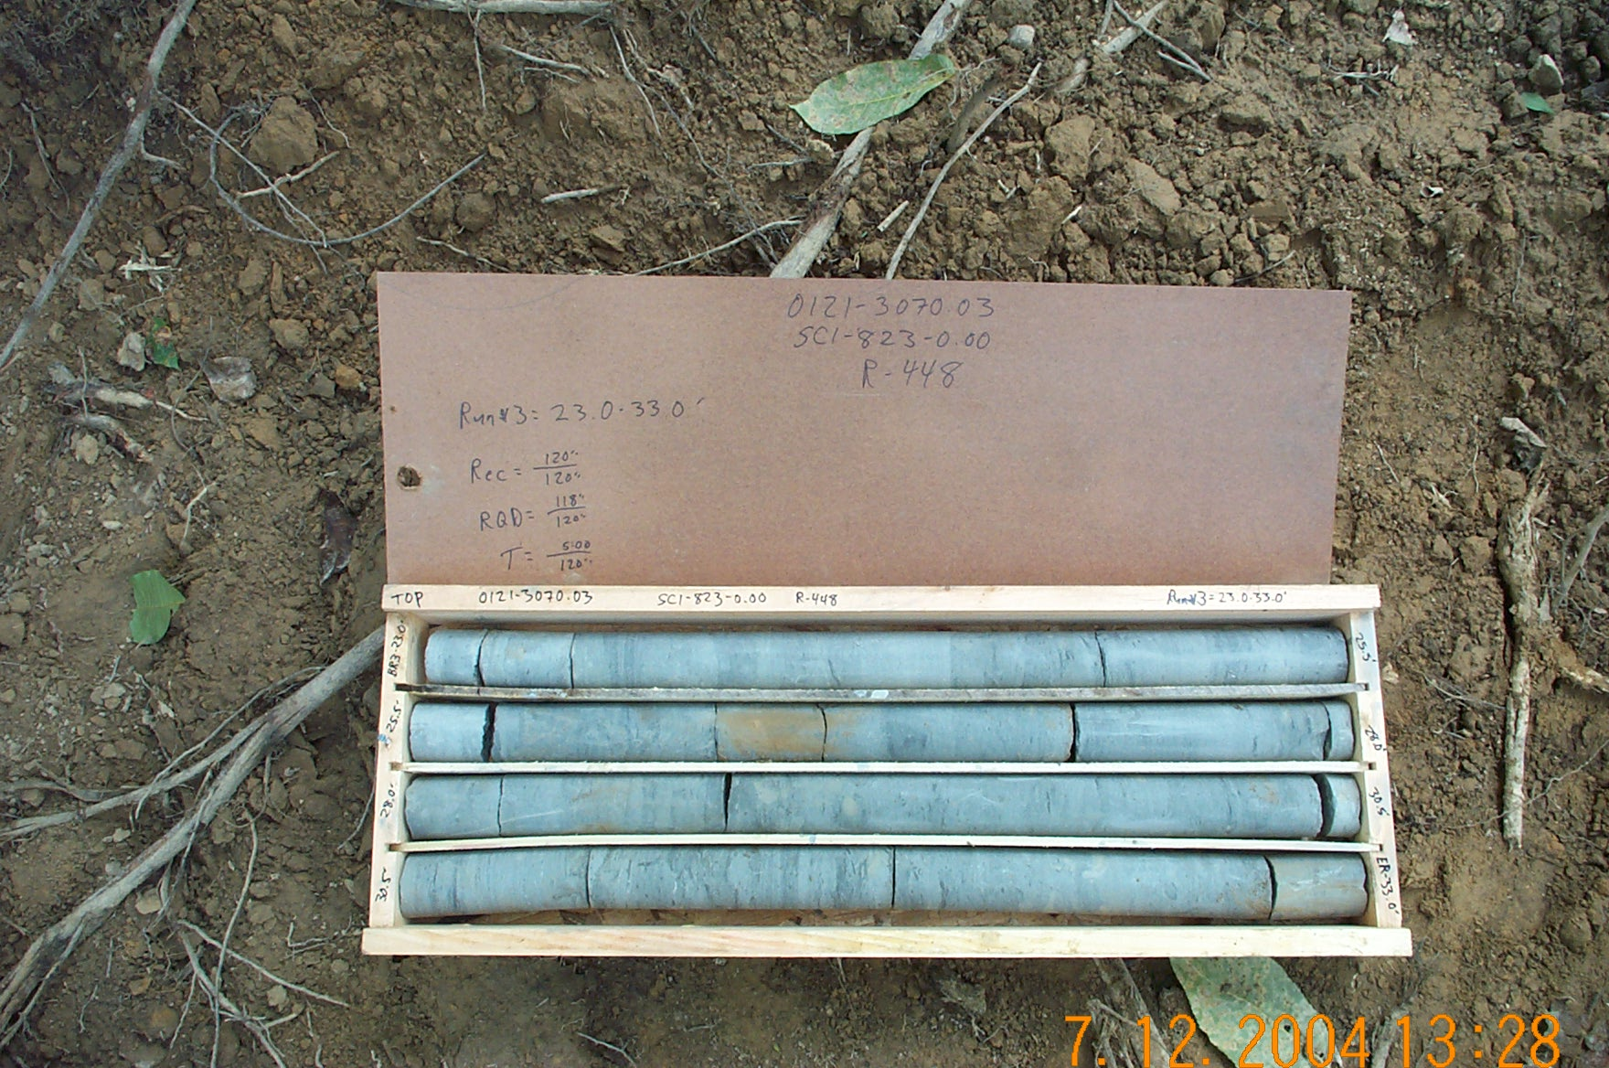
Photo 5. M:\proj\0121\3070.03\Core Photos\R-448\Rock Core Photos\R03-13fld.JPG

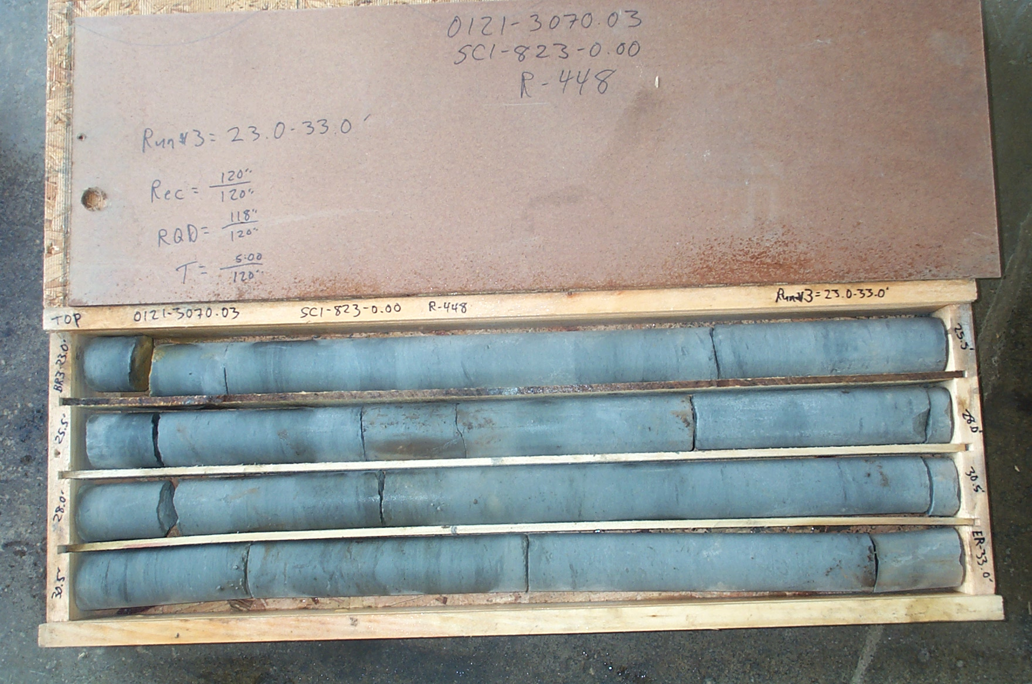
Photo 6. M:\proj\0121\3070.03\Core Photos\R-448\Rock Core Photos\R03-13shp.JPG

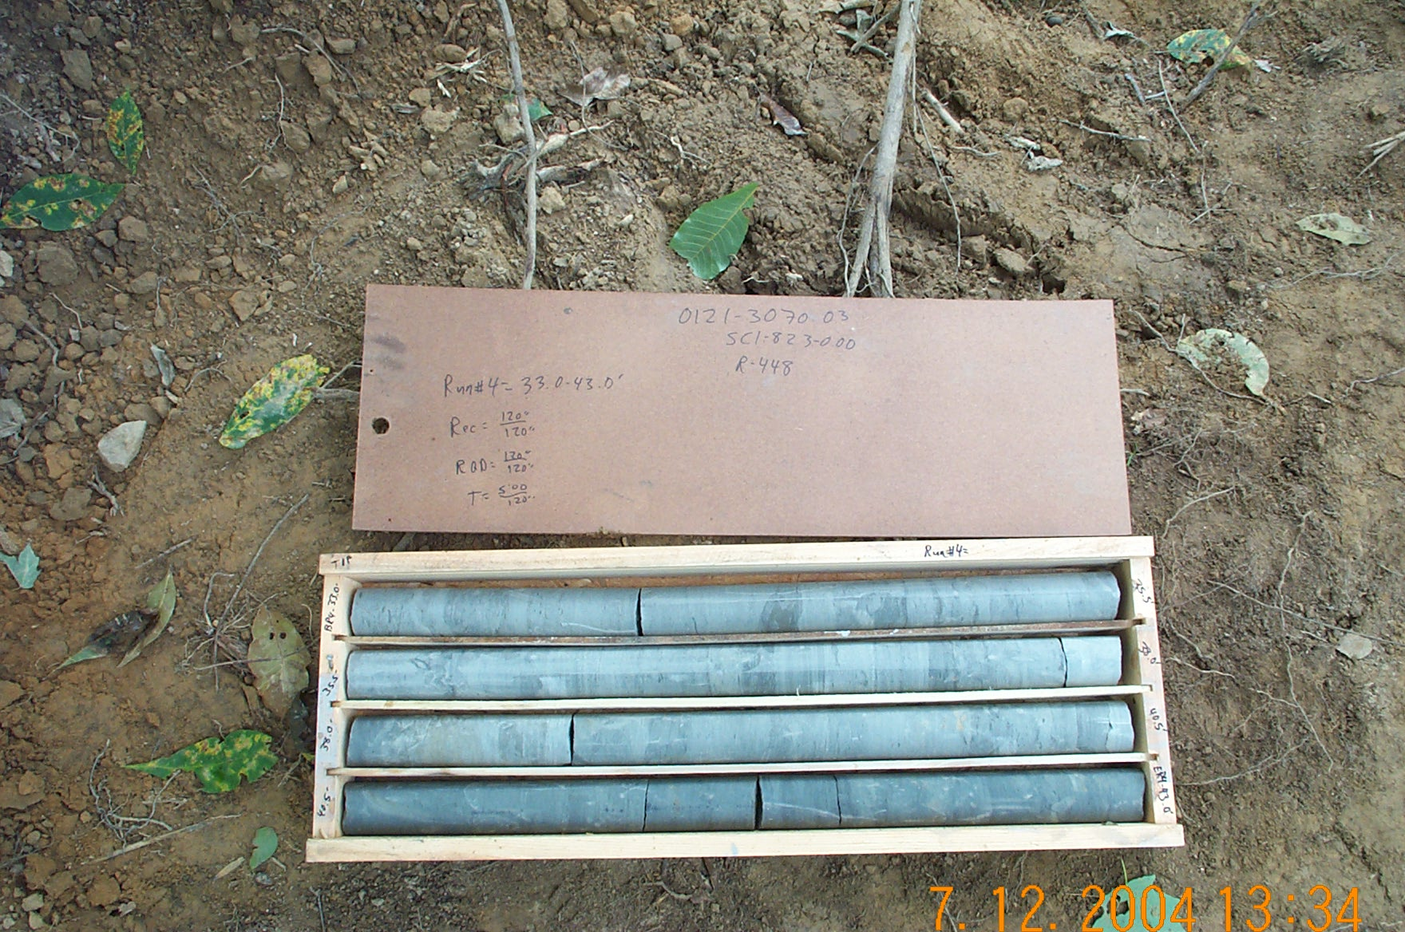
Photo 7. M:\proj\0121\3070.03\Core Photos\R-448\Rock Core Photos\R04-13fld.JPG

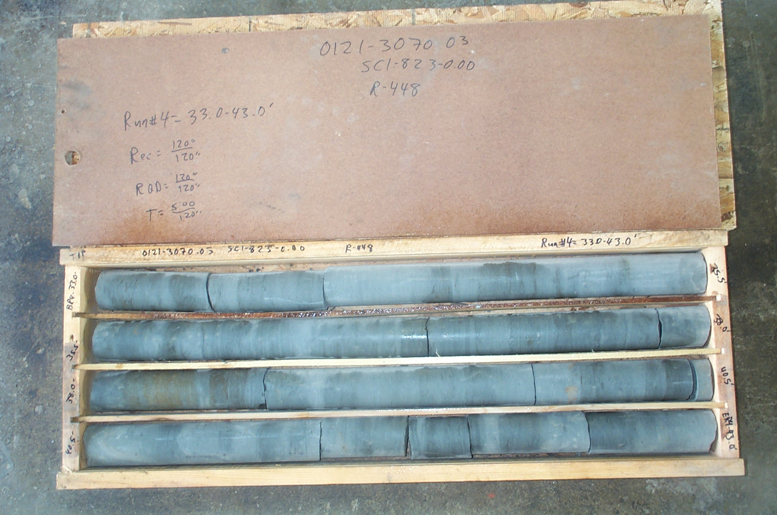
Photo 8. M:\proj\0121\3070.03\Core Photos\R-448\Rock Core Photos\R04-13shp.JPG

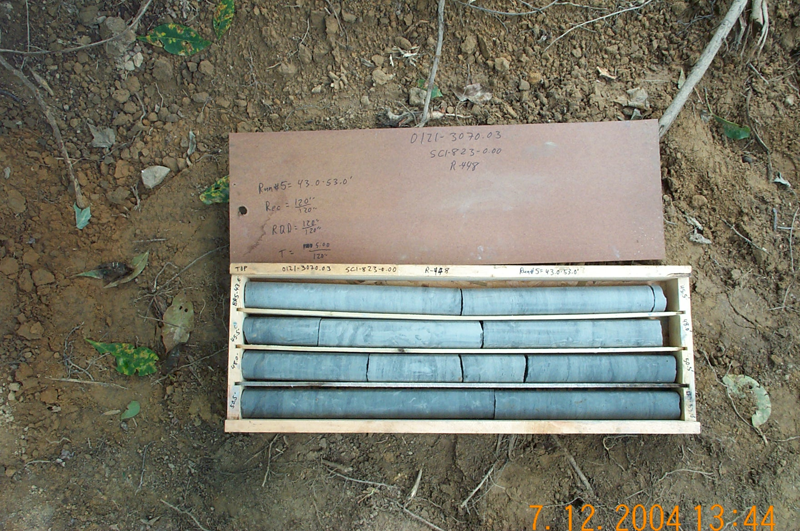
Photo 9. M:\proj\0121\3070.03\Core Photos\R-448\Rock Core Photos\R05-13fld.JPG

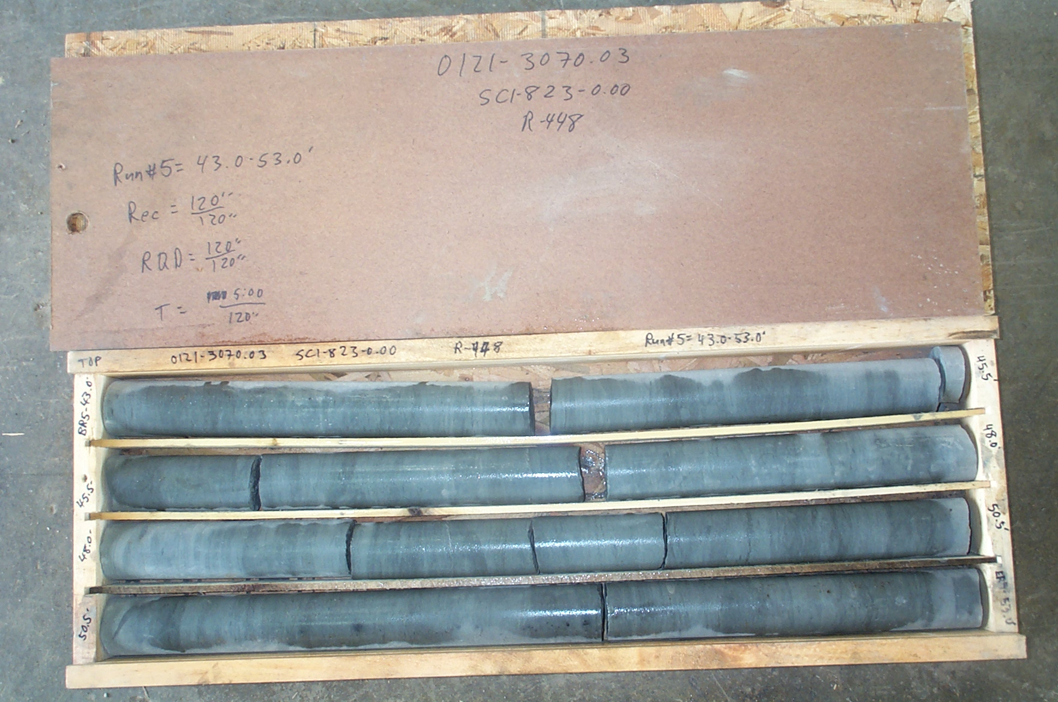
Photo 10. M:\proj\0121\3070.03\Core Photos\R-448\Rock Core Photos\R05-13shp.JPG

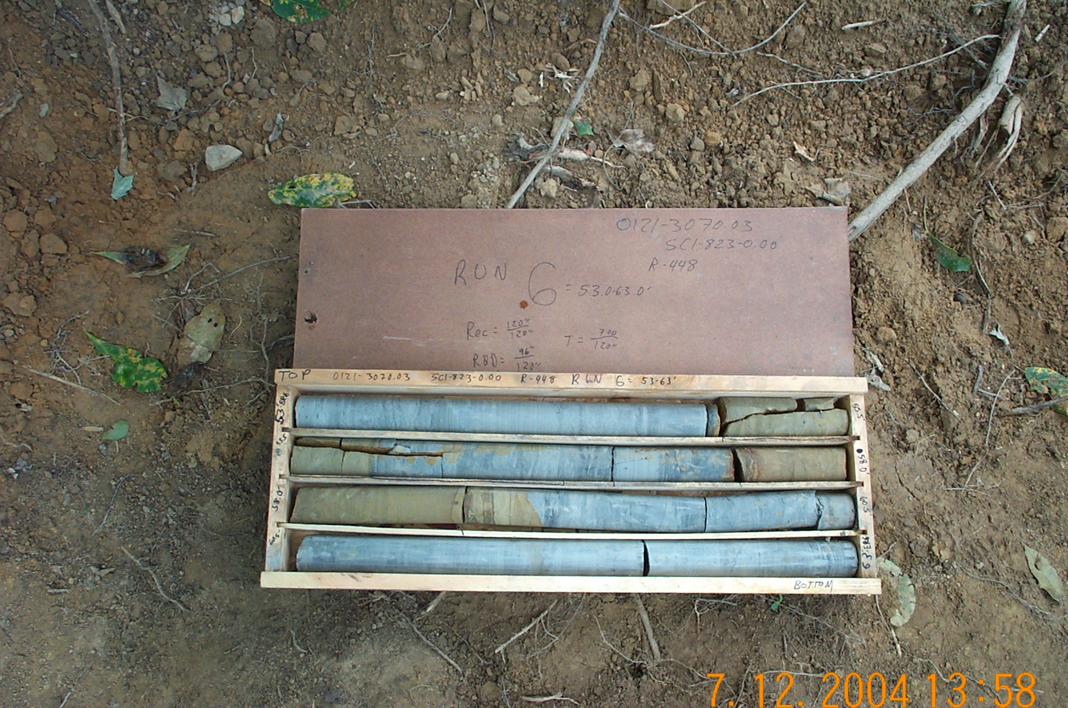
Photo 11. M:\proj\0121\3070.03\Core Photos\R-448\Rock Core Photos\R06-13fld.JPG

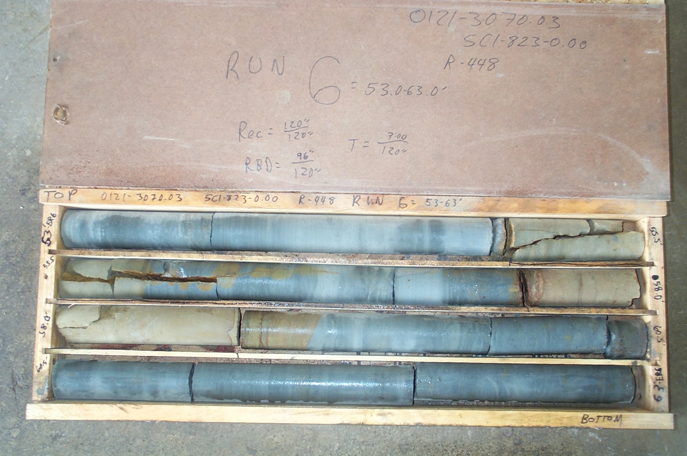
Photo 12. M:\proj\0121\3070.03\Core Photos\R-448\Rock Core Photos\R06-13shp.JPG

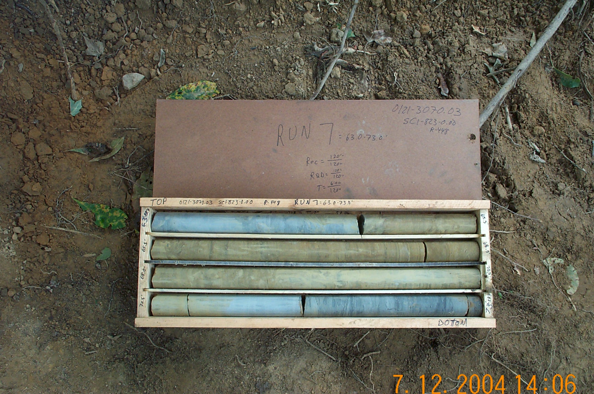
Photo 13. M:\proj\0121\3070.03\Core Photos\R-448\Rock Core Photos\R07-13fld.JPG

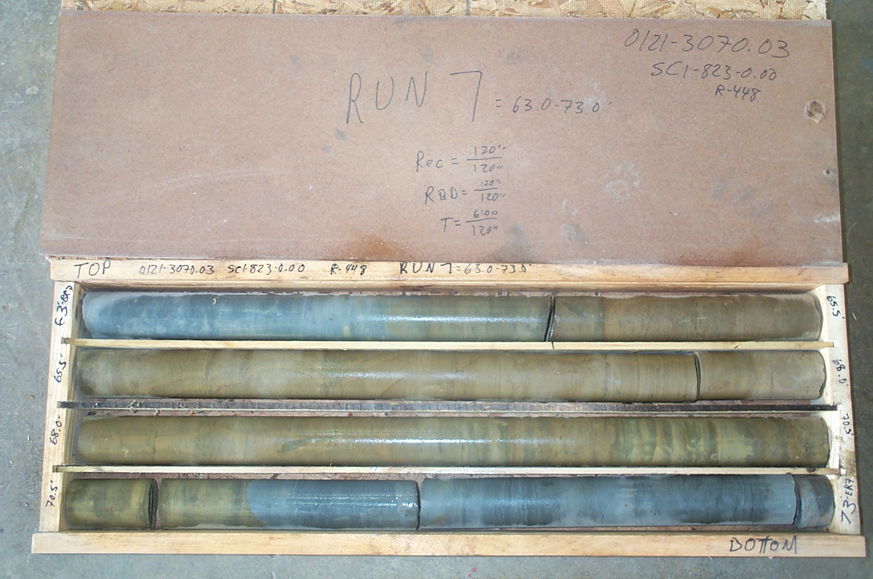
Photo 14. M:\proj\0121\3070.03\Core Photos\R-448\Rock Core Photos\R07-13shp.JPG

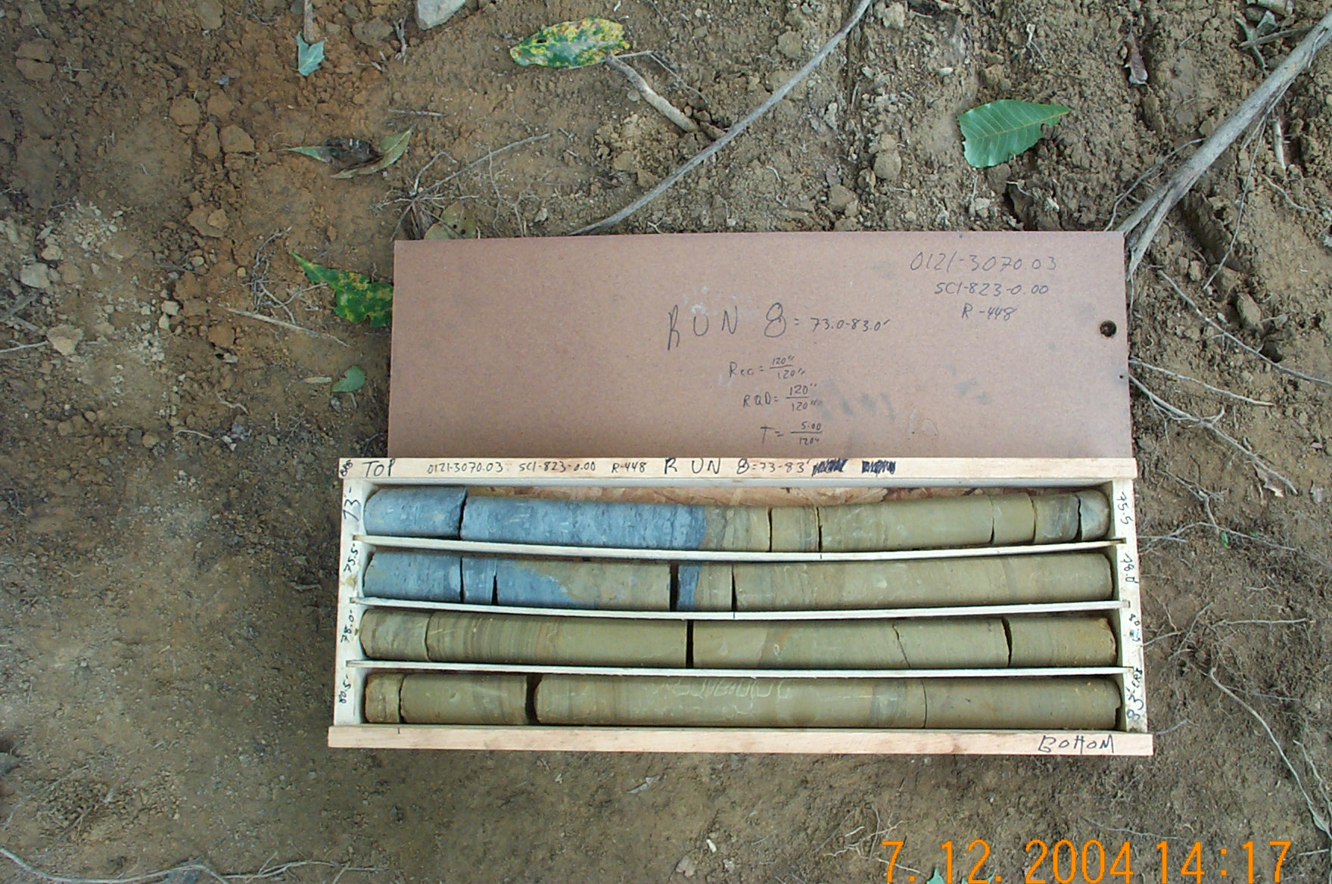
Photo 15. M:\proj\0121\3070.03\Core Photos\R-448\Rock Core Photos\R08-13fld.JPG

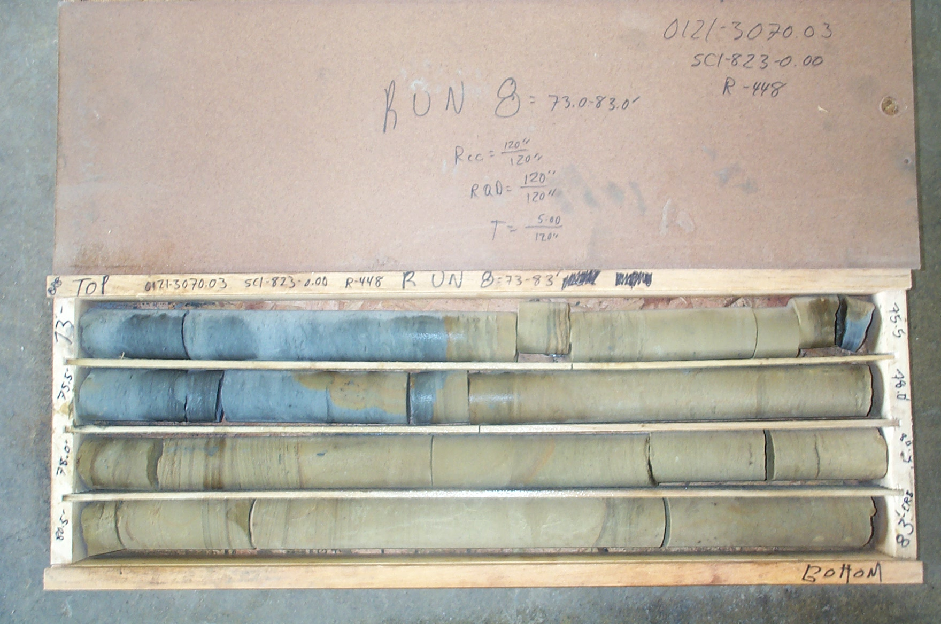
Photo 16. M:\proj\0121\3070.03\Core Photos\R-448\Rock Core Photos\R08-13shp.JPG

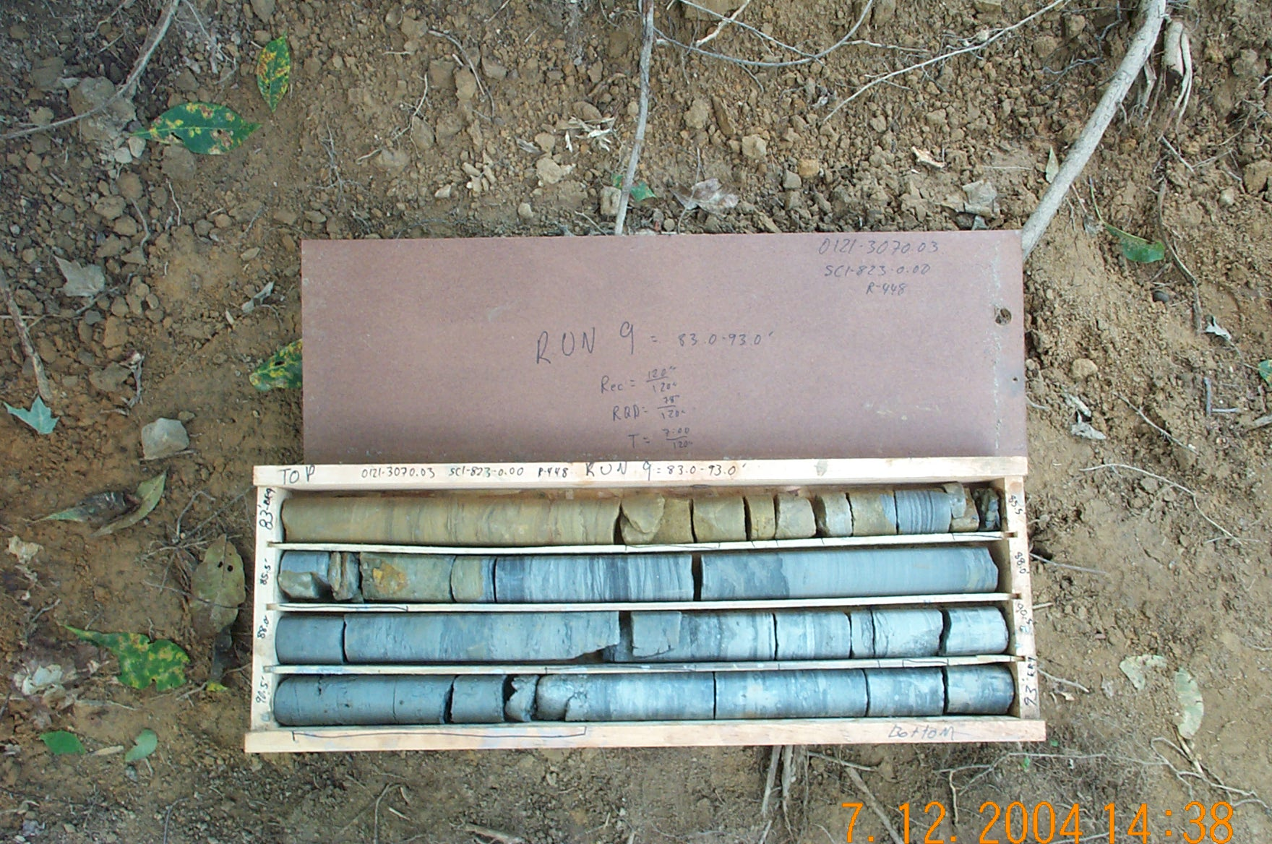
Photo 17. M:\proj\0121\3070.03\Core Photos\R-448\Rock Core Photos\R09-13fld.JPG

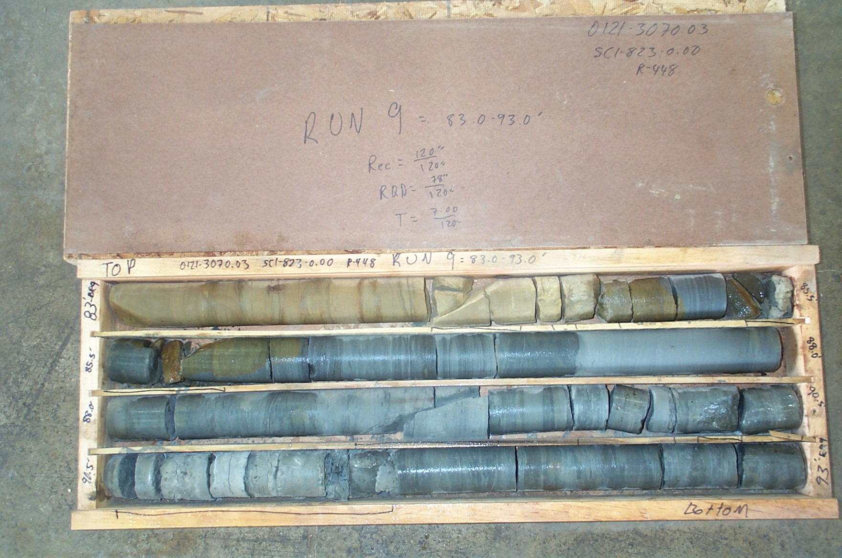
Photo 18. M:\proj\0121\3070.03\Core Photos\R-448\Rock Core Photos\R09-13shp.JPG

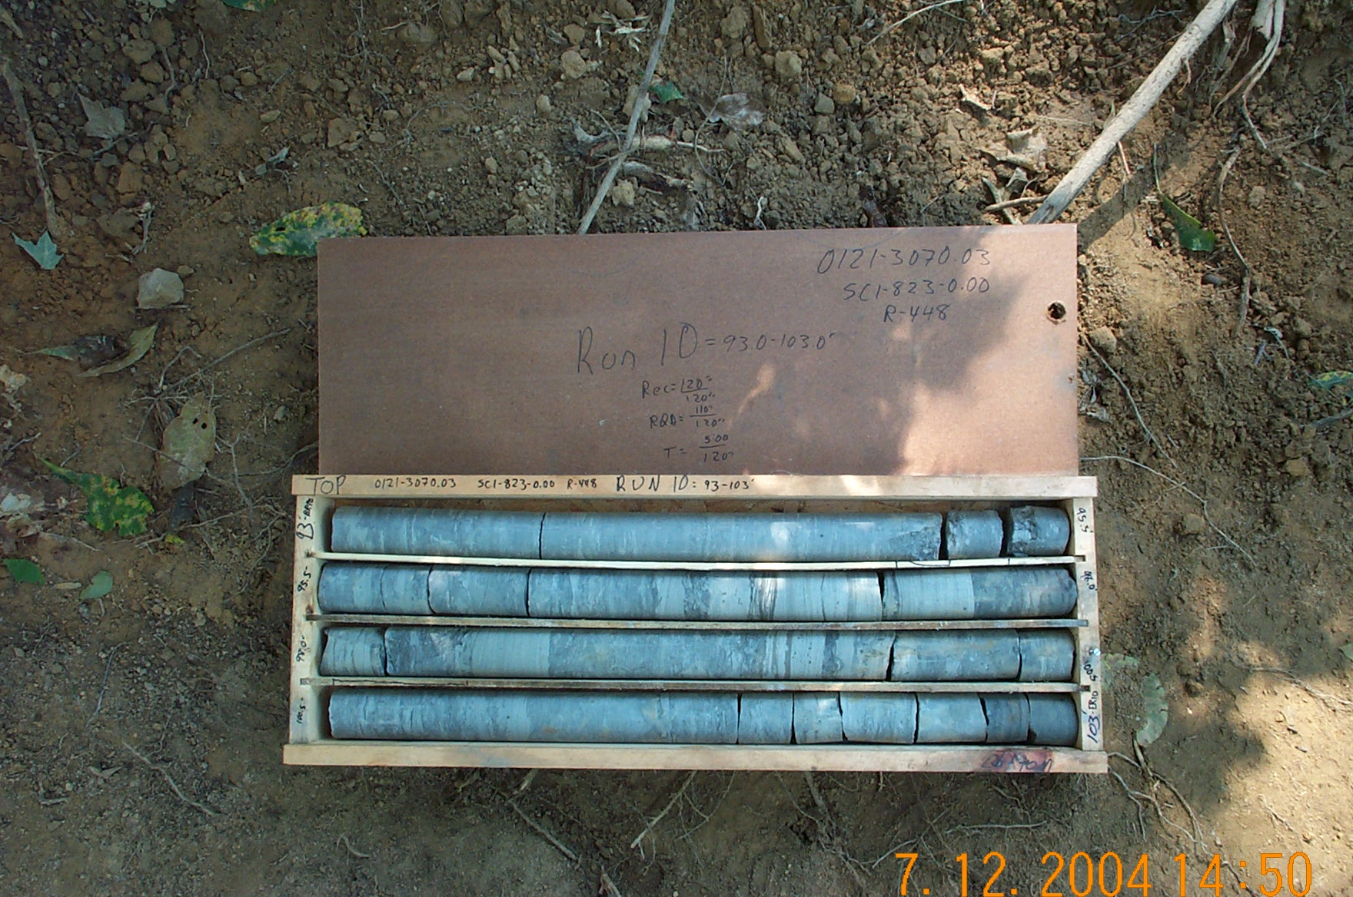
Photo 19. M:\proj\0121\3070.03\Core Photos\R-448\Rock Core Photos\R10-13fld.JPG

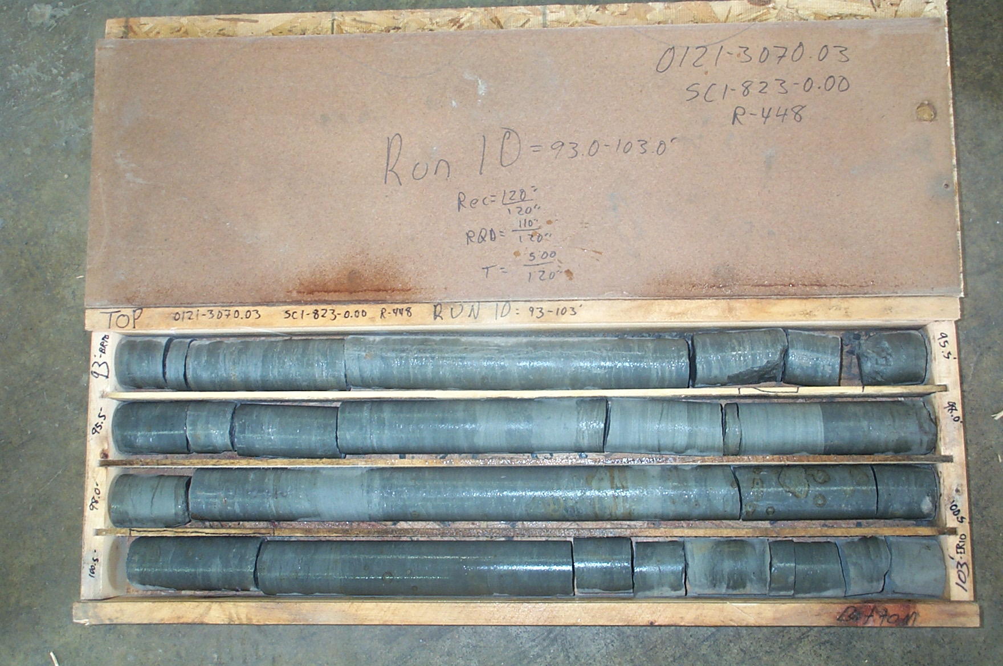
Photo 20. M:\proj\0121\3070.03\Core Photos\R-448\Rock Core Photos\R10-13shp.JPG

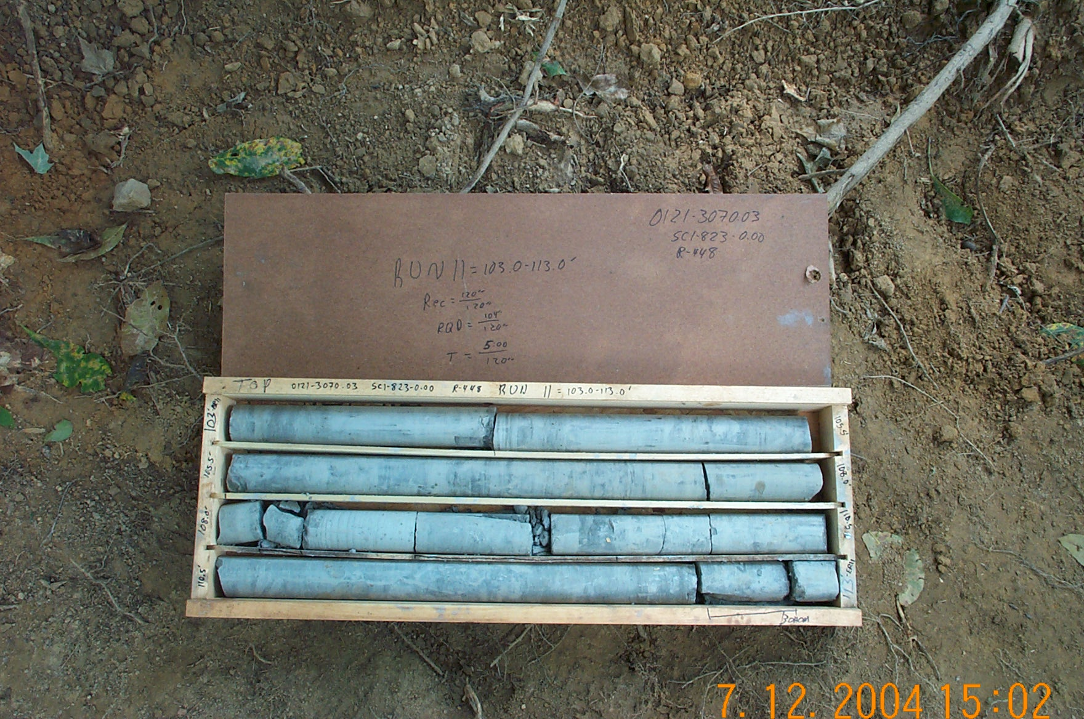
Photo 21. M:\proj\0121\3070.03\Core Photos\R-448\Rock Core Photos\R11-13fld.JPG

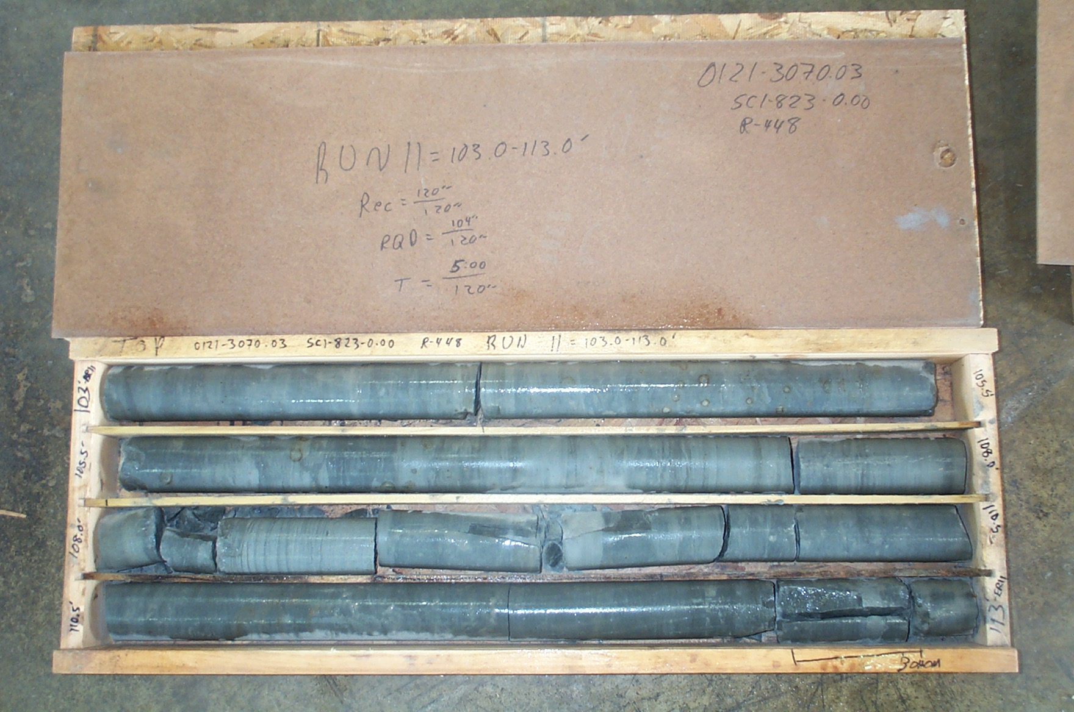
Photo 22. M:\proj\0121\3070.03\Core Photos\R-448\Rock Core Photos\R11-13shp.JPG

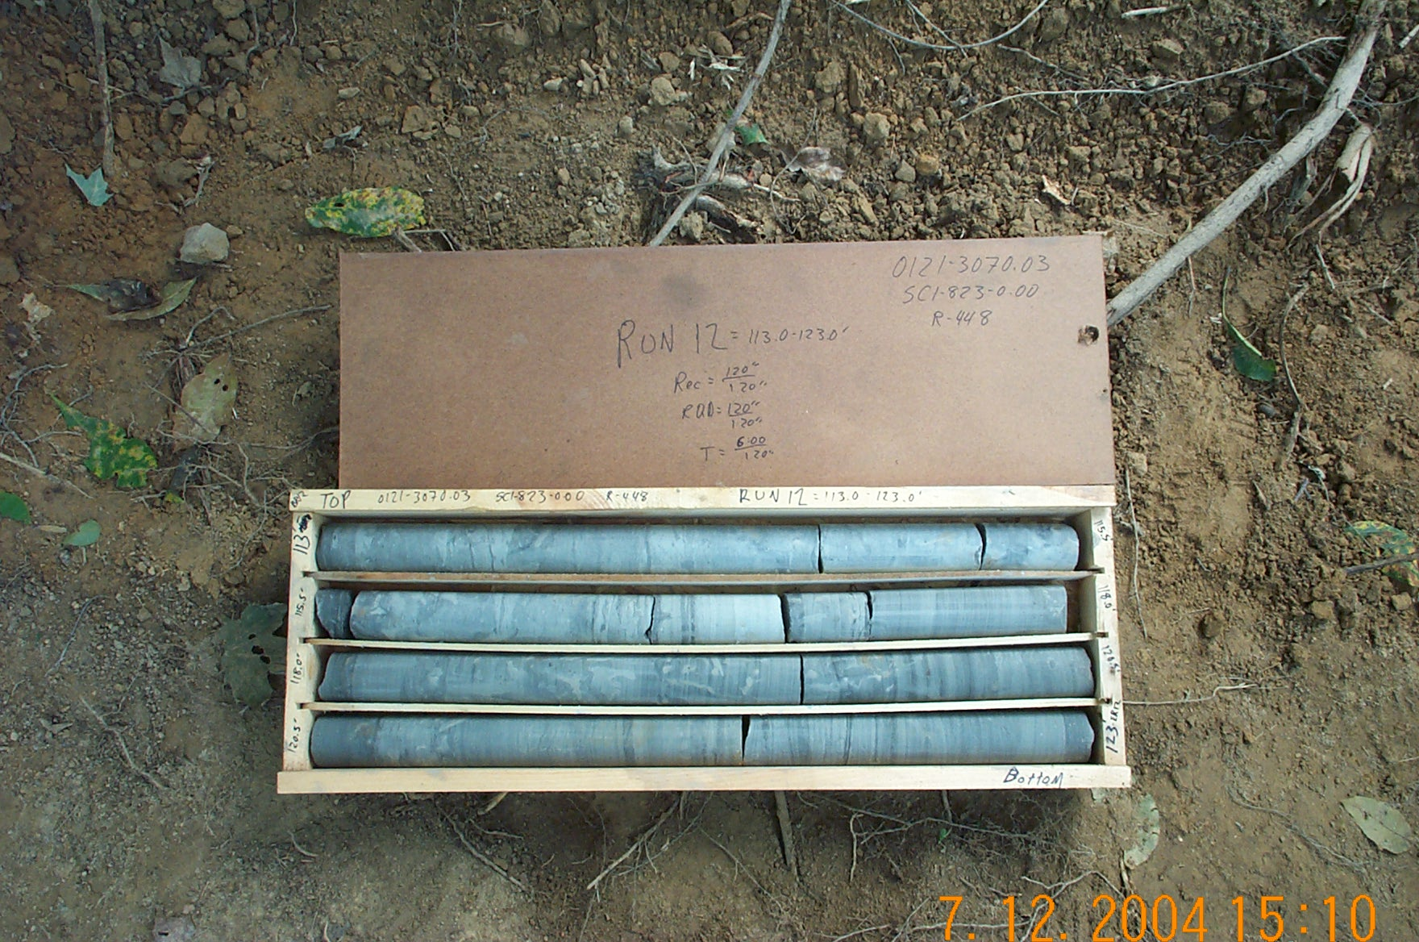
Photo 23. M:\proj\0121\3070.03\Core Photos\R-448\Rock Core Photos\R12-13fld.JPG

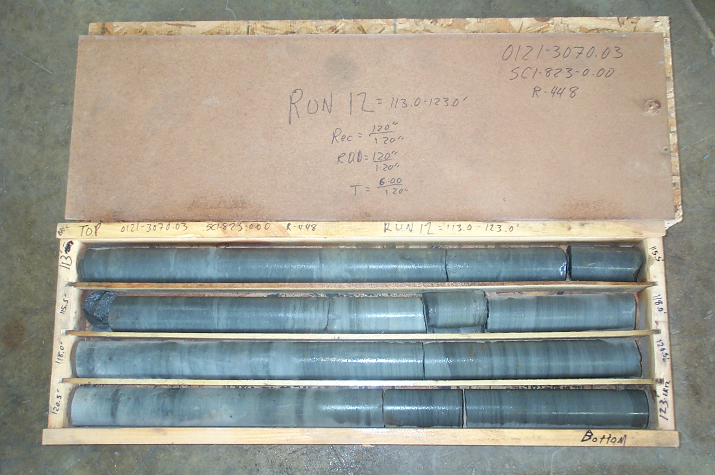
Photo 24. M:\proj\0121\3070.03\Core Photos\R-448\Rock Core Photos\R12-13shp.JPG

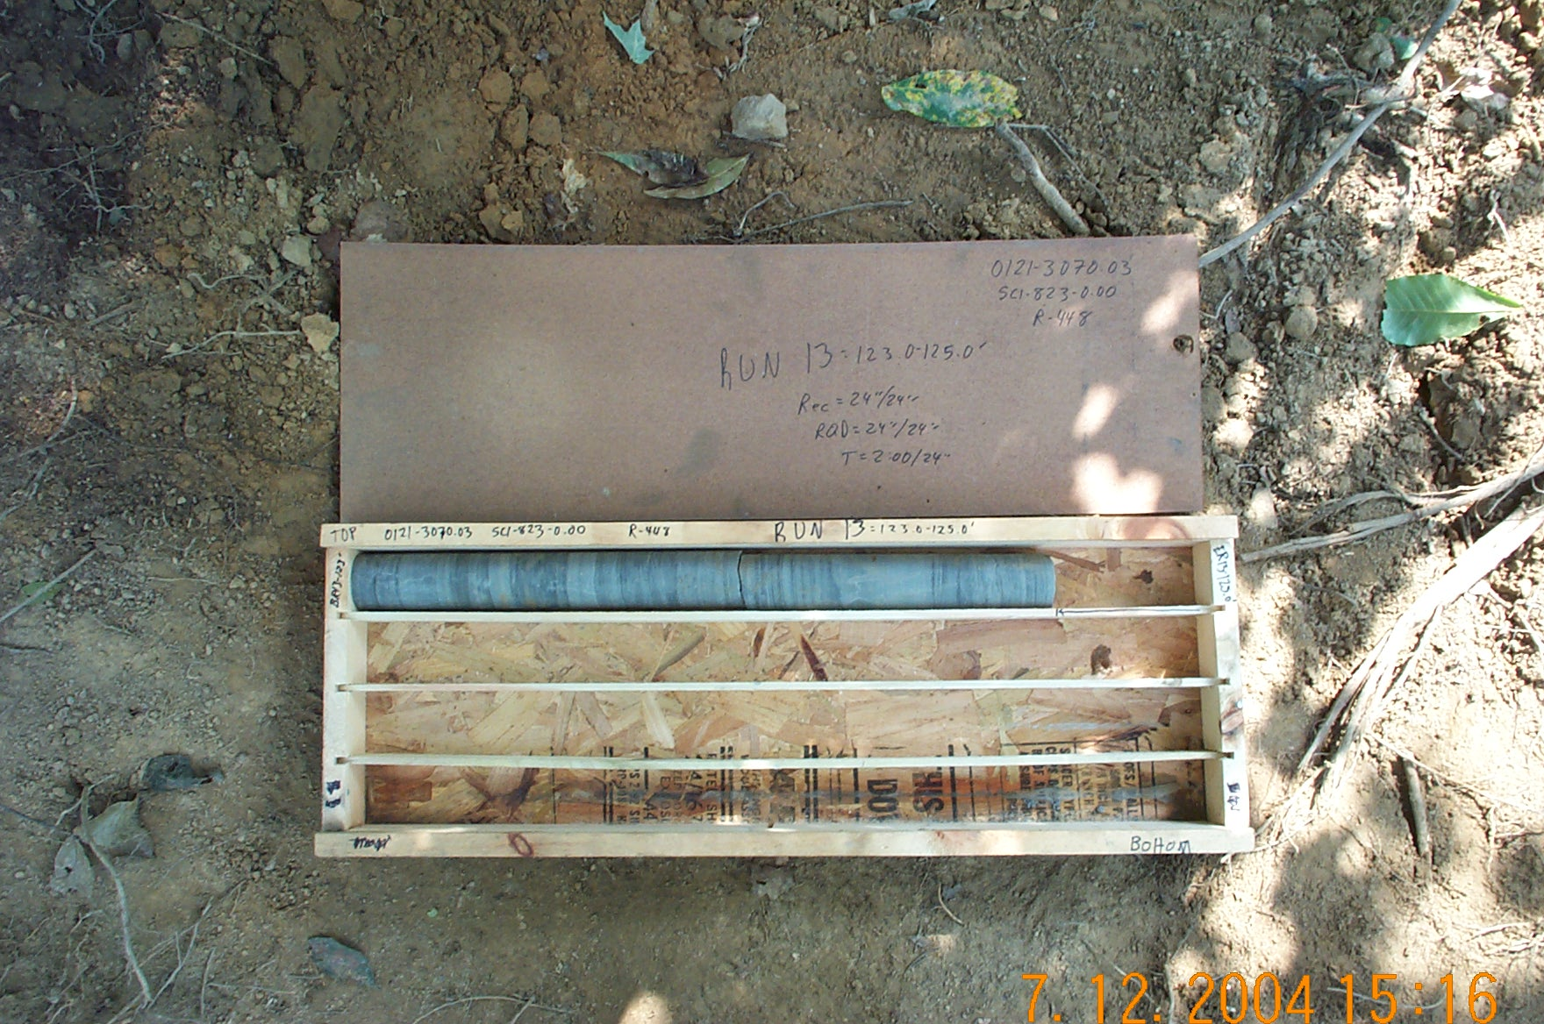
Photo 25. M:\proj\0121\3070.03\Core Photos\R-448\Rock Core Photos\R13-13fld.JPG

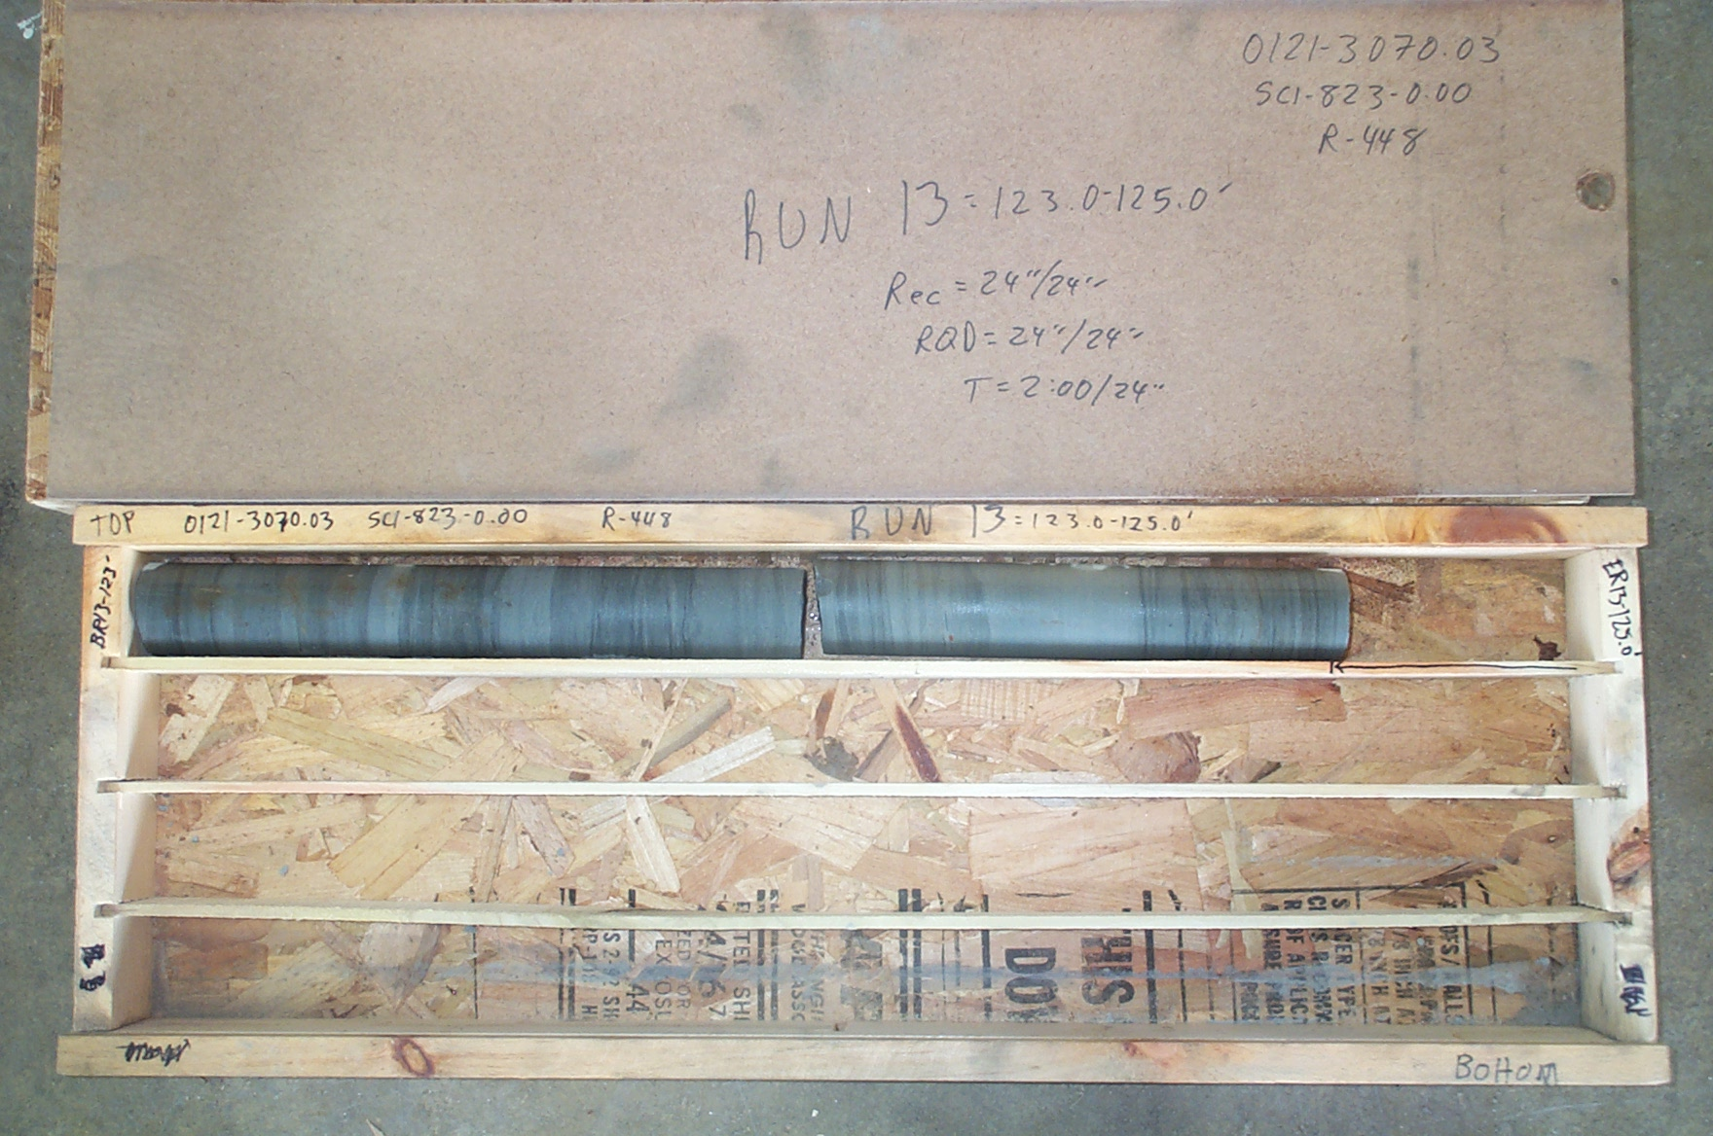
Photo 26. M:\proj\0121\3070.03\Core Photos\R-448\Rock Core Photos\R13-13shp.JPG

