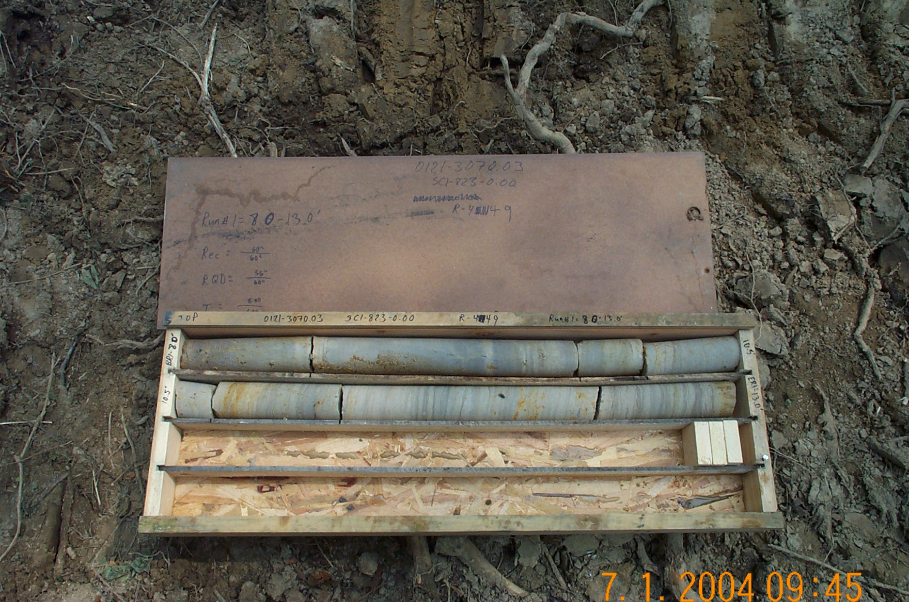
Photo 1. M:\proj\0121\3070.03\Core Photos\R-449\Rock Core\R1-12fld.JPG

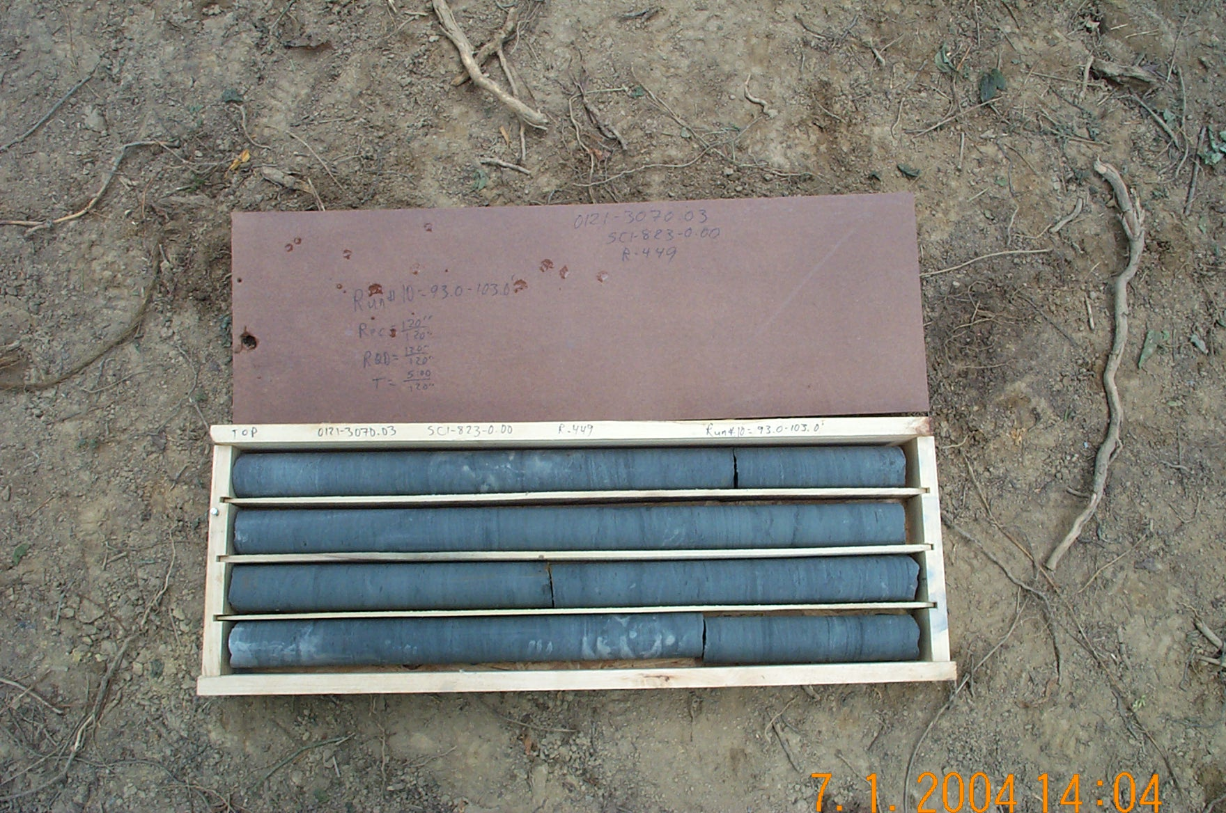
Photo 2. M:\proj\0121\3070.03\Core Photos\R-449\Rock Core\R10-12fld.JPG

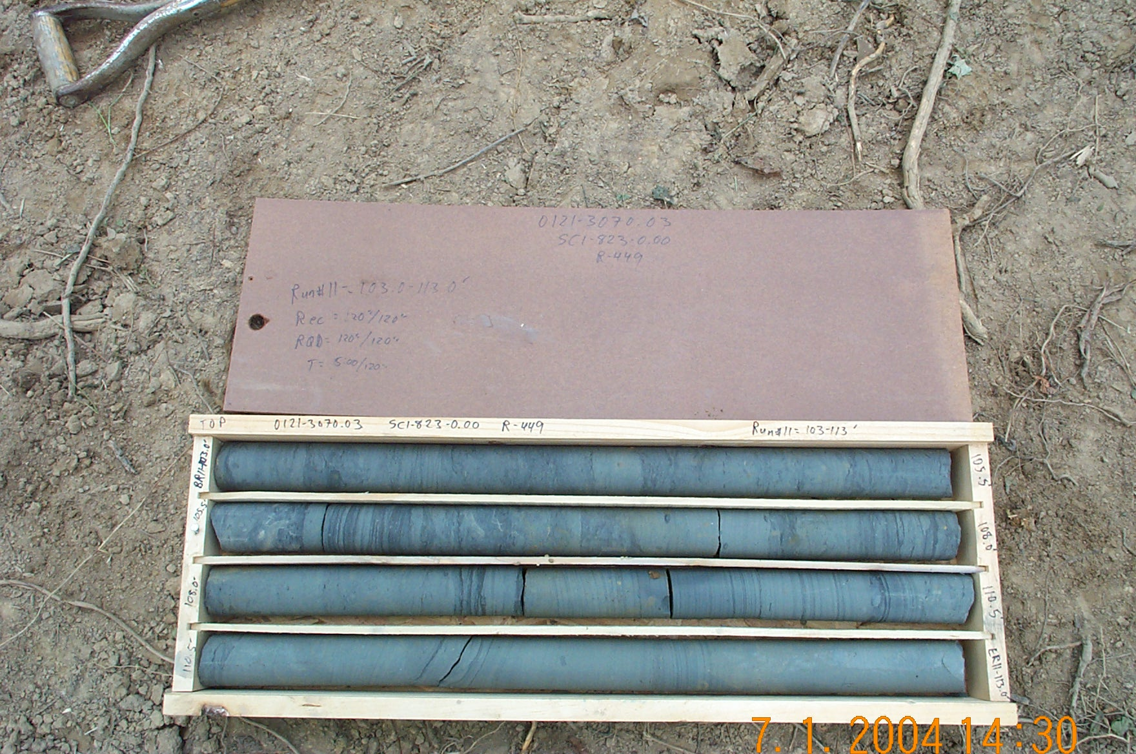
Photo 3. M:\proj\0121\3070.03\Core Photos\R-449\Rock Core\R11-12fld.JPG

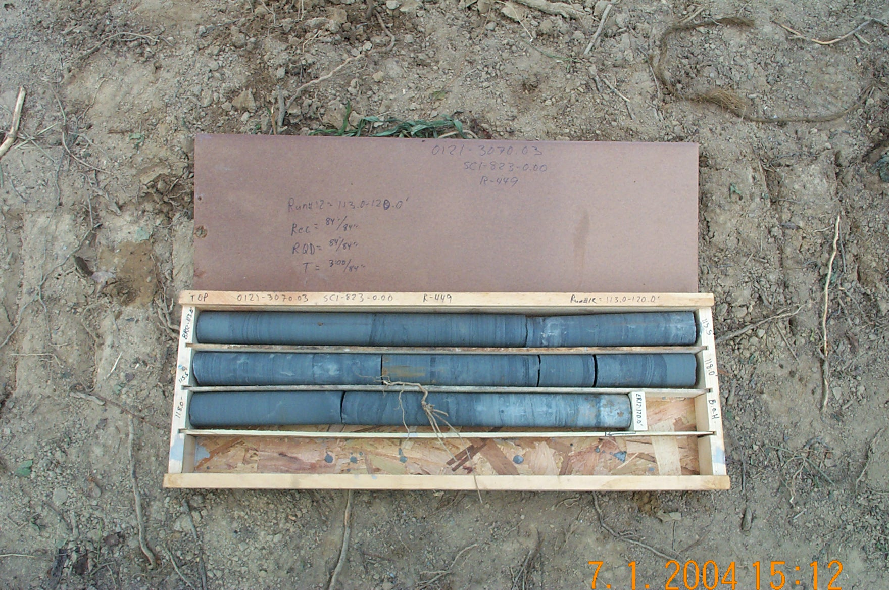
Photo 4. M:\proj\0121\3070.03\Core Photos\R-449\Rock Core\R12-12fld.JPG

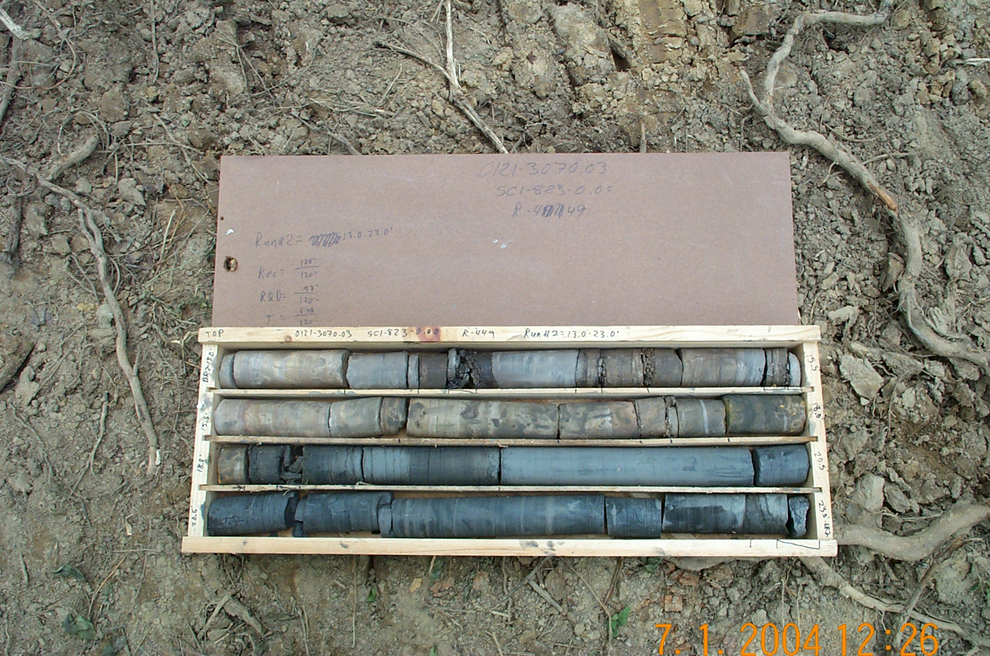
Photo 5. M:\proj\0121\3070.03\Core Photos\R-449\Rock Core\R2-12fld.JPG

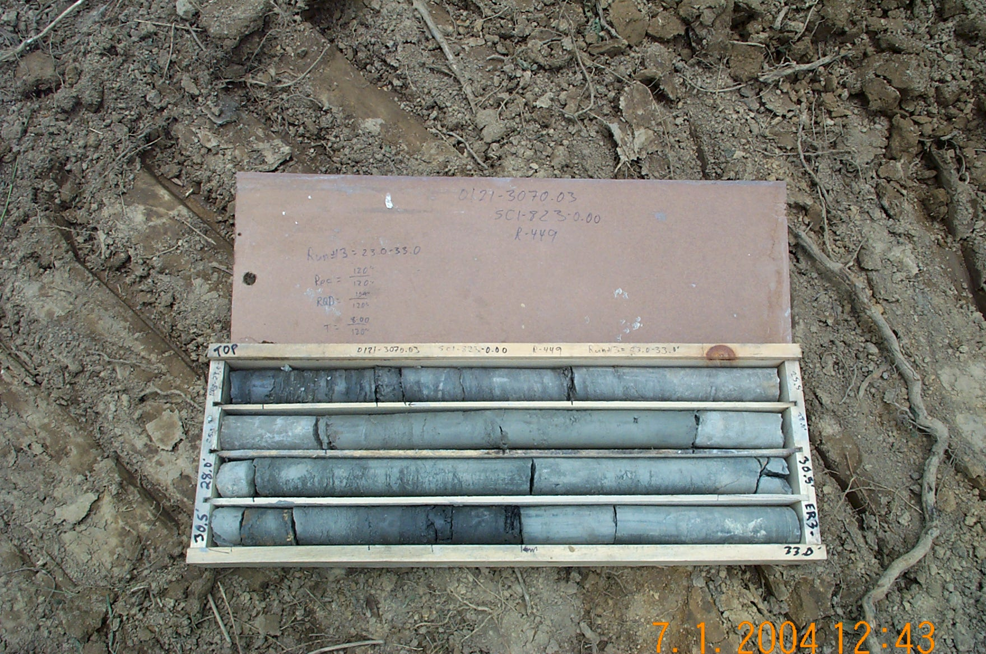
Photo 6. M:\proj\0121\3070.03\Core Photos\R-449\Rock Core\R3-12fld.JPG

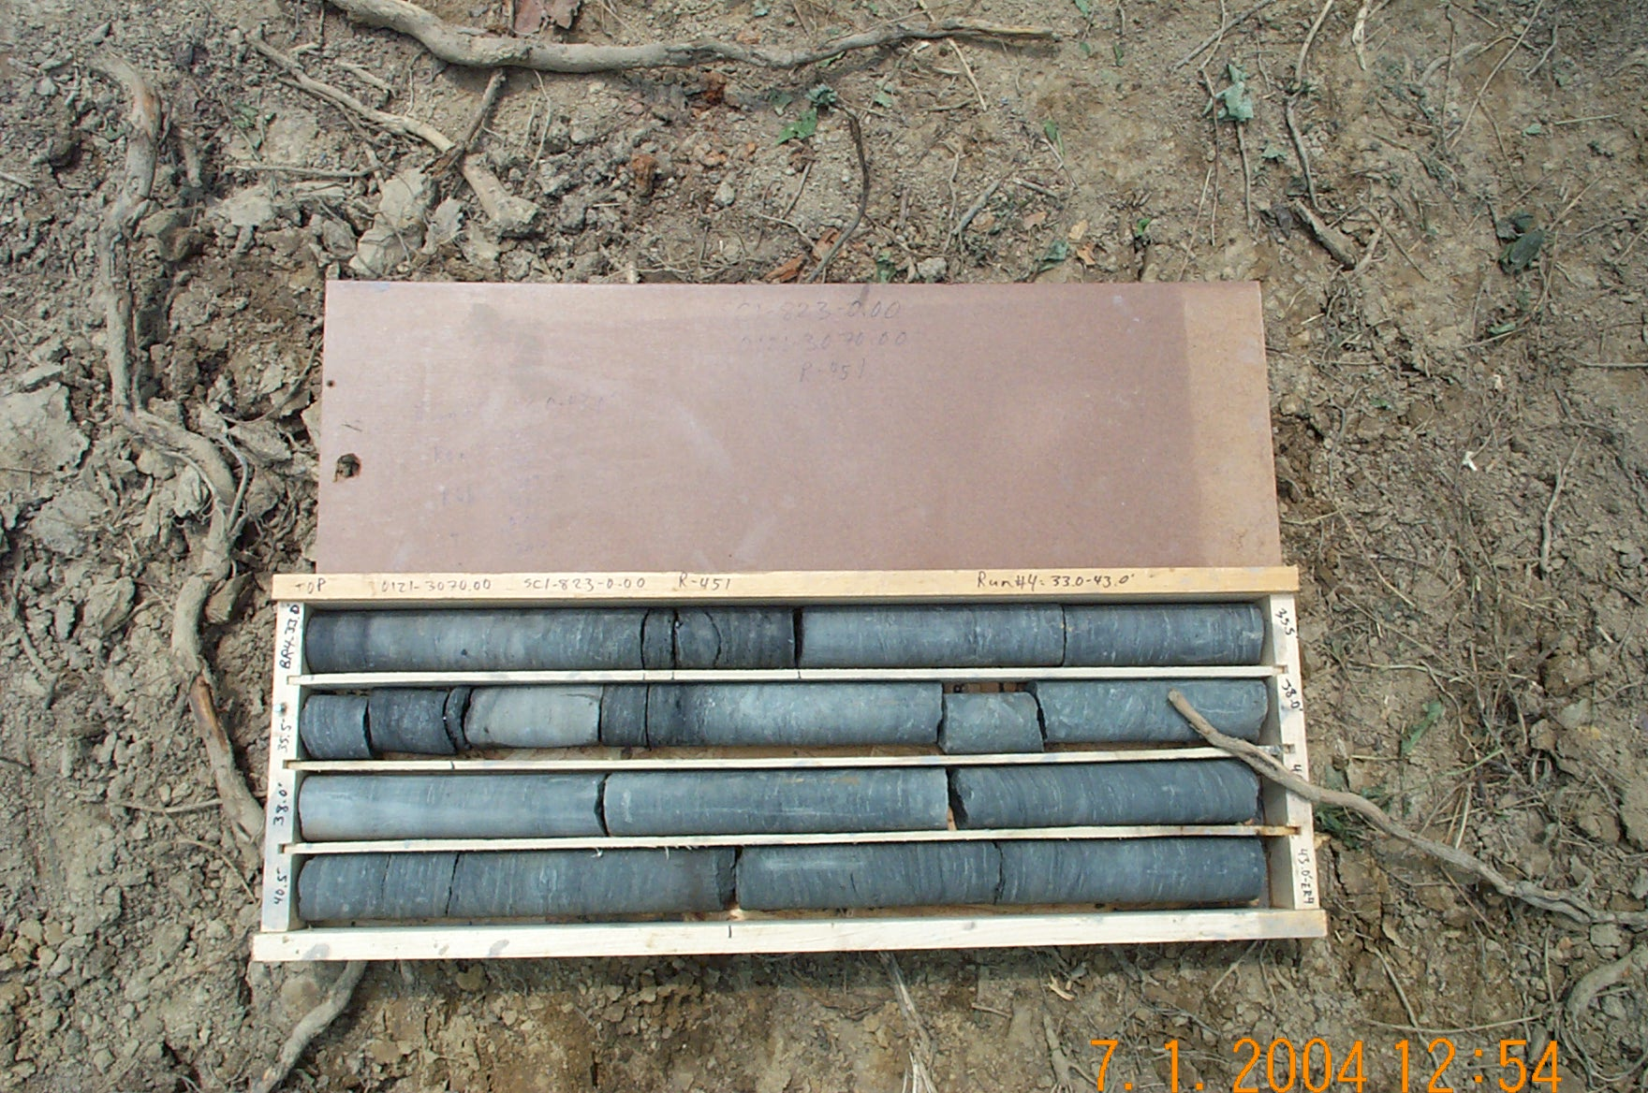
Photo 7. M:\proj\0121\3070.03\Core Photos\R-449\Rock Core\R4-12fld.JPG

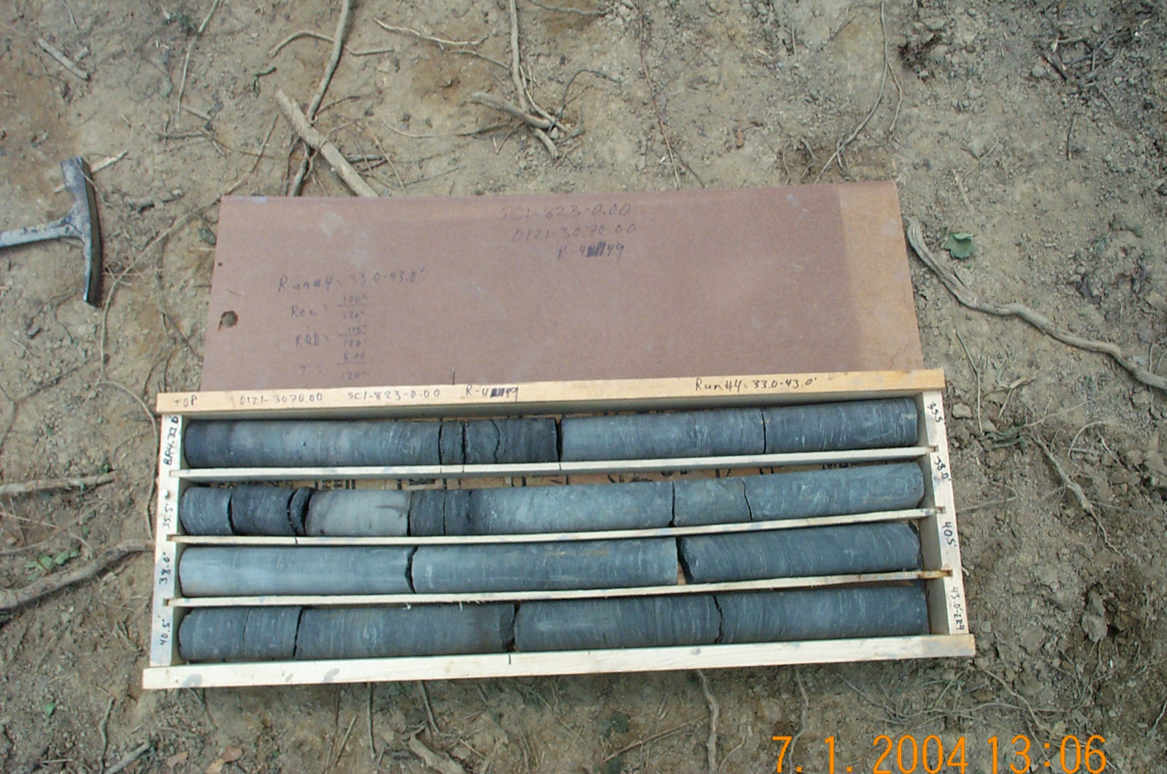
Photo 8. M:\proj\0121\3070.03\Core Photos\R-449\Rock Core\R4b-12fld.JPG

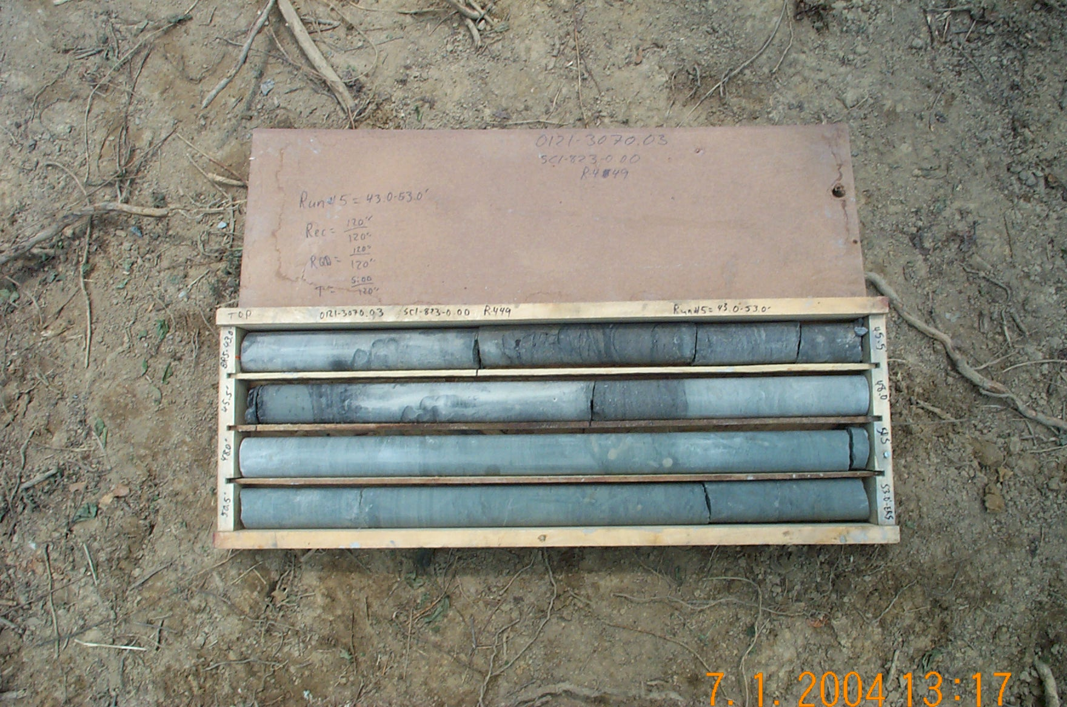
Photo 9. M:\proj\0121\3070.03\Core Photos\R-449\Rock Core\R5-12fld.JPG

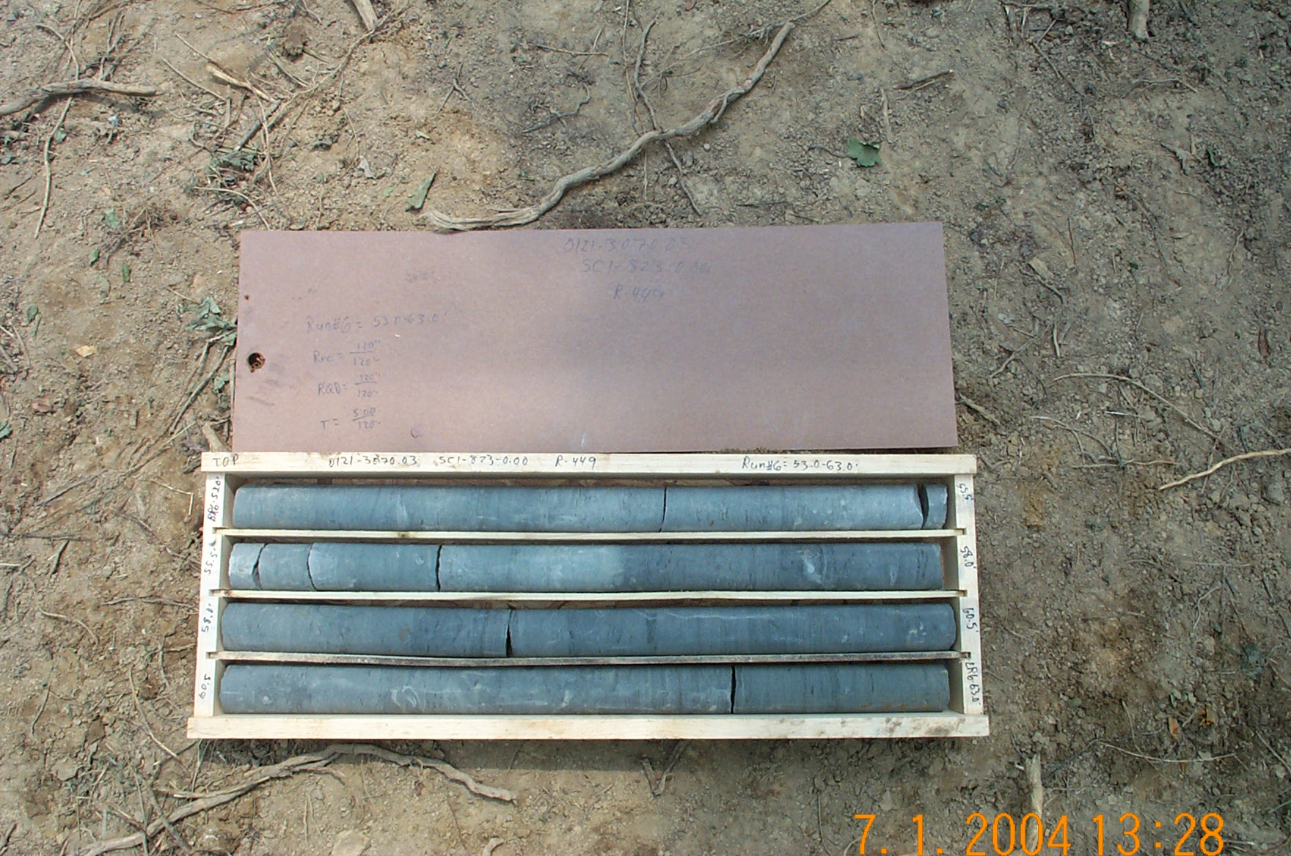
Photo 10. M:\proj\0121\3070.03\Core Photos\R-449\Rock Core\R6-12fld.JPG

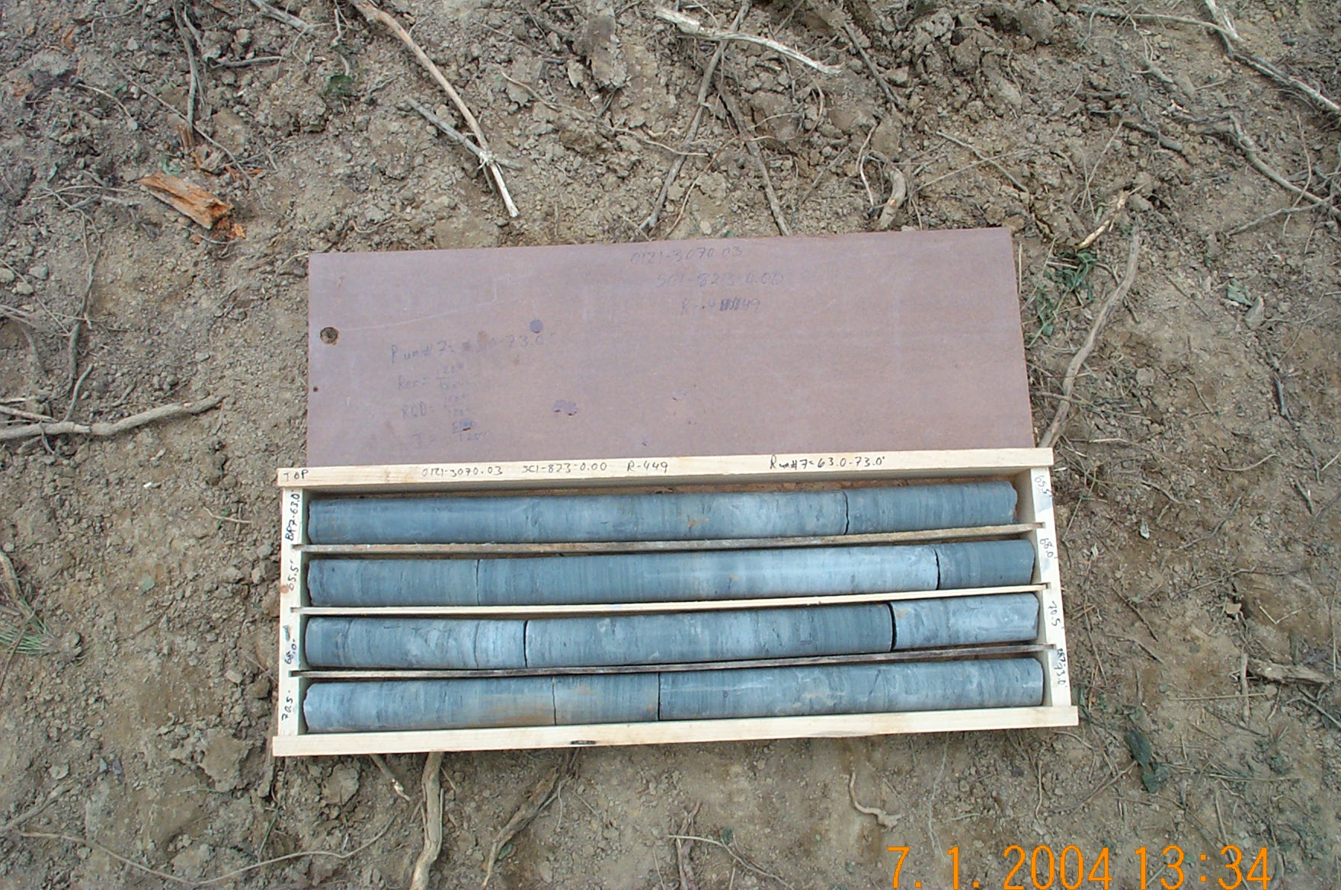
Photo 11. M:\proj\0121\3070.03\Core Photos\R-449\Rock Core\R7-12fld.JPG

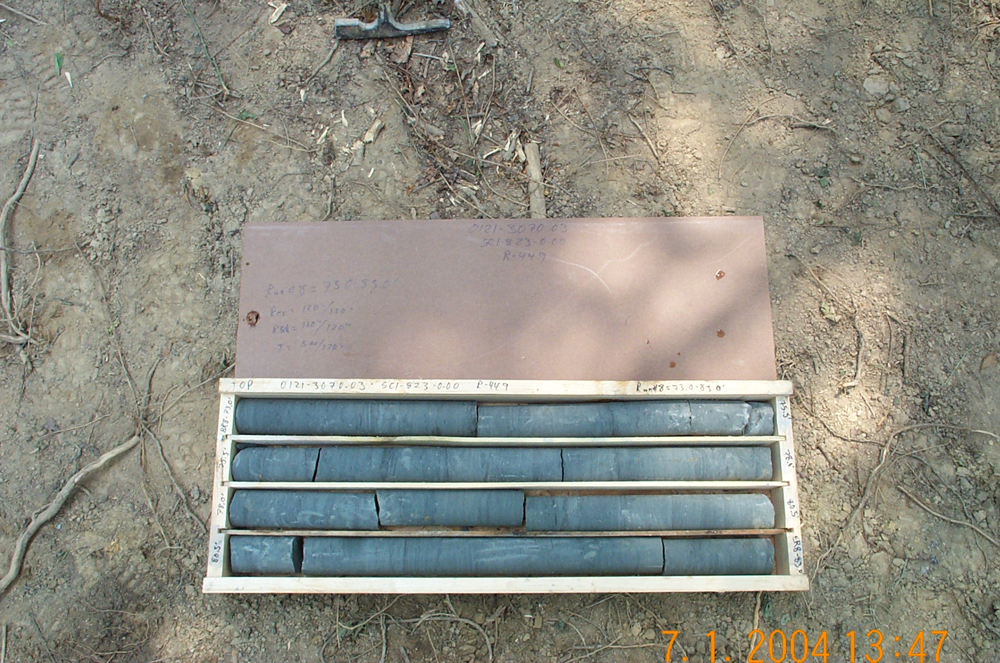
Photo 12. M:\proj\0121\3070.03\Core Photos\R-449\Rock Core\R8-12fld.JPG

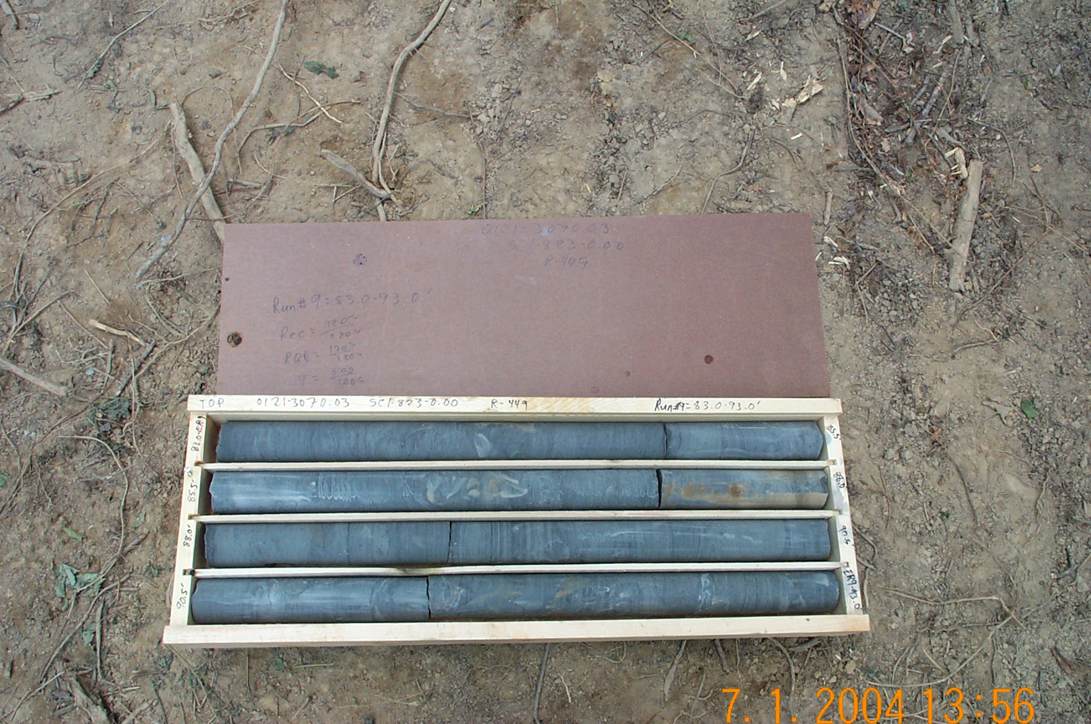
Photo 13. M:\proj\0121\3070.03\Core Photos\R-449\Rock Core\R9-12fld.JPG

