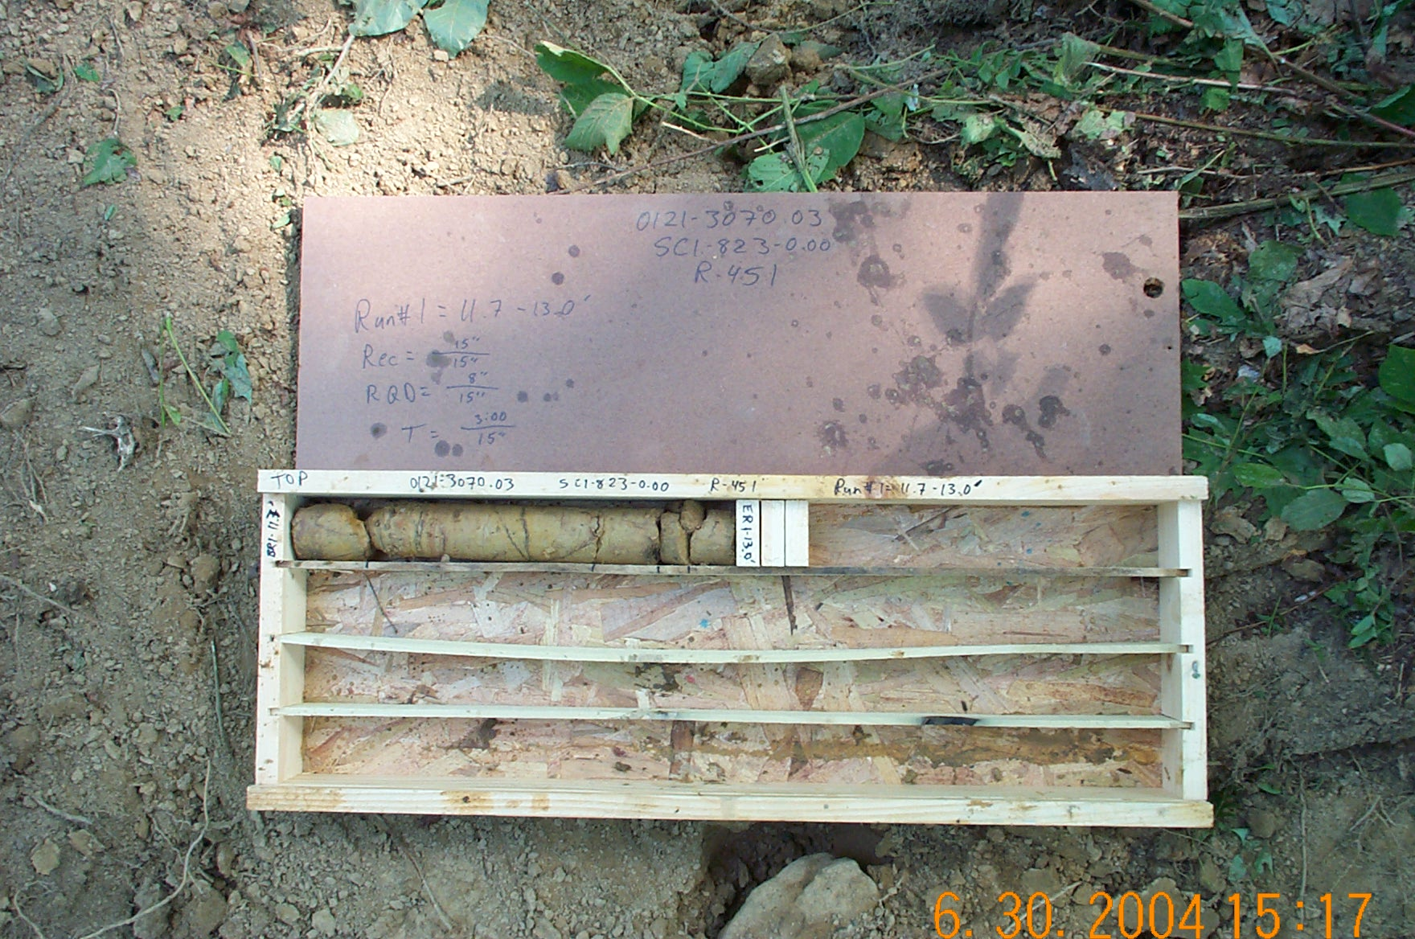
Photo 1. M:\proj\0121\3070.03\Core Photos\R-451\Rock Core Photos\R01-10fld.JPG

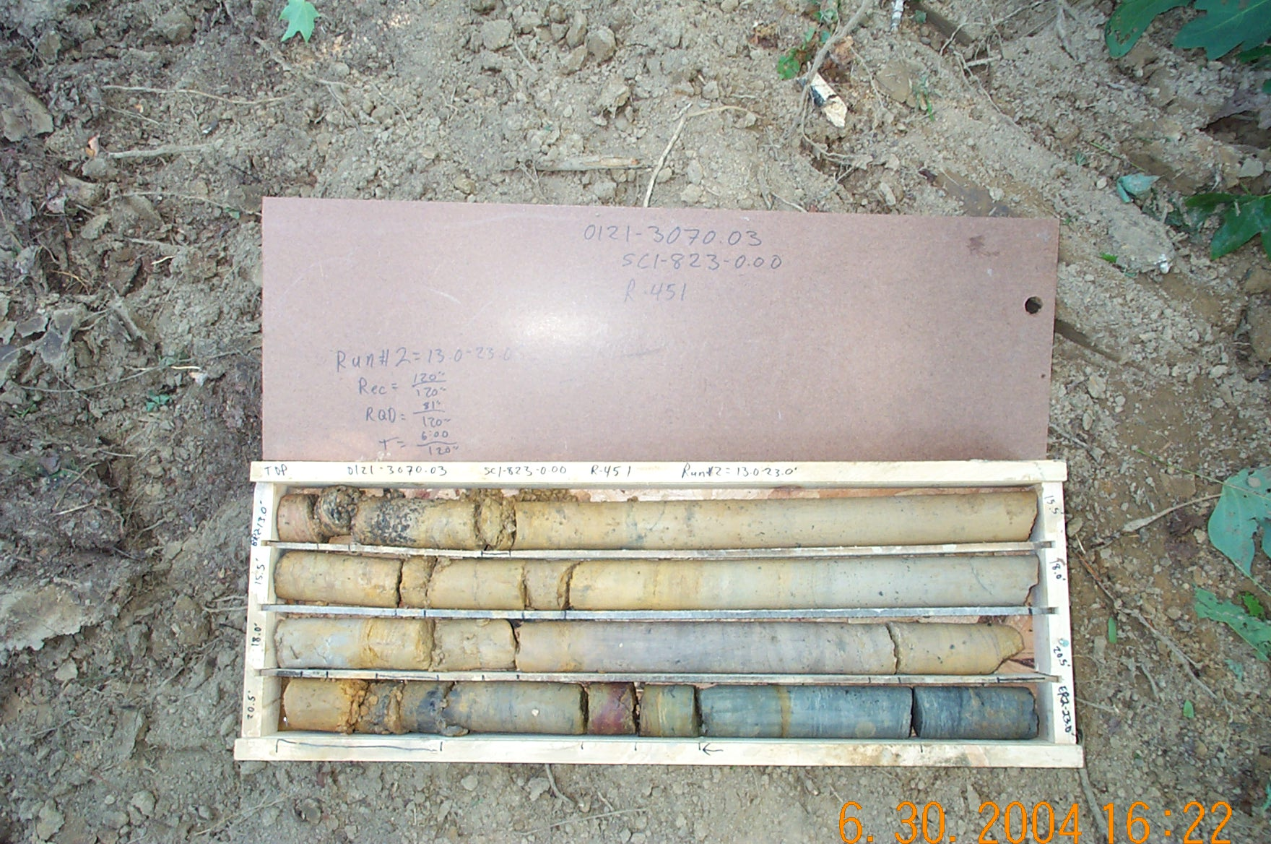
Photo 2. M:\proj\0121\3070.03\Core Photos\R-451\Rock Core Photos\R02-10fld.JPG

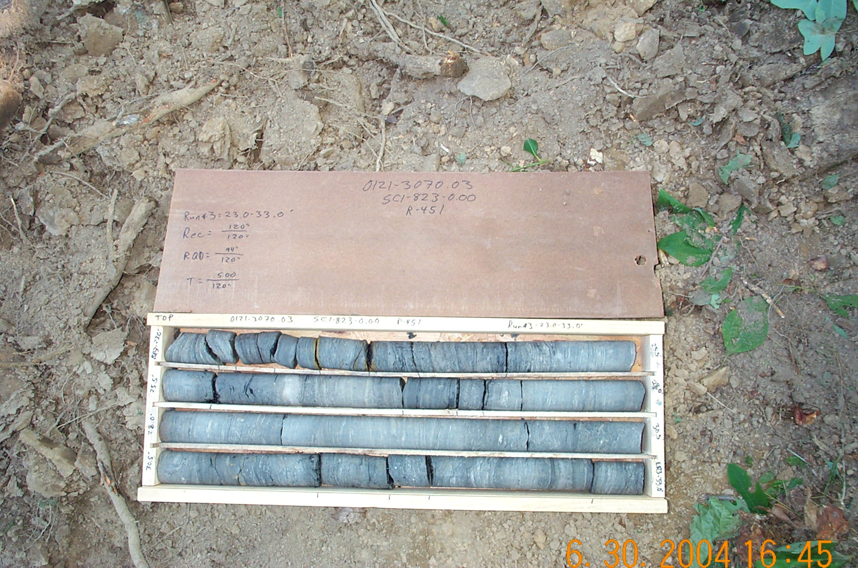
Photo 3. M:\proj\0121\3070.03\Core Photos\R-451\Rock Core Photos\R03-10fld.JPG

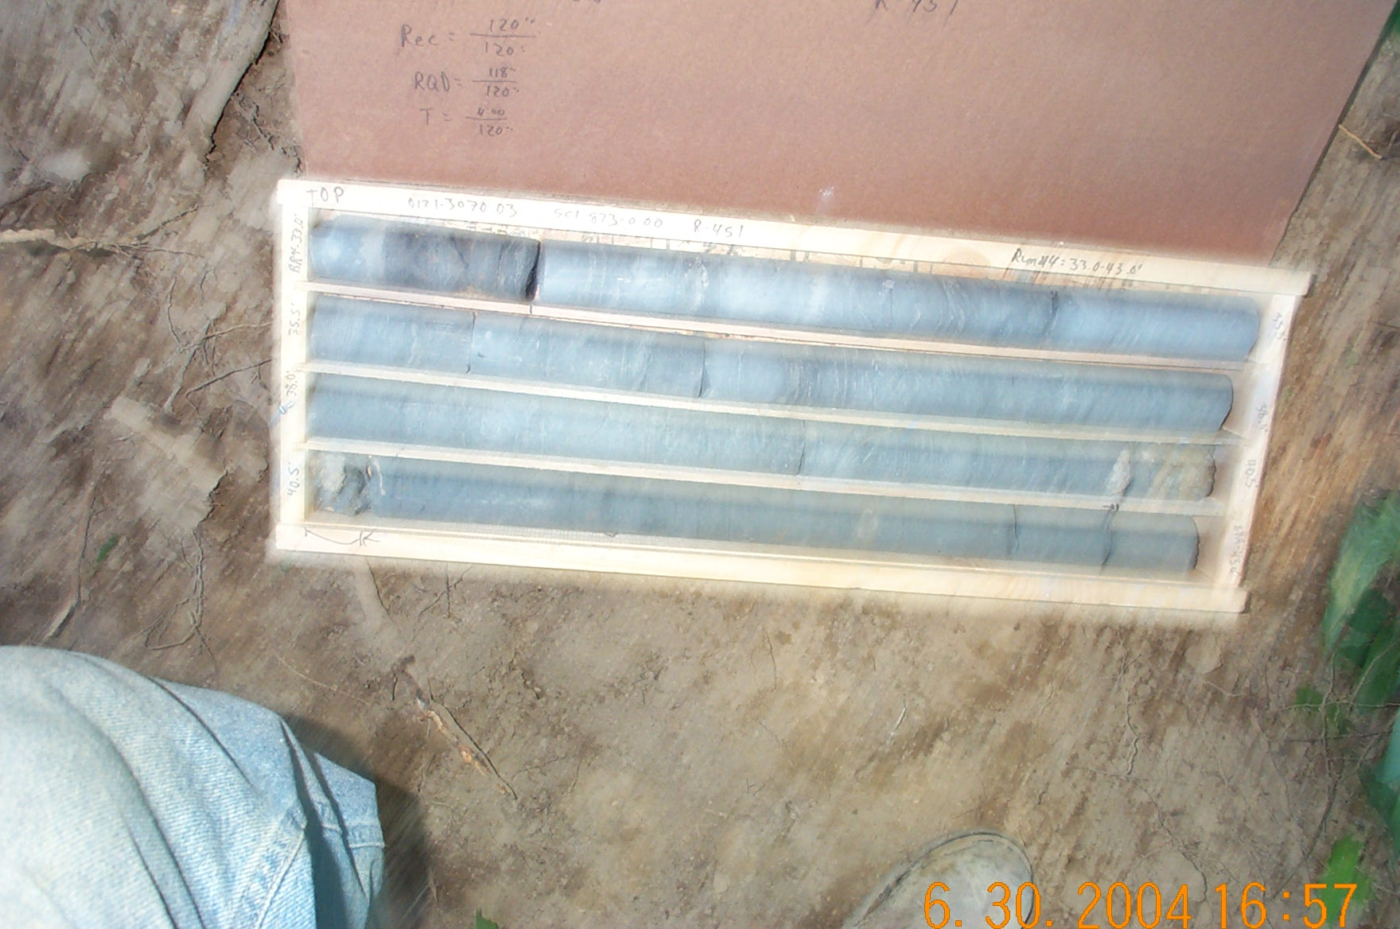
Photo 4. M:\proj\0121\3070.03\Core Photos\R-451\Rock Core Photos\R04-10fld.JPG

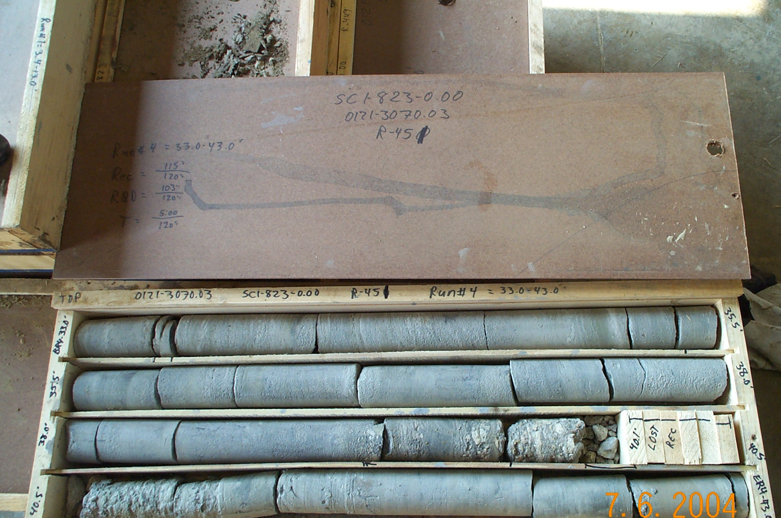
Photo 5. M:\proj\0121\3070.03\Core Photos\R-451\Rock Core Photos\R04-10shp.JPG

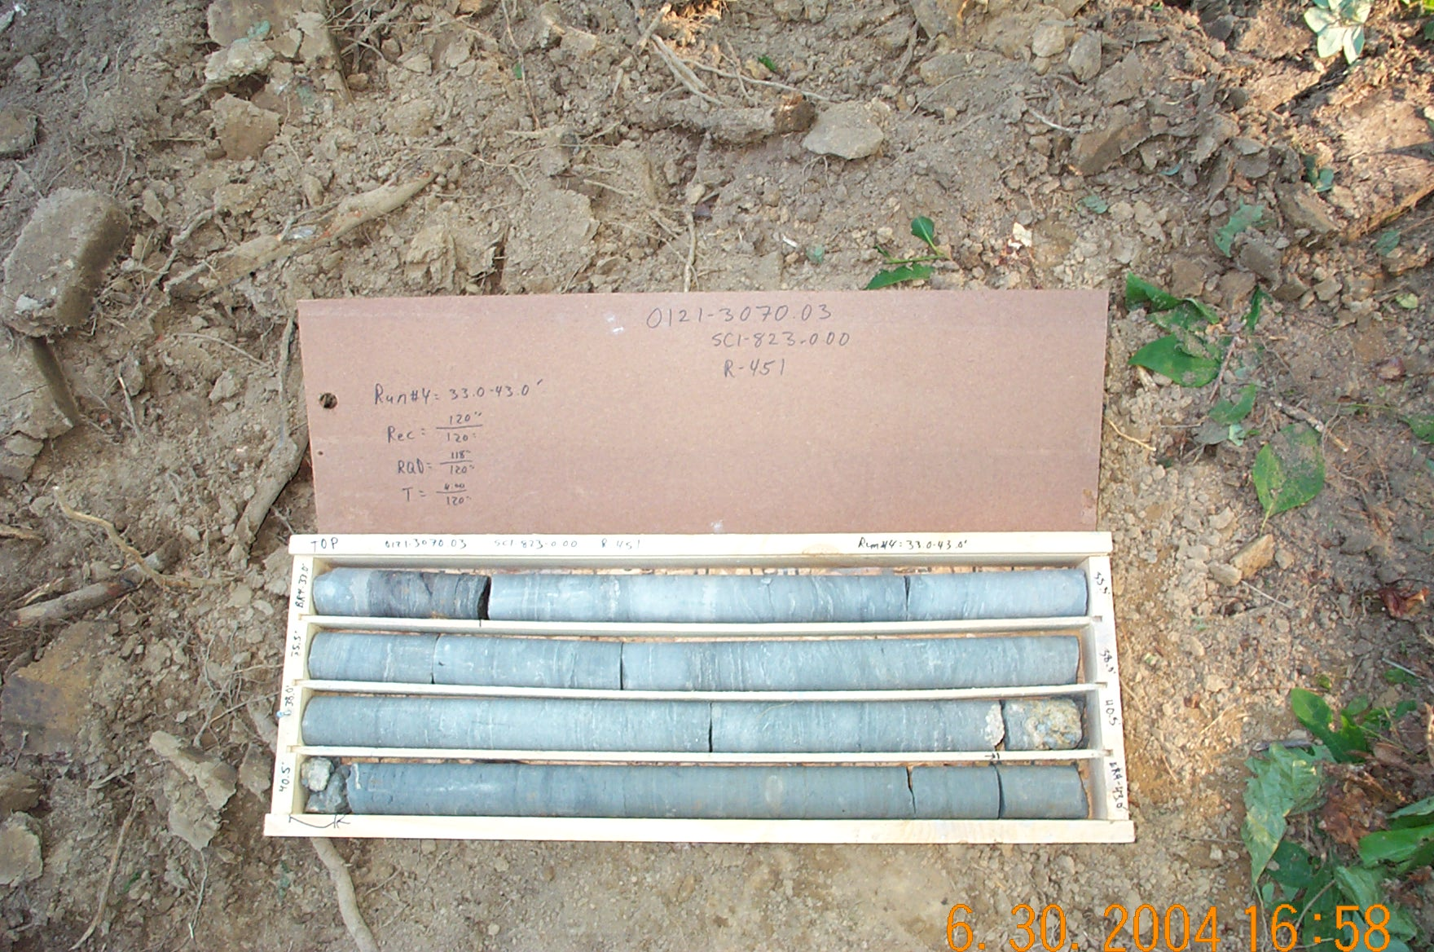
Photo 6. M:\proj\0121\3070.03\Core Photos\R-451\Rock Core Photos\R04b-10fld.JPG

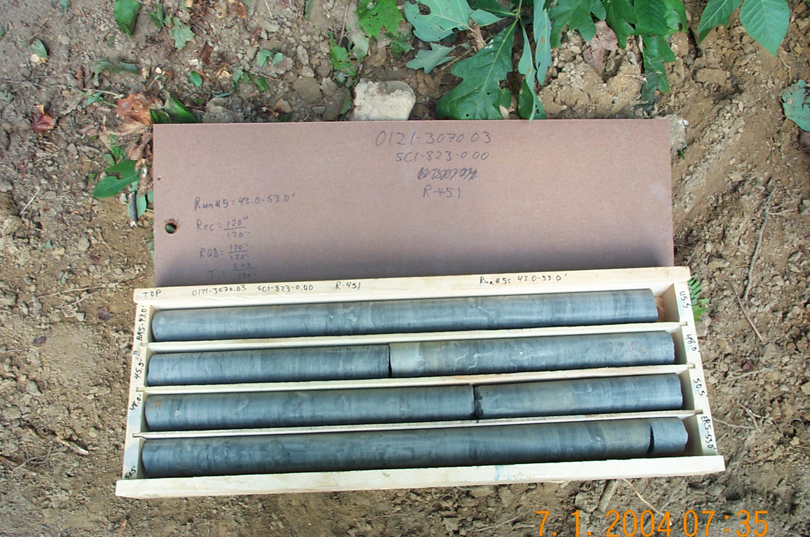
Photo 7. M:\proj\0121\3070.03\Core Photos\R-451\Rock Core Photos\R05-10fld.JPG

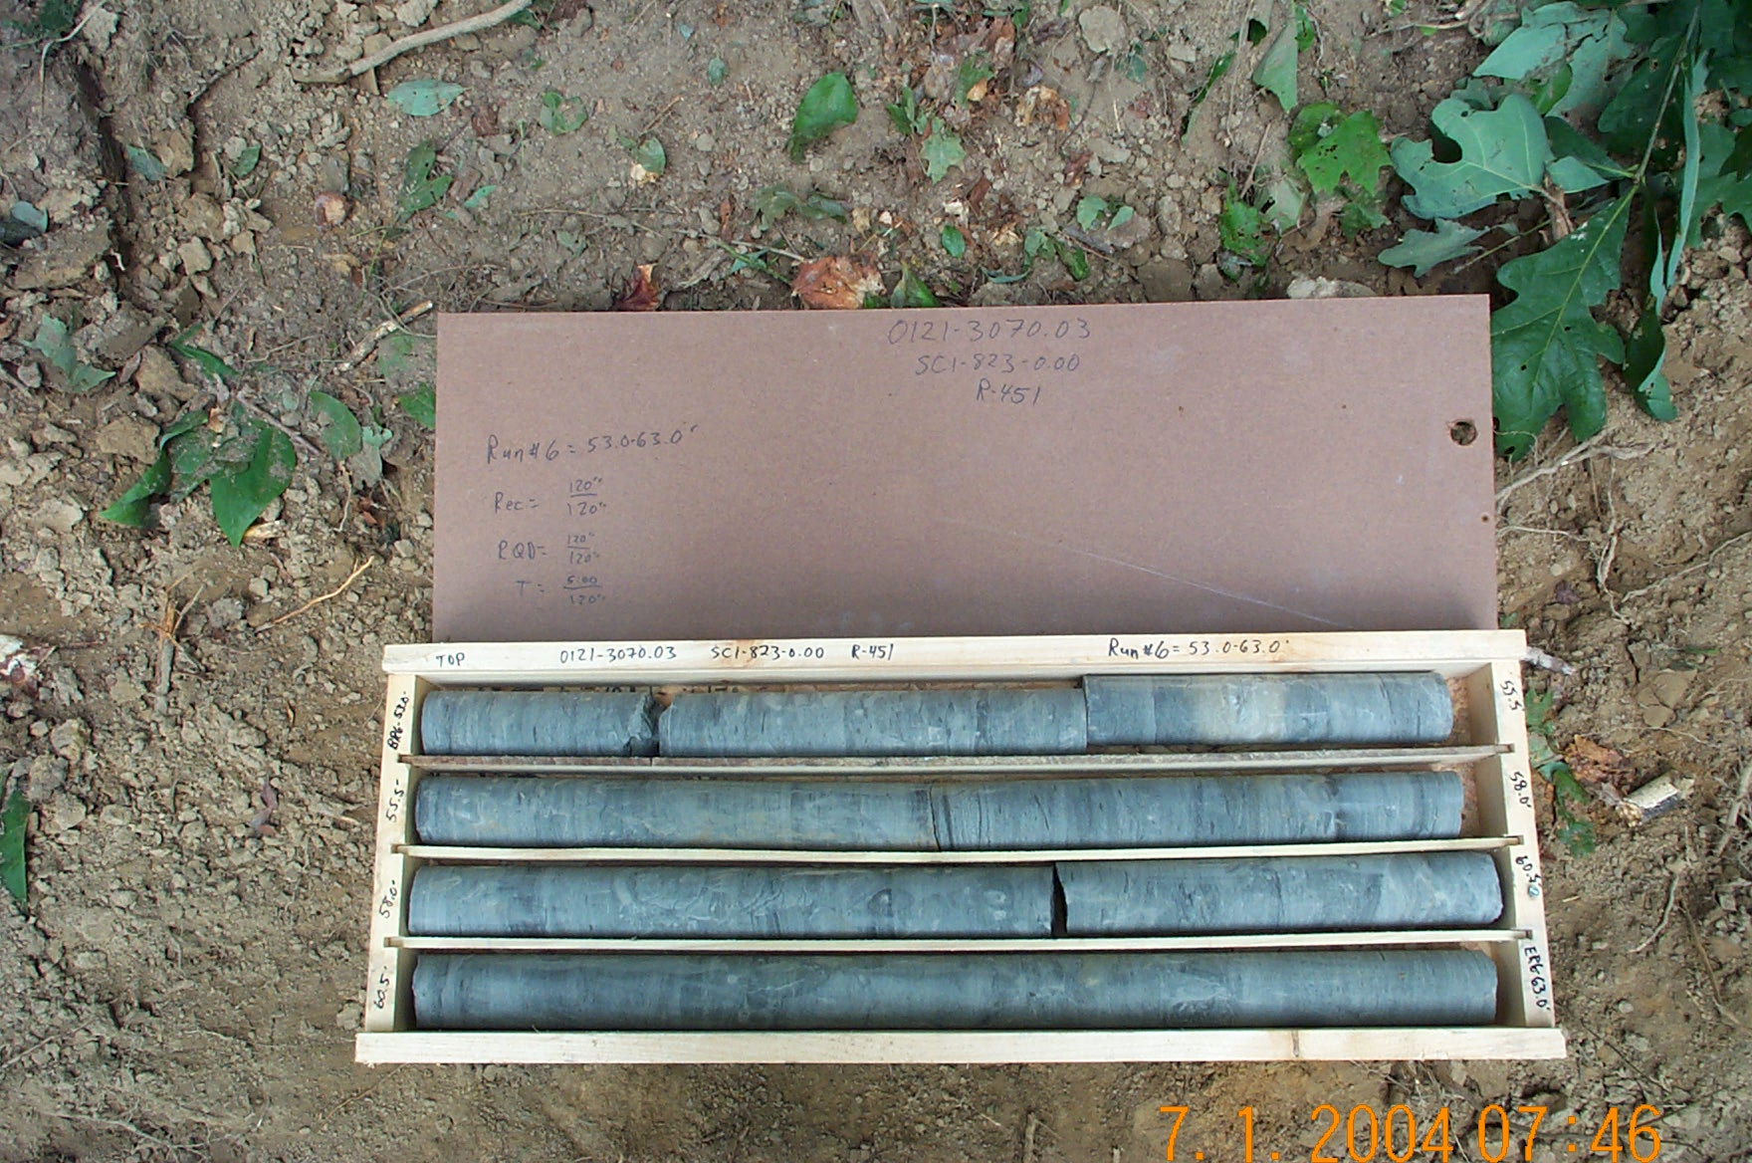
Photo 8. M:\proj\0121\3070.03\Core Photos\R-451\Rock Core Photos\R06-10fld.JPG

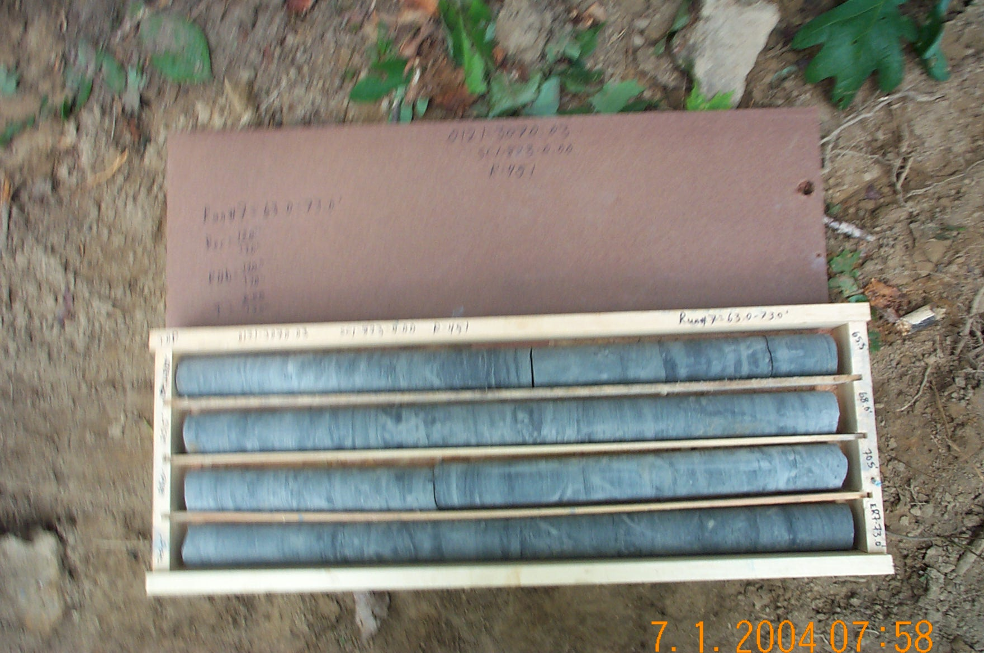
Photo 9. M:\proj\0121\3070.03\Core Photos\R-451\Rock Core Photos\R07-10fld.JPG

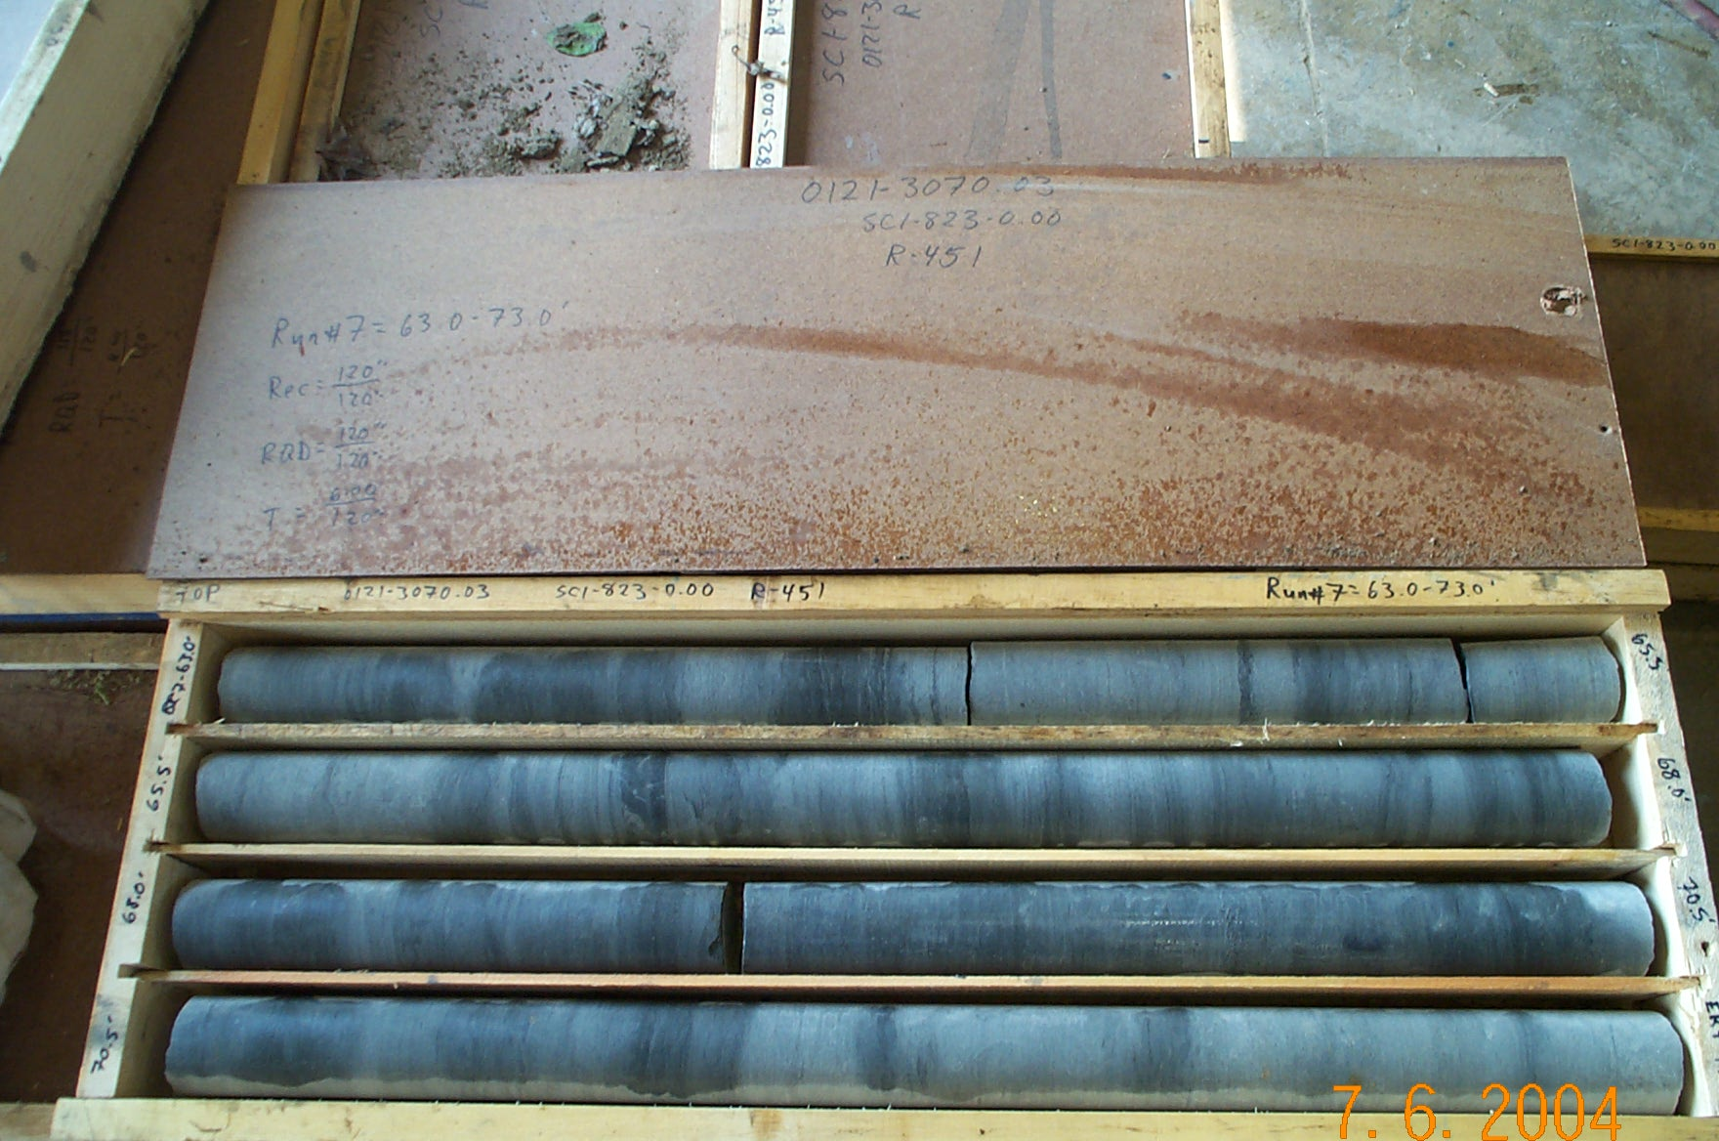
Photo 10. M:\proj\0121\3070.03\Core Photos\R-451\Rock Core Photos\R07-10shp.JPG

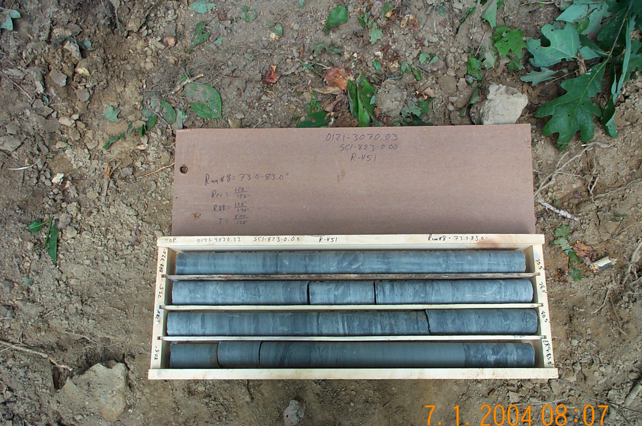
Photo 11. M:\proj\0121\3070.03\Core Photos\R-451\Rock Core Photos\R08-10fld.JPG

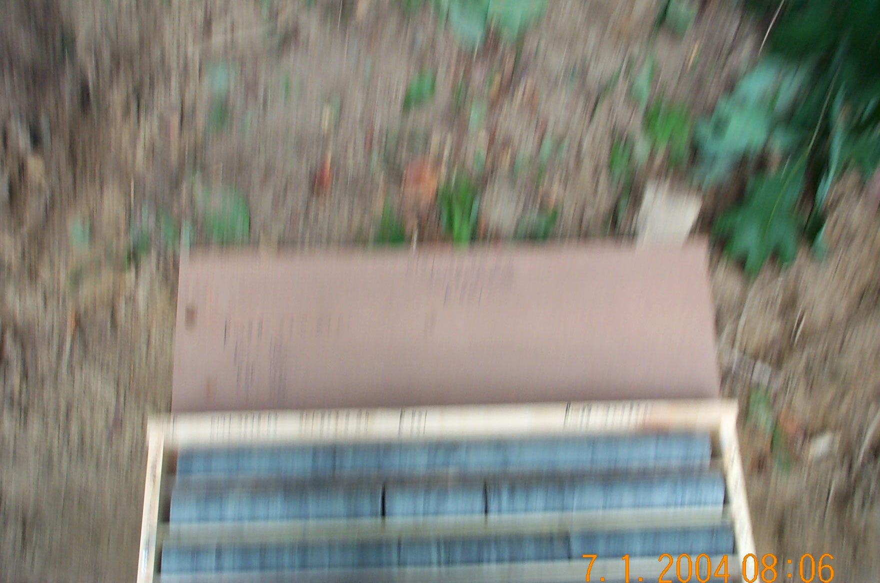
Photo 12. M:\proj\0121\3070.03\Core Photos\R-451\Rock Core Photos\R08b-10fld.JPG

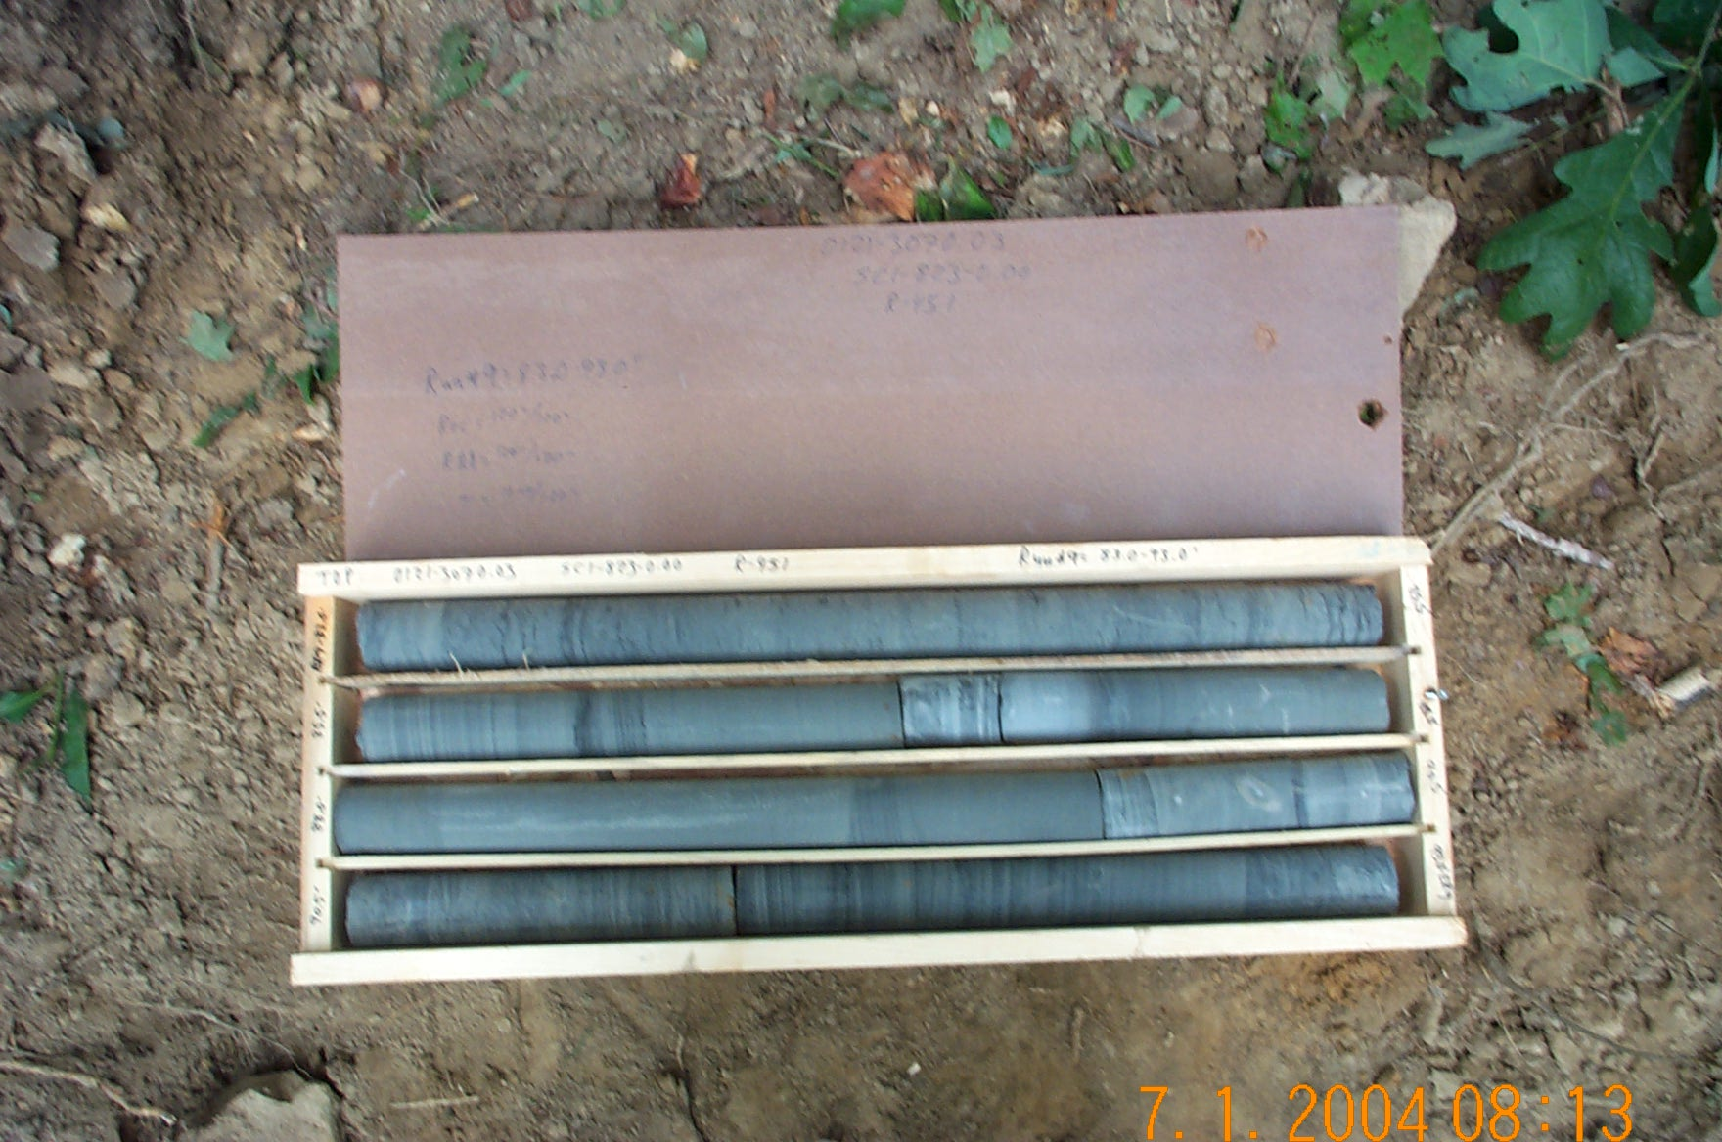
Photo 13. M:\proj\0121\3070.03\Core Photos\R-451\Rock Core Photos\R09-10fld.JPG

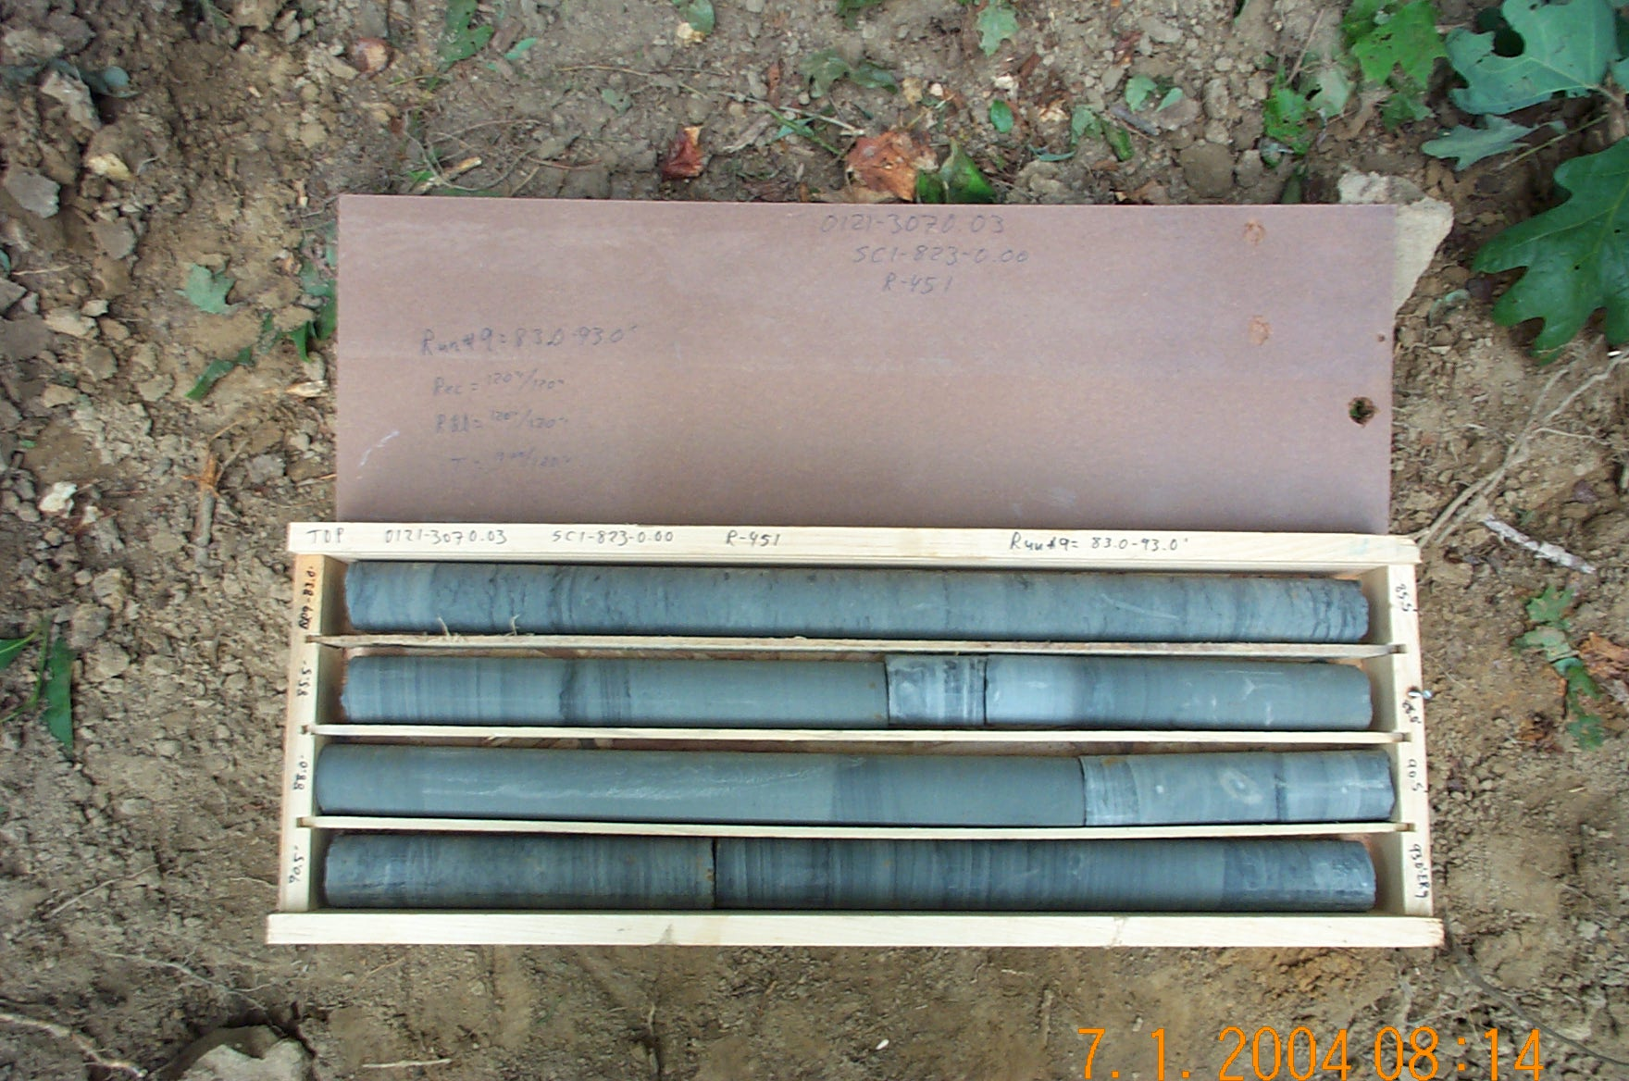
Photo 14. M:\proj\0121\3070.03\Core Photos\R-451\Rock Core Photos\R09b-10fld.JPG

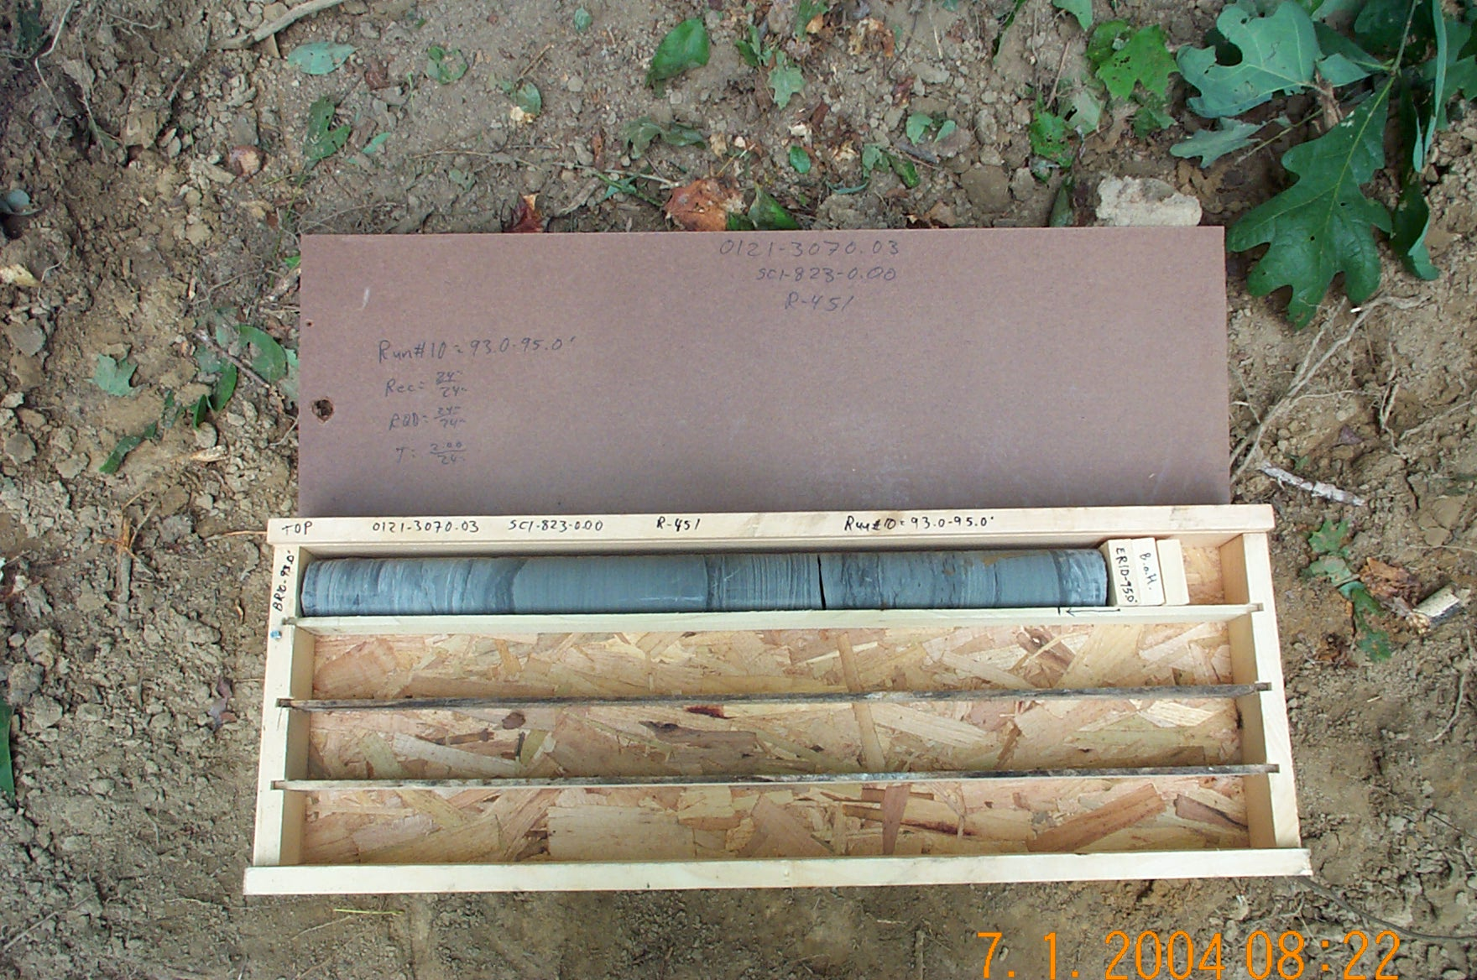
Photo 15. M:\proj\0121\3070.03\Core Photos\R-451\Rock Core Photos\R10-10fld.JPG

