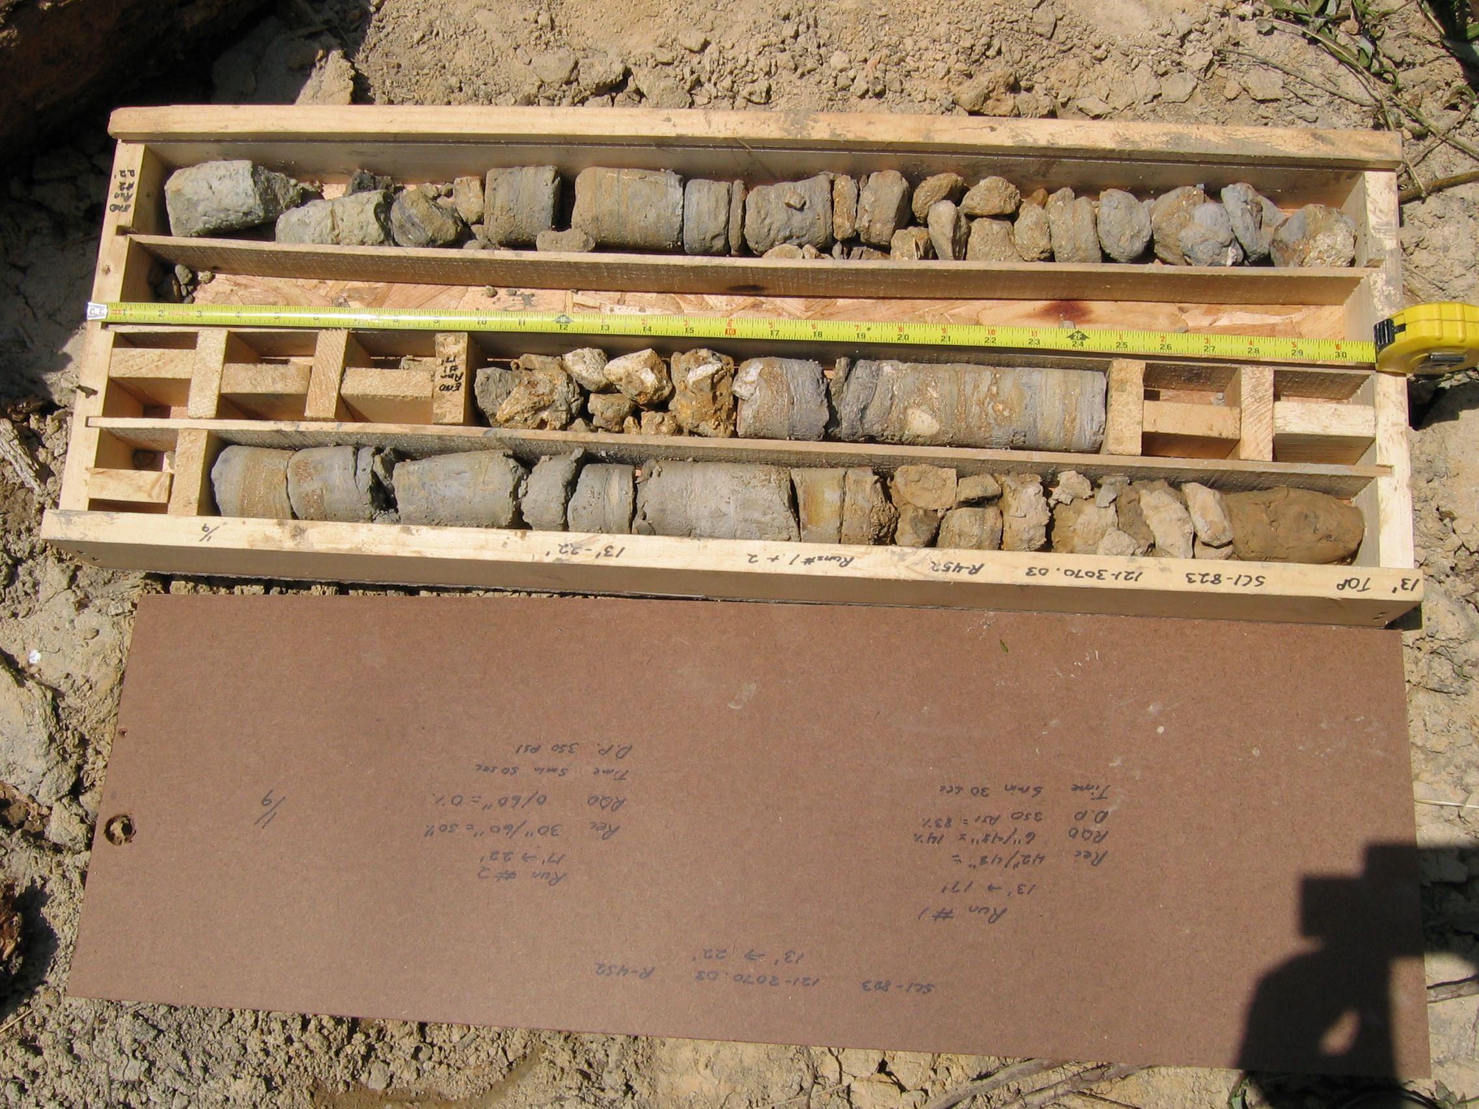
Photo 1. M:\proj\0121\3070.03\Core Photos\R-452\Rock Core Photos\R01&02-17fld.JPG

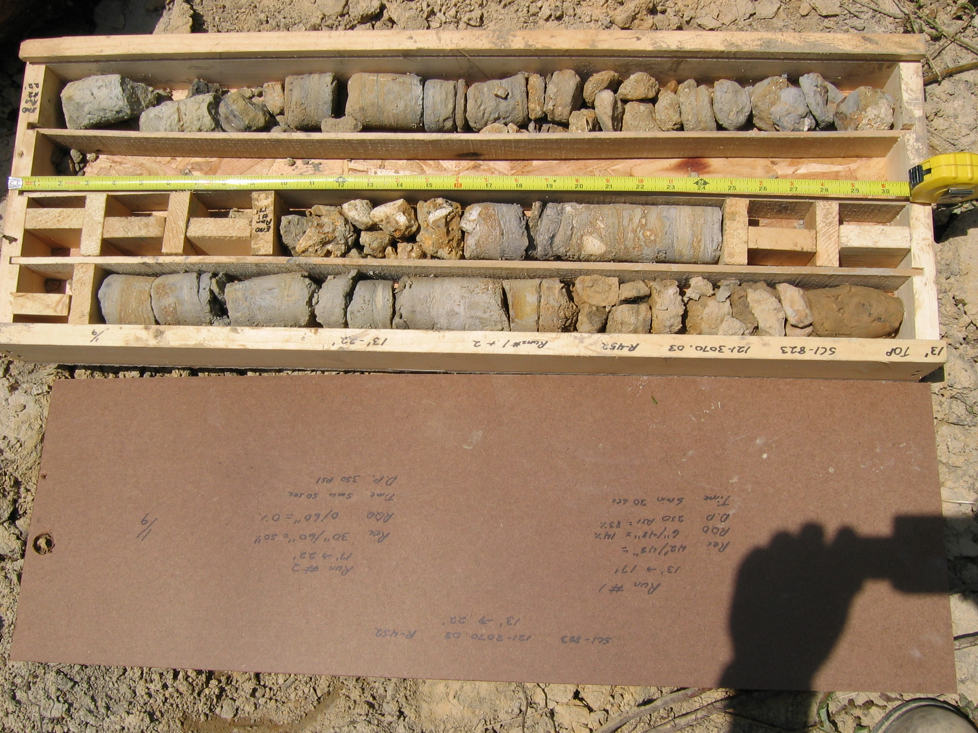
Photo 2. M:\proj\0121\3070.03\Core Photos\R-452\Rock Core Photos\R01&02a-17fld.JPG

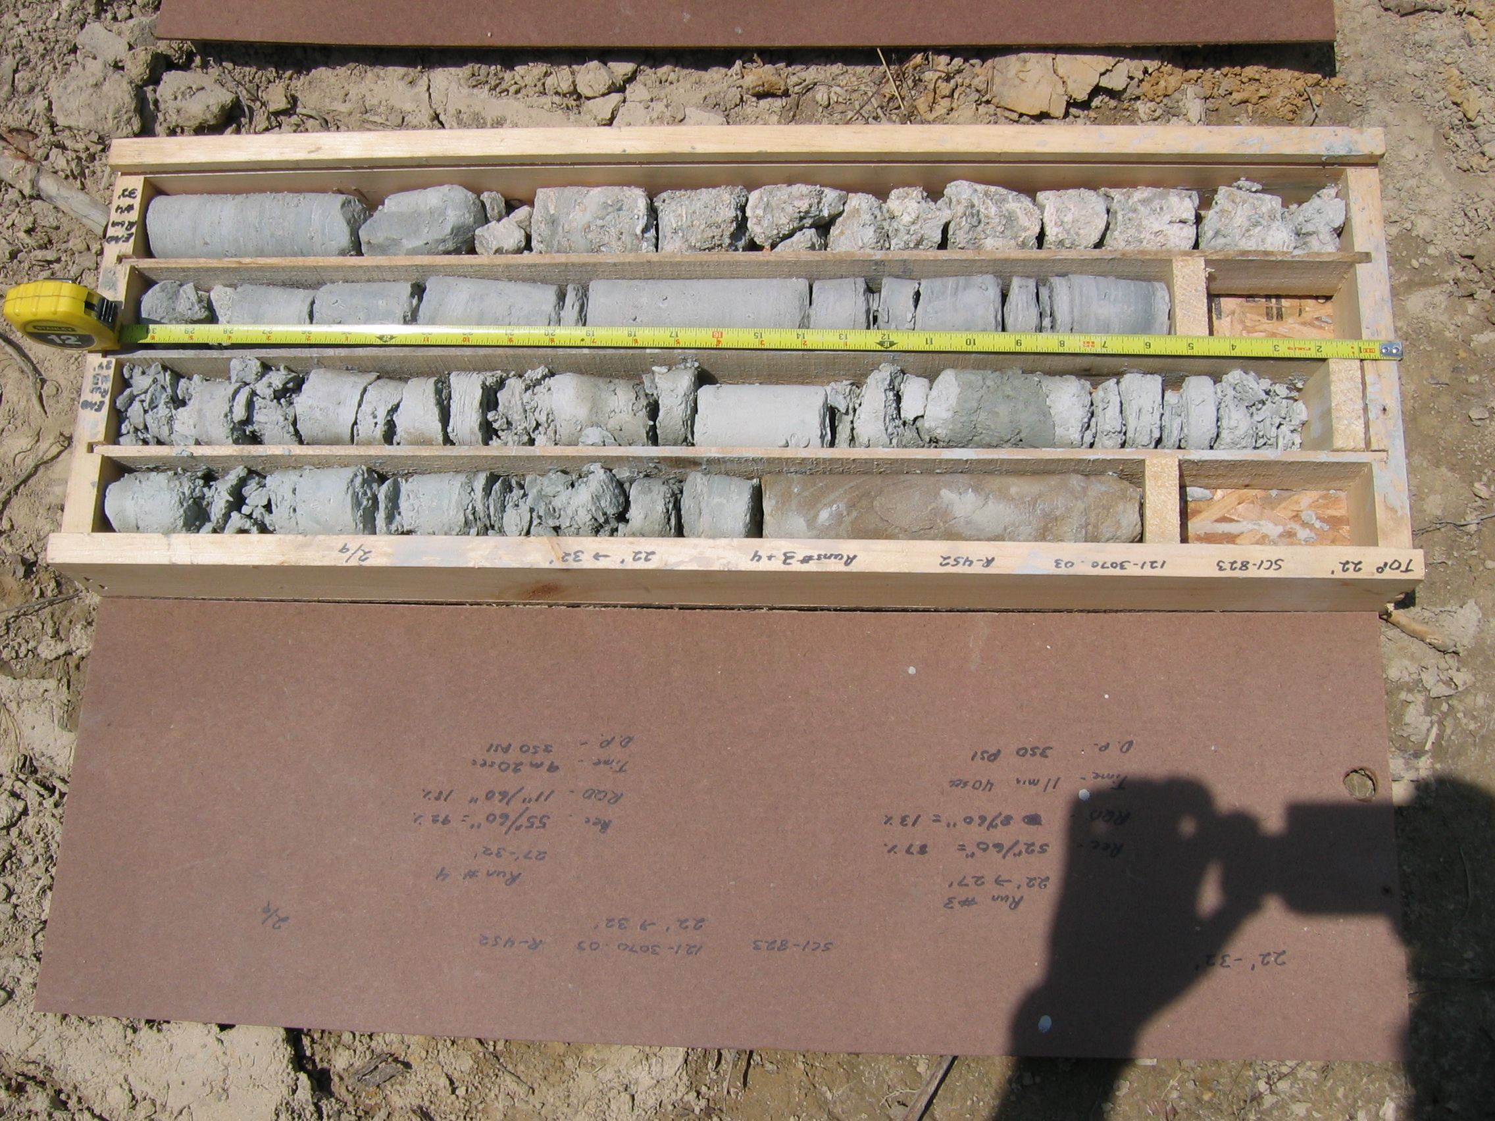
Photo 3. M:\proj\0121\3070.03\Core Photos\R-452\Rock Core Photos\R03&04-17fld.JPG

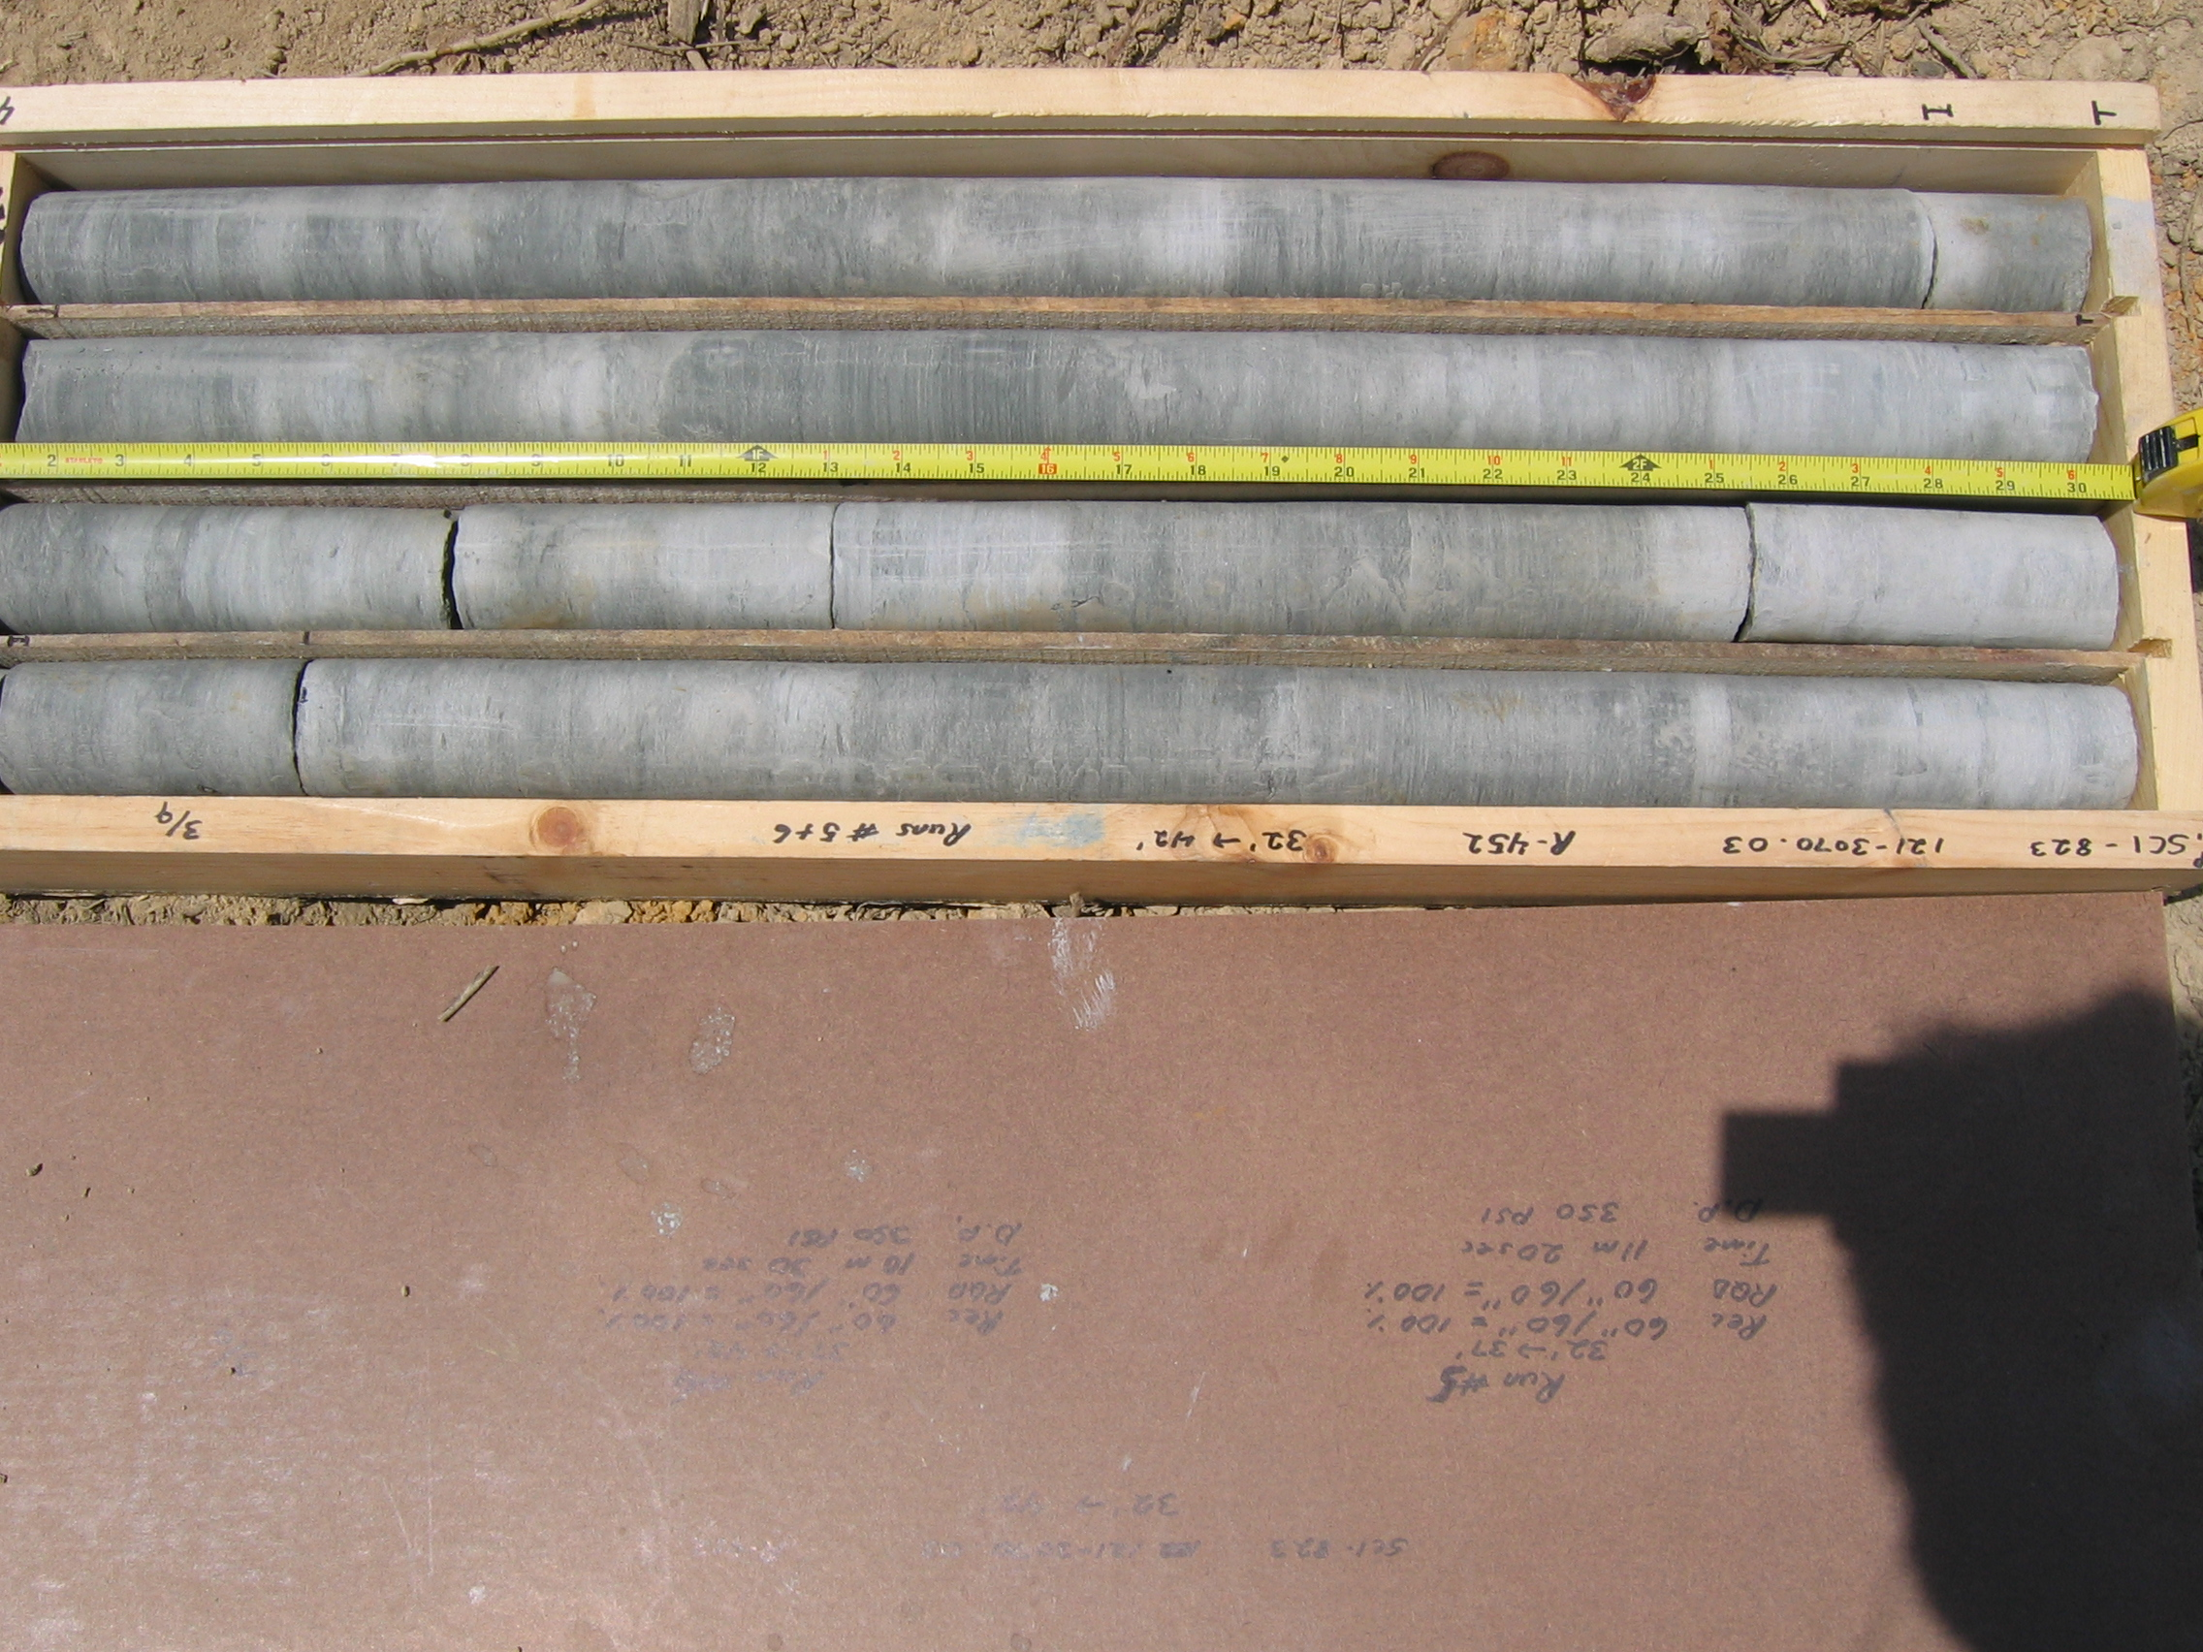
Photo 4. M:\proj\0121\3070.03\Core Photos\R-452\Rock Core Photos\R05&06-17fld.JPG

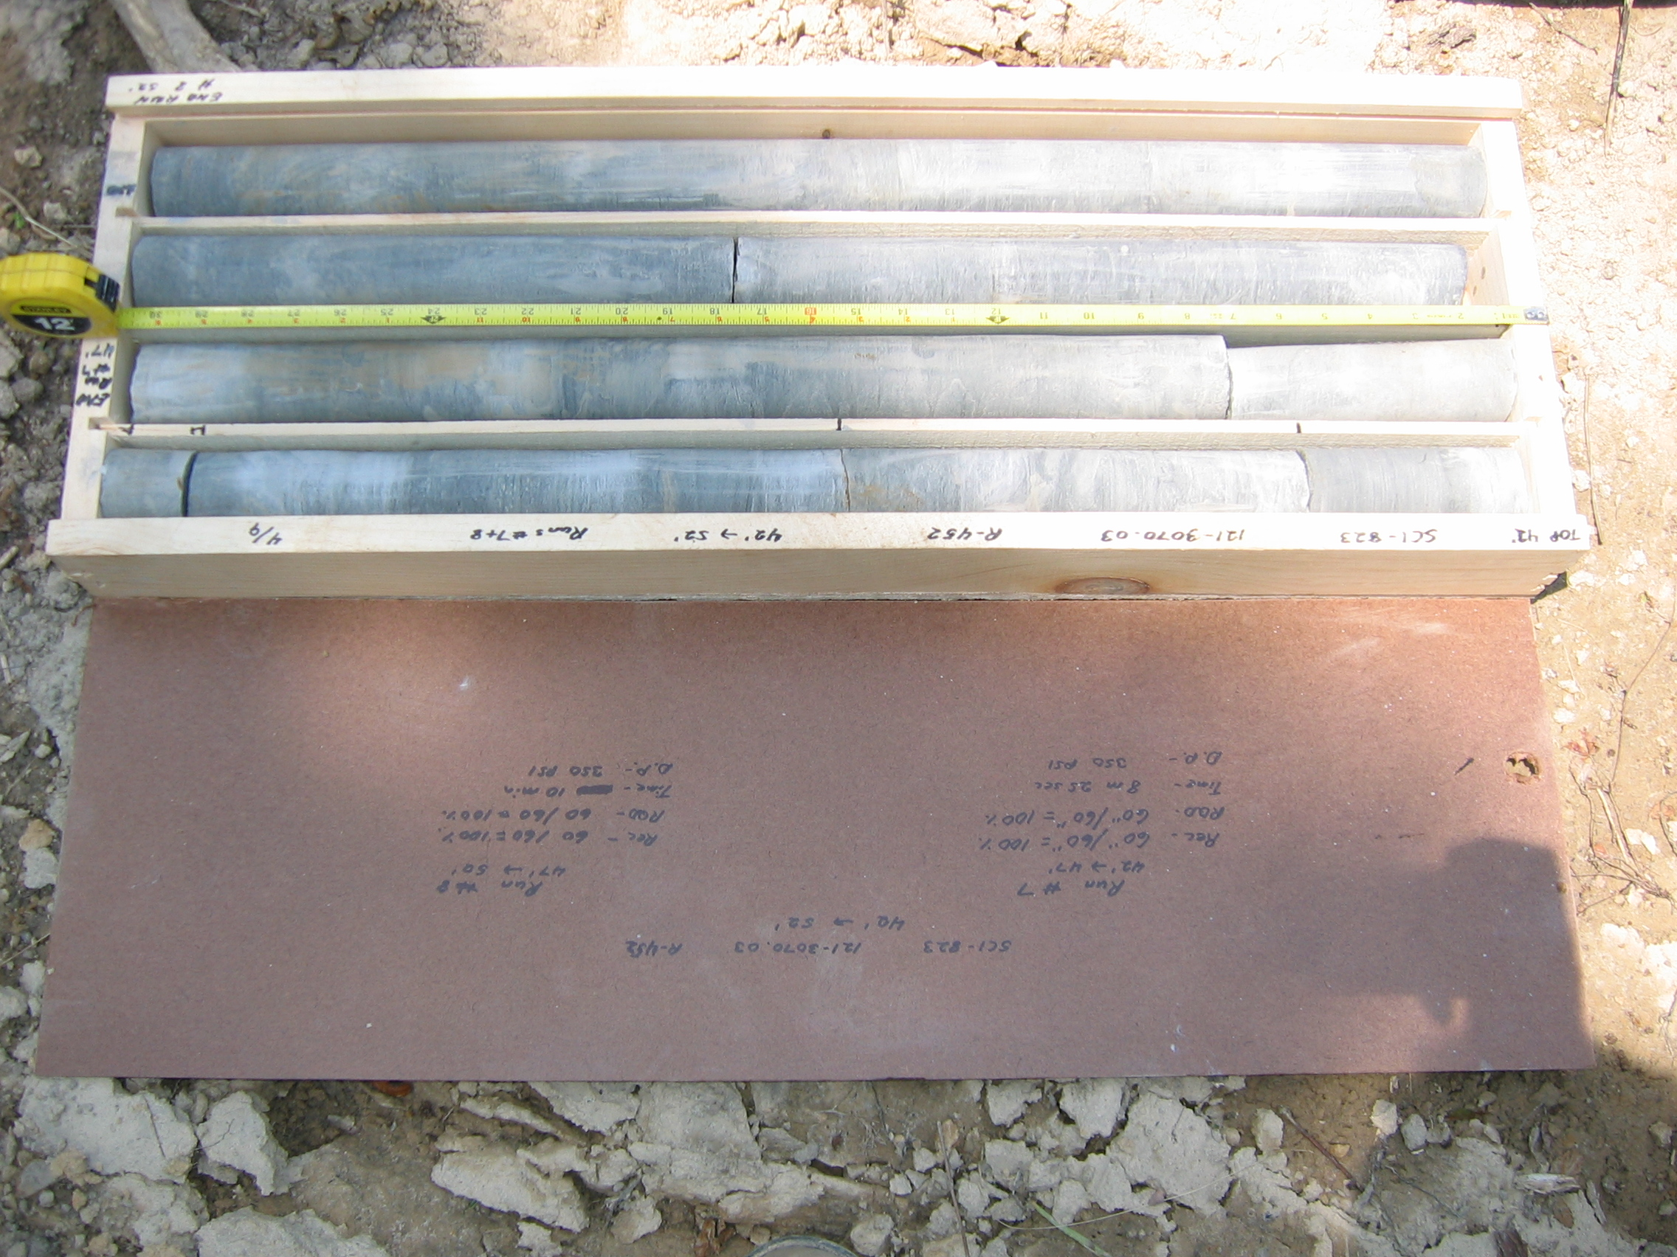
Photo 5. M:\proj\0121\3070.03\Core Photos\R-452\Rock Core Photos\R07&08-17fld.JPG

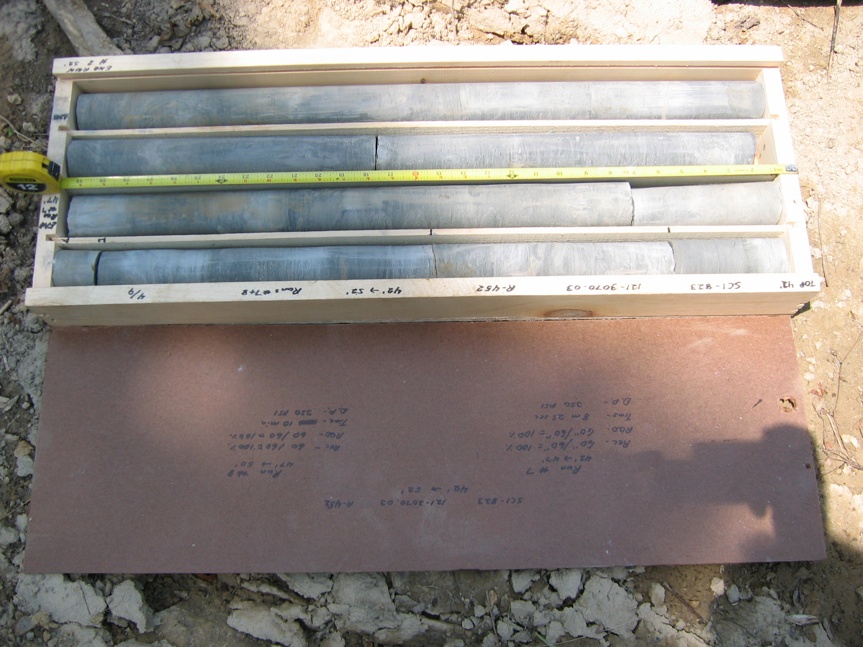
Photo 6. M:\proj\0121\3070.03\Core Photos\R-452\Rock Core Photos\R07&08a-17fld.JPG

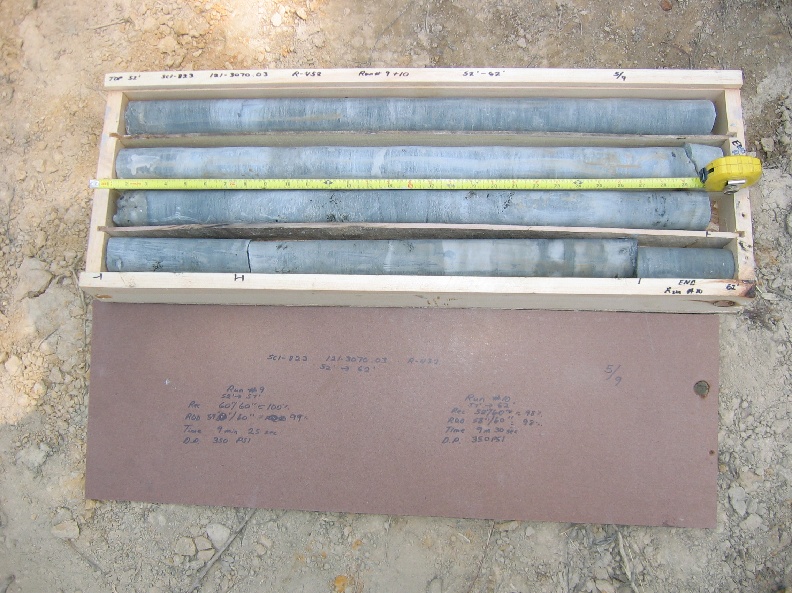
Photo 7. M:\proj\0121\3070.03\Core Photos\R-452\Rock Core Photos\R09&10-17fld.JPG

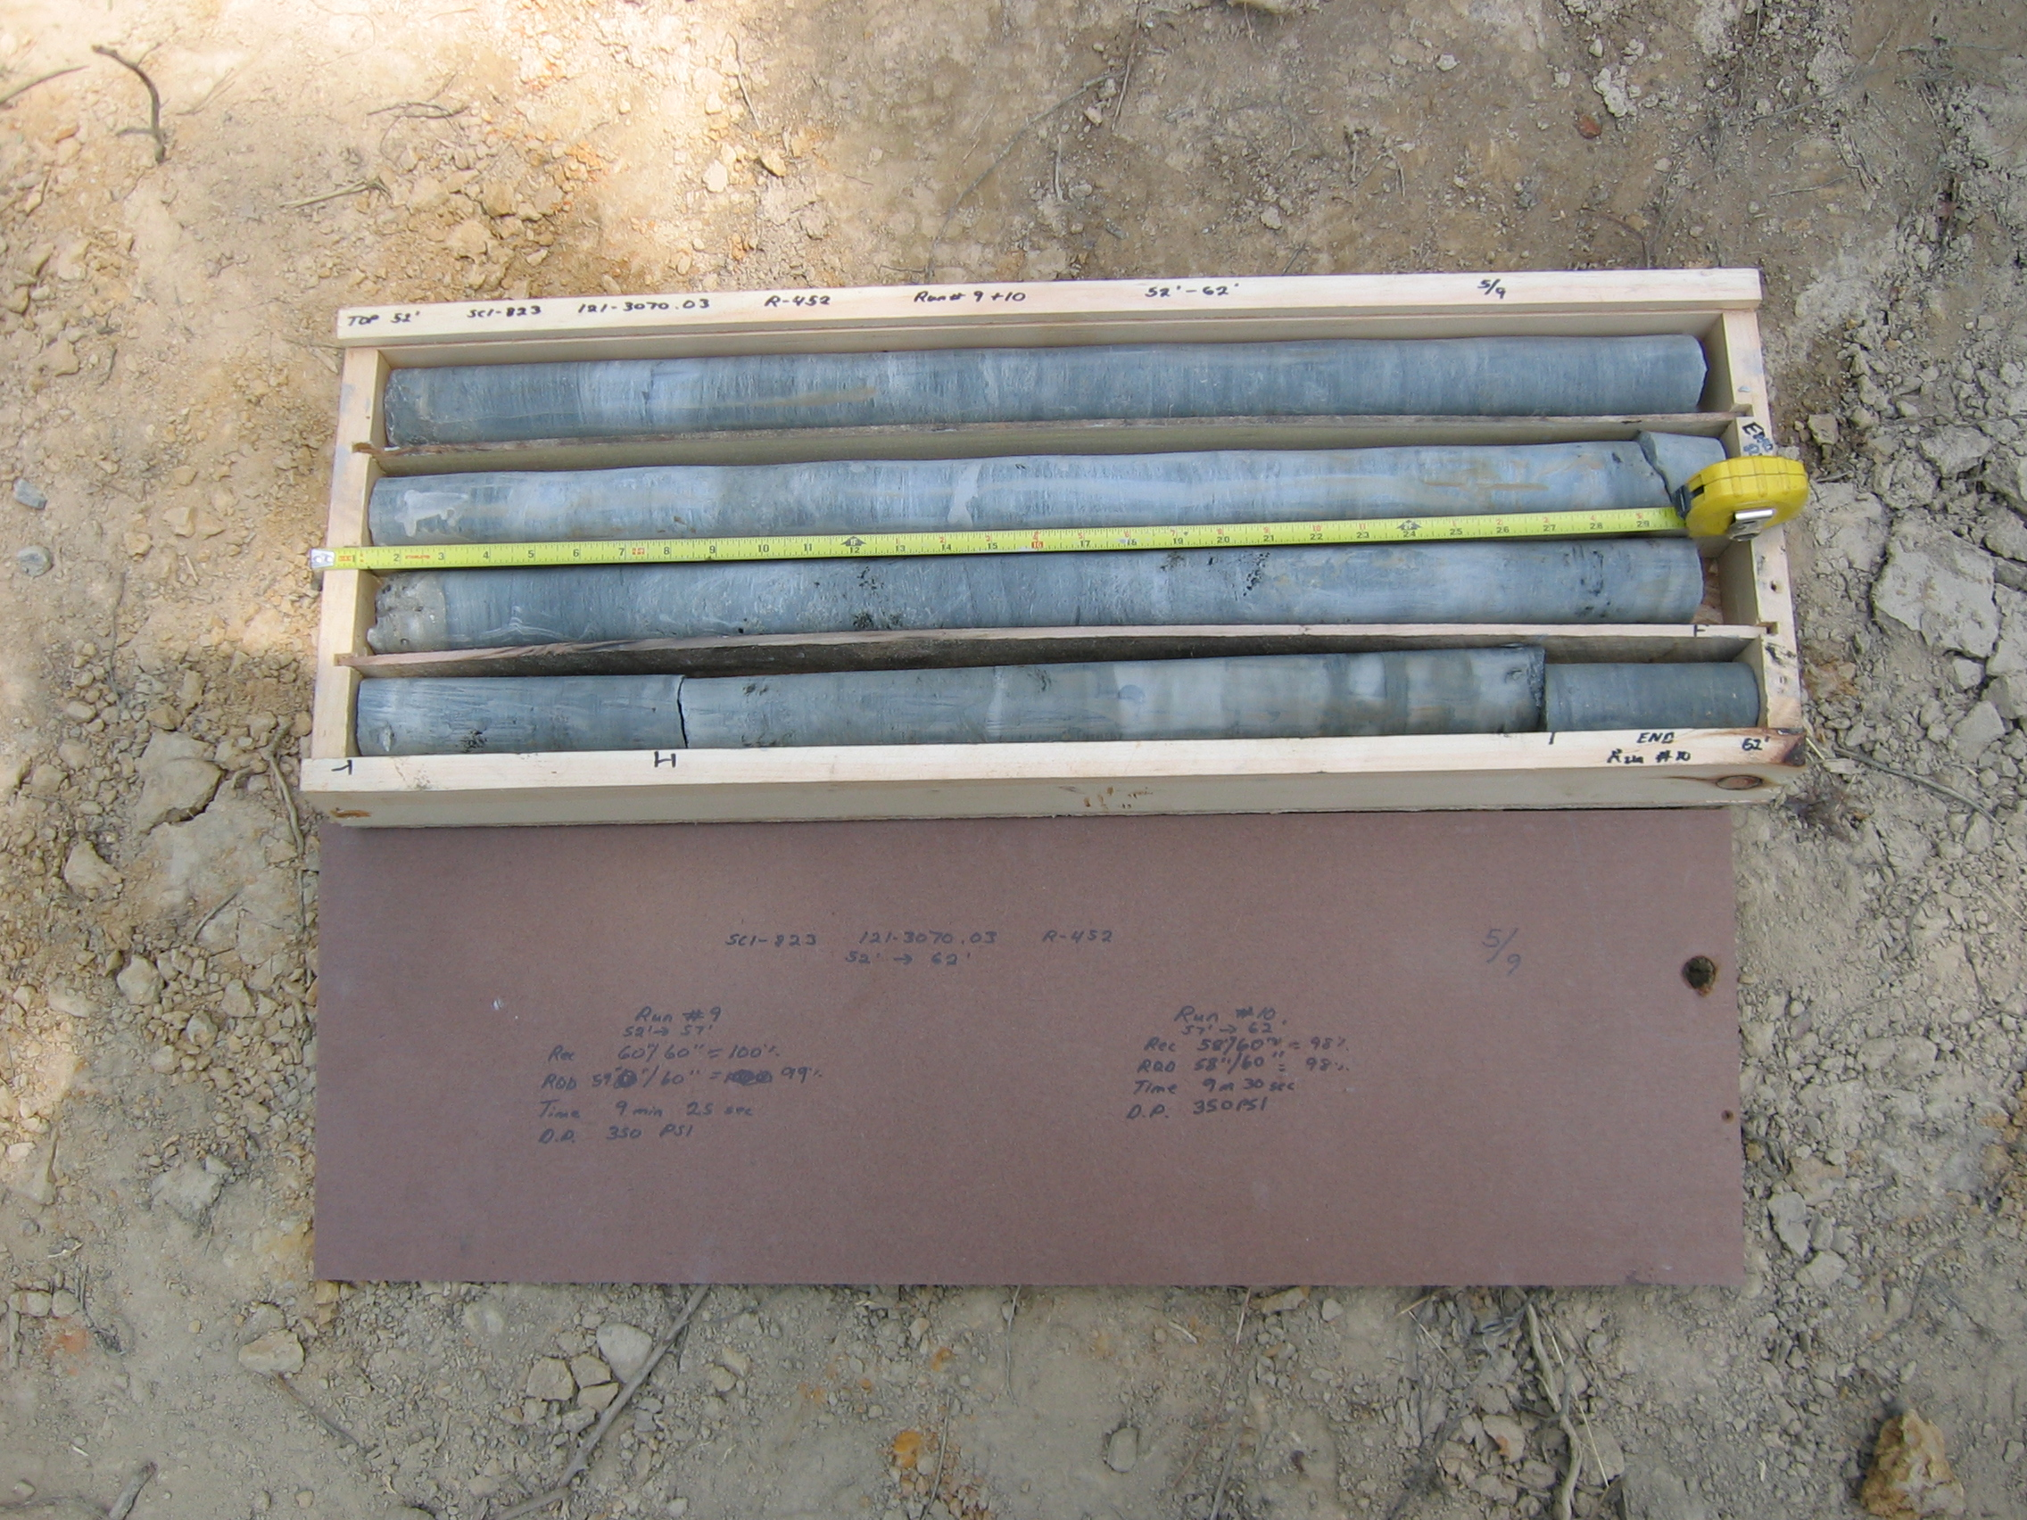
Photo 8. M:\proj\0121\3070.03\Core Photos\R-452\Rock Core Photos\R09&10a-17fld.JPG

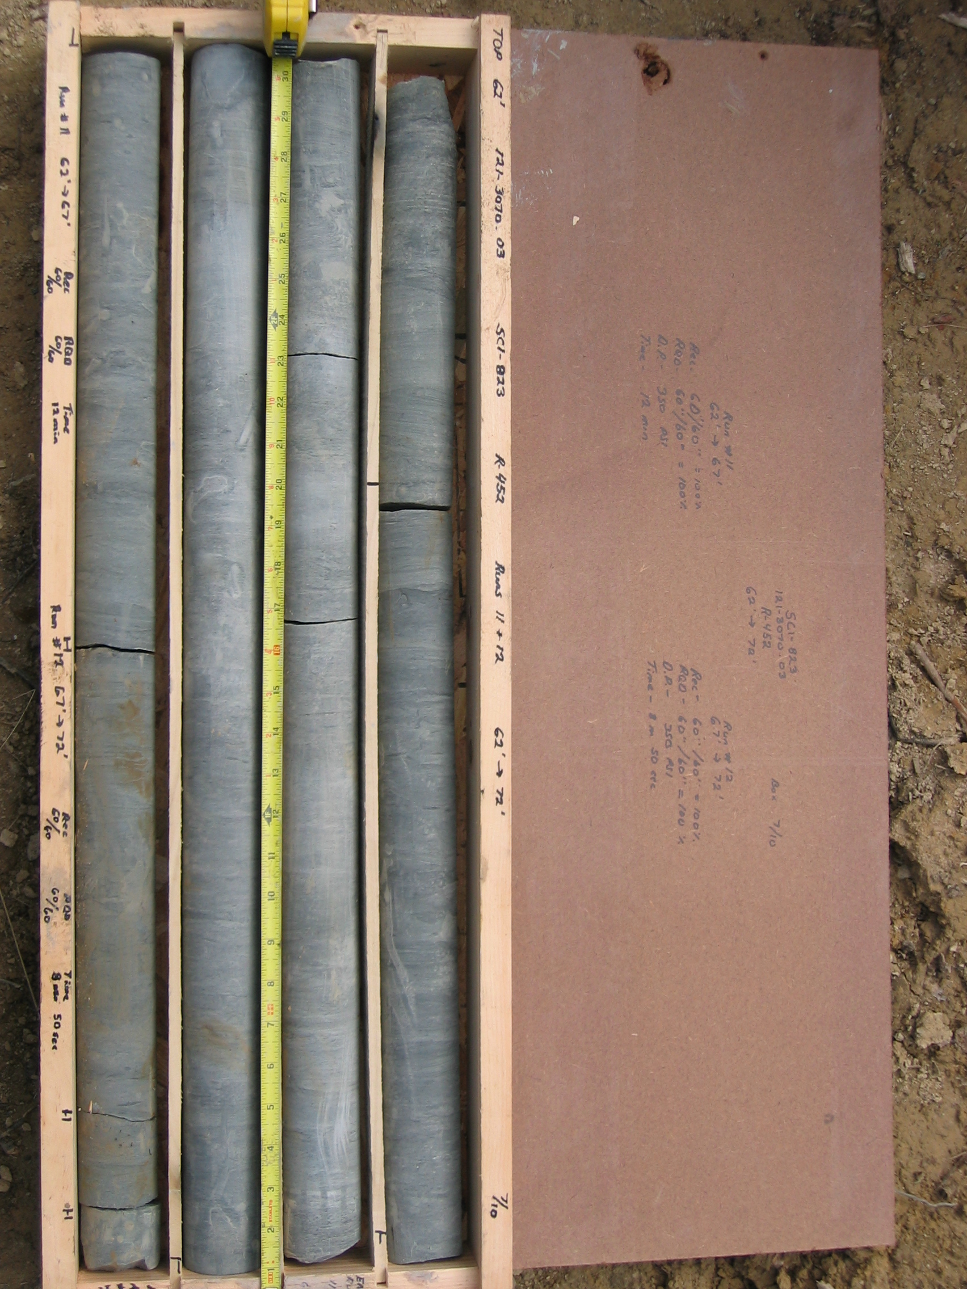
Photo 9. M:\proj\0121\3070.03\Core Photos\R-452\Rock Core Photos\R11&12-17fld.JPG

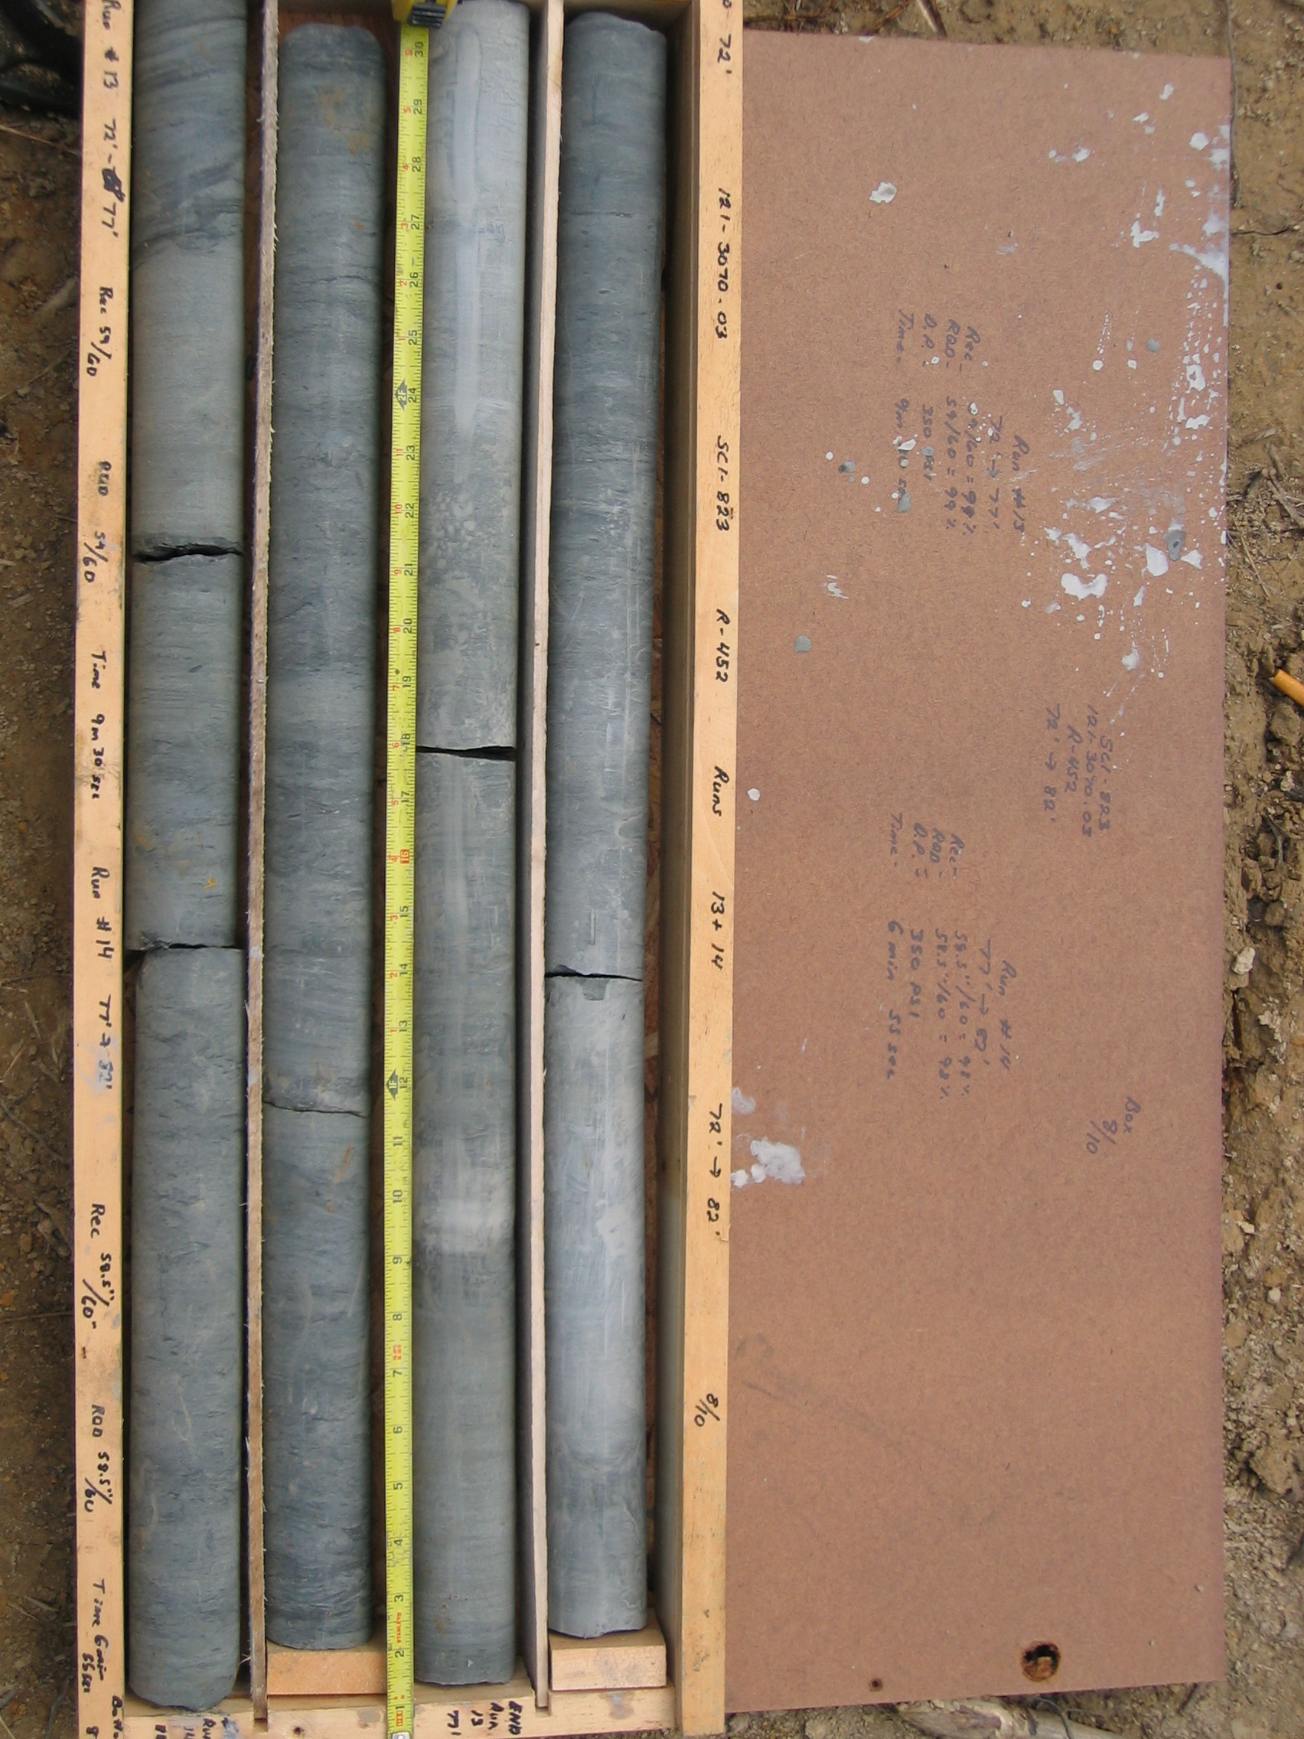
Photo 10. M:\proj\0121\3070.03\Core Photos\R-452\Rock Core Photos\R13&14-17fld.JPG

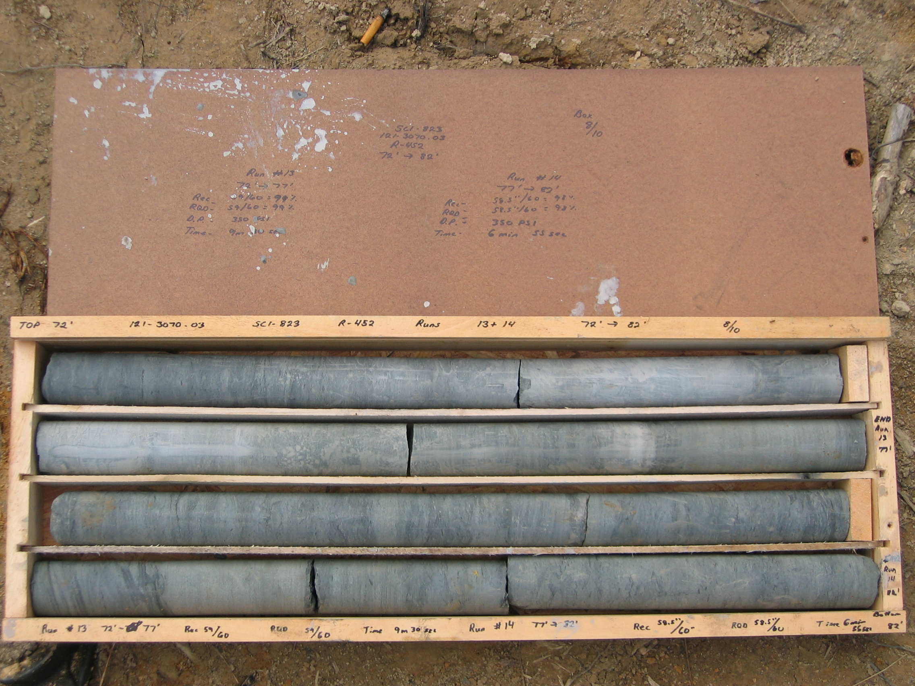
Photo 11. M:\proj\0121\3070.03\Core Photos\R-452\Rock Core Photos\R13&14a-17fld.JPG

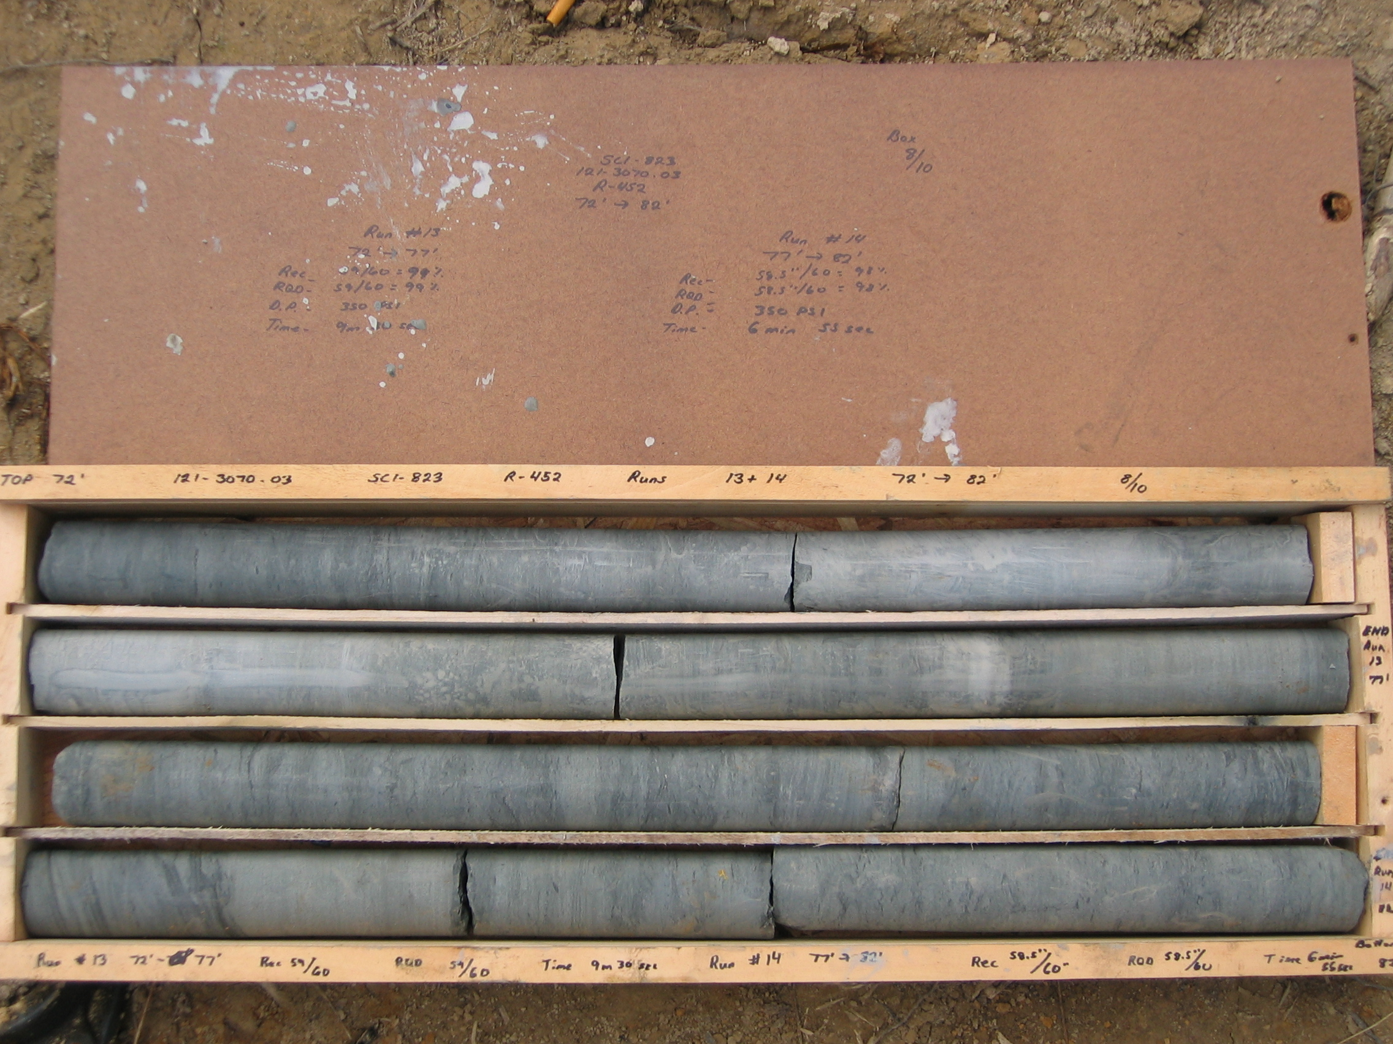
Photo 12. M:\proj\0121\3070.03\Core Photos\R-452\Rock Core Photos\R13&14b-17fld.JPG

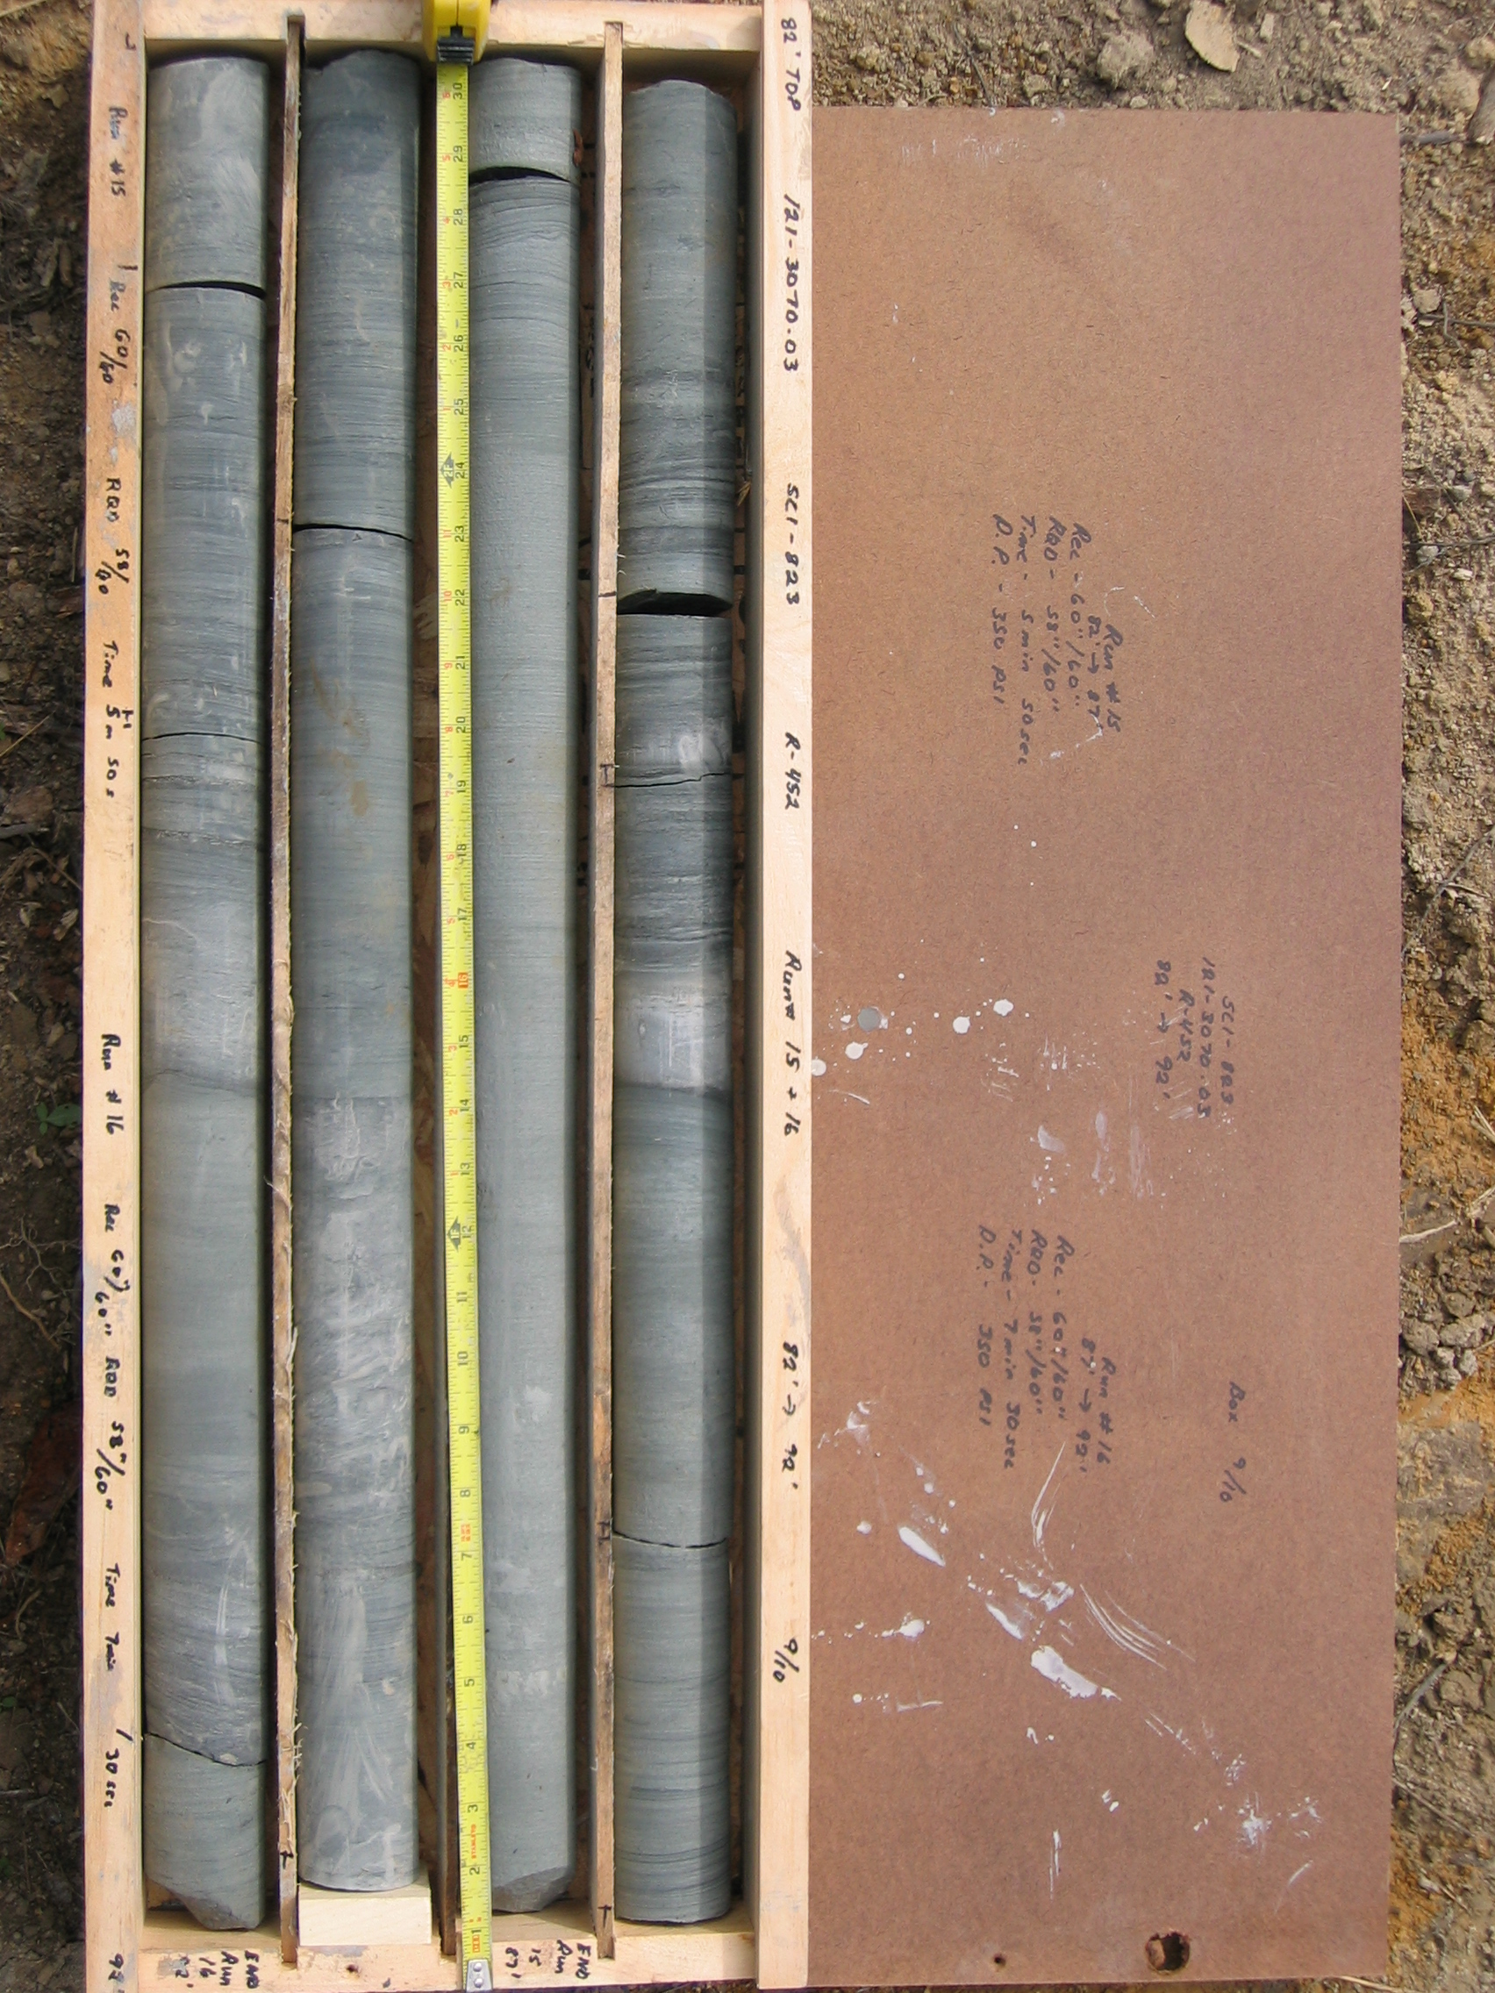
Photo 13. M:\proj\0121\3070.03\Core Photos\R-452\Rock Core Photos\R15&16-17fld.JPG

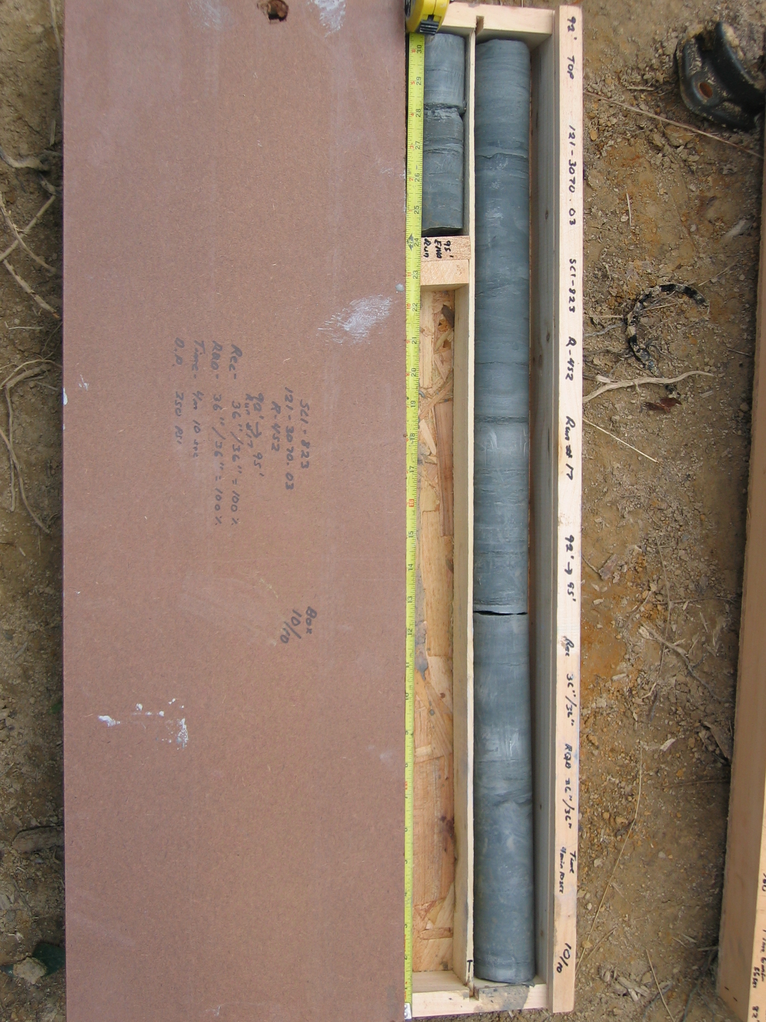
Photo 14. M:\proj\0121\3070.03\Core Photos\R-452\Rock Core Photos\R17-17fld.JPG

