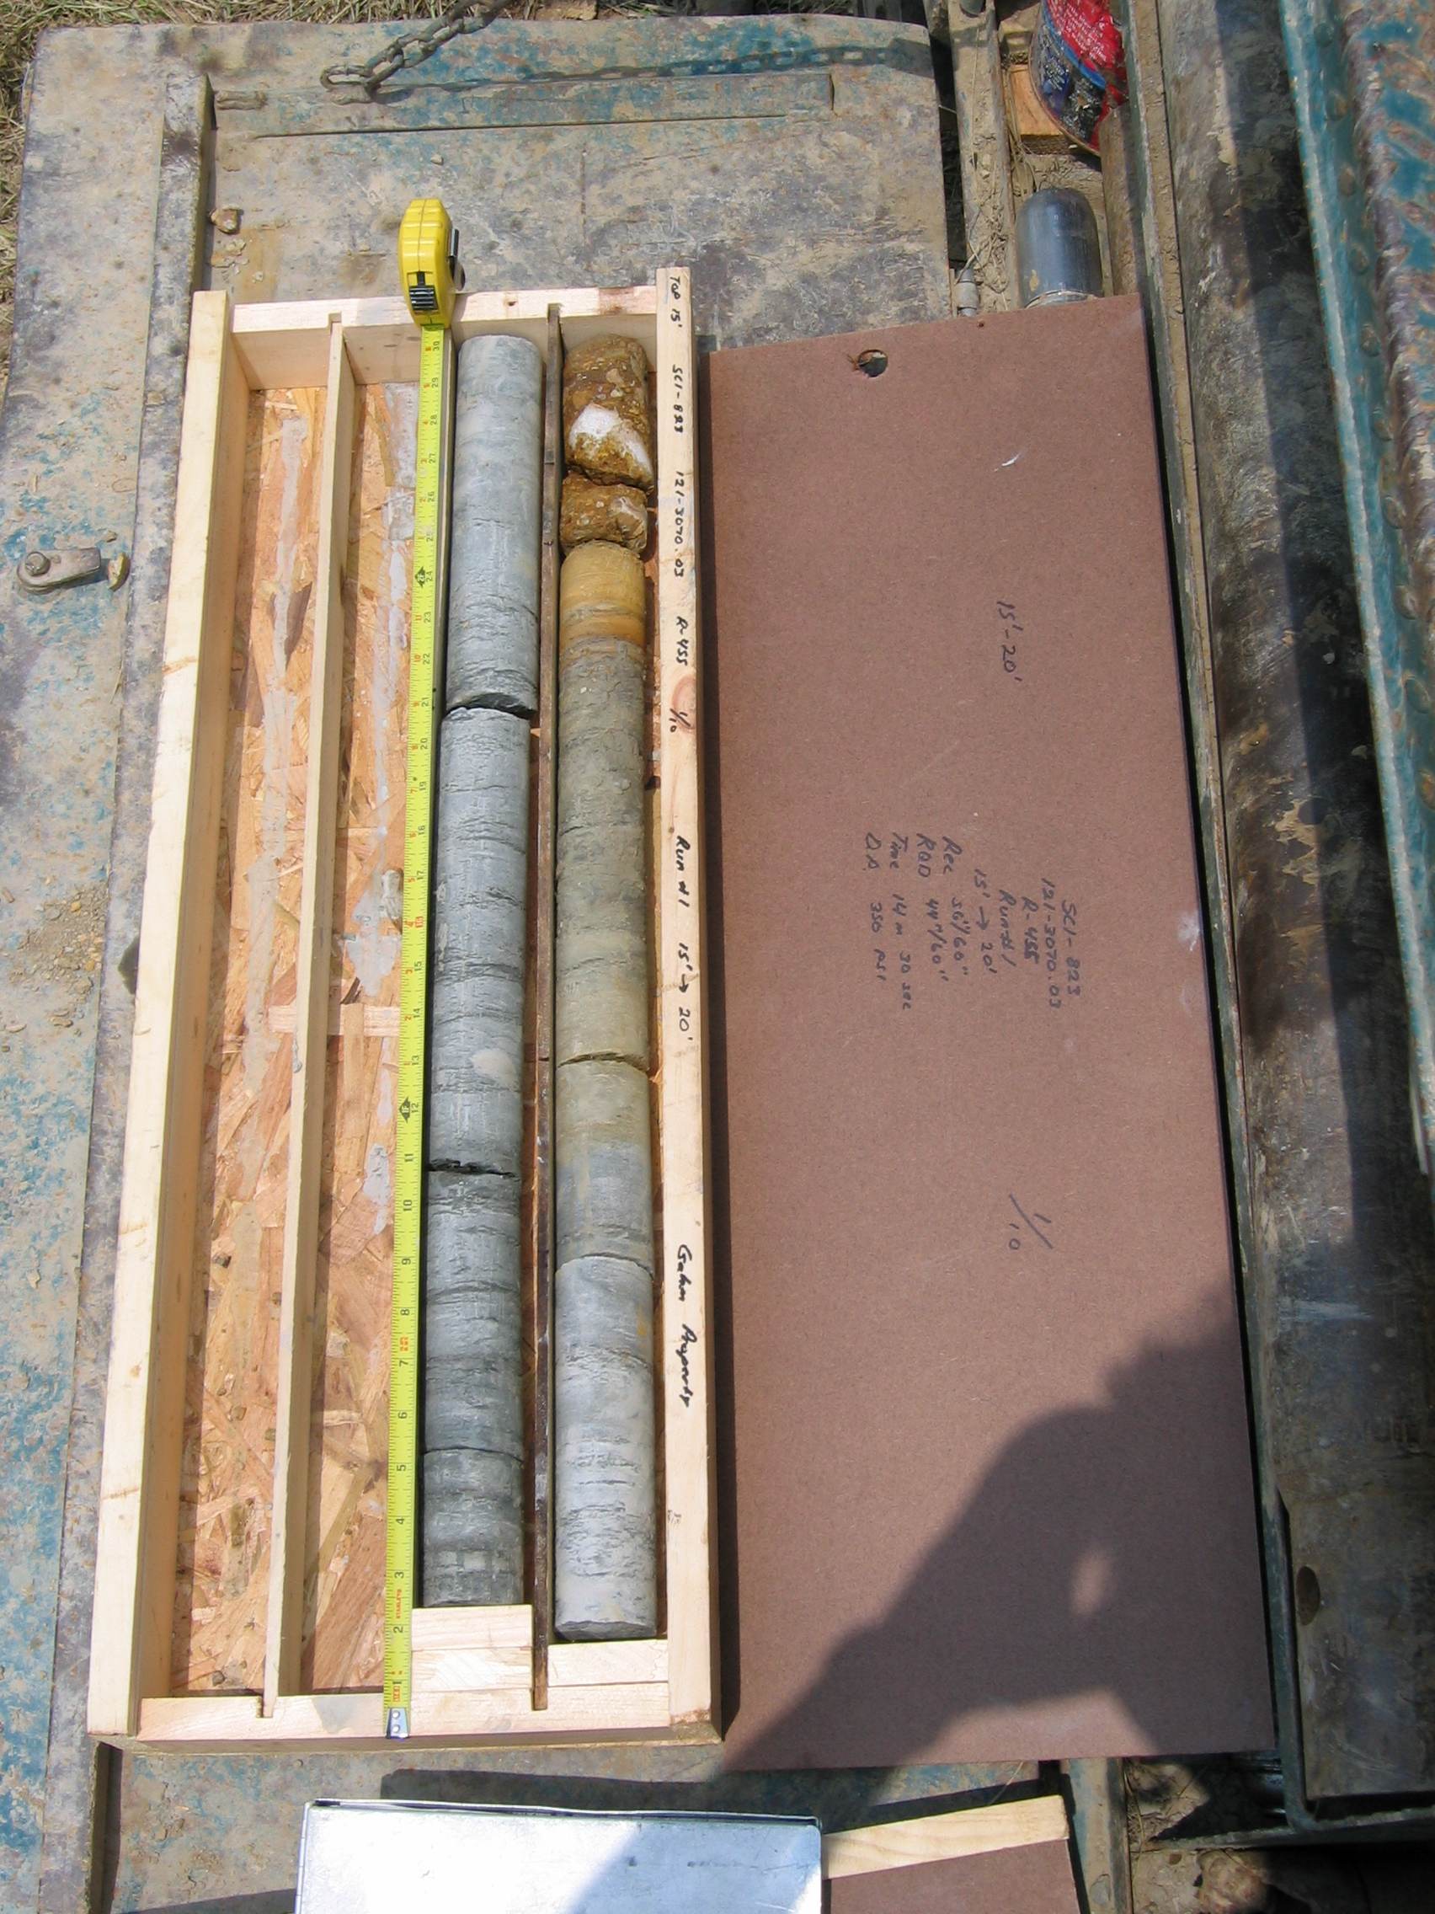
Photo 1. M:\proj\0121\3070.03\Core Photos\R-455\Rock Core Photos\R01-10fld.JPG

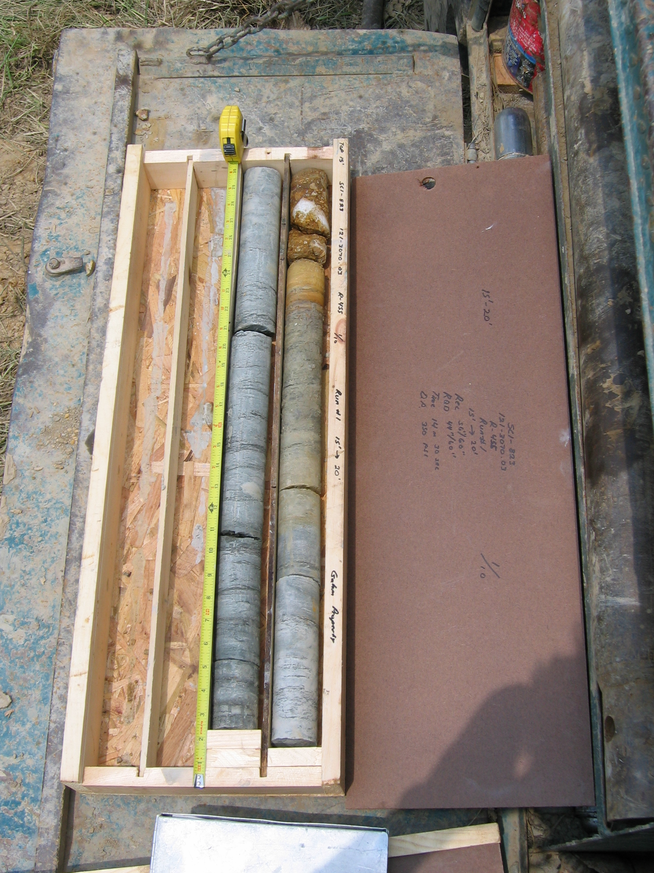
Photo 2. M:\proj\0121\3070.03\Core Photos\R-455\Rock Core Photos\R01a-10fld.JPG

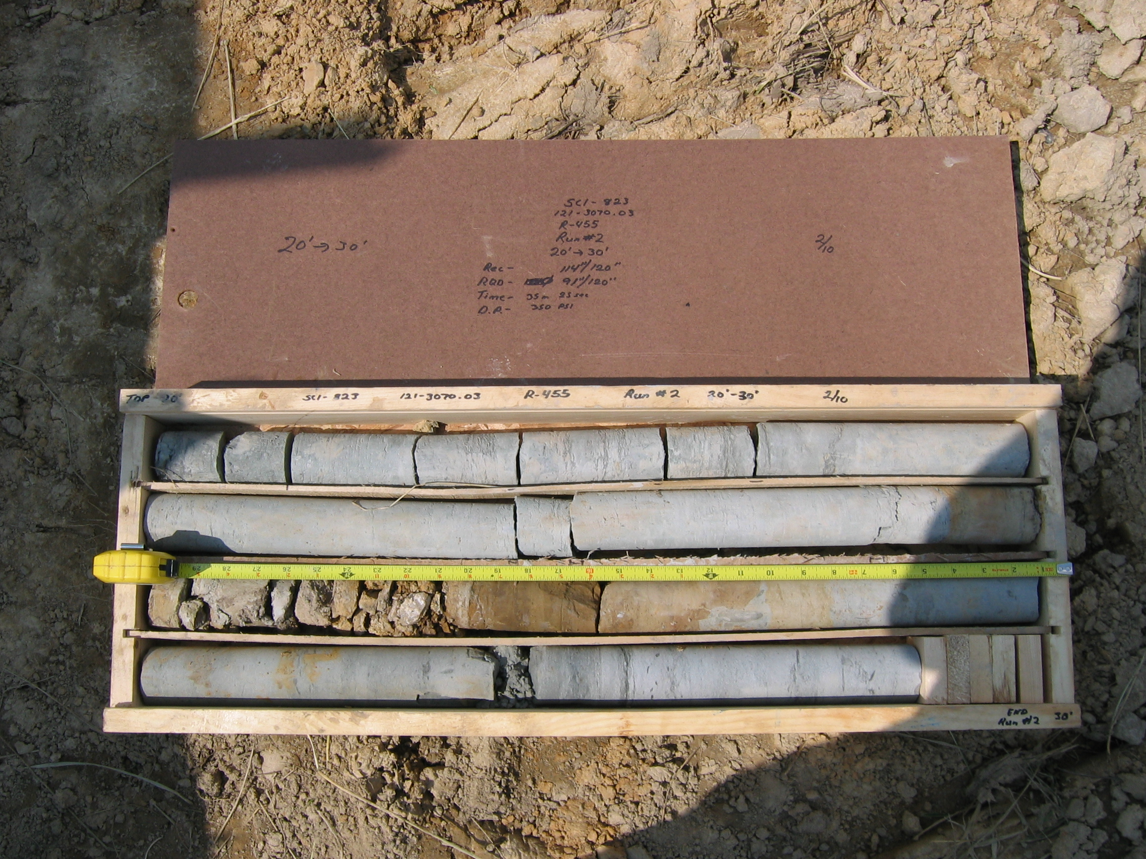
Photo 3. M:\proj\0121\3070.03\Core Photos\R-455\Rock Core Photos\R02-10fld.JPG

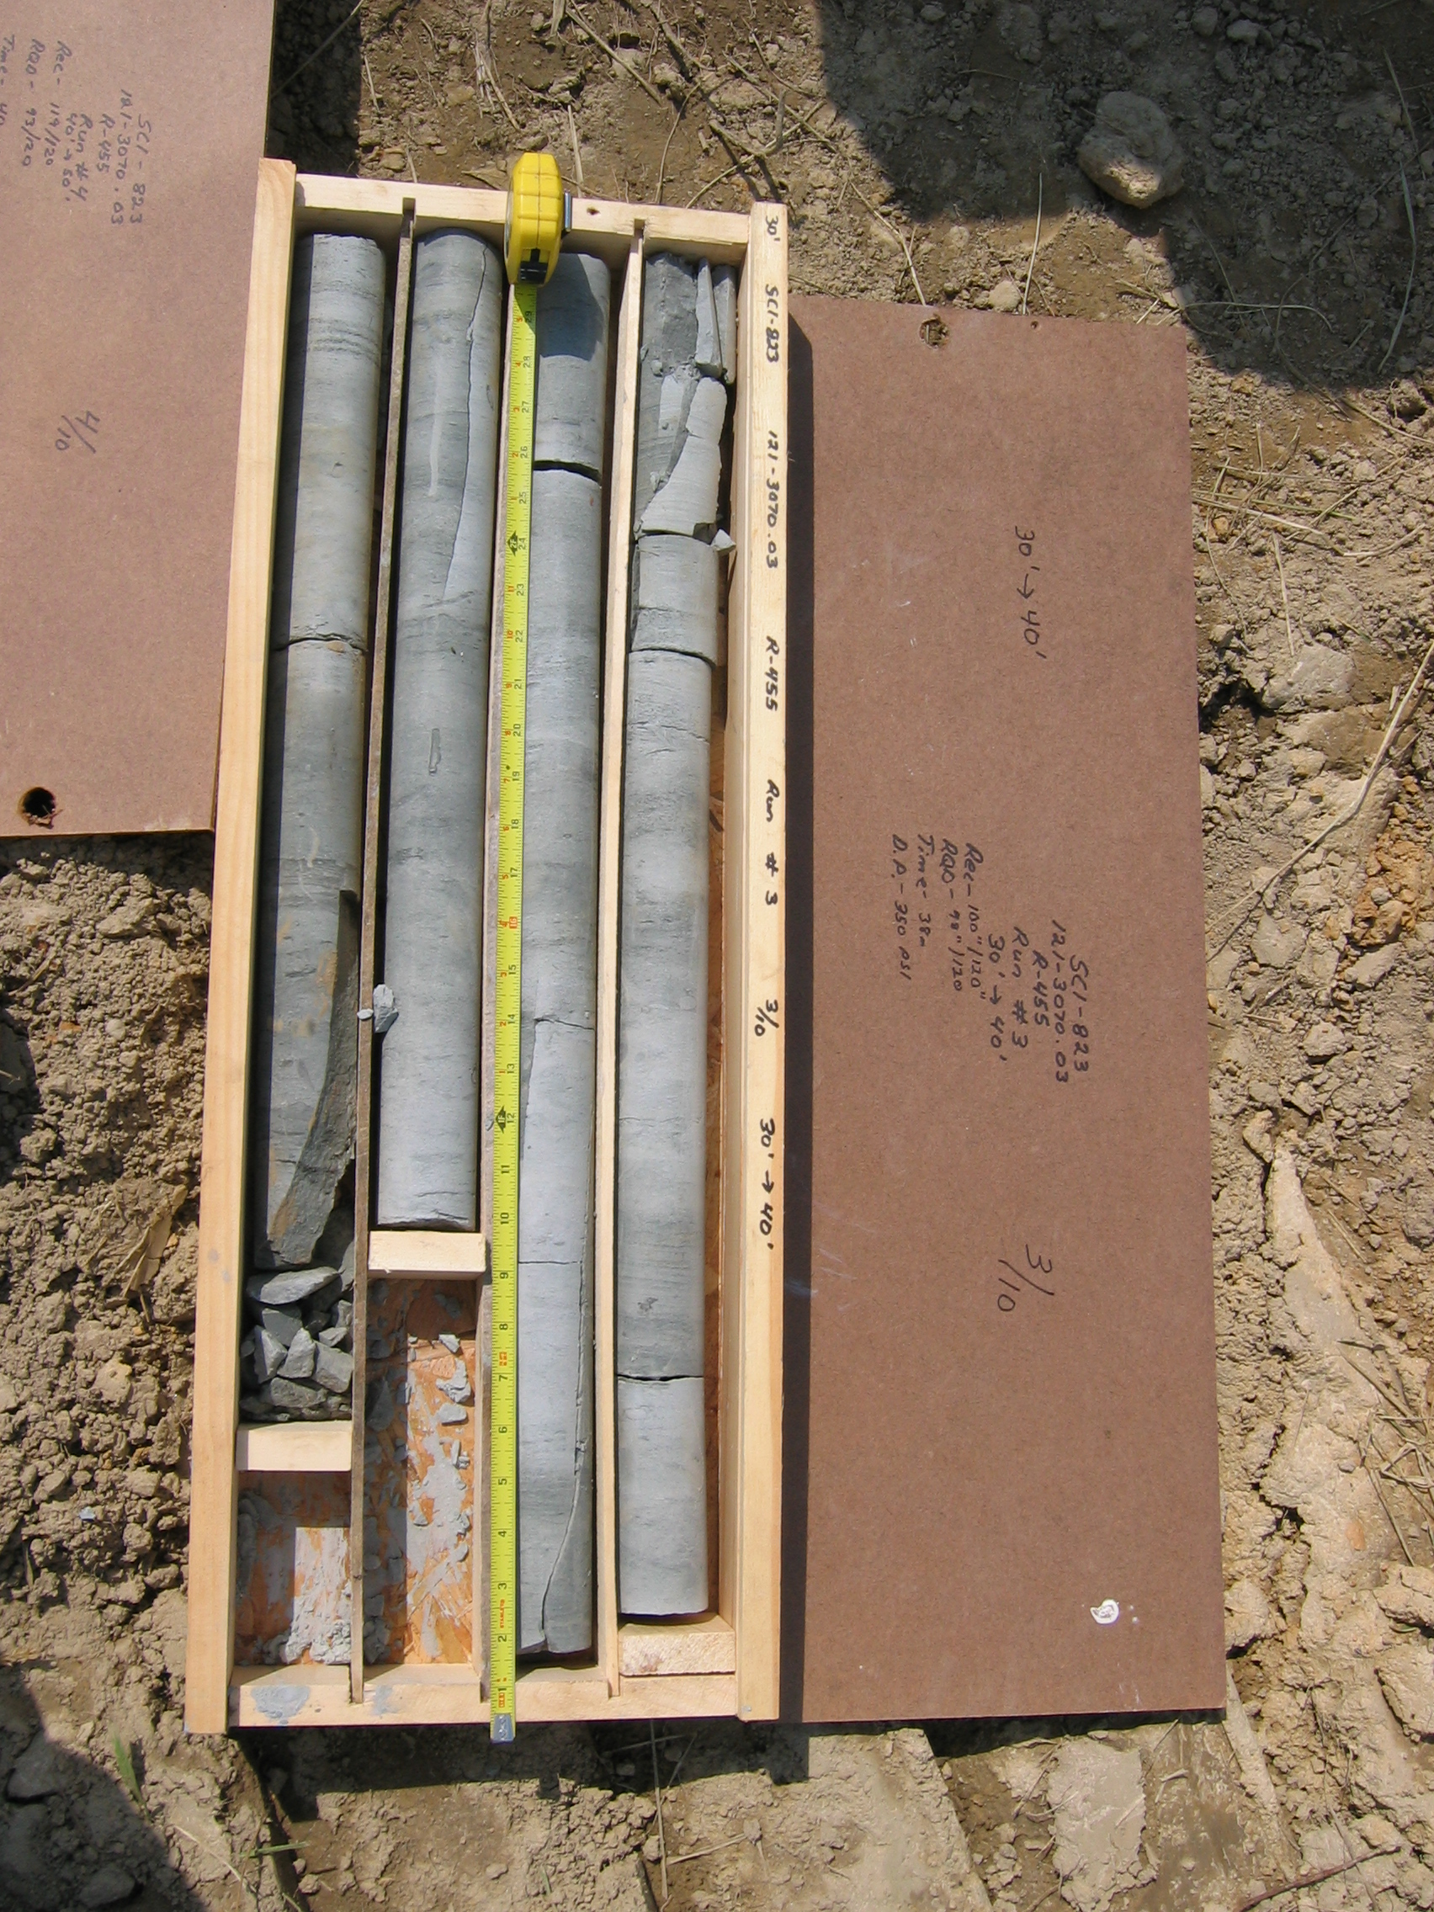
Photo 4. M:\proj\0121\3070.03\Core Photos\R-455\Rock Core Photos\R03-10fld.JPG

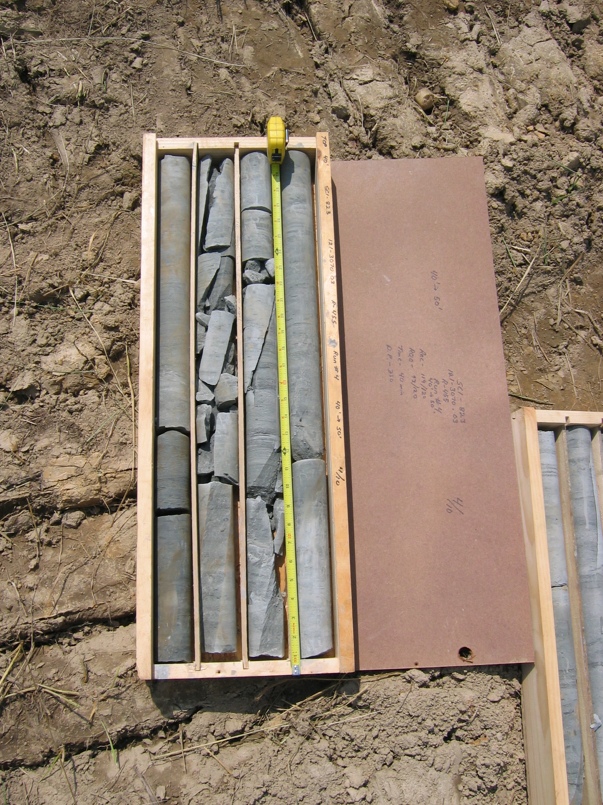
Photo 5. M:\proj\0121\3070.03\Core Photos\R-455\Rock Core Photos\R04-10fld.JPG

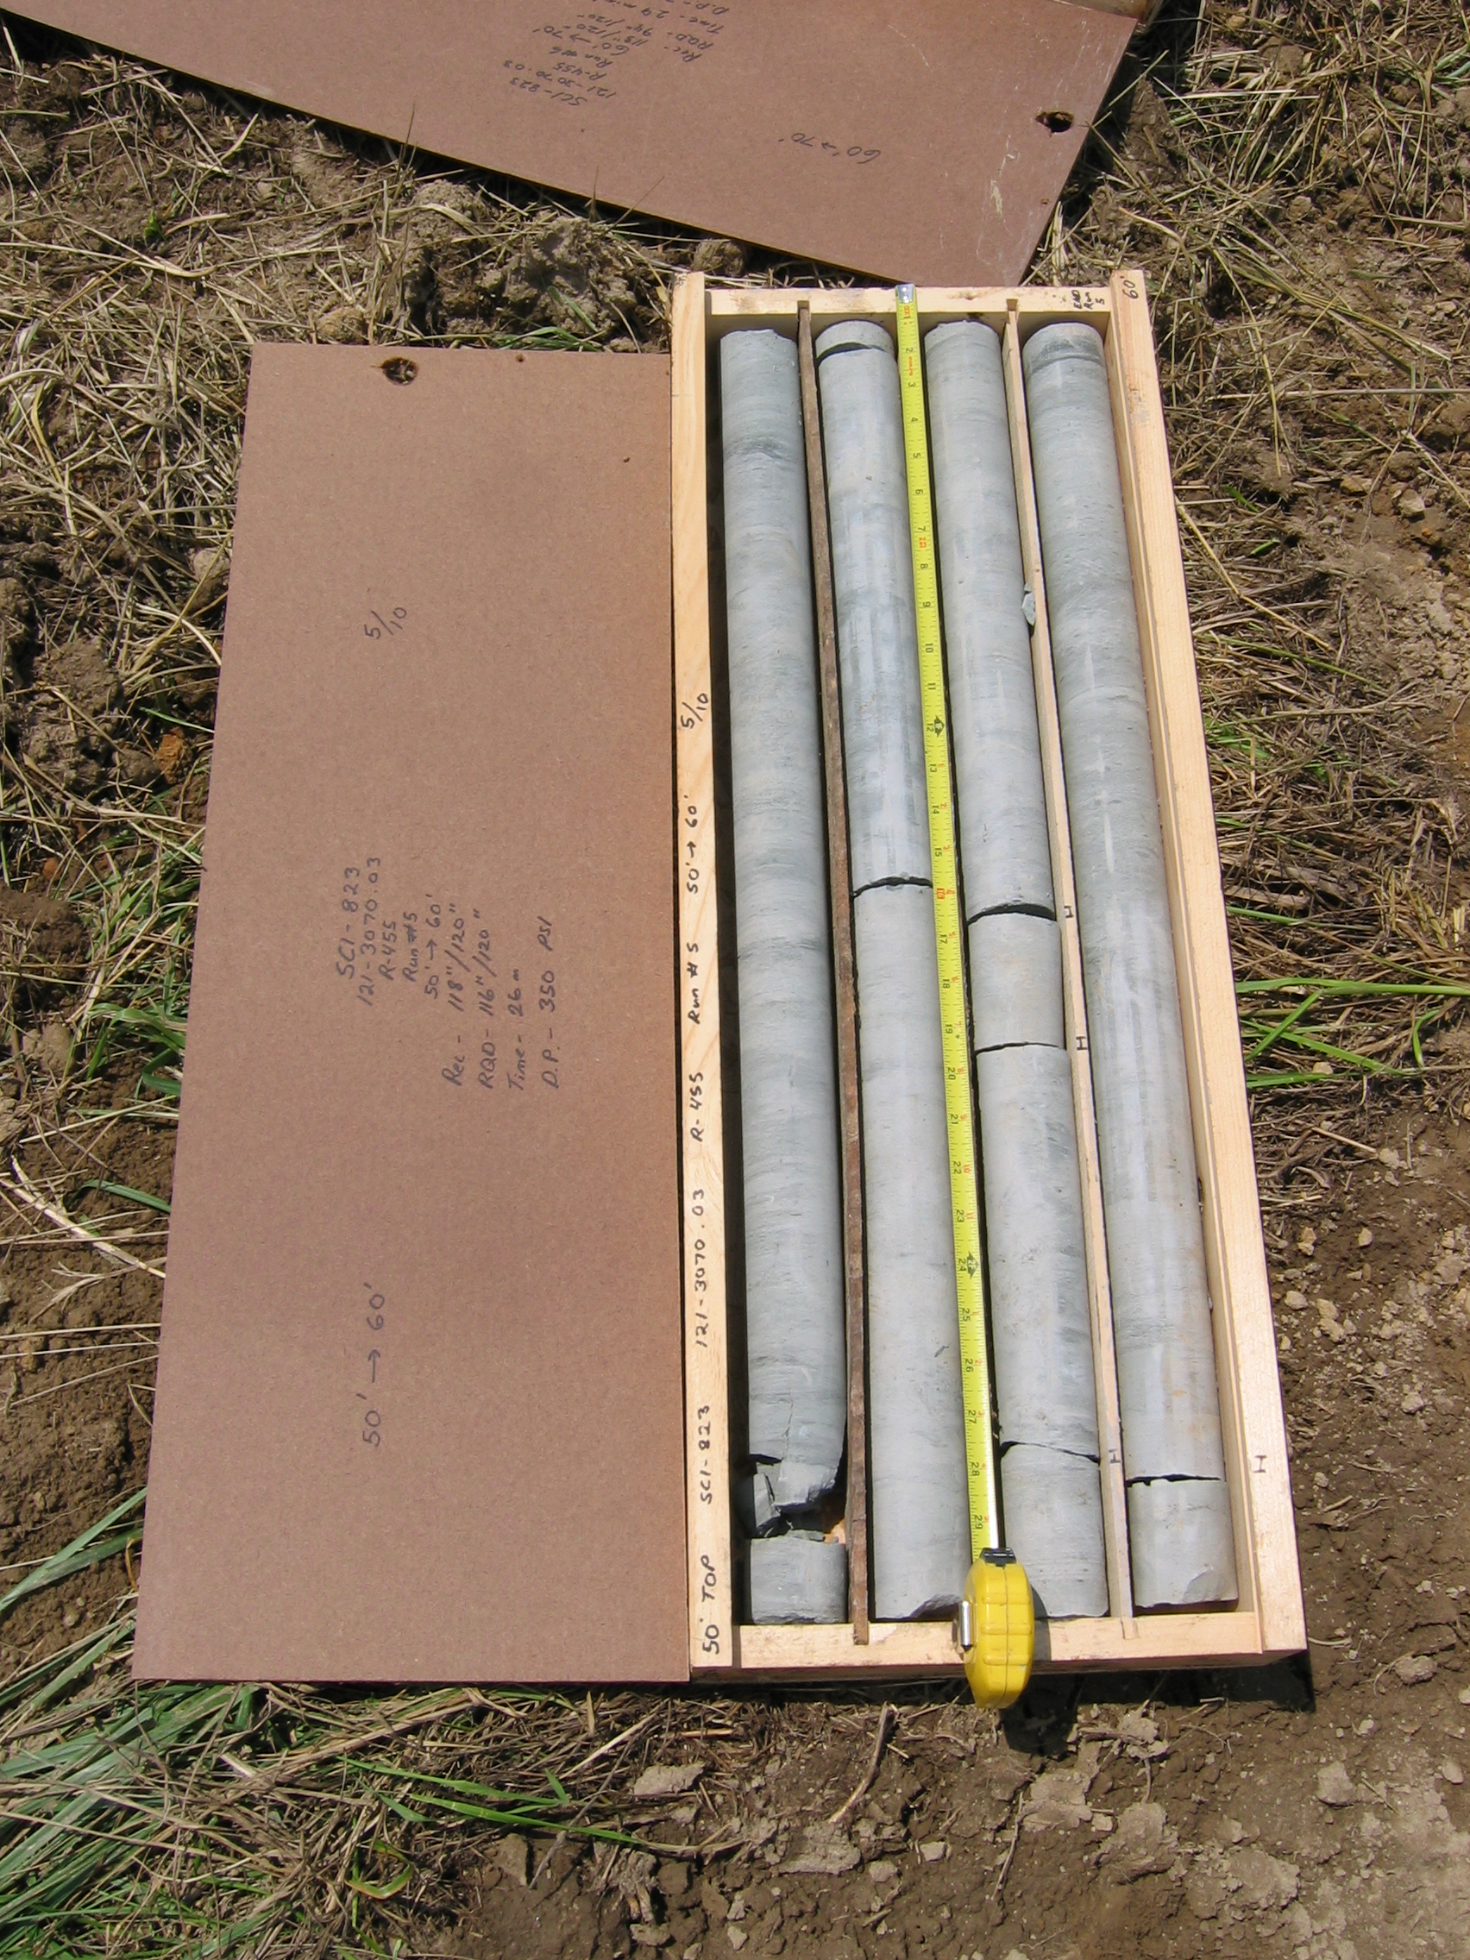
Photo 6. M:\proj\0121\3070.03\Core Photos\R-455\Rock Core Photos\R05-10fld.JPG

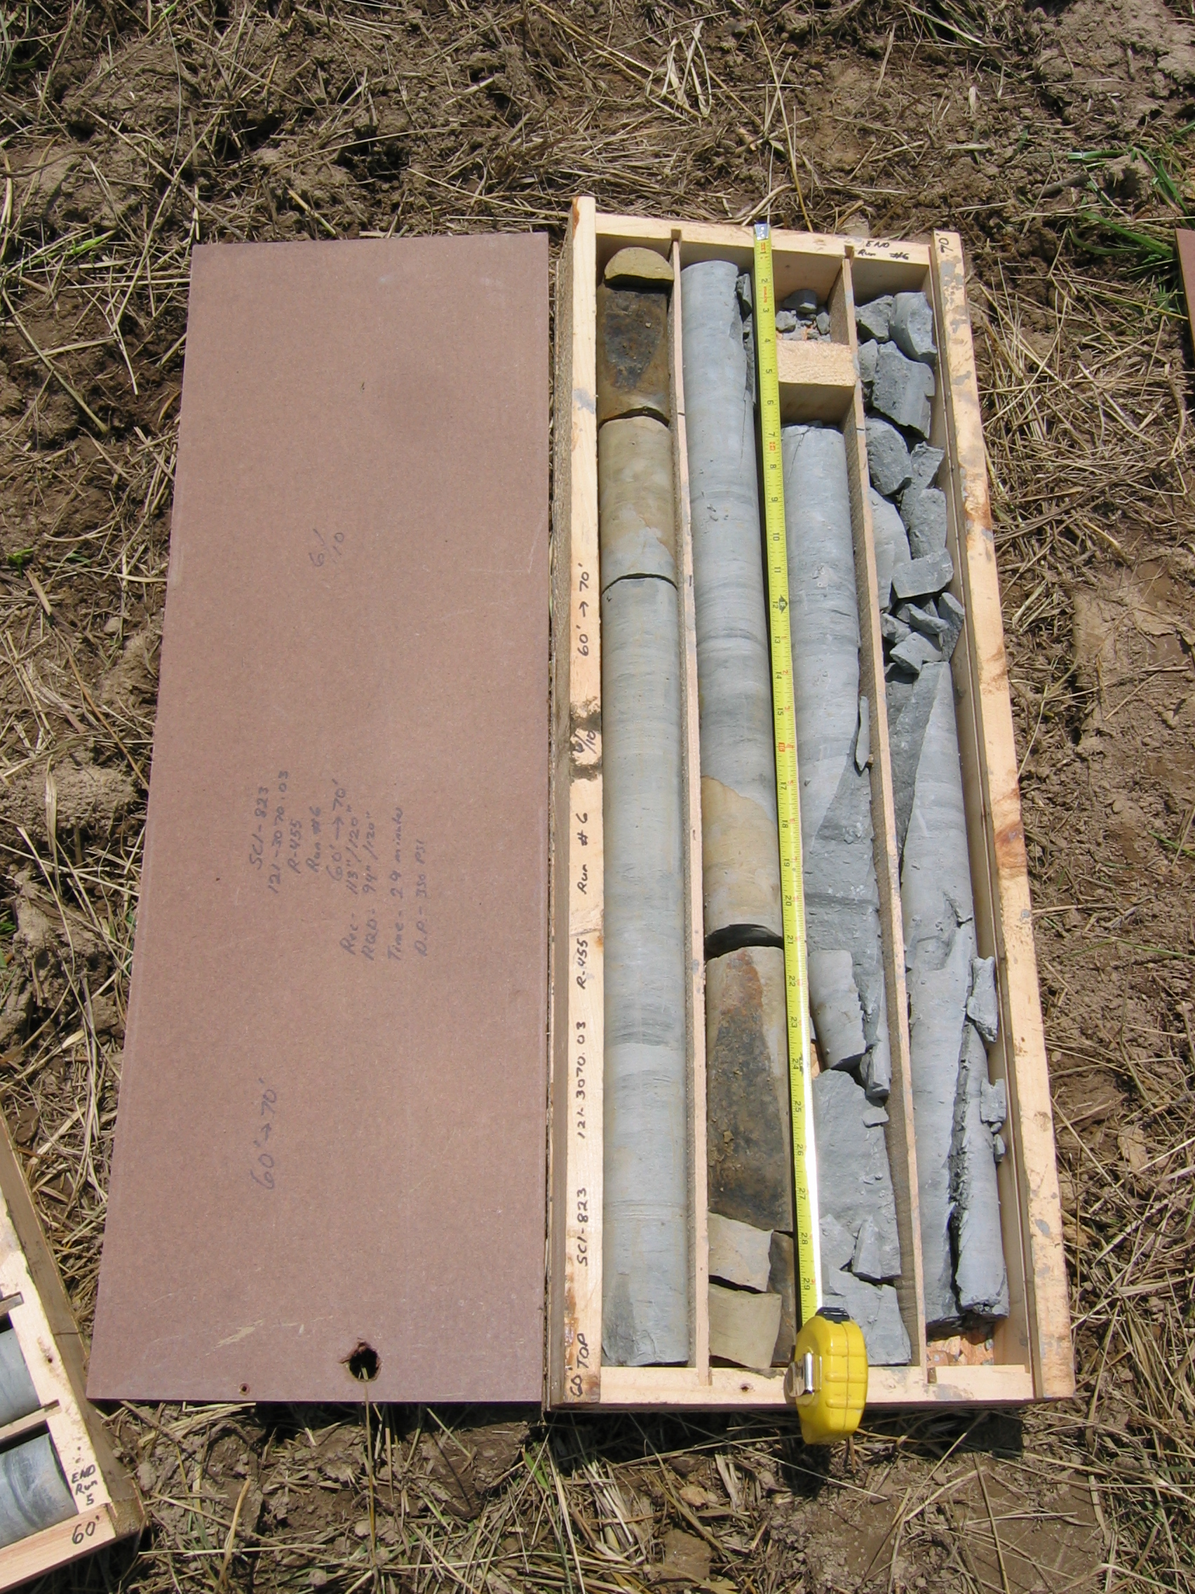
Photo 7. M:\proj\0121\3070.03\Core Photos\R-455\Rock Core Photos\R06-10fld.JPG

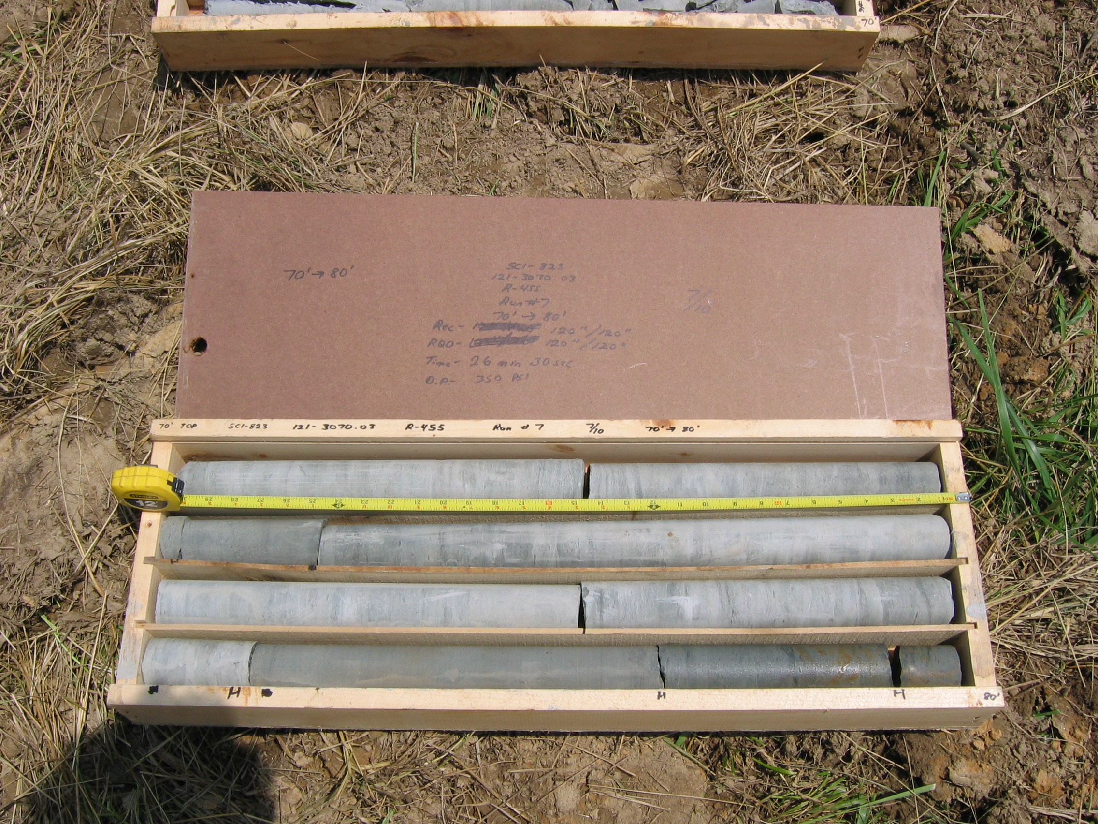
Photo 8. M:\proj\0121\3070.03\Core Photos\R-455\Rock Core Photos\R07-10fld.JPG

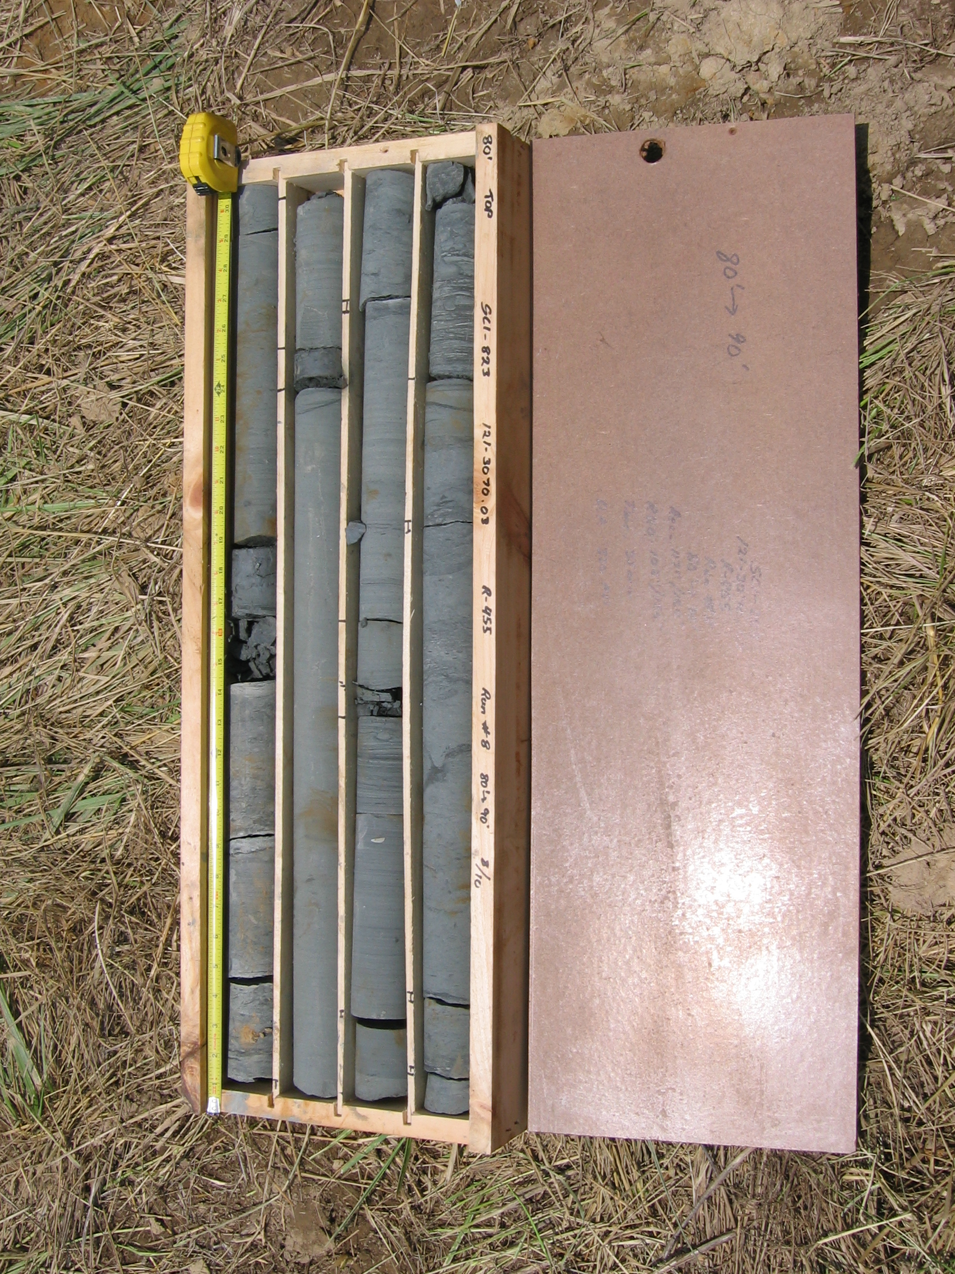
Photo 9. M:\proj\0121\3070.03\Core Photos\R-455\Rock Core Photos\R08-10fld.JPG

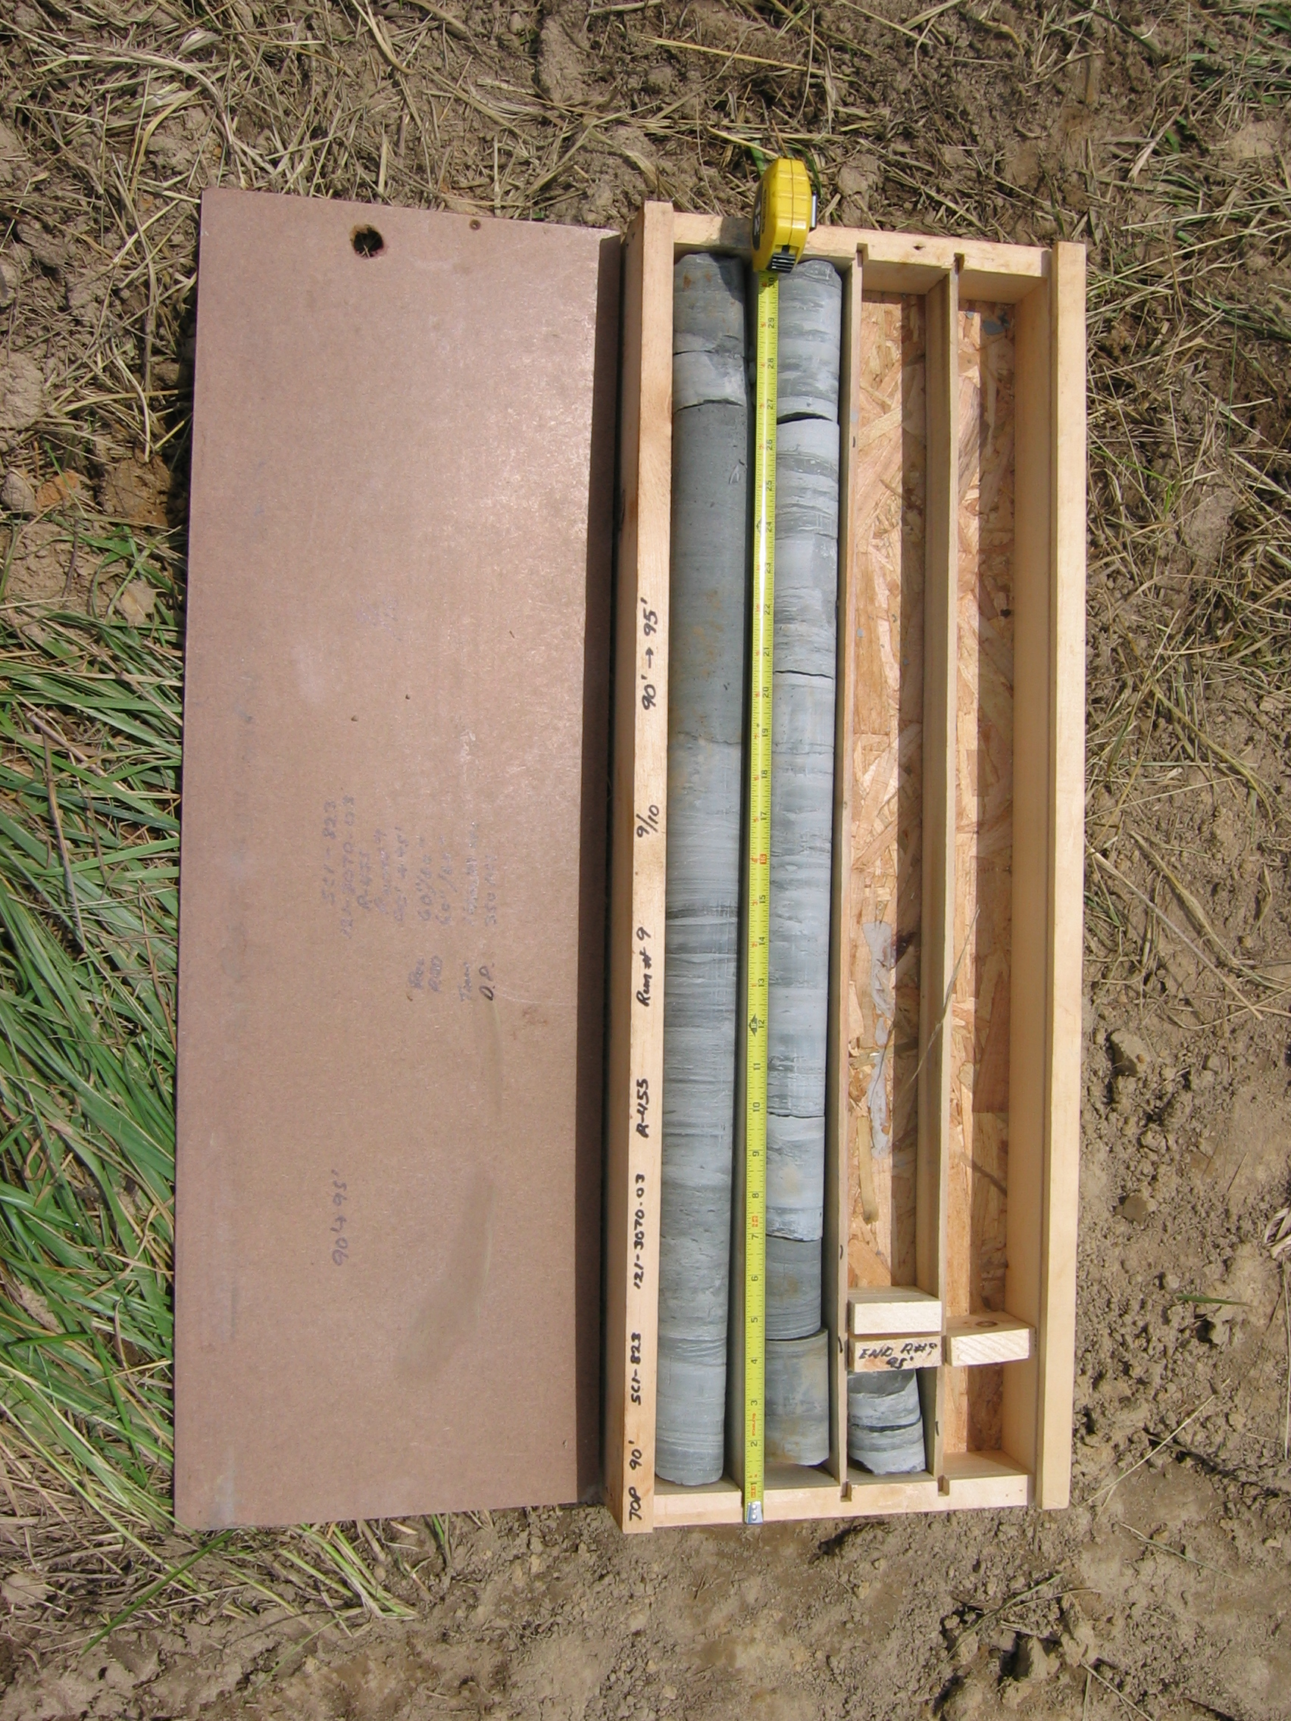
Photo 10. M:\proj\0121\3070.03\Core Photos\R-455\Rock Core Photos\R09-10fld.JPG

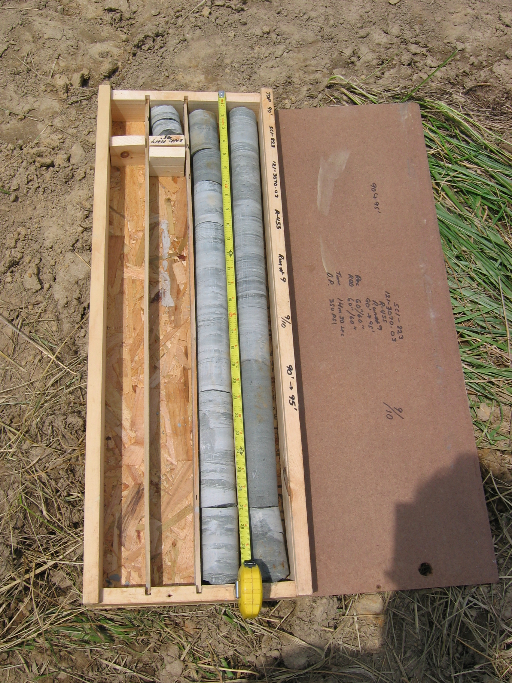
Photo 11. M:\proj\0121\3070.03\Core Photos\R-455\Rock Core Photos\R09a-10fld.JPG

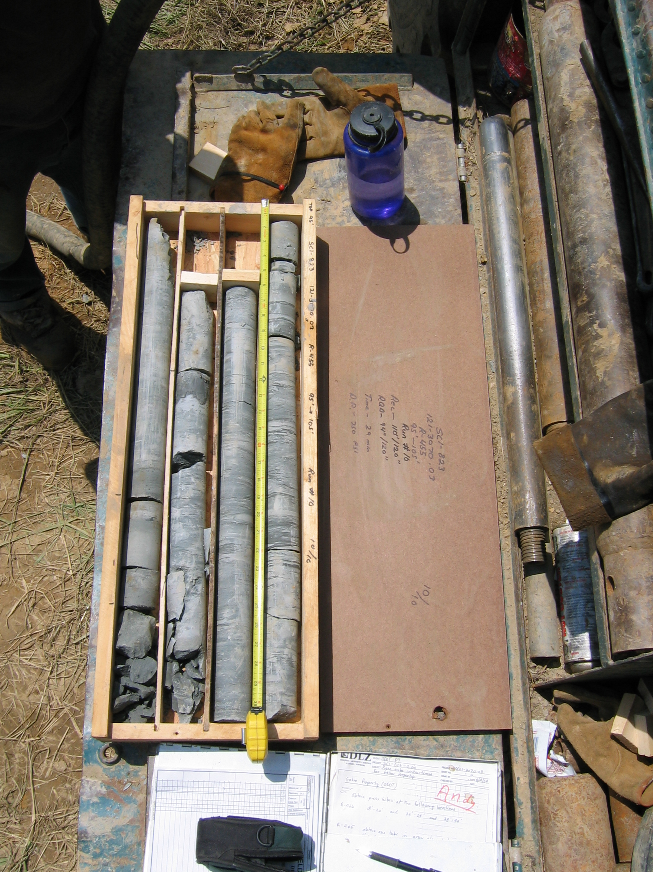
Photo 12. M:\proj\0121\3070.03\Core Photos\R-455\Rock Core Photos\R10-10fld.JPG

