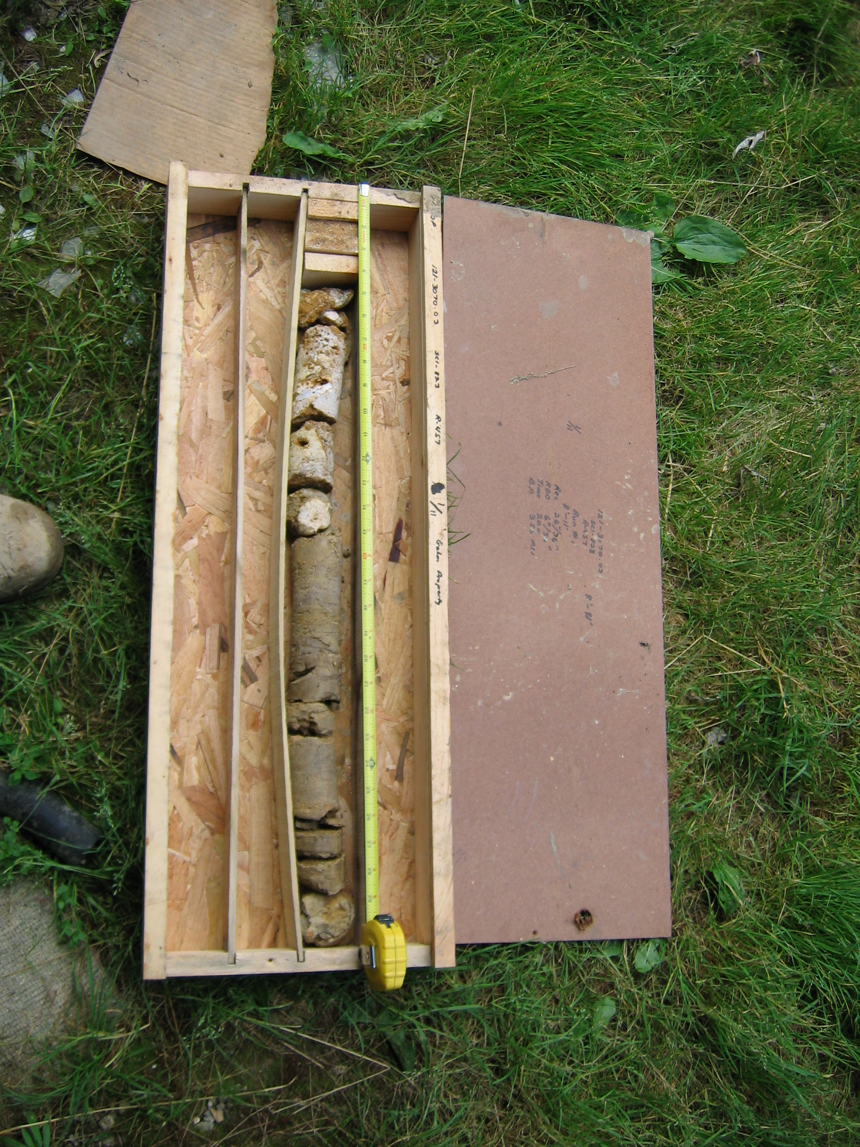
Photo 1. M:\proj\0121\3070.03\Core Photos\R-457\Rock Core Photos\R01-11fld.JPG

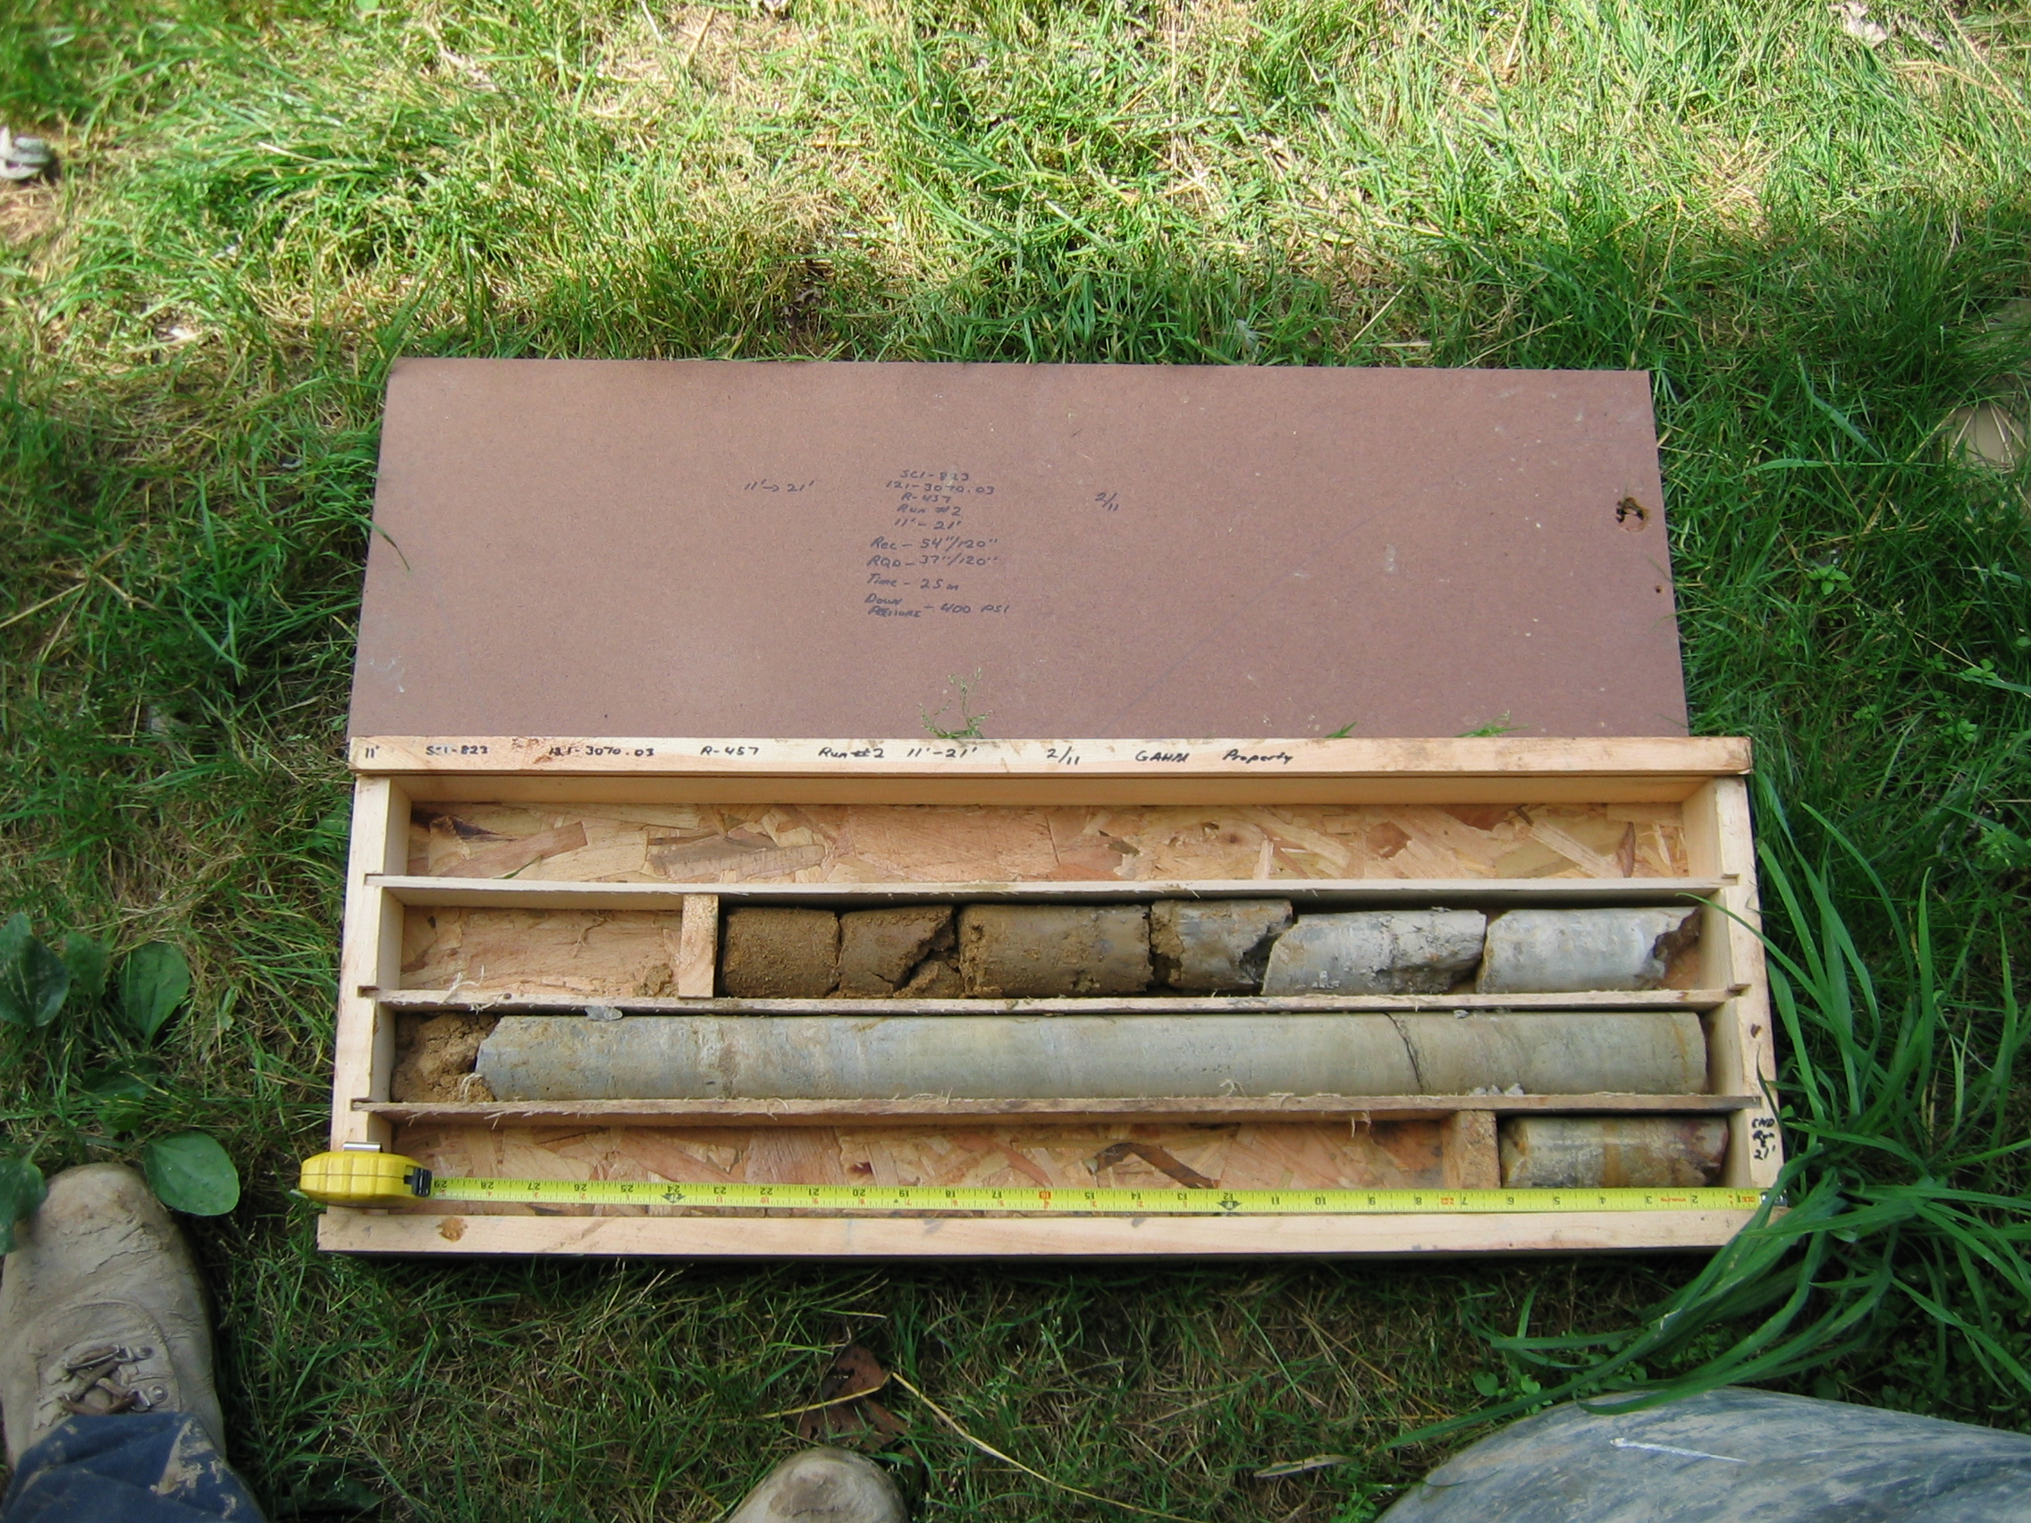
Photo 2. M:\proj\0121\3070.03\Core Photos\R-457\Rock Core Photos\R02-11fld.JPG

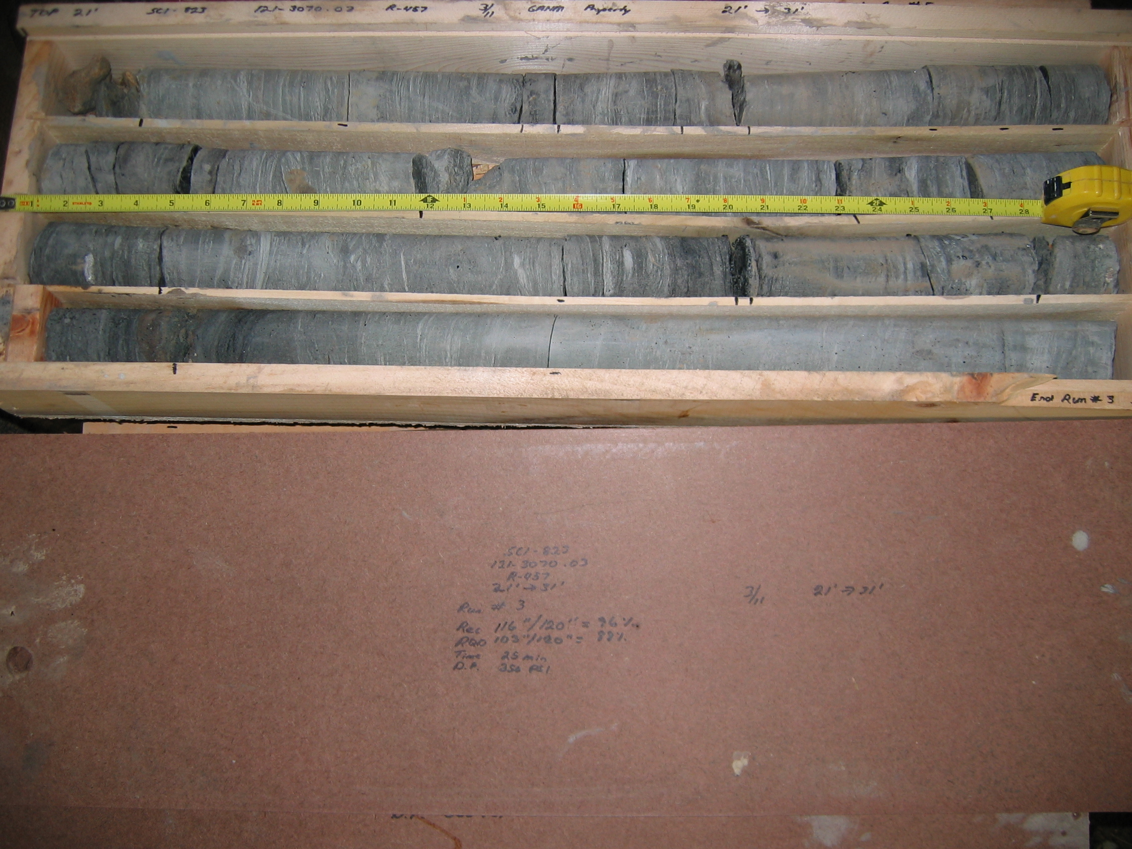
Photo 3. M:\proj\0121\3070.03\Core Photos\R-457\Rock Core Photos\R03-11fld.JPG

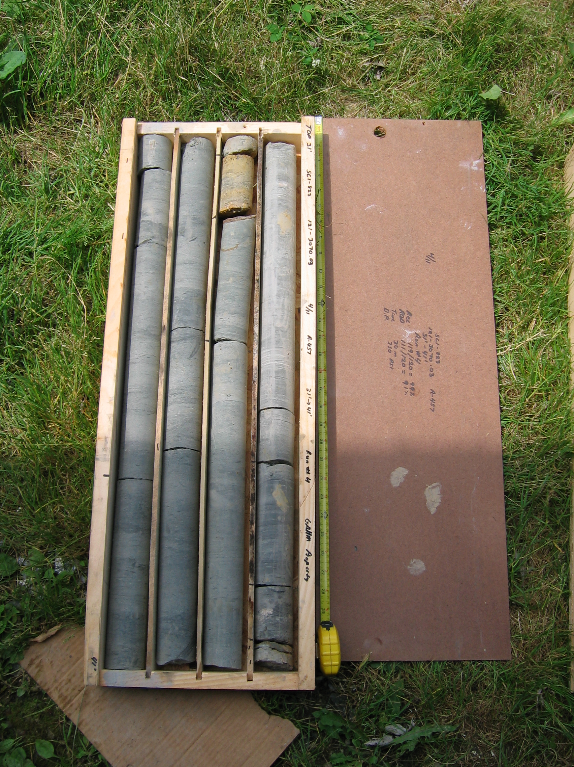
Photo 4. M:\proj\0121\3070.03\Core Photos\R-457\Rock Core Photos\R04-11fld.JPG

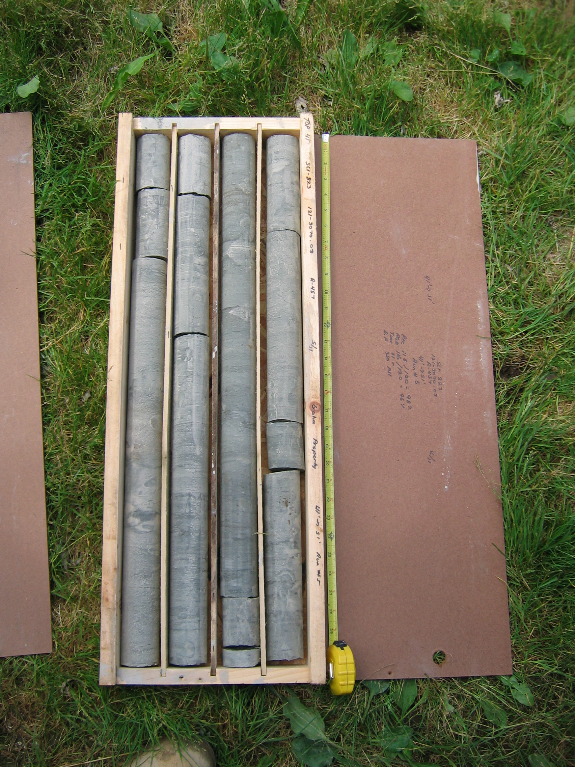
Photo 5. M:\proj\0121\3070.03\Core Photos\R-457\Rock Core Photos\R05-11fld.JPG

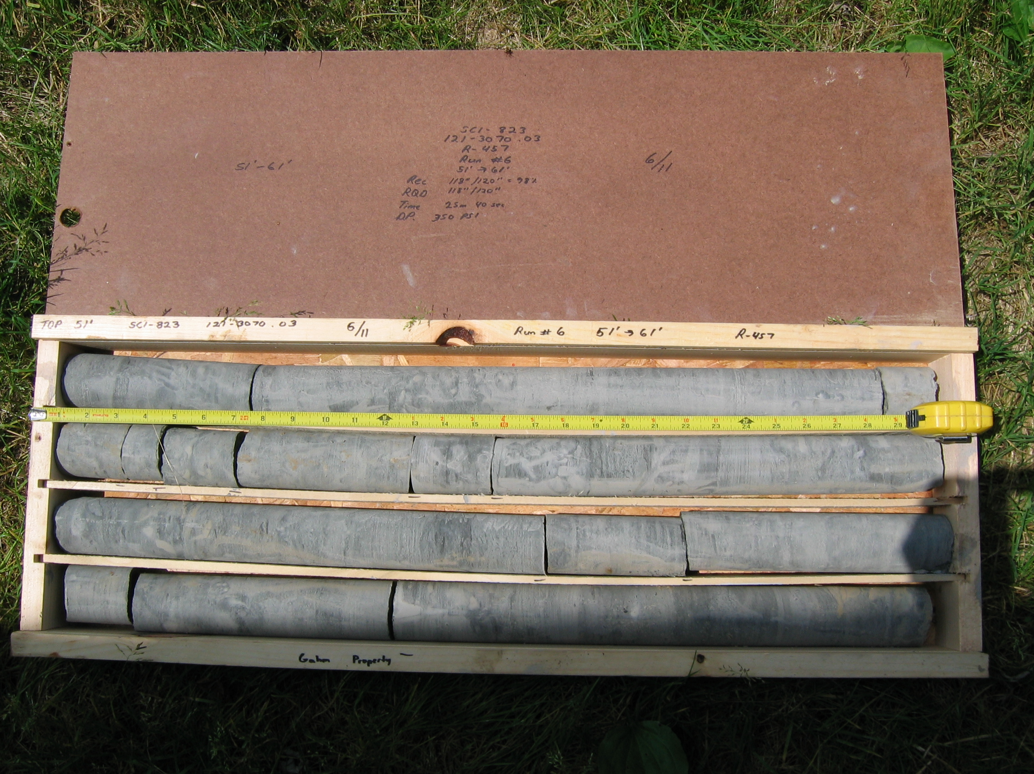
Photo 6. M:\proj\0121\3070.03\Core Photos\R-457\Rock Core Photos\R06-11fld.JPG

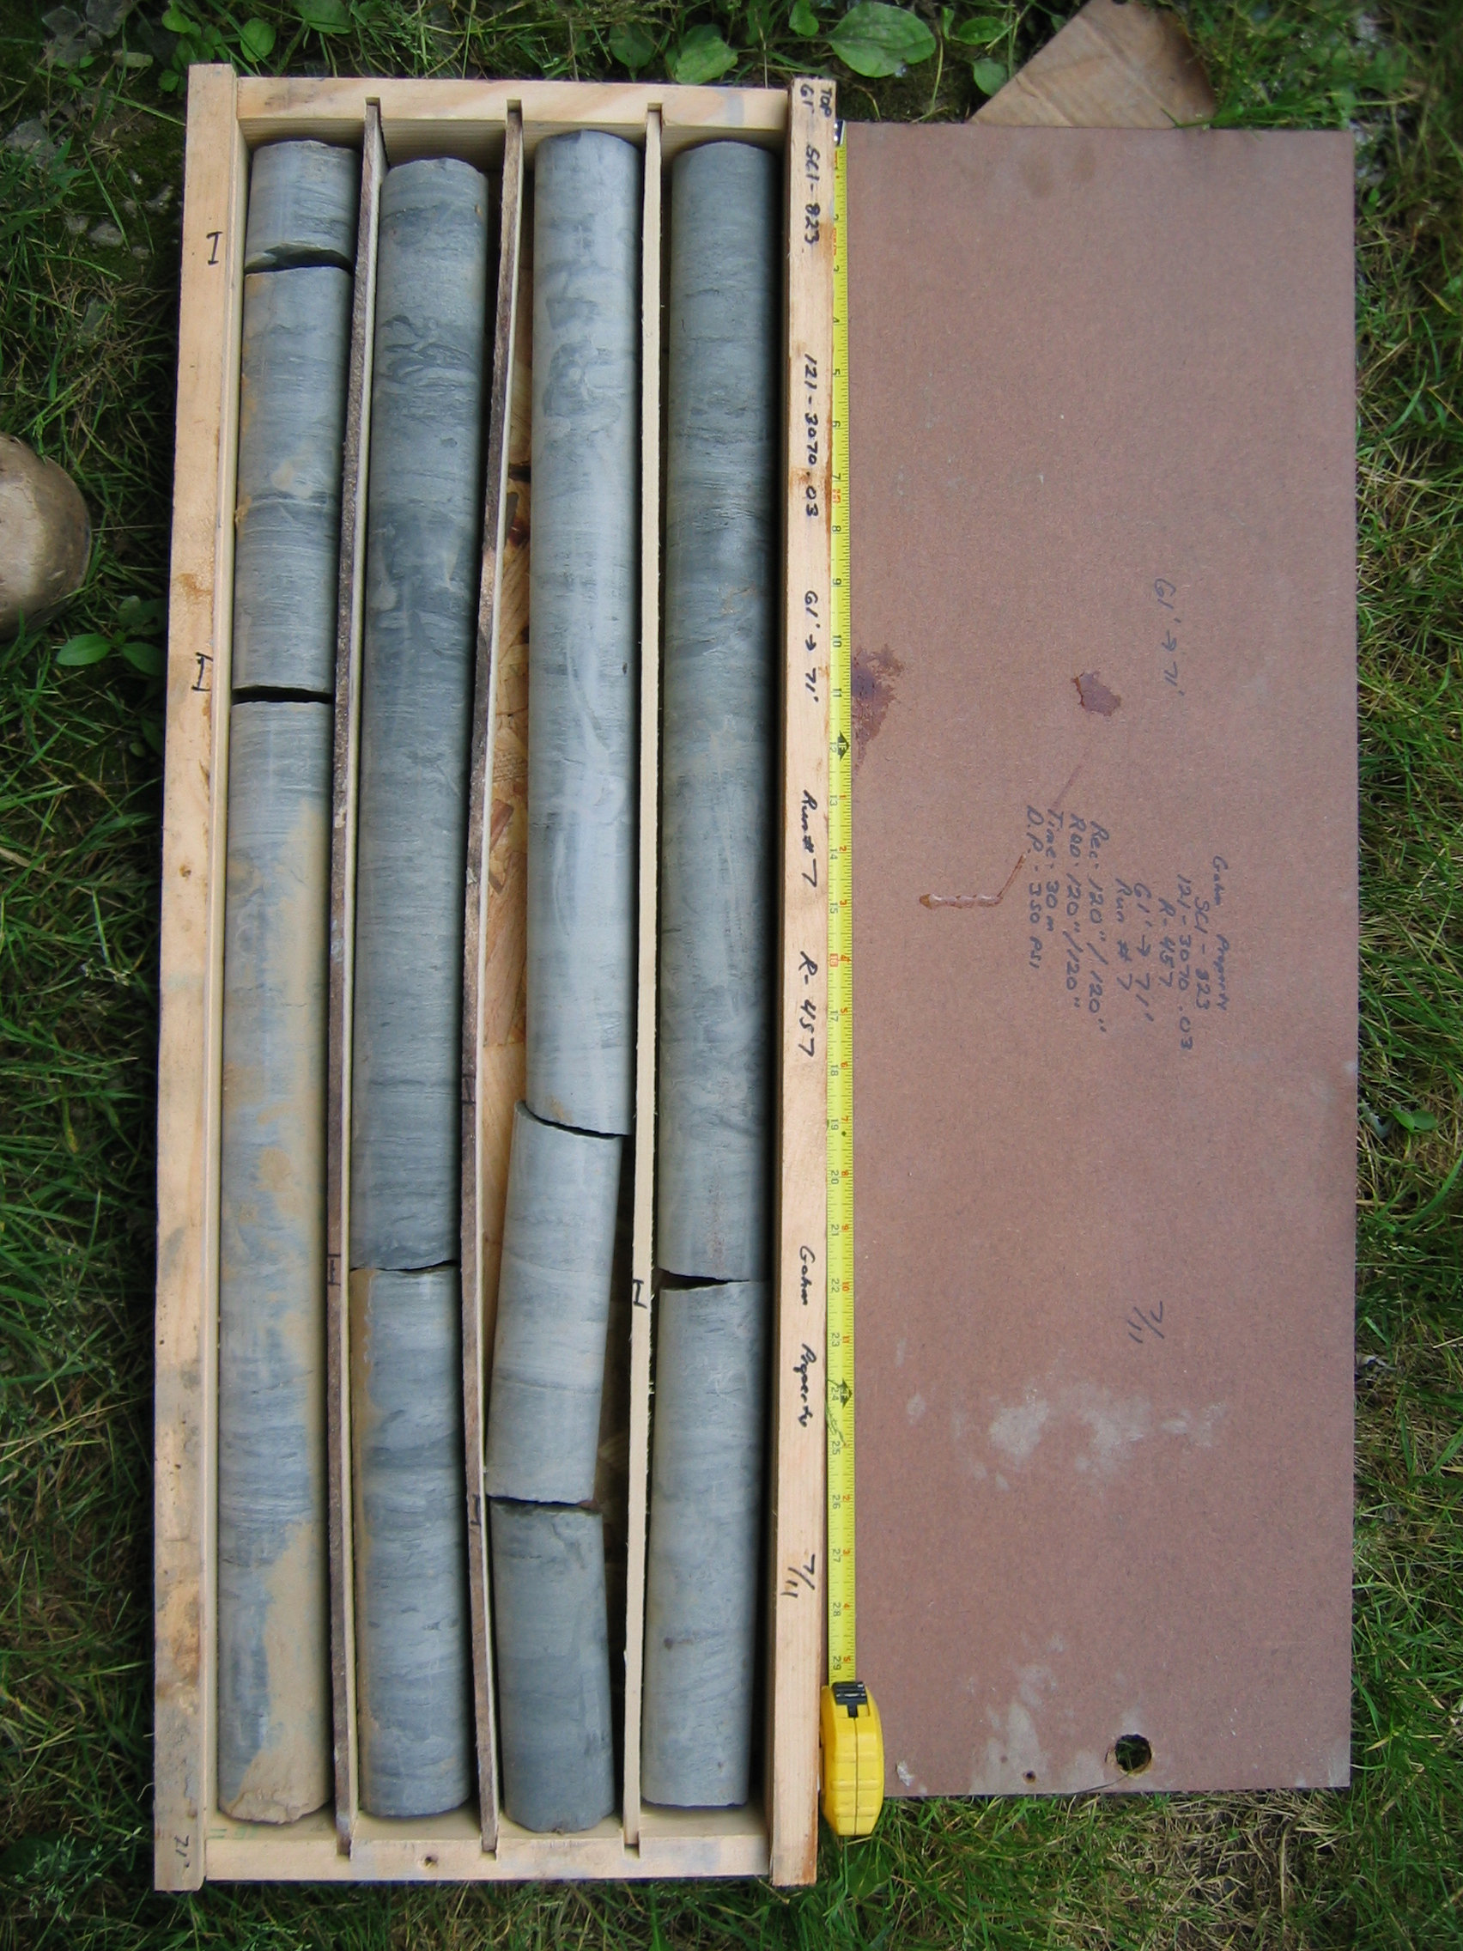
Photo 7. M:\proj\0121\3070.03\Core Photos\R-457\Rock Core Photos\R07-11fld.JPG

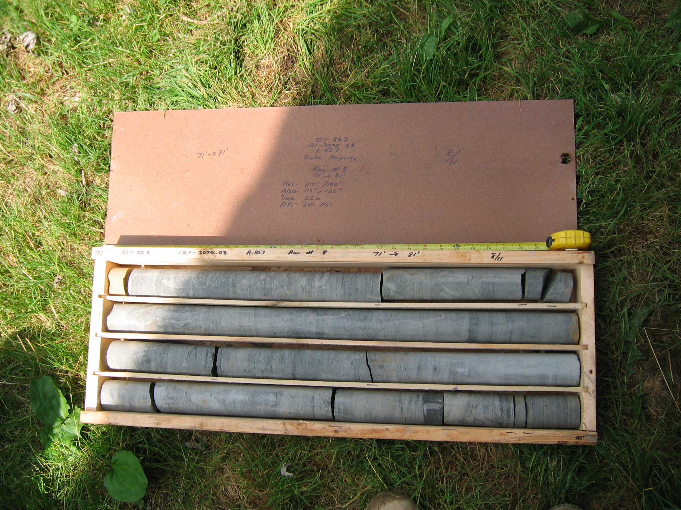
Photo 8. M:\proj\0121\3070.03\Core Photos\R-457\Rock Core Photos\R08-11fld.JPG

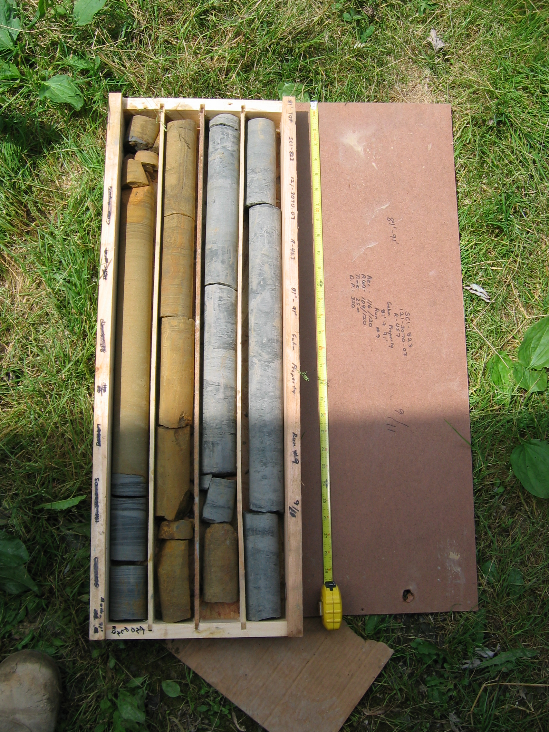
Photo 9. M:\proj\0121\3070.03\Core Photos\R-457\Rock Core Photos\R09-11fld.JPG

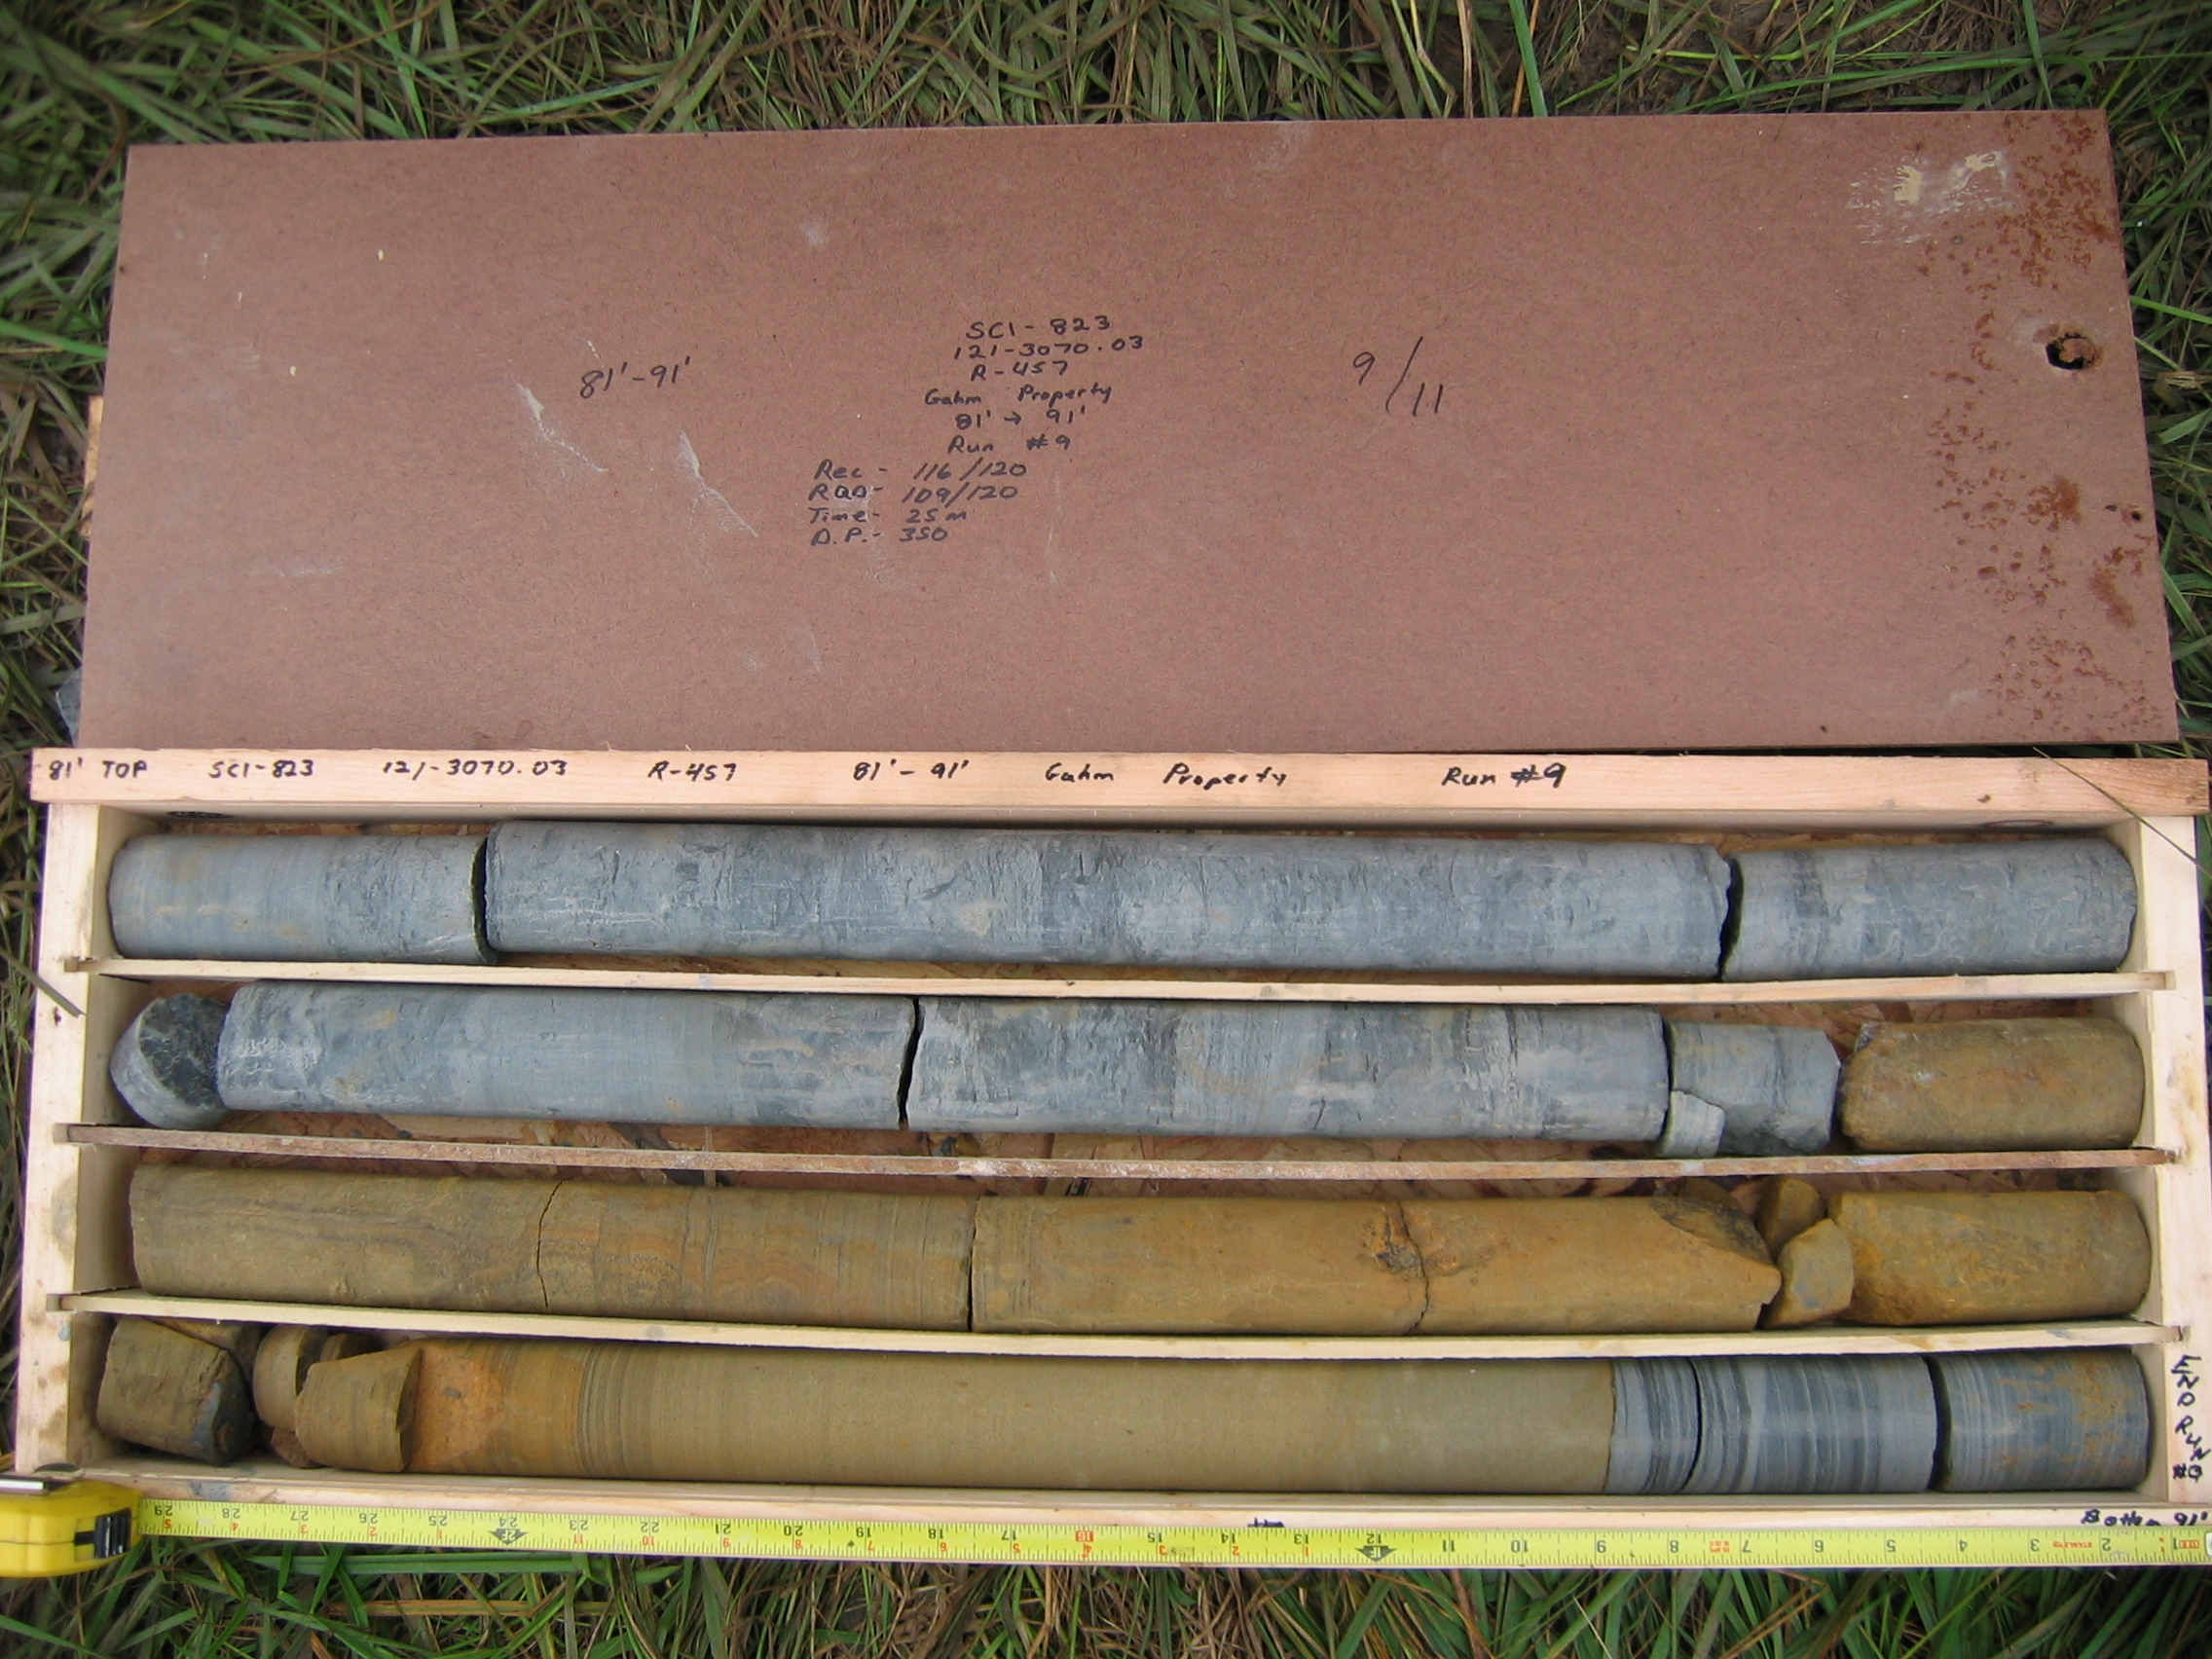
Photo 10. M:\proj\0121\3070.03\Core Photos\R-457\Rock Core Photos\R09a-11fld.JPG

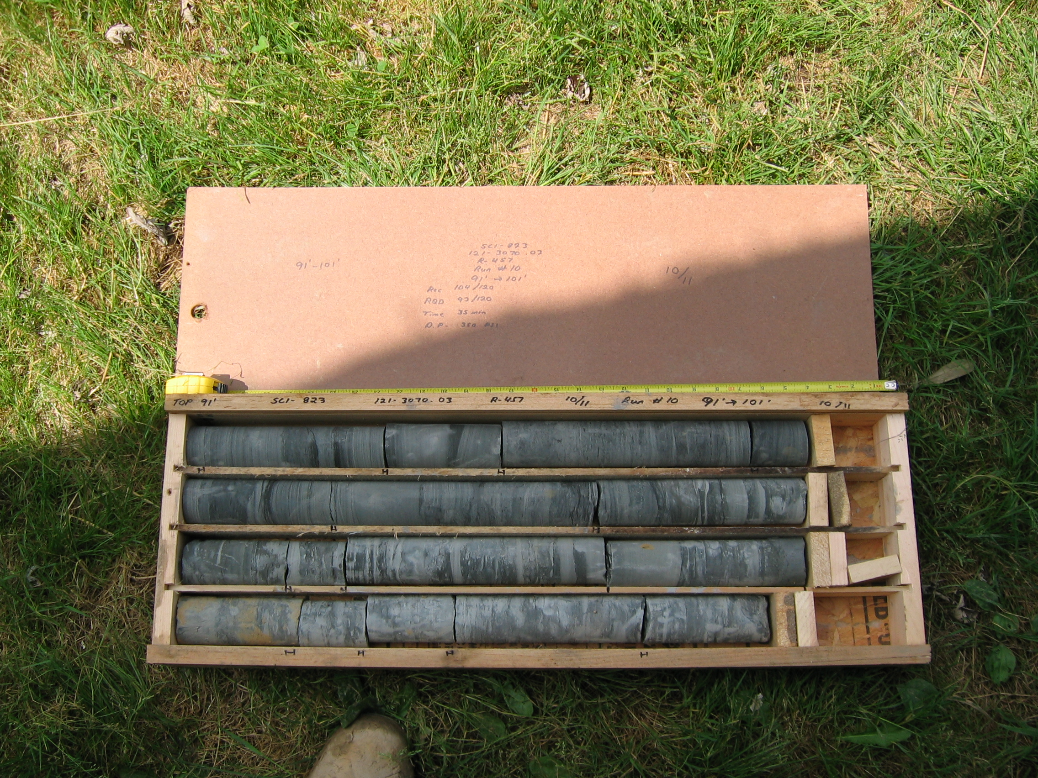
Photo 11. M:\proj\0121\3070.03\Core Photos\R-457\Rock Core Photos\R10-11fld.JPG

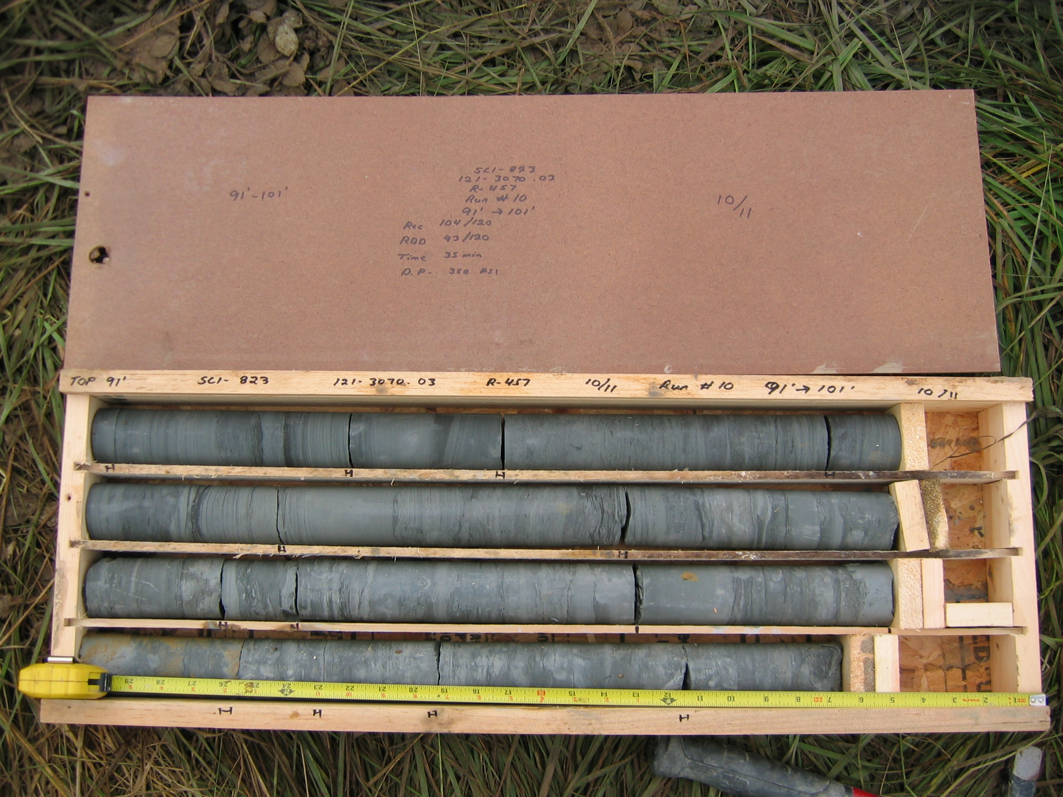
Photo 12. M:\proj\0121\3070.03\Core Photos\R-457\Rock Core Photos\R10a-11fld.JPG

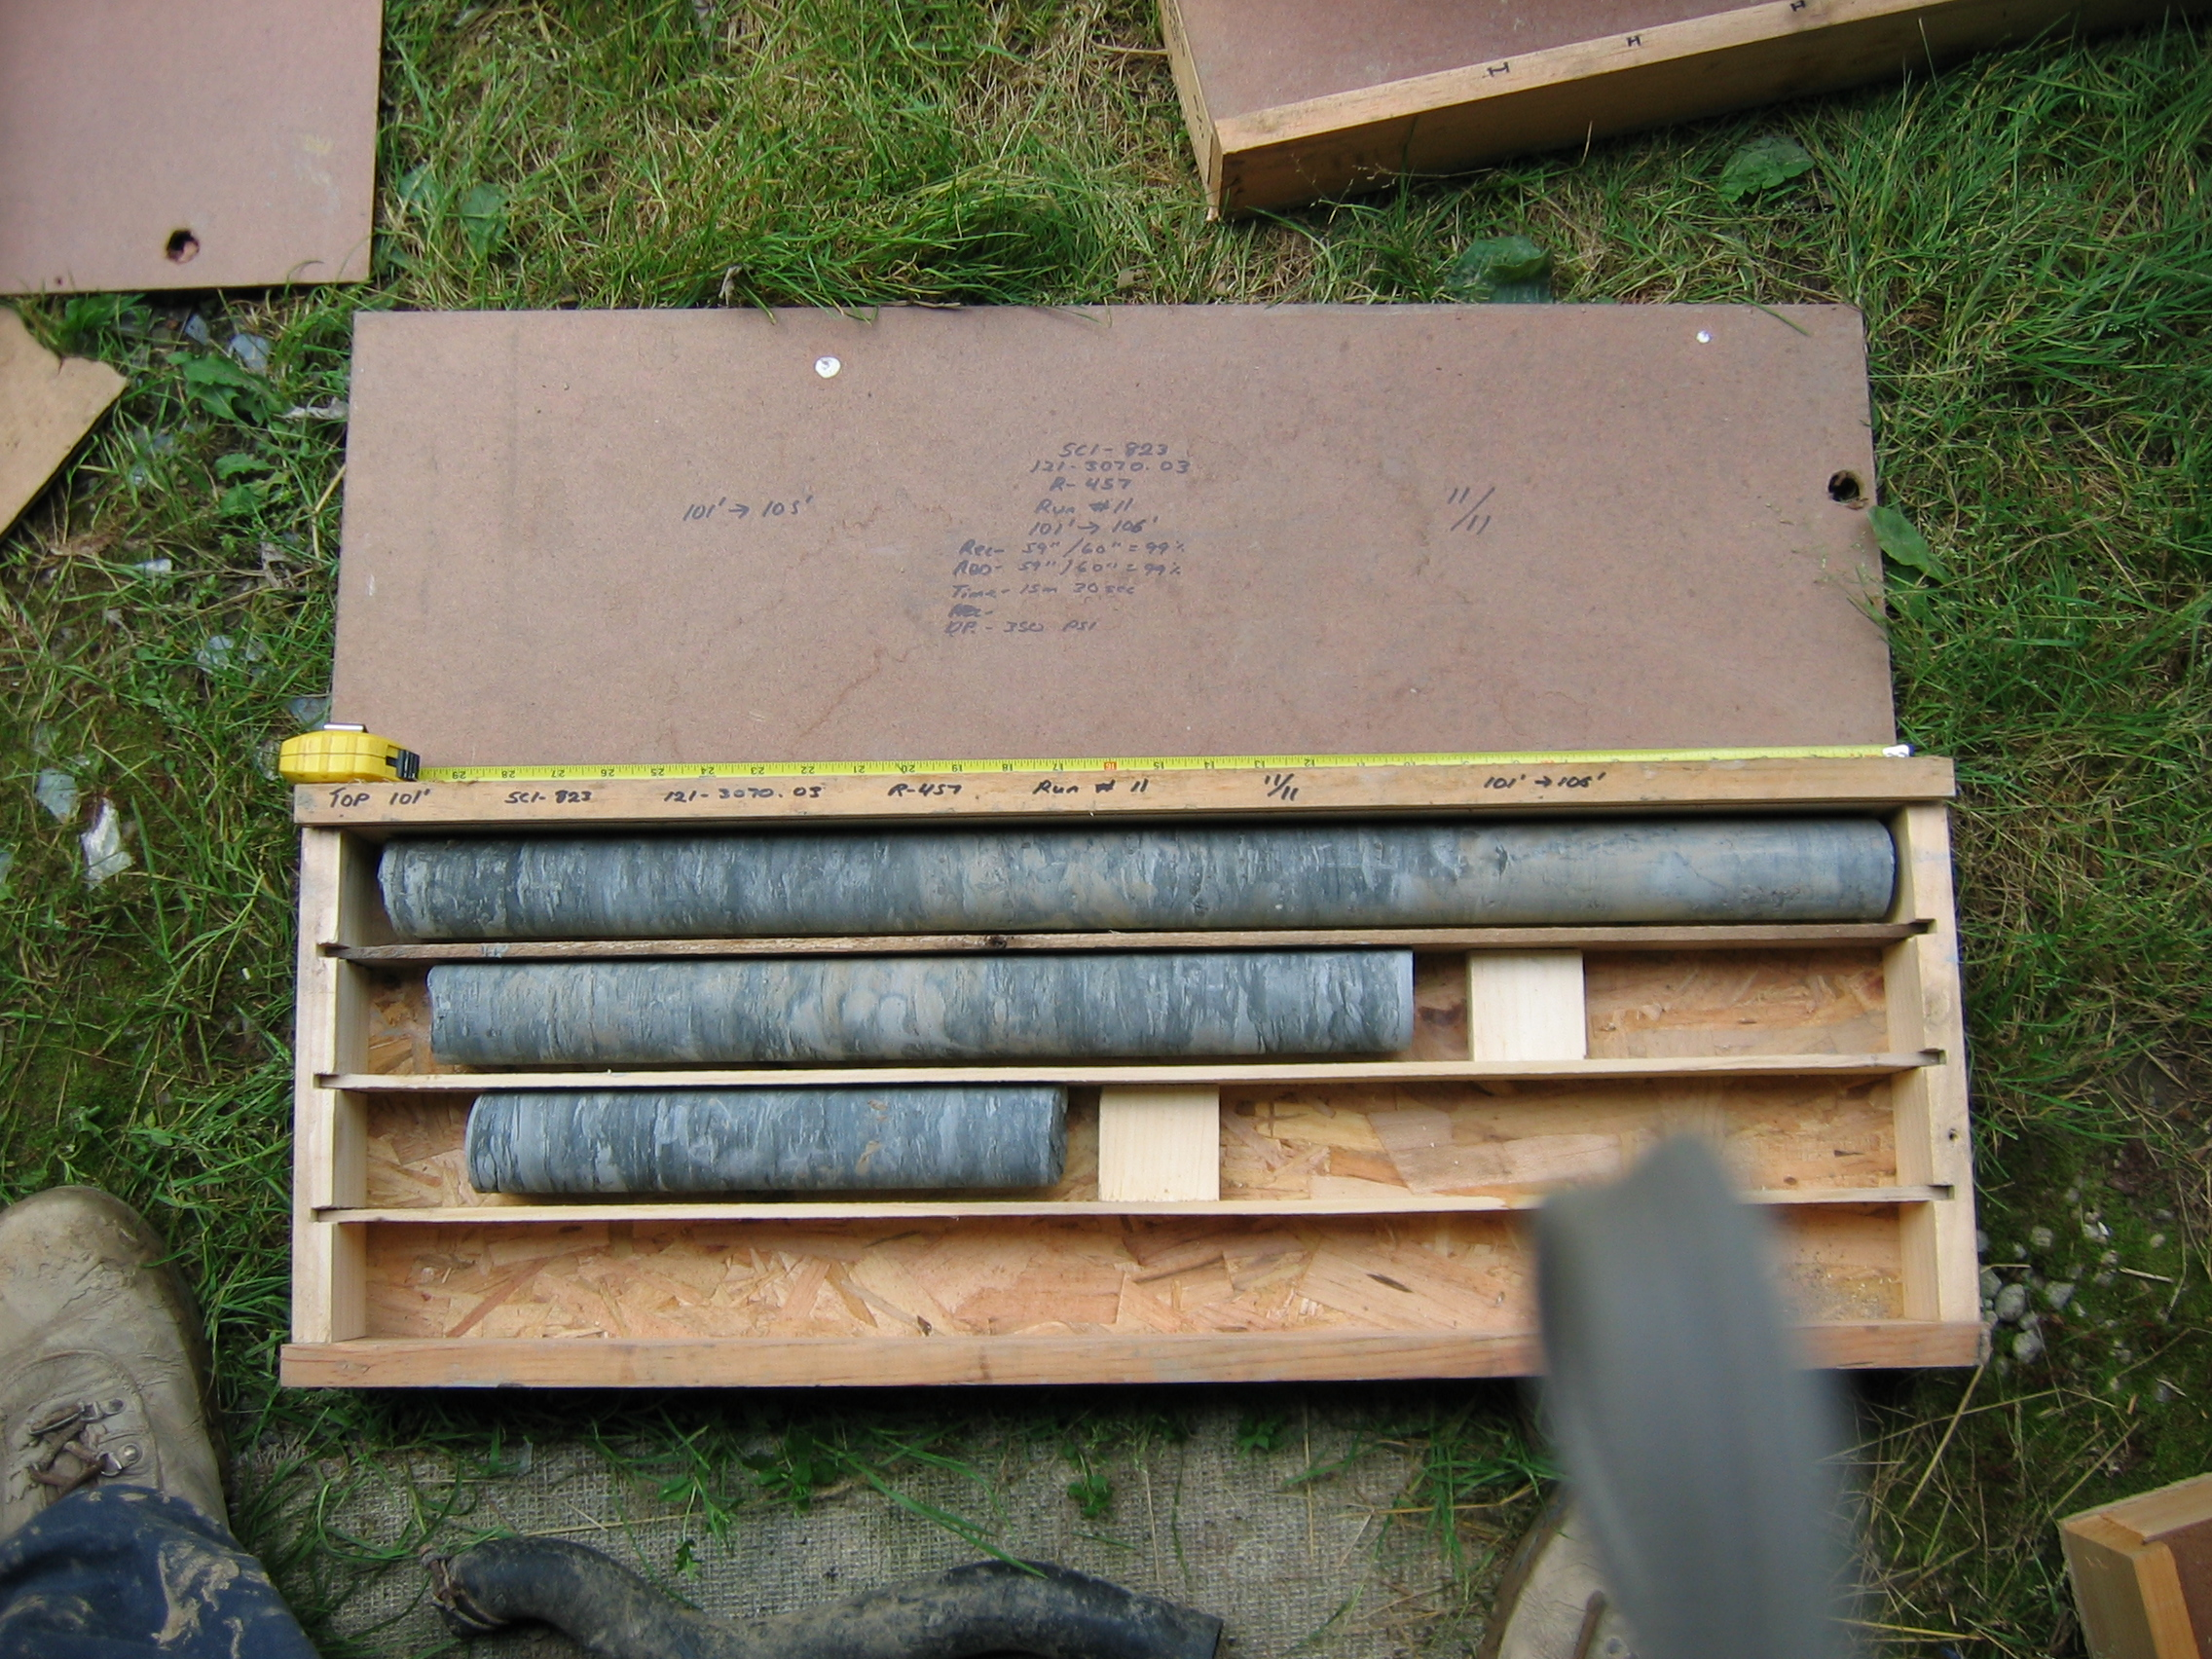
Photo 13. M:\proj\0121\3070.03\Core Photos\R-457\Rock Core Photos\R11-11fld.JPG

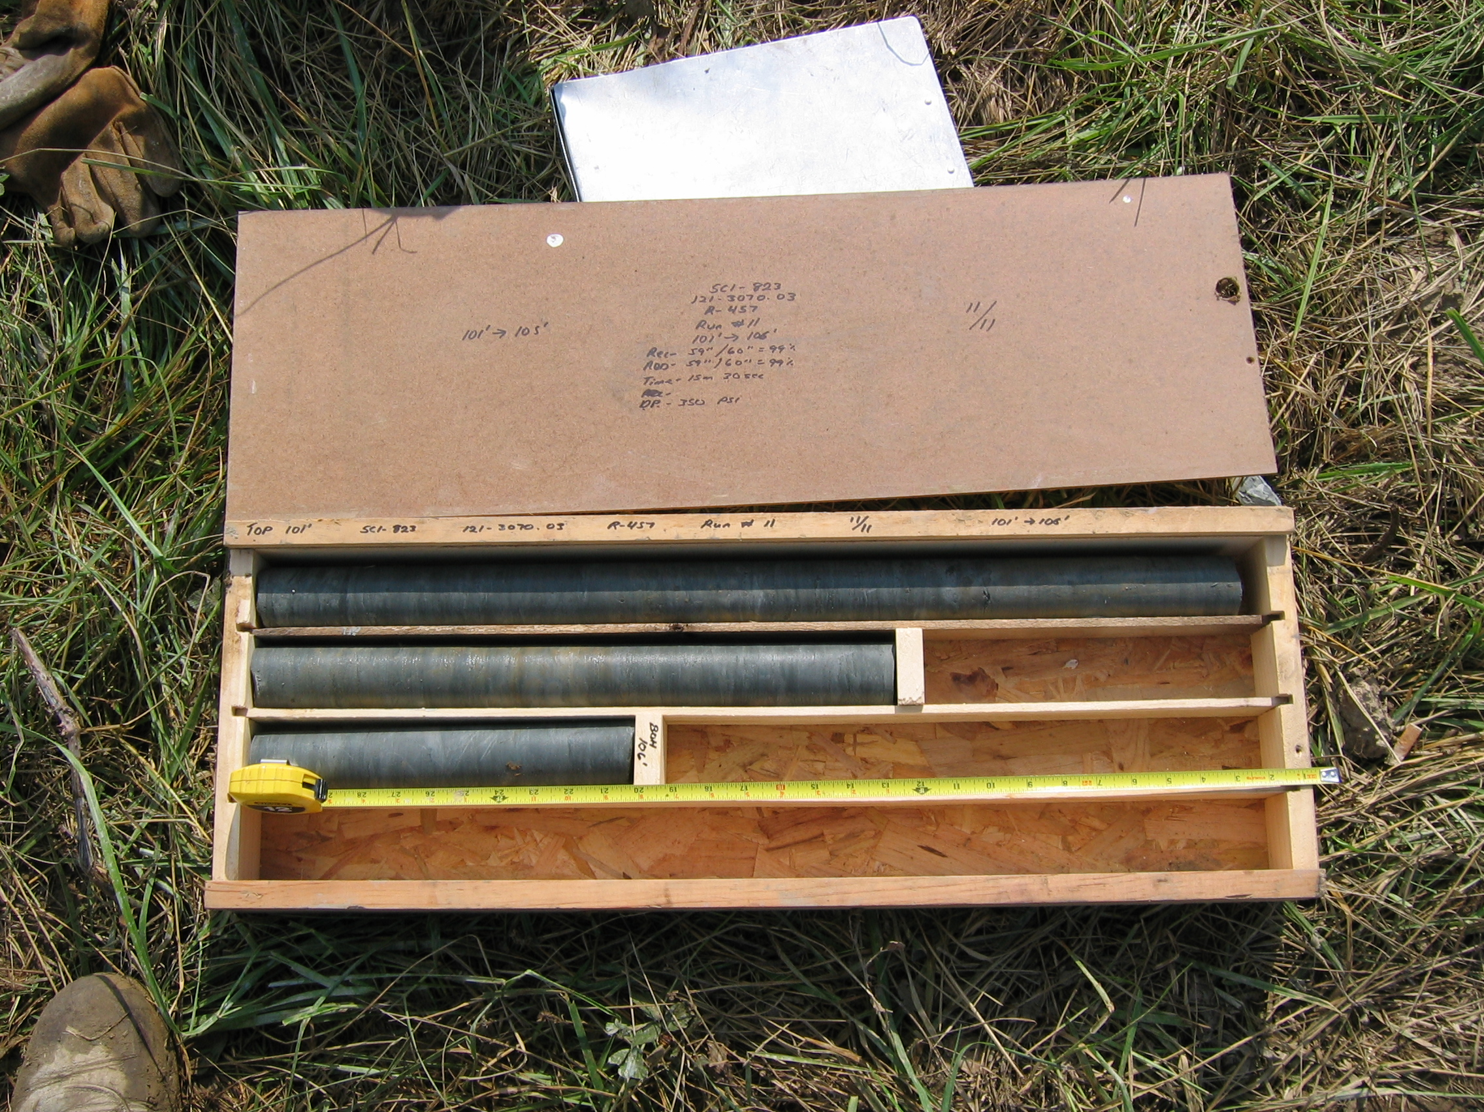
Photo 14. M:\proj\0121\3070.03\Core Photos\R-457\Rock Core Photos\R11a-11fld.JPG

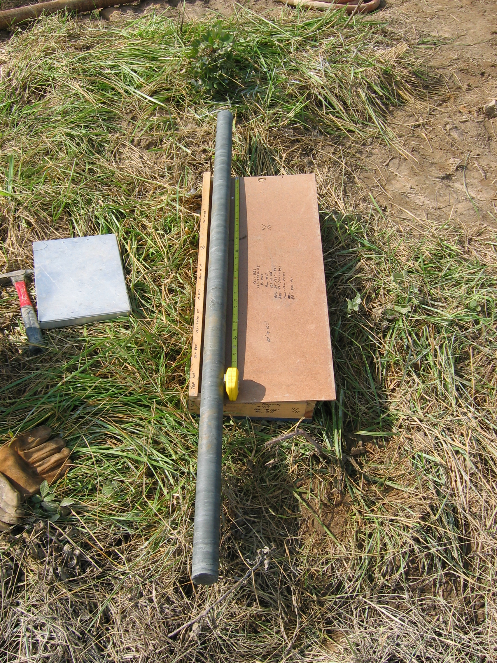
Photo 15. M:\proj\0121\3070.03\Core Photos\R-457\Rock Core Photos\R11b-11fld.JPG

