DRB ADVISORY POSITION PAPER
RE: 21-0591, CLE103954
CLE-32-3.50
48” Pipe Remove and Replace Dispute

Gentlemen,
The disputes on project 21-0591 are listed below and are presented for your review. The Department and Jurgensen request you advise on the following:
- The deflection and sag on drainage run D-18 are outside the tolerances specified in CMS 611.13. Section 611.13 states that any conduit with a deflection of more the 12% needs to be replaced. Hydraulic calculations have been completed and are included in this submittal showing that the reduced pipe capacity does not meet the requirements. Due to this reduction in theoretical size caused by the deflection, the pipe needs to be replaced.
- The structural capacity of the pipe that has been provided is potentially exceeded due to the amount of fill being placed atop the pipe. Manufacture’s requirements for overburden show a maximum fill over a 48” type B are 25’ when using compacted 57s. In some areas, the amount of total fill over the pipe is as much as 26-27’. ODOT calls into question the long-term viability of the pipe due to the overloading of embankment material.

ODOT maintains the stance that the contractor had control of the site and construction means and methods along with selecting the pipe material to be used and therefore it is their responsibility to provide The Department with a conduit run that meets the expected life cycle (75 years) and all requirements of specification 611.

ODOT’s position per dispute is as follows:
- During construction of pipe run D-18, the contractor did encounter soils that CMS 611 considers to be “unsuitable”. The soil consisted of wet silty clay which is not suitable for bedding material. CMS 611.05 touches on what to do in the event of unsuitable material in the bedding area.

“Remove any unsuitable material exposed in the bed for the width of the trench and depth of at least 6 inches. Replace the unsuitable material with structural backfill, type 1 or 2.”

JRJ did consult with ODOT to discuss treatment options, and it was decided that 1’ of material would be undercut and replaced with type 3 backfill. Per CMS 703.11, structural backfill type 3 consists of gradation No. 57 or 67. In this case, 57s were used to backfill the undercut area. Even with efforts to attempt to stabilize the bedding, the pipe still experienced settlement and developed a 12” sag. Bedding construction is mentioned in 611.05 and addresses how to address unsuitable material in the bedding area. CMS 611 also instructs the Contractor to remove any unsuitable material. With this direction given in 611.05, it is the Contractor’s responsibility to provide suitable bedding prior to placing the pipe.

- In 611.02, ODOT gives the contractor the option of selecting a material of pipe to be used in certain applications. In this instance, the contract calls for 48” type B. CMS 611.02B lists all conduit materials the contractor can select for this application. ODOT does not specify which conduit the contractor shall select. Conduit selection per 611.04B in the installation plan section, paragraph 4 states:

“Provide written confirmation from the conduit manufacturer that the pipe material and strength supplied are appropriate for the material and density requirements described in the installation plan for the backfill and bedding as well as the height of cover.”

In the suppled installation plan that was approved by the pipe manufacturer and sent to ODOT for acceptance (not approval) it lists the trench depth for this run to be 8’ which we understand is the depth of the trench below EXISITING grade. It does not account for total cover provided. This information should have been provided to the pipe supplier and a proper pipe selected. The pipe that was selected for this application was ADS 48” N-12 plastic pipe, specification 707.33, which is listed as an approved option per 611.02B. Though this is an accepted material, the maximum cover of an ADS N-12 with compacted ODOT class 3 (57s) per manufacturer’s requirements is 25’ maximum total cover.

Per the construction plans, this run is under a large amount of embankment fill. In some areas of the pipe, where it crosses under Bach Buxton Road, there is upwards of 26’ of fill or more, including roadway materials and live loading due to traffic. We have seen much of the sag at this crossing where the fill is the greatest.

The supplier was contacted when the issues were brough up and they provided a response to our concerns and stated that the pipe is potentially being pushed past its structural capacity.

For dispute 2, ODOT maintains the stance that the contractor did not provide adequate information to the pipe supplier thus the proper pipe was not selected for this application since the total backfill exceeds the maximum allowable per the manufacturer.

Timeline of discussion and testing:
The placement of the pipe occurred in May 2022. The issues with the sag were discovered in October of the same year when Spartan Construction inspected the pipe per the 611 requirements. The requirements state that the pipe run must be inspected more than 30 but less than 90 days after final grade has been established. The fill was completed in August and testing done in October, meeting that requirement. In the October inspection report, they noted a deflection of 10% in the pipe at 100’ into the run.
It was determined that we would monitor the pipe and decide how to proceed with repairs based on if the pipe continued to deflect over time. As the project was nearing completion and this issue had yet to be resolved, another inspection was done in January 2025, and it showed a maximum deflection of over 13%.
In April 2025, a meeting was held, and it was determined that the pipe would need to be removed and replaced as it was beyond the 12% allowable by CMS 611.13.
On May 19, 2025, we had a step 1 meeting where we discussed the issues and possible alternate means of correction. Following the step 1 meeting, a hydraulic analysis was done and based on the results, ODOT determined that the other options, mainly a CIPP, would not work as the hydraulic calculation did not meet requirements and the structural concerns with the fill height could not be satisfied with a CIPP. The contractor was told that the only remediation that was acceptable was to remove and replace the pipe.

Hydraulic analysis:
ODOT ran a hydraulic analysis of the current pipe condition to determine if it would adequately drain as required. Pipes are sized based on flow rate capabilities at a 10-year flood event. It has been determined that both existing condition with the sag and the existing pipe with a CIPP liner added, would not meet the hydraulic capacity for a 10-year flood.
All do meet the hydraulic grade line calculation which is based on 25-year flood event. This means that water will not affect the roadway in a 25-year flood event. The hydraulic analysis is shown below for all 3 conditions: design, with sag, with sag and a CIPP liner.

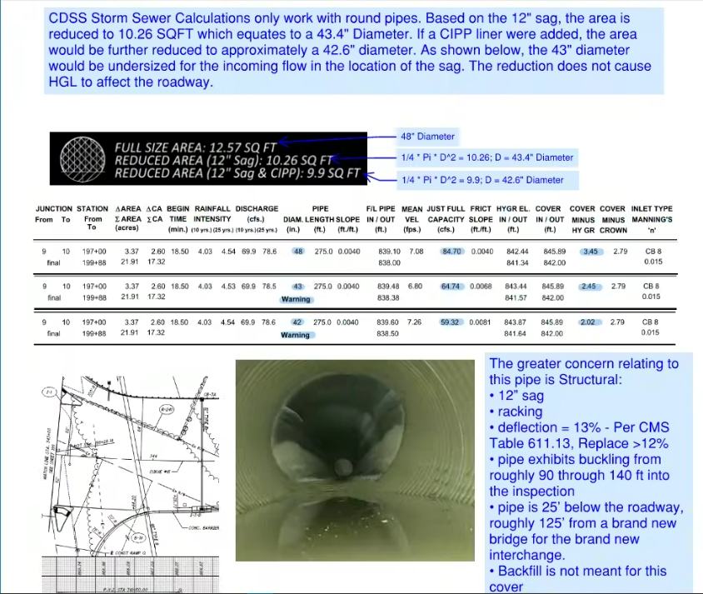

In conclusion, ODOT’s concern is that due to the contractor’s means and methods of construction and material selection, the pipe has failed and could continue to move and require added maintenance and possible premature replacement in the future. It could also cause deflections to occur in pavement if the pipe continues to move and joint separation occurs causing backfill to infiltrate the pipe and create roadway settlement. Lastly, large rain events could cause flooding due to the pipe not being sized adequately to handle the required flow.
The Department’s position stands that this is the contractor’s responsibility to make corrections to work that did not perform as expected due to factors within their control.

Provided to the Board as documentation:
- 611 plan showing 8’ trench depth but not showing a total cover. It also shows that sand was to be used as backfill but was changed to 57s with no amendment to the installation plan.
- Manufacture’s recommendation for maximum total cover
- Cross section showing approximate location of pipe sag with total cover not including roadway build-up(aggregate base and asphalt).

