SECTION 900 – BRIDGE LOAD RATING 1-1
901 PURPOSE 1-1
902 SCOPE 1-1
903 APPLICABILITY 1-1
903.1 APPLICABILITY OF AASHTO DESIGN SPECIFICATIONS 1-1
903.2 APPLICABILITY TO HIGHWAY BRIDGES 1-1
904 QUALITY MEASURES 1-1
905 DEFINITIONS AND TERMINOLOGY 1-1
906 REFERENCES 1-5
906.1 REFERENCES FROM OHIO REVISED CODE 1-5
906.2 REFERENCE PUBLICATIONS 1-7
907 BRIDGE FILES (RECORDS) 1-7
907.1 CONSTRUCTION PLANS 1-7
907.2 CONSTRUCTION & MATERIAL SPECIFICATIONS 1-7
907.3 SHOP AND WORKING DRAWINGS 1-7
907.4 AS-BUILT DRAWINGS 1-7
907.5 CORRESPONDENCE 1-8
907.6 INVENTORY DATA 1-8
907.7 INSPECTION HISTORY 1-8
907.8 PHOTOGRAPHS 1-8
907.9 RATING RECORDS 1-8
907.10 ACCIDENT DATA 1-8
907.11 MAINTENANCE AND REPAIR HISTORY 1-8
907.12 POSTING HISTORY 1-8
908 GENERAL 1-8
908.1 APPLICATION 1-8
908.2 INVENTORY AND OPERATING RATING LOADS 1-9
908.3 RATING LOADS 1-10
908.3.1 COMMERCIAL LEGAL VEHICLES 1-11
908.3.2 EMERGENCY VEHICLES 1-15
908.3.3 STATE PERMIT VEHCILES 1-16
909 UNIT WEIGHTS & DENSITIES 1-17
910 STRUCTURES EXEMPT FROM LOAD RATING CALCULATIONS 1-17
910.1 EXEMPT STRUCTURES THAT NEED A BR100 1-17
911 STRUCTURES UNDER DEEP FILL 1-17
912 WHICH PORTION OF BRIDGES SHALL BE LOAD RATED 1-18
913 PROCEDURE FOR LOAD RATING 1-18
914 WHEN LOAD RATING SHALL BE REVISED 1-19
915 ANALYSIS OF BRIDGES WITH SIDEWALKS 1-19
916 ANALYSIS FOR MULTILANE LOADING 1-20
917 ANALYSIS FOR PERMIT OR SPECIAL VEHICLE 1-20
917.1 ANALYSIS OF BRIDGE FOR PERMIT OR SPECIAL VEHICLE WHEN SCOPED 1-20
917.1.1 FIRST ANALYSIS OF BRIDGE WITH THREE OR MORE LANES 1-20
917.1.2 FIRST ANALYSIS OF BRIDGE WITH TWO LANES 1-20
917.1.3 FIRST ANALYSIS OF BRIDGE WITH A SINGLE LANE 1-20
917.1.4 SECOND ANALYSIS OF BRIDGE FOR PERMIT OR SPECIAL VEHICLE 1-21
917.2 ANALYSIS FOR PERMIT LOADS S-PL60T AND S-PL65T 1-21
918 LOAD RATING OF LONG SPAN BRIDGES 1-21
918.1 WHEN THE LOAD RATING SHALL BE DONE 1-21
918.2 HOW THE LOAD RATING SHALL BE DONE 1-21
918.2.1 INVENTORY & OPERATING LEVEL RATING USING HL93 LOADING 1-21
918.2.2 INVENTORY & OPERATING LEVEL RATING USING HS20 TRUCK 1-21
918.2.3 LOAD RATING FOR OHIO LEGAL LOADS 1-21
918.2.3.1 LONG SPAN BRIDGES WITH THREE OR MORE LANES 1-21
918.2.3.2 LONG SPAN BRIDGES WITH TWO LANES 1-21
918.2.3.3 LONG SPAN BRIDGES WITH A SINGLE LANE 1-22
918.2.3.4 BRIDGES WITH SPAN LENGHTS GREATER THAN 200 FEET 1-22
919 BRIDGE POSTING FOR REDUCED LOAD LIMITS 1-22
919.1 BRIDGE POSTING POLICY 1-22
919.2 REFERENCE TO BRIDGE POSTING 1-22
919.3 PROCEDURE FOR BRIDGE POSTING 1-22
919.3.1 BRIDGE POSTING FOLLOWING LOAD RATING 1-22
919.3.2 PROCEDURE FOR PLACING POSTING ON ODOT BRIDGES 1-23
919.4 PROCEDURE FOR RESCINDING POSTING OF ODOT BRIDGES 1-24
919.5 PROCEDURE FOR CHANGING POSTING OF ODOT BRIDGES 1-25
919.6 REQUIRED INFORMATION FOR POST, RESCIND AND CHANGE REQUESTS FROM DISTRICTS 1-25
919.7 POSTING FOR EMERGENCY VEHICLES 1-25
920 SOFTWARE TO BE USED FOR LOAD RATING OF ODOT BRIDGES 1-26
920.1 LIST OF ODOT PREFERRED LOAD RATING PROGRAMS 1-26
920.2 OTHER LOAD RATING PROGRAMS 1-26
921 LOAD RATING REPORT SUBMISSION 1-27
922 LOAD RATING USING AASHTO BrR PROGRAM 1-29
922.1 GENERAL 1-29
922.2 BrR LOAD RATING REPORT SUBMISSION 1-29
922.3 BrR COMPUTER INPUT AND OUTPUT FILES 1-29
923 LOAD ANALYSIS USING ERIKSSON-CULVERT PROGRAM 1-29
923.1 GENERAL 1-29
923.2 ERIKSSON CULVERT LOAD RATING REPORT SUBMISSION 1-29
923.3 ERIKSSON COMPUTER INPUT AND OUTPUT FILES 1-29
924 LOAD RATING OF BRIDGES USING LRFR SPECIFICATIONS 1-30
924.1 APPLICABILITY OF AASHTO DESIGN SPECIFICATIONS 1-30
924.2 GENERAL LOAD RATING EQUATION 1-30
924.3 LIMIT STATES AND LOAD FACTORS FOR LOAD RATING BY LRFR METHOD 1-31
924.4 DYNAMIC LOAD ALLOWANCE (IM) 1-32
924.5 CONDITION FACTOR (φ_{c}) 1-32
924.6 SYSTEM FACTOR (φ_{S}) 1-32
924.7 RESISTANCE FACTOR (φ) 1-33
924.8 EFFECT OF SKEW 1-34
925 LOAD RATING OF NEW BRIDGES 1-34
925.1 LOADS TO BE USED FOR LOAD RATING 1-34
925.2 LOAD RATING OF NEW BURIED BRIDGES 1-34
925.2.1 GENERAL 1-34
925.2.2 HOW THE LOAD RATING SHALL BE DONE 1-34
925.2.3 CAST-IN-PLACE CONCRETE BOX & FRAME STRUCTURES 1-35
925.2.4 PRECAST CONCRETE STRUCTURES 1-35
925.2.4.1 PRECAST CONCRETE BOXES OF SPAN GREATER THAN 12-FT 1-35
925.2.4.2 PRECAST CONCRETE BOXES OF SPAN EQUAL TO OR LESS THAN 12-FT 1-35
925.2.4.3 PRECAST FRAMES, ARCHES, AND CONSPANS & BEBO TYPE STRUCTURES 1-35
925.2.4.4 PRECAST CONCRETE BOXES NOT DESIGNED BY ASTM OR SS940 SPECIFICATIONS 1-35
925.3 LOAD RATING OF NON-BURIED STRUCTURES 1-36
925.3.1 GENERAL 1-36
925.3.2 HOW THE LOAD RATING SHALL BE DONE 1-36
925.3.3 WHEN THE BRIDGE LOAD RATING SHALL BE DONE 1-36
925.3.3.1 BRIDGES DESIGNED UNDER MAJOR OR MINOR PLAN DEVELOPMENT PROCESS 1-36
925.3.3.2 BRIDGES DESIGNED UNDER MINIMAL PLAN DEVELOPMENT PROCESS 1-36
925.3.3.3 BRIDGES DESIGNED UNDER DESIGN-BUILD PROCESS 1-36
925.3.4 BRIDGES DESIGNED UNDER VALUE ENGINEERING CHANGE PROPOSAL 1-37
926 LOAD RATING OF EXISTING BRIDGES 1-37
926.1 LOADS TO BE USED FOR LOAD RATING 1-37
926.2 LOAD RATING OF BRIDGES TO BE REHABILITATED 1-37
926.2.1 HOW THE LOAD RATING SHALL BE DONE 1-37
926.2.2 WHEN THE BRIDGE LOAD RATING SHALL BE DONE 1-40
926.2.2.1 BRIDGES DESIGNED UNDER MAJOR OR MINOR PLAN DEVELOPMENT PROCESS 1-41
926.2.2.2 BRIDGES DESIGNED UNDER MINIMAL PLAN DEVELOPMENT PROCESS 1-41
926.2.2.3 BRIDGES DESIGNED UNDER DESIGN-BUILD PROCESS 1-41
926.2.2.4 BRIDGES DESIGNED UNDER VALUE ENGINEERING CHANGE PROPOSAL 1-41
926.2.3 LOAD RATING OF EXISTING BURIED BRIDGES 1-41
926.2.3.1 CAST-IN-PLACE STRUCTURES 1-41
926.2.3.2 PRECAST BOXES OF SPAN GREATER THAN 12-FT 1-41
926.2.3.3 PRECAST BOXES OF SPAN EQUAL TO OR LESS THAN 12-FT 1-41
926.2.3.4 PRECAST FRAMES, ARCHES, AND CONSPANS & BEBO TYPE STRUCTURES 1-41
926.2.3.5 ANALYSIS OF CONCRETE BOX SECTIONS & FRAMES 1-41
926.2.4 LOAD RATING OF EXISTING NON-BURIED STRUCTURES 1-42
926.3 LOAD RATING OF EXISTING BRIDGES WITH NO REPAIR PLANS 1-42
926.3.1 HOW THE LOAD RATING SHALL BE DONE 1-42
926.3.2 WHEN THE BRIDGE LOAD RATING SHALL BE DONE 1-42
926.3.3 LOAD RATING OF EXISTING BURIED BRIDGES 1-42
926.3.4 LOAD RATING OF EXISTING NON-BURIED STRUCTURES 1-42
927 LOAD RATING OF NON-ODOT BRIDGES 1-43
928 ODOT POLICY ON ASSIGNED LOAD RATINGS 1-43
928.1 STRUCTURES DESIGNED BY LFD FOR HS20 OR HIGHER HS LOADING 1-43
928.2 STRUCTURES DESIGNED BY LRFD FOR HL93 LOADING 1-44
928.3 CULVERT TYPE BRIDGES DESIGNED USING TABLES OF ASTM C1577 (LRFD), C1433 (LFD), C789 (LFD) AND C850 (LFD) 1-44
929 LOAD RATING OF BRIDGES WITH INSUFFICIENT INFORMATION 1-45
929.1 GENERAL 1-45
929.2 METHOD A: LOAD RATING USING FIELD MEASUREMENTS AND HISTORICAL DATA (FH) 1-46
929.3 METHOD B: LOAD RATING BASED ON THE DESIGN LOAD AND RATIONAL EVALUATION (DLRE) 1-46
929.4 METHOD C: LOAD RATING BASED ON THE FIELD TESTING (FT) 1-48
930 BRIDGE LOAD RATING QUALITY CONTROL AND QUALITY ASSURANCE GUIDELINES 1-49
931 LOAD RATING FLOW CHART 1-53

SECTION 900 – BRIDGE LOAD RATING

PURPOSE
The purpose of this Section is to provide consistency and uniformity in the procedures, guidelines and policies for determining safe live load carrying capacity or load rating of the highway bridges in the State of Ohio.

SCOPE
The guidelines, policies and recommendations provided in this Section are meant to assist bridge owners and bridge raters by establishing evaluation practices that meet the Ohio Revised Code (ORC), the National Bridge Inspection Standards, Specifications for National Bridge Inventory, ODOT Bridge Design Manual and American Association of State Highway Transportation Officials.
The intent of this Section is to establish standardized load rating procedures conforming to FHWA reporting requirements and posting bridges in the State of Ohio. The provisions of BDM Section 900 apply to ODOT bridges. All provisions of BDM Section 900 may also be applied to non-ODOT bridges at the discretion of the bridge owner.

APPLICABILITY

APPLICABILITY OF AASHTO DESIGN SPECIFICATIONS
BDM Section 900 is consistent with the current edition of AASHTO LRFD Bridge Design Specifications and Standard Specifications for Highway Bridges (14th Edition). Where this Section is silent, the current AASHTO LRFD Bridge Design Specifications or Standard Specifications for Highway Bridges shall govern.

APPLICABILITY TO HIGHWAY BRIDGES
The provisions of this Section apply to all highway structures in Ohio that qualify as bridges in accordance with the definition for a bridge set herein. These provisions may be applied to smaller structures which do not qualify as bridges.

QUALITY MEASURES
To maintain the accuracy and consistency of load rating, bridge owners should implement appropriate quality assurance and quality control (QA/QC) measures. Typical quality control procedures include the use of checklists to ensure uniformity and completeness, the review of reports and computations by a person other than originating individual and periodic field review of the inspection teams and their work.
Each load rating analysis shall be performed under the supervision of an Ohio registered professional engineer (i.e. the load rater) who will sign and stamp (seal) the final load rating report before submission to the bridge owner.

DEFINITIONS AND TERMINOLOGY
ASR: Allowable Stress Rating (also known as Working Stress Rating)
ADT: Average Daily Traffic volume
ADTT: Average Daily Truck Traffic volume
AssetWise: AssetWise Asset Reliability is ODOT’s bridge inventory and appraisal data collection system. AssetWise went live on May 11, 2020.
BR100: A load rating summary form (spreadsheet) internally developed by ODOT.
Bridge: A structure, including supports, erected over a depression or an obstruction such as water, highway, bikeway or railway; and having a roadway to carry vehicular traffic and having an opening measured along the centerline of the roadway of 10-ft or more between under-copings of abutments or spring lines of arches or extreme ends of openings for multiple boxes. It may also include multiple pipes where the clear distance between openings is less than half that of the smaller contiguous opening.
Bridge Asset Name (BAN): A combination of 3-letter County Abbreviation − Route Number − County Log Point, in miles, followed by special designation, if any (e.g., HAM-71-10.680 R); 3-letter County Abbreviations are given in ODOT L&D Manual, Volume I
Bridge Appraisal Rating (BAR): Lowest of the appraisal summary ratings of the deck, superstructure and substructure or culvert.
Bridge Owner: A public or private entity that has jurisdiction over the bridge or an agency having major maintenance responsibility for a bridge. Generally, an entity responsible for the major maintenance of a bridge is considered the owner of the bridge.
Bridge Rating Engineer (BRE): The State Bridge Rating Engineer managing the state bridge rating program.
Buried Structure: A structure, including a flat slab, an arch, a frame, a box section, etc. that has a fill or pavement material of 2-ft or more on top of it.
Collapse: A major change in the geometry of the bridge rendering it unfit for its intended use
Condition Rating: The result of the assessment of the functional capability and the physical condition of a bridge’s components by considering the extent of deterioration and other defects. Generally, Condition Rating is evaluated on a scale “0” through “9” (where “9” is the best).
Control Authority Program Manager (CAPM): The designated person at a public transportation entity (Control Authority) responsible for overseeing FHWA’s National Bridge Inspection Program for that entity.
Controlling Legal Load Rating Factor: Lowest (controlling) rating factor for the State’s legal and AASHTO loads.
County Log Point: Distance in miles from the point where a route enters the county or the starting point of a route within the county traveling in the up-station direction from south-to-north or west-to-east.
Design Load: Live load for which the bridge was designed.
District Bridge Engineer (DBE): The Engineer in the respective ODOT district office managing the bridges within the district.
Emergency Vehicle (EV): An emergency vehicle, as defined in the Fixing America’s Surface Transportation Act (FAST Act), is designed to use under emergency conditions to transport personnel and equipment to support the suppression of fires and mitigation of other hazardous situations (23 U.S.C. 127(r)(2)). The GVW limit for an EV is 86,000 pounds. The statute imposes the following additional limits:
A. 24,000 pounds on a single steering axle.
B. 33,500 pounds on a single drive axle.
C. 62,000 pounds on a tandem axle; or
D. 52,000 pounds on a tandem rear drive steering axle.
Failure: A condition where a limit state is reached or exceeded. This may or may not involve collapse or other catastrophic occurrences.
Federal Bridge: A structure including supports erected over a depression or an obstruction, such as water, highway, or railway, and having a track or passageway for carrying traffic or other moving loads, and having an opening measured along the centerline of the roadway of more than 20 feet between under copings of abutments or spring lines of arches, or extreme ends of openings for multiple boxes; it includes multiple pipes, where the clear distance between openings is less than half that of the smaller contiguous opening. (23 CFR 650.305)
FHWA: Federal Highway Administration – U.S. Department of Transportation
GVW: Gross Vehicle Weight
Interstate System: The interstate routes and roadways within reasonable access to the interstate system.
Inventory Rating: Load ratings based on the inventory level allow comparisons with the capacity for new structures and, therefore, result in a live load that can safely utilize a structure for an indefinite period of time.
Legal Load: The maximum load for each vehicle configuration, including the weight of the vehicle and its payload, permitted by law for the state in which the bridge is located.
LFR: Load Factor Rating
Limit State: A condition beyond which a bridge or a component ceases to satisfy the criteria for which it was designed.
Load Effect: The response (axial force, shear force, bending moment, torque, etc.) in a member or an element due to the loading.
Load Factor: A load multiplier accounting for the variability of the loads, the lack of accuracy in analysis and the probability of simultaneous occurrence of different loads.
Load Rater: An individual person responsible for the load rating of a bridge. The Load Rater shall be a professional engineer registered in the State of Ohio.
Load Rating: The analysis to determine the safe vehicular live load carrying capacity of a bridge.
Long Span Bridge: Any single or multi-span bridge that has at least one span greater than 200-ft
LRFD: Load and Resistance Factor Design
LRFR: Load and Resistance Factor Rating
MBE: AASHTO Manual for Bridge Evaluation
MUTCD: Manual on Uniform Traffic Control Devices, A document published by the FHWA that sets standards for traffic control devices used on public roads.
NBI: National Bridge Inventory; the aggregation of structure inventory and appraisal data collection to fulfill the requirements of NBIS and SNBI.
NBI Performance Measures (Good/Fair/Poor): Starting January 1, 2018, NBI performance measures are determined as follows:
When the lowest rating of any of the 3 NBI items for a bridge (#58-Deck, #59-Superstructure, #60-Substructure) is 7, 8, or 9, the bridge is classified as Good. When the rating of NBI item for a culvert (#62-Culverts) is 7, 8 or 9, the culvert will be classified as Good.
When the lowest rating of any of the 3 NBI items for a bridge (#58-Deck, #59-Superstructure, #60-Substructure) is 5 or 6, the bridge is classified as Fair. When the rating of NBI item for a culvert (#62-Culverts) is 5 or 6, the culvert will be classified as Fair.
When the lowest rating of any of the 3 NBI items for a bridge (#58-Deck, #59-Superstructure, #60-Substructure) is 4, 3, 2, 1 or 0, the bridge is classified as Poor. When the rating of NBI item for a culvert (#62-Culverts) is 4, 3, 2, 1 or 0, the culvert will be classified as Poor.
When the lowest rating of the 3 NBI Items 58-Deck, 59-Superstructure, 60-Substructure for a bridge or the Item 62-Culvert for a culvert is 4, 3, 2, 1, or 0, the bridge or culvert shall be classified as Poor bridge.
NBIS: National Bridge Inspection Standards; Federal regulations establishing requirements for the bridge inspection organization, its inspection procedures, the frequency of inspection, the qualification of personnel, inspection reports, and preparation and maintenance of bridge inventory records. The NBIS applies to all structures defined as NBIS bridges located on or over all public roads.
Nominal Resistance: Resistance of a component or connection to load effect, based on its geometry, permissible stresses, and specified strength of materials.
Non-Buried Structure: A structure, including a flat slab, an arch, a frame, a box section, etc., that has a fill or pavement material of less than 2-ft on top of it.
Non-ODOT Bridge: A bridge on which ODOT does not have jurisdiction or major maintenance responsibility.
ODOT: Ohio Department of Transportation
ODOT Bridge: A bridge on which ODOT has jurisdiction or major maintenance responsibility.
Ohio Legal Vehicles: A set of vehicles which are legally allowed to operate on the public roads in Ohio without any permit. It consists of commercial legal loads (S-2F1, S-3F1, and S-5C1; AASHTO Type 3, Type 3S2, and Type 3-3, SHVs, SU4, SU5, SU6, and SU7); and emergency vehicle EV2; EV3 is legal to operate on Interstate system.
Operating Rating: Load ratings based on the operating rating level generally describe the maximum permissible live load to which the structure may be subjected. Allowing unlimited numbers of vehicles to use the bridge at operating level may shorten the life of the bridge.
ORC: Ohio Revised Code (as amended and adopted)
OSE: ODOT Office of Structural Engineering
Pavement of a Roadway: The pavement of a roadway includes all the paved or unpaved portions of a roadway including graded shoulders that may support vehicular traffic.
PDF: Portable Document Format, a type of industry standard electronic file format developed by the Adobe Corporation
Permit Load: A live load, which has a gross weight, axle weight, or distance between axles not conforming with State statues for legally configured vehicles.
Posting: Signing a bridge for load restriction
Preliminary Design Date: The date when Federal-aid funds are obligated for the studies or design activities related to identification of the type, size, and/or location of bridges. For ODOT projects following the Project Development Process (PDP), this date corresponds to the initiation of Step 1 for a Minimal Project, Step 3 for a Minor Project or Step 6 for a Major Project.
Quality Assurance: The use of sampling and other measures to assure the adequacy of quality control procedures in order to verify and measure the quality level of the entire bridge inspection and load rating program.
Reasonable Access to Interstate: At least one-road-mile from interchange to an interstate highway
Reliability Index: A computed quantity defining the relative safety of a structural element or structure expressed as the number of standard deviations that the mean of the margin of safety falls on the safe side.
Resistance Factor: A resistance multiplier accounting for the variability of material properties, structural dimensions, workmanship, and the uncertainty in the prediction of resistance
RF: Rating Factor, an indicator of live load carrying capacity of a member or a bridge for a specific truck or load.
Routine Permit Load: A live load, which has a gross weight, axle weight, or distance between axles not conforming with State statues for legally configured vehicles, authorized for unlimited trips over an extended period of time to move alongside other heavy vehicles on a regular basis.
Safe Posting Load/Weight: Weight of a certain vehicle or truck which can safely cross a bridge repeatedly; It is usually determined by multiplying RF with the GVW or determined by the engineer and posted on the bridge sign when a bridge posting is required; posting load cannot be more than the GVW of the legal truck
Service Limit State: Limit state related to stress, deformation and cracking.
Serviceability: A term that denotes restrictions on stress, deformation, and crack opening under regular service conditions
Serviceability Limit State: Collective term for service and fatigue limit states
SFN/NBI/SNBI Bridge Number: Structure File Number (SFN) of a structure is a unique identification number assigned to a structure. It is a seven-digit number and does not change during the service life of the bridge.
SNBI: Specifications for the National Bridge Inventory
SHV: AASHTO Special Hauling Vehicles (SU4, SU5, SU6, SU7)
Strength Limit State: Safety limit state relating to strength and stability.
Superload: In Ohio, a Superload is any permitted highway vehicular load with the total gross load equal to or more than 120,000 pounds (60 tons)
Target Reliability: A desired level of reliability in a proposed evaluation.
TEM: Traffic Engineering Manual, published and maintained by the ODOT Office of Roadway Engineering
Total Bridge Length: Total length of the bridge measured along the roadway centerline; it is usually measured from back-to-back of backwalls; it can be “Bridge Limits,” if given on bridge plans.

REFERENCES

REFERENCES FROM OHIO REVISED CODE
Selected references from the ORC related to bridge load rating and posting are as follows:
4513.34 Written permits for oversized vehicles
Effective: October 09, 2021
5501.49 Lift bridge inspection
Effective: June 30, 2007
5577.01 Load limits on highways definition
Effective: June 30, 1993
5577.02 Operation of vehicle on highways in excess of prescribed weights forbidden
Effective: June 30, 2021
5577.03 Weight of load - width of tire
Effective: October 01, 1953
5577.04 Maximum axle load, wheel load, gross weights, for pneumatic tired vehicles
Effective: June 29, 2001
5577.041 Maximum axle load, wheel load, and gross weights for solid-tired vehicles
Effective: November 21, 1967
5577.042 Weight provisions for farm, log and coal trucks and farm machinery
Effective: July 27, 2011
5577.043 Permissible weight variations for certain vehicles
Effective: July 27, 2011
5577.044 Weight restrictions for vehicles fueled by natural gas.
Effective: June 30, 2023
5577.045 Fire engine weight exemptions; permits for overweight vehicles.
Effective: June 30, 2021
5577.05 Prohibition against violation
Effective: July 01, 2013
5577.07 Reduction of weight and speed during times of thaw and moisture
Effective: September 28, 1973
5577.071 Reduction of weight of vehicle or load or speed on deteriorated or vulnerable bridge
Effective: May 31, 1988
5577.08 Classification of roads and bridges by board of county commissioners
Effective: May 31, 1988
5577.081 Surface mining vehicles overload limit to use designated roads.
Effective: September 29, 2017
5577.15 Application of size and weight provisions of chapter
Effective: July 03, 2019
5591.42 Carrying capacity of bridges - warning notice.
Effective: November 02, 1989

REFERENCE PUBLICATIONS
A. AASHTO, LRFD Bridge Design Specifications, most current Edition, and all subsequent Interims
B. AASHTO, the Manual for Bridge Evaluation, most current Edition, and all subsequent Interims
C. AASHTO, Standard Specifications for Highway Bridges, 17th Edition
D. AASHTO, Guide Specifications for Fatigue Evaluation of Existing Steel Bridges, most current Edition, and all subsequent Interims
E. AASHTO, Guide Specifications for Strength Evaluation of Existing Steel and Concrete Bridges
F. AASHTO, Manual for Maintenance Inspection of Bridges
G. AASHTO, Guide Specifications for Fracture Critical Non-Redundant Steel Bridge Members, most current edition, and all subsequent Interims
H. AASHTO Bridge Rating and AASHTO Bridge Design Software, developed by Baker Corp, Moon Township, Pittsburgh
I. Duncan, J.M., 1979, “Design Studies for Aluminum Structural Plate Box Culverts,” Kaiser Aluminum and Chemical Sales, Inc.
J. FHWA, 1995, “Recording and Coding Guide for the Structure Inventory and Appraisal of the Nation’s Bridges, Report No. FHWA-PD-96-001, December 1995
K. FHWA, 2022, “Specifications for the National Bridge Inventory, Publication No. FHWA-HIF-22-017, March 2022
L. NCSPA, “Load Rating & Structural Evaluation of In-Service Corrugated Steel Structures,” & Design Data Sheet No. 19, National Corrugated Steel Pipe Association (NCSPA, 202-452-1700)

BRIDGE FILES (RECORDS)
Bridge owners shall maintain a complete, accurate and current record of each bridge under their jurisdiction. Complete information, in good usable form, is vital to the effective management of bridges. Such information provides a record that may be important for repair, rehabilitation, replacement, and future planning.
Items that shall be assembled as part of the bridge record are discussed below. Some or all of the information pertaining to a bridge may be stored in electronic format as part of a bridge management system.

CONSTRUCTION PLANS
Each bridge record should include one clear and readable set of all drawings used to construct, repair and/or rehabilitate the bridge. In lieu of hard copies, the construction plans may be stored in an electronic format in such a way that clear and readable paper copies can easily be reproduced from the electronic records.

CONSTRUCTION & MATERIAL SPECIFICATIONS
Each bridge record should include the reference to the construction and material specification used during the construction of the bridge. Where general technical specifications were not used, only the special technical provisions need to be incorporated in the bridge record.

SHOP AND WORKING DRAWINGS
One set of all shop and working drawings approved for the construction or repair of a bridge should be saved or preserved as a part of the bridge record.

AS-BUILT DRAWINGS
If available, each bridge record should include one set of final drawings showing the “as-built” condition of the bridge, complete with signature of the individual responsible for recording the as-built conditions.

CORRESPONDENCE
Include all pertinent letters, memoranda and notices of project completion, telephone memos and other related information directly concerning the bridge in chronological order in the bridge record.

INVENTORY DATA
A complete inventory of a bridge in the ODOT AssetWise shall be done as soon as the bridge is opened to traffic. FHWA mandates, per 23CFR650.313 (b) that an initial inspection shall be performed for each new, replaced, rehabilitated, and temporary bridge as soon as practical, but within 3 months of the bridge opening to traffic. Initial inventory can be completed using the bridge plans. However, a history of dates of physical closing or opening of the traffic on the bridge should be maintained in the bridge record.

INSPECTION HISTORY
Each bridge record shall include a chronological record of the date and the type of all inspections performed on the bridge. When available, scour, seismic, wind and fatigue evaluation studies; fracture critical information; deck evaluations; field load testing, and corrosion studies should be part of the bridge record.

PHOTOGRAPHS
Each bridge record shall at least contain photographs of the bridges showing the top view, approach views and the elevation. For bridges crossing over waterways and relief, include photos of the hydraulic openings on the upstream and the downstream sides. Other photos necessary to show major defects, damages, or other important features such as utilities on or under the bridge should also be included.

RATING RECORDS
The bridge record shall include a complete record of the determination of bridge’s load-carrying capacity.

ACCIDENT DATA
Details of accidents or damage occurrences including date, description of accident, member damage and repairs, as supported by photographs and investigation reports, shall be included in the bridge record.

MAINTENANCE AND REPAIR HISTORY
Each bridge record shall include a chronological record documenting the maintenance and repairs that have occurred since the initial construction of the bridge. Include details such as date, description of project, contractor cost and related data for in-house projects as well as contracted work.

POSTING HISTORY
Each bridge record shall include a summary of all loads posting and rescinding actions taken for the bridge, including load capacity calculations, date of posting and description of signing used.

GENERAL

APPLICATION
For load rating of new bridges, BDM Sections ‎911 through ‎925 shall apply.
For load rating of existing bridges, BDM Sections ‎911 through ‎924 and ‎926 shall apply.

INVENTORY AND OPERATING RATING LOADS
Inventory and Operating Rating Loads are shown in BDM Figure ‎908.2-1and BDM Figure ‎908.2-2
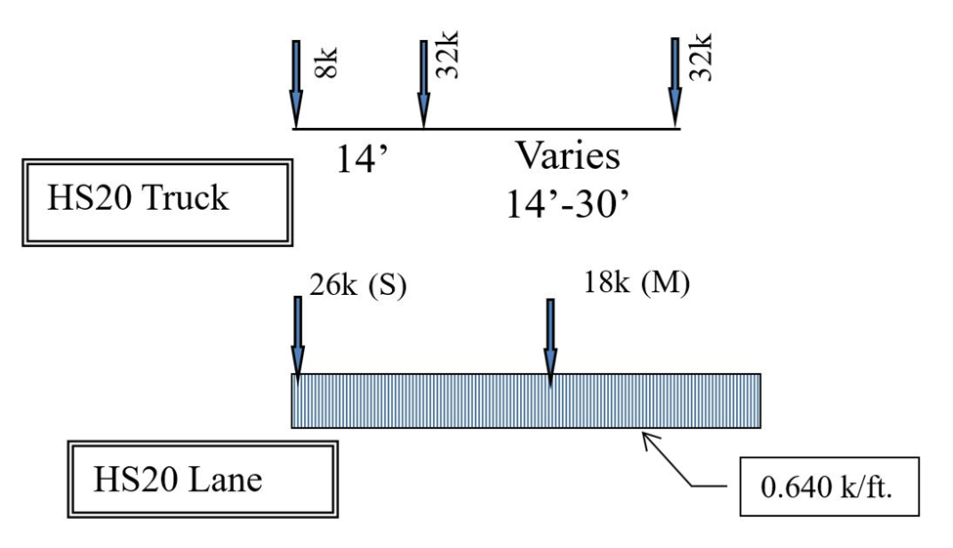
Figure ‎908.2-1: AAHSTO HS20 LOADING
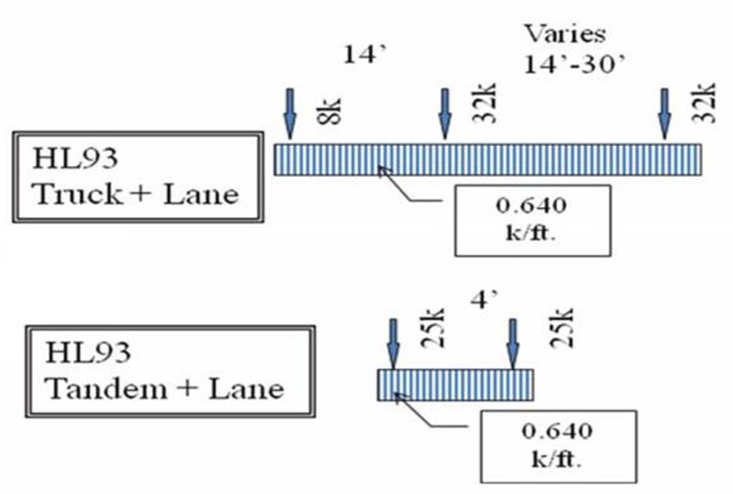
Figure ‎908.2-2: AASHTO HL93 LOADING

RATING LOADS
All bridges shall be load rated for all commercial legal vehicles (S-2F1, S-3F1, S-5C1, SU4, SU5, SU6, SU7, TYPE 3, TYPE 3S2, TYPE 3-3) emergency vehicles (EV2, EV3). ODOT bridges shall also be rated for state permit loads shown in this section by policy. Rating for permit loads is used for internal planning and screening. Owners of non-ODOT bridges may decide to rate bridges for permit loads of their choice. Agencies which issue routine permits shall load rate their bridges for routine permit loads, required by FHWA.

For all span lengths the critical load effects shall be taken as the larger of the following (Refer AASHTO MBE 6A.4.4.2.1.):
- For all load effects, all legal loads applied separately.
- For negative moments and reactions at interior supports, a lane load of 0.2 kip per linear ft. combined with two AASHTO Type 3-3 vehicles multiplied by 0.75 heading in the same direction separated by 30 ft.

COMMERCIAL LEGAL VEHICLES
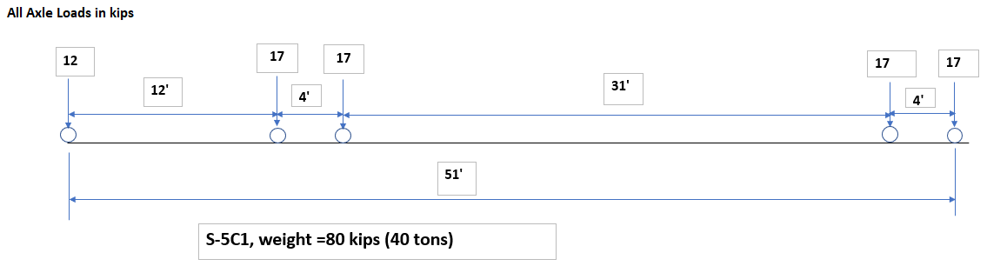
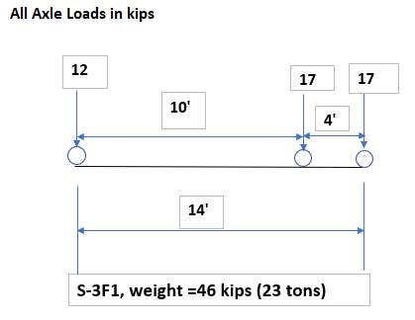
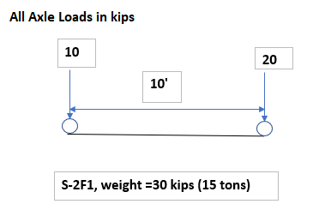

Figure ‎908.3-1: OHIO LOADS
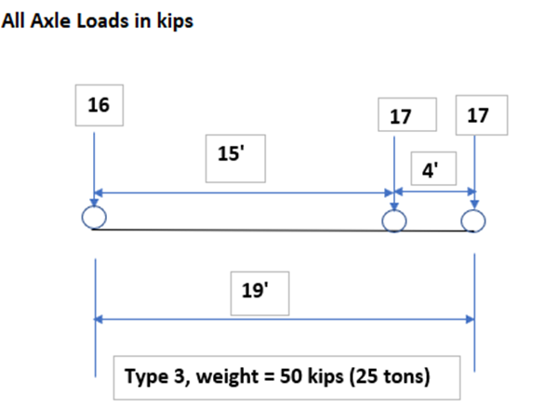
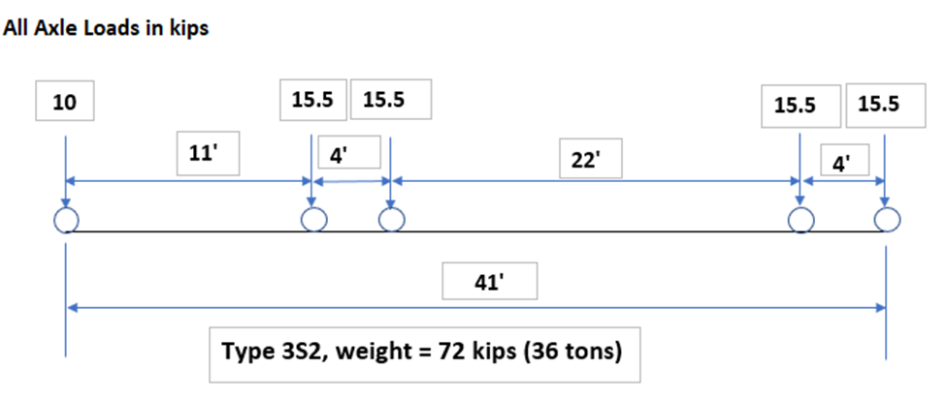
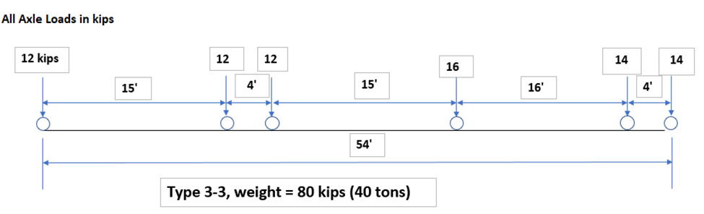
Figure ‎908.3-2: AASHTO LOADS

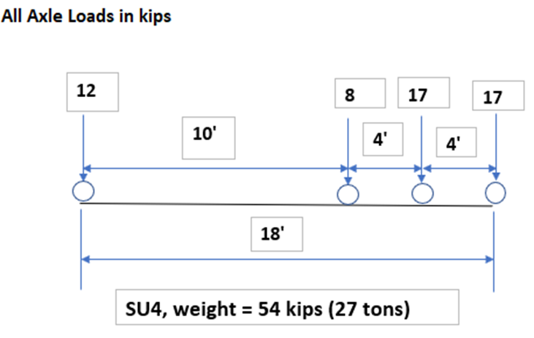
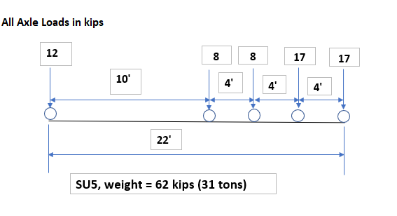

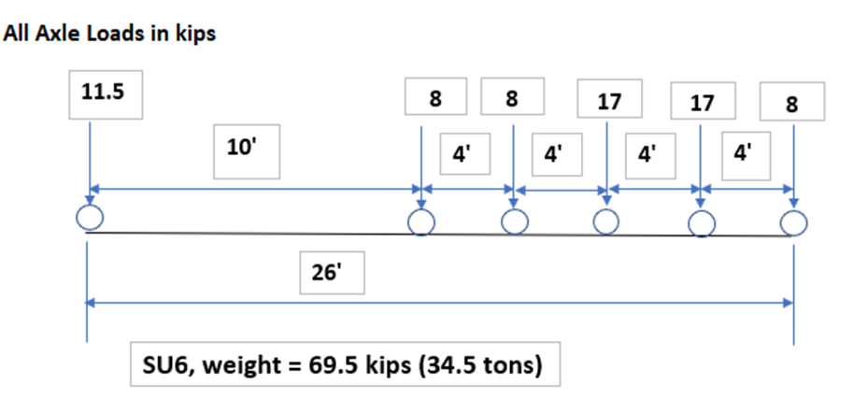

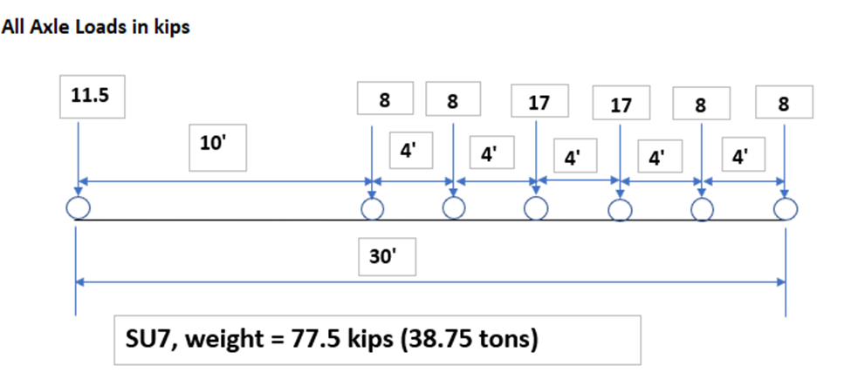

Figure ‎908.3-3: SPECIAL HAULING VEHICLES (SHV)

EMERGENCY VEHICLES
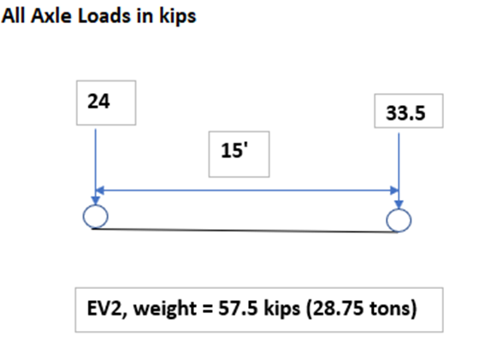

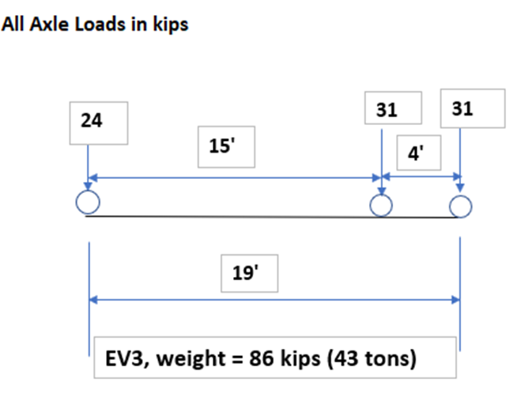

Figure ‎908.3-4: EMERGENCY VEHICLES (EVs)

STATE PERMIT VEHCILES

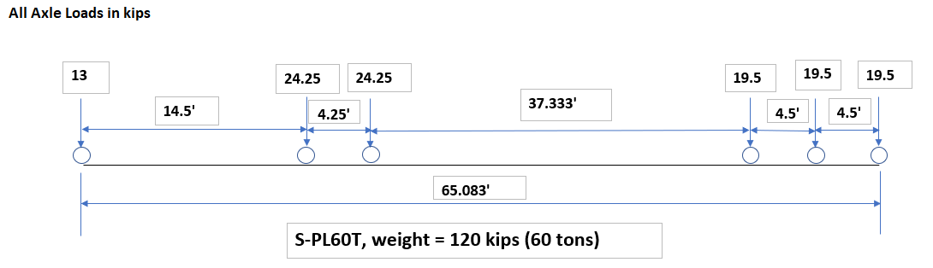
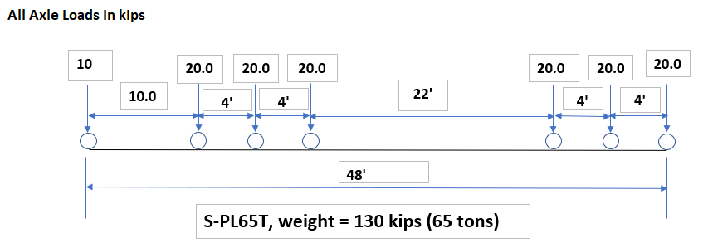

Figure ‎908.3-5: STATE PERMIT LOADS

UNIT WEIGHTS & DENSITIES
The following assumptions should be made while performing the load rating analysis unless more accurate site information is available:
A. Unit weight of asphalt 145 lb. /ft³
B. Unit weight of concrete 150 lb. /ft³
C. Unit weight of latex modified concrete 150 lb. /ft³
D. Unit weight of soil 120 lb. /ft³
E. Unit weight of steel 490 lb. /ft³
F. Water density 62.4 lb. /ft³

STRUCTURES EXEMPT FROM LOAD RATING CALCULATIONS
The following types of structures are exempt from load rating calculations under the provisions of this Section.
A. Circular plastic pipes
B. Concrete pipes (circular, or elliptical)
C. Buried metal frames
D. Junction chambers
E. Manhole flat slab tops, catch basins, inlet tops
F. Structures that do not carry vehicular traffic
G. Structures not carrying a public road
H. Structures meeting requirements of Section 911

EXEMPT STRUCTURES THAT NEED A BR100
All structures exempt under this section, carrying highway traffic and maintained in the ODOT bridge inventory (have SFN/NBI Number) shall have a load rating summary form (BR100) filed based on the original design load of the structure and current field inspection. If the design load is unknown, the load rating summary form shall be filed based on rational evaluation.
When there are no signs of distress, structural damage or deterioration, load rating factors of 1.00 for inventory, 1.30 for operating and 1.500 for legal loads shall be used.

STRUCTURES UNDER DEEP FILL
The intent of the guidelines of this section is to provide conservative recommendations on rating of structures under deep fill. It is not intended to discourage anyone from conducting detailed analysis of structures under deep fill. When reasonable concerns arise, or when field conditions or observations warrant detailed modeling or testing, such analysis and testing should be carried out.
Experience has shown that when a structure has 6.5-ft or more fill on the top, measured from the roadway centerline, the live load effect on the structure due to vehicular traffic is insignificant. ODOT recommends following rating factors for structures under deep fill when detailed calculations are not performed.
The rating factors of 1.00 for inventory, 1.30 for operating, 1.5 for legal loads and 1.3 for EV3 may be coded for LRFR method of rating for structures in Good and Fair condition, when full analyses have not been conducted. For structures in poor conditions appropriate bridge appraisal factors shall be applied to the above recommended rating factors, per Section 929.3.

WHICH PORTION OF BRIDGES SHALL BE LOAD RATED
Any structural member of a bridge that could carry vehicular traffic shall be load rated. Typically, the structural members of the bridge superstructure are load rated. Substructure elements, such as pier caps and columns, should be analyzed for their load carrying capacities in situations when they are either scoped to be analyzed or when the bridge owner or the rating engineer has reason to believe that the capacity of a substructure element may control the capacity of the bridge.

PROCEDURE FOR LOAD RATING
A. New Bridges
1. Load rate new (proposed) bridges at the design stage per BDM Section ‎925.
2. The Project Manager shall forward the load rating report, bridge structure plans and data input files to the OSE Bridge Rating Engineer for review.
B. Existing Bridges
1. Perform a field inspection of the existing bridge according to the ODOT Manual of Bridge Inspection to determine its condition and the effectiveness of the various members for carrying load, if included in the scope. All information shown in the Bridge Inventory and the Inspection Reports shall also be carefully reviewed.
2. If a field inspection of the bridge is not a part of the Scope of Services, as a minimum, review the most current inspection report (and inspection notes, if available).
3. Perform the load rating per BDM Section ‎926.
4. Use the date of construction to determine the yield stresses for the construction materials in older bridges for which plan information is not available.
5. For a load rating being requested to the OSE, the District Bridge Engineer (DBE) shall make available to the OSE, Bridge Rating Engineer (BRE), a complete inspection report (including comments), bridge photographs, field measurements and a copy of the previous rating calculation sheets. BRE will review the submitted material, analyze the bridge, and return a copy of the final rating summary (BR100) to the DBE, along with any recommendations.
6. For load rating performed by the consultant and tasked by the District, the DBE, or Project Manager (PM) shall forward the load rating report, bridge structure plans, and data input files to the BRE for review. The BRE shall review the submittal and send the comments to the DBE/PM or the recommended BR100 to the DBE or PM.
7. For load rating performed by the consultant and tasked by the OSE, the consultant shall submit the load rating report, bridge structure plans, and data input files to the BRE for review. The BRE shall review the submittal and send the recommended BR100 to the DBE, after all comments are addressed.
8. Using pertinent current information and load rating analysis, the District Bridge Engineer/Bridge Owner shall determine and record the Inventory, Operating and Legal Load Ratings in AssetWise.
9. The District Bridge Engineer/Bridge Owner shall keep the final rating summary, rating calculations or computer output (if any) and the rating report along with any recommendations in the bridge file.
C. Influence Line Connected Rating Spreadsheets
1. If directed and included in the Scope of Services, prepare Microsoft Excel spreadsheets connected to influence lines/surfaces to analyze a permit vehicle of up to 25 axles.
2. The Project Manager shall forward the load rating report, bridge structure plans, data input files and spreadsheets to the BRE for review.

WHEN LOAD RATING SHALL BE REVISED
The load rating of a bridge should be revised when:
A. The superstructure is replaced
B. The existing deck is replaced with a new deck
C. The existing deck width has changed or there is an addition of new beam(s) or girder(s) in the cross-section
D. There is a change in the dead load on the superstructure, like addition or removal of wearing Surfaces, addition or removal of sidewalks, parapets, railings, etc.
E. There is a physical change in the condition of a structural member of the bridge, which may change the capacity of the structural member.
F. Rusting or damage to a slab, beam, girder, or other structural element has resulted in section loss and change in capacity.
G. There is structural damage to steel, due to a hit by a vehicle or excessive deflection or elongation under temperature or highway loads.
H. The bridge appraisal rating drops below 5 and every time it drops any step further below.
I. When exposed or broken prestressing strands are discovered. For each broken or exposed strand, consider the adjacent strand(s) in the same row as ineffective.
J. When a bridge is rated based on “Field evaluation and documented engineering judgement (code:0)” and the bridge appraisal rating drops a step.
The load rating of a bridge does not need to be revised when:
A. The change in the thickness of external wearing surface is less than 1/2-in.
B. The change in the deadload on a beam member is not more than 10-lbs/ft.

ANALYSIS OF BRIDGES WITH SIDEWALKS
Pedestrian loads on sidewalks are not typically considered in a load rating analysis of a highway bridge, regardless of if a sidewalk on the bridge is present or not. If a bridge owner has reasons to believe that the sidewalk loads shall be included in the load rating analysis of a bridge, a pedestrian load of 75-lbs/ft² shall be applied to all sidewalks wider than 2-ft and considered simultaneously with the live load in the vehicle lane.
When pedestrian load is present, the pedestrian load effect multiplied with applicable load factor should be subtracted from the capacity of the member at the location being investigated when calculating the RF.
For bridges load rated according to the AASHTO Standard Specifications for Highway Bridges, AASHTO Table 3.22.1A applies. For bridges load rated according to the AASHTO LRFD Bridge Design Specifications, refer to BDM Section ‎924.2.
Pedestrian loads shall not be considered when performing Special or Permit Load Analysis as per BDM Section ‎917.

ANALYSIS FOR MULTILANE LOADING
A. Traffic lanes to be used for rating purposes shall be in accordance with AASHTO Specifications.
B. For rating analysis of floor beams, trusses, non-redundant girders or other non-redundant main structural members, position identical rating vehicles in one or more of the through traffic lanes on the bridge, spaced and shifted laterally on the deck within the traffic lanes to produce the maximum stress in the member under consideration.
C. Apply the multiple presence factors of AASHTO Standard Specification for Highway Bridges, Section 3.12 or AASHTO LRFD Bridge Design Specification, Section 3.6.1, accordingly.
D. For analysis of longitudinal members, position a single EV3 vehicle in one lane of the bridge. If multiple lanes are present, apply the heaviest commercial legal loads in the remaining lanes. For analysis of transverse members, place the EV3 in one lane and adjust its lateral position to induce the maximum stress in the target member. If multiple lanes are present, apply the heaviest commercial legal loads in other lanes, also laterally shifted and spaced to maximize stress effects on the transverse members.

ANALYSIS FOR PERMIT OR SPECIAL VEHICLE

ANALYSIS OF BRIDGE FOR PERMIT OR SPECIAL VEHICLE WHEN SCOPED
When the Scope of Services requires a structure to be analyzed for a special load, define the special load to be included in the analyses in the Scope.
Two analyses shall be performed as per BDM Sections ‎917.1 through ‎‎917.1.4, at the operating level.

FIRST ANALYSIS OF BRIDGE WITH THREE OR MORE LANES
A. In the right-most lane, place the permit or special vehicle positioned to produce the maximum live load effect on the component to be rated.
B. In the adjacent lanes, simultaneously place single S-5C1 vehicles. These vehicles shall be positioned to produce the maximum live load effect on the component to be rated. No partial S-5C1 vehicles shall be used. If applicable, BDM Section ‎916 shall apply.

FIRST ANALYSIS OF BRIDGE WITH TWO LANES
A. In the right-most lane, place the permit or special vehicle positioned to produce the maximum live load effect on the component to be rated.
B. In the adjacent lane, place a series of S-5C1 vehicles positioned to produce maximum live load effect on the component to be rated. The S-5C1 vehicles should be spaced in the longitudinal direction, such that the distance between the rear axle of the leading vehicle and the front axle of trailing vehicle shall be 36-ft. Place as many S-5C1 vehicles as necessary to produce the maximum load effect on the component to be rated. No partial S-5C1 vehicles shall be used. If applicable, BDM Section ‎916 shall apply.

FIRST ANALYSIS OF BRIDGE WITH A SINGLE LANE
In the traffic lane, place the permit or special vehicle positioned to produce the maximum live load effect on the component to be rated.

SECOND ANALYSIS OF BRIDGE FOR PERMIT OR SPECIAL VEHICLE
Place the permit or special vehicle positioned on the bridge to produce the maximum live load effect on the component to be rated. No other vehicle shall be placed on the bridge.

ANALYSIS FOR PERMIT LOADS S-PL60T AND S-PL65T
Bridges shall be analyzed for the permit loads S-PL60T and S-PL65T given in BDM Section ‎908.3 at the permit level for unlimited trips mixed with the regular traffic. The rating factors shall be recorded in the BR100.

LOAD RATING OF LONG SPAN BRIDGES

WHEN THE LOAD RATING SHALL BE DONE
Perform the load rating of long span bridges according to BDM Sections ‎925.3.3, ‎926.2.2, or ‎926.3.2.

HOW THE LOAD RATING SHALL BE DONE

INVENTORY & OPERATING LEVEL RATING USING HL93 LOADING
A. The HL93 live load, shown in BDM Figure ‎908.2-2, shall be used and applied as per AASHTO LRFD Design Specification.
B. Multiple presence factors shall be applied as per BDM Section ‎916.

INVENTORY & OPERATING LEVEL RATING USING HS20 TRUCK
A. The AASHTO HS20 truck or lane loading, whichever controls, shall be applied as per AASHTO.
B. Multiple presence factors shall be applied as per BDM Section ‎916.

LOAD RATING FOR OHIO LEGAL LOADS
A. The Legal Loads specified in BDM Section 908.3 shall be used. The provisions of BDM Sections ‎912 through ‎916 and ‎917 shall apply.
B. Multiple presence factors shall be applied as per BDM Section ‎916.

LONG SPAN BRIDGES WITH THREE OR MORE LANES
A. In the right-most lane, place a series of Ohio S-5C1 vehicles. The S-5C1 vehicles should be spaced such that the distance between the rear axle of the leading vehicle and the front axle of trailing vehicle shall be 30-ft. Place as many S-5C1 vehicles as necessary to produce the maximum load effect on the component to be rated. No partial S-5C1 vehicles shall be used.
B. In all other lanes in the same direction, simultaneously place single S-5C1 vehicles. These vehicles shall be positioned to produce the maximum live load effect on the component to be rated.
C. For bridges with two-way traffic, apply the live load for the opposing traffic in the same manner as the one-way traffic.

LONG SPAN BRIDGES WITH TWO LANES
A. In the right-most lane, place a series of Ohio S-5C1 vehicles. The S-5C1 vehicles should be spaced such that the distance between the rear axle of the leading vehicle and the front axle of trailing vehicle shall be 30-ft. Place as many 5C1 vehicles as necessary to produce the maximum load effect on the component to be rated. No partial S-5C1 vehicles shall be used.
B. For bridges with one-way traffic, in the other lane simultaneously place a single S-5C1 vehicle positioned to produce the maximum live load effect on the component to be rated.
C. For bridges with two-way traffic, in the other lane place a series of Ohio S-5C1 vehicles. The S-5C1 vehicles should be spaced such that the distance between the rear axle of the leading vehicle and the front axle of trailing vehicle shall be 30-ft. Place as many S-5C1 vehicles as necessary to produce the maximum load effect on the component to be rated. No partial S-5C1 vehicles shall be used.

LONG SPAN BRIDGES WITH A SINGLE LANE
The live load shall be a series of Ohio S-5C1 vehicles. The S-5C1 vehicles should be spaced such that the distance between the rear axle of the leading vehicle and the front axle of trailing vehicle shall be 30-ft. Place as many S-5C1 vehicles as necessary to produce the maximum load effect on the component to be rated. No partial S-5C1 vehicles shall be used.

BRIDGES WITH SPAN LENGHTS GREATER THAN 200 FEET
For span lengths greater than 200 feet critical load effects shall be created by placing AASHTO Type 3-3 load multiplied by 0.75 and combined with a lane load of 0.2 kip per linear ft. Refer to AASHTO MBE 6A.4.4.2.1.

BRIDGE POSTING FOR REDUCED LOAD LIMITS

BRIDGE POSTING POLICY
When the maximum load effects under Ohio law and AASHTO MBE exceed the load carrying capacity of a bridge, load posting must be considered following ODOT’s posting policy, to ensure the safety of the traveling public. ODOT’s load posting policy is given below. It is applicable to all bridges carrying public highway traffic.
- A bridge that is not already posted shall be posted for reduced commercial legal loads if the rating factor for any commercial legal load falls below the posting threshold of 1.08 For emergency vehicles (EVs), the posting threshold that requires posting is a rating factor below 1.00.
- For bridges on the interstate system and all ODOT bridges not on interstate system, if a bridge is not posted for commercial legal loads, and the rating factor of any of the emergency vehicles (EV2 or EV3) is below 1.00, it will be posted for reduced loads of Emergency Vehicles only.
- The posting load for any vehicle shall not be more than the legal gross vehicle weight (GVW).
- The minimum load posting value is 3 tons. Bridges not capable of carrying a minimum gross legal weight of 3 tons shall be closed.

REFERENCE TO BRIDGE POSTING
Ohio Revised Code, Section 5591.42.

PROCEDURE FOR BRIDGE POSTING
The Procedure outlined in this section is to be followed for posting or rescinding warnings of bridge strength deficiencies on ODOT bridges. Owners of non-ODOT bridges may modify and adapt the guidelines given in this section to post or rescind warnings of bridge strength deficiencies on their bridges.

BRIDGE POSTING FOLLOWING LOAD RATING
A. A load rater performs the bridge load rating per the ODOT Bridge Design Manual (BDM).
B. For an existing or in-service bridge, the bridge shall be load-rated based on current dead loads and the last field inspection report. The current operating status, inspection comments, photographs, and condition rating of structural elements shall be considered in the load rating.
C. Any structural deficiencies discovered during the most current field inspection, as recorded in the bridge field inspection report shall be considered during the load rating process. The Control Authority Program Manager (CAPM) shall contact the load rater to request to reanalyze a bridge in service.
D. If load rating is performed by load testing, the test load configuration shall be noted.
E. The Load Rating Report shall be signed, sealed, and dated by an Ohio registered Professional Engineer. The load rating results shall be communicated to the CAPM who will enter/update the load rating results in the ODOT AssetWise.
F. If the load rating determines a need for the bridge posting, then the bridge will be analyzed by both LFR and LRFR methods. The method which produces generally higher rating factors shall be used to determine the need for bridge posting and posting loads. The BR100 shall be prepared based on the method selected.
G. Subsequent to load rating analysis, if it is determined that the bridge needs to be posted for reduced loads (i.e., below Ohio Legal Loads), the CAPM shall note in the AssetWise, “Bridge Posting Required.” The CAPM shall initiate the process to have the posting signs installed on the bridge no later than 30 days after a load rating determines the need for such posting (FHWA - October 1, 2019.) The date of posting of sign shall be recorded in the AssetWise.
For ODOT bridges, the date on Director’s letter of posting will be used as the date of posting determination.
For Ohio Turnpike bridges, the date when the Chief Engineer approves the bridge posting will be used as the date of posting determination.

For county bridges that require a resolution from the county commissioners, the date of resolution will be used as the date of posting determination. For other county bridges, the date of rating on the BR100 will be used as the date of posting determination.
For city bridges that require a resolution from the city council, the date of resolution will be used as the date of posting determination. For other city bridges, the date of rating on the BR100 will be used as the date of posting determination.
H. It will be the responsibility of the CAPM to periodically verify that the posting signs are in place.

PROCEDURE FOR PLACING POSTING ON ODOT BRIDGES
A. The ODOT District Bridge Engineer shall submit a written bridge posting request according to BDM Section ‎919.6 to the OSE Bridge Rating Engineer.
B. After the Director signs the posting request:
1. The OSE Bridge Rating Engineer shall send a copy to each of the following:
a. District Bridge Engineer
b. Manager, ODOT Special Hauling Permits
c. Superintendent of State Highway Patrol
d. Board of County Commissioners
e. Respective County Engineer’s Office
2. The District Roadway Services Manager shall prepare, erect, and maintain all necessary signs until the bridge is either strengthened or replaced, or the posting is rescinded per Section 919.6. The sign placement may require the maintaining agency to obtain a permit to install the bridge signs from the local county/city if a route is carried inside local jurisdiction.
3. The District Bridge Engineer shall update all bridge inventory and inspection records to show the latest official posted capacity.
C. When posting of a bridge is determined necessary and no unusual or special circumstance at the bridge dictates otherwise:
1. Weight restriction regulatory signs shall be used. Follow the MUTCD, and Ohio Supplement to MUTCD. An example of the standard wording to be used on the signs is given in BDM Figure ‎919.3.2-1. Sign placement at the bridge and advance warning signs shall be placed in accordance with TEM 201-9.1.
2. Weight limits on the load posting sign shown in BDM Figure ‎919.3.2-1 (R12-H6) are the total GVW of the vehicle which can safely cross the bridge without causing stresses above safe limits. The first silhouette on top represents a single unit vehicle. 2 Axle to 5 Axle weight limits represent the maximum GVW of single unit vehicles having the specified number of axles. 6+ Axles represents the maximum GVW of single unit vehicles having six or more axles. The second silhouette represents the maximum GVW of semi-trailer combination and the third silhouette represents the maximum GVW of truck and full trailer combination. Regardless of how much of the total weight of the vehicle is actually on the bridge, the GVW must be equal or less than the limit next to the applicable vehicle. No posting sign indicates that vehicles of legal configuration are allowed to cross up to the legal GVW.
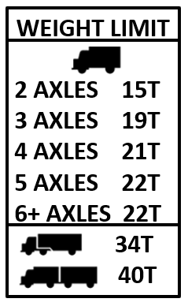
Figure ‎919.3.2-1: LOAD POSTING SIGN (R12-H6)

PROCEDURE FOR RESCINDING POSTING OF ODOT BRIDGES
- When a posted bridge has been strengthened or replaced and no longer needs posting, the District Bridge Engineer shall forward to the Bridge Rating Engineer a written request to rescind the existing signed posting. The request shall include a complete statement of the reason for the action as specified in BDM Section ‎919.6.
- If a bridge is permanently taken out of service (a bridge number is retired), the DBE shall notify the BRE of this occurrence so that the BRE removes the bridge from the list of posted bridges.
C. The Bridge Rating Engineer shall review the request submitted by the District Bridge Engineer and upon concurrence shall forward to the Director a request to rescind the posting.
D. The Bridge Rating Engineer shall distribute copies of the rescind notice as described in BDM Section ‎919.3.2.

PROCEDURE FOR CHANGING POSTING OF ODOT BRIDGES
When the rated capacity of a posted bridge changes, to require a revised posting level, the procedures in BDM Section ‎919.3 apply. Additionally, the existing posting must be rescinded as set forth in BDM Section ‎919.4.

REQUIRED INFORMATION FOR POST, RESCIND AND CHANGE REQUESTS FROM DISTRICTS
The following minimum information is required on all post, rescind and change requests:
A. Posting Request (Reduction in Load Limits)
1. Current Bridge Asset Name
2. SNBI Bridge Number/SFN
3. Feature intersected (over or under bridge)
4. Posting Load for each Ohio Legal Load or EV load
5. Controlling legal load rating factor
6. Explanation as to why the posting is required
7. If the bridge is scheduled for rehabilitation or replacement. If so, when.
B. Rescinding Request (Removal of posted load limits)
1. Current Bridge Asset Name
2. SNBI Bridge Number/SFN
3. Feature intersected (over or under bridge)
4. Existing posting (weight limits currently in effect for each of the Ohio Legal Loads or EV loads)
5. Date existing posting was effective
6. Explanation as to why the posting restrictions can now be removed
7. New load rating summary for the rehabilitated or new structure, if applicable
C. Change Request (Revision of Existing Posted Limits)
1. Current Bridge Asset Name
2. SNBI Bridge Number/SFN
3. Feature intersected (over or under bridge)
4. Existing posting (weight limit currently in effect for each of the Ohio Legal Loads)
5. Revised posting request (revised weight limit for each of the Ohio Legal Loads or EV loads)
6. Date of existing posting was effective
7. Explanation as to why posting change is necessary

POSTING FOR EMERGENCY VEHICLES
When a bridge is analyzed and determined to be incapable of carrying full loads of the EVs, and the bridge is not posted for the reduced commercial legal loads, it shall then be posted for the reduced weight limits of EVs that can cross the bridge without causing stresses above safe limits. MUTCD R12-7 sign (shown in BDM Figure ‎919.7-1) shall be used. The single axle weight limit shall be for the maximum load of a single axle. The tandem weight limit shall be the maximum load on a tandem or dual axle. The Gross shall be the maximum GVW.
If a bridge is posted for reduced commercial legal loads, it shall not be posted for EVs simultaneously. Sign placement shall be in accordance with the TEM 201-9.
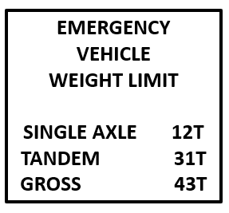
Figure ‎919.7-1: EMERGENCY VEHICLE SIGN (R12-7)

SOFTWARE TO BE USED FOR LOAD RATING OF ODOT BRIDGES

LIST OF ODOT PREFERRED LOAD RATING PROGRAMS
The bridge models developed during the load rating analyses are being used by ODOT Superload system to analyze and process hundreds of overload-permits every day. Superload system is configured to analyze bridges on a route in a fast and efficient batch process and minimize the permit analysis turnaround time. ODOT uses preferred programs to maintain and update the bridge models in the Superload system. ODOT has licenses of a few other load rating and analysis programs but not every analysis program is interfaced with the Superload system. The bridges which are not modeled using preferred programs require to be analyzed manually for permit loads, which substantially increases the process time.
A. AASHTOWare BrR: BrR is a load rating and analysis program developed and licensed by AASHTO. BrR can rate the bridges by LRFR and LFR methods. BrR can load rate a variety of bridge types including reinforced concrete box culverts and curved beam bridges. ODOT has a site license for BrR. Through a special pricing option, Counties, Cities and Consultants working on bridges in Ohio can obtain a stand-alone single user license of the BrR program from AASHTO. Please contact the ODOT Bridge Rating Engineer in the Central Office, should you need help.
B. AASHTOWare BrD: BrD is a bridge design check program developed and licensed by AASHTO. BrD can perform design check of a bridge by LRFR and LFR methods for compliance with current AASHTO Specifications. BrD program is fully compatible with BrR program, as data files created in BrD program can be used in BrR program to load rate a bridge. ODOT has a site license for BrD from AASHTO. Through a special pricing option, Counties, Cities and Consultants working on bridges in Ohio can obtain a stand-alone single user license of the BrD program from AASHTO. Please contact the ODOT Bridge Rating Engineer in the Central Office, should you need help.

OTHER LOAD RATING PROGRAMS
For the analysis of the structures that cannot be accurately modeled using ODOT’s Preferred Load Rating Programs stated in 920.1, contact the OSE Bridge Rating Engineer for software pre-approval prior to performing any load rating. The Department will not accept load ratings performed using any software not on ODOT’s preferred load rating program list or pre-approved for a bridge. Currently, ODOT licenses following additional bridge analysis programs:

A. Midas Civil: Midas Civil is a finite element analysis program by Midas IT Co., Ltd., Use this program to load rate only complex bridges that cannot be accurately modeled using the AASHTO BrR. (http://www.midasuser.com).
B. Eriksson Culvert: This program can load rate reinforced concrete flat-topped 3-sided frames and 4-sided boxes buried under the fill by LRFR and LFR methods. (www.erikssonsoftware.com)
C. MDX Software: MDX software can only be used to load rate ODOT slab-girder/beam bridges that have horizontal curvature of more than 4 degrees. This program supports Load Factor or Load and Resistance Factor methods. Do not use this program to load rate straight or low curvature bridges that can be accurately modeled using the AASHTO BrR. (http://www.mdxsoftware.com/)
D. DESCUS I: Design and Analysis of Curved I-girder Bridge Systems, marketed by OPTI-MATE, Inc. Use the most current version of the software; (www.opti-mate.com)

LOAD RATING REPORT SUBMISSION
The load rating reports shall be submitted to the ODOT project manager (PM), ODOT DBE or the respective owner (in case of a non-ODOT bridge). For an ODOT or ODOT-let bridge, the DBE or the PM shall send electronic copies of all files, including the bridge plans, rating model input files, BR100 and load rating report files to the OSE for review.
For the design check of new (proposed) bridges in accordance with BDM 925, submit the following as a minimum:
- Error-free electronic input files of the load-rating models
- Proposed bridge plans and shop drawings (if applicable)
- Supporting calculations (if applicable)
- A screenshot showing the design load rating factors at both the inventory and operating levels
The final load rating submission shall include:
- Electronic copies of all input data files of final bridge rating models, complete, error free and ready to run.
- Electronic copy of the BR100 form. BR100 form shall be submitted both in PDF and Excel formats. The PDF copy of the BR100 shall be signed, sealed, and dated by an Ohio Registered Professional Engineer.
- Electronic copy of the Load Rating Report including BR100 form. The PDF copy of the Load Rating Report shall be signed, sealed, and dated by an Ohio Registered Professional Engineer.
For existing bridges, the report shall state how the material properties were determined. Any specific details about the current conditions and bridge geometry shall be listed.
The report summary must list final inventory and operating loads and ratings of each structure unit, and the final ratings of the entire bridge summarized in a tabular form on BR100. The controlling stress (flexure, shear, tension, compression, etc.), member, location and limit state shall be stated in the Comment section of BR100. For complex structures, rating factors of critical members shall also be included in the rating report.
The load rating summary (BR100) shall include the names of the rater and an independent reviewer. One of them must have an active PE license with the Ohio Board of Professional Engineers and Surveyors. PE Number(s) shall be added.
The engineer who performed the load rating shall be responsible for incorporating any changes in the input files recommended by ODOT subsequent to its review.
An example of a Bridge Load Rating Report Summary (BR100) is shown in BDM Figure ‎921-1.

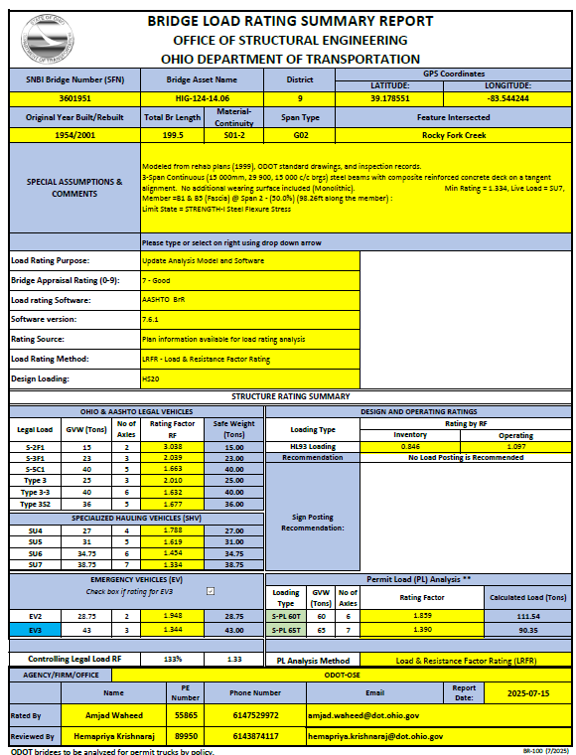
Figure ‎921-1: BR100 - LOAD RATING SUMMARY FORM

LOAD RATING USING AASHTO BrR PROGRAM

GENERAL
BrR is a load rating program licensed from AASHTO. BrR runs on Microsoft Windows and can load rate a variety of bridges by ASR, LFR as well as LRFR methods.
Include all legal loads, including AASHTO loads, SHVs, EVs, and Ohio loads in the rating and posting analyses. Also, analyze all ODOT bridges for permit loads. For non-ODOT bridges, check with the responsible owner before analyzing permit loads. The BrR vehicle library and rating templates can be customized to include all loads. Alternatively, ODOT’s BrR library and rating templates can be requested from OSE.
Always create girder system models in BrR. For complex framing plans, consult with the Rating Engineer in OSE.
The current and future wearing surface loads shall be applied on typical section of the system model. Do not apply wearing surface loads as member loads on individual members of the system model.
Specify concrete deck reinforcement, for multi-span steel beam/girders with composite concrete deck. Make sure extra reinforcement in composite decks over piers is also specified in BrR models.
Compute and fill out all live load distribution factors for LFD and LRFR methods in the BrR model. Make sure you verify the BrR models run without errors for both LFD and LRFR methods and produce reasonable rating factors.

BrR LOAD RATING REPORT SUBMISSION
The load rating report shall be submitted to the Project Manager, the District Bridge Engineer or the non-ODOT bridge owner.

BrR COMPUTER INPUT AND OUTPUT FILES
Submit the error-free and working electronic copies of the input file exported as an “XML” file. Do not submit output files of BrR program unless directed to do so.

LOAD ANALYSIS USING ERIKSSON-CULVERT PROGRAM

GENERAL
Eriksson Culvert program can be used to analyze reinforced concrete three-sided flat-topped frames and four-sided box sections. Include all legal loads, including AASHTO loads, SHVs, EVs, and Ohio loads in the rating and posting analyses. Also, analyze all ODOT bridges for permit loads. For non-ODOT bridges, check with the responsible owner before analyzing permit loads.
If haunch dimensions vary, use the smallest dimension in the analysis.

ERIKSSON CULVERT LOAD RATING REPORT SUBMISSION
The load rating report and input files shall be submitted to the Project Manager, the District Bridge Engineer or the non-ODOT bridge owner.

ERIKSSON COMPUTER INPUT AND OUTPUT FILES
Use the SNBI Bridge Number (SFN) of the bridge with prefix “R” to name and appropriate extension to name the input and output files. For example, if the SNBI Bridge Number of a bridge is 4729854, the input and output file names should be “R4729854.dat” and R4729854.cus and R4729854.xml, etc.
.

LOAD RATING OF BRIDGES USING LRFR SPECIFICATIONS

APPLICABILITY OF AASHTO DESIGN SPECIFICATIONS
This Section is consistent with the current AASHTO LRFD Bridge Design Specifications. Where this Section is silent, the current AASHTO LRFD Bridge Design Specification shall govern.

GENERAL LOAD RATING EQUATION
The following general equation shall be used in determining the load rating of each component and connection subject to a single force effect (axial force, flexure, or shear) [MBE 6A.4.2]:
$$RF=\frac{C-\left(γ_{DC}\right)\left(DC\right)-\left(γ_{DW}\right)\left(DW\right)±\left(γ_{P}\right)\left(P\right)-\left(γ_{PL}\right)\left(PL\right)}{\left(γ_{LL}\right)\left(LL\right)\left(1+{IM}/{100}\right)}$$
For Strength Limit States:
C = ϕ_{c} ∙ ϕ_{s} ∙ ϕ ∙ R_{n}
Where the following lower limit shall apply:
ϕ_{c} ∙ ϕ_{s} ≥ 0.85
For Service Limit States:
C = f_{R}
Where:
C = Capacity
DC = Dead load effect due to structural components and attachments
DW = Dead load effect due to wearing surface and utilities
f_{R} = Allowable stress specified in LRFD Code
IM = Dynamic load allowance expressed as percentage (%)
LL = Live Load effect
P = Permanent loads other than dead loads, such earth pressure, shrinkage etc.
PL = Pedestrian Load effect only to be applied when a sidewalk is present
RF = Rating Factor
R_{n} = Nominal member resistance
γ_{DC} = Load factor for DC load
γ_{DW} = Load factor for DW load
γ_{p} = Load factor for P load = 1.0
γ_{LL} = Evaluation live load factor
γ_{PL} = Load factor for PL load = 1.0
ϕ_{c} = Condition factor
ϕ_{s} = System factor
ϕ = LRFD Resistance factor
For Limit States and factors see BDM Section ‎924.3.

LIMIT STATES AND LOAD FACTORS FOR LOAD RATING BY LRFR METHOD
Strength is the primary limit state for load rating; Service and Fatigue limit states are selectively applied in accordance with the provisions of AASHTO Manual of Bridge Evaluation [MBE 6A.4.2]:
For Inventory and Operating Rating for AASHTO HL93 Loading, use the following limit states and load factors:
Table ‎924.3-1: LRFR Design Load Limit States and Load Factors [MBE Table 6A.4.2.2-1]
Bridge Type | Limit State | Dead Load  γ_{DC} | Dead Load  γ_{DW} | HL93 Loading
 |  |  |  | Inventory  γ_{LL} | Operating  γ_{LL}
Steel | Strength I | 1.25 | 1.50 | 1.75 | 1.35
Steel | Service II | 1.00 | 1.00 | 1.30 | 1.00
Steel | Fatigue | 0.00 | 0.00 | 0.80 | ---
Reinforced Concrete | Strength I | 1.25 | 1.50 | 1.75 | 1.35
Prestressed Concrete | Strength I | 1.25 | 1.50 | 1.75 | 1.35
Prestressed Concrete | Service III | 1.00 | 1.00 | 0.80* | ---
Wood | Strength I | 1.25 | 1.50 | 1.75 | 1.35
* Use γLL = 1.0 when time-dependent losses are calculated per LRFD Design Article 5.9.5.4

For rating for Legal Loads, use the following limit states and load factors:
Table ‎924.3-2: Legal Loads Limit States and Load Factors [MBE Table 6A.4.4.2.3a-1]
Bridge Type | Limit State | Dead Load γ_{DC} | Dead Load γ_{DW} | Ohio Legal Loads  γ_{LL}
Steel | Strength I | 1.25 | 1.50 | 1.45
Steel | Service II | 1.00 | 1.00 | 1.30
Reinforced Concrete | Strength I | 1.25 | 1.50 | 1.45
Prestressed Concrete | Strength I | 1.25 | 1.50 | 1.45
Prestressed Concrete | Service III | 1.00 | 1.00 | 1.00
Wood | Strength I | 1.25 | 1.50 | 1.45

For Rating for Special and Permit Loads, use the following limit states and load factors:
Table ‎924.3-3: Permit Load Limit States and Load Factors [MBE Table 6A.4.5.4.2a-1]
Bridge Type | Limit State | Dead Load γDC | Dead Load γDW | Routine Permit Loads*  γ_{LL} | Permit or Special Loads**  γ_{LL}
Steel | Strength II | 1.25 | 1.50 | 1.40 | 1.20
Steel | Service II | 1.00 | 1.00 | 1.00 | 1.00
Reinforced Concrete | Strength II | 1.25 | 1.50 | 1.40 | 1.20
Reinforced Concrete | Service I | 1.00 | 1.00 | 1.00 | 1.00
Prestressed Concrete | Strength II | 1.25 | 1.50 | 1.40 | 1.20
Prestressed Concrete | Service I | 1.00 | 1.00 | 1.00 | 1.00
Wood | Strength II | 1.25 | 1.50 | 1.40 | 1.20
*For unlimited crossings/multiple trips
**For all permits or special loads, single trip & limited crossing, other than routine permits
***For EV3, use γLL = 1.20 for bridges on Interstate system; use γLL = 1.10 for all others

DYNAMIC LOAD ALLOWANCE (IM)
A. A dynamic load allowance of 33% shall be used for all non-buried bridges, except for fatigue evaluation.
B. For fatigue evaluation, a dynamic load allowance of 15% shall be used.
C. Dynamic load allowance shall only be applied to the truck or tandem portion of HL93 loading (dynamic load allowance shall not be provided to the lane portion).
D. Dynamic load allowance shall not be applied to wood components of a bridge.
E. Dynamic allowance may be ignored for slow moving (speed less than 10 mph), special or permit loads under controlled conditions.
F. For buried bridges, dynamic allowance (IM) shall be taken as:
IM = 33 (1.0 – 0.125 DE) ≥ 0% [AASHTO 3.6.2.2-1]
Where:
DE = the minimum depth of cover above the structure (ft.)

CONDITION FACTOR (φ_{c})
A condition factor shall be applied to the calculated capacity of the structure, as follows:
Table ‎924.5-1: Condition Factors [MBE 6A.4.2.3]
Structural Condition of a Member | Bridge Appraisal Rating | Condition Factor ϕ_{c}
Good or Satisfactory | 6 or higher | 1.00
Fair | 5 | 0.95
Poor | 4 or lower | 0.85

SYSTEM FACTOR (φ_{S})
System factors are multiplied to the nominal resistance to reflect the level of redundancy of the complete superstructure [MBE 6A.4.2.4]. Bridges that are less redundant will have their factored member capacities reduced.
The following system factors may be used for Flexural and Axial Effects:
Table ‎924.6-1: System Factors [MBE 6A.4.2.4]
Superstructure Type | ϕ_{S}
Welded members in two-girder/truss/arch bridges | 0.85
Riveted members in two-girder/truss/arch bridges | 0.90
Multiple eye bar members in truss bridges | 0.90
Three-girder bridges with girder spacing 6-ft. | 0.85
Four-girder bridges with girder spacing ≤ 4-ft. | 0.95
Floor beams with spacing > 12.0-ft. and non-continuous stringers | 0.85
Redundant stringer subsystems between floor-beams | 1.00
All other girder and slab bridges | 1.00

RESISTANCE FACTOR (φ)
Resistance factor (φ) for the load rating has the same value as for a new design as given in AASHTO LRFD Specification. Also, φ = 1.0 for all non-strength limit states [MBE C6A.4.2.1]. See appropriate section in the LRFD Specification for recommended values for resistance factors [LRFD 5.5.4.2, 6.5.4.2, 8.5.2, 12.5.5].
Some of the commonly used Resistance Factors are given here:
Table ‎924.7-1: Resistance Factors
Type | ϕ
Tension controlled reinforced concrete section | 0.90
Tension controlled prestressed concrete section | 1.00
Shear and torsion in normal weight concrete | 0.90
Flexure in steel | 1.00
Shear in steel | 1.00
Axial Compression in steel only | 0.95
Axial Compression in composite | 0.90
Shear connectors, steel | 0.85
Web crippling, steel | 0.80
For block shear | 0.80
For shear rupture in connection element | 0.80
For weld metal in partial penetration and fillet weld | 0.80
Flexure in wood | 0.85
Shear in wood | 0.75
Wood connections | 0.65
RC cast-in-place buried box structures in flexure | 0.90
RC cast-in-place buried box structures in shear | 0.85
RC precast buried box structures in flexure | 1.00
RC precast buried box structures in shear | 0.90
RC precast buried 3-sided structures in flexure | 0.95
RC precast buried 3-sided structures in shear | 0.90
Structural steel pipe, minimum wall area and buckling | 1.00
Structural steel pipe, minimum longitudinal seam strength | 0.67

EFFECT OF SKEW
Effect of skew on the distribution of live loads shall be considered according to AASHTO LRFD Specifications (LRFD 4.6.2.2.2 and 4.6.2.2.3).

LOAD RATING OF NEW BRIDGES

LOADS TO BE USED FOR LOAD RATING
A. All new and replacement bridges, whose preliminary design was started after October 1, 2010, and requiring load rating, shall be load rated by the AASHTO LRFR method to comply with FHWA requirements. The load to be used for inventory and operating rating based on the LRFR method shall be AASHTO’s HL93 loading (truck and lane or tandem and lane).
B. Newly designed timber bridges shall be load rated using the LRFR method.
C. All legal loads used for analysis shall have transverse spacing, between the centerline of wheels and wheel-groups of 6-ft.
D. Long span bridges shall use the special load configurations given in BDM Section ‎917.
E. The inventory and operating ratings for AASHTO design loads shall be expressed in terms of rating factors rounded to the nearest third decimal point.
F. The ratings for each of the legal loads shall be expressed in terms of rating factors of respective legal load, rounded to the nearest third decimal point. The controlling legal load rating factor shall be the smallest rating factor of all legal loads.
G. For a bridge being designed, analysis shall be performed, and rating factors shall be checked at two stages:
- Design Check: Perform the analysis of the bridge for the Design Loading specified in plans or design documents. Apply the future wearing surface load (FWS), as specified in the design plans or design documents. The minimum acceptable inventory RF for specified design loading at inventory level is 1.00. If the RF at inventory level (for design loading) is less than 1.00, the design shall be revised to bring up the inventory RF to 1.00 or higher. Submit the new or prosed bridges for design check review of ODOT.
- Final Load Rating: After the design check is completed and approved, load rate the bridge for the current loading conditions (without adding the FWS load). Submit the final load rating report (BR100 form) for the bridge based on the current loading conditions.
H. The Bridge Owner may also require load rating to be done for special loads in addition to those specified above. The owner shall include full configurations of the special load used in the analysis, including, but not limited to, axle weights and spacing, number of tires on each axle, tire gauges and overall dimensions of the load. All special loads are to be analyzed by the method specified by the Owner.

LOAD RATING OF NEW BURIED BRIDGES

GENERAL
A. All new pre-cast and cast-in-place bridge structures under the fill of two feet or more and supporting vehicular loads shall be load-rated according to the provisions of this Section.
B. The ODOT preferred load rating programs shall be used to load rate the structure.
C. For structures under 6.5-feet or more fill on top, see BDM Section ‎911.

HOW THE LOAD RATING SHALL BE DONE
A. All spans that are designed to carry vehicular traffic shall be load rated.
B. The load rating analysis shall be based on the final design plans. At the inventory or design level, the load rating shall be equal to or greater than the Design Loading.
C. All structural members shall have actual net section and current conditions incorporated into the member analysis.
D. All dead loads are to be calculated based on the final field conditions. Future deadloads shall be applied unless directed otherwise.
E. Unless more accurate soil data exists, calculate the rating based on a lateral pressure as specified in AASHTO.
F. Apply a live load surcharge as per AASHTO.
G. The effect of soil-structure interaction shall be considered as per AASHTO.
H. Assume hinged connections between the walls and the top and bottom slabs unless there is adequate concrete reinforcement continuous between the slab and the walls at the joint. In that case, continuity between the slab and the walls can be assumed.

CAST-IN-PLACE CONCRETE BOX & FRAME STRUCTURES
A. Cast-in-place bridges shall be design-checked, and load rated by the designer of the bridge.
B. The AASHTO BrR program shall be used to load rate the structure.

PRECAST CONCRETE STRUCTURES

PRECAST CONCRETE BOXES OF SPAN GREATER THAN 12-FT
A. The load rating analysis for precast concrete box culverts of spans up to 20 feet is provided in the Supplemental Specifications SS940. The manufacturer shall submit the actual information about the dimensions and reinforcing bars/cage to the OSE along with the shop drawings before the placement of structure.
B. The load rating analysis will be performed by the OSE using the AASHTO BrR program.

PRECAST CONCRETE BOXES OF SPAN EQUAL TO OR LESS THAN 12-FT
A. The manufacturer shall submit the actual information about the dimensions and reinforcing bars/cage to the OSE along with the shop drawings before the placement of structure.
B. The design check and the load rating analysis will be performed by the OSE using the AASHTO BrR program.

PRECAST FRAMES, ARCHES, AND CONSPANS & BEBO TYPE STRUCTURES
A. The design check for the design loading (including FWS loading if specified) and the final load rating analysis shall be performed by the manufacturer. Refer to 925.1.
B. The load rating report along with the completed BR100 shall be submitted along with the shop drawings before the placement of the precast units.
C. Use the design software to load rate the bridge.
D. Provide all input files to the bridge owner.

PRECAST CONCRETE BOXES NOT DESIGNED BY ASTM OR SS940 SPECIFICATIONS
A. Precast concrete boxes, not designed and manufactured according to ASTM or ODOT Supplemental Specifications SS940 shall be designed and load rated by the manufacturer.
B. AASHTO BrR program shall be used to load rate the precast structure. BrR input files shall be submitted to the bridge owner.
C. The load rating report along with the completed BR100 in Excel and PDF formats shall be submitted along with the shop drawings before the placement of the precast units.

LOAD RATING OF NON-BURIED STRUCTURES

GENERAL
A. All structures, including arch structures, frames, box sections, etc., having a fill or pavement thickness of less than 2-ft on top shall be load rated according to the provisions of this Section.
B. All main structural members of the superstructure affected by the live load shall be analyzed.

HOW THE LOAD RATING SHALL BE DONE
A. The designer shall analyze, and load rate all spans that are designed to carry vehicular traffic.
B. The design check and load rating analysis shall be based on the final design plans.
C. All members shall have actual net section and current conditions incorporated into the member analysis.
D. Bridge members designed as non-composite with the deck slab should be analyzed as non-composite.
E. All dead loads are to be calculated based on the actual field conditions.
F. The total thickness of the composite concrete slab shall be used in load rating for the calculations of section properties. Do not subtract for the monolithic wearing surface.
G. Live load distribution factors, as defined in the current AASHTO LRFD, shall be used.

WHEN THE BRIDGE LOAD RATING SHALL BE DONE
The load rating of new bridges shall be done as per the following sub-sections:

BRIDGES DESIGNED UNDER MAJOR OR MINOR PLAN DEVELOPMENT PROCESS
For bridges designed under the Major or Minor Plan Development Process (PDP), perform the design check and the load rating, and include with the Stage 2 Detail Design Submission. When design modifications that affect the previously submitted load rating analysis occur after Stage 2 and prior to contract sale, revise and resubmit the load rating report to the District Project Manager. The District Project Manager will forward the load rating report to the District Bridge Engineer.

BRIDGES DESIGNED UNDER MINIMAL PLAN DEVELOPMENT PROCESS
For bridges designed under the Minimal Plan Development Process (PDP), perform the design check and the load rating, and include with the Stage 3 Detail Design Submission. When design modifications that affect the previously submitted load rating analysis occur after Stage 3 and prior to contract sale, revise and resubmit the load rating report to the District Project Manager. The District Project Manager will forward the load rating report to the District Bridge Engineer.

BRIDGES DESIGNED UNDER DESIGN-BUILD PROCESS
Unless otherwise indicated in the project scope, perform the design check and the load rating report for bridges designed as part of a Design Build project with the Stage 2 Detail Design Submission. When design modifications that affect the previously submitted load rating analysis occur after Stage 2, revise and resubmit the load rating report to the District Project Manager. The District Project Manager will forward the load rating report to the District Bridge Engineer.

BRIDGES DESIGNED UNDER VALUE ENGINEERING CHANGE PROPOSAL
For bridges re-designed under a Value Engineering Change Proposal (VECP), perform the design check and the load rating of the altered bridge design, and submit to the District Construction Engineer (DCE) with the Final VECP submission. The DCE will supply this information to the District Bridge Engineer.

LOAD RATING OF EXISTING BRIDGES

LOADS TO BE USED FOR LOAD RATING
A. Existing bridges shall be load rated at inventory and operating rating by either LFR or LRFR method with the prior approval of the bridge owner. When the LFR method is used, the load for inventory and operating rating shall be AASHTO HS20. When the LRFR method is used, the load for inventory and operating rating shall be AASHTO HL93. The default load rating method shall be LRFR starting June 13, 2019.
B. Existing bridges shall also be load rated for all the legal loads at the operating level. Use the same method (LFR or LRFR) consistent with the A above.
C. Existing timber bridges may be load rated using the ASR method.
D. All legal loads used for analysis shall have transverse spacing, between the centerline of wheels or wheel-groups, of 6-ft.
E. For long span bridges, refer to BDM Section ‎917.
F. The inventory and operating ratings for the AASHTO HL93 or HS20 loading shall be expressed in terms of rating factors, rounded to the nearest three decimal points.
G. The ratings for each of the legal loads shall be expressed in terms of rating factors of respective legal load, rounded to the nearest third decimal point. The controlling legal load rating factor shall be the smallest rating factor of all legal loads. The Ohio percent of legal shall be rounded off to the nearest 5 (i.e., smallest RF multiplied by 100).
H. The Bridge Owner may also require load rating to be done for special loads in addition to those specified above. The Owner shall include full configurations of the special load used in the analysis, including but not limited to, axle weights and spacing, number of tires on each axle, tire gauges and overall dimensions of the load. All special loads are to be analyzed by the LRFR method of analysis at the operating level as per BDM Section ‎917 unless specified otherwise by the Owner.

LOAD RATING OF BRIDGES TO BE REHABILITATED

HOW THE LOAD RATING SHALL BE DONE
A. The designer shall analyze, and load rate all spans that are designed to carry vehicular traffic.
B. The load rating analysis shall be based on the final design or as-built plans.
C. Future wearing surface dead loads shall be applied in load rating calculations for design checks and should not be included in the final load ratings.
D. All members shall have actual net section and current conditions incorporated into the members’ analysis. Any known section losses, defects or damage to the existing structural members shall be considered in the rating analysis.
E. Bridge members designed as non-composite with the deck slab should be analyzed as non-composite.
F. Structures to be rehabilitated shall be analyzed using the original design plans, the actual field conditions, and all major changes in the final rehabilitation plans.
G. A complete review of all the available inspection information, as well as a thorough site inspection of the existing bridge, must be performed to establish the current conditions prior to proceeding with the analysis.
H. The total thickness of the composite concrete slab shall be used in load rating for the calculations of section properties. Do not subtract for the monolithic wearing surface.
I. Live load distribution factors, in accordance with the governing AASHTO specifications, shall be used.
J. For existing bridges, the rater should review the original design plans as the first source of information for material strengths and stresses. If the material strengths are not explicitly stated on the design plans, ODOT Construction and Material Specifications (C&MS) applicable at the time of the bridge construction shall be reviewed. This may require investigations into old ASTM or AASHTO Material Specifications active at the time of construction.
K. Ultimate or yield strengths of materials shall be as specified on the original design plans unless it is required in the scope of services to conduct specific tests to determine the material strengths.
L. General information about allowable stresses in bending/shear and material strengths based on the year of construction is provided in BDM Table ‎926.2.1-1 and BDM Table ‎926.2.1-2. These are very conservative values and recommended to be used when the material strengths cannot be determined from the design plans, shop drawings, or C&MS applicable at the time of construction. Any material stresses and strengths specified on the design plans or in the C&MS applicable at the time of construction shall supersede the values given in BDM Table ‎926.2.1-1, and BDM Table ‎926.2.1-2 and BDM Table ‎926.2.1-3.
M. The rater is cautioned to pay extra attention to the design plans and the year of construction when determining material strengths for structures built during the transition years of BDM Table ‎926.2.1-1, BDM Table ‎926.2.1-2 and BDM Table ‎926.2.1-3 (e.g. for member type SS, years 1964-68, or 1988-93, etc.), as materials of the newer (or older) specifications may have been substituted.

Table ‎926.2.1-1: Custom Allowable Stresses in Bending
 |  | Type of Rating
Material of Construction | Year of Construction | Fy / Fc' (ksi) | Fy / Fc' (MPa) | Inventory (ksi) | Inventory (MPa) | Operating (ksi) | Operating (MPa) | Posting (ksi) | Posting (MPa)
Structural Steel (SS),(CSC) | < 1900 | 26.00 | 179 | 14.00 | 97 | 19.00 | 131 | 19.00 | 131
Structural Steel (SS),(CSC) | 1901 To 1930 | 30.00 | 207 | 16.00 | 110 | 22.00 | 152 | 22.00 | 152
Structural Steel (SS),(CSC) | 1931 To 1965 | 33.00 | 228 | 18.00 | 124 | 25.00 | 172 | 25.00 | 172
Structural Steel (SS),(CSC) | 1966 To 1990 | 36.00 | 248 | 20.00 | 138 | 27.00 | 186 | 27.00 | 186
Structural Steel (SS),(CSC) | 1991 To Date | 50.00 | 345 | 27.00 | 186 | 37.50 | 259 | 37.50 | 259
Reinforcing Steel (RC) | < 1935 | 32.00 | 221 | 16.00 | 110 | 24.00 | 165 | 24.00 | 165
Reinforcing Steel (RC) | 1936 To 1950 | 36.00 | 248 | 18.00 | 124 | 27.00 | 186 | 27.00 | 186
Reinforcing Steel (RC) | 1951 To 1983 | 40.00 | 276 | 20.00 | 138 | 30.00 | 207 | 30.00 | 207
Reinforcing Steel (RC) | 1984 To Date | 60.00 | 414 | 24.00 | 165 | 36.00 | 248 | 36.00 | 248
Prestress. Strands (Fs')  (CPS),(PSC) | All Years | 270.0 | 1862 | - | - | - | - | - | -
Cast-in-Place Reinf. Conc. (Compression in Bending) (RC),(CSC) | < 1930 | 2.00 | 14 | 0.70 | 5 | 1.30 | 9 | 1.30 | 9
 | 931 To 1950 | 3.00 | 21 | 1.00 | 7 | 1.50 | 10 | 1.50 | 10
 | 1951 To 1980 | 4.00 | 28 | 1.30 | 9 | 2.00 | 14 | 2.00 | 14
 | 1981 To Date | 4.50 | 31 | 1.50 | 10 | 2.20 | 15 | 2.20 | 15
Prestressed Concrete (Fc') (PSC),(CPS) | All Years | 5.50 | 38 | - | - | - | - | - | -
Cast-in-Place Comp. Slab for Prestress. Conc.  (Fc') (CPS) | All Years | 4.00 | 28 | - | - | - | - | - | -
Timber (fb) (TMB) | All Years | - | - | 1.6 | 11 | 2.128 | 15 | 2.128 | 15
Cast-in-Place Slab for Composite Reinforced Concrete | < 1930 | 2.00 | 14 | 0.70 | 5 | 1.30 | 9 | 1.30 | 9
Cast-in-Place Slab for Composite Reinforced Concrete | 1931 To 1950 | 3.00 | 21 | 1.00 | 7 | 1.50 | 10 | 1.50 | 10
Cast-in-Place Slab for Composite Reinforced Concrete | 1951 To 1980 | 4.00 | 28 | 1.30 | 9 | 2.00 | 14 | 2.00 | 14
Cast-in-Place Slab for Composite Reinforced Concrete | 1981 To Date | 4.50 | 31 | 1.50 | 10 | 2.20 | 15 | 2.20 | 15

Table ‎926.2.1-2: Custom Allowable Stresses in Shear
 |  | Type of Rating
Material of Construction | Year of Construction | Fy / Fc' (ksi) | Fy / Fc' (MPa) | Inventory (ksi) | Inventory (MPa) | Operating (ksi) | Operating (MPa) | Posting (ksi) | Posting (MPa)
Structural Steel  (SS),(CSC) | < 1900 | 26.00 | 179 | 8.50 | 59 | 11.50 | 79 | 11.50 | 79
Structural Steel  (SS),(CSC) | 1901 To 1930 | 30.00 | 207 | 9.50 | 66 | 13.50 | 93 | 13.50 | 93
Structural Steel  (SS),(CSC) | 1931 To 1965 | 33.00 | 228 | 11.00 | 76 | 15.00 | 103 | 15.00 | 103
Structural Steel  (SS),(CSC) | 1966 To 1990 | 36.00 | 248 | 12.00 | 83 | 16.00 | 110 | 16.00 | 110
Structural Steel  (SS),(CSC) | 1991 To Date | 50.00 | 345 | 17.00 | 117 | 22.50 | 155 | 22.50 | 155
Reinforcing Steel  (RC) | < 1935 | 32.00 | 221 | 16.00 | 110 | 24.00 | 165 | 24.00 | 165
Reinforcing Steel  (RC) | 1936 To 1950 | 36.00 | 248 | 18.00 | 124 | 27.00 | 186 | 27.00 | 186
Reinforcing Steel  (RC) | 1951 To 1983 | 40.00 | 276 | 20.00 | 138 | 30.00 | 207 | 30.00 | 207
Reinforcing Steel  (RC) | 1984 To Date | 60.00 | 414 | 24.00 | 165 | 36.00 | 248 | 36.00 | 248
Cast-in-Place Reinforced Conc. (RC),(CSC) | < 1930 | 2.00 | 14 | 0.70 | 5 | 1.30 | 9 | 1.30 | 9
Cast-in-Place Reinforced Conc. (RC),(CSC) | 1931 To 1950 | 3.00 | 21 | 1.00 | 7 | 1.50 | 10 | 1.50 | 10
Cast-in-Place Reinforced Conc. (RC),(CSC) | 1951 To 1980 | 4.00 | 28 | 1.30 | 9 | 2.00 | 14 | 2.00 | 14
Cast-in-Place Reinforced Conc. (RC),(CSC) | 1981 To Date | 4.50 | 31 | 1.50 | 10 | 2.20 | 15 | 2.20 | 15
Prestressed Concrete (Fc') (PSC),(CPS) | All Years | 5.50 | 38
Timber (Horizontal Shear Stress) (fb) (TMB) | All Years | - | - | 0.09 | 1 | 0.12 | 1 | 0.12 | 1

Table ‎926.2.1-3: Custom Allowable Stresses for Fasteners
Material | Constructed | LRFR | ASD
Material | Constructed | ФF_{v} | Inventory | Operating | Posting
Riveted | <1939 | 18.0 ksi | 9.5 ksi | 12.5 ksi |  | 12.5 ksi
Riveted | 1936 to 1950 | 21.0 ksi | 11.0 ksi | 15.0 ksi |  | 15.0 ksi
Riveted | 1950 to Date | 25.0 ksi | 13.5 ksi | 18.0 ksi |  | 18.0 ksi
Bolted – Bearing | < 1965 | 17.0 ksi | 11.0 ksi | 15.0 ksi |  | 15.0 ksi
Bolted – Bearing | 1965 to Date | 36.5 ksi * | NA | NA |  | NA
Bolted – Bearing | 1965 to Date | 32.0 ksi ** | NA | NA |  | NA
Bolted – Slip Critical | < 1965 | NA | NA | NA |  | NA
Bolted – Slip Critical | 1965 to Date | 17.0 ksi * | 15.0 ksi * | 20.0 ksi * |  | 20.0 ksi *
Bolted – Slip Critical | 1965 to Date | 15.0 ksi ** | 13.0 ksi ** | 17.5 ksi ** |  | 17.5 ksi **
* Diameter ≤ 1”.
** Diameter > 1”.

WHEN THE BRIDGE LOAD RATING SHALL BE DONE
The load rating of bridges to be rehabilitated shall be done as per following:

BRIDGES DESIGNED UNDER MAJOR OR MINOR PLAN DEVELOPMENT PROCESS
For bridges designed under the Major or Minor Plan Development Process (PDP), perform the load rating, and include the load rating report in the Stage 2 Detail Design Submission. When design modifications that affect the previously submitted load rating analysis occur after Stage 2 and prior to contract sale, revise and resubmit the load rating report to the District Project Manager. The District Project Manager will forward the final load rating report to the District Bridge Engineer.

BRIDGES DESIGNED UNDER MINIMAL PLAN DEVELOPMENT PROCESS
For bridges designed under the Minimal Plan Development Process (PDP), perform the load rating, and include the load rating report in the Stage 3 Detail Design Submission. When design modifications that affect the previously submitted load rating analysis occur after Stage 3 and prior to contract sale, revise and resubmit the load rating report to the District Project Manager. The District Project Manager will forward the final load rating report to the District Bridge Engineer.

BRIDGES DESIGNED UNDER DESIGN-BUILD PROCESS
Unless otherwise indicated in the project scope, include the load rating report for bridges designed as part of a Design Build project with the Stage 2 Detail Design Submission. When design modifications that affect the previously submitted load rating analysis occur after Stage 2, revise and resubmit the load rating report to the District Project Manager. The District Project Manager will forward the final load rating report to the District Bridge Engineer.

BRIDGES DESIGNED UNDER VALUE ENGINEERING CHANGE PROPOSAL
For bridges re-designed under a Value Engineering Change Proposal (VECP), perform a load rating of the altered bridge design, and submit the load rating report to the District Construction Engineer (DCE) with the Final VECP submission. The DCE will supply this information to the District Bridge Engineer.

LOAD RATING OF EXISTING BURIED BRIDGES

CAST-IN-PLACE STRUCTURES
A. Cast-in-place bridges shall be load rated by the designer of the bridge.
B. The AASHTO BrR program shall be used to load rate the structure.

PRECAST BOXES OF SPAN GREATER THAN 12-FT
A. The design check and the load rating analysis will be performed by the OSE.
B. The AASHTO BrR program shall be used to load rate the structure.

PRECAST BOXES OF SPAN EQUAL TO OR LESS THAN 12-FT
The load rating analysis will be performed by the OSE using AASHTO BrR program.

PRECAST FRAMES, ARCHES, AND CONSPANS & BEBO TYPE STRUCTURES
A. The load rating analysis for any new or replacement precast sections will be performed by the manufacturer; otherwise, the load rating analysis will be performed as per the scope of services.
B. The load rating report shall be submitted along with the shop drawings before the placement of the units.
C. The design software shall be used to load rate the bridge.

ANALYSIS OF CONCRETE BOX SECTIONS & FRAMES
Unless more accurate soil data exists, calculate the rating based on a lateral pressure as specified in AASHTO.
Apply a live load surcharge according to AASHTO.
The effect of soil-structure interaction shall be considered according to AASHTO.
Assume hinged connections between the walls and the top and bottom slabs unless there is adequate concrete reinforcement continuous between the slab and the walls at the joint. In that case, continuity between the slab and the walls can be assumed.

LOAD RATING OF EXISTING NON-BURIED STRUCTURES
All structures, including flat slabs, arch structures, frames, box sections, etc., having a fill or pavement material of less than 2-ft on top shall be load rated according to the provisions of BDM Sections ‎912 through ‎924 (as applicable).

LOAD RATING OF EXISTING BRIDGES WITH NO REPAIR PLANS

HOW THE LOAD RATING SHALL BE DONE
A. The rater shall analyze and load rate all spans that are designed to carry vehicular traffic.
B. Existing structures shall be analyzed using the information from the original design plans and the actual field conditions.
C. A complete review of all the available inspection information, as well as a thorough site inspection of the existing bridge, must be performed to establish the current conditions prior to proceeding with the analysis.
D. The bridge rated using design plans shall be noted as such in the load rating report.
E. Allowable stresses for the working stress and the ultimate or yield strengths of materials for Load Factor ratings shall be as specified on the original design plans unless it is required in the scope of services to conduct specific tests to determine the material strengths.
F. For existing bridges, the rater should review the original design plans as the first source of information for material strengths and stresses. If the material strengths are not explicitly stated on the design plans, ODOT Construction and Material Specifications (C&MS) applicable at the time of the bridge construction shall be reviewed. This may require investigations into old ASTM or AASHTO Material Specifications active at the time of construction.
G. The total thickness of the composite concrete slab shall be used in load rating for the calculations of section properties. Do not subtract for the monolithic wearing surface.
H. General information about ODOT Allowable Stresses in bending and shear and material strengths based on the year of construction is provided in BDM Table ‎926.2.1-1 and BDM Table ‎926.2.1-2.
I. The rater is cautioned to pay extra attention to the design plans and the year of construction, when determining material strengths for bridges built during transition years of BDM Table ‎926.2.1-1 and BDM Table ‎926.2.1-2 (e.g., for member type SS, years 1964-68, or 1988-93, etc.), as materials of the newer (or older) specification may have been substituted.
J. Any material stresses and specifications specified on the design plans shall supersede the values given in BDM Table ‎926.2.1-1 and BDM Table ‎926.2.1-2.

WHEN THE BRIDGE LOAD RATING SHALL BE DONE
The load rating of existing bridges shall be done as per the Scope of Services.

LOAD RATING OF EXISTING BURIED BRIDGES
A. The load rating analysis will be performed as per the Scope of Services.
B. Unless specified otherwise, structures shall be load rated for the Loads as per BDM Section ‎926.2.3.

LOAD RATING OF EXISTING NON-BURIED STRUCTURES
All structures, including flat slabs, arch structures, frames, box sections, etc., having a fill or pavement material of less than 2-ft on top of the structures shall be load rated according to the provisions of BDM Sections ‎911 through ‎924 (as applicable).

LOAD RATING OF NON-ODOT BRIDGES
A. Provisions of BDM Section 900 may also be applied to load rating of non-ODOT buried and non-buried bridges at the discretion of the respective bridge owners.
B. The load rating files and reports of a non-ODOT bridge shall be submitted to the respective bridge owners. The bridge owner shall keep the bridge load rating report in the bridge file for future reference and use.
C. Based on the field conditions and the load rating calculations, if the rating engineer determines a bridge should be posted for reduced load capacity, the engineer shall forward the recommendation to the respective bridge owner. Applicable portions of BDM Section ‎917, Bridge Posting for Reduced Load Limits may be followed.
D. It is the responsibility of the respective bridge owner (or designated consultant/rating engineer) to ensure that the load rating information is finally updated in the ODOT AssetWise.

ODOT POLICY ON ASSIGNED LOAD RATINGS
ODOT policy on assigning load rating is in accordance with the AASHTO Manual of Bridge Evaluation, 3rd edition [MBE 6A.1.1] and FHWA Memorandum HIBT-30 dated September 29, 2011.
Wherever possible, ODOT recommends modeling and rate bridges using rating software preferred by ODOT, especially when overweight loads are being regularly permitted to travel on those bridges. This policy covers all current Ohio legal and AASHTO loads and shall be re-visited/revised, if needed.
This policy is applicable to ODOT structures, which otherwise cannot be modeled by BrR or other rating programs available to raters. For non-ODOT bridges, this policy can be applied at the discretion of the bridge owner.

STRUCTURES DESIGNED BY LFD FOR HS20 OR HIGHER HS LOADING
A structure designed and checked by the Load Factor Design (LFD) method may be assigned following rating factors without performing rating calculations, provided:
- The bridge was designed and checked using AASHTO LFD method for HS20 or higher loading.
- The bridge was built in accordance with the original design plans, standard drawings, and ODOT Construction & Material Specifications.
- No changes to loading conditions or the structure conditions have occurred that could reduce the inventory rating below the design load level.
- The checked design calculations and relevant computer input and output information are accessible and referenced or included in the individual bridge records. If complete design files have not been retained for a bridge, design plans that clearly identify the design loading and bear the stamp of an Ohio licensed PE may be used by the individual responsible for load rating under FHWA 23 CFR 650.309(d) as the basis for an assigned load rating.
- A field evaluation has been completed, and the bridge has not developed any cracks, excessive deflections, or signs of deterioration.
- The main structural members of the bridge have not been damaged or repaired since it was originally built.
- The bridge was appraised “Good” during the last bridge inspection and is neither posted nor closed.
Inventory rating factor for HS20 loading = 1.00
Operating rating factor for HS20 loading = 1.67
Ohio legal loads rating factor (all legal loads) = 1.25 (125%)
Rating factor for EV3 = 1.15
SNBI Item B.LR.04: Code AR
A summary report (BR100) of the assigned load rating, which states that the above specified conditions are met, is to be included in the bridge records and signed & stamped by an Ohio PE. If any of the above conditions cannot be met for a bridge at any point during its service life, load ratings cannot be assigned and must be determined by the methods defined in BDM Section 900.

STRUCTURES DESIGNED BY LRFD FOR HL93 LOADING
A structure designed and checked by the Load & Resistance Factor Design (LRFD) method may be assigned following rating factors without performing rating calculations, provided:
- The bridge was designed and checked using AASHTO LRFD method for HL93 loading.
- The bridge was built in accordance with the original design plans, standard drawings, and ODOT Construction & Material Supplemental specifications.
- No changes to loading conditions or the structure conditions have occurred that could reduce the inventory rating below the design load level.
- The checked design calculations and relevant computer input and output information are accessible and referenced or included in the individual bridge records. If complete design files have not been retained for a bridge, design plans that clearly identify the design loading and bear the stamp of an Ohio licensed PE may be used by the individual responsible for load rating under FHWA 23 CFR 650.309(d) as the basis for an assigned load rating.
- A field evaluation has been completed, and the bridge has not developed any cracks, excessive deflections, or signs of deterioration.
- The main structural members of the bridge have not been hit or repaired since it was originally built.
- The bridge was appraised “Good” during the last bridge inspection and is neither posted nor closed.
Inventory rating factor for HL93 loading = 1.00
Operating rating factor for HL93 loading = 1.30
Ohio legal loads rating factor (all legal loads) = 1.50 (150%)
Rating factor for EV3 = 1.30
SNBI Item B.LR.04: Code AR
A summary report (BR100) of the assigned load rating, which states that the above specified conditions are met, is to be included in the bridge records and signed & stamped by an Ohio PE. If any of the above conditions cannot be met for a bridge at any point during its service life, load ratings cannot be assigned and must be determined by the methods defined in BDM Section 900.

CULVERT TYPE BRIDGES DESIGNED USING TABLES OF ASTM C1577 (LRFD), C1433 (LFD), C789 (LFD) AND C850 (LFD)
A culvert type bridge designed for AASHTO design loading using Tables given in any of the above referenced ASTM Specifications may be assigned following rating factors provided:
- The structure was designed and meets one of the above referred ASTM Specifications.
- The ASTM Specifications were referenced in the ODOT Construction & Material Specifications (CMS), and the CMS were utilized during construction.
- No changes to loading conditions or the structure conditions have occurred that could reduce the load rating below the design load level.
- The design plans and the referenced ASTM Specification are accessible to form a basis for assigned load rating under FHWA 23 CFR 650.309(d).
- A field evaluation has been completed, and the structure has not developed excessive cracks, deflections, or signs of deterioration.
The main structural members of the bridge have not been damaged or repaired since the structure was originally built.
The culvert was appraised “Good” during the last bridge inspection and is neither posted nor closed.
When Culvert is designed for HS20 loading
Inventory Rating Factor for HS20 loading = 1.00
Operating Rating Factor for HS20 loading = 1.67
Ohio legal loads rating factor (all legal loads) = 1.25 (125%)
Rating factor for EV3 = 1.15
SNBI Item B.LR.04: Code AR
When Culvert is designed for HL-93 loading
Inventory Rating Factor for HL93 loading = 1.00
Operating Rating Factor for HL93 loading = 1.30
Ohio legal loads rating factor (all legal loads) = 1.50 (150%)
Rating factor for EV3 = 1.30
SNBI Item B.LR.04: Code AR
A summary report (BR100) of the assigned load rating, which states that the above specified conditions are met, is to be included in the bridge records. BR100 shall be filled out and checked by two different engineers and one of them must be an Ohio PE. If any of the above conditions cannot be met for a bridge at any point during its service life, load ratings cannot be assigned and must be determined by the methods defined in BDM Section 900.

LOAD RATING OF BRIDGES WITH INSUFFICIENT INFORMATION

GENERAL
The purpose of this section is to specify ODOT policy on rating of bridges when complete bridge plans or sufficient information cannot be found in records or archives after all files and records are thoroughly searched. Wherever possible, ODOT recommends modeling and load rate bridges using load rating programs preferred by ODOT. This ODOT policy is applicable to ODOT structures. For non-ODOT bridges, this policy can be applied at the discretion of the bridge owner.
References shall be made to AASHTO Manual of Bridge Evaluation (MBE) Section 6.1.4, which addresses load rating of bridges with unknown structural components and National Cooperative Research Program (NCHRP) Synthesis 571, published in 2022, has stated common practices in the nation to load rate bridges and culverts with missing or incomplete as-built information.
The load rater will use one of the following methods or a combination of methods to load rate bridges without plans or with missing details.
When method A) or B), given in this policy is used to determine the load rating of a bridge, the rating information shall be coded as follows:
SNBI Coding:
Item B.LR.04: Code “EJ”
Item B.LR.05: Code inventory rating factor
Item B.LR.06: Code operating rating factor
Item B.LR.07: Code controlling legal load rating factor

METHOD A: LOAD RATING USING FIELD MEASUREMENTS AND HISTORICAL DATA (FH)
When bridge design plans or standard drawings used in design are not available or have missing information, determine if field measurements can be made to establish the overall dimensions of the bridge and the member cross-sections to create a bridge rating data model to analyze a bridge to calculate its load rating using one of the software programs preferred by ODOT. Material properties can be assumed based on the historical data and ODOT specifications applicable at the time of the bridge construction (see Bridge Design Manual, BDM Section 926.2). General information about the material strengths based on the ranges of years of construction is provided in BDM Tables 926-1 through 926-3. Extra attention should be paid when the year of construction is close to the start or end of a range as materials during construction might have been substituted. It is recommended to use conservative values.
This method is recommended to be used for most common steel and timber bridges.

METHOD B: LOAD RATING BASED ON THE DESIGN LOAD AND RATIONAL EVALUATION (DLRE)
When method A) cannot be applied, the load rating of a bridge with insufficient information may be determined using the design load and current Bridge Appraisal Rating (BAR) provided the bridge is in service for some time. Prior to determining the final rating by this method, inspection and maintenance records including historical performance, deterioration, modification, and repair records etc. of the bridge shall be thoroughly reviewed to ensure that structural material, geometry and superimposed dead load have not changed , the appraisal ratings reflect current conditions, and no localized deterioration is present that controls the rating of the entire structure.
Initial rating is based on the assumptions that the bridge is in good condition, has known (or assumed) design loading which was in use when the bridge was built, and has the inventory rating (the capacity minus dead load effect) equivalent to its design loading demand. The operating rating is then calculated from the inventory rating (OR=1.67*IR). The inventory rating factor is based on a HS20 truck assuming the design truck produces demand (moment and shear) in proportion to demand of a HS20 truck. The legal and EV rating factors are based on experience and rational evaluation.
 |  | Initial Ratings (SNBI)
Design Loading | GVW of truck (ton) | Inventory Rating (RF)* | Operating Rating (RF)* | Legal RF | EV3 RF
Unknown |  | 0.28 | 0.46 | 0.350 | 0.320
H10 | 10.0 | 0.28 | 0.46 | 0.350 | 0.320
H15 | 15.0 | 0.42 | 0.70 | 0.520 | 0.480
HS15 | 27.0 | 0.75 | 1.25 | 0.940 | 0.860
H20 | 20.0 | 0.56 | 0.93 | 0.690 | 0.640
HS25 | 45.0 | 1.25 | 2.09 | 1.500 | 1.440
HS20 | 36.0 | 1.00 | 1.67 | 1.250 | 1.150
* Based on HS20 truck GVW=36 ton
Modify the initial rating by multiplying with Bridge Appraisal Factor (BAF) based on the bridge appraisal rating (BAR).
Modified Rating = Initial rating * BAF
Bridge Appraisal Rating (BAR) | 1 | 2 | 3 | 4 | 5 | 6 | 7 | 8 | 9
Bridge Appraisal Factor (BAF) | 0.00 | 0.30 | 0.55 | 0.85 | 1.00 | 1.00 | 1.00 | 1.00 | 1.00
BAR is the lowest of the Deck, Superstructure, Substructure or Culvert appraisal ratings.
When the modified legal RF is determined to be below the posting threshold, the bridge shall be posted for the reduced legal loads determined by multiplying the GVW of each load by the modified legal RF.
When ratings are determined by this method, they shall not be used to issue permits to over-weight loads to go over the bridge.
This method is recommended for common types of concrete and masonry bridges.
An example of load rating of a bridge designed for H15 loading, and BAR = 5, based on the DLRE method.

 |  | Initial Ratings (SNBI)
Design Loading | GVW of truck (ton) | Inventory Rating (RF)* | Operating Rating (RF)* | Legal RF | EV3 RF
Unknown |  | 0.28 | 0.46 | 0.35 | 0.32
H10 | 10.0 | 0.28 | 0.46 | 0.35 | 0.32
H15 | 15.0 | 0.42 | 0.70 | 0.52 | 0.48
HS15 | 27.0 | 0.75 | 1.25 | 0.94 | 0.86
H20 | 20.0 | 0.56 | 0.93 | 0.69 | 0.64
HS25 | 45.0 | 1.25 | 2.09 | 1.50 | 1.44
HS20 | 36.0 | 1.00 | 1.67 | 1.25 | 1.15

Modify the initial rating by multiplying it by BAF based on BAR, given below:
Modified Rating = Initial rating * BAF
BAR | 1 | 2 | 3 | 4 | 5 | 6 | 7 | 8 | 9
BAF | 0.00 | 0.30 | 0.55 | 0.85 | 1.00 | 1.00 | 1.00 | 1.00 | 1.00

BAR = 5; BAF = 1.00
The initial ratings are then modified by multiplying with BAF.
Rating truck | Inventory RF | Operating RF | Legal RF | EV3 RF | Posting
HS20 | 0.42*1.00= 0.42 | 0.70*1.00= 0.70 | 0.52*1.00=0.52 | 0.48*1.00=0.48 | Yes

929.4 METHOD C: LOAD RATING BASED ON THE FIELD TESTING (FT)
When it is not possible to perform load rating of a bridge due to insufficient plans, design information, or when the methods A) and B) do not yield results conforming to the observed performance, non-destructive load testing shall be performed to obtained desired load rating results. MBE, Section 8.2 describes two types of tests for bridge evaluation: diagnostic tests and proof tests. Diagnostic tests are generally performed to validate analytical procedures. ODOT recommends use of static proof tests to establish the maximum safe load capacity of the bridge, where behavior of the bridge is within the linear-elastic range, following MBE, Section 8.8.3.
A load test is not recommended (MBE, Section 8.6) to be performed when:
- The cost of testing reaches or exceeds the cost of bridge strengthening or bridge replacement.
- Pretest evaluation shows the load test is unlikely to show the prospect of improvement in load carrying capacity.
- According to calculations, the bridge cannot sustain even the lowest level of load test.
- There is a possibility of sudden failure (shear or fracture).
- Load tests may be impractical because of access difficulties or site traffic conditions.
Use the recommended load factor (X_{p}) value of 1.40, to be multiplied with the live load in the strength calculations. Following adjustments to be applied to X_{p} by adding all percentages applicable to obtain adjusted load factor, X_{pA} (not to be less than 1.30 or more than 2.20).
Considerations | Adjustment
One-lane Load Controls | +15%
Nonredundant Structure | +10%
NSTM Details Present | +10%
Bridges in Poor Condition | +10%
In-depth Inspection Performed | -5%
Rate-able, Existing RF ≥ 1.0 | -5%
ADTT ≤ 1,000 | -10%
ADTT ≤ 100 | -15%
MBE, Table 8.8.3.3.1-1
When method C) is used to determine the load rating of a bridge, the rating information shall be coded as follows:
SNBI Coding:
Item B.LR.04: Code “LT”
Item B.LR.05: Code inventory rating factor
Item B.LR.06: Code operating rating factor
Item B.LR.07: Code controlling legal load rating factor

BRIDGE LOAD RATING QUALITY CONTROL AND QUALITY ASSURANCE GUIDELINES
930.1 GENERAL
Code of Federal Regulations 23CFR650.313(p), Federal Highway Administration (FHWA) and the American Association of State Highway & Transportation Officials (AASHTO) require using QC and QA processes to ensure and maintain high degree of accuracy and consistency in the load rating program and enhance safety. The FHWA and AASHTO recommendations were developed in response to the NTSB Recommendations No. 1 to AASHTO (H-08-20) and Recommendation No. 2 to FHWA (H-08-17).
The objectives of the QC/QA guidelines are to produce ratings representative of the bridge, data files appropriately created free of errors and omissions, clearly define sources of information, and contain as complete information as possible for future maintenance of data files. The information about the safe load carrying capacities of bridges obtained through the load ratings is used to determine the load posting needs of the bridges. Determination of safe load carrying capacity and load posting of a bridge are vital for the safety of the traveling public and ensuring the bridge will remain open and in service until it is strengthened, repaired, or replaced. Load rating and bridge posting information are also used in determining overall health of the system, & maintenance needs, prioritizing repairs, rehabilitation and replacements, allocation of resources and forecasting future needs.
930.2 QUALITY CONTROL (QC) REVIEW PROCESS
To ensure and maintain a high quality of bridge load rating analyses, the QC reviewer shall conduct a review before submitting the final rating report to the owner. The load rater must perform the load rating analyses, ensuring the assumptions, procedures, and data used are accurate and the most current deadload and inspection information are incorporated. A QC review is an internal process designed to verify the accuracy of data obtained from construction and repair and rehabilitation plans, field inspection reports, field measurements, as well as field and laboratory tests and other input parameters used in the analysis. QC reviews are generally conducted by a QC reviewer, who is not the rater, assigned from within the same agency, or company, or entity, which is performing the load rating analysis. The names of the engineers performing the bridge rating and reviewing must be documented in the final rating report (BR100).
The reviewer shall follow the following steps when performing bridge load rating QC review:

- The reviewer may use the same model that is created by the rater to check the analysis. In some instances, the reviewer may create his/her own independent model. If the same model that was generated by the rater is being used, the rater shall make a copy of the model and run it independently with the appropriate parameters to verify the load rating results obtained by the rater.
- The reviewer shall use original construction plans and all rehabilitated/rebuilt plans (if applicable) and other available documents to verify the input parameters for the rating analysis.
- The reviewer shall review the latest inspection report to see if there are any issues which may affect the rating analysis.
- The reviewer shall independently verify the parameters which may affect the load rating to ensure accuracy, and compliance with the policies and procedures defined in the BDM. The following list contains some of the parameters:
  - thickness of the existing wearing surface/overlay on the structure
  - span length
  - girder spacing
  - ultimate strength of structural material, such as concrete, steel or wood
  - allowable tension or compression of the structural material (timber)
  - section properties of the structural elements, such as girders, slabs, etc.
  - quantity of mild steel used in the analysis.
  - number of pre-stressing strands used in the analysis.
  - strength and size (cross-sectional area) of the prestressing strands
  - location/placement of pre-stressing strands in the beam or girder
  - dead load and live load
  - proper application of composite and non-composite loads
  - legal vehicles and emergency vehicles used in analysis.
  - boundary condition, such as fix, pin, roller, and the values of the rotational springs, if used
- The reviewer shall verify the assumptions and calculations (if used in rating) or perform independent calculations.
- The reviewer, if necessary, may ask for clarification from the rater, request additional calculations, and if unsure of any parameter/assumption, seek technical advice.
- The reviewer shall verify the reasonableness of results.

930.3 FOLLOW-UP PROCEDURE FOR RESOLUTION
Any data issues identified during QC review, including errors, omissions, compatibility between items, changes, or any combination thereof, shall be resolved. The data issues, errors, omissions, etc. shall be communicated to the rater by the reviewer and shall be corrected by the rater. When an error in computer input, assumptions, or load calculations is found, consider what that error will do to the outcome. If the error has a negligible impact on the final rating, it may not be necessary to return the model back to the rater to revise and redo the rating.
When an error is found that will have significant impact on the remainder of the rating model and the results, return the rating model to the rater for correction prior to completing QC review. The rater may be required to resubmit the rating data files and reports after the resolutions of all review comments. Significant impact is defined as when the error is leading to posting a bridge or a change of controlling legal rating factor of 5 percent or more.
The data issues of minor nature (which may not significantly affect the rating of the bridge) may be corrected by the rater or the reviewer after mutual consultation.
ODOT also performs courtesy reviews of the load rating data files of non-ODOT bridges designed, and rated through Local-let program for completeness, accuracy, compliance with scope, and reasonableness of results. The reviewer of the rating is responsible for the complete QC review.

930.4 ACCEPTANCE OF RATING DATA FILES
ODOT will only accept the rating data files which have been created according to BDM Section 900, following ODOT policies, and are free of errors. The ODOT engineer from the OSE accepting and saving the rating data files of bridges which are created in BrR program is responsible to ensure the data files run error-free by both LFR and LRFR methods unless an exception of a method of analysis is approved by the BRE.
930.5 RETENTION POLICY
All load rating reports, and the bridge posting/rescinding information shall be maintained in the bridge files during the service life of the bridge. The most current rating values shall be coded in AssetWise.
930.5 QUALITY ASSURANCE (QA) PROCESS
To maintain high quality of load rating process and to ensure the QC procedures are being followed consistently, a QA review of the load ratings shall be performed by a qualified QA reviewer. The QA process varies depending on the type of bridge, method of load rating used and who performed the load rating.
QA review of ODOT bridges occurs in the Load Rating Section of the Office of Structural Engineering. Local agencies shall designate qualified internal or external QA reviewers to perform such reviews.
The QA review may consist of two parts.
Part I – An office review of a representative sample of documents, data in AssetWise, and inspection reports for evaluation of the organization’s QC process, qualifications, resources, and documentation regarding the load rating for the bridges. Time required to post a bridge after determination of a bridge posting and evidence of presence of posting signs on bridges required to be posted shall also be reviewed.
Part II – If needed, review of a representative sample of the bridge files to ensure the bridge files are maintained correctly and current. This part is for county QA review.

930.5 QA REVIEW FREQUENCY
The QA period for reviews of the load rating shall be one year (± 3 months from the previous QA review date).
930.6 QA REVIEW SAMPLING
The procedure and sampling parameters for selecting bridges for independent review, shall be as follows:
- All bridges posted for reduced loads during the QA period.
- Bridge rating files may be selected by searching for known or suspected inaccuracies.
- 10 percent of randomly selected load ratings (max = 40, min = 2) completed during the QA period.

930.7 RECOMMENDED FOLLOW-UP AND PROCEDURE FOR RESOLUTION
Results and recommendations based on the QA review are used to maintain the quality of the load rating program and make improvements where needed. Following a QA review the comments and recommendations may be communicated through emails, phone calls or other means of communication. Online meetings may also be held if needed. The resolution of the errors, omissions and/or comments shall be done in an expedited manner.
- RATINGS PERFORMED IN-HOUSE BY ODOT
QA review findings and recommendations shall be communicated with the BRE, who will share them with the Load Rating Group and QC reviewers. The raters/reviewers may be required to fix errors, omissions, etc.

- RATINGS PERFORMED BY CONSULTANTS FOR ODOT
QA review findings and recommendations shall be communicated to the Rater(s). The consultants in an active contract with ODOT at the time of their review, may be asked to fix the errors and omissions in the bridge rating models and reports. If the contracts are closed, the critical errors or omissions shall be fixed/maintained by ODOT.

- RATINGS PERFORMED FOR LOCAL ENTITY
QA review findings and recommendations shall be communicated with the Program Managers. The Program Managers/owners shall get the errors and omissions in the bridge rating models and reports fixed.

LOAD RATING FLOW CHART
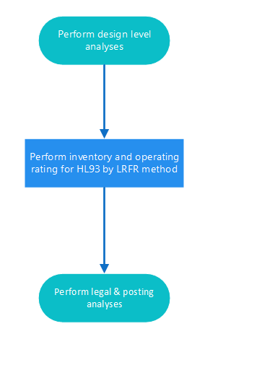
Figure ‎931-1: Inventory and Operating Load Rating Flow Chart
(See Figure ‎931-2 for Legal and Posting Load Rating Flow Chart)
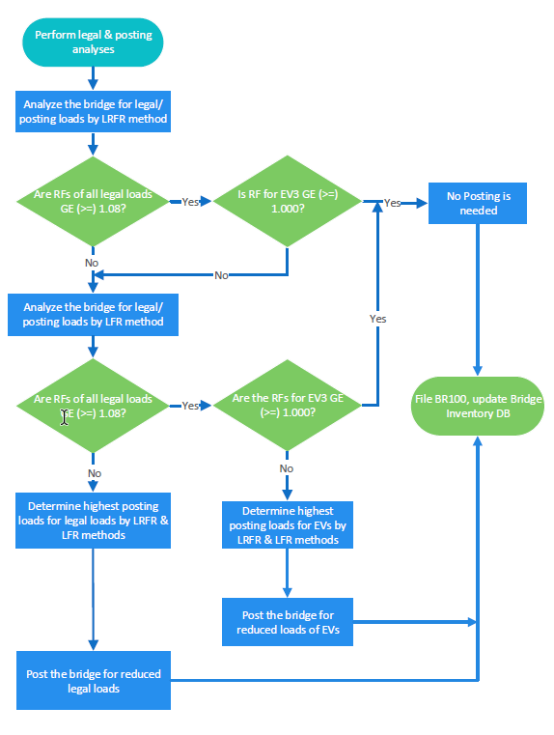
Figure ‎931-2: Legal and Posting Load Rating Flow Chart

