Location & Design Manual Volume 3
Highway Plans



January 16, 2026
OHIO DEPARTMENT OF TRANSPORTATION
Office of CADD & Mapping Services

Preface 11
Purpose 11
Application 11
Preparation 11
Format and Revisions 11
Unit of Measure 11
Ohio Counties 12
Glossary of Terms 14
1200 Plan Preparation 18
1201 General Plan Sheet Information 18
1201.1 Introduction 18
1201.2 Unit of Measure 18
1201.3 Plan Sheet Format 18
1201.4 Plan Sheet Dimensions 18
1201.5 Title Block Information 18
1201.5.1 General 18
1201.5.2 Sheet Numbers 18
1201.5.3 Project Designation 19
1201.5.4 Sheet Title 19
1201.5.5 Quantity Validation 19
1201.5.6 Plan Scales 19
1201.5.7 North Arrow 19
1201.5.8 Additional Requirements 19
1201.5.9 PID Number 19
1202 Drafting 19
1202.1 Plan Scales 20
1202.2 Lettering 20
1202.3 Cross-Section Grids 20
1202.4 Drafting Conventions 20
1202.4.1 Text Orientation 20
1202.4.2 Placement of Leaders from Notes 21
1202.4.3 Placement of Leaders to, or from, a Circular Object 21
1202.4.4 Terminators 22
1202.4.5 Placement of Balloons 22
1202.4.6 Sheet Notes, Charts, and Summary Sheets 23
1202.4.7 Overdrafting 23
1202.4.8 Horizontal Curve Data 24
1202.4.9 Dashed Lines 26
1202.4.10 Direction of Cross-Hatch Lines 26
1202.4.11 Placement of Dimension Text 28
1202.4.12 Angular Dimensions 29
1202.4.13 Dimensions in Crowded Conditions 30
1202.4.14 Dimensioning with a Dot 30
1202.4.15 Dimensioning at Angles 30
1202.4.16 Dimensioning an Object 31
1202.4.17 Crossing Dimension Lines 32
1202.4.18 Grouped Dimensions 33
1202.4.19 Use of “Typical” 34
1203 Standard Drawings 34
1203.1 Standard Construction Drawings 34
1203.2 Plan Insert Sheets 35
1204 Computer-Aided Drafting and Design (CADD) 35
1204.1 General 35
1204.1.1 Introduction 35
1204.1.2 Software 35
1204.1.3 Trademarks 36
1204.2 CADD Standards 36
1204.2.1 Installation and Configuration 36
1204.2.2 Assignments 36
1204.2.3 Colors 38
1204.2.4 Line Styles 38
1204.2.5 Line Weights 39
1204.2.6 Cell Libraries 39
1204.2.7 Fonts 40
1204.2.8 Seed Files 42
1204.2.9 Working Units 43
1204.2.10 Global Origin 43
1204.2.11 Custom Applications 43
1204.3 File Management 44
1204.3.1 General 44
1204.3.2 Project Directory Structure 44
1204.3.3 Design Files 45
1204.3.4 File Naming Conventions 46
1204.3.5 Geographic Coordinate Systems 51
1204.3.6 OpenRoads Designer 51
1204.4 Plotting 54
1204.4.1 General 54
1204.4.2 Plotting 55
Figures 58
Section 1300 Plan Components 62
1301 Introduction 62
1301.1 Standard Plans 62
1301.2 Simplified Plans 63
1302 Title Sheet 64
1302.1 General 64
1302.2 Plan Title 64
1302.2.1 Heading 64
1302.2.2 Project Designation 64
1302.2.3 Political Subdivisions 67
1302.2.4 Railroads 68
1302.3 Design Designation 68
1302.4 Design Exceptions 70
1302.5 Index of Sheets 70
1302.6 Plan Preparer Identification 70
1302.6.1 Signatures and Seals 70
1302.6.2 Design Firm Information 70
1302.7 Underground Utilities Note 71
1302.8 Location Map 71
1302.9 Supplemental Specifications 72
1302.9.1 Special Provisions 72
1302.10 Standard Construction Drawings 72
1302.11 Project Description and Earth Disturbed Areas 73
1302.11.1 Project Description 73
1302.11.2 Earth Disturbed Areas 74
1302.12 Notes 74
1302.12.1 Limited Access 74
1302.12.2 Specifications 75
1302.12.3 Maintenance of Traffic Endorsement 75
1302.13 Plan Signatures 76
1302.14 Combined Plans 76
1302.15 Americans with Disabilities Act (ADA) Design Waivers 76
1302.16 Railroad Involvement 76
1302.17 Federal Project Number 77
1303 Schematic Plan 77
1303.1 General 77
1303.2 Reference Lines 77
1303.3 Stationing 77
1303.4 Bearings 78
1303.5 Horizontal Curve Data 78
1303.6 Project Limits 78
1303.7 Work Limits 78
1303.8 Federal Project Flags 78
1303.9 Political Boundaries 79
1303.10 Waterways 79
1303.11 Bridges 79
1303.12 Roads for Maintaining Traffic 79
1303.13 Railroads 79
1303.14 Utility Lines 79
1303.15 Pipelines 79
1303.16 Service/Public Roads 79
1303.17 Culverts and Sewers 79
1303.18 Landscaped Areas 80
1303.19 Participation Splits 80
1303.20 Contractor’s Use of ODOT Right-of-Way 80
1303.21 Wetlands 80
1303.22 Project Control and Reference Points 80
1304 Typical Sections 81
1304.1 General 81
1304.2 Typical Section Type and Limits 81
1304.3 Reference Line Location 81
1304.4 Rounding 81
1304.5 Profile Grade Point 82
1304.6 Dimensions 82
1304.7 Pavement and Shoulder Cross-Slopes 82
1304.8 Subsurface Drainage 82
1304.9 Pavement Build-Up 82
1304.10 Foreslopes and Backslopes 82
1304.11 Legend 83
1304.12 Longitudinal Joints 83
1304.13 Approach Slabs 83
1304.14 Warranty Pavement 83
1304.15 Subgrade Treatment 83
1305 General Notes and Special Provisions 83
1305.1 General 83
1305.2 Special Provisions 84
1306 Maintenance of Traffic 84
1306.1 General 84
1306.2 Maintenance of Traffic Plan Contents 84
1306.3 Roads and Pavements for Maintaining Traffic 85
1307 Estimated Quantities 86
1307.1 General 86
1307.2 General Summary Sheet 86
1307.2.1 Sheet Number Columns 86
1307.2.2 Participation and Funding Splits 86
1307.2.3 Item Code, Unit of Measure, and Description 86
1307.2.4 Contingency Quantities 92
1307.2.5 Linear Grading 92
1307.2.6 “Standard”, “As Per Plan”, “Miscellaneous”, and “Special” Pay Items 93
1307.2.7 Alternate, Optional, and Additive Alternate Bid Items 93
1307.2.8 Sheet Cross References 95
1307.2.9 Buildings Demolished 95
1307.2.10 Salvage to Utility Items 96
1307.3 Subsummaries 96
1307.4 Quantity Calculations 96
1307.4.1 General 96
1307.4.2 Pavement Calculations 96
1307.4.3 Rounding of Quantities 96
1307.4.4 Validation of Quantities 97
1308 Project Site Plan 97
1308.1 General 97
1308.2 Requirements 97
1309 Plan and Profile Sheets 98
1309.1 General 98
1309.2 Format 99
1309.3 Existing Information 99
1309.3.1 Topography 99
1309.3.2 Buildings and Appurtenances 100
1309.3.3 Roadway Items 100
1309.3.4 Boundary Lines 100
1309.3.5 Utilities 101
1309.3.6 Underground Mines 101
1309.4 Proposed Facility Information 101
1309.4.1 Alignment and Grade 101
1309.4.2 Roadway Items 103
1309.4.3 Boundary Lines 103
1309.4.4 Drainage Items 103
1309.5 Quantities 104
1309.5.1 Reference Balloons 104
1309.5.2 Estimated Quantities 104
1309.6 Miscellaneous Information 105
1309.6.1 Project Control and Reference Points 105
1309.6.2 Cross References to Other Sheets 105
1309.6.3 Typical Sections of Adjoining Pavement 105
1309.6.4 Project and Work Limits 105
1309.6.5 Match Lines 105
1310 Cross-Sections 105
1310.1 General 105
1310.2 Format 105
1310.3 Earthwork and Seeding Quantities 106
1310.3.1 Earthwork Calculations 106
1310.3.2 Earthwork Corrections for Curvature 106
1310.3.3 Roads for Maintaining Traffic 107
1310.3.4 Seeding Calculations 107
1310.4 Drainage Items 108
1310.5 Drives 108
1310.6 Miscellaneous Items 108
1311 Miscellaneous Details 108
1311.1 Drive Details 108
1311.2 Grading Details 108
1311.3 Intersection Details 109
1311.4 Interchange and Ramp Terminal Details 109
1311.5 Pavement Joint Details 109
1311.6 Pavement/Transition Details 109
1311.7 Superelevation Tables 109
1311.8 Other Details 109
1312 Drainage Details 110
1312.1 General 110
1312.2 Culvert Details 110
1312.3 Storm Sewer Profiles 112
1312.4 Precast Drainage Structures 112
1312.5 Underdrain Details 113
1313 Sanitary Sewer and Water Work Plans 113
1314 Traffic Control, Lighting, Landscaping, Rest Areas, Structures, Right-of-Way, and Soil Profile 113
1314.1 Traffic Control Plans 113
1314.2 Lighting Plans 113
1314.3 Landscaping Plans 113
1314.4 Rest Area Plans 113
1314.5 Structures 114
1314.6 Right-of-Way Plans 114
1314.7 Soil Profile Sheets 114
1314.8 Mine Map Overlay Sheets 114
1315 Simplified Plans 114
1315.1 General 114
1315.2 Plan Sheets 115
1315.2.1 Title Sheet 115
1315.2.2 General Summary 115
Figures 116
Section 1400 Project Development 123
1401 Design Review Process 123
1401.1 Introduction 123
1402 Project Phases 123
1402.1 Planning Phase (PL) 123
1402.2 Preliminary Engineering (PE) 124
1402.3 Environmental Engineering (EE) 124
1402.4 Final Engineering/ROW Phase (FE) 124
1402.5 Construction (CO) 124
1403 Project Classification 125
1403.1 Path 1 Projects 125
1403.2 Path 2 Projects 125
1403.3 Path 3 Projects 125
1403.4 Path 4 Projects 125
1403.5 Path 5 Projects 125
1404 Review Process Determination 126
1404.1 Staged Review Process 126
1404.2 Limited Review Process 126
1404.3 Design-Build Process 127
1404.4 Local-Let Local Public Agency (LPA) Project Review Process 127
1404.5 Customization of Review Requirements 128
1404.5.1 Combined Reviews 128
1404.5.2 Modifications to Design Review Content 128
1404.6 Scheduling 128
1405 Review Agencies 129
1405.1 Ohio Department of Transportation 129
1405.1.1 Technical Offices and Specialty Areas 129
1405.1.2 Central Office 129
1405.2 Federal Highway Administration 129
1405.3 Local Governments 130
1405.4 Other Governmental Agencies 130
1405.5 Railroads 130
1406 Design Review Submittals 130
1406.1 General Requirements 131
1406.1.1 General 131
1406.1.2 Format 131
1406.1.3 Engineer’s Seal 132
1406.2 Stage 1 Detailed Design 132
1406.2.1 General 132
1406.2.2 Stage 1 Detailed Design Activities 133
1406.2.3 Stage 1 Detailed Design Review Submission 133
1406.3 Preliminary Right-of-way Plan 134
1406.3.1 General 134
1406.3.2 Preliminary Right-of-way Plan Tasks 134
1406.3.3 Preliminary Right-of-way Plan Review Submission 134
1406.4 Stage 2 Detailed Design 135
1406.4.1 General 135
1406.4.2 Stage 2 Detailed Design Activities 135
1406.4.3 Stage 2 Detailed Design Review Submission 136
1406.5 Compliance Right-of-way Review Submission 136
1406.5. General 136
1406.6 Final Right-of-Way Plan Submission 137
1406.6.1 General 137
1406.7 Stage 3 Detailed Design 137
1406.7.1 General 137
1406.7.2 Stage 3 Detailed Design Activities 137
1406.7.3 Stage 3 Detailed Design Review Submission 138
1406.8 Final Plan Package 138
1407 Miscellaneous Studies 139
1407.1 Airway/Highway Clearance Analysis 139
1407.1.1 Introduction 139
1407.1.2 Notification Surfaces 139
1407.1.3 Traverse Way Adjustments 139
1407.1.4 Exceptions to Notification Requirements 140
1407.1.5 Temporary Structures and Construction Equipment 140
1407.1.6 Controlled Areas 140
1407.1.7 FAA Notification/Clearance Procedures 140
1407.1.8 Private Facilities 141
1407.2 Retaining Wall Justification 141
1407.3 Service Road Justification Study 142
1407.4 Pedestrian Overpass Justification 142
1407.5 Value Engineering (VE) Studies 142
1407.6 Constructability Review 143
Figures 144
Section 1500 Plan Related Actions 159
1501 Introduction 159
1502 Documentation of Environmental Commitments 159
1503 CADD File Requirements for Design and Construction 159
1503.1 CADD Software Requirements 159
1503.2 CADD File Requirements 159
1503.2.1 Typical Requirements for Projects Following Path 1 of the Project Development Process (PDP) 159
1503.2.2 Typical Requirements for Projects Following Paths 2, 3, 4, and 5 of the Project Development Process (PDP) 160
1503.3 Submission of Files to the District 160
1503.4 Submission of Files to Central Office 161
1504 Submission of Completed Plans to District 161
1504.1 General 161
1504.1.1 Projects Administered by ODOT 161
1504.1.2 Projects Administered through the Local Public Agency (LPA) Policy 162
1505 Review of Completed Plans 162
1505.1 Plan Checking 162
1505.1.1 Projects Administered by ODOT 162
1505.1.2 Projects Administered through the Local Public Agency (LPA) 163
1505.2 Field Verification 163
1506 Submission of Completed Plans to Central Office 163
1506.1 General 163
1506.1.1 Projects Administered by ODOT 163
1506.1.2 Projects Administered through the Local Public Agency Policy 164
1507 Record of Plans 164
Section 1600 Electronic Design Deliverables 165
1601 General Electronic Design Deliverables Information 165
1601.1 Introduction 165
1601.2 Electronic Data Submission 165
1602 Plan Set Requirements 165
1602.1 Plan Set 165
1602.2 Plan Set Components and Naming Conventions 165
1602.2.1 Construction Plan 165
1602.2.2 Right-of-Way Plan Sheets 166
1602.2.3 Signature Sheet 166
1602.2.4 Special Provisions 166
1602.2.5 Survey Certifications 166
1602.3 Creation of the Plan Set PDF Package/Portfolio 167
1603 Supporting Documents Requirements 167
1603.1 .zip File Creation 167
1603.2 .zip File Contents 167
1603.2.1 Project Index File 168
1603.2.2 CADD Files 168
1603.2.3 Alignment Files 168
1603.2.4 Surface Files 169
1603.2.5 Engineering Data 169
1603.2.6 Survey Data 169
1603.2.7 CADD Project Level Standards 169
1603.3 .zip File Naming Convention 170
Appendix B – Sample Plan Notes 171
General Notes 172
Pavement Notes 183
Environmental Notes 186
Appendix D – Reproducible Forms 189

Preface

Purpose
Highway plans must ultimately satisfy many needs. In addition to the obvious needs of contractors who build the project, plans must serve the needs of designers, project engineers and inspectors, reviewers, and other interested parties. These plans become a part of the construction agreement and serve as a historic record.

Since highway plans incorporate the expertise of many specialty governmental units, organizations and personnel, various reviews are necessary throughout the plan preparation process.

Application
The guidelines contained in this manual are considered a primary source of reference by personnel involved in the preparation of highway plans for the State of Ohio.

Although this manual is an attempt to standardize the form and the process for highway plan preparation in Ohio, it is recognized that many projects will involve unusual circumstances which will require deviation from these guidelines.

Preparation
This manual has been developed by the Office of CADD and Mapping Services. Errors or omissions should be reported to the Administrator, Office of CADD and Mapping Services. A list of contacts can be found on the CADD and Mapping Services | Ohio Department of Transportation website.

Format and Revisions
A separate set of Sample Construction Plans is available and considered to be an integral part of the Plan Preparation Manual.

Manuals and revisions may be downloaded from the Publications Gateway web page. Users are encouraged to sign up on this page for electronic (email) notification of revisions.

ODOT’s Website can be accessed at https://www.transportation.ohio.gov/.

Unit of Measure
Plans are to be prepared using the English system of units.

Standard Construction Drawings (SCDs) are listed using only the root number of the drawing (e.g., BP-3.1 rather than BP-3.1M). Highway plans must always use the SCD showing the most up-to-date details available. The most current SCD may be in English and/or dual (English and metric) units.

Ohio Counties

COUNTY | CODE | DISTRICT |  | COUNTY | CODE | DISTRICT |  | COUNTY | CODE | DISTRICT
Adams | ADA | 9 |  | Hamilton | HAM | 8 |  | Ottawa | OTT | 2
Allen | ALL | 1 |  | Hancock | HAN | 1
Ashland | ASD | 3 |  | Hardin | HAR | 1 |  | Paulding | PAU | 1
Ashtabula | ATB | 4 |  | Harrison | HAS | 11 |  | Perry | PER | 5
Athens | ATH | 10 |  | Henry | HEN | 2 |  | Pickaway | PIC | 6
Auglaize | AUG | 7 |  |  |  |  |  | Pike | PIK | 9
 |  |  |  | Highland | HIG | 9 |  | Portage | POR | 4
Belmont | BEL | 11 |  | Hocking | HOC | 10 |  | Preble | PRE | 8
Brown | BRO | 9 |  | Holmes | HOL | 11 |  | Putnam | PUT | 1
Butler | BUT | 8 |  | Huron | HUR | 3
 |  |  |  |  |  |  |  | Richland | RIC | 3
Carroll | CAR | 11 |  | Jackson | JAC | 9 |  | Ross | ROS | 9
Champaign | CHP | 7 |  | Jefferson | JEF | 11
Clark | CLA | 7 |  |  |  |  |  | Sandusky | SAN | 2
Clermont | CLE | 8 |  | Knox | KNO | 5 |  | Scioto | SCI | 9
Clinton | CLI | 8 |  |  |  |  |  | Seneca | SEN | 2
Columbiana | COL | 11 |  | Lake | LAK | 12 |  | Shelby | SHE | 7
Coshocton | COS | 5 |  | Lawrence | LAW | 9 |  | Stark | STA | 4
Crawford | CRA | 3 |  | Licking | LIC | 5 |  | Summit | SUM | 4
Cuyahoga | CUY | 12 |  | Logan | LOG | 7
 |  |  |  | Lorain | LOR | 3 |  | Trumbull | TRU | 4
Darke | DAR | 7 |  | Lucas | LUC | 2 |  | Tuscarawas | TUS | 11
Defiance | DEF | 1
Delaware | DEL | 6 |  | Madison | MAD | 6 |  | Union | UNI | 6
 |  |  |  | Mahoning | MAH | 4
Erie | ERI | 3 |  | Marion | MAR | 6 |  | Van Wert | VAN | 1
 |  |  |  | Medina | MED | 3 |  | Vinton | VIN | 10
Fairfield | FAI | 5 |  | Meigs | MEG | 10
Fayette | FAY | 6 |  | Mercer | MER | 7 |  | Warren | WAR | 8
Franklin | FRA | 6 |  | Miami | MIA | 7 |  | Washington | WAS | 10
Fulton | FUL | 2 |  | Monroe | MOE | 10 |  | Wayne | WAY | 3
 |  |  |  | Montgomery | MOT | 7 |  | Williams | WIL | 2
Gallia | GAL | 10 |  | Morgan | MRG | 10 |  | Wood | WOO | 2
Geauga | GEA | 12 |  | Morrow | MRW | 6 |  | Wyandot | WYA | 1
Greene | GRE | 8
Guernsey | GUE | 5 |  | Noble | NOB | 10
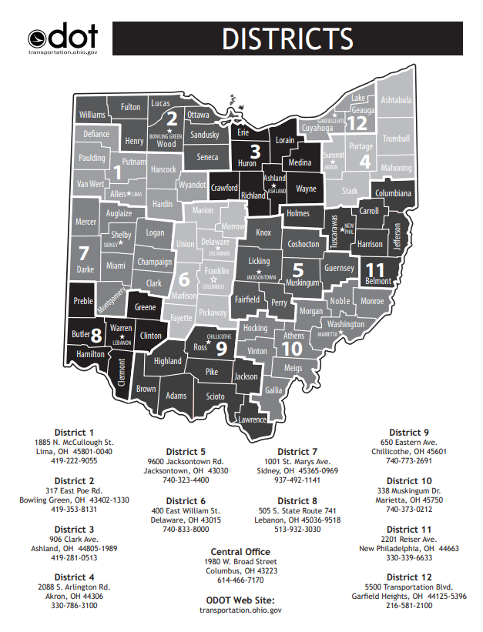

Glossary of Terms
As Per Plan Item: A standard pay item whose requirements need to be modified from that which is defined by the standard drawings, Construction and Materials Specifications, or Supplemental Specifications.

Backslope: The slope from the back of a ditch to the existing ground surface.

Benchmark: A marker of known elevation and location used in surveying for establishing vertical control.

Calculation Sheet: Highway plan sheet used to show the derivation of quantities.

Centerline of Construction: The reference line used for construction of a project. Normally located at the median centerline on a divided highway or at the normal crown point location on an undivided highway.

Centerline of Right-of-Way: The reference line used for the right-of-way of a project Normally located at the center of a highway’s existing right-of-way.

Centerline of Survey: The reference line used in the field survey of a project. Although it is usually the same as the centerline of construction, it may be a separate survey line established for convenience. With modern surveying instruments, surveys are no longer completed based on a centerline of survey.

Construction Limits: Lines shown on a plan view that outline the lateral extent of the work. Typically placed 4 feet outside the point where the backslope touches the existing ground unless additional room is required for construction activities.

Construction Plan Tracings: The original copy of a highway plan.

Cross Section: A view produced by a vertical plane cutting through the roadway, usually at right angles to the centerline or baseline, showing the transverse profile of the existing ground surface and proposed grade lines. The main use of cross-section sheets is for calculation of earthwork and seeding quantities.

Cross Slope: The rate of change of elevation along a straight line from one point in a cross section to another.

Design Agency: The firm, partnership, association, limited liability company, government entity, or corporation that employs the Designer of Record in accordance with ORC 4733.

Designer of Record: The Designer of Record is the individual that professionally endorses (signs and seals) the design in the Contract Documents in accordance with OAC 4733-23-01(C) and as specified in Section 1302.6.1 of the Location and Design Manual, Volume 3.

Design Designation: Information shown on the Title Sheet expressing basic factors which control design (Current ADT, Design Year ADT, Design Hourly Volume, Directional Distribution, Percent B&C Vehicles, Design Speed, Legal Speed, Functional Classification).

Design Exception: A document which explains the engineering and/or other reasons for allowing certain design criteria to be relaxed in extreme, unique, or unusual circumstances.

Drainage Details: A portion of a highway plan which includes design details for all prefabricated structures as well as other drainage related items.

Edge of Pavement: Edge of traveled way, located at the intersection of the mainline pavement (driving lanes) with the shoulder (treated or turf), or the curb and gutter.

Federal Project Number: A number assigned to a project when Federal participation is involved.

Foreslope: The slope from the edge of the graded shoulder to the bottom of the ditch.

General Notes: A portion of a highway plan containing those plan notes required to clarify construction items not adequately covered by the specifications or plan details.

General Summary: A portion of a highway plan used to summarize the total estimated quantities with complete pay item descriptions, item numbers, item extensions and funding splits.

Item Code: A nine-digit character used to catalog pay item descriptions.

Item Master: A list of acceptable item codes and their corresponding pay item descriptions and units of measure.

Item Special: An item that does not exist in the standard drawings, the Construction and Material Specifications or Supplemental Specifications.

Landscaped Area: An area containing an arrangement of plant materials specifically selected and located based on principles of design (line, form, color, texture, repetition, variety, balance and emphasis) for one or more of the following functions: visual control, architectural uses, climate control, noise control, erosion control, aesthetics and wildlife habitat.

Landscaping Plan: A portion of a highway plan dedicated to highway landscaping, including all plans, details and quantities required for landscaping items.

Lighting Plan: A portion of a highway plan dedicated to highway lighting, including all plans, details and quantities required for highway lighting items.

Location Map: A map on the Title Sheet showing the area in which the project is located and the project limits.

Maintenance of Traffic Plan: A portion of a highway plan which includes the notes and details required for maintaining traffic during construction.

Miscellaneous Details: A “catch-all” portion of a highway plan for details that do not specifically fall into another category.

Plan and Profile Sheet: A portion of a highway plan showing horizontal and elevation views an area before and after proposed construction: including quantities, dimensions, and other reference items required to lay out and construct a project.

Plan Insert Sheet: Special detail drawings furnished by ODOT and used with the original set of tracings as normal numbered plan sheets.

Profile Grade Point: The point on a typical highway cross-section which correlates with the profile grade line shown on the plan and profile sheets.

Project Designation: The identification assigned to a particular project. This includes county, route, section number and local name for projects on county or township systems, or county and local name for city street improvements.

Project Length: The total distance between the project limits, adjusted for station equations and suspensions, measured along the centerline of construction.

Project Limits: Points on the mainline centerline of construction where the proposed improvement, as described in the project description, begins and ends. This is generally defined as the beginning/ending of full-depth, full-width pavement. Project limits do not include incidental construction, such as: pavement feathering and tapering, traffic control devices, drainage, guardrail, drives, side roads, service roads, etc., unless this type of work is the primary reason for the improvement.

Proposal Note: A note that is a part of a project’s proposal that alters a pay item, standard drawing, Construction and Materials Specification or Supplemental Specification.

Reference Balloon: A circle with a leader line used to tie construction items to pay quantities on Plan and Profile sheets and to the legend on Typical Sections.

Reference Monument: An object that marks a point of known location. Used in surveying to establish horizontal control.

Reference Points: Fixed marked points, located on permanent objects in the field, from which various points on the reference line can be established using distances and directions.

Right-of-Way Plan: A portion of a highway plan showing a graphical representation of highway improvement and its relation to adjacent property, the parcels or portions thereof needed for highway purposes, and other pertinent information.

Sanitary Sewer Plan: A portion of a highway plan dedicated to construction of sanitary sewers, including all plans, profiles, details and quantities required for sanitary sewer items.

Schematic Plan: A portion of a highway plan which shows the geometric location of a roadway in relation to existing features, such as political boundaries, waterways, railroads, utilities, etc.

Service Road: Sometimes referred to as a Frontage Road or Access Road, it is a roadway, generally running parallel to the mainline, which provides access to commercial, residential or farm areas.

Simplified Plans: An abbreviated highway construction plan format consisting only of that information necessary to describe the type of work and its limits. Particularly adaptable to special types of projects (minor emergency relief, resurfacing, pavement markings, etc.)

Staged Review Process: A series of review submissions at various stages in the design process.

Standard Construction Drawings: Detail drawings, identified by a specific number, published by ODOT, of items which are frequently used in plans and would otherwise require redrawing for each plan and have been pre-approved for general use.

Standard Pay Item: An item whose requirements are defined by the standard construction drawings and the Construction and Materials Specifications or Supplemental Specifications.

Station: A point or position on a measured line using 100-foot increments as a base of reference.

Straight Line Distance (SLD): Distance based on the centerline of the roadway as measured from the western or southern county line or other true beginning.

Subsummary Sheet: Plan sheets used to gather quantities prior to carrying them to the General Summary.

Supplemental Specifications: Detailed specifications for items which are in the development stage or are used only occasionally. These specifications supplement or supersede the Construction and Material Specifications.

Tie Points: Any three points used to verify the location of the control point for the centerline of construction.

Title Sheet: The cover sheet in a set of highway plans showing project identification and location, sheet index, design parameters, specifications, standard construction drawings, approvals, and other pertinent information.

Traffic Control Plan: A portion of a highway plan dedicated to signing, signalization, pavement marking and other traffic control details.

Typical Section: A portion of a highway plan showing typical cross-sectional views of the existing pavement and the roadway after construction is complete.

Waterwork Plans: A portion of a highway plan dedicated to construction of waterwork items including all plans, profiles, details and quantities required for waterwork items.

Work Limits: The extreme longitudinal limits of the contractor’s responsibility, including all temporary and incidental construction (except temporary traffic control devices). Identified by the “Work Limit” station on the centerline of construction on the mainline and on the centerline of all side roads, cross-roads, and other construction generally running perpendicular to the project or separated from the project.

1200 Plan Preparation

1201 General Plan Sheet Information

1201.1 Introduction
The purpose of a set of construction plans is to delineate the proposed work with sufficient design details, supplemented with notes, calculations, and summaries of quantities, in such a manner that it can be clearly and uniformly interpreted by engineers and contractors. Sufficient data must be provided to enable the contractor to make an intelligent bid and perform the work as intended. Clarity, completeness, and conciseness are essential to avoid misinterpretation. Unnecessary details should be avoided.

1201.2 Unit of Measure
Plans shall be prepared using the English system of units.

1201.3 Plan Sheet Format
Plans should be submitted in a non-rasterized PDF format, except for the Right of Way Centerline Plat Sheet.

Where an external agency does not allow submission of a PDF, the District Project Manager will determine whether the hard copy document will be created by the District or by the consultant. The requirement to produce hard copy documents shall be included in the Scope of Services document.

Hard copies shall match the PDF and shall be printed on paper.

1201.4 Plan Sheet Dimensions
All plan sheets, including plans prepared by sub-consultants (i.e., geotechnical profile sheets), shall be the same size and format. PDF files shall be formatted to be 22 inches by 34 inches as shown in Figure 1201-1, except for the following:

Right of Way Centerline Plat Sheet that has been hand signed and stamped can be scanned in at original size.

1201.5 Title Block Information

1201.5.1 General
Figure 1201-1 shows the location of the border and title block for standard size plan sheets. An example title block is shown in Figure 1201-2. The Bridge Design Manual and Real Estate Manual show standard structures and right-of-way title sheet blocks, respectively. All plan sheets shall display, as a minimum, the plan sheet number, the project designation and the sheet title. Additional items that may be required include quantity validation initials, plan scales and a north arrow.

1201.5.2 Sheet Numbers
Sheet numbers are shown in the lower right corner of the sheet and shall be prefixed with “P.” (e.g., P.1, P.2,…P.26). With the exception of the Right of Way Plan Sheets, a sheet number and total (total number of sheets in the plan based on the last actual sheet number) shall be included. Sheets that require subset sheet numbers (e.g., structure plans and right-of-way plans) may be grouped within the plan.

Occasionally, sheets may need to be inserted into a set of plans that has already been numbered. These sheets should be labeled with the number of the preceding sheet, followed by consecutive letters (e.g., P.26A, P.26B…P.26Z) and then by consecutive double letters (e.g., P.26AA, P.26BB…P.26ZZ). This will permit the insertion of up to 52 additional sheets. The last sheet shall not be labeled with a number/letter combination. If a significant number of sheets need to be inserted or added to a set of plans, consideration should be given to renumbering the entire set.

1201.5.3 Project Designation
The project designation is normally the county code, route number, and section number as shown in the plan title on the Title Sheet (See Section 1302). When multiple section numbers are involved and space in the title block does not permit a complete listing, the county, all route numbers, and the first section number followed by the words “and various” will be shown.

1201.5.4 Sheet Title
The sheet title shall include: the general plan sheet description (i.e., Schematic Plan, General Summary, Plan and Profile, Cross-Sections, etc.), the applicable roadway, if not obvious (i.e., U.S. 35, S.R. 315, Ramp A, Main Street, Connecting Road, etc.) and the applicable station limits.

1201.5.5 Quantity Validation
Where sheets include quantities, space should be provided for the date and initials of the individuals who calculated and checked the quantities.

1201.5.6 Plan Scales
A bar scale should be shown whenever a plan view is required. Bar scales are not normally required in the vertical dimension on profiles or for cross-sections since these should be adequately labeled. If the plan sheet requires more than one scale, bar scales will be shown on the plan and the words “See Details” shown in the title block.

1201.5.7 North Arrow
A north arrow should be shown as accurately as possible (usually +/- 5°) whenever a plan view is required. If the plan sheet contains more than one plan view, no north arrow should be shown in the title block.

1201.5.8 Additional Requirements
The Bridge Design Manual, Section 100 and the Real Estate Manual, Section 3100 contain additional requirements for bridge and right-of-way plan sheets, respectively.

1201.5.9 PID Number
Each project is assigned a unique Project Identification (PID) Number when it is entered into Ellis. This number shall be shown in the proper space on the title block. On occasion, this number may change during project development. The plan, file names and directory structure shall always reflect the latest number, with former numbers noted on the Title Sheet. See Section 1302 for additional information regarding the title sheet.

1202 Drafting

1202.1 Plan Scales
The designer should prepare plans keeping in mind that a 22-inch by 34-inch full-size plan sheet may be reproduced to an 11 inch by 17-inch print.

It is recommended that plan sheet scales normally be limited to the following:

For English unit plan sheets: 1:1, 1:5, 1:10, 1:20, 1:50, 1:100, 1:200, 1:500 or 1:1000. These scales are in inches per foot. For example, 1:20 indicates 1 inch on the plan sheet equals 20 feet in the field.

Scales that are multiples of ten of the above scales may be used (i.e., 1:2000 is a multiple of 1:200). If it is believed that a better product will result, other scales may be used. The intent should always be to clearly and adequately show the work to be performed, keeping in mind that the plans used during construction could be reduced to one-half the original scale (i.e., 1:20 full size prints become 1:40 quarter size prints).

1202.2 Lettering
Lettering should be oriented in such a manner that it can be read from either the bottom or right side of the plan sheet. Fonts & text sizes shall be per Section 1204, Computer-Aided Drafting and Design.

1202.3 Cross-Section Grids
Acceptable grid systems for cross-sections and profiles are shown in Figure 1202-1. Letters and lines should be bolder when they are superimposed over cross-section grids.

1202.4 Drafting Conventions
The following sections present the preferred standard drafting guidelines for roadway construction plans. Standard drafting symbols are available from the Office of CADD and Mapping Services, CADD Services website.

1202.4.1 Text Orientation
Text on inclined lines should be orientated as shown.

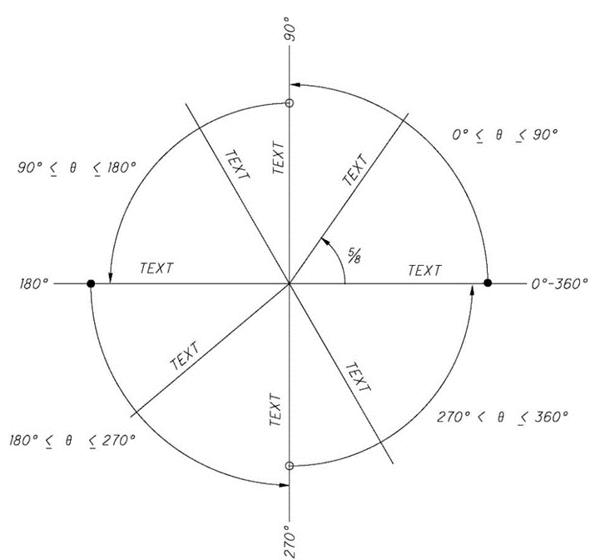

1202.4.2 Placement of Leaders from Notes
A leader line should originate from the first line on the left, the last line on the right, or from a vertical bar on either side, as shown. The leader should generally be an inclined straight line, if possible, except for the short horizontal shoulder extending from mid-height of the lettering at the beginning or end of a note.

Where space prohibits the use of straight leader lines, curved leaders may be used. Curves should be smooth and simple, beginning with a short, horizontal, shoulder extending from mid-height of the lettering.

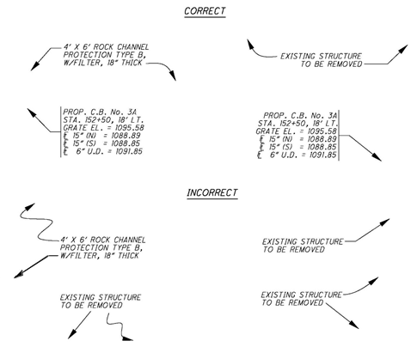

1202.4.3 Placement of Leaders to, or from, a Circular Object
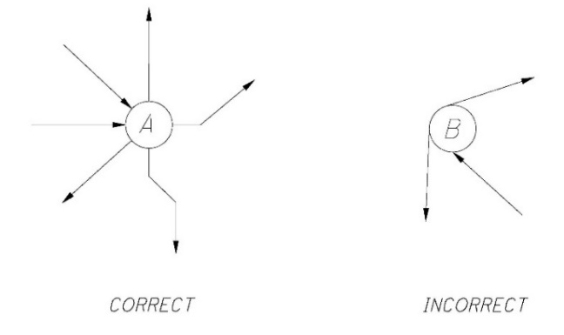
A leader to, or from, a circular object should extend radially, so that if extended it would pass through the center of the circle.

1202.4.4 Terminators
Leaders should terminate with an arrowhead when pointing to an object or to an edge and should terminate as shown when pointing to a surface or layer.

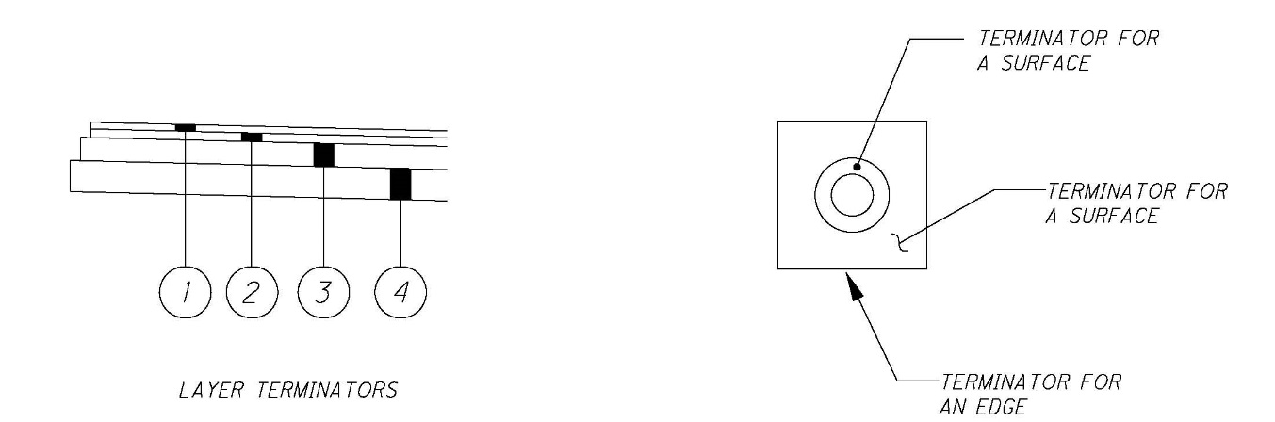

1202.4.5 Placement of Balloons
Balloons on typical sections should be aligned as much as possible, rather than placed randomly around the section. The leader lines extending from the bubbles to pavement layers should be vertical, where possible. Other items, such as guardrail and underdrains may be labeled with straight, inclined, leaders. All leaders should end with a terminator.
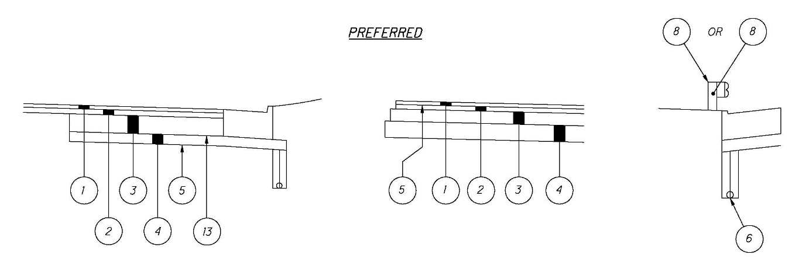
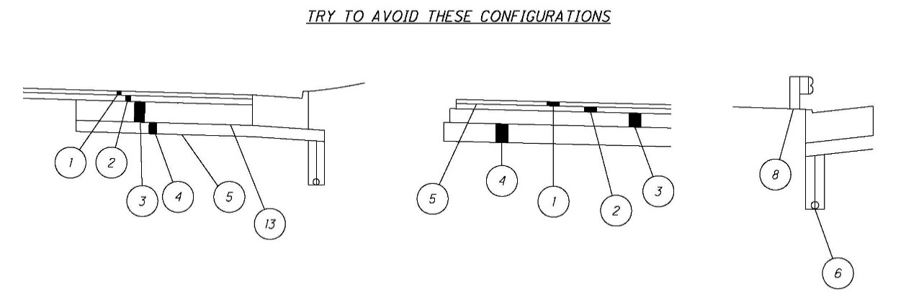

1202.4.6 Sheet Notes, Charts, and Summary Sheets
Groups of sheet notes shall be left justified.
Text in charts should be placed slightly above the lines (never directly on the line) to improve readability. It is recommended to leave an empty line at the beginning and end of the chart and between every fifth item to accommodate future additions.

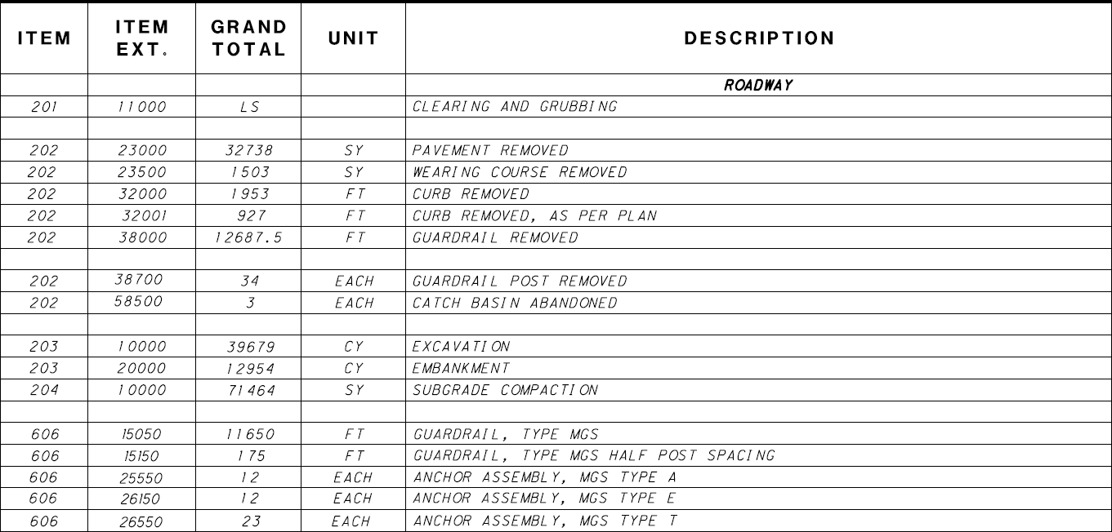

Numbers with decimals in a chart should be aligned in columns along the decimal point. Integer values should be either right justified or centered in columns.

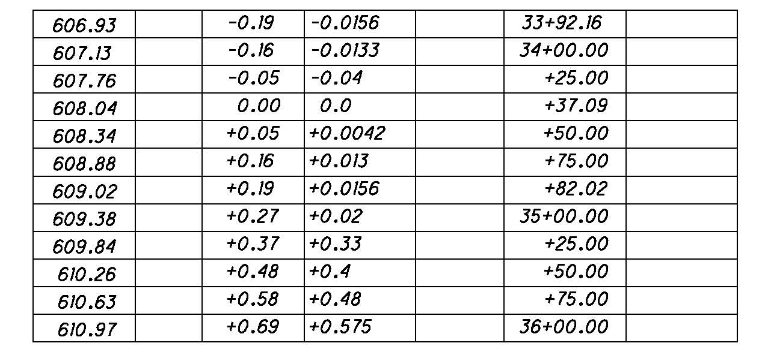

1202.4.7 Overdrafting
It is preferable to place dimensions outside areas which contain cross-hatching and other line work. Where this is not possible, the cross-hatching, or line work, should be broken around the text. Hatch lines should never cross through text, however, certain critical line work elements, such as centerlines may pass through text.

1202.4.8 Horizontal Curve Data
The curve data should be shown on the inside of the specified curve and between the PC and PT, where possible. As shown, it is permissible to jog the lines for the PC and PT provided the initial portions of the lines extending from the curve are along the correct radius.

When space prohibits or when an alignment has a large number of horizontal curves, label each curve and tabulate the curve data. If it is necessary to tabulate curve data for a few curves along an alignment, then all curves should be tabulated to provide consistency.

1202.4.9 Dashed Lines
When needed for clarity, dashed lines should connect at all points of intersection and points of tangency. (You may need to subdivide certain CADD cells into individual elements in order to connect the lines properly).

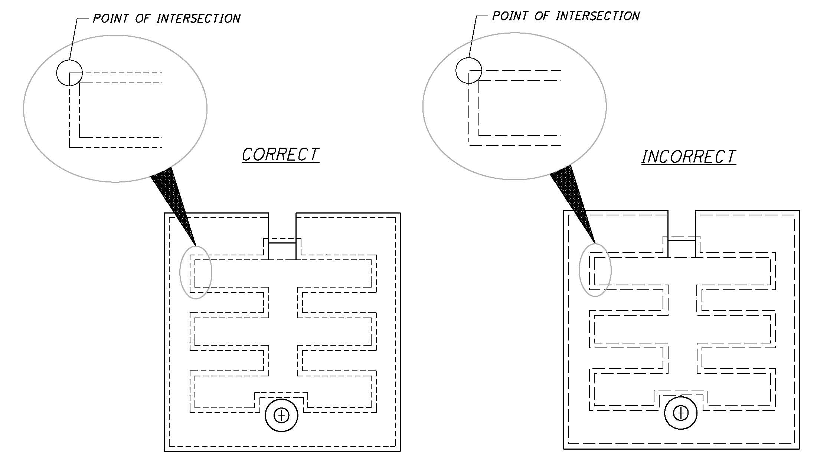
When needed for clarity, a gap should be shown at all locations where a visible edge becomes hidden by another surface as shown below.

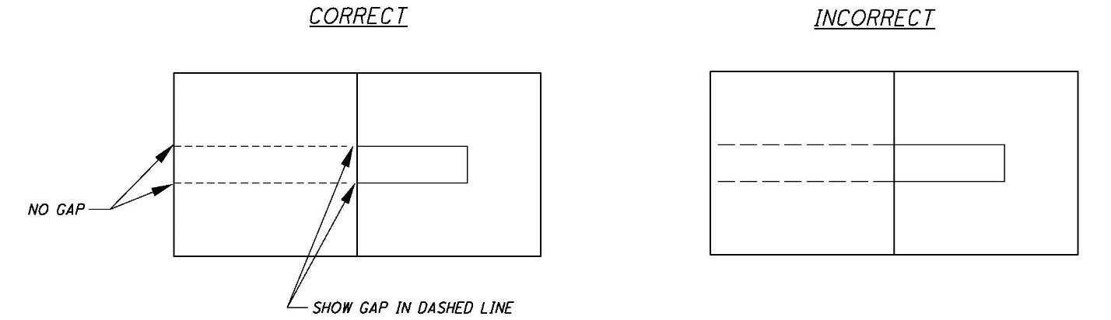

1202.4.10 Direction of Cross-Hatch Lines
In general, draw cross-hatched lines at 45° with horizontal. If cross-hatch lines drawn at 45° with horizontal would be parallel or perpendicular (or nearly so) to a prominent visible outline, the angle should be modified.

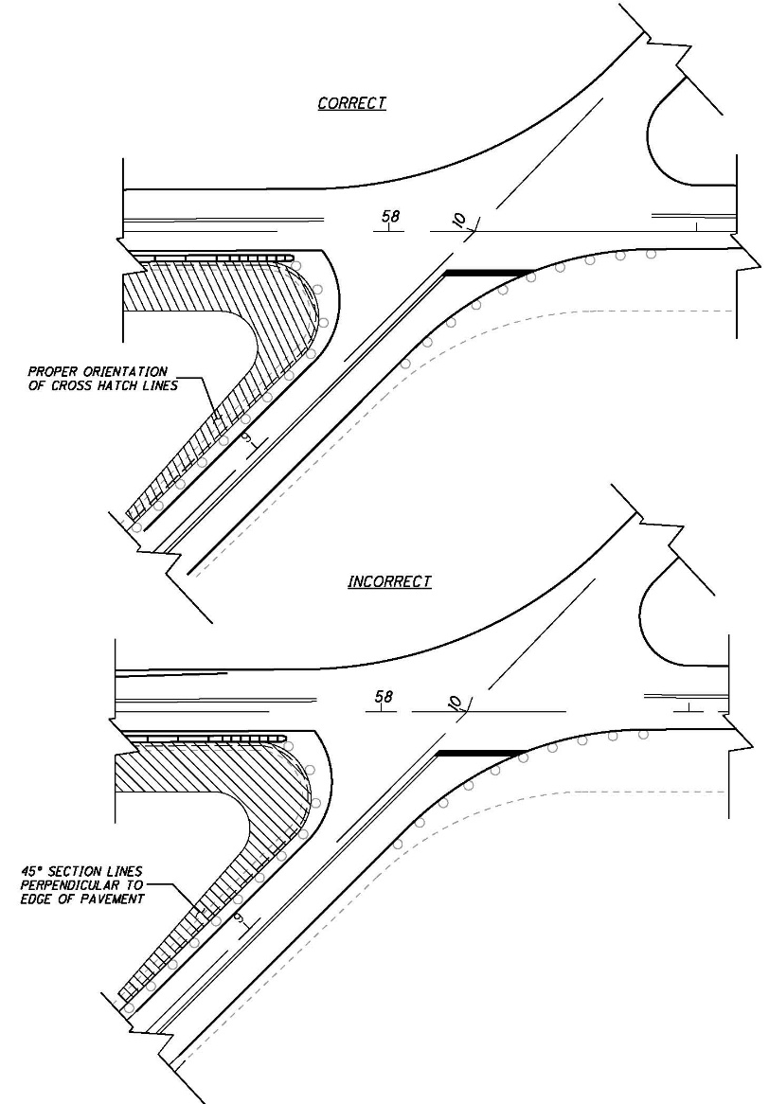
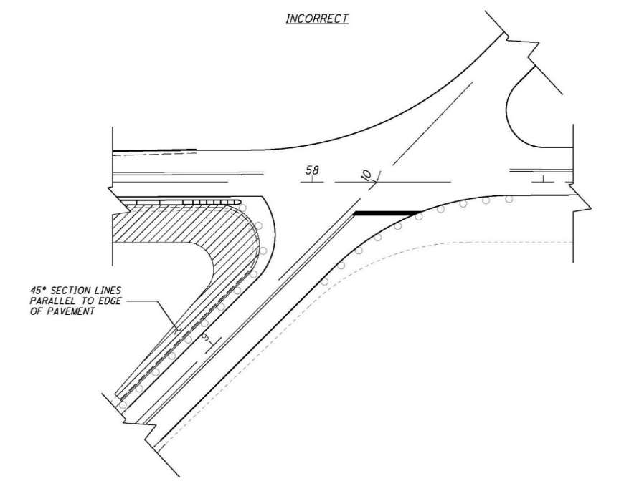

1202.4.11 Placement of Dimension Text
Generally, text should be placed above a solid dimension line and oriented parallel to the line, as shown below. Horizontal text shall be read parallel to the bottom edge of the sheet. Vertical text shall be read parallel to the right edge of the sheet. Text in dimension strings should be placed at the same level.

See examples below:

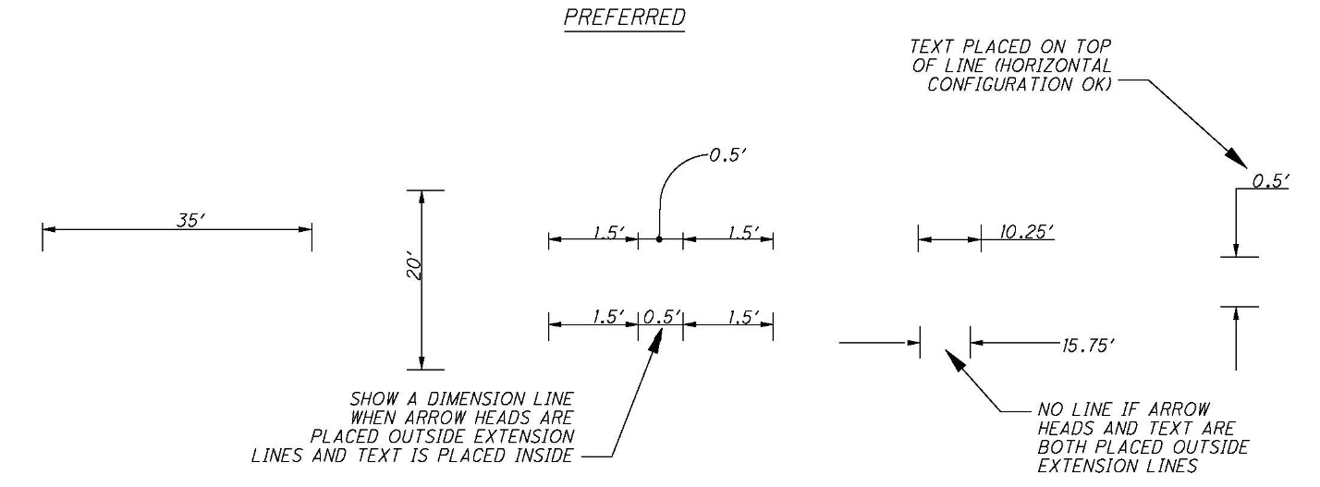

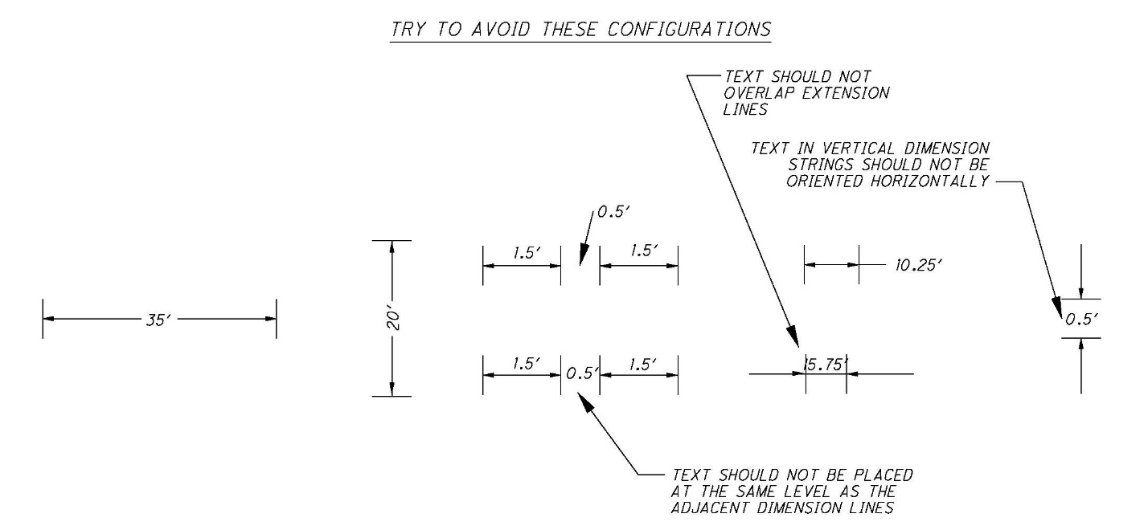

1202.4.12 Angular Dimensions
Angular dimensions should be placed with an arc drawn from the vertex of the angle.

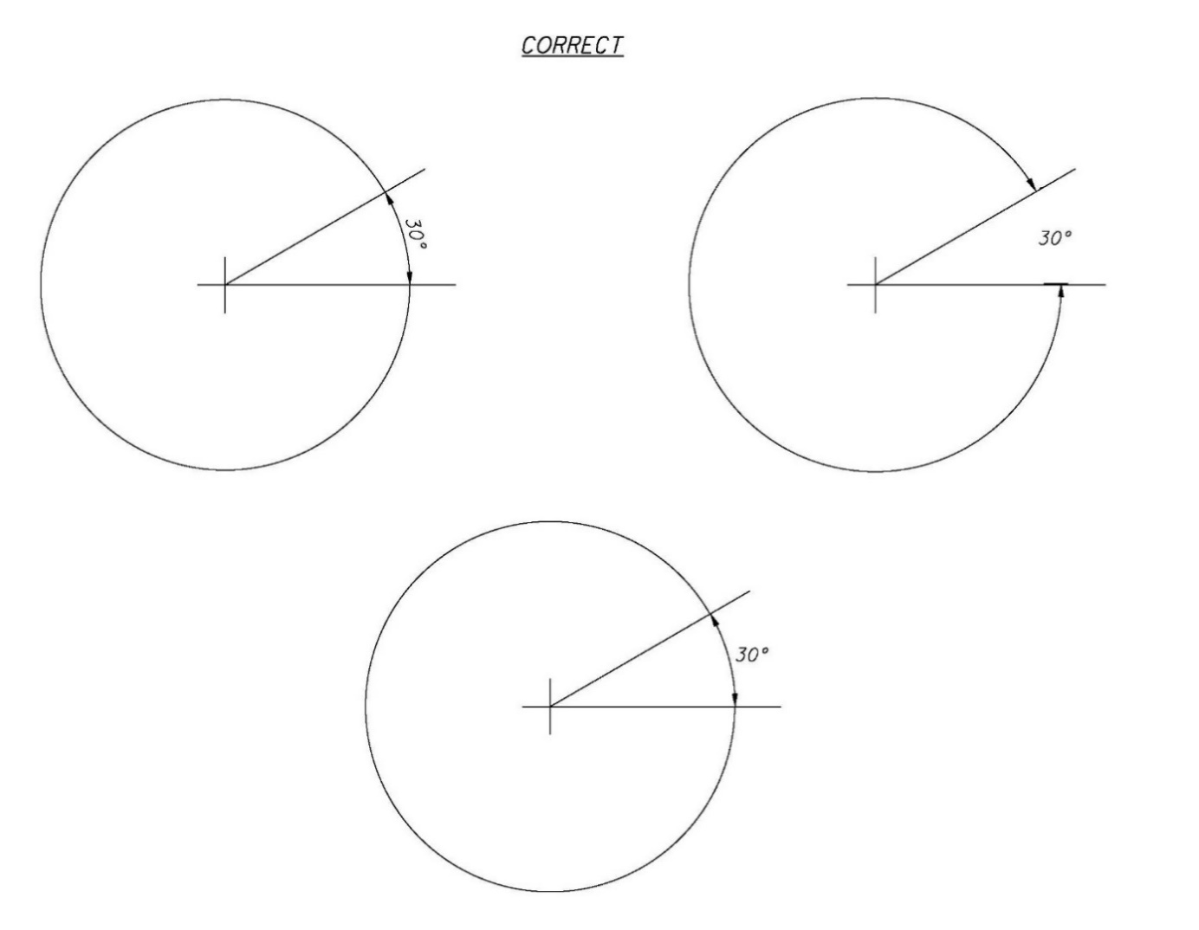

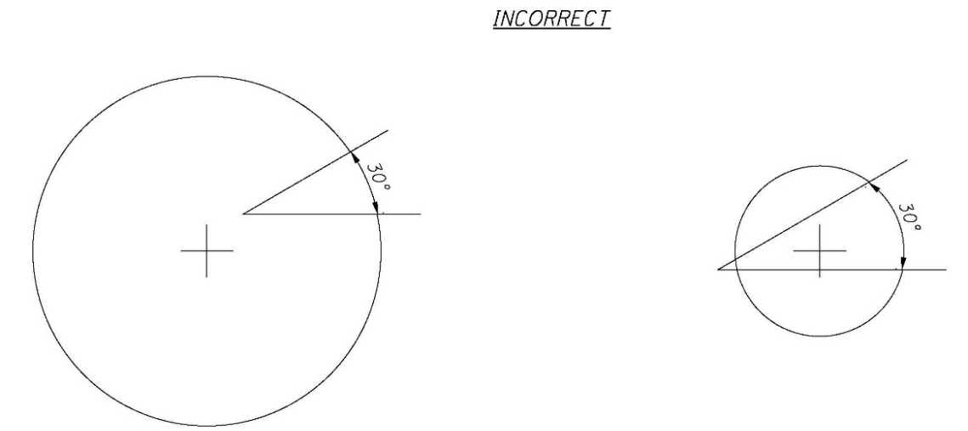

1202.4.13 Dimensions in Crowded Conditions
In crowded conditions, gaps in extension lines near arrowheads may be left as shown below, in order to clarify the dimensions.

1202.4.14 Dimensioning with a Dot
If the dimension cannot be placed on the dimension line, then a dot with a curved leader may be used as shown.

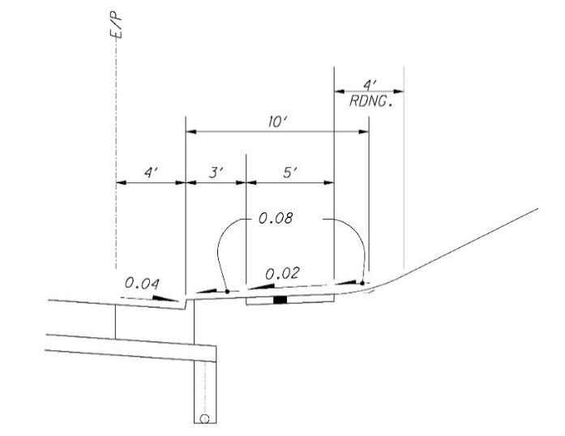

1202.4.15 Dimensioning at Angles
Dimension lines must always be drawn parallel to the edge being dimensioned. Extension lines are usually drawn at right angles to the edge being dimensioned. However, an exception may be made in the interest of clarity, as shown.

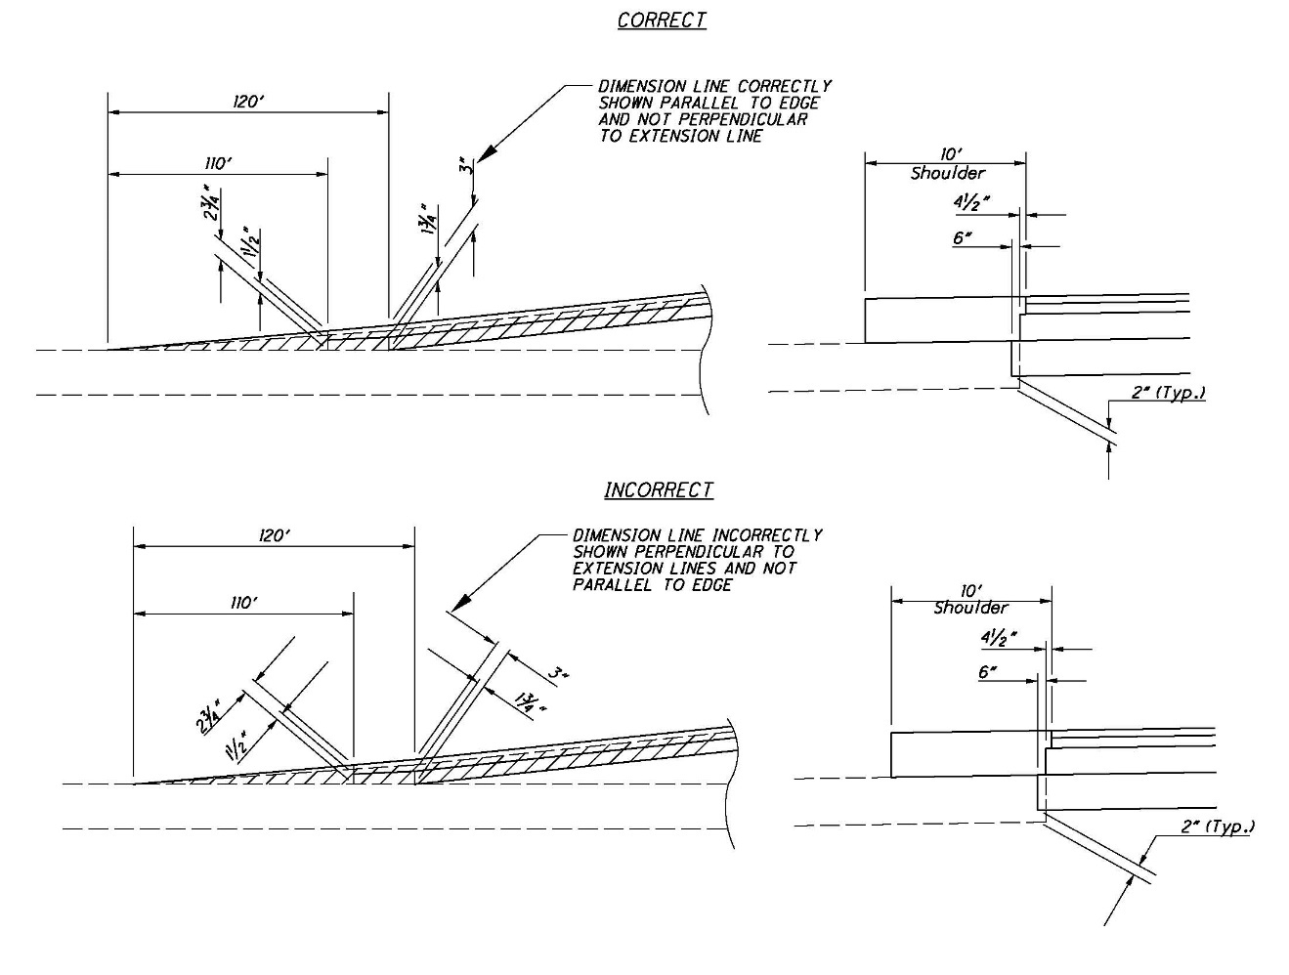

1202.4.16 Dimensioning an Object
Place shorter dimensions nearest to the object outline. As shown below, crossing the extension lines is acceptable. Dimension lines should not cross extension lines as a result of placing the shorter dimensions on the outside.

Extension lines should not be shortened. Also, a dimension line should never coincide with or form a continuation of any line of the drawing. If possible, dimensions should always be placed off the object.

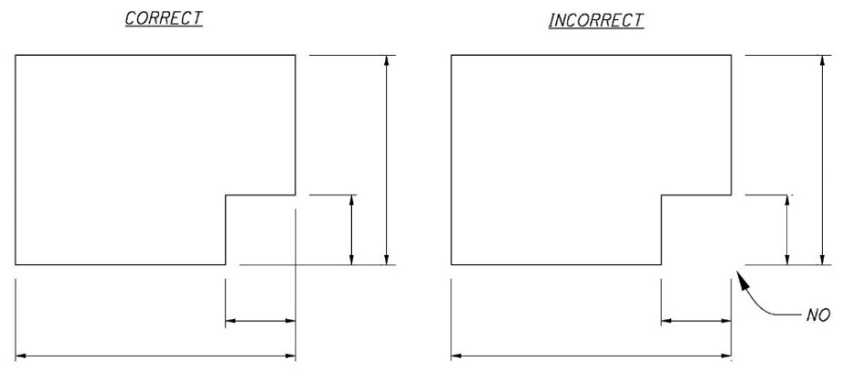

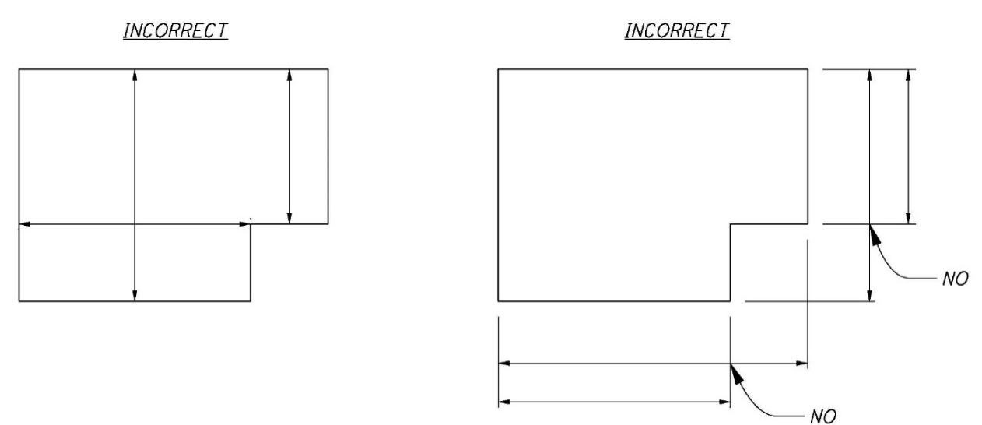

1202.4.17 Crossing Dimension Lines
Extension lines should not be broken. In addition, lines should not be centered at object edges.

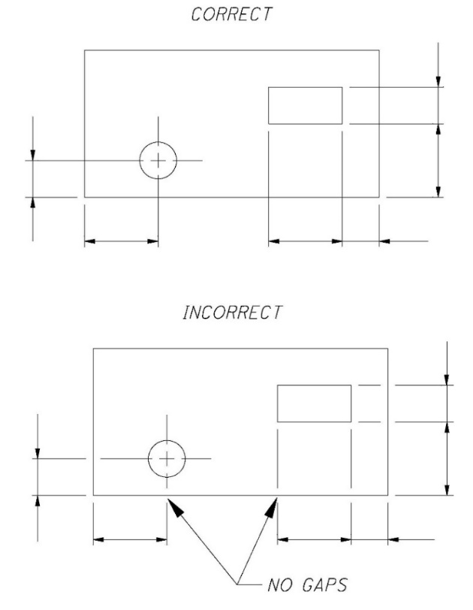

1202.4.18 Grouped Dimensions
Grouped dimensions should be in line, evenly spaced and off the object being dimensioned.

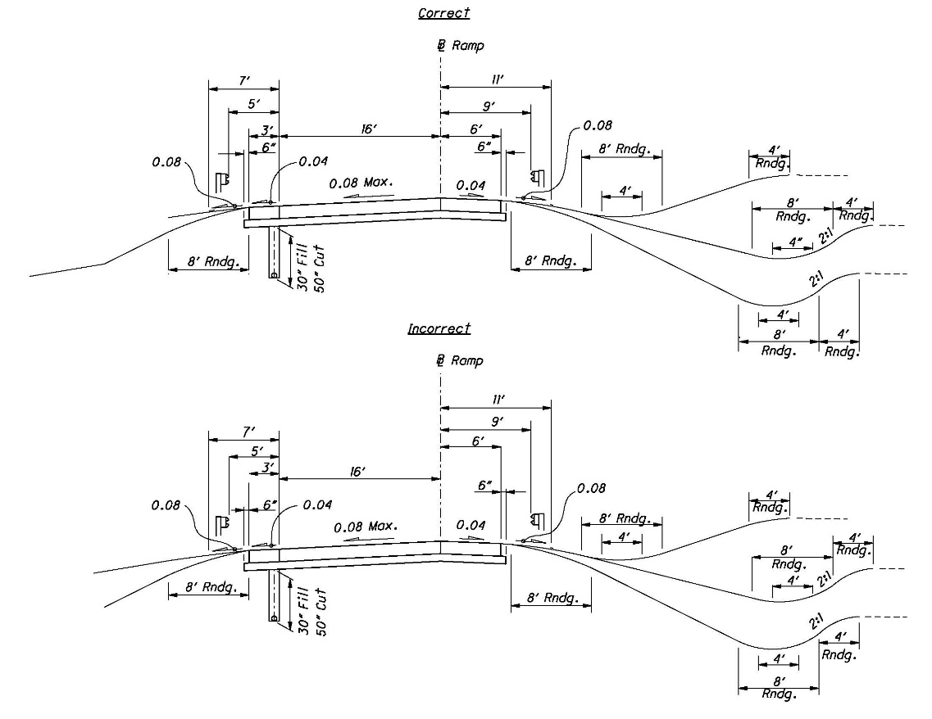

1202.4.19 Use of “Typical”
For symmetrical objects and repetitive dimensions, use the word “typical” to simplify dimensioning, as shown:

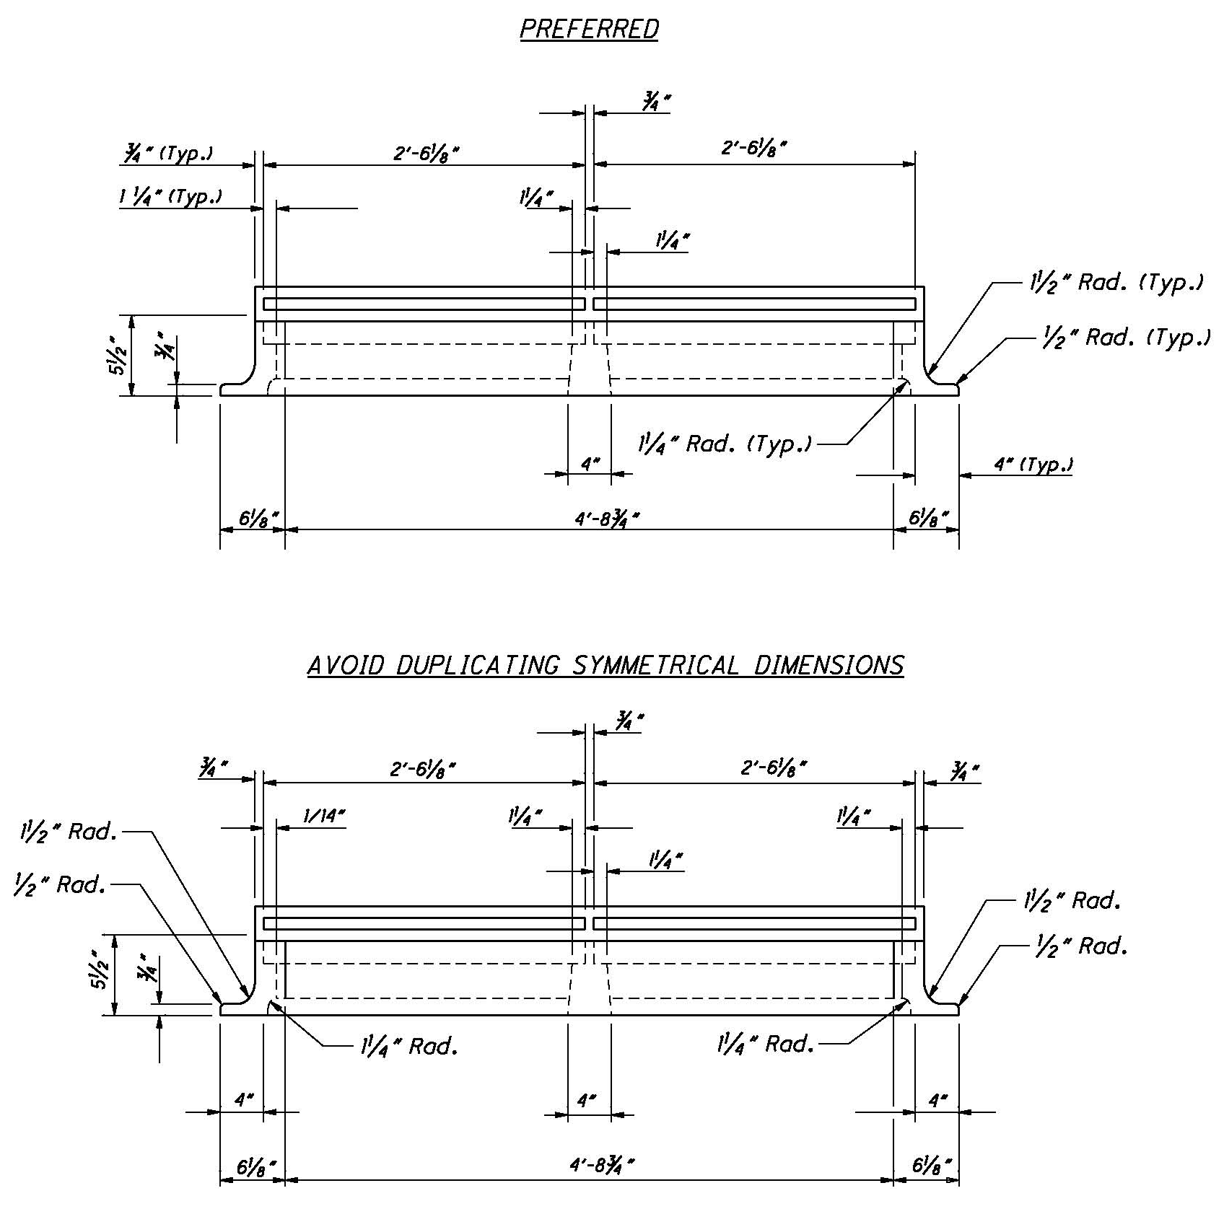

1203 Standard Drawings

1203.1 Standard Construction Drawings
Standard Construction Drawings are an integral part of the contract plans. They are used to show repetitive details such as: manholes, curbs, guardrail, and pavement joints. When referenced in the plans, these drawings, and their associated revision dates, must be listed on the Title Sheet.

1203.2 Plan Insert Sheets
Plan Insert Sheets are similar to Standard Construction Drawings but differ in the manner in which they are included in the plans. They often cover the design of standard items that are in the development stage. Plan Insert Sheets are included with the original set of construction plans. When included in a set of construction plans, project specific information must be added to these sheets. Refer to the Publications Gateway website: (https://www.transportation.ohio.gov/working/publications) for the most recent version of the Plan Insert Sheets.

1204 Computer-Aided Drafting and Design (CADD)

1204.1 General

1204.1.1 Introduction
Computer-Aided Drafting and Design (CADD) is the preferred method of preparing plans for the Ohio Department of Transportation (ODOT). These requirements ensure that CADD files can be used by the entire project team (surveyors, planners, environmentalists, designers, reviewers, contractors, etc.) throughout all phases of project development.

The standards referenced have been developed and tested using the Bentley Systems CONNECT Edition generation of products.

This section supersedes all CADD standards previously published in the Bridge Design Manual and the Right-of-Way Manual.

This section is not a textbook and does not exempt the professional from performing responsible engineering and/or surveying. It is intended to provide uniform procedures and standards for ODOT staff and organizations that perform CADD related services for ODOT. The professional shall have final responsibility for the accuracy of all input and output of computer-based applications.

1204.1.2 Software
ODOT has adopted and operates internally using Bentley Systems CONNECT Edition generation of products (including but not limited to MicroStation (MS), OpenRoads Designer (ORD), and OpenBridge Modeler (OBM)) as its standard drafting and design software packages, respectively.

ODOT will accept electronic deliverables generated from non-Bentley Systems CONNECT Edition generation of products; however, the CADD design software to be used on a project shall be mutually agreed upon by the District and primary design consultant and shall be explicitly stated in the project’s scope of services. ODOT will provide no support, standards, documentation, or guidance of any kind with respect to design and delivery of projects developed using other CADD platforms.

Once the decision has been made to use a software package other than Bentley Systems CONNECT Edition generation of products there shall be no deviation from the agreed upon design package, and the same shall be used for all aspects of the project and by all entities until the project’s completion. It is the primary design consultant’s responsibility to ensure that all sub-consultants use the agreed upon design package.

The final deliverables of a non-Bentley Systems CONNECT Edition generation of products designed project, in printed or electronic format, shall adhere to the standards provided herein. The electronic deliverables shall be delivered in the native format.

1204.1.3 Trademarks
All products under the Bentley Systems CONNECT Edition generation of products are registered trademarks of Bentley Systems, Incorporated. © 2023 Bentley Systems, Incorporated.

Other trade names, computer protocols, and file formats mentioned in this manual are the trademarks of their respective owners. In no event will the appearance of any graphic, description of any graphic, picture, screen display, or any other method of conveying meaning be considered to impair the rights of the respective owners.

1204.2 CADD Standards

1204.2.1 Installation and Configuration

1204.2.1.1 General

This section outlines the setup for a typical installation of Bentley Systems CONNECT Edition generation of products at ODOT. The configuration files discussed in this section are available from the ODOT CADD Standards Downloads website.

The OHDOT Standards can be downloaded from the ODOT CADD Services webpage.

1204.2.1.2 Installation

For a typical ODOT installation, Bentley Systems CONNECT Edition generation of products software is installed in the default location.

1204.2.1.3 CADD Standards Directory

The configuration and associated files for Bentley Systems CONNECT Edition generation of products that are used for plan development at ODOT are located within ProjectWise at the following location:

Ohio DOT Projects\Documents\03 Standards\CADD Standards\CONNECT_Config\Workspaces\OHDOTCEv02\

Configuration information for users external to ODOT can be found on the ODOT CADD Services webpage.

1204.2.1.4 Configuration Variables and Files

Configuration variables are defined in tow locations within the OHDOT CADD Standards environment:

- OHDOT_WorkSpace.cfg defines configuration variables and standards that apply to all projects developed using the OHDOT Workspace.
- Project specific variables are defined in a WorkSet Configuration file.

The OHDOT Workspace does not define a custom location for user configuration files. User configuration files are in the default directory as defined by Bentley software.

1204.2.2 Assignments

1204.2.2.1 General

ODOT has developed a standard set of levels to be used with all design files submitted to or exchanged with the Department. The levels are defined in a MicroStation DGN Library, OHDOT_Feature_Definitions.dgnlib.

Users shall not create their own levels for use in any design files submitted or exchanged with ODOT.
See the OHDOT CADD Levels for a complete list of the ODOT levels.

1204.2.2.2 Level Naming Convention

ODOT level names use the following naming convention:

Classification_Disposition_Logical Name

This Classification consists of two (2) uppercase characters used to group the levels into categories. The Classification names are listed in the table below:

Classification | Description | Classification | Description
AP | Airports | PC | Point Clouds
BD | Buildings | PF | Profile
BM | Bridge Modeling | PM | Pavement Markings
BR | Bridge | PV | Pavement
CL | Centerline | RC | Recreational
CM | Corridor Modeling | RD | Roadway
DR | Drainage | RS | Raster Files
DT | Digital Terrain Models | RW | Right-of-Way
DV | Divisions | SC | Scratch
EV | Environmental | SG | Signals
FL | Flight Mapping | SH | Sheets
GE | Geometry | SN | Signing
GM | County Map | SV | Survey
GT | Geotechnical | TR | Truck Turning Paths
HY | Hydraulics | TX | Text
LT | Lighting | UT | Utilities
MD | Modeling | VG | Vegetation
MT | Maintenance of Traffic | VL | Volume
MU | Markup | XS | Cross Section

The Disposition is used to identify the level for placement of either X (existing) or P (proposed) information.

The Logical Name is used to as a description of the element contents. Where appropriate, common industry abbreviations are used.
All ODOT levels names use alphanumeric characters only. No spaces or special characters are used other than the underscore “_” character.

1204.2.2.3 ByLevel Considerations

In general, to facilitate use of MicroStation’s ByLevel attributes, the ODOT levels have been established such that each curvilinear feature will have its own level. To keep the overall number of levels manageable, there are cases where similar features will be placed on the same level making it impossible to use ByLevel attributes for those features. Some exceptions are noted below:

- Standard OHDOT CADD Cells are placed on the level in which they were created. Each cell is not placed on its own level, rather, like cells are grouped on one level. For example, existing electric utility cells are all placed on the level UT_X_Electric_Cells.
- Maintenance of Traffic Drums – Multiple line styles have been created to represent various typical drum spacings. These lines are placed on level MT_P_Drums.

1204.2.2.4 Filters

ODOT’s level library, found in OHDOT_Feature_Definitions.dgnlib, has been configured with a set of default level filters that can be used to control the display of levels based on their attributes. Users shall not edit or delete the default filters.

1204.2.2.5 Priority and Transparency

The levels defined in OHDOT_Feature_Definitions.dgnlib utilize MicroStation’s Element Priority and Transparency functions. The priorities and transparencies are preset and based on what level is being used and should not be changed. See the OHDOT CADD Levels for a complete list of Priority and Transparency values.

1204.2.3 Colors

1204.2.3.1 General

Standard colors are specified to ensure consistency and to enable users to easily identify plan elements in shared files. For uniformity, the ODOT color table must be used and shall not be altered. See OHDOT CADD Colors for a complete list of ODOT’s color table values.

Note: The color values may vary or appear different on screen due to the difference in graphics cards, monitors display capability, etc.

1204.2.4 Line Styles

1204.2.4.1 General

Line styles are used to differentiate curvilinear elements in the design file and on the plotted sheet. ODOT uses Bentley’s default line styles, zero (0) through seven (7), along with ODOT’s developed set of OHDOT CADD Custom Line Styles. The line styles must be used to provide consistency and uniformity across plans.

The custom line style definitions are stored in a MicroStation DGN Library, OHDOT_Feature_Definitions.dgnlib.

Users shall not create their own custom line styles for use on ODOT plan sheets.
Standard line codes and custom line styles for plan graphics are specified in the OHDOT CADD Levels and displayed in OHDOT CADD Line Styles.

1204.2.4.2 Line Style Scales

The location and dimensions of all plan view basemap design file information shall be drawn in the Design model using real world dimensions at a 1:1 scale. Custom Line Styles are to be placed in the basemap at a scale of one (1) so the Drawing Scale feature can be used.

Referenced basemap design files when referenced into another file should have the line style scale se to Annotation Scale for proper scaling inside the new file.

1204.2.4.2.1 Survey Processing using Open Roads

Survey data processed using OpenRoads Survey is drawn at real world dimensions. Line Styles are according to the current MicroStation Drawing Scale setting and will respond to changes in the Drawing Scale value.

1204.2.4.2.2 Sheet Files

For basemap design files referenced into sheet files, the global line style scale must be set to Master for proper scaling to match the sheet file.

1204.2.4.2.3 Bridge Line Styles

Several line styles have been developed specifically for use on Bridge plans that are not always placed at a specific scale relative to the plotting scale. The line styles listed in the table below shall be scaled as necessary to produce a legible detail. These line styles are assigned to the appropriate level by use of ByLevel attributes.

Line Style Name | Description
bcenterline | Centerline
bconstruction | Construction Joint / Phase Construction Line
bexisting | Existing Objects (all existing lines except existing reinforcement bars)
bhiddenpr | Hidden Line Proposed
brebarpr | Proposed Reinforcement Bars
brebarex | Existing Reinforcement Bars

1204.2.5 Line Weights

1204.2.5.1 General

Line weights are used to differentiate graphical elements in the design file and on the plotted sheet. Default line weights per level are specified in the OHDOT CADD Levels.

1204.2.5.2 Plotting

See Section 1204.4, Plotting for line weight plotting thickness values.

1204.2.6 Cell Libraries

1204.2.6.1 General

For plan consistency, ODOT provides standard cell libraries containing cells representing items that will be repeatedly placed in a design file. Several ODOT standard cell libraries are available as detailed in Section 1204.2.6.2 – Cell Libraries (below).

1204.2.6.2 Cell Libraries

The following cell libraries are available to facilitate the drawing of commonly used symbols and sheet borders as described below:

Cell Library | Description
OHDOT_Aviation.cel | Cells used for Aviation plans
OHDOT_Bridge.cel | Cells used for bridge plans
OHDOT_Drainage.cel | Cells used for 2D standard drainage structures
OHDOT_DrainageAndUtilities.cel | Cells used for standard drainage structures
OHDOT_Geotech.cel | Cells used for geotechnical information
OHDOT_Labels.cel | Cells used for ORD plan labels
OHDOT_RW.cel | Cells used for right-of-way plans
OHDOT_Sheets.cel | Cells used for standard plan sheet borders
OHDOT_Symbols.cel | Cells representing standard plan symbols

Additionally, a set of cell libraries including standard signs from the Office of Roadway Engineering’s Sign Designs and Markings Manual, is included in the OHDOT CADD Standards. These sign cells are easily placed using a custom application, also provided in the OHDOT CADD Standards, see OHDOT CADD Cells for more information.

1204.2.7 Fonts

1204.2.7.1 General

The TrueType fonts Calibri and Calibri Light will be used for all plans developed using the OHDOT CADD Standards.

To supplement the use of font Calibri, the OHDOT Workspace includes a custom symbol font, OHDOTSymbols.ttf, containing commonly used engineering symbols.

1204.2.7.2 Text Size

Standard text sizes have been defined to ensure uniform legibility of all plan sheets. Standard text size refers to the size of the text on a full sized (22”x34”) sheet, not the text size in the design file.

Text Type | Plotted Text Size
Normal | 0.14”
Subtitle | 0.17”
Title | 0.20”
Main Title | 0.25”

Text sizes smaller than the Normal text size are not acceptable.

For all ODOT plans, the preferred method to set the text size is by use of the Model Annotation Scale parameter. See Section 1204.2.7.4 – Text Styles (below) for more information.

1204.2.7.4 Text Styles

ODOT’s standard text styles are defined in a MicroStation DGN Library, OHDOT_Text_Dimension_Styles.dgnlib.

The following Text Styles have been configured for use on ODOT plans:

Text Style | Text Size* | Spacing* | Font
P_Slanted - Normal Fixed Spacing | 0.14 | 1.00 | Calibri
P_Slanted - Normal LS=0.50 | 0.14 | 0.50 | Calibri
P_Slanted - Normal LS=0.50 Masked | 0.14 | 0.50 | Calibri
P_Slanted - Normal LS=0.75 | 0.14 | 0.75 | Calibri
P_Slanted - Normal LS=1.00 | 0.14 | 1.00 | Calibri
P_Slanted – Sub Title | 0.17 | 0.50 | Calibri
P_Slanted – Title | 0.20 | 1.00 | Calibri
X_Straight – Normal Fixed Spacing | 0.14 | 1.00 | Calibri Light
X_Straight – Normal LS=0.50 | 0.14 | 0.50 | Calibri Light
X_Straight – Normal LS=0.50 Masked | 0.14 | 0.50 | Calibri Light
X_Straight – Normal LS=0.75 | 0.14 | 0.75 | Calibri Light
X_Straight – Normal LS=1.00 | 0.14 | 1.00 | Calibri Light
X_Straight – Sub Title | 0.17 | 1.00 | Calibri Light
X_Straight – Title | 0.20 | 1.00 | Calibri Light
Title | 0.20 | 0.50 | Arial Black
Title – Main | 0.25 | 0.50 | Arial Black
Title - Sub | 0.17 | 0.50 | Arial Black

*Text size and Line Spacing units are Master Units.

Note: There is additional text styles included in the OHDOT CADD Standards. These text styles, which are not listed above, are configured for specific ORD labeling tasks, and are not normally selected by the user for general plan preparation annotation purposes.

All text placed on Bridge sheets, excluding text contained in standard border cells and existing topographic features, shall use the “Slanted” text styles.

1204.2.7.5 Dimension Styles

ODOT has configured a set of dimension styles to be used on ODOT plans. These styles are defined in the ODOT Standard DGN Library, OHDOT_Text_Dimension_Styles.dgnlib, which can be obtained from the ODOT CADD Standards website.

The following dimension styles have been defined in OHDOT_Text_Dimension_Styles.dgnlib:

Dimension Style | Font | Text Size* | Description
P_Dec-0, Masked, Slanted | Calibri | 0.14 | Decimal Feet, No decimal places
P_Dec-1, Masked, Slanted | Calibri | 0.14 | Decimal Feet, 1 decimal places
P_Dec-2, Masked, Slanted | Calibri | 0.14 | Decimal Feet, 2 decimal places
P_Dec-Multiline, Masked, Slanted | Calibri | 0.14 | Decimal Feet, 0.01 accuracy
P_Fract, Masked, Slanted | Calibri | 0.14 | Fractions, 1/16” accuracy
P_Fract, Slanted | Calibri | 0.14 | Fractions, 1/16” accuracy
P_Fract-Multiline, Masked, Slanted | Calibri | 0.14 | Fractions, 1/16” accuracy
X_Dec-0, Masked, Straight | Calibri Light | 0.14 | Decimal Feet, No decimal places
X_Dec-1, Masked, Straight | Calibri Light | 0.14 | Decimal Feet, 1 decimal places
X_Dec-2, Masked, Straight | Calibri Light | 0.14 | Decimal Feet, 2 decimal places
X_Dec-Multiline, Masked, Straight | Calibri Light | 0.14 | Decimal Feet, 0.01 accuracy
X_Fract, Masked, Straight | Calibri Light | 0.14 | Fractions, 1/16” accuracy
X_Fract, Straight | Calibri Light | 0.14 | Fractions, 1/16” accuracy
X_Fract-Multiline, Masked, Straight | Calibri Light | 0.14 | Fractions, 1/16” accuracy
*Text size units are Master Units.

Note: There is additional dimension styles included in the OHDOT CADD Standards. These dimension styles, which are not listed above, are configured for specific ORD labeling tasks, and are not normally selected by the user for general plan preparation annotation purposes.

Line Terminators shall be a filled arrow created with a width to height ratio of 2.5:1. The terminator width shall equal the text height.

Leader Lines or Extension Lines may be broken when crossing dimension lines but should be avoided wherever possible. To keep broken lines to a minimum, it is recommended that the user relocated the dimension callout, reposition the dimension, and/or reposition the callout. Leader, dimension, extension lines, and terminators shall be a weight of zero (0) and shall be placed on the same level as required for text notes and callouts.

Like Text Styles, the text size for Dimension Styles is set by use of the Model Annotation Scale parameter.

Bridge plans shall use the “Fract, Slanted”, “Fract-Multiline, Slanted” or “Masked Fract, Slanted”, “Masked Fract-Multiline, Slanted” dimension styles. All Bridge dimensions shall be placed associated.

Dimensions shall not have their status dropped.

1204.2.8 Seed Files

1204.2.8.1 General

MicroStation uses a “seed file” to create all design files. A seed file is a template in which standard parameters are set. Seed files do not contain elements, but like other design files they do contain settings like working units and view configurations. Using a standard, customized seed file helps maintain uniformity and keeps the user from having to adjust design file settings each time a file is created.

The following seed files are included with the OHDOT CADD Standards download. The Geographic Coordinate System (GCS) for each seed file is defined as shown in the table below:

Dimension | Seed File Name | Geographic Coordinate System
2D | OHDOT_Seed2d.dgn | None
2D | OHDOT_Seed2d_OH83-2011-NF.dgn | OH83-2011-NF
2D | OHDOT_Seed2d_OH83-2011-SF.dgn | OH83-2011-SF
2D | OHDOT_Seed2d_OH83-NF.dgn | OH83-NF
2D | OHDOT_Seed2d_OH83-SF.dgn | OH83-SF
2D | *OHDOT_Seed2d_xxxxxxx_SurvFt.dgn | NAVD88
3D | OHDOT_Seed3d.dgn | None
3D | OHDOT_Seed3d_OH83-2011-NF.dgn | OH83-2011-NF
3D | OHDOT_Seed3d_OH83-2011-SF.dgn | OH83-2011-SF
3D | OHDOT_Seed3d_OH83-NF.dgn | OH83-NF
3D | OHDOT_Seed3d_OH83-SF.dgn | OH83-SF
3D | *OHDOT_Seed3d_xxxxxxx_SurvFt.dgn | NAVD88
2D | OHDOT_DrawingSeed2d.dgn | None
2D | OHDOT_SheetSeed2d.dgn | None
* xxxxxxx = County name

1204.2.8.2 Models

ODOT’s seed files are defined to include only one MicroStation Model. The seed files are defined with a Design, Sheet, or Drawing model according to the intended usage file.

1204.2.9 Working Units

1204.2.9.1 General

The OHDOT CADD Standards include a standard unit definition file, OHDOT_Units.def, to define the U.S. Survey Foot as the standard Master Unit.

MicroStation design files used in plan preparation shall use the following standard working units as defined in the ODOT seed files and in OHDOT_Units.def:

Unit Names | Label
Master Unit: U.S. Survey Feet | ‘
Sub Unit: U.S. Survey Inches | “

The ODOT seed files have been defined with a standard resolution setting of 12000 per U.S. Survey Foot. This setting shall not be changed by the user.

ODOT’s seed files are set up with the standard working units described above. Deviation from these working units is not permitted.

1204.2.10 Global Origin

1204.2.10.1 General

In the ODOT Seed files, the point called the Global Origin is set to the design plane's exact center and assigned the coordinates 0,0 (2D files) and 0,0,0 (3D files).

The Global Origin is defined in ODOT’s Seed Files and should never be changed for ODOT projects.

1204.2.11 Custom Applications

1204.2.11.1 General

ODOT has written several programs to assist the user with specific CADD related functions. Each application can be accessed from the MicroStation CE or ORD Ribbon by selecting the OHDOT workflow.

1204.2.11.2 DGN Libraries

Several MicroStation DGN Libraries have been configured within the OHDOT workspace, for use with MicroStation CE and ORD, as detailed below.

OHDOT_DesignStandards.dgnlib
This DGN Library defines the Design Standards for Horizontal and Vertical alignments according to various standards defined in the Location and Design Manual, Volume 1 – Roadway Design.

OHDOT_Feature_Definitions.dgnlib
This DGN Library defines OpenRoads features for design and survey, as well as the MicroStation levels and element templates. The DGN Library also defines the default Survey Settings for OpenRoads.

OHDOT_Features_DrainageAndUtilities.dgnlib
This DGN Library defines OpenRoads features for subsurface utility modeling, computation, and analysis.

1204.2.11.3 Template Libraries

ODOT provides a template library, OHDOT_Templates.itl, with several templates and components that can be used as a starting point to design the typical sections for the proposed roadway corridor.

1204.3 File Management

1204.3.1 General
File management refers to how documents are organized and stored. Its primary purpose is to provide a safe repository for information and to minimize the possibility of that information being lost.

1204.3.2 Project Directory Structure

1204.3.2.1 Standard Directory Structure

A standard project directory shall be used to house all project related data for the various workflows involved in the project development process throughout the lifecycle of the project.

Alphanumeric characters, a dash “-“ and an underscore “_”, are the only characters permitted in folder names. No other special characters, or spaces, are permitted in any folder name.

A template folder structure is used for all projects. See OHDOT CADD Project Folders for the documented template folder structure.

A template folder structure is provided in the OHDOT CADD Standards in the following location:

\OHDOT\Standards\WorkSetTemplates\000000_OHDOT_Template

The project folder structure is also referred to as a “WorkSet”.

1204.3.2.2 OHDOTCreate Work Set.exe

The OHDOT WorkSet Creation Tool is a standalone application that is integrated with ProjectWise.

This application is used to assist in creating new project “Workset” and can be launched from within the standards:

..\OHDOTCEv02\Standards\Applications\OHDOTCreateWorkSet.exe

It can also be launched from the MicroStation, ORD, or OBM ribbon within the OHDOT Workflow > Apps tab.

For more information on using the OHDOT Workset Creation Tool please refer to the tutorial videos.

https://bentleysystems.service-now.com/community?id=kb_article_view&sysparm_article=KB0024577

1204.3.3 Design Files

1204.3.3.1 Basemap Design Files

Basemap design files are used to draw existing and proposed plan view information for the entire length of the project for both Roadway and Bridge projects.

Plan view information is separated into multiple discipline-specific basemap design files as listed below:

Plan View Basemap Files
Aerial Mapping | Lighting
Bridge | Maintenance of Traffic
Drainage | Proposed Roadway
Environmental | Right-of-Way
Existing Ground Survey | Signals
Geometry | Traffic Control
Geotechnical | Utilities
Landscaping | Walls

All basemap information shall be drawn in the Design model.

The location and dimensions of all plan view basemap design file information shall be drawn using real world dimensions at a 1:1 scale.
A separate cross-section basemap should be used for each alignment in the project. Cross sections shall be plotted in their own design file and never combined with any other basemap.

All basemap design files shall be stored in the appropriate discipline specific basemaps sub-directory and shall not be copied into another sub-directory for editing or referencing.

1204.3.3.2 Sheet Design Files

Sheet design files are used to assemble the plan sheets that are used for plotting a set of plans.

Sheet design files can be generated using ORD or OBM tools or generated manually using MicroStation reference tools.

When sheets are generated using the ORD or OBM tools, the Drawing model should be used to place all annotation for the sheet. The Sheet model contains the sheet border information and references the related drawing model(s).

When sheets are generated manually, the sheet design files are assembled by referencing Design models from the various basemap design files to the sheet model of the sheet file. Sheet border cells and annotation are typically placed in the sheet model.

Final plan sheets shall be in the Sheet Model. No items other than what is shown on the final plotted sheet can be shown in the Sheet Model. Any detail shown in the final plotted sheet shall be represented at a 1:1 scale in either the Design model, Drawing model, or Sheet model of the corresponding file.

Each plan sheet shall be contained within the Sheet Model. Only one plan sheet per model is permissible for all file types, including cross sections. Users may elect to create multiple sheet models in a sheet design file. Only sheets of a like type are permitted in a multi-model sheet design file. For example, it is not permissible to create a design file containing the title sheet in one model and the schematic plan in a second model.

When sheet design files are submitted to the Department, no other graphics are permitted in the Sheet model other than the graphics representing the final plotted sheet. All extra graphics used to generate the sheet, or old versions of the sheet, should be deleted or moved to a design model. No extra reference attachments that are not a part of the final sheet are permitted to be attached to the sheet model.

To ensure that reference file attachments are maintained when moving project files from the original project directory to another location, references shall be attached using relative paths. The user shall not use MicroStation option to “Save Full Path” for reference attachments.
All completed sheet design files submitted to or exchanged with ODOT shall use references where applicable. Referenced graphics shall not be copied into the sheet files for the completed sheet design files submitted to ODOT.

1204.3.4 File Naming Conventions

1204.3.4.1 General

The efficient sharing and transfer of information from consultants/contractors to ODOT and vice versa relies on the use of a systematic file naming convention. This section outlines a consistent, comprehensive file naming convention for graphic and associated files used in the CADD environment, which shall be used for all projects.

Standard naming conventions shall be used for all design files. Document all file names, both standard and project specific, in the Project Index file (For information on the Project Index File, see Section 1600, Electronic Design Deliverables). In the event a particular file type for the project is not addressed by this manual, use the file naming convention as a template for selecting an appropriate name or contact the Office of CADD and Mapping Services’ CADD Services section for assistance.

To avoid conflicting attachments of reference files, there shall be no duplicate file names within the project directory structure or copies of the same file within the project directory. It is not permissible to copy the same basemap design files into multiple discipline specific sub-directories. Submissions with duplicate file names will be rejected.

1204.3.4.2 File Extensions

Standard file name extensions for information submitted to, or exchanged with, ODOT shall be as follows:

File Type | Extension
Bentley Design File | .dgn
Bentley Cell Libraries | .cel
Portable Document Format | .pdf
Microsoft Word Documents | .doc or .docx
Microsoft Excel Spreadsheets | .xls or .xlsx
XML Files | .xml

For file types not listed above, the default file extension defined by the software shall be used.

1204.3.4.3 File Name Format

ODOT has defined the following naming convention to be used on all design files submitted to or exchanged with the Department.

Files shall be named as follows:

Design File Naming Format
nnnnnn_aa###.dgn
 | nnnnnn | = | Five (5) or Six (6) digit PID Number
 | aa | = | Two (2) letter code identifying the plan sheet type  (see File Name Type Codes Tables below)
 | ### | = | Three (3) digit number identifying the number of drawings of the same type. The three-digit number is required even if there is only one drawing of a type in the plan set.
Examples:
123456_BE001.dgn
123456_GP005.dgn

Bridge, culvert, and wall design files have unique file naming requirements, as detailed below:

Bridge and Culvert Design File Naming Format
nnnnnn_XXXyyyyyyy_aa###.dgn

 | nnnnnn |  | = | Five (5) or Six (6) digit PID Number
 | XXX |  | = | SFN (Bridge) or CFN (Culvert)
 | yyyyyyy |  | = | Seven (7) digit SFN or CFN number of the structure
 | aa |  | = | Two (2) character bridge plan sheet type  (see File Name Type Codes Tables below )
 | ### |  | = | Three (3) digit number identifying the number of drawings of the same type. The three-digit number is required even if there is only one drawing of a particular type in the plan set.
Examples:
123456_SFN1234567_SD002.dgn
123456_CFN1234567_DC006.dgn

Wall Design File Naming Format
nnnnnn_WALLyyy_aa###.dgn
 | nnnnnn |  | = | Five (5) or Six (6) digit PID Number
 | yyy |  | = | Three (3) digit wall number (three digits required and maximum).
 | aa |  | = | Two (2) digit wall plan sheet type  (see File Name Type Codes Tables below )
 | ### |  | = | Three (3) digit number identifying the number of drawings of the same type. The three-digit number is required even if there is only one drawing of a particular type in the plan set.
Examples:
123456_WALL001_WP005.dgn
123456_WALL002_WS001.dgn

File Name Type Codes Tables

Basemap Design Files
3D Line Strings (Combined Final) | KL
3D Model | KB
3D Modeling | KM
Aerial and Ground Combined | BC
Aerial Mapping | BA
Bridge | BS
Digital Terrain Model | KD
Drainage | BD
Field Digital Terrain Model | FD
Geometry | BK
Geometry (Survey) | VK
Geotechnical | BI
Landscaping | BL
Lighting | BH
MOT | BM
Point Cloud | PC
Right-of-Way | BR
Roadway | BP
Signals | BG
Superelevation | KS
Survey Field Book | FB
Traffic Control | BT
Utilities | BU
Wall | BW

Bridge Sheets
Bearing | SB
Deck Plan | SD
Estimated Quantities | SQ
Expansion Device Details | SX
Forward Abutment | SF
Foundation Plan | SO
General Notes | SN
General Plan | SG
Miscellaneous Details | SM
Piers | SI
Railing | SA
Rear Abutment | SR
Reinforcing Steel List | SL
Removal | SV
Sheeting | SH
Site Plan | SP
Staged Construction Details | SC
Superstructure Details | SS
Transverse Section | ST

Drainage Sheets
Channel Cross Sections | XD
Culvert Details | DC
Details | DD
Erosion Control | DE
Miscellaneous Details | DM
Notes | DN
Plan and Profile or Plan | DP
Profile | DF
Quantity Table | DQ
Schematic Plan | DB
Sub-Summary | DS

Geotechnical Sheets
Geohazard Boring Logs | YL
Geohazard Cover | YC
Geohazard Cross Sections | YX
Geohazard Lab Data | YD
Geohazard Plan and Profile | YP
Geohazard Profile | YF
Geotechnical Profile Cover | IC
Geotechnical Profile Cross Sections | IX
Geotechnical Profile Lab Data | ID
Geotechnical Profile, Plan and Profile or Plan | IP
Geotechnical Profile, Profile Only | IF
Structure Foundation Exploration Boring Logs | ZL
Structure Foundation Exploration Cover | ZC
Structure Foundation Exploration Lab Data | ZD
Structure Foundation Exploration Plan and Profile | ZP
Structure Foundation Exploration Profile | ZF

Landscaping Sheets
Details | PD
Miscellaneous Details | PM
Notes | PN
Plan | PP
Schematic Plan | PB
Sub-Summary | PS

Lighting Sheets
Circuit Diagrams | LC
Details | LD
Elevation Views | LE
General Summary | LG
Miscellaneous | LM
Notes | LN
Plan | LP
Quantity Table | LQ
Schematic Plan | LB
Sub-Summary | LS

Maintenance of Traffic Sheets
Cross Sections | XM
Detour Plan | MD
Miscellaneous | MM
Notes | MN
Phase Plan and Profile or Plan | MP
Phase Details | MH
Profile | MF
Quantity Table | MQ
Schematic Plan | MB
Sub-Summary | MS
Typical Sections | MY

Right-of-Way Sheets
Centerline Plat | RC
Legend | RL
Property Map | RM
Railroad Plat | RR
RW Boundary | RB
RW Detail | RD
RW Topo | RT
Summary of Additional RW | RS

Roadway Sheets
Calculations/Computations | GC
Cross Sections | XS
Drive Details | GD
Fencing Plan | GX
General Notes | GN
General Summary | GG
Grading Plan | XG
Guardrail/Barrier Details | GR
Intersection/Interchange Details | GI
Maintenance Data | GJ
Miscellaneous | GM
Pavement Details | GA
Plan and Profile or Plan | GP
Profile | GF
Quantity Table | GQ
Schematic Plan | GB
Sub-Summary | GS
Superelevation Table | GE
Title Sheet | GT
Signature Sheet | GU
Typical Sections | GY

Signal Sheets
Details | CD
General Summary | CG
Miscellaneous | CM
Notes | CN
Plan | CP
Quantity Table | CQ
Sub-Summary | CS

Survey Sheets
Survey Certification | VC

Traffic Control Sheets
Calculations/Computations | TC
Details | TD
Elevation Views | TE
General Notes | TN
General Summary | TG
Miscellaneous | TM
Plan | TP
Quantity Table | TQ
Schematic Plan | TB
Sub-Summary | TS

Utility Sheets
Calculations/Computations | UC
Details | UD
Elevation Views | UE
General Summary | UG
Miscellaneous | UM
Notes | UN
Plan and Profile or Plan | UP
Profile | UF
Quantity Table | UQ
Schematic Plan | UB
Sub-Summary | US

Wall Sheets
Calculations/Computations | WC
Cross Sections | WX
Details | WD
Elevation | WE
Estimated Quantities | WQ
Foundation | WT
Miscellaneous | WM
Notes | WN
Plan and Profile or Plan | WP
Profile | WF
Schematic Plan | WB
Sheeting | WH
Steel List | WL
Sub-Summary | WS
Typical Section | WY

For additional information see OHDOT CADD File Naming Format

1204.3.4.4 Supplemental Description Guidelines

ODOT allows users to provide supplemental description information by use of MicroStation’s File Properties. The intent of the supplemental description is to provide additional descriptive information to aid the designer in identifying a file.

The following properties are available in a MicroStation Design File: Title, Subject, Client, Keywords, and Comments.

For ODOT projects, the following properties should be used for design files submitted to or exchanged with the Department:

Title
The Title property can be used to specify the file type description. If used, the description shall correspond to the file descriptions for each file type shown in File Name Type Codes Table (Section 1204.3.4.3), prefixed with the Discipline name (see the examples on the following page).

Comments
The Comments property can be used to provide additional descriptive information to aid the designer in identifying a particular file. Comments are user definable with the following guidelines:

For Roadway design files the comment should start with the route name/number, where applicable, using the route name as follows:

IR### | Interstate route with three-digit number, e.g. IR071 for Interstate route 71.
US### | United State route with three-digit number, e.g. US033 for US route 33.
SR### | State route with three-digit number, e.g. SR315 for State route 315.
CR### | County Road with three-digit number, e.g. CR056 for County road 56.
RAMP### | Ramp with up to three-character name/number, e.g. RAMP2S for ramp 2-S.
ROADNAME | Road name, e.g. Paris for Paris road. Note, directions (N, S, E, W) can be used on projects where plans exist for two different directions of the same roadway, e.g. Paris N for Paris road north.

Following the route name/number, the Comment property can contain additional information to help identify the specific sheet of the plan.

For Bridge design files, a brief description of the plan sheet contents should be included.

1204.3.5 Geographic Coordinate Systems

1204.3.5.1 General

A Geographic Coordinate System (GCS) is used to specify the position of the design contents on the earth´s surface. A library of standard GCSs is provided with MicroStation CE and ORD. Additionally, a custom system can be defined for ODOT projects mapped to ground coordinates.

The GCS shall be appropriately defined for all design files exchanged with the department.

See the Section 2000 of the Location and Design Volume 4, Survey and Mapping Specifications, for information on positioning and control specifications.

1204.3.6 OpenRoads Designer

1204.3.6.1 Federated Files

OpenRoads data is stored in multiple discipline specific basemap design files as summarized below.

1204.3.6.1.1 Alignment Design Files

For projects with more than one alignment a federated file approach will be used, where each alignment is stored in its own design file, the BK Geometry Basemap. Each file is numbered consecutively using a three-digit number as detained in Section 1204.3.4.

1204.3.6.1.2 Corridor Modeling Design Files

Each OpenRoads corridor shall be stored in its own design file, the KM Corridor Modeling file. Each file is numbered consecutively using a three-digit number as detained in Section 1204.3.4.

1204.3.6.1.3 Survey Design Files

OpenRoads Survey information is processed in its own design file. (i.e., the FB basemap file). Each file is numbered consecutively using a three-digit number as detained in Section 1204.3.4.

1204.3.6.1.4 OpenRoads Drainage and Utilities Files

The OpenRoads Drainage and Utility commands require that a utility database is created in the design file. For this reason, subsurface utility information should be placed in its own design file (i.e., the BD basemap or the BU basemap file).

1204.3.6.2 Alignment Names for OpenRoads Designer

To facilitate the efficient sharing and transfer of Alignment information between consultants, ODOT, and contractors, the OpenRoads Designer Element Names detailed below have been established.

The following element names for horizontal and vertical alignments have been established for OpenRoads Civil Geometry elements.

Horizontal Alignments
Alternates Existing |  |  |  |  |  | AX#_rddd%%
Alternates Proposed |  |  |  |  |  | AP#_rddd%%
Baseline Existing |  |  |  |  |  | BLX_rddd%%
Baseline Proposed |  |  |  |  |  | BLP_rddd%%
Centerline Existing |  |  |  |  |  | CLX_rddd
Centerline Proposed |  |  |  |  |  | CLP_rddd
Centerline MOT Existing |  |  |  |  |  | CLX_MOT_rddd
Centerline MOT Proposed |  |  |  |  |  | CLP_MOT_rddd
Centerline Right of Way Existing |  |  |  |  |  | CLX_RW_rddd
Centerline Right of Way Proposed |  |  |  |  |  | CLP_RW_rddd
Centerline of Survey |  |  |  |  |  | CLX_SV_rddd
Where:
r | = | Route Type
 |  |  | C | = | County Road
 |  |  | I | = | Interstate Route
 |  |  | R | = | Ramp
 |  |  | S | = | State Route
 |  |  | T | = | Township Road
 |  |  | U | = | U.S. Route
ddd | = | 3 digit route number 020, 270, 142, etc.
%% | = | 1-2 digit ramp number A, 2S, 3A, etc.
# | = | 1 digit number 1, 2, . . .

Note: If the route type is unknown or the road is a local street, the “rddd” code should be replaced with the street name ensuring that the resulting horizontal alignment name is no longer than 12 characters.

For projects where multiple alternates are considered, once the alignment and profile have been selected, they should be renamed and given the name of the proposed elements. This will ensure that the proposed alignments are named uniquely rather than just being one of the many alternatives.

Vertical Alignments
Existing Profile |  |  | XGL_name
Proposed Profile |  |  | PGL_name
Proposed Profile Alternates |  |  | A#_name
Where:
name | = | The name of the horizontal alignment the profile is associated with
# | = | 1-digit number 1, 2, 3, etc.

The following element names have been established for OpenRoads Geometry elements used to define right-of-way.

Right of Way Parcels
Parent Tract |  |  |  | ##
Types of Title |  |  |  | ##-ppppnz
where:
## | = | 2 or more-digit number 01, 02, 03, . . .  Note: The number for the Types of Title shall match the number of the Parent Tract.
pppp | = | 1 to 4-character parcel identification code as shown below.
 | Fee Simple Title
 |  | Acquired Fee Simple Excess Land |  |  |  | EL
 |  | Excess Land Sold or Swapped |  |  |  | ES
 |  | Fee Simple Excess Land |  |  |  | E
 |  | Fee Simple Uneconomic Remnant |  |  |  | ER
 |  | Property Right Fee Simple |  |  |  | PRW
 |  | Limitation of Access |  |  |  | WL
 |  | Reservation of Access |  |  |  | WD
 | Easements
 |  | Aerial |  |  |  | A
 |  | Channel |  |  |  | CH
 |  | Flowage |  |  |  | FL
 |  | Limited Access |  |  |  | LA
 |  | Property Right |  |  |  | PRE
 |  | Railroad or Public Utility |  |  |  | U
 |  | Scenic Easement |  |  |  | SC
 |  | Standard Highway |  |  |  | SH
 |  | Sewer |  |  |  | S
 |  | Slope |  |  |  | SL
 |  | Temporary Easement |  |  |  | T
 | Agreements
 |  | Work |  |  |  | WA
 | Others
 |  | Present Road Occupied (PRO) |  |  |  | PRO
 |  | PRO Inside |  |  |  | PROI
 |  | PRO Total |  |  |  | PROT
n | = | When the parent tract has multiple types of title of the same type, a 1-digit number is used to identify each Type of Title.
z | = | Additional Modifiers:  In the name of another State agency, LPA, etc. |  |  |  | V
 |  | Special Reservation |  |  |  | R
Examples:
03 (parent tract)
03-LA (easement for parent tract 03)
03-WD1 (taking for parent tract 03)
03-PRO (occupied area for parent tract 03)

1204.3.6.3 Survey Point Names

The following point name prefixes have been established for OpenRoads survey points.

Point Name Prefix | Usage
AT | Aerial Mapping Control (including targets and picture points)
BM | Benchmarks (Permanent Benchmarks Only)
CP | Control Points (this includes Geodetic and Primary Control
MV | Monument Points (Centerline, RW, Property Pins…)
SV | Survey Points (All mapping/topo)

1204.4 Plotting

1204.4.1 General
ODOT requires multi-page PDF files for plan submissions. PDF printing is facilitated using the MicroStation Print Organizer.

Print Organizer is a MicroStation utility for printing and reprinting a set of design files, models, or Project Explorer links. The files that are to be printed are saved as a print set, (PSET), file.

ODOT includes a template PSET file, OHDOT_seed.pset, prepopulated with folders to organize the design files that will make up the print. The PSET folder structure mimics the plan set structure from Section 1300. Additional directories can be added if needed. When the PDF is generated, the empty directories will not be included. The PSET folder names become multi-page PDF bookmarks.

In the OHDOT_Styles_Printing.dgnlib, Print Styles are defined that control the output from Print Organizer. Print Styles include ODOT standard Plot Configuration Files and Pen Tables and enable generation of PDF files as well as printed output. The OHDOT_Styles_Printing.dgnlib also defines a named expression, ODOT_SheetName, which can be applied to the plot set. This reads the model description from the model property and applies it to the name of the page in the PSET. The template PSET file uses this named expression as the default. If the Sheet Name in Model Properties is blank, then the Model Name from the Model Properties dialog is used as the default page name.

ODOT uses pen tables that are applied to the graphical elements when the design file is plotted. The pen tables translate various elements in the design file to the final output version.

Elements are plotted black and white but may be plotted in color if necessary to more easily depict certain plan features and/or if defined by the project scope. The major grid level is set to a lower priority, so it will plot under most plan sheet details. Cross section and profile grids should be plotted as shown in the Figure 1202-1.

1204.4.2 Plotting
MicroStation pen tables and Printer Driver Configuration files for use with MicroStation Connect and OpenRoads Designer are in the following workspace directory:

\OHDOTCEv02\Standards\Pltcfg\

The following briefly describes the Printer Configuration Files.

Printer Driver Files | Description | Default Page Size
OHDOT.pltcfg | Used for printing to windows print queue | 17” x 11”
OHDOT_PDF.pltcfg | Used for printing in black to PDF file format | 34” x 22”
OHDOT_PDF_Color.pltcfg | Used for printing in color to PDF file format | 34” x 22”
OHDOT_PDF_Levels.pltcfg | Used for printing levels to PDF file format | 34” x 22”

Pen Table Files | Description
OHDOT_Pen.tbl | Used to print in black
OHDOT_PenC.tbl | Used to print in color
OHDOT_UTPen.tbl | Used to print utilities in color

Note: Elements not handled by the Shading or Masking sections of the OHDOT_Pen.tbl are plotted in black. Elements not handled by the Shading or Masking sections of the OHDOT_PenC.tbl are plotted in color.

1204.4.2.1 Line Weights

The Printer Driver Files specify the MicroStation element weight to output line thickness. Line weights in the configuration files are defined as below for 22”x34” Prints. The configuration files set the Weight Scale to 0.5 for 11”x17” and 8 ½”x11” prints, so the thickness is one-half the values shown in the table. The Style Scale is also set to 0.5 for 11”x17” and 8 ½”x11” prints, reducing the dash and gap lengths of standard MicroStation line styles by one half. Though line thicknesses are defined to weight 10, only weights 0-5 are used in ODOT’s level standards:

Element Weight | Thickness (approximate inches)
WT = 0 | 0.006”
WT = 1 | 0.014”
WT = 2 | 0.026”
WT = 3 | 0.036”
WT = 4 | 0.046”
WT = 5 | 0.056”
WT = 6 | 0.066”
WT = 7 | 0.076”
WT = 8 | 0.086”
WT = 9 | 0.096”
WT = 10 | 0.106”

Due to the variation in plotting accuracy of various printers, the thicknesses shown in the table above can be modified as deemed necessary to achieve the desired results.

1204.4.2.2 Priority and Transparency

Plotting priorities are determined by the MicroStation level and the assigned element Priority values in the ODOT_Feature_Definitions.dgnlib. Priority and Transparency are not handled in the ODOT standard pen tables.

1204.4.2.3 Shading

The following functionality to shade various plan sheet elements is included in the OHDOT_Pen.tbl and OHDOT_PenC.tbl:

Cross Section Grid
The pen table shade the Major Cross Section grid using the following settings:

Major Grid – uses Color = 42 (RGB Value = 176,176,176)

Shading Filled Shapes
Shading levels were created to fill shapes with varying shades of Gray. The pen table fills shapes based on the following shading levels:
SC_Shading1 – uses Color = 41 (RGB Value = 160, 160, 160)
SC_Shading2 – uses Color = 43 (RGB Value = 192, 192, 192)
SC_Shading3 – uses Color = 45 (RGB Value = 224, 224, 224)

Shading Reference(s)
To gray shade a reference, the Logical Name must contain “gray”, for example gray1, gray2, etc. Color 41 (RGB Value = 160, 160, 160) is used to gray shade references. When plotting a reference using a logical name containing “gray”, the pen table will gray shade the entire reference.

Title Sheet Shading
Corporation boundaries and route shields fill on the Title Sheet Area Map are handled in the pen table.

1204.4.2.4 Masking

Masking is an option to hide specific areas on a plan sheet. No elements will show underneath.
The Masking level plots all elements, or filled shapes, as White to mask any elements underneath. The pen table processes elements on the following masking level:

SH_Masking – uses Color = 255 (Background Color)

1204.4.2.5 Test Substitution

The pen tables handle text replacement on sheet borders to insert information such as file name, model name, date, time, etc. The text replacement string is located on a sheet border on the left side. See the table below for the text replacement settings.

Text String | Default Settings
````` | File Name, Model Name, Date, Time, Username
`````` | Model Name, Paper Size, Date, Time, Username
``````` | File Name

1204.4.2.6 Color Plotting

The OHDOT_PenC.tbl is used for producing color output of an ODOT plan sheet. This pen table does the Major Grids Line shading and Reference shading the same as above. Some text on the SH Data level is changed from White to Black by the pen table, so that it will display. Text substitution is handled as above. All other elements are plotted in their display colors.

Figures

Figure | Subject
1201-1 | Plan Sheet Dimensions
1201-2 | Title Sheet Block Examples for Roadway Plans
1202-1 | Acceptable Grid Systems

1201-1 | Plan Sheet Dimensions
Reference Section  1201.4, 1201.5 | Plan Sheet Dimensions

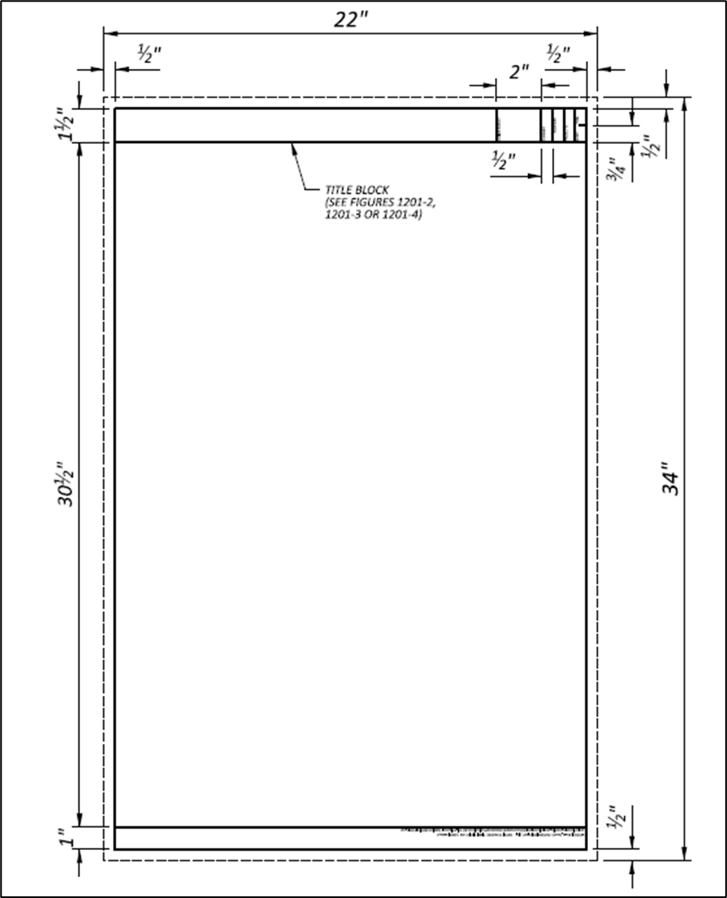

1201-2 | Title Block Examples for Roadway Plans
Reference Section 1201.5 | Title Block Examples for Roadway Plans

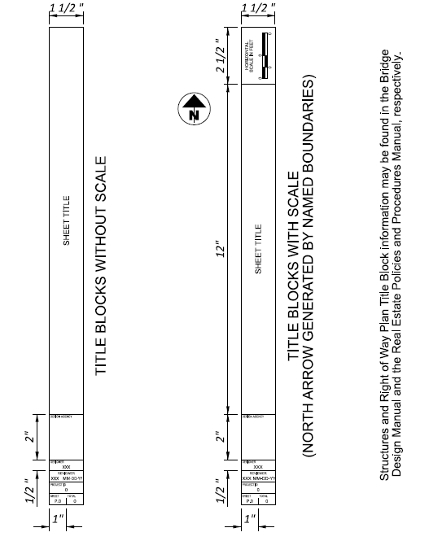

1202-1 | Acceptable Grid Systems
Reference Section  1202.3, 1204.4.1 | Acceptable Grid Systems

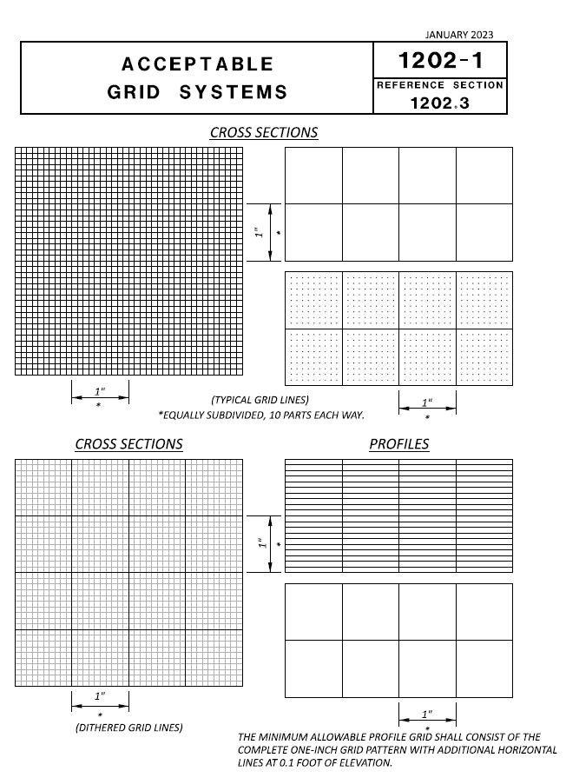

Section 1300 Plan Components

1301 Introduction

Plan development relies on standards and guidelines to provide clear, concise, and accurate construction documents. Detailed construction plans include illustrations of proposed work, plan notes, specifications, and quantities enabling contractors to bid and execute an ODOT project. Section 1300 has been developed to provide guidelines under which to develop ODOT construction plans.

Section 1300 combines many components of final plan development and outlines the content required in each plan set. The subsections listed within this document are intended to provide details related to plan format and not design standards. ODOT maintains specific manuals related to design standards (e.g. Bridge Design Manual, Location and Design Manual, Volume 1, Traffic Engineering Manual, etc.) which establish design criteria required for the facility.

Section 1300 includes references to figures and Sample Plans. The figures are tables, and diagrams, presenting plan sheet requirements and are referenced with bold text. The following is an example: Figure 1302-1.

The Sample Plans are examples of ODOT plan sheets (e.g., Title Sheet, Schematic, Typical Sections, etc.) and are intended to be used as a “guide” to assist the designer with plan development. The Sample Plans are not all-inclusive. Final plan development, in accordance with ODOT standards, is the responsibility of the designer. Structural plans (Bridge Design Manual) and Right-of-Way plans (Right-of-Way Manual) shall be developed according to their respective manuals. References to the Sample Plans are shown with brackets and bold text. The following is an example: [SP 1302-1].

1301.1 Standard Plans
Standard highway plans are made up of several components. Most of these components are discussed in detail in this section. Except for very complex projects, seldom will all components be required in a plan. However, when they are required, they shall be placed in the order indicated below:

- Title Sheet
- Schematic Plan
- Typical Sections
- General Notes
- Maintenance of Traffic (Notes and Plan Details)
- General Summary
- Subsummaries
- Calculations
- Project Site Plan
- Plan & Profile (Mainline)
- Plan & Profile (Side Roads, ramps, etc.)
- Cross-Sections (Mainline)
- Cross-Sections (Side Roads, ramps, etc.)
- Superelevation Tables
- Interchange Details
- Intersection Details
- Drive Details
- Storm Sewer Profiles
- Culvert Details
- Channel Details
- Channel Cross-Sections
- Drainage Details
- Retaining Walls (not associated with Structures)
- Sanitary Sewer
- Water Work
- Miscellaneous Details
- Traffic Control
  - Pavement Marking
  - Signing
  - Signals
- Lighting
- Landscaping
- Structure (20 Foot Span and Under)
- Structure (Over 20 Foot Span)
  - Site Plan
  - General Plan
  - General Notes
  - Estimated Quantities
  - Stage Construction Details
  - Foundation Plan
  - Abutment Details
  - Retaining Wall Details
  - Pier Details
  - Superstructure Details
  - Reinforcing Steel List
- Fence Plan
- Geotechnical Profile

On the Title Sheet, state the type of Geotechnical Explorations performed (e.g., Geotechnical Profile-Roadway, Geotechnical Profile-Bridge etc.) in accordance with Section 700 and Appendix D of the Specifications for Geotechnical Explorations. Include those sheets in the sequential numbering of the construction plan sheets.

- Right-of-Way - These sheets are not included in the sequential numbering of the construction plan and should be numbered separately.
  - Right-of-Way Legend Sheet
  - Centerline Plat
  - Property Map
  - Summary of Additional Right-of-Way
  - Detailed Right-of-Way

- Railroad or Government Land Plats - These sheets are not included in the sequential numbering of the construction plan and should be numbered separately.

1301.2 Simplified Plans
Simplified Plans are appropriate when the proposed work is simple and straightforward. Some examples include guardrail upgrading, pavement marking, herbicidal spraying, mowing, fencing, and resurfacing projects.

Simplified plans contain only the information necessary to minimally describe the type and location of the work. Typically, such plans consist of the following components:

- Title Sheet [SP 1302-7]
- Typical Sections
- General Notes
- General Summary, Subsummaries, Calculations
- General plan, sketch, line drawing, or plan and profile
- Special Details

Simplified plans may be used provided they give sufficient information to adequately describe the work so that a contractor can properly bid and construct the project. In some cases, this information can be presented entirely in written format, without the use of drawings. See Section 1315, Simplified Plans, for additional information regarding simplified plan content.

1302 Title Sheet

1302.1 General
The title sheet serves as a preface for the remainder of the construction plan. It gives a brief description and the length of the project, shows the general location of the project, sets up the specifications under which the project is to be built, states whether traffic is to be maintained or detoured, lists earth disturbed areas, gives an index of all sheets in the plan, lists standard construction drawings, railroad involvement, construction project number, federal project number, supplemental specifications, and special provisions, and contains the signature of approval by the proper officials.

1302.2 Plan Title

1302.2.1 Heading
All construction plans processed by the Ohio Department of Transportation must show in bold letters at the top of the Title Sheet, “STATE OF OHIO, DEPARTMENT OF TRANSPORTATION”.

1302.2.2 Project Designation

1302.2.2.1 Projects in One of Two Counties

A. On-System Projects - Projects on the State system are identified by county code, route number, and section number to the nearest hundredth of a mile (straight-line mileage). Following is an example [SP 1302-4] for a project in Wyandot County, on Route 30, beginning at straight-line mileage 9.11.

WYA-30-9.11

The county code consists of the first three letters of the county name with the following exceptions:

County Code

Ashland ASD

Ashtabula ATB

Champaign CHP

Harrison HAS

Meigs MEG

Monroe MOE

Montgomery MOT

Morgan MRG

Morrow MRW

The route number is identical to the actual route number assigned to the highway on which the improvement is located. The section number is the straight-line mileage (SLM) at the point where the project begins, measured from the county line in miles from west to east for east-west routes or from south to north for north-south routes, as the route is viewed across the entire state.

Listed below are several special conditions which may be encountered in determining a project designation for a project on the State system.

County Line Located on Project Centerline
The county code letters should be in accordance with the predetermined straight-line mileage assignment as listed in the Straight-Line Diagrams.

Project Limits Extend into Adjacent County
A project designation must be shown for each county.

FRA-3-26.18, DEL-3-0.00

or

FRA/DEL-3-26.18/0.00

Work Limits Extend into Adjacent County
The adjoining county code letters are shown in parentheses.

TUS-77-10.64(STA)

More than One Route (Not Overlapping)
A separate project designation is used for each.

UNI-31-8.19, UNI-37-2.04

or

UNI-31/37-8.19/2.04

For projects with various work types on three or more routes and/or ramps that are all included in the work, the primary route number, and reference to the various routes, should be shown followed by the primary route SLM and reference to the secondary route(s) various SLMs, as shown:

MAH-224/VAR-13.62/VAR

Overlapping Routes - For projects on overlapping highways of different systems (Interstate, U.S. or State), only the project designation for the highest-classed system should be used. For overlapping routes on the same system, the project designation for the lowest route number is used.

Intersecting Routes - A separate project designation is not required when other routes intersect the proposed improvement (junction or grade separation) unless it is determined that the intersecting route will have different funding than the principal route.

Suspended Projects - A separate straight-line mileage section number is used at the point where the project limit is resumed. The example below and [SP 1302-2] shows a project limit that begins at SLM 21.73, is suspended for a distance, and then is resumed at SLM 22.83. For additional information on how to determine project limits, see Section 1303.6.

DAR-121-(21.73) (22.33)

For instances where a project has numerous suspend/resume sections, the words “and various” may be used within the project designation, as shown as follows and in [SP 1302-5].

ERI-2-30.51 and various

- Off System Projects - The project designation for improvements on county or township road systems include the county code, county or township route number, and local name (if any). A section number may also be included, if appropriate. [SP 1302-6(a)]

CRA-C.R. 6–1.61 (Boundary Rd.)

POR-T.R. 233D (Asbury Road)

If a route number is not available, city street improvements simply use the county code letters and the street name as the project designation. [SP 1302-1]

JEF-FERNWOOD RD.

1302.2.2.2 District-Wide Projects

ACPV | Asphalt Concrete Paving
BC | Bridge Cleaning
BH | Bridge Repair
BI | Bridge Inspection
BK | Generic PIDs (Block)
BP | Bridge Painting
CB | Catch Basins
CH | Cleaning/Sweeping highways
CHIP | Chip Seal
CR | Small Culvert Repair/Replacement (Rise<60", round or elliptical conduit only)
CS | Crack Sealing
FEN | Fence
ENV | Environmental
GT | Geotechnical
GES | General Engineering Services Contract
GR | Guardrail
HS | Herbicidal Spraying
IMC | Interstate Maintenance Contract
ITS | Intelligent Transportation Systems
LG | Lighting
LOOP | Loop Detector Repair
MCRO | Microsurface
MOW | Mowing
NW | Noise Walls
PM | Pavement Marking
PR | Pruning, Tree/Brush removal
PS | Pavement/Shoulder Sealing
RPM | Raised Pavement Markers
RS | Ride Share
RUM | Rumble Strips
SIGN | Signing
SP | Spot Paving (less than 1000' in length)
ST | Surface Treatment (spot locations)
TSG | Traffic Signals
WIM | Weigh-In-Motion

District-wide projects are defined as projects which involve work in three or more counties within the District. The project designation for a District-Wide project is as follows: District Identifier - Project Type - Fiscal Year. Following is an example project designation for a district-wide pavement marking plan, in District 4, that is scheduled to be awarded in the fiscal year 2016.

D04-PM-FY2016

There may be a need to have multiple projects of the same project type, in the same district, in one fiscal year. If this is the case, the project designation is as follows:

D04-PM-FY2016(A)

and

D04-PM-FY2016(B)

The following is a list of project types. Contact the Office of CADD and Mapping Services if another project type is needed.

1302.2.2.3 Statewide Projects

Statewide projects should use the same project designation as District-Wide projects, except the District Identifier is replaced with STW (Statewide). For example, STW-ITS-FY2017.

1302.2.3 Political Subdivisions
Whenever any work is located within a political subdivision, it is necessary to include the name of the subdivision. If the improvement is located entirely within the corporate limits of a city or village, the township name is omitted. The order of political subdivisions, from top to bottom is city, village, township, and county. If the work limits extend into an adjoining county, the county is shown in parentheses. The following example shows how a title would read when portions of the improvement are located within several political subdivisions and the work limits extend into the adjoining county.

TUS-77-0.00 (STA)

CITY OF TROY

VILLAGE OF SPARTAN

OXFORD TOWNSHIP

TUSCARAWAS COUNTY

(STARK COUNTY)

1302.2.4 Railroads
When the improvement involves a railroad separation, the involvement must be indicated by a subtitle under the project designation [SP 1302-3].

Grade Crossing Elimination - When an existing railroad grade crossing is to be eliminated by constructing a separation or relocating the highway, the following subtitle should be used:

GRADE CROSSING ELIMINATION WITH THE ____________ RAILROAD

Separation Constructed Without Elimination - When the highway is to be separated from a railroad and the existing railroad grade crossing is not eliminated, use the following subtitle:

GRADE SEPARATION WITH THE RAILROAD

Existing Separation Rebuilt - When an existing separated crossing is to be rebuilt, the subtitle should read:

RECONSTRUCTION OF EXISTING SEPARATED CROSSING WITH THE RAILROAD

Projects which include grade separations or any other railroad involvement should list the railroad company’s name in the Railroad Involvement portion of the title block.

It should be noted that some companies are incorporated as railroads and some as railways. Verify the proper name is placed on the title sheet.

1302.3 Design Designation
The Design Designation is an expression of the basic factors that control the design of the highway. It may be included in the plan for any type of construction project, but it is required on any improvement having pavement work or geometric changes.

Normally, only one representative Design Designation is necessary. On improvements involving interchanges, major intersections, or other major traffic generators that materially affect traffic volumes, additional Design Designations are required. Design designations are necessary for side roads if relocation, or significant improvements, equal to or greater than three-hundred feet (300’) are involved. If only one Design Designation is used, it should be shown on the Title Sheet. For improvements with multiple design designations (e.g., more than one route), this information may be shown on a sheet other than the Title Sheet (e.g., Schematic Plan, specially designated sheet). However, the location of these sheet(s) must be noted in the Title Sheet’s Index of Sheets [SP 1302-5].

The following is an example of the Design Designation format [SP 1302-1 through 1302-6(b)]:

DESIGN DESIGNATION (ENGLISH UNITS)
Current ADT (2012) | 10,390
Design Year ADT (2032) | 25,200
Design Hourly Volume (2032) | 2,520
Directional Distribution | 55%
Trucks (24 hour B&C) | 2.6%
T_{d} | 4%
Design Speed | 50 MPH
Legal Speed | 40 MPH
Design Functional Classification | 03 Principal Arterial (Urban)
NHS Project | Yes

Current ADT is the Average Daily Traffic for the anticipated opening year of the project.

Design year is defined in Location and Design Manual, Volume 1, Section 102.2.

T_{d} is the percentage of trucks during the design hour in the design year, and is required for interstates, other freeways and expressways only.

Legal speeds are defined by the Ohio Revised Code in miles per hour.

If the project design is based on 3R [SP 1302-1] values the phrase “3R Project” should be used in lieu of the design speed. If a project mixes 3R work with other work that does not qualify as 3R, it is necessary to delineate or tabulate the non-3R portions and indicate the applicable design speeds.

Per the Ohio Department of Transportation Highway System Highway Functional Classification System – Concepts, Procedures, and Instructions, in addition to being classified as urban or rural, roadways are categorized as Principal Arterials, Minor Arterials, Collectors and Local Roads. Additionally, Principal Arterials and Collectors are further subcategorized, creating a total of seven (7) classifications or sub-classifications as shown in the table below:
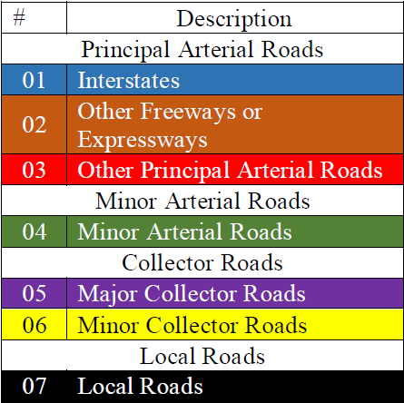

For more information on the Design Functional Classification please refer to the Location and Design Manual, Volume 1, Section 101, the Ohio Department of Transportation Highway Functional Classification System – Concepts, Procedures and Instructions, or contact the Office of Roadway Engineering.

1302.4 Design Exceptions
Design Exceptions are required as specified in Location and Design Manual, Volume 1, Section 105. The difference between the actual design and the normal design criteria must be clearly denoted on the appropriate plan sheet in the construction plans.

Design exceptions should be shown on the plan sheets in accordance with the guidelines on Figure 1302-3, Guide For Showing Design Exceptions in Plan, and on the Title Sheet [SP 1302-1] utilizing the following format:

DESIGN EXCEPTIONS
Design Feature | Approval Dates | Sheet Numbers
Lane Width | 7/7/18 | P.24
Bridge Width | 7/7/18 | P.46

If there are no design exceptions, indicate this by adding the words “None Required”. Contact the Office of Roadway Engineering with questions.

1302.5 Index of Sheets
The Index of Sheets serves as the table of contents for the entire set of plans. All sheets should appear in the index, sequentially numbered, except for as noted in 1301.1, Standard Plans. Geotechnical data from geotechnical reports may be included as Special Provisions on 8 ½ “x 11” sheets.

Since sheets are often added, deleted or rearranged during plan development, the final sheet numbering is usually deferred until the Stage 3 Review. To assist the reviewer in describing the location of review comments, sheets should be designated with numerical or alphabetical characters for each review submission.

As a last resort, sheets may be inserted into the plan by alphabetizing (Example: P.88A, P.88B, P.88C, etc.). All alphabetized sheets must be shown in the Index of Sheets. The last actual sheet number in the plan is never alphabetized. [SP 1302-4]

Sheet numbers that are not used must be noted as “Not Used”. [SP 1302-4]

1302.6 Plan Preparer Identification

1302.6.1 Signatures and Seals
All plans, including those prepared by ODOT staff, shall be digitally signed and sealed by a Registered Professional Engineer/Surveyor. Plans shall include a digital signature block and seal on the title sheet. Digital signatures and seals shall be applied in accordance with Ohio Administrative Code. More than one Engineer/Surveyor may seal the title sheet, or different Engineers/Surveyors may seal different portions of a plan (i.e., seal on bridge site plan to cover all bridge work). It must be clear what design elements each seal covers. A single Engineer’s seal on the Title Sheet is assumed to cover the entire plan, unless otherwise noted.

Sample Plan Sheets [SP 1302-1 through 1302-8] show the normal placement of the Engineer’s seal.

1302.6.2 Design Firm Information
The name and address of the firm preparing the plan should be shown [SP 1302-1 through 1302-8].

1302.7 Underground Utilities Note
The “Before You Dig” warning note will be shown on the Title Sheet for all plans. The note is shown below and on the Sample Plan sheets [SP 1302-1 through 1302-8].



1302.8 Location Map
The Location Map [SP 1302-1 through 1302-8] shows the general area in which the project is located and the project limits. The map should be approximately 7" x 7", for a full-size plan with North pointing toward the top of the sheet. A scale of 1" = 1 mile is often used; however, the map scale shall be such that the limits of the project are clearly identified and the lettering clearly legible on an 11"x17" reduced set of plans.

The Location Map shall contain sufficient information to clearly show the location of the improvement with respect to federal, state, county and township roads; identifiable streets in urban areas; villages, cities, townships and counties; and rivers and creeks.

Detour routes should be shown on the Location Map [SP 1302-2], if possible. If not, the detour should be shown on the Schematic Plan, or Maintenance of Traffic Sheets [SP 1302-6(a)], and so noted in the Index of Sheets.

The latitude and longitude shall be provided for all projects, shall be measured to the center of the project, and shall be accurate to the nearest 5 seconds of a degree.

On multiple segment contracts, the latitude and longitude used shall be the approximate center of the segments of work. The approximate center can be established by visual inspection.

On district-wide contracts, the latitude and longitude used shall be the locations in the following table:

DISTRICT | LATITUDE | LONGITUDE
1 | 40°46’18” | 84°05’34”
2 | 41°23’07” | 83°38’48”
3 | 40°52’38” | 82°17’41”
4 | 41°00’57” | 81°29’30”
5 | 39°57’06” | 82°24’41”
6 | 40°17’52” | 83°02’58”
7 | 40°17’49” | 84°09’40”
8 | 39°25’52” | 84°17’03”
9 | 39°19’28” | 82°57’47”
10 | 39°26’28” | 81°27’36”
11 | 40°27’19” | 81°24’29”
12 | 41°24’54” | 81°36’54”
Statewide | 39°57’21” | 83°03’13”

1302.9 Supplemental Specifications
A list of the Supplemental Specifications (including the current revision date) applicable to the project shall be included on the Title Sheet [SP 1302-1]. Supplements, 1000 series and above, are not to be listed on the Title Sheet.

Supplemental Specification 800 must be specified on all projects. Ensure that the most recent revision date, prior to the date of filing, of Supplemental Specification 800 is used.

A suffix indicating the applicable year of the specification book should be provided on the title sheet (i.e., when using the 2023 Construction and Material Specifications, Supplemental Specification 800-2023 should be used). The suffix is required because Supplemental Specification 800 will vary with each edition of the CMS.

1302.9.1 Special Provisions
When a special provision is needed for a project, the title and date of the special provision shall be listed on the Title Sheet [SP 1302-1]. See Section 1305.3 – Special Provisions for more information.

1302.10 Standard Construction Drawings
A list of current Standard Construction Drawings (including the current revision date) applicable to the project shall be included on the Title Sheet. The Title Sheet includes a table listing the Standard Drawings that apply to the project. During plan preparation, the drawings should be grouped by set, listed in alpha-numeric order within that set, and added to the Title Sheet [SP 1302-1].
Standard Construction Drawings are published in three sets. The sets include Roadway Drawings, Bridge Drawings, and Traffic Drawings and are maintained by the following offices:

- Roadway Drawings

Drawing Series: Office:
BP (Base Pavement) Office of Pavement Engineering
BP (Base Pavement) Office of Roadway Engineering
CB (Catch Basins) Office of Hydraulic Engineering
DM (Drainage Miscellaneous) Office of Hydraulic Engineering
F (Fence) Office of Roadway Engineering
MGS (Guardrail) Office of Roadway Engineering
HW (Headwalls) Office of Structural Engineering
I (Inlets) Office of Hydraulic Engineering
LA (Landscaping) Office of Roadway Engineering
MH (Manholes) Office of Hydraulic Engineering
RM (Roadway Miscellaneous) Office of Roadway Engineering
WQ (Water Quality) Office of Hydraulic Engineering

- Bridge Drawings

Drawing Series: Office:
A (Abutments) Office of Structural Engineering
AS (Approach Slabs) Office of Structural Engineering
BD (Bearing Details) Office of Structural Engineering
BR (Bridge Railing) Office of Structural Engineering
CPA (Capped Pile Abutments) Office of Structural Engineering
CPP (Capped Pile Piers) Office of Structural Engineering
CS (Continuous Slabs) Office of Structural Engineering
DBR (Deep Beam Railings) Office of Structural Engineering
DS (Drip Strips) Office of Structural Engineering
EXJ (Expansion Joints) Office of Structural Engineering
FB (Fixed Bearings) Office of Structural Engineering
GSD (General Steel Details) Office of Structural Engineering
HW (Headwalls) Office of Structural Engineering
ICD (Integral Construction Details) Office of Structural Engineering
NBS (Noise Barrier Specifications) Office of Structural Engineering
PCB (Portable Concrete Barrier) Office of Structural Engineering
PSBD (Prestressed Concrete Box
Beam Details) Office of Structural Engineering
PSID (Prestressed Concrete I-Beam
Details) Office of Structural Engineering
RB (Rockers and Bolsters) Office of Structural Engineering
SB (Single Span Slab Bridge) Office of Structural Engineering
SBR (Single Slope Bridge Railing) Office of Structural Engineering
SICD (Semi-Integral Construction
Details) Office of Structural Engineering
TBR (Thrie Beam Retrofit) Office of Structural Engineering
TST (Twin Steel Tube) Office of Structural Engineering
VPF (Vandal Protection Fence) Office of Structural Engineering

3. Traffic Drawings

Drawing Series: Office:
HL (Highway Lighting) Office of Roadway Engineering
ITS (Intelligent Transportation
Systems) Office of Roadway Engineering
MT (Maintenance of Traffic) Office of Roadway Engineering
TC (Traffic Control) Office of Roadway Engineering

1302.11 Project Description and Earth Disturbed Areas

1302.11.1 Project Description
The Project Description consists of a brief note describing the primary purpose of the improvement and the project’s length.

The project’s length is the total distance between the Begin and End project points, adjusted for suspensions and station equations, and measured along the centerline of construction. It is calculated to the nearest hundredth of a mile. In addition, the Project Description should describe other incidental construction. Incidental construction may include the following items (unless they are included in the primary construction): bridge work, interchanges, major connecting roads, lighting, traffic control, etc. The descriptions should use words and phrases such as: resurfacing of, widening and resurfacing of, reconstruction of, relocation of, construction of, rehabilitation of, replacement of, etc.

1302.11.2 Earth Disturbed Areas
For all projects, list the Project Earth Disturbed Area and the Estimated Contractor Earth Disturbed Area in acres to the tenth of an acre. For projects that require the submittal of a Notice of Intent (NOI), as explained in the Location and Design Manual, Volume 2, Section 1109, list the Notice of Intent (NOI) Earth Disturbed Area to the tenth of an acre. For projects with non-contiguous portions of earth disturbance located ¼ mile or more apart, list the separate non-contiguous earth disturbance area values in separate tables.

For projects involving no disturbed area, such as pavement marking, provide the estimated Project and Contractor EDA, but indicate that a Notice of Intent (NOI) is not required. Use the approach shown in the following example description:

Project Earth Disturbed Area = 0.0 Acres
Estimated Contractor Earth Disturbed Area = 0.0 Acres
Notice of Intent Earth Disturbed Area = N/A (NOI not required)

For projects involving some earthwork, but less than one acre of total earth disturbed area (EDA) (e.g., small bridge replacement), provide the estimated Project and Contractor EDA, to the tenth of an acre, but indicate that a Notice of Intent (NOI) is not required. Use the approach shown in the following example description:

Project Earth Disturbed Area = 0.5 Acres
Estimated Contractor Earth Disturbed Area = 0.2 Acres
Notice of Intent Earth Disturbed Area = N/A (NOI not required)

For projects that require a Notice of Intent (NOI), provide the estimated Project and Contractor EDA, as well as the Total EDA, called the Notice of Intent EDA to the tenth of an acre. Use the approach shown in the following example description: [SP 1302-1]

Project Earth Disturbed Area = 3.1 Acres
Estimated Contractor Earth Disturbed Area = 0.5 Acres
Notice of Intent Earth Disturbed Area = 3.6 Acres

For routine maintenance projects, per the Location and Design Manual, Volume 2, Section 1109.2, provide the estimated Project and Contractor EDA to the tenth of an acre, but indicate that a Notice of Intent (NOI) is not required. Use the approach shown in the following example description: [SP 1302-7]

Project Earth Disturbed Area = 4.0 Acres
Estimated Contractor Earth Disturbed Area = 0.1 Acres
Notice of Intent Earth Disturbed Area = N/A (NOI not required) *
* Routine Maintenance Project

1302.12 Notes

1302.12.1 Limited Access
The following note shall be used on the Title Sheet when any portion of the existing, or proposed, right-of-way is designated as Limited Access (includes cases where bridges span a limited access facility): [SP 1302-4]

LIMITED ACCESS

THIS IMPROVEMENT IS ESPECIALLY DESIGNED FOR THROUGH TRAFFIC AND HAS BEEN DECLARED A LIMITED ACCESS HIGHWAY, OR FREEWAY, BY ACTION OF THE DIRECTOR IN ACCORDANCE WITH THE PROVISIONS OF SECTION 5511.02 OF THE OHIO REVISED CODE.

1302.12.2 Specifications
The following note shall be used to indicate the publication date of the Construction and Material Specifications used on the project. The current specification revision year shall be used. Plan details and pay items must be modified to reflect the specification year used.

SPECIFICATIONS

THE STANDARD SPECIFICATIONS OF THE STATE OF OHIO, DEPARTMENT OF TRANSPORTATION, INCLUDING SUPPLEMENTAL SPECIFICATIONS LISTED IN THE PLANS AND CHANGES LISTED IN THE PROPOSAL SHALL GOVERN THIS IMPROVEMENT.

1302.12.3 Maintenance of Traffic Endorsement
All contract plans are to be endorsed. One of the notes below shall be used on the Title Sheet, as appropriate. It may be necessary to alter these notes to some degree so that the intent clearly and accurately reflects the project conditions. [SP 1302-5].

Traffic Not Rerouted

I HEREBY APPROVE THESE PLANS AND DECLARE THAT THE MAKING OF THIS IMPROVEMENT WILL NOT REQUIRE THE CLOSING TO TRAFFIC OF THE HIGHWAY AND THAT PROVISIONS FOR THE MAINTENANCE AND SAFETY OF TRAFFIC WILL BE AS SET FORTH ON THE PLANS AND ESTIMATES.

Traffic Rerouted

I HEREBY APPROVE THESE PLANS AND DECLARE THAT THE MAKING OF THIS IMPROVEMENT WILL REQUIRE THE CLOSING TO TRAFFIC OF THE HIGHWAY AND THAT DETOURS WILL BE PROVIDED AS INDICATED ON SHEET.

Traffic Rerouted for Brief Time Periods

I HEREBY APPROVE THESE PLANS AND DECLARE THAT THE MAKING OF THIS IMPROVEMENT WILL NOT REQUIRE THE CLOSING TO TRAFFIC OF THE HIGHWAY EXCEPT AS NOTED ON SHEET, AND THAT PROVISIONS FOR THE MAINTENANCE AND SAFETY OF TRAFFIC WILL BE AS SET FORTH ON THE PLANS AND ESTIMATES.

Traffic Rerouted Majority of Time

I HEREBY APPROVE THESE PLANS AND DECLARE THAT THE MAKING OF THIS IMPROVEMENT WILL REQUIRE THE CLOSING TO TRAFFIC OF THE HIGHWAY EXCEPT AS NOTED ON SHEET, AND THAT DETOURS WILL BE PROVIDED AS INDICATED ON THE PLANS.

Traffic Rerouted Approximately Half Time

I HEREBY APPROVE THESE PLANS AND DECLARE THAT THE MAKING OF THIS IMPROVEMENT WILL REQUIRE THE PART-TIME CLOSING OF THE HIGHWAY TO TRAFFIC, AS NOTED ON SHEET. DURING WHICH TIME DETOURS WILL BE PROVIDED AS SHOWN HEREIN. PROVISIONS FOR THE MAINTENANCE AND SAFETY OF TRAFFIC WILL BE AS SET FORTH ON THE PLANS AND ESTIMATES.
Traffic Rerouted for Side Road Closure

I HEREBY APPROVE THESE PLANS AND DECLARE THAT THE MAKING OF THIS IMPROVEMENT WILL NOT REQUIRE THE CLOSING TO TRAFFIC OF THE HIGHWAY EXCEPT FOR THE SIDE ROADS AS DESCRIBED ON SHEETS AND THAT PROVISIONS FOR THE MAINTENANCE AND SAFETY OF TRAFFIC WILL BE AS SET FORTH ON THE PLANS AND ESTIMATES.

1302.13 Plan Signatures
The Director, Department of Transportation & District Deputy Director signatures’ approval shall be provided in the title sheet template or placed on the title sheet signature space as a template Figure 1302-1, which is provided in the OHDOT CADD Standards, found in Section 1204 Computer-Aided Drafting and Design.

When additional signatures are desired, such as those for city or county officials, they shall be placed on the signature sheet prior to submission of final tracings, Figure 1302-2.

1302.14 Combined Plans
When construction plans for two or more projects are combined to be sold as one construction project, the following Title Sheet [SP 1302-6(a), SP 1302-6(b)] changes should be made:

- Add “Part 1” after the project designation on the first title sheet. Add “Part 2”, “Part 3”, etc. to each succeeding plan title sheet.

- Cross reference all parts on all title sheets. For example, on the first title sheet for a three-part project, add “For Part 2 see ” and “For Part 3 see .”

- Expand the Standard Construction Drawings, Supplemental Specification and Special Provisions lists on the Part 1 title sheet to include those required for all parts. Remove Standard Construction Drawing, Supplemental Specification and Special Provisions lists from all subsequent title sheets and add a cross-reference to Part 1.

In addition to the above title sheet changes, the type of Field Office specified in each plan should be adjusted to provide for the combined construction costs; and the maintenance of traffic should be coordinated for all parts.

During the design phase of a project that will use Combined Plans, two or more separate PIDs may be established to reference each Part of the project. However, the construction contract must utilize only one PID. Update Ellis to provide cross-references that correlate the design phase and construction PIDs.

Items 614, 619, 623, and 624 should be provided on all parts where they are applicable.

1302.15 Americans with Disabilities Act (ADA) Design Waivers
ADA Design Waivers are required as specified in the Multimodal Design Guide, Section 4.5.9.7. ADA Design Waivers shall be shown on the Title Sheet utilizing the following format [SP 1302-1]:

ADA DESIGN WAIVER: None Required
ADA DESIGN WAIVER: Required

Additional information will be provided in the General Notes for ADA features requiring a waiver. See the Location and Design Manual, Volume 1, Sample Plan Notes for details. Contact the Office of Roadway Engineering with questions.

1302.16 Railroad Involvement
The names of all railroads involved in the project must be entered in the space provided on the title sheet. If there is no railroad involvement, this should be indicated by entering the word “NONE” in this space.

1302.17 Federal Project Number
The Federal Project Number should be entered in the appropriate space on the title sheet. If the project has no federal participation, the words “Non-Federal” should be entered in this space.

1303 Schematic Plan

1303.1 General
The purpose of a Schematic Plan [SP 1303-1] is to show the geometric location of proposed roadway segments in relation to existing roadway segments and other features. All projects shall include a Schematic Plan unless the project is short enough to be shown entirely on less than four Plan & Profile sheets.

Schematic Plans are normally prepared to a scale of 1"=100', 1"=200', or 1"=400'. It is preferable to limit the Schematic Plan to one sheet. The scale shall be shown in bar format.

Many of the features included on a Schematic Plan are discussed in the following sections. Other features may be added, as necessary, to provide a clearer picture of the proposed improvement and its relationship to existing facilities.

1303.2 Reference Lines
All reference lines should be clearly shown on the Schematic Plan [SP 1303-1]. These include the centerline of construction, baselines of ramps, directional roadways and other similar facilities. The centerline of construction and centerline of Right-of-Way should normally be the same. When they differ, their relationship to each other must be shown in the plan. Typically, the relationship is only shown on the Right-of-Way plan sheets.

With modern survey technology, topographic surveys are no longer completed based on a centerline of survey. Consequently, survey centerlines are a misnomer and should not be shown.

The intersection angle, as well as the intersecting stations, should be shown for all intersecting roadways. It may be more convenient to show this information on an intersection detail.

1303.3 Stationing
In general, tick marks shall be shown at full stations (100 ft. intervals) along the center and base reference lines. The centerline stationing on a project should reflect the straight-line mileage shown on the “section” (County-Route-Section). Centerline stationing may also be established based on existing monumentation, bridges and prior projects. Stationing shall increase in the direction of the straight-line mileage.

The Schematic Plan should generally be oriented in such a manner that the stationing on the mainline will increase from left to right, regardless of the north direction [SP 1303-2].

Ramp stationing should be a continuation of mainline stationing from the exit or entrance nose and should increase or decrease along the ramp as it does along the mainline. In general, it is not desirable to use ramp stations in the terminal area, as the required pavement slopes and transitions can be laid out using the mainline stations.

Station equations, if necessary, are to be indicated on the reference line by stating the station back and station ahead [SP 1303-3].

If the basis for centerline stationing is unclear or there is a lack of monumentation, structures or prior project stationing documentation, the designer establishing the centerline stationing shall coordinate with the District Survey Section and/or District Real Estate Section to determine the appropriate basis for centerline stationing.

1303.4 Bearings
Bearings shall be shown for the tangent sections of all reference lines.

1303.5 Horizontal Curve Data
Horizontal curve data, and deflections without curves, for all existing and proposed alignments must be shown on the Schematic Plan. Figures 1303-1 through 1303-3 show elements and data for simple curves, spiral curves, and for when combining spirals between two simple curves. Curve data (except angles) should be shown to two decimal place accuracy. Deflections without curves are identified as follows:

P.I. = Sta. _______________

Deflection = ______________

NO CURVE

Use “e_{max} = NC” to indicate that normal crown is provided.

1303.6 Project Limits
Project limits are points on the mainline centerline of construction where the proposed improvement, as described in the project description on the Title Sheet (excluding incidental construction), begins and ends. Project limits are generally defined as the beginning/ending of proposed full-depth, full-width pavement. Incidental construction includes all work required to complete a project in addition to the primary purpose for the improvement. Work such as pavement feathering and tapering, traffic control devices, drainage, guardrail, drives, side roads, service roads, etc., may be considered as incidental construction and not be included in the project limits.

Where the primary work on the mainline is suspended for a substantial distance, suspend and resume project points must also be shown.

Begin Project, End Project, Suspend Project, and Resume Project points shall be shown on the Schematic Plan and the Plan & Profile sheets and include both stationing and straight-line mileage (SLM).

1303.7 Work Limits
Work Limits are the extreme limits of the contractor’s responsibility on a project, including all temporary and incidental construction, with the exception of work zone traffic control devices required for maintenance of traffic. Work Limit stations are shown along the centerline of construction of the mainline facility and along the centerline of all side roads, crossroads, and other construction generally running perpendicular to the project or separated from the project.

1303.8 Federal Project Flags
Federal Project Flags, including Federal Project numbers, should be placed at the project limits [SP 1303-2]. The flags shall always point toward the project. If more than one Federal number is used, the limits of each Federal number should be shown, again pointing to the portion of the project to which it applies.

1303.9 Political Boundaries
All county, township, corporation limits, and other political boundaries shall be labeled. The station where these boundaries intersect the centerline of construction shall be shown. When the political boundary is located along the centerline, stationing shall be shown at the points where the political boundary meets and leaves the centerline.

1303.10 Waterways
All waterways (jurisdictional streams, rivers, ditches, lakes, reservoirs, ponds), crossing or adjacent to the proposed improvement, shall be shown, labeled, and the direction of flow shall be indicated. This includes any relocated waterways. See Office of Environmental Services’ Waterway Permits Manual for more information on waterway permits.

1303.11 Bridges
All bridges existing and proposed, shall be shown at their appropriate location and identified by their structure number, including left and right notation.

1303.12 Roads for Maintaining Traffic
The location of all roads for maintaining traffic located on an independent alignment shall be shown. Roads for maintaining traffic may be shown using centerline only.

1303.13 Railroads
All railroads in the vicinity of the proposed improvement shall be shown. If a railroad intersects the highway, the station shall be indicated.

1303.14 Utility Lines
High voltage power lines and other major overhead utilities shall be shown. High pressure underground utility lines shall also be shown. Include size/voltage and ownership for these lines [SP 1303-3].

1303.15 Pipelines
All major pipelines shall be located and shown.

1303.16 Service/Public Roads
All existing and proposed service roads and other public roads shall be shown and identified by the name and number.

1303.17 Culverts and Sewers
All existing and proposed culverts shall be shown at their appropriate location and the size indicated. Include flow arrows showing direction of flow in the culvert. List the structure number for any structure on the State/Federal system having a span greater than or equal to 10 feet.

Outfall sewers shall be shown.

Drive pipes do not need to be shown.

1303.18 Landscaped Areas
All existing and proposed landscaped areas should be shown. If no landscaped areas exist, then include the phrase “There are no existing landscaped areas within the work limits.”

1303.19 Participation Splits
All participation split locations shall be shown. Participation splits are necessary when portions of the project are financed under different Federal Project Numbers, are split by municipal corporation lines, or there are areas to be paid for by only one agency.

1303.20 Contractor’s Use of ODOT Right-of-Way
On large projects it may be economical for the Department to permit the contractor to use ODOT property to dispose of waste material and construction debris, excavate borrow material or place a portable plant.

These areas should be checked to ensure that their use is in keeping with all design criteria, environmental regulations and public involvement commitments. When evaluating an area for waste material, the designer should consider future widening and the location of underground utilities.

Areas where the above activities are permissible should be identified in the plans (e.g., on the schematic plan, on the plan and profile sheets, on the cross-sections, in a plan note). Grading restrictions should be identified on the cross sections or specified in the General Notes. Unless additional requirements are provided in the plans, there are no limits on the type of waste material that can be used (e.g., plant material, stumps, etc.). The plan should show whether environmental and/or FEMA permits have been obtained or if the contractor is required to obtain them.

1303.21 Wetlands
All existing wetlands within 100 feet of the proposed construction limits shall be shown and labeled. Wetlands are located and delineated as per the Office of Environmental Services Ecological Manual.

1303.22 Project Control and Reference Points
All necessary survey/mapping parameters should be conveyed in the General Notes as established in Sample Plan Note G105, in Appendix B. Points used to establish project control and reference points should be shown in the Schematic Plan [SP 1303-1] or listed in the General Notes [SP 1305-1].

The survey/mapping for all projects should be developed utilizing the ODOT Survey and Mapping Specifications which are found in the Location and Design Manual, Volume 4, Section 2000, and the Office of CADD and Mapping Services website.

A table listing project control and reference information such as the primary project control monuments, azimuth marks and/or temporary benchmarks (see Section 2000 of the Location and Design Volume 4 Manual, Survey and Mapping Specifications, for descriptions of these items) should be provided. The following information should be included:

- Point number
- Grid and scaled coordinates in U.S. Survey feet (northing/easting)
- Orthometric Height (Elevation)
- Description (i.e. Primary Project Control - steel rod set in concrete)

See [SP 1305-1] for an example of the project control table.

1304 Typical Sections

1304.1 General
The Typical Section is a portrayal, with dimensions, of how a cross-sectional view of the roadway would appear after construction is completed. Except in the case of some ramps, typical sections should be shown relative to the direction of increasing stationing regardless of the direction of travel. Sections should generally be drawn to the same scale horizontally and vertically, although the vertical scale of the pavement thickness may be exaggerated to show the thickness of the various layers. The scale should be large enough to clearly show the proposed section, as well as existing features. No scale should be shown on the typical section. Although sections on the same sheet are usually drawn to the same scale, enlarged details may be used to show items such as pavement edge treatment. Ground lines, existing pavement and all other existing features should be shown (if relevant) using dashed lines.

Mainline, ramp and other roadway typical sections should be grouped together.

Most of the features included in the Typical Sections are discussed in the following sections. Other features may be necessary to cover special circumstances. Examples are included in the Sample Plan Sheets.

1304.2 Typical Section Type and Limits
Unless they have identical typical sections, separate sections must be shown for the mainline, side roads, crossroads, ramps, and other roadways involving paving or earthwork. The typical section of the adjoining pavement including type, thickness, and cross slopes of all pavement courses should be provided.

Sections should be shown for each roadway when: the pavement build-up changes, the type of median changes, guardrail and concrete barriers begin or end, lanes are added or dropped (minimum and maximum limits are sufficient), and in superelevated areas. Separate sections and lane widths are not required for intersections.

Varying pavement widths in intersection return areas should also be disregarded. A reference to the sheet containing the intersection detail may be added, if necessary. Each section must be adequately labeled to indicate if it is a normal or superelevated section and the roadway and station limits where it applies. Partial sections may be applicable for: changes in treated shoulder build-up; shoulder slope changes in superelevated sections; cut and fill slopes; and other similar situations.

Special sections may be required for speed change lanes, approach slabs, linear grading, etc. Typical sections should also be shown where pavement composition is adjusted over culverts with shallow fill.

Under each section, the station limits where the typical section is applicable shall be indicated. Calculation of the lengths where these typicals apply is not necessary.

Limiting stations for side road typical sections shall break at the side road stations of the extended mainline edges of pavement.

1304.3 Reference Line Location
The location of the centerline or baseline of construction must be shown on each typical section.

1304.4 Rounding
Rounding of slopes shall be shown on each typical section where applicable.

1304.5 Profile Grade Point
The location of the profile grade elevation (normally the crown point) shall be noted on each typical section. Its location should be clearly identified. On a divided highway the profile grade for both sides shall be shown. When the crown-line and profile-grade line are not the same [SP 1304-5], their relationship to each other must be shown.

1304.6 Dimensions
Items on each typical section shall be dimensioned. All dimensions must be shown either in a vertical or horizontal plane. None are to be measured along slope lines. When referring to items detailed in the Standard Construction Drawings, dimensions may be omitted.

If a dimension varies within the limits of a typical section, it should be noted as “varies”, the maximum and minimum dimensions within the limits shall be identified. The limits shall be clearly shown, either on the Typical Section, the Plan and Profile Sheet, or other appropriate detail sheet.

Vertical dimensions include pavement course thicknesses, edge thicknesses, underdrain depths, ditch depths, etc. Where variations in a pavement course thickness are proposed, the typical section should show the thickness as “varies” and the variations shown in tabular form. Vertical dimensions shall normally be in inches.

Horizontal dimensions include widths of pavement, graded shoulders, treated shoulders, steps at edges of pavements, ditches, sidewalks, approach slabs, rounding, pavement widening, medians, barrier offsets, etc. On projects with multilane configurations or curbed shoulders, the lane locations and widths should be shown. Variations in horizontal dimensions due to intersections, etc. should not be included in the typical section. They should be clearly shown on the pertinent plan detail sheets. Horizontal dimensions shall normally be in tenths of a foot.

1304.7 Pavement and Shoulder Cross-Slopes
The shape of the finished surface of the pavement and shoulders should be shown on each typical section by indicating the direction (by an arrow pointing downslope) and the rate of slope. Cross-slopes on pavements and shoulders are to be expressed in dimensionless, vertical-to-horizontal ratios, in decimal form (e.g. 0.01, 0.016, 0.08, etc.).

1304.8 Subsurface Drainage
The location of pipe underdrains, aggregate drains, etc. should be shown on each typical section. Include slopes for aggregate drains. See the Pavement Design Manual, Section 205 - Subsurface Pavement Drainage for guidance.

1304.9 Pavement Build-Up
Pavement and treated shoulder build-ups and course steps shall be clearly indicated on each typical section. This includes such items as: surface, base and subbase courses; curb, curb and gutter; saw cuts; depth of planning; pavement for maintaining traffic to remain, etc.

Step details may be needed to adequately show pavement “steps” as per the Pavement Design Manual.

1304.10 Foreslopes and Backslopes
If the limiting stations of a typical section include both cuts and fills, examples of each should be shown. Cut and fill foreslope and backslope rates shall be indicated as 2:1, 3:1, 4:1, (horizontal: vertical) etc. Percentages should not be used. Guardrail offset locations shall also be shown where applicable.

1304.11 Legend
The legend is required to describe the pay items used in the Typical Sections and the build-up of the existing pavement. It may be shown on only the first Typical Section sheet with a cross-reference shown on each succeeding sheet.
Numbered or lettered balloons are used to tie the legend to the drawings. Proposed items are to be differentiated from existing by using numbers for proposed and letters for existing. In addition, dashed balloons may be used to show existing items. Balloon references should be consistent throughout the typical section sheets.

The legend for proposed items shall include the specification number and the exact pay item description, as listed in the ODOT Item Master. The legend for existing items should never include a specification number but should describe the item in more generic terms such as: Asphalt Concrete, Reinforced Concrete, or Subbase. The approximate existing depth (+/-) should be listed.

1304.12 Longitudinal Joints
For rigid pavements, the location and type of all longitudinal joints should be indicated on each typical section [SP 1304-3].

1304.13 Approach Slabs
Although approach slabs are paid for as structure items, base pavement, cross slopes, etc. must be shown on the typical sections.

1304.14 Warranty Pavement
When warranty pavement is included in a project, show the total thickness of the pavement along with an assumed configuration.

1304.15 Subgrade Treatment
Subgrade treatments such as lime stabilization, cement stabilization or undercuts are to be shown on the typical sections and the cross sections.

Illustrate the subgrade treatment on the cross-sections with a distinct hatching pattern. Provide a legend on the cross-sections indicating the proposed subgrade treatment type and depth.

1305 General Notes and Special Provisions

1305.1 General
The General Notes contain those plan notes required to clarify construction items that are not satisfactorily covered by the specifications or plan details. They are also used to modify the Standard Construction Drawings. All pay items that are “As Per Plan” or “Item Special” require a plan note, a special detail, or both.

On small projects, the General Note Sheets will include the majority of all plan notes for the project. For large projects, components such as Maintenance of Traffic, Sanitary Sewers, Water Work, Traffic Control, Lighting, Landscaping or Structures should be accompanied by their own plan notes.

Plan notes are to be consistent with the intent and requirements of the plans. Notes that repeat provisions clearly covered by the Construction and Material Specifications, Supplemental Specifications or Standard Construction Drawings should be avoided. For unusual or potentially controversial plan notes, contact the involved specification committee chair for advice on the content of the note.

Sample Plan Sheet [SP 1305-1] shows an example General Note format. Specific notes must be selected by the project designer. Notes may be block justified as shown in [SP 1305-1]; or left justified as shown in [SP 1306-1].

1305.2 Special Provisions
Special Provisions are notes and/or specifications developed for a project that are not related to standard ODOT Construction and Material Specifications. Ordinarily, these notes should be included in the General Notes. However, when these notes would take up a significant number of plan sheets, the designer may opt to include them with the plan as Special Provisions produced on 8-1/2” x 11” sheets.

For waterway permits, the Office of Environmental Services (OES) provides Special Provisions in the form of Waterway Permit conditions, which include requirements of the Section 404 permit, Section 401 Water Quality Certification and any U.S. Coast Guard and U.S. Army Corps of Engineers navigation requirements on larger waterways. Special Provisions also contain ODOT requirements that facilitate enforcement of the waterway permits. The regulatory permits are also sent by OES to the district office to be provided to the contractor and displayed on the project site.

The title and date of all Special Provisions are listed on the Title Sheet. A reproducible letter size copy of all Special Provisions is to be included in the Final Plan Package submitted to the Office of Estimating.

1306 Maintenance of Traffic

1306.1 General
Maintenance of Traffic sheets normally follow the General Notes. On projects where traffic maintenance is uncomplicated or traffic is detoured, a separate Maintenance of Traffic section of the plan is not required, and the notes may be included with the General Notes. When bridge plans include staged construction details, a cross-reference to these details should be added to the Maintenance of Traffic notes.

Examples of Maintenance of Traffic sheets are included in the Sample Plan Sheets [SP 1306-1 through SP 1306-8].

1306.2 Maintenance of Traffic Plan Contents
Probably the least complicated plans for maintaining traffic result when through traffic is detoured during the entire construction period. In such cases, the detour route is shown on the Title Sheet Location Map [SP 1302-2], Schematic Plan, General Notes or on a separate detour sheet [SP 1306-3]. If the detour is shown somewhere other than on the Title Sheet Location Map, it should be referenced in the Index of Sheets.

When traffic is maintained during construction, the plan will normally require a number of notes along with several details. The following is a list of some of the details that may be required:

- Sequence of operations [SP 1306-1 and SP 1306-2].
- Phase drawings showing construction by phase [SP 1306-4(a) through 1306-8], method of maintaining traffic for each phase, barriers, drums, maintenance of traffic signing, existing signing, and pavement marking. Phasing plans may be drawn at 1”=20’, 1”=30’, 1”=40’, 1”=50’, 1”=100’ or 1”=200’.

- Section details for maintaining traffic, showing existing pavement widths, pavement for maintaining traffic widths (including guardrail offset and grading), lateral construction limits, placement of channeling devices (barriers, drums, etc.) and work zone lane widths.

- Supplemental details for work zone traffic control devices.

- Plan insert sheets Crossover details

- Roads / Pavement for maintaining traffic details

- Miscellaneous MOT details

The Traffic Engineering Manual provides guidance on how to maintain traffic during construction and gives specific details on what is required on maintenance of traffic sheets.

For additional information regarding Maintenance of Traffic, contact the Office of Roadway Engineering.

1306.3 Roads and Pavements for Maintaining Traffic
A temporary road is a road whose sole purpose is to temporarily maintain traffic during construction, after which it is normally removed. Temporary roads are constructed using Item 615, Roads for Maintaining Traffic and Item 615, Pavement for Maintaining Traffic.

Item 615, Roads for Maintaining Traffic is a lump sum quantity that includes all embankment and excavation necessary to construct and remove the temporary road. When undercuts are necessary for permanent mainline pavement or embankment construction, the proposed temporary road should be evaluated for undercuts. A geotechnical evaluation should be considered to determine if the existing soil conditions are adequate to support the temporary road. Additional soil borings along the temporary road are not normally required to make the geotechnical evaluation.

Item 615, Pavement for Maintaining Traffic is paid for by the square yard and includes the necessary pavement for the temporary road as per CMS 615.05. When the pavement build-up differs from that shown in CMS 615.05, Item 615, Pavement for Maintaining Traffic, As per Plan, shall be used with the pavement build-up as shown in the plans.

Sample Plan Sheets [SP 1306-6 and 1306-7] show details such as alignment, grade, typical sections, cross-sections, and superelevation that are typically required for a temporary road on independent alignment. Independent alignments should be drawn at 20’=1” [20:1] or 50’=1” [50:1].

When the earthwork required to maintain traffic is relatively small, a plan note can be used to indicate that the earthwork required to construct the temporary road will be included as part of Item 615, Pavement for Maintaining Traffic, As Per Plan and not paid for separately under Item 615, Roads for Maintaining Traffic. [SP 1306-4(a)] shows an example of when it may be beneficial to combine the two quantities.

Item 615, Pavement for Maintaining Traffic should not be confused with items such as 410, 441, and 616 which may also be included in the plans to be used for maintenance of traffic. Nor should it be confused with the pavement quantities listed in the Local Alternate Detour note.

1307 Estimated Quantities

1307.1 General
Quantities shall be calculated and presented in the plan in such a manner that they may be traced from the General Summary sheet to their origin through a system of cross-referencing. Sample Plan sheets [SP1307-1 through 1307-6] provide examples of Subsummary and General Summary formats.

The General Summary for all projects is required to be in an Excel format using the standard spreadsheet, CTY-PID-GENSUM.xlsm, available on the CADD Services’ external webpage. This excel spreadsheet is used to transfer all plan quantities directly into the Office of Estimating’s AASHTOWare software to create proposals for advertising and bidding.

The spreadsheet can be copied, or linked, to a CADD file containing a standard sheet border for inclusion in the plan images set, or for printing purposes.

1307.2 General Summary Sheet

1307.2.1 Sheet Number Columns
The sheet number columns are used to show a cross-reference to the sheet from which the quantities are carried. Extra columns should be provided to allow for possible additions. Quantities may originate from many sources, and these sources may often exceed the number of columns available on the General Summary. For this reason, subsummaries are often used. Subsummaries are described in more detail in Section 1307.3.

1307.2.2 Participation and Funding Splits
To facilitate project accounting, pay quantities should be separated in the General Summary and throughout the plans according to participation by the involved agencies [SP 1307-4 and 1307-5]. This usually applies to situations where portions of the project are financed under different federal project numbers, are split by municipal corporation lines, or contain items that are to be paid for by only one agency. The General Summary should show a separate subtotal for each unique combination of Local, State and Federal fund participation, including subtotals for all Incidental pay items, in addition to the grand total. Funding splits for projects using combined funds (e.g. Bridge and Safety) shall also show separate subtotals for each unique combination of funding, in addition to the grand total in the General Summary. When participation or funding splits are needed for a project, the participation or funding split columns are to be included on all sheets of the General Summary.

In lieu of creating separate columns in the General Summary, the use of an asterisk to identify items with participation or funding splits is allowable for projects with one or two affected items. A note associated with the asterisk shall provide details regarding the participation or funding split.

Pavement Quantities listed under the “Office Calcs” column on the General Summary should reflect participation or funding splits when needed.

If space permits, extra columns should be provided on the General Summary to permit additional participation or funding splits.

1307.2.3 Item Code, Unit of Measure, and Description
The ODOT Item Master is a listing of construction item codes, their corresponding pay item descriptions, and units of measure. This list is continually updated and posted on the Office of Estimating’s website. Questions regarding the ODOT Item Master should be directed to the Office of Estimating.
The item code is a nine-character identifier used to catalogue pay item descriptions into a computerized database. All item codes and descriptions must be written exactly as listed in the Item Master. The first three digits of the item code generally refer to the specification number of the pay item and are entered in the “Item” column on the General Summary. The last five digits of the item code (referred to as the “Item Extension”) are used to catalogue the pay items within the specification number. The item extension is entered in the “Item Extension” column. The fourth character refers to the type of measurement being used (“E” for English) and should not be included in the item code on the General Summary. It will be added at the time the information is entered into the computer during final plan processing.

Item Specials are an exception to the above and are discussed in Section 1307.2.6 – “Standard”, “As Per Plan”, “Miscellaneous”, and “Special” Pay Items. Item extensions are to be shown on the General Summary only (not subsummaries, notes, etc.).

Water work items using city specifications are to be Item “Specials” and their descriptions are to be per ODOT’s Item Master. Refer to the Item Master page on the Office of Estimating’s website for guidance.

Item descriptions are limited to an additional 120 characters beyond those shown in the Item Master.

Lump sum items shall show ”LS” in the Grand Total column with the Unit column left blank.

Supplemental descriptions are occasionally required for standard items and are always required for miscellaneous items. Refer to the “Special Instruction” column in ODOT’s Item Master for a list of items requiring a supplemental description. Spaces, colons, and/or semicolons are not to be placed before a supplemental description, nor is the supplemental description to be placed within quotation marks.

The various items of work are grouped in order in the General Summary under the following headings:

Roadway
Erosion Control
Environmental / Remediation
Drainage
Pavement
Water Work
Sanitary Sewer
Lighting
Electrical
Other Utilities
Traffic Surveillance
Traffic Control
Traffic Signals
Landscaping
Retaining Walls (Identifying Information)
Building Demolition
Noise Barriers
Structures:
Structure Repair (Bridge Number and SFN)
Structure 20 Foot Span and Under (Bridge Number and SFN)
Structure Over 20 Foot Span (Bridge Number and SFN)
Miscellaneous Structure
Maintenance of Traffic
Items of Work
Engineering and Surveying Services
Incidentals

Alternate, optional, and additive alternate bid items shall be listed under separate headings that are modified from the headings listed.

Alternate bid items shall be listed in the General Summary under a separate heading selected from the headings listed in this section, followed by the word “ALTERNATES” (e.g., ROADWAY ALTERNATES, DRAINAGE ALTERNATES, etc.), and placed directly after its corresponding heading section. For more information, see Section 1307.2.7 – Alternate, Optional, and Additive Alternate Bid Items and Sample Plan Sheet [SP 1307-4].

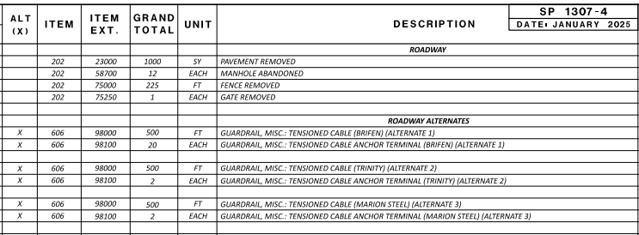

As with alternate bid items, optional bid items shall also be listed in the General Summary under a separate heading selected from the headings listed in this section, with each set of optional bid items grouped together and designated with an alphabetical label (e.g., OPTION A, OPTION B, etc.) added to the heading. The heading shall be followed by a brief description and placed in alphabetical order directly after its corresponding heading section. For more information, see Section 1307.2.7 – Alternate, Optional, and Additive Alternate Bid Items and [SP1307-3(c)].

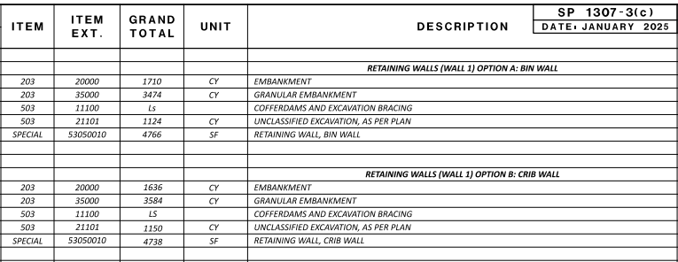

Additive alternate bid items shall be listed in the General Summary under an “ADDITIVE ALTERNATE” heading followed by a numerical label (e.g. 1, 2, etc.). The heading shall be followed by a brief description and placed in numerical order directly before the incidental pay items. For more information, see Section 1307.2.7 – Alternate, Optional, and Additive Alternate Bid Items and Sample Plan Sheet [SP1307-3(d)].

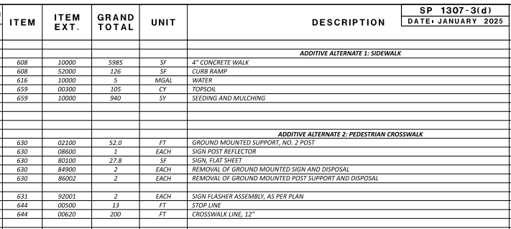

A Bridge Number is the SLM of the structure, written without the decimal point (i.e., MER-707-1692L&R or HIG-TR607-0168). The SFN is the Structure File Number that uniquely identifies a bridge.

Three-sided culverts must be listed as separate structures. Prefabricated structures with spans greater than or equal to 10 feet should be listed as structure items. Prefabricated structures with spans less than 10 feet should be included with the drainage items. Work that may require a sub-contractor may have a separate summary, or subsummary, unless very few items are involved. Examples are Water Work, Lighting, Traffic Control, Traffic Signals, Landscaping, Retaining Walls and Structures. When a separate summary is used, a cross reference must be shown on the General Summary to the sheet numbers on which the quantities are listed. A separate summary is usually provided for Sanitary Sewer items, although these items may be included under Drainage if the sanitary work involves only minor adjustments.

Building Demolished is often considered a Roadway item when only a few buildings are involved. To facilitate the collection of data for reports required by FHWA, Structures are divided into four categories: Structure Repair, Structure 20 Foot Span and Under, Structure Over 20 Foot Span, and Miscellaneous Structure.

The General Summary shall be required in an Excel format using the standard spreadsheet, CTY-PID-GENSUM.xlsm.

More information on the use of the CTY-PID-GENSUM.xlsm spreadsheet can be found in Section 1307.1 and on the Office of Estimating’s website.

The pay items within each of the listed headings must be arranged in ascending numerical order by the item code. For items with the same item code but different supplemental descriptions, the items are placed in alpha-numeric order by supplemental description. As a general rule, at least one blank line should be left between every five pay items to provide for possible additions.

Pay items should be included under each heading as per the following list. Unless otherwise noted, all items under the stated specification number are included.

Roadway - 201, 202 (except Structure Removed, Portions of Structure Removed, Approach Slab Removed, and Building Demolished), 203 (except when used for mechanically stabilized earth walls), 204, 205, 206, 208, 209, 606 (except Noise Barrier), 607, 608, 622 (except Portable Barrier), 623 (except Construction Layout Stakes and Surveying), 625 (Ground Rod for fence), 651, 652, 653, 654, 656, 690 (pertinent pay items), 862, 863, 871, 878.

Erosion Control - 601, 616 (when used for Erosion Control), 659, 660, 670, 671, 690 (pertinent pay items), 832, 836, 838.

The Department will furnish Item 832, Each, Erosion Control/Construction Erosion Control with an amount in the proposal to pay for Temporary Sediment and Erosion Control (TSEC) Best Management Practices (BMP) work. This amount is an estimate by the Department of the total cost of TSEC BMP work. If the TSEC BMP work exceeds this amount, the TSEC BMP work will still be paid at the pre-determined prices. The pre-determined prices are located in Supplemental Specification 832.

A LS pay item for the Storm Water Pollution Prevention Plan (SWPPP) shall be included in the General Summary when a SWPPP is required.

Item 616, Water, must be added to all projects that require waterway permits. This quantity of water is used to comply with permit requirements regarding erosion and dust control near waterways. In addition, projects that include the Dust Control Plan note from the Traffic Engineering Manual should include this Item 616, Water, in the Maintenance of Traffic section of the General Summary.

Environmental / Remediation – 690 (pertinent pay items)

Drainage - 602, 605, 611 (when used for Drainage, except structures requiring a Structure File Number (SFN) and conduit for Pull Boxes), 613, 690 (pertinent pay items), 833, 837, 839, 841, 895, 899.
Pipe Alternates - In the following examples, the figure in parentheses at the end of the corrugated metal pipe descriptions indicates the metal thickness of the pipe; if there are two figures, the first figure indicates the thickness of the top plates and the second figure indicates the thickness of the bottom plates. If there is no figure, the thickness shown for that pipe size in the appropriate 707 Table of the Construction and Material Specifications will suffice and need not be shown on the plan. A figure in parentheses for 707.04 indicates the height of corrugation. A 1-inch corrugation should generally be noted for pipe diameters over 48 inches.

Small Diameter (Less than 36")

611 Ft. 21" Conduit, Type A 706.01, 706.02, 706.08 or 24" 707.01 (0.138), 707.04 (0.109), 707.05 (0.109), 707.21.

611 ________Ft. 24” Conduit, Type A 706.01, 706.02, 706.08, 707.33, 707.85 or 30” 707.01 (0.138), 707.04, 707.05, 707.21.

Large Diameter (36" and over)

611 _______ Ft. 60” Conduit, Type A 706.02, 707.33, 707.85 or 72” 707.02 (0.138), 707.03, 707.04 (1”), 707.07 (0.109), 707.22.

611 Ft. 66" Conduit, Type A 706.02 or 72" 707.02 (0.138), 707.04 (1") (0.109), 707.07 (0.109), 707.22.

Pavement - 251, 252, 253, 254, 255, 256, 257, 258, 300, 301, 302, 304, 305, 320, 321, 400, 407, 408, 409, 411, 421, 422, 423, 424, 441, 442, 443, 450, 451, 452, 609, 617, 618, 690 (pertinent pay items), 803, 822, 823, 826, 827, 852, 859, 860, 872, 874, 875, 881, 882,, 886, 888, 897.

Water Work - 638 (Item Special when local government specification is used), 690 (pertinent pay items).

Sanitary Sewer - 611 (when used for Sanitary Sewer, except structures requiring a Structure File Number (SFN) and conduit for Pull Boxes), 690 (pertinent pay items).

Lighting - 625 (when used for Lighting, except Ground Rod for fence), 690 (pertinent pay items) 812, 818, 820, 893 (when used for Lighting).

Electrical - 625 (when used for Electrical, except Ground Rod for fence), 690 (pertinent pay items), 864 (when used for Electrical).

Other Utilities - 611 (when used for Other Utilities, except structures requiring a Structure File Number (SFN) and conduit for Pull Boxes), 625 (when used for Other Utilities, except Ground Rod for fence), 690 (pertinent pay items), 864 (when used for Other Utilities).

Traffic Surveillance - 625 (when used for Traffic Surveillance, except Ground Rod for fence), [630, 631, 632, 633] (when used for Traffic Surveillance), 690 (pertinent pay items), 804 (when used for Traffic Surveillance), 809 (pertinent pay items), 864 (when used for Traffic Surveillance).

Traffic Control - 620, 621, 626, [630, 631] (when used for Traffic Control), 640, 642, 643, 644, 645, 646, 647, 648, 690 (pertinent pay items), 807, 814, 850, 893 (when used for Traffic Control).

Traffic Signals - 611 (conduit for Pull Boxes), 625 (when used for Traffic Signals, except Ground Rod for fence), [632, 633] (when used for Traffic Signals), 690 (pertinent pay items), 804 (when used for Traffic Signals), 805, 809 (pertinent pay items), 810, 815, 816, 819, 824, 828, 898.

Landscaping - 657, 658, 661, 662, 666, 690 (pertinent pay items).

Retaining Walls - 203 (when used for mechanically stabilized earth walls. See the Bridge Design Manual for additional information), [503, 504, 505, 506] (when used for Retaining Walls), 507 (pertinent pay items), [509, 510] (when used for Retaining Walls), [511, 512, 513, 514, 516, 517, 518, 519] (pertinent pay items), [520, 523, 524] (when used for Retaining Walls), 530 (pertinent pay items), 690 (pertinent pay items), 840, [843, 844, 845] (when used for Retaining Walls), 851, 855 (when used for Retaining Walls), 866, 867, 870, 883 (when used for Retaining Walls), 885 (pertinent pay items), [893, 894] (when used for Retaining Walls).

Building Demolition - 202 (Building Demolished), 690 (pertinent pay items).
Noise Barriers - 606 (Noise Barrier), 690 (pertinent pay items), 893 (when used for Noise Barriers).

Structures - 202 (Structure Removed, Portions of Structure Removed, and Approach Slab Removed), [503, 504, 505, 506] (when used for Structures), 507 (pertinent pay items), [509, 510] (when used for Structures), [511, 512, 513, 514] (pertinent pay items), 515, [516, 517, 518, 519] (pertinent pay items), 520 (when used for Structures), 522, [523, 524] (when used for Structures), 526, 530 (pertinent pay items), 611 (structures requiring a Structure File Number (SFN)), 690 (pertinent pay items), 842, [843, 844, 845] (when used for Structures), 846, 847, 848, 849, 855 (when used for Structures), 856, 858, 869, 883 (when used for Structures), 885 (pertinent pay items), 894 (when used for Structures).

In order to effectively track bridge maintenance costs, quantities must be recorded separately for each bridge structure utilizing its assigned SFN. The following three options are acceptable:

Providing a separate general summary for each bridge by SFN within the bridge sheets with a reference from the General Summary to each Structure General Summary.

Providing a combined structure general summary that separates quantities for each bridge by SFN, also with a reference from the General Summary for each bridge.

Providing quantities for each bridge, broken out separately by SFN, on the General Summary.

Each Structure General Summary shall be combined with the General Summary in an Excel format using the standard spreadsheet, CTY-PID-GENSUM.xlsm. See Section 1307.1 - General for more information.

Maintenance of Traffic - 410, 502, 614 (except Maintaining Traffic), 615, 616 (when used for Maintenance of Traffic), 622 (Portable Barrier), 690 (pertinent pay items), 808, 829, 831, 896, any additional items used specifically for maintenance of traffic.

Items of Work – 680, 690 (pertinent pay items), 691, 692, 893 (when used for Items of Work), 900, 950.
Engineering and Surveying Services – 107, 690 (pertinent pay items).

Incidentals – 108, 614 (Maintaining Traffic), 619, 623 (Construction Layout Stakes and Surveying), 624, 690 (pertinent pay items).

The following incidental pay items shall be provided on the General Summary:

Incidentals –

614 LS, Maintaining Traffic
619 MNTH, Field Office, Type A, B or C
623 LS, Construction Layout Stakes and Surveying
624 LS/Each, Mobilization

Building Demolition is a type of project that would not require Item 614, Maintaining Traffic.

Two-lane resurfacing, mowing, pavement marking, guardrail replacement, bridge painting, and other similar types of projects may not require pay items for Field Office, Construction Layout Stakes and Surveying, or Mobilization.
The District Highway Management Administrator should be consulted when there is a question regarding the need for these incidental pay items.

The following guidelines are recommended when determining the type of Field Office to specify on a project:

Estimated Project
Construction Cost | Office Type
Less than $500,000 | Type A
$500,000 to $5,000,000 | Type B
Over $5,000,000 | Type C

The basis of payment for a Field Office should be MNTH, unless otherwise instructed.

1307.2.4 Contingency Quantities
In some cases, it may not be feasible to obtain precise quantities due to uncertainties regarding existing conditions. In these cases, a reasonable estimate (not contingency) of the items necessary, along with the location to where they apply, should be completed and appropriate quantities shown in the plans. Contingency quantities should not be used.

Pavement cores, soil borings and other condition surveys commensurate with the nature of the proposed work should be used to assist with the determination of these quantities.

1307.2.5 Linear Grading
Linear grading pay items are intended for shallow grading and/or filling operations performed from the edge of pavement outward, to prepare, dress and/or reshape the roadside.

Item 209 - Reshaping Under Guardrail and Item 209 - Preparing Subgrade for Shoulder Paving are described in the Construction and Material Specifications. Item 209 - Linear Grading may be used at other locations with minor grading. All three pay items are based on a linear measurement along each side of the pavement.

Sufficient detail must be included in the plans to estimate and construct the work. When two or more different types of Item 209 - Linear Grading are required in the same plan, they should be differentiated by designating them as “Method A”, “Method B”, etc.

If off-project material is needed for the work, a quantity of Item 209 - Borrow must be specified in the plans. Consideration should be given as to how this item is paid. If Item 209 - Borrow can be measured and calculated, then payment should be by the Cu. Yd. If the borrow cannot be measured due to settlement, or because the area is under water, then payment should be by the Ton.

1307.2.6 “Standard”, “As Per Plan”, “Miscellaneous”, and “Special” Pay Items
There are four types of pay items in a construction plan, “Standard”, “As Per Plan”, “Miscellaneous”, and “Special”. A “Standard” pay item is one whose requirements are defined by the Standard Construction Drawings and the Construction and Material Specifications or Supplemental Specifications. The description of a “Standard” pay item is consistent from plan to plan and is listed under the heading “Basis of Payment” in the Construction and Material Specifications or Supplemental Specifications.

An “As Per Plan” item is a standard pay item whose requirements need to be modified from that which is defined by the Standard Construction Drawings, the Construction and Material Specifications, or Supplemental Specifications. Every “As Per Plan” item must have a corresponding plan note, Proposal Note, plan detail, or combination thereof which clearly and completely explains the deviation(s) from the standard item. The “As Per Plan” descriptor should not be included as part of a “Miscellaneous” or “Special” pay item description. The location of “As Per Plan” notes and details shall be cross-referenced in the “See Sheet No.” column on the General Summary.

A “Miscellaneous” item code is used for unique or infrequently performed items. These items shall be within the guidelines of the Standard Construction Drawings, the Construction and Material Specifications, Supplemental Specifications, or any other authoritative document. Every “Miscellaneous” item must have a corresponding plan note, proposal note, plan detail, or combination thereof to completely explain the item. The location of “Miscellaneous” notes and details shall be cross-referenced in the “See Sheet No.” column on the General Summary sheet. If the item is “Miscellaneous”, the word “MISC.:” will be part of the item description.

A “Special” item is an item that does not exist in the Standard Construction Drawings, the Construction and Material Specifications or Supplemental Specifications. It must be created by means of plan notes, plan details, proposal notes, special provisions or a combination thereof, which clearly and completely define all aspects of the item. The location of “Special” item notes and details shall be cross-referenced in the “See Sheet No.” column on the General Summary. “Special” pay items are coded according to the closest related Specification number. If the item is a “Special”, the word “Special” must be entered in the “Item” column and all eight digits of the item code are entered in the “Item Extension” column.

1307.2.7 Alternate, Optional, and Additive Alternate Bid Items
Alternate, optional, and additive alternate bid items are included in a plan when so dictated by the sponsoring agency.

Alternate bid items shall be listed in the General Summary under a separate heading selected from the headings listed in Section 1307.2.3 – Item Code, Unit of Measure, and Description. This heading shall be modified by adding the word “ALTERNATES” (e.g., ROADWAY ALTERNATES, DRAINAGE ALTERNATES, etc.) and placed directly after its corresponding heading section. The description of individual alternate bid items shall include “ALTERNATE” followed by an appropriate numerical value, in parentheses, at the end. For each alternate bid item, an “X” shall be placed in the “ALT(X)” column in the General Summary [SP 1307-4].

The description for alternate bid items should vary to give distinction between items. One group of bid items can be alternated to another group of bid items without there being a one-to-one item match. Plan notes, plan details, proposal notes, special provisions, or a combination thereof shall be provided to clearly and completely define and identify the alternates. The bidder is required to bid on all alternate items.
The sponsoring agency will determine the alternate item, or group of alternate items, selected for the contract to be awarded. When the higher priced alternate item is selected, the additional cost of the alternate will be the responsibility of the sponsoring agency.

Optional bid items shall be listed in the General Summary under a separate heading selected from the headings listed in Section 1307.2.3 – Item Code, Unit of Measure, and Description, with each set of optional bid items grouped together and designated with an alphabetical label (e.g., OPTION A, OPTION B, etc.) added to the heading. The heading shall be followed by a brief description and placed in alphabetical order directly after its corresponding heading section [SP 1307-3(c)].

When a group of bid items is optional to another group of bid items, each group of items will be given a single label. The bidder is to bid on one option only, with the bidder deciding which option to bid on.

Additive alternate bid items shall be listed in the General Summary under an “ADDITIVE ALTERNATE” heading followed by a numerical label (e.g. 1, 2, etc.). The heading shall be followed by a brief description and placed in numerical order directly before the incidental pay items [SP1307-3(d)].

Incidental pay items that incur additional costs due to the inclusion of the additive alternate shall be included in the bid items for the additive alternate.

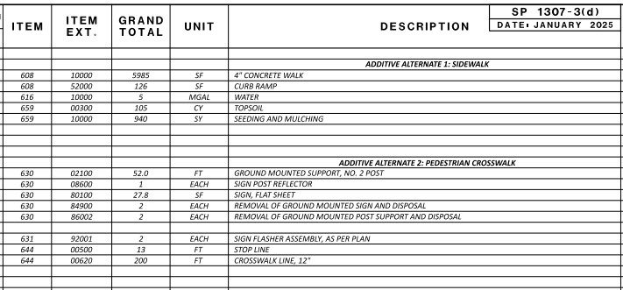

Multiple sets of additive alternates are permissible. When multiple sets are used, the additive alternates are to be listed numerically in order of highest to lowest priority. The sponsoring agency will determine the order of priority. The bidder is required to bid on all additive alternate items.

Questions regarding the setup of alternate, optional, and additive alternate bid items on the General Summary should be addressed to the Office of Estimating.

1307.2.8 Sheet Cross References
The “See Sheet No.” column is used to show a cross-reference to a general note sheet, plan detail sheet or description group general summary. References to a general note or plan detail for items that are not “As Per Plan” or “Special” should be made when the note or detail describes a specific method of performing work. Description groups that have their general summaries cross-referenced should be listed in the order shown in Section 1307.2.3 – Item Code, Unit of Measure, and Description.

Reference to a Proposal Note may be made at the end of a pay item description only if the pay item is new or rarely used.

1307.2.9 Buildings Demolished
Buildings to be demolished should be paid for under Item 202, Building Demolished. A single lump sum item is used for each parcel. The item description should include the parcel number and a list of the buildings to be removed.

For example:

Item 202, Building Demolished, Parcel 10 WD, 2-Story Framed House, Basement, Shed

Item 202, Building Demolished, Parcel 20 T, 1-Story Brick House, 2-Car Detached Garage

Item 202, Building Demolished, Parcel 102 WL, Remove 20 Trailers, 6 Sheds

For additional information contact the Office of Real Estate.

1307.2.10 Salvage to Utility Items
Existing utility facilities (fire hydrants, valve boxes, etc.) to be removed by the highway contractor shall be disposed of and replaced, adjusted, or removed and reset. These items shall not be removed and stored for retrieval by the utility owner. The rules governing utility relocation and reimbursement differ from other functions of the highway construction process. The removal of existing facilities for storage would require that a salvage credit be given to the project for the value of the removed items, and any contractor charges for handling and/or transportation of the items would be ineligible for project cost.

1307.3 Subsummaries
A limited number of sheet number columns are available on the General Summary. This limits the number of sheets from which quantities can be brought forward. It is therefore necessary, on larger plans, to summarize quantities in stages. Subsummaries are plan sheets where quantities from several sheets are gathered. The items may or may not have some relationship to each other.

Some of the pavement marking quantities are subdivided and subtotaled by color and/or type. Examples of subsummary sheets are included in the Sample Plan Sheets.

Subsummaries are generally located in a set of plans near (normally in front of) the source of the quantities they summarize. However, when they summarize a number of unrelated items, they may be located either after the General Summary or after the calculation sheets.

1307.4 Quantity Calculations

1307.4.1 General
In order to prepare a valid engineering cost estimate for a project, it is essential that quantities be accurately calculated, accurately carried to the General Summary, and that substantiating data for all calculated items be included in the plan.

1307.4.2 Pavement Calculations
Pavement, subgrade compaction and treated shoulder quantity computations should be completed on 8 1/2” x 11” sheets. Computations are to clearly show how the quantities were derived. Irregular areas should be noted as CADD generated areas. All sheets must include the project title and be numbered (e.g., 2 of 10). Quantities are to be carried to the General Summary and listed under a column entitled “Office Calcs.” [SP 1307-3(a) and 1307-3(b)].

1307.4.3 Rounding of Quantities
Rounding of quantities should be made at the subsummary level. All quantities are whole numbers except as follows:

- Carried to tenths:
Cubic Yards - Masonry
Square Feet - Signs
Feet - Ground Mounted Sign Supports

- Carried to the nearest foot
Feet - Conduit and Underdrains, Subdrainage piping (Structural)

- Carried to hundredths:
Miles - Pavement Marking
Feet - Bridge Deck Joints, Drip Strip, Prestressed Concrete Bridge Members
Tons - Commercial Fertilizer
Acres - Lime

- Nearest 100 Pounds
Pounds - Structural Steel

Guardrail quantities are normally determined in standard 12.5' panel lengths.

1307.4.4 Validation of Quantities
Prior to submission of the completed plans, all plan quantities shall be independently checked by competent personnel other than the person(s) who originally computed the quantities. Each plan sheet that lists quantities or calculations shall be validated by the signed initials or names of persons who computed the quantities, and also those who performed the checking operations. These initials should be shown in the title block. While it is contemplated that spot checks of quantities will be made during review of the plan, the correctness of the quantities is the responsibility of the design unit preparing the plans.

1308 Project Site Plan

1308.1 General
A Project Site Plan is required for all projects that require the submittal of a Notice of Intent (NOI) or post construction BMPs, as explained in the Location and Design Manual, Volume 2, Section 1109. The Project Site Plan is prepared by the designer and provided as part of the contract documents. Electronic design files used to create the Project Site Plan are also a part of the contract documents and shall be provided. For more information, see Section 1600, Electronic Design Deliverables. A sample Project Site Plan is shown in the Sample Plan Sheets [SP 1308-1].

For non-contiguous portions of projects sold under one contract, as described in Location and Design Manual, Volume 2, Section 1109, provide a Project Site Plan for each individual site that exceeds one acre of earth disturbing activity.

A Storm Water Pollution Prevention Plan (SWPPP) is required for all projects that submit a Notice of Intent (NOI) for permit coverage under the Ohio EPA’s Construction General Permit. Projects that may have environmental impacts to habitat, or species, may also be required to prepare a SWPPP as determined by the District Environmental Coordinator. The construction contractor is responsible for modifying the Project Site Plan to prepare a SWPPP that meets the Ohio EPA NPDES (National Pollutant Discharge Elimination System) Permit requirements. The contractor shall develop the SWPPP in accordance with Supplemental Specification 832. The contractor’s engineer must sign, seal, and submit the proposed plan to ODOT for review. Additional guidance can be found in the Location and Design Manual, Volume 2, Section 1110.

1308.2 Requirements
The Project Site Plan shall consist of a schematic plan similar to that required in Section 1303 – Schematic Plan. It will generally have a scale of 1"=200'. This plan shall show all Project Disturbed Areas.

The following items shall be included on the plan and may be listed in tabular form:

- A site description indicating the nature and type of construction activity.

- The total area of project (right-of-way, including permanent easements).
- The total area of “Project Earth Disturbing Activities” that is expected to undergo earth disturbing activities as estimated from Location and Design Manual, Volume 2, Figure 1109-1.

- The area of “Contractor Earth Disturbing Activities” as estimated from Location and Design Manual, Volume 2, Figure 1109-1.

- The area of “NOI Earth Disturbing Activities” as estimated from Location and Design Manual, Volume 2, Figure 1109-1.

- An approximate determination of the Rational Method runoff coefficient for both the pre-construction and post-construction site conditions.

- An estimate of the impervious (paved) area for both the pre-construction and post construction site conditions.

- The name and location of the immediate receiving stream or surface water(s) and the subsequent named receiving water(s) (e.g. Black Run/Sandy Creek).

  - Surface water locations including streams, lakes, ponds, wetlands, jurisdictional and regulated ditches, springs, etc. within 200' of the right-of-way.

- The approximate latitude and longitude (+ 5 seconds) of the center of the project.

- The name and number of the USGS 7.5-minute quadrangle map(s) on which the project is located.

- Existing contours with enough accuracy to define the existing drainage patterns.

- Flow arrows indicating proposed drainage patterns.

  - Existing buildings and current land uses (e.g. residential, commercial, or agricultural).

- Permanent drainage items such as culverts, storm sewers, catch basins, etc.

The location of permanent storm water Best Management Practices (BMP) through a description, graphically, and in tabular form. Ensure all latitude and longitude positions are in units of decimal degrees and have 6 values after the decimal. Furnish a begin position and end position for the following linear BMPs: Vegetated Filter Strip and Vegetated Biofilter. Furnish just the outlet position of all other BMPs. Include a table that lists each individual BMP, the BMP type, the Begin Latitude/Longitude, the End Latitude/Longitude (if applicable), the BMP Width (strip width for Vegetated Filter Strips and bottom width for Vegetated Biofilters only), and the EDA Treatment Credit. In the same table, provide the summation of EDA Treatment Credit from all BMPs, as well as the EDA Treatment Credit Required for the project.

1309 Plan and Profile Sheets

1309.1 General
Plan & Profile Sheets [SP 1309-1(a) through SP 1309-8] show what an area looks like before (existing) and after (proposed) construction of the project. In addition, they show quantities, dimensions, and other items required to construct the project. Plan and Profile Sheets are normally drawn to the following scales:

Rural Projects:

- Horizontal: 1"=50', or 1"=20'
- Vertical: 1"= 5', or 1"=10'

Urban (or Short Rural) Projects:

- Horizontal: 1"=20'
- Vertical: 1”=5' (preferred) or 1”=10'

The above scales will result in coverage on a typical sheet of 1500' at 1"=50' and 600' at 1"=20'. For convenience, the scale used for the roadway plan and profile sheets should match the scale used on the right-of-way detail sheets.

The profile should be plotted on a square grid system subdivided in accordance with the examples shown in Figure 1202-1, Acceptable Grid Systems.

The plan and profile sheets at the beginning and end of the project should include additional length of existing topographic features beyond the ends of the permanent pavement construction. The minimum additional length is 300 feet for design speeds of 40 mph or less and 500 feet for design speeds over 40 mph. Horizontal and vertical alignments and all topography should be shown in these “extension” areas.

To avoid misinterpretations, the use of abbreviations in the plans, except those defined in the Construction and Materials Specifications or generally understood by engineers and contractors, should be minimized. If abbreviations are used, a legend explaining the abbreviations should be included.

1309.2 Format
Plan & Profile Sheets are composed of three distinct parts - plan, profile and quantities. All of these parts may be shown on a single sheet [SP 1309-5, 1309-6, and 1309-8]. However, because of the complexity of some plans, it may be necessary to vary the format to more clearly show the proposed work. In such cases, the plan, profile and quantities may be shown on separate sheets [SP 1309-2] or combined in any manner [SP 1309-1(a) and 1309-1(b)]. When varying from the single-sheet format, the designer should locate the plan, profile and quantity sheets as near to each other as possible and provide cross-references on each sheet.

1309.3 Existing Information
- All existing features should be shown and the disposition of all such items within the existing and/or proposed right-of-way should be indicated. Existing features, except buildings, should be shown using dashed lines. The following sections list many of the existing items that should be shown on a Plan & Profile Sheet. This list should not be considered all-inclusive.

1309.3.1 Topography
- Trees and stumps – For projects involving earth disturbing activities or any other construction activity that may require tree removal, the diameter of all trees and stumps 12 inches and over must be shown. Symbols should be used to differentiate between deciduous and coniferous trees. Species names (e.g., Oak, Maple, Pine) do not need to be labeled. In general, labels designating tree size (as defined in the Construction and Material Specifications) should be provided for trees located within the construction limits and 25 feet outside the project construction limits. Trees and stumps to be removed should be noted by an “X”.

- Shrubs

- Moving water such as creeks, streams, rivers and ditches - The direction of flow should be denoted by flow arrows.

- Ponds and lakes

- Wetland areas

1309.3.2 Buildings and Appurtenances
- Buildings – Identify usage (i.e., residential commercial, etc.), type of construction and number of stories

- Wells, cisterns, sanitary systems (leach fields, septic tanks)

- Underground storage tanks, oil and gas wells with associated piping

- Walks, drives, paved areas

- Walls, fences

- Non-highway signs – Highway signs are not typically shown on the Plan and Profile Sheets but rather in the Traffic Control Plans.

Railroad facilities shall be shown when they are located within the normal limits of the Plan & Profile Sheet. The location of the tracks with respect to the centerline of construction should be shown together with the rail elevations at intervals not to exceed 500 feet. This information may be shown on the cross-sections if more convenient.

1309.3.3 Roadway Items
- Pavement, curbs, treated shoulder, drives, sidewalk, shared-use path.

- Guardrails, concrete barrier, fences.

- Profile of the ground line at the centerline of construction, with elevations every 50' and at abrupt changes [SP 1309-1(a) through SP 1309-8].

- Storm sewers, inlets, manholes, catch basins, culverts, headwalls (type, size and elevations) [SP 1309-6 and 1309-8].

- Bridges.

- Light poles.

1309.3.4 Boundary Lines
- Property lines, easements.

- Right-of-way lines.

- Governmental boundaries (State, County, City, Village, Township, etc.).

- Railroad right-of-way lines.

1309.3.5 Utilities
- Location and depth of underground utilities (gas, telephone, water, sanitary, etc.)
- Location of overhead utilities (electric, telephone, cable television, etc.). Only poles should be shown unless actual lines are located such that they may impact the contractor’s operations. Indicate the rating of major overhead electric transmission lines and the existing clearance.

1309.3.6 Underground Mines
- Location of any field observed or mapped mine features (openings, subsidence features, etc.).

- Limits of mapped mine workings labeled with the Ohio Department of Natural Resources Division of Geological Survey Mine Code. A note referencing the appropriate Mine Map Overlay Sheets should be shown on the Plan & Profile sheets when the extent of the mine workings exceeds the normal limits of the sheet.

1309.4 Proposed Facility Information
Following are many of the proposed facility items that should be shown on a Plan & Profile sheet. This list should not be considered all-inclusive.

1309.4.1 Alignment and Grade
Centerline of construction and any other construction baselines should be shown along with their relationship to each other. Stations, station equations, and bearings (at each tangent and at least one per sheet) must be shown.

The centerline of construction should match the centerline of right-of-way. In those instances where it is not possible to match the two centerlines, a constant offset between the two centerlines is preferred. When the two centerlines differ, their relationship must be shown in the right-of-way plans. It is not necessary to show this relationship within the construction plans.

Stationing shall be designated in feet per the following examples:
104+59.35, meaning 10,459.35 feet from Sta. 0+00.

When giving locations of points intermediate of full stations and leaving off the full station designation, all leading zeros should be included. For example: +03.17 would be the abbreviated form of Sta. 2+03.17.

When a centerline includes a deflection angle (i.e., a P.I. without a horizontal curve), there can be confusion on how to measure stations and offsets from the back and forward tangents. The following figure clarifies which tangent to use depending on a point’s location in the “overlap” area.

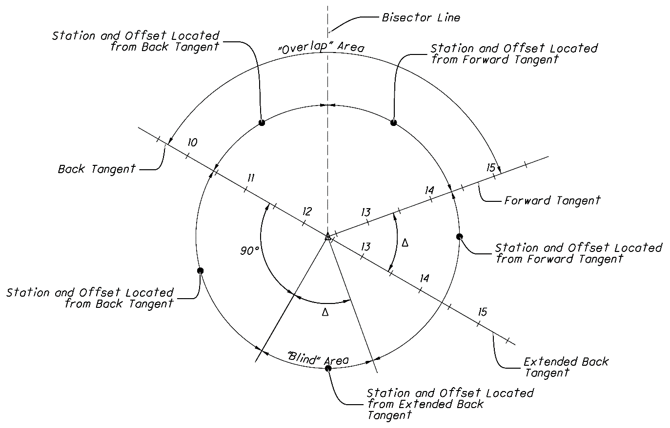

In addition to the “overlap” area, there is a “blind” area in which a station and offset cannot be measured from either the back or forward tangent. Stations and offsets in the “blind” area should be measured off an extended back tangent as shown in the figure.

Indicate when station and offset are being reported along the extended back tangent in the “blind” area as follows:

Sta. 12+75.00, 30.00’ Rt., on Extended Back Tangent

- Grades are to be shown using percentages to the hundredths.

- Profile grade elevations are to be shown every 25'. The location of the profile grade elevation is shown on the Typical Sections.

- Elevations shall be expressed in feet above the specified datum.

- Horizontal alignment data – Show all data for simple curves and spiral curves (See Figures_1303-1, 1303-2 and 1303-3). All proposed horizontal alignment data (e.g. curve information, station equations, reference points, etc.) shall be specified to the nearest hundredth of a foot.

- Vertical alignment data – The data includes the station and elevation of the PVI and the limits and length of vertical curve. When there is a grade break without a vertical curve, the words “NO CURVE” should be added adjacent to the PVI station and elevation [SP 1309-1(a)].

- Vertical clearance under overhead structures - The existing, proposed and required clearance shall be shown.

- Vertical clearance under major overhead electric transmission lines.

1309.4.2 Roadway Items
- Lane widths – Where lane widths are not obvious, they should be shown on the plan view or on a separate sketch. The location and dimensions of all pavement transitions should be shown, including “tie-ins” to existing pavement.

- Pavement width, treated shoulder width – Label width dimensions left and right of the centerline of construction at transition end points [SP 1309-5].

  - Curbs – Show and label transitions [SP 1309-1(a)].

    - Drives – Label the location, type, existing surface type, width, and alignment with mainline (i.e., angle relative to centerline) on plan and profile sheets, drive detail sheets or tables.

    - Sidewalks & Share use paths – Label width dimensions and offset from curb/edge of shoulder.

      - Guardrail – Label anchor assemblies, bridge terminal assemblies, terminal stations, flare and radii [SP 1309-2 and 1309-8].

      - Concrete barrier – Label terminal stations, end anchorages, transitions, and end treatments like impact attenuators.

        - Signs – Identify sign structures (i.e. cantilever and trusses), controllers and signal poles. Smaller traffic control signs (i.e. mounted on yielding posts) are normally shown on a separate traffic control plan sheet.
        - Bridge limits, structure number, approach slab limits, and pier locations [SP 1309-8].

1309.4.3 Boundary Lines
- Right-of-Way, easement, temporary right-of-way and limited access lines

- Construction limits – These limits must encompass all work. This includes removals, room for construction equipment to complete work, site access, etc. Construction limits are not intended to encompass storage areas for materials or equipment. However, it may be necessary to address storage areas when determining a project’s environmental impacts.

- Property Lines – Show property lines when right-of-way is being acquired or when the project includes access management changes for properties along the roadway.

1309.4.4 Drainage Items
Proposed drainage items should be shown. This includes, but is not limited to: ditches, permanent erosion control items, storm sewers, culverts, headwalls, catch basins, inlets, manholes, drive pipes, and other longitudinal drainage items.

- Storm sewers, inlets, manholes, catch basins, culverts, headwalls - Show these items in both plan view and profile view [SP 1309-1(a), 1309-3, 1309-4, 1309-5, 1309-6]. Label the proposed drainage structures with reference balloons in plan view and profile view. Label the proposed conduit with reference balloons, size and type (e.g. 36” – Type C) in the plan view and profile view. Proposed detailed drainage structure and conduit information should be shown per Section 1312.3 – Storm Sewer Profiles. Label existing drainage structure and conduit information in the plan view and profile view pertinent for design analysis, review, and constructability.

- Manholes and Catch Basins reconstructed or adjusted to grade – Label on the plan view and profile view pertinent information for design analysis, review, and constructability, this includes proposed and existing elevations.
- Existing facilities to be removed or abandoned should be so noted.

- Underdrains - Include all bends, branches, outlet offsets and elevations [SP 1309-5]. In addition, include the profile grade for unclassified underdrains only.

- Flow arrows showing direction of flow in ditches, streams, underdrains, storm sewers, drive pipes, and culverts in plan view.

  - Erosion protection - includes dimensions of rock channel protection, sodding, ditch erosion protection, etc.

  - Slope lines, where necessary, to better define drainage.

  - Design and 1% AEP water elevations, if not shown elsewhere in the plans (e.g., culvert details, etc.).

1309.5 Quantities
Plan & Profile sheets are used to show many of the plan quantities as described in the following sections.

1309.5.1 Reference Balloons
Reference balloons are used to tie the items on the plan to the pay quantities in the estimated quantities table. The designations within the balloon correspond with the reference designation in the estimated quantities table. Dashed balloons are used to indicate that quantities are picked up on a different sheet.

Reference balloon numbering may be restarted on each plan sheet or may be carried through the entire plan. A consistent system of reference balloon numbering should be used for each project. [SP1309-1(a)] and [SP 1309-1(b)] provide an example of sequential balloon numbering that is carried through all plan and profile sheets. [SP 1309-6] provides an example of balloon numbering that is restarted for each plan and profile sheet.

For drainage reference balloons use unique balloon numbering for each drainage structure and conduit run. Do not reuse balloon references within the same plan set. Provide reference balloon on each sheet for each run of conduit.

1309.5.2 Estimated Quantities
Quantities should be shown in tabular form in such a manner as to clearly show the following:

- Reference Designation - This is usually a combination of letters and numbers. The letters indicate the general description of the item (Example - UD or U for underdrain, GR or G for guardrail, D for drainage structures, P for conduit, S for sanitary sewer, C for curb, DR for driveways, R for removal, WQ for manufactured water quality structure), and numbers differentiate between similar items (D-1, D-2 and D-3 might be used when there were three drainage items on one Plan & Profile Sheet).

  - Location - This includes the limiting stations and side (Rt. or Lt.)

  - Item Number or Special and item description

  - Unit of Measure (ft², yd³, mi., etc.)

  - Item quantity and total quantity

Indicate whether the total quantities are carried to the General Summary or to a Subsummary Sheet.

1309.6 Miscellaneous Information
In addition to existing and proposed information and quantities, Plan & Profile sheets include other information pertinent to the project, such as the following:

1309.6.1 Project Control and Reference Points
Points used to establish project control along with the associated reference points are more commonly shown on the Schematic Plan or General Notes. When a Schematic Plan is not provided or for other unique situations where the project control points and reference points cannot be shown in the Schematic Plan or General Notes, these points should be shown on the Plan sheets as described in Section 1303.2.2.

1309.6.2 Cross References to Other Sheets
Where quantities, details, etc. are shown on other sheets, cross-references are required.

1309.6.3 Typical Sections of Adjoining Pavement
When not shown with the Typical Section Sheets, the first and last Plan & Profile Sheet should show a detail of the Typical Section of the Adjoining Pavement, including type, thickness and cross slopes of all pavement courses.

1309.6.4 Project and Work Limits
If the Project and Work Limits are not provided in the Schematic Plan, the limits should be shown on the appropriate Plan & Profile Sheets.

1309.6.5 Match Lines
A match line should be shown, and the station given, wherever the plan view, work or quantities are continued on another sheet. It is recommended that the match lines be made at a location where the stationing is a multiple of 100 feet.

1310 Cross-Sections

1310.1 General
Although the main purpose for cross-sections is to show end areas and surface dimensions for the calculation of earthwork and seeding quantities, they conveniently show a wealth of additional information, which will be discussed in part in the following sections [SP 1310-1 through SP 1310-4].

In complicated areas such as interchanges, a cross-section layout sheet may be required. A cross-section layout sheet is a plan sheet showing where each section is located [SP 1310-6].

1310.2 Format
Cross-Sections are plotted on a 1" x 1" grid system subdivided in accordance with the examples shown in Figure 1202-1. Horizontal and vertical scales are equal - usually 1"=5' or 1"=10'. Elevations are labeled along each side at the major grid lines. When a 1"=10' scale is used, the even elevations are located at the 1" grid lines. The distance, measured from the centerline of construction, is labeled at the top and bottom of the sheet at the vertical major grid lines.

Intervals between regular sections should normally be 50'. Intervals of 25' should be used where greater detail is required. In addition, sections (or partial sections) are plotted at abrupt ground line changes or to show special features such as drives, bridges, or drainage items. Sections must be shown as often as necessary to accurately determine the character and extent of the proposed work. When existing and proposed features are located between two cross-sections, it is preferred that either additional cross-sections be included at the location of the feature, or they be shown on a storm sewer profile sheet.

Cross section sheets shall be laid out such that stationing increases from the bottom to the top of the sheet. The station is shown in bold print under each section at the centerline of construction. The existing ground elevation at the centerline of construction is shown directly below the station number and the elevation of the proposed grade at the profile grade point is shown directly above the station number. A project may require two profile grade points to be shown on the cross-sections.

Exaggerated cross-sections may be included in the plan, or provided on separate sheets, with the Stage 3 submission for review and reference during construction of the project. They are used to calculate variable depth pavement leveling course quantities or to show variable depth pavement planning.

Existing features are shown with dashed lines and proposed features are shown with solid lines. Surface, base and subbase courses of proposed pavement are not shown. Likewise, interpretations of the subsurface investigation, such as top of rock, are not shown. The limits of the existing pavement should be shown.

Illustrate the subgrade treatment on the cross-sections with a distinct hatching pattern. Provide a legend on the cross-sections indicating the proposed subgrade treatment type and depth.

The ratio for each side-slope and back-slope (2:1, 3:1, etc.) should be labeled at the top and bottom sections on each sheet and at any intermediate sections where there is a change in the slope.

1310.3 Earthwork and Seeding Quantities

1310.3.1 Earthwork Calculations
End areas (calculated to the nearest square foot and earthwork volumes (cubic yards are shown for cuts and fills in the columns on the right side of the cross-section sheet. Separate calculations must be shown when different types of earthwork (e.g., Item 203 and Item 204) are included [SP 1310-2 and 1310-4].

Concrete pavement removal must be itemized separately and paid for under Item 202, Pavement Removed. On large projects, asphalt concrete pavement removal should be itemized separately under Item 202, Pavement Removed, Asphalt [SP 1310-7]. Adjustments must be made for drives, intersections, etc. When pavement is removed and is to be replaced with embankment material, the quantity of embankment must be included in the plans using the applicable 203 or 204 pay item.

End areas may be determined using computer programs, planimetering, or summation of geometric shapes. Subtotals for earthwork quantities should be shown on each sheet and carried to a subsummary in advance of the cross-sections or directly to the General Summary.

1310.3.2 Earthwork Corrections for Curvature
When computing earthwork for a project, it is important that the designer consider the effect of curvature on the volumes of cut and fill, and adjust the quantities where warranted. Curvature may have a significant effect where there are side-hill cuts and/or fills where the centroid of either area is significantly displaced from the centerline. The magnitude is a function of the curve radius, with shorter radii curves (such as may be used on ramps) having the greater effect. Whenever the true volume of cut or fill, or both combined, based on the centroidal arc length, differs by one cubic yard per yard of distance between adjacent cross-sections from the estimated volumes based on the survey length, a correction shall be shown in the plans.

It is assumed that the actual true volume of a curved prismoid is the product of the average area of end sections times the arch length passing midway between the centroids (centers-of-gravity) of the end sections. If the centroidal arc lies on the inside of a curve, its length is shorter than the centerline distance; if it lies on the outside, its length is longer.

To adjust earthwork volumes for curvature, the corrected-arc-length method should be used. This method is simple and easy to understand and is easily adapted to computer programs for earthwork. An example of this method is shown in the following figure:

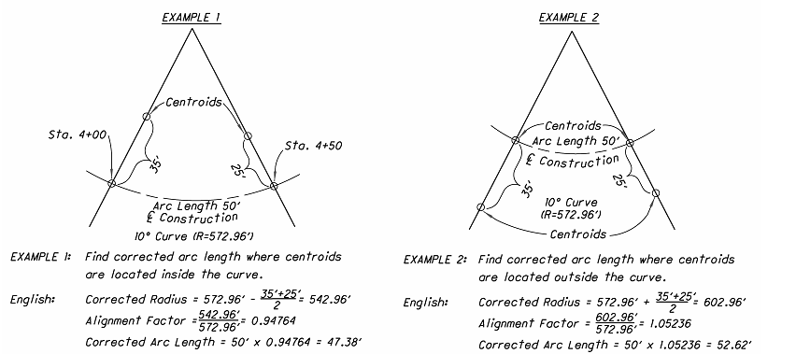

The diagram of the example showing the method of correction should be shown on the General Note Sheet. The corrected arc lengths should be shown in the earthwork tabulations on the cross-section sheets.

1310.3.3 Roads for Maintaining Traffic
Roads for Maintaining Traffic, along with their baseline (if any) should be shown on the cross-sections [SP 1310-2 and SP 1310-3]. Earthwork for Roads for Maintaining Traffic shall be shown by heavy dashed lines. This includes both the portion to be removed under Item 615, Roads for Maintaining Traffic, as well as the overlapping areas of earthwork that will remain as part of the permanent facility.

Earthwork cut and fill end areas for Roads for Maintaining Traffic may be shown on the cross-sections with quantities located in separate cut and fill columns or marked with an asterisk. Alternatively, they may be calculated and included for estimating purposes on the Office of Estimating’s Estimated Quantities form which can be found in Appendix D. The totals of the earthwork cut and fill for Roads for Maintaining Traffic shall be provided in the General Notes.

1310.3.4 Seeding Calculations
Except on projects where the seeding quantities can otherwise be determined with reasonable accuracy, seeding end widths and areas should be shown on the cross-sections. The limits of seeding shall be all areas of exposed soil between the right-of-way lines and within the construction limits for areas outside the right-of-way lines.

End widths measured to the closest foot and seeding areas (sq. yards) are shown in the columns on the left side of the Cross-Section sheet. Adjustments must be made for drives, intersections, etc. [SP 1310-3] Subtotals for seeding quantities should be shown on each sheet and carried to a subsummary in advance of the Cross-Sections or directly to the General Summary.

1310.4 Drainage Items
Existing and proposed drainage facilities should be shown on the Cross-Sections. This includes, but is not limited to ditches, permanent erosion control items, storm sewers, culverts, headwalls, catch basins, inlets, manholes, drive pipes, and other longitudinal drainage items.

Ditch flowline elevations and flow arrows should be shown.

Existing facilities to be removed or abandoned should be so noted.

Existing normal water level elevations should also be noted for lakes, ponds, reservoirs, rivers and streams. The elevation of the Ordinary High Water Mark (OHWM) should be identified for all applicable waterways (i.e., jurisdictional streams, rivers, ditches, lakes, reservoirs, ponds)

Drainage items are normally shown on the Plan & Profile Sheets and the Drainage Detail sheets, in addition to the Cross-Sections. Label the proposed drainage structures with reference balloons. Label the proposed conduit with reference balloons, size, and type (e.g., 36” – Type C). Detailed information for proposed drainage structure and conduit information should be shown per Section 1312.3 – Storm Sewer Profiles. Label existing drainage structure and conduit information pertinent for design analysis, review, and constructability.

1310.5 Drives
Drive profiles should be shown on the cross-sections. Profiles which do not fall at a full cross-section should be shown on a partial section. The drive’s station, length and grade should be labeled. Separate drive profile sheets are not typically required, although they may be needed for long drives [SP 1310-5].

1310.6 Miscellaneous Items
Some of the other items that should be shown on the Cross-Sections include retaining walls, limits of subgrade stabilization and all underground utilities.

1311 Miscellaneous Details

Miscellaneous Details is a section of the plan that serves as a “catch-all” for items that do not fit under other headings. Some of the items that may fall into this category are included in the following subsections.

1311.1 Drive Details
Drive details [SP 1311-4 and 1311-5] show the geometry and build-up of drives. Typically, this information can be adequately presented in tabular format and separate drive details are not needed.

1311.2 Grading Details
Grading Details [SP 1311-12] are sheets showing the graded shoulder, slope breaks, drainage structures, ditches, and flow arrows. A grading detail should be provided for intersections and interchanges on complicated plans where cross-sections and profiles cannot adequately describe the grading.

1311.3 Intersection Details
Intersection Details [SP 1311-2 and SP 1311-3] show the intersection angle, pavement widths, radius return curve data (location of origin point, radius, interior angle and length of curve), centerline and edge of pavement elevations at 25 ft. intervals, elevations around the radius returns at 10 to 15 ft. intervals, drainage structures including elevations, ditch and conduit flow arrows, and top of curb elevation. An intersection detail should be provided for all intersections.

1311.4 Interchange and Ramp Terminal Details
Addition of new or modification of existing interchanges should be accompanied by Interchange Details showing baseline layout information, profiles, horizontal alignment, ramp intersections, class terminals, tapers in terminal areas, superelevation rates and superelevation transition lengths.

Ramp Terminal Details [SP 1311-13] show pavement elevations and stations for proposed edge of pavement, crown and edge of shoulder. Width dimensions associated with ramp terminals are provided.

1311.5 Pavement Joint Details
A Pavement Joint Detail [SP 1311-7(a) and 1311-7(b)] should be provided for all intersections, ramp terminals and other varying width sections when constructed with concrete pavement. The Pavement Joint Detail shows the locations of all expansion, longitudinal and contraction joints.

1311.6 Pavement/Transition Details
Pavement/Transition Details [SP 1311-6 and 1311-9 through 1311-11] show the pavement build-up within a transition. A Pavement/Transition Detail should be provided for areas at the ends of a project that are not easily depicted by a typical section.

1311.7 Superelevation Tables
Superelevation Tables [SP 1311-1] show edge of pavement elevations, profile grade elevation, pavement cross slopes at 25 ft. intervals and at all P.C., P.T., T.S., S.C., S.T., and C.S. as well as the transition rates.

1311.8 Other Details
Additional details that may be needed include:

- Noise Barriers - Additional information may be obtained by contacting the Office of Environmental Services.

  - Linear Grading Details

  - Median Crossover Details [SP 1311-8]

  - Roundabout Details [SP 1311-14(a) and 1311-14(b)] show roundabout geometry in addition to what is shown on the Schematic Plan. Additional information may be obtained by contacting the Office of Roadway Engineering.

  - Curb Ramp Details – Provide horizontal layout dimensions, slopes, and elevations to provide ADA-compliant curb ramps.

1312 Drainage Details

1312.1 General
Drainage Details include details for prefabricated structures and other drainage related items that cannot be adequately shown on other plan sheets. Several of these are discussed in the following sections.

1312.2 Culvert Details
Show culvert details on a separate sheet which includes plan view, profile view, and conduit information [SP 1312-1, 1312-2, 1312-3 and 1312-7]. If space permits, two or more details may be placed on one sheet. The horizontal and vertical scales are the same, preferably 1"=10'. Include the following on the culvert details for the material option having the longest length:

A. Hydraulic Design Data to be shown on the profile or as an information block for each culvert:

- Drainage area to the nearest acre.

  - Design AEP and 1% AEP discharge in cfs.

  - Design AEP and 1% AEP velocity in ft/s.

  - Design AEP and 1% AEP headwater elevation to the nearest 0.1 ft.

  - Elevation of the Ordinary High Water Mark (OHWM) above sea level for jurisdictional waterways.

  - Amount of fill material below the OHWM for jurisdictional waterways. See the Office of Environmental Services’ Waterway Permits Manual for more information.

  - All existing structure data - size, type, length, date built.

  - Design Service Life: 75 yr.

  - Stream pH

  - Abrasion Level: 1 - 6

  - Conduit File Number (CFN). Required for Type A conduits having an opening, measured along the centerline of the roadway, of 12 inches or greater but less than 120 inches.

B. Plan View Information:

  - Station to nearest 0.01 ft. where structure centerline intersects centerline of construction.

  - Skew angle to the nearest degree as measured from the centerline of the culvert to the centerline of the roadway.

  - Stations and offsets (nearest 0.01 foot at structure ends).

  - Channel protection with dimensions.

  - Slope treatment.

  - Conduit channels and ditches with flow arrows.

  - Pavement dimensions.
  - Guardrail dimensions and offsets.
  - Headwall angle to structure and location with dimensions.
  - Right-of-Way limits, easements.

  - Construction limits.

C. Profile Information:

  - Culvert type, length and grade.
  - Culvert grade to nearest hundredth of a percent.

  - Inlet and outlet flowline elevations to the nearest 0.1 foot

  - Profile grade elevation.

  - Edge of pavement elevations.
  - Minimum cover elevation to the nearest foot.

  - Maximum cover elevation to the nearest foot.

  - Type of headwall with elevations.

  - Ditch grades to the nearest tenth of a foot.

  - Type of channel and/or ditch protection with thickness.

  - Guardrail treatment.
  - Centerline of construction.
  - All offsets (measured along centerline of culvert).
D. Estimated Quantities:
  - End treatment (riprap, etc.).

  - Item 602, Concrete Masonry for headwalls or Item 511, Concrete if non-standard.

  - Conduit. The pay quantity for pipe on slopes 3:1 or steeper is measured along the invert. All other pipe is measured horizontal from station to station.

  - Pavement restoration. All items that are required to restore the pavement after the installation of 611 items.

If the quantities are carried to any sheet other than the General Summary, a cross-reference note should be added.
All items that are located such that they would prevent a 611, or 605, item from being constructed require a 202 removal item (headwall removed, pipe removed, catch basin removed, etc.).

Provide the design live load (HL-93) with the future wearing surface load (60 PSF) information on the Culvert Detail Sheet or Site Plan for precast reinforced concrete box culverts (spans 14 feet or greater), precast reinforced concrete three-sided flat-topped culverts, precast reinforced concrete arch culverts, and precast reinforced concrete round sections.

1312.3 Storm Sewer Profiles
Show storm sewer profiles on a separate sheet which includes a schematic plan view of the storm sewer system and table detailing drainage structure and conduit information. See Sample Plans [SP 1312-4a and 1312-4b].

Label the proposed drainage structures with reference balloons in plan view and profile view. Label the proposed conduit with reference balloons, size, and type (e.g., 36” – Type C) in the plan view and profile view. Label flow arrows showing direction of flow for conduits in the plan view. Label existing drainage structure and conduit information pertinent for design analysis, review, and constructability.

The detailed drainage structure table should include reference number, reference alignment name, station, offset, side, type, grate/rim elevation, invert elevation, connected pipe information (direction of flow, conduit balloon reference number, cardinal direction, size, and invert elevation,), and existing structure disposition.

The detailed conduit table should include reference number, Conduit File Number, length, size, type, slope, start/stop structure reference numbers, start/stop invert elevations, and existing conduit disposition.

Include a Conduit File Number (CFN) for Type B conduits with a span as measured along the centerline of the roadway, of 12 inches or greater but less than 120 inches. Conduits with a span equal to or greater than 120 inches require a Structural File Number (SFN).

1312.4 Precast Drainage Structures
In addition to the culvert details specified in Section 1312.2 – Culvert Details, precast drainage structures (i.e. C&MS 706.05, 706.051, 706.052 & 706.053) require the Designers to prepare plans using one of the methods listed below. For more information about choosing a Plan Preparation method refer to BDM Section 311.2.2.

- Cast-in-place full-height headwalls as illustrated in Sample Plan Sheets [SP 1312-6(a) through 6(h)] with the following minimum Plan Details:

  - Wall and slab thickness of the drainage structure.
  - Fully detailed headwalls including footings, wingwalls, foreslope walls, and cutoff walls.
  - Reinforcing steel list.
  - Structure number with station.
  - Foundation notes.
  - Estimated quantities – 503, 509, and 511. The plans should define the limits of work under 503 and 611.

- Precast full‐height headwalls as illustrated in Sample Plan Sheets [SP 1312‐6(i) through 6(p)] with the following minimum Plan Details:

  - Wall and slab thicknesses of the drainage structure
  - Fully detailed footings, foreslope walls and cutoff walls
  - Reinforcing steel list (for footings, foreslope walls and cutoff only)
  - Structure number with station.
  - Foundation notes
  - Estimated quantities ‐ 503, 509, 511 (for footing and headwalls only) and 851 (see Designer Notes for quantity information). The plans should define the limits of work under 503 and 611.

For three-sided culvert plans involving optional designs (flat top/arch top), the structure details may be combined or separated, depending on the degree of similarity. Footing and wingwall designs should generally be the same for each option. Quantities for optional designs should use one of the following formats:

  - Separate list of estimated quantities for each option.
  - A combined list with all common quantities listed together and all quantities not common listed separately under each option (i.e., Option A, Option B, etc.)

1312.5 Underdrain Details
Underdrains are typically shown in detail in the plan view of the Plan & Profile sheets. However, in cases where the Plan & Profile sheets are too congested, it is recommended to show underdrains on a separate sheet. Underdrain details show the size of underdrain, type of underdrain, tees, bends, crosses, and outlets for underdrains.

1313 Sanitary Sewer and Water Work Plans

Normally, sanitary sewer and water work can adequately be shown on the regular Plan & Profile sheets. Occasionally, however, where the project is complex, or the magnitude of this type of work is extensive, special plan sheets may be required [SP 1313-1 and SP 1313-2].

1314 Traffic Control, Lighting, Landscaping, Rest Areas, Structures, Right-of-Way, and Soil Profile

1314.1 Traffic Control Plans
Plans and details involving permanent traffic control items, such as pavement markings, signing, and signalization [SP 1314-1 through 1314-4], shall be prepared in accordance with the Ohio Manual of Uniform Traffic Control Devices, Signal Design Reference Packet, and the Traffic Engineering Manual. Additional information may be obtained by contacting the Office of Roadway Engineering and the Office of Traffic Operations.

1314.2 Lighting Plans
Lighting plans should be prepared in accordance with the Traffic Engineering Manual [SP 1314-9 through 1314-11]. The Office of Roadway Engineering should be contacted for assistance in the preparation of plans involving highway lighting.

1314.3 Landscaping Plans
The Office of Roadway Engineering and the Office of Environmental Services should be contacted for assistance in the preparation of plans involving highway landscaping [SP 1314-12].

1314.4 Rest Area Plans
The Office of Facilities Management should be contacted for assistance in the preparation of plans involving rest areas.

1314.5 Structures
Structure plan preparation should be in accordance with the Bridge Design Manual. Additional information may be obtained by contacting the Office of Structural Engineering.

1314.6 Right-of-Way Plans
The Real Estate Administration Policies and Procedures Manual should be used as a guide for preparation of Right-of-Way plans. Right-of-way sample plan sheets are contained within the Real Estate Manual. Additional information may be obtained by contacting the Office of Real Estate.

1314.7 Soil Profile Sheets
Soil Profile sheets should be prepared using the Specifications for Geotechnical Explorations. Additional geotechnical information, if any, may be obtained by reviewing the ODOT Transportation Information Mapping System (TIMS) and then contacting the Office of Geotechnical Engineering and the District Geotechnical Engineer.

Include all available geotechnical information in the contract documents. This is usually accomplished by the use of Soil Profile sheets. Special Provisions or plan notes referencing the location of additional geotechnical information may also be used.

1314.8 Mine Map Overlay Sheets
Mine Map Overlay sheets should be used when a mine exists within 500’ of the proposed work. These sheets should show mine maps overlain on the proposed roadway. Additional features located within 500 feet on both sides of the centerline, including but not limited to the following, should be shown on the overlay sheets:

  - Location of any field observed or mapped mine features (openings, subsidence features, etc.).
  - Limits of the mapped mine. A note should be shown on the Plan & Profile sheets when the extent of the mine workings exceeds the normal limits of the sheet.
  - Existing and proposed roadways and centerlines
  - Property and Section lines
  - Contours
  - Construction limits
  - Existing and proposed structures (houses, bridges, culverts, etc.)
  - Driveways
  - Railroads
  - Streams, seeps, and springs
  - All-terrain vehicle trails, hiking and horse trails, and bike paths

Additional information regarding Mine Map Overlay Sheets may be obtained by contacting the Office of Geotechnical Engineering. High resolution tiff images, and their associated georeferencing files, of abandoned underground maps are available from the Ohio Department of Natural Resources (ODNR), Division of Geological Survey.

1315 Simplified Plans

1315.1 General
Simplified plans [SP 1315-1 through SP 1315-4] are not required to follow the format requirements described in the previous sections. However, they shall contain enough information to adequately describe the work so that the contractor can properly bid and construct the project.

1315.2 Plan Sheets
As a minimum, all plan sheets shall have a project identifier and sheet number.

1315.2.1 Title Sheet
The following is the minimum information that shall be provided on the title sheet:

- Plan Title - Section 1302.2
- Design Designation – Section 1302.3
- Design Exceptions – Section 1302.4
- Index of Sheets – Section 1302.5
  - Plan Preparer Identification - Section 1302.6
  - Underground Utilities Note - Section 1302.7
  - Location Map - Section 1302.8
  - Supplemental Specifications - Section 1302.9
  - Standard Construction Drawings - Section 1302.10
  - Project Information – Section 1302.11
  - Notes - Section 1302.12
  - Plan Signatures - Section 1302.13

Quarter size sheets should follow the format shown on Figure 1302-1.

1315.2.2 General Summary
All Simplified Plans must include a General Summary. The format of the General Summary shall be as per Section 1307.2 – General Summary Sheet.

Figures

Figure | Subject
1302-1 | Standard Title Sheet Layout/Simplified Plan Title Sheet Layout: 11” x 17” Size
1302-2 | Digital Signature Sheet Layout
1302-3 | Guide for Showing Design Exceptions in Plan
1303-1 | Simple Curve Elements and Data
1303-2 | Spiral Curve Elements and Data
1303-3 | Combining Spiral Curve Elements and Data

1302-1 | Standard Title Sheet Layout/Simplified Plan Title Sheet Layout:  11” x 17” Size
Reference Section
1301, 1302, 1315.2.1

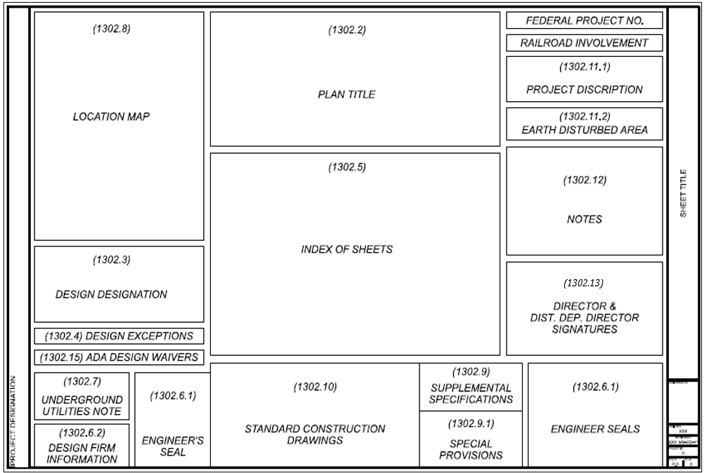

1302-2 | Digital Signature Sheet Layout:  8.5” x 11” Size
Reference Section  1302.13 | Digital Signature Sheet Layout:  8.5” x 11” Size

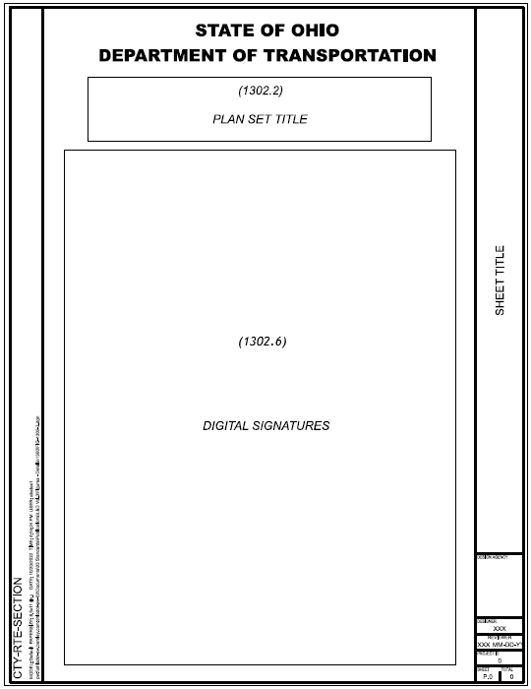
1302-3 | Guide for Showing Design Exceptions in Plan
Reference Section  1302.4 | Guide for Showing Design Exceptions in Plan

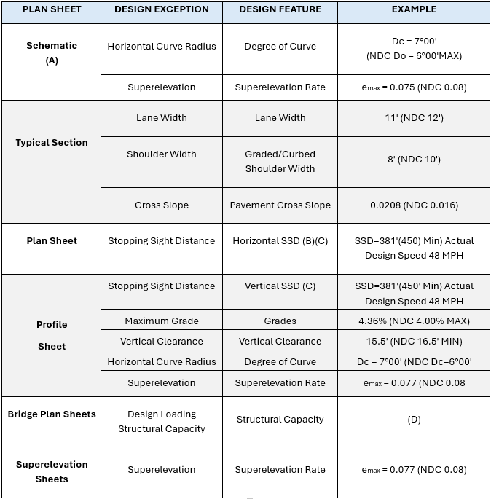

1303-1 | Simple Curve Elements and Data
Reference Section  1303.5, 1309.4.1 | Simple Curve Elements and Data

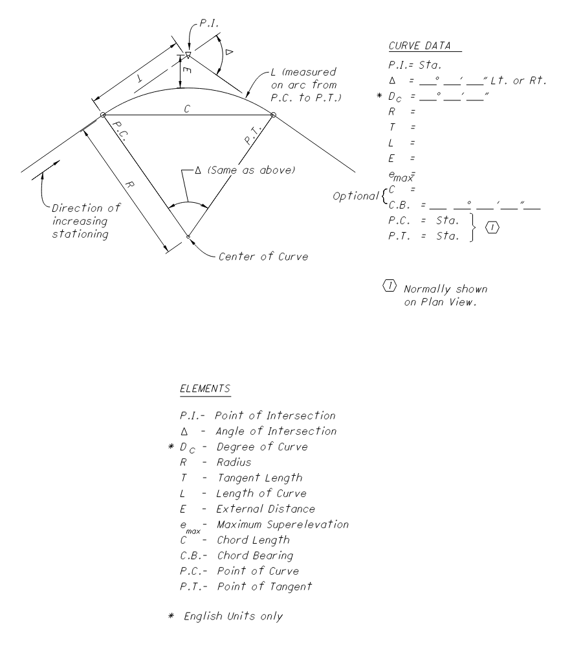

1303-2 | Spiral Curve Elements and Data
Reference Section  1303.5, 1309.4.1 | Spiral Curve Elements and Data

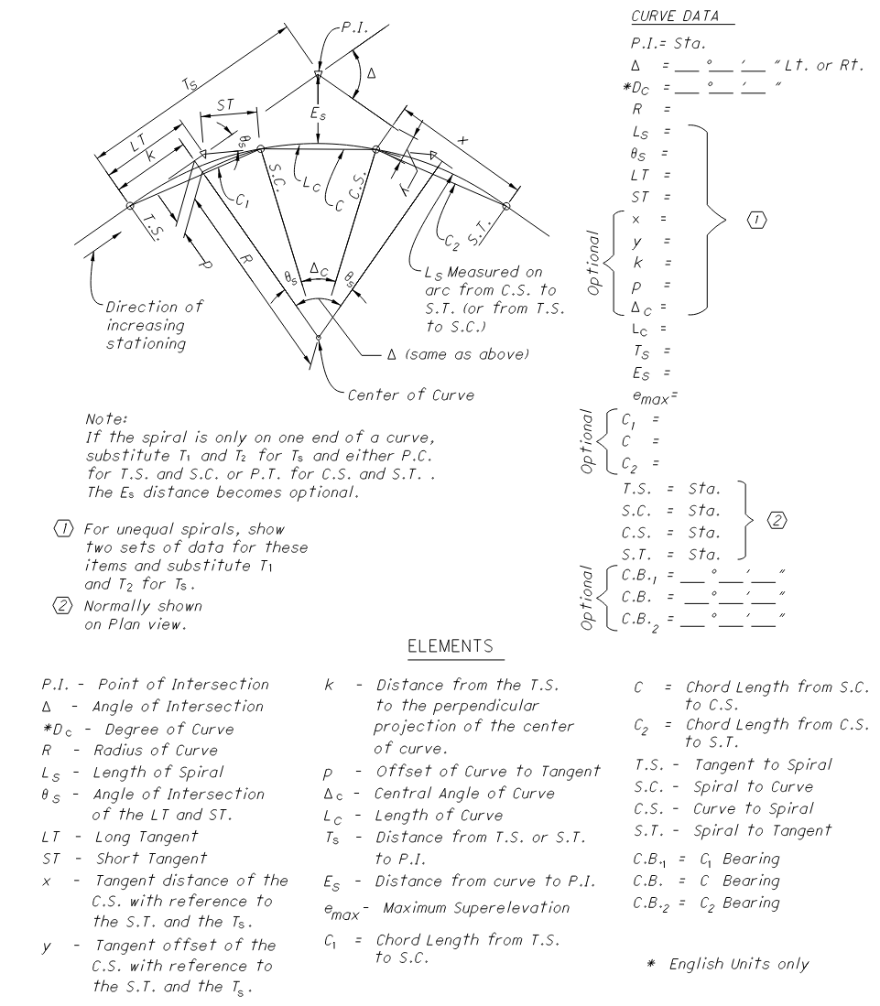

1303-3 | Combining Spiral Curve Elements and Data
Reference Section  1303.5, 1309. 4.1 | Combining Spiral Curve Elements and Data

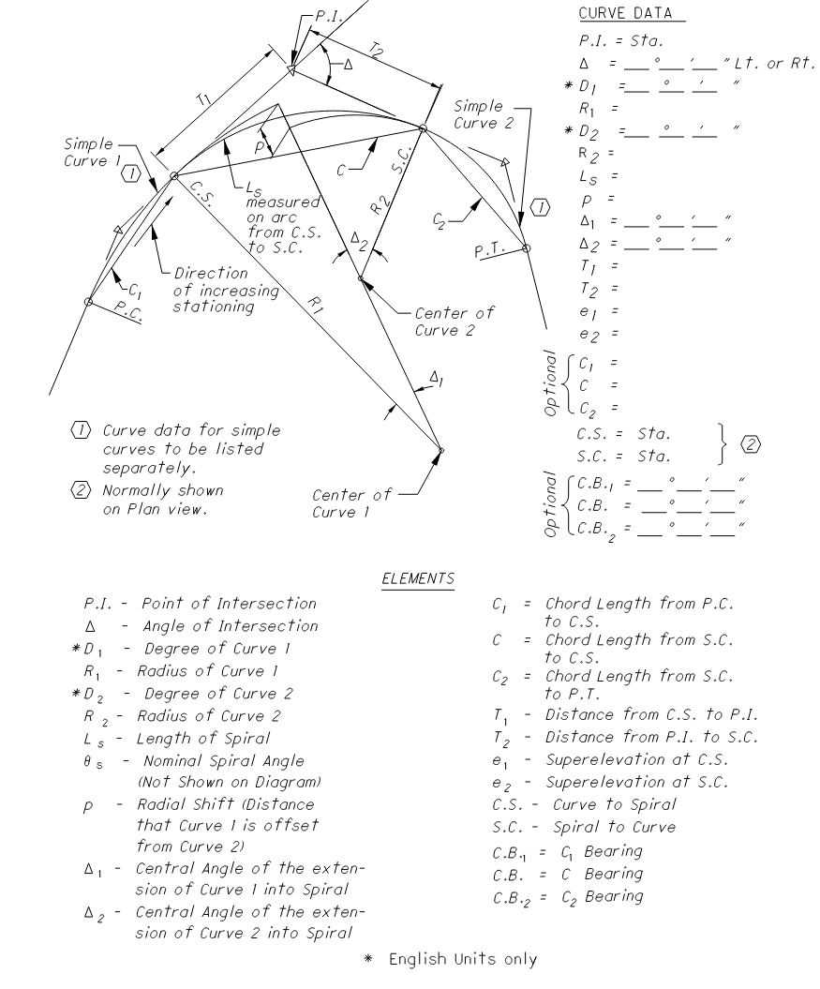

Section 1400 Project Development

1401 Design Review Process

1401.1 Introduction
ODOT’s Project Development Process is a project management and decision-making process, which provides a team-oriented approach to developing a transportation project. It is the framework for project development and guides it from conception through completion. The PDP also establishes the scope of work for a project and its deliverables. Refer to the PDP Manual and PDP website for more information.

This section of the Location and Design Manual provides a general overview of plan development. It does not detail design standards, nor provide guidance on how to evaluate any particular design component or environmental issue. Design and environmental requirements are provided in various technical manuals and policies.

1402 Project Phases

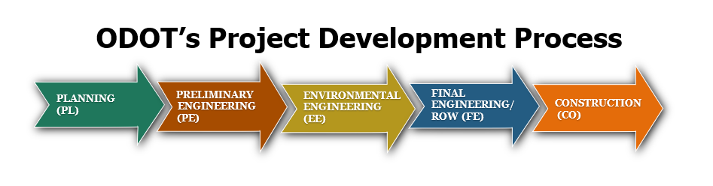
(See also Figure 1402-1)

The Project Development Process (PDP) is a project management and transportation decision-making tool that outlines project development from concept through completion. It encourages communication among disciplines, eliminates duplication of effort, minimizes cost overruns, and provides for early identification of potential issues. For example, by identifying environmentally sensitive resources early in the PDP process opportunities to minimize direct impacts are afforded, thereby resulting in the production of quality plans.

The PDP consists of five phases that projects must advance through. These phases are Planning (PL), Preliminary Engineering (PE), Environmental Engineering (EE), Final Engineering/ROW Phase (FE), and Construction (CO). Depending on the project’s size, complexity, and/or potential impact to the environment, the amount of time spent in each phase will vary.

A brief overview of project phases is detailed in the following sections.

1402.1 Planning Phase (PL)
Planning is the first phase of the PDP and provides a starting point for decision-making. It creates the foundation upon which the later PDP phases depend and assumes that a transportation improvement is warranted to address a problem identified through a prioritization process. But it does not assume the specific project-level needs to be addressed, facility type or project to be constructed.

1402.2 Preliminary Engineering (PE)
Preliminary Engineering begins the process of collecting more detailed information in order to develop and compare alternatives. This is done by conducting field investigations, performing technical studies, and developing preliminary engineering level of plans. This work builds upon, and refines, the information and analysis produced during the Planning Phase (PL). A primary product of Preliminary Engineering is the recommendation of the preferred alternative for the project. PE initiates the Stage 1 detailed design.

1402.3 Environmental Engineering (EE)
In the Environmental Engineering (EE) phase, detailed environmental analysis of the preferred alternative is performed concurrently with detailed engineering, and other technical studies.

The EE builds upon and refines the information and analyses produced during the Preliminary Engineering Phase (PE). The intent of the process is to have refined environmental studies and design work initiated concurrently on the preferred alternative, along with solid decision-making.

1402.4 Final Engineering/ROW Phase (FE)
During the Final Engineering/ROW Phase, projects are advanced to full development.

The acquisition of any necessary right-of-way is finalized in this phase.

Stage 3 detailed design is also completed during this phase. Plans must contain all details and quantities required to bid and construct the proposed project, including a final cost estimate. A Stage 3 Detailed Design Review Submission must also be reviewed and approved by the District. It Is recommended that a second Stage 3 Detailed Design Review be conducted if more than two years have elapsed since the first Stage 3 Detailed Design Review, and the Final Tracing Package has not been submitted to Central Office.

The Project Manager is responsible for ensuring:

- project has been fully developed,
- all necessary legislation has been completed,
- PS&E package has been finalized,
- performance of any other technical and engineering tasks,
- Plan Package meets all construction schedule deadlines.

Before the project can proceed to the next phase, the Final Plan Package is prepared and submitted to the ODOT Office of Estimating.

1402.5 Construction (CO)
The Construction Phase can be defined as the execution and administration of the contract documents and is the final step in the Project Development Process (PDP). It begins when the Final Plan Package has been submitted to Central Office. After the contract is awarded, ODOT monitors, manages, and documents the contractor’s activities to ensure compliance with the plans, proposal, and specifications.

The Contractor is responsible for constructing the work as detailed in the contract documents. The Project Engineer is responsible for ensuring that the terms of the construction contract are fulfilled. The Contract is a written agreement between the Department and the Contractor, setting forth the obligations of the parties, including, but not limited to the performance of the work and the basis of payment. Requirements for the management of the contract after the award can be found in the Construction Administration Manual of Procedures and the ODOT Construction and Materials Specifications (CMS).

1403 Project Classification

ODOT projects fall into one of five path categories (Paths 1-5). Selection of the appropriate project path is based on the project’s size, anticipated level of project complexity and/or potential impact to the environment. The project’s path identifies the recommended level of analysis, amount of stakeholder involvement, and activities performed during each phase. For classification purposes, the relative complexity of a project should be evaluated on a statewide, rather than a district-wide basis.

When trying to determine which path a project should follow, it may be difficult to determine if it fits better in one category versus another. When this situation arises, it is recommended that the higher category be selected.

More information on Project Path categories can be found in the following sections, and in the PDP Manual.

1403.1 Path 1 Projects
Path 1 projects are defined as “simple” transportation improvements generated by traditional and preventative maintenance. They may involve structure work and roadway resurfacing but do not include ROW or utility impacts. From an environmental perspective, they are typically processed as low-level Categorical Exclusion (CE) NEPA documents.

1403.2 Path 2 Projects
Path 2 projects are simple transportation projects which include non-complex structure, or roadway work. These projects typically include minor ROW acquisition (e.g., strip takes, temporary easements). Path 2 projects are typically low-level Categorical Exclusion (CE) NEPA documents and will likely have one viable alternative.

1403.3 Path 3 Projects
Path 3 projects involve a higher level of difficulty than projects in Paths 1 or 2. These projects are generally located on an existing alignment, although to improve geometric conditions small adjustments to the existing alignment and which do not result in significant environmental impacts may be involved. They involve moderate roadway and/or structure work and may include capacity additions. They can also involve utility relocations and ROW acquisitions, including relocations. Due to the wide range of potential impacts, and the amount of H required, Path 3 projects can fall under a wide range of environmental document levels, from C2 through D3.

1403.4 Path 4 Projects
Path 4 projects include roadway and structure work that add capacity and involve consideration of complex and competing interests. Path 4 projects may have multiple alignment alternatives and can include extended highway widening (typically not within the median) in suburban settings, new alignments in rural settings, or implementing corridor-wide access management. These projects have substantial utility and/or ROW relocations/impacts. They typically require a higher-level Categorical Exclusion, Environmental Assessment, or Environmental Impact Statement NEPA document.

1403.5 Path 5 Projects
Mostly urban transportation improvements, Path 5 projects involve the highest complexity of design work; have a higher probability of public controversy, multiple alternatives, and complex utility and access management issues.

In addition to requiring a substantial financial investment, Path 5 projects can be expected to have a significant impact on the highway’s level of service, traffic flow, mobility patterns, mode shares and right-of-way.

From an environmental standpoint, Path 5 projects include any project type in an urban setting that might impact a high-quality environmental resource or require agency coordination at several decision points in the PDP. They’re typically higher level NEPA documents and require an Environmental Impact Statement (EIS) or an Environmental Assessment (EA) NEPA document, but in some instances could be processed as a high-level Categorical Exclusion (CE) NEPA document.

1404 Review Process Determination

The District shall ensure every ODOT project is reviewed for compliance with the Scope of Services. There are several review categories in which a project may fall:

- Staged Review
- Limited Review
- Design-Build
- Local-Let Development Process

The review process which may be applied to a project is based upon its path and is determined by the District office. Irrespective of the number, or the detail of review submittals required, the Designer of Record is responsible for plan accuracy and adherence to all design and plan preparation requirements.

A description of each review process can be found in the sections which follow.

1404.1 Staged Review Process
The Staged Review Process consists of a series of review submissions at various stages of the design process. As the number of project alternatives is reduced, the level of design detail increases.

The Staged Review Process may be customized by combining review submissions and/or modifying the content of individual review submissions. Customizations of the Staged Review Process must be listed in the project’s Scope of Services document.

The Districts shall ensure that plans processed through the Staged Review Process are reviewed for compliance with the Scope of Services and to ensure compliance with current specifications, standards, policies and procedures.

1404.2 Limited Review Process
The Limited Review Process may be applied to Path 1, Path 2, and Path 3 projects which have a well-defined scope, limited environmental impact and utility involvement. Except for the Feasibility Study, bridge projects, and Final Right-of-way plans, ODOT will not review the plans for accuracy and adherence to design and plan preparation requirements. However, projects must still be in compliance with the Scope of Services.

Although design activities associated with Stage 1 Detailed Design, Stage 2 Detailed Design, Stage 3 Detailed Design, and Preliminary Right-of-way must be performed, their review submittals may be omitted. If no temporary or permanent right-of-way is to be acquired, the Compliance Right-of-way review submission may also be omitted.

External agency approvals (e.g. FAA Notification/Clearance, Waterway Permits, LD-33 County Engineer Approval, Railroad Agreements), and Central Office approvals (e.g. Design Exceptions, Maintenance of Traffic Exceptions Committee, and Waterway Permit determination) must be obtained.
The Design Agency shall receive acceptance from the District for any minor design decisions that occur after the Feasibility Study. The Design Agency must notify the District with the description of each alternative and an assessment of the impacts of each alternative on project cost, traffic operation, right-of-way cost, utility relocations, environmental impacts and any other associated impacts.

Below are typical design review submittals required by the Limited Review Process:

- Project Initiation Package
- Feasibility Study
- Compliance Right-of-way

It is important to note that the Limited Review Process cannot be applied to projects requiring Federal oversight. The Federal Highway Administration (FHWA) is responsible for ensuring that all federal-aid highway programs are delivered consistent with established requirements.

1404.3 Design-Build Process
Design-Build projects combine the detailed design and construction of a project into a single contract. The Design Agency and construction contractor form a team. They work concurrently on the design and construction phases of a project, which expedites project delivery.

For Path 1 projects, the Design-Build team will submit Stage 3 Detailed Design plans (without quantities) for review and acceptance. Other reviews are not normally required.

For higher path projects, the Design-Build team will submit Stage 1 and Stage 2 Detailed Design for review and acceptance. The Design-Build team may design and submit Stage 1 and Stage 2 information in phases consisting of buildable units (e.g., earthwork, pavement replacement, etc.) for review. The scope and design shall be coordinated with the District and authorization must be granted prior to submitting various plan components for review.

All external agency approvals (e.g., FAA Notification/Clearance, Waterway Permits, LD-33 County Engineer Approval, Railroad Agreements) and Central Office approvals (e.g., Waterway Permit Determinations, Design Exceptions, Maintenance of Traffic Exceptions Committee) must be obtained.

Additional information on the Design-Build process can be found at the following link:

https://www.transportation.ohio.gov/working/construction/alternative-project-delivery

1404.4 Local-Let Local Public Agency (LPA) Project Review Process
LPA projects are transportation improvement or enhancement projects that are funded primarily with federal or state monies, and if required, matched with local resources. Traditional LPA projects are those administered by ODOT, whereas Local-let LPA projects are those in which the LPA assumes project administration duties.

To the extent practical and feasible, ODOT will minimize its direct involvement in the design and delivery of projects that are funded with local and federal monies, or local and state monies, which do not directly involve routes on the National Highway System. Local public agencies may voluntarily assume the responsibility for project management tasks as determined and in coordination with the ODOT District Office.

For these local-let LPA projects, review submittals shall be as detailed in the Locally Administered Transportation Projects Manual of Procedures. ODOT-Let LPA Projects will follow the Project Development Process.

1404.5 Customization of Review Requirements
The PDP’s phased approach allows for the customization of a project’s review process. It allows for more flexibility between project phases and allows the Project Manager to tailor the process to meet the project’s individual needs.
The Staged Review Process may be customized by adding review submissions, combining review submissions and/or modifying the content of individual review submissions. Customizations of the Staged Review Process must be listed in the project’s scope of services document. These customizations should be evaluated on a case-by-case basis by ODOT personnel prior to scoping. During the scoping process, Consultants are encouraged to submit suggestions for modifications that allow for more effective use of resources, while still providing adequate evaluation of design and environmental issues.

1404.5.1 Combined Reviews
Combined Review submissions are recommended for relatively straightforward projects. Elements from each involved submission must be included in the combined submission. It is not acceptable to disregard elements associated with earlier deliverables and focus only on elements from the later review when they are necessary in the evaluation of the combined review submission (e.g., Path 1 Preliminary Engineering) elements (e.g., Stage 1 Detailed Design).

1404.5.2 Modifications to Design Review Content
It is possible to make modifications to design review content by changing the order in which activities occur in the Staged Review Process. For instance, the timing of a design activity may be modified allowing it to occur earlier or later, by moving it to another phase in the project development process. This may be justified when particular activities add significant cost to a project’s design as a result of performing the task on multiple alternatives. The postponement of activities to a later phase must not diminish the Design Agency’s ability to evaluate alternatives, or to adequately determine the project’s scope, schedule, and budget. Conversely, review elements should be moved forward in the process when they can be obtained at relatively low costs and would add greatly to the Design Agency’s ability to evaluate alternatives or determine scope, schedule, and budget. For example, in order to identify the Preferred Alternative, a Path 3 project may require investigating a vertical profile during the development of the Feasibility Study, even though this task is listed under the Alternative Evaluation Report (AER) tasks. Alternatively, to avoid investigating structure details on alternatives which are eliminated, a Path 3 project considering multiple alignments for a stream crossing may delay the Structure Type Study until the AER.

There is a limitation on the modification of design review content. For instance, when federal funding is used for design work, the environmental document must be approved prior to the authorization of final design activities (e.g., Stage 3 Detailed Design) and/or any Right-of-way acquisition.

1404.6 Scheduling
Good scheduling helps a project to run smoothly and helps to ensure it is completed in a timely manner. When developing schedules, particular attention must be paid to items that fall on the critical path (e.g., Right-of-way acquisition, utility relocation, individual waterways permits, etc.) and items that must be completed during a particular time of year (e.g., aerial mapping, ecological studies, etc.)

In ODOT’s Project Development Process, Gantt chart schedules are used to coordinate the various tasks associated with project development against time. Consultants are required to submit updated Gantt chart schedules each month which include baseline, actual, and current finish dates. The Project Manager must accept any modification to the schedule which alters commitment dates.

Projects which are behind schedule must include a recovery plan.

1405 Review Agencies

With the exception of external agency coordination performed by the Office of Environmental Services, all review submissions must be coordinated by, and are the responsibility of, the District. This ensures consistency of review comments, scope compliance, and project intent.
Submissions may be reviewed by the District Office, Central Office, an external agency, a resource agency, or one contracted by ODOT for all (or part) of the submission. External reviews may be necessary based upon agreement (e.g., Memorandums of Understanding (MOU), Memorandums of Agreement (MOA)). The determination of an external review will be made during the design Scope of Services meeting.

1405.1 Ohio Department of Transportation
The District Project Manager is the first point of contact for all review questions. The Project Manager:

- verifies required review information is submitted in accordance with the project schedule.
- ensures review comments are appropriately addressed.
- coordinates the appropriate and timely execution of reviews, not only within the District, but Central Office as well.

1405.1.1 Technical Offices and Specialty Areas
Projects prepared by the District office may require a review by a technical office or specialty area. Figure 1405-1 lists ODOT Central Office Technical Specialty Areas. At the District’s request, these offices/specialty sections will assist in the review of unique or complex items.

1405.1.2 Central Office
Projects prepared by the District Office should be submitted by the Project Manager directly to each involved office, or technical specialty area, for review. Figure 1405-1 lists ODOT Central Office Technical Specialty Areas. Reviews must be conducted by someone other than the project designer.

For projects developed by a consultant, there are two methods for sending review submissions to Central Office:

- Documents are submitted directly to each involved office or technical specialty area. The consultant should provide a copy of all transmittals to the Project Manager.

- Multiple copies of the review documents are submitted to the Project Manager for distribution to each involved technical office and/or specialty area.

The consultant Scope of Services document should address which method of submission is desired by the District.

1405.2 Federal Highway Administration
The Federal Highway Administration (FHWA) is accountable for ensuring that all Federal-aid highway programs are delivered consistently with established requirements. The Federal-Aid Highway Program Stewardship and Oversight Agreement outlines the respective roles and responsibilities of ODOT and the FHWA in administering the federal-aid program.

At the time of programming, the District will determine the level of oversight required on a project and enter it into Ellis. On projects subject to federal oversight, the FHWA and ODOT should discuss which submissions should be sent to the FHWA. For federal oversight projects, a copy of all required review submittals must be furnished directly to the FHWA by the preparing agency, or local government. Due to fluctuations in workloads, the FHWA may request federal oversight on a project that would normally be State administered.

1405.3 Local Governments
When the Design Agency is working for a local government, the local government may either have review materials processed through its office or have the preparing agency make submittals directly to the District Office. In either case, unless otherwise notified, ODOT will assume the submittal reflects the intent and desires of the local government.

1405.4 Other Governmental Agencies
Review and approval from the Federal Aviation Administration (FAA), U.S. Army Corps of Engineers (USACE), Federal Emergency Management Agency (FEMA), U.S. Coast Guard, U.S. Fish and Wildlife Service, Ohio Department of Natural Resources (ODNR), State Historic Preservation Office (SHPO) and Ohio Environmental Protection Agency (OEPA) may be required.

Other required environmental approvals and agency coordination are detailed in various manuals, and handbooks, published by the Office of Environmental Services.

Submissions to the environmental resource agencies (e.g., the Bureau of Underground Storage Tank Regulation, Ohio Department of Natural Resources, Ohio Environmental Protection Agency, Ohio Department of Agriculture, National Park Service, State Historic Preservation Office, U.S. Army Corps of Engineers, U.S. Coast Guard, U.S. Department of the Interior, U.S. Fish and Wildlife Service and U.S. Environmental Protection Agency) must be submitted through the Office of Environmental Services. Contact the Office of Environmental Services for more information.

1405.5 Railroads
When railroad property falls within the work limits of a proposed project, the possibility of railroad involvement exists. Rail companies must be informed at an early stage of plan development whenever their facilities may be affected in any manner. Some examples include work on structures passing over a rail line, new grade separations, reconstruction or rehabilitation of existing grade separations, drainage work, removal of Right-of-way encroachments, utility work, etc. In addition, projects with an intersection within the project’s limits, located within 400 feet of an at-grade rail crossing, require coordination with the Ohio Rail Development Commission to determine the need for preemption.

All projects with rail involvement must be coordinated with the Central Ohio Railroad Coordinator who is responsible for preparing and processing, all railroad construction agreements. The construction agreement process is initiated at Stage 1 and finalized at Stage 3. The District is required to send a copy of the final plans to the affected railroad company.

For projects involving of rail Right-of-way, the involved rail company will be allowed an opportunity to comment on the Right-of-way plans and legal descriptions associated with acquisition of their property. The Acquisition Support Section in the Office of Real Estate coordinates the acquisition of Right-of-way from rail companies.

1406 Design Review Submittals

Review submissions are designed to ensure that all projects are developed in compliance with the Scope of Services, ODOT standards, and policies. The Project Manager is responsible for verifying that all required review information is submitted in accordance with the project’s schedule, and that review comments are appropriately addressed. Information regarding the content requirements of each review submission can be found within the appropriate ODOT technical manuals and webpages (i.e., Waterway Permits Manual, Right-of-way Plan Manual).

1406.1 General Requirements
Each review submission includes a list of design activities. Therefore, each project should be scheduled based on its required design activities and anticipated design development timeframes.

There may be instances where specific design recommendations may come from someone other than the Designer of Record responsible for the overall project design. For example, a sub-consultant might prepare the Geotechnical Exploration Report whose recommendations are incorporated into the project’s plans by the prime consultant. To ensure that their recommendations have been correctly interpreted and incorporated into the project’s design, the sub-consultant should be given an opportunity to review the plans prior to their submission to ODOT.

Unless otherwise noted in the Scope of Services document, all review submissions should be sent to the District office. Multiple copies and direct submittals to Central Office and external agency reviewers may be required. Care should be taken to ensure that each submission includes all information required to process the review. Review submissions that lack required information, or contain inaccuracies which preclude meaningful review, will be rejected.

Since right-of-way acquisition is frequently on the critical path for overall project development, preliminary Right-of-way plan preparation and Stage 2 Detailed Design should be developed concurrently. Compliance Right-of-way plan development will normally occur immediately after preliminary Right-of-way approval.

The following sections provide information for design review submission. No attempt has been made to either detail design standards or to provide guidance on how to evaluate any particular design component or issue. Design standards are provided in the technical manuals and design policies listed in Figure 1405-1.

1406.1.1 General
All submissions must include the following in the letter of transmittal:

- Project identification: County, Route, Section (Street Name), PID number, Federal number or program (if known).
- Identification of the type of review submission
- Indication of any local government involvement along with any comments the local government may have regarding the submission
- Explanation of any special items, situations, or potential problem areas
- Disposition of previous review comments
- A current cost estimate factored up to the year the project will be awarded and indicating reasons for any significant increase or decrease in project cost
- Identification of all plan sheets, reports, and other materials

When both environmental and design documentation are required to complete a review, all documentation should be submitted at the same time. A sufficient number of copies of all submissions must be provided to allow for adequate review by all involved parties.

1406.1.2 Format
The format and number of copies required for all submissions is determined during the design Scope of Services meeting(s). For plan sets, quarter size 11" x 17" sheets are usually preferred. Plan sets must be bound. Calculations, reports and other documentation should normally be submitted on 8 1/2" x 11" paper. Large size exhibits, or preliminary design work, may be needed for public involvement meetings. Multiple sets of documents may be required to facilitate the review.

Plan sheet image files shall be provided in PDF format. Text-based documents should be provided as searchable PDF files. With the exception of some local-let projects, plans shall be submitted in a PDF electronic image format in accordance with the requirements of the electronic image file submission procedures available on the Office of Contracts website.

The District may consider allowing electronic submittals in addition to, or as a replacement for, paper submittals. The number of paper or electronic copies required for a particular review should be addressed in the Scope of Services document and be based on previous project experience, existing inter-agency agreements, and/or information from the review agency.

All projects requiring submittal of CADD files shall be developed using Bentley in accordance with the Section 1600, Electronic Design Deliverables, and Section 1204, Computer-Aided Drafting and Design (When scoped in the project’s Scope of Services document and in accordance with the Section 1600 Electronic Design Deliverables, and Section 1204, Computer-Aided Drafting and Design, comparable CADD software may be accepted). See Section 1503.1 for more information.

Some external agencies do not allow submission of electronic images. In instances where hard copy (e.g., paper) documents are required, the District CPA will determine whether the hard copy document will be created by the District or by the consultant.

1406.1.3 Engineer’s Seal
All final submissions must be sealed by a Registered Professional Engineer in accordance with the Ohio Administrative Code 4733-23-01. This includes not just final plan sets but also Access Point Request documents and Design Exceptions. If an Engineer has been hired to prepare plans through the Final Plan Package Submittal, then only the final plans and supporting documentation must be sealed.

Situations may occur where the detailed design will not be developed by the same engineer, or design firm, who prepared the preliminary engineering. In this case, the detailed design Engineers may rely on the preliminary development completed and sealed by the preliminary engineering consultant as the basis for their design. This information should be noted on the Title Sheet of the plans.

1406.2 Stage 1 Detailed Design

1406.2.1 General
Stage 1 Detailed Design begins after the identification of a preferred alternative. It refines and builds upon the preliminary engineering design completed in order to reach a decision on the preferred alternative.

Stage 1 plans are developed to a sufficient level of design detail to ensure that Preliminary Right-of-Way plan development may begin immediately after completion. Construction limits should be accurate; with little or no changes anticipated due to Stage 2 development.

Stage 1 Detailed Design is part of the Preliminary Engineering (PE) Phase of the PDP. Path 1 and Path 2 projects do not typically require a Stage 1 Detailed Design submission. It is required for Path 4 and Path 5 projects, and for most Path 3 projects.

1406.2.2 Stage 1 Detailed Design Activities
Since each project is unique, Project Managers have the flexibility to determine which activities are necessary based on the project’s scope. Therefore, there is no one-size-fits-all when it comes to the tasks necessary to complete a project’s design.

Following are activities are typically part of a Stage 1 Detailed Design:

- Design Exception request
- Driveway details
- BMP design
- Drainage calculations
- Utility coordination and documentation
- Develop Retaining Wall plans
- Complete LD-33 County Engineer approval form.
- Detour Plan
- Traffic Control
- Signal plans
- Determine Right-of-way costs
- Refine construction limits.
- Final Structure Site Plan
- Service Road Justification
- Railroad coordination
- Complete Airway/Highway Clearance Analysis, if not completed previously

For a complete listing of typical Stage 1 Detailed Design activities, see ODOT’s Scope and Fee System (SAFe).

1406.2.3 Stage 1 Detailed Design Review Submission
After Stage 1 Detailed Design is finalized for a preferred alternative, the project can be moved into the next phase of project development. The Stage 1 Detailed Design must be submitted to the District for review and acceptance.
Although each project is unique, there are certain key elements which are a part of the Stage 1 Detailed Design Review Submission:

- Title Sheet
- Schematic
- Typical Section sheets
- General Notes
- Plan and Profile sheets
- Cross Section sheets
- Superelevation table(s)
- Intersection Details sheets
- Driveway Detail sheets
- Culvert Detail sheets
- Channel Relocation Detail sheets
- Channel Section sheets
- Conceptual Maintenance of Traffic, if revised from previous submissions
- Preliminary Pavement Marking Plan
- Revised Systems Engineering Analysis for Intelligent Transportation System (ITS) projects
- Retaining Wall plans
- Geotechnical Reports
- Documentation of approved Interchange Justification Studies
- Documentation of approved Design Exception(s)
- Service Road Justification
- Drainage calculations
- LD-33 County Engineer Approval form
- Bridge Design report
- Retaining Wall plans
- Utility coordination and documentation
- Documentation of Airway/Highway Clearance Analysis, if not previously submitted
- Final Post Construction Storm Water Best Management Practices (BMP) Design Calculations and documentation of any BMP implementation issues

Refer to ODOT’s Scope and Fee System (SAFe) task list for a complete list.

1406.3 Preliminary Right-of-way Plan

1406.3.1 General
Preliminary Right-of-Way Plans are required for all projects that involve acquisition of temporary or permanent Right-of-way, and should be prepared in accordance with the Right-of-way Plan Manual, Section 3100. They provide information to define the extent of the right-of-way required to construct and maintain a highway.

Since acquisition of property can be a long process that in many cases dictates the overall schedule of a project prior to construction, preliminary right-of-way plans should be developed concurrently with Stage 2 detailed design. They should incorporate all Stage 2 review comments related to right-of-way issues.

1406.3.2 Preliminary Right-of-way Plan Tasks
For a complete listing of tasks of which should be completed during the development of the Preliminary Right-of-way Plan, consult the SAFe Task List.

Refer to the Office of Real Estate, Right-of-Way Plan Manual, Section 3100, for details regarding Preliminary Right-of-way Plan development.

1406.3.3 Preliminary Right-of-way Plan Review Submission
The following documents are required as part of the Preliminary Right-of-way Plan Review Submission:

- Right-of-way Legend Sheet
- Centerline Plat Sheet
- Property Map Sheet
- Summary of Additional Right-of-way Sheet
- Right-of-way Detail Sheet
- Right-of-way Topography Sheet (if scoped)
- Right-of-way Boundary Sheet (if scoped)
- Railroad Plat
- Copy of property owner deeds and recorded easements
- One Sample Legal Descriptions
- Right-of-way Review Checklist (See Appendix H of the R/W Plan Manual)
- Field Review Checklist (See Section 3110.3 and Appendix I of the R/W Plan Manual).

In addition to the Preliminary Right-of-way Review Submission, a Conceptual Right-of-way Review Submission may be requested by the District Real Estate Administrator as part of the project’s Scope of Services document. The Conceptual Right-of-way Review Submission will typically apply to large, complex projects, and should not be considered a substitute for the Preliminary Right-of-way Review Submission.

The Preliminary Right-of-way Plan Review Submission must be reviewed and accepted by the District.

For a complete list of Preliminary Right-of-way Plan tasks, refer to the Right-of-way Plan Manual, Section 3110.3 or ODOT’s Scope and Fee (SAFe) System task list. Contact the Office of Real Estate with questions.

Also, as part of this submission, the Right-of-Way designer and/or reviewer are required to perform a field review. The Field Review Checklist (Right of Way Manual - Appendix I) is to be completed prior to the preliminary right-of-way review submission, and then again within 15 working days of submitting the Final Right-of-way Plans. Refer to the Right-of-Way Plan Manual, Section 3110.4, for more information on the Field Review Process.

1406.4 Stage 2 Detailed Design

1406.4.1 General
Stage 2 Detailed Design is part of the Environmental Engineering (EE) phase of the Project Development Process (PDP). Its primary purpose is to detail and draft the ideas and concepts set forth in the Preliminary Engineering and the Stage 1 Detailed Design. Stage 2 Detailed Design is typically where the majority of the design detailing and plan preparation takes place At the end of the Stage 2 Detailed Design, all design issues of any significance should be resolved.

For more information on when Stage 2 Detailed Design occurs, see the Project Development Process Manual (PDP).

1406.4.2 Stage 2 Detailed Design Activities
The following is a list of typical Stage 2 Detailed Design activities:

- Add pavement elevations to Interchange Details. Develop grading plans.
- For widening projects saw cutting the pavement, provide the longitudinal sawcut elevation as well as sufficient information (profile grade location, profile grade elevations, cross slope, superelevation, and width dimensions) so the edge of travelled way and/or face of curb elevations can be determined.
- For concrete pavements, determine locations of longitudinal and transverse joints. Show the locations of these joints on the Intersection Details and Interchange Details.
- Prepare reinforcing details for full height culvert walls.
- Submit designs for precast reinforced concrete box culverts, three-sided flat-topped culverts and precast reinforced concrete arch sections where the usual maximum height of cover is exceeded.
- Complete retaining wall detail design.
- Update Signing Plan. Re-evaluate guardrail length of need if use to protect major guide signs.
- Lighting analysis to determine pole spacing and locations. Voltage drop calculations.
- Determine the disposition of all miscellaneous items (e.g., mailboxes).
- Prepare plan for fencing at Right-of-way lines.
- Add proposed Right-of-way lines to Plan and Profile and cross section sheets.
- Evaluate railroad/railway responses to Stage 1 plans. Revise plans to incorporate responses, if warranted. Send copy of Stage 2 Detailed Design plans to the railroad/railway company.
- Obtain approval from the Design Aesthetics Committee for all aesthetic items (e.g., concrete textures, landscape design, color).
- Evaluate and incorporate recommendations from Detailed Design Phase Value Engineering Study.
- Prepare plans for Constructability Review.
- Update the construction cost estimate.

A complete list of Stage 2 Detailed Design activities can be found in ODOT’s Scope and Fee (SAFe) System task list.

1406.4.3 Stage 2 Detailed Design Review Submission
Although each project is unique, there are certain key elements which are a part of the Stage 2 Detailed Design Review Submission. Following are items which are typically included as part of Stage 2:

- Title Sheet per Section 1302; except Engineer’s seal, Supplemental Specifications, Special Provisions, Standard Construction Drawings, and Earth Disturbed Areas.
- Schematic Plan sheet per Section 1303
- Typical Sections sheets per Section 1304
- General Note sheet listing utility companies as per Appendix B, Note G102
- Maintenance of Traffic phasing plans, including sequence of operations
- Detour map, notes, and County Engineer Approval
- Plan and Profile sheets as per Section 1309. Estimated quantities are not required.
- Cross Sections sheets, as per Section 1310, except earthwork and seeding calculations.
- Intersection Details sheets
- Interchange Detail sheets
- Drive Detail sheets showing plan and profile information
- Culvert Detail sheets as per Section 1312.2, except estimated quantities.
- Headwall/wingwall details for those not covered by the Standard Construction Drawings.
- Channel section and relocation detail sheets
- Storm Sewer Profile sheets
- Water work and sanitary sewer plans, if not covered by the Plan and Profile sheets
- Pavement Marking and Signing Plan sheets as per the Traffic Engineering Manual
- Revised Systems Engineering Analysis for Intelligent Transportation System (ITS) projects
- Signal Plan sheets as per the Traffic Engineering Manual
- Lighting plan as per the Traffic Engineering Manual, except estimated quantities
- Landscaping Plan, except estimated quantities
- Noise wall details
- Bridge plans as per the Bridge Design Manual, except estimated quantities and reinforcing steel tables.
- Approval of aesthetic details
- Retaining Wall detail sheets
- Fencing Plan
- Detailed Right-of-way Plan Sheets from the Preliminary Right-of-way Review
- Copies of utility company correspondence
- Copies of railroad/railway company correspondence
- Disposition of Detailed Design Phase Value Engineering recommendations
- Plans for Second Constructability Review
- Cost estimate for construction and right-of-way acquisition. The District Utility Coordinator to provide revised utility reimbursement cost estimate, if necessary. Explain any significant increase or decrease in estimated cost from previous estimates.
- Disposition of Stage 1 Review comments
- Geotechnical Plan Review Certification

The Stage 2 Detailed Design must be reviewed and accepted by the District.

1406.5 Compliance Right-of-way Review Submission

1406.5. General
Compliance Right-of-way Review Submission plans are part of the Final Engineering/ROW (FE) phase of the Project Development Process (PDP). They incorporate comments generated during the Preliminary Right-of-way Plan development, and any Stage 2 Detailed Design comments which affect the right-of-way plan, legal descriptions, and calculations. Stage 2 design issues affecting right-of-way must be resolved prior to submission of the Compliance Right-of-way Review Submission.

The Compliance Right-of-Way Review Submission must be reviewed and accepted by the District.

1406.6 Final Right-of-Way Plan Submission

1406.6.1 General
They incorporate comments generated during the Compliance Right-of-way Plan development and any Stage 2 Detailed Design comments which effect the right-of-way plans and legal descriptions. The right-of-way designer and/or reviewer will verify and update the property owner information for each property and perform a field review including a completed Field Review Checklist within 15 working days of submitting the Final Right-of-way Plans. The Final Right-of-way Plan Submission shall include:

- Right-of-way Plan Sheets (Digital Signature and Seal)
- Centerline Plat Sheet (Signed, Sealed and Recorded)
- Legal descriptions (signed and pre-approved when applicable)
- Closure calculations
- Completed Field Review Checklist (Appendix I)
- Completed Right-of-way Description Checklist (Appendix J)
- Disposition of comments generated from the Compliance Right-of-way Review

1406.7 Stage 3 Detailed Design

1406.7.1 General
The Stage 3 Detailed Design should complete the design and detailing of the project. These plans must contain all details and quantities required to bid and construct the proposed work. Plans should be numbered and submitted as a complete set and organized as per Section 1301.1.

Stage 3 Detailed Design is part of the Final Engineering/ROW (FE) phase of the Project Development Process (PDP). A Stage 3 Detailed Design review is required for all projects, except Limited Review and Design-Build Projects.

It is recommended that a second Stage 3 Detailed Design review be conducted if more than two years have elapsed since the first Stage 3 Detailed Design Review, and the Final Plan Package has not been submitted to Central Office. The purpose of this review is to ensure that the plans reflect current field conditions, as well as all current design standards, policies, and specifications.

1406.7.2 Stage 3 Detailed Design Activities
The preparation of a Stage 3 Detailed Design typically involves the following activities:

- Preparation of Simplified Plans
- Preparation of underdrain bends and branches list.
- Preparation of the Project Site Plan.
- Determination of all estimated quantities plan (e.g., pavement, drainage, earthwork, signing)
- Determination of appropriate notes (e.g., general notes, MOT notes, traffic control notes)
- Determination of any participation splits
- Preparation of the General Summary and Bridge Estimated Quantity sheets.
- Finalization of the Systems Engineering Analysis for Intelligent Transportation System (ITS) projects.
- Completion of traffic signal plans
- Completion of signing plans.
- Submission of plans to involved railroad/railway companies for approvals. Railroad agreement must be obtained prior to submission of Final Plan Package to Central Office.
- Preparation of FAA Form 7460-1 for Airway/Highway Clearance.
- Revision of construction utility reimbursement cost estimates.

Refer to ODOT’s Scope and Fee (SAFe) task list for a complete list of the activities required to complete the Stage 3 Detailed Design.

1406.7.3 Stage 3 Detailed Design Review Submission
Although not an all-inclusive list, the Stage 3 Detailed Design Review Submission should include:

- A complete set of construction and Right-of-way plans
- Acceptance of non-standard plan notes.
- Systems Engineering Analysis for Intelligent Transportation System (ITS) projects
- Railroad Agreement
- Completed FAA Form 7460-1 per Section 1407.1.7
- ODNR plan approvals
- Construction and utility reimbursement cost estimates
- Disposition of Constructability Review comments
- Disposition of Stage 2 Detailed Design Review comments

The Stage 3 Detailed Design Review Submission must be reviewed and accepted by the District.

Refer to ODOT’s Scope and Fee (SAFe) System task list for a complete list of the activities required to complete the Stage 3 Detailed Design.

1406.8 Final Plan Package
Submission of the Final Plan Package is part of the Final Engineering/ROW (FE) phase of the Project Development Process (PDP). ODOT has established uniform procedures and criteria for the submission of plan packages to the Office of Estimating. The Final Plan Package for a project is to be submitted in accordance with the schedule prepared by Central Office and the Districts. It must include documentation that confirms the project is eligible and ready to be advertised for bids.

The project’s plan final plan package contains all files and information relevant to the project, such as the:

- Design Estimate
- Proposal Note List
- Construction Plans
- Electronic files (i.e., CADD files, Excel files, alignment files, etc.)
- Estimated Quantities Form

Project Managers are required to create and submit plan package documentation in electronic format, as a single PDF. All ODOT-let projects shall be submitted to Project Coordination via the ODOT Plan Package Submittal internal SharePoint site located here:

https://portal.dothttps://portal.dot.state.oh.us/Divisions/Planning/estimating/SitePages/Preconstruction%20Main.aspx

The submission of completed plans to the District from a consultant should follow Section 1505 of this manual.

1407 Miscellaneous Studies

1407.1 Airway/Highway Clearance Analysis

1407.1.1 Introduction
The purpose of an Airway/Highway Clearance Analysis is to determine if a proposed project will encroach into the theoretical approach, or traverse surfaces, of an airport or heliport. When a project is identified as being within 20,000 feet of a public-use or military airport, or heliport, an analysis must be performed to determine if FAA notification is required. The initial determination whether or not a project is within the 20,000-foot distance is to be made at the time of programming, and it should be so noted on the programming forms and in ODOT’s project management system.

The Airway/Highway Clearance Analysis procedures contained in this manual are based on the “Federal Aviation Regulations, Part 77 - Objects Affecting Navigable Airspace.” Information on the location of airports and lengths of runways may be obtained from the “Ohio Airport Directory,” as published by the Ohio Department of Transportation, Office of Aviation.

1407.1.2 Notification Surfaces
The following conditions need to be examined to determine if notification is required.

- Any construction or alterations of more than 200 feet in height above ground level.
- Any construction or alteration of greater height than an imaginary surface extending outward and upward at the following slopes:

- 100:1, for horizontal distance of 20,000 feet from the nearest point of the nearest runway, for any airport with at least one runway with a length of more than 3,200 feet, excluding heliports.
- 50:1, for a horizontal distance of 10,000 feet from the nearest point of the nearest runway, for any airport where the length of the longest runway does not exceed 3,200 feet, excluding heliports.
- 25:1, for a horizontal distance of 5,000 feet from the nearest point of the nearest landing and takeoff area, for a heliport.

See Figure 1407-1 for a graphical depiction of these surfaces.

1407.1.3 Traverse Way Adjustments
In determining whether any roadway or other traverse way (e.g., railroad, waterway, bikeway, etc.) will violate the limits described in the previous section, it is necessary to include an additional upward height above the traverse way elevation for vehicles that might travel on the facility. The adjustments are as follows:

- 17 feet for Interstate highways, other freeways, and expressways
- 15 feet for all other public roadways and commercial driveways
- 10 feet for all private roads and driveways
- 23 feet for railroads
- an amount equal to the height of the highest mobile object that would normally traverse the facility, for a waterway or for any other traverse way not previously mentioned

This additional height must be considered to apply over the full width of the traveled portion and the shoulders of the roadway. Figure 1407-1 includes examples of several traverse way adjustments.

1407.1.4 Exceptions to Notification Requirements
FAA notification is not required where one or more of the following applies to the object penetrating the notification surface:

- The object is shielded by existing structures of a permanent and substantial character or by natural terrain or topographic features, of equal or greater height.
- The object is located in the congested area of a city, town, or settlement, where it is evident beyond all reasonable doubt that there could be no adverse effect on safe air navigation.
- The object is an antenna of 20 feet or less in height, except one that would increase the height of another antenna structure.

Figure 1407-2 includes examples of locations where FAA notification is, and is not, required.

1407.1.5 Temporary Structures and Construction Equipment
It is possible that a project located within 20,000 feet of an airport will not require FAA notification for permanent features but will require notification for temporary structures or construction equipment. Figure 1407-3 contains height allowances for equipment or structures associated with various types of construction. These allowances should be used to determine if the notification surface will be penetrated. For short projects (100 feet or less in length), any applicable heights should be considered to apply over the entire length of the project.

Judgment must be used when applying these heights to longer projects. For example, the allowance for equipment used to construct a bridge would only be needed in the vicinity of the bridge; however, the allowance for earth moving and paving equipment should be applied over the entire length. If any doubt exists, consult the Office of Aviation.

1407.1.6 Controlled Areas
Figure 1407-4 displays cross-sectional and profile views of imaginary surfaces that exist above the notification surface. Figure 1407-5 depicts an area at the end of a runway called the Runway Protection Zone (RPZ). Figure 1407-6 contains dimensions defining the sizes of RPZ’s for different facilities. Projects should be designed so that these controlled areas are not penetrated by any features, as the FAA will not normally permit violations.

1407.1.7 FAA Notification/Clearance Procedures
Whenever a project is located within 20,000 feet of a public-use or military airport or heliport, an Airway/Highway Clearance Analysis must be performed. Documentation which provides the information contained in Figure 1407-7 must be supplied. The District will use this information to complete FAA Form 7460-1. The FAA requires the use of English units.

The District will submit the following information to the FAA for approval:

- Two completed FAA Form 7460-1's. One form is for the proposed project and the other form is for the construction equipment and/or temporary structures.
- Latitude, longitude (NAD), and elevation (above mean sea level) of the following points:
- For short bridge projects, 100 feet or less in length:
- Highest point of the superstructure of the bridge.
- For all other projects:
- Beginning of the project
- End of the project
- Highest point of the project
- Closest point to the runway
- Any other points that may be important to the study (e.g., various high points throughout the project that may penetrate the imaginary surface)
- Each light tower or signal pole. In addition, include structure number, latitude, longitude, ground elevation, structure height and overall height
- Highest point of the superstructure of each bridge
Accuracy of points should be within 50 feet horizontally and 20 feet vertically.
- A USGS map of the project location relative to the airport showing a reference for each point listed above.

Instructions on how to file the 7460-1 form with the FAA can be found on the Office of Aviation’s website at:

https://www.transportation.ohio.gov/programs/aviation/airports/protection-act

When approval (or comments) is received from the FAA, the District Project Engineer will retain the original correspondence and distribute copies to the Office of Aviation and the FHWA (for federal oversight projects only). Submit FAA approvals to the Office of Aviation electronically at the following web address:

Ohio.Airport.Protection@dot.ohio.gov

FAA comments will generally relate to certification of the coordinates submitted or the submission of Form 7460-2, Supplemental Notice. The FAA may also request that a light pole, or other similarly tall structure, be visibly marked or possibly reduced in height.

Approvals are valid for a period of eighteen (18) months. The District will monitor project status (sale date) relative to the approval expiration date and submit a request for extension to the FAA at least two (2) weeks prior to the expiration date.

When construction equipment is expected to penetrate the notification surface of a public-use or military airport or heliport, note G118A should be added to the plans. When construction equipment is not expected to penetrate the notification surface, but the project is within the influence area of a public-use or military airport or heliport, note G118B should be used.

1407.1.8 Private Facilities
An Airway/Highway Clearance Analysis is required for private airports and heliports. The notification surfaces detailed in Section 1407.1.2 – Notification Surfaces shall apply to both public and private facilities. If there are any penetrations into the notification surfaces that impact a private facility, coordination with the private owner, and the Office of Aviation, shall be made and note G118C should be added to the plans. Coordination with the FAA is not required.

1407.2 Retaining Wall Justification
A Retaining Wall Justification compares the impacts and costs (both right-of-way and construction) of the project with and without retaining walls. Estimated right-of-way costs are to be provided or verified by the Office of Real Estate.

A Retaining Wall Justification should include:
- Plan sheets showing wall and no-wall alternatives, including:
- Approximate construction limits
- Right-of-way parcels affected
- Cross sections showing wall and no-wall alternatives.
- Economic analysis comparing right-of-way and construction costs, with and without the wall.
- Discussion of environmental impacts with and without the wall (optional).

1407.3 Service Road Justification Study
Service roads (sometimes called access or frontage roads) are used to: reduce the number of existing access points, connect roads cut off by highway relocation, and to provide access to parcels that would otherwise be landlocked by a highway relocation. The decision to use a service road to decrease the number of existing access points is usually made for safety or capacity reasons, although in some cases it could be based on economics. Using a service road to connect roads cut off by a relocation is done primarily to provide needed traffic circulation. Providing access via a service road to otherwise landlocked parcels is primarily an economic decision.

Maintenance of service roads by the State is not desirable because, in many cases, these facilities are not readily accessible from a state highway. It is therefore necessary that a statement of acceptance of routine maintenance by a local government agency be obtained.

A Service Road Study Form (see Appendix D) must be completed. In preparing the analysis, maintenance costs related to the service road must be considered. Estimated right-of-way costs are to be provided or verified by the Office of Real Estate. For information and guidance on preparing the Service Road Study Form contact the Office of Roadway Engineering.

1407.4 Pedestrian Overpass Justification
A Pedestrian Overpass Justification compares the impacts and costs of a project with and without a pedestrian overpass. A statement of acceptance by a local government agency assuming responsibility for all routine maintenance of the structure and approaches must be obtained. Routine maintenance includes clearing debris from the deck, sweeping, snow and ice removal, minor wearing surface patching, clearing bridge drainage systems, marking decks for traffic control, minor and emergency repairs to railing and appurtenances, emergency patching of deck and maintenance of traffic signal and lighting systems, including the supply of electrical power. For information on Pedestrian Overpasses, refer to Multimodal Design Guide, Section 4.7.2.

1407.5 Value Engineering (VE) Studies
Value Engineering (VE) is a systematic analysis by a multi-discipline team which identifies the functions of a project, establishes the worth of that function, generates alternatives through the use of creative thinking, and identifies ways to provide the needed functions at the lowest overall cost, without sacrificing safety, quality, and the environmental attributes of the project.

The Department requires that Value Engineering studies be performed on federally funded projects meeting the following criteria:

- All projects on the federal-aid system with an estimated total cost in excess of fifty (50) million dollars (including design, right-of-way, and construction)
- All bridge projects located on the federal-aid system with an estimated cost in excess of forty (40) million dollars (including design, right-of-way, and construction)
- Any other project selected by FHWA

Appropriate timing of VE studies will ensure that there is sufficient information to analyze during the Value Engineering Session and that accepted recommendations can be successfully implemented without impeding the overall project development schedule. Typically, this can be accomplished by scheduling a Value Engineering Workshop at the end of Stage I Detailed Design. Another beneficial time for a Value Engineering Workshop is during preliminary engineering, especially if determining the best alternative is problematic.

The criteria used to determine if a project qualifies for Value Engineering can be found in ODOT’s Standard Procedure No. 414-001(SP), Design Value Engineering Standard Procedures. The Design Value Engineering Policy can be found in Policy No. 21-006(P).

It is the District’s responsibility to review projects currently programmed in the Planning, Preliminary Engineering, and/or Final Engineering/ROW phase to determine if a project qualifies for Value Engineering. The District Value Engineering Coordinator is also responsible for monitoring project schedules and contacting the Office of Roadway Engineering Value Engineering Coordinator (COVEC) to schedule a Value Engineering Study.

The COVEC oversees ODOT’s VE program, provides assistance to the Districts, ensures that all VE recommendations are fully evaluated, and all accepted recommendations of the VE team are implemented.

Since each project is unique, there may be instances where multiple value engineering studies may be required. Typically, Path 3, and some Path 4, projects that qualify for Value Engineering require only one Value Engineering Study to be performed. More complex Path 4 and Path 5 projects, with extensive impacts, will likely require two Value Engineering studies.

Contact the Office of Roadway Engineering for more information on Value Engineering.

1407.6 Constructability Review
The intent of a Constructability Review is to check the plans for potential construction strategies, techniques and logistical issues. It is an evaluation of the project plans, sometimes supplemented by a site visit conducted by an individual familiar with construction techniques, to evaluate construction means and methods. The Constructability Review also checks construction durations, and alternative designs. It identifies labor and material availability, access for large equipment, project phasing, and the conceptual maintenance of traffic.

The Project Manager will determine if a Constructability Review will be conducted concurrent with the Preliminary Engineering Phase.

To ensure an independent evaluation, constructability reviews should not be conducted by the design consultant who prepared the plans. Designers should routinely consider constructability issues during the normal course of project development.

Figures

Figure | Subject
1402-1 | Project Development Process Project Phases and Paths
1405-1 | Design Information Sources
1405-2 | Federal Oversight Determination Process
1407-1 | Relationship of Traverse Ways to the Imaginary Notification Surface
1407-2 | Examples of Factors Affecting the Imaginary Surface
1407-3 | Maximum Operating Height of Construction Equipment
1407-4 | Cross-Sectional and Profile Views of Imaginary Surfaces
1407-5 | Runway Protection Zone
1407-6 | Dimensions for Runway Protection Zone
1407-7 | Sample Letter of Airway/Highway Clearance Analysis

1402-1 | Project Development Process  Project Phases and Paths
Reference Section  1402.1-1402.5 | Project Development Process  Project Phases and Paths

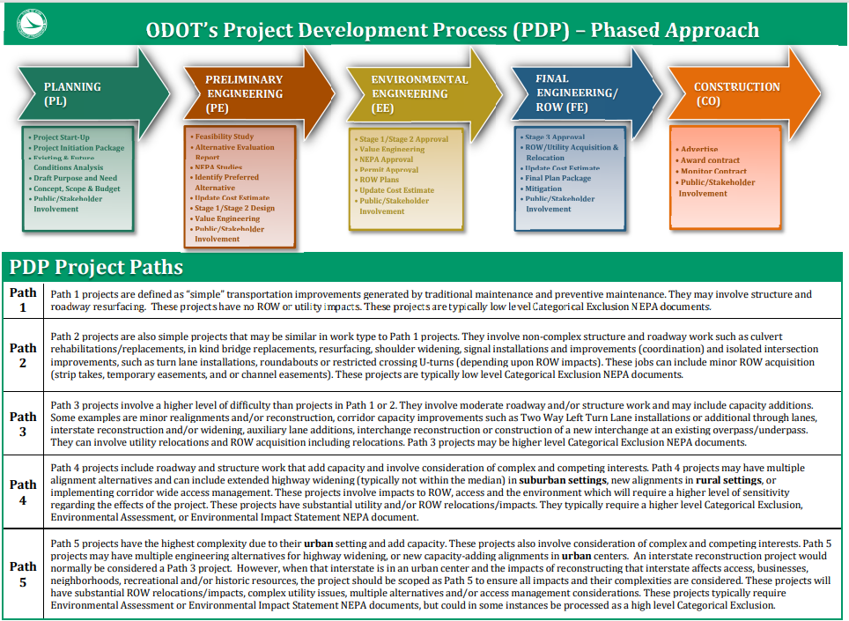
1405-1 | Design Information Sources
Reference Section  1405.1.1, 1405.1.2, 1406.1 | Design Information Sources

OFFICE/  SPECIALTY AREA | CENTRAL OFFICE  DESIGN AREA OF EXPERTISE | DESIGN MANUALS, STANDARD DRAWINGS AND POLICIES
Alternative Project Delivery | - Design Build  - Value Based Contracting | - Design-Build Manual  - ODOT Design-Build Value-based Selection Policy (#27-022 (P))  - Implementation and Administration of Warranty Provisions Policy (#27-015(P))  - Innovative Contracting Policy (#27-013(P))
Aviation | - Airports and Heliports  - Airway/Highway Clearance Analysis  - Flight Operations  - Unmanned Aerial Systems (UAS) | - Airspace Protection  - Federal Aviation Regulations, Part 77-Safe, Efficient Use, and Preservation of the Navigable Airspace
CADD and Mapping Services | - Aerial mapping  - Lidar  - Ground surveys  - CADD (OpenRoads Designer, MicroStation and GEOPAK)  - ProjectWise  - Mobile Mapping  - GIS | - Survey and Mapping Specifications  - Location and Design Manual, Vol. 3  - Sample Plan Sheets  - CADD Engineering Standards  - ODOT Guidelines for Electronic Design Deliverables  - Location and Design Manual, Vol. 4
Construction Administration | - Specification Development  - Supplemental Specifications  - Proposal Notes  - Change Orders  - Warranties  - LPA Construction Contract Administration | - Construction and Material Specifications  - Supplemental Specifications  - Proposal Notes  - ODOT Design Build Value-based Selection Policy (#27-022(P))  - Innovative Contracting Policy (#27-013(P))  - Manual of Procedures
Environmental Services | - Ecological Resources and Permits  - Coast Guard Permits  - Cultural Resources  - Environmental Policy & NEPA  - Noise walls  - Aesthetic Design  - Environmental Commitments  - Environmental Site Assessment  - Project Development Process | - Cultural Resources Manual  - Ecological Manual  - Regulated Materials Review Manual  - Environmental Justice and Other Traditionally Underrepresented Populations Guidance  - ODOT NEPA Assignment Categorical Exclusion Guidance  - Environmental Commitments Guidance  - ODOT Floodplain Management Guidelines  - Noise Analysis Manual  - ODOT Aesthetic Design Guidelines  - Project Development Process (PDP) Manual  - Project-Level Air Quality Manual  - Section 4(f) Manual  - Waterway Permits Manual
Estimating | - Application of design related proposal notes  - Historical cost data  - Items numbers and Item Extensions  - Bid analysis and review  - Construction cost estimating  - General Summaries (GenSum)  - Project Coordination | - Item Master  - Summary of Contracts Awarded
Geotechnical Engineering | - Roadway and Geohazards  - Foundations and Retaining Walls  - Field Explorations | - Manual for Abandoned Underground Mine Inventory and Risk Assessment (AUMIRA)  - Rock Slope Design Guide  - Specifications for Geotechnical Explorations (SGE)  - Geotechnical Engineering Design Checklists  - Manual for Rock Slope Inventory  - Manual for Landslide Inventory
Hydraulic Engineering | - Roadway hydraulics (storm sewers, culverts)  - Post-Construction Storm Water BMP’s  - Channels  - Floodplain Management  - Storm Water Management Program (SWMP) | - Hydraulic Standard Construction Drawings  - Conduit Management Manual  - Location and Design Manual, Volume 2 – Drainage Design  - MS4 Storm Water Outfall Inventory Manual
Pavement Engineering | - Pavement Design  - Subsurface drainage (underdrains, aggregate drains) | - Pavement Design Manual  - Pavement Standard Construction Drawings
Policy | - Policy | - Policies and Procedures
Program Management-(Know Our Programs) | - Traffic Data  - Crash Data & Analysis  - Major Programs  - Highway Safety  - Capital Reporting | - ODOT Highway Functional Classification System Concepts, Procedures and Instructions  - Major Bridge Policy  - Safety Study Guidelines  - Highway Safety Improvement Program Procedures Manual
Rail Development Commission | - Railroad coordination  - Railroad agreements | - Design manuals published by individual railroad/railway companies
Real Estate | - Acquisition  - Utilities  - Relocation  - Subsurface Utility Engineering (SUE)  - Right-of-Way certification and appraisal  - Right-of-Way  - Property Management  - Oil and Gas Wells | - Right-of-way Plan Manual  - Real Estate Manual
Roadway Engineering | - Americans with Disabilities Act (ADA)  - Design Exceptions  - Geometric features (alignments, profiles, typical sections, drives, slopes, guardrail, barrier wall)  - Intelligent Transportation Systems (ITS)  - Landscaping  - Lighting  - Maintenance of Traffic  - Multimodal Design  - Preliminary Design  - Signal Warrants  - Signing  - Studies and Access Management  - Traffic Control  - Traffic Sign Models (Synchro)  - Value Engineering  - Work Zones | - Appropriate Design Criteria Guide  - Location and Design Manual, Volume 1 – Roadway Design  - Standard Construction Drawings  - Plan Insert Sheets (Roadway, Traffic)  - Curb Ramps Required in Resurfacing Plans (Policy #21-003(P))  - Traffic Management in Work Zones (Policy #21-008(P)) (Standard Procedure # 123-001(SP))  - Design Value Engineering Standard Procedure (414-001(SP)  - Ohio Manual of Uniform Traffic Control Devices (OMUTCD)  - Sign Design and Markings Manual (SDMM)  - Temporary Traffic Control Manual (TTCM)  - Traffic Engineering Manual (TEM)  - Multimodal Design Guide | Ohio Department of Transportation
Statewide Planning & Research | - Certified Traffic  - Bike & Pedestrian Design  - Statewide & regional planning  - Modeling & Forecasting (Air Quality, Travel Demand Modeling)  - Research  - Maritime & Freight program  - Metropolitan Planning | - AASHTO Guide for the Development of Bicycle Facilities  - Ohio Certified Traffic Manual  - Ohio MPO Administration Manual  - Ohio Traffic Forecasting Manual  - Research, Development & Technology Transfer (RD&T2) Manual of Procedures
Structural Engineering | - Bridges (structural design & detailing)  - Retaining walls (structural design & detailing)  - Mechanically Stabilized Earth (MSE) Retaining Walls  - Headwalls | - Bridge Design Manual  - Standard Bridge Drawings  - Plan Insert Sheets  - Bridge Maintenance Manual  - Bridge Inspection Manual
Systems Planning and Program Management | - Major Programs  - Crash Analysis  - GIS Analysis | - ODOT Highway Functional Classification System Concepts, Procedures and Instructions  - Functional Classification Maps
Technical Services | - Transportation Information Mapping System (TIMS)  - Asset Management  - Traffic Monitoring  - Infrastructure Transportation Management | - County Maps  - Digital Photo Log  - Traffic Counts (Traffic Survey Reports & Maps)  - Straight Line Diagrams
Traffic Operations | - Incident Management Programs  - Signals  - Signing Programs | - Signal Design Reference Packet  - Office of Traffic Operations Manuals and Standards

NOTES:

- This is not an all-inclusive list of manuals published by each technical office. Only those manuals containing design standards and policies are shown.
- Design manuals, specifications and standard drawings can be found in ODOT’s Publications | Ohio Department of Transportation
- The Policies and Procedures website can be found at the following link:
http://portal.dot.state.oh.us/Groups/policies/default.aspx

1407-1 | Relationship of Traverse Ways to the Imaginary Notification Surface
Reference Section
1407.1.2, 1407.1.3

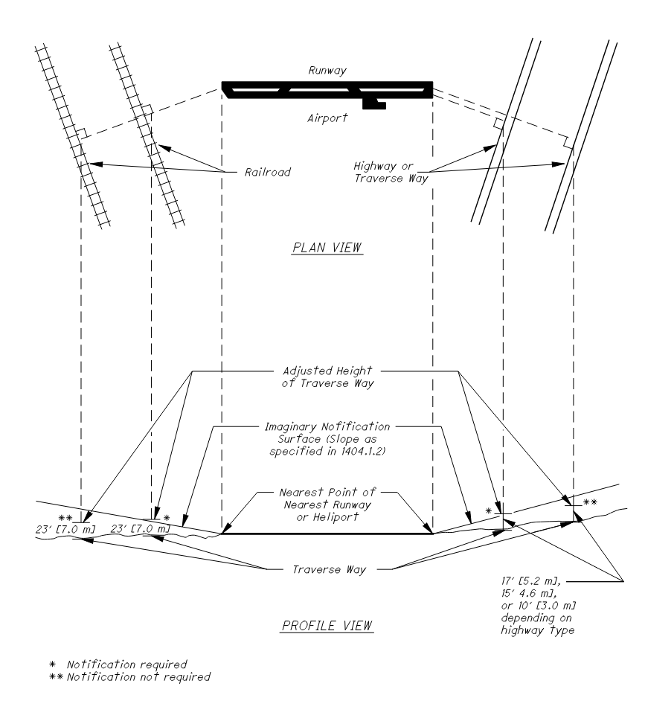

1407-2 | Examples of Factors Affecting the Imaginary Surface
Reference Section  1407.1.4 | Examples of Factors Affecting the Imaginary Surface

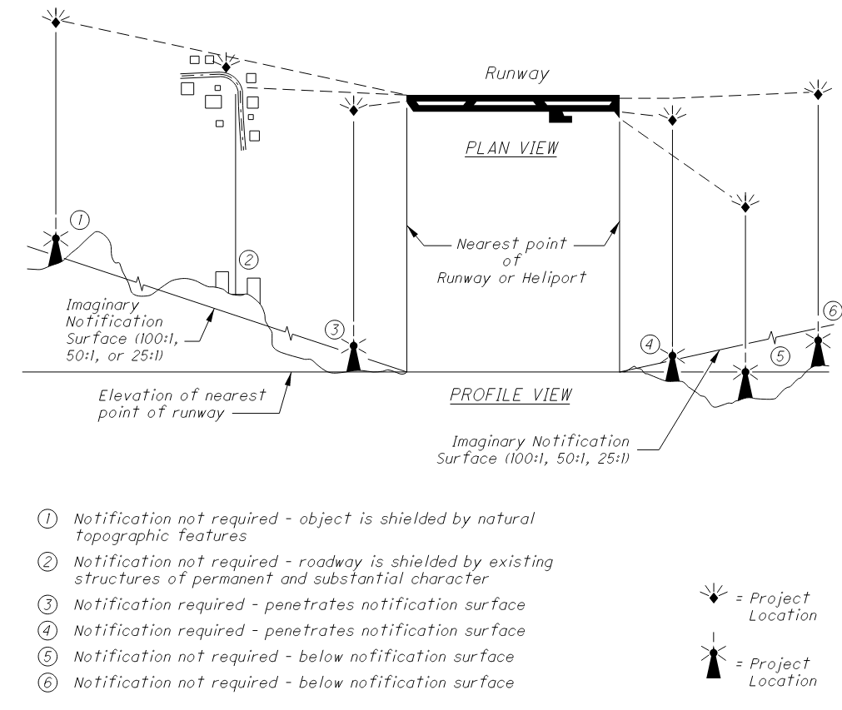

1407-3 | Maximum Operating Height of Construction Equipment
Reference Section  1407.1.5 | Maximum Operating Height of Construction Equipment

WORK TYPE | HEIGHT | CONTROLLING CRITERIA
Barrier Construction | 50 Ft. | Crane
Bikeways | 25 Ft, | Truck
Bridge Painting | Bridge Height + 10 Ft. | Containment Structure
Culverts | 50 Ft. | Crane
Deck Overlays | 25 Ft. | Truck
Earthwork | 25 Ft. | Truck
Guardrail | 25 Ft. | Auger
Highway Lighting | Pole Height | Pole Height
House Demolition | 25 Ft. | Excavator
Large Bridges | 100 Ft. | Crane
Mowing/Landscaping | 10 Ft. | Mower
Noise Walls | 25 Ft. | Crane
Pavement Marking | 12 Ft. | Truck
Pavement Repair | 25 Ft. | Raised Dump Truck
Pile Driving | 50 Ft. | Crane
Resurfacing | 25 Ft. | Raised Dump Truck
Rest Areas | 50 Ft. | Crane
Slope Repair | 25 Ft. | Excavator/Grader
Small Bridges | 60 ft. | Crane
Traffic Signals | 50 Ft. | Cherry Picker
Trash Collection | 25 Ft. | Truck

- The heights given are an average height for the specific types of projects. These heights should be adjusted, as necessary, for any project.

1407-4 | Cross – Sectional and Profile Views of Imaginary Surfaces
Reference Section  1407.1.6 | Cross – Sectional and Profile Views of Imaginary Surfaces

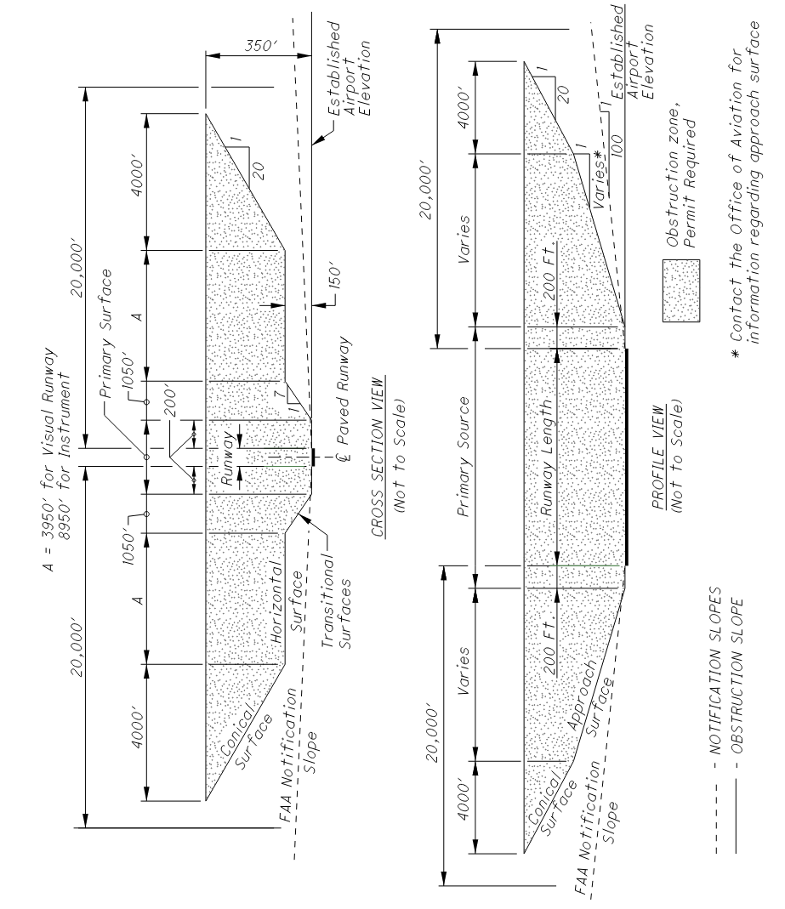

1407-5 | Runway Protection Zone
Reference Section  1407.1.6 | Runway Protection Zone

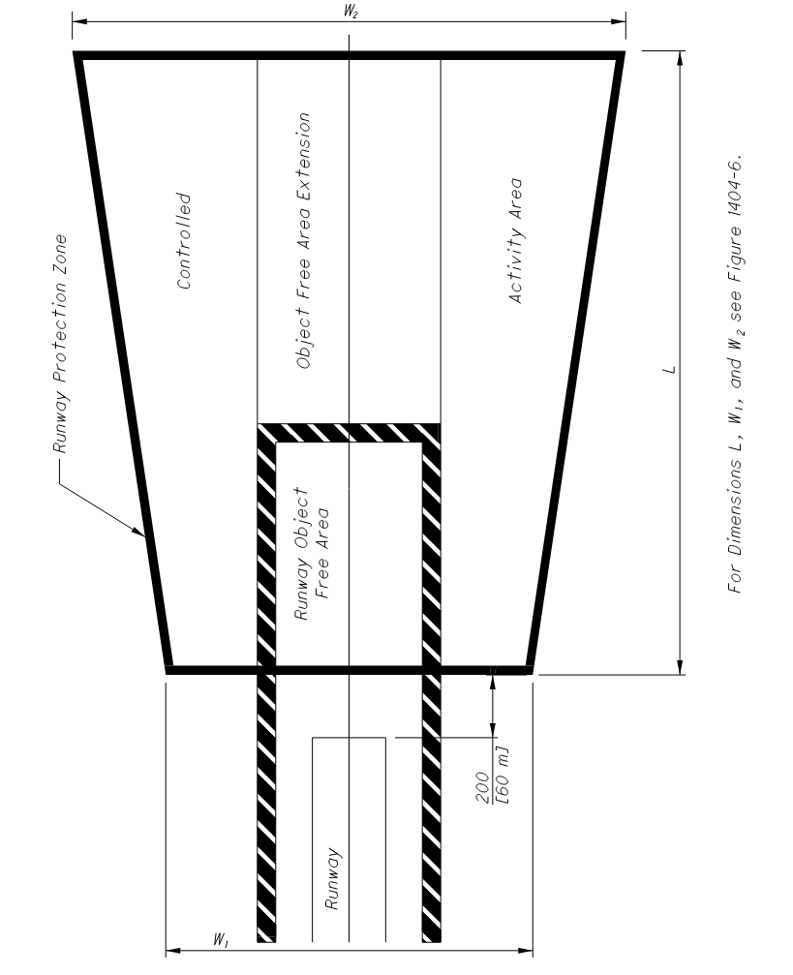

1407-6 | Dimensions for Runway Protection Zone
Reference Section  1407.1.6 | Dimensions for Runway Protection Zone

V = Visual approach
NP = Nonprecision instrument approach with visibility minimums not more than ¾ statute mile
NP ¾ = Nonprecision instrument approach with visibility minimums as low as ¾ statute mile
P = Precision instrument approach
**For locations of L, W₁, and W₂ see Figure 1407-5.

1407-7 | Sample Letter of Airway/ Highway Clearance Analysis
Reference Section  1407.1.7 | Sample Letter of Airway/ Highway Clearance Analysis

District Production Administrator
Title
ODOT-District Office
Address
City, State & Zip

Re: Airway/Highway Clearance Analysis
County-Route-Section
PID:

Dear Mr. /Ms.,

We have reviewed the above-mentioned project and have determined that the project (will/will not) not encroach into the (X:1) notification surface. This determination is based on an airport elevation of (A) feet, a project elevation of (B) feet, with a distance of (C) feet between the airport and the project locations. The attached diagram will provide a detailed analysis of the study. The study has also determined that a height of (Z) feet exists between the (X:1) notification surface and the project. Therefore, based on this height and the heights from Figure 1407-3, plan note [G119A: Use note G119A when the construction equipment penetrates the notification surface of a public use airport or heliport; G119B: Use note G119B when the construction equipment does not penetrate the notification surface of a public airport or heliport; or G119C: Use note G119C when the construction equipment penetrates the notification surface of a private use airport.] (will/will not) be required.

Respectfully,

John Doe
Title
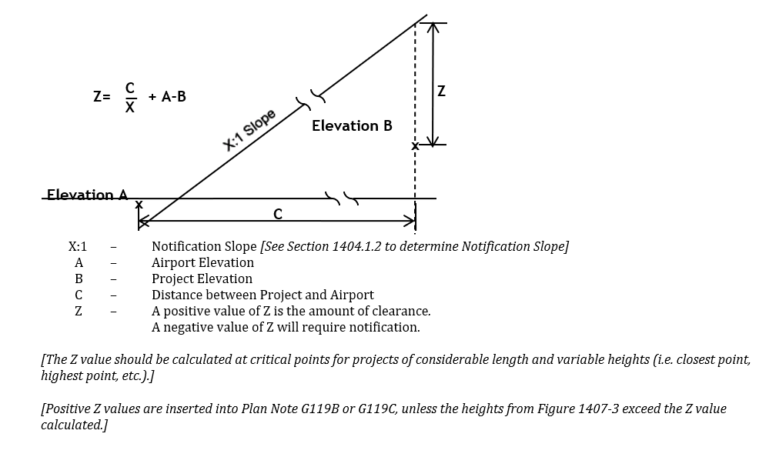

Section 1500 Plan Related Actions

1501 Introduction

There are several actions that are required to complete the processing of a highway construction plan. Section 1500 includes a discussion of these related actions.

1502 Documentation of Environmental Commitments

Environmental commitments are any agreed upon actions to mitigate (e.g., restore, enhance, avoid, minimize, and/or replace) impacts to the human environment. Environmental Commitments are captured in the environmental document and are the link between the Environmental (EE) phase of the project and the Final Engineering/Right-of-way (FE/RW) and Construction (CO) phases of the Project Development Process (PDP).

To ensure environmental commitments are carried out appropriately, an Environmental Consultation Form (ECF) is to be completed, signed by the District Environmental Coordinator, and submitted with the Plan Package to ODOT’s Office of Contracts. The District Environmental Coordinator will communicate all applicable environmental commitments to designers. Environmental commitments must be incorporated into a plan’s design and/or plan notes so that they can be implemented during construction.

For more information, contact the Office of Environmental Services or see the Office of Environmental Services’ Environmental Commitments Manual.

1503 CADD File Requirements for Design and Construction

1503.1 CADD Software Requirements
All projects requiring submittal of CADD files shall be developed using Bentley in accordance with Section 1204, Computer-Aided Drafting and Design (CADD), Section 1600, Electronic Design Deliverables and Scope of Services. Although ODOT will accept CADD files developed using comparable CADD software, no support, standards, documentation, or guidance of any kind with respect to design and delivery will be provided. For more information, see SECTION 1204, Computer -Aided Drafting and Design (CADD).

1503.2 CADD File Requirements
Unlike electronic image files (i.e., PDF images) that are part of the contract documents, CADD files (i.e., basemap files) provided to contractors are for reference purposes only. In the event that there is a conflict between the CADD files and the bidding documents, the bidding documents shall take precedence.

CADD files, and a Project Index File, shall be provided in accordance with the requirements for Electronic Submittals described in Section 1600, Electronic Design Deliverables, located on the Office of CADD and Mapping Services website, and included in the Final Plan Package submittal.

1503.2.1 Typical Requirements for Projects Following Path 1 of the Project Development Process (PDP)
For projects scoped to Path 1 of the PDP, the following files are typically required for reference purposes only:
- Existing Plans (Roadway and Bridge)
- Designer Office Calculations (such as Pavement, Earthwork, and Structure Quantities)
- Final Geotechnical Report(s)
Most Path 1 projects are simple transportation improvements generated by traditional maintenance and preventative maintenance. They may involve structure or roadway resurfacing and have no right-of-way or utility impacts. However, there are some projects which require more detail in their design than a “typical” Path 1 project but still meet the criteria of a Path 1 project. For these projects, electronic design files (e.g., .gpk, triangle model, ASCII text files, etc.), if generated, shall be submitted with the project’s Plan Package. For example, on projects requiring a Project Site Plan, electronic design files generated during the project’s design are required in the final plan submission. These files will be made available to contractors during ODOT’s construction contract bidding process.

Information to be made available to bidders should be determined, and documented, in the project’s Scope of Services document.

For more detailed information on electronic files required to be submitted with the Final Plan Submission, see Section 1600, the Electronic Design Deliverables.

1503.2.2 Typical Requirements for Projects Following Paths 2, 3, 4, and 5 of the Project Development Process (PDP)
The PDP provides Project Managers with the flexibility to tailor the requirements of a project to meet its individual needs. Therefore, the requirements for each project are based upon the path it is following. Electronic Files (e.g., CADD files, alignment files, basemap files, etc.) shall be in accordance with the requirements for electronic submittals described in Section 1600, Electronic Design Deliverables. Contact the Office of CADD and Mapping Services, CADD Services section with questions.

Although not all-inclusive, following is a listing of files which, if available, shall be made available to bidders:

- Plans and Profile Sheets
- Cross Section Sheets and Cells
- Intersection/Interchange Details
- Project Site Plan
- Reference Basemap Files
- Files for reference purposes only:
  - Existing Plans (Roadway and Bridge)
  - Designer Office Calculations (such as Pavement, Earthwork, and Structure Quantities)
  - Final Geotechnical Report(s)
- All other electronic files shall be in accordance with the requirements for electronic submittals described in Section 1600, Electronic Design Deliverables.
- Other files may be required at the District’s discretion, but this should be documented in the project’s scope.

The District CPA may elect to waive all, or a portion of the CADD file requirements (except for the submittal of existing plans and designer office calculations) for projects that have less than one acre of earth disturbed area. Waiver of these requirements shall be noted in the Scope of Services document.

Since each project is unique, information to be made available to bidders should be determined, and documented, in the project’s Scope of Services document.

1503.3 Submission of Files to the District
CADD and electronic image files shall be supplied to ODOT via CD, DVD, or other media as approved by the District, pursuant to the project Scope of Services document.

For detailed information on the electronic files required to be submitted to ODOT, see Section 1600, Electronic Design Deliverables.

1503.4 Submission of Files to Central Office
The plan package for a project is to be submitted in accordance with the schedule prepared by Central Office and the Districts. The plan package must include documentation confirming that the project is eligible and ready to be advertised for bids.

Submission of the Final Plan Package is part of the Final Engineering /Right-of-Way (FE/RW) Phase of ODOT’s Project Development Process (PDP). Project Managers are required to create and submit the final plan package documentation in electronic format as a single PDF. To reduce the size of PDF files, vectorized elements are preferred to raster PDF, with the exception of the Title Sheet. The Title Sheet is the only document which can be a raster PDF. The District shall review the electronic documents for completeness to ensure that all required files are transmitted to Central Office.

A project’s CADD files, if created, are required to be submitted with the Final Plan Package. ODOT provides CADD files to contractors for reference purposes only. For more details on the electronic files required to be submitted to ODOT, see Section 1600, Electronic Design Deliverables.

All ODOT-let projects shall be submitted to Project Coordination via the ODOT Plan Package Submittal internal SharePoint site located here:

https://portal.dot.state.oh.us/Divisions/Planning/estimating/SitePages/Preconstruction%20Main.aspx

1504 Submission of Completed Plans to District

1504.1 General
When a design agency other than ODOT prepares the construction plans, the final plan shall be submitted to the District Office. The final plan submittal shall include information described in the sections which follow.

1504.1.1 Projects Administered by ODOT
Pursuant to the requirements of the project’s Scope of Services document, below are items and information the final plan submission should contain:

- Completed Right-of-Way plans and final construction plans, including geotechnical profile sheets in an electronic image file format (i.e., PDF images). Electronic image files shall be provided in accordance with the requirements found in 1600, Electronic Design Deliverables, and the PDF Submission Procedure available on the Office of Contracts website.
- Completed Standard Forms
- Estimated Quantities Form - Formerly the LD-4 form, this electronic form is a summation of a project’s specific quantities, and cost information, used in developing the official Engineer’s Estimate. This form shall be submitted to ODOT Districts as part of the Plan Package Submittal process. See Appendix D for more information.
- ODOT Districts shall transfer estimated quantity information electronically via the ODOT Plan Package Submittal SharePoint website.
- LD-33 County Engineer Approval Form (including signature) - This form is required per Ohio Revised Code 6131.631. See Location and Design Manual, Volume Two, Appendix B for a copy of this form.
- Marked review plans (if retained by the design agency) and the disposition of all review comments.
- Excel file containing project’s General Summary (CTY-PID-GENSUM.xlsm).
- Quantity calculations not typically included in the plans (e.g., structure calculations and pavement calculations).
- Cost estimates for items and/or services, or other special items furnished by the local government.
- Documents/Records (e.g., photography, survey data, reports, studies, drawings, maps, computations, plans, specifications, estimates).
- Final Geotechnical Report(s)
- Electronic Files (e.g., CADD files, alignment files, basemap files, etc.) in accordance with the requirements for electronic submittals described in Section 1600, Electronic Design Deliverables. The electronic image file requirement applies to all ODOT-Let projects. However, Local-Let projects may elect to waive the electronic image file requirement with specific submittal guidance provided in the project Scope of Services document.

1504.1.2 Projects Administered through the Local Public Agency (LPA) Policy
ODOT may qualify an LPA to administer its own project, with the exception of those projects that are part of the National Highway System (NHS). ODOT shall retain all administration and management duties for the delivery of these projects. Any exception to this rule requires written approval from ODOT’s Division of Planning, Local Programs.

The LPA Manager for the ODOT District office whose jurisdiction includes the LPA’s project, shall be the Department’s point of contact to the LPA. The LPA Manager will routinely provide guidance and coordination throughout the project’s entire development process, including actively tracking and facilitating project progress to the extent practicable. Other District personnel, including but not limited to the District Real Estate Administrator (REA) and the District Environmental Coordinator (DEC) or their designees, will also provide guidance as necessary.

Local-let LPA projects shall include the applicable information required by the Scope of Services document, and be in accordance with the Local-Let Manual of Procedures. Project submittal checklists for Local-Let LPA projects are available on the Local Programs’ website.

1505 Review of Completed Plans

1505.1 Plan Checking
The District office shall determine the review process to be followed and shall assume responsibility for determining when a plan is complete and ready for sale. It is the Project Manager’s responsibility to ensure that:

- Plans are thoroughly checked.
- All proper reviews have been performed.
- All review comments have been resolved and documented.
- Plans are in compliance with the Scope of Services document and with Section 1600, Electronic Design Deliverables.

1505.1.1 Projects Administered by ODOT
Plans should be thoroughly checked by District and/or Central Office personnel to ensure the following:

- The proposed design is in compliance with the Scope of Services document, current specifications, design standards, policies, procedures, environmental commitments, and mitigation plans.
- Accurate depiction of topographic and construction features.
- Plans contain all details, and quantities, required to bid and construct the proposed project.
- Existing topographic features are adequately and properly designated on the plans.
- Right-of-Way certification is complete, including coordination of encroachment removals and utility relocations.
- Electronic files are included as per Section 1600, Electronic Design Deliverables.
- Geotechnical final plan review certification is complete.

The District Office shall determine the review process to be followed and shall assume responsibility for determining when the plan is complete and ready for sale.

1505.1.2 Projects Administered through the Local Public Agency (LPA)
ODOT may qualify an LPA to administer its own project, with the exception of those which are part of the National Highway System (NHS). ODOT shall retain all administration and management duties for the delivery of these projects. Any exception to this rule requires written approval from ODOT’s Division of Planning, Local Programs.

The LPA Manager for the ODOT District office whose jurisdiction includes the LPA’s project, shall be the Department’s point of contact to provide guidance and coordination to the LPA throughout the project’s entire development. Other District personnel including, but not limited to, the District Real Estate Administrator (REA) and the District Environmental Coordinator (DEC) or their designees will also provide guidance as necessary.

Local-let projects must be reviewed at least on a quarterly basis. At any time, the LPA Manager can request additional reviews or special meetings to ensure the project is consistent with the established schedule and environmental commitments are being addressed.

Plans shall be checked to ensure compliance with the project’s Scope of Services document, and that they are in accordance with the Local-Let Manual of Procedures located on the Local Programs website.

1505.2 Field Verification
District representatives should conduct a field verification to ensure that conditions have not materially changed before filing the plans with Central Office.

1506 Submission of Completed Plans to Central Office

1506.1 General
After the District Office completes its review of the construction plans, and any supplemental information, the project’s Plan Package shall be prepared. Information regarding the Plan Package, its contents, and submission procedure, can be found under ODOT Plan Package Submittal on the Preconstruction Cooperative SharePoint site. Contact the Office of Estimating with questions.

1506.1.1 Projects Administered by ODOT
Once plans are ready to be advertised for bid, the project must follow ODOT’s electronic plan submittal process which requires all ODOT Districts to submit a plan package. The project’s plan package, used by both the Office of Estimating and the Office of Contracts, contains all relevant files and documentation confirming that the project is eligible and ready to be advertised for bids. The plan package for a project is to be submitted in accordance with the schedule prepared by Central Office and Districts.

Submission of the Final Plan Package is part of the Final Engineering /ROW (FE) Phase of ODOT’s Project Development Process (PDP). Project Managers are required to create and submit the plan package documentation in electronic format as a single PDF. To efficiently use PDF plan sets in construction, all pages of the PDF, with the exception of the Title Sheet, shall be in vector format. PDF files shall not be rasterized. The District shall review the electronic documents for completeness to ensure that all required files are transmitted to Central Office.
A project’s CADD files, if created, are required to be submitted with the Final Plan Package. ODOT provides CADD files to contractors for reference purposes only. For more information on the electronic files which are required to be submitted with the Final Plan Package, see Section 1600, Electronic Design Deliverables.

All ODOT-let projects shall be submitted to Project Coordination via the ODOT Plan Package Submittal Internal SharePoint site located here:

https://portal.dot.state.oh.us/Divisions/Planning/estimating/SitePages/Preconstruction%20Main.aspx

1506.1.2 Projects Administered through the Local Public Agency Policy
ODOT may qualify an LPA to administer its own project, with the exception of those which are part of the National Highway System (NHS). ODOT shall retain all administration and management duties for the delivery of these projects. Any exception to this rule requires written approval from ODOT’s Division of Planning, Local Programs.

The Local-Let Manual of Procedures can be found on the Local Programs website. It provides information on the requirements and procedures for projects administered through Local Public Agencies (LPA’s).

1507 Record of Plans

After the project has been awarded, the District Office shall provide permanent storage in accordance with the Department’s records retention policy and shall make arrangements to return completed plans for off-system projects to the originating agency.

Section 1600 Electronic Design Deliverables

1601 General Electronic Design Deliverables Information

1601.1 Introduction
Each project submission includes delivery of electronic files. This section serves to outline the requirements and the formats for delivery of electronic project documents.

1601.2 Electronic Data Submission
The Project Manager shall be the point of contact for all communication between the contractor or consultant, and ODOT. An email notification shall be sent to the Project Manager if compliance with these guidelines is not met.

ODOT reserves the right to reject any electronic data, or files, that do not meet requirements; data and files shall be corrected before resubmission.

1602 Plan Set Requirements

A Plan Set shall be a single PDF Package/Portfolio only if there is more than one individual PDF making up the Plan Set. Otherwise, it shall be a single multi-page pdf.

1602.1 Plan Set
The Plan Set PDF Package/Portfolio can be named initially as follows:

[YYYYMMDD]-[PID]-PlanSet.pdf

Where [YYYYMMDD] is the 8-digit submission date and [PID] is the project identifier.

The Name of the Plan set will change when being submitted to Central Office based on the type of submission it is (Initial Plan Filing, Pre-Addendum, Addendum). See Project Submission Procedure (Internal Link Only) for naming requirements and procedures when making a submission to Central Office. The Project Submission is to be done by the District Project Manager.

1602.2 Plan Set Components and Naming Conventions
When two or more projects are combined to be sold as one construction project, the Plan Set components listed below shall have their name appended with Part#, where # is the sequential numbering for each project. There should still only be one overall Plan Set PDF Package/Portfolio.

1602.2.1 Construction Plan
When generating a PDF plan set, the plan sheets (excluding R/W sheets) within the PDF Package/Portfolio shall be named as follows:

[CTY]-[PID]-Plan.pdf

Where [CTY] is the main county abbreviation listed in ELLIS for the project and [PID] is the project identifier.
All signatures within this PDF, requiring a professional seal shall follow the digital signature requirements.

1602.2.2 Right-of-Way Plan Sheets
When generating a PDF plan set, the Right-of-Way portion of the plan set shall be a separate PDF document within the plan set PDF Package/Portfolio and shall be named as follows:

[CTY]-[PID]-Plan-RW.pdf

Where [CTY] is the main county abbreviation listed in ELLIS for the project and [PID] is the project identifier.

While the Right-of-way plan sheets are still considered to be a sub-set of the overall plan sheets, they do not have to be included in the overall sequential numbering of the plan (only the sub-set sheet number is required).

Plan Sheets that are being used for the acquisition of right of way and/or centerline plats shall follow the conveyance standards of that county. In addition, if the county requires “wet signatures”, then those sheets shall be scanned in, added to the Plan Set, and digital signatures added for each “wet signature”.

The R/W Legend Sheet shall still follow all digital signature requirements.

1602.2.3 Signature Sheet
If additional non-sealed signatures (excluding the Director and District Deputy Director) are desired (i.e., city official), they shall be placed on a separate signatures PDF within the plan set PDF Package/Portfolio and shall be named as follows:

[CTY]-[PID]-Signatures.pdf

Where [CTY] is the main county abbreviation listed in ELLIS for the project and [PID] is the project identifier.

Non-sealed signatures are not subject to the digital signature requirements and therefore can follow the criteria or requirements of the entity requesting them.

1602.2.4 Special Provisions
Each special provision for the project shall be a separate PDF document within the Plan Set PDF Package/Portfolio and shall be named as follows:

[CTY]-[PID]-SP-[Desc].pdf

Where [CTY] is the main county abbreviation listed in ELLIS for the project, [PID] is the project identifier, and [Desc] is a short description of the special provision (i.e. WaterWayPermit).

1602.2.5 Survey Certifications
Each Survey Certification for the project shall be a separate PDF document within the Plan Set PDF Package/Portfolio and shall be named as follows:

[CTY]-[PID]-SurveyCert[###].pdf

Where [CTY] is the main county abbreviation listed in ELLIS for the project, [PID] is the project identifier, and [###] is a 3-digit sequential number.

While survey certification sheets are still considered to be a sub-set of the overall plan sheets, they do not have to be included in the overall sequential numbering of the plan (only the sub-set sheet number is required).

All signatures within this PDF, requiring a professional seal shall follow the digital signature requirements.

See L&D Volume 4, Section 2008.4.1 Surveyor’s Certification Plan Sheet for more details on Survey Certification sheets.

1602.3 Creation of the Plan Set PDF Package/Portfolio
In order to create a PDF Package/Portfolio, a PDF editor application like Bluebeam Extreme or Adobe Pro is required (it cannot be done with free PDF viewers). The design team creating the plans should create the PDF Package/Portfolio. If the design team does not have access to a PDF editor capable of creating a PDF Package/Portfolio then the District Project Manager shall create the PDF Package/Portfolio Plan Set, ensuring all the required documents are contained within and named correctly.

1603 Supporting Documents Requirements

Supporting documents refer to files that were generated during the creation of contract documents that can include, but are not limited to, CADD files, Excel files and design calculations. All supporting documents relevant to the creation of the Plan Set shall be submitted. These documents shall be submitted as a .zip file and will also contain an Excel file as an index for the contents of the .zip file. The .zip file will be provided at bidding time as reference only material to assist bidders. Supporting documents are required to be submitted at the same time the final Plan Set is submitted. If the project also has design work being done by internal ODOT personnel, and the consultant is working outside ODOT’s ProjectWise data source, then the supporting documents are also required at each staged submission.

Supporting Documents shall be stored within the Project’s Folder Structure. This Project Folder Structure shall follow Section 1204.3.2, Project Directory Structure, of this manual.

Note: All information provided below uses the folder template from the CONNECT OHDOT Workspace.

1603.1 .zip File Creation
The supporting documents .zip file can be created using the OHDOTCEv02_Indexer.exe application. It is provided within the CADD standards. See OhioDOT CADD Wiki Page for information on how to use this application.

1603.2 .zip File Contents
The .zip file shall contain all relative documents created/used throughout the creation of the project’s Plan Set. This includes but not limited to the following:

- Project Index File
- CADD File
- Alignment Files
- Surface Files
- Engineering Data
- Survey Data
- CADD Project Level Standards

1603.2.1 Project Index File
The Project Index File is an Excel file which acts as an index for all the design and supplemental files created/used through-out the creation of the project’s plan set. Therefore, whenever files are submitted or exchanged with the Department, a Project Index File in Excel format shall be provided.

ODOT provides a custom program, OHDOTCEv02_Indexer.exe, which creates the Project Index Excel file and .zip file. The program is available within the OHDOTCEv02 standards on the ODOT CADD Standards Downloads website page.

The Project Index file shall be named as follows:

[CTY]-[PID]-ProjectIndex.xlsx

Where [CTY] is the main county abbreviation listed in ELLIS for the project and [PID] is the project identifier.

1603.2.2 CADD Files
The content of the plan set’s CADD files delivered in the above-mentioned .zip file shall match the content of any PDF file(s).

CADD files required to be submitted consist of the following three types:

- Basemap Files
- Sheet Files
- 3D Line Strings (Combined File)

All CADD files shall follow the naming convention specified in Section 1204, Computer-Aided Drafting and Design, of this manual. A complete list of Basemap and Sheet files can be found in Section 1204.3.4, File Naming Conventions.

ODOT provides a custom program, OHDOT Create Design Files, which assists in the creation and naming of the “.dgn” basemap and sheet files. The program is available within the OHDOTCEv02 standards on the ODOT CADD Standards Downloads page.

Note: All CADD files included in the .zip file should not contain broken references, and all referenced files should be included in the .zip file.

1603.2.3 Alignment Files
All alignment files generated for use within contract documents (existing and proposed), shall be submitted in the form of a LandXML file.

Horizontal alignments and vertical (profile) alignments shall follow the naming convention defined in Section 1204.3.6.2, Alignment Names for OpenRoads Designer.

Only one horizontal alignment should be contained within a single LandXML file. Each horizontal alignment LandXML file should also contain its associated vertical alignments if they exist.

Note: ODOT cannot guarantee the accuracy of horizontal and vertical alignment information exported to LandXML format and imported into another software package, due to differences in interpretation of the LandXML 1.2 schema between different software packages. The results of a LandXML import should always be checked for accuracy using the content of the alignment basemap file, or the contract plans.

1603.2.4 Surface Files
All surfaces (existing and proposed top surface) shall be submitted in the form of a LandXML file. Only one surface should be contained within a single LandXML file.

1603.2.5 Engineering Data
All projects are required to submit the following engineering data files:

- General Summary Excel File
- Tables
- Supplemental Engineering Data Files

All Engineering Data Files should be stored in an EngData folder.

1603.2.5.1 General Summary Excel File

The General Summary for all projects shall be required in an Excel format using the standard spreadsheet CTY-PID-GENSUM.xlsm. This spreadsheet is available in the OHDOT standards, or from the CADD Standards Downloads page.

This Excel spreadsheet is used to transfer all plan quantities directly into the Office of Estimating’s AASHTOWare software.

1603.2.5.2 Tables

All tables shown in the plan set shall be submitted in their native format (i.e., Excel format). This includes but is not limited to curb and pavement tables, superelevation spreadsheets, pavement details, bridge summaries, and sub-summaries.

1603.2.5.3 Supplemental Engineering Data Files

The Department requires that all supplemental engineering data files (e.g., Hec-Ras, etc.) that are required by the Scope of Services document, be delivered in the native format used to produce them. Reference the respective technical manual (e.g., Bridge Design Manual, etc.) for software requirements.

1603.2.6 Survey Data

1603.2.6.1 Survey Master

This Surveyor Report is an Excel file that contains all the pertinent information a surveyor would need. This includes Datum and Coordinate information, scale factors, Monument tables, etc. See Section 2000, Survey and Mapping Specifications, of the L&D Volume 4 for more information.

1603.2.6.2 Raw Data

All raw data collected shall be included in the .zip file.

1603.2.7 CADD Project Level Standards
The projects 990-WorkSetStandards folder shall be included in the .zip file. This should include seed files, template libraries, geographic coordinate system (DTY) files, and print set files.

1603.3 .zip File Naming Convention
The .zip file containing all supporting documentation shall be named as follows:

[CTY]-[PID]-CADDFiles.zip

Where [CTY] is the main county abbreviation listed in ELLIS for the project and [PID] is the project identifier.

Appendix B – Sample Plan Notes

The Sample Plan notes included in this Appendix are those most frequently used. Each note is accompanied by a “Designer Note” to provide guidance on how to apply the note (i.e., when the note should be used, how to estimate quantities for some of the items where the methods for quantity calculations are not obvious).

The following note categories are included:

CATEGORY LETTER PREFIX

General Notes G

Pavement Notes P

Environmental Notes V

Additional notes may be found in the following manuals:

Traffic Engineering Manual
Bridge Design Manual
Location and Design Manual, Volume 1
Location and Design Manual, Volume 2

None of these notes should be used unless the situation is known, or is considered likely, to occur on the project involved. All sub-paragraphs and parenthetical phrases that do not apply to the project involved shall be excluded. If quantities are provided in the notes, participation splits shall be shown when required.

https://portal.dot.state.oh.us/Divisions/Planning/estimating/SitePages/Preconstruction%20Main.aspx

General Notes

NUMBER | NAME
G101 | ROUNDING
G102 | UTILITIES
G103 | EXISTING PLANS
G104 | CONSTRUCTION NOISE
G105 | SURVEYING PARAMETERS
G106 | WORK LIMITS
G107 | PROTECTION OF RIGHT-OF-WAY LANDSCAPING
G108 | CLEARING AND GRUBBING
G109 | BENCHING OF FOUNDATION SLOPES
G110 | MONUMENT ASSEMBLIES
G111 | ITEM 204 – PROOF ROLLING
G112 | ITEM 601 – DUMPED ROCK FILL, TYPE, AS PER PLAN /
G113 | ITEM 203 – EMBANKMENT USING NO. 8 AGGREGATE
G114 | NOT USED
G115 | CHANNEL EMBANKMENTS
G116 | BORROW MATERIAL
G117 | ITEM 607 – FENCE REBUILT, TYPE ( )
G118 | AIRWAY/HIGHWAY CLEARANCE FOR AIRPORTS AND HELIPORTS
G119 | FENCE LENGTHS
G120 | ITEM SPECIAL – SOIL STERILANT
G121 | ITEM 204 – SUBGRADE COMPACTION AND PROOF ROLLING
G122 | NATIONAL GEODETIC SURVEY (NGS) BENCHMARKS
G123 | CHEMICALLY STABILIZED SUBGRADE

G101 – ROUNDING
THE ROUNDING AT SLOPE BREAKPOINTS SHOWN ON THE TYPICAL SECTIONS APPLIES TO ALL CROSS-SECTIONS, EVEN THOUGH OTHERWISE SHOWN.

Designer Note: When appropriate, the Typical Sections should show rounding at the slope breakpoints in accordance with the Location and Design Manual, Volume 1. Since rounding is not shown on the cross-sections, the above plan note should be used on all plans where rounding is called for on the Typical Sections.
G102 – UTILITIES
Designer Note: Note G102A is used on all plans where utilities presently exist within the construction limits of the project. The second paragraph (G102A1, A2, or A3) is in reference to the location of existing underground utilities. The specific paragraph shall be determined as follows:

Note G102A1 is used when all known underground utilities are shown in the plan.

Note G102A2 is used when the existing underground utilities will not be adversely affected because of the nature of the proposed work (no excavation, other ground penetration, etc.).

Note G102A3 is used only if there are no existing underground utilities within the construction limits.

Note G102B is used only if no underground, or overhead, utilities exist within the construction limits.

G102A

LISTED BELOW ARE ALL UTILITIES LOCATED WITHIN THE PROJECT CONSTRUCTION LIMITS TOGETHER WITH THEIR RESPECTIVE OWNERS:

(List all sanitary, telephone, electric, | (Name of Owner, Street or P.O. Box,
gas, water, cable TV, etc.) | City, State, Zip Code, and Emergency
 | Telephone Number.)

G102A1

THE LOCATION OF THE UNDERGROUND UTILITIES SHOWN ON THE PLANS ARE AS OBTAINED FROM THE OWNERS AS REQUIRED BY SECTION 153.64 O.R.C.

G102A2

THERE ARE NO UNDERGROUND UTILITIES SHOWN ON THIS PLAN. THE NATURE OF THE WORK REQUIRED BY THIS PROJECT WILL NOT AFFECT ANY KNOWN UNDERGROUND UTILITIES THAT EXIST UNDER, OR ADJACENT TO, THE WORK AREA.

G102A3

THERE ARE NO KNOWN UNDERGROUND UTILITIES ON THIS PROJECT.

G102B

THERE ARE NO KNOWN UNDERGROUND, OR OVERHEAD UTILITIES, WITHIN THE PROJECT CONSTRUCTION LIMITS.

G103 - EXISTING PLANS
EXISTING PLANS ENTITLED _______________ MAY BE INSPECTED IN THE ODOT DISTRICT ____ OFFICE IN _______________.

Designer Note: Use this note when existing plans are available.

G104 - CONSTRUCTION NOISE
ACTIVITIES AND LAND USE ADJACENT TO THIS PROJECT MAY BE AFFECTED BY CONSTRUCTION NOISE. IN ORDER TO MINIMIZE ANY ADVERSE CONSTRUCTION NOISE IMPACTS, DO NOT OPERATE POWER-OPERATED CONSTRUCTION-TYPE DEVICES BETWEEN THE HOURS OF _______ AND ______. IN ADDITION, DO NOT OPERATE AT ANY TIME ANY DEVICE IN SUCH A MANNER THAT THE NOISE CREATED SUBSTANTIALLY EXCEEDS THE NOISE CUSTOMARILY AND NECESSARILY ATTENDANT TO THE REASONABLE AND EFFICIENT PERFORMANCE OF SUCH EQUIPMENT.

Designer Note: The above note should be used when work is to be accomplished in noise-sensitive areas. Times are usually normal sleeping hours; however, other time periods may be used depending upon the area.

G105 – SURVEYING PARAMETERS
Designer Note:

Use note G105, unless otherwise directed by the District Survey Operations Manager. Projects should have utilized Section 2000, Survey and Mapping Specifications, of the L&D Volume 4 Manual on the Office of CADD and Mapping Services’ website. Specify primary project control parameters and provide a table in the plans with the following information for primary project control monuments, including azimuth marks and temporary benchmarks: Point Number, Grid Coordinates (Northing, Easting), Scaled Coordinates (Northing, Easting), Elevation, and Description of Monument. At a minimum, the Description of Monument in the table shall indicate the type of monument (i.e., iron pin, concrete monument, etc.) and whether the monument is for project control or traverse purposes. If a Monument, Type B, is used for project control, do not provide an elevation in the Elevation column of the table. Use of a Monument, Type B, establishes horizontal control only. A separate vertical benchmark (i.e., aluminum disc on bridge abutment) will need to be included in the table. Project control is typically established prior to construction. If the designer determines that the location of the monuments associated with project control may be disturbed by the Contractor’s construction activities, provide quantities for resetting the monuments in the plans according to the Construction and Material Specifications (C&MS), Item 623, Construction Layout Stakes and Survey Monuments. Standard Construction Drawing RM-1.1 and Section 2000, Survey and Mapping Specifications, of the L&D Volume 4 Manual provide further information regarding project control.

G105A (Ohio State Plane (North/South)

SURVEYING PARAMETERS – OHIO STATE PLANE (NORTH/SOUTH)

pRIMARY Project control Monuments govern all positioning on ODOT projects. See sheet ___ of the plans for a table containing project control information.

USE THE FOLLOWING PROJECT CONTROL, VERTICAL POSITIONING, AND HORIZONTAL POSITIONING PARAMETERS FOR ALL SURVEYING:

PROJECT CONTROL
POSITIONING METHOD: ____________________________
MONUMENT TYPE: ____________________________

VERTICAL POSITIONING
ORTHOMETRIC HEIGHT DATUM: ____________________________
GEOID: ____________________________

HORIZONTAL POSITIONING
REFERENCE FRAME: ____________________________
ELLIPSOID: ____________________________
MAP PROJECTION: ____________________________
COORDINATE SYSTEM: ____________________________
COMBINED SCALE FACTOR: ____________________________
ORIGIN OF COORDINATE SYSTEM: ____________________________

use the POSITIONING METHODS AND monument TYPE used in the original survey to Restore all monuments related to PRIMARY project control that are damaged or destroyed by construction activities. RESTORE THE DAMAGED OR DESTROYED MONUMENTS IN ACCORDANCE WITH CMS 623.

UNITS ARE IN U.S. SURVEY FEET.

G105B (Ohio County Coordinate System (OCCS))

SURVEYING PARAMETERS – OHIO COUNTY COORDINATE SYSTEM (OCCS)

pRIMARY Project control Monuments govern all positioning on ODOT projects. See sheet ___ of the plans for a table containing project control information.

USE THE FOLLOWING PROJECT CONTROL, VERTICAL POSITIONING, AND HORIZONTAL POSITIONING PARAMETERS FOR ALL SURVEYING:

PROJECT CONTROL
POSITIONING METHOD: ____________________________
MONUMENT TYPE: ____________________________

VERTICAL POSITIONING
ORTHOMETRIC HEIGHT DATUM: ____________________________
GEOID: ____________________________

HORIZONTAL POSITIONING
REFERENCE FRAME: ____________________________
ELLIPSOID: ____________________________
COORDINATE SYSTEM: ____________________________
MAP PROJECTION: ____________________________
CENTRAL LATITUDE: ____________________________
CENTRAL LONGITUDE: ____________________________
FALSE NORTHING: ____________________________
FALSE EASTING: ____________________________
PROJECTION SCALE FACTOR: ____________________________

use the POSITIONING METHODS AND monument TYPE used in the original survey to Restore all monuments related to PRIMARY project control that are damaged or destroyed by construction activities. RESTORE THE DAMAGED OR DESTROYED MONUMENTS IN ACCORDANCE WITH CMS 623.

UNITS ARE IN U.S. SURVEY FEET.

G106 - WORK LIMITS
THE WORK LIMITS SHOWN ON THESE PLANS ARE FOR PHYSICAL CONSTRUCTION ONLY. PROVIDE THE INSTALLATION AND OPERATION OF ALL WORK ZONE TRAFFIC CONTROL AND WORK ZONE TRAFFIC CONTROL DEVICES REQUIRED BY THESE PLANS WHETHER INSIDE OR OUTSIDE THESE WORK LIMITS.

Designer Note: Use the above note on projects where temporary traffic control devices are located outside normal work limits.

G107 - PROTECTION OF RIGHT-OF-WAY LANDSCAPING
PRIOR TO BEGINNING WORK, THE CONTRACTOR, THE PROJECT ENGINEER, AND A REPRESENTATIVE OF THE MAINTAINING AGENCY WILL REVIEW AND RECORD ALL LANDSCAPING ITEMS WITHIN THE RIGHT-OF-WAY (BOTH WITHIN AND OUTSIDE THE CONSTRUCTION LIMITS). A RECORD OF THIS REVIEW WILL BE KEPT IN THE PROJECT ENGINEER’S FILES. PRIOR TO FINAL ACCEPTANCE, A FINAL REVIEW OF LANDSCAPING ITEMS WILL BE MADE.
CONSTRICT ALL ACTIVITIES, EQUIPMENT STORAGE, AND STAGING TO WITHIN THE CONSTRUCTION LIMITS. UNLESS OTHERWISE IDENTIFIED IN THE PLANS OR PROPOSAL, THE CONSTRUCTION LIMITS ARE IDENTIFIED AS 30 FEET FROM THE EDGE OF PAVEMENT.

SUBMIT A WRITTEN REQUEST TO THE PROJECT ENGINEER TO USE ANY AREA OUTSIDE THESE LIMITS. THE DOCUMENT SUBMITTED MUST CLEARLY IDENTIFY THE AREA AND EXPLAIN THE PROPOSED USE AND RESTORATION OF THE AREA. EXCEPT AS INDICATED ON SHEET ____, USE OF THESE AREAS FOR DISPOSAL OF WASTE MATERIAL AND CONSTRUCTION DEBRIS, EXCAVATION OF BORROW MATERIAL AND PLACEMENT OF PORTABLE PLANTS IS PROHIBITED. THE REQUEST MUST BE APPROVED, IN WRITING, BEFORE THE CONTRACTOR HAS PERMISSION TO USE THE AREA.

ANY ITEMS DAMAGED BEYOND THE CONSTRUCTION LIMITS, AS DEFINED ABOVE, WILL BE REPLACED IN KIND OR AS APPROVED BY THE PROJECT ENGINEER.

Designer Note: This note should be used on all interstate projects. On non-interstate projects, the District will decide if this note should be included in the plan. Edit note to provide locations where disposal of waste material and construction debris, excavation of borrow material and placement of portable plants is permitted.

G108 - CLEARING AND GRUBBING
Designer Notes: Note G108A should be used when Item 201, Clearing and Grubbing is in the plan and no trees or stumps have been specifically marked for removal.

Note G108B should be used when Item 201, Clearing and Grubbing, is in the plan and individual trees and stumps to be removed are clearly shown on the plan. If there are no trees or stumps to be removed greater than 12 inches in diameter, use note G108A. See Section 201.05 of the Construction and Material Specifications (C&MS) for conversion from actual size to size to be used in the note.

Note G108C should be used on heavily wooded projects where an accurate count of trees is not practical. Where feasible, individual trees and stumps should be shown in the plans. In areas where it is difficult to survey the locations of individual trees, the limits of heavily wooded areas should be shown. All trees within the construction limits which are to remain must be shown and labeled as ”Do Not Disturb“ on the Plan and Profile and the Right-of-Way Plan sheets. All projects must list an estimate of the number of trees and stumps to be removed on the Office of Estimating’s Estimated Quantities form (formerly the LD-4 form). In heavily wooded areas, in lieu of actual count on the entire area, a representative area may be counted and the results used to calculate the count for the entire area.

G108A

ALTHOUGH THERE ARE NO TREES OR STUMPS SPECIFICALLY MARKED FOR REMOVAL WITHIN THE LIMITS OF THE PROJECT, A LUMP SUM QUANTITY IS INCLUDED IN THE GENERAL SUMMARY FOR ITEM 201, CLEARING AND GRUBBING. ALL PROVISIONS AS SET FORTH IN THE SPECIFICATIONS UNDER THIS ITEM ARE INCLUDED IN THE LUMP SUM PRICE BID FOR ITEM 201, CLEARING AND GRUBBING.

G108B

REMOVE ALL TREES AND STUMPS SPECIFICALLY MARKED FOR REMOVAL WITHIN THE CONSTRUCTION LIMITS UNDER THE LUMP SUM BID FOR ITEM 201, CLEARING AND GRUBBING. THE FOLLOWING IS AN APPROXIMATE ESTIMATE OF THE NUMBER OF TREES AND STUMPS TO BE REMOVED.

SIZES | NO. TREES | NO. STUMPS | TOTAL
18"
30"
48"
60"

G108C

THE DEPARTMENT HAS NOT MARKED INDIVIDUAL TREES AND STUMPS FOR REMOVAL. UNLESS SPECIFICALLY DESIGNATED AS” DO NOT DISTURB“ IN THE PLANS, REMOVE ALL TREES AND STUMPS WITHIN THE CONSTRUCTION LIMITS UNDER THE LUMP SUM BID FOR ITEM 201 CLEARING AND GRUBBING.

G109 - BENCHING OF FOUNDATION SLOPES
ALTHOUGH CROSS-SECTIONS INDICATE SPECIFIC DIMENSIONS FOR PROPOSED BENCHING OF THE EMBANKMENT FOUNDATIONS IN CERTAIN AREAS, NO WAIVER OF THE SPECIFICATIONS IS INTENDED. BENCH ALL OTHER SLOPED EMBANKMENT AREAS AS SET FORTH IN SECTION 203.05 OF THE CONSTRUCTION AND MATERIAL SPECIFICATIONS (C&MS). NO ADDITIONAL PAYMENT WILL BE MADE FOR BENCHING REQUIRED UNDER THE PROVISIONS OF SECTION 203.05

Designer Note: Use this note in conjunction with special embankment slope foundation benching.

G110 – MONUMENT ASSEMBLIES
CONSTRUCT MONUMENT ASSEMBLIES IN ACCORDANCE WITH THE DETAILS SHOWN ON THE STANDARD CONSTRUCTION DRAWINGS AND AT THE LOCATIONS SHOWN ON SHEET NO. ______.

Designer Note: This note should be used when monument assembly construction is included in the plan.

G111 - ITEM 204 - PROOF ROLLING
THE FOLLOWING QUANTITY IS PROVIDED IN THE GENERAL SUMMARY TO ADDRESS LOCATIONS REQUIRING PROOF ROLLING. SEE PLAN SHEET NO________FOR ADDITIONAL INFORMATION.

ITEM 204 – PROOF ROLLING_________HOUR.

Designer Note: The estimate should be based on one hour of roller time for each 2000 Sq. Yd. of Item 204, Subgrade Compaction for reconstruction projects and 3000 Sq. Yd. of Item 204, Subgrade Compaction for new construction. Proof Rolling is recommended on all projects where subgrade compaction is required, except very short projects such as bridge approaches.

G112 – ITEM 601 – DUMPED ROCK FILL, TYPE, AS PER PLAN /
ITEM 203 – GRANULAR MATERIAL, TYPE, AS PER PLAN
IN THE AREA BETWEEN STATIONS AND , DUMPED ROCK FILL, TYPE _____/GRANULAR MATERIAL, TYPE ____, AS SHOWN ON THE CROSS-SECTIONS, MAY BE PLACED BY THE METHOD OF END DUMPING IF SURFACE WATER IS PRESENT AT THE TIME OF CONSTRUCTION. END DUMPING METHODS MAY BE USED UP TO AN ELEVATION 2 FEET ABOVE THE WATER LEVEL. ABOVE THIS ELEVATION, EMBANKMENT CONSTRUCTION METHODS WILL BE IN ACCORDANCE WITH SECTIONS 203.5 TO 203.07 OF THE CONSTRUCTION AND MATERIAL SPECIFICATIONS (C&MS), INCLUSIVELY. DURING NORMAL CLEARING AND GRUBBING, WHERE END DUMPING IS PERMITTED, THE REQUIREMENTS OF C&MS 201.04 FOR SCALPING SHALL BE WAIVED.

Designer Note: Use this note for placement of embankment through standing water. Granular Materials Type C, D, or E may be used where water depth is less than 5.0 feet and displacement of soft soils is not anticipated. Dumped Rock may be used where water depths are greater than 5.0 feet and/or soft soil displacement is anticipated. Larger sizes are to be used for greater depths.

G113 – ITEM 203 – EMBANKMENT USING NO. 8 AGGREGATE
FURNISH DURABLE, NATURAL AGGREGATE NO. 8 SIZE. PLACE THE AGGREGATE AT THE THICKNESS AND SLOPE AS SHOWN ON THE CROSS-SECTIONS.

Designer Note: This note is used where a drainage blanket is placed on the slope before placing embankment.

G114 - NOT USED

G115 - CHANNEL EMBANKMENTS
FILL AND SLOPE PORTIONS OF THE EXISTING CHANNEL TO DRAIN AS SHOWN IN THESE PLANS. IN CHANNEL EMBANKMENT AREAS WHICH WILL NOT SUPPORT ANY PORTION OF THE NEW ROAD BED OR STRUCTURAL EMBANKMENTS, THE CONTRACTOR MAY UTILIZE EMBANKMENT METHODS MEETING THE FOLLOWING REQUIREMENTS:

CLEAR ALL WEEDS AND BRUSH IN AREAS WHERE CHANNEL EMBANKMENTS ARE TO BE PLACED. THE REQUIREMENTS FOR MOISTURE, DENSITY CONTROL, BENCHING AND SUITABLE MATERIALS IS WAIVED. PLACE THE MATERIAL IN 8-INCH LOOSE LIFTS.THE ENGINEER MAY INCREASE THE LIFT THICKNESS IN ORDER TO BRIDGE THE SOFT OR WET FOUNDATIONS DEPENDING ON THE STABILITY OF THE FOUNDATION. THE ENGINEER MAY INCREASE THE LIFT THICKNESS UP TO 24 INCHES TO OBTAIN STABILITY AT THE TOP OF THE LIFT.

PAYMENT FOR ALL OF THE ABOVE SHALL BE INCLUDED IN THE CONTRACT PRICE FOR ITEM 203, EMBANKMENT.

Designer Note: This note should be used whenever there is considerable channel embankment outside roadway or structure earthwork areas.

G116 - BORROW MATERIAL
IDENTIFICATION OF BORROW AREAS ON THE PLANS DOES NOT INDICATE THAT THE MATERIAL AVAILABLE FROM THESE AREAS MEETS THE REQUIREMENTS OF C&MS 203.

Designer Note: Use this note when borrow areas are indicated on the plans.

G117 - ITEM 607 - FENCE REBUILT, TYPE ( )
CAREFULLY RECONDITION AND RE-ERECT FENCE AND COMPONENT PARTS AS DETAILED ON THE PLANS. DO NOT DAMAGE THE FENCE OR COMPONENT PARTS. ANY NEW PARTS WHICH ARE NEEDED, AS DETERMINED BY THE ENGINEER, WILL BE SUPPLIED BY THE CONTRACTOR AT NO ADDITIONAL COST TO THE STATE.

THE AMOUNT OF REBUILT FENCE TO BE PAID FOR WILL BE THE NUMBER OF FEET REBUILT, COMPLETE IN PLACE, AND MEASURED AS PROVIDED FOR IN SECTION 607.09 OF THE CONSTRUCTION AND MATERIAL SPECIFICATIONS (C&MS)

PAYMENT FOR THE ABOVE WILL BE PAID FOR AT THE CONTRACT PRICE PER FOOT FOR ITEM 607, FENCE REBUILT, TYPE _____.
Designer Note: Fence which is to be rebuilt shall be removed under Item 202, Fence Removed for Reuse. The length removed for reuse should equal the length rebuilt.

G118 – AIRWAY/HIGHWAY CLEARANCE FOR AIRPORTS AND HELIPORTS
G118A

THIS PROJECT HAS BEEN IDENTIFIED AS BEING WITHIN THE INFLUENCE AREA OF A PUBLIC USE AIRPORT OR HELIPORT. NO TEMPORARY STRUCTURES OR CONSTRUCTION EQUIPMENT AT MAXIMUM OPERATING HEIGHT SHALL EXCEED A HEIGHT OF____ FT. IF ANY TEMPORARY STRUCTURES OR CONSTRUCTION EQUIPMENT WILL EXCEED THIS HEIGHT, FURTHER COORDINATION WITH THE FEDERAL AVIATION ADMINISTRATION (FAA), AND THE ODOT OFFICE OF AVIATION, WILL BE NECESSARY PRIOR TO ERECTING SUCH TEMPORARY STRUCTURES OR OPERATING SUCH EQUIPMENT ON THE PROJECT. THE CONTRACTOR WILL BE REQUIRED TO FILE A NEW FAA FORM 7460-1, ADVISING THE FAA THAT AERONAUTICAL STUDY NUMBER ____ IS BEING RESUBMITTED AND THAT AN ALTERATION TO THE ORIGINAL SUBMISSION IS REQUESTED.

NOTIFY THE ODOT OFFICE OF AVIATION WHEN RESUBMITTING FAA FORM 7460-1. NO TEMPORARY STRUCTURES OR CONSTRUCTION EQUIPMENT SHALL EXCEED THE PERMISSIBLE HEIGHT, UNTIL A COPY OF THE FAA APPROVAL AND THE ODOT OFFICE OF AVIATION PERMIT HAS BEEN FURNISHED TO THE PROJECT ENGINEER.

FAA APPROVAL MAY TAKE UP TO 45 DAYS. ALL SUBMISSIONS SHALL BE DIRECTED TO THESE OFFICES:

Federal Aviation Administration Ohio Department of Transportation
Southwest Regional Office Office of Aviation
Obstruction Evaluation Group 2829 West Dublin-Granville Road
10101 Hillwood Parkway Columbus, Ohio 43235
Fort Worth, TX 76177
FAX: (817) 222-5920
http://ceaaa.faa.gov

Designer’s Note: Use note G118A when the construction equipment penetrates the notification surface of a public-use airport or heliport. The omitted height shall be that which is determined by the FAA in its letter of response, or approval to Form 7460-1, regarding the elevations that were submitted. If the FAA approves the original submission, then the maximum height included in the original submission shall be entered in the note. However, if the FAA approves contingent upon a lesser elevation, then that elevation shall be entered. The Aeronautical Study Number is assigned by the FAA when the Form 7460-1 is originally submitted.

G118B

THIS PROJECT HAS BEEN IDENTIFIED AS BEING WITHIN THE INFLUENCE AREA OF A PUBLIC USE AIRPORT OR HELIPORT. NO TEMPORARY STRUCTURES OR CONSTRUCTION EQUIPMENT AT MAXIMUM OPERATING HEIGHT SHALL EXCEED A HEIGHT OF ____ FT. IF ANY TEMPORARY STRUCTURES OR CONSTRUCTION EQUIPMENT WILL EXCEED THIS HEIGHT, FURTHER COORDINATION WITH THE FEDERAL AVIATION ADMINISTRATION (FAA), AND ODOT OFFICE OF AVIATION, WILL BE NECESSARY PRIOR TO ERECTING SUCH TEMPORARY STRUCTURES OR OPERATING SUCH EQUIPMENT ON THE PROJECT. THE CONTRACTOR WILL BE REQUIRED TO SUBMIT FORM 7460-1 TO THE FAA. NOTIFY THE ODOT OFFICE OF AVIATION WHEN SUBMITTING FAA FORM 7460-1.

NO TEMPORARY STRUCTURES OR CONSTRUCTION EQUIPMENT SHALL EXCEED THE PERMISSIBLE HEIGHT, UNTIL A COPY OF THE FAA APPROVAL AND THE ODOT OFFICE OF AVIATION PERMIT HAS BEEN FURNISHED TO THE PROJECT ENGINEER.

Federal Aviation Administration Ohio Department of Transportation
Southwest Regional Office Office of Aviation
Obstruction Evaluation Group 2829 West Dublin-Granville Road
10101 Hillwood Parkway Columbus, Ohio 43235
Fort Worth, TX 76177 Ohio.airport.protection@dot.ohio.gov
Fax: (817) 222-5920
http://ceaaa.faa.gov

Designer’s Note: Use note G118B when the construction equipment does not penetrate the notification surface of a public airport, or heliport. The omitted height shall be the available clearance below the notification surface.

G118C

THIS PROJECT HAS BEEN IDENTIFIED AS BEING WITHIN THE INFLUENCE AREA OF A PRIVATE-USE AIRPORT OR HELIPORT. NO TEMPORARY STRUCTURES OR CONSTRUCTION EQUIPMENT, AT MAXIMUM OPERATING HEIGHT, SHALL EXCEED A HEIGHT OF ____ FT. IF ANY TEMPORARY STRUCTURES OR CONSTRUCTION EQUIPMENT WILL EXCEED THIS HEIGHT, COORDINATION WITH THE AIRPORT OWNER AND THE ODOT OFFICE OF AVIATION WILL BE NECESSARY PRIOR TO ERECTING SUCH TEMPORARY STRUCTURES OR OPERATING SUCH EQUIPMENT ON THE PROJECT. FOR PRIVATE USE AIRPORTS OR HELIPORTS, COORDINATE WITH THE AIRPORT OWNER AND THE ODOT OFFICE OF AVIATION. NO TEMPORARY STRUCTURES OR CONSTRUCTION EQUIPMENT SHALL EXCEED THE PERMISSIBLE HEIGHT, UNTIL COORDINATION IS MET AND DOCUMENTATION HAS BEEN FURNISHED TO THE PROJECT ENGINEER. IF COORDINATION IS NOT OBTAINED, THEN THE PROJECT ENGINEER WILL HAVE THE AUTHORITY TO PROVIDE RESTRICTIONS AS REQUIRED.

The Private Airport
The Private Airport Owner
Address of Airport
City, State, Zip Code
(Area Code) - Phone Number

Designer’s Note: Use note G118C when the construction equipment penetrates the notification surface of a private-use airport or heliport. The omitted height shall be the available clearance below the notification surface.

G119 - FENCE LENGTHS
THE LENGTHS OF FENCE SHOWN IN THE PLANS ARE HORIZONTAL DIMENSIONS. MEASUREMENTS OF THE FINAL QUANTITIES WILL BE IN ACCORDANCE WITH ITEM 607.

Designer’s Note: This note should be used on every project that includes fence quantities.

G120 - ITEM SPECIAL - SOIL STERILANT
USE ONE OF THE SOIL STERILANT PRODUCTS LISTED BELOW, OR AN APPROVED EQUAL. APPLY THE SOIL STERILANT TO LOCATION(S) WHERE IN-ROAD VEGETATION EXISTS AS DETERMINED BY THE ENGINEER. THIS SHOULD BE DONE IMMEDIATELY PRIOR TO PLACING THE PROPOSED (ROAD SURFACE).

PRAMITOL 25 E | ROUNDUP PRO L | HYVAR XL
MCINTOSH, ALABAMA 36553 | MONSANTO COMPANY | DUPONT CORPORATION
 | 800 N. LINDBERGH BLVD. | 1007 MARKET STREET
 | ST. LOUIS, MO 63167 | WILMINGTON, DELAWARE 19898

COMPACT THE SITE FOLLOWING PLOWING OR DISKING. APPLY THE SOIL STERILANT AT THE SUGGESTED MANUFACTURER’S RATE.

THE PREFERRED TIME FRAME TO APPLY THE SOIL STERILANT IS BETWEEN JUNE 15 AND OCTOBER 15. VERY DRY SOIL CONDITIONS MAY RESULT IN POOR WEED CONTROL. DO NOT APPLY THE SOIL STERILANT TO SOIL OR BALLAST MATERIAL WHICH IS SATURATED WITH WATER. CONSULT WITH MANUFACTURER IN REGARD TO THE HANDLING AND PHYSICAL CHEMICAL HAZARDS ASSOCIATED WITH THE SOIL STERILANT.
PAYMENT FOR THE ABOVE REFERENCED ITEM IS INCLUDED IN THE PRICE PER SQUARE YARD OF ITEM SPECIAL, SOIL STERILANT. A QUANTITY OF _____ SQUARE YARDS IS INCLUDED IN THE GENERAL SUMMARY TO BE USED AT LOCATIONS AS DETERMINED BY THE ENGINEER.
EACH SUCCESSFUL BIDDER MUST BE LICENSED BY THE STATE OF OHIO, DEPARTMENT OF AGRICULTURE, AS A COMMERCIAL APPLICATOR. IN ADDITION, ALL PERSONS INVOLVED IN THE ACTUAL SPRAYING OF HERBICIDE WILL BE LICENSED AS COMMERCIAL OPERATORS IN THE APPROPRIATE SPRAY CATEGORY. SUBMIT APPROPRIATE LICENSES TO THE PROJECT ENGINEER, PRIOR TO COMMENCING WORK, FOR VERIFICATION.

Designer’s Note: This note should be used on all projects using soil sterilant.

G121 - ITEM 204 - SUBGRADE COMPACTION AND PROOF ROLLING
Construct the subgrade as follows and in the following sequence:

- Shape the subgrade to within 0.2 feet of the plan subgrade elevation.

- Excavate and replace unsuitable subgrade before proof rolling. The excavation limits are shown and labeled on the cross sections as unsuitable subgrade. Unsuitable subgrade includes unsuitable soil (A-4b, A-2-5, A-5, A-7-5, and soil with a liquid limit greater than 65) and any coal, shale, or rock which needs to be removed according to SECTION 204.05 OF THE CONSTRUCTION AND MATERIAL SPECIFICATIONS (C&MS).

If there is unsuitable subgrade in a shallow fill location, excavate and replace the unsuitable subgrade before constructing the shallow fill and shaping the subgrade.

- Compact the subgrade according to C&MS 204.03.

- Approximate limits for excavation of unstable subgrade are shown and labeled on the cross sections as unstable subgrade. The Engineer will identify the actual limits of excavation for unstable subgrade based on the proof rolling results and visual observations.

Proof roll the compacted subgrade according to C&MS 204.06.

- Excavate unstable subgrade as directed by the Engineer and stabilize by replacing with the specified materials according to C&MS 204.07. Excavations will extend 18 inches beyond the edge of the surface of the pavement, paved shoulders, or paved medians.

- Proof roll the stabilized areas according to C&MS 204.06 to verify stability.

- Fine grade the subgrade to the specified grade.

The quantities for excavating the unsuitable subgrade and unstable subgrade are both paid under Item 204, Excavation of Subgrade.

Designer’s Note: Use this note when subgrade stabilization by excavating and replacing is required. Label the unsuitable subgrade and/or unstable subgrade on the cross sections. Add the two quantities, unsuitable subgrade and unstable subgrade, together and have one pay item as Excavation of Subgrade.

In shallow fills, unsuitable soils must be removed to a depth of three feet below proposed subgrade (refer to C&MS 203.03). Coal, shale and rock must be removed to a depth of two feet below bottom of pavement (refer to C&MS 204.05).

Base the subgrade compaction quantity on the total subgrade area, plus the area that will require stabilization, estimated according to Subgrade Analysis Spreadsheet . Base the proof rolling quantity on the total quantity of subgrade compaction, converted to hours, and provide quantities and types of replacement materials according to the Geotechnical Design Manual, Section 607.

G122 – NATIONAL GEODETIC SURVEY (NGS) BENCHMARKS
NOTIFY THE DISTRICT SURVEYOR, BY PHONE AT _________________ AT LEAST THREE (3) WEEKS PRIOR TO REMOVAL OF THE STRUCTURE THAT THE NATIONAL GEODETIC SURVEY (NGS) DISK WILL BE REMOVED. REMOVE THE NGS DISK WITHOUT DAMAGING THE FACE AND SUBMIT IT TO THE DISTRICT SURVEYOR. ALL COSTS ASSOCIATED WITH THE REMOVAL AND SALVAGE OF THE NGS DISK ARE INCLUDED IN THE PAYMENT FOR ITEM 202 STRUCTURE REMOVED, OR ITEM 202, PORTIONS OF STRUCTURE REMOVED.

Designer’s Note: Use this note if the structure being replaced contains a Federal government (NGS or USGS) benchmark disk.

G123 – CHEMICALLY STABILIZED SUBGRADE
Designer’s Note: Use note G123A or G123B when chemically stabilized subgrade is included in the pavement structural design. Contact the Office of Pavement Engineering if there are questions about the need for this note.

G123A – ITEM 206 - CEMENT STABILIZED SUBGRADE

THE CEMENT STABILIZED SUBGRADE IS REQUIRED AS PART OF THE STRUCTURAL DESIGN OF THE PAVEMENT. ANY CHANGES TO THE STABILIZATION MAY REQUIRE ADDITIONAL PAVEMENT THICKNESS. CONTACT THE OFFICE OF PAVEMENT ENGINEERING PRIOR TO ANY NON-PERFORMANCE OR CHANGES TO THE CEMENT STABILIZED SUBGRADE.

G123B – ITEM 206 – LIME STABILIZED SUBGRADE

THE LIME STABILIZED SUBGRADE IS REQUIRED AS PART OF THE STRUCTURAL DESIGN OF THE PAVEMENT. ANY CHANGES TO THE STABILIZATION MAY REQUIRE ADDITIONAL PAVEMENT THICKNESS. CONTACT THE OFFICE OF PAVEMENT ENGINEERING PRIOR TO ANY NON-PERFORMANCE OR CHANGES TO THE LIME STABILIZED SUBGRADE.

Pavement Notes

NUMBER | NAME
P101 | PAVING AT RAILROAD CROSSING
P102 | PROFILE AND ALIGNMENT
P103 | CONTRACTION AND/OR EXPANSION JOINTS
P104 | CONTRACTION JOINTS IN CONCRETE PAVEMENT OR BASE WIDENING
P105 | PART-WIDTH CONSTRUCTION
P106 | MEDIAN AND/OR CURBING ON APPROACH SLABS
P107 | ITEM 880 – ASPHALT CONCRETE WITH WARRANTY
P108 | PAVEMENT RESTORATION FOR PIPE INSTALLATIONS AND/OR REMOVALS
P109 | PAVEMENT RESTORATION FOR DRAINAGE STRUCTURE INSTALLATIONS
P110 | PAVEMENT RESTORATION FOR MONUMENT ASSEMBLY INSTALLATIONS

P101 - PAVING AT RAILROAD CROSSING
WORK THE CROWN OUT OF THE PROPOSED PAVEMENT ON EACH SIDE OF THE RAILROAD CROSSING, BEGINNING 50 FEET FROM THE NEAREST RAIL, BY RAISING THE EDGES OF THE NEW PAVEMENT TO MEET THE PLATFORM ELEVATION.

Designer’s Note: Use this note on resurfacing projects involving at-grade railroad crossings.

P102 - PROFILE AND ALIGNMENT
PLACE THE PROPOSED PAVEMENT TO FOLLOW THE ALIGNMENT AND PROFILE OF THE EXISTING PAVEMENT. (PREVIOUS CONSTRUCTION PLANS, PROJECT NO. ____, SHOWING THE ORIGINAL ALIGNMENT AND PROFILE, ARE AVAILABLE FOR INSPECTION AT THE ODOT DISTRICT ________ OFFICE). PLACE THE PROPOSED ASPHALT CONCRETE OVERLAY (WITH A UNIFORM THICKNESS OF _____ INCHES (VARYING IN THICKNESS FROM _____ INCHES AT THE CROWN TO _____ INCHES AT THE PAVEMENT EDGE)(AS SHOWN ON THE TYPICAL SECTIONS).

Designer’s Note: Use this note on resurfacing projects where the profile and alignment are not shown on the plan. Eliminate the second sentence if old plans are not available.

P103 - CONTRACTION AND/OR EXPANSION JOINTS
ALTHOUGH SPECIFIC LOCATIONS OF CERTAIN CONTRACTION AND EXPANSION JOINTS HAVE BEEN DETAILED ON THIS PLAN, NO WAIVER OF THE SPECIFICATIONS IS INTENDED. IN ALL CASES, THE PROVISION OF EXPANSION JOINTS AT ALL MAJOR STRUCTURES INCLUDING THE MAXIMUM SPACING BETWEEN CONTRACTION JOINTS IS IN ACCORDANCE WITH STANDARD CONSTRUCTION DRAWING BP-2.2 AND THE SPECIFICATIONS.

Designer’s Note: Use this note with concrete pavement or base.

P104 – NOT USED

P105 - NOT USED
P106 - MEDIAN AND/OR CURBING ON APPROACH SLABS
WITHIN THE LIMITS OF THE APPROACH SLAB, TRANSITION THE SHAPE OF THE MEDIAN AND/OR CURBING ON APPROACH SLABS FROM THE STANDARD SECTION ON THE APPROACHES TO THE SECTION USED ON THE BRIDGE.

Designer’s Note: Use this note when the height, width, or shape of a median or curb changes from the approach to the bridge.

P107 - ITEM 880 - ASPHALT CONCRETE WITH WARRANTY
INDIVIDUAL LIFT THICKNESSES AND STEP WIDTHS SHOWN IN THE PLAN ARE THE PLAN LINES AND DIMENSIONS USED FOR QUANTITY CALCULATION. THEY ARE NOT THE REQUIRED LIFTS OR STEPS FOR ACTUAL CONSTRUCTION, BUT NO ADJUSTMENT WILL BE MADE TO THE PLAN QUANTITY DUE TO DIFFERENT LIFT THICKNESSES AND/OR STEP WIDTHS WHEN A UNIFORM THICKNESS IS SPECIFIED.

Designer’s Note: Add this note whenever Item 880, Asphalt Concrete Pavement with Warranty is specified.

P108 - PAVEMENT RESTORATION FOR PIPE INSTALLATIONS AND/OR REMOVALS
THE FOLLOWING QUANTITY HAS BEEN PROVIDED FOR PAVEMENT RESTORATION FOLLOWING INSTALLATION AND/OR REMOVAL OF PIPES.

ITEM 301 - ASPHALT CONCRETE BASE, PG64-22 ______ CU. YDS.

THE ABOVE QUANTITY IS BASED ON A 301 THICKNESS OF _____ INCHES AND A PAVEMENT RESTORATION WIDTH THAT INCLUDES THE TRENCH WIDTH PLUS TWO FEET ON EACH SIDE OF THE TRENCH.

PROVIDE ANY MATERIALS USED OUTSIDE THE LIMITS STATED ABOVE AT NO ADDITIONAL COST.

Designer’s Note: Use this note whenever pipe is removed under Item 202 and/or Item 611, 605, or 638 and will require pavement restoration not otherwise covered in the plans. Edit note to call out Item 605 or 638, when these items are included in the plans. Include 301 thickness used in the quantity calculations. Add additional items such as 441 or 609 when they are needed for repairs. Revise note if a different method of calculation was used to determine the pavement restoration quantity (e.g., for very deep pipes an additional width might be needed). For projects with full-depth pavement work, pavement removal associated with pipe installations shall be included under the applicable pay item used for pavement removal or excavation (Item 202 Pavement Removed, Item 202 Pavement Removed, Asphalt or Item 203 Excavation). For projects without other pavement work, the designer shall add a quantity of Item 202 Pavement Removed, Item 202 Pavement Removed, Asphalt, or Item 203 Excavation. Assume a trench width of 1.5 times the span length (1.5 X Span).

P109 - PAVEMENT RESTORATION FOR DRAINAGE STRUCTURE INSTALLATIONS
THE FOLLOWING QUANTITY IS PROVIDED FOR PAVEMENT RESTORATION FOLLOWING INSTALLATION OF ITEM 611, DRAINAGE STRUCTURES.

ITEM 301, ASPHALT CONCRETE BASE, PG64-22 ______ CU. YDS.

THE ABOVE QUANTITY IS BASED ON A 301 THICKNESS OF _____ INCHES AND A WIDTH OF TWO FEET AROUND THE PERIMETER OF THE DRAINAGE STRUCTURE.

PROVIDE ANY MATERIALS USED OUTSIDE THE LIMITS STATED ABOVE AT NO ADDITIONAL COST.

Designer’s Note: Use this note whenever 611 or 638 items are specified and will require pavement restoration not otherwise covered in the plans. Edit note to call out Item 638 when included. Include 301 thickness used in the quantity calculations. Add additional items such as 441 or 609 when they are needed for repairs. Revise note if a different method of calculation was used to determine the pavement restoration quantity.
P110 - PAVEMENT RESTORATION FOR MONUMENT ASSEMBLY INSTALLATIONS
THE FOLLOWING QUANTITY IS PROVIDED FOR PAVEMENT RESTORATION FOLLOWING INSTALLATION OF ITEM 623, MONUMENT ASSEMBLIES.

ITEM 301, ASPHALT CONCRETE BASE, PG64-22 ______ CU. YDS.

THE ABOVE QUANTITY IS BASED ON A 301 THICKNESS OF _____ INCHES AND A WIDTH OF TWO FEET AROUND THE PERIMETER OF THE MONUMENT ASSEMBLIES.

PROVIDE ANY MATERIALS USED OUTSIDE THE LIMITS STATED ABOVE AT NO ADDITIONAL COST.

Designer’s Note: Use this note whenever Item 623, Monument Assembly, is specified and will require pavement restoration not otherwise covered in the plans. Include 301 thickness used in the quantity calculations. Add additional items such as 441, or 609 when they are needed for repair. Revise note if a different method of calculation was used to determine the pavement restoration quantity.

Environmental Notes

NUMBER | NAME
V101 | CONTRACTOR’S USE OF ODOT RIGHT-OF-WAY
V102 | NOT USED
V103 | ARCHAEOLOGICAL SITES ADJACENT TO RIGHT-OF-WAY
V104 | NOT USED
V105 | ENDANGERED BAT HABITAT REMOVAL

V101 - CONTRACTOR’S USE OF ODOT RIGHT-OF-WAY

Designer’s Note: This note should be used when waste and borrow areas are shown on the plans. The note should be edited to include one note from each of the following sets.

Note V101A1 should be used when waste and borrow areas shown on the plans have been investigated for aquatic resources (e.g., streams, wetlands, ditches, lakes, ponds) and no resources were determined to be present.

Note V101A2 should be used when the contractor is required to hire an environmental consultant to investigate aquatic resources further, which have been identified in the borrow and waste areas.

Note V101B1 should be used when waste and borrow areas shown on the plans have been investigated for archeological requirements. Use this note in conjunction with note V103, Archeological Sites Adjacent to Right-of-Way, when there are archeological sites on the plan.

Note V101B2 should be used when the contract documents require a cultural resource investigation be performed by the Contractor. Contact the Office of Environmental Services for guidance on using this note. Use this note in conjunction with note V103, Archeological Sites Adjacent to Right-of-Way.

Note V101C1 should be used when waste and borrow areas shown on the plans have been determined not to be in a Federal Emergency Management Agency (FEMA) floodplain zone.

Note V101C2 should be used when the waste and borrow areas shown on the plans have been determined to be in a Federal Emergency Management Agency (FEMA) floodplain zone. The contractor is required to obtain FEMA clearances.

Note V101D1 should be used when there might be suspect borrow areas having contaminated soil or water.

V101A1
THE WASTE AND BORROW AREAS SHOWN IN THE PLANS HAVE BEEN PREVIOUSLY INVESTIGATED FOR AQUATIC RESOURCES AND NONE HAVE BEEN IDENTIFIED. IT IS NOT NECESSARY TO HIRE AN ECOLOGICAL ENVIRONMENTAL CONSULTANT AS PER CONSTRUCTION AND MATERIAL SPECIFICATION 105.16 TO INVESTIGATE THESE AREAS FURTHER. ALL OTHER REQUIREMENTS OF C&MS 105.16 APPLY.

V101A2
HIRE AN ECOLOGICAL ENVIRONMENTAL CONSULTANT TO CERTIFY THAT THE PROPOSED BORROW AND WASTE OPERATIONS WILL NOT IMPACT “ WATERS OF THE UNITED STATES”, OR ISOLATED WETLAND(S), OR TO OBTAIN A U.S. ARMY CORPS OF ENGINEERS 404 PERMIT, OHIO EPA ISOLATED WETLAND PERMIT AND AN OHIO EPA 401 PERMIT, PER THE REQUIREMENTS OF CONSTRUCTION AND MATERIAL SPECIFICATIONS 105.16.

V101B1
THE WASTE AND BORROW AREAS SHOWN IN THE PLANS HAVE BEEN INVESTIGATED BY A CULTURAL RESOURCE CONSULTANT. IT IS NOT NECESSARY TO HIRE A CULTURAL RESOURCE CONSULTANT AS PER CONSTRUCTION AND MATERIAL SPECIFICATION 105.16 TO INVESTIGATE THESE AREAS. ALL OTHER REQUIREMENTS OF C&MS 105.16 APPLY.

V101B2

HIRE A CULTURAL RESOURCE ENVIRONMENTAL CONSULTANT, PER SECTION 105.16 OF THE CONSTRUCTION AND MATERIAL SPECIFICATIONS, TO PERFORM A CULTURAL RESOURCE INVESTIGATION FOR ALL WASTE AND BORROW AREAS OUTSIDE THE RIGHT-OF-WAY LIMITS.

V101C1
THE WASTE AND BORROW AREAS SHOWN ON THE PLANS HAVE BEEN INVESTIGATED AND ARE NOT IN THE FEDERAL EMERGENCY MANAGEMENT AGENCY (FEMA) FLOODPLAIN ZONE.

V101C2
THE WASTE AND BORROW AREAS SHOWN ON THE PLANS ARE WITHIN FEDERAL EMERGENCY MANAGEMENT AGENCY (FEMA) FLOODPLAIN ZONE. WORK WITH ODOT DISTRICT OFFICE TO OBTAIN THE REQUIRED APPROVAL FROM THE LOCAL FLOODPLAIN COORDINATOR BEFORE WORKING IN THESE AREAS.

V101D1
THE CONTRACTOR SHALL NOT BORROW FROM A SITE KNOWN, OR SUSPECTED OF HAVING, CONTAMINATED SOIL OR WATER.

V102 - NOT USED

V103 - ARCHAEOLOGICAL SITES [HISTORIC PROPERTIES] ADJACENT TO RIGHT-OF-WAY
AS A RESULT OF A CULTURAL RESOURCE SURVEY, ARCHAEOLOGICALLY [OR HISTORICALLY] SENSITIVE AREAS HAVE BEEN IDENTIFIED ADJACENT TO THE PROPOSED RIGHTS-OF-WAY. THESE ARCHAEOLOGICALLY [OR HISTORICALLY] SENSITIVE AREAS HAVE BEEN DENOTED ON MAPPING THAT IS AVAILABLE FOR REVIEW AT THE STATE HISTORIC PRESERVATION OFFICE, (OHIO HISTORICAL SOCIETY, 800 EAST 17TH AVENUE, COLUMBUS, OHIO 43211-2474), ODOT’S OFFICE OF ENVIRONMENTAL SERVICES, AND THE DISTRICT ____ OFFICE (LOCATION). THESE IDENTIFIED AREAS CANNOT BE USED FOR BORROW AREAS, WASTE, OR ANY OTHER PROJECT RELATED ACTIVITIES, SUCH AS TEMPORARY OFF-SITE STORAGE OR FIELD OFFICE PLACEMENT, PORTABLE PLANT LOCATIONS, ETC., UNLESS PRIOR APPROVAL IS OBTAINED, IN WRITING, FROM THE OHIO HISTORIC PRESERVATION OFFICE IN COLUMBUS.

Designer’s Note: Use this note when there are known archaeological sites, or historically significant properties, on a project that will be protected as a result of a formal agreement between ODOT and the Ohio Historic Preservation Office.

V104 - NOT USED

V105 – ENDANGERED BAT HABITAT REMOVAL
THIS PROJECT IS LOCATED WITHIN THE KNOWN HABITAT RANGES OF THE FEDERALLY LISTED AND PROTECTED INDIANA BAT, AND NORTHERN LONG-EARED BAT. NO TREES SHALL BE REMOVED UNDER THIS PROJECT FROM APRIL 1 THROUGH SEPTEMBER 30. ALL NECESSARY TREE REMOVAL SHALL OCCUR FROM OCTOBER 1 THROUGH MARCH 31. THIS REQUIREMENT IS NECESSARY TO AVOID AND MINIMIZE IMPACTS TO THESE SPECIES AS REQUIRED BY THE ENDANGERED SPECIES ACT (ESA). FOR THE PURPOSES OF THIS NOTE, A TREE IS DEFINED AS: A LIVE, DYING, OR DEAD WOODY PLANT, WITH A TRUNK 3 INCHES OR GREATER IN DIAMETER AT A HEIGHT OF 4.5 FEET ABOVE THE GROUND SURFACE, AND WITH A MINIMUM HEIGHT OF 13 FEET.

Appendix D – Reproducible Forms

Service Road Study Form
(For more information on Service Roads, contact the Office of Roadway Engineering or see the Location and Design Manual, Volume 1, Section 506.)

Estimated Quantities (formerly the LD-4 Form)
(This Estimated Quantities form is for use by external users only. ODOT districts shall transfer estimated quantity information via the ODOT Plan Package Submittal SharePoint site. Contact the Office of Estimating with questions.)

