

Ohio Department of Transportation

SPECIFICATIONS FOR GEOTECHNICAL EXPLORATIONS

TABLE OF CONTENTS
SECTION 100 GENERAL INFORMATION 1-1
101 PURPOSE OF EXPLORATION 1-1
102 PROJECT DEVELOPMENT PROCESS 1-1
103 EXPLORATION TASKS 1-1
104 CONSULTANT PREQUALIFICATION 1-1
105 REVIEW OF THE PLANS 1-2
SECTION 200 GEOTECHNICAL RED FLAG SUMMARY (RETIRED) 2-1
SECTION 300 RECONNAISSANCE AND PLANNING 3-1
301 general 3-1
302 RECONNAISSANCE 3-1
302.1 Plans 3-1
302.1.1 Roadway 3-1
302.1.2 Structures 3-3
302.1.3 Geohazards 3-3
302.2 Office Reconnaissance 3-3
302.2.1 Literature Search 3-3
302.3 Field Reconnaissance 3-5
302.3.1 Existing Pavements 3-5
302.3.2 Existing Structures 3-5
302.3.3 Embankments 3-5
302.3.4 Drainage 3-5
302.3.5 Landslides 3-5
302.3.6 Bedrock Exposures 3-6
302.3.7 Dumps 3-6
302.3.8 Mining 3-6
302.3.9 Soft Soils 3-6
302.3.10 Water Crossings 3-6
302.3.11 Land Usage 3-6
302.3.12 Karst 3-6
303 PLANNING 3-6
303.1 General 3-6
303.2 Exploration Identification Number 3-7
303.3 Borings for Evaluation of Existing Pavement Subgrade (Type A) 3-9
303.4 Roadway Borings (Type B) 3-10
303.4.1 Embankment Foundations (Type B1) 3-10
303.4.2 Cut Sections (Type B2) 3-11
303.4.3 Sidehill Cut Sections (Type B3) 3-11
303.4.4 Sidehill Cut-Fill Sections (Type B4) 3-12
303.4.5 Sidehill Fill Sections on Unstable Slopes (Type B5) 3-12
303.5 Geohazard Borings (Type C) 3-13
303.5.1 Lakes, Ponds, and Low-Lying Areas (Type C1) 3-13
303.5.2 Peat Deposits, Compressible Soils, and Low Strength Soils (Type C2) 3-14
303.5.3 Uncontrolled Fills, Waste Pits, and Reclaimed Surface Mines (Type C3) 3-14
303.5.4 Underground Mines (Type C4) 3-14
303.5.5 Landslides (Type C5) 3-14
303.5.6 Rockfall (Type C6) 3-15
303.5.7 Karst (Type C7) 3-15
303.6 Proposed Underground Utilities (Type D) 3-15
303.7 Structure Borings (Type E) 3-16
303.7.1 Scour Sampling 3-16
303.7.2 Bridges (Type E1) 3-19
303.7.3 Culverts (Type E2) 3-19
303.7.4 Retaining Walls (Type E3) 3-20
303.7.5 Noise Barrier (Type E4) 3-20
303.7.6 CCTV, Overhead Signs, and High Mast Lighting Towers (Type E5) 3-21
303.7.7 Buildings and Salt Domes (Type E6) 3-21
304 METHOD OF PAYMENT 3-21
SECTION 400 BORING, SAMPLING, AND FIELD TESTING 4-1
401 GENERAL 4-1
401.1 Schedule of Borings 4-1
401.2 Inspection and Supervision 4-1
401.3 Field Location of Test Borings 4-1
401.4 Access 4-1
401.5 Permits 4-1
401.6 Underground Installations 4-1
401.7 Operation on Navigable Waters 4-2
401.8 Stream Gauges 4-2
401.9 False Starts 4-2
401.10 Abandoned Borings 4-2
401.11 Cave-ins and Voids 4-2
401.12 Hazardous and Toxic Materials 4-2
401.13 Damage to Property 4-2
401.14 Traffic Maintenance 4-3
401.15 Groundwater Determination 4-3
402 METHODS OF ADVANCING BORINGS 4-3
402.1 Hand Operated Equipment 4-3
402.1.1 Hand Auger 4-3
402.1.2 Mechanical Auger 4-3
402.1.3 Peat Sampler 4-3
402.1.4 Other 4-4
402.2 Rotary Drilling 4-4
402.2.1 Continuous Flight Solid Stem Augers 4-4
402.2.2 Hollow Stem Augers 4-4
402.2.3 Cased (Concentric) Boring 4-4
402.2.4 Rotary Wash (Mud) Drilling 4-5
402.3 Other Boring Methods 4-5
403 TYPES AND METHODS OF SAMPLING 4-5
403.1 Disturbed Samples 4-5
403.2 Undisturbed Samples 4-5
403.2.1 Thin-walled (Shelby) Tube Sampler 4-6
403.2.2 Piston Sampler 4-6
403.2.3 Other Undisturbed Samplers 4-6
403.3 Coring of Rock 4-6
404 STANDARD PENETRATION TESTING (SPT) CALIBRATION 4-6
404.1 General 4-6
404.2 Calibration Testing 4-7
404.3 Determination of N₆₀ Value 4-7
405 SIZE, IDENTIFICATION, PRESERVATION, HANDLING, AND STORAGE OF SAMPLES 4-7
405.1 General 4-7
405.2 Standard Penetration Samples 4-7
405.3 Other Disturbed Samples 4-8
405.4 Undisturbed Samples 4-8
405.5 Rock Cores 4-8
406 FIELD TESTS 4-9
406.1 Test Pits 4-9
406.2 Cone Penetration Test 4-9
406.3 Dynamic Cone Penetration Test 4-10
406.4 Pressuremeter Test 4-10
406.5 Vane Shear Test 4-10
406.6 Flat Plate Dilatometer Test 4-10
406.7 Geophysical Testing 4-10
406.8 Subsurface Void Imaging 4-11
407 SEALING OR BACKFILLING OF BORINGS 4-11
407.1 Backfilling Borings 4-11
407.2 Sealing Borings 4-12
407.2.1 Bentonite Chips or Pellets (BCP) 4-12
407.2.2 High Solids Content Bentonite Grout (HSB) 4-13
407.2.3 Neat Portland Cement Grout (PC) 4-13
407.2.4 Cement Bentonite Grout (C/B) 4-13
407.2.5 Grout Placement 4-13
407.3 Special Conditions 4-14
407.3.1 Body of Water 4-14
407.3.2 Voids 4-14
407.3.3 Flowing Artesian Conditions 4-14
408 coring and patching of bridge decks 4-15
409 FIELD BORING LOGS AND OTHER RECORDS 4-16
409.1 Field Boring Logs 4-16
409.1.1 Field Boring Log Heading 4-16
409.1.2 Field Boring Log Data 4-17
409.2 Rock Core Photograph 4-18
409.3 Field Test Pit Log 4-18
409.3.1 Field Test Pit Log Heading 4-18
409.3.2 Field Test Pit Log Data 4-19
410 METHOD OF PAYMENT 4-19
SECTION 500 INSTRUMENTATION 5-1
501 Types of Instrumentation 5-1
501.1 Monitoring Wells 5-1
501.2 Open Standpipe Piezometers 5-1
501.3 Inclinometers 5-1
501.4 TDR Cable 5-1
501.5 Other Instrumentation 5-1
502 Monitoring Wells/PIEZOMETERS 5-2
502.1 Materials 5-2
502.1.1 Riser Pipe 5-2
502.1.2 Well Screen 5-2
502.1.3 Bottom Cap 5-2
502.1.4 Top Cap 5-2
502.1.5 Filter Pack 5-3
502.1.6 Bentonite Seal 5-3
502.1.7 Grout 5-4
502.1.8 Protector Cover 5-4
502.2 Boring Construction and Preparation. 5-4
502.2.1 Boring Construction 5-4
502.2.2 Diameter of Annulus 5-4
502.2.3 Determining Well Interval 5-5
502.2.4 Depth of Boring 5-5
502.3 Standard Installation 5-5
502.3.1 Initial Filter Pack Placement 5-6
502.3.2 Instrument Construction 5-7
502.3.3 Filter Pack 5-7
502.3.4 Bentonite Seal 5-7
502.3.5 Grout 5-7
502.3.6 Protector Cover 5-7
502.3.7 Installation Report 5-8
502.4 Development 5-8
502.5 Bedrock Installation 5-8
502.6 Special Installations 5-10
502.6.1 Permeability/Permissivity 5-10
502.6.2 Multiple Installations 5-10
503 Inclinometers 5-10
503.1 Materials 5-10
503.1.1 Inclinometer Casing 5-10
503.1.2 Bottom Cap 5-10
503.1.3 Top Cap 5-11
503.1.4 Bentonite/Cement Grout 5-11
503.1.5 Protector Cover 5-11
503.2 Boring Construction and Preparation 5-11
503.3 Installation 5-12
503.3.1 Initial Grout Placement 5-12
503.3.2 Inclinometer Casing 5-13
503.3.3 Bentonite/Cement Grout 5-14
503.3.4 Protector Cover 5-15
503.3.5 Installation Report 5-15
504 Protector Covers 5-15
504.1 Materials 5-15
504.1.1 Above-Ground Protector Cover 5-15
504.1.2 Flush-Mounted Protector Cover 5-16
504.1.3 Portland Cement Concrete 5-16
504.1.4 Padlock 5-16
504.2 Installation 5-16
504.2.1 Above-Ground Protector Cover 5-16
504.2.2 Flush-Mounted Protector 5-17
505 METHOD OF PAYMENT 5-18
SECTION 600 LABORATORY TESTING 6-1
601 GENERAL 6-1
602 VISUAL DESCRIPTION OF SOILS 6-1
602.1 Compactness or Consistency 6-2
602.1.1 Non-Cohesive Soils 6-2
602.1.2 Cohesive Soils 6-2
602.2 Color 6-2
602.3 Components 6-3
602.3.1 Silt 6-4
602.3.2 Clay 6-4
602.4 Identification of Components 6-4
602.4.1 Organics in Soils Except Peat 6-4
602.4.2 Peat Soils 6-4
602.4.3 Gravel and Stone fragments 6-4
602.5 Modifiers of Components 6-4
602.6 Supplementary Descriptive Terms 6-4
602.7 Water Content 6-5
603 SOIL CLASSIFICATION 6-5
603.1 ODOT Soil Classification Method 6-5
603.2 Testing Requirements 6-8
603.3 Modifications to Test Methods 6-9
603.3.1 Organic Content by Loss on Ignition 6-9
603.3.2 Particle-Size Analysis 6-9
603.3.3 Plastic Limit and Plasticity Index 6-9
603.3.4 Liquid Limit 6-9
603.4 Organic Silts and Clays 6-9
603.5 Granular and Silt-Clay Soils Containing Organics 6-9
603.6 Peat Soils 6-10
603.7 Sulfate Content in Soils 6-10
604 STRENGTH AND CONSOLIDATION TESTING OF SOILS 6-10
604.1 Laboratory Strength and Consolidation Test Methods 6-10
604.2 Index Strength Tests 6-11
604.3 Other Tests 6-11
605 BEDROCK DESCRIPTION 6-11
605.1 General 6-11
605.2 Bedrock Type 6-12
605.3 Color 6-12
605.4 Weathering 6-12
605.5 Relative Strength 6-13
605.6 Texture 6-14
605.7 Bedding 6-15
605.8 Descriptors 6-16
605.9 Discontinuities 6-16
605.9.1 Description Utilizing Modified RMR 6-16
605.9.2 Description Utilizing GSI 6-18
605.10 Rock Quality Designation (RQD) 6-19
605.11 Core Recovery 6-20
606 TESTING OF ROCK 6-20
606.1 Test Methods 6-20
606.2 Other Tests 6-20
607 METHOD OF PAYMENT 6-21
SECTION 700 GEOTECHNICAL EXPLORATION REPORTS 7-1
701 GENERAL 7-1
702 Geotechnical PROFILE - roadway 7-1
702.1 Form of Presentation 7-1
702.2 Scale 7-1
702.3 Cover Sheet 7-2
702.3.1 General Information 7-2
702.3.2 Legend 7-3
702.3.3 Location Map 7-3
702.3.4 Index of Sheets 7-3
702.3.5 Index of Bridges 7-3
702.3.6 Testing for Scour Analysis 7-3
702.3.7 Summary of Soil Test Data 7-4
702.4 Presentation of Undisturbed Test Results 7-4
702.5 Presentation of Surface Data 7-4
702.5.1 Existing Surface Features 7-5
702.5.2 Proposed Construction 7-5
702.5.3 Exploration Locations 7-6
702.5.4 Notes 7-6
702.5.5 Surface Contours 7-6
702.5.6 Cross Section Index 7-6
702.6 Presentation of Subsurface Data 7-6
702.6.1 Profile View 7-6
702.6.2 Cross Sections 7-6
702.6.3 Graphical Boring Logs and Bedrock Exposures 7-7
702.6.4 Boring Logs 7-8
702.6.5 Rock Core Photographs 7-8
703 geotechnical profile – [structure] 7-8
703.1 Cover Sheet 7-9
703.2 Plan and Profile 7-9
703.3 Boring Logs 7-9
703.3.1 Heading 7-9
703.3.2 Boring Information 7-10
703.4 Presentation of Undisturbed Test Results 7-11
704 geotechnical profile – [geohazard] 7-11
705 geotechnical design memorandum 7-11
706 REPORT OF GEOTECHNICAL EXPLORATION, FINDINGS AND RECOMMENDATIONS 7-12
706.1 Report Title 7-12
706.2 Executive Summary 7-12
706.3 Introduction 7-12
706.4 Geology and Observations of the Project 7-12
706.5 Exploration 7-12
706.6 Findings 7-12
706.7 Analyses and Recommendations 7-13
706.7.1 Roadway Exploration 7-13
706.7.2 Structure Foundation Exploration 7-13
706.7.3 Geohazard Exploration 7-14
706.8 Appendices 7-14
706.8.1 Boring Plan 7-14
706.8.2 Boring Logs 7-14
706.8.3 Undisturbed Test Data 7-14
706.8.4 Calculations 7-16
707 METHOD OF PAYMENT 7-16
SECTION 800 PROPOSAL and invoice 8-1
801 Proposal 8-1
802 invoice 8-1

GENERAL INFORMATION

PURPOSE OF EXPLORATION
The purpose of the geotechnical exploration is to provide geotechnical-related surface and subsurface information necessary for the planning, design, and construction of the project.

PROJECT DEVELOPMENT PROCESS
The ODOT Project Development Process (PDP) is a phased approach to developing a transportation project from concept to completion. The PDP classifies transportation projects into one of five paths, based on the complexity of the project work. An overview of the entire PDP is contained in the Project Development Process Manual. Geotechnical design review submissions are detailed in Section 700 of this manual.
The Project Initiation Package (PIP) is intended to provide a summary or overview of potential issues and concerns that could create major scope, schedule, or cost issues during project development. Knowing about and avoiding problematic issues will save time and money. The PIP is produced early in the Planning Phase by the ODOT District Staff and is required for projects following Paths 2-5.

EXPLORATION TASKS
The extent of exploration is limited to the acquisition of geotechnical data for geotechnical conditions and properties that affect the plans, designs, and construction of ODOT transportation projects, or existing ODOT transportation infrastructure and associated appurtenances. The geotechnical exploration is comprised of four primary tasks and applies to roadway, bridges, retaining walls, miscellaneous structures, and geohazards. The exploration of geohazards is limited to only those conditions warranted, which could affect ODOT transportation plans, designs, construction or existing infrastructure assets. For some projects, some of these tasks may need to be performed on a preliminary basis for planning purposes. The four tasks are as follows:
- Reconnaissance and Planning
- Boring, Sampling, and Field Testing
- Laboratory Testing
- Geotechnical Exploration Report
For guidance on performing some of these tasks and geotechnical analyses, please refer to the Geotechnical Design Manual and other materials prepared by the Office of Geotechnical Engineering, which can be viewed at Manuals and Standards | Ohio Department of Transportation.

CONSULTANT PREQUALIFICATION
ODOT maintains prequalification requirements for geotechnical engineering laboratories, field exploration services, drilling inspection services, and the performance of geotechnical engineering services. Prequalification requirements are set out in the ODOT Consultant Prequalification Requirements and Procedures, which can be viewed at Consultant Prequalification Requirements & Procedures | Ohio Department of Transportation. The ODOT Specifications for Consulting Services stipulates that consultants must be prequalified to perform these services, and further states that these services cannot be subcontracted to a non-prequalified firm. On local government projects that utilize federal funds, ODOT requires consultants hired by local governments be prequalified.

REVIEW OF THE PLANS
The consultant will ensure any plans submitted to ODOT for review according to the ODOT staged review process are reviewed by the registered engineer(s) responsible for preparation of the Geotechnical Exploration Report prior to submittal to ODOT. The registered engineer responsible for preparation of the Geotechnical Exploration Report is required to submit letters certifying their review of the Stage 2 and Final plan sets, and these letters will be included in the Stage 2 and Final Plan Set submissions to ODOT. Certification letter templates can be found in the Appendix and on the OGE website.

GEOTECHNICAL RED FLAG SUMMARY (RETIRED)
Section has been retired. Information on resources for geotechnical information can be found in Section 302.2.

RECONNAISSANCE AND PLANNING

general
Geotechnical exploration and testing programs should be planned together and should specifically characterize the geotechnical conditions for anticipated project needs. As such, prior to planning the exploration and testing programs for a specific project, the anticipated engineering parameters necessary for design and construction should be identified to the fullest extent practicable, and the scope of exploration, sampling, and testing should be estimated. During the exploration and testing programs, the resulting information should be compared for consistency with those conditions previously speculated and reconciled. If subsequent exploration and testing results are not consistent with the developing model of subsurface conditions, then further exploration and testing will be needed to reconcile those differences and adjust the model of subsurface conditions accordingly. The reliability of the parameters and resolution of subsurface conditions will be directly influenced by the exploration, sampling and testing methods employed, quality of workmanship, and the frequency, locations, and depths explored. Please refer to Figure 300-1.

RECONNAISSANCE
The reconnaissance consists of studying the visible site conditions, site history, and the soil and geologic conditions for the design of the proposed work and establishing tentative types, locations and depths of exploratory methods for the subsurface exploration, with respect to project needs. Additional reconnaissance may be needed as unknown geologic and geotechnical conditions are encountered during the project development.

Plans
Review all available design plans for the project. Projects are planned in steps, recognizing that unknown geologic and geotechnical conditions will be encountered and defined during planning level site reconnaissance and exploration. Maintain a close liaison with the transportation system planners, dealing with developing findings. Begin coordination during concept development and continue through the Project Development Process. Plans necessary prior to commencement of the subsurface exploration reconnaissance are as follows:

Roadway
Plans for the roadway showing:
- Topography of the site
- the proposed alignment
- Centerline or baseline ground profile
- Proposed grade
- Typical sections
- General cross sections in sidehill areas and critical foundation areas
- General location map of the project referenced to existing roads and streets
- Proposed drainage features (e.g. culverts, channels/ditches, drop inlets/outlets, etc.)
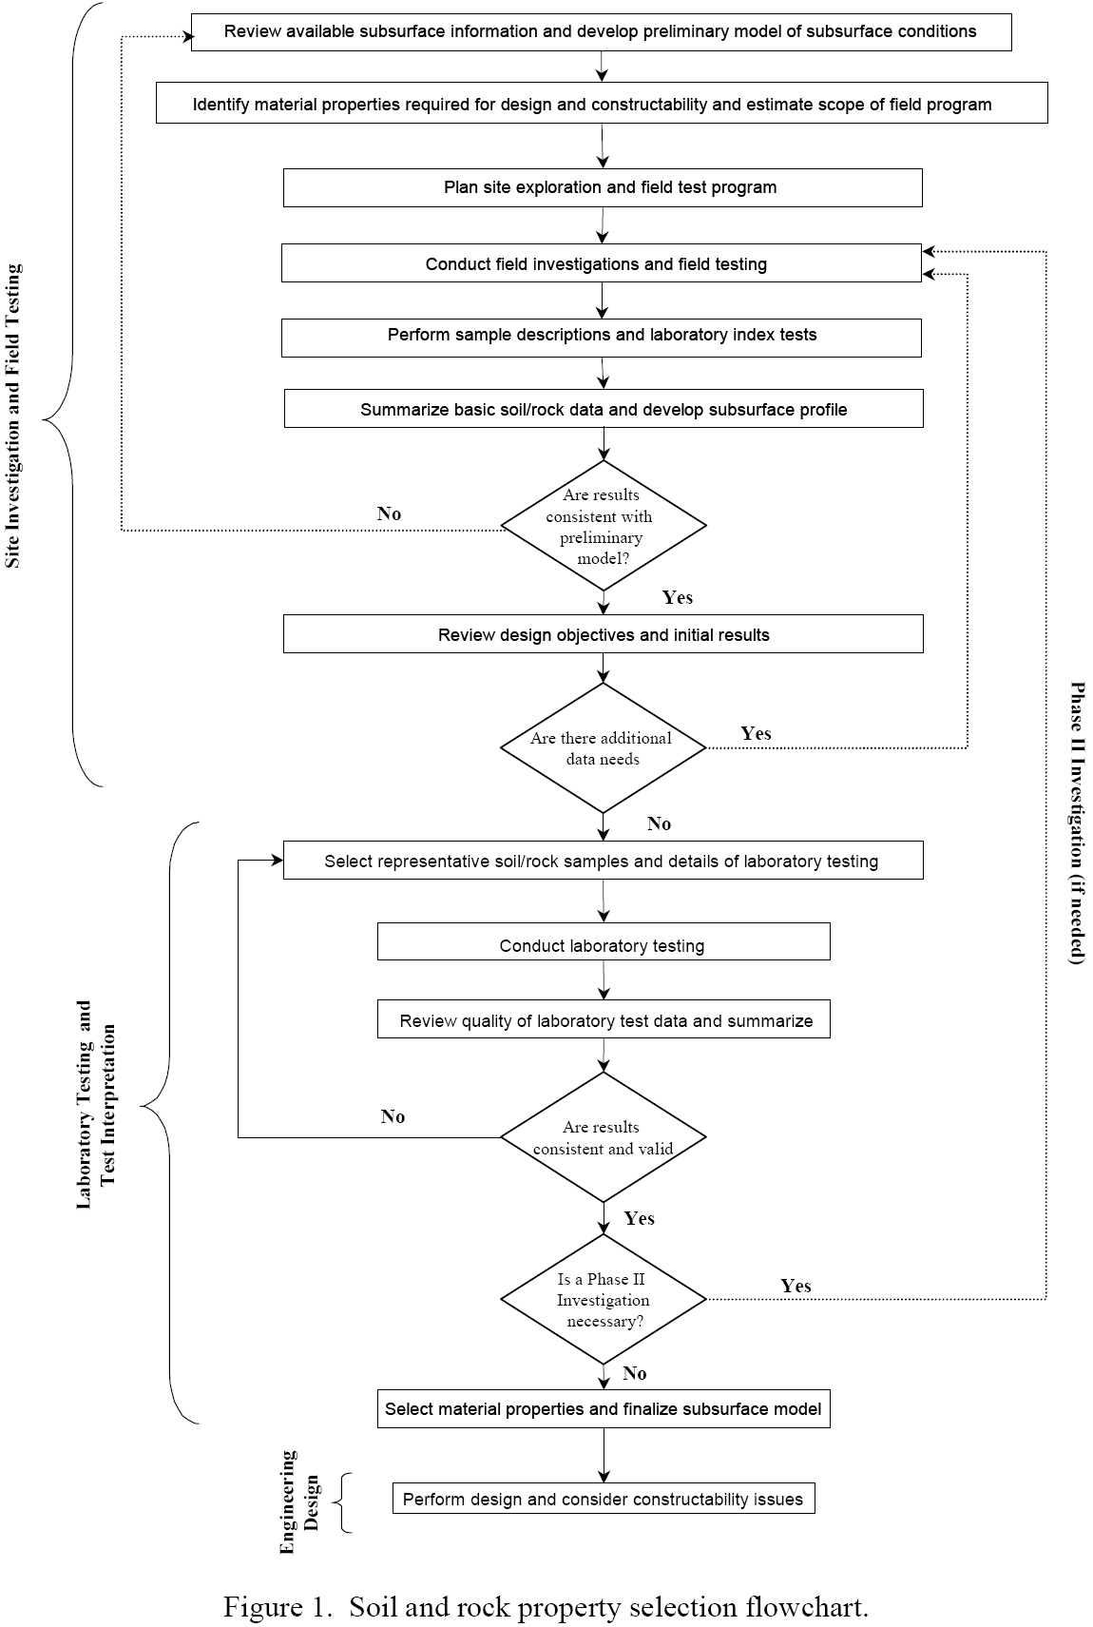
Figure 300-1. Soil and rock property selection flowchart (FHWA-IF-02-034, page 5)

Structures
Plans for bridges, retaining walls, and other structures showing:
- Topography of the site
- Plan view of structure showing proposed alignment and the location of proposed foundations
- A general location map showing the structure location with respect to existing roads and streets

Geohazards
Plans for remediation of geohazards, including landslides, rockfall, mines, and karst, are typically developed after the subsurface exploration. Perform a complete survey of the site, including topography and location of roadway and geohazard features, as soon in the planning process as possible. Depict this survey on a stationed plan view and closely spaced cross sections.

Office Reconnaissance
Review the Project Initiation Package (PIP) prepared for the project. In addition, consider all of the resources listed in Section 302.2.1 as part of the office reconnaissance. The level of effort expended on this review is established by the size and complexity of the project. However, regardless of the size of a project, some review must take place prior to the field reconnaissance.

Literature Search
Conduct a literature search of the soil and geologic conditions of the project. Provide a comprehensive review of all existing information available for the study area. Much of this information is available electronically, and can be readily incorporated into base mapping for presentation. It is assumed, based on the project type, that not all reference materials listed herein may be applicable for use. Consider the following resources, but do not limit the search to only these:

Information from ODOT
- Plan views, profiles, and cross-sections of previous projects
- Construction diaries and inspection reports
- Documented changes to the plans during construction activities (e.g., slope, spring drains)
- Maintenance records
- Boring logs, geotechnical profiles, structure foundation exploration plans or other project related documents on file with the Office of Geotechnical Engineering (can be obtained at Geotechnical | ODOT TIMS (state.oh.us) or the District
- Environmental subsurface explorations on record with the Office of Environmental Engineering or the District
- History and occurrence of landslides
- History and occurrence of rockfalls
- Pile driving records from the respective District or from the Office of Geotechnical Engineering

ODNR Division of Geological Survey
- Boring logs on file
- Measured geologic sections
- Bedrock Geology Maps
- Bedrock Topography Maps
- Bedrock Structure Maps
- Geologic Map of Ohio
- Quaternary Geology of Ohio
- Known and Probable Karst in Ohio
- Bulletins
- Information Circulars
- Report of Investigations
- Location and information on underground mines
- Location and characteristics of karst features
- Landslide Maps

ODNR Division of Mineral Resource Management
- Applications and permits files for surface mines (coal & industrial mineral)
- Active, reclaimed or abandoned surface mines
- Abandoned Mine Land (AML) sites
- Emergency Projects

ODNR Division of Water Resources
- Water well logs
- Ohio Wetland Inventory Maps
- Maps Identifying the presence of lake bed sediments, organic soils or peat deposits

Other Sources
- Aerial photographs
- National Wetland Inventory Maps (USFWS)
- Satellite imagery
- Soil Surveys (USDA NRCS)
- USGS quadrangles
- USGS publications and files
- City and County Engineers
- Academia with engineering or geology programs
- USGS Open File Map Series #78-1057 “Landslides and Related Features”

Field Reconnaissance
Observe the following features during the field reconnaissance. Record GPS coordinates of all notable features – see Section 303.2.

Existing Pavements
Identify and document the condition of existing pavements, noting the locations of wet or pumping subgrade or poorly performing pavement.

Existing Structures
Identify and document the condition of existing structures, noting signs of distress and the impact of any existing structure on the exploration or the proposed construction.

Embankments
Identify and document the condition of existing embankments, noting evidence of either general or differential settlement, erosion, localized sags, or slope failures.

Drainage
Identify and document the general drainage capability of soils, the location of springs and seeps, and the extent of poorly drained areas, wetlands, swamps, bogs, and ponds. Identify and document the condition and functionality of existing drainage features and systems relative to performance of geotechnical structures and earthwork.

Landslides
Identify and document evidence of dormant or active landslides, their locations and limits, and landslide topography in general. Note all surface cracks, scarps, toe bulges, and other indications of landslide activity.

Bedrock Exposures
Identify and document the limits of bedrock exposures and the types and vertical intervals of bedrock exposed. If possible, note the strike and dip of the bedrock. Note rock fall hazards along existing alignments.

Dumps
Identify and document the limits and general composition of rubbish, debris, and other waste fills or waste pits. If during reconnaissance, any materials such as, but not limited to, drums, tanks, or stained earth or any unusual odors are encountered, discontinue geotechnical exploration work and notify the District Geotechnical Engineer immediately. The site will be considered to contain hazardous or toxic material and must be handled in accordance with ODOT policy.

Mining
Identify and document the limits and status of surface or underground mining, quarrying, reclaimed areas, or other excavation operations. Note any evidence of mining operations, spoil piles, mine water discharge, and possible mine subsidence features. Refer to the ODOT Manual for Abandoned Underground Mine Inventory and Risk Assessment for additional guidance.

Soft Soils
Identify and document the limits of compressible or low strength soil, such as peat or soft clay that will affect settlement, embankment stability or foundation support.

Water Crossings
Identify and document the condition of foundations of existing structures, noting any settlement, scour, streambed and bank composition, and channel migration (erosion or sedimentation). Contact the District Bridge Engineer for bridge inspection information.

Land Usage
Identify and document the current land usage. Categories of land usage include but are not limited to agricultural, wooded, residential, rural residential, commercial, and industrial.

Karst
Identify and document ground surface features that may be related to karst formations, for karst prone areas.

PLANNING

General
For ODOT projects, a typical geotechnical exploration includes drilled borings. Therefore, references made in this specification for the development of a geotechnical exploration program are for a drilled boring program, except as noted. Other methods of subsurface exploration are available, as discussed in Section 400, and may provide useful and efficient design data in conjunction with or in place of borings. Contact the District Geotechnical Engineer for review and approval of any geotechnical exploration program that utilizes a method other than borings.
Planning of a geotechnical exploration program cannot be prescribed by simple guidelines to fit all conditions. However, follow the guidelines given in this section whenever practical. Evaluate a project considering its specific geological conditions, the proposed work, and existing subsurface information. Selectively locate borings for development of maximum subsurface information, using a minimum number of borings to achieve that end. Also consider topography, geologic origin of materials, surface manifestation of soil conditions, and any special design considerations when determining the spacing and depth of the borings. Locate the borings to provide adequate overhead clearance for equipment, adequate clearance of underground utilities, minimum damage to private property, and minimum disruption of traffic, without compromising the quality of the geotechnical data.
When office reconnaissance discloses historic geotechnical exploration(s), utilize this information to the fullest extent possible. As subsurface information becomes available during progression of the boring and sampling program or if the alignment or locations of the roadway or structures change during the project development, review the locations of the borings; consider increasing or decreasing the number of borings initially considered or moving borings to more strategic locations.
If during the planning stage, any materials such as, but not limited to, drums, tanks, or stained earth or any unusual odors are encountered, discontinue geotechnical exploration work and notify the District Geotechnical Engineer immediately. The site will be considered to contain hazardous or toxic material and must be handled in accordance with ODOT policy.
All references to blow counts for determination of boring depths refer to the N₆₀ value – see Section 404.
All boring plans must be submitted to the District Geotechnical Engineer and approved before beginning the boring, sampling, and field testing task. Submit a scaled boring plan, showing all project and historic borings, and a schedule of borings in tabular format. In the schedule of borings, present the following information for each boring:
- exploration identification number
- location by station and offset
- estimated amount of rock and soil. Also show the total of each for the entire program.

Exploration Identification Number
Survey and record all exploration (borings, probes, test pits, etc.) locations according to the ODOT Survey & Mapping Specifications. See Survey & Mapping Specifications Section 300 for Datum and Coordinate Systems and Section 400 for precision requirements. Determine the station and offset of all explorations. For geotechnical documents and reports, report exploration locations in geographic coordinates (Latitude and Longitude) shown as decimal degrees to six decimal places. Report all stations and offsets to the whole foot and elevations to one decimal place.
Assign each exploration with an identification number, unique within a project, according to the following format:
X-ZZZ-W-YY, where:

“X” designates the method of geotechnical exploration, using:

B – Drilled boring
C – Static cone
D – Dynamic cone
T – Test pit
H – Hand auger
X – Other (use for pavement cores)

A pavement core by itself is not a subsurface exploration method, and therefore, do not number borings and pavement cores consecutively such as B-001-0-20, X-002-0-20, B-003-0-20, etc. Use a completely separate numbering sequence for pavement cores only.

Use “ZZZ” and “W” to identify an exploration location within a particular geotechnical exploration program. The primary set of numbers, “ZZZ”, begins at 001 for each project and continues consecutively in the cardinal direction. Show all three digits, including leading zeroes. The secondary number, “W”, designates explorations located between, or offset from, consecutively numbered explorations. For the first exploration with a particular primary number, assign the number zero for “W.” Use the numbers 1 through 9 for “W” for additional explorations offset from the first or located between consecutively number explorations. For example, explorations located between B-005-0 and B-006-0 are designated B-005-1, B-005-2, etc.
Use “YY” to designate the year that the geotechnical exploration program began. Note that this is not necessarily the year that the exploration was performed. A boring planned in 2007 but drilled in 2008 will use “07”, such as B-005-0-07. The numbers “YY” may be used to distinguish between different phases of geotechnical exploration performed several years apart.
Do not repeat primary and secondary combinations. For example, B-005-0-07 and C-005-0-07 should not exist on the same project. Instead use B-005-0-07 and C-005-1-07 or C-006-0-07. For another example, B-004-0-11 and B-004-0-13, drilled as part of different phases of geotechnical exploration, should not exist on the same project. Instead use B-004-0-11 and B-004-1-13 (if the latter boring was drilled between explorations 4 and 5).
Either “W” or “YY” or both may be omitted in references to the explorations, such as in reports or drawings, so long as the omission will not cause any confusion. If omitted, “W” is assumed to be zero and “YY” is assumed to be the year of the current geotechnical exploration program.
For example:
Exploration Identification Number: B-014-1-07
A drilled boring located between explorations 14 and 15. Part of a geotechnical exploration program planned in 2007.

Exploration Identification Number: T-004
A test pit that was performed as part of the current geotechnical exploration program.

When referring to historic explorations that did not use the above identification scheme, assign an exploration identification number that is similar to the original identification number, using the following guidelines and examples.
Use the first letter of the original exploration identification for “X” and the original number for “ZZZ”. If the original exploration identification number includes a secondary letter after the primary number, such as B-3A, use the secondary letter for “W” (for example, B-003-A), otherwise use zero for “W”. Use the year of the geotechnical exploration program for “YY”. The year the exploration was performed may be used for “YY” if the year the project was planned is not known. When assigning exploration identification numbers to historic explorations, duplicate numbers are acceptable, so long as the first letter, “X”, is different. For example, R-003-0-69 and S-003-0-69 may exist on the same project.
Table 300-1. Examples of Exploration Identification
Numbers For Historic Explorations.
Original  Boring  Identification | Year of  Original  Boring | New Exploration  Identification Number
B-1 | 1969 | B-001-0-69
S-5B | 1969 | S-005-B-69
B-24A | 1997 | B-024-A-97
P-27 | 1997 | P-027-0-97
EB-56 | 2000 | E-056-0-00
NB-56 | 2000 | N-056-0-00

Borings for Evaluation of Existing Pavement Subgrade (Type A)
For projects involving rehabilitation or widening of existing pavement, and where the proposed subgrade will not vary from existing subgrade by more than 3.0 feet, locate borings based on the proposed pavement work as follows:

If the proposed pavement work consists of replacing or rubblizing the existing pavement only, drill 100 percent of the borings through the existing pavement.

If the proposed pavement work involves adding a lane, along with replacing or rubblizing the existing pavement, drill 50 percent of the borings through the existing pavement and 50 percent of the borings in the planned widened area.

If the proposed pavement work involves adding a lane without replacing or rubblizing the existing pavement, drill 100 percent of the borings in the planned widened area.
Where subsurface conditions are considered uniform, space the borings a maximum of 400 feet apart, including one boring at the beginning of the project and one boring at the end of the project. Place borings closer than 400 feet as necessary to identify non-uniform or problematic conditions. Offset borings from the centerline or baseline as needed to obtain representative samples of the subgrade that will be encountered during construction. Locate borings to explore poorly performing pavements and the presence of wet or soft subgrade conditions when field reconnaissance indicates their potential existence. Do not rely solely on historic borings to evaluate subgrade conditions.
Extend borings 6 feet below proposed top of subgrade or below existing grade, whichever is lower in elevation. Extend borings through any soft or loose soil into stiff or medium dense soil.
Perform continuous Standard Penetration Test sampling for the 6-foot (2-meter) interval immediately below proposed top of subgrade.
Mainline borings drilled through the pavement may be used to represent the shoulder subgrade when evaluating shoulders for maintenance of traffic.

Roadway Borings (Type B)
For projects involving a new horizontal alignment or where the existing vertical alignment will change by more than 3.0 feet, locate borings as near as practical to the centerline or baseline of the proposed roadway except where surface or subsurface conditions disclose variable conditions. Locate borings to disclose the nature of subsurface materials at the deepest points of cuts, areas of transition from cut to fill, and foundation areas beneath the points of highest embankment.
Where subsurface conditions are considered uniform, space the borings a maximum of 400 feet apart, including one boring at the beginning of the project and one boring at the end of the project. Place borings closer than 400 feet as necessary to identify non-uniform or problematic conditions. Consider all the proposed routes and ramps of the project, utilizing boring locations that contribute to more than one alignment whenever possible.
Extend borings to a depth of 10 feet below proposed grade or existing ground surface, whichever is lower in elevation, unless bedrock is encountered at a shallower depth or unless noted otherwise. In areas where soft or loose soils are encountered, extend the borings 5 feet into stiff or medium dense soils, with a minimum boring depth of 10 feet, or to bedrock, whichever is encountered first.
Perform Standard Penetration Test sampling at 2.5-foot intervals unless noted otherwise. Obtain representative undisturbed samples when appropriate.

Embankment Foundations (Type B1)
Determine the maximum height of embankment by measuring vertically from the existing ground line to the proposed ground line. Locate borings to disclose the nature of subsurface materials beneath the points of highest embankment. Where weak or compressible soils are encountered and stability or settlement problems are anticipated, locate borings transverse to centerline or baseline, as required to establish the lateral extent of such conditions beneath the full width of the proposed embankment. Obtain additional borings along the alignment to define the problem limits as necessary. At bridges, the abutment borings may be used to explore the approach embankment foundations.
Extend borings to a minimum depth equal to the height of the embankment or 10 feet, whichever is greater, of which the last 10 feet must be in stiff or medium dense soils. Terminate the boring if bedrock is encountered.
Obtain samples at maximum 5-foot intervals below 20 feet.

Cut Sections (Type B2)
Determine the maximum depth of cut by measuring vertically from the existing ground line to the proposed ground line. Locate borings to disclose the nature of subsurface materials at the deepest points of cuts. Locate a minimum of one boring on centerline or baseline where the depth of cut is relatively uniform in the cross section. Obtain offset borings if soft, loose, or wet soils are encountered and stability of the cut slopes is a concern.
Extend borings in stiff or medium dense soil to a minimum depth of 10 feet below the proposed grade.
In cut sections involving bedrock, core bedrock to a depth of 10 feet below the proposed excavation at maximum intervals of 1000 feet. These borings will typically be located at the back of the ditch line at the points of deepest cut. Where major changes in the geology or lithology occur, reduce the interval to establish the limits of these changes. Keep in mind that more severely weathered and deteriorated rock conditions are typically encountered on the sides and ends of a hill as compared to the middle. Keep the amount of rock core utilized in developing the stratigraphic column of bedrock to a minimum. Supplement borings that core bedrock with soil borings that extend to the top of bedrock spaced a maximum of 400 feet apart, in order to develop the elevation of the bedrock surface and the nature of the soil overburden throughout the cut. Complete mapping of all bedrock exposures within the project limits to augment the proposed boring plan.

Sidehill Cut Sections (Type B3)
Where the slope and the thickness of soil overburden are relatively uniform in the cross section, and the depth of cut is significantly greater on one side of centerline or baseline than on the other, locate borings as follows:

Locate one boring in the back of the proposed ditch line area on the uphill side. Locate an additional boring on the uphill side, at a point where it is anticipated the backslope will intersect the ground line. If the horizontal distance between borings is inadequate to define subsurface conditions, or in the case where irregular slope, talus, or residual cover is encountered, obtain one or more intermediate borings as necessary.
Extend upper borings to depths sufficient to vertically overlap the adjacent lower boring by at least 10 feet. Where the depth of cut exceeds 35 feet with at least half the interval anticipated being through bedrock, extend the upper borings to depths sufficient to provide at least 10 feet of vertical overlap in bedrock between adjacent borings.

Where the slope is irregular or the overburden is estimated to be non-uniform in thickness, obtain additional borings on the downhill side in the proposed ditch line area.

Obtain additional borings as necessary to determine the profile of top of bedrock or variability of soil type.

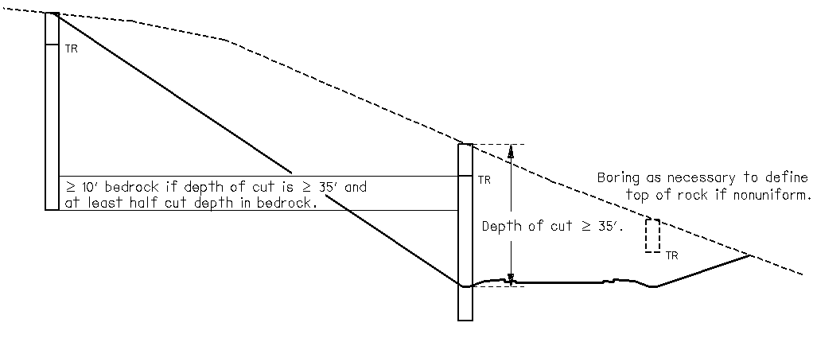
Figure 300-2. Example boring layout in cross section for sidehill cut section.

Sidehill Cut-Fill Sections (Type B4)
Where the slope and the thickness of soil overburden are relatively uniform in the cross section, and where one side of the centerline or baseline requires excavation and the other side requires fill, locate borings as follows:

Where the depth of cut exceeds 10 feet, regardless of the embankment height, locate and drill borings according to Section 303.4.3 to explore the cut.

Where the maximum height of embankment at the outer edge of shoulder is 5 feet or less, obtain one boring on the centerline or baseline, in addition to any borings drilled in the cut section.

Where the maximum height of embankment is between 5 and 10 feet, obtain one boring at the outer edge of shoulder in the embankment section, in addition to any borings drilled in the cut section.

Where the maximum height of embankment exceeds 10 feet, locate the borings in the embankment section according to Section 303.4.5, in addition to any borings drilled in the cut section.

Sidehill Fill Sections on Unstable Slopes (Type B5)
Where embankment fill will be placed on slopes with signs of sloughing or sliding, obtain a minimum of two borings on the downhill side. Locate one boring at the point where a 1:1 slope from the proposed pavement edge intercepts the ground line and locate the other where the proposed embankment slope intercepts the ground line. If the horizontal distance between borings is inadequate to define subsurface conditions, or in the case where irregular slope, talus, or residual cover is encountered, obtain one or more intermediate borings.
Extend borings 10 feet into stiff or medium dense soils below what is considered to be unstable material. Where bedrock is at a shallow depth, extend the lower borings to a depth of 10 feet into bedrock and extend the upper borings to depths as required to define a complete stratigraphic column continuous with the bedrock penetrated by the lower boring.
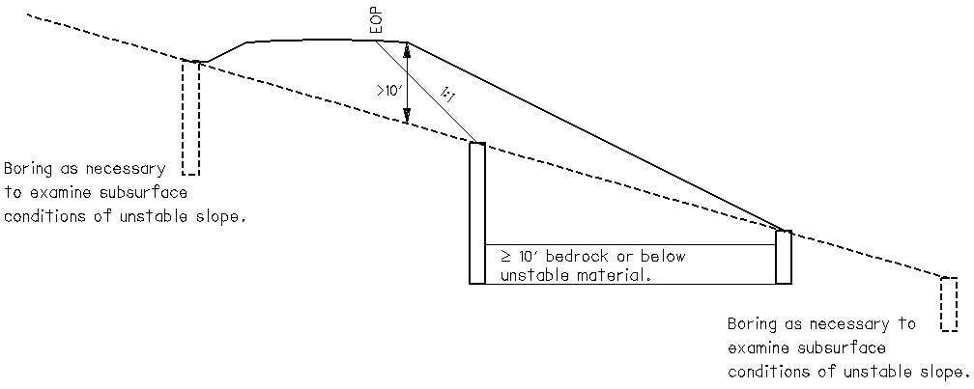
Figure 300-3. Example boring layout in cross section for sidehill fill greater than 10 feet and sidehill fill on unstable slope.

Geohazard Borings (Type C)
Locate borings within the limits of known or suspected geohazards to identify the vertical and lateral extents of the problematic condition(s). Additional borings may be drilled immediately outside the geohazard limits to confirm the lateral extent. Boring locations, spacings, and depths must be determined based on the known or suspected conditions of the geohazard, subsequent to field and office reconnaissance. Consider other exploratory methods as detailed in Section 406, where appropriate.
Perform continuous Standard Penetration Test sampling unless noted otherwise. Obtain representative undisturbed samples where appropriate.

Lakes, Ponds, and Low-Lying Areas (Type C1)
Identify lakes, ponds, and low-lying areas where wet surface soils occur, where wetland or swamp conditions exist, or where no functioning drainage outlet can be observed. Determine the depth of lakes and ponds and the thickness of muck. Determine the thickness of soft surface soils in wetlands and low-lying wet areas. Methods of disturbed sampling other than Standard Penetration Test and undisturbed sampling may be considered. Comply with applicable regulations related to wetlands.

Peat Deposits, Compressible Soils, and Low Strength Soils (Type C2)
Locate borings to identify the vertical and lateral extents of areas of peat deposits, compressible soils, and low strength soils, where significant consolidation or danger of shear failure is considered possible. Consider geophysical or cone penetrometer testing to replace borings to the extent that it is cost effective. See Section 406 for additional information regarding other exploratory methods.

Uncontrolled Fills, Waste Pits, and Reclaimed Surface Mines (Type C3)
Locate borings within the limits of uncontrolled fills, waste pits, and reclaimed surface mines to determine the composition and extent of the fill and character of the underlying natural soils. Locate borings transverse to centerline or baseline as required to establish the lateral extent of such conditions beneath the full width of the proposed embankment. Extend borings through rubbish, debris, scrap, waste materials, clean fill soils, or other artificial fill materials, through underlying soft soils, and into stiff or medium dense soils or bedrock. Comply with all environmental regulations.

Underground Mines (Type C4)
Where the roadway crosses areas of known or possible underground mining, locate borings transverse to centerline or baseline as necessary to establish the lateral extent of mining conditions. Consider surface features, geology, and mine records in determining boring locations. Use geophysical techniques, where appropriate, with drilling, as part of a comprehensive exploration program. Each program exploring underground mines must be tailored for the specific project and site conditions. Contact the District Geotechnical Engineer immediately if a void and/or tool drop is encountered in any boring. Do not attempt to seal the borehole unless directed to do so by the District Geotechnical Engineer.
For a preliminary boring program, extend borings to 5 to 20 feet below the lowest known mined interval. Obtain enough information to determine the presence or absence of minable seams and voids, to define the vertical and lateral extent of the seam including its strike and dip, to determine mining impacts, and to determine the phreatic water surface and water quality of each minable seam.
Additional borings may be needed to explore voids or other anomalies encountered in the preliminary borings. For subsequent explorations, extend borings to 5 feet below the lowest known mined interval. Use angled borings, if necessary, when exploring shafts or other slope entries or consider geophysical techniques. Refer to the ODOT Manual for Abandoned Underground Mine Inventory and Risk Assessment for additional guidance.

Landslides (Type C5)
Locate borings within the top, middle and bottom of the landslide area, or as near to these locations as practical. Obtain additional offset and longitudinal borings to define the landslide limits and the bedrock surface as necessary, considering the anticipated remediation. Extend borings through overburden soils and into bedrock. If bedrock is known to be very deep, extend the borings at least 30 feet below the estimated failure surface.
If bedrock is encountered, sample a minimum of 10 feet of bedrock at each boring location. Adjust boring spacing and location, bedrock coring, and boring depth per Section 303.7.4 if the landslide repair will involve a retaining wall.
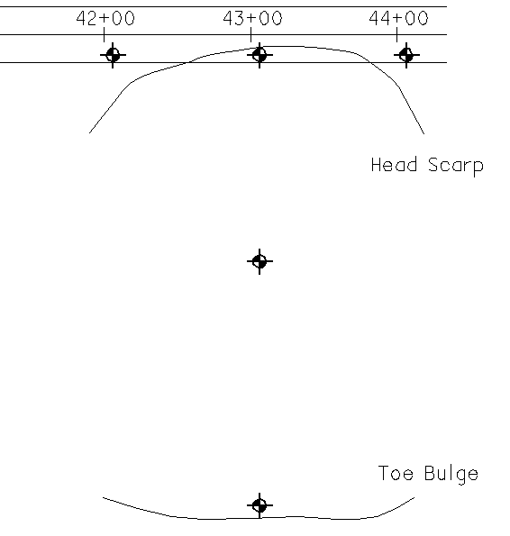
Figure 300-4. Example boring plan for a landslide exploration.

Rockfall (Type C6)
Refer to Section 303.4.2 with the exception that the mapping of existing bedrock exposures becomes the primary method of exploration with the proposed boring plan used to augment the mapping.

Karst (Type C7)
Subsurface karst features are best explored using both boring and geophysical testing methods. Contact the District Geotechnical Engineer if karst features are suspected.

Proposed Underground Utilities (Type D)
Locate borings as near as practical to the centerline of proposed underground utilities to disclose the nature of subsurface materials and determine whether the required excavation will be in soil or bedrock.
Where subsurface conditions are considered uniform, space the borings a maximum of 600 feet apart, including one boring at the beginning of the excavation and one boring at the end of the excavation. Place borings closer than 600 feet as necessary to identify non-uniform or problematic conditions.
Extend borings to a depth of 3 feet below the depth of any proposed underground utilities. Drill borings deeper if significant sheeting or shoring is required.
Perform Standard Penetration Test sampling at maximum 5.0-foot intervals. Obtain representative undisturbed samples when appropriate.

Structure Borings (Type E)
Locate borings within the limits of the proposed substructure elements. Locate borings initially to provide adequate information for the design of the complete substructure unit. If the initial data does not reveal sufficient information to define the subsurface conditions relative to structural support and performance, or if the structure location or concept is changed, obtain additional borings.
Exceptions to the boring depths specified in this section may be made if the size and type of structure or subsurface conditions warrant. Extend borings through any unsuitable or questionable foundation materials into stiff or medium dense soil or into bedrock to sufficient depth where the loads imposed by the structure do not significantly affect settlement. As a general rule, carry borings to such depths that the net increase in soil stress under the load of the structure is less than 10 percent of the effective soil stress at that depth, unless hard or dense soils or bedrock are encountered first.
Unless noted otherwise, obtain samples in structure borings at 2.5-foot intervals to a depth 20 feet below the proposed footing elevation. Obtain samples below this depth at maximum 5-foot intervals. For scour sampling requirements, see Section 303.7.1.

Where bedrock is exposed within or near the limits of the proposed structure, determine the bedrock surface elevation and the horizontal and vertical limits of the exposed bedrock by survey methods. Determine the type of bedrock by visual inspection at the site of the exposure.

Scour Sampling
For foundation elements subject to scour, obtain continuous samples for a depth of 6 feet as described below, and perform a complete classification in accordance with Section 603 on each sample.
When sampling at abutments, start scour sampling at ground surface elevation at the face of the abutment. When sampling at any other location, start scour sampling at the ground surface.

For a single span bridge, scour sample only at abutments.

For a short multi-span bridge, scour sample both at the abutments and in the stream channel. A short multi-span bridge can be defined as having 2 to 3 spans, with one or more pier located within the limits of the stream channel, and none located in the overbank areas.

For a long multi-span bridge, scour sample at abutments, in the stream channel, and in overbank pier areas. A long multi-span bridge can be defined as having 2 spans or more, with one or more pier(s) located within the limits of the overbank areas.

For a major river crossing, scour sample at every substructure.
Do not perform scour sampling at substructure locations outside of the limits of the 500-year flood.
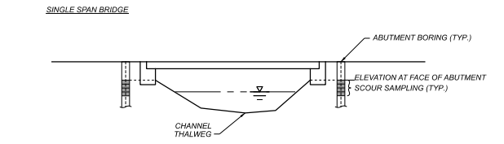
Figure 300-5A. Scour Sampling for Single Span Bridge.
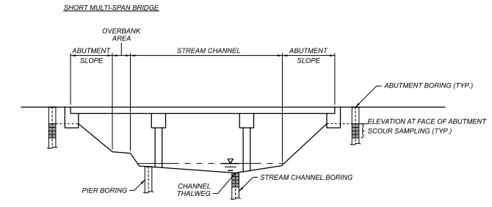
Figure 300-5B. Scour Sampling for Short Multi-Span Bridge.
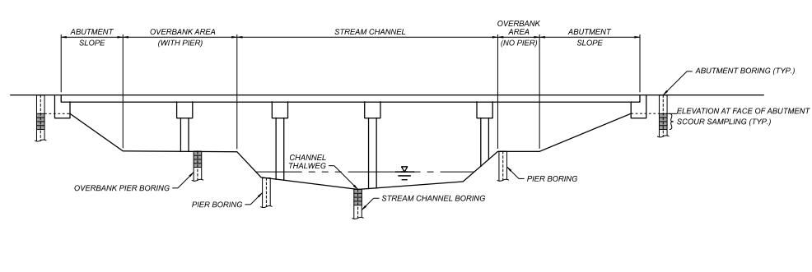
Figure 300-5C. Scour Sampling for Long Multi-Span Bridge.

Bridges (Type E1)
Obtain a minimum of one boring for each substructure unit. For substructure units over 100 feet in width, obtain a minimum of two borings. Consider twin parallel structures as one structure, unless site conditions dictate that they should be considered as individual structures. If the initial data does not reveal sufficient information to define the subsurface conditions, obtain additional borings. Where the bedrock surface varies significantly, additional borings may be required to adequately define the subsurface conditions.
Extend borings for bridges in soil through soft or loose soil and 30 feet into hard or dense soils requiring not less than 30 blows per foot. Extend borings in soil to depths not less than 30 feet but no greater than 100 feet below the proposed footing elevation.
Where bedrock is encountered above the proposed footing elevation, core bedrock to a depth of 5 feet below the proposed footing elevation. Where bedrock is encountered below the proposed footing elevation, core a minimum of 10 feet of bedrock. Core additional (deeper) bedrock if drilled shafts are being considered.

Culverts (Type E2)

(Type E2a) For three-sided culverts, and pipe culverts or box culverts with a planned diameter or span greater than 10 feet , obtain two borings at opposite corners, one each near the proposed inlet and outlet. Extend borings through soft or loose soil and 20 feet into soils requiring not less than 20 blows per foot. Extend borings in soil to a minimum depth of 30 feet below the bottom of the culvert, or 5 feet into bedrock, whichever is less. Scour sampling and testing are not required for pipe culverts and box culverts.

(Type E2b) For pipe culverts or box culverts with a planned diameter or span less than or equal to 10 feet and planned full height headwalls, locate embankment borings at the proposed culvert to define the subsurface conditions. No additional borings are required. If no embankment borings are planned, such as for a culvert replacement, obtain two borings at opposite corners, one each near the proposed inlet and outlet, each to a depth of 20 feet below the invert elevation of the culvert or to auger refusal on bedrock, whichever is shallower. If auger refusal is encountered above the stream bed, core bedrock to the elevation of the stream bed. Scour sampling and testing are not required for pipe culverts and box culverts. Do not drill borings for a culvert with planned half-height headwalls or a pipe culvert with a planned diameter less than 5 feet.

(Type E2c) For culverts of any size that will be bored and jacked or tunneled, obtain a minimum of two borings, one each near the proposed inlet and outlet. Obtain additional borings as needed to define all materials to be penetrated by boring and jacking or tunneling.

For any culverts with a planned span greater than 20 feet, obtain borings per Section 303.7.2.

Retaining Walls (Type E3)
Obtain borings for retaining walls along the proposed wall alignment. Obtain a minimum of one boring for each retaining wall. For walls over 100 feet in length, obtain a minimum of two borings. For walls over 300 feet in length, space borings a maximum of 150 feet apart. Obtain additional borings as required for stability considerations for walls above or below slopes.
Where two retaining walls will be placed back-to-back within 100 feet of each other, such as an elevated ramp, alternate the boring locations between the two walls and space the borings approximately 150 feet apart.

(Type E3a) For retaining walls 8 feet high or less, extend the borings below the bottom of the wall face to a depth of twice the height of the wall, including bedrock coring as necessary.

(Type E3b) For retaining walls more than 8 feet high, extend the borings as follows.

For borings in soil, extend the borings below the estimated bottom of the wall face through soft or loose strata 20 feet into very stiff or medium dense soils requiring not less than 16 blows per foot, or having an estimated undrained shear strength >2.0 ksf, but not less than 1.5 times the wall height.

For borings that encounter bedrock above the estimated bottom of the wall face, core bedrock to a depth of 10 feet below the estimated bottom of the wall face.

For borings that encounter bedrock below the estimated bottom of the wall face, extend the boring 10 feet into bedrock.

For retaining walls which have a drilled-in foundation, such as soldier pile and drilled shaft wall types, extend the borings to a depth below the bottom of the wall face equal to the wall height whether bedrock is encountered or not.
If the proposed wall is to include permanent tiebacks or soil nails, obtain additional borings to determine the subsurface conditions in the anchor zone. Locate borings at a distance 1.0 to 1.5 times the wall height behind the proposed wall (anchor zone may be further behind wall depending on the subsurface conditions and backslope – adjust boring locations accordingly) and at the same spacing as the borings located along the wall alignment. Extend the additional borings to the same elevation as the bottom of the borings located along the wall alignment.

Noise Barrier (Type E4)
Obtain borings for noise barrier foundations along the proposed barrier alignment, or as close as practical without compromising the quality of the geotechnical data. Space the borings approximately 200 feet apart. Extend borings to depths of 25 feet or 5 feet into bedrock, whichever is less. Obtain samples at 2.5-foot intervals for the entire depth of the boring.

CCTV, Overhead Signs, and High Mast Lighting Towers (Type E5)
In most cases, additional borings for CCTV tower, overhead sign structures, and light tower foundations are not necessary, as the project and/or historic borings for the nearby roadway and structures are sufficient for the design of the foundations. Refer to GDM Section 1200 for the design of these foundations. When additional borings are necessary, extend borings to depths of 25 feet or 5 feet into bedrock, whichever is less. Obtain samples at 2.5-foot intervals for the entire depth of the boring.

Buildings and Salt Domes (Type E6)
Drill a minimum of two borings for each building or salt dome less than 100 feet in length, width, or diameter. Locate borings along the perimeter of the proposed structure. Drill additional borings spaced approximately 100 to 150 feet apart if the dimensions of the proposed structure are greater than or equal to 100 feet. Extend borings a minimum of 10 feet below the anticipated foundation depth for lightly loaded buildings, such as maintenance garages. Extend borings a minimum of 20 feet below the anticipated foundation depth for heavily loaded structures and salt domes. Terminate the boring if bedrock is encountered below the footing elevation. Additional borings or deeper borings may be needed if soft or organic soils, shallow bedrock, or uncontrolled fills are encountered at the site.

METHOD OF PAYMENT
Reconnaissance and Planning is an engineering service to be performed and paid for according to the engineering agreement and the Specifications for Consulting Services. The method of compensation will be actual cost plus a net fee.

BORING, SAMPLING, AND FIELD TESTING

GENERAL
Perform the work in a manner to promote the greatest accuracy in results, efficiency in execution, safety of life, protection of property, and according to the directions and to the satisfaction of ODOT and the Consultant. Refer to “Geotechnical Engineering Circular No. 5, Geotechnical Site Characterization,” FHWA NHI-16-072, for state of the practice information regarding boring, sampling, and field testing.

Schedule of Borings
Prepare a complete boring schedule prior to proceeding with the borings. For each boring, provide a reference to centerline or baseline, planned depth, sampling frequency, and any planned in-situ testing – subject to approval by the District Geotechnical Engineer. Schedule borings so as to minimize delays and moving of drilling equipment.

Inspection and Supervision
The Consultant is responsible for the inspection and supervision of the boring and sampling as it is being performed. The use of faulty equipment or improper procedures is not permitted. Failure to correct faulty equipment or improper procedures is cause for stopping the work.

Field Location of Test Borings
The Consultant is responsible for placing necessary staking on a project site. Identify the location of test borings for roadway, bridges, retaining walls, or other purposes on the ground by a stake showing boring exploration identification number.

Access
Access to the project site will be as stipulated in the ODOT Specifications for Consulting Services. Prior to entry on private property, coordinate right of entry with the District. If access to private property is denied, notify the District Production Administrator.

Permits
Obtain all necessary permits from government and private agencies. For work performed within ODOT right-of-way, complete Form MR 505 and submit to the District Permit Department.

Underground Installations
Determine the location of all underground installations such as gas lines, water lines, sewers, electrical cables, telephone cables, highway lighting, or other structures prior to performing the borings. Notify the appropriate owners of such installations of the work to be performed. Most utility owners can be contacted through the Ohio Utilities Protection Service (1-800-362-2764 or http://www.oups.org) and usually require at least two business days’ notice prior to commencing the work. Local municipalities or the ODOT District that own or maintain utilities may need to be contacted directly. Exercise caution to avoid damage to underground installations.

Operation on Navigable Waters
In cases where borings are to be performed within the limits of navigable waters, notify the authority having jurisdiction over such waters (the District Engineer of the U.S. Army Corps of Engineers; the United States Coast Guard; the port, river, or harbor authority; or any other applicable authority) of the proposed work. Obtain approval for entry on such waters and conform to any regulations of the governing authority.

Stream Gauges
At sites where borings are made from a barge, boat, or other piece of floating equipment, install an adequate stream level gauge and keep records of water surface elevations for determining accurate boring elevations. Furnish a reference elevation point necessary for proper setting of the gauge. Establish this point in accordance with the latest ODOT Survey Manual, as defined for low order spot elevations.

False Starts
If a boring cannot be completed due to encountering underground utilities, structures, or hazardous materials, the existence and location of which were not previously known, the boring will be considered a false start, for which payment will be made.

Abandoned Borings
Advance borings to the depths specified through whatever material is encountered, including boulders, fill, and other types of obstructions. No measurement or payment will be made for borings abandoned or lost before reaching the specified depth, except as provided for by false starts. Do not abandon any boring without first obtaining the approval of the District Geotechnical Engineer.

Cave-ins and Voids
If, while drilling borings, cave-ins or voids are encountered in the soil or bedrock, including at a possible mine or karst location supporting existing roadways, contact the District Geotechnical Engineer. Take care to prevent cross-hole communication, artesian flow of groundwater from the void, or any other potential dewatering.

Hazardous and Toxic Materials
If during drilling operations, any materials such as, but not limited to, drums, tanks, or stained earth or any unusual odors are encountered, discontinue geotechnical exploration work and notify the District Geotechnical Engineer immediately. The site will be considered to contain hazardous or toxic material and must be handled in accordance with ODOT policy.

Damage to Property
Perform the operations in such a manner to minimize damage. Repair any damage and restore the premises to the conditions initially encountered as much as practical.
Report property damage within one week of completing all work on the property. Use the property damage report in Appendix B to report damage and submit to the District Production Administrator. ODOT is not liable for damage to property when such damage is a result of negligence in the performance of the work.

Traffic Maintenance
Provide traffic control according to the Ohio Manual of Uniform Traffic Control Devices for the appropriate Typical Application Number for the site. This publication is available at Manuals & Design Standards | Ohio Department of Transportation.

Groundwater Determination
Measure and record the groundwater level in all borings drilled on land prior to adding drilling fluid, at the completion of drilling, and at other times as necessary. If more than one day is required to complete a boring, measure and record the depth of the boring at the end of each day and the groundwater level at the beginning and end of each day. No additional compensation will be made for groundwater determinations except when required for instrumentation.

METHODS OF ADVANCING BORINGS

Hand Operated Equipment
These types of equipment are portable, relatively easy to move, and can sample to relatively shallow depths either individually or in conjunction with multiple pieces of equipment. General types of hand operated equipment include, but are not limited to, hand augers, mechanical soil augers, and peat samplers. Refer to ASTM D 1452 for guidance on equipment and procedures for the use of earth augers in shallow geotechnical explorations.

Hand Auger
Hand augers are acceptable for obtaining disturbed samples of fine grained soils, free of larger gravels, cobbles, boulders, large rock fragments, or construction debris. This equipment can also be used in granular soils or saturated fine grained soils, but with limited effectiveness.
The equipment should be of a type that will retain the soil as it is cut with a minimum 2-inch (50 mm) diameter cutting head. The cutting head may be a bucket style, which retains the sample within the cutting head, or a screw style, which retains the sample on the auger flight.

Mechanical Auger
A mechanical auger is acceptable for obtaining disturbed samples of fine grained soils, free of larger gravels, cobbles, boulders, large rock fragments, or construction debris, above the piezometric surface. This equipment can also be used in granular soils or saturated fine grained soils, but with limited effectiveness.
The equipment is advanced using a continuous flight auger, with a power source at the end of the shaft. Power sources include, but are not limited to, hand-held drill, small hand-operated combustion or electric engine, or a portable drilling platform.

Peat Sampler
A peat sampler is acceptable for obtaining disturbed samples of saturated or very soft, fine grained soils or peat, free of larger gravels, cobbles, boulders, large rock fragments, or construction debris. The peat sampler can be used in conjunction with a hand auger or a mechanical soil auger to reach the desired sample depth prior to use.
The equipment consists of an open plate sampling head which is pushed into the undisturbed soils for the length of the sampling head. The sampler is then twisted 180º clockwise, cutting a sample core which is then retracted to the ground surface.

Other
Other forms of hand operated equipment such as, but not limited to, tripod with portable motorized cathead, probing rods, or retractable plug sampler, may be used with prior authorization from the District Geotechnical Engineer.

Rotary Drilling
This type of equipment employs either mechanical or hydraulic power from an integral motor or power take-off from the carrier vehicle. Rotary drills are equipped with an automatic hammer for drive sampling, hydraulic head, and a chain or cable pulldown for press sampling and coring. These drill rigs are available in truck-mounted, track-mounted, rubber-tired ATV-mounted, skid-mounted, or trailer-mounted. Use a calibrated automatic hammer, except for portable drilling equipment such as a skid rig. Other exceptions require prior authorization from the District Geotechnical Engineer. Air or water rotary drilling is permissible as long as the operation minimizes adverse impact to the surrounding formation. General types of rotary drilling are: continuous flight solid stem auger, hollow-stem auger, cased (concentric), and rotary wash (mud) drilling.

Continuous Flight Solid Stem Augers
This method is acceptable to determine the vertical sequence of fine grained soils relatively free of cobbles and boulders, and for obtaining disturbed or undisturbed samples. This method should not be used in soil formations where the boring walls become unstable when not supported.

Hollow Stem Augers
This method is acceptable to determine the vertical sequence of subsurface strata in materials relatively free of cobbles and boulders, and for obtaining disturbed or undisturbed samples. This method of drilling is acceptable for advancing the boring and recovering undisturbed samples, provided the inside diameter of the auger stem is large enough to permit recovery of 3-inch (75-millimeter) diameter or larger undisturbed samples.
Except in saturated sand, use a center plug when advancing the augers between sample intervals to limit soil cuttings from entering the hollow stem augers.

Cased (Concentric) Boring
This method is acceptable for all borings in soil and rock. Casings maintain an open drill hole, ensure maximum circulation of drilling fluid, and prevent foreign materials from falling into the hole. Use flush-joint casing for drilling or driving. Use commercial pipe with couplings only for driving. Telescoping casing may be used as long as the minimum size does not restrict sampling. Perform all sampling in advance of the casing shoe.

Rotary Wash (Mud) Drilling
This method is acceptable for advancing the boring, maintaining an open hole, and obtaining either disturbed or undisturbed samples, especially below the piezometric surface. Maintain a head of drilling fluid above the piezometric surface when advancing the boring.
Use and dispose of drilling fluids and muds properly and according to all manufacturer recommendations and applicable state and federal regulations.

Other Boring Methods
Other forms of boring methods such as bucket augers, sonic drilling, direct push, and angle hole drilling, may be used with prior authorization from the District Geotechnical Engineer.

TYPES AND METHODS OF SAMPLING
In general, there are three types of samples obtained in a subsurface exploration: disturbed samples, undisturbed samples, and rock cores. Obtain samples that are representative of the in situ soil and rock. During the advancement of the boring, inspect the cuttings generated at the surface for signs of strata changes. Refer to ASTM D 4700 for guidance on both disturbed and undisturbed sampling of soils from the vadose zone. As a minimum, obtain a soil sample at each strata change and at intervals not to exceed 5 feet. Obtain soil samples at more frequent intervals as required in Section 300. When encountered, obtain continuous samples of bedrock as required in Section 300.

Disturbed Samples
Disturbed samples of soil are samples obtained in a manner that does not cause alteration in the composition of the material, but may cause a major disturbance in the soil structure. Disturbed samples are commonly used for visual description, water content determination, and soil classification. The most common and accepted method of obtaining disturbed samples in soils free of cobbles and boulders is split-spoon sampling performed during the Standard Penetration Test. Perform the Standard Penetration Test as outlined in AASHTO T 206 or ASTM D 1586 and as directed in Section 300, except as noted here. If the sampler sinks under the weight of the rods or under both the weight of the rods and hammer, note the length of travel to the nearest inch (25 mm) and drive the sampler through the remainder of the test interval. If the sampler sinks for a complete 6-inch increment, record 0 blows for that increment. Do not drive the sampler more than 18 inches. Use a calibrated automatic hammer, except for portable drill rig(s) utilized for difficult access. Other exceptions require prior authorization from the District Geotechnical Engineer.
Disturbed samples may also be obtained with hand operated or rotary drilling equipment (auger samples), in test pits (bulk samples), and auger tube sampler.

Undisturbed Samples
Undisturbed samples of soil are samples obtained in a manner that causes minimum disturbance to both the structure and composition of the soil. Undisturbed soil samples are obtained primarily with thin-walled tube samplers and piston samplers.

Thin-walled (Shelby) Tube Sampler
This type of sampler consists of an open tube constructed from steel, galvanized steel, or brass. Collect thin-walled tube samples according to AASHTO T 207 or ASTM D 1587.

Piston Sampler
For very soft or highly saturated soils, where poor recovery from a thin-walled tube sampler occurs, a piston sampler can be used. The piston sampler is very similar to the thin-walled tube sampler, except that a piston is used to create a vacuum within the tube which holds the sample in place, reducing the potential for the sample loss.

Other Undisturbed Samplers
Other types of undisturbed samplers such as Denison sampler, pitcher sampler, and WES sampler, can be used with prior authorization from the District Geotechnical Engineer.

Coring of Rock
During drilling operations, exercise extreme care in determining the top of bedrock. Upon encountering top of bedrock, take a continuous cylindrical core to disclose the sequence of rock strata and for laboratory analysis as necessary. Perform coring in accordance with AASHTO T225, except a single tube barrel is not permitted. As a minimum, use a double tube core barrel, swivel type.
Water, air and slurry drilling methods are all acceptable. Select a method that minimizes loss or breakage of the core and minimizes the impact to the in-place formations.
Use a size and type of core barrel and bit in the coring of rock, concrete, or boulders that permits maximum recovery of the penetrated interval. A Type N series core barrel (NX or NQ) is preferred. Smaller sizes than Type N are not permitted. Adjust drill fluid or air pressure and rate of flow, speed of bit rotation, and pressure on the bit as necessary to try to achieve 100 percent recovery. Do not exceed 5 feet in the initial coring run below top of rock. Do not exceed 5 feet in a coring run in fractured or highly fractured rock. After achieving 90 percent recovery in rock that is moderately fractured or better, increase core run lengths to a maximum of 10 feet.
Angle hole core drilling or scribe knife core drilling may be used to better define the bedding planes and fracture orientations with prior authorization from the District Geotechnical Engineer.

STANDARD PENETRATION TESTING (SPT) CALIBRATION

General
Standard Penetration Testing (SPT) has well-documented variation in the energy delivered to the split-spoon sampler from the hammer. The SPT hammer efficiency variation results in SPT blow counts that may not be representative of the actual subsurface conditions. Some items affecting the energy delivered to the split-spoon sampler include the drill rig type, hammer type, drill rod, and hammer operating system. In an effort to normalize SPT, calibration of each SPT hammer utilized on ODOT projects is required such that an N₆₀ value, penetration resistance normalized to 60 percent drill rod energy ratio, can be determined for each split-spoon sample. Details of the calibration requirements are presented below.

Calibration Testing
Calibrate each hammer system by energy testing in accordance with ASTM D 4633 and calculate a drill rod energy ratio, ER. Perform the calibration under the supervision of a Registered Engineer.
Perform the SPT energy calibration for each hammer system at least once every two years and after any hammer system change or repair. Keep a copy of the latest calibration records for the hammer system being used with the drill rig. Provide a copy of each calibration to the Office of Geotechnical Engineering, Attn: Field Exploration and Lab Section Head.

Determination of N₆₀ Value
Record the blow count (N) values for the SPT. Correct the measured N value to an equivalent rod energy ratio of 60 percent, N₆₀, by the following equation:
N₆₀ = N_{m} x (ER/60)
Where:
N_{m} = measured N value = Y+Z
Y = number of blow counts in second 6-inch interval
Z = number of blow counts in third 6-inch interval
ER = drill rod energy ratio, expressed as a percent, for the system used

Record the N₆₀ value to the nearest whole number. Utilize the hammer system measured ER value up to a maximum ER value of 90%. It is not necessary to correct refusal blow counts, defined as an SPT drive requiring more than 50 blows with less than 6 inches of penetration.

SIZE, IDENTIFICATION, PRESERVATION, HANDLING, AND STORAGE OF SAMPLES

General
Clearly and permanently identify all samples with the minimum information: County-Route-Section, Exploration Identification Number, field sample number, and depth from ground surface. Provide suitable facilities for storage, packaging and delivering of samples to guard against theft, loss, damage or breakage. Do not permit samples to freeze under any circumstances prior to visual description and testing.
Retain all untested portions of samples through completion and ODOT approval of Stage 2 plans. Prior to disposing rock cores, contact the District Geotechnical Engineer so that they may take possession if they choose to do so.

Standard Penetration Samples
Place a representative sample of material in a tightly capped container immediately after collection to prevent loss or gain of moisture. Resealable bags are not acceptable as a sample container. Place material from a single soil stratum in the sample container. If multiple soil strata are encountered in a sample, use a separate container for each stratum sample. Identify each sample by the same sample number, but label as “A”, “B”, “C”, etc. for each stratum encountered in the sample from top to bottom. Record the sample depth at which the strata change occurred.
Do not jam the sample into the container, and take care to minimize damage to the soil structure of the sample. Remove any excess drilling fluid from the sample. Label, preserve and transport the soil samples according to ASTM D 4220, Paragraph 4.1.2.

Other Disturbed Samples
Collect disturbed samples obtained from test pit or by hand operated equipment in accordance with Section 405.2 Standard Penetration Samples.
Place bulk samples collected in a tightly woven bag, retaining a small portion of the sample in a tightly capped container for moisture determination. When moisture density testing is required, collect at least 20 pounds (9 kilograms) if the sample is fine grained, and relatively free of large gravel, cobbles, boulders, or deleterious materials. If the sample contains a large amount of granular materials, increase the sample size to 40 pounds (18 kilograms).

Undisturbed Samples
Obtain undisturbed samples that are not less than 3 inches in diameter, and not less than 18 inches nor greater than 24 inches in length, exclusive of any material removed from the ends of the sample prior to sealing. Seal and label samples according to AASHTO T 207 or ASTM D 1587. Transport undisturbed samples according to ASTM D 4220, Paragraph 4.1.4.

Rock Cores
Submit rock cores in compartmented corrugated cardboard boxes, plastic boxes, or wooden boxes with a cover and prevent accidental opening during handling. The inside of the box should be partitioned into either four or five compartments, each being 2-1/4 inches by 2-1/4 inches in cross-section and hold a total length of no greater than 10 feet of rock core. For quality photographic purposes, the box length will be no greater than 2.5 feet. Identify boxes of rock cores, in addition to the above requirements, by box number and total number of boxes per boring. Additionally, record the core run recovery and run RQD. Place all labeling information on the top of the cover and side of the box. Figure 400-1 illustrates the labeling of the core box.

Place cores in a box in the exact order as removed from the boring. Clearly and permanently mark the top and bottom depths of each coring run and insert and secure dividers between each coring run. Securely block core in a partially filled compartment to prevent shifting and dislocation including where voids or core loss are encountered. Do not divide core from the same core run between boxes. Do not place rock cores from more than one boring in the same box.
If testing is anticipated, protect rock cores during transport and storage until testing can be accomplished. Preserve these rock cores according to ASTM D 5079, Paragraph 7.5.2, excluding the use of microcrystalline wax.
Figure 400-1. Rock Core Labeling.
ABC-123-12.34 (PID 12345)
B-001-0
R-1
12.3’ – 22.3’
Rec 100/120 RQD 85/120
Box 1 of 5
Core Loss
L = 20”
Core Box
Core Box Lid
ABC-123-12.34 (PID 12345)
B-001-0 R-1 12.3’-22.3’
Rec 100/120 RQD 85/120
Box 1 of 5
(Side View)
End of Run-1
22.3’
Top of Run-1
12.3’

FIELD TESTS
The following field tests are acceptable test methods and explorations and may be used with prior authorization from the District Geotechnical Engineer.

Test Pits
Perform test pits utilizing excavation equipment. Construct the test pits to the appropriate depth and width to expose the interval to be examined. Comply with applicable regulations regarding trench safety.
Examine the soil and moisture conditions of the test pit sidewalls and bottom of the excavation. Note the soil type, layer thickness, seepage depths, moisture condition, and soil strength measured using a hand penetrometer. Obtain samples for classification and moisture content testing. Record findings and observations on the Field Test Pit Log, which is described in Section 409.3. A sample Field Test Pit Log is presented in Appendix B. Take representative digital photographs of test pit sidewalls.

Cone Penetration Test
The cone penetration test (CPT) is the hydraulic push of an instrumented steel probe at a constant rate to obtain continuous vertical profiles of stress, pressures, and/or other measurements. No boring, cuttings, or spoil are produced by this test. Testing is conducted according to ASTM D 5778. The cone penetration test can be conducted without the use of a pore pressure measurement (i.e. CPT) or can be conducted using a device to measure penetration pore pressure using a piezocone (i.e. CPTu). Some equipment has the capability to measure the propagation of shear waves using a seismic piezocone (i.e. SCPTu).

Dynamic Cone Penetration Test
The dynamic cone penetration (DCP) test is performed using a steel rod with a metallic cone attached to one end, driven into the soil by dropping a sliding, calibrated hammer from a standard height. ODOT typically utilizes light and medium probing for geotechnical design purposes. Light DCP probing can be utilized for evaluation of compaction of fills and characteristics of deeper soils as well as evaluation of the strength of pavement and subgrade materials. Testing for subgrade exploration is conducted according to ASTM D 6951 where a dual mass (10.1 & 17.6 pound [4.6 and 8 kg] hammer) are utilized for the evaluation relative to the in-situ strength. The material strength is measured by the penetration in inches (millimeters) per hammer blow. The results of the DCP test can be correlated with CBR, unconfined compressive strength, resilient modulus, and shear strengths. Medium weight DCP units come in a variety of drive hammer weights and typically correlates to an N value based on the International Society for Soil Mechanics and Geotechnical Engineering (ISSMGE) “Dutch Method”.

Pressuremeter Test
The pressuremeter test (PMT) involves inflating a cylindrical probe against the sidewalls of a boring. In general, the instrument is placed in a pre-bored hole prior to expansion, although it is possible to self-bore the instrument to the test location. The pressuremeter can be used to obtain specific strength and deformation properties of the subsurface soils and rock.
Testing is performed according to ASTM D 4719. A pseudoelastic modulus can be calculated from the pressuremeter readings.

Vane Shear Test
The vane shear test (VST) is the use of a simple rotated blade to evaluate the undrained shear strength in soft clays and silts. The use of the VST should be limited to soils in which slow (6 degrees per minute) rotation of the blade will lead to undrained shearing. Testing is performed according to ASTM D 2573.

Flat Plate Dilatometer Test
The flat plate dilatometer test (DMT) involves pushing an instrumented steel blade into the subsurface soils and periodically stopping the penetration to obtain specific pressure measurements at the selected depth. No boring cuttings or spoil are generally produced by this test, although it is possible to advance a conventional soil boring and then perform the DMT downhole within the boring.
Testing is performed according to ASTM D 6635. The pressure measurements, combined with the hydrostatic water pressure, produce three index parameters related to soil classification, compressibility, and horizontal stress.

Geophysical Testing
Geophysical testing methods are often non-invasive and the results can be used to establish the stratification of subsurface materials, the profile of the top of bedrock, depth to groundwater, limits of types of soil deposits, rippability of hard soil and rock, and the presence of voids, buried pipes, and depths of existing foundations. In general, geophysical testing can cover a relatively large area with few tests. Results are interpreted qualitatively and best when correlated with information obtained from borings, test pits, and other direct methods of exploration. Major types of geophysical testing include seismic (seismic refraction and spectral-analysis-of-surface waves (SASW)), electrical (DC resistivity, electromagnetics, and ground penetrating radar (GPR)), gravity, and magnetic methods. Refer to “Application of Geophysical Methods to Highway Related Problems” FHWA-IF-04-021 dated August 2004 for more information regarding applicability of methods. This publication is also available at:
https://ntrl.ntis.gov/NTRL/dashboard/searchResults/titleDetail/PB2005102288.xhtml.
FHWA has developed a companion web tool to aid in the selection of appropriate geophysical methods which is available here: Application of Geophysical Methods to Highway Related Problems (https://dfi-geophysics-tool.org/)

Subsurface Void Imaging
Methods that have been used to image or map subsurface voids include boring cameras, boring LIDAR, and sonar. These methods can provide more information about the condition, size, and orientation of voids when that information is needed.

SEALING OR BACKFILLING OF BORINGS
Backfill or seal all borings in accordance with these specifications and in a manner which ensures against subsequent damage or injury to persons, animals, or equipment. The Consultant will be liable for claims and any regulatory violation resulting from borings which are not properly backfilled or sealed, except when the borings are performed by ODOT. Refer to Section 500 for abandonment of instrumented borings.
These requirements are not intended to be used if known contamination exists at a site, or where borings encounter contamination during the exploration. Seal borings completed at sites where contamination is known or thought to exist in accordance with the applicable oversight agency’s requirements.

Backfilling Borings
Not all borings require sealing. Backfilling a boring is a semi-uncontrolled process of placing a mixture of natural soil and bentonite pellets or chips into the boring following completion of the drilling. Backfill a boring if it meets any of the following conditions; otherwise, seal it:

- Drilled to a depth of 10.0 feet or less
- Encountered predominantly granular soils (more than 75% of the profile)
- Did not encounter static groundwater level considered to be hydraulically connected with the groundwater table (naturally occurring static water). Prior knowledge of geology and groundwater conditions in the area will be necessary.

Backfill a boring to a maximum depth of 40 feet. If a boring extends deeper than 40 feet, seal the portion of the boring below 40 feet in accordance with the requirements of Section 407.2, regardless of the conditions encountered. When predominantly granular soils are encountered pull the augers or casing to allow the natural formation to collapse. Backfill the remaining borehole which has remained open to the ground surface. It is the responsibility of the Consultant to avoid any negative impact to the environment and settlement of the backfill material.
Backfill material shall consist of a mixture of natural soil and a minimum of 20% bentonite chips or pellets, by volume. A general estimate is one 50-pound bag of bentonite chips for every 15.0 feet of boring in a 6.5-inch diameter hole. Thoroughly mix the chips or pellets and the natural soil utilizing a shovel at the ground surface and ensure that the material is sized to enable placement down the hole without bridging. Where isolated seams, layers, or pockets of water seepage are encountered, increase the amount of bentonite at those depths.
Compact the upper 10.0 feet of backfill material. Backfill to a depth of 2.0 feet below the top of the boring. For the upper 2.0 feet, place the same material as encountered in the upper 2.0 feet of the boring, matching any pavement.

Sealing Borings
Sealing a boring is a controlled process of constructing a permanent hydraulic barrier in a hole using knowledgeable seal selection and conscientious seal placement. For a boring that requires sealing, refer to Table F.1 in Appendix F for sealant material selection, depending on boring diameter and depth. The placement of the sealant material within the boring is an essential function for the sealing performance. Improper placement of a seal can result in voids and internal erosion of the seal.
If the boring is advanced into bedrock more than 10 feet, the core hole should be sealed.
Seal borings using either bentonite chips or pellets (BCP) or grout to a depth of two feet below the ground surface. For the upper 2.0 feet, place the same material as encountered in the upper 2.0 feet of the boring, matching any pavement. Acceptable use of BCP and grout mixtures are presented below.

Bentonite Chips or Pellets (BCP)
BCP may be used to seal a boring to a maximum depth of 40 feet.
When chips are added to water they generally hydrate and swell quickly. If chips are added to a boring too quickly they can wedge and block the hole, referred to as bridging. When fully hydrated, the bentonite forms a solid low hydraulic conductive layer which seals against the boring walls. However, hydrated bentonite has low strength and provides little bearing support.
Bentonite pellets typically hydrate at a slower rate than the chips. If the pellets are coated, then the onset of hydration is retarded until the coating has dissolved. This allows for the pellets to reach the bottom of a water filled boring prior to creating the seal.
Refer to Table F.2 for recommended sizes of bentonite chips and pellets, depending on the boring depth and diameter, based on NCHRP’s “Guide for Sealing Geotechnical Exploratory Holes”.
BCP are typically placed by “pouring” into an open boring from the surface. When placing this way, the rate of pouring is critical. Too quick of a rate of placement can result in bridging. Periodically sound the boring to determine if bridging is occurring. If bridging occurs, use a tamper to break the blockage, allowing the bentonite to fall to the bottom of the boring. Typical rate of placement of bentonite chips is 20 lbs/min.
When the boring contains a water column, bentonite pellets settle through the water column at a rate of approximately 1 ft/sec. To avoid bridging, the pellets should be placed at a rate no greater than one 50 pound bag in 2 minutes.

High Solids Content Bentonite Grout (HSB)
HSB is relatively thick with high viscosity. Generally, this type of grout has at least 20% solids content. The percentage of solids is determined based on the solids content, by dry weight of dry powdered bentonite and mixing water. For a solids content of 30% or more, a positive displacement pump will be necessary for pumping. Powdered bentonite and commercial one-sack grouts are readily available which only require water and means of mixing.

Neat Portland Cement Grout (PC)
PC consists of ASTM C150 Type I Portland Cement mixed with clean water. Typically, 5 to 7 gallons of water are mixed with 94 pounds of cement. The mixing proportions can be expressed in terms of the water:cement ratio (w/c) which is based on the weight of water being mixed to the weight of dry cement. The unit weight of water is assumed to be 8.34 pounds per gallon. Additives are typically not utilized in this grout. Typical PC mixture designs are presented in Table F.3.

Cement Bentonite Grout (C/B)
C/B typically contains the same volumes of materials utilized in PC, but with the addition of bentonite. Mix proportions for a 5% C/B are presented in Table F.3.

Grout Placement
Mix the selected grout in accordance with industry standard practices and manufacturer’s specifications. Place all grout by tremie method. The tremie pipe can either be inserted through the hollow stem augers or casing prior to removal, or within the open boring after removal of tooling. Insert the tremie pipe to just above the bottom of the open boring making sure the tip of the tremie pipe is not inserted into loose materials. After insertion of the tremie pipe, begin grout placement either by gravity or pressure (pumped). Once grouting starts, keep the discharge end of the tremie pipe in the grout column until grouting operations are completed.
After completing the grouting operations, wait to place the top two feet of material to determine if any settlement of the grout occurs. If grout settlement occurs, add additional grout as needed before placing the upper two feet of in kind material.

Special Conditions

Body of Water
If a boring is drilled in a body of water and is 12 inches or less in diameter, do not backfill or seal the boring. It is preferred that the boring collapse and fill naturally.

Voids
Contact the District Geotechnical Engineer immediately if a void and/or tool drop is encountered in any boring. Do not attempt to seal the borehole unless directed to do so by the District Geotechnical Engineer.
If further exploration is necessary, such as borehole camera or downhole mapping, install an open ended solid casing from the ground surface into the void. Install a shale trap immediately above the top of the void. Install a hose clamp on the shale trap to minimize movement after placement. If sufficient annulus exists between the boring wall and the casing place fine aggregate (ODOT CMS Item 703.02) to 5 feet above the shale trap then place C/B grout to the ground surface. If insufficient annulus exists for placement of the fine aggregate, place the C/B grout directly on top of the shale trap.
If no further exploration is necessary, seal the boring. Place a grouting basket or plug in the boring immediately above the top of the void. After placement, install 5 feet of fine aggregate (ODOT CMS Item 703.02) on top of the basket or plug. Seal the remainder of the boring with C/B grout via tremie to ground surface.
If multiple voids are encountered within a single boring, seal using a staged grouting process, tremie method. First, seal from the bottom of the boring to the base of the lowest void with C/B grout. Allow to set for a minimum of 12 hours. Second, install a grouting basket or plug at the top of the lowest void. Seal the section of boring between the lowest void and the next overlying void. Allow to set for a minimum of 12 hours. Repeat as many times as necessary based on number of voids encountered.

Flowing Artesian Conditions
A flowing artesian condition occurs when the hydrostatic head pressure of a water source is greater than the distance from the ground surface to the top of the water-bearing stratum. When the confining layer is penetrated by the boring, water flows from the top of the boring. A head pressure several feet above the ground surface may be encountered. As the boring is advanced, the flow may become restricted. If a flowing artesian condition is encountered at any time during the drilling process, the boring must be sealed in accordance with these requirements.
Capture the artesian head pressure immediately upon encounter and upon drilling completion, if still flowing, by adding a sufficient number of augers or casing to confine the flowing water. Record the height of the water column above the ground surface. Depending on the depth to the top of the water bearing stratum and the measured head pressure above the ground surface, prepare a grout mix to seal the boring that is heavy enough to overcome the hydrostatic pressure (heavy grout). Refer to Table F.4 for design of the heavy grout mix. If a HSB grout is used, the grout will need to be around 30% solids or greater, or include weighting agent drilling additives to overcome the hydrostatic head pressure.
Place the heavy grout using a tremie method within the augers or casing for the full depth of the boring. After initial grout placement, incrementally remove the augers or casing while maintaining a full column of grout and inspecting for water flow at the ground surface. Add grout as necessary to maintain a boring full of grout throughout the removal process. After removal and grout placement, inspect for flowing water at the ground surface. If water flow is observed, reinstall the augers or casing and replace grout with a heavier grout mix. Refer to Table F.4 for design guidance of a heavier grout mix.
When unable to capture the head with the addition of the augers or casing, the use of a disposable or grouting packer may be necessary to restrict the artesian flow to allow for grout placement.

coring and patching of bridge decks
When advancing a boring through a bridge deck, locate the boring to avoid any structural members. If the structure contains prestressed box beams, do not drill through the beams. If a bridge structural member is struck or damaged, immediately contact the District Geotechnical Engineer. When possible, place the boring in the shoulder or in the center of a driving lane to avoid the wheel path of a driving lane.
When coring through a bridge deck, utilize the following procedure unless otherwise directed by the District Geotechnical Engineer or District Bridge Engineer. Step-core the corehole using thin walled core bits. Do not use augers to advance through bridge decks. A step-cored hole consists of two concentric cores, a through core and an over core. The through core consists of a core hole slightly larger in diameter than the outside diameter of the auger or casing to be used in advancing the boring. The through core is advanced the full depth of the bridge deck. The over core will be at least 2 inches larger in diameter than the through core to allow for a minimum 1-inch lip inside the two holes. Advance the over core approximately one-third the depth into the bridge deck.
Upon completion of the boring, place a minimum ¼-inch thick steel plate, cut to the diameter of the over core, on the lip to close off or seal the through core. Fill the over core hole with a high strength quick set concrete flush with the surface of the bridge deck, as shown in Figure 400-2.

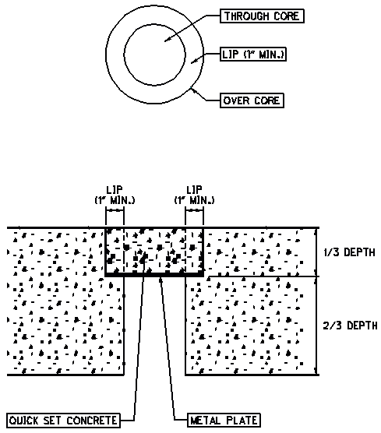
Figure 400-2. Typical patch of a bridge deck.

FIELD BORING LOGS AND OTHER RECORDS

Field Boring Logs
Complete a field boring log for each boring hole drilled. The field boring log will contain heading and field data sections which are described in more detail as follows.

Field Boring Log Heading
Record the following information in the heading of the field boring log:
- Project Designation (generally either County-Route-Section or Bridge Number)
- Exploration identification number
- Location; referenced to centerline or baseline or survey stationing, measured to the nearest 1 foot. Include GPS coordinates, see Section 303.2
- Type and make of drilling equipment
- ER and date of last calibration of hammer system
- Method of drilling and sampling employed
- Boring diameter
- Dates of start and completion of the boring
- Names of personnel on site, including crew chief, crew members, and logger
- Ground surface elevation of boring, measured to the nearest 0.1 foot and referenced datum
- Sheet number and total number of log sheets for the boring
- Method and material (including quantity) used for backfilling or sealing, including type of instrument installation, if any
- Any general remarks concerning the drilling operations

Field Boring Log Data
Record the subsurface information relating to the strata conditions and sampling information on the field boring log. Measure depths to the nearest 0.1 foot. Include the following information:
- Thickness of pavement, sod, or topsoil cover at surface
- Depth, length and type of each sample
- Number of blows, in 6-inch increments when standard penetration tests are taken
- Length of each rock core run
- Amount of sample recovered in each sample, measured in inches (millimeters)
- Measurement of the Rock Quality Designation (RQD) of the core run
- Depths of strata changes
- Visual description of each strata encountered, according to Section 600
- Depth where seepage or wet conditions were encountered, including any free water within the sample
- Depth and thickness where obstacles were encountered, such as boulders, squeezing ground, heaving sands, caving materials, or buried structures
- Depth to water level prior to introduction of drilling fluid, for rock core or to wash out heaving sands
- Depth of interval where wash water or air return circulation was lost
- Depth of interval where water gain occurred, and approximate amount of gain
- Color of water and type of cuttings flushed to surface
- Change in resistance or rate of advancement
- Any unusual conditions encountered in advancing the boring and sampling
- Reason for abandoning the boring in the event that the planned depth was not reached
- Depth to water at completion of the drilling operations prior to backfilling

Rock Core Photograph
Obtain a digital photograph of each core run after placing in the box, looking directly down onto the core. Take a sufficient number of photographs of each box of core to depict the pertinent characteristics of the rock, including any necessary close-up photographs. Wet the rock to enhance the color contrast of the core. Include the project, boring, and rock core run information and a legible scale in each photograph.

Field Test Pit Log
Complete a field test pit log for each test pit excavated. Complete the heading and field data sections as follows.

Field Test Pit Log Heading
Record the following information in the heading of the field test pit log:
- Project Designation (generally either County-Route-Section or Bridge Number)
- Exploration identification number
- Location; referenced to centerline or baseline or survey stationing, measured to the nearest 1 foot. Include GPS coordinates, see Section 303.2
- Type and make of excavation equipment
- Dates of start and completion of the excavation
- Names of personnel on site, including equipment operator and logger
- Ground surface elevation at test pit, measured to the nearest 0.1 foot and referenced datum
- Sheet number and total number of log sheets for the test pit
- Method of shoring used, if any
- Method of backfilling or sealing
- Any general remarks concerning the excavating operations

Field Test Pit Log Data
Record the subsurface information relating to the strata conditions and sampling information on the field test pit log. Include the following information:
- Thickness of pavement, sod, or topsoil cover at surface
- Depths where bulk samples were taken
- Depths of strata changes
- Visual description of each strata encountered according to Section 600
- Depth where seepage or wet conditions were encountered, including any free water
- Depth and thickness where obstacles were encountered, such as boulders, squeezing ground, heaving sands, caving materials, or buried structures
- Any unusual conditions encountered in excavating the test pit
- Reason for abandoning the test pit in the event that the planned depth was not reached
- Depth to water at completion of the excavation prior to backfilling

METHOD OF PAYMENT
Boring, Sampling, and Field Testing is an engineering service to be performed and paid for according to the engineering agreement and the Specifications for Consulting Services. The method of compensation for the work involved in Boring, Sampling, and Field Testing, will be on a unit cost basis. The tasks and corresponding units for this work are listed in the Proposal/Invoice form presented in Appendix E. The work includes technical supervision of the agreement and field logging; supplying sample containers, cases, bags, sample tubes and core boxes; delivery and storage of samples; preparation, duplication and delivery of records; backfilling; furnishing all other labor, tools, machinery, materials, supplies, equipment (including floating equipment), and utilities necessary and incidental to completing the work in strict accordance with these specifications. Detailed accounting of direct non-salary expenses will be required in accordance with the Specifications for Consulting Services.
Field coordination and field logging are engineering services to be performed and paid for according to the engineering agreement and the Specifications for Consulting Services. Field coordination includes making arrangements for site access, procuring any necessary permits, clearing utilities, preparing damage reports, and property damage restoration oversight. Field logging includes preparing all records presented in Section 409. The method of compensation for the work involved in field coordination will be actual cost plus a net fee. The method of compensation for the work involved in field logging, if drilling is subcontracted, will be actual cost plus a net fee, otherwise, it will be included in the unit cost of drilling.

INSTRUMENTATION

Types of Instrumentation

Monitoring Wells
Monitoring wells are a type of instrument used to measure groundwater levels. They can also be used for collecting groundwater samples and testing aquifer parameters. Installation involves drilling a test boring, inserting riser pipe with a screened interval into the boring, backfilling with granular material (filter pack) around the screened interval, sealing the remaining annulus above the sensing zone, and providing a protector cover. The screened length may vary, but commonly are sized for the anticipated range of the seasonal fluctuation of the groundwater and may extend for the majority of the boring depth. Geotechnical Engineering Circular No. 5 and ASTM D5092 provide guidance for construction of monitoring wells.

Open Standpipe Piezometers
Open standpipe piezometers are a type of monitoring well with a small diameter (two inches or less) and a screened interval. Their purpose is to measure groundwater levels and piezometric pressures within isolated water-bearing formations in soil or rock. Open standpipe piezometers are designed and installed in similar fashion to monitoring wells.

Inclinometers
Inclinometers are used to monitor lateral movement of a soil or rock mass through the use of an inclinometer probe or tilt indicator probe inserted into an inclinometer casing. The inclinometer probe is a wheeled instrument, which uses force-balanced accelerometers to measure its inclination from vertical. The inclinometer casing is grooved along its length on the inside so as to accept the wheels of the inclinometer probe and maintain its horizontal orientation. Inclinometers can be used for both quantitative and qualitative measurements of slope movements.

TDR Cable
TDR (Time Domain Reflectometry) is a method used to measure subsurface deformation utilizing a vertically or horizontally placed coaxial cable to monitor the location of a shearing plane in a soil or rock mass. An electronic signal sent down the length of the cable is reflected back from the other end. Any points of deformation (kinks, bends, breaks, or elongations) in the cable will cause increased resistance in the reflected signal, allowing the locations of these deformations to be determined along the length of the cable. Prior to installation, the TDR cable is crimped at regularly spaced intervals to provide calibration reference points. The location of the shearing plane or the location of the vertical subsurface movement in a moving soil or rock mass can therefore be determined by referencing the crimped intervals. If TDR cable installation is proposed on a project, contact the District Geotechnical Engineer for guidance.

Other Instrumentation
Other types of geotechnical instrumentation may be installed if project-specific circumstances warrant their use. Other instrumentation may include, but are not limited to, pneumatic piezometers, vibrating wire piezometers, extensometers, and strain gages. In addition, instrumentation used for pressuremeter testing, sonic testing, and seismic testing may be installed. The use of other geotechnical instrumentation will require prior approval of the District Geotechnical Engineer.

Monitoring Wells/PIEZOMETERS

Materials
Construct the monitoring well or piezometer with a minimum 1-inch nominal inside diameter to allow for monitoring groundwater levels. If groundwater sampling, pumping, and other testing of the formation under study is desired then a minimum 2-inch nominal inside diameter should be utilized. The following materials are required to install a monitoring well or piezometer.

Riser Pipe
Furnish flush-threaded, schedule 40 PVC solid pipe. Typical sections are 2.5-foot, 5-foot, and 10-foot long with watertight connections. Other materials, such as stainless steel, ABS, and fluoropolymer material, may be used for riser pipe if approved by the District Geotechnical Engineer.

Well Screen
Furnish flush-threaded, schedule 40 PVC pipe, machine slotted. Wire wound stainless steel, pre-packed screens and porous tips may also be used for well screens, if approved by the District Geotechnical Engineer.
The screen should be otherwise identical material to the riser pipe, with the same connections. Typically, well screens are commercially available in 2.5-foot, 5-foot, and 10-foot long sections. For groundwater monitoring, only a generic slot size of 0.010-inch openings is recommended. For any installation where sampling or testing from the well then select the slot size of the screen based upon the grain size distribution of the aquifer material, according to ASTM D5092. If a naturally developed filter pack is utilized, the slot size of the screen should retain at least 70% of the formation material. If an artificial filter pack is used, the slot size of the screen should retain at least 90% of the filter pack.

Bottom Cap
Furnish a flush-threaded or slip bottom cap made of PVC or other approved material for the bottom end of the well screen. Do not attach bottom caps in monitoring wells with PVC solvent glue or any other material that could alter the groundwater chemistry.
If a natural filter pack, or aquifer material is such that the collection of fines with the installation is anticipated, include a sediment sump as part of the bottom cap. A sediment sump should be a small section of riser pipe placed below the screen to allow for accumulation of fine sediment without clogging of the screen.

Top Cap
Furnish a flush-threaded cap, slip-type removable cap or expandable plug made of PVC or other approved material, designed to fit snugly on the top end of the riser pipe. Vent the cap.

Filter Pack
Furnish either a naturally developed or artificial filter pack. The filter pack should be installed beneath the bottom cap and extend above the top of the screen a sufficient length to ensure that the water levels and quality is not being impacted by the rest of the well installation. The filter pack should be sized to minimize the migration of the natural soil particles from the ground formation into the well screen.

Naturally Developed Filter Pack. With a naturally developed filter pack, the granular material of the formation is allowed to collapse around the screen and riser. A naturally developed filter pack may be considered for formations that contain predominantly coarse grained, free-draining materials. This type of filter pack is appropriate when the grain size distribution of samples from the studied formation indicate that the effective grain size (D₁₀) is greater than 0.01 inch and the uniformity coefficient (D₄₀/D₉₀) is greater than 3. If the natural formation does not meet these criteria or if the grain size distribution of the natural formation is not known, an artificial filter pack should be used.

Artificial Filter Pack. An artificial filter pack consists of a granular material deliberately placed within the annulus between the screen and the outside of the boring. An artificial filter pack, sometimes referred to as sand pack, gravel pack, or well pack, is composed of hard durable granular material that has been washed, screened, and dried and is chemically inert, such as silica sand.

For groundwater monitoring only clayey materials use a generic artificial pack consisting of Global® #5 quartz sand of equivalent. Ensure that the artificial filter pack material meets the following gradation.
Table 500-1. Filter Pack Gradation
U.S. Standard Sieve Sizes | Opening size in inches | Total Percent Passing
#4 | 0.1874 | 100%
#10 | 0.0787 | 85%
#16 | 0.0469 | 35%
#40 | 0.0165 | 1%
#100 | 0.0059 | 0%

For any installation where sampling or testing from the well then furnish a filter pack meeting the requirements of ASTM D5092.
Pre-packed screens may also be used in place of artificial filter packs.

Bentonite Seal
Furnish bentonite (hydrous aluminum silicate, sodium montmorillonite or calcium montmorillonite) powder, granulation, chips or pellets (coated or uncoated) to create a low permeability seal at the top of the filter pack. Make sure that the filter pack is sufficiently placed to allow for minor migration of the seal into the granular material without impacting the screen.
A bentonite grout, as described in Section 502.1.7.a, may also be used to form the bentonite seal. However, an additional 6 to 12-inch layer of fine sand will also need to be placed in the upper portion of the filter pack to minimize infiltration of grout into the sensing zone.

Grout
Furnish one of the following types of grout to backfill the boring from the bentonite seal to the ground surface.

Bentonite Grout. Furnish a mixture of powdered or granular bentonite with water. Typical bentonite grout mix consists of 1 to 1.25 pounds of bentonite per gallon of water. Use of granular bentonite with a hydration inhibiting catalyst is acceptable.
When the backfill zone is above the water level in the boring, dry granular bentonite or bentonite chips may be used to backfill the boring annulus.

Bentonite/Cement Grout. Furnish a mixture of powdered bentonite and Type I Portland Cement. Typical bentonite/cement grout mix ratio consists of 6 to 7 gallons of water and 3 to 9 pounds of powdered bentonite per one 94-pound bag of Portland Cement.

Neat Cement Grout. Furnish a mixture of Type I Portland Cement and water. Quick setting types of cement should not be used in a neat cement grout. Typical neat cement grout mix consists of 6 to 7 gallons of water per one 94-pound bag of cement.

Protector Cover
Furnish a protector cover according to Section 504.

Boring Construction and Preparation.

Boring Construction
Advance borings using hollow stem augers or other approved techniques. Construct the boring in a manner to minimize the development of a mud “skin” or smearing on the walls of the boring. Keep the boring clean and open for the full depth prior to the installation of the monitoring well. Install the monitoring well after the boring is completed to the desired depth. If the boring is not being drilled for a geohazard, continuous sampling may be necessary to determine the limits of the saturated zone(s).

Diameter of Annulus
Construct the boring so as to maintain a minimum of a continuous 1-inch annulus between the inside of the augers (or the wall of the boring if solid stem augers are used) and the riser pipe and screen. If the diameter of the boring is inadequate to maintain a 1-inch annulus, then ream the boring to the required diameter.

Determining Well Interval
After completion of the sampling, determine the saturated zone in which the instrument will be installed in. Determine the limits of the filter pack, or sensing zone, so that it maximizes the majority of the saturated zone, or zone of interest. The filter pack should not extend beyond the saturated zone and should allow for the bentonite seal. Based on the length of the filter pack, size the well screen length so that it is completely encompassed within the filter pack.

Depth of Boring
Advance the boring to 6 to 12 inches below the planned depth of the filter pack. If the boring has been drilled deeper than the planned depth, backfill the additional boring depth with bentonite grout or bentonite chips or pellets. If bentonite chips or pellets are used, hydrate in lifts while backfilling. If grout is used, place grout to the depth of the base of the filter pack and allow time for the grout to harden before installing the filter pack. Install grout according to Section 502.3.5.

Standard Installation
The following installation procedure is applicable to a single monitoring well installed in soil. For monitoring wells installed in bedrock and special installations, refer to Sections 502.5 and 502.6. Figure 500-1 shows a typical monitoring well installation.
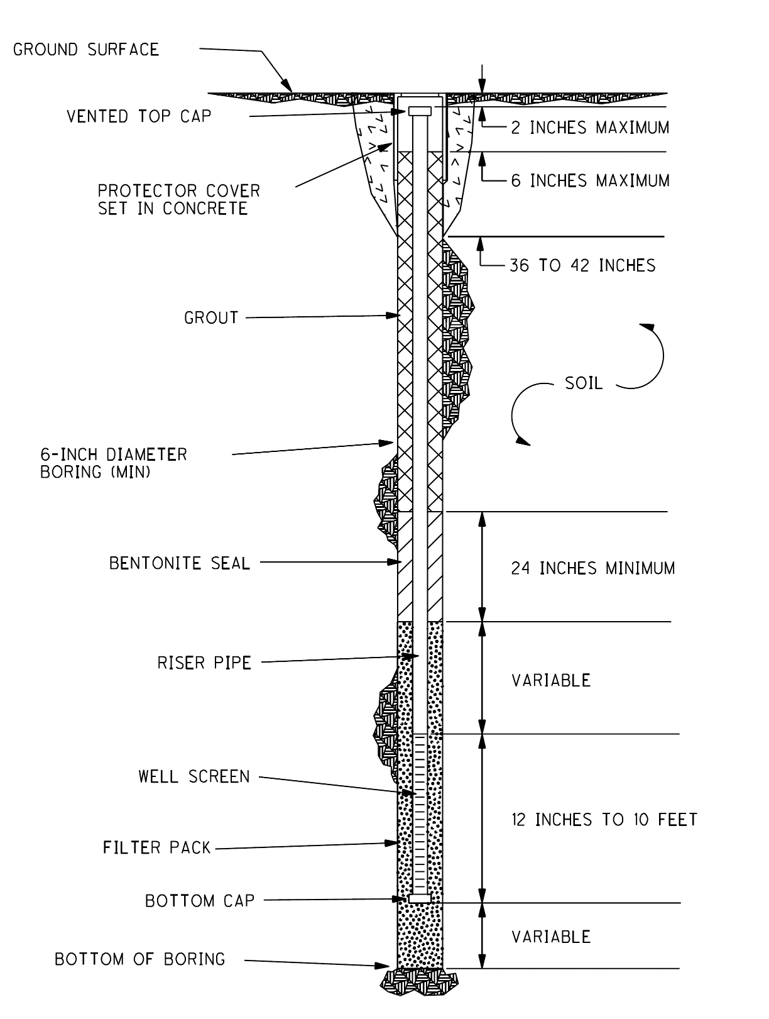
Figure 500-1. Typical Monitoring Well Installation

Initial Filter Pack Placement
Install the filter pack from the bottom of the boring, grout or bentonite to the depth of the bottom cap.

Instrument Construction
Assemble the full length of the instrument (bottom cap, well screen and riser pipe) either at the ground surface prior to placement in the boring or as the pipe configuration is being lowered into the boring inside the hollow stem augers. Place the instrument such that the installation is centered with the borehole. The well screen should be placed to ensure proper placement of the filter pack and the riser pipe should be placed to ensure a proper seal around it. Place centralizers so that they do not impede or obstruct the placement of filter pack, bentonite seal, or grout. Place the top cap on the top end of the riser pipe prior to placement of any additional material.

Filter Pack
After the instrument has been placed, fill the annulus with the filter pack up to the top of the intake or sensing zone. Typically, the top of the well screen will be at least two feet lower than the top of the filter pack. Do not allow bridging (obstruction preventing the full or proper placement) of the filter pack to occur. Remove the hollow stem augers gradually as the filter pack is placed, taking care to not allow the top of the filter pack material to drop below the bottom of the hollow stem augers.

Bentonite Seal
Place a minimum two-foot thick bentonite seal directly into the annulus. Ensure that bridging of the material does not occur, allowing for complete filling of the annulus with impermeable material. Remove the hollow stem augers gradually as the bentonite seal is placed, ensuring that the top of the bentonite seal does not drop below the bottom of the hollow stem augers.
If bentonite grout is used to form the seal, place a 6 to 12-inch layer of fine sand (sugar sand) in the upper portion to the filter pack to minimize the infiltration of grout into the sensing zone.

Grout
After the bentonite seal is in place, fill the remainder of the boring annulus with grout using a tremie pipe for placement from the bottom to top. Continue grout placement until the consistency of the return grout material at the ground surface is similar to the original grout. The hollow stem augers will remain in place until the grout reaches the ground surface at which time gradually begin removing the hollow stem augers. Add additional grout as needed to ensure that the top of the grout material does not drop below the bottom of the hollow stem augers.
Confirm the top of grout surface 24 hours after placement to ensure the grout has not shrunk or dropped. If the top of grout surface has dropped to a level more than 36 inches below the ground surface, then place additional grout.

Protector Cover
Install a protector cover at the ground surface according to Section 504.

Installation Report
Record field measurements on an installation report representing the actual construction of the monitoring well. Report measurements to the nearest 0.1 feet, referenced to the ground surface. At a minimum, include the following information on the installation report:
- Exploration Identification Number | - Top of filter pack depth/elevation  - Top of screen depth/elevation
- Date of well installation | - Bottom of screen depth/elevation
- Site name (county/route/section) | - Bottom of filter pack depth/elevation
- PID Number | - Bottom of boring depth/elevation
- Location: Lat., Long., Station,  offset distance and direction | - Type of riser and screen material  - Type of filter pack
- Inspectors name | - Type of grout
- Ground surface elevation | - Depth to water at completion
- Top of riser height/elevation | - Depth to water at 24 hrs. after comp.
- Top of grout depth/elevation | - Other pertinent information
- Top of bentonite seal depth/ elevation | - Field Labeling

A typical monitoring well installation report is presented in Appendix B.

Development
Upon completion of installation, develop the instrument. At a minimum, for those instruments that are to be utilized only for groundwater level observations, first surge and then bail or pump until the purged water is clear. Any instrument that is to be utilized for in-situ testing of the hydrogeologic conditions of the monitored interval which will result in a high inflow of water will be further developed. The most common methods of monitoring well development include mechanical surging and bailing or pumping, over-pumping, air-lift surging, and jetting. Begin all methods of development slowly and gently and increase in energy as the monitoring well is developed until sufficient energy is applied to disturb the filter pack, thereby freeing the fines and allowing them to be drawn into the monitoring well.
Monitor the development process quantitatively through the use of direct reading instruments. These include single or multi-parameter instruments that measure the water quality parameters of turbidity, pH, conductivity, and temperature. A well will be considered developed when the water has cleared and the water quality parameters have stabilized.

Bedrock Installation
A monitoring well or piezometer may be installed to monitor groundwater levels in bedrock. This application may include, but is not limited to, slope stability explorations, mine or karst investigations, and new construction evaluations. The monitoring zone may span the entire bedrock interval or may isolate a specific zone within the bedrock. Figure 500-2 shows a monitoring well installation in bedrock with a void.

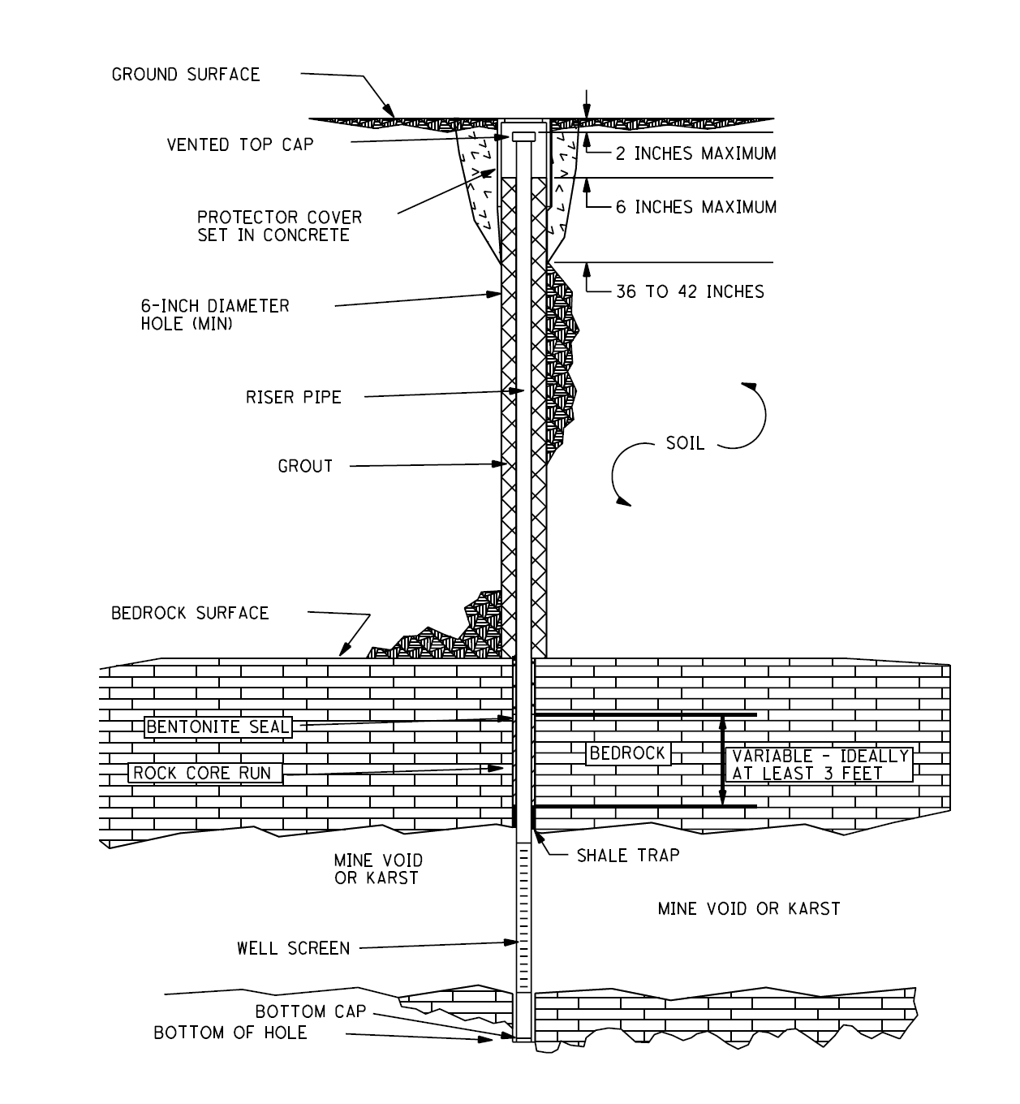

Figure 500-2. Monitoring Well Installed in Bedrock with Void

Generally, a filter pack is not utilized in a bedrock installation due to the narrow annulus between the screen and the sides of the boring. If a filter pack is required, the boring may be reamed with a tricone roller bit to increase the diameter of the boring and facilitate the installation of a filter pack. A pre-packed screen may also be used in a bedrock monitoring well installation.
Attach a shale trap or basket to the riser pipe just above the well screen to allow for placement of the bentonite seal.
When voids are the studied formation, such as in an underground mine or a karst investigation, place the screened section within the void. To permit grouting of the annulus, attach the shale trap or basket to the riser pipe in the zone of competent rock just above the void.
Once the shale trap or basket is in position, place the bentonite seal in the annulus. A two-foot bentonite seal is generally sufficient. However, if the screen is placed within a void, use a minimum three-foot seal above the shale trap to ensure a good seal. If the bedrock above the well screen is highly fractured, increase the length of the bentonite seal so that two feet of the seal is above the highly fractured zone. Backfill the remainder of the annulus with grout and finish the installation according to the standard monitoring well installation procedure.

Special Installations
Monitoring wells/piezometers may be installed for special conditions or purposes, which include, but are not limited to permeability/permissivity studies and multiple installations.

Permeability/Permissivity
In this application, also known as time-lag or slug test, a monitoring well is used to study the permeability of the water bearing zone. Here the inflow of water from the surrounding soil mass is critical. The filter pack must be at least as permeable as the formation being studied, but not so open-graded that it allows infiltration of the soil particles and possible fouling of the filter pack and clogging of the well screen. Proper installation and development of the monitoring well is essential in this type of installation.

Multiple Installations
Monitoring wells piezometers are most commonly installed with a single riser pipe/well screen assembly in a borehole. Multiple installations can include a cluster of closely spaced installations or nested installations (multiple riser pipe/well screen assemblies installed in the same borehole) or a multiple-port well.

Inclinometers

Materials
Use the following materials to install an inclinometer.

Inclinometer Casing
Furnish ABS pipe in 5 or 10-foot long sections, 2.75-inch outside diameter with snap lock “quick connections.” Other size casings and different materials and connections may be used if approved by the District Geotechnical Engineer. The inside of the pipe has machined grooves at four equidistantly spaced locations along the longitudinal axis. All joints will have watertight connections to prevent grout from entering the casing during installation.

Bottom Cap
Furnish a permanently fixed ABS cap with a watertight connection designed to seal off the bottom of the inclinometer casing.

Top Cap
Furnish a removable ABS cap designed to fit snugly onto the top of the inclinometer casing.

Bentonite/Cement Grout
Furnish a mixture of powdered bentonite and Type I Portland Cement to backfill the boring. Match the strength of the grout mix to the strength of the formation into which the inclinometer is being installed, according to Table 500-2.
If directed by the District Geotechnical Engineer, make one set of three 2-inch by 2-inch grout cubes in the field for compressive strength testing. Ship these to the location specified by the District Geotechnical Engineer.
Table 500-2 Grout Mix Design for Inclinometers
Application | Grout for Hard Soils and Rock (SPT>4blows per foot) |  | Grout for Soft Soils  (SPT≤4 blows per foot)
Material | Weight | Ratio  By Weight | Weight | Ratio  By Weight
Water | 30 gallons | 2.5 | 76 gallons | 6.6
Portland Cement  (Type I) | 94 lbs  (1 bag) | 1 | 94 lbs  (1 bag) | 1
Bentonite | ±25 lbs. | 0.3 | ±39 lbs. | 0.4
Notes: | ~100 psi 28-day compressive strength. Similar strength to hard clay. |  | ~ 4 psi 28-day compressive strength. Similar strength to very soft clay.
- Grout Mix Design Source is Durham Geo Slope Indicator
- Mix the water and cement together first to maintain the water-cement ratio prior to the addition of the bentonite. If the bentonite is mixed first it is difficult to maintain the water-cement ratio.

Adjust the bentonite mix ratio until grout has a heavy cream consistency. Thin grouts will result in separation of the solids and water. Thick grouts will be difficult to pump

Protector Cover
Furnish a protector cover according to Section 504.

Boring Construction and Preparation
Advance the test boring to the termination depth or top of competent bedrock using hollow stem augers or other approved method. Take a minimum of 10 feet of rock core if the failure surface is suspected to be within the overburden soils. If the failure surface is suspected to be within the bedrock, core bedrock to a minimum depth of 20 feet below the anticipated location of the failure surface. If bedrock is impractically deep, the test boring may be terminated in soil as long as the bottom is at least 30 feet below the anticipated failure surface.
Upon completion of the drilling activities, and prior to placement of the inclinometer casing, inspect the inside of the boring for obstructions and depth. If the inspection indicates that the boring has caved in or soil and/or rock cuttings have accumulated in the boring, either ream the boring with a tricone bit, flush, or re-drill to remove the obstructions.

Installation
Once the boring has been completed to the specified depth and is clear of obstructions and debris, install the inclinometer casing as outlined below. Figure 500-3 shows a typical inclinometer installation.

Initial Grout Placement
Prior to installation of the casing, place bentonite/cement grout through a tremie pipe placed the bottom of the boring, until approximately the lower half of the boring is filled.

Figure 500-3. Typical Inclinometer Installation

Inclinometer Casing
Assemble the full length of the bottom cap and the inclinometer casing at the ground surface or as it is lowered into the boring. Insert the inclinometer casing into the boring, through the hollow stem augers, and rest the bottom cap directly on the bottom of the boring displacing the initial grout placement. If the inclinometer casing cannot be inserted the entire depth of the boring due to an obstruction, remove the casing, ream out the boring, replace the grout and re-install the casing. Do not force the inclinometer casing into the boring, especially by utilizing down pressure from the drill rig. To counteract the buoyant forces from the water and grout within the boring, fill the casing with clean, potable water or place a weighted rod inside the entire length of the casing. Place the top cap on the top end of the casing prior to the placement of any additional material.
Place one of the two sets of opposing grooves within the casing in-line with the assumed direction of movement, as shown in Figure 500-4. Mark the grooves of the casing with the A-A’ axis (direction of movement) and the B-B’ axis (perpendicular to the direction of movement). If the orientation of the grooves is not perfectly aligned upon completion of the placement of the casing, do not attempt to rotate the casing to re-align. This may result in spiraling of the casing.

Figure 500-4. Typical Inclinometer Casing Grooves and Axes

Bentonite/Cement Grout
Fill the remaining annulus between the outside of the inclinometer casing, placing grout through a tremie pipe inserted approximately two feet into the existing grout. As the grout is added to the boring, any water located within the boring will be displaced to the ground surface. Continue grout placement until the consistency of the return grout material is similar to the original grout. Begin removing the hollow stem augers gradually after the top of the grout reaches the ground surface and the return material has the proper consistency, ensuring that the top of the grout material does not drop below the bottom of the hollow stem augers. Place additional grout as needed until all the augers are removed.
Confirm the top of grout surface 24 hours after placement to ensure the grout has not shrunk or dropped. If the top of grout surface has dropped to a level more than 36 inches below the ground surface, then place additional grout.

Protector Cover
Install a protector cover according to Section 504.

Installation Report
Record field measurements on an installation report representing the actual construction of the inclinometer. Report measurements to the nearest 0.1 feet, referenced to the ground surface. At a minimum, include the following information on the installation report:
- Exploration Identification Number | - Top of casing height/elevation
- Date of installation. | - Top of grout depth/elevation
- Site name (county/route/section)  - PID Number | - Bottom of boring depth/elevation
- Location: Lat., Long., Station.,  offset distance and direction | - Type of casing material  - Type of grout
- Inspectors name | - Labeling of A-A’ and B-B’ axes
- Ground surface elevation | - Other pertinent information

A typical inclinometer installation report is presented in Appendix B.

Protector Covers
A protector cover is placed at the top of any boring containing geotechnical instrumentation to protect it from contamination, debris, and vandalism. This cover may either be above-ground or flush-mounted. An above-ground protector is typically preferred, however, a flush-mounted protector must be used wherever an above-ground protector would interfere with motor vehicle traffic, such as inside guardrail, anywhere in the roadway or shoulders, or within a paved or grass median, which is not protected from traffic by a guardrail or concrete crash barrier.

Materials

Above-Ground Protector Cover
Furnish an aluminum or steel casing, typically five feet long and a minimum four inches square or in diameter, with a lockable aluminum cover at the top.

Flush-Mounted Protector Cover
Furnish a flush-mounted protector cover consisting of a steel casing, usually 9 to 12 inches long, with a cast-iron lid at the top. The cast iron lid is fixed down with threaded stainless steel bolts with lubricant and contains a gasket to minimize water collection within the cover. The top of the lid is typically marked as either “Monitoring Well” or “Test Well.”

Portland Cement Concrete
Furnish Type I Portland cement concrete.

Padlock
Furnish a weather resistant keyed brass padlock to secure the above-ground protector cover. Key the lock to a specific ODOT key code, which is available upon request.

Installation

Above-Ground Protector Cover
After completely backfilling the annulus between the instrumentation and the boring with grout according to the previous sections, excavate an approximate 2-foot wide by 36 to 42-inch deep conical/cylindrical hole at the ground surface around the top of the instrumentation. Cut the inner casing or riser off below the anticipated top of the protector casing to a sufficient depth so that readings can be performed.
Mix the Type I Portland cement concrete with water according to manufacturer’s directions. Place the protector cover in the ground around the top of the instrumentation and the fill the excavation with Type I Portland cement concrete around the bottom of the protector cover. Set the protector cover so that the top of the protector casing is approximately two to three feet (24 to 36 inches) above the ground surface and it extends at least 9 inches below the ground surface.
If the installation is for an inclinometer casing, center the installed inclinometer casing within the protector cover so that the clamp and collar on the pulley system, if used when taking readings, can be attached to the head of the installation without interference from the protector cover. Fill the annulus with sand to within six inches of the top of the protector casing to hold the free end of the inclinometer casing firmly in place. Ensure that the top cap is in place on the inclinometer casing before pouring the sand. Drill a weep hole through the protector cover just above the top of the concrete to allow an outlet point for any water accumulation within the sand fill.
Install the brass padlock to secure the cover. Provide a copy of the padlock key to the District Geotechnical Engineer if requested. A typical above-ground protector cover installation is shown in Figure 500-6.

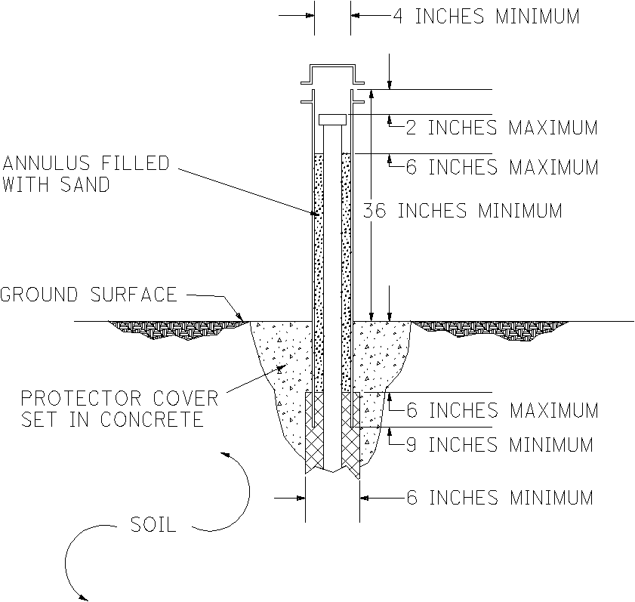
Figure 500-6. Above-Ground Protector Cover

Flush-Mounted Protector
Prepare the excavation and the Type I Portland cement concrete according to Section 504.2.1. Cut the inner casing or riser pipe off below the level of the ground surface to a sufficient depth so that readings can be performed when the lid is removed.
If the installation is for an inclinometer casing, center the installed inclinometer casing within the protector cover, so that the clamp and collar on the pulley system, if used when taking readings, can be attached to the head of the installation without interference from the protector cover.
Place the protector cover in the ground around the top of the instrumentation and the fill the excavation with Type I Portland cement concrete around the protector cover. Set the protector cover so the lid is flush with the existing ground surface or pavement.
A typical flush-mounted protector cover installation is shown in Figure 500-7.
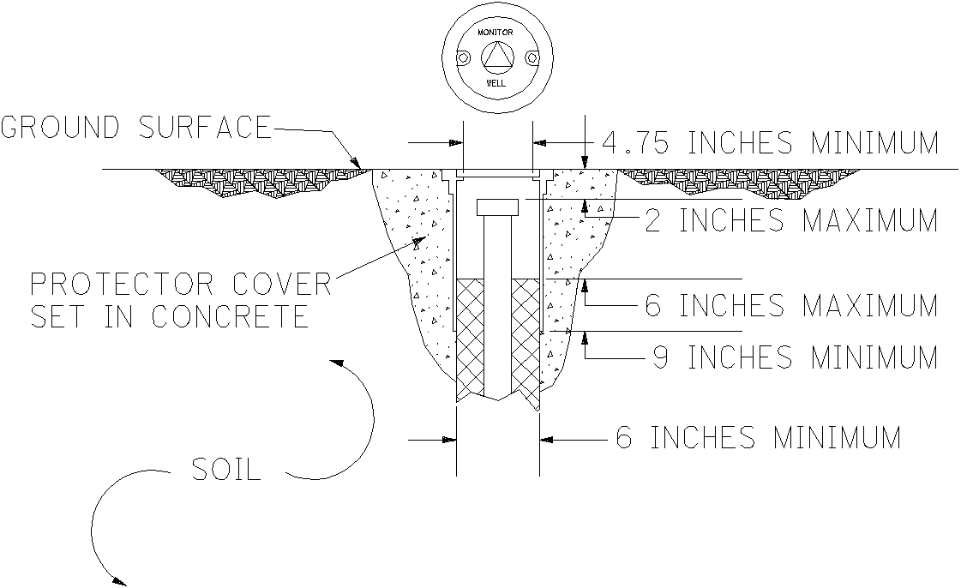
Figure 500-7. Flush-Mounted Protector Cover

METHOD OF PAYMENT
Instrumentation is an engineering service to be performed and paid according to the engineering agreement and the Specifications for Consulting Services. The method of compensation for the work involved in Instrumentation will be on a unit cost basis. The tasks and corresponding units for this work are listed in the Proposal/Invoice form presented in Appendix E. The work includes technical supervision of the agreement; preparation, duplication, and delivery of records; furnishing all labor, tools machinery, materials, supplies, equipment, and utilities necessary and incidental to completing the work strictly according to these specifications.

LABORATORY TESTING

GENERAL
The purpose of the laboratory testing is as follows:
- Classify all soil, rock, and man-made materials which have been sampled
- Define physical properties to be used for the design and construction of the project
Only qualified personnel working under the supervision of a licensed Professional Engineer may perform laboratory testing. Use only appropriate AASHTO or ASTM standard test methods unless otherwise stated herein or requested by the District Geotechnical Engineer. Develop the testing program so as to provide the necessary data in the most efficient manner. Refer to “Geotechnical Engineering Circular No. 5, Geotechnical Site Characterization,” FHWA NHI-16-072, for state of the practice information regarding boring, sampling, and field testing.

Soils having widely different physical characteristics are encountered throughout Ohio. To simplify the presentation and facilitate the interpretation of soils information for design and construction purposes, use the ODOT Soil Classification Chart, as shown in Figure 600-1. Perform all subsurface explorations for ODOT by classifying soils and miscellaneous materials according to this chart.
Determine the water content and visually describe every soil sample. Select a sufficient number of soil samples for classification testing to define the subsurface conditions. For each boring, perform at least one classification test for each distinct soil stratum encountered and for all samples at critical locations and depths related to stability, settlement, unsuitable materials, subgrade, or foundation design, including scour. Use classification testing to confirm or modify the visual descriptions of samples.
Visually describe all bedrock samples according to Section 605.

VISUAL DESCRIPTION OF SOILS
Determine the water content and visually describe every soil sample. Visually describe the soil samples using techniques and terminology described herein when manipulating and examining a soil. Use terms in the description of soils in the following order: compactness or consistency, color, primary component, secondary component(s) with modifier(s), supplementary descriptive terms (when appropriate), and water content.
Following are two examples of visual soil descriptions:
- Medium dense, brown COARSE AND FINE SAND, some gravel, trace silt and clay, well-graded, wet
- Very stiff, mottled brown and yellow CLAY, some sand, little stone fragments, moist
- Since visual descriptions are based on estimates of particle size distribution and plasticity characteristics, it may be difficult to clearly identify the soil’s primary component. Secondary components may be used to describe primary components, such as silty clay or sandy silt, when the anticipated classification calls for it (see descriptions in Figure 600-1) or to indicate the soil may fall into one of two possible primary groups (i.e., borderline classifications).
- Visually inspect each soil sample representing proposed pavement subgrade for the presence of gypsum (CaSO₄·2H₂O). Gypsum crystals are soft (easily scratched by a knife; they will not scratch a copper penny), translucent (milky) to transparent, and do not have perfect cleavage (do not split into thin sheets). Photos of gypsum crystals are shown in Supplement 1120. If gypsum is present, test the sample for sulfate content in accordance with Supplement 1122.

Compactness or Consistency
Use the terms defined herein to refer to the relative compactness of a non-cohesive soil (ODOT Classifications A-1, A-2, A-3, and non-plastic A-4 and A-8) and to the relative consistency of a cohesive soil (ODOT Classifications plastic A-4 and A-8, A-5, A-6, and A-7).

Non-Cohesive Soils
Describe the relative compactness of non-cohesive soils according to Table 600-1:
Table 600-1. Relative Compactness of Non-Cohesive Soils
Description | Standard Penetration  Blows Per Foot, N₆₀
Very Loose | Less than 5
Loose | 5 – 10
Medium Dense | 11 – 30
Dense | 31 – 50
Very Dense | Greater than 50

Cohesive Soils
Describe the relative consistency of cohesive soils according to Table 600-2. Unconfined compressive strength is preferred over standard penetration for description of relative consistency.

Color
Describe the color of the soil in clear and concise terms, such as: brown, gray, or black. Where two major and distinct colors are present, use both in the description, such as: brown and gray. Where a major color appears to be modified by a secondary color, refer to the modifying color first, such as: yellowish-brown, or greenish-gray. Where two major and distinct colors appear swirled in the soil, describe the colors as mottled, such as: mottled brown and gray.

Table 600-2. Relative Consistency of Cohesive Soils
Description | Unconfined  Compressive Strength*,  tsf (kPa) | Standard Penetration  Blows Per Foot, N₆₀ | Hand Manipulation
Very Soft | Less than 0.25 (24) | Less than 2 | Easily penetrated 2 in.  by fist
Soft | 0.25 – 0.5 (24 – 48) | 2 – 4 | Easily penetrated 2 in.  by thumb
Medium Stiff | 0.5 – 1.0 (48 – 96) | 5 – 8 | Penetrated by thumb with moderate effort
Stiff | 1.0 – 2.0 (96 – 192) | 9 – 15 | Readily indented by thumb but not penetrated
Very Stiff | 2.0 – 4.0 (192 – 383) | 16 – 30 | Readily indented by thumbnail
Hard | Greater than 4.0 (383) | Greater than 30 | Indented with difficulty by thumbnail
*As determined by hand penetrometer or torvane tests.

Components
Use the particle sizes in Table 600-3 to describe the components of the soil:
Table 600-3. Description of Particle Size
Component |  | Size
Boulders |  | Larger than 12 in.  (300 mm)
Cobbles |  | 3 in. to 12 in.  (75 mm to 300 mm)
Gravel | Coarse | ¾ in. to 3 in.  (19 mm to 75 mm)
Gravel | Fine | #10 sieve to ¾ in.  (2.0 mm to 19 mm)
Sand | Coarse | #40 sieve to #10 sieve  (0.42 mm to 2.0 mm)
Sand | Fine | #200 sieve to #40 sieve  (.074 mm to 0.42 mm)
Silt |  | 0.005 mm to #200 sieve  (0.005 mm to 0.074 mm)
Clay |  | Smaller than 0.005 mm

Differentiate between silts and clays by manipulation as follows:

Silt
When subjected to shaking in the palm of the hand, a pat of saturated inorganic silt expels enough water to give a glossy appearance to the surface and, when bent or slightly squeezed between the fingers, the surface of the pat will become dull. The pat, upon working in the hand, loses moisture, becomes brittle, and breaks easily into very fine particles.

Clay
Clay is sticky at high water contents, plastic over a wide range of water contents, and can be rolled into a fine thread without breaking. Upon drying it becomes hard and will not break into fine particles.

Identification of Components
Describe soil components as: gravel, stone fragments, sand, silt, clay, organic materials such as root fibers or wood fragments, miscellaneous materials such as uncontrolled fill, or peat, or any combination thereof.

Organics in Soils Except Peat
Describe organics by characteristics such as smell, texture, staining, color, or presence of organic material.

Peat Soils
Describe soils composed primarily of plant tissue in various stages of decomposition and having a fibrous to amorphous texture, a dark brown to black color, and an organic odor as a peat. Distinguish among various peat soils according to its composition, for example, woody peat, fibrous peat, sedimentary peat, fine textured peat, loamy peat, marly peat, marls, or various combinations thereof.

Gravel and Stone fragments
Differentiate between gravel and stone fragments as follows: Gravel is rounded or sub-rounded pieces of rock exposed to either stream or glacial abrasion. Stone fragments are angular pieces of rock subjected to little or no abrasive action or manufactured materials such as blast furnace slag.

Modifiers of Components
Use modifiers of components according to Table 600-4:
Table 600-4. Modifiers of Components
Term | Percent By Weight
Trace | 0 to 10
Little | >10 to 20
Some | >20 to 35
And | >35

Supplementary Descriptive Terms
Use supplemental descriptive terms for additional information when appropriate, such as: glacial till, alluvial, or residual type of manufactured material (i.e. slag, recycled asphalt or concrete, etc). Use secondary descriptive terms such as: a description of foreign material, organic odor, fissures, voids or cavities, staining, or lenses.

Water Content
Describe the relative water content of the soil samples according to Table 600-5:
Table 600-5. Water Content of Soils
Term | Criteria
Dry | - Soil leaves no moisture when pressed between fingers.  - For cohesive soils, is brittle to powdery.  - Water content well below the plastic limit
Damp | - Soil leaves very little moisture when pressed between fingers.  - Soil contains a small amount of moisture.  - Water content below the plastic limit.
Moist | - Soil leaves small amount of moisture when pressed between fingers.  - Water content above the plastic limit to -3% of the liquid limit.
Wet | - For cohesive soils, the water content is near or above the liquid limit.  - For non-cohesive soils, the pore space is filled with water and water can be poured from sample with ease.

SOIL CLASSIFICATION

ODOT Soil Classification Method
Classify soils by their physical characteristics using the ODOT Soil Classification Chart, shown in Figure 600-1, based on test data for grain size distribution, liquid limit, and plasticity index. Classify soils by proceeding from top to bottom of the chart. Place a soil in the first classification in which the properties of the soil meet all the requirements of that classification.
The ODOT Soil Classification Chart is in general agreement with the "Classification of Soils and Soil Aggregate Mixtures for Highway Construction Purposes", AASHTO M 145, with modifications. These modifications have been made as a result of ODOT's experience with the behavior of subgrade and foundation soils encountered in Ohio.
The ODOT Soil Classification Chart provides for the classification of all materials commonly encountered in subsurface explorations. These materials are grouped into three general categories, as follows.
- Granular material, having 35 percent or less by weight passes the No. 200 U.S. Standard sieve
- Silt-clay material, having more than 35 percent by weight passes the No. 200 U.S. Standard sieve
- Miscellaneous materials classified by visual inspection and not readily identified by the tests used for classification of soils
The first two categories are similar to those of the AASHTO classification system while the third category is a provision only of the ODOT Soil Classification Chart. The classifications within these categories are discussed in the following paragraphs.
The classifications for granular materials are the same as those adopted by AASHTO with the following exception: granular materials containing a minimum of 50 percent by dry weight of coarse and fine sand sizes and a maximum plasticity index of 6 have been classified as Group A-3a.
The classifications for silt-clay materials of the AASHTO classification have been modified as follows:

The A-4 classification has been divided into A-4a and A-4b. A-4a soils are sandy silt soils containing less than 50 percent silt sizes. A-4b soils are predominantly silts containing not less than 50 percent silt sizes. Silt sizes are particles passing the No. 200 U.S. Standard sieve, or smaller than 0.074 millimeter, and larger than 0.005 millimeter in diameter.

The A-6 classification has been divided into A-6a and A-6b. A-6a soils are predominantly silts and clays having a maximum liquid limit of 40 and a plasticity index of 11 to 15 inclusive. A-6b materials are silty clays with a maximum liquid limit of 40 and a plasticity index of 16 or greater.

The A-8 classification is an optional AASHTO classification which is adopted by ODOT for organic silt or clay soils, not including peat. A-8 soils are defined as those soils which would otherwise classify as A-4, A-5, A-6, or A-7, but have a liquid limit value after oven drying less than 75 percent of its liquid limit before oven drying. The A-8 classification has been divided into A-8a and A-8b. A-8a soils are sandy silt soils which otherwise would have classified as an A-4 soil and exhibit the loss in liquid limit value upon oven drying as noted above. A-8b soils are predominantly silts and clays which otherwise would have classified as an A-5, A-6, or A-7 soil and exhibit the loss in liquid limit value upon oven drying as noted above.
The classification of miscellaneous materials is also provided by the ODOT Soils Classification Chart. These materials, which are commonly encountered in subsurface explorations, do not lend themselves to standard laboratory classification tests and are therefore classified by visual inspection based on their general character or geologic nature.

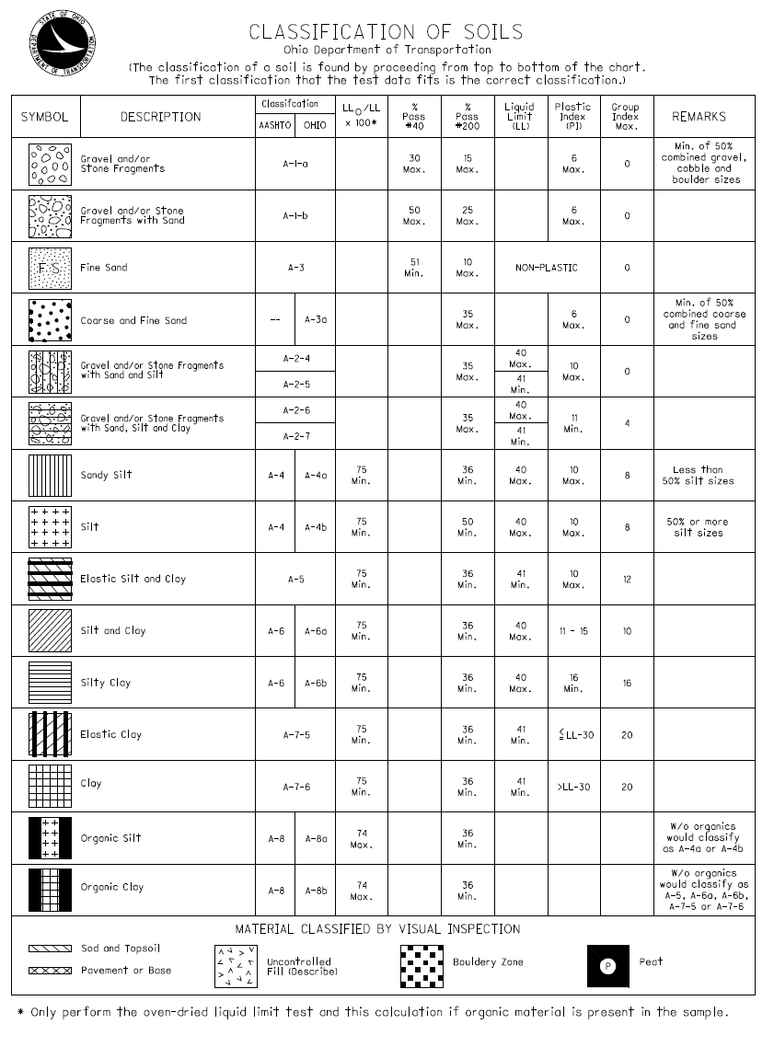
Figure 600-1. ODOT Soil Classification Chart
Examples of miscellaneous materials include topsoil, pavement and base, berm material, uncontrolled fill, cobble or boulder zones, and peat.
The AASHTO classification system provides a parameter for the characterization of soils referred to as the Group Index. This methodology has been included in the Ohio Classification Chart with modifications. Modifications to the AASHTO Group Index consist of limiting the value of the Group Index to 0 to 20, based on an empirical formula, weighted to take into account variations in the percentage of coarse material, the liquid limit, and the plasticity index. Assuming good drainage and thorough compaction, the suitability of soils as subgrade materials is inversely related to the Group Index. That is to say, the lower the Group Index, the better the supporting characteristics of the soil as a subgrade material. The modified empirical formula is as follows:

Group Index = 0.2A + 0.005AC + 0.01BD

where:
A = That portion of the percentage passing the No. 200 sieve greater than 35 percent and not exceeding 75 percent, expressed as a positive whole number (0 to 40).

B = That portion of the percentage passing the No. 200 sieve greater than 15 percent and not exceeding 55 percent, expressed as a positive whole number (0 to 40).

C = That portion of the numerical liquid limit greater than 40 and not exceeding 60, expressed as a positive whole number (0 to 20).

D = That portion of the numerical plasticity index greater than 10 and not exceeding 30 expressed as a positive whole number (0 to 20).

Testing Requirements
Classify representative soil samples by the ODOT Soil Classification Method. Perform the tests listed in Table 600-6 utilizing either AASHTO or ASTM test methods, except modify the Particle-Size Analysis according to Section 603.3.
Table 600-6. Testing Requirements for Classification of Soils
Test Method | AASHTO  Designation | ASTM  Designation
Water Content Determination | T 265 | D 2216
Organic Content by Loss on Ignition | T 267 | D 2974
Particle-Size Analysis | T 88 | D 422*
Liquid Limit | T 89 | D 4318
Plastic Limit and Plasticity Index | T 90 | D 4318

D 422 is withdrawn from ASTM Standards but should continue to be used until a replacement procedure is identified.

Modifications to Test Methods

Organic Content by Loss on Ignition
Perform the organic content by loss on ignition test only on samples visually described as moderately to highly organic or as peat.

Particle-Size Analysis
Perform the particle-size analysis of soils as described by AASHTO T 88 or ASTM D 422 except:
- Limit the length of the hydrometer test to two hours
- Do not perform the hydrometer test on non-cohesive materials essentially free of material passing the No. 200 U.S. standard sieve, as determined by visual inspection

Plastic Limit and Plasticity Index
Perform the plastic limit test prior to performing the liquid limit test.

Liquid Limit
Determine the liquid limit of soils as described by AASHTO T 89 or ASTM D 4318 only on samples determined to be plastic by means of the plastic limit test.
Determine the liquid limit of silt-clay soils visually described as moderately to highly organic on each sample twice. First determine the liquid limit when prepared by air drying as described by AASHTO R 58 or ASTM D 421 dry preparation method. Then determine the liquid limit on the same sample when prepared by oven drying as described by AASHTO T 265 or ASTM D 2216.

Organic Silts and Clays
Designate organic silts and organic clays as such when they have sufficient organic content to influence the soil properties. Classify a soil as an A-8a organic silt when it would have otherwise classified as an A-4 soil and its liquid limit value after oven drying is less that 75 percent of its liquid limit value before oven drying. Classify a soil as an A-8b organic clay when it would have otherwise classified as an A-5, A-6, or A-7 soil and its liquid limit value after oven drying is less that 75 percent of its liquid limit value before oven drying. Perform the organic content by loss on ignition test to determine the percent organic content.

Granular and Silt-Clay Soils Containing Organics
Classify granular soils and silt-clay soils which contain organics but retain 75 percent or more of its liquid limit value after oven drying according to the ODOT classifications A-2 through A-7. Verify the organic content of soils containing organic material visually described as moderately to highly organic by performing the organic content by loss on ignition test. Modify, as necessary, the description of the soil according to Table 600-7:

Table 600-7. Organic Content of Soils
Percent of Organic Matter  (By Weight) | Description
2 to 4 | Slightly Organic
4 to 10 | Moderately Organic
> 10 | Highly Organic

Peat Soils
Do not subject samples visually identified as peat to further classification testing. Unless the peat is fibrous or woody, perform the organic content by loss on ignition test to determine the percent organic content.

Sulfate Content in Soils
Use the test procedure described in Supplement 1122 for the determination of the sulfate content of soils.

STRENGTH AND CONSOLIDATION TESTING OF SOILS
Perform strength and consolidation testing when necessary for design of the project. Do not test undisturbed samples until after related samples have been classified to determine the nature of subsurface conditions.

Laboratory Strength and Consolidation Test Methods
Use only relatively undisturbed samples, successfully obtained using a thin-walled tube of suitable diameter per AASHTO T 207 or ASTM D 1587. Classify the undisturbed samples by performing testing on a portion of the sample as described above. In addition, test samples selected for strength or consolidation determinations using the appropriate test methods from the list below. Use either AASHTO or ASTM test methods:

Table 600-8. Strength and Consolidation Testing Requirements for Soils
Test Method | AASHTO  Designation | ASTM  Designation
Unconfined Compressive Strength | T 208 | D 2166
Direct Shear | T 236 | D 3080
Unconsolidated-Undrained Triaxial Compression | T 296 | D 2850
Consolidated-Undrained Triaxial Compression | T 297 | D 4767
One-Dimensional Consolidation | T 216 | D 2435
Specific Gravity | T 100 | D 854

Index Strength Tests
Perform index strength tests such as hand penetrometer and torvane tests according to manufacturer's instructions. Do not rely solely on these index strength results to determine strength parameters for final design. Use these results for relative consistency and strength, and comparative indication to anticipated and achieved laboratory and field test results.

Other Tests
Perform other tests, when necessary for design of the project, with prior approval from the District Geotechnical Engineer.

BEDROCK DESCRIPTION

General
Bedrock encountered in Ohio is sedimentary. Metamorphic and igneous rocks are encountered only in the form of gravel, cobbles, and boulders, which were carried and deposited into the state as a result of glaciation.
Visually describe all bedrock encountered. Use terms described herein for the description of bedrock, which may include in the following order: bedrock type, color, degree of weathering, strength, texture, bedding, other descriptors, type and condition of discontinuities, unit RQD, and unit recovery (Rec.). Unit RQD, and unit Rec. are not required for bedrock exposures or rock sampled by means other than a core barrel. The term unit is presented here to distinguish the difference between the lithological stratigraphic unit and the core run values. The term unit does not need to be presented within the descriptions presented on the boring logs or within the geotechnical profile sheets.
Following are two examples of visual rock descriptions:
- Sandstone, gray, unweathered, strong, very fine to coarse grained, thick bedded, argillaceous, Unit RQD 90%, Unit Recovery 95%
- Shale, variegated brown and gray, moderately weathered, slightly strong, thin bedded to laminated, fissile, jointed, moderately fractured, narrow, slightly rough, Unit RQD 85%, Unit Recovery 100%

Bedrock Type
Determine the type of in-place bedrock based upon its physical characteristics. The primary bedrock types encountered in Ohio are: claystone, coal, dolomite, limestone, sandstone, shale, siltstone, and underclay. Refer to Appendix A for a complete listing and brief description of all rock types.
When alternating layers occur between two distinct rock types describe the material as “Interbedded” with the major rock type first, with estimated percentage, and the secondary rock type second, with estimated percentage. Provide the unit RQD and unit recovery (Rec.), then describe each rock type in detail, such as:
- Interbedded Shale (70%) and Limestone (30%), blocky, fair to good, RQD 50%, Rec. 90%;
Shale, gray, moderately weathered, weak, laminated, calcareous, ranges in thickness from 8 inches to 24 inches;
Limestone, light gray, slightly weathered, moderately strong, thin bedded, fossiliferous, ranges in thickness from 2 inches to 6 inches

Color
Determine the color of the bedrock using the wet color of the rock. Describe the color of the bedrock, for example: brown, gray, or black. Colors may be modified as light or dark. If the primary color appears to be tinted by a secondary color, refer to the secondary color first, such as: greenish-gray, yellowish-brown, or brownish-gray. Where two or more major and distinct colors appear in the rock, describe the color as variegated, such as: variegated red and gray.

Weathering
Describe the degree of weathering of the rock mass according to Table 600-9. Do not describe weathering for coal, fireclay, or underclay.

Table 600-9. Weathering of Bedrock
Description | Parameters
Unweathered | No evidence of any chemical or mechanical alternation of the rock mass. Mineral crystals have a bright appearance with no discoloration. Fractures show little or no staining on surfaces.
Slightly Weathered | Slight discoloration of the rock surface with minor alterations along discontinuities. Less than 10 percent of the rock volume presents alteration.
Moderately  Weathered | Portions of the rock mass are discolored as evident by a dull appearance. Surfaces may have a pitted appearance with weathering “halos” evident. Isolated zones of varying rock strengths due to alteration may be present. 10 to 15 percent of the rock volume presents alterations.
Highly Weathered | Entire rock mass appears discolored and dull. Some pockets of slightly to moderately weathered rock may be present and some areas of severely weathered materials may be present.
Severely Weathered | Majority of the rock mass reduced to a soil-like state with relic rock structure discernable. Zones of more resistant rock may be present, but the material can generally be molded and crumbled by hand pressures.

Relative Strength
Describe the relative strength of the bedrock according to Table 600-10:

Table 600.10. Strength of Bedrock
Description | Field Parameters | Range of Unconfined Compressive Strength
Description | Field Parameters | psi (ksf) | MPa
Extremely Strong | Cannot be scratched by a knife or sharp pick. Chipping of hand specimens requires hard repeated blows of the geologist hammer. | Greater than 30,000  (> 4320) | Greater than 200
Very Strong | Cannot be scratched by a knife or sharp pick. Breaking of hand specimens requires hard repeated blows of the geologist hammer. | 15,000 to 30,000  (2160 to 4320) | 100 to 200
Strong | Can be scratched with a knife or pick only with difficulty. Requires hard hammer blows to detach hand specimen. Sharp and resistant edges are present on hand specimen. | 7500 to 15,000  (1080 to 2160) | 50 to 100
Moderately Strong | Can be scratched with a knife or pick. Grooves or gouges to ¼” (6mm) deep can be excavated by hand blows of a geologist’s pick. Requires moderate hammer blows to detach hand specimen. | 3600 to 7500  (520 to 1080) | 25 to 50
Slightly Strong | Can be grooved or gouged 0.05 inch (2 mm) deep by firm pressure of a knife or pick point. Can be excavated in small chips to pieces about 1-inch (25 mm) maximum size by hard blows of the point of a geologist’s pick. | 1500 to 3600  (215 to 520) | 10 to 25
Weak | Can be grooved or gouged readily by a knife or pick. Can be excavated in small fragments by moderate blows of a pick point. Small, thin pieces can be broken by finger pressure. | 750 to 1500  (108 to 215) | 5 to 10
Very Weak | Can be carved with a knife. Can be excavated readily with a point of a pick. Pieces 1 inch (25 mm) or more in thickness can be broken by finger pressure. Can be scratched by fingernail. | 40 to 750  (6 to 108) | 0.3 to 5

Texture
Describe the rock texture by the grain size of the parent material from which the rock is composed. Use the particle sizes in Table 600-11, which are based upon the American Geological Institute, to describe the rock texture:

Table 600-11. Texture of Bedrock
Component |  | Particle Size
Boulder |  | Larger than 12 in. | Larger than 300 mm
Cobbles |  | 3 in. to 12 in. | 75 mm to 300 mm
Gravel |  | 0.08 in. to 3 in. | 2 mm to 75 mm
Sand | Coarse | 0.02 in. to 0.08 in.  (#35 to #10 sieve) | 0.5 mm to 2 mm
Sand | Medium | 0.01 in. to 0.02 in.  (#60 to #35 sieve) | 0.25 mm to 0.5 mm
Sand | Fine | 0.005 in. to 0.01 in.  (#120 to #60 sieve) | 0.125 mm to 0.25 mm
Sand | Very Fine | 0.003 in. to 0.005 in.  (#200 to #120 sieve) | 0.074 mm to 0.125 mm

Bedding
The bedding thickness is the average perpendicular distance between bedding surfaces. Describe bedding thicknesses according to Table 600-12:

Table 600-12. Bedding Thickness of Bedrock
Description | Thickness
Very Thick | Greater than 36 in.  (> 1000 mm)
Thick | 18 in. to 36 in.  (500 mm to 1000 mm)
Medium | 10 in. to 18 in.  (250 mm to 500 mm)
Thin | 2 in. to 10 in.  (50 mm to 250 mm)
Very Thin | 0.4 in. to 2 in.  (10 mm to 50 mm)
Laminated | 0.1 in. to 0.4 in.  (2.5 mm to 10 mm)
Thinly Laminated | Less than 0.1 in.  (< 2.5 mm)

Descriptors
Describe secondary characteristics of bedrock as necessary. Use no more than three characteristics in the description. Use the list of common terms, which are defined in Appendix A.
- Arenaceous | - Argillaceous | - Brecciated
- Calcareous | - Carbonaceous | - Cherty
- Clay Seams | - Conglomeritic | - Crystalline
- Dolomitic | - Ferriferous | - Fissile
- Fossiliferous | - Friable | - Iron Stained
- Lithic | - Micaceous | - Pyritic
- Siliceous | - Stylolitic | - Vuggy
- Vitreous | - Coal Stringer

Discontinuities
When a bedrock description is necessary due to a design element relative to the condition of the bedrock, such as a foundation supported on/or into bedrock or a cut slope within bedrock, provide a description of the bedrock discontinuities. Typically, for spread footings founded on/or into bedrock, utilize a modified Rock Mass Rating (RMR) description of the discontinuities as outlined in Section 605.9.1. For drilled shafts extending into bedrock provide a Geologic Strength Index (GSI) description of the discontinuities as outlined in Section 605.9.2. For rock cut slopes, utilize both modified RMR and GSI discontinuities descriptions as outlined in Section 605.9.1 and 605.9.2.

Description Utilizing Modified RMR
Describe discontinuities according to Table 600-13:
Table 600-13. Discontinuities in Bedrock
Description | Parameters
Fault | Fracture which expresses displacement parallel to the surface that does not result in a polished surface.
Joint | Planar fracture that does not express displacement. Generally occurs at regularly spaced intervals.
Shear | Fracture which expresses displacement parallel to the surface that results in polished surfaces or slickensides.
Bedding | A surface produced along a bedding plane.
Contact | A surface produced along a contact plane.  (generally not seen in Ohio)

When the discontinuity is a fracture (i.e. fault, joint, or shear), describe the degree and condition of the fracturing. Determine the degree of fracturing based on the average distance between recognized natural fractures. Describe the conditions of the fractures based on average aperture width and surface roughness, as shown in Tables 600-14 and 600-15:

Table 600-14. Degree of Fracturing in Bedrock
Description | Spacing
Unfractured | Greater than 10 ft.
Intact | 3 ft. to 10 ft.
Slightly Fractured | 1 ft. to 3 ft.
Moderately Fractured | 4 in. to 12 in.
Fractured | 2 in. to 4 in.
Highly Fractured | Less than 2 in.

Table 600-15. Condition of Fractures in Bedrock
A. Aperture Width
Description |  | Width
Open |  | Greater than 0.2 in. | Greater than 5.0 mm
Narrow |  | 0.05 in. to 0.2 in. | 1.0 mm to 5.0 mm
Tight |  | Less than 0.05 in. | Less than 1.0 mm
B. Surface Roughness
Description | Criteria
Very Rough | Near vertical steps and ridges occur on the discontinuity surface
Slightly Rough | Asperities on the discontinuity surface are distinguishable and can be felt.
Slickensided | Surface has a smooth, glassy finish with visual evidence of striations.

Description Utilizing GSI
Describe discontinuities according to Table 600-16:
Table 600-16. Structure
Description | Parameters
Intact or Massive | Intact rock with few widely spaced discontinuities
Blocky | Well interlocked undisturbed rock mass consisting of cubical blocks formed by three interesting discontinuity sets
Very Blocky | Interlocked, partially disturbed mass with multi-faceted angular blocks formed by 4 or more joint sets
Blocky/Disturbed/  Seamy | Angular blocks formed by many intersecting discontinuity sets, Persistence of bedding planes
Disintegrated | Poorly interlocked, heavily broken rock mass with mixture of angular and rounded rock pieces
Laminated/Sheared | Lack of blockiness due to close spacing of weak shear planes

Table 600-17. Surface Condition
Description | Parameters
Very Good | Very rough, fresh unweathered surfaces
Good | Rough, slightly weathered, iron stained surface
Fair | Smooth, moderately weathered and altered surfaces
Poor | Slickensided, highly weathered surface with compact coatings or fillings or angular fragments
Very Poor | Slickensided, highly weathered surfaces with soft clay coating or fillings

Rock Quality Designation (RQD)
The Rock Quality Designation, RQD, is an index of fracture frequency. Determine the RQD value for each core run (Run RQD) and for the total length of each bedrock unit encountered by a boring (Unit RQD). The RQD value is calculated by adding up the total length of each rock core piece which is 4 inches, or longer, and dividing by the total length of the core run or total rock unit thickness. Express the value as a percentage. Take measurements along the centerline axis of the core. Consider only natural fractures for the RQD determination, discounting mechanical breaks resulting from the drilling operations or transport of the core. If there are fractures that cannot be determined to be either mechanical or natural, consider these to be natural. Figure 600-2 illustrates the procedure for calculating RQD.
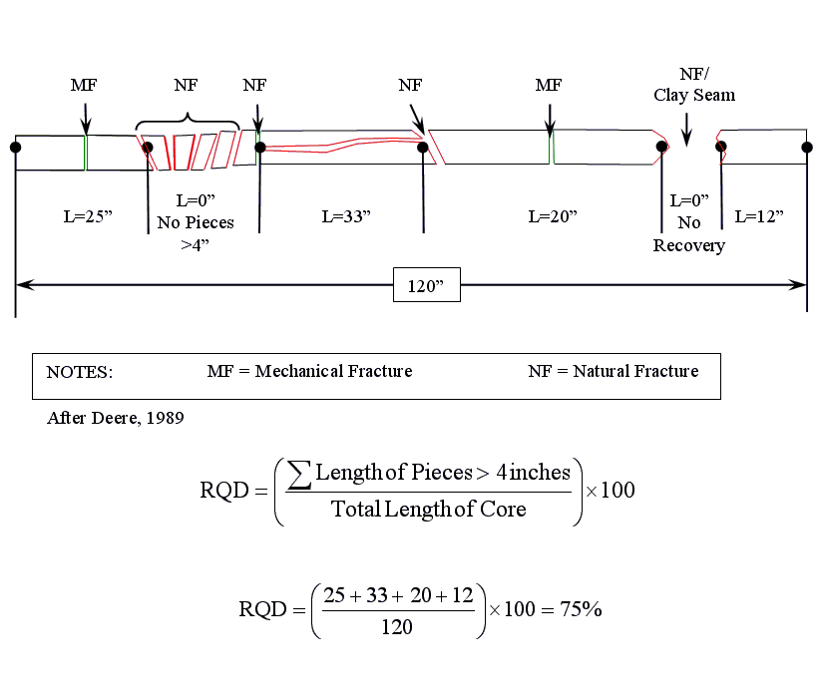

Figure 600-2. Typical RQD Calculation

Core Recovery
Calculate core recovery within each core run (Run Recovery) and for each rock unit (Unit Recovery). Calculate the run recovery for each core run, expressed as a percentage, by the following equation

Where: R_{R} = Length of recovered core of the core run.
L_{R} = Length of the core run

Calculate the unit recovery for each rock unit, expressed as a percentage, by the following equation

Where: R_{U} = Length of recovered core for the bedrock unit.
L_{U} = Length of core run for the bedrock unit.

TESTING OF ROCK

Test Methods
When necessary for design of the project, perform testing on rock according to the test methods listed in Table 600-18:
Table 600-18. Rock Testing Methods
TEST METHOD | ASTM  DESIGNATION
Slake Durability | D 4644
Point Load Strength Index | D 5731
Uniaxial Compressive Strength of Intact Rock Specimens | D 7012, Method C*
Elastic Moduli of Intact Rock Specimens in Uniaxial Compression | D 7012, Method D

*For uniaxial compressive strength testing of intact rock specimens, the requirements of ASTM D 4543 are waived and the use of caps or gypsum capping compound is acceptable.

Other Tests
Perform other tests necessary for the design of the project, with prior approval of the District Geotechnical Engineer.

METHOD OF PAYMENT
Laboratory Testing is an engineering service to be performed and paid for according to the engineering agreement and the Specifications for Consulting Services.
The method of compensation for the work involved in Laboratory Testing will be unit cost. The quantities of pay items for Laboratory Testing will be the actual number of units completed and accepted. The unit prices in the engineering agreement for the respective pay items shall include all testing, determinations, measurements, computations, tabulations, and other work required in the performance of the tests; technical supervision and engineering oversight; and services, labor, storage, equipment, transportation, materials, and supplies necessary for and incidental to the completion of the laboratory testing work specified herein, including work reasonably implied. A unit for the direct shear test and consolidated-undrained triaxial compression test will include testing of three specimens. Payment for the visual description of bedrock will be included in the cost of procuring the bedrock cores.
The quantities of pay items for Laboratory Testing shall be the actual number of units completed and accepted. The basis of payment shall be the quantity of accepted work multiplied by the unit price in the engineering agreement for each of the items of Laboratory Testing.

Pay items for Laboratory Testing according to Table 600-19:

Table 600-19. Method of Payment
Description | Unit | Unit Price
Water Content Test and Visual Description | Each | $17
Classification Package, per Table 600-6, excluding Organic Content by Loss on Ignition, and including Visual Description and Hydrometer | Each | $211
Organic Content by Loss on Ignition | Each | $64
Liquid Limit Test | Each | $47
Plastic Limit Test | Each | $46
Particle Size Analysis--Sieve and Hydrometer | Each | $120
Particle Size Analysis--Sieve Only** | Each | $91
Unconfined Compression Test on Soil | Each | $96
Direct Shear Test | Each | $615*
Unconsolidated-Undrained Triaxial Compression Test | Each | $205
Consolidated-Undrained Triaxial Compression Test | Each | $1,094
One-Dimensional Consolidation Test | Each | $620
Specific Gravity Test | Each | $81
Sulfate Content in Soils – Colorimetric Method | Each | $124
Slake Durability | Each | $258
Point Load Strength Index | Each | $80
Uniaxial Compressive Strength of Intact Rock Specimens | Each | $117
Elastic Moduli of Intact Rock Specimens in Uniaxial Compression | Each | $295
Misc.:______________________ | Each

*Unit price assumes intact specimens with a maximum time to failure of 24 hours each

**Sieve Only includes a dry sieve on the #200 (no wash sieve).

GEOTECHNICAL EXPLORATION REPORTS

GENERAL
Provide all geotechnical information as required to complete the project planning and design in accordance with the Project Development Process, or as directed by ODOT. Provide an electronic copy of all geotechnical submissions to the District Geotechnical Engineer. Clearly identify on every submission (reports, plan drawings, etc.), the geotechnical specification (title and date) under which the geotechnical work was contracted and performed. Label the first complete version of all documents being submitted as “draft”. Subsequent to ODOT review and approval, submit a complete version of the document, revised as necessary, and label “final”.
Submit electronic copies of all final Geotechnical Exploration plan sheets in accordance with Location & Design Manual Volume 3, Section 1201. Geotechnical Exploration plan sheets include Geotechnical Profile – Roadway sheets, Geotechnical Profile – Structure sheets, and Geotechnical Profile – Geohazard sheets. When submitting the final Geotechnical Exploration plan sheets, also submit final boring data in electronic format for inclusion in the ODOT Geotechnical Data Management System (GeoMS). All boring data shall be compliant with the Data Interchange for Geotechnical and Geoenvironmental Specialists (DIGGS) standard. Logs prepared using the latest ODOT gINT library will meet this requirement. Submittal of gINT project files that can then be successfully auto-converted to DIGGS format by ODOT is acceptable. Additional information on DIGGS can be found at https://www.geoinstitute.org/special-projects/diggs.
Provide a black & white pdf file of all Geotechnical Profile sheets, except provide color versions of sheets presenting ODOT Rock Core Photograph Report pages. See Section 702.6.5 and Appendices C and D for additional information.

Geotechnical PROFILE - roadway
Present roadway and subgrade explorations as plan drawings in the form of a Geotechnical Profile - Roadway. If the project includes structures, present all structure explorations in the Geotechnical Profile - Roadway as well. Do not create a separate set of plan sheets for structure explorations. A sample Geotechnical Profile - Roadway is provided in Appendix D. Use the form of presentation and include the features described below.

Form of Presentation
Conform to the ODOT CADD Engineering Standards Manual regarding the size, format, lettering, and file management for the plan sheets. A listing of sheet title examples is provided in Appendix D.

Scale
For cover sheets and laboratory test data sheets use a scale of 1”=1’. For projects, or individual alignments, less than 1250 feet in length, use the largest standard horizontal scale (1”=5’, 1”=10’, 1”=20’, 1”=25’, 1”=40’, 1”=50’) appropriate to present the entire plan and profile on one sheet. For projects, or individual alignments, greater than 1250 feet in length, use a scale of 1”=50’ (or 1:500). A vertical scale of 1”=10’ (or 1:100) is required.
Plot all cross sections to the same horizontal and vertical scale. Use a scale according to the ODOT Location and Design Manual, Volume 3, Section 1310.2, except that a scale of 1”=20’ (or 1:200) is allowed for higher or wider slopes. A 1”=10’ scale is preferred. Plot more than one cross section per sheet if space permits.

Cover Sheet
Include the following information on the cover sheet of the Geotechnical Profile.

General Information
Include the following information in written text on the cover sheet.

Project Description: A brief description of the project. Include the bridge number (e.g. FRA-71-0025) of each bridge included in the plan set, if any.

Historic Records: Identify historic geotechnical explorations referenced in this exploration. State if no historic records are available.

Geology: Provide generalized information about the project area, such as the terrain (i.e., Physiographic Region general description), soil origin (i.e., lacustrine, clayey or glacial till, outwash, alluvial, residual soils, colluvium), relative thickness (thin, thick, deep), any feature relative to the soils (e.g. buried valleys, boulder belts, peat deposits), bedrock type(s) and age (e.g. Berea Sandstone of Devonian Age or shale, sandstone, claystone, coal and limestone of Pennsylvanian aged Conemaugh Group)

Reconnaissance: A brief presentation of site geology and topographical information as derived from the field reconnaissance notes. Include any site surface features of geotechnical importance. Comment on the good or bad performance of slopes, structures, and pavements. Identify historic geotechnical explorations referenced in this exploration. Make sure date and personnel who performed field reconnaissance are listed.

Subsurface Exploration: A brief description of the test boring and sampling methods. Include the date of last calibration and drill rod energy ratio as a percent for the hammer system(s) used. If multiple drill rigs are utilized, provide information for each rig.

Exploration Findings: A summary of soil, bedrock, and groundwater conditions encountered and a generalized interpretation of the findings.

Specifications: Identify which version of the SGE, by date, the exploration was performed in accordance with, which should be the version current at the time of submitting stage 2 plans.

Available Information: Provide statement that “The soil, bedrock, and groundwater information collected for this subsurface exploration that can be conveniently displayed on the geotechnical profile sheets has been presented. Geotechnical reports, if prepared, are available for review on the Office of Contract Sales website.”

A list of the initials of the personnel and the dates they performed a field reconnaissance of the site, the subsurface exploration (i.e., drilling), and the preparation of the Geotechnical Profile. If these tasks were performed over a period of many days, present the range of dates during which the tasks were performed.

Legend
Include a legend on the cover sheet of the drawings which contains the following information:

Soil and Rock Symbology. Show and define only the symbology for soil and bedrock types that appear in the Geotechnical Profile. Use the symbology and descriptions for soil and bedrock types as presented on the Soil and Rock Symbology chart presented in Appendix D.

Miscellaneous Symbols. Show and define all miscellaneous symbols and acronyms used on any of the Geotechnical Profile sheets. Do not list symbols that were not used.

Number of Tests. Identify the numbers of soil samples for each classification that were mechanically classified and visually described. Do not include test results of historic geotechnical explorations in this number of tests, but calculate and show these results in a separate table.

Location Map
Include a map showing the general location of the project, with the beginning and ending stations indicated. Size the map as defined in the ODOT Location and Design Manual, Volume 3, Section 1302.8, Location Map.

Index of Sheets
Identify, in a table, the station limits for each plan and profile sheet and cross section sheet for projects greater than 1500 feet in length, having multiple alignments, or if cross sections are used.

Index of Bridges
Identify, in a table, the list of bridges for which structural foundation explorations were performed.

Testing for Scour Analysis
If sampling and testing for a scour analysis were performed, present this data, including D₅₀ (metric units), Critical Shear Stress (τ_{c}), Erodibility Index (K), and Erosion Category (EC), on the cover sheet in tabular form if space permits, otherwise present this data on a new sheet after the boring log sheets. Only show the results if the final foundation design requires scour analysis. Refer to GDM Section 1302 for further guidance on the scour evaluation.

Summary of Soil Test Data
Show a summary of test data for all roadway and subgrade boring samples on the cover sheet if all the test data fits on the front sheet, otherwise, present on additional sheets. Rotate summary table 90° when warranted to maximize number of borings presented on the additional sheets.
Display the data by roadway and subgrade borings in ascending stationing order for each roadway. When borings from historic geotechnical explorations are being used, include their test data in a separate table and make a note as to its source. Provide the exploration identification number and centerline or baseline station and offset of each boring. For each sample, record the following:

The sample depth interval.

Sample number and type, for example, SS-1, SS-2, ST-3, SS-4, etc. Do not repeat sample numbers in the same boring.

N₆₀

Percent recovery.

Hand Penetrometer.

The percentage each of aggregate, coarse sand, fine sand, silt, and clay size particles; the liquid limit, plastic limit, plasticity index, and water content, all rounded to the nearest whole percent or number, for those samples mechanically classified.

The classification of the soil by the ODOT Soil Classification Method as described in Section 600, including the Group Index in parentheses.

A visual description of those samples not mechanically classified by the ODOT Soil Classification Method, including water content and the estimated ODOT Classification with “Visual” in parentheses. Reference to a mechanically classified sample, for example, “SAME AS SS–10” is satisfactory in lieu of a visual description.

Sulfate Content Test Results

Presentation of Undisturbed Test Results
Display any undisturbed test results in graphical format on the sheets prior to the presentation of the surface and subsurface data.

Presentation of Surface Data
Prepare a roadway plan drawing showing the existing surface features, the proposed construction, and exploration locations. Include the following information on the drawing:

Existing Surface Features
Show the locations and limits of existing surface features, in general conformance with the ODOT Location and Design Manual, Volume 3, Section 1309.3, except no utilities or horizontal curve data shall be shown. Show additional surface features, such as, but not limited to:
- Poorly performing pavement sections
- Springs
- Rock outcrops
- Uncontrolled fills, dumps, waste pits, excavations
- Low-lying poorly drained areas, swamps, bog areas, lakes, ponds, abandoned streams, existing streams, and intermittent streams
Identify existing land usage, such as, but not limited to:
- Wooded areas
- Agricultural (Grazing land / Cultivated land)
- Brush
- Grass (ODOT or Local Agency Maintained)
- Residential or Rural Residential
- Commercial
- Industrial
- Cemetery
- Park/Recreation Area

Identify the type, limits, and locations of geohazard features, such as, but not limited to:
- Landslides
- Rockfall
- Mine areas
- Karst features

Use appropriate symbols and labels as defined in the ODOT CADD Engineering Standards Manual. Otherwise, identify features with text and boundary limits as necessary.

Proposed Construction
Show the proposed construction, in general conformance with the ODOT Location and Design Manual, Volume 3, Section 1309.4.

Exploration Locations
Show locations of project, instrumented, and historic borings with appropriate exploration symbols, as defined in the ODOT CADD Engineering Standards Manual, and corresponding exploration identification numbers according to Section 303.2. Where borings are not shown in profile on the same sheet, indicate the sheet where the graphical boring log can be found. Boring targets should be aligned with the centerline or baseline of reference. Do not show locations where only pavement cores were performed.

Notes
Include notes regarding observations not readily shown by drawings.

Surface Contours
As a minimum, present existing ground surface major contours developed for the design project. Present the minor contours if doing so does not compromise the presentation of other geotechnical information or topographic features. Showing both major and minor contours is preferred for geohazard explorations.

Cross Section Index
On each sheet, present a cross section index of sheets where cross sections within the station limits presented on that sheet can be found.

Presentation of Subsurface Data
Present the roadway subsurface data in the form of a profile along the centerline or baseline and on cross sections, when applicable.
Plot graphical boring logs to a vertical scale only. Indicate the location and depth of borings by means of a heavy dashed vertical line. Present the exploration identification number above the boring. Indicate soil and bedrock layers by symbols 0.4 inches in width and centered on the heavy dashed vertical line where possible. Use 0.4-inch wide symbols for bedrock exposures as well, except, do not include a heavy dashed vertical line. Use the symbols shown on the Soil and Rock Symbology chart in Appendix D. Ensure that a graphical boring log for every project boring appears at least once in the sheets, either in a profile or cross section view.
Show borings from historic explorations in the same manner as described above and present the exploration identification number above the graphical boring log.

Profile View
Show the proposed grade line, the existing ground profile, and information disclosed by borings and testing on the profile view. Display the existing ground line and the proposed grade line according to the ODOT CADD Engineering Standards. Do not show curve data. Indicate the offsets of borings with respect to centerline or baseline immediately above the borings shown on the profile. Reference borings located immediately adjacent to the centerline or baseline and considered representative of centerline or baseline subsurface conditions directly to the centerline or baseline. Present offset borings on cross sections.

Cross Sections
Cross sections provide the opportunity to conveniently show a wealth of additional information not available in a profile view. Prepare cross sections to show subsurface conditions disclosed by a series of borings drilled transverse to centerline or baseline using the following guidelines:
For projects where only pavement widening is proposed, and no profile view is presented on the Construction Plan, present all borings on cross sections.
Present all cross sections analyzed in design in the Geotechnical Profile.
Plot offset borings on cross sections. Include centerline borings drilled at or near the same cross section, regardless of whether they are presented in the profile view.
Display the existing and proposed ground lines according to the ODOT CADD Engineering Standards. Indicate the station of borings with respect to centerline or baseline immediately above the borings shown on the cross section. Bedrock exposures shown on cross sections may be plotted along the contour of the cross section.

Graphical Boring Logs and Bedrock Exposures
Show the following information adjacent to each graphical boring log or bedrock exposure, when applicable:

The thickness, to the nearest inch, of any shallow surface material such as sod, topsoil, asphalt, concrete, aggregate base, uncontrolled fill, or peat, written immediately above the boring.

Top of rock indicated at the elevation by a line with “TR”.

The numeric value, to the nearest whole percent, of the moisture content of each sample tested, placed with the bottom of the text aligned with the bottom of the sample, immediately adjacent to the boring. Present this information on the right side of the graphical boring log if space allows. Identify this column at the bottom of the boring with the label “WC” (water content).

N₆₀, placed with the bottom of the text aligned with the bottom of the sample, immediately adjacent to the boring. Also show the refusal blow counts as uncorrected blows and if the penetration is less than 6” then show the penetration in inches. Example format is shown in the sample plans in Appendix D. Present this information on the left side of the graphical boring log if space allows. Identify this column at the bottom of the boring with the label “N_{60.}”

Free water indicated at the elevation encountered during the drilling process by a medium weight horizontal line with the letter "w" attached, water level measured at the end of drilling by an open equilateral triangle, point down, and water level measured after drilling completion with time identified and a shaded equilateral triangle, point down. Present this information on the same side of the graphical boring log as the moisture content, if space allows.

When in place bedrock is encountered, provide a complete geologic description of each bedrock unit. When testing is performed (for example, point load strength index, SDI, and compressive strength), provide test results. When rock core is obtained, include unit recovery and unit RQD values within the description. Use headings or footings for clarity as necessary. If there is not sufficient room to present these descriptions on the same sheet, present them on a subsequent(s) sheet(s). Do not present a complete geologic description of each bedrock unit for structure or geohazard borings for which this information is presented on the boring log as described in 703.3.

Visual description of any uncontrolled fill or any interval not adequately defined by a symbol on the graphical borings.

Indication of organic content using the modifiers listed in Section 603.5. Include results for loss on ignition, for example, moderately organic (LOI=5.1%).

Each moisture content of a plastic soil that is equal to or greater than the liquid limit minus three, designated by a 1/8-inch (3-millimeter) solid black circle placed immediately adjacent to the moisture content value.

Each moisture content of a non-plastic soil either greater than or equal to 25 percent, or greater than or equal to 19 percent but appearing wet initially, designated by an open 1/8-inch (3-millimeter) circle with a horizontal line through the circle placed immediately adjacent to the moisture content value.

The reason for discontinuing a boring before reaching the planned depth indicated immediately below the boring. If the reason was because of the use of hand equipment, indicate this, for example, "Refusal-Hand Auger.”

Boring Logs
Show the boring logs of all structure borings and any roadway borings drilled in the vicinity of the structure on the boring log sheet(s) following the plan and profile sheet(s). Create the boring logs in accordance with Section 703.3.

Rock Core Photographs
When a project includes rock coring, show the core photographs following the plan and profile sheet(s) or boring log sheet(s) when present. Take photographs as described in 409.2 and insert into the ODOT Rock Core Photograph Report provided in Appendix C. Place a maximum of 2 reports on one geotechnical profile sheet.

geotechnical profile – [structure]
Present the geotechnical exploration involving structures only (i.e., no roadway), including bridges, culverts, retaining walls, and noise walls, as plan drawings in the form of a Geotechnical Profile – [Structure]. Structures explored as part of the same construction project may be presented together under the same cover sheet. A sample Geotechnical Profile – [Structure] is provided in Appendix D. Use the same form of presentation and features to be included as described in Section 702, except as noted below:

Cover Sheet
Do not prepare a Summary of Soil Test Data or an Index of Sheets. If sampling and testing for a scour analysis was performed, present this data, using metric units for the diameter, on the cover sheet in tabular form if space permits, otherwise present this data on a new sheet after the boring log sheets.

Plan and Profile
Place the plan and profile views of the structure on a subsequent sheet(s), following the cover sheet. Show the plan and profile sheet(s) at the same scale as the Site Plan for the proposed structure when possible. Show the existing and proposed profiles and the locations of the proposed structure foundation elements on the profile view. Information regarding the preparation of Site Plans is contained in the ODOT Bridge Design Manual, Section 200. Do not present a complete geologic description of each bedrock unit on the profile, rather, present this information on the boring log as described in 703.3.
For culverts present the plan and profile along the flowline of the culvert.

Boring Logs
Show the boring logs of all structure borings on the boring log sheet(s) following the plan and profile sheet(s). Create the boring logs in the same format as those presented in the sample Geotechnical Profile – [Structure] in Appendix D. Boring logs may be created using the boring log report forms in the Office of Geotechnical Engineering gINT library (oh dot.glb), found at Pages - gINT Downloads (state.oh.us).
ODOT has transitioned to OpenGround boring log software. Logs prepared for ODOT projects in OpenGround must be completed in ODOT’s OpenGround cloud environment. To initiate a project in OpenGround, please complete the project initiation form here:
https://odot.formstack.com/forms/openground_project_initiation_request
For boring log sheets created in gINT, use a scale of 1”=1’. The maximum depth of a boring log on a single plan sheet should be limited to 60 feet. For boring logs created in OpenGround use the scale appropriate for the depth of the boring with a maximum depth on a single plan sheet generally limited to 50 feet. Develop the boring logs by integrating the driller's field logs, laboratory test data, and visual descriptions. Include the following information on the boring logs:

Heading
Include the following in the heading:
- Exploration identification number
- Project designation (C-R-S) and PID
- Structural File Number (if applicable) and project type. Note if the structural file number listed is existing (E) or proposed (P)
- Centerline or baseline name, station, offset, and surface elevation
- Coordinates, see Section 303.2
- Names of drilling, sampling and logging firm(s) and personnel
- Methods of drilling and sampling
- Name/type of drill rig and hammer system
- Date started and date completed
- Date of last calibration and drill rod energy ratio (ER) in percent for the hammer system(s) used
- Boring completion depth

Boring Information
Include the following on the boring log:
- A depth and elevation scale
- Indication of stratum change
- Description of material in each stratum with hatching that represents the primary material or design stratum
- Depth of bottom of boring
- Depth of boulders or cobbles, if encountered
- Caving depth
- Water level observations including time of measurement reported in hours when applicable
- Artesian water and height of rise
- Heaving sand with location and height
- Cavities or other unusual conditions
- Method and material (including quantity) used for backfilling or sealing, including type of instrument installation, if any
- Depth interval represented by sample
- Sample number and type (restart sampling numbering for each boring)
- Percent recovery for each sample
- Measured blow counts for each 6 inches of drive for split spoon samples, numeric entries only
- N₆₀ to the nearest whole number
- Hand penetrometer and/or torvane test results
- Particle-size analysis
- Liquid limit, plastic limit, plasticity index
- Water content
- ODOT soil classifications, with “V” in parentheses for those samples that are not mechanically classified
- Top of bedrock and bedrock descriptions of all in place bedrock encountered
- Run rock core percent recovery
- Run RQD
- Unit rock core percent recovery
- Unit RQD
- SDI, if applicable, with lithology described for any interlayered unit
- Compressive strength test results, if applicable, with lithology described for any interlayered unit
- For borings drilled through a bridge deck, do not present the bridge deck and void from the bridge deck to the ground line in the Material Description and Notes column of the log. Instead, start the boring log at the ground surface/bottom of the stream and indicate in the Notes Section that the boring was drilled through the bridge deck, and what the bridge deck elevation is.

Presentation of Undisturbed Test Results
Display any undisturbed test results in graphical format on the sheets prior to the presentation of the surface and subsurface data.

geotechnical profile – [geohazard]
Present the geotechnical exploration for geohazards as plan drawings in the form of a Geotechnical Profile – [Geohazard]. Use the same form of presentation and features to be included as described in Section 703, except present the scales and cross sections as described in Section 702.2. Identify the geohazard type(s) (landslide, rockfall, abandoned underground mine) in the title block.

geotechnical design memorandum
All subsurface explorations will result in a single report for the project, containing a comprehensive account of the exploration and all geotechnical recommendations, as described in Section 706. Many projects include both roadway and structures for which design recommendations are needed at various points along the project development process. If a project includes multiple design features, such as roadway, bridges, culverts, noise walls, retaining walls, etc. and it is necessary to present recommendations individually for one of these features during the project design process, prior to the completion of the final report, do so in the form of a Geotechnical Design Memorandum. The Design Memorandum is to be clear and concise, presented in a letter format with supporting documentation attached, such as boring logs, calculations, etc. Issue Design Memorandums as required, numbered sequentially, and titled appropriately for the content of the memorandum.

REPORT OF GEOTECHNICAL EXPLORATION, FINDINGS AND RECOMMENDATIONS
Present a report of the geotechnical exploration and findings along with analyses and recommendations in a written text format. Identify the project PID and contact person (with contact information). Include the report in the appropriate planning/design step submission according to the ODOT Location and Design Manual, Volume 3 and the ODOT Bridge Design Manual. For reports specific to Mixture Design for Chemically Stabilized Soils, refer to Supplement 1120. For all other reports, present information using the following headings and directions:

Report Title
Depending on the contents of the report, use one of the following titles:
- Roadway Exploration
- Structure Foundation Exploration
- Geohazard Exploration – (Identify Type of Geohazard)

Executive Summary
Present a brief summary of the findings and recommendations at the front of the report. List specific recommendations that will result in a deviation from the ODOT Construction and Material Specifications or from standard earthwork practices for the project.

Introduction
Describe the project, including the project limits, and a description of the geotechnical report being submitted.

Geology and Observations of the Project
Provide a description of the general geology and hydrogeology, listing sources of information. Present field and office reconnaissance notes, emphasizing geotechnical features of interest.

Exploration
Describe the exploration performed, including the following:
- List of projects from which historic boring programs were referenced and included
- Project exploration program
- Boring method(s) or other type of exploration method(s)
- Sample method(s) and intervals
- Laboratory testing program

Findings
Describe the geotechnical conditions revealed by the borings or other exploratory method(s). Give a description of the topography, drainage features, geology, and any other factors that might affect the design and construction of the project in the report. Also, identify areas where remedial measures may be required due to soft subgrade, soft embankment foundation, stability problems, settlement, or other concerns.

Analyses and Recommendations
Clearly document analyses which have been performed in order to develop recommendations regarding stability, settlement, and/or structure foundations. Include a diagram(s) showing the section(s) analyzed. Present calculations in a logical format in the appendix, as noted below. Describe how soil and bedrock parameters used in the analyses were determined. Acknowledge and explain any discrepancies between these parameters and field or laboratory test data.
Incorporate special drawings relating to stability, settlement, or foundation analysis of a size that produce a clear presentation and permit compact and neat folding for inclusion into the report.
Present recommendations as described below for each report type. Do not restate ODOT Construction and Material Specifications; include only recommended exceptions.

Roadway Exploration
Prepare recommendations related to the design and construction of the roadway that include any remedial measures necessary to complete the project. Provide specific treatment of soft foundation areas, design of cut slopes, drainage considerations, embankment design related to stability or settlement, construction sequence, instrumentation, field controls, and any other design factors affecting the project.
Be specific in the recommendations, noting the areal extent (by station and width) and depth of all required remedial earthwork measures. Likewise, be specific regarding locations concerning cut and fill slope recommendations. Non-specific recommendations are not acceptable.
Prepare recommendations related to the pavement design and subgrade support parameters and construction of the roadway subgrade in accordance with the Geotechnical Design Manual, Section 600. Present a Subgrade Analysis spreadsheet in the report. Provide specific treatment of unstable subgrade. Be specific in the recommendations, noting the areal extent (by station and width) and depth of all required remedial earthwork measures. Also identify limits of unsuitable subgrade. Non-specific recommendations which state, for example, to "undercut soft subgrade where it occurs,” are not acceptable.

Structure Foundation Exploration
For recommendations related to the design and construction of structures, include all design details, plan notes and construction constraints necessary to complete the project. Consider all available geotechnical information, including historic explorations, in formulating the design recommendations. Provide foundation or pile type, treatment of the foundation, nominal and factored bearing resistances of spread footings, design of piles and their estimated length, footing elevations, construction sequence, instrumentation, field controls and any other design factors affecting the project. Non-specific recommendations will not be accepted.
Present a statement of the parameters used in the analysis of the foundation design, such as those related to bearing resistance and settlement. Show the method(s) of analysis and diagram(s) of the section(s) analyzed. Consider each pier and each abutment individually. Give consideration to the effect of approach embankment loadings on the structure.

Geohazard Exploration
Present a list and description of alternatives considered for the remediation of the geohazard. Include a cost estimate for each alternative. Present a recommended preferred alternative.

Appendices
Present the following information in the appendices to the report.

Boring Plan
Present a site plan showing all boring locations. Present the plan in a scale that will allow the text to be legible and require the fewest number of sheets. Present a north arrow and a legend.

Boring Logs
Include boring logs as described in Section 703.3 in the report. The maximum depth of a boring log on a single 8-½” x 11” sheet should be limited to 30 feet, and the maximum depth of a boring log on a single 11” x 17” sheet should be limited to 60 feet. Present color pictures of rock cores immediately following the log. If the pages of rock core pictures exceed 20, only present the pictures on the electronic copy of the report.
Include particle size analyses gradation curves for scour samples only in the report.

Undisturbed Test Data
Report undisturbed test data as described below. Use the forms for undisturbed test reports presented in Appendix C.

Unconfined Compression Test. Provide a report of the unconfined compression test according to AASHTO T 208 or ASTM D 2166 and include the following:
(1) Heading. Include project identification, boring number, station and offset, depth interval of sample, and sample number in the report heading.

(2) Graphical Data. Show a graph of the stress-strain relationship. Present an interpretation of the results including the maximum stress at the corresponding strain.

(3) Specimen Data. Show specimen data including dimensions of specimen, wet unit weight, dry unit weight, failure sketch to scaled size showing front and side views disclosing major crack patterns, description of material, particle-size analysis, liquid limit, plastic limit, plasticity index, moisture content.

Triaxial Compression Test. Provide a report of the triaxial compression test according to AASHTO T 296 or T 297, or ASTM D 2850 or D 4767, and include the following:
(1) Heading. Include information according to Section 705.8.3.a (1) in the heading.

(2) Graphical Data. For each test specimen, show the relationship for the vertical stress versus strain and the pore pressure versus strain in graphical form. For the appropriate range of stress conditions selected, show the Mohr's stress circles based on total and effective stress. Provide an interpretation of the cohesion and friction angle from the data.

(3) Test Data. For each specimen, include moisture content, wet and dry unit weights, liquid limit, plastic limit, plasticity index, particle-size analysis, chamber pressures, and failure sketches to a scaled size showing front and side views disclosing major crack patterns. Record a description of the material and the type of triaxial test.

Direct Shear Test. Provide a report of the direct shear test according to AASHTO T 236 or ASTM D 3080 and include the following information:
(1) Heading. Include information according to Section 705.8.3.a (1) in the heading.

(2) Graphical Data. Present normal pressure versus shear stress and shear displacement versus shear stress in graphical form, established on the basis of not less than three normal loads.

(3) Test Data. For each of the three specimens, include initial (wet) weight and volume of the specimen, wet unit weight, and moisture content. In addition, include the following information on one or more of the test specimens: liquid limit, plasticity index, and particle-size analysis. Record a description of the material and the type of test. Provide an interpretation of the cohesion and friction angle from the data.

Consolidation Test. Provide a report of the consolidation test according to AASHTO T 216 or ASTM D 2435 and include the following information:
(1) Heading. Include information according to Section 705.8.3.a (1) in the heading.

(2) Pressure-Void Ratio. On the first sheet of the report, graphically present the pressure-void ratio relationship with void ratio plotted to arithmetic scale and pressure plotted to logarithmic scale for both the loading and rebound. Show the initial void ratio value at the start of the test on the margin of the graphical presentation.

(3) Time-Consolidation Curves. Present the time-consolidation curves for the last four loadings (not reboundings) of the specimen on supplemental sheets. Show consolidation in dial readings to the nearest 0.0001 inch, plotted to an arithmetic scale, with time in minutes plotted to a logarithmic scale or square root-of-time plotted to an arithmetic scale. Indicate the pressure for each curve. Show the entire curve of any one loading on a single sheet. Use abbreviated heading information on each sheet.

(4) Coefficient of Consolidation. Show the curve of the coefficient of consolidation on the same sheet as the pressure-void ratio curve. On this graph, plot the coefficient of consolidation to an arithmetic scale and plot the average pressure to a logarithmic scale.

(5) Data Sheet. For each consolidation test, include diameter, initial thickness, specific gravity, initial moisture content, initial void ratio, wet and dry unit weights, liquid limit, plastic limit, plasticity index, and particle-size analysis of samples. Include a description of the soil.

Calculations
Present calculations in a logical format to support recommendations.

METHOD OF PAYMENT
Geotechnical Exploration Reports is an engineering service performed and paid for according to the engineering agreement and the Specifications for Consulting Services. The method of compensation for the work involved in Geotechnical Exploration Reports is actual cost plus a net fee.

PROPOSAL and invoice

Proposal
Prepare the price proposal for geotechnical explorations as specified herein and according to the Specifications for Consulting Services, Chapter 6. For proposal cost summaries, utilize the proposal form presented in Appendix E or as approved by the Office of Consultant Services and the Office of Geotechnical Engineering. Only modify the proposal format to best represent the proposed labor personnel categories. Otherwise, do not modify the proposal format. Enter data only in the highlighted cells. An electronic copy of the proposal/invoice form in Excel format can be obtained at Manuals & Contract Documents | Ohio Department of Transportation. Subconsultants must submit a proposal to the prime Consultant in this same format.
For all subsurface exploration programs proposed, include a scaled boring plan, showing all project and historic borings, and a schedule of borings in tabular format. Identify whether the exploration program is for a local let or ODOT let project. In the schedule of borings, present the following information for each boring.
- exploration identification number
- location by station and offset
- estimated amount of rock and soil. Also show the total of each for the entire program.
Boring, Sampling, and Field Testing will be compensated on a unit price per foot basis. Laboratory Testing will be compensated on a unit price basis, however, the unit costs are fixed, based on recent historic averages.

invoice
Prepare the invoice for geotechnical explorations as specified herein and according to the Specifications for Consulting Services. Utilize the invoice tabs of the same form mentioned above and presented in Appendix E. Only modify the invoice format to best represent the proposed labor personnel categories. Otherwise, do not modify the invoice format. Enter data only in the highlighted cells. An electronic copy of the proposal/invoice form in Excel format can be obtained at Manuals & Contract Documents | Ohio Department of Transportation. Subconsultants must submit an invoice to the prime Consultant in this same format.

