STATE OF OHIO
DEPARTMENT OF TRANSPORTAION

SUPPLEMENT 1033
DETERMINING THE CRACKING RESISTANCE OF ASPHALT MIXTURES
USING THE INDIRECT TENSILE ASPHALT CRACKING TEST

January 16, 2026

1033.01 Description
1033.02 Testing Device
1033.03 Fabrication of Test Specimen
1033.04 Specimen Conditioning and IDEAL-CT Test Procedure
1033.05 Test Parameters
1033.06 Outliers
1033.07 Report

1033.01 Description. This test method is used to determine the cracking resistance properties of asphalt mixtures at intermediate temperatures. In this test, a cylindrical specimen is vertically loaded along its diameter until the specimen breaks and the measured load drops to nearly zero. The cracking parameter obtained from this test is called the cracking tolerance index (CT_{Index}), which can be used to identify brittle asphalt mixtures that may be prone to premature cracking.

This supplement is based on the most recent ASTM standard test method for the Indirect Tensile Asphalt Cracking Test (IDEAL-CT) as documented in ASTM D8225−19 with some modifications.

1033.02 Testing Device. To conduct the test, use an indirect tensile cracking test system consisting of the following:
- An axial loading device that is capable of applying an average constant deformation rate of 50 ± 2 mm/min. A hydraulic, electromechanical, screw-driven, or pneumatic frame may be used if the frame is able to maintain the specified average constant deformation rate.
- A load measurement device with a resolution of 10 N or lower and a capacity of at least 25 kN.
- A loading strip that has a width of 19.05 ± 0.3-mm; conforms to Option A, Option B, or Option C in Section 6 of ASTM D8225−19; and has a concave surface with a radius of curvature that is equal to the radius of the test specimen.
- Specimen deformation measurement devices with a resolution of 0.01 mm or lower.
- A digital control and data acquisition system that is capable of collecting load and displacement test data at a sampling frequency of at least 40 Hz.
1033.03 Fabrication of Test Specimens. Both field cores and Superpave gyratory compacted (SGC) specimens can be used as IDEAL-CT test specimens. The preparation procedure for the various types of specimens is discussed below.

- SGC Specimens Prepared from Loose Mixtures from Laboratory Mixed, lab Compacted:
  - For short-term oven aging (STOA), mix the sample, place the asphalt mixture into a tray, and place the tray in an oven for short-term aging according to AASHTO R 30 for two hours prior to compaction. Place digital thermometers in the mix and control the oven temperature to achieve the curing temperature based on the mix temperature and not the oven temperature. Compact immediately for short-term aging only. Use the maximum specific gravity (Gmm; rice) from a loose mix aged for two hours at the JMF compaction temperature to determine the air voids of the compacted specimen.
  - For long-term oven aging (LTOA), STOA the mixture as described above, then long-term age the mixture per AASHTO R 121 Method D at 230 °F (110 °C) oven for 20 hours ± 0.5 hours except as follows. Place digital thermometers in the mix and control the oven temperature to achieve the curing temperature based on the mix temperature and not the oven temperature. The loose mix after LTOA may be immediately placed in an oven at compaction temperature rather than cooled to room temperature. However, referee testing will require the mix to cool down before reheating. Use a rice that also followed the STOA and LTOA procedures to determine the air voids of the compacted specimen.

- SGC Specimens Prepared from Plant Produced Mixtures: For both methods below, record the time the sample was taken to the nearest 15 minutes and record the time the specimens were compacted. An average time may be used if all specimens for the test are compacted consecutively with minimal downtime.
  - For hot-compacted specimens, sample the mixture, split the mix into pan at the weight needed to meet the pill height and target air voids, ensure mix is 1.0 to 2.0 inches (25 to 50 mm) thick in the pan, and immediate put into an oven at compaction temperature for 30 minutes regardless of silo time. After 30 minutes, immediately compact the pills to the proper height and air voids. Use a rice sample following the same procedure to determine the air voids of the compacted specimen.
    - Note: It is recommended to set the gyratory compactor to the target height and adjust the mix weight to achieve the target air voids. National Center for Asphalt Technology has a trial weight estimating spreadsheet to assist in adjust the weight based on a dummy pill or two being made. Dummy pills can use the JMF IDEAL-CT dry weight as a good starting point. Typing “NCAT trial weight estimating spreadsheet” into your browser should bring the spreadsheet up to be downloaded or go to NAPA’s BMD Resource Guide under tools.
  - For reheating asphalt mixtures, sample the mix into proper containers, then allow the mix to cool to a temperature below 104 °F (40 °C). Containers of mix should only be reheated once. When ready to reheat, place container in oven at 275 ± 5 °F (135 ± 3 °C) with lid loosely on bucket or boxes still closed. Five-gallon buckets may take 3.0 to 4.0 hours and 10 kg boxes may take 1.5 to 2.5 hours to get workable. Once workable, split into proper size weights for compacted specimens and rice, place in pans 1.0 to 2.0 inches (25 to 50 mm) thick, and place in oven at 275 ± 5 °F (135 ± 3 °C). Place digital thermometers in the mix and immediately compact once the mix hits 275 ± 5 °F (135 ± 3 °C) or lay rice out and let cool. Use this rice to determine the air voids of the compacted specimens.
    - Workable simply means the mix is warm enough to work with and split the mix properly into the appropriate containers without chunks. Middle of the mix being approximately 190 to 200 °F (88 to 93 °C) for non-polymer mixes has worked well and took approximately 1.75 hours.
    - For PG 88-22M mixtures, place in oven at compaction temperature and compact once the mix is compaction temperature ± 5 °F (± 3 °C).

To fabricate IDEAL-CT test specimens in the laboratory from a loose asphalt mixture, place the asphalt mixture in a 150-mm Superpave gyratory mold and compact the mixture to the target height shown in Table 1033.03-1 in accordance with AASHTO T 312. All other mixes, follow ASTM D8225-19 Section 8.2.1.
Table 1033.03-1: Target Specimen Heights for Various Asphalt Mixes
Mix Type | Target Height
Item 301 Mixes | 95 mm ± 3 mm
Item 302 Mixes | 95 mm ± 3 mm
Item 424A Mixes | 62 mm ± 2 mm
Item 424B Mixes | 62 mm ± 2 mm
Item 441 Type 1 Surface Mixes | 62 mm ± 2 mm
Item 441 Type 1 Intermediate Mixes | 62 mm ± 2 mm
Item 441 Type 2 Intermediate Mixes | 62 mm ± 2 mm
Item 442 Mixes | 62 mm ± 2 mm
Item 443 Mixes | 62 mm ± 2 mm
SS-823 Type 1 Surface Mixes | 62 mm ± 2 mm
SS-823 Type 1 Intermediate Mixes | 62 mm ± 2 mm
SS-823 Type 2 Intermediate Mixes | 62 mm ± 2 mm
SS-860 (Thinlay) Mixes | 62 mm ± 2 mm
Measure the specimen diameter at four locations along the height of the specimen to the nearest 0.1 mm using a caliper and record the average diameter to the nearest 0.1 mm. Measure the specimen thickness at four locations along the circumference of the specimen to the nearest 0.1 mm using a caliper and record the average to the nearest 0.1 mm.

Measure the bulk density of the compacted specimen according to Supplement 1036 and use it to calculate the air void level for each specimen to ensure that a target air void level of 7.0 ± 0.5% is achieved. Test a minimum of six specimens for each IDEAL-CT test.

Field Core Specimens: Field cores with an approximate diameter of 6 inches (150 mm) and a thickness of at least 1.5 inch (38 mm) can be used as IDEAL-CT test specimens. For thinner lifts, field cores with an approximate diameter of 4 inches (100 mm). To preserve the core thickness, leave the as-compacted face of the field core intact (in other words, do not trim the as-compacted face). Measure the air void content of each disc in accordance with Supplement 1036. It is noted that the air void requirement does not apply to the field cores. Generally, as density decreases, the CT_{Index} increases and adjustments would need to be done to correlate to the appropriate air void requirements.

1033.04 Sample Conditioning and IDEAL-CT Test Procedure. After measuring the bulk density of the compacted specimen, dry the specimen. The CoreDry or a fan may be used. Drying specimens by fan can be achieved by placing the specimen on a metal rack similar to an oven rack and directing the fan toward the specimen to allow airflow from all directions until dry. Allow for a minimum of 16 hours after measuring the bulk density before beginning to condition the specimen for IDEAL-CT testing (i.e., do not test the specimen until the following day after the bulk density is measured), and maintain the specimens at a temperature ranging between 68 °F and 86 °F (20 °C and 30 °C) prior to conditioning. For plant produced mixtures, specimens may be conditioned after measuring the bulk density and drying back.

Condition the IDEAL-CT test specimens in a water bath or an environmental chamber at 25 ± 1°C for 2 hrs ± 10 minutes before testing. Use bags or plastic concrete cylinder tubes to keep samples dry in the water bath. For each specimen, position the sample and complete the IDEAL-CT test within four minutes of removing the specimen from the environmental chamber or the water bath.

Position the conditioned test specimen on the loading frame so that it is centered and makes uniform contact with the loading fixture. Conduct the IDEAL-CT test at a loading rate of 50 ± 2 mm/min. During the test, collect the load and displacement data at a minimum sampling frequency of 40 Hz in order to obtain a smooth load-displacement curve. Stop the IDEAL-CT test when the load drops below 0.1 kN.

1033.05 Test Parameters. Several test parameters are obtained from the load versus displacement curve in the IDEAL-CT test. These test parameters include the work of fracture (G_{f}), secant stiffness (S), displacement corresponding to the 75 percent of the peak load in the post-peak stage (l₇₅), and post-peak slope (m₇₅), as illustrated in Figure 1. These parameters can be used to calculate the cracking tolerance index (CT_{Index}) using Equations 1 and 2:

${CT}_{Index}= \frac{t}{62} ×\frac{G_{f}}{\left|m_{75}\right|} × \frac{l_{75}}{D}$ (1)

where,
t = specimen thickness (mm)
D = sample diameter (mm)

$m_{75}= \frac{P_{85} - P_{65}}{l_{85} - l_{65}}$ (2)

where,
P₈₅ = 85 percent of the peak load in the post-peak stage (kN)
P₆₅ = 65 percent of the peak load in the post-peak stage (kN)
l₈₅ = displacement corresponding to 85 percent of the peak load in the post-peak stage (mm)
l₆₅ = displacement corresponding to 65 percent of the peak load in the post-peak stage (mm)

Contact the manufacturer of your axial loading device or smart jig for additional information on how to analyze the load versus displacement data to obtain the CT_{Index}.

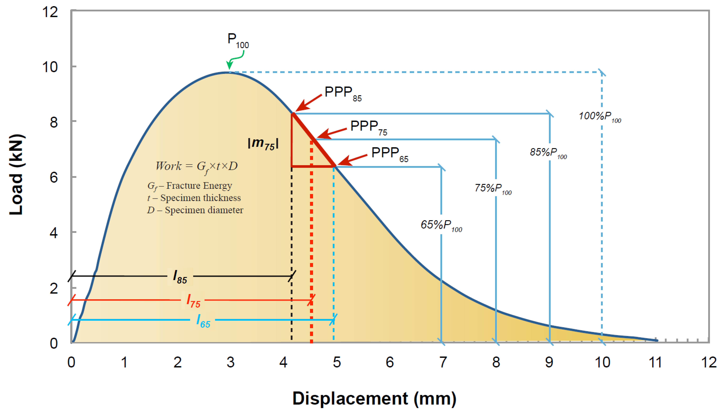
Figure 1: Typical Load versus Displacement Curve.

1033.06 Outliers. Follow the Grubbs Test with 95% confidence per ASTM E178 to determine if any of the six specimen results are outliers for the Cracking tolerance index, CT_{Index}. Report all outliers but remove them from the final average CT_{Index}.

1033.07 Report. Report the following information for each of the six specimens:
- Mix producer.
- Project identification number (e.g., construction project number, LPA number, or general lab ID)
- Job mix formula (JMF) number (if available)
- Mix type
- Equipment Manufacturer and Model Name
- Test date
- Test temperature, °C (to the nearest 0.1 °C)
- Specimen identification number
- Specimen air voids, % (to the nearest 0.1%)
- Specimen diameter, mm (to the nearest 0.1 mm)
- Specimen thickness, mm (to the nearest 0.1 mm)
- Peak load, kN (to the nearest 0.1 kN)
- Indirect tensile strength, kPa (to the nearest 0.1 kPa)
- Displacement, l₇₅, mm (to the nearest 0.1 mm)
- Failure energy, G_{f}, Joules/mm² (to the nearest 0.1 Joule/mm²)
- Post-peak slope, |m₇₅|, N/mm (to the nearest 0.1 N/mm)
- Cracking tolerance index, CT_{Index} (to the nearest 0.1)
- Load versus displacement curves for all specimens.

Summarize the test results on the electronic IDEAL-CT worksheet located on OMM’s webpage. Provide the load versus deformation data and graphs for all specimens including the outliers to OMM with each mix design submittal. Report the final average CT_{Index} on the mix design.

