STATE OF OHIO
DEPARTMENT OF TRANSPORTATION
SUPPLEMENT 1126
DEVELOPING AND SUBMITTING A PORTLAND CEMENT CONCRETE
MIX DESIGN FOR APPROVAL

January 16, 2026

1126.01 Scope
1126.02 Mix Design Submittals for Job Mix Formula (JMF)
1126.03 Documentation and Electronic Submittal Requirements
1126.01 Scope. This Supplement establishes the testing and documentation requirements for Portland Cement Concrete (PCC) mix designs and procedures for submitting the tested designs for approval by the Department. Approved design submittals are issued a Job Mix Formula (JMF) number in accordance with Item 499 and this Supplement. A JMF number identifies the mix proportions and materials for the concrete that will be used on Department projects. Use only approved mix designs with an active JMF when providing concrete for a Department project.
Approved JMFs may be rejected by the Department if performance is inadequate or the mix is not workable or finishable in the field.
1126.02 Mix Design Submittals for Job Mix Formula (JMF). Submit all mix design information according to 1126.03. Develop concrete mix designs conforming to Tables 499.03-1, 499.03-2, and 499.03-3, and the requirements of Item 499.03. Ensure that the absolute volume of the mix design is 27.0 ± 0.05 cubic feet at the design air content of 7 percent for one inch (25 mm) nominal maximum size aggregate. Use a design air content of 8 percent when a 3/8 inch (9.5 mm) nominal maximum size aggregate is specified. Use a design air content of 6 percent for QC RS mixes.
Individual(s) testing any Class of concrete in Table 499.03-1, must be certified as ACI Concrete Field Testing Technician – Grade I and ACI Concrete Strength Testing Technician.
Provide information and data corresponding to the appropriate JMF as follows:
- New QC 1, QC 1P, QC 2, QC 3, or QC 4 Mix Designs. For new QC 1 through QC 4 mix designs, develop and test the mix designs according to the following:
  - Concrete Strength. Determine the required average compressive strength (f’_{cr}) according to ACI 301, section 4.2.3. If no field data is available, select the over-design for the mix from ACI 301, Table 4.2.3.3b. Follow ACI 301 section 4.2.3.4.a or 4.2.3.4.b when using field or laboratory data, respectively, to establish a mix design.
If the laboratory trial mix procedure is used to support the mix design, a single mix may be used if all requirements for the specified mix, including well-graded aggregate, are met. An AASHTO accredited laboratory will mix the trial batch, sample and test the specimens (ACI301, 4.2.3.4.b).
If testing in the field, mix a 3 yd³ (2.3 m³) minimum size load. An ACI Grade 1 Field Testing technician may perform the sampling at the plant if a representative of the AASHTO laboratory witnesses the process. Use 4 x 8 inch (100 x 200 mm) cylinders for the compressive strength testing by the AASHTO accredited laboratory.
The water–cementitious ratio (W/Cm) selected using the ACI 301, section 4.2.3.4b method or single mix method becomes the maximum W/Cm ratio for the proposed mix if approved by the Department. When using carbonate micro-fines, also include the water to powder (w/p) ratio according to ACI 211.7R, Chapter 6, along with the maximum W/Cm ratio.
Test mixes with:
    - The maximum chosen water content
    - Admixtures needed to achieve the maximum slump to within ¾ inch (16 mm) in Table 499.03-4
    - Air content between 7 and 9 percent.
Measure the slump, air content, temperature, unit weight, and yield and produce the strength specimens from the same mix. Test the strength at 3, 7 and 28 days. For QC 4 Mass concrete mixes, if the mix is intended for 56-day acceptance criteria also test compressive strength at 56 days. Determine the aggregate correction factor.
  - Permeability / Resistivity – Obtain samples for determining permeability or resistivity from the same batch as the strength samples. Test the permeability or resistivity using an AASHTO accredited laboratory. Test according to AASHTO T 277 or T 358, as modified in 499.03.
  - Aggregate Gradation - Use a minimum nominal maximum aggregate size of 1 inch (25 mm). Proportion the aggregates to provide a well-graded combined gradation within Zone II (Optimal) of the Coarseness Factor Chart shown in Figure 1126.02-1 and within the limits of the Tarantula Curve shown in Figure 1126.02-2.
    - If using software other than the Department specified “Optimized Gradation Tools”, contact the Department’s Cement and Concrete Engineer at the Office of Materials Management to receive approval of the software before submitting the mix.
    - For QC 1P JMFs, provide coarse aggregate that meets the freeze-thaw requirements listed in Item 703.13.
    - For QC 2 JMFs, provide coarse aggregate that meets the superstructure requirements listed in Item 703.02.B.2.
    - Use the following sieve sizes, as required or used within the gradation range, for the gradation analysis of the aggregates:
Required Sieve Sizes for Input
1 1/2 inch (37.5 mm) | No. 8 (2.36 mm)
1 inch (25 mm) | No. 16 (600 µm)
3/4 inch (19mm) | No. 30 (600 µm)
1/2 inch (12.5 mm) | No. 50 (300 µm)
3/8 inch (9.2 mm) | No. 100 (150 µm)
No. 4 (4.75 mm) | No. 200 (75 µm)

Do not eliminate documented sieve sizes within the range of the gradation, even if the size is not part of the standard gradation requirements.
Use aggregates and data only from ODOT certified aggregate suppliers. Use average gradation data based on at least the latest 10 supplier gradation tests.
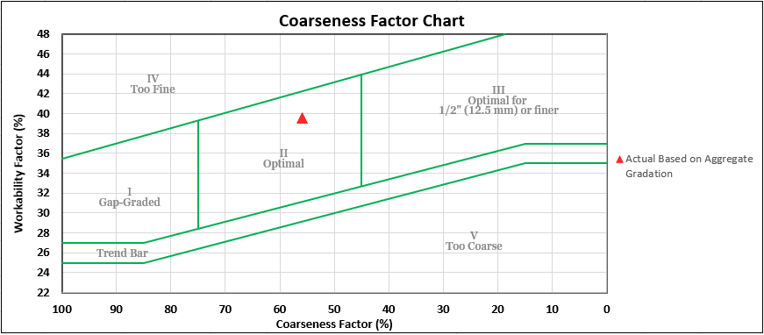Figure 1126.02-1
Coarseness Factor Chart

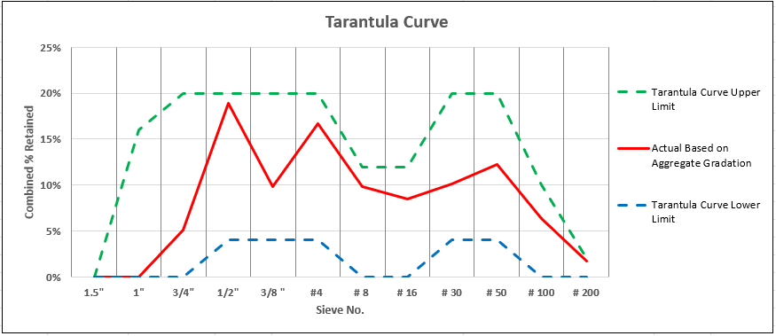Figure 1126.02-2
Tarantula Curve Graph
In the Coarseness Factor Chart:
The vertical axis is the Workability Factor (%). It is the percent passing the No. 8 (2.36 mm) sieve for the combined aggregate gradation.
The horizontal axis is the Coarseness Factor (%). It is the combined percent retained above the 3/8 inch (9.5 mm) sieve divided by the combined percent retained above the No. 8 (2.36 mm) sieve. The value is multiplied by 100 to obtain percent.
Coarseness Factor = $\frac{Percent retained above the 3/8 inch \left(9.5 mm\right)sieve}{Percent retained above the \#8 \left(2.36 mm\right)sieve} x (100\%)$
In the Tarantula Curve:
The vertical axis is the Combined % Retained (%). It is the percent retained on each sieve for the combined aggregate gradation.
The horizontal axis is the Sieve Numbers.
- New QC MS Mix Designs. Develop QC MS mix designs for acceptance and provide the following data:
  - Concrete Strength - Follow the requirements of 1126.02.A.1, except as modified in this section. Determine the center- or third-point flexural strength curve for the proposed mix at laboratory temperatures. Test conforming to ASTM C293 or C78, respectively. An AASHTO accredited laboratory is not required.
    - Develop a QC MS mix targeted to achieving 400 psi (2.8 MPa) within 24 hours. The Office of Materials Management will approve a mix design achieving 400 psi (2.8 MPa) within 28 hours and issue a JMF.
      - Make at least three 6-inch by 6-inch (15 mm by 150 mm) beam specimens and test them at 20, 24 and 28 hours. Plot the results to produce a curve.
  - Permeability / Resistivity – Not required.
  - Aggregate Gradation – Well-graded aggregate - not required. Nominal maximum 1-inch (25 mm) size is required.
- New QC MISC Mix Designs. Provide the following data:
  - Concrete Strength – Follow the requirements of 1126.02.A.1, except as modified in this section. Provide test results that verify that the strength meets the ACI overdesign requirements for the mix. An AASHTO accredited laboratory is not required.
  - Permeability / Resistivity – Not required.
  - Aggregate Gradation – Use a 1 inch (25 mm) nominal maximum sized coarse aggregate.
- New QC 5 Mix Designs. Provide the following data:
  - Concrete Strength – Follow the requirements of 1126.02.A.1, and test using an AASHTO accredited laboratory. Provide test results that verify that the strength meets the ACI overdesign requirements for the mix.
  - Permeability / Resistivity – Not required.
  - Aggregate Gradation – Use a 1 or 3/8 inch (25 or 19 mm) nominal maximum size coarse aggregate. When using a QC 5 JMF for Item 519, provide coarse aggregate that meets the superstructure requirements listed in Item 703.02.B.2.
- New QC SCC Mix Designs. For new QC SCC mix designs, develop and test the mix designs according to ACI 237 and the following:
  - Concrete Strength –Determine the required average compressive strength (f’_{cr}) according to ACI 301, section 4.2.3. Select the over-design for the mix from ACI 301, Table 4.2.3.3b. Follow ACI 301 section 4.2.3.4.b when using laboratory data to establish a mix design.
If the laboratory trial mix procedure is used to support the mix design, a single mix may be used if all requirements for the specified mix, including well-graded aggregate, are met. An AASHTO accredited laboratory will mix the trial batch, sample and test the specimens (ACI301, 4.2.3.4.b).
If testing in the field, mix a 3 yd³ (2.3 m³) minimum size load. An ACI Grade 1 Field Testing technician may perform the sampling at the plant if a representative of the AASHTO laboratory witnesses the process. Use 4 x 8 inch (100 x 200 mm) cylinders for the compressive strength testing by the AASHTO accredited laboratory.
The water–cementitious ratio (W/Cm) selected using the ACI 301, section 4.2.3.4b method or single mix method becomes the maximum W/Cm ratio for the proposed mix if approved by the Department. When using carbonate micro-fines, also include the water to powder (w/p) ratio according to ACI 211.7R, Chapter 6, along with the maximum W/Cm ratio.
Test mixes with:
    - The maximum chosen water content.
    - Admixtures needed to achieve the design slump flow for the SCC class listed in Table 499.03-5, minimum passing ability and maximum static segregation.
    - Air content between 7 and 9 percent for 1 inch (25 mm) nominal maximum aggregate size and 8 to 10 percent for 3/8 inch (9.5 mm) nominal maximum aggregate size.
Measure the air content, temperature, unit weight, and yield and produce the strength specimens from the same mix. Test the strength at 3, 7 and 28 days. Determine the aggregate correction factor.

  - Slump Flow- Using an AASHTO Accredited Laboratory, provide slump flow according to the class listed in Table 499.03-5 and in accordance with ASTM C1611. Individual(s) testing for slump flow and the items listed below must be certified as an ACI Self-Consolidating Concrete Testing Technician. In addition, provide the following items:
    - Visual Stability Index (VSI)- Provide a VSI of 0 or 1 as listed in ASTM C1611 for acceptance of the mix design.
    - J-Ring- Test J-ring passing ability in accordance with ASTM C1621. The measured difference between the slump flow and J-ring flow must be 2 inches or less to be acceptable.
    - Static Segregation- Test for static segregation according to ASTM C1712. The measured penetration must be one-half inch or less to be acceptable.
  - Permeability / Resistivity – Obtain samples for determining permeability or resistivity from the same batch as the strength samples. Test the permeability or resistivity using an AASHTO accredited laboratory. Test according to AASHTO T 277 or T 358, as modified in 499.03.
  - Aggregate Gradation – Use a 1 or 3/8 inch (25 or 19 mm) nominal maximum size coarse aggregate. Proportion the aggregates to provide a well-graded combined gradation to meet the slump flow and additional requirements provided above under 1126.02.E.2. Slump Flow using the Department specified “Optimized Gradation Tools” software.
    - If using software other than the Department specified “Optimized Gradation Tools”, contact the Department’s Cement and Concrete Engineer at the Office of Materials Management to receive approval of the software before submitting the mix.
    - For QC SCC JMFs, provide coarse aggregate that meets the superstructure requirements listed in Item 703.02.B.2.

- New QC RS Mix Designs. Develop QC RS mix designs for acceptance and provide the following data:
  - Concrete Strength - Follow the requirements of 1126.02.A.1, except as modified in this section. Determine the center- or third-point flexural strength curve for the proposed mix at laboratory temperatures. Test conforming to ASTM C293 or C78, respectively. An AASHTO accredited laboratory is not required.
    - Develop a QC RS mix targeted to achieving 300 psi (2.1 MPa) in not less than 4 hours and not more than 6 hours.
    - Use a maximum cementitious content of 850 pounds (385 kg) and a maximum Portland cement content of 660 pounds (300 kg).
    - A maximum of 0.5 percent calcium chloride by mass of cementitious content, a non-chloride accelerating admixture, or both may be used to generate early strength development.
    - Use a minimum dosage rate of macro-fibers of 4.0 lb/yd³ (2.4 kg/m³) of concrete. Ensure the final proposed mix is workable and produced without balling or clumping of the macro-fibers.
    - Make at least four 6-inch by 6-inch (150 mm by 150 mm) beam specimens and test them at 3, 4, 6 and 8 hours. Plot the results to produce a curve. Alternatively, develop the mix’s maturity curve according to Supplement 1098.
  - Permeability / Resistivity – Obtain samples for determining permeability or resistivity from the same batch as the strength samples. Test the permeability or resistivity using an AASHTO accredited laboratory. Test according to AASHTO T 277 or T 358, as modified in 499.03.
  - Aggregate Gradation – Follow the requirements of 1126.02.A.3.
- New Micro-Silica Modified, Latex Modified, or Superplasticized Dense Concrete Mix Designs. Develop mix designs in accordance with the proportioning requirements of Supplemental Specification 847 or 848. Submit according to 1126.03, except as modified in Supplemental Specification 847 or 848. Section 1126.03.1 – 6 and the 1126.03 retesting requirements do not apply.
- New Shotcrete Mix Designs. Develop mix designs in accordance with Item 520.03.A using an AASHTO accredited laboratory. Submit according to 1126.03..
1126.03 Documentation and Electronic Submittal Requirements. Complete the PCC JMF Submittal Form available at:
https://www.transportation.ohio.gov/working/construction/materials/reports/concrete-jmf
Ensure the submittal includes electronic copies of all required information including:
  - Certified test data;
    - Ensure that batch weights tested and specified in the JMF Form are included in the certified test data report. This would also include items required to be listed on the JMF as defined in each Class, such as the w/cm, slump, air, unit weight, temperature, yield, Aggregate Correction Factor (ACF), etc.
    - When an AASHTO Accredited Laboratory is specified for the mix classification, the Lab used must be independent of the Ready-Mix company.
    - Provide the full name of the person performing each test.
  - Gradation reports for each aggregate.
  - Department specified “Optimized Gradation Tools” Report (or other approved software);
    - All output showing where individual gradations and combined gradations fall in the Coarseness Factor Chart in Figure 1126.02-1 and within the limits of the Tarantula Curve shown in Figure 1126.02-2.
  - For well graded aggregate - The certified aggregate producer’s average of at least the most recent 10 gradation tests for the selected aggregates, not to exceed 18 months from the submittal date, unless approved by the Laboratory.
  - Any additional test data depending on which mix options have been selected.
  - For QC 3, QC 4, and as per plan mixes, include an attachment of the Project Plan Notes. Fill out the highlighted information in the JMF Form (PID, Page Number of Plan Note, Description of JMF used in the specified project).
Use the most recent version of the form for each submittal. Use the most recent aggregate specific gravity and absorption values from the ODOT Specific Gravity Report.
Submit a completed form and all other required data electronically to:
dot.cen.pccjmf@dot.ohio.gov
Submit the JMF request at least 20 days prior to expected use. An approved mix will be issued a JMF number by the Department and the submitter will be notified electronically of the status.
Retesting is required when changing the W/Cm ratio, cementitious material quantity, aggregate type, cement type, pozzolan class or grade, or cementitious material source.
Retesting is not required when adjustments are made to the JMF’s aggregate portions. Submit a material change request and select “MATERIAL CHANGE TO JMF” on the submittal form and include the related JMF that will be adjusted.
Changing sources of prequalified admixtures does not require a new JMF number; the sources are to be identified in the submittal, and in the field according to 499.07. When changing sources of prequalified admixtures, provide OMM with the updated source, brand name, and dosage rate if applicable. The Department is not liable for adverse performance, workability, or finishability effects of any approved JMF or approved changes to a JMF.
Complete a PCC JMF Submittal Form when changing aggregate sources of an approved JMF. Select “MATERIAL CHANGE TO JMF” on the submittal form and include the related JMF that you are using for the aggregate source change. Provide the Department specified “Optimized Gradation Tools” analysis and supporting gradation reports for the new sources, as necessary.

